Design of smart-real time monitoring wearable safety jacket for hard industrial environments

.

ABSTRACT

|  |
| --- |
| **Aims:** The objective of smart clothing is to integrate fashion, engineering, user experience, cybersecurity, design, and science to develop technologies capable of anticipating users' needs and desires.  Study Design: This research aims to design, develop, and systematically evaluate a wearable smart safety vest intended to enhance industrial worker safety by continuously monitoring both environmental and physiological parameters.  **Place and Duration of Study:** The study was conducted at [The Higher Institute of Engineering and Technology in New Damietta] from [January 2024 to December 2024].  **Methodology:** This study explores the potential of smart textiles that communicate with smartphones to process vital biometric data such as heart rate, temperature, respiration, movement, acceleration, stress levels, and even fingerprints. Additionally, hormone levels were considered as a key factor, signalling the emergence of a new era in wearable technologies. The paper addresses the core requirements for developing IoT-enabled smart apparel and discusses the potential long-term impact of these advancements on business models.  **Results:** The system alerts industrial workers through the app with notifications generated by various sensors. Each sensor is linked to specific auditory cues to enhance user awareness. The app allows users to monitor automation processes, view DataStream events, and access real-time sensor data, providing comprehensive feedback on sensor readings.  **Conclusion:** The paper outlines the primary types and components of smart IoT clothing and wearables, highlighting their essential features and the most recent advancements in the field. It also presents a global IoT framework for smart clothing and offers recommendations for designing networks that will connect apparel with other IoT devices, paving the way for future developments in the integration of smart clothing and the Internet of Things. |

*Keywords: Smart safety jacket, Real-time monitoring, Temperature, sensors, GPS, ESP32, health monitoring.*

1. INTRODUCTION

In the current era, where security and well-being are the most important needs in various basic cycles, people in coal ventures essentially promise the same thing. The Worldwide Coalition has accounted for approximately one episode while focusing on the most recent reality. In support of Iranian laborers (Suttitatee et al., 2024; Balaji et al., 2023). This incident occurred at the Sanjdi coal mine near Quetta, Baluchistan, and resulted in the deaths of six persons due to toxic gasses. Although the Pakistan Central Mines Labor Federation and the Industrial Global Union are well aware of this problem, there isn't a perfect answer. Thousands of lives could be spared at the appropriate moment if the suggested method were implemented in a coal mine even though it can't be put into practice after being monitored on a wireless sensor network. Additionally, this is a first-of-its-kind approach due to the number of effective sensors recommended in this research (Lee & Baek, 2021; Raj, 2024; Zakir, 2021). There are other potential solutions to the same issue, many of which have been tried previously, but monitoring them following a coal mine collapse for any reason is a significant challenge (Azhan et al., 2024). The disaster management authority starts a protracted excavation of the entire site in such a situation. Most of the time, the rescue crew cannot find victims with the right pulse rate, therefore they are unable to save all of the victims. This technology will continuously update the miner's pulse rate and determine the exact depth and GPS location of the miner (De Fazio et al., 2022; Ananth et al., 2022; Sakhare et al., 2023). Using this technique, the rescue crew can excavate exactly where the miners are stuck and at the ideal depth to bring them back to the ground (Chandrasekaran et al. 2023). In (Narasimha et al., 2013), Numerous health related parameters are detected by the prototype, such as the miner's global geolocation, the present temperature and humidity, the miner's pulse rate, and the exact depth location. A semi-conductor gas sensor is described in (Pandey et al., 2016) as one of the most effective ways to identify the presence of toxic gases. It is possible to install these sensors in the area of coal mineshafts. In other cases, the sensor gadget was often accidentally damaged. Another alternative is to deploy a robot. Meanwhile, because of their ability to monitor the environment in a wide range of locations, ZigBee-based wireless sensor networks have recently been the focus of research. A significant amount of research has been done on the creation of health monitoring devices, as stated in (Jubadi & Sahak, 2009). Heart Beat Monitoring Via Alert is a new technology that may be used soon, according to War-suzarina Mat Jubadi and her colleagues. The purpose of this warning system is to monitor a patient's heart rate in order to avert cardiac arrest. This technique is called electrocardiography (PPG) and it uses the photoplethysmography principle to monitor heart rate with excellent precision. After a PIC16F87 microcontroller received and processed the PPG signal, the data could be Elabd et al.; J. Eng. Res. Rep., vol. xx, no. xx, pp. xx-xx, 20YY; Article no. JERR.134979 5 utilized to determine the heartbeat rate per minute. In the case of a medical emergency, family members or medical professionals received an emergency text message alert (Bhagchandani & Augustine, 2019). In particular, this study makes use of the photoplethysmography (PPG) technology. This system uses the PIC16F87 microcontroller, which is available here. The results may be a little delayed because this approach just measures heart rate. As stated in (Akash & Shikder, 2020), the Patient Monitoring System (sometimes called PMS) uses GSM technology to achieve this objective. An ongoing surveillance system maintains.

**1.1 Importance of smart safety jacket**

This project addresses a real and growing need in industrial safety. By providing a smart solution that combines health tracking, environmental monitoring, and location tracking, it offers enhanced protection for workers and peace of mind for supervisors. The system could significantly reduce workplace accidents, improve emergency response time, and increase productivity in hazardous work conditions. By developing the smart safety Jacket and linking it to an application that displays real-time worker data, we have theoretically demonstrated the potential for enhancing worker safety in hazardous work environments.

In the long term, this project has the potential to be commercialized and adopted widely in both public and private sectors, contributing to the development of Industry 4.0 and smart safety systems.

1. MEthodology

**(IoT)** technologies involved a multi-phase approach, encompassing hardware selection, sensor integration, embedded system programming, wireless communication setup, and cloud-based data management. The overall objective was to design a compact, wearable system capable of real-time monitoring of both environmental and physiological parameters for enhanced industrial safety.

**2.1 System Design and Component Selection**

The project began with a comprehensive analysis of the functional requirements, which included real-time data acquisition, wireless transmission, health tracking, and alert generation. Based on these requirements, key components were selected to ensure performance, power efficiency, and cost-effectiveness. As illustrated in Figure 1, these components were carefully chosen to align with the system's intended functionality.

**2.1.1 Gas Monitoring**

The MQ-135 gas sensor was used to detect air quality and the presence of toxic gases such as ammonia, nitrogen oxides, alcohol, benzene, smoke, and carbon dioxide — essential in hazardous work environments. As shown in Figure 1, the sensor was selected for its broad detection range and sensitivity to various harmful gases.

**2.1.2 Vital Sign Monitoring**

A pulse sensor was integrated to continuously track the user's heart rate and help identify signs of fatigue, stress, or medical emergencies. According to Figure 1, continuous monitoring of vital signs was prioritized to ensure rapid detection of potential health risks in real-time.

**2.1.3 Motion and Orientation Detection**

The MPU-6050 accelerometer and gyroscope were used to monitor body orientation and sudden changes in movement, particularly to detect falls or abnormal body posture. As demonstrated in Figure 1, this sensor was integral in detecting movement patterns and maintaining user safety in dynamic environments.

**2.1.4 Location Tracking**

A GPS module was incorporated to determine the precise geolocation of the user at any moment, which is crucial during emergencies and rescue missions. Figure 1 highlights the importance of real-time location data in critical scenarios to ensure effective intervention.

**2.1.5 Environmental Monitoring**

The BMP-180 sensor was used to measure atmospheric pressure and temperature, providing context about the working environment and detecting potential risks. Figure 1 emphasizes the relevance of environmental data in assessing and preventing external threats during work-related activities.

**2.1.6 Other Modules**

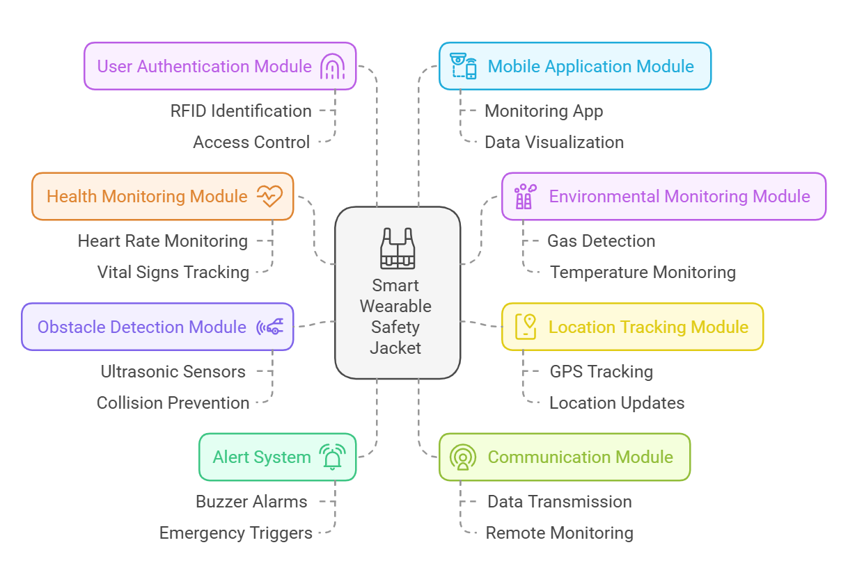 Additional components such as an ultrasonic sensor, RFID reader, vibration sensor, buzzer, push button, and a rechargeable battery were included to enhance the overall functionality, user interaction, and safety automation of the jacket. As depicted in Figure 1, these supplementary components ensure the jacket is versatile and effective in a wide range of applications. The ESP32 microcontroller served as the brain of the system. It was selected due to its dual-core processor, low-power operation, multiple analogy/digital interfaces, and built-in Wi-Fi, which enabled smooth and efficient data transmission to cloud services. As indicated in Figure 1, the ESP32's features made it an ideal choice for seamless communication and real-time data processing.

**Fig. 1. System Architecture**

**2.2 Sensor Integration and PCB Design**

All selected sensors were interfaced with the ESP32 through a custom-designed Printed Circuit Board (PCB). The PCB was designed using professional EDA tools and fabricated to ensure minimal wiring complexity, efficient space utilization, and ease of assembly. Special attention was given to signal routing, power regulation, and noise reduction to ensure reliable performance in industrial environments. Sensor calibration was performed for each module individually. For instance, the MQ-135 was tested under various gas concentrations to derive reliable threshold values, while the pulse sensor was validated through comparison with medical-grade heart rate monitors.

**2.3 Embedded System and Firmware Development**

The firmware was developed using the Arduino IDE and tailored to manage multiple tasks concurrently. The core functions included reading and processing data from all sensors, filtering out erroneous data or noise using software-based validation algorithms, managing Wi-Fi connectivity and error handling, and sending structured data packets to a Firebase Realtime Database at consistent time intervals. Power management strategies were also implemented within the firmware to optimize energy usage and extend battery life, including deep sleep modes during inactivity and sensor polling based on activity thresholds.

**2.4 Cloud Architecture and Mobile Application Development**

The backend system was built on Google Firebase, which offered a scalable and efficient platform for storing and synchronizing sensor data. Data was pushed in real time to Firebase using HTTP and MQTT protocols, ensuring minimal latency and reliable communication. A mobile application, named Jicky, was developed using Flutter to provide a cross-platform user interface. The application offered live dashboards displaying sensor readings such as heart rate, gas levels, and temperature. It also provided alerts and notifications for abnormal readings (e.g., elevated gas levels or rapid heart rate), maps, and geolocation tracking through the Google Maps API to help supervisors monitor the real-time position of the worker wearing the jacket. Additionally, it maintained a historical log of sensor data for analysis and safety auditing.

**2.5** **Testing, Validation, and Optimization**

Extensive testing was conducted in both controlled environments and simulated industrial conditions. Each feature of the smart jacket was evaluated independently and in combination to validate system integrity. Test cases included exposure to varying concentrations of gases to assess MQ-135 accuracy, monitoring heart rate during rest and physical activity, simulated falls to verify MPU-6050 sensitivity and trigger response, and real-time GPS location updates in indoor and outdoor settings. Wireless communication was tested for consistency and range, ensuring data could be transmitted without interruption within a standard factory environment.

**2.6 Final Assembly and Deployment**

Upon successful validation, the system was encapsulated into a wearable format with ergonomic consideration. The battery was integrated with an efficient charging module and protected circuitry to prevent overcharging or overheating. The jacket components were housed in shock-resistant enclosures and embedded within the fabric in a way that maintains user comfort and mobility. This final version of the Smart Safety Jacket is now fully functional and ready for deployment in real-world industrial environments, providing enhanced health monitoring, situational awareness, and life-saving capabilities through smart wearable technology and IoT-driven automation.

**3. Work in**

**3.1 Simulation**

To assess the performance and functionality of the Smart Safety Jacket before hardware deployment, a full simulation was carried out using Proteus and the Arduino IDE. The simulation replicated a real-world industrial environment, integrating all the main components of the system. The ESP32 microcontroller was central to the setup, managing sensor inputs and handling wireless communication. The MQ-135 gas sensor was used to detect the presence of harmful gases such as carbon monoxide, ammonia, and benzene in the surrounding air, alerting the system in case of unsafe concentrations. The BMP-180 sensor was responsible for monitoring atmospheric pressure and ambient temperature, providing insight into the environmental conditions in which the worker is located. For motion sensing, the MPU-6050 sensor, which combines an accelerometer and a gyroscope, was used to detect sudden movements, falls, or abnormal tilting that may indicate an accident. The pulse sensor continuously measured the worker’s heart rate by detecting blood flow through the fingertip or wrist, helping assess the individual’s physical state. The GPS module was implemented to provide real-time tracking of the worker's location, which is crucial in emergencies for quick rescue operations. The ultrasonic sensor measured the distance from nearby objects or obstacles, enhancing situational awareness, especially in tight or hazardous spaces. The RFID module enabled identification of the person wearing the jacket, allowing for secure login and tracking of individual workers. The vibration sensor was used to detect strong shocks or structural disturbances, which may indicate danger in the environment. A buzzer was added to give audible alerts when the system detects abnormal conditions, while a manual emergency button allowed the user to trigger an emergency alert manually if needed.During this process, several components—such as the MPU-6050 sensor, the vibration motor, and the ESP32—lacked native libraries in Proteus. Additionally, the ESP8266 module we used was of a different version than the one supported by the software. As a result, we developed custom libraries and made modifications to simulate these components accurately. This allowed for complete testing of the system's responses, data flow, and interactions in a virtual environment, ensuring stability and functionality before physical implementation. The simulation layout of the hardware is visually represented in Figure 2, illustrating the comprehensive integration of all components in the test environment.

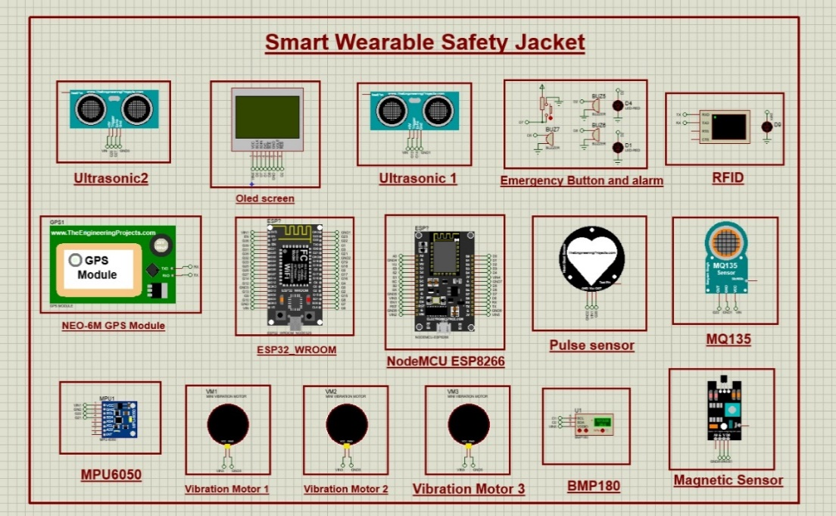**Fig*.* 2.Smart Wearable Safety Jacket Simulation**

**3.2 Hardware**

The hardware system of the Smart Safety Jacket was carefully designed to optimize space and performance.One ESP32 microcontroller and one ESP8266 module were used, each mounted on a custom-designed PCB to distribute tasks efficiently and reduce overall size within the jacket. One board was responsible for vital sign monitoring, while the other handled environmental sensing and location tracking. The MQ-135 gas sensor was integrated to detect hazardous gases like carbon dioxide and ammonia, triggering alerts in case of elevated concentrations. A pulse sensor was included to continuously monitor the wearer’s heart rate, providing essential health insights. The MPU-6050 sensor, with its built-in accelerometer and gyroscope, was utilized to detect falls or abnormal tilting that might indicate accidents. A GPS module was connected for real-time geolocation tracking, essential for worker safety in hazardous environments. RFID technology was used for identifying the individual wearing the jacket, enabling secure login and monitoring. An ultrasonic sensor was added to detect nearby obstacles or dangers by measuring distance. The BMP-180 sensor was employed to measure atmospheric pressure and temperature, which helps assess environmental conditions. A vibration sensor was also included to identify strong shocks or structural disturbances. The system featured a buzzer to deliver audio warnings and a manual emergency button that workers can press to call for help. Power was supplied by a rechargeable lithium-polymer battery, supported by a power management circuit for stable operation and extended battery life. As illustrated in Figure 3, the front view of the PCB shows the organized layout of components, while Figure 4 presents the back view, 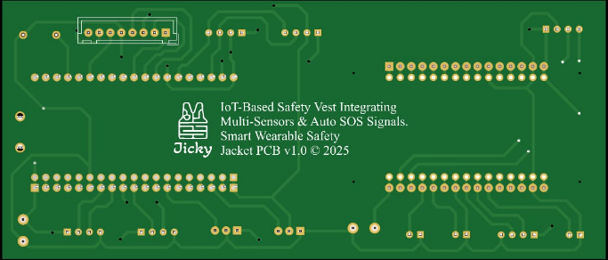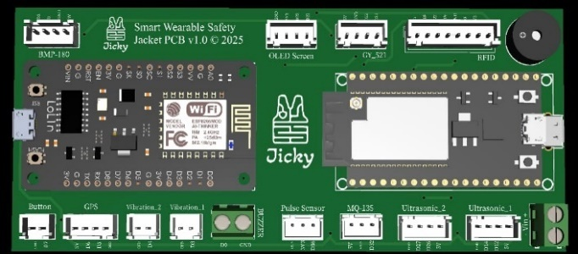demonstrating the compact and efficient hardware design.

**Fig. 3. PCB design: Top Layer Fig. 4. PCB Design: Bottom Layer**

**3.3 Software**

**3.3.1 Mobile Application**

 The mobile application, developed using Flutter, is a core component of the software system for the Smart Safety Jacket. Designed with a clean, cross-platform interface, the app includes multiple specialized screens to support both monitoring and emergency functions. Upon launch, users are directed to the Login screen, with an option to reset their credentials through the Forgot Password screen. The interface shown in Figure 5 illustrates the Login page layout and flow. Once authenticated, users are navigated to the Home Page, which provides a real-time overview of sensor data such as heart rate, gas levels, temperature, and pressure, displayed with dynamic indicators to reflect the worker’s condition. The structure and features of this screen are depicted in Figure 6, offering a clear representation of how critical information is visualized. The Alarms screen handles instant notifications triggered when critical thresholds are exceeded, while the Emergency screen enables rapid response by alerting supervisors or emergency services. The Location screen integrates Google Maps API to continuously track the worker’s live position, enhancing situational awareness and rescue response. The layout and functionality of this feature are exemplified in Figure 7, emphasizing its role in real-time tracking. Dedicated screens like Worker and Workers allow supervisors to view details and statuses of individual or multiple users wearing the jacket. The user management interface is effectively demonstrated in Figure 8, which presents the Workers screen. The Account screen gives access to personal settings, where users can adjust alert preferences, review app activity, and manage their profile. All screens are connected through real-time data synchronization with Firebase, ensuring secure and accurate communication between the wearable system and the control interface.

**Fig. 5. Application: Login Fig. 6. Application: Home Page**

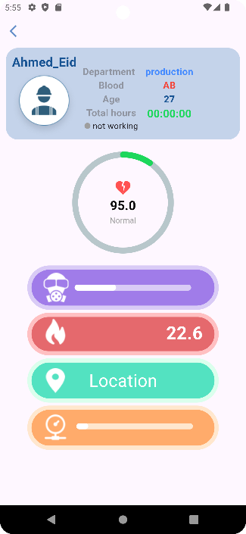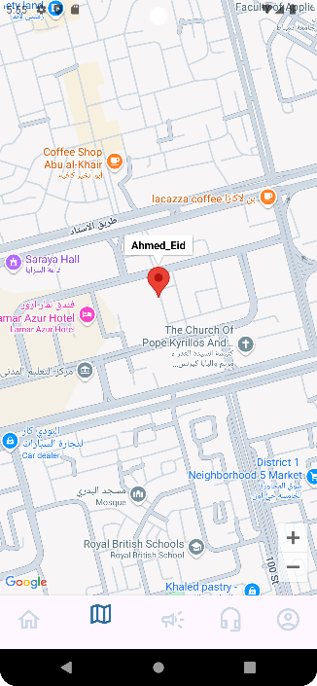

**Fig. 7. Application: Location Page** **Fig. 8. Application: Worker Page**

**3.3.2 Website**

The website was designed to serve as a comprehensive control platform that enables supervisors and administrators to monitor workers' status in real time through an intuitive graphical interface. The dashboard features a live map displaying the geographical locations of all workers wearing the smart safety jacket, along with live sensor data such as heart rate, toxic gas levels, temperature, and atmospheric pressure. Alerts and warnings are also shown if any of these parameters exceed safe thresholds, allowing the safety team to respond promptly. In addition, the website allows for user account management and provides access to historical sensor data, which supports periodic evaluations and safety audits. It is connected to a Firebase real-time database to securely store and synchronize data with the jacket and the mobile application. The platform also offers easy integration with safety management tools used in industrial environments. This interface, as illustrated in Figure 9, represents the main webpage of the smart safety jacket system, demonstrating its real-time monitoring and control capabilities.

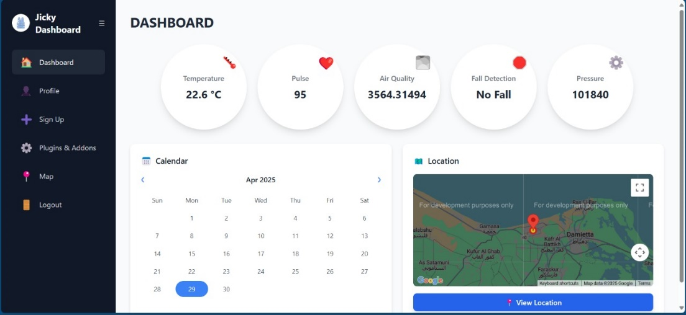

**Fig. 9. Smart Safety Wearable Jacket Website**

**3.4 Smart Safety Jacket Design**

The design of the Smart Safety Jacket was carefully planned to ensure that all sensors and components are positioned optimally for accurate data collection and functionality. The jacket incorporates various sensors and devices, each strategically placed for maximum effectiveness and comfort. The gas sensor is positioned at the neck area, allowing it to quickly detect hazardous gases due to its proximity to the air intake and the source of human respiration. Slightly lower, on the right side, is the ultrasonic sensor, used for measuring distance and detecting nearby objects. On the left side, aligned with the ultrasonic sensor, is the screen, providing real-time data to the user. Beneath this, on the left side of the jacket, is the GPS sensor, which tracks the wearer's location, ensuring that emergency services or supervisors can easily locate them. Moving further down on the right side, the button is placed near the BMP sensor, which measures environmental parameters like temperature and atmospheric pressure. Just below this, the MPU sensor is positioned to monitor the wearer's movements, detecting falls or sudden shifts in posture. Below the MPU sensor is the microcontroller, located near the center of the jacket to control and manage data processing from all sensors.The battery is placed on the left side of the jacket, ensuring proper balance of weight and easy access for power management. The RFID sensor is situated on the right sleeve, allowing for tracking and identification purposes. Beneath the RFID, the vibration sensor is located to alert the wearer of any significant vibrations or emergency signals. On the left sleeve, near the wrist, the pulse sensor is strategically placed to measure heart rate, particularly close to the vein for better accuracy. Above the pulse sensor is another vibration sensor, which provides alerts in the case of emergency situations or hazardous conditions.The jacket also features reflective light strips throughout, especially around the arms, back, and chest. These reflective strips enhance the visibility of the wearer in low-light environments, significantly improving safety in industrial or hazardous work environments. The reflective lines serve an important function, making sure that workers are easily visible to others, especially in emergency situations or during night shifts. This thoughtful design ensures that all sensors are placed in convenient and effective locations while maintaining comfort and functionality for the wearer**.**

**4.Results and Discussion**

The Smart Safety Jacket was tested under various environmental and physiological conditions to evaluate its functionality, reliability, and accuracy. These tests were carried out in both controlled indoor laboratory environments and simulated industrial scenarios that mimicked real-world conditions, such as elevated temperatures, gas exposure, and sudden movement or impact. The objective was to assess not only the performance of individual sensors but also the responsiveness and stability of the entire system when operating as an integrated unit. The testing process covered several key parameters. Sensor accuracy was validated by comparing sensor readings—such as heart rate, gas concentrations, temperature, and atmospheric pressure—with reference equipment. The system demonstrated high accuracy and consistency across all trials, with minimal deviation from expected values. Additionally, real-time response was evaluated by triggering simulated emergency events, such as high gas levels or sudden falls, to ensure the jacket could detect and report incidents immediately. Data transmission between the ESP32 microcontrollers, mobile application, and Firebase cloud database was stable and efficient, with transmission delays averaging less than one second. Application performance was also tested, and the mobile app was found to update sensor data and location information smoothly with low latency. Alerts were displayed in real time, and historical data was properly logged and synchronized between the wearable and web platforms. These results confirm that the Smart Safety Jacket performs effectively in diverse scenarios, offering a dependable safety solution that combines accurate sensing, robust communication, and user-friendly interfaces for both workers and supervisors.

|  |  |  |  |  |
| --- | --- | --- | --- | --- |
| Sensor | Measured Parameter | Normal Range | Test Reading | Remarks |
| MQ-135 | Air Quality (ppm) | 100 – 200 ppm | 170 ppm | Within normal range |
| Pulse Sensor | Heart Rate (BPM) | 60 – 100 BPM | 92 BPM | Stable during rest |
| MPU-6050 | Acceleration/Fall Detection | N/A | Fall Detected | Triggered correctly |
| BMP-180 | Temperature (°C) | 20 – 30°C (indoor) | 28.5°C | Accurate and consistent |
| GPS | Location Accuracy | ≤ 5 meters | 3.8 meters | Accurate GPS fix |

**Table. 1. Sensors Performance**

**4.1 Sensor Performance**

Each sensor was calibrated and tested for accuracy. The table below presents sample readings from selected sensors during different test scenarios. As shown in Table 1, the performance of each sensor is clearly demonstrated, providing insight into their behavior and reliability under varying conditions.

**4.2 System Alerts and App Integration**

The system was tested for its ability to trigger alerts and communicate with the mobile app in real time. The table below shows the test outcomes for critical events and responses. As demonstrated in Figure 10, the alert system is tightly integrated with the mobile application, enabling immediate push notifications and visual updates on the user's interface. This ensures that users receive timely warnings in hazardous situations, significantly improving responsiveness and safety in real-world applications

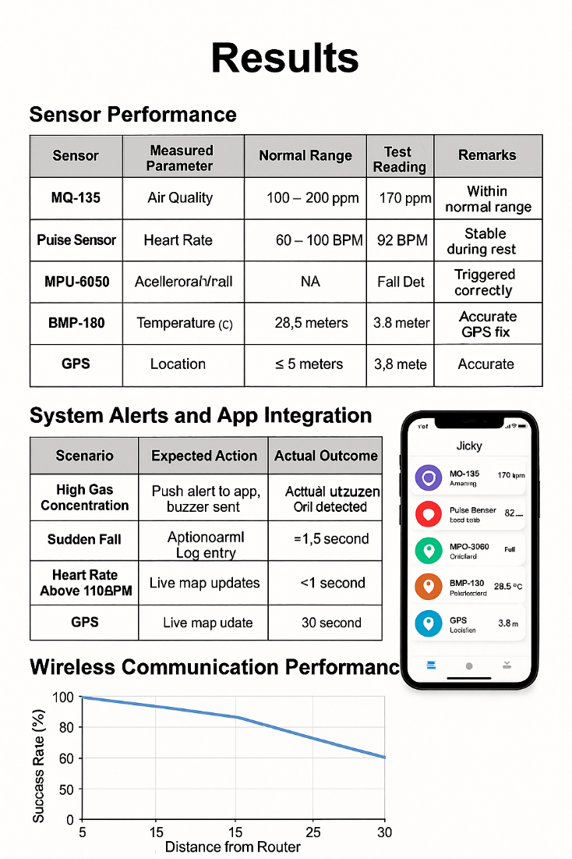.

**Fig. 10. System Alerts and Application Integration**

**4.3 Wireless Communication Performance**

The system's communication remained stable and reliable over distances of up to 30 meters in a factory-like environment, with minimal obstacles and interference. During testing, data transmission was consistent, with a data loss rate of less than 2%, which falls within acceptable limits for real-time industrial applications. This level of performance confirms the suitability of the communication protocol used for environments that require dependable data flow between wearable devices and central monitoring systems.

. **4.4 Final Prototype Assembly and System Integration**

After the full assembly and integration of all hardware components, the Smart Safety Jacket prototype was successfully constructed and tested in a controlled environment. Figure 11 showcases the final physical implementation of the jacket, with all sensors, modules, and electronic components properly installed and operational. The jacket was equipped with dual ESP32 microcontrollers, custom PCBs, and a range of sensors including MQ-135 for gas detection, BMP-180 for temperature and pressure, an ultrasonic sensor for obstacle detection, a pulse sensor, MPU-6050 for motion tracking, GPS, RFID, vibration sensor, and buzzer system — all embedded seamlessly within the wearable fabric to ensure comfort and usability. Once powered, the system demonstrated full functional integration. Each sensor was successfully calibrated and communicated data in real time to both the mobile application and the Firebase-connected web dashboard. The wearable responded efficiently to changes in environmental conditions and physiological inputs. For instance, the gas sensor correctly triggered alerts when exposed to smoke or elevated gas levels, while the pulse sensor continuously updated the user's heart rate. The MPU-6050 accurately detected orientation changes and simulated falls, prompting emergency triggers when needed. The GPS provided consistent and accurate location tracking, critical for field applications in remote or hazardous work environments. One of the significant outcomes of the test was the smooth coordination between hardware and software components. The mobile application displayed real-time data updates with minimal delay, and alerts were promptly triggered upon detecting any critical parameter thresholds. Communication between the two ESP32 boards was stable, and the system maintained reliable performance over extended periods.

This final implementation validated the design assumptions and showed that the smart jacket is capable of providing continuous health monitoring, environmental awareness, and emergency communication — all in one wearable platform. These results underscore the jacket’s potential in industrial safety applications, particularly for workers in hazardous environments like mining, construction, or chemical plants. In future iterations, further miniaturization and robustness improvements will be explored to enhance wearability and long-term deployment.

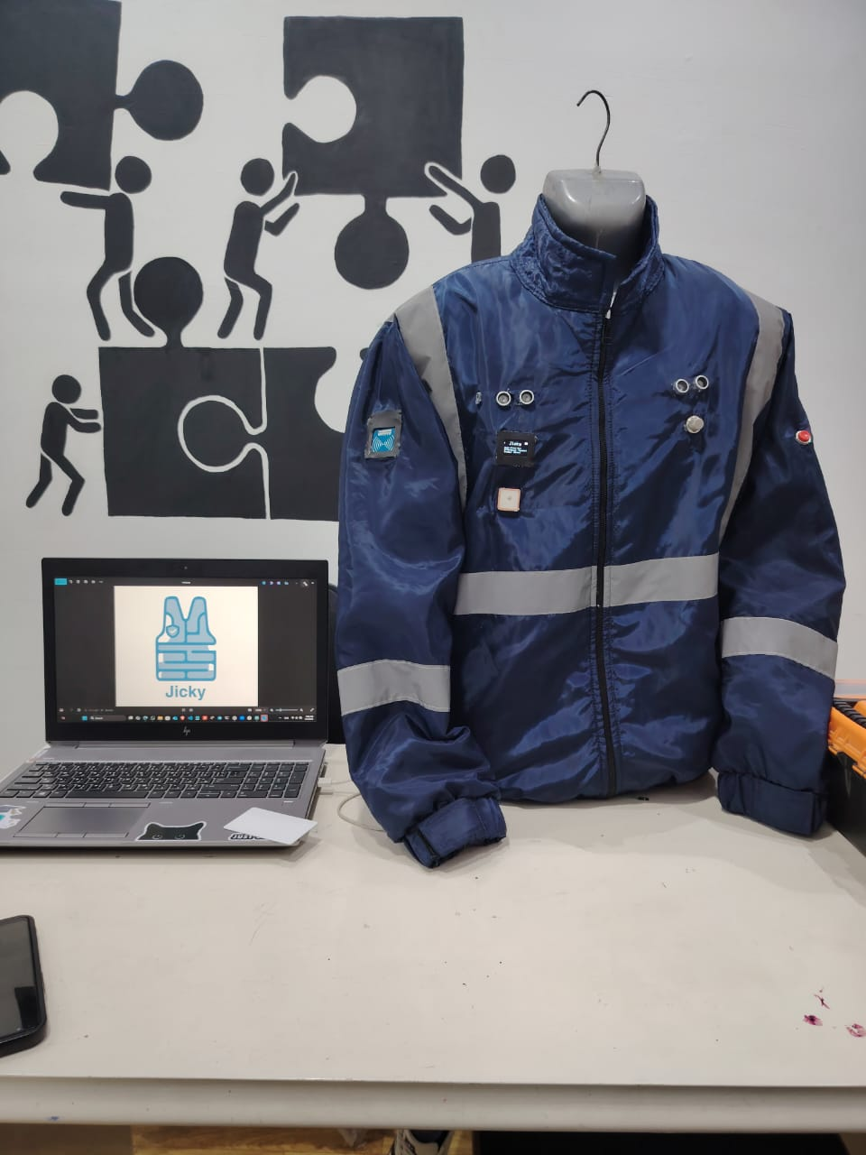

**Fig. 11. Final Prototype**

**5.** **CONCLUSION AND FUTURE DIRECTION**

The proposed real-time smart safety jacket represents a significant step forward in the integration of wearable technology for personal safety. By combining advanced sensor modules with cloud-based data processing and real-time alert mechanisms, the system enhances both user awareness and emergency responsiveness in hazardous environments. The literature review confirms the relevance and necessity of such solutions, especially in sectors like mining and industrial labor where risks are high and response time is critical. Our design offers a novel approach that leverages modern IoT infrastructure to provide continuous monitoring and immediate feedback, ultimately reducing the chances of accidents and improving worker safety.

Future enhancements could include the integration of additional sensors, such as alcohol detectors, advanced heart rate monitors, or gas-specific sensors like CO and CH₄ detectors to further ensure the safety of users. Moreover, incorporating wireless communication modules would enable rapid contact with safety teams, improving the chances of timely rescue in emergencies. We are committed to the continuous development and practical implementation of this model, aiming to bring it from prototype to real-world deployment where it can make a tangible difference in occupational safety.

**5.1 Future work**

* **Improved Battery Life and Power Management**

Integrating high-efficiency lithium batteries with solar charging.

Using sleep modes in the ESP32 to save energy.

* **Adding cellular connectivity (SIM/4G LTE)**

For work environments where Wi-Fi is not available.

Simplifying alerts even from remote locations such as mines or oil sites.

* **Improving AI algorithms and smart analytics**

Analysing biological and environmental data to predict hazards before they occur (predictive analytics).

Examples: predicting worker fatigue or the possibility of a chemical spill.

* **Multi-sector versions**

A special version for rescue and emergency services.

A version for chemical plants.

A version for electricity and mining workers.

Disclaimer (Artificial intelligence)

Option 1:

Author(s) hereby declare that NO generative AI technologies such as Large Language Models (ChatGPT, COPILOT, etc.) and text-to-image generators have been used during the writing or editing of this manuscript.

Option 2:

Author(s) hereby declare that generative AI technologies such as Large Language Models, etc. have been used during the writing or editing of manuscripts. This explanation will include the name, version, model, and source of the generative AI technology and as well as all input prompts provided to the generative AI technology

Details of the AI usage are given below:

1.

2.

3.

**6.** **References**

Karthika, S., Jayabaskaran, G., Sivahari, P. S., Hariharan, M., Poonthamizhan, M., & Poongothai, G. (2023). *Realtime embedded smart jacket system for coal miners*. 2023 9th International Conference on Advanced Computing and Communication Systems (ICACCS). IEEE

Ashwini, U., S. R. S., S. S., S. S., S. S., & S. S. (2023). *Design of a smart wearable jacket for the safety of workers in mines*. *International Journal of Advanced Research in Engineering and Management Sciences*, 1(3), 145-150.

Belay Etana, B., Malengier, B., Krishnamoorthy, J., & Van Langenhove, L. (2024). Integrating wearable textile sensors and IoT for continuous sEMG monitoring. *Sensors, 24*(6), 1834.

Wang, X., Yu, H., Kold, S., Rahbek, O., & Bai, S. (2023). Wearable sensors for activity monitoring and motion control: A review. *Journal of Rehabilitation Research and Development, 60*(1), 1-18.

Xu, K., Lu, Y., Takei, K., & Yao, S. (2021). Energy solutions for wearable sensors: A review. *Sensors*, *21*(13), 4511.

Whitley, E. (2024). *A comprehensive exploration of the role safety plays in manufacturing and industrial organizations*. Occupational Health & Safety.

.Patel, H., & Sharma, P. (2024). *Enhancing worker safety in manufacturing with IoT and ML*. International Journal of Future Research in Management and Research (IJFMR). Retrieved from

Misra, S., Roy, C., Sauter, T., Mukherjee, A., & Maiti, J. (2022). Industrial Internet of Things for safety management applications: A survey. *IEEE Access*, *10*, 85786–85818.

Srinivas, K. (2020). *Industrial safety system using Internet of Things*. International Journal of Scientific Research in Engineering and Technology (IJSRET), 6(3), 331–336.

Rajuskar, C. S., & Warule, S. (2020). *Safety environment in manufacturing industry*. International Journal of Engineering Research & Technology (IJERT), 9(3).

Ali, M. A. M., Noor, M. S. M., Isa, M. S. M., & Salleh, M. F. M. (2021). *An overview of the sensors for heart rate monitoring used in extramural applications*. *Sensors*, *21*(15), 5114

Anjaneyulu, S. S. R., Anjaneyulu, S. S. R., & Anjaneyulu, S. S. R. (2023). Real-time remote patient monitoring and alarming system for healthcare applications. Journal of Healthcare Engineering, 2023, 9965226.