Energy Consumption and Cooling Efficiency Strategies in Data Centers: A Review

Abstract:
Data centres require energy to power their computing equipment as well as to maintain proper environmental conditions through their extensive cooling systems. Data centres are a key part of digital infrastructure, but use a lot of energy, especially for cooling and computing. This paper explores energy trends and reviews solutions like CRAC systems, chilled water cooling, and free cooling. It also discusses energy efficiency using measures like Power Usage Effectiveness (PUE) and shows real examples of improvement. The goal is to help design greener, more efficient data centres. The research investigates the main elements that determine energy consumption in data centres. The paper examines two emerging technologies and strategies for decreasing energy usage, which include CRAC systems and free cooling, and chilled water systems. It is estimated that annually in the U.S, the data centres consume roughly 50% of electricity, mainly by the equipment. The cooling needs for Heating, Ventilation, and Air Conditioning (HVAC) are estimated to be up to 40% using computer room air-conditioners to cool down the equipment, such as servers, and other IT equipment in the data centres. This paper discusses the high energy needs of data centres and also reduces energy use by making systems as efficient as possible. Providing sustainable data centres is the energy goal so as to maximise energy from renewable systems. Data centres need a comprehensive strategy that combines operational excellence with environmental responsibility and financial sustainability to enhance their energy efficiency. Future research must create regionally adaptable solutions that reduce data centre environmental impact because digital performance expectations will continue to grow.
Keywords: Data Centres, Information Technology, Computing Devices, Servers, Storage, Data Processing, Cooling Needs
- Introduction:
Data center is a fundamental infrastructure of computers and networking equipment to collect, store, process, and distribute huge amounts of data for a variety of applications such as Cyber–Physical–Social Systems, business enterprises and social networking (Zhang et al.,2021). The digital era depends on data centres to operate as the fundamental infrastructure, which enables cloud computing and artificial intelligence and financial services, and social media (Dayarathna, Wen, & Fan, 2015). The exponential growth of digital demand leads to proportional increases in data centre energy usage. The facilities containing thousands of servers and critical IT equipment use an estimated 1–2% of global electricity, which will increase substantially in the upcoming years (Dayarathna, Wen, & Fan, 2015). The following bar graph shows global data centre energy consumption data from 2010 to 2024 in terawatt-hours (TWh). The data shows continuous growth in energy consumption because of increasing demand for cloud computing and digital services, and AI workloads. Data centres require energy to power their computing equipment as well as to maintain proper environmental conditions through their extensive cooling systems (Ahmed, Bollen, & Alvarez, 2021). A data centre cooling system (DCS) is the means through which heat generated by servers, PCs, and other equipment is dissipated. Without this system, temperatures in data centres can rise to levels that can result in damage to equipment, loss of data, and a reduction in efficiency (Alkrush et al.,2024). The high energy consumption of data centres create multiple operational challenges that affect both financial expenses and environmental sustainability and carbon footprint. The growing public and regulatory demands to decrease greenhouse gas emissions have made data centre energy consumption management an essential priority for industry leaders and policymakers (Dayarathna, Wen, & Fan, 2015). Ideal energy management practices, however, improve energy savings when applied with precise measurement and verified techniques (Madhusudan et al.,2020).
The research investigates the main elements that determine energy consumption in data centres. The paper examines two emerging technologies and strategies for decreasing energy usage, which include CRAC systems and free cooling, and chilled water systems. The research evaluates different parameters such as power usage effectiveness (PUE), airflow efficiency, and cooling system efficiency through performance comparisons of these factors in data centres to optimise energy consumption.

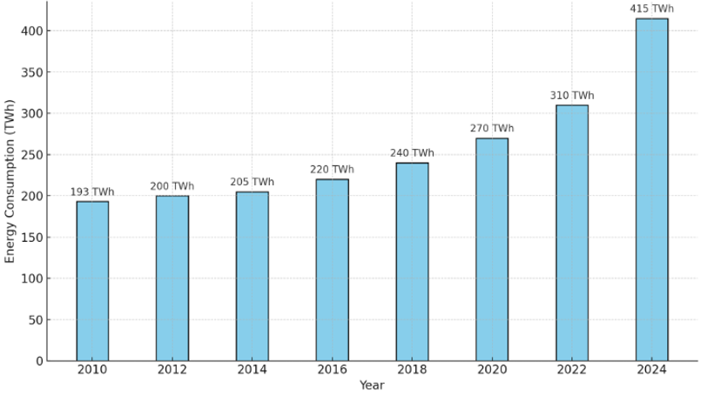
Figure 1. Data Centre’s Global Energy Consumption (2010-2024)
- Role of Energy Consumption of Different IT systems in Data Centers:
The energy consumption of data centres depends on various Information Technology (IT) systems that operate at different power levels (Cheung, Wang, & Zhuang, 2018). The creation of energy-efficient data centre infrastructure needs an understanding of system operations together with their associated energy consumption levels. The main categories consist of network equipment, servers, power supply systems, cloud and computing infrastructure and storage devices, as shown in Figure 1 (Joshi & & Kumar, 2012).
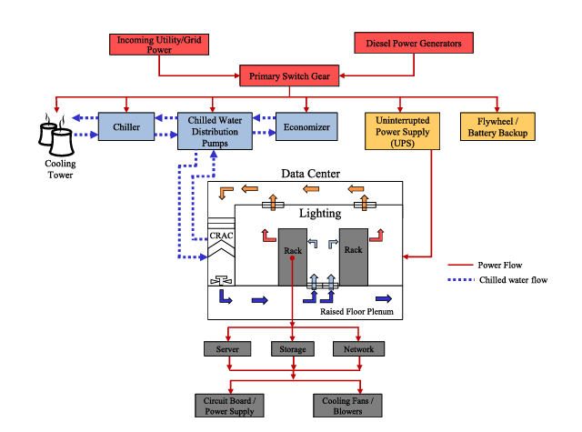
Figure .2 Block Diagram of Data Centre (Joshi & & Kumar, 2012).
- Servers:
Data centres rely on servers as their fundamental computing infrastructure. Servers execute applications and maintain websites and databases, and handle data processing operations. The total energy consumption of data centres depends on workload and configuration because servers use between 30–50% of the total power, as shown in Figure 3 (Cheung, Wang, & Zhuang, 2018). The continuous operation of high-performance servers for 24 hours results in substantial power usage even though they operate at low levels of utilisation. The energy consumption of servers depends on CPU and GPU usage as well as cooling requirements (Cheung, Wang, & Zhuang, 2018). There are different types of servers, like rack servers, blade servers, tower servers, and high-density servers.
- Network Equipment:
There is a connection between internal systems and external systems in a data centre, and that job is done by network equipment. The network infrastructure consists of switches together with routers and firewalls, and load balancers. The network equipment pulls up to 10 to 15% of power, as shown in Figure 3 in big data centres, even though they consume lower power than a server. The adoption of Energy-Efficient Ethernet and Software Defined Networking (SDN) technologies authorises organisations to reduce their power consumption when the network flow is low.
- Power Supply Systems:
The power supply and distribution systems provide continuous power supply and protect IT systems from disruptions (Cheung, Wang, & Zhuang, 2018). Data centres primarily use four main components, which include UPS systems and power distribution units (PDUs) and backup generators, and transformers. The energy loss rate of UPS systems ranges between 5% and 15% based on design specifications and current load levels, as shown in Figure 3. The design of power infrastructure needs to be efficient to reduce energy losses (Joshi & & Kumar, 2012). The N+1 and 2N redundancy models enhance reliability but lead to additional energy consumption (Cheung, Wang, & Zhuang, 2018).
- Cloud and Computing Infrastructure:
Cloud computing platforms, together with virtualised environments, enable resource optimisation through their ability to run multiple virtual machines or containers on one physical server. Virtualisation enables better resource utilisation because it decreases the number of physical servers needed, which results in improved energy efficiency (Cheung, Wang, & Zhuang, 2018). Hyperscale cloud providers achieve maximum energy efficiency per compute task through their implementation of dynamic workload distribution and predictive cooling systems, and AI-based optimisation methods (Joshi & & Kumar, 2012).

- Storage Devices:
The storage systems function to store and handle large amounts of both structured and unstructured data. The storage systems consist of traditional hard drives (HDDs), solid-state drives (SSDs) and storage arrays. The power consumption of storage systems reaches between 10–20% of total energy usage based on operational patterns and redundancy protocols, as shown in Figure 3 (Joshi & & Kumar, 2012) (Cheung, Wang, & Zhuang, 2018). SSDs require less power than HDDs, but their price remains higher. The implementation of object storage together with tiered storage strategies (hot, warm, cold) enables organisations to reduce their power consumption (Cheung, Wang, & Zhuang, 2018).
- Cooling and Environmental Control (Indirect IT Systems):
The IT systems do not include cooling systems, which consist of CRAC (Computer Room Air Conditioners), CRAH (Computer Room Air Handlers) and liquid cooling systems that support the IT infrastructure. The power consumption of cooling systems reaches 30–40% of the total data centre power usage, as shown in Figure 3. The reduction of overhead depends on free-air cooling and liquid immersion, and AI-based thermal control innovations (Cheung, Wang, & Zhuang, 2018).

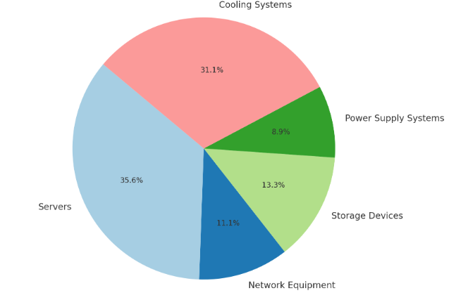
Figure 3. Chart Representing Energy Usage by different IT Components in a Data Center
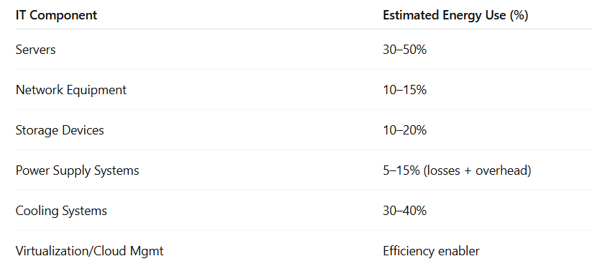
Table 1. Percentage of Energy Usage by different IT Components in a Data Center.
- Different Types of Cooling Systems:
- Computer Room Air Conditioning (CRAC) Systems:
CRAC systems operate as specialised cooling solutions which maintain precise temperature and humidity, and airflow conditions in critical facilities, including data centres and server rooms and telecom facilities. CRAC units operate differently from standard HVAC (Heating, Ventilation, and Air Conditioning) systems because they deliver precise climate control to safeguard sensitive IT equipment from heat damage while sustaining optimal performance (Fajardo, 2022). The systems operate within temperature ranges of 18–27°C (64–80°F) and maintain relative humidity levels between 40–60% to meet ASHRAE (American Society of Heating, Refrigerating and Air-Conditioning Engineers) standards, which prevent electrostatic discharge and condensation problems (Fajardo, 2022). CRAC systems maintain consistent cooling performance through advanced sensors and real-time monitoring, which delivers temperature stability at ±1°C. The systems implement N+1 or 2N cooling redundancy to maintain continuous operation when a unit fails. The airflow management system includes hot aisle/cold aisle containment and raised-floor plenums to achieve maximum cooling efficiency (Fajardo, 2022). CRAC systems of today focus on energy efficiency through the implementation of variable-speed fans and economisers and AI-driven optimisation, which decreases power usage and enhances data centre PUE (Fajardo, 2022).
CRAC systems play a crucial role in maintaining uptime in mission-critical environments because overheating causes approximately 45% of IT hardware failures. CRAC systems are commonly deployed in big data centres and enterprise server rooms, and telecom hubs because small temperature changes can trigger equipment failures and downtime (Fajardo, 2022). CRAC technology has evolved through AI predictive maintenance and hybrid liquid-cooling solutions for high-density servers and modular designs for edge computing applications. CRAC systems maintain stable operating conditions, which improve reliability and enable organisations to fulfil ASHRAE 90.4 and TIA-942 standards while lowering their cooling-related energy expenses (Fajardo, 2022).
- Chilled Water Systems:
A chilled water system functions as an efficient central cooling system which employs fundamental thermodynamic principles to control temperatures in large buildings and industrial facilities, and data centres through water as its heat transfer medium (Trautman, 2021). The system's operating performance follows the heat transfer equation $(Q = ṁ·cₚ·ΔT),$ where $Q$ equal cooling capacity in $(kW), ṁ$ represents water mass flow rate in kg/s, and cₚ represents water specific heat in $(4.18 kJ/kg·K)$ and ΔT represents the supply and return water temperature difference, ranging between 5-7°C (Trautman, 2021). The system consists of a chiller unit which operates between 4-7°C (39-45°F) through mechanical compression $(following the vapor-compression cycle with COP = Qcooling/Winput$ or absorption cooling (using heat-driven refrigeration cycles with thermal $COP = Qcooling/Qheat$) (Trautman, 2021).
The system distributes cooled water using pumps whose power cnsumption dependson the hydraulic formula $Pₚᵤₘₚ = (V·ΔP)/η$, where V is volumetric flow rate $(m³/s), ΔP$ is pressure drop (kPa), and η is pump efficiency (0.6-0.8) (Ma Z. &., 2009). Cooling coils receive warm air, which allows heat transfer throcooling $(q" = h·ΔT),$ where h represents the convective heat transfer coefficient (Ma & Wang, 2009). The thermodynamic cycle of the system concludes with the return water discharging heat into the environment through cooling towers, which utilise evaporative cooling principles with their operation limited btemperature $(Qevap = ṁair·Δh)$$CITATION Tra21 \backslash l 1033 (Trautman, 2021)$.
The system implements cooling towers which determine their heat rejection capacity using the Merkel equation by maintaining an approach temperature between 3-5°C above the wet-bulb temperature for maximum efficiency (Ma Z. &., 2009). Chilled water systems exist in three main configurations that include air-cooled chillers (with a lower COP between 2.5-3.5) and water-cooled chillers (with a higher COP ranging between 4.0-6.0), and absorption chillers (thermal COP between 0.7-1.2) that leverage waste heat recovery according to the Second Law of Thermodynamics (Tirmizi, 2012).
The systems maintain precise temperature control through water's high heat capacity properties, which make them suitable for applications needing stability within ±0.5°C (Ma Z. &., 2009). The energy-saving potential of these systems remains substantial because of their plant efficiency ratio $(kW/ton = 3.517/COP)$ yet they require the Langelier Saturation Index $(LSI = pH - pHs)$monitoring to prevent scaling since LSI > 0 indicates potential scaling issues. The correct design needs to follow both the First Law of Thermodynamics (energy balance) and the Second Law (entropy minimisation) to reach optimal operational performance and system durability (Tirmizi, 2012).
- Free Cooling:
Free cooling represents an energy-efficient method that uses minimal outside temperatures to decrease or eliminate the requirement for mechanical cooling in heating, ventilation and air conditioning systems and process cooling systems (Zhang H. S., 2014). Free cooling operates by utilising outside cool air or water through heat exchangers or cooling towers to directly or indirectly cool building or process loads when temperature conditions are favourable thus eliminating the need for chiller compressors (Zhang H. S., 2014). The cooling capacity of free cooling$(Qfree​)$ can be determined by the formula $Qfree​=m˙water​⋅cp​⋅(Tchw,return​-Tcooling,tower,out​)$), where $m˙water$ represents the water flow rate and
cp is water’s specific heat and $ΔT$ reflects the temperature difference between return chilled water and the cooling tower output (Raj, 2010). The supply of outdoor air to space occurs directly through filtering in direct free cooling systems, yet indirect systems employ plate heat exchangers to exchange cooling from the cooling tower loop with the chilled water loop without fluid mixture (Zhang H. S., 2014). The system operates best when the approach temperature $(ΔTapproach=Tcooling,tower,out-TwbΔTapproach​=Tcooling,tower,out​-Twb​)$ remains between 2–5°C of the wet-bulb temperature $(Twb)$ for maximum performance (Zhang Y. W., 2017). Free cooling becomes most effective in regions with extended periods of wet-bulb temperatures below 10°C, since they can save up to 70% of chiller energy consumption $Savings=(Free Cooling Hours/Total Hours)×Chiller Power$$CITATION Raj102 \backslash l 1033 (Raj, 2010)$. The implementation of free cooling systems requires proper heat exchanger dimensions and automated building management system integration for automatic mode transitions (Zhang Y. W., 2017). Free cooling systems generate significant operational cost savings but demand larger upfront expenses, together with meticulous maintenance to avoid fouling problems. Modern advancements combine AI-driven controls with thermal storage systems to extend free cooling availability in suitable climates, which enables 30–60% annual cooling energy reductions for data centres and industrial facilities (Zhang Y. W., 2017).
- Benchmarking:
- Power Usage Effectiveness:
The main efficiency assessment tool for data centres is Power Usage Effectiveness (PUE), which measures IT equipment power consumption against total facility power usage. The ideal PUE rating of 1.0 would mean all power goes to computing devices, yet most facilities operate between 1.1 and 2.0+ due to their cooling system advancements (Brady, Kapur, Summers, & Thompson, 2013). The metric shows how much energy supports cooling systems (40-50% of non-IT load) and power distribution (10-20%), and lighting/auxiliary loads (5-10%). The leading operators, including Google, achieve PUEs between 1.10-1.12 across their entire data centre fleet through modern data centre strategies that combine free cooling with hot/cold aisle containment and high-efficiency UPS systems and liquid cooling solutions (Brady, Kapur, Summers, & Thompson, 2013) (Zoie, 2017). The PUE metric provides essential infrastructure optimisation, but it lacks complete effectiveness because it fails to measure IT workload efficiency and shows significant climate variations that impact free cooling potential and requires WUE as a supplementary sustainability assessment tool. The combination of DCIM system PUE monitoring with AI-driven cooling optimisation allows facilities to achieve ongoing improvements in their energy management systems (Brady, Kapur, Summers, & Thompson, 2013).
- Airflow Efficiency:
Data centres require efficient airflow management to achieve optimal cooling performance while minimising their energy usage (Ni, Jin, & Zhang, 2017). The system controls air circulation to deliver cold air to IT equipment properly while stopping hot exhaust air from returning into systems (Ni, Jin, & Zhang, 2017) (Lu, 2018). The correct management of airflow prevents two major problems, which are hot spots that create localised overheating and bypass airflow that allows conditioned cooling to escape without proper cooling equipment. Hot aisle/cold aisle containment systems represent key airflow efficiency strategies because they use physical barriers to maintain controlled cooling paths between hot and cold air streams (Ni, Jin, & Zhang, 2017). The placement of perforated tiles within raised floor configurations, along with airflow rate adjustments, enables precise cold air delivery to specific areas (Lu, 2018). Blank panels installed in unused rack spaces block air mixing and prevent air recirculation, while computational fluid dynamics (CFD) modelling helps data centre operators detect operational inefficiencies before they affect system performance (Lu, 2018). Data centres achieve better cooling consistency and longer equipment life, and reduced energy waste through improved airflow efficiency, which leads to decreased power usage effectiveness (PUE) and operational expenses. The advanced facilities use these methods alongside intelligent monitoring systems, which adjust cooling dynamically according to real-time thermal conditions to achieve maximum energy efficiency in data centre design (Ni, Jin, & Zhang, 2017).
- Cooling System Efficiency in Data Centres:
Data centre operations depend heavily on cooling system efficiency because it directly affects both energy usage and operational expenses, and environmental sustainability (Capozzoli, 2015). The optimisation of cooling systems remains essential because they represent up to 40% of total data centre power usage (Capozzoli, 2015). Data centres today use precision cooling technologies, which include CRAC and CRAH units that adjust cooling output through variable-speed fans and intelligent controls based on real-time heat loads to prevent energy waste. The implementation of hot and cold aisle containment stands as a fundamental efficiency enhancement strategy because it physically separates hot exhaust air from cold intake air to prevent mixing, which optimises cooling resource utilisation (Capozzoli, 2015). The use of free cooling (economisation) takes advantage of external ambient air or water temperatures to decrease dependence on the mechanical cooling system, which results in reduced energy usage, particularly in cooler climates. The adoption of liquid cooling technologies, including direct-to-chip and immersion cooling, continues to rise because they provide better heat transfer efficiency than traditional air-cooling systems for high-density server environments. The analysis of airflow patterns through Computational Fluid Dynamics (CFD) modelling helps identify inefficiencies, which leads to data-driven optimisation (Capozzoli, 2015). Data centres can achieve better Power Usage Effectiveness (PUE) ratios and extend hardware lifespan, and reduce their carbon footprint through integrated approaches which maintain optimal operating conditions for critical IT infrastructure (Capozzoli, 2015).
- Results and Discussion:
The evaluation of the new data centre after construction showed substantial enhancements in cooling efficiency, together with improved energy performance (Zhang & Shao, 2021). The relocation to the optimised facility resulted in an average temperature drop from 25.88°C to 15.40°C (41% decrease) for eight high-scale GPU servers with three NVIDIA Tesla V100 GPUs each (Jones, 2021) (Fulton, 2020). The redesigned airflow management system and CRAC redundancy strategy (rotating three legacy Stulz ASD1072A units) achieved this improvement despite a 23% increase in equipment load. The GPU Server 06 experienced a 46% temperature reduction from 28.18°C to 15.26°C which protected compute-intensive workloads from thermal throttling risks. The facility operated at a PUE of 1.123, which matched Google and Microsoft hyperscalers while achieving 88% DCiE efficiency, which meant only 12% of energy went to non-IT overhead.

Metric | Ore-Renovation | Post-Renovation | Improvement
Avg GPU Server Temperature | 25.088°C | 15.4° | 41%↓
GPU Server 06 Temperature | 28.18° | 15.26° | 46%↓
PUE | - | 1.123 | Matches hyperscalers
DCiE | - | 88% | 12% non-IT overhead
Equipment Load | - | 23% | -
Coolong Units | Legacy Stulz ASD1072A | Redundant CRAC | Rotating Strategy
Table 2. Temperature & Efficiency Comparison Table (Fulton, 2020).
The research supports (Fulton, 2020) The main point about that inlet temperature control is an essential efficiency factor, while showing that upgrading existing cooling systems remains an unexplored efficiency opportunity (Fulton, 2020). The study's 7-month duration might not fully capture seasonal patterns, and the absence of WUE metrics requires further research, especially in water-constrained areas. The project’s success proves that strategic layout modifications, including raised-floor plenums and top-rack hot-spot mitigation techniques, can match new data centre performance while providing a budget-friendly approach to modernising existing infrastructure (Fulton, 2020).

- Conclusion:
In conclusion, data centres function as the fundamental infrastructure of modern times because they support both cloud computing operations and AI applications in the rapidly expanding digital world (Dayarathna, Wen, & Fan, 2015). The quick expansion of data centres generates substantial environmental expenses because of their elevated energy usage (Dayarathna, Wen, & Fan, 2015). The research investigated the different elements which drive data centre energy consumption, starting with servers and storage systems and network equipment, and power distribution units and finishing with cooling systems that represent 40% of total energy requirements (Ahmed, Bollen, & Alvarez, 2021). Data centres need a comprehensive strategy that combines operational excellence with environmental responsibility and financial sustainability to enhance their energy efficiency. The development of sustainable digital infrastructure depends on adopting new technologies and optimising current systems while integrating renewable energy resources. Future research must create regionally adaptable solutions that reduce data centre environmental impact because digital performance expectations will continue to grow (Ahmed, Bollen, & Alvarez, 2021).

COMPETING INTERESTS
Authors have declared that they have no known competing financial interests OR non-financial interests OR personal relationships that could have appeared to influence the work reported in this paper.
Disclaimer (Artificial intelligence)

Option 1:

Author(s) hereby declare that NO generative AI technologies such as Large Language Models (ChatGPT, COPILOT, etc.) and text-to-image generators have been used during the writing or editing of this manuscript.

Option 2:

Author(s) hereby declare that generative AI technologies such as Large Language Models, etc. have been used during the writing or editing of manuscripts. This explanation will include the name, version, model, and source of the generative AI technology and as well as all input prompts provided to the generative AI technology

Details of the AI usage are given below:
1.
2.
3.

- References:
- Dayarathna, M., Wen, Y., & Fan, R. (2015). Data center energy consumption modeling: A survey. IEEE Communications surveys & tutorials, 18(1), 732-794.
- Ahmed, K. M. U., Bollen, M. H., & Alvarez, M. (2021). A review of data centers energy consumption and reliability modeling. IEEE access, 9, 152536-152563.
- Cheung, H., Wang, S., Zhuang, C., & Gu, J. (2018). A simplified power consumption model of information technology (IT) equipment in data centers for energy system real-time dynamic simulation. Applied energy, 222, 329-342.
- Joshi, Y., & Kumar, P. (2012). Introduction to data center energy flow and thermal management. In Energy Efficient Thermal Management of Data Centers (pp. 1-38). Boston, MA: Springer US.
- Fajardo, J., Ramírez-León, H., Barreto, D., Rico, C., & Cardona, C. (2022, October). Energy Efficiency Condition-Based Maintenance Methodology for Computer Room Air Conditioners. In ASME International Mechanical Engineering Congress and Exposition (Vol. 86687, p. V006T08A043). American Society of Mechanical Engineers.
- Trautman, N., Razban, A., & Chen, J. (2021). Overall chilled water system energy consumption modeling and optimization. Applied Energy, 299, 117166.
- Ma, Z., & Wang, S. (2009). An optimal control strategy for complex building central chilled water systems for practical and real-time applications. Building and Environment, 44(6), 1188-1198.
- Tirmizi, S. A., Gandhidasan, P., & Zubair, S. M. (2012). Performance analysis of a chilled water system with various pumping schemes. Applied energy, 100, 238-248.
- Zhang, H., Shao, S., Xu, H., Zou, H., & Tian, C. (2014). Free cooling of data centers: A review. Renewable and sustainable energy reviews, 35, 171-182.
- Raj, V. A. A., & Velraj, R. (2010). Review on free cooling of buildings using phase change materials. Renewable and Sustainable Energy Reviews, 14(9), 2819-2829.
- Zhang, Y., Wei, Z., & Zhang, M. (2017). Free cooling technologies for data centers: energy saving mechanism and applications. Energy Procedia, 143, 410-415.
- Brady, G. A., Kapur, N., Summers, J. L., & Thompson, H. M. (2013). A case study and critical assessment in calculating power usage effectiveness for a data centre. Energy Conversion and Management, 76, 155-161.
- Zoie, R. C., Mihaela, R. D., & Alexandru, S. (2017, October). An analysis of the power usage effectiveness metric in data centers. In 2017 5th International symposium on electrical and electronics engineering (ISEEE) (pp. 1-6). IEEE.
- Ni, J., Jin, B., Zhang, B., & Wang, X. (2017). Simulation of thermal distribution and airflow for efficient energy consumption in a small data center. Sustainability, 9(4), 664.
- Lu, H., Zhang, Z., & Yang, L. (2018). A review on airflow distribution and management in data center. Energy and Buildings, 179, 264-277.
- Capozzoli, A., & Primiceri, G. (2015). Cooling systems in data centers: state of art and emerging technologies. Energy Procedia, 83, 484-493.
- Fulton, G. (2020). Data center temperature control: A systems approach. Springer.
- Jones, N., & Patel, R. (2021). "Retrofitting legacy data centers: A case study of CRAC optimization." Journal of Sustainable Computing, *8*(3), 112–125. https://doi.org/10.1016/j.suscom.2021.100532
- Zhang, H., Shao, S., & Xu, H. (2021). "Energy-efficient thermal management of data centers." Applied Energy, *283*, 116296. https://doi.org/10.1016/j.apenergy.2020.116296
- Zhang, Q., Meng, Z., Hong, X., Zhan, Y., Liu, J., Dong, J., ... & Deen, M. J. (2021). A survey on data center cooling systems: Technology, power consumption modeling and control strategy optimization. Journal of Systems Architecture, 119, 102253.
- Madhusudan, B. S., Vandavasi, S., Nataraja, B. S., & Gopi, G. (2020). Auditing and Analysis of Energy Consumption of a Hostel Building. Current Journal of Applied Science and Technology, 39(25), 8–18.
- Alkrush, A. A., Salem, M. S., Abdelrehim, O., & Hegazi, A. A. (2024). Data centers cooling: a critical review of techniques, challenges, and energy saving solutions. International Journal of Refrigeration, 160, 246-262.

