Method Article

A Conceptual Framework for Machine Learning-Integrated Drilling Fluid Systems: Toward Predictive Rheology in Complex Downhole Environments
.
ABSTRACT
With drilling operations continuing to venture into increasingly complex environments, particularly in deepwater and high-pressure, high-temperature (HPHT) settings, the demand for intelligent, real-time fluid management strategies continues to grow. Traditional rheological models often fail to capture the nonlinear and transient behaviours of drilling fluids under the dynamic downhole conditions encountered in these complex environments. This paper presents a conceptual framework for integrating machine learning (ML) into drilling fluid systems to facilitate predictive modelling and adaptive control. The proposed framework architecture combines real-time sensor data, feature engineering, supervised learning models, and decision support layers to forecast key fluid properties. These include viscosity, gel strength, and equivalent circulating density (ECD). Potential use case scenarios are discussed, including early barite sag detection, fluid loss prediction in fractured zones, and dynamic ECD optimisation. Implementation challenges related to data quality, model generalisation, system latency, and interpretability are explored, along with future research directions. By bridging data-driven modelling with operational decision-making, this work lays the foundation for the development of intelligent, self-optimising fluid systems in next-generation drilling environments.

Keywords: fluid rheology, predictive modelling, adaptive fluid systems, digital drilling operations, machine learning

1. INTRODUCTION
The growing complexity of deepwater and high-pressure high-temperature (HPHT) drilling environments has placed increasing demands on the performance of drilling fluids. Drilling fluids play a central role in maintaining wellbore stability, managing formation pressure, suspending cuttings, and preventing formation damage. However, the dynamic nature of downhole conditions, including fluctuating pressure regimes, variable temperature gradients, and unpredictable formation responses, makes it difficult to maintain optimal fluid rheology throughout the drilling process.
Traditionally, rheological modelling of drilling fluids has relied on models such as the Bingham Plastic or Herschel–Bulkley models, which are supported by periodic surface measurements. While effective under relatively stable conditions, these methods often fall short in capturing transient behaviours, localised anomalies, or subtle variations in downhole fluid dynamics, particularly in deepwater wells where surface measurements may not accurately represent annular conditions (Agwu et al., 2021b, 2021a; Gautam et al., 2022; Shah et al., 2010; Sui et al., 2011). With drilling operations becoming more digitised, a growing volume of real-time data is now being acquired from downhole sensors, telemetry systems, and rig instrumentation. This presents an opportunity to leverage data-driven approaches, specifically machine learning (ML) and artificial intelligence (AI), to enhance predictive capabilities and enable real-time decision support for fluid management.
Recent advancements in AI/ML have shown promise in modelling complex nonlinear systems, particularly in situations where empirical or physics-based models are difficult to parameterise. In the context of drilling fluid systems, ML models can be trained to predict rheological behaviour based on operational parameters, formation characteristics, and historical fluid data. These models offer the potential to detect anomalies, forecast instability, and recommend fluid adjustments in real time.
Despite this potential, the integration of AI and ML into drilling fluid systems remains in its infancy. Challenges persist around data quality, model interpretability, and the operationalisation of predictive tools in high-risk environments. A clear conceptual framework is needed to guide the design, deployment, and evaluation of ML-enhanced rheological modelling systems in real-world drilling scenarios.
This paper presents a conceptual framework for integrating machine learning into the prediction and management of drilling fluid behaviour under dynamic downhole conditions. It outlines key system components, data requirements, model types, and potential use cases. By bridging traditional fluid modelling techniques with intelligent data-driven systems, this work aims to support the development of fully adaptive fluid strategies for complex drilling environments.

2. BACKGROUND
2.1 Drilling Fluids in Complex Environments
Drilling fluids are engineered to perform a range of critical functions, including maintaining hydrostatic pressure, transporting cuttings, stabilising the wellbore, and minimising formation damage. These functions are highly dependent on the fluid’s rheological properties, which describe how it flows under varying shear conditions.
In most drilling operations, particularly in HPHT or deepwater wells, fluids behave as non-Newtonian materials, exhibiting shear-thinning or yield stress characteristics. Accurate prediction of these behaviours is essential for effective pressure management, hole cleaning, and wellbore stability. Rheological models such as the Bingham Plastic, Power Law, and Herschel–Bulkley equations are commonly used to characterise the relationship between shear stress and shear rate. However, these models often assume steady-state or idealised flow conditions, which may not reflect the dynamic, multiphase, and spatially variable environments encountered in actual wellbores (Hafezzadeh et al., 2024; Kiran et al., 2017; Singh et al., 2024; Sui et al., 2011).
In addition, surface-based rheological measurements do not fully capture downhole behaviour, especially under extreme temperature and pressure conditions where fluid viscosity, gel strength, and particle settling may differ significantly from laboratory results (Andaverde et al., 2019; Palaoro et al., 2022). This mismatch increases the risk of fluid-related incidents such as barite sag, excessive equivalent circulating density (ECD), or loss of circulation, contributing to non-productive time (NPT) and well control challenges (Gautam et al., 2022; Lalji et al., 2023; Yang et al., 2022).

2.2 Limitations of Traditional Modelling Approaches
Conventional rheological models rely on deterministic equations that require prior knowledge of fluid composition, formation properties, and operational parameters. While useful for design and pre-job planning, these models lack the flexibility to adapt in real time to evolving downhole conditions.
In dynamic drilling environments, real-time decision-making depends on the continuous monitoring and interpretation of high-volume, multi-source data. Standard rheological models are not designed to ingest and respond to such data streams, limiting their utility for predictive or adaptive control. Additionally, they may not effectively capture nonlinear or transient phenomena such as time-dependent gelation, thixotropy, or filter cake dynamics, all of which impact drilling performance.

2.3 Emergence of AI/ML in Drilling Operations
Artificial intelligence and machine learning offer powerful tools for modelling complex, nonlinear systems where traditional approaches fall short. In the drilling industry, ML techniques have already been successfully applied to optimise rate of penetration (ROP), detect stuck pipe events, and forecast equipment failures (Agwu et al., 2018; Jahanbakhshi & Keshavarzi, 2015; Murillo et al., 2009; Zhong et al., 2022). These successes have resulted in growing interest in applying similar techniques to fluid system modelling.
Machine learning models, such as decision trees, ensemble regressors, and neural networks, can learn patterns from historical and real-time datasets without explicit programming of physical laws. This makes them well-suited to modelling rheological behaviour as a function of operational inputs like pressure, temperature, flow rate, shear rate, and mud composition.
Emerging approaches in AI and ML include physics-informed machine learning (PIML), which embeds domain knowledge and governing equations within the learning process (Sinha & Dindoruk, 2025). These hybrid models offer a pathway to retain physical interpretability while benefiting from the flexibility of ML techniques.
Despite this potential, the application of ML to drilling fluid systems is still in its formative stages. Key challenges include the availability of high-quality, labelled datasets, the integration of ML models into existing monitoring and control infrastructure, and the need for interpretable models that can be trusted in safety-critical operations (Koroteev & Tekic, 2021; Li et al., 2024; Ma & Ye, 2025; Sircar et al., 2021).

2.4 Need for a Predictive Framework
The intersection of real-time sensing, advanced rheological formulations, and data-driven modelling presents an opportunity to redefine how drilling fluids are monitored and managed. However, the lack of a structured framework for integrating ML into fluid system design and operations has limited progress. To address this gap, the present work proposes a conceptual framework that links sensor data, feature engineering, ML models, and decision-making tools into a cohesive system capable of supporting predictive fluid control in real time.

3. conceptual framework for ml-integrated drilling fluid systems
To enable predictive control and intelligent fluid optimisation in complex downhole environments, a machine learning-based framework is proposed for integrating real-time data sources with rheological modelling systems. This conceptual framework is designed to support enhanced decision-making in drilling operations by forecasting fluid behaviour and identifying early indicators of instability.
This section outlines the proposed architecture for an integrated machine learning system designed to predict and manage drilling fluid behaviour under dynamic downhole conditions.

3.1 Objective
The framework aims to predict critical rheological parameters such as viscosity, gel strength, and ECD in real time, based on continuously acquired operational and environmental data. These predictions can inform proactive fluid conditioning, improve wellbore stability, and reduce NPT in high-risk zones such as salt intrusions, hydrate-bearing formations, and fractured intervals.

3.2 Architecture Overview
The framework is composed of four interdependent layers: data acquisition, feature engineering, predictive modelling, and decision output. Together, these layers enable the transition from traditional static fluid design to adaptive, real-time fluid management.

3.2.1 Data Acquisition Layer
The foundation of the framework is continuous data collection from multiple surface and downhole sources. These include:
- Downhole Sensors: Pressure-while-drilling (PWD), distributed temperature sensing (DTS), downhole rheometers.
- Surface Data: Pump pressure, flow rate, standpipe pressure, mud weight, temperature at shaker and mud pits.
- Historical Data: Previous well logs, lab-measured rheological profiles, and fluid formulation records.

All data are time-synchronised and tagged by depth to allow alignment with operational and geological parameters.

3.2.2 Feature Engineering and Processing Layer
This layer cleans and transforms the data and generates input features like temperature-pressure gradients, rate of change in ECD, and shear stress derived from pump performance. Raw input data are processed to derive meaningful features for model training and prediction.
Key transformations include:
- Derived Inputs:
  - Shear rate estimation based on annular velocity and geometry.
  - Change in ECD over depth or time (for anomaly detection).
  - Formation lithology indicators based on bit position.
- Signal Conditioning:
  - Filtering to remove noise and sensor drift.
  - Normalisation/scaling to improve model performance.

This layer ensures that input variables represent physically meaningful and temporally relevant indicators of fluid behaviour.

3.2.3 Predictive Modelling Layer
This layer contains the core ML engine responsible for forecasting fluid performance metrics. Predictive models are trained on historical and simulated data using supervised learning techniques. Where feasible, hybrid models incorporating domain knowledge (e.g., Herschel–Bulkley equations) enhance prediction robustness.
This layer may include:
- Model Types:
  - Supervised Regression: Random forest, gradient boosting, feedforward neural networks.
  - Hybrid Models: Physics-informed neural networks (PINNs) embedding Herschel–Bulkley equations or gelation kinetics.
  - Time-series Models: Long short-term memory (LSTM) or gated recurrent units (GRUs) for sequential data.
- Target Variables:
  - Viscosity at depth or time.
  - Gel strength recovery during pump-off events.
  - Barite sag index.
  - Fluid loss tendencies under varying circulation conditions.

Models are trained and validated using historical data, then deployed in real time to provide forward predictions or anomaly scores.

3.2.4 Descriptive Output and Decision Layer
The final layer translates ML model outputs into actionable insights for drilling engineers and control systems. Outputs may include:
- Real-time predictions of fluid properties at bit depth.
- Alerts or flags for conditions such as:
  - Sudden viscosity drop → early sign of dilution or degradation.
  - Abnormal gel strength → sag or cuttings settlement risk.
  - Increasing ECD → risk of fracturing or formation influx.
- Control recommendations:
  - Adjust fluid additive concentrations.
  - Modify pump rate or rotation speed.
  - Initiate circulation breaks or pilot flow changes.

These outputs can be visualised on rig dashboards, sent to remote operations centers, or integrated with automated control systems to support closed-loop fluid management.

3.3 Data and Modelling Considerations
The framework is designed to be modular and scalable, allowing for future enhancements such as:
- Integration with twin models.
- Connection to fluid automation systems (e.g., mud mixing skids.
- Use of federated learning for multi-asset model training without centralised data sharing.

Inputs will include shear rate, mud weight, flow rate, well depth, annular pressure, and downhole temperature. Targets will include dynamic viscosity at depth, gel strength trends, and barite sag risk index. Candidate models include Random Forest, gradient boosting, neural networks, and physics-informed neural networks (PINNs). Deployment will be on-site servers or cloud-based analytics platforms, with feedback integration into rig control systems.

Figure 1 presents an overview of the proposed system architecture.

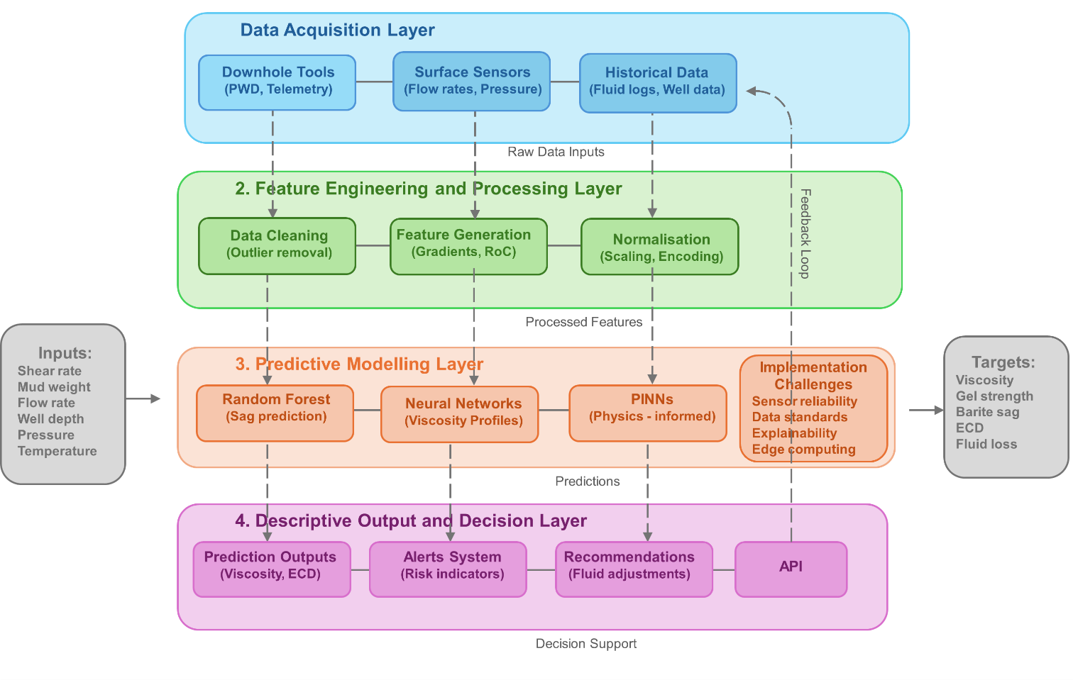
Figure 1. Layered architecture for real-time ML-integrated fluid prediction and control.

4. potential use cases
The integration of machine learning into drilling fluid systems offers a range of practical applications, particularly in environments where dynamic conditions challenge traditional monitoring and modelling approaches. The following use case scenarios illustrate how the proposed framework can be deployed to enhance operational decision-making, reduce NPT, and improve downhole performance.

4.1 Early Detection of ECD Excursions
In narrow-margin wells, especially those with salt intrusions or fractured zones, small deviations in ECD can lead to severe well control issues, such as lost circulation or formation influx. Using real-time pressure, flow rate, and mud weight data, the ML model can forecast ECD trends and detect developing excursions before they reach critical thresholds.

Actionable Output:
- Predictive ECD chart with tolerance bands.
- Early warning notification.
- Automated recommendation to adjust flow rate or fluid density.

4.2 Dynamic Prediction of Barite Sag
Barite sag, particularly under static or low-flow conditions, can lead to density variations that compromise wellbore integrity and bottomhole pressure control. The framework can use logging while drilling (LWD) pressure trends, annular velocity, and gel strength profiles to model barite settling risk in real time.

Actionable Output:
- Sag index based on current downhole conditions.
- Pump schedule modification suggestion (e.g., increase revolutions per minute (RPM), circulate break).
- Additive concentration adjustments for sag mitigation.

4.3 Fluid Loss Anticipation in Fractured Formations
Fractured carbonates and faulted intervals often result in unanticipated fluid loss events. By analysing transient pressure responses, temperature gradients, and prior loss zone behaviour, the model can predict zones with high loss potential.

Actionable Output:
- Real-time probability score for fluid loss risk.
- Trigger to switch to lost circulation material (LCM) treatment.
- Suggestive flag to activate self-healing gel mechanism (if compatible).

4.4 Optimisation of Gel Strength for Hole Cleaning
Maintaining the right balance of gel strength is essential for effective cuttings suspension during pump-off events. If it is too low, cuttings settle, and if it is too high, it may impair restart flow or cause surge/swab issues. The model uses flow rate history, cuttings return data, and viscosity trends to optimise gel behaviour.

Actionable Output:
- Predicted gel strength under next static period.
- Pump-off gel profile recommendation.
- Fluid formulation tweak for better suspension.

4.5 Real-Time Recommendations for Fluid Conditioning
Variations in formation temperature, pressure, and composition may alter mud performance. By continuously modelling the evolving wellbore environment, the ML system can suggest proactive adjustments to maintain fluid stability and integrity.

Actionable Output:
- Alert for onset of thermal thinning or instability.
- Additive blend suggestion to rebalance viscosity or yield point.
- Visualisation of fluid property drift over measured depth.

These use case scenarios demonstrate the practical value of predictive modelling in reducing uncertainty and enhancing fluid system performance in complex drilling environments. With further development, this framework could support fully adaptive, closed-loop fluid control systems that adjust in real time to evolving downhole conditions.
Figure 2 summarises the use cases and gives a comprehensive summary of how the proposed ML framework addresses specific drilling fluid challenges and delivers actionable insights.

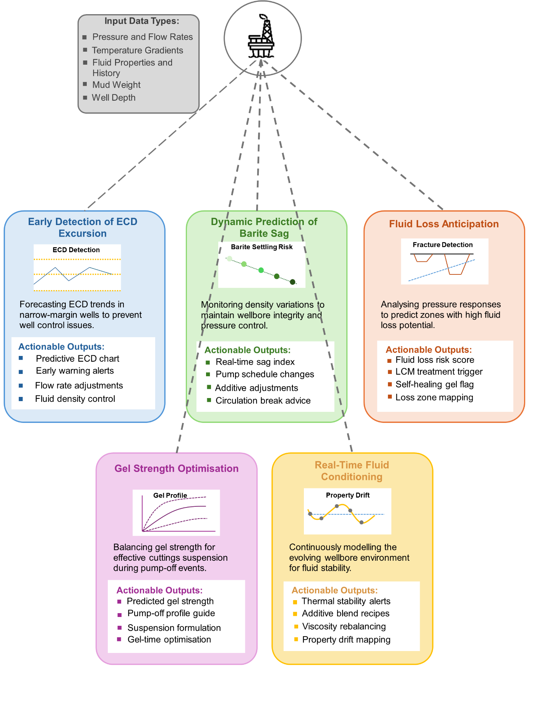
Figure 2. Summary of Use Cases for ML-Integrated Drilling Fluid Systems

5. Implementation challenges and research directions
While the integration of machine learning into drilling fluid systems presents significant potential, its practical deployment in operational environments introduces several challenges. These challenges include data availability, system robustness, model interpretability, and infrastructure constraints. Addressing these barriers is critical for realising the full benefits of predictive fluid modelling in deepwater and HPHT drilling operations.

5.1 Data Availability and Quality
The accuracy of ML models depends heavily on the quality, granularity, and contextual relevance of input data. In the drilling domain, data may be:
- Incomplete, due to sensor failures or missing depth intervals.
- Noisy or uncalibrated, especially under HPHT conditions where sensors experience drift.
- Heterogeneous, with different sampling rates or formats across tools and rigs.
Future work should focus on:
- Standardising drilling fluid and sensor data schemas.
- Developing automated data cleaning and outlier detection pipelines.
- Creating shared datasets (where proprietary concerns allow) for model benchmarking and training.

5.2 Model Generalisation Across Wells and Fluids
Models trained on a specific well or mud system may not perform reliably when applied to different formations or operating conditions. Geological variability, mud chemistry differences, and operational parameter shifts can all affect model behaviour.
Potential solutions include:
- Transfer learning: Adapting pre-trained models to new wells using limited local data.
- Ensemble modelling: Combining multiple models to improve robustness.
- Model retraining protocols: Incorporating feedback loops for continuous learning during drilling.

5.3 Real-Time Deployment Constraints
Drilling environments are latency-sensitive and risk-intolerant. Real-time predictions must be both fast and reliable, often within seconds of data acquisition. Bandwidth limitations, especially offshore, may constrain cloud-based inference models.
Key research needs:
- Lightweight models optimised for edge computing.
- Validation frameworks for real-time reliability under dynamic conditions.
- Offline fallback modes in case of telemetry loss or sensor degradation.

5.4 Interpretability and Operational Trust
ML models—especially deep learning systems—are often criticised for being “black boxes.” However, for high-stakes decisions such as adjusting fluid properties in real time, operators must understand and trust model outputs.
Research directions include:
- Use of explainable AI (XAI) methods (e.g., SHAP (Shapley additive explanations) values, local interpretable model-agnostic explanations (LIME)) to identify which variables most influence predictions.
- Incorporation of uncertainty quantification to signal confidence levels in model output.
- Human-in-the-loop frameworks that combine expert feedback with model learning.

5.5 Integration with Digital Drilling Ecosystems
The future of intelligent drilling lies in closed-loop systems that integrate ML with real-time data and automated control systems. Achieving this integration requires overcoming interoperability issues and aligning ML systems with industry control logic.
Key future directions:
- Development of (application programming interface (API) standards for ML integration into rig control platforms.
- Alignment of ML output formats with existing drilling advisory and visualisation tools.
- Simulation environments (e.g., digital twins) for safe testing of predictive models prior to deployment.

By addressing these challenges through targeted research and interdisciplinary collaboration, the drilling industry can accelerate the transition from reactive fluid management to proactive, intelligent, and adaptive systems. This shift holds the promise of enhanced efficiency, reduced operational risk, and improved sustainability across increasingly complex offshore operations.

6. Conclusion
The complexity of modern drilling environments, particularly in deepwater and HPHT settings, demands more adaptive and predictive fluid management strategies. Traditional rheological models, while foundational, often fall short in capturing the transient and nonlinear behaviour of drilling fluids under evolving downhole conditions. At the same time, advancements in sensor technologies and the proliferation of real-time data streams have created new opportunities for integrating machine learning (ML) into drilling fluid system design and optimisation.
This paper proposed a conceptual framework for ML-driven prediction and control of drilling fluid behaviour. By combining real-time data acquisition, feature engineering, supervised modelling, and actionable outputs, the system offers a pathway toward intelligent, adaptive fluid management. Use case scenarios such as early ECD excursion detection, sag mitigation, and fluid loss prediction illustrate how such a system could enhance operational decision-making and reduce non-productive time.
However, practical deployment of this framework will require addressing several challenges, including data standardisation, model generalisation, real-time deployment constraints, and system interpretability. Research in areas such as physics-informed ML, explainable AI, and edge-based computation will be critical to overcoming these barriers and building trust in intelligent fluid systems.
As the industry moves toward greater automation and digital integration, the ability to predict and control drilling fluid behaviour in real time will become increasingly central to safe, efficient, and sustainable well construction. The framework presented here represents an early step in that direction, offering a foundation for future development, validation, and field implementation.

Disclaimer (Artificial intelligence)
The Author declares that Grammarly was used during the editing of this manuscript. The Grammarly plugin within Microsoft Word was used for correcting grammar. The tool’s suggestions for correctness, clarity and tone were also used.

COMPETING INTERESTS DISCLAIMER:
Authors have declared that they have no known competing financial interests OR non-financial interests OR personal relationships that could have appeared to influence the work reported in this paper.

References
Agwu, O. E., Akpabio, J. U., Alabi, S. B., & Dosunmu, A. (2018). Artificial intelligence techniques and their applications in drilling fluid engineering: A review. Journal of Petroleum Science and Engineering, 167(April), 300–315. https://doi.org/10.1016/j.petrol.2018.04.019
Agwu, O. E., Akpabio, J. U., Ekpenyong, M. E., Inyang, U. G., Asuquo, D. E., Eyoh, I. J., & Adeoye, O. S. (2021a). A comprehensive review of laboratory, field and modelling studies on drilling mud rheology in high temperature high pressure (HTHP) conditions. Journal of Natural Gas Science and Engineering, 94. https://doi.org/doi.org/10.1016/j.jngse.2021.104046
Agwu, O. E., Akpabio, J. U., Ekpenyong, M. E., Inyang, U. G., Asuquo, D. E., Eyoh, I. J., & Adeoye, O. S. (2021b). A critical review of drilling mud rheological models. Journal of Petroleum Science and Engineering, 203(December 2020), 108659. https://doi.org/10.1016/j.petrol.2021.108659
Andaverde, J. A., Wong-Loya, J. A., Vargas-Tabares, Y., & Robles, M. (2019). A practical method for determining the rheology of drilling fluid. Journal of Petroleum Science and Engineering, 180(April), 150–158. https://doi.org/10.1016/j.petrol.2019.05.039
Gautam, S., Guria, C., & Rajak, V. K. (2022). A state of the art review on the performance of high-pressure and high-temperature drilling fluids: Towards understanding the structure-property relationship of drilling fluid additives. Journal of Petroleum Science and Engineering, 213(December 2021), 110318. https://doi.org/10.1016/j.petrol.2022.110318
Hafezzadeh, R., Autelitano, F., & Giuliani, F. (2024). Laboratory investigation of the mechanical and functional properties of cold mix patching materials. Alexandria Engineering Journal, 108(June), 332–343. https://doi.org/10.1016/j.aej.2024.07.074
Jahanbakhshi, R., & Keshavarzi, R. (2015). Quantitative and qualitative analysis of lost circulation in natural and induced fractured formations: the integration of operational conditions and geomechanical parameters. European Journal of Environmental and Civil Engineering, 19(4), 418–444. https://doi.org/doi.org/10.1080/19648189.2014.949872
Kiran, R., Teodoriu, C., Dadmohammadi, Y., Nygaard, R., Wood, D., Mokhtari, M., & Salehi, S. (2017). Identification and evaluation of well integrity and causes of failure of well integrity barriers (A review). Journal of Natural Gas Science and Engineering, 45, 511–526. https://doi.org/10.1016/j.jngse.2017.05.009
Koroteev, D., & Tekic, Z. (2021). Artificial intelligence in oil and gas upstream: Trends, challenges, and scenarios for the future. Energy and AI, 3, 100041. https://doi.org/10.1016/j.egyai.2020.100041
Lalji, S. M., Ali, S. I., Ullah, R., Ali, S. M., Zia, Y. K., Ghauri, R., & Ahmed, A. (2023). Experimental investigation of rheological behaviour and stability of mud system using novel image processing application in presence of activated carbon and silica-coated iron oxide nanoparticles. Applied Nanoscience, 13, 6405–6420. https://doi.org/doi.org/10.1007/s13204-023-02935-x
Li, J. X., Zhang, T., Zhu, Y., & Chen, Z. (2024). Artificial general intelligence for the upstream geoenergy industry: A review. Gas Science and Engineering, 131(May), 205469. https://doi.org/10.1016/j.jgsce.2024.205469
Ma, Y., & Ye, M. (2025). Application of Machine Learning in Hydraulic Fracturing: A Review. ACS Omega. https://doi.org/10.1021/acsomega.4c11342
Murillo, A., Neuman, J., & Robello, S. (2009). Pipe Sticking Prediction and Avoidance Using Adaptive Fuzzy Logic and Neural Network Modeling. SPE Production and Operations Symposium. https://doi.org/doi.org/10.2118/120128-MS
Palaoro, G., Andrade, D. E. V., Galdino, Jonathan, F., Franco, Admilson, T., Alves, E., & Waldmann, A. (2022). Influence of pressure on the gel strength and on the solid-like behavior for an inverted emulsion drilling fluid. Journal of Petroleum Science and Engineering, 219. https://doi.org/doi.org/10.1016/j.petrol.2022.111114
Shah, S. N., Shanker, N. H., & Ogugbue, C. C. (2010). Future Challenges of Drilling Fluids and Their Rheological Measurements. American Association of Drilling Engineers Fluids Conference and Exhibition, 10, 1–16.
Singh, R., Sharma, R., & Rao, G. R. (2024). Investigation of the effects of ultra-high pressure and temperature on the rheological properties of a novel high-density clear completion fluids using magnesium bromide for applications in HPHT reservoirs. Geomechanics and Geophysics for Geo-Energy and Geo-Resources, 10(1). https://doi.org/10.1007/s40948-023-00724-y
Sinha, U., & Dindoruk, B. (2025). Review of physics-informed machine learning (PIML) methods applications in subsurface engineering. Geoenergy Science and Engineering, 250, 213713. https://doi.org/10.1016/J.GEOEN.2025.213713
Sircar, A., Yadav, K., Rayavarapu, K., Bist, N., & Oza, H. (2021). Application of machine learning and artificial intelligence in oil and gas industry. Petroleum Research, 6(4), 379–391. https://doi.org/doi.org/10.1016/j.ptlrs.2021.05.009
Sui, D., Nybø, R., Gola, G., Roverso, D., & Hoffmann, M. (2011). Ensemble methods for process monitoring in oil and gas industry operations. Journal of Natural Gas Science and Engineering, 3(6), 748–753. https://doi.org/doi.org/10.1016/j.jngse.2011.05.004
Yang, S., Zhan, Q., Pan, Y., Wang, X., & Narimane, B. (2022). Research progress on low-temperature rheology of high-performance ocean deepwater drilling fluids: An overview. Journal of Petroleum Science and Engineering, 218. https://doi.org/doi.org/10.1016/j.petrol.2022.110978
Zhong, R., Salehi, C., & Johnson, R. (2022). Machine learning for drilling applications: A review. Journal of Natural Gas Science and Engineering, 108(October). https://doi.org/10.1016/j.jngse.2022.104807

