**Original Research Article**

**RETScreen-Based Techno-Economic Study of Wave Energy Potential in Bonny Island, Nigeria.**

**Abstract**

*Climate change and its impact on the environment is driving the adoption of renewable energies. In order to reduce greenhouse gas emissions, the use of renewable energy requires focused attention. This study presents the techno-economic viability of wave energy in Bonny Island Rivers State, Nigeria to determine the suitability of siting wave farms for 30 a MW power generation. In this study, 39-years (1984 – 2023) data of nearshore and offshore wave regimes of Bonny Island at 13 m and 133 m water depth respectively were collected and used to predict the dynamic behavior of wave energy in the area using stochastic Navier-Stokes wave model and validated by Renewable-energy and Energy-efficiency Technology Screening (RETScreen). The result showed offshore wave regime have more potential than nearshore; and the chosen Alstom Kaplan wave converter turbine can generate total annual electricity of 2,146,200 MWh at an energy cost of $0.11/ kWh and 928,413 tons of CO2 on greenhouse gas saving equivalent to 2.15 million barrels of crude oil. The simple payback period (SPP) for the 30 MW wave power plant is 10.5 years, benefit cost ration of 1.3 and Net Positive Value (NPV) of $171,857, 502. These indicate that the 30 MW power plant in Bonny Island is a profitable investment portfolio.*

**Keywords: RETScreen, GHG Emission, Energy Management, Wave Energy.**

1. **INTRODUCTION**

Inadequate power supply leading to energy crises and environmental pollution has become global critical challenge for mankind. This requires urgent attention by human beings to save the planet and live a fulfilled life (Ambuhl and Guzzella, 2015).

The need for energy to support population growth, economic development, and infrastructure is a problem for most developing economies especially Nigeria (Ozohu-Suleiman, 2021).

In the past, the Nigerian government has taken a few steps to address these challenges. Some of the step include introduction of Nigerian Electricity Regulatory Commission (NERC) in 2005 to regulate and control power generation and distribution, implementation of National Integrated Power Project (NIPP) in 2018 to enhance power generation. Despite these initiatives, there is no noticeable improvement in electricity supply to the populace (PWC, 2018).

According to World Bank report, out of a documented connection rate of 54.4% and 59.5% for Nigeria in 2017 and 2021 respectively, only 22.6% and 26.3% of rural Nigeria's population had access to the electricity distribution grid.

(World Bank, Electricity Access, <http://data.worldbank.org/indicator>). One of such town without access to the grid is Bonny Island.

An estimated 29,000 MW of electricity will be needed in Nigeria by 2025. The current power generation capacity will not meet this near future need. The good news is the Nigeria coastal regions have wave energy from the ocean readily accessible to these coastal communities for about 853 km along the coastline facing the Atlantic Ocean. But research carried out to harness the wave energy at the coastal region is still skeletal and insufficient (Asiegbu, 2021).

To this end, this paper is to conduct a techno-economic viability assessment of wave energy potentials of Bonny Island as a sustainable renewable energy alternative to fossil fuel generation.

The aim is to assess the renewable wave energy of the region to solve the power problem of the town and to reduce GHG emission from existing fossil fuel generators.

With the rising demand to protect the environment and control climate change, government, agencies around the world have turned to renewable energies to provide cleaner energy for human energy needs.

Wave energy is a form of renewable energy obtained from ocean wind kinetic energy. Extracting energy from wave relies on the available wave energy resource and it is subject to changes due to several factors – meteorological data, season etc. Wave parameters are dependent largely on three factors: Wave height, energy period and wave direction (Lavidas & Kamranzad, 2020). Ocean waves are described considering its specific parameters – wave height, amplitude, wavelength and period. The period (T) is time for the wave to complete a cycle and is the inverse of the frequency (f).

**Objectives**

The specific objectives are to:

1. Collecting and analyzing wave data from Bonny Island.
2. Formulation of governing wave energy equations.
3. Assess the technical and economic feasibility of wave energy system at Bonny Island coastal region and the impact on power capacity and Green House Gas (GHG) emission reduction.
4. Evaluation of the feasibility study and potential impact of utilizing wave energy in the region.

**Literature Review**

The amount of energy carried by a wave depends on three factors – wind speed, the period or duration and the size of the area over which the wind blows, normally called the fetch.

Ocean wave contains both potential and kinetic energy due to free surface displacement and wave motion respectively. (Simon, 2021).

Sierra *et al*. (2016) assessed the wave energy resource of Morocco Atlantic coastline by applying numerical modelling on a 44-years wave data regime. The paper estimated an average wind power resource of about 30 kW/m and annual wave energy generation of 262 MWh/m. The study further indicates wave energy resource is higher during winter than summer period.

Kumar *et al* (2018) in a study, three years (2013, 2015 and 2017) wave energy potential near Ratnagiri was estimated for four locations at 15 minutes intervals for the year 2014. The simulation results indicated an average wave energy potential along the Ratnagiri coast is in the range of 5.92 to 6.9 kW/m occurring mainly during the monsoon season (June – September) in the south and west directions with wave heights ranging 1.5 to 2.5m and average wave period of 6 to 8 seconds. During the monsoon period at the 4 identified locations, the simulated wave power potential is 15.5 to 18 kW/m while the annual average is 6 to 7 kW/m.

Warpindyasmoro (2018), investigated wave energy potential of four Indonesia coastal locations within East Java namely - Pacitan, Jember, Besuki and Tuban regions; by obtaining their significant wave heights and period from Environmental Research Division's Data Access Program server. The maximum wave energy flux observed for Pacitan, Jember, Besuki and Tuban were 232, 190, 8.6 and 9.5 MWh/m/ year respectively; revealing the south coast of East Java has higher potency of wave electricity generation than the rest regions studied.

Houngue *et al.* (2019)assessed the potential of wave energy generation for Benin coastline using extreme wave dataset from 16-years ERA reanalysis of European Centre for Medium-Range Weather Forecasts and Buoy ALIZE located six kilometers off the port of Cotonou in Benin Republic at a depth of 15m with coordinates (2°28'46E, 6°18'49N). The assessment revealed that between May to September, the extreme wave has an occurrence of 77% with the peak observed in the months of May, July and September. The paper estimated from the evaluation, that the wave energy during this period is 646.26 MWh/m which could be harnessed to provide useful energy to the country.

Kayode and Koya (2019) investigated the wave power potential of Nigeria coast using WAVEWATCH III model for a period of 5-years (2010 – 2015). The results indicated a mean annual wave power between 5.64 – 10.74 kW/m. The report also affirmed during the raining season; the wave power output is higher than in the dry season. It concluded that wave power is closely related to the mean monthly rainfall experienced. Houngue *et al.* (2019),assessed the potential of wave energy generation for Benin coastline using extreme wave dataset from 16-years ERA reanalysis of European Centre for Medium-Range Weather Forecasts and Buoy ALIZE located six kilometers off the port of Cotonou in Benin Republic at a depth of 15 m with coordinates (2°28'46E, 6°18'49N).

The assessment revealed that between May to September, the extreme wave has an occurrence of 77% with the peak observed in the months of May, July and September. The paper estimated from the evaluation, that the wave energy during this period is 646.26 MWh/m which could be harnessed to provide useful energy to the country. Agbakwuru and Akaawase (2020) presented a detailed study of ocean wave spectral characteristics of Bonny shallow water using 3-years data at 19 m off the coastline as obtained from Shell Nigeria analyzed using wave analysis toolbox of MATLAB. The wave spectra are found to be mono-modal and this is against the general belief that West African offshore locations are bi-modal. Also, the study identified a predominant wave direction as the south-west and an average wave height of 1.2 m for the period studied.

Saim *et al.* (2020), conducted a review of UK wave energy status, potential, challenges, and prognostics. It concluded that the available wave energy resource in the UK is about 120 GW and harnessing this will help UK achieve her net zero energy target by 2050. It further concluded that wave energy system can pose environmental concerns related to alteration of the water ecosystem, limits dredging and contributes to noise and vibrations. The paper identified the commercial deployment of wave energy system is still being debated in the UK due to high cost of standalone wave energy conversion system, technical performance, and reliability of the wave energy devices. The paper recommended further research work is needed to improve these parameters in near future.

Romero *et al.* (2019), studied the mechanical design of a wave power generation which transforms the heaving movement of a buoy into a rotation movement of the arm that house a linear generator in the Colombian Pacific Ocean using Ansys Aqwa numerical software under different swelling conditions. The amount of electric power generated was simulated using MATLAB calculus routine. The simulation results indicated under regular and irregular swell conditions, the electric power generated was 1.17 and 0.5 kW respectively. The paper concluded that the proposed devices is suitable for rural coastlines that are far from the existing grid network.

Lemessy *et a*l (2020), reviewed the barriers limiting wave energy harvesting and proposed ways to overcome the identified barriers. The review concluded that by combining wave energy generation technologies with social responsibilities such as tourism and shore protection, can lead to enhanced value and cost reductions.

Tetu and Chozas (2021), presented an economic model based on a target LCOE for the economic evaluation of wave energy preliminary cost at early project development stages as a function of both CAPEX and OPEX costs as well as associated uncertainties in order to deliver electricity to the grid at a competitive cost leading to a competitive pathway to wave energy generation commercialization. Shi *et al.* (2022), estimated the wave energy resource of China using dispersion relation model. To conduct the study, 40-years (1979 – 2019) spectral wave energy was retrieved from European Centre for Medium-Range Weather Forecasts Reanalysis v5 (ERA5) datasets with the main aim of investigation the spatio-temporal offshore wave energy of China sea. The study indicated nearshore zones between Zhejiang to Guandong region produced an average annual wave energy density of 10 kW/m or higher.

Padrón *et al.* (2022)presented an assessment of the energy potential in the coastal area of El Hierro for the purpose of determining the best location for installation of WEC. The result indicated the best location to install an OWC wave power plant is the “Llanos Blancos” coast, where the mean significant wave height and period were 1.41 m and 9.23 s with a predominant wave direction of NNE. In addition, the estimated annual energy generation was around 265.40 MWh/m, and the yearly average power was about 30.3 kW/m. These results clearly showed the wave resource available at the “Llanos Blancos” coast is suitable to drive a WEC system to generate electricity.

Tulashie *et al.* (2022)assessed the wave energy potential of Ghanian coastline using a 21-years (1979 – 2020) significant wave height and period datasets based on ERA5 resourced retrieved from European Centre for Medium-Range Weather Forecast. From the study, the paper concluded that a wave power of 7215 MW could be generated from the wave dataset, which is adequate to power Ghana energy demand. Hence the study considered wave energy as a viable renewable energy that the country can tap into.

Jahangir *et al.* (2023) presented a hybrid renewable (PV & wave energy) and Diesel power generation system using Homer software for the Persian Gulf Island of Lavan in limited and unlimited scenario. It also conducted a techno-economic assessment of the five wave energy converters (Pelamis, Wavestar, Langley, OWC and Aqua Buoy). In the limited scenario, the hybrid generation system of solar PV, diesel generator and wavestar converter yielded an optimal outcome of cost of 0.224 $/kWh energy and NPV of $11million. In the unlimited scenario, the hybrid generation system of solar PV, diesel generator and AquaBuoy converter yielded an optimal outcome of cost of 0.209 $/kWh energy and NPV of $10.3 million. In addition, the OWC unit had the largest electricity generation out of the five converters studied.

Orji *et al.* (2023) carried out the analysis of point absorber WEC performance along Nigeria west coast with the aim to evaluate the device output power and efficiency under various wave conditions in the Gulf Gunea using WEC-Sim software in MATLAB. The simulation results showed the device output power is highest at significant wave height of 4 m and peak period of 15 s. Similarly, the device efficiency was highest at wave height of 2 m at peak period of 11 s. But it was noted that the device power output increases, the efficiency decreases. The paper recommended further research to be carried out on optimizing the mooring line design and cost effectiveness evaluation of the point absorber WEC in the region.

There is a lack of comparative studies on the wave energy potential of Bonny Island relative to other Nigerian coastal regions or international locations with similar geographic and climatic conditions.

Addressing these research gaps will enhance the understanding of wave energy potential in Bonny Island, Nigeria, and provide a robust framework for future wave energy projects in the region. Utilizing advanced tools like statistical probability distribution for modeling irregular wave patterns, combined with RETScreen for energy yield and feasibility analysis, holds significant promise for advancing wave energy development in Nigeria’s coastal areas. Further research into the environmental, socioeconomic, and technical aspects of these projects would be crucial for ensuring sustainable and impactful energy solutions.

1. **MATERIALS AND METHOD**

**Materials**

The wave energy potential of Bonny Island was analysed from 39 years wave data resource using Excel and its techno-economic assessment via RETScreen software.

Bonny Island is an industrial town in Niger Delta region of Nigeria and situated about 40 km south-east of Port Harcourt in Rivers State, Nigeria (Akintoye *et al.* 2016). Geographically, it is located roughly 40 24’ North, 70 11’ East and South of the inter-tropical convergence zone (ITCZ). It is surrounded by the Atlantic Ocean on the southern part, Bodo on the North, Yellow Island on the West and Opobo on the East. Bonny Island is a Town and a Local Government Area in Rivers State, of southern Nigeria.

For this research work, 39 years (1984 - 2023) nearshore and offshore wave data for the location 7°N, 4°E, on Bonny Island, are obtained from BMT ARGOSS, retrieved from the global numerical weather prediction model of NCEP (National Centre of Environmental Prediction). The location is situated approximately 48km southwest of Bonny Island in a water depth of approximately 133 m as summarized in Tables 1 to 4.

**Table 1:** Bonny Island offshore wave heights and associated periods due to sea condition 1984-2023 (Source: Train 7 metocean modelling report, 2023)

|  |  |  |  |  |  |  |
| --- | --- | --- | --- | --- | --- | --- |
| **Return period (years)** | **Direction (SSE)**  **168.75° till 91.25°** | | **Direction (SSW)**  **191.25° till 213.75°** | | **Direction (SW)**  **213.75° till 236.25°** | |
| HS (m) | TP, (sec) | HS (m) | TP, (sec) | HS (m) | TP, (sec) |
| 1 | 2.01 | 6.1 | 2.43 | 6.1 | 2.11 | 7.18 |
| 5 | 2.39 | 6.7 | 2.70 | 6.7 | 2.57 | 8.54 |
| 10 | 2.53 | 6.9 | 2.79 | 6.9 | 2.74 | 9.04 |
| 50 | 2.82 | 7.3 | 2.99 | 7.3 | 3.08 | 10.08 |
| 100 | 2.93 | 7.4 | 3.06 | 7.4 | 3.2 | 10.47 |

**Table 2:** Bonny Island offshore wave heights and associated periods due to swell condition 1984-2023 (Source: Train 7 metocean modelling report, 2023)

|  |  |  |  |  |  |  |
| --- | --- | --- | --- | --- | --- | --- |
| **Return period (years)** | **Direction (SSE)**  **168.75° till 191.25°** | | **Direction (SSW)**  **191.25° till 213.75°** | | **Direction (SW)**  **213.75° till 236.25°** | |
| HS (m) | TP, (sec) | HS (m) | TP, (sec) | HS (m) | TP, (sec) |
| 1 | 2.01 | 11.6 | 2.43 | 13.4 | 2.11 | 12.9 |
| 5 | 2.39 | 12.7 | 2.70 | 14.1 | 2.57 | 14.3 |
| 10 | 2.53 | 13.1 | 2.79 | 14.3 | 2.74 | 14.7 |
| 50 | 2.82 | 13.8 | 2.99 | 14.8 | 3.08 | 15.6 |
| 100 | 2.93 | 14.1 | 3.06 | 15.0 | 3.2 | 15.9 |

**Table 3:** Bonny Island nearshore wave heights and associated periods due to sea condition 1984-2023 (Source: Train 7 metocean modelling report, 2023)

|  |  |  |  |  |  |  |
| --- | --- | --- | --- | --- | --- | --- |
| **Return period (years)** | **Direction (SSE)**  **168.75° till 91.25°** | | **Direction (SSW)**  **191.25° till 213.75°** | | **Direction (SW)**  **213.75° till 236.25°** | |
| HS (m) | TP, (sec) | HS (m) | TP, (sec) | HS (m) | TP, (sec) |
| 1 | 0.31 | 3.2 | 0.58 | 3.8 | 0.65 | 3.9 |
| 5 | 0.39 | 3.4 | 0.65 | 3.9 | 0.81 | 4.1 |
| 10 | 0.42 | 3.4 | 0.68 | 4.0 | 0.86 | 4.2 |
| 50 | 0.48 | 3.5 | 0.73 | 4.0 | 0.95 | 4.3 |
| 100 | 0.50 | 3.5 | 0.75 | 4.0 | 0.99 | 4.3 |

**Table 4:** Bonny Island nearshore wave heights and associated periods due to swell condition 1984-2023 (Source: Train 7 metocean modelling report, 2023)

|  |  |  |  |  |  |  |
| --- | --- | --- | --- | --- | --- | --- |
| **Return period (years)** | **Direction (SSE)**  **168.75° till 191.25°** | | **Direction (SSW)**  **191.25° till 213.75°** | | **Direction (SW)**  **213.75° till 236.25°** | |
| HS (m) | TP, (sec) | HS (m) | TP, (sec) | HS (m) | TP, (sec) |
| 1 | 0.28 | 4.4 | 0.64 | 4.7 | 0.48 | 4.1 |
| 5 | 0.47 | 4.4 | 0.72 | 4.7 | 0.65 | 4.5 |
| 10 | 0.61 | 4.4 | 0.73 | 4.8 | 0.70 | 5.1 |
| 50 | 0.63 | 4.7 | 0.74 | 4.8 | 0.72 | 5.0 |
| 100 | 0.63 | 4.7 | 0.74 | 4.9 | 0.73 | 4.9 |

**Method**

According to Blackledge *et al.* (2013), the wave energy density (Joules/m2) of sea surface wave in motion can be estimated considering the oscillatory motion of the water column perpendicular to the water plane. An expression for wave energy density ( $Ẽ)$ is of the form:

${Ẽ= \frac{1}{8}ρgH^{2} ( in J/m}^{2})$)(1)

${Ẽ ≈1.23H^{2} ( in kJ/m}^{2}$**)** (2)

Where:

ρ is ocean water density (kg/m3 at sea level)

$g$ is acceleration due to gravity on the sea wave (m/s2)

H is significant wave height (m)

In assessing wave power resource, a key factor giving indication of promising potential is the wave energy density. According to Houngue *et al.* (2019), wave power can be obtained using equation of shallow waters.

$P_{wave} = \frac{1}{T} \int_{0}^{T}{\int_{-H}^{0}{\left(P+ρgz\right)uδtδZ}}$ (3)

where: t: time (s); T: Wave period (s) and Z: Water depth (m), u: wave velocity (m/s); h: water depth, ρ is seawater density, and P is pressure (Pa).

Integrating equation (1) over the wave period and water dept yields equation 3 and 5.

${ P}_{wave} = { ẼC}_{g}$ (4)

where: Cg denotes wave group velocity and $Ẽ$ the wave energy density.

Ẽ can be expressed as shown.

$Ẽ= \frac{1}{16} ρgH_{s}^{2}$ (5)

The power can be rewritten into equation (6)

$P= Ẽ \left(\frac{gT_{e}}{2π} tanh(kh)\right) P_{1}$ (6)

The wave number k (m−1) as a function of λ (wavelength in meters) is giving by equation (7)

$k= \frac{2π}{λ}$ (7)

And

$P_{1} = \frac{1}{2} \left[1+\frac{2kh}{sinh(2kh)}\right]$ (8)

In offshore deep water,

$\frac{h}{λ} ≥ \frac{1}{2};P_{1} = \frac{1}{2} and tanh\left(kh\right)≈1$

When included in Equation (6) and rearranged conduced to the equation (9):

$P_{wave} = \frac{1}{64π} ρg^{2}H_{s}^{2}T_{e}$ (9)

Wave Energy Converter (WEC) is the mechanical component that converts mechanical energy of the wave into electrical energy (Jahangir *et al*, 2023). The maximum theoretical wave power extractable from the ocean wave regime if given in the equation shown.

$P_{WEC} = \frac{1}{64π} ρg^{2}H_{s}^{2}T_{e}L_{max}$ (10)

Substituting equation 5 into 10,

$P_{WEC} = \frac{1}{512π} ẼgT_{e}L_{max}$ (11)

where: PWEC is the maximum power that can be extracted, ρ is the water density, g (m/s2) is the gravitational acceleration, Te is the wave period, Hs (m) is the significant wave height and Lmax (m) is the Absorption width at maximum power.

**Techno-Economic Assessment with RETScreen**

RETScreen wind energy project model was used to technically and commercially evaluate the performance of a 30 MW wave power plant for Bonny Island. Figure 1 shows the flowchart.

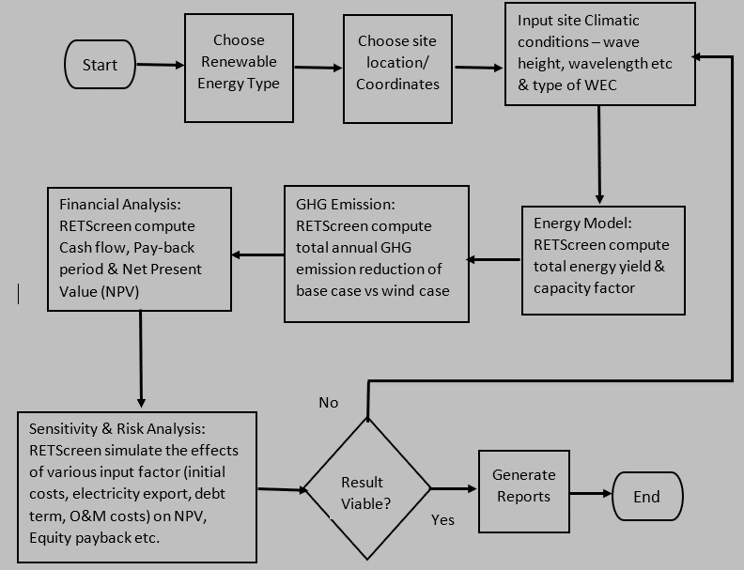

**Figure** **1:** RETScreen Wave Energy Project Model Flow Chart

The climatic data of Bonny Island location under study was retrieved from RETScreen at Latitude 4.70 N and Longitude 6.90 E as shown in figure 2.

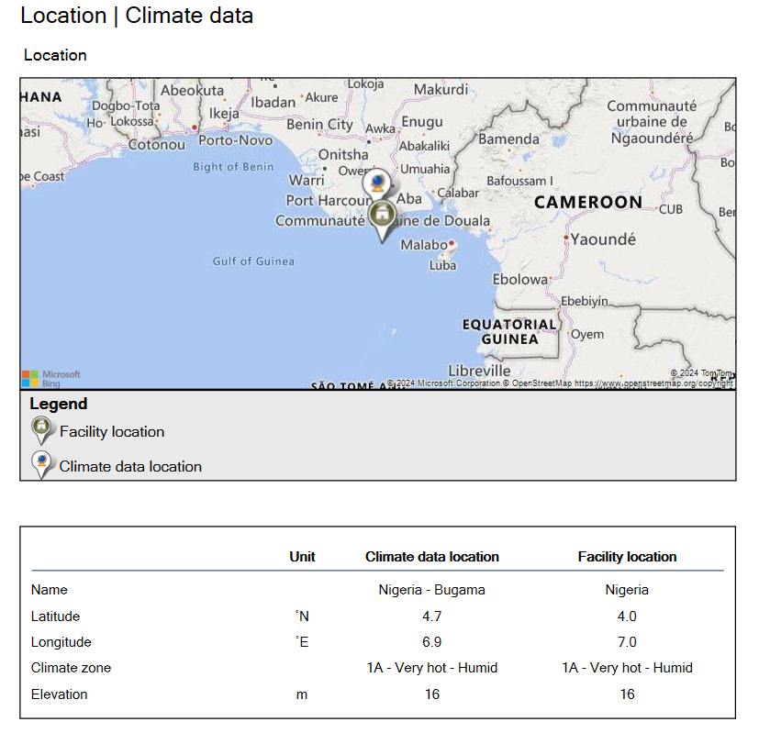

**Figure 2:** Climatic Data of Bonny Island (Source: RETScreen)

**3. RESULTS AND DISCUSSION**

**Wave energy output potential of Bonny Island**

The theoretical extracted power from the wave regime is shown in figures 3 and 4. For offshore location is (8 – 35 MW) while the nearshore areas was (0.25 – 0.6 MW). This showed offshore wave data have more promising power output than the nearshore regime as shown in figure 3 and 4 below.

**Figure 3.** – Bonny Island nearshore sea wave theoretical extracted power

**Figure 4** – Bonny Island offshore sea wave theoretical extracted power

**Discussion on Annual Wave Energy Production from RETScreen**

The key findings of this analysis from the RETScreen assessment are as presented.

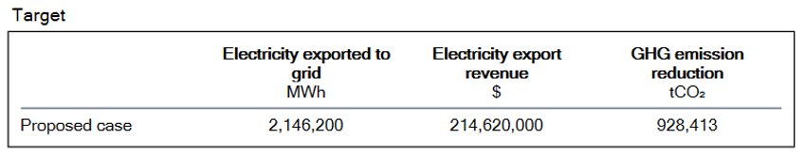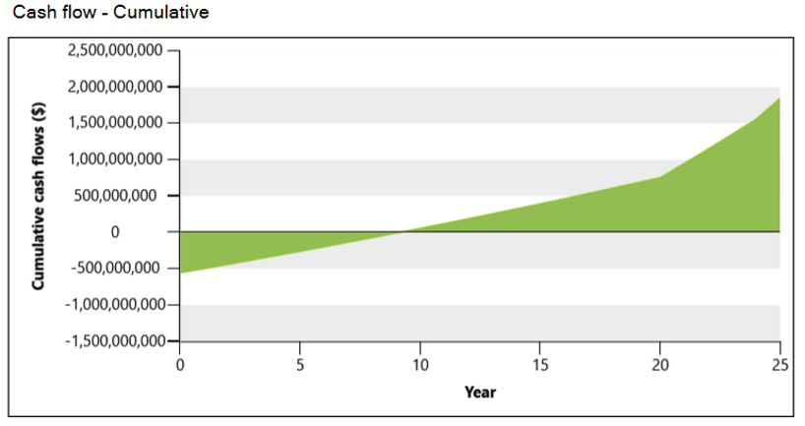

**Figure** **5:** Annual Energy Production for Bonny Island

For this study, the generated electricity shall be connected the local captive grid network and is considered an off-grid system. From Figure 6, the annual energy production from the Bonny Island wave power plant is 2,146,200 MWh of power.

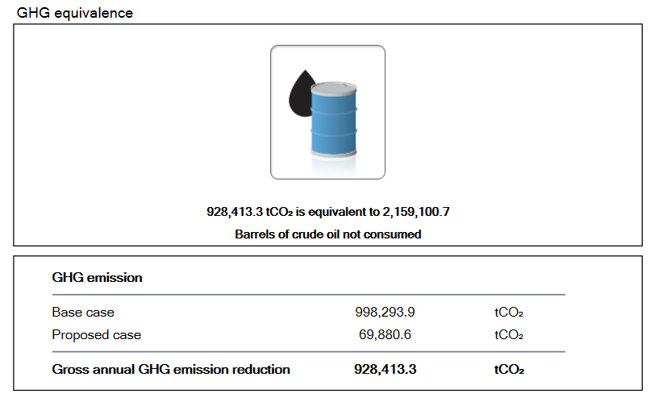

**Figure** **6:** Green House Emission Potential Saving for Bonny Island

The GHG analysis was carried out by comparing the base case (a thermal plant that runs on oil) with a proposed case (the 30 MW wave power plant). The net annual GHG emission saving for Bonny Island is 928,413 ton of CO2. This is equivalent to 2,159,100 Barrels of crude oil saved for the 25-years study period.

The financial profile of the 30 MW wave power plant in Bonny Island is shown in Table 5, Table 6 and figure 5. The total annual cost element considering annual Operation and Maintenance (O&M) cost of $38,500,000 and annual debt payment of $122,238,839 is $160,738,839. The net annual revenue generated from electricity export ($214,620,000), amount to a net yearly cash flow of $53,881,161 after annual cost payments or deductions.

**Table** **5:** Cost & Saving from a 30 MW Power Plant in Bonny Island

|  |  |  |
| --- | --- | --- |
| **Annual Revenue** | **Unit (USD)** | **Sub-Total (USD)** |
| Total initial cost | 1,850,000,000 | 1,850,000,000 |
| *Annual cost & debt - year1:* | | |
| O&M cost | 38,500,000 |  |
| Debt payment – 25-years | 122, 238,839 |  |
| **Total annual cost** |  | **160,738,839** |
| *Annual savings/revenue:* | | |
| Electricity export revenue | 214,620,000 |  |
| **Total annual savings/revenue** |  | **214,620,000** |
| Net yearly cash flow year1: |  | **53,881,161** |

**Table** **6:** Financial viability of a 30 MW Power Plant in Bonny Island

|  |  |
| --- | --- |
| **Parameter** | **Unit (USD)** |
| Pre-tax IRR – equity | 18.4 % |
| Pre-tax MIRR – equity | 11.4 % |
| Pre-tax IRR – assets | 3.8 % |
| Pre-tax MIRR – assets | 6.2 % |
| Simple payback | 10.5 years |
| Equity payback | 9.1 years |
| Net present value (NPV) | $ 171,587,502 |
| Annual life cycle savings | $ 17,496,168/ year |
| Benefit-Cost (BC) ratio | 1.3 |
| Debt service coverage | 1.5 |
| GHG reduction cost | $ 18.85 /tCO2 |
| Energy production cost | $ 0.11/kWh |

Overall, the results from the RETScreen assessment showed the offshore wave resource can generate total annual electricity of 2,146,200 MWh at an energy cost of $0.11/ kWh and 928,413 tons of CO2 on greenhouse gas reduction. The simple payback period (SPP) for the 30 MW wave power plant is 10.5 years, while the Net Positive Value (NPV) is $171,857, 502. These indicate that the 30 MW power plant is a profitable investment portfolio.

**Discussion:** The above results correlate with the results from other researchers, with higher wave power observed as one moved offshore. Results of Agbakwuru and Idubor (2019) inferred offshore wave regime has more wave power than nearshore. Kayode and Koya (2019) investigation of Nigeria Coastal using WAVEWATCH III indicated a mean annual wave power between 5.64 – 10.74 kW/m with higher wave power observed during the raining season.

Similar study by Jahangir *et al.* (2023) on hybrid renewable wave energy (solar PV and diesel generation) using Homer software for the Persian Gulf Island of Lavan, yielded an optimal outcome of cost of 0.224 $/kWh energy and NPV of $11million. It can be inferred the cost of electricity generation at the locations are almost same but cheaper and more profitable for Bonny Island WEC generation system based on the unit cost electricity generation and NPV indices

**4. CONCLUSION**

In this research, the viability of wave energy in Bonny Island was investigated for power generation and sustainable development. In this work, 39-years wave data (1984-2023) for nearshore and offshore wave regimes of Bonny Island at 13 m and 133 m water depth respectively was analyzed and used to predict the behavior of wave energy in the area. RETScreen was used to assess the techno-economic viability of the wave regime of Bonny Island for a 30 MW wave farm. The results indicated the nearshore wave data can generate between 0.25 – 0.6 MW while the offshore can generate between 8 – 35 MW power of electricity. Therefore, the offshore region has more promising potential for a wave farm project. However, due to intermittent nature of the wave power output, further studies on the integration of energy storage system like battery system with the wave energy conversion system is suggested.

Based on the wave regime data of Bonny Island, the results from the RETScreen assessment showed the offshore wave resource can generate total annual electricity of 2,146,200 MWh at an energy cost of $0.11/ kWh and 928,413 tons of CO2 on greenhouse gas reduction. The simple payback period (SPP) for the 30 MW wave power plant being 10.5 years, while the Net Positive Value (NPV) is $171,857, 502. These indices indicate that the 30 MW power plant in Bonny Island is a profitable investment portfolio. Therefore, Bonny Island has high potential to generate electricity from its wave energy resource. The electricity generated from wave energy is cleaner and eco-friendlier than the existing fossil fuel generations. As such, having a wave power plant in Bonny Island will reduce GHG emission, provides a cleaner environment and provides reliable power generation for sustainable development in the region.

**Disclaimer (Artificial intelligence)**

Author hereby declares that NO generative AI technologies such as Large Language Models (ChatGPT, COPILOT, etc.) and text-to-image generators have been used during the writing or editing of this manuscript.

COMPETING INTERESTS DISCLAIMER:

Authors have declared that they have no known competing financial interests OR non-financial interests OR personal relationships that could have appeared to influence the work reported in this paper.

**REFERENCES**

Agbakwuru, J. A. & Akaawase, B. T. (2020). “Spectral Characterization of Bonny Offshore Water Wave in Nigeria”, Uniport Journal of Engineering and Scientific Research (UJESR), 5(2), 1-5. ISSN: 2616-1192

Ambuhl.D, Guzzella.L. (2015). Predictive Reference Signal Generator for Hybrid Electric Vehicles. IEEE Transactions on Vehicular Technology,.vol.58, pp.30–40

Asiegbu, N. M. (2021). “Design of a Combined Offshore Renewable Energy System for Bonny Nigeria Based on Comparative Feasibility Analysis”; International Journal of Renewable Energy Research, 11(3), 968 -978.

Kumar, R., Barve, K.H., Singh, A., Ahsan, T., & Ranganath, L.R. (2018). “Assessment of Wave Energy Potential Using Three Years Offshore Wind and Wave Data Near Ratnagiri, Maharashtra”. INCHOE-2018, *Indian Society for Hydraulics and Central Water & Power Research Station*, Pune, India

Blackledge, J., Coyle, E., Rearney, D., McGuirk, R. & Norton, B. (2013). “Estimation of Wave Energy from Wind Velocity”, *IAENG Engineering Leters, 2013, 1-13*<https://www.researchgate.net/publication/283368443>

Houngue, G. H., Houepkonheha, M. A., Tokpohozin, N. B. & Kounouhewa, B. B. (2019). “Wave Energy Potential Assessment during Recent Extreme Events Observed on Benin’s Coastal Area, Gulf of Guinea (West Africa)”. Journal de physique de la SOAPHYS, J. P. Soaphys, 1(2019) C19A14, ISSN Print : 2630-0958,

<http://www.soaphys.org/journal/>

Jahangir, M. H., Alimohamadi, R., & Montazeri, M. (2023). “Performance comparison of pelamis, wavestar, langley, oscillating water column and Aqua Buoy wave energy converters supplying islands energy demands”, Energy Reports 9 (2023) 5111–5124,

<https://doi.org/10.1016/j.egyr.2023.04.051>

Kayode, O., & Koya, O. A. (2019). “Wave Energy Along the Gulf Coast of Nigeria”, Applied Engineering Letters 4(4), 128-135. <https://doi.org/10.18485/aeletters.2019.4.4.4>

Lavidas, G. & Kamranzad, B. (2020). “Assessment of Wave Power Stability and Classification with two global datasets”, International Journal of Sustainable Energy, DOI: 10.1080/14786451.2020.1821027

Lemessy, K. G., Manohar, K., & Adeyanju, A. (2020). Reducing the Barriers to Wave Energy Harvesting: Review. Journal of Scientific Research and Reports, 26(2), 107–116. https://doi.org/10.9734/jsrr/2020/v26i230230

NLNG Train 7 Metocean Modelling Report (T-14.203.046 Revision A, 2023).

Orji, C. U., Oyegbemi, K.O., & Ibiba D. (2023). “Performance Analysis of a Point Absorber Wave Energy Converter in Nigerian West Coast; Gulf of Guinea”, *International Journal of Marine Engineering Innovation and Research*, 8(2), 272-278

Ozohu-Suleiman A. (2021). “The Energy Crises and Environmental Concerns in Sub-Saharan Africa (Nigeria): A perspective on Public Governance for Climate Action”. Journal of Public Administration and Governance ISSN 2161-7104 2021, Vol. 11, No. 2

Padrón, I., García, M.D., Marichal, G.N., & Avila, D. (2022). “Wave Energy Potential of the Coast of El Hierro Island for the Exploitation of a Wave Energy Converter ”.

Romero, F. M., Rubio, A., & Chica, E. (2019). “Design of a wave energy converter system for the Colombian Pacific Ocean”, *Revista Facultad de Ingeniería Universidad de Antioquia, no. 94*, 8-23,

<https://www.doi.org/10.17533/udea.redin.20190406>.

Saim, M., Olatunde, M. L., Sumair, A. T. & Bilal, K. (2020). “Wave energy in the UK: Current scope, challenges and prognostications”. *International Journal of Solar Thermal Vacuum Engineering 2*(1), 59-78.

Shi, H., Zhang, X.;, Du,W., Li, Q., Qu, H., & You, Z. (2022). “Assessment of Wave Energy Resources in China”, Journal of Marine Science and Engineering 2022, 10, 1771 2-14, <https://doi.org/10.3390/jmse10111771>

Sierra, J. P., Martín, C., Mösso, C., Mestres, M. & Jebbad, R. (2016). “Wave energy potential along the Atlantic coast of Morocco”. *Renewable Energy (2016), 96*, 20-32

Simon, P. N. (2021). Introduction to Ocean Renewable Energy, Elsevier Comprehensive Renewable Energy, 2-5.

Tẽtu. A. & Chozas. J. F. (2021). “A proposed Guidance for the Economic Assessment of Wave Energy Converters at Early Development Stages”, Energies 2021, 14, 4699, <https://doi.org/10.3390/en14154699>

Tulashie, S. K., Odai R., Dahunsi A. M., Atisey, S. & Amenakpor, J. (2022). “Feasibility Study of Wave Power in Ghana”, *International Journal of Sustainable Engineering,* 15(1), 299-311.

Warpindyasmoro, H.S. (2018). “Wave energy potency in East Java coast”, MATEC Web of Conferences 177, 01018 (2018)

<https://doi.org/10.1051/matecconf/201817701018>

World Bank, (2017). World Bank, Electricity Access, <http://data.worldbank.org/indicator>