Investigation of Desert Date Seed (Adua Seed) Oil for Waxy
Crude Treatment in Nigeria

Abstract

Wax accumulation in crude oil during transit and production causes significant issues like reduced Investigation of Desert Date Seed (Adua Seed) Oil for Waxy flow and blockages in pipelines, which adversely affect pipeline operation. This project aims to address the issues related to waxy crude in the oil and gas sector by utilizing locally obtained desert date seed oi . The desert date seed oil was produced synthetically and the waxy crude oil was obtained. The study found that desert date seed oil is an effective additive for treating waxy crude oil, based on the results of tests conducted on several parameters. The wax content of the crude oil sample was initially 5.60% and was subsequently reduced to 4.70% for Adua seed oil and 0.8% for EVA. The two additions showed improved performance in the waxy crude Appearing Temperature, with increases of 26% for Adua seed oil and decreases of 19% and 3% for EVA. There has been notable enhancement in the treatment of the viscosity of the Wax crude oil sample with the use of Adua seed oil, as well as the specific gravity and API gravity of the Wax crude oil. In the Pour point temperature analysis, the two additions significantly reduced the Pour point temperature of the Wax crude oil sample from 15ºC to 9ºC for Adua seed oil and -9ºC for EVA. The Adua seed oil can be used as a novel additive for treating waxy crude oil in the oil and gas industry.

Keywords: Waxy Crude, Temperature, Pour Point, Adua seed, Crude Oil.

- INTRODUCTION
Waxy crude oil is crude oil with a significant concentration of long-chain paraffin wax (alkanes) components, resulting in a high pour point and possibly a low API gravity. A waxy crude oil is distinguished by the fact that it exhibits non-Newtonian rheological behavior at low range of temperature (for instance, roughly 20 ⁰F above the pour point). For such non-Newtonian behaved crude oils, the effective viscosity is not only temperature dependent but also a function of the effective rate of shear in the pipeline. At reservoir conditions, due to high pressure and temperature, wax molecules are generally dissolved in the crude oil to form a single continuous hydrocarbon liquid phase. While running through pipes, especially in sub-sea conditions, due to cooling down, wax crystals may start to precipitate from this continuous phase, and eventually the fluid may lose its fluidity characteristic. This shift of flow behavior generally starts to occur when the crude temperature goes lower than its cloud point or wax appearing temperature (WAT) Chalaet al., (2018) as referenced in Mysara et al., (2019).
The wax occurring in crude oil generally contains paraffin hydrocarbon (C18-C36) identified as paraffin wax and naphthenic hydrocarbon (C30-C60). The hydrocarbon element of wax is possible to present in many phases, for instance gas, liquid, and particles (solids), based on the flow circumstances, i.e., pressure and temperature. When the temperature of wax falls, the agglomerates and the wax crystals from paraffin wax are characterized as microcrystalline or naphthenic hydrocarbon Daungkaew, et al., (2012) as mentioned in Ramasamy, (2019). Crude oil is a complicated multi-component organic mixture consisting largely of hydrocarbons and a few non-hydrocarbons. The general composition is classed into saturates, aromatics, resins, and asphaltenes (Xiong et al., 2020a, 2020b) as referenced in Wyclif, et al., (2022). Some of the saturate compounds have high melting points, thereby easily solidifying at low temperatures. They precipitate out of the fluid as the temperature lowers to a particular degree - often below 80 ⁰C - to form colloids known as wax. The wax making molecules are mostly regular and branched alkanes however some naphthenes connected to long carbon chains are also probable wax generating molecules. The deposition of wax in the oil and gas sector is both an economic and practical concern. These difficulties occur throughout production, shipping, and storage. Amongst them are blockage of well tubing and transport pipes, reduction of the drawdown pressure; fouling of surface facilities like separators and tankers; and increased energy input for pumps. As energy consumption across the globe continues to expand at an exponential rate, so are the conventional supplies being rapidly depleted. This phenomenon has accelerated the quest to discover alternative energy sources and led to increased production from offshore oil deposits in addition to other extreme climatic regions over the past decade (Bai and Bai, 2018) as mentioned in Wyclif et al., (2022). Production from these fields sometimes necessitates transportation of crude oil over considerable distances to processing facilities. If suitable counter control measures are not applied, oil temperature may decrease to that of the environment, causing precipitation of wax from the oil. When this deposition is sufficiently high, it can generate operational challenges that may splash cold water on the economic prospects of projects due to the costly solutions necessary. In most cases, this problem is inevitable as numerous waxy oil fields are spread across the globe, yet no single universal solution exists (Batsberg et al., 1991; Del Carmen Garcia, 2001; Ding et al., 2006; Rønningsen, 2012; Pedersen et al., 1991; Suppiah et al., 2010). Most companies implement pigging as the most recommended cleanup technology. However, it should be highlighted that this technology is also connected with some limitations such a disruption of industrial processes. Moreover, its frequency also adds extra expenditures (such single pigging power, electric and thermal costs) to the entire production budget (Niesen, 2002; Xie et al., 2018) as referenced in Wyclif et al., (2022).
The aim of this paper work is to investigate the potential of desert date seed (adua seed) oil in the treatment waxy crude oil in the flow system in Nigeria and the objectives are: To extract the desert date seed oil from the raw source, to treat the waxy crude oil with the sourced desert date seed oil, and to compare the result of the treated wax oil in the laboratory with the standard method of additive in the petroleum industry.
- METHODOLOGY

MATERIALS: The materials and the equipment used for the project work are: Pour Point machine/Refrigerator, Test jar, Thermometer, Cork, Beaker, Wax crude oil sample, Fresh Water, weighing balance, measuring cylinder, Ethylene Vinyl-Acetate (EVA), n-hexane (solvent), Adua seed oil, Acetone, Xylene, Filter paper, Density bottle.
METHOD: This is the overall methods in carrying out this research work;
Extraction of Desert Date (Adua seed) oil:
The extraction of methods followed almost the same with the African pear seed oil and is analysis as followed: Collection of the fruits, dehulling, drying, characterization of the sample, size reduction to various size ranges and extraction of the oil. The same process as (Hosakatte et al., 2020).
Determination of Wax content of the crude oil
Procedure: To get rid of the particles, xylene is used to cleanse the sieve. After that, dry for about an hour in the oven. It is then allowed to cool before the sieve's initial weight is measured. Using a measuring cylinder, 100 milliliters of the sample (wax crude) was measured as shown in figure 1 below. The sample was then weighed in the measuring cylinder to determine its weight. The weight retained sample was sent through the sieve, then it was heated mechanically and cleaned with acetone. After allowing the wax to dry out at room temperature for approximately 20 minutes, the mesh was reweighed to determine the final weight of the 45micron sieve containing crude oil.
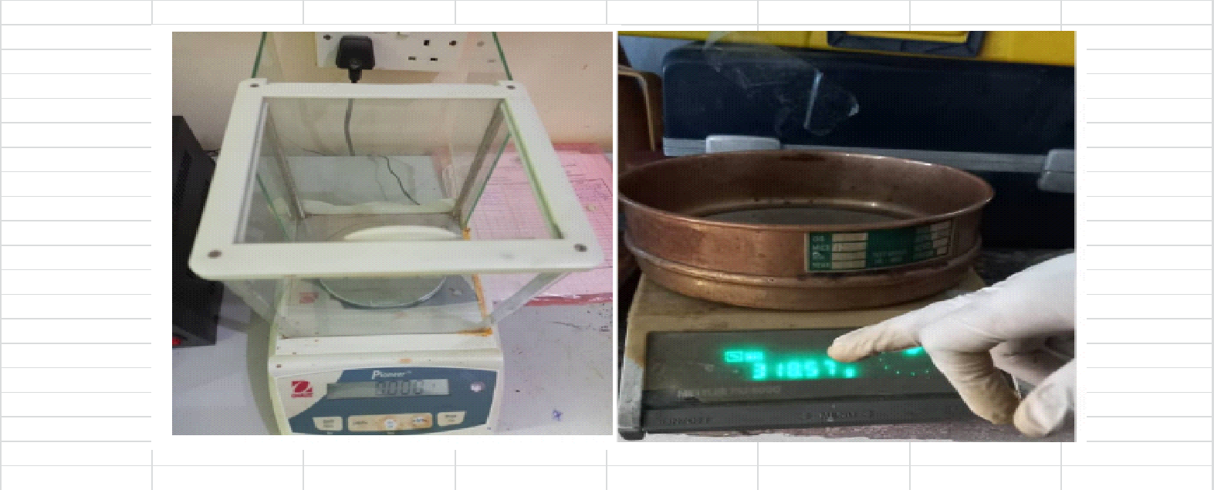

Fig. 1: Wax content determination Apparatus

Determination of Wax Appearing Temperature (WAT) (%)
The procedure of the determining (WAT) is as followed:
1. The sample is filled into the test jar to the designated mark, sealed with a cork, and the thermometer is inserted into the sample through the cork. Shaking the sample will alter its WAX, therefore avoid doing so.
2. After turning on, the wax machine was left to run until it got cold. Next, the apparatus containing the sample, test jar, cork, and thermometer was placed inside.
3. Keep checking to determine if the sample has begun to precipitate at one-minute intervals.
4. Tilt the jar further to the horizontal position for five seconds after the sample begins to flow when it is tilted. If the sample stops flowing even after that, record the temperature.

Determination of the crude kinematic and Dynamic Viscosity

Procedure
The crude oil was poured into the reservoir arm of the U-tube viscometer to the indicated mark meniscus A. The crude oil sample was sucked through the working arm above meniscus C and was corked. The timer was set ready and the cork was removed for the crude oil to run from meniscus C to B and the time was taken and recorded as shown in figure 2 below.
Calculation for kinematic viscosity
V = CT
where: V = Kinematic viscosity, C = Certificate of calibration
T = time taken for the crude to flow from C to B
Dynamic viscosity calculation
Ṵ = ΡV

where,

Ṵ = Dynamic viscosity, Ρ = Density of the crude, V = Kinematic viscosity
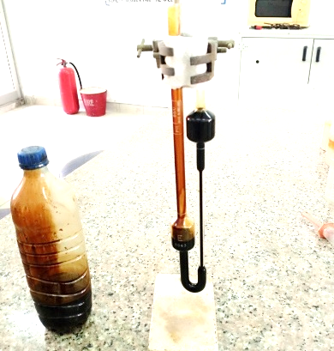

Fig.2: U-tube Viscometer (glass capillary tube)

Determination of Crude oil specific gravity and API gravity

To determine the specific gravity and API Gravity of the sample using the density bottle method.
Procedure
The empty density bottle was placed on the weighing balance and the weight was recorded. The same density bottle was used to measure oil in the weighing balance and the weight was recorded as shown in figure 3. The process was repeated for water and the weight was recorded. The values got were used to compute for the specific gravity and the corresponding result of the specific gravity was used to compute for the API gravity
Calculation
Relative density = mass of Oil mass of fresh water
API = (141.5/SG@60⁰F) -131.5
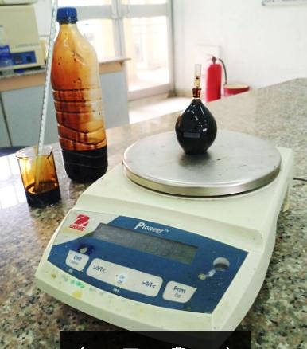

Fig. 3: Weighing balance with crude oil for Relative density.

Determination of pour point of the waxy crude oil.
Procedure: The sample is filled into the test jar to the designated mark, sealed with a cork, and the thermometer is then inserted into the sample through the cork as shown in figure 4. Shaking the sample will alter its pour point, therefore avoid doing so. After turning on, the pour point machine was left to run until it got cold. Next, the sample, test jar, cork, and thermometer assembly were placed within the apparatus. Keep checking to verify if the sample has poured at the intervals. When the jar is tilted, as soon as the sample begins to flow, tilt it further to the horizontal position for five seconds. If the sample stops flowing even after that, record the temperature.
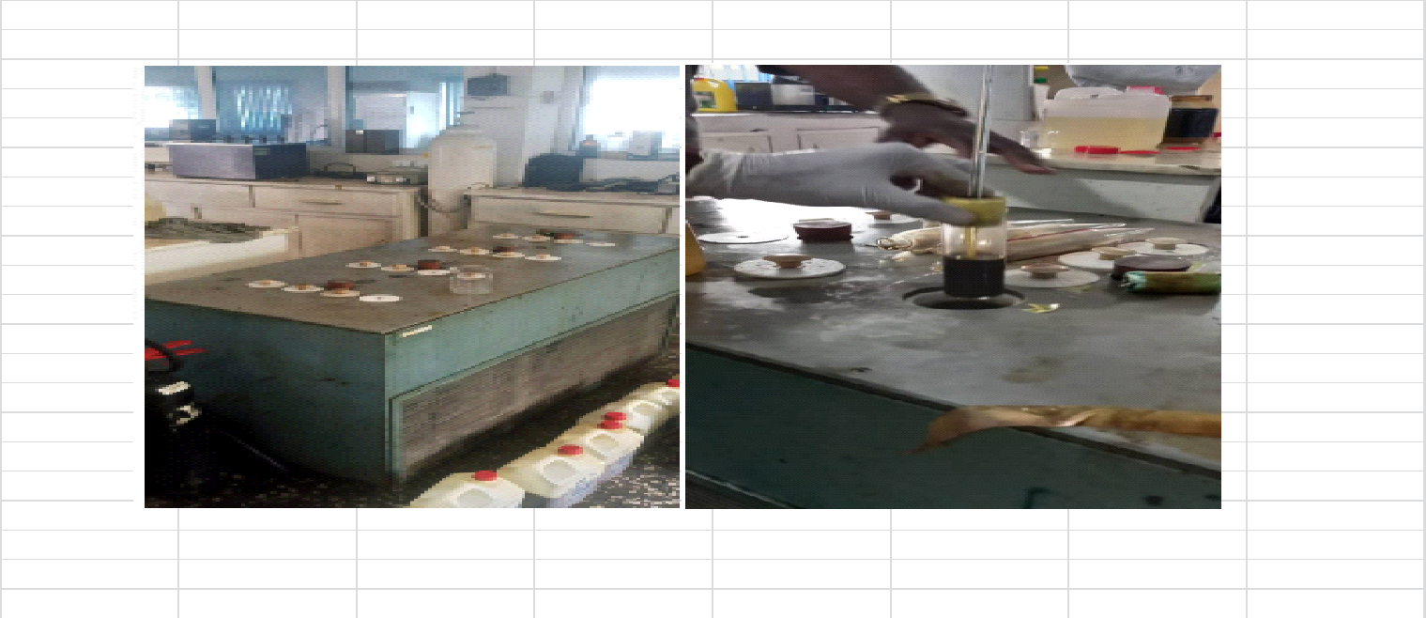

Fig. 4: Pour point analyst (machine)

- RESULTS AND DISCUSSION

The table 1 below shows the detailed result of all the experiments above with respect to the eaxy crude treatment

Table 1: The results of the Wax content, WAT, viscosity, gravity and pour point of Waxy crude oil mixed with desert date seed oil and Ethylene Vinyl Acetate
 |  | U | A | EVA
Wax content | 1ml | 5.6 | 5.3 | 0.08
Wax content | 2ml | 5.6 | 4.9 | 0.5
Wax content | 3ml | 5.6 | 4.4 | 0.17
WAT | 1ml | 26 | 21 | -3
WAT | 2ml | 26 | 20 | -3
WAT | 3ml | 26 | 19 | -3
Viscosity | Kinematic Viscosity | 8.9 | 6.15 | 4.4
Viscosity | Dynamic Viscosity | 7.18 | 5 | 3.51
Gravity | Specific gravity | 0.818 | 0.804 | 0.801
Gravity | API gravity | 41.41 | 44.5 | 45.17
Pour point | 1ml | 15 | 14 | -15
Pour point | 2ml | 15 | 11 | -12
Pour point | 3ml | 15 | 9 | -9
U = Undopped (without additives)
A = Adua seed (desert date seed) oil
EVA = Ethylene Vinyl Acetate

Wax Content (%) of the Waxy crude
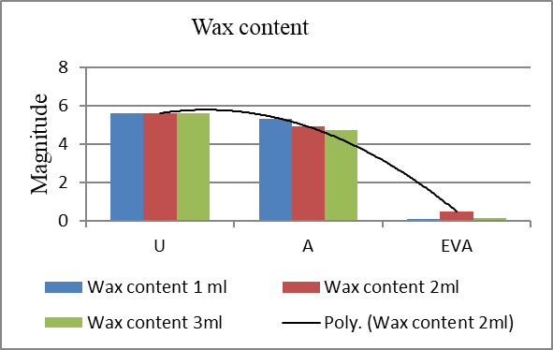

Fig. 5: Wax content of the waxy crude
From the analysis of the crude oil in figure 5 above, it shows that the crude oil originally has 5.60 wax Content but when the Adua seed (desert date seed) oil and the EVA (Ethylene/Vinyl Acetate) were added at 1ml ratios, the result was (5.30 and 0.08) respectively. EVA performed the best, followed by the formulated desert date seed oil and lastly is the undoped (without additive).
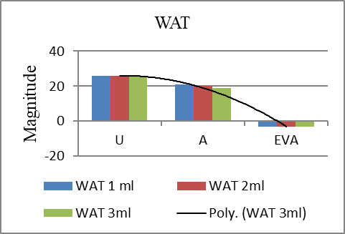
3.1 Wax Appearing Temperature (%) of the Waxy crude.

Fig. 6: WAT of the waxy crude
The graph in figure 6 above shows that the original Wax Appearing Temperature (WAT) (ºC) was 26 ºC. When 1ml ratio of Adua seed oil and EVA were added to it, the wax Appearing temperature reduced to 21ºC and -3ºC respectively. Further increment of 2ml and 3ml of the Adua seed oil reduced to Wax Appearing Temperature of the waxy crude oil to 20ºC and 19ºC respectively but it remains -3 ºC in EVA irrespective of the dosage concentration.

- The Waxy crude oil Viscosity.
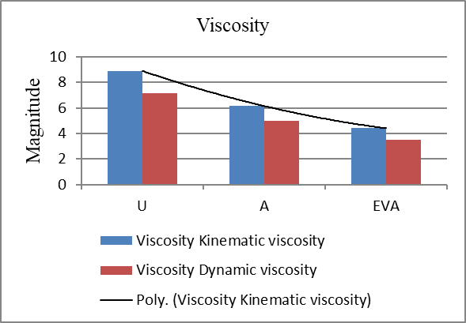

Fig. 7: Kinematic and Dynamic Viscosity of the waxy crude
Before the treatment of the Wax crude oil sample, the kinematic viscosity was 8.90 mm²/second. When the Adua seed oil and EVA were added to the waxy crude oil sample, the kinematic viscosity of the Wax crude oil sample reduced to (6.15 and 4.40) respectively. The additives also work variably in the dynamic viscosity when applied.

3.3 The Waxy crude oil specific gravity and API gravity.
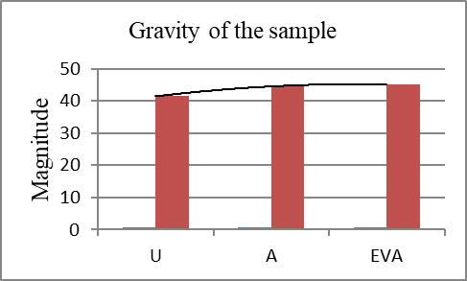

Fig. 8: The Gravity of the waxy crude
From figure 8 above, it shows that the Waxy crude oil sample was having high specific gravity and low API gravity with the magnitude of 0.818 and 41.41 respectively. When the Wax Crude oil was treated with the Adua seed oil and EVA, the specific gravity reduced to 0.804 and 0.801 respectively. Also, the calculated API gravity of the Wax crude oil sample was increased to 44.5 and 45.17 respectively. This implies that the Adua seed oil and EVA were able to react positively on the waxy crude oil sample.

3.4 The Waxy crude oil Pour Point (⁰C).
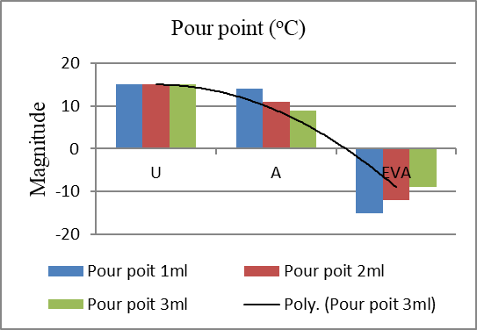

Fig. 9: Pour Point of the waxy crude
The Pour point of the crude oil sample originally was 15ºC. When 1ml of the additives were added to it, the Pour point was 14ºC and -15ºC respectively for Adua seed oil and EVA. The Pour point further reduced on 2ml increment to 11ºC and -12ºC respectively for Adua seed oil and EVA and performed better on 3ml as seen in the graph above.

- CONCLUSION
Conclusively from the result analysis in chapter four above, it shows that the locally indigenous sourced material, the desert date (Adua seed) oil is a good additive for Wax Crude oil treatment as appeared in the various parameters tested. The Wax Content of the Wax crude oil sample that was originally 5.60% was treated to 4.70 and 0.8 respectively for Adua seed oil and EVA. The two additives performed better in the waxy crude Appearing Temperature from 26% to 19 and -3 for Adua seed oil and EVA respectively. There is also significant improvement in the treatment of the Wax crude oil sample Viscosity with respect to the Adua seed oil and the EVA as well as the specific gravity and API gravity of the Wax crude oil. Finally in the Pour point temperature analysis, the two additives performed exceedingly in reducing the Pour point temperature of the Wax crude oil sample from 15ºC to (9 and -9) ºC respectively for Adua seed oil and EVA. This implies that the Adua seed oil can serve as a standard novel additive for the treatment of waxy crude oil in the oil and gas industry.

References
Britannica,T.Editors of Encyclopaedia, (2023). Crude oil. Encyclopedia Britannica. https://www.britannica.com/science/crude-oil
Davidson Chukwudi Onwumelu ,Michael Kelechi Onwuka, Stanley Ebuka Nnebeana, Tobechukwu Charles Okoro, Anaele Frank Ekeocha, Chidiebere Cosmas Offurum and Victor Ndudim Ndubuisi, (2022): Cross-section of a pipe with deposited wax, digital image, accessed in December, 2023, : https://doi.org/10.30574/wjarr.2022.15.1.0770
Faith Samir Soliman, (2020): Introductory chapter: Petroleum Paraffins. DOI: 105772/intechopen 87090
Hosakatte Niranjana Murthy, Guggalada Govardhana Yadav, Yeser Hassan Devir and Abullah Ibrahim, (2020): Morphology of Balanites aegyptiaca (L.) Delile, digital image, accessed in December, 2023, https://doi.org/10.3390/plants10010032
Marwa R. Elkatory, Emad A. Soliman,Ahmed El Nemr,Mohamed A. Hassaan, SafaaRagab,Mohamed A. El-Nemr,and Antonio Pantaleo, (2022); Mitigation and Remediation Technologies of Waxy Crude Oils’ Deposition within Transportation Pipelines: A Review. Polymers (Basel) PMC9413815. DOI: 10.3390/polym14163231
Muhammad Ali Theyab, (2018): Wax deposistion process; Mechanisms, affecting factors and Mitigation methods. Open Acess/Sci/DOI: 10.15406/Oajs.00054
Quan, S. Wang, N. Sun, Y. Wang, R. Li, J. Gong (2020): Experimental study on wax deposition of gas-liquid under intermittent flow Petrol. Sci. Technol., 38 (4) pp. 331-337
Ramasamy MarappaGounder, (2019): Processing of Heavy Crude Oils: Challenges and Opportunities. Electronic books, Petroleum-Refining. SBN:9781839684098, 1839684097
Soliman E.A., Elkatory M.R., Hashem A.I., Ibrahim H.S., (2018): Synthesis and performance of maleic anhydride copolymers with alkyl linoleate or tetra-esters as pour point depressants for waxy crude oil. DOI: 10.1016/j.fuel..09.038. [CrossRef] [Google Scholar] [Ref list]
Soloman E., (2019): Flow of heavy oils at low temperatures: Potential challenges and solutions. In: Gounder R.M., editor. Processing of Heavy Crude Oils-Challenges and Opportunities. Intech Open Limited; London, UK: [Google Scholar] [Ref list]
Taheri-Shakib, I. Zojaji, N. Saadati, E. Kazemzadeh, A. Esfandiarian, M. Rajabi-Kochi (2020): Investigating molecular interaction between wax and asphaltene: accounting for wax appearance temperature and crystallization J. Petrol. Sci. Eng., 191, 107278
Theyab MA (2018): Wax Deposition and Mitigation Methods. Lambert Academic Publishing. ISBN-13: 978-613-9-97327-9, ISBN-10: 6139973279.
Wyclif Kiyingi, Ji-Xiang Guo, Rui-Ying Xiong, Li Su, Xiao-Hui Yang, Shi-Ling Zhang, (2022): Crude oil wax: A review on formation, experimentation, prediction,
Wyclif Kiyingi, Ji-Xiang Guo, Rui-Ying Xiong, Li Su, Xiao-Hui Yang, Shi-Ling Zhang, (2022): Microscopic view of wax crystallization in oil using commercial wax (high power magnification , digital image, accessed in December 2023, ISSN 1995-8226, https://doi.org/10.1016/j.petsci.2022.08.008.
Zhou, Z.W. Xie, X.H. Xu, Q. Li (2020): A new model of overall heat transfer coefficient of hot wax oil pipeline based on dimensionless experimental analysis Case Stud. Therm. Eng., 20 Article 100647 and remediation techniques, Petroleum Science, https://www.cup.edu.cn/ petroleumscience/docs/2022-11/abf6edf032624ef1a9e3756b04fbf7b2.pdf

