Organizational Justice and Quality of Work Life as a pushing of Organizational Citizenship Behavior (OCB): The Mediating Effect of Organizational Commitment

.
ABSTRACT

Objective: This study aims to analyze the influence of Organizational Justice and Quality of Work Life on Organizational Citizenship Behavior (OCB) with Organizational Commitment as a Mediation Variable, using the Education Office of Ciamis Regency, West Java, Indonesia, West Java, Indonesia as a case study.
Study Design: This research uses a quantitative approach with data collection using questionnaires. All of these research items were measured using a likert scale of 1 to 5. This study uses saturated sampling techniques.
Place of Study: The population of this study is members of the Education Office of Ciamis Regency, West Java, Indonesia, West Java, Indonesia.
Methodology: This study used saturated sampling so that the sample totaled 105. Data processing uses the SmartPLS 4 application with the Structural Equation Modeling-Partial Least Square (SEM-PLS) technique. Data analysis was carried out using loading factors, validity test and reliability test, Discriminant Validity: Fornell-Larcker, deep model with R-Square and hypothesis test.
Results: The findings of the study show that Organizational Justice, Quality of Work, and Organizational Commitment have a significant positive effect on Organizational Citizenship Behavior. Meanwhile, Organizational Commitment that mediates Organizational Justice has a negative effect on Organizational Citizenship Behavior. Then the Organizational Commitment mediates the Quality of Work Life which has a positive effect on the Organization's Citizenship Behavior.
Conclusion: These results show that when employees are treated fairly and have a good quality of life, they tend to exhibit extra-role behaviors that are beneficial to the organization. In addition, organizational commitment has been proven to mediate the influence of QWL on OCB, but it does not play a mediator in the relationship between organizational justice and OCB.

Keywords: Organizational Justice, Quality of Work Life, Organizational Citizenship Behavior, Organizational Commitment

1. INTRODUCTION

The effectiveness and performance of a team in any organization is determined by the ability of team members to work in a team (Novianti, 2021). In reality, not everyone is able to work in a team, as it requires the individual's ability to communicate openly, honestly, cooperate with others, and be able to resolve conflicts (Widodo et al., 2023). However, the existence of a work team is not only seen as an organizational demand so that employees are able to carry out their duties together, but the work team is basically an organizational need to support the smooth operation of the institution as a whole.
Education has an important role in the progress of a nation (Muhtar & Wahyudi, 2024). Education plays a role in developing skills, shaping character, and creating a dignified nation's civilization to educate the nation's life and form individuals who have faith, piety, noble character, intelligence, independence, creativity, and responsibility as democratic citizens (Perdani et al., 2024). Based on this, the government through the Education Office at the national, provincial, and district/city levels continues to play a role in making contributions, including in overcoming the problems of education personnel and educational facilities (Handayani et al., 2024).
Human resources are an important element for an organization because the success or effectiveness of an organization depends heavily on the quality and performance of its human resources (Sara et al., 2023). Therefore, it is important for organizations to be able to manage employees as human resources well and wisely.
The Education Office of Ciamis Regency, West Java, Indonesia as one of the government institutions that plays an important role in carrying out strategic responsibilities in the implementation of education. Public perception of the services provided by the Education Office of Ciamis Regency, West Java, Indonesia is greatly influenced by public satisfaction with the good or bad services provided. This is a challenge in carrying out services to the community that demands excellent service. So that the quality of human resources is an aspect that must be considered
Today, a new view is developing that sees employees not only as resources, but also as valuable assets or capital of the organization that need to be managed and developed (Nurjanah et al., 2020). Good human resource management in an organization will make it easier for the organization to achieve its goals. An organization's ability to achieve its goals is determined not only by the employee's behavior in carrying out his duties according to his job description, but also by the extra behavior of the employee's role outside of his or her primary duties (Rimatanti & Darmawan, 2023).
Organizational Citizenship Behavior (OCB) is an individual's behavior that is independent and not directly related to the main task, but can contribute to improving organizational performance (Hermawan et al., 2024). In other words, OCB is one of the important aspects that support the effectiveness and productivity of the organization. OCB characteristics reflect positive employee behaviors that go beyond the tasks, roles, and job descriptions that the organization requires (Nurjanah et al., 2020). Employees who have OCB behaviors will demonstrate exceptional dedication, drive, and insight, exceeding the tasks necessary for the benefit of the organization (Asgari et al., 2020).
The Low OCB behavior in local government employees can be the focus of this study. Low-level phenomena Organizational Citizenship Behavior (OCB) in local government institutions can be caused by several factors, such as the low desire of employees to help each other in the work environment or because each employee feels able to complete his or her own tasks without the need for the help of colleagues. If this trend continues, it could be that the work culture in the office environment emphasizes more on individualism than teamwork. Therefore, it is necessary to further examine the factors that affect low OCB, whether it comes from Organizational Justice which builds perceptions in managing employees, work systems, or individual factors of each employee. that are fixed. A low willingness of employees to play an extra role can negatively impact relationships between employees, increase non-compliance with organizational rules, trigger jealousy towards colleagues, lead to delays in task completion, decrease organizational stability, and reduce individual and organizational performance (Zahra & Siregar, 2023).
In an organization, OCB can be influenced by Organizational Justice (Romadhona & Prawitowati, 2024). Organizational Justice is an employee's perception of the Justice received in an organization (Manihuruk, 2023). If an organization has a high level of Justice, then the planning and execution of the decision-making process and the results will be done fairly (Lim & Setyawan, 2023). By showing a fair and equitable nature, employees will tend to work according to what is expected when carrying out their work (Kamil & Rivai, 2021). Research from Bastyant et al., (2024), Kamil and Rivai (2021), Lim and Setyawan (2023), Romadhona and Prawitowati (2024), Syafriyanti and Anisah (2021) revealed that organizational Justice has a positive and significant effect on OCB. The existence of equal treatment between employees is necessary to foster the desire to improve OCB's behavior (Kamil & Rivai, 2021). While research from Nurhafni et al., (2022) shows that organizational justice has no effect on OCB.
Moreover Quality of Working Life (QWL) is also a factor that can affect OCB (Rimatanti & Darmawan, 2023). QWL is an overview of the extent to which human needs are met in the work environment (Agustina et al., 2022). QWL also refers to the overall well-being of employees in the workplace. Optimally designed QWL will be able to have a positive impact on employees and the organization. Quite a few studies have linked its influence Organizational Justice and QWL against Organizational Citizenship Behavior (OCB), but there are still differences in the results of the research. For example, research from Bastyant et al., (2024), Kamil and Rivai (2021), Lim and Setyawan (2023), Romadhona and Prawitowati (2024), Syafriyanti and Anisah (2021) reveals that Organizational Justice has a positive and significant effect on OCB. The existence of equal treatment between employees is necessary in fostering the desire to improve OCB's behavior (Kamil & Rivai, 2021). While research from Nurhafni et al., (2022) shows that Organizational Justice has no effect on OCB. Research from Purwanto et al., (2021, 2023), Rimatanti and Darmawan (2023), Widodo et al. (2023), (Sumarsi & Rizal, 2021) showed that QWL had a positive and significant effect on OCB. Prioritizing QWL will also benefit employees and the organization as a whole (Mehra, 2023). However, there is research from Hidayah and Hendarsjah (2021) which indicates that OCB levels cannot be affected by QWL.
From the explanation above, it can be seen that there are still inconsistencies between the relationships Organizational Justice and QWL against OCB. The researcher tries to provide a solution to the research gap by adding a mediation variable. Organizational commitment considered to be able to mediate the relationship between Organizational Justice and QWL against OCB. Organizational commitment can form the value of positive attitudes from employees so that it can strengthen the relationship between Justice in the organization and the quality of life of employees to be able to show extra role behavior. Research from Firmansyah et al., (2022), Hermawanto et al., (2022), Nurjanah et al., (2020), and Widodo et al., (2023) shows that the sense of commitment from employees to the organization is able to improve OCB behavior in employees. Employees with levels Organizational commitment those who are tall tend to exhibit high OCB behavior Purwanto et al., (2023) Research from Rato and Rahmat, (2020) explains that Organizational Justice Affect Organizational commitment, in addition to research from Astuti & Soliha (2021) Resulting in quality of working life affects Organizational commitment.
Previous research by (Romadhona & Prawitowati, 2024) show Organizational commitment able to act as a mediator of organizational Justice and quality of work life. while research according to Ulum et al., (2024) explain Organizational commitment can mediate the influence of QWL on OCB.
Current research builds on research findings from Putri and Nurmayanti (2024) However, this study is unique in that it explores organizational commitment as a mediating variable. The researcher added Organizational commitment as a mediator. Previous research examined consulting services in hotel and housing design projects (PT Eka Dana Consultant located in the city of Mataram, West Nusa Tenggara, Indonesia. Meanwhile, this study research researched government institutions, namely the Education Office of Ciamis Regency, West Java, Indonesia. In addition, the researcher developed research findings from (Kamil & Rivai, 2021) regarding the quality of work life as a variable independent. The research examined PT Telekomunikasi Indonesia (TELKOM) Padang City, West Sumatra, Indonesia.
This study is the first comprehensive study that examines the relationship between Organizational Justice and Quality of Work Life as a pushing of Organizational Behavior Citizenship (OCB): The Mediating Influence of Organizational Commitment. Therefore, this study comprehensively examines the relationship between Organizational Justice and Quality of Work Life as a pushing of Organizational Citizenship Behavior (OCB): The Mediating Influence of Organizational Commitment.

2. Literature Review

2.1 Social Exchange Theory

Social Exchange Theory (SET) is the basis for explaining the relationship between independent variables and OCB in this study. SET highlights the nature of interpersonal relationships and social interactions, in which a person who receives a good influence or perception is expected to show gratitude and reciprocate it when the opportunity arises (Blau, 1964). When employees have a relatively positive influence or perception, they tend to reply in a practical and effective way (Rimatanti & Darmawan, 2023). In addition, employees who feel that the organization cares about their well-being and engage in responsible social activities, employees will exhibit a positive attitude and extra role behavior (Liaquat & Mehmood, 2017). Based on this explanation, it can be said that when employees feel support, Justice, and Justice from the organization and its leaders, they are more likely to exhibit extra-role behaviors that support the effectiveness of the organization. This results in an understanding that the relationship between employees and the organization is based on a reciprocal aspect, where the nature of this mutually beneficial relationship can determine the behavior of employees towards their organization (Liaquat & Mehmood, 2017).
Organizational Citizenship Behavior (OCB) is sourced from the framework Social Exchange Theory (Hermanto et al., 2024). Therefore, the SET can be the basis for explaining the relationship between independent variables and OCB in this study. SET highlights the nature of interpersonal relationships and social interactions, in which a person who receives a good influence or perception is expected to show gratitude and reciprocate it when the opportunity arises (Blau, 1964). When employees have a relatively positive influence or perception, they tend to reply in a practical and effective way (Rimatanti & Darmawan, 2023). In addition, employees who feel that the organization is fair and cares about welfare as well as engaging in responsible social activities, employees will exhibit a positive attitude and extra role behavior (Liaquat & Mehmood, 2017). Based on this explanation, it can be said that when employees feel support, Justice, and attention from their organization, they are more likely to exhibit extra-role behaviors that support the effectiveness of the organization.

2.2 Organizational Citizenship Behavior

Organizational Citizenship Behavior (OCB) is defined as voluntary behavior that involves the actions of more employees to support the progress of their organization (Novianti, 2021). OCB can be described as an out-of-role behavior that employees voluntarily perform, which goes beyond their formal duties, but contributes to the effectiveness and efficiency of the organization in achieving its goals Widodo et al., (2023). OCB also refers to an individual's social behavior in the workplace that exceeds expectations, such as voluntarily helping a coworker during breaks or outside of work hours (Hermawan et al., 2024). OCB can be measured using several indicators from Podsakoff et al., (2000) which includes mutually helpful behavior, sportsmanship, loyalty to the organization, obedience to the organization, individual initiative, good citizenship, and self-development.
The basis that distinguishes OCB from other activities is that they are voluntary or based on personal choice, where they are outside the job description and have a positive impact on the organization (Rimatanti & Darmawan, 2023). Employees with a high OCB level will later show improved performance, a friendlier and more sociable attitude, and accept assigned tasks without complaints or debates (Purwanto, 2022).

2.3 Organizational Justice and Organizational Citizenship Behavior

Organizational Justice is defined as the equal and fair treatment that a person receives at his or her workplace (Lim & Setyawan, 2023). The existence of equal treatment between employees is necessary in fostering the desire to improve OCB's behavior (Kamil & Rivai, 2021). Individuals who feel that there is justice in the organization tend to have a positive attitude towards the organization, including OCB's behavior (Lim & Setyawan, 2023).
Organizational Justice have an important role when the award given is in accordance with the field of work and is worthy of acceptance by employees in the work environment (Bastyant et al., 2024). According to Flint et al., (2012), Organizational Justice It can be measured for 4 dimensions including distributive justice, interpersonal justice, procedural justice, and information justice. By showing an equal and fair nature, employees will tend to work according to what is expected when carrying out their work (Kamil & Rivai, 2021). Research from Bastyant et al., (2024), Kamil and Rivai (2021), Lim and Setyawan (2023), Romadhona and Prawitowati (2024), Syafriyanti & Anisah (2021) (C. S. Ulfa & Siwi, 2021). reveals that Organizational Justice has a positive and significant effect on OCB. The existence of equal treatment between employees is necessary in fostering the desire to improve OCB's behavior (Kamil & Rivai, 2021).

H1: Organizational Justice Has a Positive and Significant Effect on Organizational Citizenship Behavior

2.4 Quality of Work Life and Organizational Citizenship Behavior

Quality of Working Life (QWL) is a management system approach in an organization that aims to improve the quality of life of employees in the work environment simultaneously and sustainably (Hermanto et al., 2024). If employees do not get a good quality of work life, such as. appropriate compensation and conducive work environment, they will not be motivated or have the opportunity to grow, which will hinder the formation of positive OCB (Sumarsi & Rizal, 2021). QWL is an overview of the extent to which human needs are met in the work environment (Agustina et al., 2022). Sirgy et al., (2001) revealed that QWL can be measured with several dimensions of measurement such as safety and health needs, social, family and economic needs, rewards and recognition, self-actualization, creativity, and self-development. Optimally designed QWL is expected to have a positive impact on employees and the organization (Hermanto et al., 2024). Research from Purwanto et al., (2021, 2023), Rimatanti and Darmawan (2023), Widodo et al., (2023)and (Sumarsi & Rizal, 2021). showed that QWL had a positive and significant effect on OCB. Prioritizing QWL will also benefit employees and the organization as a whole (Mehra, 2023).

H2: Quality of Work Life Has a Positive and Significant Effect on Organizational Citizenship Behavior

2.5 Organizational Commitment and Organizational Citizenship Behavior

Organizational commitment is the willingness of individuals to bond and show loyalty to the organization because they feel involved in various organizational activities (Rimatanti & Darmawan, 2023). Organizational commitment It is also defined as the employee's level of trust in the organization and its goals, along with the desire to remain part of the organization, which reflects an attitude of loyalty to the organization (Nurjanah et al., 2020). Organizational commitment can be measured by Meyer and Allen (1991) Three-Component Commitment Model which includes Affective, Continuation and Regulations.
Organizational commitment demonstrated by employees has a positive impact on OCB's behavior. When employees show a sense of belonging and loyalty as a form of their commitment to the organization, it tends to improve OCB behavior, which is reflected in the positive actions employees show towards the organization Firmansyah et al., (2022). The explanation shows that strong commitment can encourage employees to be more proactive in supporting the achievement of organizational goals through the contribution of extra roles. Research from Firmansyah et al., (2022), Hermawanto et al., (2022), Nurjanah et al., (2020), Purwanto (2022), and Widodo et al., (2023) shows that Organizational commitment has a positive and significant effect on OCB. Employees with a strong level of commitment tend to exhibit good organizational family behavior, and the higher the employee's commitment, the higher the OCB level shown (Hermawan et al., 2024).

H3: Organizational commitment has a positive and significant effect on Organizational Citizenship Behavior

2.6 The Mediating Role of Organizational Commitment

Employees who feel that policies, resource distribution, and treatment in the workplace are given fairly, they tend to have a higher level of commitment to the organization (Kamil & Rivai, 2021). This strong commitment then encourages them to exhibit extra role behaviors, such as helping colleagues, adhering to organizational rules, and contributing more than their primary duties (Romadhona & Prawitowati, 2024). So that Organizational Justice not only has a direct impact on improving OCB, but also indirectly through increasing employee commitment to the organization. Previous research from Kamil and Rivai (2021), Lim and Setyawan (2023), Romadhona and Prawitowati (2024), Syafriyanti and Anisah (2021) states that Organizational commitment able to strengthen the relationship between Organizational Justice and OCB. When individuals feel they are treated fairly, they tend to retaliate with positive attitudes and behaviors that benefit the organization in the form of OCB (Syafriyanti & Anisah, 2021).

H4: Organizational Commitment mediates the influence of Organizational Justice on Organizational Citizenship Behavior

Quality of working life (QWL) is a management viewpoint that focuses on employees, jobs, and organizations to improve organizational effectiveness (Ulfa et al., 2021). This attachment is then reflected in the increase Organizational commitment, which can ultimately encourage them to exhibit extra role behaviors, such as helping colleagues, working more than just primary responsibilities, and volunteering to support organizational goals (Ulum et al., 2024).
Previous research from Ulfa et al., (2021) and Ulum et al., (2024) shows that Organizational commitment can strengthen relationships Quality of Working Life towards Organizational Citizenship Behavior. This shows that a good QWL not only has a direct impact on OCB, but can also increase employee commitment which in turn encourages them to contribute more to the organization. In other words, employees who feel comfortable, valued, and have opportunities to grow will have a high level of commitment, so they are more motivated to demonstrate OCB behavior in the workplace (Ulfa et al., 2021).

H5: Organizational Commitment mediates the influence of Quality of Work Life on Organizational Citizenship Behavior

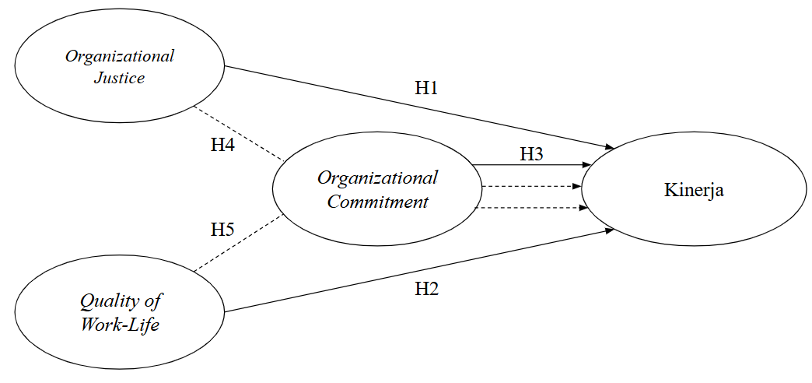
Figure 1 Frame of mind

This research is expected to provide useful information in solving problems practically in the field. This research was conducted because there is a gap between the results of the previous research and the phenomenon that occurs in the work environment. Therefore, the aim of this study is to further analyze how the influence of organizational Justice and quality of work life on organizational Citizenship behavior can be mediated by organizational commitment.

2.7 Research Methods

This study aims to make the findings widely applicable to population members, so that a representation of population characteristics in a suitable sample is needed (Scott, 2018). A total sample of 105 respondents was obtained using saturated sampling techniques. Saturated sampling is a sampling technique in which all members of the population are used as samples (Scott, 2018)

Table 1. Population Size
Source : Primary Data 2024

Number of Employees | Total Population
105 People | 100%

This research is a quantitative research. Data was obtained through questionnaires that were distributed to all employees Education Office of Ciamis Regency, West Java, Indonesia, except for the head of the Education Office of Ciamis Regency, West Java, Indonesia which totals 105 employees. The likert scale is used for measurement, which utilizes variable indicators presented in the form of statements or questions on questionnaire items (Scott, 2018).
The data analysis in this study involves statistical and descriptive analysis for PLS-SEM. Descriptive analysis is intended to describe respondents' responses and identify respondents' patterns. To test the system Structural Equation Modeling (SEM), using the SmartPLS 4 testing program. SEM analysis was chosen for its ability to provide a direct representation of variable relationships and perform path analysis (Hair et al., 2017). Process Needed Two stages: the first stage is to evaluate the assessment model Outdoor Models, while the second stage involves the evaluation of structural models (Inner Model) to test hypotheses and explain variable relationships. Convergent validity is confirmed with a loading value exceeding 0.6 and an AVE value above 0.5 (Ghozali, 2014). The discriminant validity was assessed to have cross-loading and Fornell-Larcker values, and the reliability of the indicators was validated with Cronbach's alpha values and Composite Reliability >0.70 (Hair et al., 2017).

3. Results and Discussion

3.1 Characteristics of Respondents

The first analysis in this study is the Demographic Analysis listed in Table 1. Demographic analysis aims to provide additional information to future readers or researchers.

Table 2. Demographic Analysis
Source: Primary Data, 2024
Not. | Group | Frequency | %
1. | Gender  Man  Woman  Entire | 73  32  105 | 69.5%  30.5%  100%
2. | Age  ≤ 20 years old  26 – 30 years old  31 – 35 years old  36 – 40 years old  ≥ 40 years old  Entire | 1  5  16  18  13  52  105 | 1.0%  4.8%  15.2%  17.1%  12.4%  49.5%  100%
3. | Marital Status  Marry  Unmarried  Entire | 97  8  105 | 92.4%  7.6%  100%
4. | Education  JUNIOR  SMA  Diploma  S1  S2  Entire | 2  25  3  53  22  105 | 1.9%  23.8%  2.9%  50.5%  21.0%  100%
5. | Part  Secretariat of the Division of Workforce Development  Early Childhood Development Field  Primary School Development Field  Junior High School Coaching Field  Junior High School Supervision Field  Office Kids  Entire | 37  11  14  13  13  11  6  105 | 35.2%  10.5%  13.3%  12.4%  12.4%  10.5%  5.7%  100%
6. | Long Time Working  ≤ 1 year  1 – 3 years  4 – 5 years  6 – 7 years  8 – 10 years  ≥ 10 years  Entire | 13  16  11  5  8  52  105 | 12.4%  15.2%  10.5%  4.8%  7.6%  49.5%  100%

Demographic analysis of respondents showed that the majority of respondents were male (69.5%), while female respondents were as many as (30.5%), with the dominant age group being over 40 years old (49.5%). Most of the respondents had a S1 educational background (50.5%), and (49.5%) had more than 10 years of work experience, indicating that employees with high work experience and high educational backgrounds were more involved in the study.

3.2 Outer Model Test

3.2.1 Outer Loading

In this Outer loading test process, the researcher conducted three tests. In the first test, there were several variable statement items with a value of <0.60 so that values below 0.60 were corrected by removing items from the model. Then in the second test, the researcher eliminated several variables that caused the AVE value to be below 0.5, so that when conducting the 3rd run test, the AVE value could meet the requirements above 0.5. Details can be seen in the images of the Outer load test results before the model and after they are removed from the model.

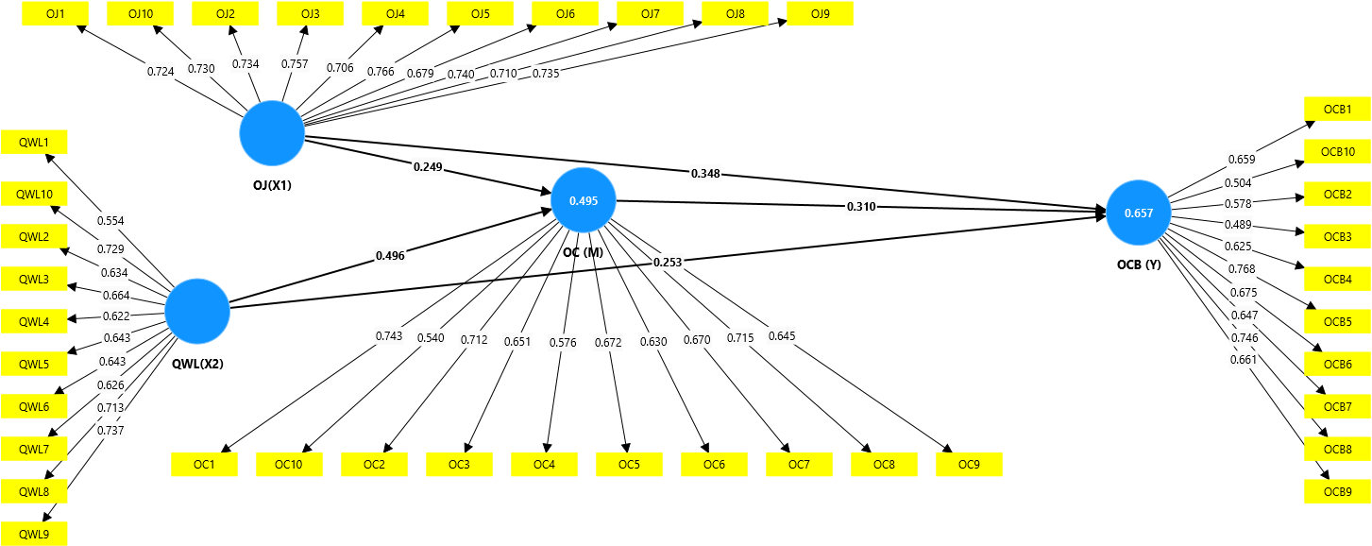
Figure 2 Outdoor Model 1 Walk
Source: Primary Data, 2025

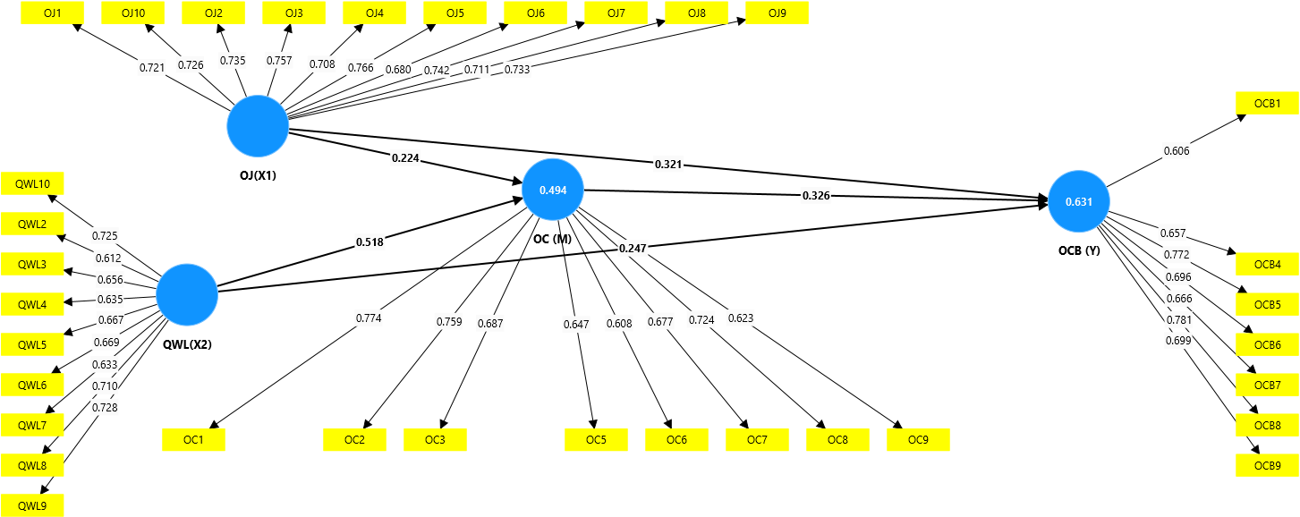
Figure 3 Outdoor Model After the 2nd Run
Source: Primary Data, 2025

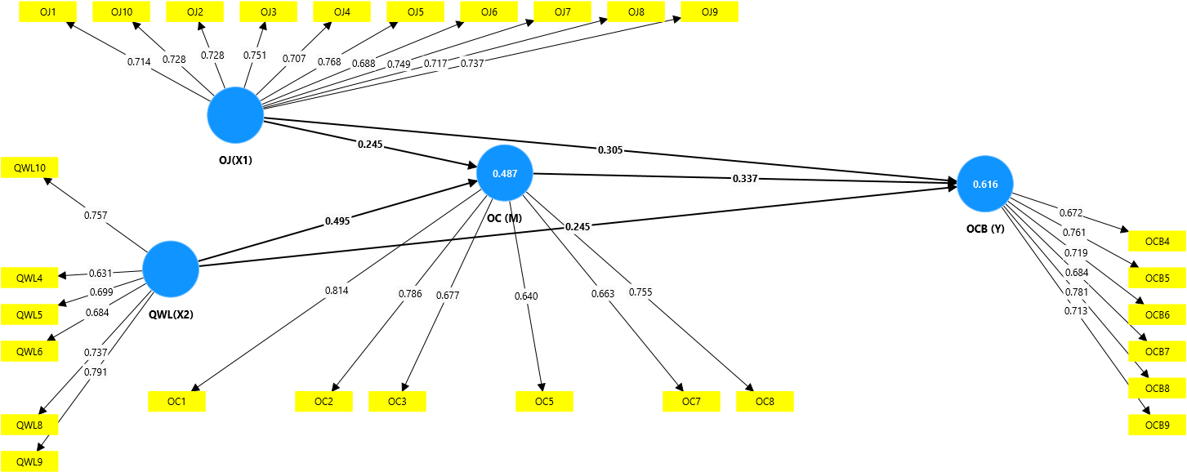
Figure 4 Outdoor Model After 3rd Run
Source: Primary Data, 2025

From the output of the Outer load, it can be seen that before it was repaired, there were several statement items that had an Outer loading value of <0.60, namely QWL 2 and OCB 2,3,10 items which meant invalid. Then in the 2nd run, there were several items removed, namely QWL 1, Commitment 4, 10, and OCB 2.3 10. because the AVE value is <0.50. Then in the 3rd run there are several items that must be deleted again, namely, QWL 2,3,7 and Commitment 6,9 and OCB 1. From these results, all Outher Loading have an AVE value of >0.50 and it can be considered that the statement of each of these variables is declared valid (Ghozali, 2014)

3.3 Measurement Model Analysis

This stage of measurement model evaluation includes testing for convergent validity, reliability, and discriminant validity. Table 3 shows the results of the converged validity and reliability.

Table 3 Validity and Reliability
Source: Primary Data, 2025
Variable | Alpha Cronbach | Composite Reliability | Average Variance Extracted (AVE)
Organizational Justice | 0.902 | 0.919 | 0.531
Organizational Commitment | 0.819 | 0.869 | 0.526
Organizational Citizenship Behavior | 0.816 | 0.867 | 0.522
Quality of Working Life | 0.811 | 0.864 | 0.516

Convergent validity is achieved with the value Loading Factor > 0.6 and AVE > 0.5 (Ghozali, 2014). After evaluating and sorting out a number of indicators that have a value Loading Factor <0.6, the rest of the indicator has a > value of 0.6 so that it can be declared valid. In addition, all Composite Reliability and Cronbach alpha values are at > 0.70, indicating good reliability for each variable

Table 4 Differentiating Validity: Fornell-Larcker
Source: Primary Data, 2025
Variable | OJ | OC | OCB | QWL
Organizational Justice | 0.729
Organizational Commitment | 0.616 | 0.726
Organizational Citizenship Behavior | 0.696 | 0.690 | 0.723
Quality of Working Life | 0.750 | 0.679 | 0.702 | 0.718

Table 4 shows that the Fornell-Larcker criteria have been well met, which is characterized by a higher value of the square root of AVE on the diagonal than with any other value for each variable. the reliability of Cronbach alpha and the actual composite, not just >0.70.

3.4 Structural Model Analysis

The purpose of structural model evaluation is to analyze the relationships between variables, assess significance values, and determine the R-square value of the research model. The initial step in the evaluation of the structural model is to review the R-squared values of each dependent variable, as described in Table 5.

Table 5 R-Square
Source: Primary Data, 2025
Variable | R-Square
Organizational Commitment | 0.487
Organizational Citizenship Behavior | 0.616

The R-square assessment in Table 5 shows good results. An R-squared value of 0.616 for organizational Citizenship behavior suggests that 61.6% of these variables can be explained by independent variables in the study, while others are influenced by other factors outside the study. This shows that this study has a good prediction.

Table 6 Hypothesis Test
Source: Primary Data, 2025
Hypothesis |  | Path Coefficient (β) / Original Sample | Statistics T | P value | Conclusion
I → OCB | H1 | 0.305 | 2.555 | 0.005 | Accepted
QWL → OCB | H2 | 0.245 | 2.254 | 0.012 | Accepted
OC → OCB | H3 | 0.337 | 3.355 | 0.000 | Accepted
I → OC → OCB | H4 | 0.082 | 1.634 | 0.051 | Rejected
QWL → OC → OCB | H5 | 0.167 | 3.141 | 0.001 | Accepted

Hypothesis testing assumes the influence of independent variables on bound variables if the statistical T value > 1.960 and the P value is less than 0.05. The results of this test are shown in Table 5 which shows that all variable relationships have a positive path coefficient (β). However, hypothesis 4 in this study was rejected because it had a statistical T value and a P value that did not meet the requirements
.
4. Discussion

4.1 The Influence of Organizational Justice on Organizational Citizenship Behavior

The research findings show that organizational Justice has a positive and significant impact on the organization's Citizenship behavior or H1 acceptance. This means that the higher the level of Justice perceived by employees in the organization, the more likely they are to exhibit OCB behaviors, such as assisting coworkers, working outside of formal responsibilities, and supporting the interests of the organization. This suggests that the perception of Justice in an organization can increase employee motivation to contribute more than just their primary task.
These findings are in line with Social Exchange Theory, which outlines that the relationship between individuals and organizations is based on the principle of reciprocity. When employees feel they are treated fairly, they tend to retaliate by exhibiting positive behavior that benefits the organization. The trust and loyalty formed through organizational Justice encourages employees to voluntarily participate in activities that support the organization's goals. Therefore, organizational Justice can be a key factor in creating extra engagement and contributions from employees.
The results of this study are also in line with the findings of the Bastyant et al., (2024), Kamil and Rivai (2021), Lim and Setyawan (2023), Romadhona and Prawitowati (2024), Syafriyanti and Anisah (2021), which states that Organizational Justice play a role in increasing employee OCB. When employees feel transparency and Justice in decision-making and resource distribution, they tend to be more motivated to take actions that benefit the organization. It confirms that creating a fair system within the organization not only increases job satisfaction, but also forms a more collaborative and proactive work culture.

4.2 The Influence of Quality of Working Life on Organizational Citizenship Behavior

The findings of the study show that the quality of work life has a positive and significant impact on the behavior of organizational citizenship or H2 acceptance. This shows that the better the quality of work life that employees feel, the more likely they are to exhibit OCB behaviors, such as helping colleagues, taking initiative at work, and showing loyalty to the organization. The high quality of work life reflects comfortable working conditions, work-life balance, and organizational support, which ultimately improves OCB's behavior.
These findings are in line with Social Exchange Theory, which states that the relationship between employees and organizations is based on the principle of reciprocity. When an organization provides a supportive work environment and well-being for employees, employees are likely to reciprocate by exhibiting positive behaviors that benefit the organization. In other words, employees who feel valued and comfortable in their jobs will be more motivated to contribute more than just their main tasks.
The results of this study are also in line with the findings of the Purwanto et al., (2021, 2023), Rimatanti and Darmawan (2023), Widodo et al., (2023),Sumarsi and Rizal, (2021) which states that the quality of work life plays a role in improving the OCB of employees. Employees who have positive work experience, including work-life balance, a conducive work environment, and decent rewards, are more likely to engage in voluntary organizational behavior. This reinforces that organizations that invest in improving the quality of their employees' working lives not only improve individual well-being, but also build a more collaborative and productive work culture.

4.3 The Influence of Organizational Commitment on Organizational Citizenship Behavior

The findings of the study revealed that organizational commitment has a positive and significant influence on the organization's Citizenship behavior or H3 received. These findings suggest that the higher the employee's commitment to the organization, the more likely they are to exhibit OCB behaviors, such as helping colleagues, being loyal to the organization's policies, and contributing more than just their primary duties. Therefore, increasing organizational commitment can be an important strategy to build a more harmonious and productive work environment.
These findings are in line with Social Exchange Theory, which explains that the relationship between employees and organizations is reciprocal. When employees feel they have a strong bond with the organization and have a positive work experience, they are likely to reciprocate by exhibiting behaviors that are beneficial to the organization. High commitment makes employees feel responsible to contribute more, including in the form of OCB.
The results of this study are also in line with the findings of the Firmansyah et al., (2022) Hermawanto et al., (2022), Nurjanah et al., (2020), and Widodo et al., (2023), who found that Organizational commitment play a role in increasing employee OCB. Employees who have a high level of commitment are more likely to exhibit extra role behaviors because they feel that they are an important part of the organization. This shows that organizations that are able to build and maintain employee commitment, whether through inspirational leadership, an inclusive work culture, or policies that support employee well-being, will find it easier to create a productive, team-oriented work environment.

4.4 Organizational Commitment to Mediate the Influence of Organizational Justice on Organizational Citizenship Behavior

The results of the study show that organizational commitment does not mediate the impact of organizational justice on the organization's Citizenship behavior or H4 is rejected. This shows that although organizational Justice has a positive effect on OCB, the effect is not through the variables of the organization's commitment as a mediator. In other words, employees who feel that there is justice in the organization do not necessarily increase their commitment first before showing OCB behavior. These findings suggest that organizational Justice can directly encourage employees to behave positively without having to rely on their level of commitment to the organization.
These findings are not in line with the results of the study Kamil and Rivai (2021), Lim and Setyawan (2023), Romadhona and Prawitowati (2024), Syafriyanti and Anisah (2021), which states that Organizational commitment act as a mediator in the relationship between Organizational Justice and OCB. Employees who feel treated fairly tend to increase their commitment first before finally exhibiting OCB behavior (Lim & Setyawan, 2023). However, the results of this study show that in Education Office of Ciamis Regency, West Java, Indonesia, employees can respond immediately Organizational Justice with positive behavior without going through the improvement stage Organizational commitment. This can be caused by other factors, such as work culture, reward systems, or social norms in the organization that are more influential in encouraging OCB.

4.5 Organizational Commitment to Mediate the Influence of Quality of Working Life on Organizational Citizenship Behavior

The results of the study showed that organizational commitment was able to mediate the relationship between the quality of work life and the behavior of organizational citizenship or H5 acceptance. This shows that a good quality of work life not only directly improves OCB, but also plays a role in strengthening employees' commitment to the organization, which ultimately encourages them to contribute more voluntarily. With a comfortable work environment, work-life balance, and support from the organization, employees are likely to develop a higher sense of attachment and loyalty. This strong commitment then encourages them to exhibit extra role behaviors, such as helping colleagues and voluntarily supporting organizational goals.
These findings are in line with Social Exchange Theory, which states that the relationship between employees and organizations is reciprocal. When an organization provides a quality work environment, employees feel valued and more committed to the organization. This commitment then motivates them to show positive behaviors that benefit the organization, including OCB.
The results of this study are also in line with the findings of the Ulfa et al., (2021) and Ulum et al., (2024), which found that Organizational commitment plays an important role in connecting Quality of Working Life with OCB. Employees who feel satisfied with their work environment tend to be more committed to the organization, which ultimately encourages them to behave positively at work. This shows that organizations can improve OCB among employees, who focus not only on creating a good quality of work life but also building employee commitment as a key factor in the process.

5. CONCLUSION and SUGGESTIONS

Based on the results of the study, it was found that organizational Justice, quality of work life, and organizational commitment have a positive and significant influence on organizational citizenship behavior (OCB). These results suggest that when employees feel they are treated fairly and have a good quality of work life, they are more likely to exhibit extra role behaviors that benefit the organization. In addition, organizational commitment has been shown to mediate the influence of the quality of work life on OCB, but it does not play a mediator in the relationship between organizational justice and OCB. Thus, this study emphasizes that to improve OCB, organizations need to pay attention to aspects of justice, work welfare, and strengthen employee commitment to the organization.
The implications of the findings are First, organizations must create and implement fair, clear, and open justice systems for decision-making processes, task sharing, and performance evaluation. Additionally, it is essential for companies to create a healthy work environment that allows employees to feel valued and motivated to do more. Second, organizations should concentrate on increasing employee commitment, especially by improving the quality of work life, such as providing psychological support, career development opportunities, and greater work flexibility. This will increase OCB by increasing the emotional commitment of employees. However, because organizational Justice affects OCB directly, strategies to improve Justice must be implemented directly without relying on increased commitment. Third, organizational Justice, quality of work life, and organizational commitment are three things that company leaders must include in strategic planning and managerial policies. To consistently evaluate and improve these aspects, two-way communication forums between management and employees, manager training, and regular job satisfaction surveys can be used.
This research has a number of limitations that must be considered in future research. This study did not consider the demographic aspect of the relationship in the construction of the study, so it did not explore in more depth a number of other factors such as age that can affect OCB through a qualitative approach. Second, the method aimed at is mainly quantitative-based, so it has not explored more deeply a number of other factors that can affect OCB through a qualitative approach. Finally, in this study, it was found that organizational commitment was not able to mediate organizational Justice towards OCB. Therefore, further research can expand the scope of the sample to different sectors and combine quantitative and qualitative research methods to gain a more comprehensive understanding of the factors affecting OCB.

Consent
As per international standards or university standards, respondents’ written consent has been collected and preserved by the author(s).

Disclaimer (Artificial intelligence)

Option 1:

The author hereby declares that NO generative AI technologies such as Large Language Models (ChatGPT, COPILOT, etc.) and text-to-image generators have been used during the writing or editing of this manuscript.

Option 2:

The author hereby states that generative AI technologies such as Large Language Models, etc. have been used during the writing or editing of the manuscript. This explanation will include the name, version, model, and source of generative AI technology and as well as all input hints given to generative AI technology

Details of AI usage are given below:

1.
2.
3.

REFERENCE

Agustina, R., Yusuf, M., Sutiyan, O. S. J., Ardianto, R., & Norvadewi. (2022). Employee Performance Mediated Quality of Work Life Relationship Satisfaction on the Job and Organizational Commitment. Darma Agung Journal, 30(2), 589–605. https://doi.org/10.46930/ojsuda.v30i2.2278
As, E., Muhtar, E. A., & Wahyudi, H. (2024). The Influence of Communication and Work Environment on Employee Performance at the Education Office. Ganaya: Journal of Social Sciences and Humanities, 7(4), 162–169. https://doi.org/10.37329/ganaya.v7i4.3424
Asgari, A., Mezginejad, S., & Taherpour, F. (2020). The Role of Leadership Styles in Organizational Citizenship Behavior through The Mediation of Perceived Organizational Support and Job Satisfaction. Innovation, 30(75), 87–98. https://doi.org/10.15446/innovar.v30n75.83259
Astuti, J. P., & Soliha, E. (2021). The effect of quality of work life and organizational commitment on performance with moderation of organizational culture: study on public health center puskesmas in gabus district. International Journal of Social and Management Studies, 2(6), 89-99.
Chicago

Bastyant, M. N., Sari, E. Y. D., & Bashori, K. (2024). Organizational Citizenship Behavior (OCB) Reviewed from Organizational Commitment and Organizational Justice. JIIP - Scientific Journal of Educational Sciences, 7(3), 2238–2244. https://doi.org/10.54371/jiip.v7i3.3536
Blau, P. M. (1964). Exchange and Power in Social Life. In John Wiley & Sons, Inc. https://doi.org/10.4324/9780203792643
Firmansyah, A., Junaedi, I. W. R., Kistyanto, A., & Azzuhri, M. (2022). The Effect of Perceived Organizational Support on Organizational Citizenship Behavior and Organizational Commitment in Public Health Center during COVID-19 Pandemic. Frontiers in Psychology, 13. https://doi.org/10.3389/fpsyg.2022.938815
Flint, D., Haley, L. M., & McNally, J. J. (2012). Dimensionality of Organizational Justice in a Call Center Context. Psychological Reports, 110(2), 677–693. https://doi.org/10.2466/01.07.21.PR0.110.2.677-693
Ghozali, I. (2014). Structural equation modeling, alternative method with partial least square (PLS). Semarang: Diponegoro University Publishing Agency.
Hair, J. F., Hult, G. T. M., Ringle, C. M., & Sarstedt, M. (2017). A Primer on Partial Least Squares Structural Equation Modeling. In Long Range Planning (Vol. 46, Issues 1–2). SAGE Publications. https://doi.org/10.1016/j.lrp.2013.01.002
Handayani, H., Musdiani, M., & Novita, R. (2024). The Contribution of the Education and Culture Office in Overcoming the Shortage of Educators and Elementary Level Education Facilities in Pidie Regency. Domain Research: Journal of Multidisciplinary Research and Development, 6(5), 1403–1413. https://doi.org/10.38035/rrj.v6i5.986
Hermanto, Y. B., Srimulyani, V. A., & Pitoyo, D. J. (2024). The Mediating Role of Quality of Work Life and Organizational Commitment in The Link between Transformational Leadership and Organizational Citizenship Behavior. Heliyon, 10. https://doi.org/10.1016/j.heliyon.2024.e27664
Hermawan, F., Purnomo, H., Kusumastuti, D., Fitriana, R., Octaleny, E., Ie, M., & Sudadi. (2024). The Role of Transformational Leadership, Job Satisfaction and Organizational Commitment on Organizational Citizenship Behavior (OCB) of SMEs Employees in the Digital Era. Journal of Infrastructure, Policy and Development, 8(7), 1–16. https://doi.org/10.24294/jipd.v8i7.5194
Hermawanto, A. R., Ahman, E., & Supriadi, Y. N. (2022). Mediation Effects of Organizational Commitment between Organization Citizenship Behavior, Transformational Leadership, and Quality of Work Life. Quality - Access to Success, 23(189), 107–117. https://doi.org/10.47750/QAS/23.189.13
Hidayah, N., & Hendarsjah, H. (2021). The Impact of Quality of Work Life (QWL) and Work Motivation on The Organizational Citizenship Behavior (OCB) with Job Satisfaction as a Mediating variables. JPPI (Indonesian Journal of Education Research), 7(3), 499–506. https://doi.org/10.29210/020211247
Kamil, I., & Rivai, H. A. (2021). The Influence of Organizational Culture and Organizational Justice on Organizational Citizenship Behavior (OCB) with Organizational Commitment as a Mediation Variable. JMK (Journal of Management and Entrepreneurship), 6(3), 49–64. https://doi.org/10.32503/jmk.v6i3.1924
Liaquat, M., & Mehmood, K. (2017). Organization Citizenship Behavior: Notion of Social Exchange Theory. Journal of Business and Social Review in Emerging Economies, 3(2), 209–216. https://doi.org/10.26710/jbsee.v3i2.137
Lim, V. E., & Setyawan, A. (2023). Factors Influencing Organizational Citizenship Behavior are mediated by Organizational Commitmet at Beauty Clinics. Scientific Journal of Management, Economics, & Accounting (MEA), 7(3), 902–914. https://doi.org/10.31955/mea.v7i3.3454
Manihuruk, F. E. (2023). Analysis of the Influence of Organizational Justice, Job Satisfaction and Organizational Commitment on the Performance of BPJS Ketenagakerjaan Jambi City Employees. Journal of Applied Management and Finance (Mankeu), 12(1), 115–128. https://doi.org/10.22437/jmk.v12i01.16877
Mehra, R. (2023). A Study of Impact of Quality of Work Life on Organizational Commitment in Manufacturing Sector. International Journal of Research and Analytical Reviews (IJRAR), 10(1), 500–504. https://doi.org/10.1177/0258042X19851912
Meyer, J. P., & Allen, N. J. (1991). A Three-Component Conceptualization of Organizational Commitment. Human Resource Management Review, 1(1), 61–89. https://doi.org/10.1016/1053-4822(91)90011-Z
Novianti, K. R. (2021). Does Organizational Commitment Matter? Linking Transformational Leadership with Organizational Citizenship Behavior (OCB). Journal of Management Applications, 19(2), 335–345. https://doi.org/10.21776/ub.jam.2021.019.02.09
Nurhafni, I., Zefriyenni, & Very, J. (2022). Analysis of Transformational Leadership, Competence, and Organizational Justice on Employee Performance through Organizational Citizenship Behavior (OCB) as a Mediator. Journal of Business and Economics (JBE), 7(3), 279–289. https://doi.org/10.35134/jbeupiyptk.v7i3.175
Nurjanah, S., Pebianti, V., & Handaru, A. W. (2020). The Influence of Transformational Leadership, Job Satisfaction, and Organizational Commitments on Organizational Citizenship Behavior (OCB) in The Inspectorate General of The Ministry of Education and Culture. Cogent Business and Management, 7, 1–12. https://doi.org/10.1080/23311975.2020.1793521
Perdani, A. S., Busri, H., & Tabrani, A. (2024). The Journey of Education in Indonesia in the Philosophical Perspective of Ki Hajar Dewantara. Al Qalam: Scientific Journal of Religion and Society, 18(2), 1197–1205. http://dx.doi.org/10.35931/aq.v18i2.3124
Podsakoff, P. M., MacKenzie, S. B., Paine, J. B., & Bachrach, D. G. (2000). Organizational Citizenship Behaviors: A Critical Review of the Theoretical and Empirical Literature and Suggestions for Future Research. Journal of Management, 26(3), 513–563. https://doi.org/10.1177/014920630002600307
Purwanto, A. (2022). The Role of Transformational Leadership and Organizational Citizenship Behavior on SMEs Employee Performance. Journal of Industrial Engineering & Management Research, 3(5), 39–45.
Purwanto, A., Purba, J. T., Bernarto, I., & Sijabat, R. (2021). The Role of Transformational leadership, Leader Member Exchange, Digital Transformation on Organizational Citizenship Behaviour and Work Innovation Capabilities in during Covid-19 Pandemic. Antverpiensia Linguistics, 2, 2908–2932. https://doi.org/10.29210/020211163
Purwanto, A., Purba, J. T., Bernarto, I., & Sijabat, R. (2023). Investigating The Role Digital Transformation and Human Resource Management on the Performance of The Universities. International Journal of Data and Network Science, 7, 2013–2028. https://doi.org/10.5267/j.ijdns.2023.6.011
Putri Asdi Ira Danisya; Nurmayanti Siti. (2024). The Effect of Quality of Work Life and Organizational Justice on Organizational Citizenship Behavior (OCB) in Employees of PT. Eka Dana Cosultant. JPSDM (JOURNAL OF HUMAN RESOURCE RESEARCH), 3(3), 110–121.
Rato, K. W., & Rahmat, A. (2020). The Influence of Organizational Justice on Organizational Commitment with Job Satisfaction as a Mediation Variable. Journal of Non-Formal Education, 6(3), 295. https://doi.org/10.37905/aksara.6.3.295-306.2020
Rimatanti, N. F., & Darmawan, A. (2023). Influence of Quality of Work Life (QWL), Organizational Commitment (OC) and Transformational Leadership on Organizational Citizenship Behavior (OCB). Journal of Economics, Social, and Humanities, 1(1), 12–26. https://doi.org/10.30595/jesh.v1i1.76
Romadhona, L. L., & Prawitowati, T. (2024). The Relationship between Organizational Justice and Organizational Citizenship Behavior of Generation Z Employees of East Java with Commitment Mediation. Dialectics: Journal of Economics and Social Sciences, 9(1), 115–125. https://doi.org/10.36636/dialektika.v9i1.3929
Sarah, M. A., Niha, S. S., & Manafe, H. A. (2023). The Effect of Job Satisfaction and Work Environment on Organizational Citizenship Behavior (OCB) through Employee Loyalty as a Mediation Variable. Journal of Science, 4(3), 403–411. https://doi.org/doi.org/10.31933/jimt.v4i3
Sirgy, M. J., Efraty, D., Siegel, P., & Lee, D.-J. (2001). A New Measure of Quality of Work Life (QWL) Based on Need Satisfaction and Spillover Theories. Social Indicators Research 2, 55(3), 241–302. https://doi.org/10.1023/A:1010986923468
Sugiyono. (2018). Quantitative, Qualitative, and R&D Research Methods. Alphabet.
Sumarsi, & Rizal, A. (2021). The Effect of Competence and Quality of Work Life on Organizational Citizenship Behavior (OCB) with Organizational Commitment Mediation. International Journal of Social and Management Studies (Ijosmas), 2(6), 69–88. https://doi.org/10.61707/ne843b17
Syafriyanti, & Anisah, H. U. (2021). Analysis of the Influence of Organizational Justice and Job Satisfaction on Organizational Citizenship Behavior (OCB) by Mediating Organizational Commitment at the Office of the National Defense Agency (BPN) of Banjarmasin City. Journal of Management Insights, 9(1), 51–61. https://doi.org/10.20527/jwmthemanagementinsightjournal.v9i1.31
Ulfa, C. S., & Siwi, T. P. U. (2021). The Effect Work-Family Conflict, Organizational Justice, Job Stress on Organizational Citizenship Behavior Mediating by Supervisor Trust. Asian Journal of Economics, Business and Accounting, 21(4), 97–118. https://doi.org/10.9734/ajeba/2021/v21i430374
Ulfa, M., Thoyib, A., & Ratnawati, K. (2021). Quality of Work Life and Organizational Citizenship Behavior: The Mediation Role of Organizational Commitment. South East Asia Journal of Contemporary Business, Economics and Law, 25(1), 100–109.
Ulum, R., Hermawati, A., & Mas, N. (2024). The Influence of Spiritual Leadership and QWL (Quality of Work Life) on OCB (Organizational Citizenship Behavior) Mediated by Organizational Commitment. Journal of Scientific Horizons, 4(1), 3899–3926.
Widodo, W., Gustari, I., & Permana, R. (2023). A Mediation Model of the Effect of Visionary Leadership on Teachers' Organizational Citizenship Behavior. International Journal of Learning, Teaching and Educational Research, 22(4), 104–123. https://doi.org/10.26803/IJLTER.22.4.7
Zahra, D., & Siregar, O. M. (2023). The Effect of Job Satisfaction and Organizational Commitment on Organizational Citizenship Behavior (OCB) (Study on Tea Processing Employees of PTPN IV Bah Butong). Indonesian Journal of Economics, Accounting, and Management, 2(1), 1–15.

