Examining Blockchain and Cryptocurrency: Disruption, Integration, and Unresolved Challenges in Global Finance

Abstract:
This article critically examines the dual role of blockchain and cryptocurrency technologies as both disruptive forces and pathways for sustainable integration into global financial markets. Through analysis of case studies and regulatory developments, the paper explores the tension between innovation and institutional adaptation. Key findings include case study evidence showing up to 30% cost reduction in blockchain-based remittance systems, juxtaposed with estimated annual global losses exceeding $3.5 billion due to cryptocurrency-related fraud and scams. The study evaluates institutional responses ranging from cautious experimentation to full adoption, and reviews global regulatory strategies, from progressive frameworks like the EU’s MiCA to outright bans in certain jurisdictions. While the paper presents a broad synthesis of policy and market dynamics, it acknowledges the limitation of sparse empirical data and emphasizes the need for ongoing interdisciplinary research. Ultimately, the manuscript argues that hybrid approaches—such as private blockchain consortia and central bank digital currencies (CBDCs)—represent the most viable path forward, balancing innovation with financial stability and compliance.

KEY WORDS: Blockchain, Cryptocurrency, Disruption, Integration, and Unresolved, Global Finance

- Introduction

There is no denying that the technology behind blockchain and cryptocurrencies is a game-changer in the finance field. In its essence, cryptocurrencies are digital assets with decentralized aspects that are secured using cryptography, while Blockchain is the underlying technology behind it and can provide a safe, open, and unalterable ledger that requires no intermediaries. The blockchain world has grown rapidly since Bitcoin emerged in 2009, spawning decentralized finance (DeFi) platforms, systems of loans and other financial instruments that operate based on smart contracts, as well as hundreds of digital assets[1].
These technologies are changing how value is held, transmitted, and regulated; the pace at which they are being accepted and implemented across sectors is an indication of this, from banking and asset management to supply chain finance and remittances; it’s a new world. Because of their revolutionary potential and unifying possibilities, the technologies that make up these markets are being researched by central banks for digital money, institutional investors for crypto assets, and traditional financial institutions for blockchain-based services[2].
In this research, the question being addressed is whether the overhyped forces behind blockchain technology and cryptocurrencies will crash the established financial system or will they be linked as an available solution to enhance the existing financial infrastructure. This perspective attempts to take an evenhanded look at these technologies by exploring their potential transformational impact and systemwide considerations.
Having framed the disruptive impact of blockchain technology and cryptocurrencies, the paper will explore pathways for integration. Then, it will provide some reflections on how these technologies could support, or whittle away at, our current financial system after considering institutional, technological, and regulatory challenges.

II. Background and Foundations
A. Cryptocurrency:
There is a specific species of virtual assets, called cryptocurrency, which uses cryptography to enable secure peer-to-peer transactions without the requirement for intermediaries to be centrally based[3]. The concept was first conceived by the mysterious Satoshi Nakamoto in 2009; he created a decentralized alternative to central banking with Bitcoin. The idea of a scarce digital money that operates on an open ledger was first introduced in Bitcoin[4]. Thousands of other cryptocurrencies have appeared since then with their use cases. Through the use of programmable smart contracts — self-operating code that triggers when specified conditions are reached — Ethereum, which launched in 2015, made blockchain technology even more practical and gave rise to innovations like non-fungible tokens (NFTs) and decentralized finance(DeFi)[5].
B. Blockchain Technology:
Blockchain is the decentralized record-keeping technology behind cryptocurrency. It records transactions in tamper-resistant, linked “blocks” of data that are cryptographically secured. Alison says key features are transparency (anyone in the network is able to check their copy of the data), immutability (once it is verified, it is not possible to edit the record), and decentralization (control is spread throughout network members). These all facilitate a trustless model that shouldn’t require intermediary parties.[6]
C. The Original Promise of Decentralization and Disintermediation:
Initially, blockchain technology and cryptocurrency were hailed for disrupting traditional finance by making disintermediation, or the removal of centralized organizations like banks and payment processors, possible. The goal was to disintermediate the financial system and to develop a fairer financial ecosystem by making access to financial services more democratic, reducing the costs associated with transactions, and returning control of their financial assets to the people[7].
D. Early Reception and Skepticism from Traditional Financial Institutions:
Traditional banks were hesitant and skeptical. Among the leading concerns have been volatility, uncertainty in regulation, security vulnerabilities, and the potential for cryptocurrencies to be used for illicit purposes. While that sentiment has begun to shift as use cases and adoption have increased, many believed that these innovations were too experimental and not aligned enough with their existing systems for risk management and compliance[8].
III. Cryptocurrency and Blockchain as Disruptive Forces
A. Disintermediation:
When you remove traditional financial intermediaries from the mix, such as the bank, the broker, and the payment processor, you talk about disintermediation, and disintermediation is one of the most important disruptive effects brought about by cryptocurrencies and blockchain technology. As the facilitator of peer-to-peer transactions and decentralized recordkeeping, blockchain obviates the need for trustworthy intermediaries, thereby reducing transaction costs, increasing productivity, and decentralizing authority from institutions to individuals[9].
B. Alternative Store of Value and Medium of Exchange:
Like gold, digital cryptocurrencies have been advertised as a form of store of value, specifically Bitcoin. Cryptocurrency real estate is becoming more and more viewed as a hedge against the devaluation of money in places with high inflation or uncertain state currencies. At the same time, the rise of cryptocurrencies like stablecoins (USDC, USDT) that are fairly stable in price, cryptocurrencies can be issued as mediums of exchange, enabling cross-border trade and remittances that don't require traditional banking infrastructures[10].
C. Decentralized Finance (DeFi):
DeFi is a financial services paradigm shift. DeFi protocols built on blockchain platforms like Ethereum allow users to trade, lend, borrow, and earn interest without banks or centralized services. Automated smart contracts substitute manual handling, making overheads lower and market operations available 24 hours a day. But this sector is not without new risks, such as the vulnerability of liquidity, market manipulation, and smart contract issues[11].
D. Challenges to Monetary Sovereignty:
Cryptocurrencies' worldwide accessibility and resistance to censorship will undermine that monetary sovereignty, especially for governments in the developing world[12]. Cryptocurrencies might make it harder for central banks to control inflation, apply capital constraints to maintain financial stability, as they enable people to do business outside the state-run financial system. That has prompted regulatory crackdowns in several countries[13].
E. Case Examples of Disruption:
These disruptive trends are exemplified by several developments. While such sales are sometimes criticized as being fraudulent and poorly regulated, they have proven to be a popular alternative to traditional venture financing, allowing entrepreneurs to raise money by selling tokens or cryptocurrencies directly to investors. Non-Fungible Tokens (NFTs), on the other hand, have completely warped how we think about (and what is) digital asset ownership, collectibles, art, and IP. These innovations have opened up new markets and revenue opportunities, but they've also been criticized for rampant speculation and poorly explained regulations[14].
IV. The Financial Market Response
A. Institutional Adoption vs. Resistance:
A juxtaposition of the embrace and resistance of institutional acceptance has characterized financial markets’ response to cryptocurrencies and blockchain. Huge yawns and belly laughs will give way to envy as market cap rises, demand grows, and regulations take shape, forcing many banks to dabble either reluctantly or enthusiastically. While some remain wary and reluctant to enter the ecosystem due to regulatory uncertainty, reputational risk, and concerns that the infrastructure for crypto is underdeveloped, major asset managers, banks, and payment companies are beginning to offer services relating to crypto. Not all is the same for how institutions view blockchain and cryptocurrencies[15]. This spectrum of institutional responses is illustrated in Figure 1, which highlights that there is a continuum from conservative rejection to proactive adoption.
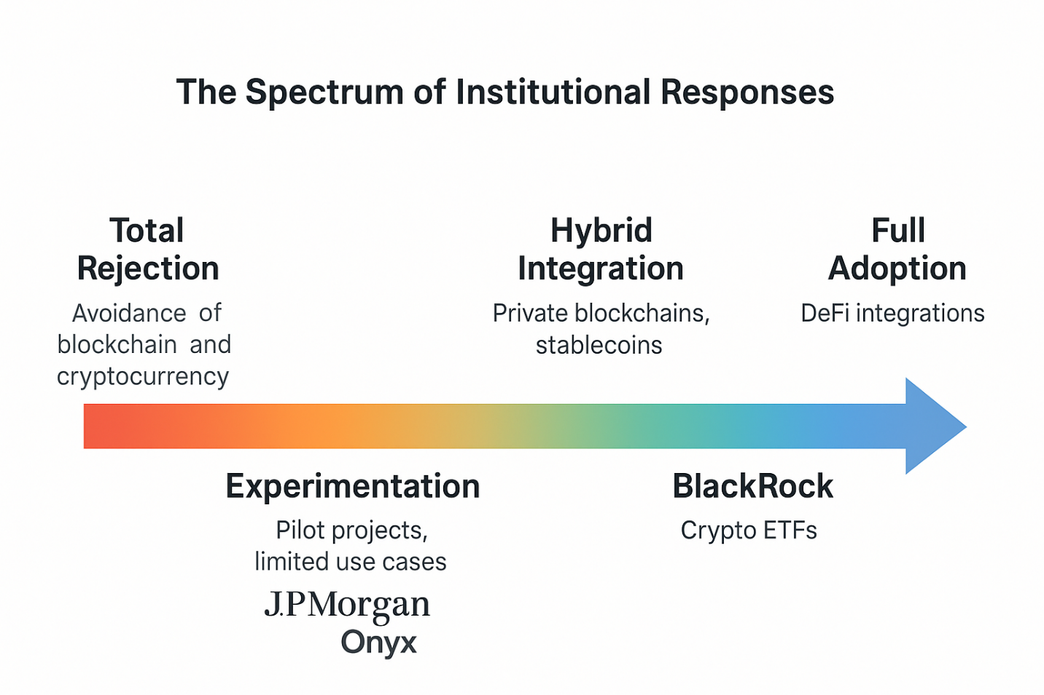
Figure 1: The Spectrum of Institutional Responses to Blockchain and Cryptocurrency. This figure conceptualizes the range of institutional responses to blockchain and cryptocurrency technologies. It illustrates how financial institutions move from outright rejection and experimentation to hybrid integration through private blockchains and stablecoins, and ultimately to full adoption, including DeFi applications and tokenized assets. Real-world examples such as JPMorgan Onyx and BlackRock’s crypto ETFs demonstrate this evolving trajectory.

B. Emergence of Crypto-Based Financial Instruments:
There are already a variety of financial products based on cryptocurrency to satisfy the increasing demand from investors[16]. Exchange-traded funds (ETFs) that provide exposure to Ethereum and Bitcoin, cryptocurrency futures and options, and structured products associated with digital assets are a few examples. The distinction between traditional and decentralized finance is blurred by these products, which offer institutional investors legal routes to access cryptocurrency markets, improve liquidity, and aid in price discovery[17].
C. Role of Venture Capital and Institutional Investment in Crypto Startups:
The development of the cryptocurrency ecosystem has been greatly aided by institutional and venture capital investment[18]. From layer-1 blockchains and decentralized banking platforms to cryptocurrency exchanges and Web3 infrastructure, billions of dollars have been invested in blockchain firms. In addition to speeding up technology advancement, this money infusion has given the industry some respectability, which has affected regulatory agendas and broader market perspectives[19].
D. Impact on Traditional Asset Classes:
Whether cryptocurrencies are starting to correspond with more conventional asset classes is a crucial topic. During times of market stress, cryptocurrencies—especially Bitcoin—have shown an increasing correlation with tech stocks and risk-on assets, while initially being seen as uncorrelated "alternative assets." This casts doubt on the idea that cryptocurrencies are a haven and raises the possibility that they could be incorporated into more general market dynamics, especially when institutional investors begin using traditional portfolio methods on digital assets[20].
E. Examples:
Major players in finance have ventured into blockchain and crypto. The largest asset manager in the world, BlackRock, has launched Bitcoin private trusts and is involved in several crypto ETF ventures. After regulators penalized JPMorgan for undermining Bitcoin in the past, the banking giant decided to do the same thing Bitcoin developers have been doing — create a blockchain (Onyx) and its virtual currency (JPM Coin) to speed up the international payments and settlements networks. These developments underscore a remarkable shift in the financial establishment from denial to timid experimentation and integration.
V. Regulatory Landscape and Institutional Adaptation
Because of diverse institutions, policy, and economic considerations, the universal regulatory reaction to cryptocurrencies and blockchain technologies has been nothing if not inconsistent. Some countries have severely limited or banned dual-use items because of sensitivity and concerns about stability, fraud, and the preservation of monetary sovereignty, whereas others have embraced dual-use technologies as opportunities for modernization and economic development[21]. The variety of regulatory approaches taken around the world is shown in Figure 2, and the dichotomy between these stark positions creates uncertainty for businesses, investors, and developers amid such a landscape of change (see Figure 2).
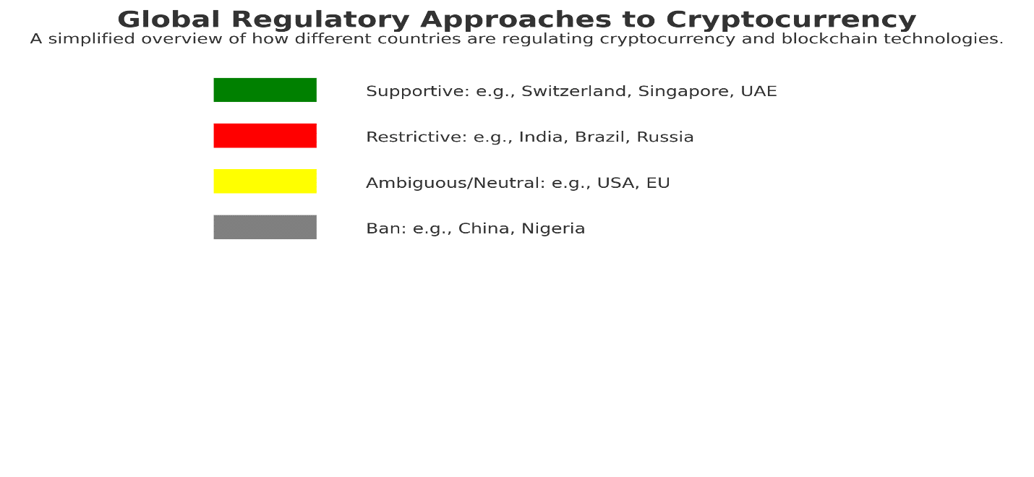
Figure 2: Worldwide Approaches to Cryptocurrency Regulations. This schematic classifies the most populous countries into four categories based on their current standing in regulation for cryptos and blockchain. Supportive, restrictive, ambiguous/neutral, and absolute prohibitions are the four primary strategies identified, with examples from each country being provided. The fragmented and evolving global regulatory climate is well portrayed in this image as a significant barrier to institutional convergence and global acceptance.

A. Regulatory Approaches Worldwide:
Blockchain and cryptocurrency regulation remain a varied mix of acceptance, control, and questioning globally. And a few countries, including Switzerland, Singapore, and the United Arab Emirates, have adopted relatively crypto-friendly regulations to manage risks and attract innovation. Others, including China and India, have meanwhile clamped down heavily on cryptocurrency mining and trading due to concerns over illicit activity, capital flight, and financial stability. For both crypto companies and users from around the world, such diversity renders it nearly impossible to comply, while creating a fractured market space[15].
B. Key Regulatory Frameworks:
Some States have commenced developing more coherent and comprehensive structures. The EU introduced an omnibus regulation called Markets in Crypto-Assets (MiCA) to unify laws relating to stablecoin issuers, custodial wallet providers, and issuers of crypto assets among the EU27 and EEA states. In the US, the Commodity Futures Trading Commission (CFTC) and the Securities and Exchange Commission (SEC) are vying for control and have occasionally classified some coins as securities, which would require strict disclosure and investor protection mandates. It is this latter context of change that determines the institutional appeal and the legal legitimacy of the digital asset[22].
C. Concerns about Compliance and Transparency:
The lack of a compliance framework, particularly regarding KYC, AML, and taxation, is a common problem in crypto markets. Anonymity and decentralization are at odds with transparency and regulatory oversight. This is because the institutional players struggle to comply with the requirements on decentralised systems, which has led to the creation of compliant intermediaries, including custodians, wallets with KYC, and permissioned blockchain solutions[12].
D. Institutional Adaptation:
Instead, traditional financial players are finding increasingly regulated workarounds just to keep their competitive edge by getting on the blockchain bandwagon. Private and consortium blockchains offer efficiency over public networks without the instability. itcoin atm niches in New York. Central bank digital currencies (CBDCs) and stablecoins backed by fiat reserves provide regulated digital substitutes that preserve authority in a centralized way, thereby ensuring they appeal to both banks and governments[23].
E. CBDCs and Tokenized Assets Visualization: Example
Several central banks, including the ECB’s digital euro program, Nigeria’s eNaira, and China’s digital yuan, are experimenting with or implementing CBDCs. This is an effort to counter the effects of private coins and improve payment systems. To boost the speed of settlements, transparency, and fractional ownership, financial institutions are experimenting with tokenized assets — blockchain representations of financial instruments that can range from bonds to real estate[24].
VI. Opportunities and Risks: A Balanced View
A. Potential Benefits:
The blockchain and cryptocurrency know-how have a number of revolutionary challenges for the banking industry. One of the most talked-about is financial inclusion, and not surprisingly, in geographic regions with few traditional banking options. Blockchain infrastructure is minimal, and it could enable unbanked people to have access to savings, credit, and remittance services. Another key benefit is the enhancements in efficiency, such as in payment transaction efficiency and settlement speed. By eliminating intermediaries and using smart contracts to automate reconciliation, blockchain can reduce costs in making transactions and speed up goods’ processing times. Security and transparency provided by blockchain through immutable ledgers further enhance auditability, reduce fraud, and increase stakeholders’ trust in complex financial transactions[25].
B. Key Risks and Challenges:
This does not dispel the danger anyway. Price volatility and speculation have made them unreliable as a source of value beyond a speculative action, something that leads to the skeptics’ need to bin the phrase “cryptocurrencies,” to start with. Retail investors continue to be victims of regulatory arbitrage and fraud, such as Ponzi schemes, rug pulls, and sales of unregistered securities. Serious threats also come from cybersecurity vulnerabilities: wallets and exchanges are often the victim of hackers, which can lead to huge money losses. Environmental concerns have also been raised, particularly about proof-of-work mining, which has been disparaged for being intensive and energy-hungry. While there are alternative consensus mechanisms, like proof-of-stake, sustainability remains a contentious issue.
C. Views of other stakeholders:
Doing so, regulators are Hover over the profile picture and click the Following button to unfollow any account. They focus on building robust legal frameworks, implementing compliance, and preventing abusive use. Institutional interest is growing, but traditional investors remain cautious, often waiting for more secure, regulated infrastructure and a more established regulatory landscape before they get involved wholesale. “Tokenization, digital ID, and blockchain settlement systems have enduring significance to many people. Meanwhile, retail investors are often driven by speculative objectives and drawn to new asset classes such as meme coins and NFTs that are capable of delivering outsized returns. Yet they are the most vulnerable to fraud and market manipulation.
In addressing all of these perspectives, they all signal the need for balanced governance to drive innovation and solve the ethical and structural perils of this evolving environment:
VII. Sustainable Integration: Pathways Forward
Perhaps the future of blockchain and cryptocurrency lies not in radical disintermediation of the financial industry, as it evolves, but in gradual assimilation using a hybrid approach. Permissioned ledgers, also known as private blockchain solutions, present a middle ground with the benefit of blockchain and the continuing control, privacy, and legal compliance. These solutions are particularly appealing to organizations that want to upgrade infrastructure without ceding control to open, decentralized networks[26].
Several blockchain consortia, such as the Hyperledger Project and R3’s Corda, are classic models of consortium-based frameworks designed to integrate blockchain with legacy financial services. These platforms are examples of how blockchain can enhance, rather than replace, existing institutions, by making supply chain management, trade finance, identity verification, and interbank payments more efficient[27].
There are a few possible scenarios down the road. It appears that cryptocurrencies and decentralized systems will probably be living with the likes of regulated banks. A certain degree of displacement may occur. A gap displacement can occur in some niches, especially when conventional ways are inefficient or prohibitive. But the technological, regulatory, and educational divide needs to be bridged for that kind of integration to occur.
Digital literacy and training are important in accomplishing this transition. Consumers will have to be mathematically and technologically literate to find their way around decentralized networks and understand risks. For institutions and regulators, the devil’s in the details of the blockchain in order to craft smart regulations and to seize opportunities for profitable partnership.
In the end, maneuvering toward durable integration of blockchain, in a multi-stakeholder effort of innovation and governance, eye on pointedly enhancing the promises and taming the risks, is required[28].
VIII. Conclusion
Blockchain technology and cryptocurrency are having a double effect: they are overthrowing powerful financial institutions, and they are representing possibilities for integration using imaginative, structural applications. In order to keep risks down while not holding back progress, their future development requires a delicate dance between technology development and regulatory authority. Cross-sector cooperation, intelligent regulation, and flexibility will be crucial as financial markets negotiate this transition. The intentional integration of decentralized technologies into current systems, rather than their complete replacement, may be the key to altering global banking in a way that is more resilient, efficient, and inclusive.

Disclaimer (Artificial intelligence)
Option 1:
Author(s) hereby declare that NO generative AI technologies such as Large Language Models (ChatGPT, COPILOT, etc.) and text-to-image generators have been used during the writing or editing of this manuscript.
Option 2:
Author(s) hereby declare that generative AI technologies such as Large Language Models, etc. have been used during the writing or editing of manuscripts. This explanation will include the name, version, model, and source of the generative AI technology and as well as all input prompts provided to the generative AI technology
Details of the AI usage are given below:
1.
2.
3.

REFERNCES
1. Albshaier L, Almarri S, Hafizur Rahman MM. A Review of Blockchain’s Role in E-Commerce Transactions: Open Challenges, and Future Research Directions. Computers. 2024 Jan;13(1):27.
2. Kayani U, Hasan F. Unveiling Cryptocurrency Impact on Financial Markets and Traditional Banking Systems: Lessons for Sustainable Blockchain and Interdisciplinary Collaborations. Journal of Risk and Financial Management. 2024 Feb;17(2):58.
3. Taryanto R, Syahbandi, Wendy, Mustaruddin, Afifah N. Crypto Price Prediction as an Investment Opportunity: An Empirical Study of Three Global Cryptocurrencies. Asian Journal of Economics, Business and Accounting. 2023 Jan 16;35–47.
4. Lawal OP, Egwuatu EC, Akanbi KO, Orobator ET, Eweje OZ, Omotayo EO, et al. Fighting Resistance With Data: Leveraging Digital Surveillance to Address Antibiotic Misuse in Nigeria. Path of Science. 2025 Mar 31;11(3):1009–17.
5. Bongini PA, Mattassoglio F, Pedrazzoli A, Vismara S. Crypto ecosystem: navigating the past, present, and future of decentralized finance. J Technol Transf [Internet]. 2025 Jan 30 [cited 2025 Jun 7]; Available from: https://doi.org/10.1007/s10961-025-10186-x
6. Sachitra V, Dayaratna D. Examine the Feasibility of Implementing Blockchain Technology in the Sri Lankan Banking System. Asian Journal of Advanced Research and Reports. 2023 Jul 6;17(9):115–25.
7. Kukman T, Gričar S. Blockchain for Quality: Advancing Security, Efficiency, and Transparency in Financial Systems. FinTech. 2025 Mar;4(1):7.
8. Deed - Attribution-NonCommercial 4.0 International - Creative Commons [Internet]. [cited 2025 Jun 7]. Available from: https://creativecommons.org/licenses/by-nc/4.0/
9. Fridgen G, Radszuwill S, Schweizer A, Urbach N. Blockchain Won’t Kill the Banks: Why Disintermediation Doesn’t Work in International Trade Finance. Communications of the Association for Information Systems [Internet]. 2021 Dec 10;49(1). Available from: https://aisel.aisnet.org/cais/vol49/iss1/33
10. Crypto assets as a threat to financial market stability | Eurasian Economic Review [Internet]. [cited 2025 Jun 7]. Available from: https://link.springer.com/article/10.1007/s40822-025-00311-4
11. Ozili PK. Decentralized finance research and developments around the world. J BANK FINANC TECHNOL. 2022 Oct 1;6(2):117–33.
12. Lawal OP, Igwe EP, Olosunde A, Chisom EP, Okeh DU, Olowookere AK, et al. Integrating Real-Time Data and Machine Learning in Predicting Infectious Disease Outbreaks: Enhancing Response Strategies in Sub-Saharan Africa. Asian Journal of Microbiology and Biotechnology. 2025 May;10(1):147–63.
13. El Hajj M, Farran I. The Cryptocurrencies in Emerging Markets: Enhancing Financial Inclusion and Economic Empowerment. Journal of Risk and Financial Management. 2024 Oct;17(10):467.
14. The Role Of Blockchain Technology In Entrepreneurship:conclusion: Unlocking A New Era Of Entrepreneurship With Blockchain Technology [Internet]. FasterCapital. [cited 2025 Jun 7]. Available from: https://fastercapital.com/topics/the-role-of-blockchain-technology-in-entrepreneurship:conclusion:-unlocking-a-new-era-of-entrepreneurship-with-blockchain-technology.html/1
15. Shahzad MF, Xu S, Lim WM, Hasnain MF, Nusrat S. Cryptocurrency awareness, acceptance, and adoption: the role of trust as a cornerstone. Humanit Soc Sci Commun. 2024 Jan 2;11(1):1–14.
16. Okafor CE, Egwuatu EC, Owosagba VA, Njei T, Adeyemi BI, Onuche PUO, et al. From Bench to Bedside: Medicinal Chemistry Strategies in the Development of Kinase Inhibitors for Cancer Therapy. Journal of Cancer and Tumor International. 2025 May 10;15(2):79–96.
17. Cryptocurrency Explained With Pros and Cons for Investment [Internet]. Investopedia. [cited 2025 Jun 7]. Available from: https://www.investopedia.com/terms/c/cryptocurrency.asp
18. Lawal O, Oyebamiji HO, Kelenna IJ, Chioma FJ, Oyefeso E, Adeyemi BI, et al. A Review on Usage of Digital Health Literacy to Combat Antibiotic Misuse and Misinformation in Nigeria: Review Article. Journal of Pharma Insights and Research. 2025 Apr 5;3(2):258–69.
19. Habib G, Sharma S, Ibrahim S, Ahmad I, Qureshi S, Ishfaq M. Blockchain Technology: Benefits, Challenges, Applications, and Integration of Blockchain Technology with Cloud Computing. Future Internet. 2022 Nov;14(11):341.
20. Deed - Attribution 3.0 Unported - Creative Commons [Internet]. [cited 2025 Jun 7]. Available from: https://creativecommons.org/licenses/by/3.0/
21. Ediagbonya V, Tioluwani TC. The Growth and Regulatory Challenges of Cryptocurrency Transactions in Nigeria. In: The Complexities of Sustainability [Internet]. WORLD SCIENTIFIC; 2022 [cited 2025 Jun 7]. p. 267–97. (Science, Technology and Sustainability; vol. Volume 1). Available from: https://www.worldscientific.com/doi/10.1142/9789811258756_0009
22. Jiang J (Xuefeng), Cram P, Qi K, Bai G. Challenges and dynamics of public health reporting and data exchange during COVID-19: insights from US hospitals. Health Aff Sch. 2024 Jan 9;2(1):qxad080.
23. (PDF) The Impact of Cryptocurrency on Traditional Financial Systems [Internet]. ResearchGate. 2025 [cited 2025 Jun 7]. Available from: https://www.researchgate.net/publication/390098330_The_Impact_of_Cryptocurrency_on_Traditional_Financial_Systems
24. Sethaput V, Innet S. Blockchain application for central bank digital currencies (CBDC). Cluster Comput. 2023 Aug 1;26(4):2183–97.
25. El Hajj M, Farran I. The Cryptocurrencies in Emerging Markets: Enhancing Financial Inclusion and Economic Empowerment. Journal of Risk and Financial Management. 2024 Oct;17(10):467.
26. Oladejo MT, Botes V, Low M, Reeves S. Blockchain technology disruptions: Exploring accounting and auditing academics and practitioners’ perception. Accounting & Finance [Internet]. [cited 2025 Jun 7];n/a(n/a). Available from: https://onlinelibrary.wiley.com/doi/abs/10.1111/acfi.13383
27. Ioannou I, Demirel G. Blockchain and supply chain finance: a critical literature review at the intersection of operations, finance and law. J BANK FINANC TECHNOL. 2022 Jun 1;6(1):83–107.
28. Lawal O, Elechi K, Adekunle F, Farinde O, Kolapo T, Igbokwe C, et al. A Review on Artificial Intelligence and Point-of-Care Diagnostics to Combat Antimicrobial Resistance in Resource-Limited Healthcare Settings like Nigeria: Review Article. Journal of Pharma Insights and Research. 2025 Apr 5;3(2):166–75.

