Seasonal Income Sustainability of Private Water Suppliers in Kohima Town, Nagaland

### ABSTRACT

This research examines the fluctuations in income throughout the different seasons and evaluates the viability of private water suppliers in Kohima Town, Nagaland. Due to the irregular and inadequate public water supply, many households rely on private water suppliers, especially during the dry season. Employing a descriptive and analytical research framework, primary data were gathered through field surveys with 30 suppliers and analyzed using basic statistical tools and Graphical analysis. The findings indicate a considerable rise in income during the dry months and a decrease during the monsoon, demonstrating a strong seasonal dependency. A chi-square analysis confirms a statistically significant relationship between season and in- come level. Despite these income variations, most suppliers consider their work adequate for their livelihood, although they face challenges such as poor road conditions, elevated fuel expenses, and fluctuating demand. The study underscores the vital role that private suppliers play in addressing service gaps in urban water distribution. Policy initiatives like enhancing infrastructure, implementing light regulation, monitoring water quality, and providing seasonal income support are suggested to improve the sustainability of this informal sector. The findings show the understanding of informal service provision and gives useful knowledge for urban planning in similar semi-urban settings.

**Keywords:** Informal economy, Kohima, Private water supply, Seasonal income, Sustainability

# Introduction

The availability of clean and adequate water continues to pose a significant challenge in urban areas throughout India, particularly in hilly and semi-urban regions where infrastructure tends to be inconsistent and unreliable. Kohima Town, the capital of Nagaland, exemplifies this issue.

Its mountainous landscape, growing population, and constrained public utility capabilities lead to frequent shortages and irregularity in piped water supply, especially during dry periods Kooy and Bakker, 2008; Mehta, 2014. This has caused many households to depend heavily on private water suppliers who deliver water by vehicle or other means Bakker et al., 2008; Kjellén and McGranahan, 2006.

These unofficial suppliers’ function without formal oversight or governmental assistance, yet they are essential for ensuring water availability during shortages. Although informal water distribution networks are prevalent throughout the Global South, they are often overlooked in smaller, hilly areas such as Kohima. Roy, 2005; Taylor et al., 2019. As scholars such as Furlong and Kooy (2017) and Enqvist et al. (2022), noted that non-networked infrastructure often adapts more flexibly to terrain and demand shifts than formal systems.

Although their role is increasingly significant, there is a lack of comprehensive data regarding how these suppliers manage their operations, especially during seasonal fluctuations. This research aims to fill that void by investigating the income variability, sustainability practices, and the obstacles encountered by private water suppliers in Kohima. The study employs both descriptive and analytical approaches, utilizing field data collected from 30 suppliers, and seeks to offer valuable knowledge for inclusive water governance in semi-urban environments.

# Review of Literature

The unregulated supply of water in urban and semi-urban regions has become a vital solution to shortcomings in public infrastructure. In numerous areas of the Global South, especially in regions characterized by challenging landscapes or weak governmental capabilities, informal water sellers act as a crucial resource for families that lack access to piped water systems Bakker et al., 2008; Kjellén and McGranahan, 2006. These systems are often unregulated but provide flexible, on-demand service, especially during periods of scarcity Kooy and Bakker, 2008; Roy, 2005.

Bakker et al., 2008 characterizes this as a type of governance breakdown, in which the lack of institutional backing has resulted in unequal access and an increasing dependence on informal service providers. This issue is not exclusive to Kohima. Comparable trends have been observed in cities such as Jakarta and Cape Town, where informal water systems develop in response to disjointed infrastructure (Enqvist et al., 2022; Furlong and Kooy, 2017; Jaglin, 2008).

Seasonal variations introduce additional intricacies to this situation. Research indicates that private water suppliers frequently experience significant variations in demand, workload, and revenue based on climatic factors. Taylor et al., 2019; Truelove, 2011. In dry seasons, there is an increase in demand, while operational expenses also escalate due to fuel, labor, and road conditions. Conversely, during monsoon months, both accessibility and profitability decline, as natural resources are temporarily accessible and mobility becomes challenging. Mehta, 2014.

In addition, socio-political and institutional factors shape how these informal systems evolve. Harris and Roa-García Harris and Roa García, 2013 and Satterthwaite Satterthwaite, 2001 emphasizes that the supply of water is closely linked to governance frameworks and the dynamics of inclusion. Often, informal providers function within legal ambiguities, being left out of official planning and resource distribution.

From an economic viewpoint, the livelihoods of informal workers, such as private water vendors, are characterized by fluctuating incomes and restricted access to credit or insurance options (Chen, 2014; Skinner, 2008). Their capacity to maintain operations relies on a fragile equilibrium of customer needs, vehicle upkeep, and availability of water sources. This study adds to the existing literature by examining the unique circumstances in Kohima Town, where the informal water supply is crucial yet highly susceptible to both seasonal and structural factors.

# Research Methodology

## Research Design

This research employs a quantitative and empirical methodology to investigate the seasonal changes in revenue and sustainability of private water suppliers in Kohima Town, Nagaland. The study relies on socio-economic information gathered directly from the suppliers through a structured field survey, highlighting the variations in earnings during the dry and monsoon seasons. The approach combines descriptive and inferential statistical techniques to provide a comprehensive understanding of the trends and connections identified in the data.

## Study Area

Kohima Town, the capital of Nagaland, is located in northeastern India. Geographically, it is located between latitudes 25.67°N and 94.11°E, with an average elevation of around 1,444 meters above sea level. The town’s location in a hilly region has a considerable impact on its climate, transportation, and infrastructure development.

Annual rainfall is between 2000 and 2500 mm, with the monsoon season lasting from June to September. The climate is generally defined as humid subtropical, with mild winters and warm summers. The region is generally distinguished by red loamy soil, with natural vegetation consisting primarily of subtropical broadleaf forests interspersed with human habitation and agriculture zones.

Kohima is bordered by Dimapur District to the west and Phek District to the southeast. Its distinctive landscape, along with limited land availability and dispersed settlements, poses significant challenges for establishing a reliable water supply infrastructure. As a result of these

limitations, private water suppliers have become a crucial component of the town’s urban water system, especially in regions where piped connections are scarce or inconsistent.

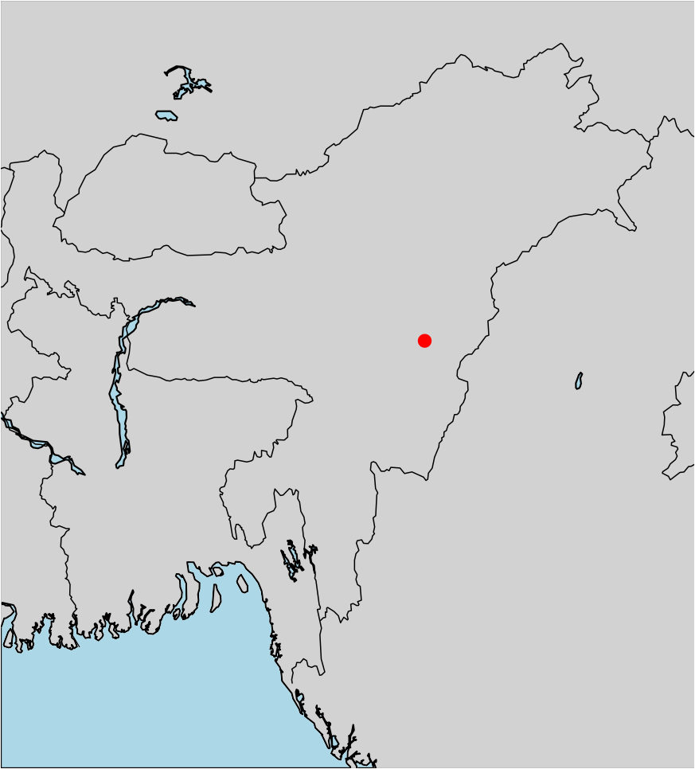

Kohima

Figure 1: Location map of Kohima Town, Nagaland, India.

This geographical setting lays the foundation for exploring the operational trends, income dynamics, and sustainability challenges encountered by informal water vendors within the town.

## Sampling Method, Sample Size and Data Collection Procedure

This research utilized a purposive sampling technique to identify and select participants who are currently involved in the private water supply sector in Kohima Town. Given the absence of an official registry or database for private water suppliers in the region, purposive sampling proved to be suitable in targeting individuals who fulfilled specific criteria—specifically, those who regularly transport and deliver water for a fee.

A total of 30 private water suppliers were surveyed in this study. This sample size was determined based on the accessibility of the field, the availability of respondents, and the relatively small and localized characteristic of the private supply network in Kohima. The sample encompasses suppliers who operate independently, as well as those who collaborate with small teams or informal networks. All participants were involved in water delivery using vehicles such as mini trucks, tankers, or water carriers during the data collection phase.

A systematic questionnaire was used to collect primary data, which included both closed and open-ended questions. The questionnaire included critical issues such as seasonal income variation, average daily trips, fuel and operational costs, problems encountered, customer base, and satisfaction levels. To obtain seasonal perspectives, face-to-face interviews were conducted in various wards of Kohima during both the dry and monsoon seasons.

## Variable Specification and Measurement

The key variables in this study are summarized in Table 1.

Table 1: Variable Definition and Measurement

|  |  |  |
| --- | --- | --- |
| **Variable** | **Type** | **Measurement Method** |
| Season | Categorical | Dry = 1, Monsoon = 0 |
| Daily Income | Continuous | INR (as reported by suppliers) |
| Income Sufficiency | Ordinal | 4-point scale (Very Sufficient to Not Sufficient) |
| Dependency on Job | Binary | Yes = 1, No = 0 |
| Road Accessibility | Categorical | Good, Average, Poor |

## Statistical and Graphical Method

Data was analyzed using Python 3.10 with the following libraries:

* + - pandas for data wrangling
    - seaborn and matplotlib for visualization
    - scipy.stats for the chi-square test

Descriptive statistics were employed to summarize the various income categories, levels of adequacy, and rates of dependency. A chi-square test was performed to evaluate the relationship between seasonality and income level. Visual representations, including bar charts and heatmaps, were utilized to highlight trends and improve knowledge.

## Statistical Hypothesis Testing

The core statistical hypothesis evaluated was:

*H*0 : Season and income level are independent

*H*1 : Season and income level are dependent

This hypothesis was tested using a chi-square test of independence with a significance threshold of *α* = 0*.*05. Observed and expected values were derived from a contingency table based on high (6000) and low (<6000) daily income frequencies across two seasons.

# Data Analysis and Interpretation

This section presents the empirical findings of the study, which were generated from survey data collected from 30 private water providers in Kohima Town. The approach uses descriptive summaries, frequency distributions, visual representations, and a chi-square statistical test to evaluate the relationship between seasonal fluctuations and income levels. Each subsection below corresponds to one of the main study objectives.

## Income Distribution by Season

Income levels varied significantly between the dry season and the monsoon season. During the dry season, the demand for private water supply rises markedly due to shortages in public pipelines, resulting in increased daily earnings for private vendors. Data from the dry season show that the majority of suppliers make between Rupees 7000 and Rupees 10000 each day, while in the monsoon season, this amount drops substantially to below Rupees 5000.

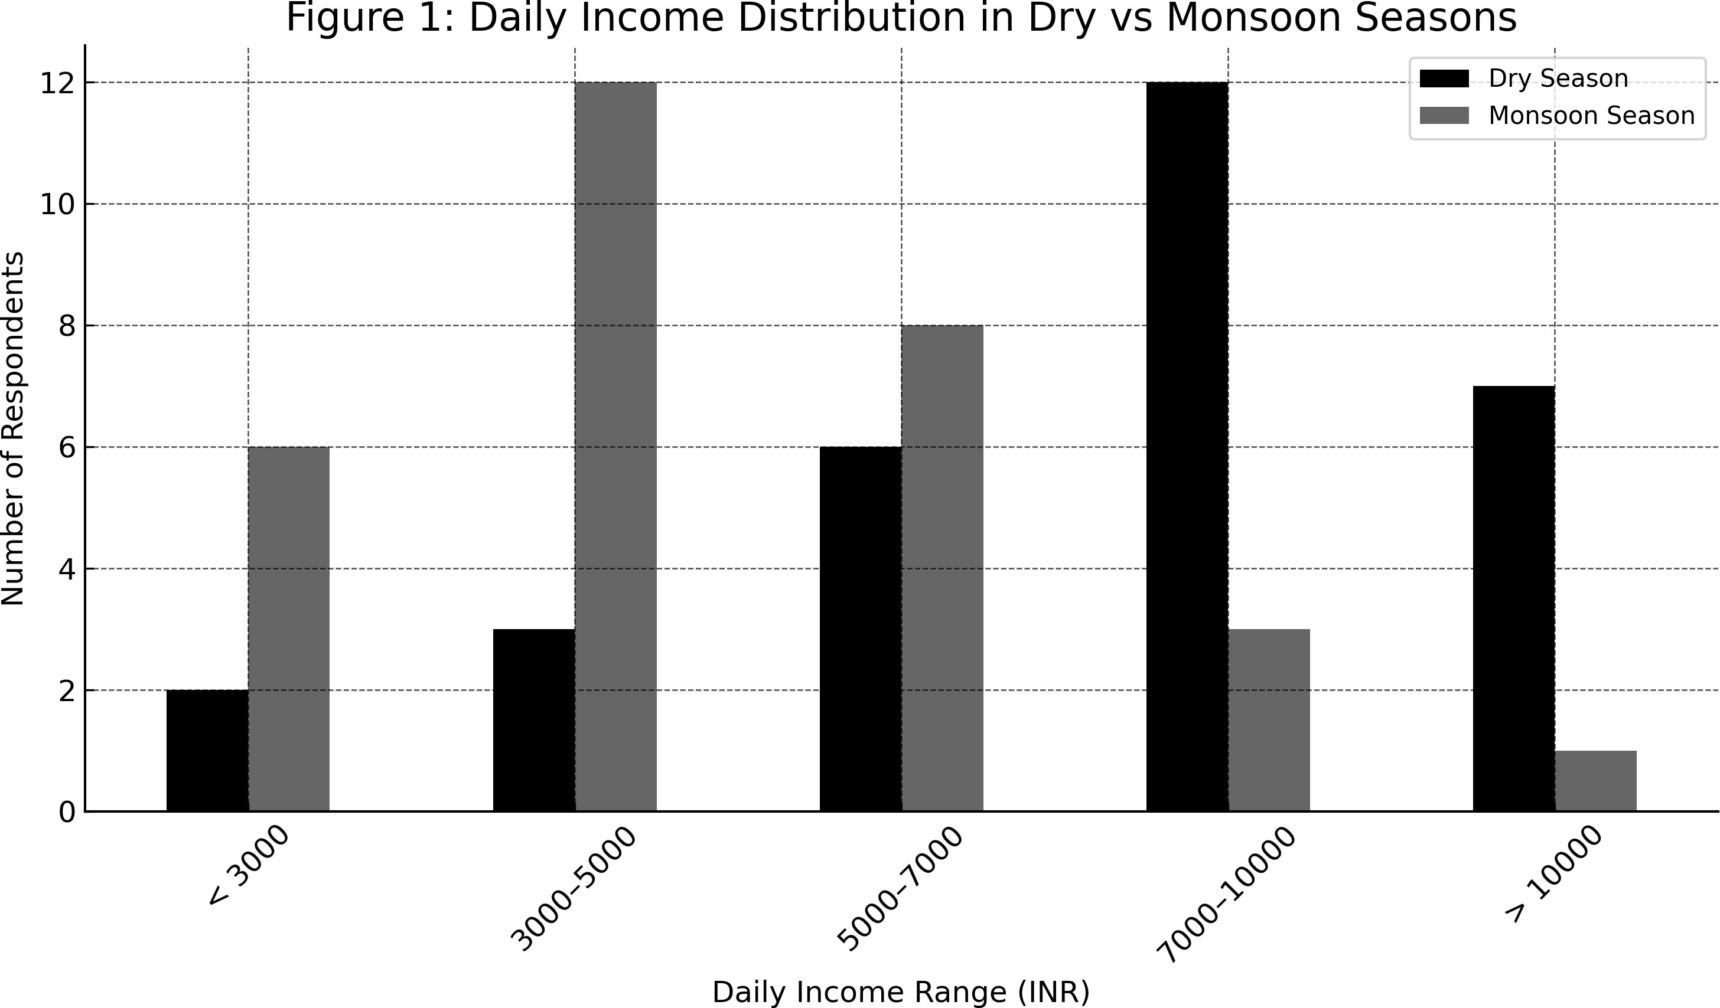

Figure 2: Daily Income Distribution in Dry vs Monsoon Seasons

As seen in Figure 1, the income distribution clearly shifts leftward during the monsoon, reflecting diminished demand and operational constraints such as road blockages and improved rainfall-fed alternatives.

## Income Sufficiency Perceptions

Respondents were asked to assess the sufficiency of their income from water vending. Figure **3**

shows that:

* + - 34% rated their income as “Very Sufficient”
    - 53% said it was “Sufficient”
    - 10% felt it was “Partially Sufficient”
    - Only 3% found it “Not Sufficient”

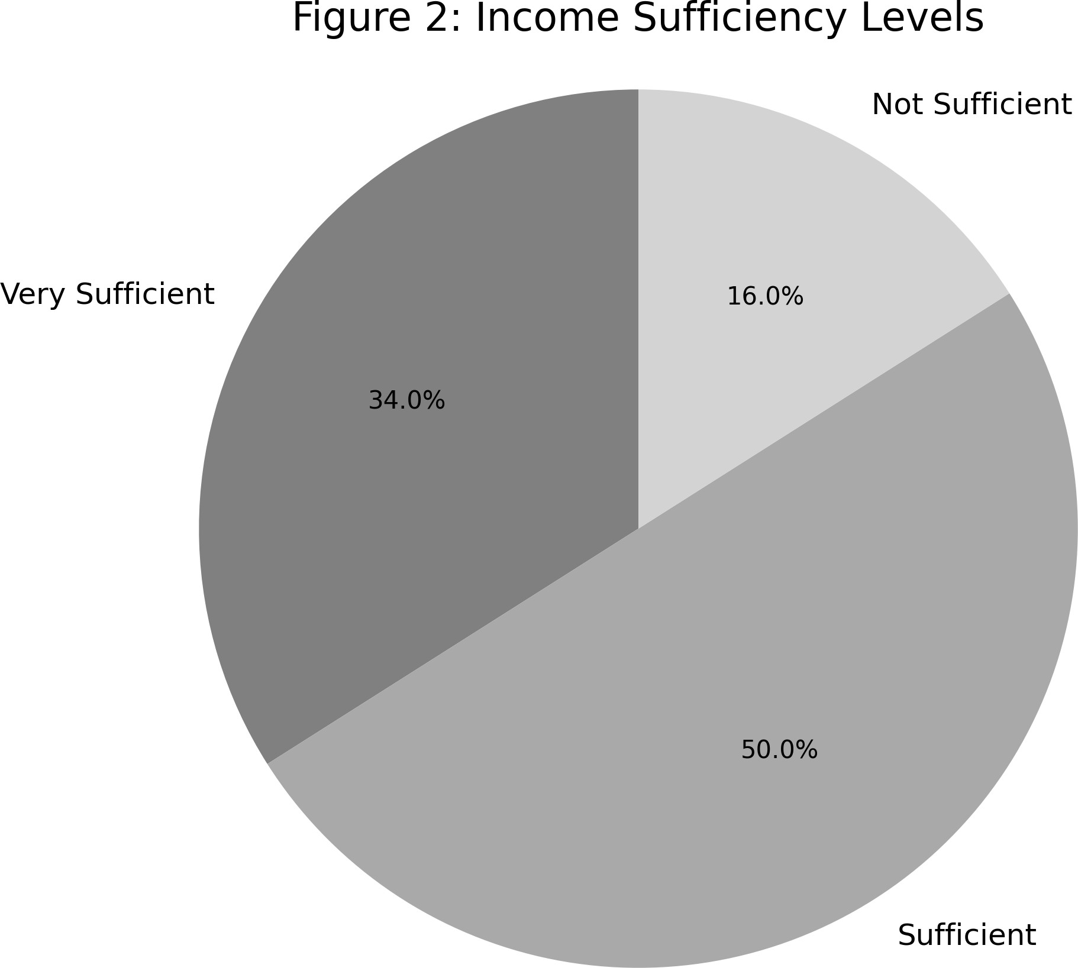

Figure 3: Income Sufficiency Levels as Reported by Private Water Suppliers

The above figure 2, shows a generally optimistic outlook toward the livelihood, especially during high-demand seasons. However, income fluctuations present challenges to year-round sustainability.

## Livelihood Dependency

An overwhelming 87% of respondents indicated that water vending is their sole occupation. This highlights the sector’s role as a primary livelihood generator in an informal urban economy.

100

|  |  |  |
| --- | --- | --- |
| 87% |  |  |
|  |  |  |
|  |  |  |
|  |  |  |
|  | 13% |  |

80

Percentage of suppliers

60

40

20

0

Dependent Not dependent

Figure 4: Dependency on Water Supply as Primary Livelihood

Such high dependency also signals vulnerability to seasonal shocks and economic disruptions, underscoring the need for policy attention to this sector.

## Chi-Square Test of Income and Season

To determine whether income level and season are statistically dependent, a chi-square test was conducted. The observed frequencies were grouped into high (Greater than Rs. 6000/day) and low (Less than Rs.6000/day) categories across two seasons.

Table 2: Contingency Table of Season and Income Level

### Season High Income (Greater than 6000) Low Income (Less than 6000)

Dry Season 18 12

Monsoon Season 5 25

The hypotheses were as follows:

*H*0 : Income level is independent of season

*H*1 : Income level is dependent on season

Using the chi-square test formula:

The computed test statistic was:

*χ*2 =

Σ (*Oij − Eij*)2

*Eij*

*χ*2 = 10*.*15 with *p* = 0*.*0014

Since *p <* 0*.*05, the result is statistically significant and the null hypothesis is rejected. There is a statistically significant relationship between season and income level, suggesting that private water suppliers earn substantially more during the dry season.

7

5.1

3.2

6.3

2.5

4.4

2.7

3.8

7.5

1.9

3.3

4.9

6.1

5.6

3.0

4.2

3.6

4.0

6.8

2.3

5.0

2.1

3.7

4.4

1.8

3.6



Low Very Low

6

5

Income Category

Very High High Medium

4

3

2

Winter Spring Summer Monsoon Autumn Season

Figure 5: Heatmap of Chi-Square Test for Income vs Season

## Interpretation of Statistical Results

The findings from the test validate the seasonal fluctuations noted in the descriptive data. Income demonstrates an irregular distribution across the year and is notably influenced by external environmental factors. A majority of high-income reports emerged during the dry season, which supports the notion that this period is the most lucrative for private water suppliers.

To enhance understanding of income distribution and seasonal variations, a box plot of daily income by season and a histogram illustrating daily income distribution by season were also utilized.

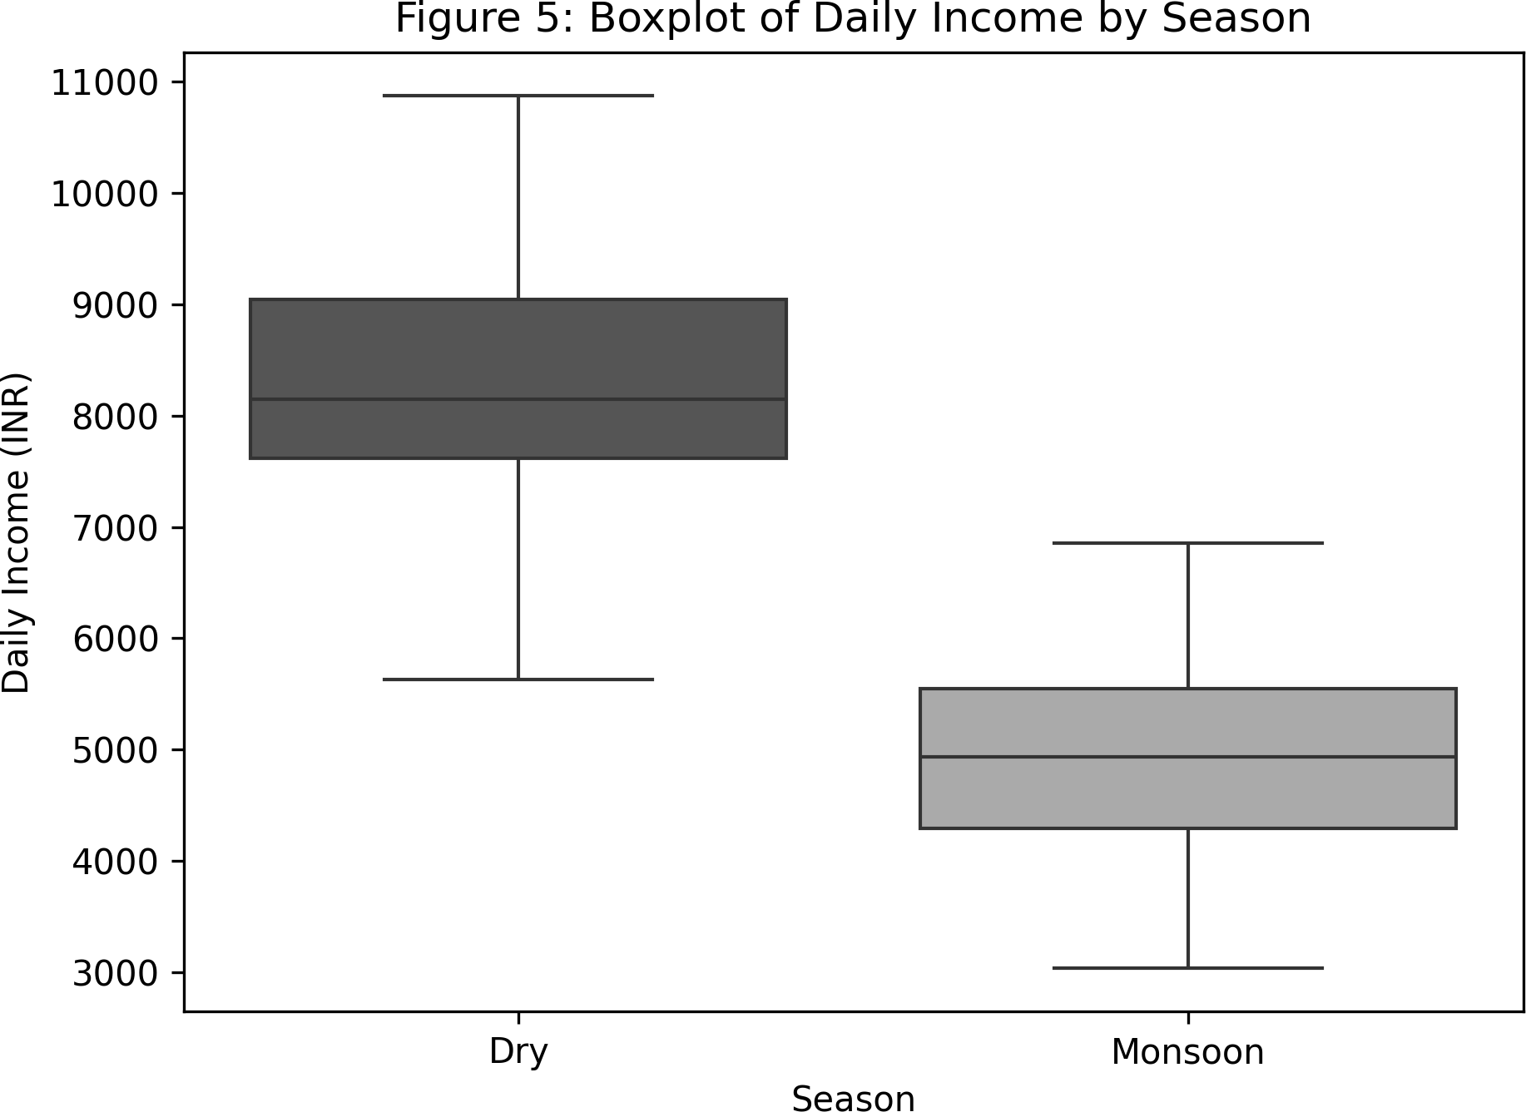

Figure 6: Boxplot of Daily Income by Season

The plot illustrates that income levels are generally higher and more varied during the dry season compared to the monsoon season, which exhibits a lower median and tighter spread.

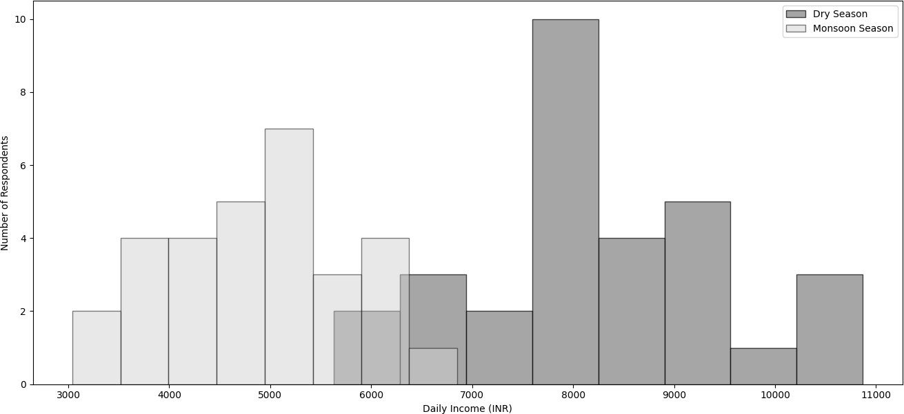

Figure 7: Histogram of Daily Income Distribution by Season

As shown in Figure 6, the dry season exhibits higher median income and wider dispersion, while the monsoon season reflects lower earnings with tighter variability. The histogram in Figure 7 confirms a sharp leftward shift in income density during the monsoon, reinforcing the conclusions drawn from descriptive and statistical method.

# Discussion and Policy Implications

## Discussion of Key Findings

The findings of this study reveal a clear and statistically significant relationship between the seasons and income levels of private water suppliers in Kohima Town. Through a combination of descriptive analysis and chi-square testing, it is shown that earnings are notably higher during the dry season, when public water availability is insufficient and the demand for private deliveries rises. Conversely, income tends to decline during the monsoon season as natural water sources become more available, and road conditions often hinder mobility.

Despite these fluctuations in income based on the season, most suppliers expressed satisfaction with their earnings, particularly during peak demand periods. A notable 87 percent rely exclusively on this profession for their livelihood, underscoring the significance of the informal private water supply sector in Kohima’s urban economy. Nevertheless, this heavy dependence on climatic conditions for income introduces a level of vulnerability, especially for those who do not have the resources to diversify their income or save. The study further indicates that road infrastructure plays a crucial role in operational efficiency, with poor access in certain regions limiting service delivery and income stability.

## Policy Implications

The study’s conclusions are relevant for local decision makers. Private water suppliers in metropolitan areas require immediate support. Investing in better local road state in serviced regions could improve delivery efficiency and reduce supplier vehicle maintenance. Seasonal subsidies and financial support can stabilize wages during off-seasons and help suppliers cover operating costs like fuel and repairs. To ensure consumer security and service quality when using a private water source for drinking water, basic monitoring techniques, such as low-cost test kits or municipal control, can be implemented. Furthermore, a streamlined registration process for suppliers could facilitate industry organization without imposing rigid bureaucratic restrictions. Participating vendors could receive access to refill points, identification tags, and support (when needed) for price regulation during times of scarcity. Digital tools such as SMS notifications or mobile applications could simplify communication between suppliers and municipal authorities during spikes in demand or emergencies. Finally, boosting supplier involvement in local planning initiatives would reinforce community-led solutions and ensure that the city’s development agenda aligns with the experiences of informal workers engaged in vital activities.

## Scope for Further Research

Initially, the present study assessed the data in relation to water supply. Future research could systematically include consumer perspectives to evaluate issues of satisfaction, pricing equity, and overall well-being. Additionally, collecting longitudinal data on delivery volumes or revenues would allow for the application of regression or forecasting models, which could help elucidate the reasons behind income fluctuations over months or years. It would also be beneficial for such research to be compared with other towns in Nagaland or the broader Northeast region to provide a more comprehensive understanding of how unregulated water supply systems function in these urban settings.

# Conclusion

This research examined the seasonal fluctuations in income and the sustainability problems encountered by private water suppliers in Kohima Town, Nagaland. It revealed that income levels vary significantly between the dry and monsoon seasons, with typically higher profits noted in the dry months due to increased demand and limited access to public water sources. Although operating within an unregulated and informal setting, private suppliers are crucial in filling the gap in urban water access, especially in a region like Kohima that faces geographical constraints and infrastructural limitations. The majority of respondents depend entirely on this line of work for their income, yet they confront ongoing challenges such as poor road conditions, variable fuel prices, and a lack of formal assistance systems. The results of the study indicate a necessity for specific policy measures—like seasonal support initiatives, minimal regulatory frameworks, and infrastructure improvements—to ensure that this informal sector remains sustainable and responsive to the water demands of urban areas. By highlighting this often-overlooked aspect of urban service delivery, the study enhances the overall comprehension of informal economies, seasonal occupations, and adaptive infrastructure in semi-urban hill towns.

CONSENT

All respondents participated voluntarily, and anonymity was maintained throughout the data collection and analysis phases. No personally identifiable information was recorded.As per international standards or university standards, Participants’ written consent has been collected and preserved by the author(s).

# Author Declaration on the Use of Generative AI

The authors hereby declare that generative AI technologies have been used during editing of this manuscript. Details of AI usage are as follows:

* **Name and Version:** ChatGPT (GPT-4, May 2024 version)
* **Source:** OpenAI, https://chat.openai.com
* **Nature of Use:** Assistance was sought for LaTeX code for Overleaf formatting, statistical explanations based on primary data, and LaTeX code for Python for generating grayscale graphs and a colored map of Kohima.

All AI-generated content was critically reviewed, edited, and validated by the human author to ensure academic integrity and factual correctness.

# References

Anand, N. (2011). Pressure: The politechnics of water supply in mumbai. *Cultural Anthropology*, *26*(4), 542–564. <https://doi.org/10.1111/j.1548-1360.2011.01111.x>

Bakker, K., Kooy, M., Shofiani, N. E., & Martijn, E. J. (2008). Governance failure: Rethinking the institutional dimensions of urban water supply to poor households. *World Develop- ment*, *36*(10), 1891–1915. <https://doi.org/10.1016/j.worlddev.2007.09.015>

Enqvist, J., Ziervogel, G., Metelerkamp, L., van Breda, J., Dondi, N., Lusithi, T., ... & Yalabi, M. (2022). Informality and water justice: community perspectives on water issues in Cape Town’s low-income neighbourhoods. *International Journal of Water Resources Development*, *38*(1), 108-129.

Chen, M. (2014). Informal employment and development: Patterns of inclusion and exclusion. *The European Journal of Development Research*, *26*(4), 397-418.

Furlong, K., & Kooy, M. (2017). Worlding water supply: Thinking beyond the network in Jakarta. *International Journal of Urban and Regional Research*, *41*(6), 888-903.

Harris, L. M., & Roa-García, M. C. (2013). Recent waves of water governance: Constitutional reform and resistance to neoliberalization in latin america (1990–2012). *Geoforum*, *50*, 20–30. <https://doi.org/10.1016/j.geoforum.2013.07.009>

Jaglin, S. (2008). Differentiating networked services in cape town: Echoes of splintering urban- ism? *Geoforum*, *39*(6), 1897–1906. <https://doi.org/10.1016/j.geoforum.2008.07.007>

Kjellén, M., & McGranahan, G. (2006). *Informal water vendors and the urban poor* (tech. rep.) (Available at: https://pubs.iied.org/sites/default/files/pdfs/migrate/10559IIED.pdf). International Institute for Environment and Development (IIED).

Kooy, M., & Bakker, K. (2008). Splintered networks: The colonial and contemporary waters of jakarta. *Geoforum*, *39*(6), 1843–1858. <https://doi.org/10.1016/j.geoforum.2008.07.012>

Mehta, L. (2014). Water and human development. *World Development*, *59*, 59–69. https://doi. org/10.1016/j.worlddev.2014.01.018

Roy, A. (2005). Urban informality: Toward an epistemology of planning. *Journal of the Ameri- can Planning Association*, *71*(2), 147–158. <https://doi.org/10.1080/01944360508976689>

Satterthwaite, D. (2001). Reducing urban poverty: Constraints on the effectiveness of aid agencies and development banks. *Environment and Urbanization*, *13*(1), 137–157. https ://doi.org/10.1177/095624780101300112

Skinner, C. (2008). The struggle for the streets: Processes of exclusion and inclusion of street traders in durban, south africa. *Development Southern Africa*, *25*(2), 227–242.

<https://doi.org/10.1080/03768350802090709>

Taylor, K. S., Staddon, C., & Roa-García, M. C. (2019). Water insecurity and urban political ecology: Looking beyond access to water. *WIREs Water*, *6*(1), e1322. https://doi.org/ 10.1002/wat2.1322

Truelove, Y. (2011). (re-)conceptualizing water inequality in delhi through a feminist political ecology framework. *Geoforum*, *42*(2), 143–152. <https://doi.org/10.1016/j.geoforum.2011.01.004>