Forecasting India’s Spice Export Performance: A Comparative Analysis of Neural Networks and Fuzzy Time Series Models
ABSTRACT
Agriculture contributes significantly to India’s economy, with exports playing a vital role in earning foreign exchange and supporting millions of farmers. India dominates global spice production and trade, being the top producer and exporter of Chilli, known for its pungency and quality, and Turmeric, renowned for its culinary and medicinal value. The purpose of this study is to determine the best model by comparing the Artificial Neural Network and Fuzzy Time Series. For this study, secondary data were collected from 1970-1971 to 2023-2024 and used to predict the Chilli and Turmeric exports in 2026-2027. The diagnostic criteria used in this study for comparison were Root Mean Square Error (RMSE), Mean Absolute Error (MAE), and Mean Absolute Percentage Error (MAPE). The results of this study showed that the Artificial Neural Network (ANN) method had the smallest error values compared to Fuzzy Time Series, which means it was more accurate in forecasting the export quantity of Chilli and Turmeric from India. In order to meet the increasing demand for Indian spices, it is important to enhance quality by improving farming practices.
Key words: Chilli, Turmeric, Export, ANN and Fuzzy.
1. INTRODUCTION
India exports a wide range of agricultural products, including Basmati rice, spices, tea, coffee, cotton, fruits, vegetables, pulses and sugar. The Government of India, through the Agricultural and Processed Food Products Export Development Authority (APEDA) and other agencies, actively promotes agricultural exports by contributing financial assistance, infrastructure development and market access support. Key export markets include the Middle East, the United States, the European Union, Southeast Asia, and Africa. Despite challenges such as price volatility, trade barriers and climate change, India’s agricultural export sector continues to expand, focusing on enhancing value addition and adopting sustainable trade practices. India is the world's leading global supplier of spices.
Andhra Pradesh, Telangana, Madhya Pradesh, Karnataka, and West Bengal are the major producing states of Chilli in India. The area and production under Chilli cultivation in India were 851607 hectares and 2782009 tonnes during 2022-2023. Andhra Pradesh leads India in Chilli cultivation with 258204 hectares and production of 1458787 tonnes, followed by Madhya Pradesh (117375 hectares) and Telangana (112393 hectares) (Spices Board, 2023). As the world’s largest producer, consumer and exporter of Chilli in the world, India exported 601084.45 tonnes worth Rs. 1249248.40 lakhs in 2023-2024. China (179672.38 tonnes) is the largest importer of chilli from India with worth of 412363.03 lakhs, followed by Thailand (59838.98 tonnes) and Bangladesh (90570.52 tonnes) (Indiastat, 2023-2024).
In India, the area under turmeric cultivation was 320782 hectares during 2022-2023. Maharashtra (88318 hectares) ranked first followed by Andhra Pradesh (33416 hectares) and Orissa (31240 hectares). Total Production in India was recorded as 1169982 tonnes. In terms of production, Maharashtra (323215 tonnes) ranks first followed by Telangana (173610 tonnes) and Tamil Nadu (173610 tonnes) (Spices Board, 2023). India exported 162018.62 tonnes to the world, worth Rs. 187586.83 lakhs from 2023-2024. Bangladesh (37577.13 tonnes) is the largest importer of turmeric from India with the worth of 32825.54 lakhs, followed by the United Arab Emirates (17316.11 tonnes) and the USA (8602.79 tonnes) (Indiastat, 2023-2024).
India is one of the world’s leading exporters of Chilli and Turmeric, contributing significantly to the country’s agricultural export earnings due to their high global demand and competitive production. The export performance of Chilli (Bansal et al., 2022) and Turmeric (Jadhav et al., 2022) in India emphasizes the importance of their exports. Artificial Neural Networks (ANN) and Fuzzy Time Series (FTS) are widely used forecasting methods that have shown diverse levels of effectiveness in predicting outcomes within the agricultural and trade sectors. ANN outperformed fuzzy time series for wheat yield in Haryana Eastern agro climatic zone (Sindu, 2019) and air pollution forecasting in Malaysia (Rahman et al., 2015). Fuzzy time series showed better accuracy for natural rubber exports in Malaysia (Muhamad et al. 2021) and wheat production in India (Selvakumar & Kasthuri 2022). By keeping its importance, the present study was formulated to forecast the exports of Chilli and Turmeric through a comparative study between ANN and Fuzzy models.

2. MATERIALS AND METHODS
The study was based on secondary data sourced from the India stat from 1970-1971 to 2023-2024.
2.1 Artificial Neural Network Model (ANN)
The Artificial Neural Network (ANN), also called neural network (NN), is a data-driven, self-adaptive, nonlinear and non-parametric statistical method. In this architecture, each unit within a layer performs an identical function. The first layer comprises input units, which statistically represent the independent variables. The final layer contains output units, representing the dependent variables. The intermediate units between these layers are known as hidden units, i.e, hidden layers. The main architectures of artificial neural networks, considering the neuron nature, as well as how they are interconnected and how their layers are composed. In the present study, multilayer feed forward network was employed in developing ANN model.

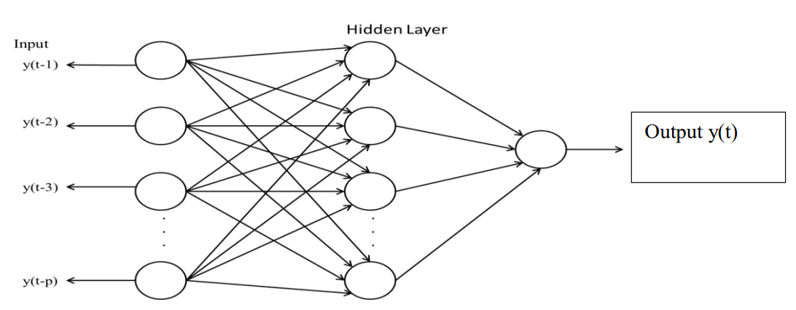
Fig. 1. Architecture of ANN for timeseries forecasting

2.1.1 Architecture of ANN for timeseries forecasting
The relationship between the output y_{t} and the inputs (y_{t-1}, y_{t-2}, …, y_{t-p}) can be mathematically represented as follows:
………. (1)
where, w_{j} (j=0,1,2…q) and w_{ij} (i = 0,1,2…p, j=0,1,2…q) are the model parameters often called the connection weights, p is the number of input nodes and the number of hidden nodes is denoted as q, g and f denote the activation function at hidden and output layer respectively. The activation function shows the relationship between a network's inputs and outputs by defining the degree of nonlinearity. In this study, we employed a sigmoid activation function for the hidden layer and an identity activation function for the output layer (Rathod et al., 2017).
2.1.2 Diagnostic Criterion to select the appropriate model among ANN models
In this study, model performance among the selected ANN models was verified by diagnostic criteria, namely RMSE, MAE, and MAPE. The model with the least MAPE, MAE, and RMSE was preferred over others, for forecasting the chilli and turmeric export quantity. In addition to these diagnostics, the Ljung-Box test was also employed to verify whether the residuals are independently distributed or not.
2.2 FUZZY TIME SERIES
A time series is referred to as a fuzzy time series if its observations are linguistic values represented by fuzzy sets, and the relationship between these values at different times is expressed through fuzzy logic (Song and Chissom, 1993).
There are various models proposed by (Song & Chissom, 1993), the (Chen, 1996) model, the Heuristic (Huarng, 2001) model, the (Abbasov & Mamedova, 2003) model, the (Chen & Hsu, 2004) model, and the (Singh, 2008) model.
2.2.1 General steps involved in fuzzy time series
- Define the Universe of Discourse
Let D_{min} and D_{max} be the minimum and maximum values of the data. The universe U is defined as:
U = [ D_{min} – D₁, D _{max} + D₂] ……. (2)
Where D₁ and D₂ are small positive constants.
- Divide U into intervals or define the intervals.
- Define fuzzy sets over the universe of discourse.
- Transform the data into values which are based on the universe of discourse and corresponding fuzzy set defined in step 2 and step 3.
- Establish Fuzzy Logical Relationships.
- Prepare the Fuzzy logical relational groups.
- Forecast the future export values.
- Defuzzification of the forecasted fuzzified outputs.
2.3 Model Evaluation
In this study, the comparison was made between the Chen, Singh, and Heuristic Fuzzy time series models based on RMSE, MAE, and MAPE.
Root Mean Square Error (RMSE): Measures the average magnitude of prediction error
$RMSE= \sqrt{\frac{\sum_{t=1}^{n}{{(Y_{t}-\hat{Y_{t}})}^{2}}}{n}}$ ……… (3)
Mean Absolute Error (MAE): Average of absolute errors
$MAE=\frac{1}{n}\sum_{t=1}^{n}{\left|Y_{t}-{\hat{Y}}_{t}\right|}$ ……. (4)
Mean Absolute Percentage Error (MAPE): Measures the average of percentage errors. Gives error in percentage terms

$MAPE = \left(\frac{100}{n}\right)\sum_{i=1}^{n}{\left|\frac{\left(A_{i}– F_{i}\right)}{A_{i}}\right|}$ …….. (5)
The model which is having the lowest RMSE, MAE and MAPE is considered as the best model.

3. RESULTS AND DISCUSSION
3.1 Chilli Analysis
3.1.1 Artificial Neural Network
The network structure 2-5-1 (2 input nodes, 5 hidden nodes with 1 output layer) had the smallest RMSE (10.31), MAE (8.00), and MAPE (83.85) as shown in the table 1.
Table.1 Comparative evaluation of different numbers of Neural Network Models for Chilli Analysis
Model | RMSE | MAE | MAPE
2-3-1 | 11.71 | 8.88 | 87.96
2-4-1 | 10.62 | 8.25 | 95.71
2-5-1 | 10.31 | 8.00 | 83.85
2-6-1 | 10.70 | 8.01 | 84.47
2-7-1 | 11.03 | 8.19 | 87.81
2-8-1 | 11.06 | 8.93 | 91.37

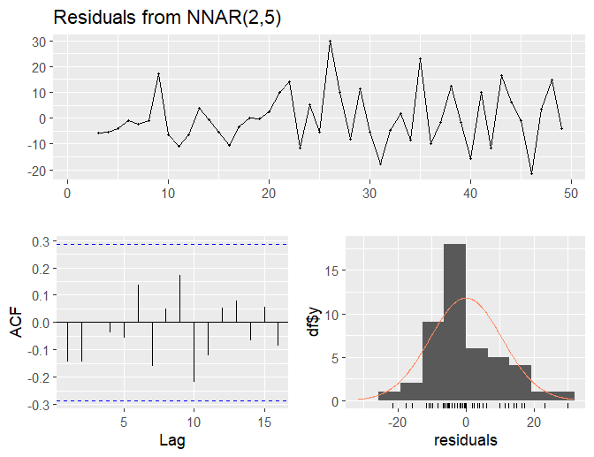
Fig. 2. Residual plots for Chilli export (quantity) from India
It was also observed that the none of the lags of residual ACF chart were found to be significant as per Fig.2 and the Ljung- box test also concluded the same as p- value is 0.45 (>0.05), hence null hypothesis was accepted as residuals were independently distributed, which indicated that the identified ANN (2-5-1) was found to be one of the appropriate model.
3.1.2 Fuzzy time series
Later, Fuzzy time series models such as Singh, Chen, and Heuristic were employed for the Chilli export quantity (‘000 Tonnes) from India. The models were also evaluated based on RMSE, MAE, and MAPE.
Table 2. Comparison of different fuzzy time series models
MODEL | RMSE | MAE | MAPE
SINGH | 15.91 | 12.19 | 109.84
CHEN | 46.75 | 41.53 | 223.43
HEURISTIC | 36.00 | 31.12 | 149.74

Among the models, the Singh model outperformed others with the lowest RMSE (15.91), MAE (12.19), and MAPE (109.84) as per Table 2.
The export quantity of Chilli for the study period is divided into 6 fuzzy sets by using the Sturgess' rule as follows: K=1+3.3log(𝑛) ….. (6)
K = 1+3.322×log (54) = 6.755 ≈ 7.

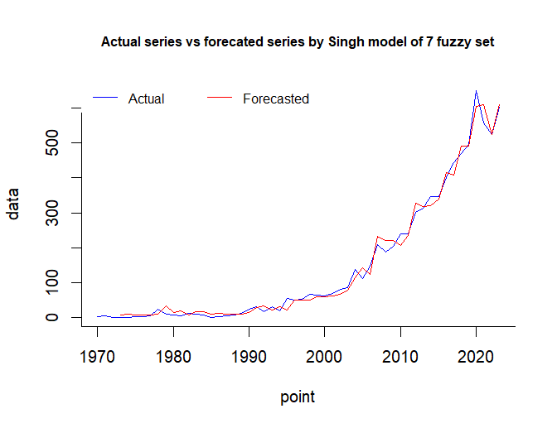
Fig. 3. Graph for Actual vs Forecasted Chilli export (quantity) by Singh method

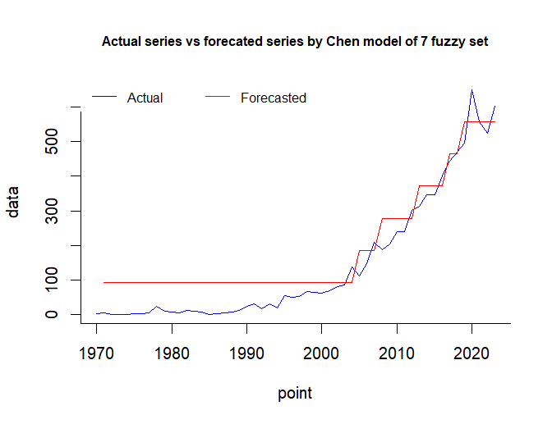
Fig. 4. Graph for Actual vs Forecasted Chilli export (quantity) by Chen method

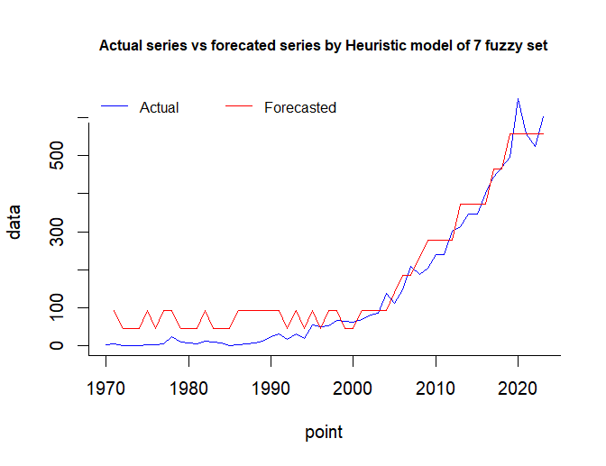
Fig. 5. Graph for Actual vs Forecasted Chilli export (quantity) by Heuristic method
The above three graphs were used to compare the actual data series with the forecasted series generated by three different fuzzy time series models – Singh, Chen, and Heuristic, utilizing the seven fuzzy sets over the decades from 1970 to 2023. The initial forecast point was missed as it requires lagged export data for initialization. Based on Fig. 3, the comparison between the original data and forecasted values showed that some points in the estimated plot deviate slightly from actual data. In 2023, the original data and the forecasted estimate showed an increasing trend. Based on Fig. 4 from 1970 to 2005, the forecasted series remains constant at a fixed value. The actual and forecasted series exhibit an increasing trend after 2005. Based on Fig.5, forecasted values show that few deviations exist with the actual values in the initial periods of export quantity. At the point 2023, original data show an increasing trend, whereas forecasted estimates show a constant trend.

3.1.3. Forecast the export (quantity) of Chilli from India through the Best fitted Model
Among the selected models from ANN (NNAR (2-5-1)) and Fuzzy time series (Singh model), ANN was recognized as the best model due to the lowest RMSE, MAE, and MAPE.

Table.3 Comparison of selected models for Chilli exports (quantity) from India
MODEL | SINGH | ANN
RMSE | 15.91 | 10.31
MAE | 12.19 | 8.00
MAPE | 109.84 | 83.85

In 2022, the demand for red Chilli exports declined due to a lower availability of premium quality (Chilli Outlook – March 2023). Enhancing the quality of Indian Chilli could boost future demand. According to analysis forecasts of Chilli exports (quantity) from India were done by ANN (2-5-1), and it was revealed that the projected export quantity would be 560.75 (‘000 Tonnes) for 2026-2027.
3.2 Turmeric Analysis
3.2.1 Artificial Neural Network
Similarly, among several potential models, the top-performing models were listed in Table 4, based on RMSE, MAE, and MAPE. Here, a neural network model 4-5-1 outperformed with the lowest RMSE (3.41), MAE (2.55), and MAPE (13.76) among other neural network models.

Table.4 Comparative evaluation of different numbers of Neural Network Models for Turmeric Analysis
Model | RMSE | MAE | MAPE
4-3-1 | 5.00 | 3.78 | 17.66
4-4-1 | 3.88 | 3.01 | 15.49
4-5-1 | 3.41 | 2.55 | 13.76
4-6-1 | 3.99 | 3.05 | 14.14
4-7-1 | 4.16 | 3.84 | 15.62
4-8-1 | 4.34 | 3.92 | 15.69

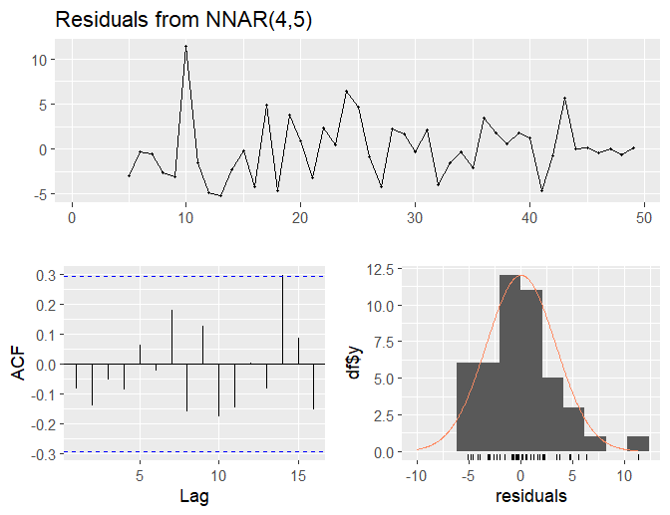
Fig.6. Residual plots for Turmeric export (quantity) from India
To validate the adequacy of the selected neural network model (4-5-1), residual analysis was conducted. The residual ACF plot (Fig. 6) revealed that there were no significant autocorrelations at any lag, and the Ljung-Box test also informed the same, as its p-value was 0.706 (>0.05), leading to acceptance of the null hypothesis that the residuals were independently distributed. These results concluded that the model provides a good fit to the data.
3.2.2 Fuzzy time series
Later, Fuzzy time series models such as Singh, Chen, and Heuristic were also applied for the Turmeric export quantity (‘000 Tonnes) from India and made a comparative study on the basis of RMSE, MAE, and MAPE.
Table 5. Comparison of different fuzzy time series models
MODEL | RMSE | MAE | MAPE
SINGH | 4.76 | 3.81 | 18.59
CHEN | 11.91 | 10.11 | 61.13
HEURISTIC | 9.70 | 8.01 | 43.88

Among the models Singh model outperformed others with the lowest RMSE (4.76), MAE (3.81), and MAPE (18.59) as per Table 5.
The export quantity of Turmeric for the study period is divided into 7 fuzzy sets by using the Sturgess' rule as follows: K ≈ 7.

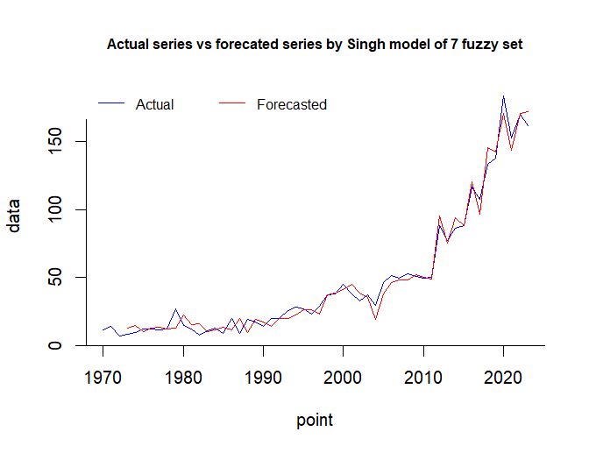
Fig. 7. Graph for Actual vs Forecasted Turmeric export (quantity) by Singh method

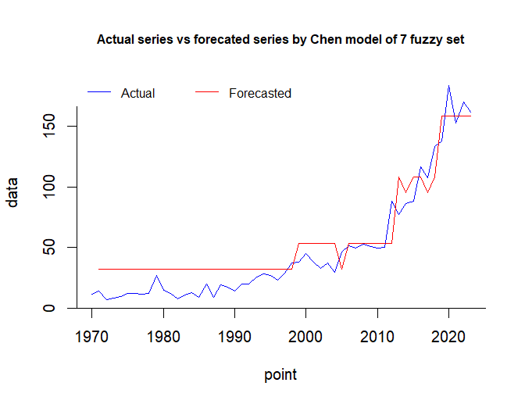
Fig. 8. Graph for Actual vs Forecasted Turmeric export (quantity) by Chen method

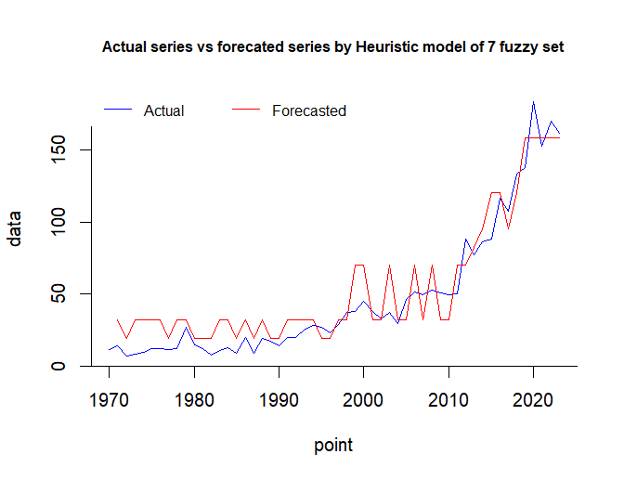
Fig. 9. Graph for Actual vs Forecasted Turmeric export (quantity) by Heuristic method
In the above three graphs, the actual data series with the forecasted series generated by 3 different fuzzy time series models – Singh, Chen, and Heuristic, utilizing the seven fuzzy sets over the decades from 1970 to 2023, were compared. The initial forecast point was missed as it requires lagged export data for initialization. Based on Fig. 7, the comparison between the original data and forecasted values showed that some points in the estimated plot deviate slightly from actual data. In 2023, the original data showed a decreasing trend, whereas the forecasted estimate showed an increasing trend. Based on Fig. 8 from 1970 to 1998, the forecasted series remains constant at a fixed value. The actual series shifts to an increasing trend during 2005 to 2020, while the forecasted series follows a step–wise increasing trend. Based on Fig.9, the forecasted values showed that more deviations exist between the actual values in the initial periods of export quantity. At the point 2023, original data showed a decreasing trend, whereas forecasted estimates show a constant trend.

3.2.3 Forecast the export (quantity) of Turmeric from India through the Best-fitted Model:
Among the selected models, ANN (NNAR (4-5-1)) and Fuzzy time series (Singh model) were recognized as the best models due to the lowest RMSE, MAE, and MAPE.
Table 6. Comparison of selected models for Turmeric exports (quantity) from India
MODEL | SINGH | ANN
RMSE | 4.76 | 3.41
MAE | 3.81 | 2.55
MAPE | 18.59 | 13.76

Hence, the ANN model was considered as the most suitable for forecasting turmeric exports (quantity) from India, and it was projected for 2026-2027 as 159.98 (‘000 Tonnes).

4. CONCLUSION
In conclusion, the comparative analysis of forecasting models revealed that the Artificial Neural Network (ANN) outperformed Fuzzy Time Series in predicting Chilli and Turmeric exports, as evidenced by its lower error metrics. For Chilli exports, ANN recorded an RMSE of 10.31, an MAE of 8.00, and an MAPE of 83.85, while for Turmeric exports, RMSE, MAE, and MAPE were recorded as 3.41, 2.55, and 13.76, respectively. Finally, it was concluded that the projected export quantities for 2026-2027 would be 560.75 (‘000 Tonnes) for Chilli and 159.98 (‘000 tonnes) for Turmeric from India.

Disclaimer (Artificial intelligence)
Option 1:
Author(s) hereby declare that NO generative AI technologies such as Large Language Models (ChatGPT, COPILOT, etc.) and text-to-image generators have been used during the writing or editing of this manuscript.
Option 2:
Author(s) hereby declare that generative AI technologies such as Large Language Models, etc. have been used during the writing or editing of manuscripts. This explanation will include the name, version, model, and source of the generative AI technology and as well as all input prompts provided to the generative AI technology
Details of the AI usage are given below:
1.
2.
3.

REFERENCES
Alam, T. 2019. Forecasting exports and imports through artificial neural network and autoregressive integrated moving average. Decision Science Letters. 8(3): 249-260.
Bansal, Rachna, Mohit Kumar, and A. S. Shaikh. 2022. "Export performance of Indian chilli." Gujarat J Ext Educ.34: 66-72.
Chilli Outlook – March 2023, PJTSAU (https://www.pjtsau.edu.in)
Dhage, V.P. 2021. Export performance of turmeric in India. Doctoral dissertation. Vasantrao Naik Marathwada Krishi Vidyapeeth, Parbhani.
Gade, P.A. 2020. Export performance of chilli from India. Doctoral dissertation. Vasantrao Naik Marathwada Krishi Vidyapeeth, Parbhani.
Hanafiah, N.S.B.M., Shafii, N.H.B., Fauzi, N.F.B., Nasir, D.S.M. and Nor, N.A.M. 2022. Comparison of Fuzzy Time Series and ARIMA Model for Predicting Stock Prices. Journal of Computing Research and Innovation. 7(2): 366-378.
Hosseini Vardanjani, S.M., Ganjikhorramdel, N., Khaltabadi Farahani, A., Khoshravesh, M. and Nouri Khajebelagh, R. 2024. A generalization of the M5 Tree model and artificial neural network model for estimating daily reference evapotranspiration under minimal climatic data conditions. Journal of Water and Climate Change, 15(12): 5882-5892.
Indiastat. (https://indiastat.com).
Jadhav, V.G., Baviskar, P.P., Waghmare, S.N. and Bhosale, G.V. 2022. Export performance of Turmeric in India. The Pharma Innovation Journal. 11(1): 425-427.
Muhamad, S.N.N., Sofean, S.H., Moktar, B. and Shahidan, W.N.W. 2021. Fuzzy time series and artificial neural network: forecasting exportation of natural rubber in Malaysia. Journal of Computing Research and Innovation. 6(1): 22-30.
Rahman, N.H.A., Lee, M.H., Suhartono and Latif, M.T. 2015. Artificial neural networks and fuzzy time series forecasting: an application to air quality. Quality & Quantity. 49: 2633-2647.
Ramadhan, A.J., Priya, S.K., Naranammal, N., Pavishya, S., Naveena, K., Ray, S., Mishra, P., Abotaleb, M., Alkattan, H. and Albadran, Z. 2024. Comparison Study Using Arima and Ann Models for Forecasting Sugarcane Yield. In BIO Web of Conferences. 97: 00078. EDP Sciences.
Rasna, D.L. and Sudarsana, W. 2021. Forecasting Of Crude Palm Oil By Using Fuzzy Time Series Method (Study Case: PT. Buana Mudantara Plantation). J. Stat. 1(1): 31-40.
Reddy, G.R., Gita, B.M., Ketali, S.S. and Reddy, M.C. 2021. Price-behaviour and forecast of chilli prices in Andhra Pradesh: a comparative analysis using ARIMA and ANN models. J. Res. ANGRAU 49(4): 95-112
Selvakumar, S and Kasthuri, V. 2022. Wheat Production Prediction in India using ARIMA, Neural Network and Fuzzy Time Series. London Journal of Research in Science: Natural and Formal. 22(15).
Setiya, P., Nain, A.S. and Satpathi, A. 2024. Comparative analysis of SMLR, ANN, Elastic net and LASSO based models for rice crop yield prediction in Uttarakhand. MAUSAM. 75(1): 191-196.
Sindhu, A. 2019. Prediction of wheat yield using Artificial Neural Network and Fuzzy time series models in Eastern agro climatic zone of Haryana. Doctoral dissertation. CCSHAU.
Spices Board. Government of India. (http://www.indianspices.com).
Thimmegowda, M.N., Manjunatha, M.H., Huggi, L., Shivaramu, H.S., Soumya, D.V., Nagesha, L. and Padmashri, H.S. 2023. Weather-based statistical and neural network tools for forecasting rice yields in major growing districts of Karnataka. Agronomy. 13(3): 704.

