A Bibliometric Review of Machine Learning Applications in Soil Science Using Digital Spectroscopy (2008–2024)
Abstract
Machine learning (ML) has rapidly advanced soil science, particularly in the last decade. This bibliometric study examines the scholarly production on machine learning in soil science from 2008 to 2024, analysing research impact, leading groups, and trends. The study reveals a significant increase in research output, with China emerging as the most prolific country after 2020. Collaboration networks highlight significant partnerships, with Zhejiang University and the Czech University of Life Sciences acting as central hubs. The analysis underscores the transition of ML in soil science from a nascent field to a well-established area characterized by increased research activity and interdisciplinary collaboration. Soil property prediction using ML techniques has been a major focus, with approximately 60% of studies dedicated to predicting organic carbon, nitrogen, moisture, texture, pH, and heavy metals. Digital soil mapping, soil profile analysis, and soil classification using ML account for about 20% of the research. Soil health assessment, including predicting soil health indicators, optimizing nutrient management, and developing remediation strategies, accounts for around 15% of the studies. Emerging trends include the rise of deep learning, the increased focus on soil health assessment, and the growing integration of ML with remote sensing techniques. While Chinese institutions lead in publication volume, organizations from Greece, Brazil, and Australia demonstrate higher research impact. The study underscores the importance of international collaboration in advancing this field and suggests a need to strengthen international networks and explore emerging interdisciplinary connections.
Keyword: Bibliometric Analysis, Dimensions. AI, Machine Learning, Soil science

- Introduction
Machine learning (ML) is a subset of artificial intelligence (AI) that use algorithms to analyse large amounts of data, identify patterns, and make decisions (Arrieta et al., 2020). It can perform tasks such as classification and prediction based on large text, numerical, and image data. The application of machine learning (ML) techniques in various fields of science has increased rapidly, especially in the last ten years, particularly in medical science, earth science, agricultural science etc (Gill et al., 2022; Prajapati et al., 2023). Machine learning applications in soil science include predicting soil types and properties by using digital soil mapping (DSM) or pedotransfer functions and analyzing infrared spectral data to determine soil properties. A machine learning model utilizing spectral analysis has been employed to predict various soil properties, including physical characteristics (Dalal & Henry, 1986), chemical composition (De Santana & Daly, 2022), and fertility aspects (Munawar et al., 2020; Ben‐Dor & Banin, 1995). Several countries, including Brazil (Araújo et al., 2014), have begun utilizing machine learning techniques in conjunction with infrared (IR) spectroscopy. These machine-learning approaches have been utilized to predict soil organic matter content (Conforti et al., 2015) and nitrogen levels (Rosin et al., 2021). Additionally, they have been applied in soil surveys to fulfil the quantitative requirements for soil mapping (Seybold et al., 2019).
Bibliometric analysis provides a suitable way through which to examine the scientific contributions and evolution of knowledge within this field (Xie et al., 2020). Bibliometric analysis is used by scientists worldwide to understand the evolution and scientific contribution of a given area of knowledge, thus mapping the science produced and determining the trend in research topics (De Souza Oliveira Filho, 2020). This paper offers a bibliometric review of the scholarly production on the application of machine learning to soil science based on papers published in journals during the period of 2008-2024.
The main objectives of this study were to:
a) Analyse the impact of countries and institutions regarding their involvement in scientific research
b) Identify the leading groups and research institutions
c) Identify the major research fields and their trend of publications over time.

- Material and Methods
  - Data Collection
The datasets for machine learning in soil science were obtained from "Dimension.ai," a free integrated research knowledge system developed by Digital Science with over 100 of the world's best research organizations (Gorji et al., 2024). It integrates publications, citations, alternative metrics, clinical trials, patents, and policy papers to facilitate users' rapid discovery and retrieval of the needed data, assessment of scholarly and general research results, and intelligence gathering to develop future action plans.
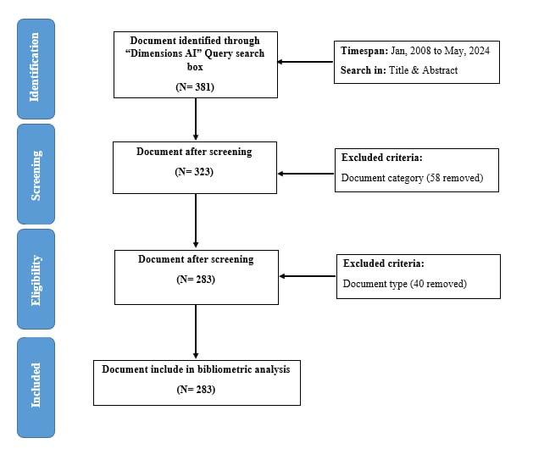

Fig. 1. Flowchart of steps followed for the bibliometric study on use of machine learning in soil analysis for the period 2008-2024
The flowchart (Fig 1) illustrates the methodology employed for a bibliometric analysis of research on machine learning, soil science, and spectroscopy from January 2008 to May 2024. The searches started with a query on Dimension.ai, a research knowledge system, using the keywords "machine learning AND soil AND spectroscopy". This yielded 381 initial documents. A multi-stage screening process was implemented. The initial 381 documents were screened based on specified criteria. This resulted in two exclusion stages. In the first screening stage, 58 documents were excluded due to their document category while 48 were excluded in second screening based on document type. After applying the exclusion criteria, 283 documents remained, which forms the basis for the bibliometric analysis. The search specifically targeted documents with the keywords in both the title and the abstract, indicating that only relevant articles were selected. The documents were exported as a CSV file with complete data and citation data for further bibliometric analysis. Data cleaning is often needed for analysis and network mapping based on the data (Lim et al., 2024). This was done by eliminating the duplicates and unwarranted text from the dataset using Microsoft Excel.

  - Data Analysis
The variables a) country production over time, b) organisation, c) top 10 authors, d) countries, and e) publication per journal from 2008-16 and 2017-2024 were analysed using “Biblioshiny” in RStudio-version:2024.04.2+764 and can be downloaded from Bibliometrix website, (https://www.bibliometrix.org).
The h-index was mentioned for the number of publications per author and journal. According to Hirsch (2005), the h-index measures the impact of a researcher, institution, or scientific journal by indicating that they have published h papers, each of which has been cited at least h times. For example, if an institution has 20 publications and each has received at least 20 citations, the institution's h-index would be 20.
A freely available computer program was used for the visualization and network mapping VOS viewer 1.6.20 tool (Yu et al., 2020), which included a) collaboration among authors, organisations, and countries and b) most-used keywords. In the visualisation network, items were represented by labels and circles, the size of which indicated the number of documents and the frequency of keyword usage (Gandasari et al., 2024)
Few labels have been displayed in the figures generated to avoid overlapping. Collaborations between countries and institutions were established based on co-authorship and formed individual clusters represented by the same colour (Ortega & Aguillo, 2013).

- Result And Discussion
  - Soil Properties with Machine Learning Techniques (2008-2024)
Soil Property Prediction (50-60%) appears to be the largest category based on the high number of titles focused on predicting specific soil properties like organic carbon, nitrogen, moisture, texture, pH, and heavy metals (Li et al., 2021; Chen et al., 2022; Wudil et al., 2024; Gholizadeh et al., 2016; Yang et al., 2019). A significant number (20-30%) of titles focus on using machine learning (ML) for digital soil mapping (Takoutsing et al., 2022), soil profile analysis (Pham et al., 2021), and classification (Huang et al., 2023) based on spectral data. A good proportion (15-20%) of titles deal with using ML for soil health assessment (Mahlein, 2015), nutrient management (Zhao et al., 2018), remediation (Y. Gou et al., 2024) and addressing specific soil health challenges. Emerging Applications (5-10%) category includes innovative uses of ML, such as applications with remote sensing (Neto et al., 2017), weed detection (Mudereri et al., 2019), disease monitoring (Galieni et al., 2022), and microplastic detection (S. Zhao et al., 2022).
Further, specific trends, such as the rise of deep learning (Padarian et al., 2022) for soil analysis, the use of ML for soil health assessment, or the growing integration of ML with remote sensing data, were also observed in many of the studies during the assessment period. Although the rise in deep learning (5-10%) is gaining traction, it is still a relatively new area of soil science compared to traditional ML methods. Focus on soil health assessment (10-15%) seems to grow significantly, with increasing interest in using ML for soil health monitoring and management. There is also evidence of the integration of ML with remote sensing (15-20%) becoming increasingly common in soil science research.
  - Countries Production over Time
Figure 2 represents the number of research articles published by five countries—Brazil, Germany, USA, China, and Australia—on machine learning techniques in soil science from 2008 to 2024. The figure depicts the contribution of different countries, thereby reflecting the academic output of these countries towards using machine learning techniques in soil science over two-time scales. China has been found to be the most productive country since 2020 when its number of publications annually has significantly increased. The growth in the number of publications was very well observed during 2024, which is likely to become the highest during the study period (2008-2024), thereby reflecting the dominance of China and its effort in integrating machine learning techniques into soil science research.
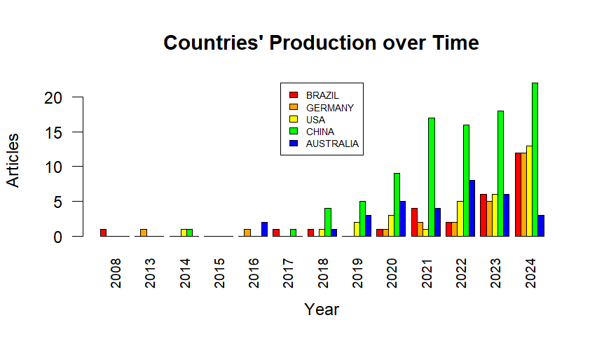

Fig. 2. Country production over time in machine learning techniques in soil science from 2008 to 2024
In the case of Germany and the USA, there has been a consistent increase in the number of publications, especially starting around 2019 although the peak was seen in the year 2024. However, China seems to surpass them in overall output. Similarly, Brazil and Australia have also shown a steady rise in their research output, particularly from 2018 onwards. Although the production of both countries was slightly lower than China, Germany and the USA, they exhibited strong performance in 2022 and 2023. Since the overall research output was low from 2008 to 2016, using machine learning techniques in soil science was still in infancy in these five countries. Padarian et al. (2020) have reported a gradual increase in publications around 2017, suggesting a growing recognition of machine learning techniques' importance and potential use in soil science. The dramatic increase in publications post-2019 across all countries, particularly China, reflects a broader trend in the scientific community's adoption of machine learning for soil science research. This increased interest may be attributed to technological advancements, increased computational power, and the growing importance of global sustainable agriculture and soil management practices (Jordan & Mitchell, 2015).
  - Organizational Co-Authorship
Organization co-authorship (Figure 3) depicts the collaborative landscape among research institutions regarding using machine learning techniques in soil science research from 2008 to 2024.
The figure reveals the connections between various universities and research centres, highlighting the strength and extent of their collaborations. As can be seen, Zhejiang University and the Czech University of Life Sciences are central to the network, implying their prominent roles in promoting cooperation (Xu et al., 2024). Both universities have strong networks with several other institutions, suggesting they are key players in advancing research in this field. Tel Aviv University and Büchi Labortechnik also appear as significant hubs, collaborating with multiple organisations. Similar results have also been reported by Rossel et al., 2016 while creating the World Soil spectral database library. Their relative position in the network reflects their active involvement in cross-institutional research efforts. The University of Sydney and Universidad de São Paulo, both from two distinct clusters, were observed to collaborate closely in the southern hemisphere. These universities are also connected with prominent universities like the University of Campinas, emphasizing their role in both regional and international research networks.
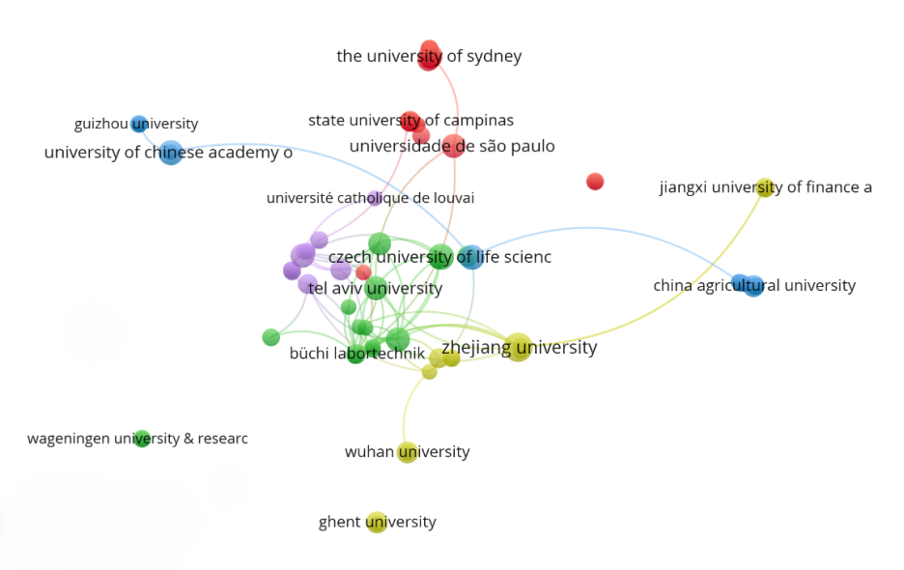

Fig. 3. Network visualization of organisation co-authorship in the bibliometric analysis for using machine learning techniques in soil science from 2008-2024 (Size of the circle represent number of documents published by each organisation; Line indicates collaborations among organisation)
On the other hand, China Agricultural University and Wuhan University show specific but strong connections, especially with Jiangxi University, demonstrating targeted collaboration within China. Some organisations, such as Wageningen University & Research and Ghent University, appear on the network's periphery with fewer connections. This could indicate specialised or isolated research collaborations compared to the more interconnected institutions. The diagram also shows smaller clusters or isolated nodes, like Université Catholique de Louvain, suggesting that while these institutions contribute to the research field, their collaborations are less extensive. The co-authorship network diagram illustrates the growing collaboration between the different research institutions, thereby exhibiting the increased role of machine learning use in the soil science research landscape (Mokhnacheva & Tsvetkova, 2020). The key universities, including Zhejiang University, Czech University of Life Sciences, and Tel Aviv University, play a significant role in driving research and promoting partnerships within the network (Xu et al., 2024; Rossel et al., 2016). The connections between these institutions reflect a robust international collaboration essential for advancing knowledge and innovation in the field
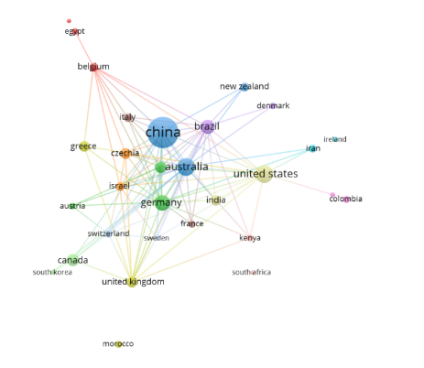
  - Country Collaboration

Fig. 4. Scientific cooperation among countries for the set of articles published in the use of machine learning in soil science during the period 2008-2024. (Size of circles represents number of documents published by each country; Lines represent collaborations among countries)

Figure 4 visually represents international collaboration among various countries for research publications on using machine learning in soil research. The size of each node (country) corresponds to its level of involvement, likely based on the number of co-authored publications. The connection network indicates the link between the countries' co-authorship. China, Australia, and the United States are the most significant nodes, indicating they are the most active in international collaborations. Germany and the United Kingdom also play significant roles but with fewer connections than the top three. These five countries could be considered the “central actors” in publishing journal papers on the use of machine learning in soil science during the period 2008-2024. A dense connection was observed between China and several countries, including Australia, the United States, Germany, and the United Kingdom, highlighting China’s central role in using machine learning techniques and contributing towards global research networks. The United States was strongly linked with countries like the United Kingdom, Australia, Germany, and China, suggesting a wide-reaching collaborative influence. A noticeable cluster of geographically close countries, such as European countries (Germany, the United Kingdom, Italy and Belgium), indicated regional cooperation. They could be considered as “regional actors” in furthering research on using machine learning in soil science from 2008 to 2024. Additionally, countries like Morocco, South Korea, South Africa, and Colombia are on the periphery, indicating limited international collaboration compared to central actors. Similarly, Egypt and Belgium are connected but somewhat isolated, suggesting specialized or less widespread collaboration networks. These clusters of countries could be considered as the “peripheral actors”. The country co-authorship highlights the global nature of research collaboration, with certain countries like China, the United States, and Australia being central hubs. There is a strong inclination toward collaboration within regions (Europe, North America) and cross-regional partnerships (Awais et al., 2023). Enhancing connections for peripheral countries could be critical to further expanding the global research network (Minasny et al.,
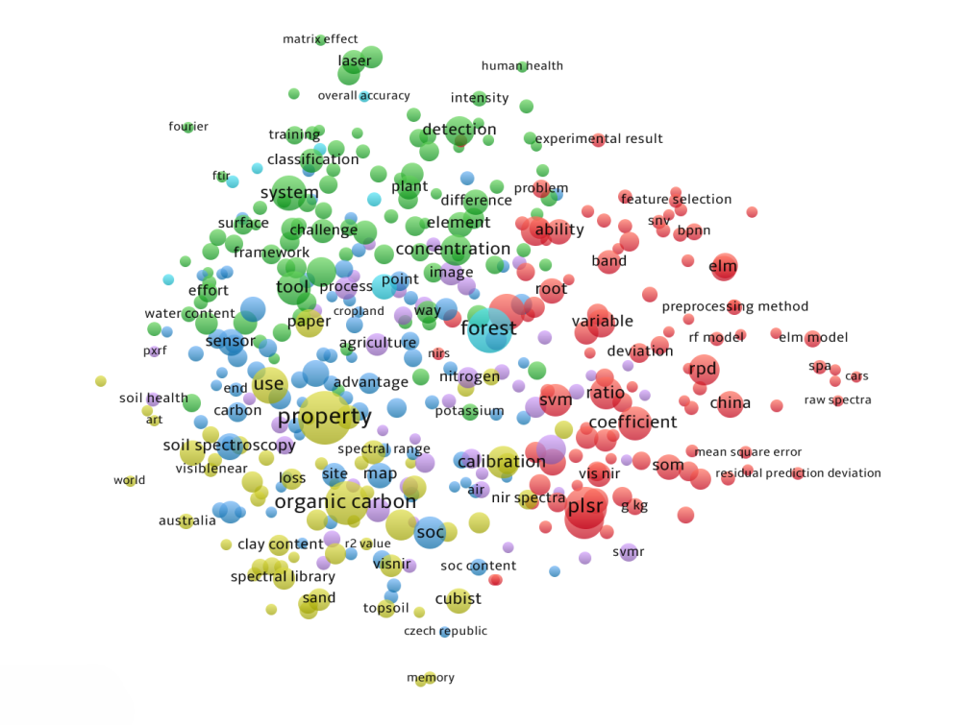

2020).

Fig. 5. The word occurrence diagram for bibliometric analysis of machine learning techniques in soil science from 2008 to 2024. (Size of circles represent number of occurrence of words)
The word occurrence diagram for bibliometric analysis of machine learning techniques in soil science from 2008 to 2024 (Figure 5) provides valuable insights into this research area's key themes and trends. The largest and most central terms include "organic carbon", "property", and "calibration", indicating that much of the research is concentrated on understanding soil properties, particularly organic carbon, and the calibration of models for accurate predictions. "Forest" and "concentration" are also prominent, suggesting a significant focus on soil characteristics in forest ecosystems and measuring various soil constituents. Specific machine learning methods like "plsr" (Partial Least Squares Regression), "svm" (Support Vector Machines), and "elm" (Extreme Learning Machines) are frequently mentioned, indicating their widespread application in soil science. The presence of "rpd" (Residual Prediction Deviation) and "coefficient" suggests an emphasis on model performance metrics and accuracy. Terms like "use", "end use", "system", "sensor", and "detection" suggest that machine learning is being applied to various practical aspects of soil science, such as monitoring and predicting soil properties, possibly using remote sensing or in-field sensors. "Soil spectroscopy" and "spectral range" are notable, highlighting the integration of spectral data with machine learning for soil analysis. The term "China" appears prominently, suggesting a significant contribution or focus on soil science research involving machine learning within China. "Agriculture", "cropland", and "nitrogen" emphasize the relevance of this research in agricultural contexts, focusing on optimizing soil health and nutrient management. Smaller but relevant terms such as "classification", "feature selection", and "preprocessing method" indicate ongoing challenges in refining machine learning models for better soil analysis. "Human health" suggests emerging research linking soil science with broader environmental or health outcomes. The word occurrence diagram reveals a robust and evolving research landscape where machine learning techniques are increasingly integrated into soil science. The focus on organic carbon, calibration, and specific machine learning methods indicates that researchers are primarily concerned with improving model accuracy and understanding soil properties, especially in agriculture and forest ecosystems. As machine learning advances, its application in soil science will likely expand, addressing both traditional challenges and new interdisciplinary connections (Sadeqi-Arani & Kadkhodaie, 2023).

Table 1. Top ten organisations involved in research on using machine learning techniques in soil science from 2008 to 2024.
Top 10 Organisations
Organisation | N | TC | TC/N | TLS
Zhejiang University (China) | 17 | 430 | 25.29 | 11
Czech University of Life Sciences (Prague, Czechia) | 11 | 196 | 17.82 | 18
University of the Chinese Academy of Sciences (China) | 10 | 156 | 15.60 | 5
Institute of Soil Science, Chinese Academy of Science (China) | 10 | 176 | 17.60 | 10
Aristotle University of Thessaloniki (Greece) | 9 | 686 | 76.22 | 6
University of Sydney (Australia) | 9 | 407 | 45.22 | 5
University of São Paulo, (Brazil) | 9 | 665 | 73.89 | 10
Tel Aviv University (Israel) | 8 | 114 | 14.25 | 20
Helmholtz Centre Potsdam -GFZ German Research Centre for Geosciences (Germany) | 7 | 93 | 13.29 | 20
China Agricultural University (China) | 6 | 54 | 9.00 | 0
(N: Number of publication; TC: Total citation; TC/N: Citation per publication; TLS: Total Link Strength)
The analysis of the top 10 organisations involved in research on using machine learning techniques in soil science from 2008 to 2024 (Table 1) highlights key contributors and their impact within the field. The table provides insights into the number of publications (N), total citations (TC), average citations per publication (TC/N), and total link strength (TLS), which reflects the degree of collaboration and co-authorship with other organisations. Zhejiang University (China) is the most prolific contributor, with 17 publications, accumulating 430 citations and an average of 25.29 citations per publication. Its total link strength (TLS) of 11 reflects moderate collaboration with other institutions. The Czech University of Life Sciences, Prague, follows with 11 publications, 196 citations, and a robust collaborative network, as indicated by its highest TLS of 18 among the top 10.
Aristotle University of Thessaloniki (Greece) and the University of São Paulo (Brazil) stand out with the highest average citations per publication, 76.22 and 73.89, respectively, highlighting their high impact on the field despite a relatively minor number of publications (9 each). Their high TLS values (6 and 10, respectively) suggest effective international collaboration (Goranin et al., 2024). The University of Sydney (Australia) also shows a significant impact, with 45.22 citations per publication, supported by a robust collaborative network (TLS of 5). Chinese institutions dominate the list, with four entries viz., Zhejiang University, University of the Chinese Academy of Sciences, Institute of Soil Science, Chinese Academy of Science, and China Agricultural University. These organisations have collectively contributed significantly to the research output in this area, although their average citations per publication vary, indicating differing levels of impact. The Institute of Soil Science, Chinese Academy of Science, shows a balanced performance with 176 citations from 10 publications and a TLS of 10, indicating both impact and collaboration. Tel Aviv University (Israel) and the Helmholtz Centre Potsdam - GFZ German Research Centre for Geosciences (Germany), while contributing fewer publications (8 and 7 respectively), have the highest TLS values (20 each), reflecting their strong engagement in international research networks. However, their average citations per publication are lower than others on the list. China Agricultural University (China), although a key contributor with six publications, has the lowest average citations per publication (9.00) and does not exhibit any collaborative links (TLS of 0), suggesting limited influence and networking in the field.
The bibliometric analysis reveals that while Chinese institutions lead in publication volume, organisations from Greece, Brazil, and Australia demonstrate higher research impact through higher citation averages. The study also highlights the importance of international collaboration, as evidenced by the high TLS values of specific institutions, which correlate with more significant academic influence (Dagli et al., 2024). Strengthening collaboration could further enhance the global impact of research in applying machine learning to soil science.

Table 2. Scientific journals focusing on using machine learning techniques in soil science from 2008 to 2024.
Journals | N | TC | TC/N | H-index
2008-2016
Geoderma | 2 | 218 | 109 | 2
Applied Spectroscopy | 1 | 37 | 37 | 1
Biosystems Engineering | 1 | 358 | 358 | 1
Environmental Modelling & Software | 1 | 114 | 114 | 1
Guang Pu | 1 | 1 | 1 | 1
Journal Of Chemometrics | 1 | 11 | 11 | 1
Remote Sensing | 1 | 45 | 45 | 1
Remote Sensing of Environment | 1 | 48 | 48 | 1
Spectrochimica Acta Part B Atomic Spectroscopy | 1 | 108 | 108 | 1
Waste Management | 1 | 24 | 24 | 1
2017-2024
Geoderma | 22 | 663 | 30.14 | 12
Remote Sensing | 18 | 416 | 23.11 | 9
European Journal of Soil Science | 10 | 139 | 13.90 | 6
Sensors | 7 | 214 | 30.57 | 6
Spectrochimica Acta Part A Molecular And Biomolecular Spectroscopy | 8 | 148 | 18.50 | 6
Computers And Electronics in Agriculture | 8 | 194 | 24.25 | 5
Geoderma Regional | 7 | 323 | 46.14 | 5
Scientific Reports | 6 | 159 | 26.50 | 5
The Science of The Total Environment | 7 | 168 | 24.00 | 5
Catena | 7 | 169 | 30.14 | 4
(N: Number of publication; TC: Total citation; TC/N: Citation per publication)

The bibliometric analysis of scientific journals focusing on using machine learning techniques in soil science from 2008 to 2024 (Table 2) reveals essential trends and shifts in the research landscape over time. The data has been divided into two periods, 2008-2016 and 2017-2024, highlighting changes in publication volume, citation impact, and journal influence.
During the period 2008-2016, a limited Number of publications with high impact was evident. During this period, a few journals (10) published research on the application of machine learning in soil science, reflecting the emerging nature of this field. However, the impact of these publications was significant, as evidenced by the high average citations per publication (TC/N) for several journals (Surendar et al., 2024). Biosystems Engineering stands out with the highest average citations per publication (358 TC/N) despite having only one paper, indicating a substantial influence in the early development of this research area. Geoderma also played a significant role with 2 publications that garnered 218 total citations, resulting in a high average of 109 citations per paper, further demonstrating the journal's early impact in the field. Journals like Environmental Modelling & Software and Spectrochimica Acta Part B Atomic Spectroscopy also contributed impactful research, each having just one paper but with 114 and 108 citations, respectively.
During 2017-2024, a growth in publication volume and diversification of Journals was evident. In this period, publications and journals significantly increased, reflecting the growing interest and maturity of machine learning applications in soil science. Geoderma remains the leading journal, with 22 publications and 663 citations. Although the average citations per publication (30.14 TC/N) are lower than in the earlier period, the journal has a high H-index of 12, indicating sustained influence and relevance. Remote Sensing has also become a key platform with 18 publications and 416 citations, reflecting its importance in geospatial technologies and machine learning studies. Newer entries like the European Journal of Soil Science and Sensors have emerged as significant contributors, with 10 and 7 publications, each having a solid average citation per paper, demonstrating the field’s expansion into more specialised journals. Journals such as Geoderma Regional and Computers and Electronics in Agriculture have also become significant, indicating a broader acceptance of machine learning in applied soil science research.
The earlier period (2008-2016) was characterised by fewer publications with exceptionally high average citations, suggesting that only pioneering and impactful studies were published then. The later period (2017-2024) shows a notable increase in the number of publications across a broader range of journals, reflecting the expansion of the research field and the increased adoption of machine-learning techniques in soil science. While the average citations per publication are generally lower in the later period, the overall H-index values are higher, indicating sustained and cumulative research impact (Ciriminna & Pagliaro, 2013).

- Conclusion
This bibliometric analysis highlights the remarkable growth and evolution of machine learning (ML) applications in soil science between 2008 and 2024. China's emergence as a leading contributor to the field, alongside the significant contributions from institutions like Zhejiang University and the Czech University of Life Sciences. The analysis reveals a strong focus on predicting soil properties, particularly organic carbon, nitrogen, moisture, texture, pH, and heavy metals. Additionally, research on digital soil mapping, soil profile analysis, and soil classification using ML techniques continues to expand. The growing interest in soil health assessment, including research on predicting soil health indicators and developing sustainable management practices, further highlights the field's evolution towards a more holistic approach to soil management. Emerging trends, such as the increasing use of deep learning algorithms, the growing integration of ML with remote sensing techniques, and the development of specific tools and resources for soil analysis, showcase its potential to address complex soil science challenges. The findings emphasize the importance of international collaboration in advancing this field and suggest a need to strengthen international networks and explore emerging interdisciplinary connections.

Abbreviations:
N: Number of publications
TC: Total Citation
TC/N: Citation per Publication
TLS: Total Link

Disclaimer (Artificial intelligence)
Author(s) hereby declare that NO generative AI technologies such as Large Language Models (ChatGPT, COPILOT, etc.) and text-to-image generators have been used during the writing or editing of this manuscript.

References:
- Araújo, S. R., Wetterlind, J., Demattê, J. a. M., & Stenberg, B. (2014). Improving the prediction performance of a large tropical vis‐NIR spectroscopic soil library from Brazil by clustering into smaller subsets or use of data mining calibration techniques. European Journal of Soil Science, 65(5), 718–729. https://doi.org/10.1111/ejss.12165.
- Arrieta, A. B., Díaz-Rodríguez, N., Del Ser, J., Bennetot, A., Tabik, S., Barbado, A., Garcia, S., Gil-Lopez, S., Molina, D., Benjamins, R., Chatila, R., & Herrera, F. (2020). Explainable Artificial Intelligence (XAI): Concepts, taxonomies, opportunities and challenges toward responsible AI. Information Fusion, 58, 82–115. https://doi.org/10.1016/j.inffus.2019.12.012
- Awais, M., Naqvi, S. M. Z. A., Zhang, H., Li, L., Zhang, W., Awwad, F. A., Ismail, E. a. A., Khan, M. I., Raghavan, V., & Hu, J. (2023). AI and machine learning for soil analysis: an assessment of sustainable agricultural practices. Bioresources and Bioprocessing, 10(1). https://doi.org/10.1186/s40643-023-00710-y.
- Ben‐Dor, E., & Banin, A. (1995). Near‐Infrared analysis as a rapid method to simultaneously evaluate several soil properties. Soil Science Society of America Journal, 59(2), 364–372. https://doi.org/10.2136/sssaj1995.03615995005900020014x
- Chen, Z., Ren, S., Qin, R., & Nie, P. (2022). Rapid detection of different types of soil nitrogen using Near-Infrared Hyperspectral Imaging. Molecules, 27(6), 2017. https://doi.org/10.3390/molecules27062017.
- Ciriminna, R., & Pagliaro, M. (2013). On the use of the h-index in evaluating chemical research. Chemistry Central Journal, 7(1). https://doi.org/10.1186/1752-153x-7-132
- Conforti, M., Castrignanò, A., Robustelli, G., Scarciglia, F., Stelluti, M., & Buttafuoco, G. (2015). Laboratory-based Vis–NIR spectroscopy and partial least square regression with spatially correlated errors for predicting spatial variation of soil organic matter content. CATENA, 124, 60–67. https://doi.org/10.1016/j.catena.2014.09.004
- Dagli, N., Haque, M., & Kumar, S. (2024). Bibliometric analysis of clinical trials on the effect of sugar alcohol consumption on oral health: Trends, insights, and future directions (1967-2024). Cureus. https://doi.org/10.7759/cureus.60248.
- Dalal, R. C., & Henry, R. J. (1986). Simultaneous determination of moisture, organic carbon, and total nitrogen by near infrared reflectance spectrophotometry. Soil Science Society of America Journal, 50(1), 120–123. https://doi.org/10.2136/sssaj1986.03615995005000010023x
- De Santana, F. B., & Daly, K. (2022). A comparative study of MIR and NIR spectral models using ball-milled and sieved soil for the prediction of a range soil physical and chemical parameters. Spectrochimica Acta Part a Molecular and Biomolecular Spectroscopy, 279, 121441. https://doi.org/10.1016/j.saa.2022.121441
- De Souza Oliveira Filho, J. (2020). A bibliometric analysis of soil research in Brazil 1989–2018. Geoderma Regional, 23, e00345. https://doi.org/10.1016/j.geodrs.2020.e00345.
- Galieni, A., Nicastro, N., Pentangelo, A., Platani, C., Cardi, T., & Pane, C. (2022). Surveying soil-borne disease development on wild rocket salad crop by proximal sensing based on high-resolution hyperspectral features. Scientific Reports, 12(1). https://doi.org/10.1038/s41598-022-08969-5
- Gandasari, D., Tjahjana, D., Dwidienawati, D., & Sugiarto, M. (2024). Bibliometric and visualized analysis of social network analysis research on Scopus databases and VOSviewer. Cogent Business & Management, 11(1). https://doi.org/10.1080/23311975.2024.2376899
- Gholizadeh, A., Borůvka, L., Saberioon, M., & Vašát, R. (2016). A Memory-Based learning approach as compared to other data mining algorithms for the prediction of soil texture using diffuse reflectance spectra. Remote Sensing, 8(4), 341. https://doi.org/10.3390/rs8040341
- Gill, S. S., Xu, M., Ottaviani, C., Patros, P., Bahsoon, R., Shaghaghi, A., Golec, M., Stankovski, V., Wu, H., Abraham, A., Singh, M., Mehta, H., Ghosh, S. K., Baker, T., Parlikad, A. K., Lutfiyya, H., Kanhere, S. S., Sakellariou, R., Dustdar, S., . . . Uhlig, S. (2022). AI for next generation computing: Emerging trends and future directions. Internet of Things, 19, 100514. https://doi.org/10.1016/j.iot.2022.100514
- Goranin, N., Hora, S. K., & Čenys, H. A. (2024). A bibliometric review of Intrusion Detection research in IoT: evolution, collaboration, and emerging Trends. Electronics, 13(16), 3210. https://doi.org/10.3390/electronics13163210.
- Gorji, R., Skvaril, J., & Odlare, M. (2024). Applications of optical sensing and imaging spectroscopy in indoor farming: A systematic review. Spectrochimica Acta Part a Molecular and Biomolecular Spectroscopy, 322, 124820. https://doi.org/10.1016/j.saa.2024.124820
- Gou, Y., Fu, X., Zhao, S., He, P., Zhao, C., & Li, G. (2024). Improved convolutional neural network-assisted laser-induced breakdown spectroscopy for identification of soil contamination types. Spectrochimica Acta Part B Atomic Spectroscopy, 106910. https://doi.org/10.1016/j.sab.2024.106910
- Hirsch, J. E. (2005). An index to quantify an individual’s scientific research output. Proceedings of the National Academy of Sciences, 102(46), 16569–16572. https://doi.org/10.1073/pnas.0507655102
- Huang, Y., Bais, A., & Hussein, A. E. (2023). Pseudo-shot learning for soil classification with Laser-Induced Breakdown Spectroscopy. IEEE Transactions on Artificial Intelligence, 5(2), 709–723. https://doi.org/10.1109/tai.2023.3262503
- Jordan, M. I. and Mitchell, T. M.: Machine learning: Trends, perspectives, and prospects, Science, 349, 255–260, 2015.
- Li, S., Rossel, R. a. V., & Webster, R. (2021). The cost‐effectiveness of reflectance spectroscopy for estimating soil organic carbon. European Journal of Soil Science, 73(1). https://doi.org/10.1111/ejss.13202.
- Lim, W. M., Kumar, S., & Donthu, N. (2024). How to combine and clean bibliometric data and use bibliometric tools synergistically: Guidelines using metaverse research. Journal of Business Research, 182, 114760. https://doi.org/10.1016/j.jbusres.2024.114760
- Ma, Y., Minasny, B., and Wu, C.: Mapping key soil properties to support agricultural production in Eastern China, Geoderma Regional, 10, 144–153, 2017.
- Mahlein, A. (2015). Plant disease detection by imaging sensors – parallels and specific demands for precision agriculture and plant phenotyping. Plant Disease, 100(2), 241–251. https://doi.org/10.1094/pdis-03-15-0340-fe
- Minasny, B., Fiantis, D., Mulyanto, B., Sulaeman, Y., & Widyatmanti, W. (2020). Global soil science research collaboration in the 21st century: Time to end helicopter research. Geoderma, 373, 114299. https://doi.org/10.1016/j.geoderma.2020.114299.
- Mokhnacheva, Y. V., & Tsvetkova, V. A. (2020). Bibliometric analysis of soil science as a scientific area. Eurasian Soil Science, 53(6), 838–844. https://doi.org/10.1134/s1064229320060095
- Mudereri, B. T., Dube, T., Niassy, S., Kimathi, E., Landmann, T., Khan, Z., & Abdel-Rahman, E. M. (2019). Is it possible to discern Striga weed (Striga hermonthica) infestation levels in maize agro-ecological systems using in-situ spectroscopy? International Journal of Applied Earth Observation and Geoinformation, 85, 102008. https://doi.org/10.1016/j.jag.2019.102008
- Munawar, A. A., Yunus, Y., Devianti, N., & Satriyo, P. (2020). Calibration models database of near infrared spectroscopy to predict agricultural soil fertility properties. Data in Brief, 30, 105469. https://doi.org/10.1016/j.dib.2020.105469
- Neto, O. R., Teixeira, A., Leão, R., Moreira, L., & Galvão, L. (2017). Hyperspectral remote sensing for detecting soil salinization using ProSPeCTIR-VS aerial imagery and sensor simulation. Remote Sensing, 9(1), 42. https://doi.org/10.3390/rs9010042
- Ortega, J. L., & Aguillo, I. F. (2013). Institutional and country collaboration in an online service of scientific profiles: Google Scholar Citations. Journal of Informetrics, 7(2), 394–403. https://doi.org/10.1016/j.joi.2012.12.007
- Padarian J, Minasny, B and McBratney A. B. (2020). Machine learning and soil sciences: a review aided by machine learning tools. Soil. 6(1) pp 35-52.
- Padarian, J., Minasny, B., & McBratney, A. (2022). Assessing the uncertainty of deep learning soil spectral models using Monte Carlo dropout. Geoderma, 425, 116063. https://doi.org/10.1016/j.geoderma.2022.116063
- Pham, V., Weindorf, D. C., & Dang, T. (2021). Soil profile analysis using interactive visualizations, machine learning, and deep learning. Computers and Electronics in Agriculture, 191, 106539. https://doi.org/10.1016/j.compag.2021.106539
- Prajapati, H. A., Kadam, D. M., Aitwar , S. S., Jagtap, P. D., Singh, D., Nandeha, N., & Mukherjee, D. (2023). Application of Robotics, Artificial Intelligence and Deep Learning in Modern Agriculture Technology: A Review. International Journal of Plant & Soil Science, 35(23), 106–116. https://doi.org/10.9734/ijpss/2023/v35i234222
- Rosin, N. A., Dalmolin, R. S. D., Horst-Heinen, T. Z., Moura-Bueno, J. M., Da Silva-Sangoi, D. V., & Da Silva, L. S. (2021). Diffuse reflectance spectroscopy for estimating soil organic carbon and make nitrogen recommendations. Scientia Agricola, 78(5). https://doi.org/10.1590/1678-992x-2019-0246
- Rossel, R. V., Behrens, T., Ben-Dor, E., Brown, D., Demattê, J., Shepherd, K., Shi, Z., Stenberg, B., Stevens, A., Adamchuk, V., Aïchi, H., Barthès, B., Bartholomeus, H., Bayer, A., Bernoux, M., Böttcher, K., Brodský, L., Du, C., Chappell, A., . . . Ji, W. (2016). A global spectral library to characterize the world’s soil. Earth-Science Reviews, 155, 198–230. https://doi.org/10.1016/j.earscirev.2016.01.012.
- Sadeqi-Arani, Z., & Kadkhodaie, A. (2023). A bibliometric analysis of the application of machine learning methods in the petroleum industry. Results in Engineering, 20, 101518. https://doi.org/10.1016/j.rineng.2023.101518.
- Seybold, C. A., Ferguson, R., Wysocki, D., Bailey, S., Anderson, J., Nester, B., Schoeneberger, P., Wills, S., Libohova, Z., Hoover, D., & Thomas, P. (2019). Application of Mid‐Infrared Spectroscopy in soil survey. Soil Science Society of America Journal, 83(6), 1746–1759. https://doi.org/10.2136/sssaj2019.06.0205
- Surendar, D., Veerappan, S., Sindhu, S., & Arvinth, N. (2024). A bibliometric study of publication- citations in a range of journal articles. Indian Journal of Information Sources and Services, 14(2), 97–103. https://doi.org/10.51983/ijiss-2024.14.2.14.
- Takoutsing, B., Heuvelink, G. B. M., Stoorvogel, J. J., Shepherd, K. D., & Aynekulu, E. (2022). Accounting for analytical and proximal soil sensing errors in digital soil mapping. European Journal of Soil Science, 73(2). https://doi.org/10.1111/ejss.13226
- Wudil, Y. S., Al-Osta, M. A., Gondal, M. A., & Kunwar, S. (2024). Predicting soil moisture content based on Laser-Induced Breakdown Spectroscopy-Informed Machine learning. Arabian Journal for Science and Engineering. https://doi.org/10.1007/s13369-024-08762-8
- Xie, H., Zhang, Y., Wu, Z., & Lv, T. (2020). A Bibliometric analysis on land degradation: current status, development, and future directions. Land, 9(1), 28. https://doi.org/10.3390/land9010028.
- Xu, J., Li, Y., Zhang, M., & Zhang, S. (2024). Sustainable agriculture in the digital era: Past, present, and future trends by bibliometric analysis. Heliyon, 10(14), e34612. https://doi.org/10.1016/j.heliyon.2024.e34612.
- Yang, M., Xu, D., Chen, S., Li, H., & Shi, Z. (2019). Evaluation of machine learning approaches to predict soil organic matter and pH using Vis-NIR spectra. Sensors, 19(2), 263. https://doi.org/10.3390/s19020263
- Yu, Y., Li, Y., Zhang, Z., Gu, Z., Zhong, H., Zha, Q., Yang, L., Zhu, C., & Chen, E. (2020). A bibliometric analysis using VOSviewer of publications on COVID-19. Annals of Translational Medicine, 8(13), 816. https://doi.org/10.21037/atm-20-4235
- Zhao, D., Zhao, X., Khongnawang, T., Arshad, M., & Triantafilis, J. (2018). A VIS‐NIR Spectral library to predict clay in Australian cotton growing soil. Soil Science Society of America Journal, 82(6), 1347–1357. https://doi.org/10.2136/sssaj2018.03.0100
- Zhao, S., Zhang, Y., Qiu, Z., He, Y., & Zhang, Y. (2022). Towards a fast and generalized microplastic quantification method in soil using terahertz spectroscopy. The Science of the Total Environment, 841, 156624. https://doi.org/10.1016/j.scitotenv.2022.15662

