**Mulberry wood: A Comprehensive Review of Properties, Applications and Sustainable Industrial Utilizations**

**ABSTRACT**

|  |
| --- |
| Mulberry wood, derived from *Morus spp*., is a versatile material with a rich history and a wide range of applications in various industries. This review paper explores into the comprehensive properties of mulberry wood, including its physical, mechanical, thermochemical, and chemical characteristics, which contribute to its multifaceted industrial utility. Originating from the northern hemisphere, mulberry has been cultivated across diverse climates and is particularly noted for its role in sericulture. The paper highlights the potential of mulberry wood in traditional uses such as furniture making and modern applications like bioenergy production. It also discusses about the genetic diversity of mulberry and its implications for biomass productivity. The review emphasizes the importance of sustainable agroforestry practices to meet the growing demand for wood and wood products. By exploring the characteristics and applications of mulberry wood, this paper aims to encourage further research and development in the field of wood science and technology, promoting the optimal use of this valuable resource. |

*Keywords: Wood quality profiling, physicochemical properties, thermochemical properties, mechanical properties, multifarious industrial utility.*

**1. INTRODUCTION**

Wood, as a natural resource, holds immense significance in diverse industrial applications due to its unique combination of physical, mechanical, thermochemical, chemical properties. The quality of wood plays a pivotal role in determining its suitability for various purposes, ranging from traditional applications such as construction and furniture manufacturing to emerging fields like bioenergy production and advanced materials development. In this context there has been a growing interest in recent years in understanding and improving the quality of wood from certain tree species and genetic resources.Top of Form

Wood is renowned for its multi-functional properties rendering it suitable for diverse applications(Golpayeganiet al., 2012). Due to factors including population growth, urbanization, shifting government regulations, and legal challenges, there is a significant increase in the demand for wood and wood products(Parthiban and Fernandaz, 2017).India is predicted to require more than 80 million m3 of wood to meet its multifarious needs (IWST, 2021). In 2020, India’s wood-based industries required 153 million m3 of wood, but the domestic supply was only 60 million m3, resulting in the country’s dependence on imported raw materials due to a low productivity rate of 0.7 m³/ha/year (Samy et al., 2023). The demand of Wood for plywood and other wood- based industries is predicted to rise dramatically from 15 million m3 in 2021 to over 57 million m3 by 2030, contributing significantly to a projected total timber demand of 98 million m3 by 2030. (Kant and Nautiyal, 2020). Agroforestry has been essential since the beginning of time to meet the requirements of food and timber production. The need for wood and wood products has, however, grown significantly as a result of economic growth-relatedurbanization and industrialization, but there is no concurrent scheme for plantation development(Mithilasriet al.,2021).

A considerable amount of effort is going into finding and promoting quick-growing woody tree species that are easy to propagate, can adapt to a variety of agroclimatic conditions, can be coppiced intensively, can yield high-quality fuel wood, and have many positive social and economic effects (Christersson, 2010). *Morus spp.* stands out as one such rapidly growing woody tree fitting these criteria. Mulberry, known for its economic importance in sericulture, has traditionally been grown for its leaves, which serve as the main source of nutrition for silkworms. Wood derived from mulberry trees holds immense potential for multifarious industrial applications, ranging from traditional uses to modern, innovative sectors.However, the studies about Mulberry genetic resources grown in India are dismally modest. Hence, the current review is designed to explore the potential opportunity of characterizing and profiling identified mulberry genetic clones for multifarious industrial utility.

**2. MULBERRY TREE ORIGIN AND ITS DISTRIBUTION**

Mulberry is a quicklyexpanding deciduous, woody, perennial, highly heterozygous plant also called “**Kalpavriksha**” as it can be used for multiple purposes. According toBenavides et al.(1994) and Hou (1994), *Morusspp.* is thought to have derived from the northern hemisphere, mainly in the low hills of the Himalayas, and then extended to the southern hemisphere's tropical regions. Vavilov (1951) categorized*Morus L.* in the China–Japan center of plant origin when examining the centers of the genesis of crop plants.The genus *Morus* demonstrates a global distribution, extending across diverse continents including Asia, Europe, North and South America, and Africa, spanning latitudinal regions from 50°N to 10°S and encompassing a wide range of elevationsfrom sea level to four thousand meters in altitude (Tutin 1996; Machii et al., 1999). China and India, each leading silk-producing hubs, have successfully bred numerous mulberry varieties suitable for diverse agroclimatic conditions (Datta, 2000; Pan, 2000; Pan, 2003). These varieties primarily originate from a select few species within the *Morus* genus, such as *M. alba*, *M. atropurpurea*, *M. bombycis*, *M. indica*, *M. latifolia*, and *M. multicaulis*, despite the existence of over 68 reported *Morus* species (Datta, 2000). The dispersion of mulberry trees throughout India's many areas has been observed (Gamble and Fischer, 1957; Nair, 1977; Kanjilal et al., 1940). According to Hooker (1885) and Brandis (1906) report, the *Morus* genus is represented in India by four species: *Morus indica, Morus alba, Morus serrata,* and *Morus laevigata*. Parkinson (1923) noted the existence of *M. laevigata* in the Andaman and Nicobar Islands.

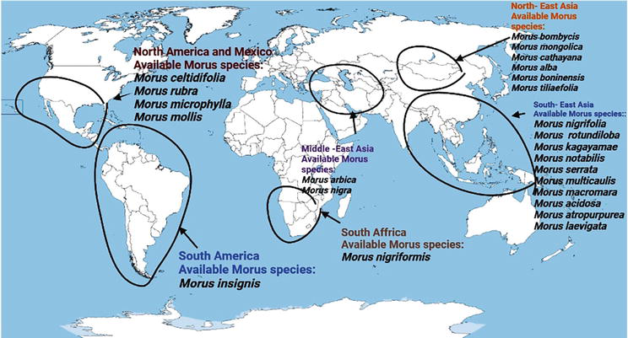

**Fig. 1. Zone- specific species availability and mulberry’s geographic spread(Acharya et al.,2022)**

**3. MORPHOLOGY AND ANATOMY OF MULBERRY WOOD**

Understanding the morphology and anatomy of mulberry wood is essential for various applications, including woodworking, furniture production, and scientific studies related to tree growth and development (Balzano et al., 2024).

The heartwood of the mulberry is golden brown. With the aging of the tree, the colour of the wood becomes medium or reddish brown. Sapwood is pale yellowish white in colour and its Overall appearance is very similar to Osage Orange. It exhibits a straight grain, displaying a consistent medium texture, and possesses a pleasing natural luster. These morphological characteristics make mulberry wood notable for various applications, including woodworking and crafting.

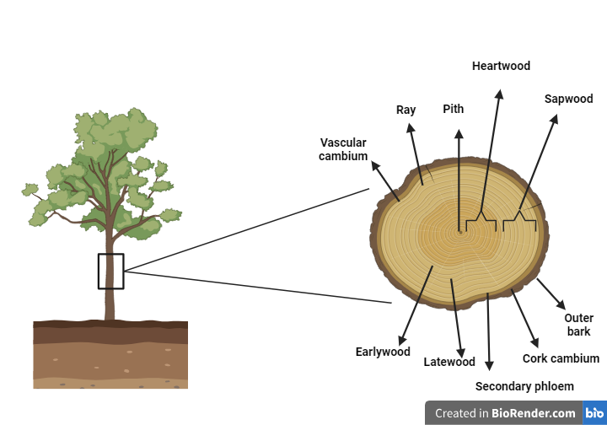

**Fig. 2. Mulberry wood and its dynamic structure**

The transverse section of wood magnified would generally serve as a way of identification and also the anatomy of the wood forms a strong basis for species identification (Howard, 1942). The wood anatomical features of six mulberry genotypes (Selection 1, Thaibeelad, Mysore Local, Selection 1635, Jhoropakari, Triploid 10) were evaluated by Guha and Reddy (2013) in comparison to Victory 1 (V1). To assess the anatomical and chemical properties of mulberry wood, standardized protocols are employed. Anatomical traits such as fibre cell density, lumen diameter, wall thickness, and vessel characteristics are analyzed using scanning electron microscopy (SEM) after ethanol–glycerol fixation, rehydration, and gold coating where as Chemical properties are examined using confocal laser scanning microscopy (CLSM), with cellulose stained by Congo red (514 nm excitation) and lignin visualized through auto fluorescence (405 nm) (Guha and Reddy, 2013). In this study the wood density (*D*w), represents the storage of carbon per unit volume which is crucial for higher woody biomass (Chave et al. 2009). Under this study, they found that HPG (High- performance group) genotypes, notably V1, had a higher level of*D*w (>0.60 gram/cm3) in contrast with Average performance group (APG) and Poor performance group (PPG) genotypes. Scanning electron micrographs revealed uniform-sized fiber cells within a genotype with homogeneously thick cell walls. HPG genotypes exhibited greater FCn (The number of fiber cells), smaller and more closely packed cells, with mean FCd (fiber cell diameter) smallest in Selection1 and highest in Triploid10 and Jhoropakari. Significant *D*L (Fiber cell lumen's diameter) variation ranged from 18.1 μm (Selection1 and Victory1) to 25.2 μm (Selection1635). FCLA (Fibre cell lumen’s cross-sectional areas) /FCWA (fiber cell wall thickness), indicative of *Dw*, was lower in HPG than PPG, intermediate in APG (Mysore Local). *V*D (density of xylem vessels) was higher in APG and PPG, lowest in Victory1 (17.6 mm⁻²), correlating inversely with *D*w. Despite lower *V*A (The proportion of stem cross-sectional area occupied by xylem vessels), HPG maintained higher Kh (In situ leaf-specific hydraulic conductance) and ΨL (leaf water potential), possibly due to greater cellulose deposition. HPG genotypes exhibited higher cellulose, while PPG had higher lignin content. The genotypes of HPG mulberries found through coppice rotation trials appear to have a greater biochemical conversion capability, based on their low lignin and cellulose content. Under this study the anatomical investigation of mulberry genotypes revealed significant genotypic diversity in wood characteristics, crucial for biomass productivity. High-performance genotypes exhibited a higher density of fiber cells and greater wood density, which correlated positively with aboveground woody biomass yield. The study found that wood density, stem wood cross-sectional area, and fiber cell number are integral traits for screening mulberry genotypes for enhanced woody biomass productivity. These findings suggest that incorporating these stem wood traits could be beneficial in selecting mulberry genotypes with high biomass yield potential, particularly for short-rotation coppice systems. The anatomical traits, therefore, play a pivotal role in the functional and structural integration of mulberry trees, contributing to their overall growth performance and biomass production.

**Top of Form**Mithilasri et al.(2022) studied 30 mulberry clones in 11 different species collected from Central Sericultural Germplasm Resources Centreand found that the assessment of anatomical properties revealed significant variability among mulberry clones. Fiber length ranged from 692.63 μm (MI-0013) to 961.38 μm (ME-0001), fiber diameter varied from 14.88 μm (ME-0220) to 20.20 μm (MI-0663), and the Runkel ratio showed differences from 0.68 (MI-0013) to 1.44 (MI-0109). This analysis underscores the considerable potential of mulberry as a novel and alternative genetic resource for the paper industry.

Karami et al. (2010) studied the wood anatomy of two native Iranian mulberry species, white mulberry (*M. alba* L.) and black mulberry (*M.nigra* L.), to identify anatomical differences and similarities.Under this investigation, they found that the primary similarities between these two species are paratracheal parenchyma, which can be either aliform confluent or vasicentric; apotracheal as marginal bands; vessel solitary in irregular clusters or short radial multiples; fiber nonseptate; rays uniseriate and multiseriate type; rhombic crystals found in rays and sometimes in the parenchyma. The main differences they founded that *Morus alba* exhibits a semi-ring porous vessel distribution, while *Morus nigra* has fewer vessels and includes aliform parenchyma. Despite these distinctions, the critical features of both species are comparable. Therefore, it is advisable to consider both of these species for crafting musical instruments.

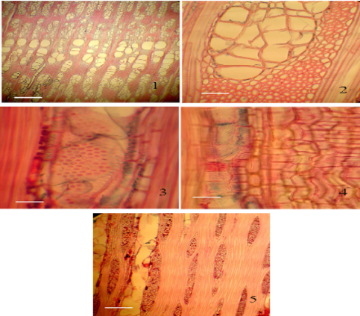

**Fig. 3. Sections of *M. alba* under a microscope (Karami et al., 2010)**

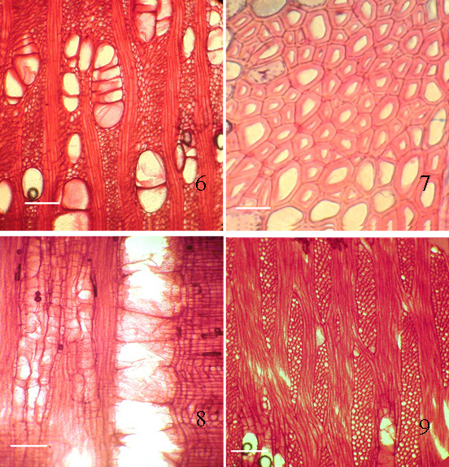

**Fig. 4. Sections of *M. nigra* under a microscope (Karami et al.,2010)**

Akkemik et al., (2019) also studied the anatomical features of mulberry which are used as a pole in the ancient djemevies in Onar Village, Malatya-Arapgir district. Under this study they found that in the earlywood, the wood ring has distinct porous and the boundary of the tree ring is clear. The vessels in the earlywood are arranged in 2-4 rows, either alone or in radial groups of up to 4 vessels. The latewood vessels are small in diameter and generally found in clusters. The axial parenchyma is dense and located around the vessels. The perforation plates are simple in structure. The height of the rays can reach up to 60 cells, and their width can extend up to 7 cells. The rays have different cell types, with the body ray cells lying flat and 1-2 rows of upright or squared cells. Crystalline structures are visible within the ray cells (Schweingruber, 1988; Akkemik and Yaman, 2012). With such unique anatomical features mulberryholds an immense strength and shows more resistant to decay and stand as one of the popular trees in the construction of such historic buildings during ancient time.

**4. MULBERRY WOOD QUALITY PROFILING AND ITS VARIOUS IMPORTANT PROPERTIES FOR INDUSTRIAL APPLICATION**

Wood quality profiling involves a systematic assessment of various wood properties, including density, moisture content, mechanical strength, and chemical composition.Recognizing the biological, hygroscopic, and anisotropic characteristics of wood is essential for optimizing its utilization, and fostering advancements in wood science, technology, and industry, as these traits collectively render wood a heterogeneous material (Duquette,2021). Mulberry wood exhibits notable mechanical properties that make it valuable for various woodworking applications. Renowned for its moderate to high density, mulberry wood boasts commendable strength and hardness, making it suitable for projects requiring durability and resistance to wear. The wood’s stiffness, characterized by a moderate to high modulus of elasticity, contributes to its stability under different loads. Mulberry wood is generally considered easily workable with both hand and machine tools, allowing for precise shaping and finishing. While its durability may vary among different species, mulberry wood is commonly utilized in indoor applications due to its relatively lower resistance to environmental factors. Whether employed in furniture crafting or artistic woodworking, mulberry wood’s mechanical properties make it favorable and a valuable choice for a range of projects. These parameters collectively define the overall quality and utility of the wood.

The quantitative characteristics of wood and how it responds to outside factors other than applied forces are referred to as physical characteristics. (Winandy, 1994). The mechanical properties of wood, such as its strength and elastic qualities that indicate resistance to deformation and applied loads, are mostly determined by the density of wood and its moisture content (Ali, 2011).In the context of modeling modulus of rupture and elasticity, compression strength, and even hardness in softwoods, density typically accounts for 60% to 98% of the observed variations (Tsoumis, 1991). The water content of wood affects its strength, density, shrinkage, and resistance to insect and, fungal damage and in general, the moisture content has a significant impact on the strength properties of timber (Latib et al.,2014).The suitability of wood for specific uses is determined by characters such as density and length of the fiber, while the pulping industry utilizes markers including basic density,length of the fiber, thethickness of cell wall, whiteness, and extractive grade to assess wood quality for diverse industrial operations (Igartua et al., 2003).

A study has been conducted on the assessment of the drying process.The assessment of the drying procedure showed that the mulberry, hybrid plane, and pagoda tree species all had moisture contents of about 45% when wet and that the pagoda tree had the highest density of all the species examined, at 0.86 gcm-3(Velázquez-Martí et al., 2014).The physical properties of *Morus nigra* or black mulberry, were assessed by (Walia, 2013),who noted that for *Morus nigra*, the basic density is 0.50. *Morus nigra* was found to have fibers that are 1.28 mm in length, 0.023 mm in diameter, 0.0142 mm in lumen width, and 0.0036 mm in thickness which indicate that mulberry is hardwood in nature.Noticeably, a crucial factor in determining the quality of raw materials for pulping is density. Improved utilization of digester capacity is facilitated by high densities. (Rahman and Jahan, 2013) conducted a study to evaluate the mulberry plant as a pulping raw material. In this study, they found that a twelve-month-old mulberry plant's wood density was somewhat higher (0.41gcm-3) than that of an eight-month-old plant (0.39gcm-3). The wood density was shown to rise with the age of the tree. Thedensity of the wood of mulberry plant is marginally higher than that of the *Trema orientalis*, whose stem and branches had densities of 0.368gcm-3 and 0.330gcm-3, respectively (Jahan et al., 2010).

Wood exhibits distinctive chemical properties primarily determined by its composition of cellulose, hemicellulose, and lignin. Cellulose, a complex carbohydrate, provides strength and structure to wood, while hemicellulose, a more branched carbohydrate, contributes to the binding of cellulose fibers. Lignin, a complex polymer, enhances rigidity and acts as a natural preservative, making wood resistant to decay. Extractive compounds, including resins, tannins, oils, and waxes, influence wood's color, scent, and resistance to environmental factors. For a variety of purposes, such as woodworking, building, and the manufacturing of paper and other wood-based products, it is imperative to comprehend the chemical properties of wood. Variations in the chemical composition of different wood species result in a myriad of physical and mechanical capabilities.

Undoubtedly, the rapidly growing mulberry is abundant in cellulose (57.4%), hemicellulose (16.3%), and lignin (24.6%) (Sharmaand Madan, 1994).Rahman and Jahan (2014) investigated the chemical composition of the mulberry plant at two different ages, 8 months and 12 months. The findings indicated that the mulberry plant exhibited moderate levels of holocellulose, Klason lignin, acid-soluble lignin, and pentosan across the two age groups respectively. Additionally, the plant displayed a one percent NaOH solubility of 23.1±0.4% to 21.7±0.3% and A-B extractive percentage of 2.57±0.02% to 2.37±0.02% for the 8 to 12-month-old mulberry plants. The ash content in the mulberry plant was consistently 2%, and the study found no significant impact of plant age on the ash content.

**Table 1. Chemical composition of mulberry plant of two different ages**

|  |  |  |
| --- | --- | --- |
| **Parameters** | **8 months old mulberry** | **12 months old mulberry** |
| Holocellulose (%) | 72.2±1.4 | 72.3±1.3 |
| Klason lignin (%) | 23.0±0.4 | 21.3±0.3 |
| Acid soluble lignin (%) | 3.0±0.06 | 2.0±0.04 |
| Pentosan (%) | 18.8±0.3 | 18.3±0.3 |
| 1 % NaOH solubility (%) | 23.1±0.4 | 21.7±0.3 |
| A-B Extractive (%) | 2.57±0.02 | 2.37±0.02 |
| Ash (%) | 2.0±0.03 | 2.01±0.02 |

***\*Source*:** Rahman and Jahan (2014)

In order to determine the chemical composition of *Morus nigra* wood Walia (2013) conducted research on wood powder of *Morus nigra*and foundan ideal range of ash content, solubility in cold water, hot water,one percent NaOH, alcohol-benzene,Ether, pentosan content,α-cellulose content, holocellulose content and lignin in *Morus nigra*. These findings indicated that *Morus nigra* is a more favorable plant for producing pulp of high quality.

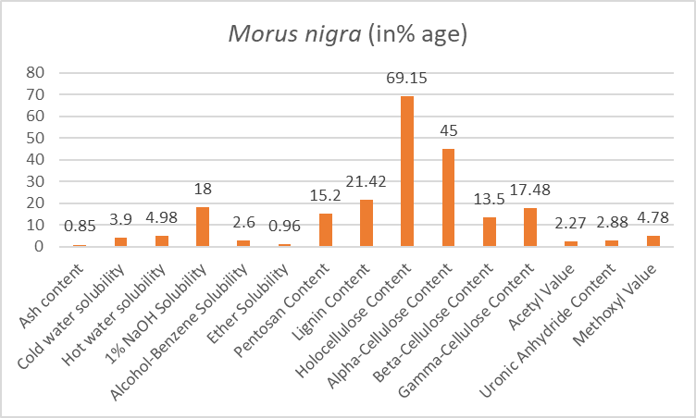

**Fig. 5. Chemical analysis data (O.D. % basis) for wood dust from *Morusnigra*(Walia, 2013)**

The thermochemical properties of wood refer to its characteristics and behavior when subjected to heat or chemical processes. As it is already discussed wood is a complex organic material primarily composed of cellulose, hemicellulose, and lignin and each shows distinct responses to temperature changes. When exposed to heat, wood undergoes a series of transformations; including dehydration, devolatilization, and pyrolysis, releasing volatile compounds such as water vapor, gases, and tar. The energy content of wood is also a crucial thermochemical property, as it determines its suitability as a fuel source. Additionally, the combustion process involves the reaction of wood with oxygen, producing heat, carbon dioxide, and ash. Understanding the thermochemical properties of wood is crucial in various applications, especially in the context of biomass utilization for energy production. The combustion or pyrolysis of wood can be optimized by considering these properties, influencing factors like temperature, pressure, and residence time. Additionally, studying the thermochemical properties of wood is essential for assessing its suitability for different industrial processes, such as bioenergy production and the manufacturing of bio-based products.

Woodchips, charcoal, and firewood are the main products of forest biomass, considereda renewable energy source that is utilized in homes, businesses, and agriculture. (Simioni et al., 2017) The fuel value of wood biomass is mostly determined using heating value, which is widely accepted as one of the factors used to evaluate fuels. Biomass loses most of its heating value when it becomes moist. The heating value is directly influenced by two significant parameters: extractive content and ash. Parts of plants with high levels of ash content are not much desired as fuel, while those with a high extractive content are more appealing (Demirbas, 2002).

According to Sheth and Babu (2009), the red mulberry possesses the lowest moisture content, falling within their indicated range and showing their potentiality to utilize for energy generation. Goswami & Das(2020) explore red mulberry's (*Morus rubra*) gasification potential in a downdraft biomass gasifier, finding ahigher heating value (HHV) of solid biomassof 18.36 MJ/kg which wasmoderately higher compared to sesame (18.06 MJ/kg), Husk pellet of rice (17.28 MJ/kg), cedar (19.30 MJ/kg) and branches of tea (18.50 MJ/kg) (Sheth and Babu, 2009; Yoon et al., 2012; Wang et al., 2007; Dutta and Baruah, 2014). Red mulberry's carbon composition is 45.03%, a little bit exceeding than tea branches (44.43%) (Dutta and Baruah, 2014). Notably, it has the lowest N (Nitrogen percentage in the solid biomass) and S (Sulfur percentage in the solid biomass)compositions. O (Oxygen percentage in the solid biomass) composition (40.75%) surpassing rice husk pellet (37.40%) but slightly lower than sesame (44.87%), cedar (41.70%) and branches of tea (41.90%) (Sheth and Babu, 2009; Yoon et al., 2012; Wang et al., 2007; Dutta and Baruah, 2014). Red mulberry's volatile matter is 85.13%, higher compared to sesame (80.40%), Husk pellet of rice (65.10%), and branches of tea (81.16%), but lower than cedar (Wang et al., 2007). Its fixed carbon content is the lowest at 12.65%, and ash content is 2.21%, higher than cedar (0.40%) but smaller than sesame (3.90%), Husk pellet of rice (9.30%), andbranches of tea (5.48%) (Sheth and Babu, 2009; Yoon et al.,2012; Dutta and Baruah, 2014). This study aims to optimize the efficient utilization of biomass made of dead red mulberry (*M. rubra*) wood for heating, electricity generation, and domestic cooking in underutilized areas. A comparison with the above-mentioned biomasses from previous research underscores the promising energy conversion potential of red mulberry biomass.

Bora et al. (2024) explored the thermochemical properties and gasification potential of three mulberry species (*Morus laevigata*, *Morus nigra,* and *Morus australis*) as renewable energy sources. The analysis revealed favorable characteristics for fuelwood, including low moisture content (8.43%-8.65%), moderate ash content (1.26%-2.00%), and high volatile matter content (81.67%-82.10%). The calorific value and higher heating value fell within ranges (18.04 MJ Kg-1 to 19.87 MJ Kg-1 and 18.73 MJ Kg-1 to 20.64 MJ Kg-1, respectively) suitable for energy generation. Gasification analysis indicated that the syn-gas composition primarily consisted of CO (24.3%-27.9%), H₂ (12.0%-12.7%), CH₄ (2.1%-2.3%), CO₂ (10.2%-10.9%), and N₂ (47.2%-50.7%). The syn-gas calorific value ranged from 5.51 MJ m-3 to 5.97 MJ m-3, with thermal conversion efficiency varying between 59.18% and 62.18%. These findings underscore the potential of mulberry species as sustainable and efficient bioenergy sources.

Wood exhibits a diverse range of mechanical properties that make it a unique and valuable material in various applications.With its unique anisotropy from cellulose fiber arrangement, it exhibits essential mechanical properties such as elasticity, strength (tensile, compressive, shear), and moderate hardness. Its resilience allows deformation under stress and recovery to the original shape. Varying hardness among species influences resistance to wear. These properties make wood ideal for construction, furniture, and diverse applications requiring a blend of strength, durability, and aesthetic appeal, emphasizing the need for a nuanced understanding of engineering and design.

Talaei and Yaghoobi (2009) carried out research to look into the effects of hydrothermal modification on the mechanical and physical characteristics of mulberry wood, utilized in Iranian musical instruments. Samples of mulberry wood measuring 20×20×360 mm were placed in a stainless-steel cylinder filled with water and treated for 1 to 5 hours at temperatures of 100, 120, and 140ºC. Following a two-month conditioning period at room temperature and relative humidity, mechanical and physical attributes were assessed. Water absorption, swelling, modulus of elasticity, bending strength (MOR), and impact resistance were evaluated in both treated and untreated samples in the study. According to the results, wood that had been hydrothermally treated had much greater dimensional stability than those that had not been treated. At high temperatures, bending strength values were decreased, but at low temperatures, there was no significant decrease. Hydrothermally treated samples showed a considerable decrease in impact resistance values compared to the control, but an increase in modulus of elasticity. The results indicate that low-temperature hydrothermal treatment of mulberry wood can successfully regulate dimensional variations in a range of climates without significantly compromising its mechanical properties.

Mechanical and acoustical properties of mulberry species have been studied rarely and not investigated properly (Mansour and Behzad, 2010). Mohebbyet al.(2007) conduct an experiment to explore the impact of hydrothermal modification on the musical properties of mulberry wood. Samples sized 20×20×360 mm were oven-dried for density determination, and sound properties were assessed using vibration techniques. Subsequently, samples were treated at 100, 120, and 140 ºC for 1 and 5 hours, followed by re-oven drying. Specific Young's modulus, shearing modulus, tangent δ, quality factor (Q), and density were measured before and after treatment. They concluded that the quality factor and particularly Young's modulus increased, but there were no discernible effects on tan δ. The hydrothermal treatment lowered swelling and water absorption. Acoustic Conversion Efficiency (ACE) was marginally decreased in treated samples by the hydrothermal treatment.

**5. INDUSTRIAL UTILIZATION OF MULBERRY WOOD**

The industrial utilization of mulberry wood encompasses a diverse range of applications, which highlights its importance as a significant raw material. Mulberry wood, with a fine grain and eye-catching appearance, makes it favorable for making high-quality furniture, helping to create items that are both aesthetically pleasing and long-lasting. Due to its solidity and acoustic qualities, the wood is used in the building of musical instruments, improving the quality of parts like pegs and fingerboards. As industries increasingly recognize the diverse scopes of mulberry wood, its importance grows not only for its aesthetic appeal but also for its contribution to the longevity and functionality of products across woodworking, craftsmanship, and various industrial sectors.

Exploiting the potential of sericultural end products in diverse sectors such as human and animal nutrition, soap production, glycerine extraction, pharmaceuticals, bio-gas generation, organic manure production, chlorophyll and carotene extraction, phytol, n-triacontanol, pectin isolation, fiber production, papermaking, and artisanal crafts is crucial. The multifaceted utility extends to using mulberry shoot extract as an adhesive, branches for crafting baskets, toys, and sports goods, bark for creating artificial leather, trunks in furniture production, wood ash as a disinfectant, latex for skin ointments, fruits for fabric dye, and roots for therapeutic applications. This diverse array of applications underscores the potential for value addition, highlighting the prospect of maximizing the benefits derived from the various components of the mulberry tree in different industrial and creative endeavors (Angadi et al., 2013).

**Fig.6. Multifarious industrial utilization of mulberry wood**

Alcohol, benzene, lignin, hemicelluloses like pentosan and galactan, crude proteins, nitrogen, and ash levels of mulberry indicate their use in a range of industries (Aruga, 1994). The paper industry in China and Europe uses the stem bark, young and small pruned branches of mulberry while the digested and bleached bark of mulberry is utilized to extract a soft white fiber for use in textile industries (Angadi et al., 2013). Moreover, adhesives, industrial chemicals, biodegradable polymers, vinegar, chipboards, fibers, charcoal, and premium activated carbon were among the several products that were extracted from the chemical constituents of shoots, wood, and bark of mulberry (Angadi et al., 2013).

Mulberry branches have a substantially higher unit of combustion value, thus can be used as an excellent source of biomass fuel (Wani et al., 2017) such as other tree species and agricultural leftover. Mulberry wood is highly valued for crafting sports goods due to its remarkable elasticity and flexibility, and its wood pieces are employed in antiseptic treatments, with comparable resistance, strength, and hardness to teak wood (Buhroo et al., 2018). Due to its flexibility and elasticity, the wood can be used to make a variety of items, including picker's arms, bobbins, tennis, badminton, squash rackets, cricket bats, and stumps (Angadi et al., 2013). Because of its extensive smoothness, high strength, low weight, and lack of defects, the wood is suited for use in the construction of boats and ships (Singhal et al., 2001; Srivastav et al., 2007;Suryanarayana, 2002). Among all these,the wood of mulberry is also utilized in plywood, toy- making, tanning, and color making industries. Its wood is utilized for crafting tea boxes and toys and also serves a as suitable material for low-grade plywood, panelling, carving, and turnery, while its extracts are deemed appropriate for tanning and coloring applications (Buhroo et al., 2018).

Ferrandez-Villena et al.(2022) found that particleboards made from pruning residues of mulberry wood (*Morus alba* L.) exhibited promising thermal and acoustic properties, making them a viable and environmentally friendly alternative to conventional non-biodegradable insulation materials such as polyurethane foam, polystyrene, rock wool, fiberglass, etc.Thus, mulberry wood can be effectively used as an alternative material for making particleboards in particleboard manufacturing industries.

The Wood of mulberry also gains its importance in wine industries.Barrels crafted from mulberry wood, known for its exceptional aromatic qualities, impart a striking sweet aroma and create spirits with intense color. According to Flamini et al. (2007), the wood extract of mulberry exhibits a minimal concentration of volatile benzene compounds, suggesting its potential suitability for the wine aging process. Two mulberry species, *M. alba* L. and *M. nigra* L. have been proposed as potential new woods in wine aging (Martinez-Gil et al., 2018).

Mulberry wood holds significant importance in the musical instrument-making industry, particularly in crafting string instruments valued for their resonance and tonal qualities. Iran has been using string instruments since 970 B.C. The white mulberrywood is specifically used to make the long-necked lutes Tar, Setar, and Kamancheh(Golpayegani et al., 2011). The evidence of using white mulberry wood was also found in Japan for manufacturing a Japanese short- necked musical instrument (lute) called Biwa (Yoshikawa, 2007).

**6. CHALLENGES AND FUTURE PROSPECTIVE**

The utilization of mulberry wood presents a set of challenges and holds fascinating future prospects. One notable challenge is the limited size and irregular shapes of mulberry trees, making it challenging to obtain standardized pieces for manufacturing purposes. The wood's hardness can also pose difficulties for traditional woodworking techniques, necessitating specialized tools and skills. Additionally, mulberry wood is susceptible to warping, splitting,andinsect infestations, which canaffectitsoverallqualityand durability. Unfortunately, the white mulberry tree has exhibited potential toxicity, unrelated to its fruit but associated with its wood. Multiple studies have explored the link between extended exposure to white mulberry wood and diverse health issues, including headaches, nausea, vomiting, coughing, shortness of breath, allergic reactions, and skin irritations. However, people exposed to white mulberry wood and dust for extended periods, such as those employed in the musical instrument manufacturing industry, appeared to experience these symptoms for less than 24 hours (Golpayegani et al., 2014).However, looking ahead, there is potential for advancements in sustainable forestry practices to address the slow growth rates and limited availability of mulberry trees. Researchers and industries may explore innovative techniques to enhance the wood's workability and resistance to environmental factors. Mulberry wood's unique aesthetic qualities, such as its attractive grain patterns, could drive increased demand in niche markets, fostering a renewed interest in its utilization. Furthermore, ongoing research into the development of engineered wood products and the exploration of alternative uses, such as in the production of bio-based materials, could open up new avenues for mulberry wood in the future. Balancing these challenges with innovative solutions could position mulberry wood as a valuable and sustainable resource in the upcoming years.

**7. CONCLUSION**

Based on the comprehensive review of mulberry wood's properties and applications, it is evident that mulberry wood is a versatile and valuable resource for various industries. Its unique combination of mechanical, physical, thermochemical, and chemical properties makes it suitable for traditional uses such as furniture and musical instrument making, as well as modern applications like bioenergy production and advanced materials development. The potential of mulberry wood in sustainable industrial applications is significant, and further research and innovation could enhance its utilization and contribute to meeting the growing demand for renewable resources. The study underscores the importance of characterizing and profiling identified mulberry genetic clones to maximize their industrial utility, ensuring a sustainable and profitable future for mulberry wood applications.

**Disclaimer (Artificial intelligence)**

Option 2:

Author(s) hereby declare that generative AI technologies such as Large Language Models, etc. have been used during the writing or editing of manuscripts. This explanation will include the name, version, model, and source of the generative AI technology and as well as all input prompts provided to the generative AI technology

Details of the AI usage are given below:

1. BioRender Software Version 04 is being used for generating the images.

**REFERENCES**

1. Top of Form

Abd Latib, N., Kasim, N. S. M. T. J. (2014): Physical and chemical properties of Kelempayan (*Neolamarckia Cadamba Sp.*) wood. - International Journal of Latest Research in Science and Technology3(6): 215-219.

Acharya, R., Bagchi, T., Gangopadhyay, D. (2022): Mulberry as a Valuable Resource for Food and Pharmaceutical Industries: A Review. - CBS Publishers & Distributors Pvt. Ltd, 588p.

Akkemik, Ü., Yaman, B. (2012): Wood anatomy of Eastern Mediterranean species. - Kessel Publishing House, Germany.

Akkemik, Ü., Zencirkaya, A., Kaygusuz, İ. (2019): Identification and evaluation of the wood materials used in two historical djemevies in the village of Onar (Arapgir, Malatya). - Eurasian Journal of Forest Science 7(1): 40-53.

Ali, A. C. (2011): Physical-mechanical properties and natural durability of lesser used wood species from Mozambique. – Ph.D. Thesis, Swedish University of Agricultural Sciences, Uppsala, Sweden.

Angadi, B. S., Reddy, R. M., Sivaprasad, V. (2013): Scope of Product Diversification and Value Creation in Indian Sericulture Industry. - Journal of engineering, computers and Applied Sciences 2(5): 33-39.

Aruga, H. (1994): Principles of Sericulture. – CRC Press (1st ed.), 358-365pp.

Balzano, A., Merela, M., De Micco, V. (2024): Advances in wood anatomy: Cutting-edge techniques for identifying wood and analyzing its structural modifications. - Forests 15(10): 1802.

Benavides, J. E., Lachaux, M., Fuentes, M. (1994): Efecto de la aplicación de estiércol de cabra en el suelo sobre la calidad y producción de biomasa de Morera (*Morus sp*.). - Árboles y arbustos forrajeros en América Central 2: 495-514.

Bora, N. R., Parthiban, K.T., Brahma, D., Vishnu, M.V.J., Vasanth, V., Rajah, R. A., Krishnan, S. N., Bhatt, M. R., Narzary, P. R., Dhanush, M. (2024): Evaluation of Mulberry species (*Morus spp.*) as a potential source of bioenergy through thermochemical characterization and gasification. – Plant Archives 24 (1): 1125-1132.

Brandis, D. (1906): Indian Trees. - Archibald Constable 7 Co. Ltd, London.

Buhroo, Z. I., Bhat, M. A., Malik, M. A., Kamili, A. S., Ganai, N. A., Khan, I. L. (2018): Trends in development and utilization of sericulture resources for diversification and value addition. - International Journal of Entomological Research6(1): 27-47.

Carrillo, A., Garza, M., Nañez, M. D. J., Garza, F., Foroughbakhch, R., & Sandoval, S. (2011): Physical and mechanical wood properties of 14 timber species from Northeast Mexico. - Annals of Forest Science 68: 675-679.

Chave, J., Coomes, D., Jansen, S., Lewis, S. L., Swenson, N. G., Zanne, A. E. (2009): Towards a worldwide wood economics spectrum. - Ecology Letters 12(4): 351-366.

Christersson, L. (2010): Wood production potential in poplar plantations in Sweden. - Biomass and Bioenergy 34(9): 1289-1299.

Datta, R. K. (2000): Mulberry cultivation and utilization in India. – In: FAO Electronic Conference on Mulberry for Animal Production (*Morus* L). <https://www.fao.org/4/X9895E/x9895e04.htm#TopOfPage>

Demirbas, A. (2002): Relationships between heating value and lignin, moisture, ash and extractive contents of biomass fuels. - Energy Exploration & Exploitation 20(1): 105-111.

Duquette, B. A. (2021): Evaluation of decay effect on tension perpendicular to grain properties of wood*. –* Msc. Thesis, Mississippi State University, Mississippi state.

Dutta, P. P., Baruah, D. C. (2014): Gasification of tea (*Camellia sinensis* (L.) O. Kuntze) shrubs for black tea manufacturing process heat generation in Assam, India. - Biomass and Bioenergy 66: 27-38.

Ferrandez-Villena, M., Ferrandez-Garcia, A., Garcia-Ortuño, T., Ferrandez-Garcia, M. T. (2022): Acoustic and Thermal Properties of Particleboards Made from Mulberry Wood (*Morus alba* L.) Pruning Residues. - Agronomy 12(8): 1803.

Flamini, R., Vedova, A. D., Cancian, D., Panighel, A., De Rosso, M. (2007): GC/MS‐positive ion chemical ionization and MS/MS study of volatile benzene compounds in five different woods used in barrel making. - Journal of Mass Spectrometry 42(5): 641-646.

Gamble, J.S., & Fischer, C.E.C. (1957): Flora of the Presidency of Madras. – Adlard & Son Publishing, London 2, pp 946-958.

Goswami, R., Das, R. (2020): Energy cogeneration study of red mulberry (*Morus rubra*)-based biomass. - Energy Sources, Part A: Recovery, Utilization, and Environmental Effects 42(8): 979-1000.

Guha, A., Reddy, A. R. (2013): Leaf functional traits and stem wood characteristics influencing biomass productivity of mulberry (*Morus spp.* L) genotypes grown in short-rotation coppice system. - BioEnergy Research 6(3): 547-563.

Hooker, J. D. (1885): The Flora of British India (Reprinted). - Bishen Singh Mahendra Pal Singh, Dehradun, India, 491-498p.

Hou, Y. J. (1994): Mulberry breeding. – Ph.D. Thesis, Sericulture Department, Zhejiang Agriculture University, Hangzhou, China.

Howard, A. L. (1942): Studies of the identification of timbers: With a note on the seasoning of wood. – Macmillan & Co. Ltd, London. 110pp.

Igartua, D. V., Monteoliva, S. E., Monterubbianesi, M. G., Villegas, M. S. (2003): Basic density and fibre length at breast height of *Eucalyptus globulus* ssp. *globulus* for parameter prediction of the whole tree. - IAWA Journal 24(2): 173-184.

IWST. 2021: Wood is Good, grow more, Use more. - India wood sector report 2021.

Jahan, M. S., Chowdhury, N., Ni, Y. (2010): Effect of different locations on the morphological, chemical, pulping and papermaking properties of *Trema orientalis* (Nalita). - Bioresource Technology 101(6): 1892-1898.

Kanjilal, U. N., Kanjilal, P. C., De, R. N., Das, A. (1940): Flora of Assam. Vol. IV. Nyctaginaceae to Cycadaceae. – Prabasi Press, Calcutta. 377pp.

Kant, P., & Nautiyal, R. (2020): India timber supply and demand 2010–2030. - International Tropical Timber Organization, 57.

Karami, E., Pourtahmasi, K., Shahverdi, M. (2010): Wood anatomical structure of *Morus alba* L. and *Morus nigra* L., native to Iran. - Notulae Scientia Biologicae 2(4): 129-132.

Machii, H. (1999): A list of genetic mulberry resources maintained at National Institute of Sericulture and Entomological Science. - Misc. Publ. Natl. Seric. Entomol. Sci. (Japan) 26: 1-77.

Mansour, H., & Behzad, M. (2010): An Experimental Study to Find the Acoustic Quality Indicators of Mulberry Wood. – In: ASME International Mechanical Engineering Congress and Exposition 44502: 43-47.

Martínez-Gil, A., del Alamo-Sanza, M., Sánchez-Gómez, R., Nevares, I. (2018): Different woods in cooperage for oenology: A review. - Beverages 4(4): 94.

Mithilasri, M. (2022): Clonal evaluation, wood and leaf quality characterization of mulberry genetic resources. – Ph.D. Thesis, Tamil Nadu Agricultural University, Coimbatore, Tamil Nadu.

Mohebby, B., Yaghoubi, K., Roohnia, M. (2007): Acoustic properties of hydrothermally modified mulberry (*Morus alba* L.) wood. – In: The Third European Conference on Wood Modification, Hill, CAS, Jones, D., Militz, H., Ormondroyd, GA (eds.),pp. 15-16.

Nair, N. C. (1977): Flora of Bushahr Himalayas. - International Bio Science Publishers. Hisar.

Pan, Y. L. (2000): Progress and prospect of germplasm resources and breeding of mulberry. - Acta Sericologic Sinica 26(Suppl): 1-8.

Pan, Y. L. (2003): Popularization of good mulberry varieties and sericultural development. - Acta Seric Sin 29 (1): 7-13.

Parkinson, C. E. (1923): A Forest Flora of the Andaman Islands (Reprinted). - Bishen Singh Mahendra Pal Singh, Dehradun, India.

Parthiban, K. T., Fernandaz, C. C. (2017): Industrial Agroforestry-Status and developments in Tamil Nadu. - Indian journal of Agroforestry 19(1): 1-11.

Rahman, M. M., Jahan, M. S. (2014): Evaluation of mulberry plant as a pulping raw material. - Biomass Conversion and Biorefinery 4: 53-58.

Samy, A., Meena, R.K. & Kumari, T. (2023): Growth of Wood Based Industry through Industrial Agroforestry in India. - The Agriculture Magazine 1(10): 131-134.

Schweingruber, F. H. (1990): Anatomy of European woods. – Paul Haupt, Bern. 800pp.

Se Golpayegani, A., Brémaud, I., Gril, J., Thevenon, M. F., Arnould, O., Pourtahmasi, K. (2012): Effect of extractions on dynamic mechanical properties of white mulberry (*Morus alba*). - Journal of wood Science 58(2): 153-162.

Se Golpayegani, A., Thévenon, M. F., Gril, J., Masson, E., Pourtahmasi, K. (2014): Toxicity potential in the extraneous compounds of white mulberry wood (*Morus alba*). - Maderas. Ciencia y tecnología 16(2): 227-238.

Sharma, S., Madan, M. (1994): Potential of mulberry (*Morus alba*) biomass. - Journal of Scientific and Industrial Research 53(9): 710–714.

Sheth, P. N., Babu, B. V. (2009): Experimental studies on producer gas generation from wood waste in a downdraft biomass gasifier. - Bioresource technology 100(12): 3127-3133.

Simioni, F. J., Moreira, Á. P., Magalhães, J. M., Fachinello, A. L., Cesar de Almeida Buschinelli, C., Ieda da Silveira Folegatti Matsuura, M. (2017): Evolução e concentração da produção de lenha e carvão vegetal da silvicultura no Brasil. - Ciência Florestal27(2): 731-742.

Singhal, B. K., Dhar, A., Sharma, A., QADRI, S. H., Ahsan, M. M. (2001): Sericultural by-products for various valuable commercial products as emerging bioscience industry. - Sericologia 41(3): 369-391.

Srivastav, P., Chakrabarti, S., Khan, M. (2007): Integration of sericulture with allied industries in India. - Sericologia 47(2): 117-143.

Suryanarayana, N. (2002): Mulberry and its therapeutic values. - Indian Silk 41(7): 11-13.

Talaei, A., Yaghoobi, K. (2009): Physical and mechanical properties of hydrothermally modified mulberry wood. - The International Research Group on Wood Preservation, IRG/WP 9: 24-28.

Tsoumis, G. (1991): Science and technology of wood: Structure, properties, utilization. - Van Nostrand Reinhold, New York 115.

Tutin, G. T. (1996): *Morus* L. - In: Flora Europa, Psilotaceae to Platanaceae, Tutin, G.T., Burges, N.A., Chater, A.O., Edmondson, J.R., Heywood, V.H., Moore, D.M., Valentine, D.H., Walters, S.M., Webb, D.A. (eds) Cambridge University Press, Australia, 2nd ed., Vol. 1.

Vavilov, N. I. (1951):  *The origin, variation, immunity and breeding of cultivated plants* (Vol. 72, No. 6, p. 482). LWW.

Velázquez-Martí, B., Sajdak, M., López-Cortés, I., Callejón-Ferre, A. J. (2014): Wood characterization for energy application proceeding from pruning *Morus alba* L., *Platanus hispanica*Münchh., and *Sophora japonica* L. in urban areas. - Renewable Energy 62: 478-483.

Walia, Y. K. (2013): Chemical and physical analysis of *Morus nigra* (Black mulberry) for its pulpability. - Asian Journal of Advanced Basic Sciences 1(1): 40-44.

Wang, Y., Yoshikawa, K., Namioka, T., Hashimoto, Y. (2007): Performance optimization of two-staged gasification system for woody biomass. - Fuel Processing Technology 88(3): 243-250.

Wani, M. Y., Mir, M. R.,Baqual, M. F., Ganie, N.A., Bhat, Z. A., Ganie, Q. (2017): Role of mulberry tree. – The Pharma Innovation Journal 6(9): 143-147.

Winandy, J. E. (1994): Wood properties. - In: Encyclopedia of Agricultural Science, Arntzen, C. J. (ed.) Academic Press. San Diego, CA. 4: 549- 561.

Yoon, S. J., Son, Y. I., Kim, Y. K., Lee, J. G. (2012): Gasification and power generation characteristics of rice husk and rice husk pellet using a downdraft fixed-bed gasifier. - Renewable Energy 42:163-167.

Yoshikawa, S. (2007): Acoustical classification of woods for string instruments. - The Journal of the Acoustical Society of America 122(1): 568-573.

1. Top of Form

Top of Form