***In Vitro* Evaluation of The Effectiveness of Commonly Used Fungicides Against *Phytophthora Colocasiae* in Ghana**

**Abstracts**

Study to determine the percentage inhibition and radial mycelial growth of five selected fungicides including Carbendazim, Mancozeb, Chemoliette (forsetyl-aluminium), Agro Comet (metalaxyl + copper (1) oxide) and TOPS-M (Methylthiophanal) at different concentrations (100, 200, 300, 400, and 500 ppm) were evaluated against *Phytophthora Colocasia*, the causal organism of the taro leaf blight disease, in vitro. The aim of the study was to identify the type of fungicide with the rate or concentration that can best be used in the management of the taro leaf blight disease caused by *P. colocasiae*. All the five fungicides showed different effect against the fungal pathogen (*Phytophthora* *Colocasia*) but Chemoliette (Forsetyl-aluminium) and Agro Comet (metalaxyl + copper (1) oxide) were the most effective at the different concentrations, especially from 300 ppm to 500 ppm. The two fungicides also recording the highest percentage inhibitions of 63.59% and 53.88% respectively and can therefore be combine with other management strategies to manage the disease effectively.

**Keywo*rds****Taro*, *, Fungicides, Mycelial, Radial, Inhibition*

**Introduction**

Taro (Colocasia esculenta (L.) Schott) is a staple crop appreciated by millions of people from developing countries (Mishra et al. 2008). It is particularly cultivated in Ghana, Nigeria and Cameroon (Bandyopadhyay et al. 2011, Ackah et al. 2014). The crop is cultivated in almost every part of the country, making it one of the most important food security crops (Ackah et al. 2014). All parts of the plant including corm, cormels, rhizome, stalk, leaves and flowers are edible and contain abundant starch (Omane et al. 2012). The production is however limited by the taro leaf blight disease, caused by *Phytophthora* *colocasia, which was first detected in Ghana in 2009* (Omane et al. 2012; van der Puije et al. 2015).

Phytophthora colocasiaeis a foliar pathogen which mostly attack the petioles, leaves and sometimes the corms of its hosts. The organism is also an aerial pathogen which form sporangia at the margins of lesions. The shape of the sporangia are ovoid to ellipsoid with a narrow apical plug. The sporangia mostly germinate indirectly under low temperatures, with high relative temperatures producing zoospores that swim for a few minutes after which they encyst and then form germ tubes on the upper surface of infected leaves and petioles. In warmer temperatures, sporangia can germinate directly and form germ tubes, but under most conditions germination is indirect (Brooks, 2005).

The taro leaf blight disease affects the leaves of taro, causing chlorosis and necrosis of the leave blade and eventual collapsing of the petioles (Carmichael et al. 2008) and can also cause a serious post-harvest decay of taro corms (Misra 1997).

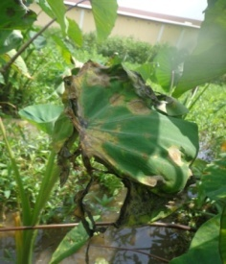

Figure 1: A picture of a taro plant showing symptoms of taro leaf blight disease

The use of ecological approaches such as the removal of infected leaves as a means of management could lead to complete defoliation of the crop with consequent effects on yield (Adams, 1999). Lack of resistant varieties in Ghana is increasingly making chemical control an option to farmers (Omane et al, 2020). Hence the need to evaluate the efficacy of fungicides against taro leaf blight disease. Meanwhile, Integrated Pest Management strategies are gradually leading to reduction in the amounts of chemical used in controlling pests and diseases. Minimum dosages of chemicals (fungicides) for controlling diseases could therefore be determined and incorporated into IPM programs, since high dosage can have effect on the environment and can often lead to resistance development. Residues can end up in run-off water into river bodies causing environmental pollution. The performance of minimum doses is thus needed and laboratory experiments should be carried out to ascertain their effectiveness before field trials are allowed.

It is therefore important to identify fungicides that are effective in managing the disease in Ghana. This research therefore evaluated the efficacy of some fungicides in controlling growth of *P. colocasiae* in vitro.

**MATERIALS AND METHODS**

**Study Location**

The experiment was conducted at the Plant Pathology Laboratory of the School of Agriculture, University of Cape Coast, Ghana.

**Isolation and culture of the Pathogen (*P. colocasiae*)**

The *P. colocasiae* pathogen that was used for this experiment was isolated from a taro leaves showing typical symptom of the leaf blight disease which was collected from a farm in the Fanteakwa district in the Eastern Region of Ghana. The collected leaf was kept in zip lock transparent polythene bag and kept in a cool ice chest to avoid further decomposition and infections during the transportation to the laboratory.

A leaf segment of 1 cm × 1 cm was cut from the lesion margin on the infected leaves. The leaf segments were surface sterilized in 5% bleach for 5 min, washed three times with sterile distilled water, dried and then plated on carrot agar amended with streptomycin in nine (9) centimetres Petri dishes. The carrot agar was used because it is a selective media for isolating Phytophthora. The plates with the diseased tissue were incubated at 28oC in an incubator. Fungal growth from the plated disease tissues were sub-cultured onto freshly prepared PDA in a nine centimetres Petri dish using mycelial plugs, after three days of growth. Sub-culturing was continued until pure cultures of isolates were obtained. All these were done in a laminar flow unit.

**Characterization of Isolates of *P. colocasiae***

Freshly prepared PDA was poured into a 9 cm Petri dish and allowed to solidify. A 1 cm-disc of each pure culture of an isolate was transferred onto the medium, incubated at 28oC and then observed for growth. The isolate was characterized based on its morphology (culture and sporangia characteristics) using methods described by Gallegly & Hong (2008). The mycelial growths of the isolate was compared as well as the sporangia. Data were collected on culture characteristics (colony colour from surface and reverse colour, texture, shape, growth rate, and size) and microscopic characteristic (shape of sporangia, size (length and width), papillate, colour, and pedicel length) using a compound microscope with eye piece ocular and stage micrometer. Radial growth was measured each day with a ruler for each isolate until the plate was completely covered.

**Pathogenicity Testing of *P. colocasiae* Isolate**

The detached leaf method was used to perform this experiment. The second youngest leaves of uninfected or healthy taro leaves were detached and taken to the Plant pathology laboratory of the Department of Crop Science for the experiment. Leaf segments of 5 x 5 cm were cut from the leaf. Three segments were cut from the leaves and then surface sterilized .. Each segment was inoculated with a drop of an isolate from a two weeks old *P. colocasiae* culture with a suspension of 50-70 sporangia in the middle. The suspension was prepared by flooding the Petri dish containing the two-week-old *P. colocasiae* culture with 10 ml of distilled water for 12 hrs. The inoculated leaf segments were arranged in a transparent 40 x 25 cm plastic container with a glass of water kept in it to increase the relative humidity. The containers were then covered and kept under room temperature. The setup was monitored daily for symptoms development. Re-isolation was also done from the symptoms developed on the leaf segments to confirm the pathogenicity of the organism.

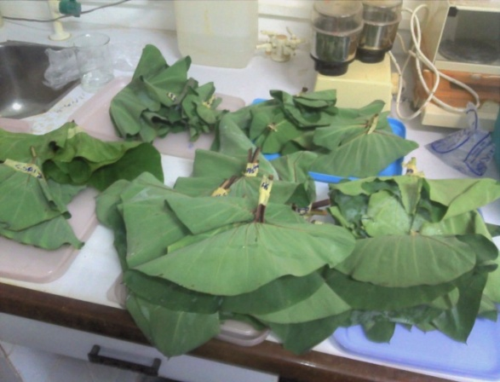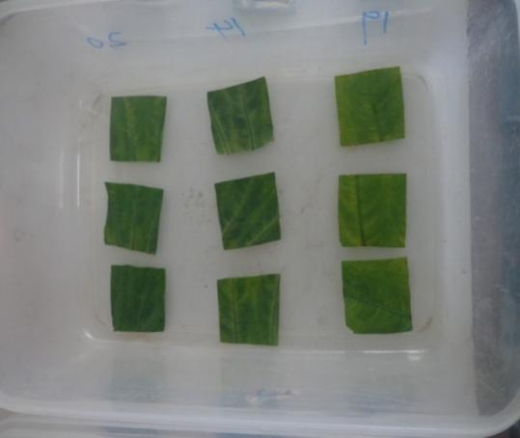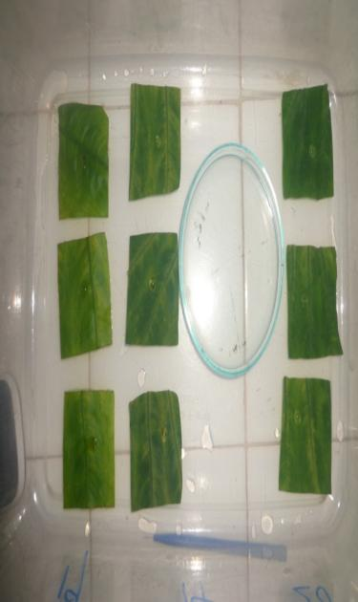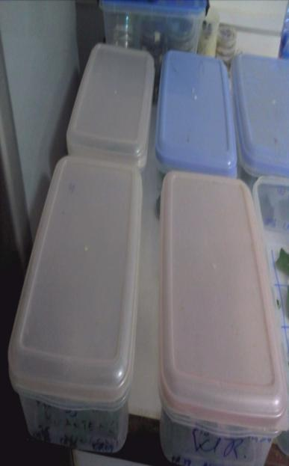

D

C

B

A

Figure 2: Set-up of the detached leaf experiment **A**-Leaves of the varieties collected from the field, **B**-Cut leaf discs arranged in a container, **C**-Leaf discs inoculated in the middle with a drop of water containing a suspension of *Phytophthora colocasiae ,* **D**-The setup covered

**Evaluation of selected fungicides against *P. colocasiae***

A modified bioassay technique of Sharvelle (1961) was employed to evaluate the effects of the five fungicides on mycelial growth of *P. colocasiae* *in-vitro*. The selected fungicides were Carbendazim (carbendazim 500 g kg-1), Mancozeb (mancozeb 80%), Chemoliette (800 g kg-1 forsetyl-aluminium), Agro Comet (120g kg-1 metalaxyl + 600 g kg-1 copper (1) oxide) and TOPS-M (Methylthiophanal).

**Preparation of Fungicides**

Recommended weights of individual fungicides according to the manufacturer for the control of Phytophthora were used . A weight of 0.66 g of Carbendazim, 0.33 g of Chemoliette and Mancozeb, and 0.5 g of Agro comet and TOPS-M were each suspended in 100 ml sterile distilled water to give stock solution of each. Serial dilutions of 100, 200, 300, 400, and 500 ppm concentrations of each fungicide were prepared from the stock solution and used.

**Fungal Inoculation of PDA-amended fungicide**

Each mass of the fungicide concentrations prepared was mixed with 15 ml of PDA. The mixture was poured into sterilized Petri dishes and allowed to solidify. An 0.8 cm -diameter cork borer was used in taking mycelia from the edge of a 10- day old actively growing culture of *P. colocasiae* to inoculate the modified PDA and the culture kept in an incubator at 28 oC ± 1 or 2 oC. *Phytophthora colocasiae* grown on PDA without any fungicides served as the control.

**Effects of fungicides treatments on radial growth of pathogen**

The radial growth of colony was recorded in each experimental plate. Colony diameters were measured in two directions (randomly and at right angles) and adjusted for the diameter of the plug. Measurements were taken each day for 7 days. Percent inhibition was determined using ‘Vincent’s formula’ by Jamadar and Lingaraju (2011) shown below:

I = ( C – T)/C x 100%

Where: I = Percentage inhibition

C = Radial growth in control plate

T = Radial growth in fungicide plates

Radial growth was measured to assess the toxicity of each fungicide concentration. Each set of treatments was replicated three times. The treatments were set up in a completely randomized design (CRD).

**2.9 Data analysis**

Mycelial growth progress curves for *P. colocasiae* response were constructed for each fungicide applied. Mean radial growth and percentage inhibition were subjected to analysis of variance (ANOVA) using GenStat 12th edition. Means were separated using Fisher’s protected least significance difference method (LSD) at a probability level of 5%.

**3. RESULTS**

**3.1 Morphological Characteristics of Isolates**

The isolates had a whitish colony as observed from the surface and from reverse with floccose or cottony texture and a regular margin (Figure 3B).

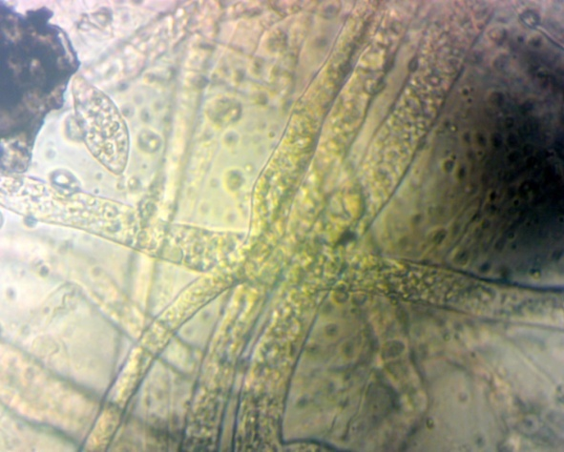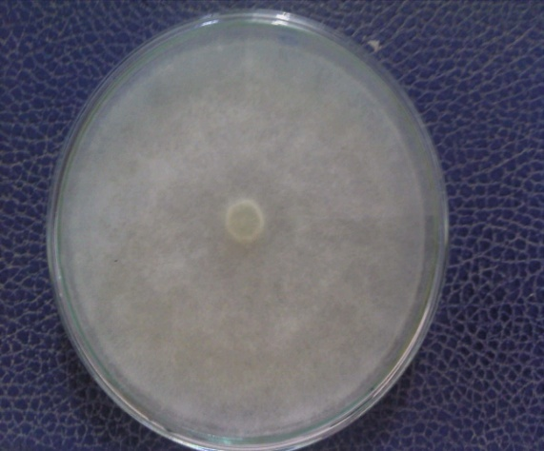

B

A

Figure 3. A- Micrograph of a uniform mycelium of an isolate, B-A 7 day old culture of isolate on media (PDA) at 25° C.

It was observed that all the isolates had mycelia that were uniform, smooth walled, hyaline and aseptate (Figure 3A). The sporangia shapes range from ellipsoid to ovoid in shape with an apical plug observed as semi papillate and non-papillate. The average sporangia length recorded was 36 µm to 61.67 µm with an average sporangia width of between 20 µm to 28 µm. The pedicel length ranges from 3.667 µm to 12.333 µm.

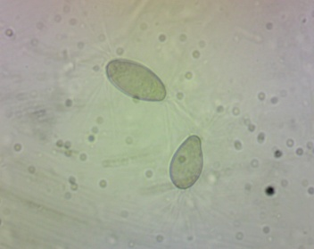

Figure 4: A picture showing sporangia of *P. colocasiae* after 14 days of inoculations on PDA

**3.2 Pathogenicity Test of *P. colocasiae* Isolates**

Figure 5 shows the results of the Pathogenicity test three days after inoculation at 25 oC. Water droplets could be observed in the container as well as brown lesions which had developed at the point of inoculation on the leaf disc and had grown rapidly with a red-brown water droplet oozing it. The fungus re-isolated was also similar morphologically to the one used for the inoculation.

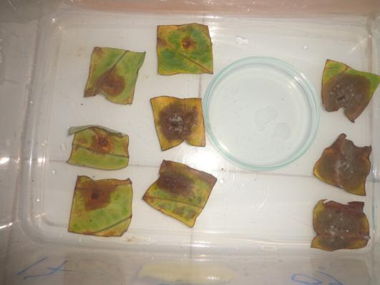

Figure 5. Symptoms developed on taro leaf segments after 3 days of inoculation with *P. colocasia*

**3.3 Effects of Different Rates of Fungicides on Radial Growth of *P. Colocasiae***

From the table below (Table 1) , at 100 ppm and 200 ppm, there was a clear difference (P=0.005) between Carbendazim, which recorded mean radial growth of 5.343 cm at 100 ppm and 4.963 at 200 ppm, and all the other fungicides and the control. At 300, 400 and 500 ppm, there were no significance differences in radial growth on Carbendazim and Agro Comet, but growth was significantly lower than on other fungicides and the control. Radial growth on the control was highest than on all the rates of fungicides used.

Table 1**.** Radial Mycelial growth (cm) of *P.colocasia* on different Concentrations of fungicides

|  |  |  |  |  |  |
| --- | --- | --- | --- | --- | --- |
| Fungicides | Mean Radial Growth (ppm) | | | | |
| 100 | 200 | 300 | 400 | 500 |
| Control | 7.843 a | 7.843 a | 7.843 a | 7.843 a | 7.843 a |
| TOPS-M | 7.847 a | 7.827 a | 7.820 a | 7.797 a | 7.320 a |
| Mancozeb | 7.690 a | 7.287 a | 7.570 a | 7.077 a | 6.833 a |
| Chemoliette | 7.570 a | 7.187 a | 7.333 a | 6.903 a | 6.753 a |
| Agro Comet | 7.117 a | 6.827 a | 5.100 b | 4.433 b | 3.993 b |
| Carbendazim | 5.343 b | 4.963 b | 4.737 b | 4.303 b | 2.290 b |
| LSD | 1.735 | 1.758 | 1.678 | 1.723 | 1.806 |

Table 1, presents the mean radial growth of *P. colocasiae* mycelia on PDA amended across concentrations of selected fungicides. The least mean radial growth of 4.668 cm was recorded for Carbendazim at the end of the study, but was not significantly different (P<0.005) from that recorded for Agro Comet (5.153 cm). Growth was significantly higher on the other fungicides, with TOPS-M and the Control having the highest, 7.8 and 7.3 respectively.

Figure 6. Mean Radial Mycelial Growth of *P.colocasiae* on PDA Amended with Different Fungicides

**3.5 Percentage Inhibitions of Different Fungicides on the Growth of**

***P. colocasiae.***

From Figure 7, Carbendazim had the highest percentage inhibition of 63.59% followed by Agro Comet (53.88%), Mancozeb (31.40%), Chemoliette (23.47%), and TOPS-M (3.03%). The percentage inhibition of all these fungicides were significantly different (P=0.005) from each other with TOPS-M being the least effective.

Figure 7. Percent inhibition of mycelial growth of *P. colocasiae* on fungicides-amended PDA

**DISCUSSIONS**

The pathogen isolated from the leaf tissues on PDA at 25°C appeared whitish on both the surface and reverse. The mycelia of all were hyaline and uniform when observed under a compound microscope. The sporangia shape varied from ellipsoid to ovoid with some being semi-papillate and others not having papillae (non-papillate). All the isolates easily shed their sporangia from the sporangiophores (caduceus). Typically, *P*. *colocasiae* is characterized by the production of ovoid, ellipsoid, or fusiform, semi-papillate sporangia that are caduceus and ranges in length from 45 to 75 µm x 25 to 37 µm, with a medium pedicel length of about 12 µm long, where less than 5 µm is considered short, 5-20 µm is medium and greater than 20 µm is considered long (Gallegly, & Hong, 2008 and Brooks 2005). This indicates that, the isolates are identified as *P. colocasia,*. The fact that all the leaf discs showed symptoms of TLBD three days after inoculation during the Pathogenicity test suggests that *P. colocasiae* are the causal agents for the disease in these districts. The symptoms were similar to those found on the leaves in the field. This description is the same as observed by Ackah et al., (2015).

In an experiment to find effective fungicides against *P. colocasiae*, all five fungicides showed differences in their effectiveness against the pathogen. Higher concentrations of each fungicide inhibited to a certain degree, radial growth in all the plates. Carbendazim (carbendazim) and Agro Comet (Metalaxyl and Copper) were identified to be most effective. Carbendazim was effective at all the concentrations used (100 ppm to 500 ppm) but Agro Comet became effective from 200 ppm to 500 ppm. The two fungicides (Carbendazim and Agro Comet) were equally effective from 300 ppm to 500 ppm .

Again, though Carbendazim and Agro Comet were most effective in inhibiting the growth of *P. colocasiae*, Mancozeb and Chemoliette (Fosetyl Aluminum) showed no differences in their ability to inhibit growth. TOPS-M (Methylthiophanol) was however not effective at all since it was not able to inhibit the growth of *P. colocasiae* .

The efficacies of the active ingredients of the various fungicides may account for their effectiveness against the pathogen. Carbendazim is a systemically active benzimidazole fungicide that inhibits the synthesis of ȕ-tubulin. It has been reported to be effective in controlling most plant pathogens. Lopez-Herrera & Zea-Bonilla (2006) in their research to determine the effects of benomyl, carbendazim, ﬂuazinam and thiophanate methyl on white root rot of avocado observed a 97% growth inhibition by carbendazim. Mathivanan & Prabavathy (2007) also reported of the inhibition of mycelial growth by Carbendazim on *Altenaria helianthi* in their research to determine the effect of carbendazim and mancozeb combination on Alternaria leaf blight and seed yield in sunflower (*Helianthus annus* L.). It is therefore not surprising that it exhibited great efficacy on *P. colocasiae*. Agro Comet is a combination of metalaxyl and Copper (1) oxide. These active ingredients (Metalaxyl and Copper) have been reported to be effective on *P. colocasiae*. Copper based fungicides release copper ions from copper deposits, which provide residual protection against plant pathogens (Noyce et al., 2006; Mehtar et al., 2008) whereas Metalaxyl based fungicides inhibit uridine incorporation into RNA and specific inhibition of +RNA synthesis (Sukul and Spiteller, 2000). The combined effect of metalaxyl and copper could have contributed to the efficacies recorded. This confirms the report by Fullerton and Tyson (2004) that successful control of taro leaf blight is possible with copper and metalaxyl. Misra (1996) and Jackson (1999) in their studies have demonstrated the effectiveness of metalaxy and Copper oxychloride in controlling TLBD in field or *in vitro*. Though the percentage inhibition of Carbendazim and Agro Comet are not as high as observed by Lopez-Herrera and Zea-Bonilla (2007), they can be integrated with other control strategies for a successful management of the disease.

**CONCLUSION**

Carbendazim and Agro Comet (Metalaxy and Copper (1) oxide) were the most effective fungicide inhibiting growth of *P. colocasiae*.

**DISCLAIMER (ARTIFICIAL INTELLIGENCE)**

Author(s) hereby declare that NO generative AI technologies such as Large Language Models (ChatGPT, COPILOT, etc.) and text-to-image generators have been used during the writing or editing of this manuscript.

**References**

Ackah, F. K., Puije, G.C. van der and Moses, E. (2014). First evaluation of taro (*Colocasia* *esculenta*) genotypes against leaf blight (*Phytophthora* *colocasiae*) in Ghana, HortFlora Res. Spectrum, 3(4): 390-391.

Bandyopadhyay, R., Sharma, K., Onyeka, T. J., Aregbesola, A., & Lava K. P. (2011). First report of taro (*Colocasiae esculenta*) leaf blight caused by *Phytophthora colocasiae* in Nigeria. *Plant Diseases, 95*,618.

Brooks, F. E. (2005). Taro leaf blight. *The Plant Health Instructor*. DOI: 10.1094/PHI-I-2005-0531-01.

Carmichael, A., Harding, R., Jackson, G., Kumar, S., Lal, S., Masamdu, R., Wright, J. and Clarke, A. (2008). Taropest: an illustrated guide to pests and diseases of taro in the South Pacific. Canberra: Australian Centre for International Agricultural Research.

Fullerton, R., & Tyson, J. (2001 ). Overview of leaf diseases of taro. In *Proceedings of Taro Pathology and Breeding Workshop, 5–7 November (*pp. 4–7) Alafua Campus, Samoa.

Jackson, G.V.H. (1996). Taro leaf blight. *In* *Pest Advisory Leaflet* (No. 3, pp. 2); the Plant Protection Service of the Secretariat of the Pacific Community: Noumea, New Caledonia.

Jamadar, M. & Lingaraju, S. (2011). In vitro evaluation of fungicides, botanicals and bio-agents against *Elisinoe ampelina*. *Journal of Agricultrual Science*, *24*, (2), 146-148.

Lopez-Herreraa, C. J & Zea-Bonilla, T. (2006).Effects of benomyl, carbendazim, ﬂuazinam and thiophanate methyl on white root rot of avocado. *Crop Protection.* 26, 1186–1192.

Mathivanan N. & Prabavathy V. R. (2007). [Effect of carbendazim and mancozeb combinationon Alternaria leaf blight and seed yield in sunflower (*Helianthus annus* L.)](http://www.tandfonline.com/doi/full/10.1080/03235400500321768). *Phytopathology and Plant Protection*, *40*, 2.

Mehtar S., Wiid, I. and Todorov, S. (2008). The antimicrobial activity of copper and copper alloys against nosocomial pathogens and *Mycobacterium tuberculosis* isolated from healthcare facilities in the Western Cape: an *in vitro* study. *Journal of Hospital Infection*, *68* (1), 45.

Mishra A., Sharma K. and Misra R. (2008). Effect of benzyl amino purine on the pathogen growth and disease development of taro leaf blight caused by Phytophthora colocasiae. Journal of Plant Pathology, 90, 191-196.

Misra, R. S. (1996). A note on zoosporogenesis in *Phytophthora colocasiae*. *Indian Phytopathology, 49* (1), 80-82.

Moy, G. and Wessel, J. (2000). Codex Standard for Pesticides Residues. Gaithersburg, MD, USA: *Aspen Publishers Incoperation*.

Noyce, J., Michels, H. and Keevil, C. (2006). Potential use of copper surfaces to reduce survival of epidemic meticillin-resistant Staphylococcus aureus in the healthcare environment. *Journal of Hospital Infections*, *63* (3), 289.

Shakywar, R. C., Pathak, S. P., Pathak, M. & Singh A. K. (2012). Evaluation of taro (*Colocasia esculenta* var. Antiquorum) genotypes against leaf blight (*Phytophthora colocasiae*) under Eastern Uttar Pradesh Condition. *Hortflora Research Spectrum*; *1*(2), 184-186.

Sharvelle, E. (1961). *The nature and use of modern fungicides*. Minnesota, USA: Burgees publishing company.

Sukul, P. & Spiteller M. (2000). Metalaxyl: persistence, degradation, metabolism, and analytical methods. National Centre for Biotechnology Information Retrieved from <http://www.ncbi.nlm.nih.gov/pubmed/12587832>.

Van der Puije, G.C., Ackah, F.K. and Moses E. (2015). Prevalence of Leaf Blight Disease Caused by *Phytophthora* *colocasiae* in Taro in the Aowin Suaman District of Ghana, HortFlora Res. Spectrum 4 (3):282-284.

Omane, E., Oduro, K. A ., Corneliusric, E. W., Akrofi, A. Y. , Asare, E. K & Adongo B. A (2020). Improvement in the Management of Leaf Blight Disease of Taro (Colocasia Esculenta) With Copper and Metalaxyl Fungicides”. Journal of Experimental Agriculture International 42 (3):127-36. DOI.org/10.9734/jeai/2020/v42i330490.

Omane E., Oduro, K. A., Cornelius, E. W., Opoku, I. Y., Akrofi ,A. Y., Sharma K, Kumar P. Lava, & Bandyopadhyay, R.( 2012). First Report of Leaf Blight of Taro (*Colocasia esculenta*) Caused by *Phytophthora colocasiae* in Ghana. *APS*. V 96, 2: 292.

Figure 8. Mean Radial Mycelial Growth of *P.colocasiae* on PDA Amended with Different Fungicides

Figure 9. Percent inhibition of mycelial growth of *P. colocasiae* on fungicides-amended PDA