Engineering a Sustainable Battery Powered Shielded Sprayer on vegetable crops for Precision Agriculture

*_____________________________________________________________________________*

**ABSTRACT**

This study tackles the challenges of pesticide drift and low mechanization in Indian smallholder agriculture by developing a battery-powered, shielded inter-row sprayer tailored for vegetable crops. Designed at CAET, AAU, Godhra, the sprayer was tested on chilly and cabbage crops under various nozzle types, forward speeds, and nozzle heights. The system comprises a DC motor-driven unit with lithium-ion batteries, a 40-liter tank, a 12V diaphragm pump, and an adjustable boom supporting shielded, interchangeable nozzles to minimize off-target drift. Laboratory analysis (as per IS standards) and ImageJ software were used to assess droplet size, density, and homogeneity factor (VMD, NMD, HF). Field trials over 54 plots measured performance indicators such as field capacity, efficiency, and economic viability. The sprayer significantly reduced drift, increased uniform deposition, and improved time and cost efficiency compared to traditional knapsack sprayers. The system demonstrated a high B:C ratio (3.13), making it an affordable and sustainable option for small and marginal farmers.Compared to a knapsack sprayer (₹626/ha), the developed unit cuts application costs (nearly by half). It covers 1 ha in 4.40 hours, whereas the knapsack sprayer requires 11.62 hours (2.5 times longer) highlighting superior time efficiency.

***Keywords:*** *Shielded sprayer, Drift reduction, precision spraying, field efficiency, mechanization*

**1. INTRODUCTION**

India’s agriculture sector, employing over 42% of the population and contributing 18.2% to GDP, faces unique challenges due to small landholdings over 86% of farmers own less than 2 hectares. Traditional pesticide application methods contribute to inefficient spraying, chemical wastage (up to 90%), environmental pollution, and human health risks. These inefficiencies are compounded by low mechanization levels and increasing labor shortages. With the workforce share in agriculture projected to drop from 58.2% in 2001 to 25.7% by 2050 (India Economic Survey, 2018), there is an urgent need for affordable, efficient, and scalable mechanization solutions.

Manual spraying remains common but is labor-intensive and environmentally unsustainable. Global research supports the use of shielded sprayers for drift control (Threadgill & Smith, 1975; Ozkan et al., 1997), yet their adoption in India is largely restricted to basic knapsack types. With the rising costs of chemicals and labor, a low-cost, battery-operated shielded sprayer offers a viable solution. This study aims to address drift reduction, improve application efficiency, and promote sustainable pest and weed control in vegetable crops through a compact, inter-row battery-powered sprayer.

**2. MATERIALS AND METHODS**

**2.1 Design and Fabrication**

The developed sprayer consists of an adjustable mild steel (MS) frame with dimensions of 1000–1400 mm (length) and 460–1350 mm (width), with a total weight of 60 kg (loaded). It integrates:

* A 40-liter PVC tank
* 12V diaphragm pump (100 psi, 3A)
* Two Lithium-ion batteries (12V, 25Ah for traction; 12V, 15Ah for pumping)
* 0.5 hp brush-less DC motor controlled by an Atmega16 micro controller
* Interchangeable nozzles: hollow cone and flat fan (spray angle 70–80°)
* Rubber wheels: Front (300 mm), Rear (400 mm)
* Shielded nozzles with vertical/horizontal adjustment on a sliding bracket

**Main frame**

The main frame served as the base for mounting all sprayer components. It was constructed using 25 × 25 × 5 mm MS rectangular hollow pipes, supported by MS angles and hollow sections of varying sizes. Two front vertical MS angles (600×50×20 mm) and two rear angles (450×50×20 mm) supported the rear platform. Horizontal supports included 450×30×30 mm MS angles on both sides. These components were welded together to form the complete frame. The overall frame measured 600 mm in length, 450 mm in width and height, and provided mounting support for the tank, motor, battery, boom, and other parts.

**Battery with charger**

Lithium-ion batteries were chosen for their lightweight nature, high energy density, fast charging, and extended operational duration over lead-acid alternatives. A 12 V 25 Ah battery powered the sprayer’s movement; while a 12 V 15 Ah operated the pump. Both batteries charge fully within 40–60 minutes. With a power demand of 88.7 W, the main battery can support operation for approximately 3.3 hours.

**Ground Wheels**

Solid non-pneumatic rubber wheels were used for both front and rear due to their low maintenance. Wheel dimensions were selected for easy field transport and to support the machine’s load, including the tank and components. The front wheels (300 mm diameter, 30 mm width) served as drive wheels, while the rear wheels (400 mm diameter, 50 mm width) provided support.

**Steering System**

The wheel system, suited for flat terrain (Xue *et al*., 2017), includes a manual steering mechanism with a vertical shaft linked to a handle for directional control as shown in Fig.1. The shaft rotates within a vertical tube and turns a spiked front wheel with a tire. This manual setup ensures precise, power-free steering, making it practical and reliable for field operations.

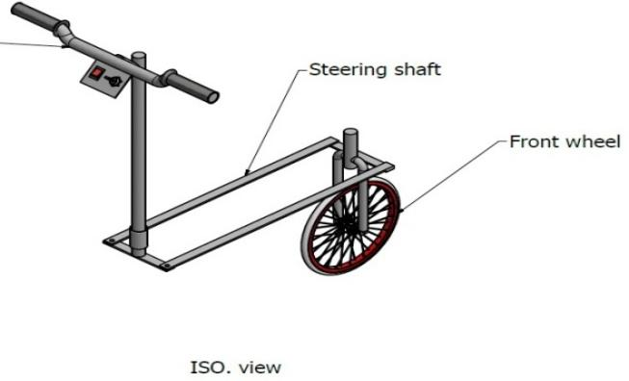

**Fig.1 A views of Steering System**

**Spraying Unit**

The spraying unit precisely applies liquids/pesticides/pesticides to crops, ensuring uniform coverage, minimizing waste, and maximizing treatment effectiveness.

**Adjustable Boom**

The boom, attached to the front of the main frame, was built from 40 × 20 mm hollow MS sections (5 mm thick) in 700 mm and 450 mm lengths. It held the shields, nozzles, and related components, with 30 mm spaced holes enabling vertical nozzle adjustment for crop height. The boom stand allowed height variation to suit different field conditions (Gholap et al., 2013).

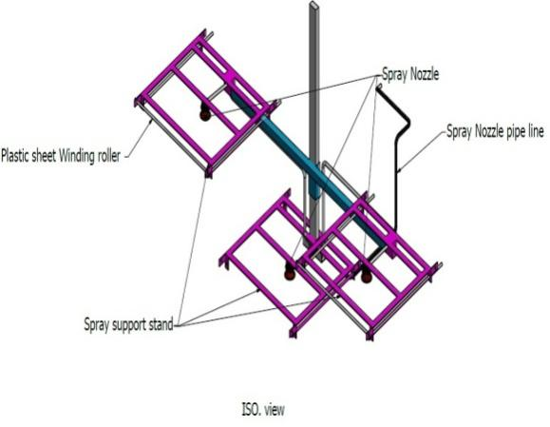

**Fig. 2 Top views of adjustable boom**

**Shield frame with winding roller**

Shield design matched the boom's geometry and required ground clearance. Each 300 mm high shield maintained a 450–600 mm gap above crops (Ozkan et al., 1997), with three shields—two for pesticides and one for herbicide fully enclosed and made from 2 mm plastic. The mounting frame, built from 450 × 20 × 2 mm MS plate, was tailored to crop row spacing and spray pattern. Shields were interchangeable based on crop type and height. Each included support pipes, clamps, and four 45 × 45 mm, 2 mm thick brackets with 10 mm holes. Shields were fixed using clamps and nuts, allowing vertical and horizontal adjustments via sliding brackets. A cylindrical rod with a washer end, attached by welded brackets, likely acted as a guide or mounting point for a winding mechanism.

**2.2 Experimental set up for field operation of developed sprayer**

Field trials were conducted on 54 plots to assess performance under varying combinations:

* Nozzle Type: N1 (Hollow cone), N2 (Flat fan)
* Forward Speed: S1 (0.4 m/s), S2 (0.55 m/s), S3 (0.7 m/s)
* Nozzle Height: H1 (0.4 m), H2 (0.5 m), H3 (0.6 m)

A methylene blue dye solution was sprayed, and deposition was collected on glossy papers placed under each nozzle. ImageJ software was used to quantify:

* Droplet Density (DD), no./cm²
* Volume Median Diameter (VMD), µm
* Number Median Diameter (NMD), µm
* Homogeneity Factor (HF)
* Deposition, %

Field performance indicators such as Effective Field Capacity (EFC), Field Efficiency (FE) and plant damage were recorded. Cost economics, man-hour requirements, and benefit-cost ratio were calculated for economic assessment.

**2.3 Statistical Analysis and Optimization**

Data obtained from experiments was also assessed through RBD statistical analysis was used to correlate response variations with independent variables. Optimum process conditions are required to significantly enhance the performance of battery-operated sprayer with shield. Numerical optimization has been conducted to evaluate the different nozzles, optimum forward speed and height of spray nozzle for chilly and cabbage were used for the design of experiments to study the effects.

**3. RESULTS & DISCUSSIONS**

**3.1 Effect of independent variables on droplet density**

An experiment was conducted to know the effect of type of nozzle(N), forward speed(S) and height of nozzle(H) on the droplet density. Fig.3.a shows that the effect of type of nozzle(N), forward speed(S), km/h and height of nozzle(H), m on the droplet density was found of significant. Droplet density obtained highest in N1S1H1 (Chilly: 57.47 no./cm²; Cabbage: 58.00 no./cm²), lowest in N2S3H3 (Chilly: 42.75; Cabbage: 43.38).

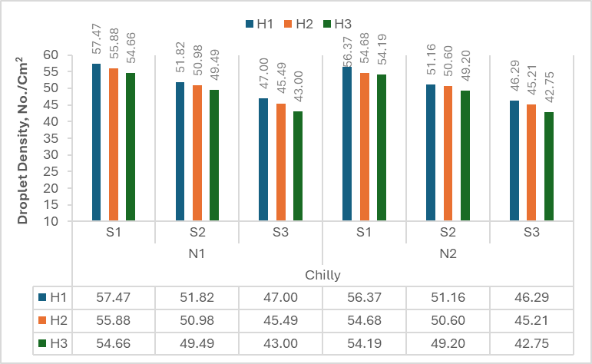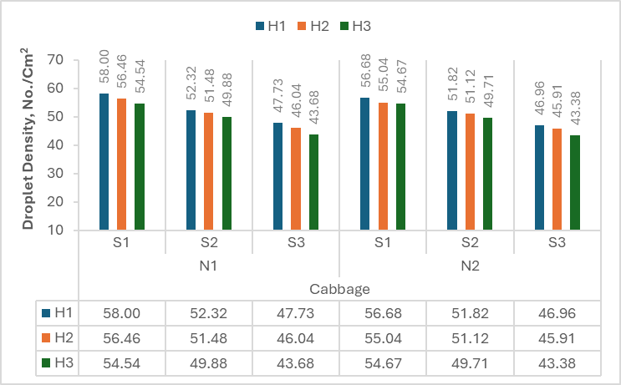

**Fig. 3.a Effect of nozzle type (N), forward speed(S) and height of nozzle(H) on droplet density**

**3.2 Effect of independent variables on Homogeneity Factor**

An experiment was conducted to know the effect of independent variables i.e., type of nozzle(N), forward speed(S) and height of nozzle(H) on the HF at both crops. The homogeneity factor (HF) is the ratio of the VMD to NMD. Fig.3.b shows that effect of types of nozzles, forward speed(S) and height of nozzle (H) on the HF was found significant. HF obtained peak in N1S2H1 (2.00 Chilly, 1.99 Cabbage), lowest in N2S3H1 (1.58), suggesting better uniformity with hollow cone nozzles.

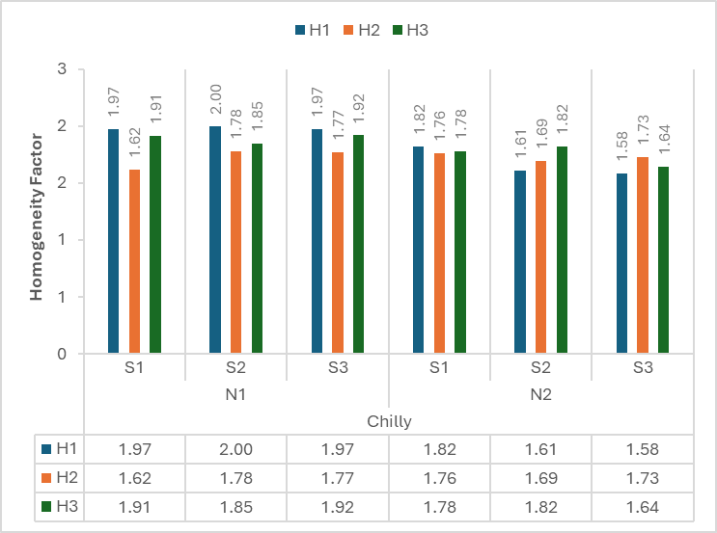

**Fig. 3.b Effect of nozzle type (N), forward speed(S) and height of nozzle(H) on HF**

**3.3 Effect of independent variables on Deposition**

An experiment was conducted to know the effect of type of nozzle(N), forward speed(S) and nozzle height(H) on the deposition of both crops. Fig.3.c indicates the percentage of other losses, which is the spray that does not reach the target and deposition losses away. Comparing the heights of nozzle, no one major changes of deposition percentages for chilly and cabbage crops. Deposition obtained maximum in N1S2H2 (85.17%); minimum in N1S3H1 (82.44%) for chilly. While, Cabbage showed maximum at 95.07% in N2S3H2.

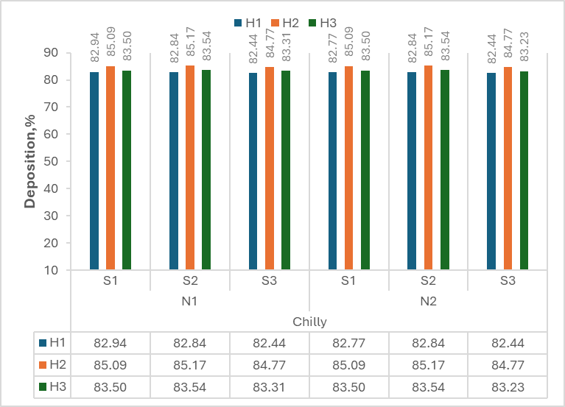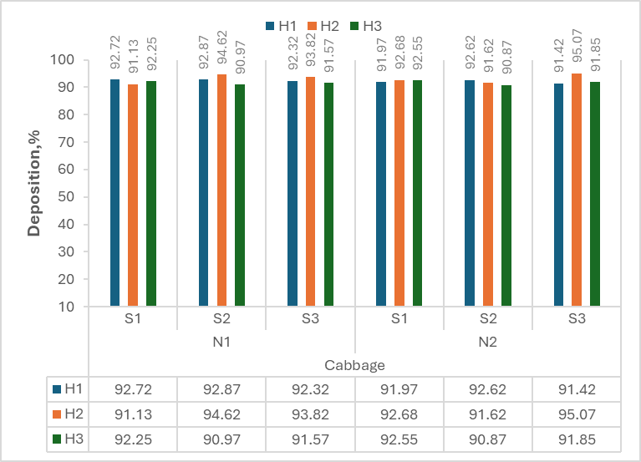

**Fig. 3.c Effect of nozzle type (N), forward speed(S) and height of nozzle(H) on deposition**

**3.4 Effect of independent variables on Effective Field Capacity (EFC)**

An experiment was conducted to know the effect of type of nozzle(N), forward speed(S) and nozzle height, on the Effective field capacity (EFC) of both crops. Fig.3.d indicates the effect of height of nozzle(H) and forward speed(S) on EFC found significant for both crops. Effective field capacity obtained at maximum in N1S3H3 (0.33 ha/h); minimum in N1S1H2 (0.23 ha/h) for both crops.

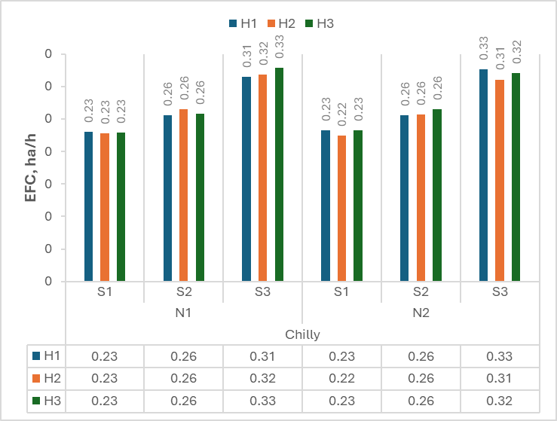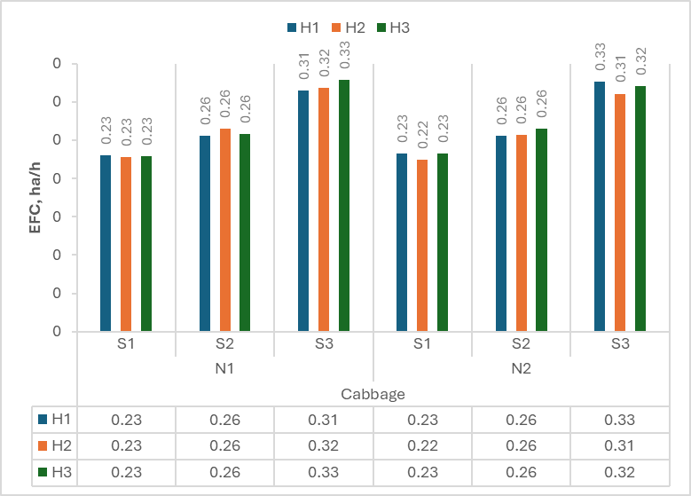

**Fig. 3.d Effect of nozzle type (N), forward speed(S) and height of nozzle(H) on EFC**

**3.5 Effect of independent variables on Plant damage**

An experiment was conducted to know the effect of type of nozzle (N), forward speed(S) and height of nozzle (H) on the plant damage. Fig.3.e indicates that the effect of type of nozzle(N), forward speed(S), km/h and height of nozzle(H), m on the plant damage was found of significant for both crops. Plant damage obtained maximum in N1S2H1 (4.30% Chilly), N1S3H2 (2.86% Cabbage); Zero in N1S1H3 and N2S2H1 for both crops.

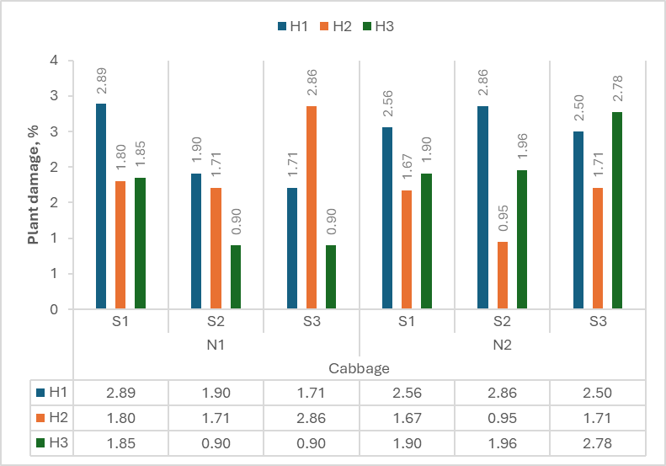

**Fig.3.e Effect of nozzle type (N), forward speed(S) and height of nozzle(H) on plant damage**

**3.3 Cost Analysis**

The developed sprayer operates at a cost of 74.65 ₹/hour (329 ₹/ha) and requires 4.40 man-h /ha. A net benefit of ₹53.87/hour, with a payback achieved at ₹1024.29/hour or 232.36 ha (pesticide), depending on custom rates. The sprayer shows a Benefit-Cost (B: C) ratio of 3.13, demonstrating high economic viability for small and marginal farmers. Compared to a knapsack sprayer (₹626/ha), the developed unit cuts application costs (nearly by half). It covers 1 ha in 4.40 hours, whereas the knapsack sprayer requires 11.62 hours (2.5 times longer) highlighting superior time efficiency.

**4. CONCLUSIONS**

The battery-powered shielded sprayer demonstrated effective precision spraying with reduced drift, improved uniformity, and higher field efficiency. Optimal spraying at lower speeds and nozzle heights (N1S1H1, N1S2H2). Substantial reduction in labor and application costs compared to traditional knapsack methods. Improved environmental safety through minimized pesticide wastage. High B:C ratio (3.13), ensuring economic viability for small-scale farmers. Compared to a knapsack sprayer (₹626/ha), the developed unit cuts application costs (nearly by half). It covers 1 ha in 4.40 hours, whereas the knapsack sprayer requires 11.62 hours (2.5 times longer) highlighting superior time efficiency. This sprayer presents a sustainable, ergonomic, and cost-efficient solution for modernizing pesticide and herbicide application in Indian vegetable farming. The battery-powered, shielded sprayer results in effective, precise spraying, reduced drift, improved uniformity, and higher field efficiency. Spraying chemicals helps directly to farmers.

**Disclaimer (Artificial intelligence)**

Option 1:

Author(s) hereby declare that NO generative AI technologies such as Large Language Models (ChatGPT, COPILOT, etc.) and text-to-image generators have been used during the writing or editing of this manuscript.

Option 2:

Author(s) hereby declare that generative AI technologies such as Large Language Models, etc. have been used during the writing or editing of manuscripts. This explanation will include the name, version, model, and source of the generative AI technology and as well as all input prompts provided to the generative AI technology

Details of the AI usage are given below:

1. No any type generative latest technology.

2. -

3. -

**5. REFERENCES**

Ajayi, A. B., Fagbola, M. T., (2022). “Development of a Semi-automatic Hand-pushed Weeder”. *ABUAD Journal of Engineering Research and Development,* 5(1):134–146. <http://ajerd.abuad.edu.ng/wp-content/uploads/2022/07/AJERD0501-12.pdf>

Anibude, E. C., Jahun, R. F., & Abubakar, M. S. (2016). Development of an animal drawn hydraulic boom sprayer. *American Journal of Engineering Research*, 5 (2), 222-228.

Babasaheb, G., & Kushwah, O. (2015). Comparative performance of tractor operated boom type field sprayers on cotton crop. *International Journal of Agricultural Engineering*, 8 (1), 85-91.

Chauhan, S. (2015). Motor torque calculations for electric vehicle. *International Journal of Scientific & Technology Research*, 4 (8): ISSN 2277-8616. https://ijstr.org/final-print/aug2015/Motor-Torque-Calculations-For-Electric-Vehicle.pdf

Corlett, E.N., & Bishop, R. P. (1976). A technique for assessing postural discomfort. *Ergonomics,* 19(2)*,* 175-82.

Directorate of Agriculture (2021). *Government of Gujarat.* https://doh.gujarat.gov.in /Images/directorofhorticulture/pdf/statistics/Yearwise-Comparative-up-to-20-21.pdf

Gholap, B., & Mathur, R. (2013). Field evaluation of tractor operated boom sprayer of cotton crop. *International Journal of Agricultural Engineering*, 6 (2), 372-374.

Gupta, P., Sirohi, N. P. S., & Kashyap, P. S. (2011). Effect of nozzle pressure, air speed, leaf area density and forward speed on spray deposition in simulated crop canopy. *Annals of Horticulture,* 4 (1), 72-77.

IS: 11313 (2007). Test procedure for power sprayers. Indian Standards Institution. Government of India, New Delhi.1-16. <https://ia601405.us.archive.org/0> /items/gov.in.is.11313.2007/is.11313.2007.pdf

IS: 9164 (1979). Guide for estimating cost of farm machinery operation. Indian Standards Institution. Government of India, New Delhi. 1-17.

Jasna, V.K., Singh, P., & Ummer, N. (2023). Overview of pesticide use in vegetable cultivation: ground truth. Journal of Krishi Vigyan. 11, 164-170. https://doi.org/10.5958/2349-4433.2023.00106.X

Kepner, R.A., Bainer, R. & Barger, E. L. (2005). Principles of farm machinery. AVI Publishing (4th), INC, Westport.

Krishnaleela, P., Prakash, R. M., Ramalakshmi, K., Manikandamoorthi, M., Jaisolairaj, J. and Sanjai, T. (2024). "Multi-Purpose Agricultural Pesticide Spraying Robot Using IoT," *2nd International Conference on Artificial Intelligence Trends and Pattern Recognition* (ICAITPR), Hyderabad, India, 2024, pp. 1-6, 10.1109/ICAITPR63242.2024.10959847.

Lal, S., Meena, S. S., & Khan, H. N. (2021). Estimation of cost economics of developed battery-operated boom sprayer. The Pharma Innovation Journal, 10(7), 415-417.

Lal G., Patidar, S., Pooniya, R., Kumar, K., & Kumar, M. (2022). Performance evaluation of battery-operated knapsack sprayer cum fertilizer broadcaster. The Pharma Innovation Journal, 11 (2), 875-879.

Ozkan, H. E., Miralles, A., Sinfort, C., Zhu, H., & Fox, R. D. (1997). Shields to reduce spray drift. *Journal of Agricultural Engineering Research*, 67, 311-322.

Makwana, A., & Mohnot, P. (2022). Effect of spraying using sprayer robot for cotton crop. Journal of Agri Search, 9 (3), 255-259.

Singh, S. K., Dixit, A. K., Singh, S., & Rohinisb, K. (2010). Development of field evaluation of tractor mounted air assisted sprayer for cotton. *Agricultural Mechanization in Asia, Africa & Latin America*, 41 (4), 49-54.

Sidahmed, M. M., Awadalla, H. H., & Haidar, M. A. (2004). Symmetrical multi-foil shields for reducing spray drift. *Biosystems Engineering,* 88, 305-312.

Zaffar, O., & Sanjay, K. (2023). Development of a wheel operated boom sprayer for hilly regions of Jammu and Kashmir. Current Advances in Agricultural Sciences, 15 (1). 69-74. <https://doi.org/10.5958/2394-4471.2023.00013.8>

Zang, Y., Zhou, Z., Zang, Y., Luo, X., Liao, J., Ming, R., & Xiao, H. (2021). Optimization of aviation adjuvants based on wettability analysis for 56 insecticide application on maize using UAV. International Journal of Agricultural & Biological Engineering, 14 (5), 11-18.

Zhu, H., Masoud, S., & Robert, D. F. (2011). A portable scanning system for evaluation of spray deposit distribution. *Computers & Electronics in Agriculture,* 76 (2), 38-43.