Assessing Algorithm Performance in Satellite-Based Banana Area Mapping in Rayalaseema zone of Andhra Pradesh, India

Abstract

In this study, a simple methodology used for estimation banana growing area in Andhra Pradesh. The methodology consists algorithms process the satellite data by using Landsat imagery from the 2024 growing season and four classification techniques such as Random Forest, K-Nearest Neighbours, its optimized KD-tree KNN, and Maximum Likelihood classification were tested. The results revealed that among the different techniques huge differences was observed, the KNN method estimated 53,239 hectares under cultivation, while Random Forest produced a more conservative 45,689 hectares. This substantial variation (about 16%) highlights how methodological choices can dramatically impact area estimates. Several important patterns emerged from our analysis. The KNN approaches, while effective at capturing spectral variability in mixed agricultural landscapes, consistently generated higher estimates. Random Forest, though more restrained, may better reflect actual planting areas. The current study suggests that combining multiple approaches with ground verification may offer the most reliable estimates, especially for smallholder plots that dominate the region's horticulture landscape.

Key words: Machine learning; Banana; RF; KNN; Andhra Pradesh
- Introduction
Banana cultivation occupies a pivotal role in India's agricultural economy, with Andhra Pradesh ranking among its most productive states. Current estimates indicate India supplies over one-quarter of global banana production, exceeding 33 million metric tons annually from approximately 924,000 hectares under cultivation (Yange et al., 2020 and Kikulwe et al., 2022). Within this national context, Andhra Pradesh contributes significantly, producing nearly 5.7 million metric tons from 88,960 hectares during the 2022-23 growing season (Karthikkumar et al., 2019 and Morales et al., 2023). This substantial output underscores the crop's dual importance as both an economic driver and nutritional resource for local populations. Bananas represent one of India's most economically important crops, with Andhra Pradesh standing out as a major production centre. As the global leader in banana production, India grows over a quarter of the world's supply, and our study region contributes significantly to this output. However, accurately monitoring these plantations has remained challenging due to limitations in conventional survey methods.
Traditional approaches to monitoring banana cultivation areas in Andhra Pradesh have long depended on labour-intensive field surveys, subjective farmer interviews, and outdated land record systems. These conventional methodologies present several well-documented limitations, including inconsistent data quality, temporal delays in reporting, and inadequate spatial coverage (Handique et al., 2021). Such constraints become particularly problematic when attempting to generate accurate, timely estimates for large-scale agricultural planning and policy development.
Recent technological advancements in remote sensing have introduced transformative capabilities for agricultural monitoring. Satellite-based optical sensors now enable systematic observation of banana plantations through analysis of their distinctive spectral properties, particularly in the near-infrared and red-edge wavelength regions (Johansen et al., 2018). This technological approach offers distinct advantages over ground-based methods, including comprehensive spatial coverage, regular temporal revisit capability, and cost-effective scalability (Ye et al., 2021). Besides the above, Kumaraperumal et al., 2019 attempted to estimate banana area using dual polarised RISAT-1 (C-band) and Sentinel-1 (C-band) data. Using aerial RGB imagery and machine learning algorithms banana area was estimated in smallholder farms (Michael et al., 2020). Vegetation indices derived from these spectral data have become essential analytical tools, though their application requires careful consideration of specific crop characteristics.
The widely-used Normalized Difference Vegetation Index (NDVI), while valuable for general vegetation assessment, demonstrates significant limitations when applied to dense banana canopies due to signal saturation effects. Researchers have consequently turned to more specialized indices such as the Red-Edge Chlorophyll Index (CIRE) and Normalized Difference Red Edge (NDRE), which provide enhanced sensitivity to chlorophyll content and better performance throughout the crop's growth cycle (Nathgosavi et al., 2021 and Olivares et al., 2022). These advanced metrics have proven particularly valuable during later phenological stages when conventional indices often fail to discriminate subtle variations in plant health.
Parallel developments in computational analysis have substantially enhanced remote sensing applications through machine learning techniques. Contemporary algorithms including Random Forest classifiers, Support Vector Machines, and Convolutional Neural Networks now enable more sophisticated interpretation of spectral data than traditional classification methods (Kikulwe et al., 2022). Each approach offers distinct advantages: Random Forest excels at handling high-dimensional datasets while maintaining interpretability, Support Vector Machines effectively separate complex spectral classes, and deep learning architectures automatically extract relevant spatial features from imagery (Olivares et al., 2022). These methodological advances have collectively improved the accuracy and efficiency of large-scale crop mapping initiatives.
The convergence of improved remote sensing capabilities and advanced analytical techniques creates new opportunities for precision agriculture. This study examines their integrated application for banana cultivation monitoring in Andhra Pradesh, with particular emphasis on overcoming previous limitations in accuracy and scalability. The resulting methodologies promise to support more informed decision-making for agricultural management and policy formulation in this economically significant region.
- Methodology
The study focuses on 22 administrative mandals spanning Anantapuramu, Annamayya, and Sri Satyasai districts in Andhra Pradesh, India, located between 13.8271°–15.0748°N latitude and 77.7726°–78.8754°E longitude. This region features undulating terrain with small hills and valleys, where agriculture relies heavily on groundwater resources due to limited surface water availability. The climate is characterized as moderate tropical, transitioning from hot moist semi-arid to dry sub-humid conditions, with distinct dry periods during summer and rainfall concentrated in the southwest (June–September) and northeast (October–December) monsoon seasons. Annual precipitation ranges from 530 mm to 780 mm, occurring over approximately 48 rainy days. The predominant red soils exhibit medium-to-heavy textures with shallow depth, influencing both water retention and crop suitability. Cloud-free Landsat 8 OLI/TIRS satellite imagery from May 2024 (Paths 143–144, Row 50) was acquired and processed, focusing on key spectral bands including Green, Red, NIR, and SWIR. The data underwent radiometric calibration and atmospheric correction using the FLAASH algorithm before being mosaicked and subset to the study area boundary. A false-color composite (NIR-Red-Green) was generated to enhance vegetation detection, and NDVI was calculated to assess vegetation health and distribution.
Field data collection employed a stratified random sampling approach, yielding 84 geotagged ground truth points with GPS accuracy under 5 meters. These points represented major land cover classes, including banana plantations, other crops, fallow land, and non-vegetated areas. The dataset was divided, with 60% used for training classification models and the remaining 40% reserved for validation. Four classification algorithms were implemented in SNAP 11.0 to map banana cultivation: K-Nearest Neighbors (KNN), which classifies pixels based on proximity to training samples; KD-tree KNN, an optimized version of KNN that improves computational efficiency; Random Forest (RF), an ensemble method using 100 decision trees to enhance accuracy and reduce overfitting; and maximum likelihood algorithm, which compares pixel spectra to reference endmembers based on angular similarity. Classification accuracy was assessed using a confusion matrix derived from the validation points, ensuring robust evaluation of each algorithm's performance in distinguishing banana cultivation from other land cover types.
- Results & Discussion
Analysis of Landsat-9 data for banana crop extent estimation during May 2024 revealed significant variability in results depending on the machine learning approach employed. The RF classifier estimated a cultivation area of 45,689 hectares (Fig-1), while the KNN method produced a substantially higher estimate of 53, 239 hectares (Fig-2) a difference of approximately 16.5% which is nearer to KD-Tree KNN (Fig-3) estimated area (52, 843 ha). The ML algorithm estimated banana area was 49, 134 ha (Fig-4). This substantial divergence in area estimates underscores the critical importance of classifier selection in agricultural remote sensing applications.
The performance characteristics of different algorithms align with findings from previous studies. This crop-specific variability in classifier performance has been corroborated by Qi et al. (2024), who noted similar patterns in their comparative analysis of machine learning methods for tropical crop mapping. Alabi et al. (2022) and Pena et al. (2024) revealed that RF algorithm proved better in banana mapping using high resolution satellite data compared to SVM and CNN methods.
The superior performance of KNN in our study may be attributed to several factors. As noted by Mountrakis et al. (2011), KNN's non-parametric nature makes it particularly effective in heterogeneous agricultural landscapes where training data may not fully represent all spectral variations. Manjunath et al. (2019) and Canpolat (2024) revealed that misclassification of machine learning algorithms due to the mixed cropping systems practised by the farmers in tropical regions.
The estimated banana cultivation area (in hectares) across 22 mandals using four different algorithms RF, KNN, KD_KNN, and (ML) method presented in Table 1. The results show variability in area estimates across algorithms, with KNN and KD_KNN generally yielding higher values of 53,239 and 52,843 ha, respectively compared to RF with an 45,689 ha and ML estimation of 49,134 ha. Notably, ML produced the highest estimate for Jammalamadugu (2,835 ha) and Mylavaram (6,019 ha), while KNN-based methods consistently overestimated in mandals like Galiveedu and Mylavaram. RF provided more conservative estimates, particularly in Chinnamandem (1,174 ha) and Sambepalle (1,366 ha). The discrepancies highlight the influence of algorithmic choice on area estimation, with KNN variants tending to overshoot and ML showing extreme values in certain regions. Further validation is needed to determine the most accurate method for banana acreage assessment.
- Conclusion
The findings of this study indicate that the KNN method provides the most accurate results for mapping banana crops in fragmented agricultural areas when using Landsat-9 satellite imagery. Its ability to handle the mixed spectral signatures characteristic of these landscapes gives it an advantage over other classification techniques we tested. However, we observed notable differences (16%) in area estimates between methods, reminding us that the choice of analysis approach significantly affects mapping outcomes. While Landsat data offers practical benefits for regional monitoring, we identified limitations in detecting small fields and capturing growth stage variations that future work should address. Moving forward, combining different classification techniques, integrating data from complementary satellite systems like Sentinel-2, and implementing more rigorous field validation methods could substantially improve banana crop monitoring. Such developments would make satellite-based mapping more reliable for supporting agricultural planning and food security initiatives in banana-growing regions.
DISCLAIMER (ARTIFICIAL INTELLIGENCE)
Author(s) hereby declares that NO generative AI technologies such as Large Language Models (ChatGPT, COPILT etc.) and text-to-image generators have been used during the writing or editing of this manuscript

References:
Alabi TR, Adewopo J, Duke OP, Kumar P.L. (2022). Banana Mapping in Heterogenous Smallholder Farming Systems Using High-Resolution Remote Sensing Imagery and Machine Learning Models with Implications for Banana Bunchy Top Disease Surveillance. Remote Sensing, 14(20), 5206.
Alejandro Morales, Francisco J Villalobos (2023): Using machine learning for crop yield prediction in the past or the future, Frontiers in Plant Science, Vol. 14, doi: 10.3389/fpls.2023.1128388.
Canpolat, F. A. (2024). Projecting Agricultural Land Abandonment and Expansion in Turkiye Using the Subspace KNN Algorithm (2030). Cografya Dergisi, (47), 149-163.
Handique B.K, Khan A.Q, Goswami C, Prashnani M, Gupta C, Raju P.L.N. (2021). Detection of Banana Plants Using Multi-Temporal Multispectral UAV Imagery. Remote Sensing, 13(11), 2073.
Johansen K., Raharjo T, McCabe M.F. (2018). UAV remote sensing of spatial variation in banana production. Precision Agriculture, 19(1), 135-152.
Karthikkumar A, Kumaraperumal R, Ramalingam K. (2019). Generating Banana area map using VV and VH Polarized Radar Satellite Image. International Journal of Recent Technology and Engineering, 8(2), 3758-3761.
Kikulwe E, Kyanjo JL, Kato E, Ssali RT, Erima R, Mpiira S. (2022). Banana Mapping in Heterogeneous Smallholder Farming Systems Using High-Resolution Remote Sensing Imagery and Machine Learning Models with Implications for Banana Bunchy Top Disease Surveillance. Remote Sensing, 14(19), 4960.
Kumaraperumal R, Natarajan S, Ramalingam K, Sivasamy R. (2019). Mapping banana growing area in Tamil Nadu using SAR data. Journal of the Indian Society of Remote Sensing, 47, 1327-1335.
Manjunath C.B., Gnanappazham L., Vijayakumar R.M., Kavino M., Jagadeeswaran R., Ramsubramoniam S. (2019). Machine learning classifiers on Sentinel-2 satellite image for the classification of banana (Musa Sp.) plantations of Theni district, Tamil Nadu, India. International Journal of Chemical Studies, 7(5), 1424–1433.
Maya Gopal, P.S., and Bhargavi, R. (2019): Performance Evaluation of Best Feature Subsets for Crop Yield Prediction Using Machine Learning Algorithms, Applied Artificial Intelligence, 33 (7)621–642, doi:10.1080/08839514.2019.1592343
Michael, G. S., Alejandro, V., Frank. M., Henry, A.R., Nancy, S., Dries, R., Walter, O., Jules, N., Laurent, T., Aman, B.O. and Guy, B. (2020). Detection of banana plants and their major diseases through aerial images and machine learning methods: A case study in DR Congo and Republic of Benin. ISPRS Journal of Photogrammetry and Remote Sensing, 169, 110-124.
Mountrakis, G., Im, J., & Ogole, C. (2011). Support vector machines in remote sensing: A comprehensive review and application in urban crop mapping. ISPRS Journal of Photogrammetry and Remote Sensing, 66(3), 247-259.
Olivares, B. O., Vega, A., Rueda Calderón, M. A., Montenegro-Gracia, E., Araya-Almán, M., & Marys, E. (2022). Prediction of Banana Production Using Epidemiological Parameters of Black Sigatoka: An Application with Random Forest. Sustainability, 14(21), 14123.
Peña, F. J., Hübinger, C., Payberah, A. H., & Jaramillo, F. (2024). DeepAqua: Semantic segmentation of wetland water surfaces with SAR imagery using deep neural networks without manually annotated data. International Journal of Applied Earth Observation and Geoinformation, 126, 103624.
Yange, S. T., Charity Ojochogwu Egbunu, Malik Adeiza Rufai, Oluoha Onyekwere, Alao Abiodun Abdulrahman, and A. Abdulkadri (2020): "Using prescriptive analytics for the determination of optimal crop yield," International Journal of Data Science and Analysis, 6(3), 72-82.
Zhang, X., Liu, L., Liu, X., Xiao, Y., & Zhao, J. (2022). Comparative analysis of machine learning methods for tropical crop mapping using multi-temporal Sentinel-2 imagery. Remote Sensing of Environment, 270, 112856.
Nathgosavi, V., Sachin, Patil, S. (2021): A Survey on Crop Yield Prediction using Machine Learning, Turkish Journal of Computer and Mathematics Education, 12,(13), 2343–2347, doi: 10.17762/turcomat.v12i13.8924

Table-1. Mandal wise estimated banana area in hectares during 2024 cropping season
S. No | Mandal Name | RF | KNN | KD_KNN | ML
1 | Chakrayapet | 1381 | 2037 | 1997 | 905
2 | Chinnamandem | 1174 | 1652 | 1626 | 298
3 | Galiveedu | 2374 | 3948 | 3925 | 2134
4 | Jammalamadugu | 1223 | 1174 | 1165 | 2835
5 | Kondapuram | 1188 | 1478 | 1469 | 2382
6 | Lingala | 4750 | 4466 | 4463 | 4537
7 | Muddanur | 950 | 722 | 718 | 1760
8 | Mudigubba | 3555 | 4410 | 4374 | 3663
9 | Mylavaram | 2855 | 3968 | 3938 | 6019
10 | Nambulipulikunta | 2139 | 2596 | 2586 | 2195
11 | Peddamudium | 1798 | 2132 | 2114 | 2007
12 | Pulivendla | 1808 | 1801 | 1796 | 1409
13 | Putlur | 3695 | 3994 | 3958 | 3632
14 | Sambepalle | 1366 | 2219 | 2198 | 696
15 | Simhadripuram | 1273 | 1289 | 1287 | 1327
16 | Tadimarri | 2075 | 2893 | 2855 | 1553
17 | Tadpatri | 2223 | 1943 | 1919 | 3408
18 | Talupula | 1494 | 1701 | 1675 | 1424
19 | Thondur | 669 | 676 | 670 | 1068
20 | Vempalle | 1769 | 1939 | 1934 | 978
21 | Vemula | 2299 | 2045 | 2039 | 2002
22 | Yellanur | 3630 | 4157 | 4136 | 2902
Total |  | 45689 | 53239 | 52843 | 49134

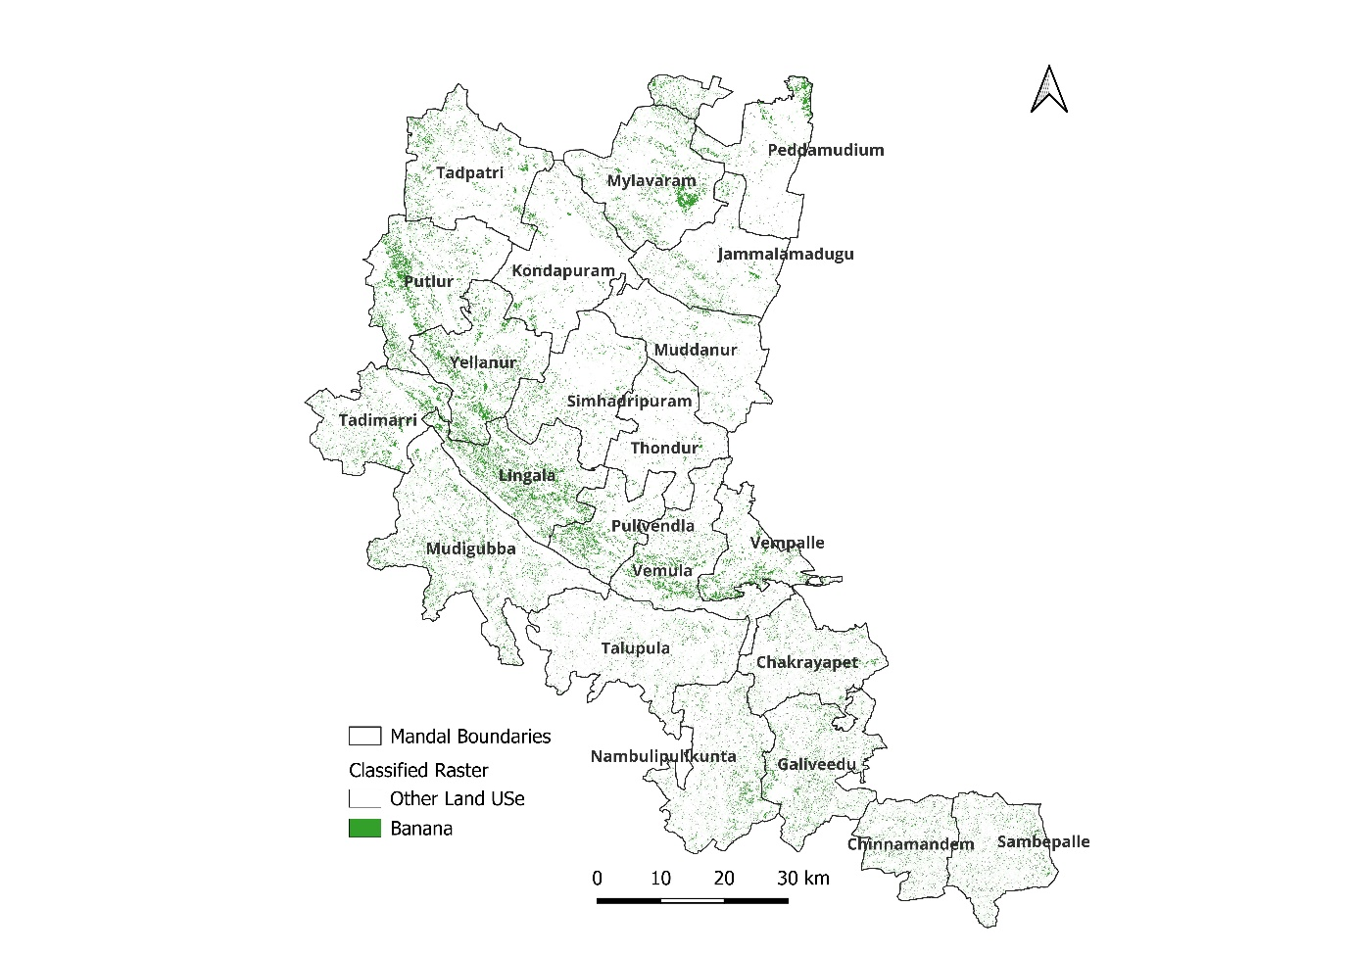
Fig-1. Estimated Banana area using RF algorithm

Fig-2. Estimated Banana area using KNN algorithm

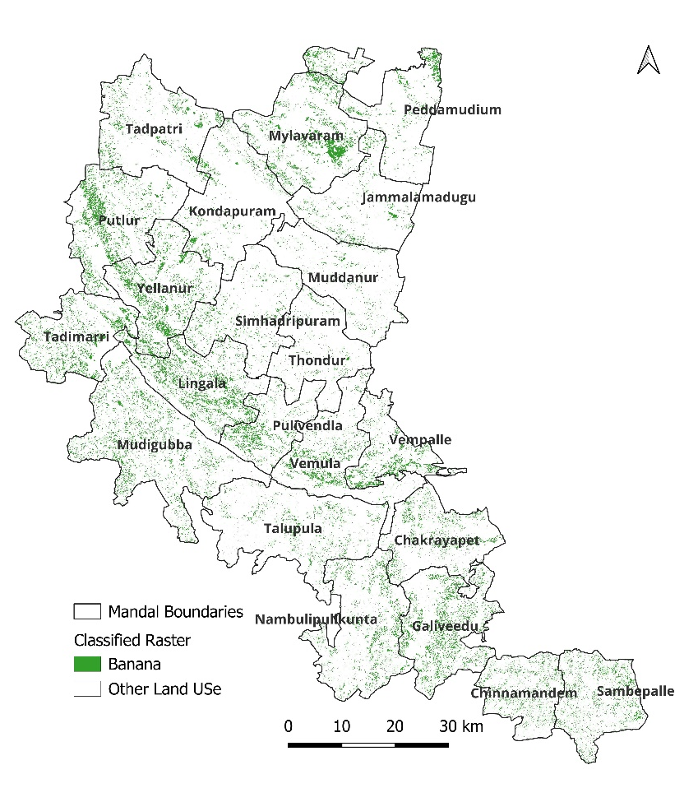
Fig-3. Estimated Banana area using KN tree KNN algorithm

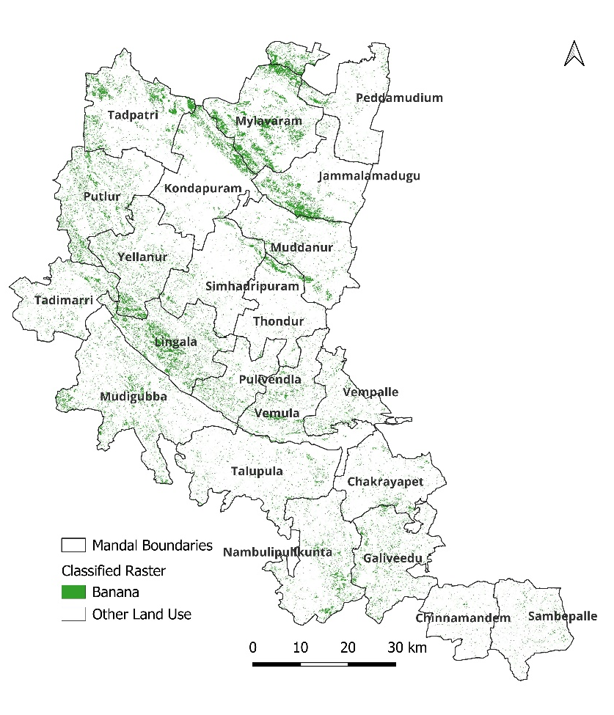
Fig-4. Estimated Banana area using Maximum Likelihood algorithm

