Original Research Article

**Pig Manure Management Practices in Fako Division, Southwest Region of Cameroon: Implications for Greenhouse Gas Emissions**

**ABSTRACT**

|  |
| --- |
| **Aims:** To investigate pig manure management techniques employed by pig farmers in Fako Division, to identify the socio-economic factors influencing these practices, and to assess their environmental implications, particularly regarding greenhouse gas emissions and pollution risks.  **Study design:** Cross-sectional survey design to collect data from pig farmers in Fako Division. It applied quantitative methods to assess manure management practices, environmental impacts, and the role of socio-demographic factors in adopting eco-friendly methods.  **Place and Duration of Study:** Fako Division, South West region of Cameroon, between January and May 2024.  **Methodology:** The study used purposive sampling to select 120 pig farms across five Sub Divisions in Fako Division, focusing on farms with over 10 pigs. Data on manure management and farmer socio-economic profiles were collected through checklists, interviews, and structured questionnaires. Participation was voluntary, supported by promised veterinary follow-up. Data were analyzed using Excel, MINITAB 19, and SPSS 21, with descriptive statistics and binary logistic regression used to identify factors influencing eco-friendly waste management practices.  **Results:** Results revealed that 66.4% of farms produce solid waste, with 59.1% storing it for less than a week. However, only 4.5% of farms compost manure and 3.6% use biogas, while the majority (44.5%) dump waste on land and 32.7% into streams, posing serious environmental risks and contributing to GHG emissions. Socio-demographic factors significantly influenced sustainable practices. Male farmers were more likely to adopt eco-friendly methods than females (p = 0.027). Higher education levels (p = 0.034), higher income (p = 0.042), farmers' experience (p=0.044), and distance to waste disposal site (0.015) had a positive impact on the likelihood of a pig farmer engaging in eco-friendly pig waste management practices.  **Conclusion:** Most pig farms in Fako Division poorly manage manure, with minimal use of composting and biogas; adoption of sustainable practices depends on farmers’ socio-economic factors. |

*Keywords: Pig manure, greenhouse gases, Fako Division, manure management, environmental impacts, Cameroon.*

**1. INTRODUCTION**

The agricultural sector is the backbone of Cameroon’s economy, employing the majority of the active population and contributing significantly to the nation’s gross domestic product (GDP). In 2017, agriculture accounted for approximately 76.38% of the GDP, demonstrating its critical role in the country’s socio-economic development (MINADER, 2018). Within this sector, pig farming stands out as a notable activity practiced by independent breeders across various age groups, genders, and geographical regions. For many Cameroonians, pig farming serves as a secondary occupation, supplementing household income and providing nutritional benefits (Abdoulay & Sevidzem, 2018).

Globally, the demand for pork is projected to rise by nearly 40% by 2050, with much of this increase occurring in developing countries such as Cameroon, fuelled by demographic growth and economic development (FAO, 2020). Cameroon ranks first in pig production in the Central African Economic and Monetary Community (CEMAC) and second in West Africa after Nigeria (Defang et al., 2014). As of 2020, Cameroon had an estimated pig population of around 3.9 million, reflecting steady growth driven by programs and policies aimed at enhancing the livestock sector (FAOSTAT, 2020). These initiatives have promoted pig farming as a viable means of livelihood, recognizing its efficiency in converting diverse feed sources, such as food leftovers and agricultural by-products, into high-quality meat (Joseline et al., 2018). Pigs are prolific breeders capable of producing multiple piglets annually, making them highly attractive for livestock farmers seeking profitability and productivity improvements (ILRI, 2000). Pig farming is a significant component of the agricultural landscape in Cameroon's Southwest Region, particularly within the Fako Division. The region's pig population was reported at 13,928 in 2018 (SOWEDA, 2020) and has experienced steady growth. This growth is driven by increasing demand for pork, influenced by factors such as population expansion, urbanization, and evolving dietary preferences.

However, while the supply of pork in Cameroon stands at approximately 3.02 kg per person annually, it remains insufficient to meet the growing demand of 6.6 kg per person annually (MINEPIA, 2021). This disparity has fuelled an increase in pork production to bridge the gap, accompanied by a corresponding rise in manure generation from pig farming operations. Improper management of pig manure poses significant environmental risks, such as the release of greenhouse gases (GHG) (Tiku et al., 2025) and the leaching of nutrients, which can negatively impact soil and water quality.

Pig manure management is widely recognized as a primary contributor to GHG emissions from pig farming, with methane (CH₄) and nitrous oxide (N₂O) being the most potent gases. CH₄ has a global warming potential 21 times greater than CO₂, while N₂O is 310 times more potent (Myhre et al., 2013). In Cameroon, pig manure management practices are diverse and influenced by factors such as farm size, available resources, and farmers' technical knowledge. Standard manure management practices include open-air dumping, windrow composting, land application and dumping in running streams, which vary in their efficiency and environmental impact (Tiku et al., 2023). Open-air dumping is prevalent due to its low cost and simplicity; however, it poses significant environmental hazards, including nutrient leaching and contamination of water bodies. Similarly, the practice of disposing of manure directly into streams leads to the degradation of water quality and subsequent public health risks.

Given that pig farming in Cameroon holds socio-economic importance, offering opportunities for poverty alleviation, improved nutrition, and women’s empowerment. The relatively low input requirements for labor and feed, combined with pigs' ability to thrive under varying conditions, make pig farming accessible to diverse communities (Joseline et al., 2018), advancing sustainable manure management practices is critical not only for mitigating environmental risks but also for enhancing the livelihoods of farmers and supporting the agricultural sector’s contribution to Cameroon’s economy.

This paper examines pig manure management practices in the Fako Division, Southwest Region of Cameroon, and their environmental implications. Specifically, it aims to summarize the various pig manure management practices currently employed by pig farmers, identifying the socio-economic factors that influence their choice of manure management methods. The study contributes to the understanding of the environmental impacts of existing pig manure management practices employed by farmers in the Fako Division of Cameroon. It highlights the consequences of these practices on the local environment and the well-being of the general population. The findings aim to provide valuable insights for policymakers, community organizations, government agencies, and agricultural stakeholders, enabling them to make informed decisions regarding effective waste and manure management strategies within urban municipalities in the region.

**2. materials and methods**

**2.1 Study Area and Data Collection**

This study was conducted in the Fako Division, one of the six divisions in the South West region of Cameroon. It comprises five main sub-divisions; namely, Buea, Limbe, Tiko, Muyuka, and West Coast sub-divisions (Fig. 1). The study area is geographically located between latitude 3° 57′ 17″ to 4° 09′ 72″ N and longitude 8° 58′ 49″ to 9° 27′ 86″ E. Fako division has a surface area of 2031.93km2 and a population density of 229.5/km2 from 1987 to 2005 compared to a national average of 56.34/km2 (Ewane, 2021).

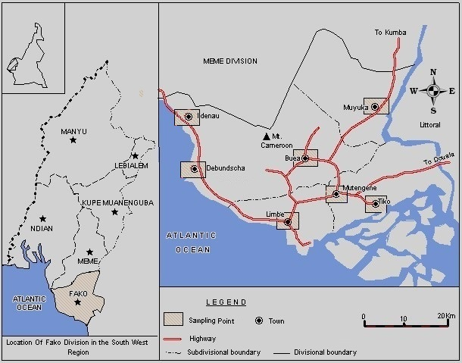

Source: Adapted from Kimengsi *et al.* (2016) and Miegoue *et al*. (2019)

Fig 1- study area

During the field studies, pig farms in the five Sub Divisions in Fako Division were visited. The number of farms visited in a particular Sub Division was determined by the size of the Sub Division and the pig farm density of the Sub Division. A total of 120 farms were sampled in the following order; 30 farms each in Buea and Limbe respectively, 20 farms each in Tiko, Muyuka and West Coast respectively. Farms sampled were purposively sampled based on the size of the herd, only farmers with more than 10 pigs were considered in the study. Information about the various pig manure management options in the study sites was obtained with the use of a checklist, direct interviews and field observations. The quantity of waste generated by pig farms was determined by breeders’ testimony and was compared with Ngwabie et al., (2018). A structured questionnaire was employed to gather data on the socio-economic profiles of pig farmers, including information on gender, age, occupation, income, educational level, farming experience, pig production scale, livestock housing, and manure management practices. For farmers who were unable to read or write English, the questionnaire was translated into their native language or Pidgin English as the case demanded, and their responses were documented accordingly. Participation in the study was limited to those farmers who willingly engaged with the researchers and provided the required information. Respondents were assured that all data collected would remain confidential. They were also informed of their right to decline participation. Nonetheless, participation was positively influenced by a commitment made during the pilot phase of the study, in which researchers promised to offer follow-up veterinary support such as guidance on herd health and production management after sharing the study findings with the farms.

**2.2 Statistical Analysis.**

The data from this research were entered in excel version 19, averaged and normalized. Analyses were performed using the MINITAB package version 19 and the Statistical Package for Social and Management Sciences (SPSS) version 21. Descriptive statistics such as mean, median, mode, range, standard deviation, variance, and percentiles were used to summarize and describe the main features of the collected dataset, while charts were produced to show trends. The binary logistic regression model was used to examine the factors that influenced the choice of eco-friendly pig manure management among the farmers. The logistic regression model is appropriate in analyzing the relationships involving a binary dependent variable and a set of independent variables and has been used in a similar study by Onyia et al. (2020). The model is expressed as follows;

LnYn (Pi/ 1-Pi) = β0+β1X1 +β2X2 +--------- +βn X n+ μ …………………………. (Eqn 7)

Where:

Yi =A binary variable which is identified as 1 if farmer practices eco-friendly piggery wastes management (appropriate land application, biogas production, composting, or sell) and 0; if otherwise (open air dumping or thrown in running stream).

Pi= the probability that piggery farm uses eco-friendly piggery wastes management Ln. = Natural logarithm function.

β0= A constant

β1 – βn = Logistic regression coefficient

X1- Xn = Explanatory variables expressed as follows;

X1= Gender of farmer (male and female)

X2 = Age of pig farmer (years)

X3 = Primary occupation

X4 = Income levels

X5 = Farm manager’s year of experience (years)

X6 = Number of pigs

X7 = Distance of piggery farm to dumping site (meters)

X8 = Farming system

X9 = Manure generation rates

X10 = State of manure

X11= Household size

X12= Feed type

X13 = Mode of feeding

μ = error term.

**3. results and discussion**

**3.1 Daily pig manure generation**

Result shows that most pig farms in the Fako Divison generate between 61–70 kg (25%) and 71–80 kg (23.33%) of waste each day. Farms producing 81–90 kg contribute 18.33%, while those generating over 90 kg represent 16.67%. Additionally, 10% of farms fall within the 50–60 kg range, showing a moderate level of waste output. The smallest group, accounting for just 6.67%, consists of farms producing less than 50 kg of waste daily (Fig. 2)

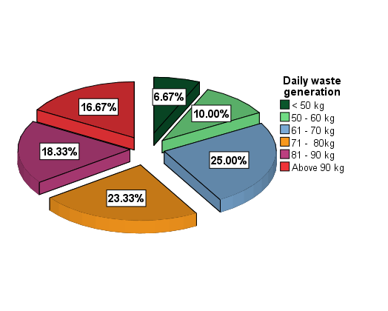

**Fig. 2: Daily pig manure generation**

The pig manure generation patterns in the Fako Division align with broader trends in pig farming and manure management, as highlighted in recent studies, such as Dennehy et al. (2018), emphasize that manure management is a significant source of GHG emissions, particularly CH₄ and N₂O, which are byproducts of anaerobic decomposition in manure storage and handling. The dominance of farms generating 61–80 kg of waste daily in Fako Division suggests a prevalence of medium to large-scale operations, which are usually not managed effectively hence contribute substantially to GHG emissions.

Häner et al. (2025) underscore the potential of anaerobic digestion as a mitigation strategy, highlighting that anaerobic digestion of pig manure can significantly reduce methane emissions while producing biomethane as a renewable energy source. However, the adoption of such technologies in Fako Division may be limited by socio-economic factors, such as the cost of installation and maintenance, as well as farmers' awareness and education on sustainable practices.

**3.2 State of pig manure**

Fig. 3 highlights that pig waste in Fako Division is predominantly solid (85%), with watery waste constituting 15%. This distribution has significant environmental implications, particularly concerning GHG emissions and waste management practices. Solid waste, being the majority, is often easier to manage and can be composted or processed into fertilizers, reducing methane emissions compared to slurry. However, studies such as Venslauskas et al. (2022) emphasize that improper handling of solid pig waste can still contribute to CH₄ and N₂O emissions during decomposition, especially in open storage systems, which are the dominant in the Fako Division.

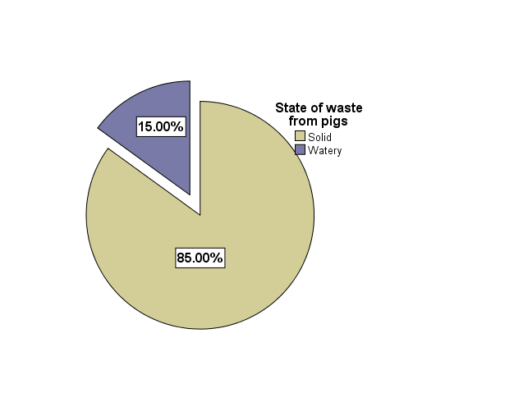

**Fig. 3: State of pig manure**

The predominance of solid manure in Fako presents both opportunities and challenges. On the one hand, solid manure is relatively easier to handle, store, and repurpose. Many farmers in the region apply this manure directly to their farms or sell it to crop growers as organic fertilizer. This practice, if done correctly, can reduce reliance on synthetic fertilizers, improve soil health, and contribute to carbon sequestration when composted properly. As highlighted by Sommer et al. (2013), aerobic composting of solid manure reduces CH₄ emissions by limiting anaerobic microbial activity, which is particularly important in warm tropical climates like that of Fako, where microbial decomposition is rapid.

However, the absence of structured composting systems in most farms in Fako poses a significant risk. Uncontrolled heaps of manure are left to decompose openly under high humidity and rainfall still become anaerobic, emitting CH₄ and N₂O gases that have global warming potentials 25 and 298 times greater than CO₂, respectively (IPCC, 2019). Moreover, the region’s topography and rainfall patterns, especially in areas like Buea and Limbe, increase the risk of leachate and nutrient runoff from improperly managed solid pig manure, contributing to water pollution and eutrophication in nearby streams, rivers, and coastal zones.

**3.3 Duration of manure storage**

A majority of pig farmers in the Fako Division (51.67%) store pig manure for less than three days before disposing, while 18.33% of manure is stored between 3 – 5 days. The remaining 30% is equally split between durations of 6 – 8 days and more than 8 days (Fig. 4).

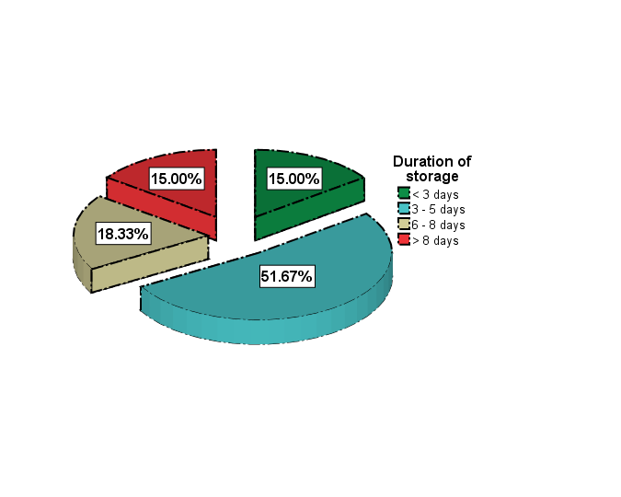

**Fig. 4: Duration of manure storage**

Shorter storage periods, which are most common in the Fako Division, are generally linked to lower GHG emissions, as there’s less time for anaerobic decomposition to occur and release gases like CH₄ and N₂O. Still, research by Viguria et al. (2015) shows that even brief storage can lead to ammonia (NH₃) emissions, which negatively affect air quality and ecosystems. Although longer storage periods are less frequent, they present a higher risk of GHG emissions due to extended anaerobic breakdown. Studies such as Turbí et al. (2024) demonstrate that mitigation measures like applying straw covers or introducing beneficial microbes can effectively lower methane and ammonia emissions during storage but these measures are usually not practiced by pig farmers in the Fako Division of Cameroon. Similarly, Ferreira et al. (2021) highlight the potential of anaerobic digestion systems to convert stored waste into biogas, simultaneously reducing emissions and generating renewable energy, though this is not a common practice among pig farmers in the study area.

**3.4 Treatment before disposal**

A striking 61.67% of farmers in the Fako Division reportedly do not treat their pig waste before disposal, which reflects a significant shortfall in sustainable waste management practices (Fig. 5). This untreated waste is typically disposed of directly into the environment, potentially leading to environmental degradation, including soil and water contamination, and contributing to GHG emissions. Sommer et al. (2021) highlighted that untreated pig manure, when left exposed or inadequately managed, undergoes anaerobic decomposition, releasing substantial amounts of CH₄ and N₂O, both potent greenhouse gases.

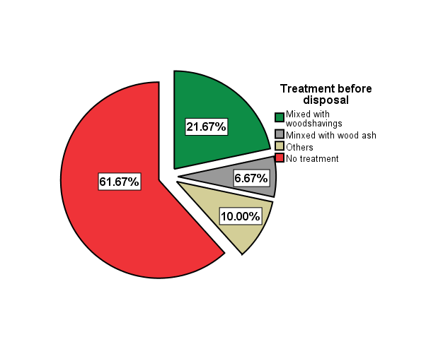

**Fig. 5: Pig manure treatment before disposal**.

About 21.67% of farmers in Fako mix pig waste with wood shavings. This practice not only improves the handling of waste but also suggests an intention to compost, which can significantly mitigate emissions. Tiku et al. (2023), and Tiku et al. (2025) indicated that co-composting pig manure with carbon-rich materials like wood shavings enhances aeration, reduces NH₃ volatilization, and curbs methane emissions by promoting aerobic decomposition. Moreover, such composted material can enrich soil fertility, thereby supporting sustainable agriculture. Interestingly, a smaller proportion, 6.67%, of pig farmers in the Fako Division mix pig waste with wood ash, a method noted by Nziguheba et al. (2022) to help stabilize pH and reduce odor and pathogen loads.

**3.5 Pig manure management/disposal practices**

The data from Fig. 6 highlights pig manure disposal methods in Fako Division which is predominantly unsustainable, with 38.33% of farmers dumping manure in the open air and 30% discharging it directly into running streams. These methods pose severe environmental threats. Open dumping allows anaerobic decomposition, which emits CH₄, a potent greenhouse gas, as highlighted by Sommer et al. (2021). The exposure of manure to the atmosphere contributes to NH₃ volatilization, negatively impacting air quality and causing nutrient imbalances in nearby soils. Disposing of pig manure in streams introduces high biological and chemical oxygen demand (BOD and COD) loads into water bodies. According to Nziguheba et al. (2022), such practices in sub-Saharan Africa contribute to eutrophication, loss of aquatic biodiversity, and potential public health issues due to the presence of pathogens and heavy metals in livestock waste. In Fako Division, where many communities depend on surface water for daily use, this method of disposal poses both ecological and human health risks.

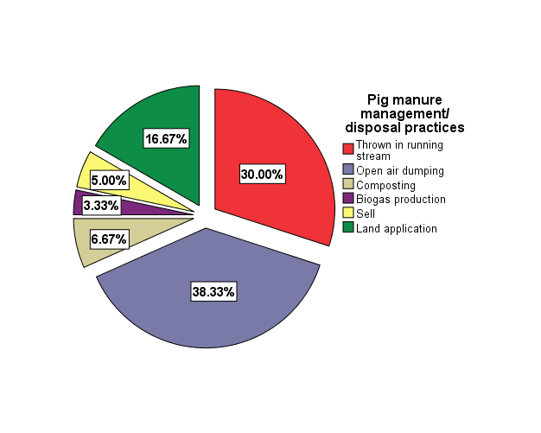

**Fig. 6: Pig manure management/disposal practices**

On a more positive note, 16.67% of farmers apply manure to land, a practice supported by Agyarko-Mintah et al. (2023) as a way to recycle nutrients and enhance soil organic matter. However, its effectiveness in reducing GHGs depends on the timing, method of application, and degree of manure stabilization. Uncomposted or fresh manure, when applied inappropriately, can still lead to N₂O emissions due to microbial nitrification and denitrification processes, especially under Fako’s humid conditions.

Composting, practiced by only 6.67% of farmers, offers a more climate-smart solution. Composting stabilizes organic matter, reduces pathogenic loads, and can significantly lower CH₄ and NH₃ emissions when managed correctly. As shown by Viguria et al. (2015); Tiku et al. (2023), and Tiku et al. (2025), integrating bulking agents like wood shavings (already used by some farmers in Fako) improves aeration and carbon-to-nitrogen balance, making composting more effective and environmentally beneficial. Biogas production, adopted by a mere 3.33%, remains underutilized despite its significant potential. Ferreira et al. (2021) argue that small-scale anaerobic digesters in tropical regions like Fako could transform manure into clean energy while drastically reducing GHG emissions. Methane, instead of escaping into the atmosphere, is captured and used, aligning with circular economy principles.

**3.6 Distance between pig pens and disposal sites**

Significant majority of pig pens in Fako Division are situated relatively close to their corresponding manure disposal sites, with 31.67% located within 100 meters and 46.67% between 100 and 500 meters (Fig. 7). This proximity suggests ease of waste transport and reduced labor demands for farmers, which is a practical advantage in low-resource settings. However, this pattern has noteworthy environmental and health implications, especially given that open dumping is the primary method of pig manure disposal in the region. Open dumping near pig pens increases the risk of localized air, water, and soil pollution. Sommer et al. (2021) noted that when pig manure is dumped openly and left untreated, it decomposes anaerobically, releasing significant amounts of CH₄ and N₂O both powerful greenhouse gases. Additionally, proximity to human settlements or livestock operations intensifies exposure to NH₃, which contributes to odor nuisance, respiratory issues, and acidification of nearby soils.

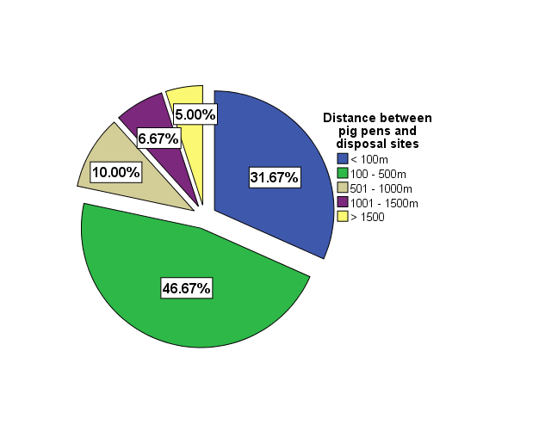

**Fig. 7: Distance between pig pens and disposal sites**

In a humid tropical region like Fako, Nziguheba et al. (2022) warned that short distances between pens and open dumpsites can also increase runoff risk during rainfall events, carrying nutrient-rich effluents directly into surrounding water bodies. This exacerbates eutrophication, degrades aquatic ecosystems, and compromises public health where surface water is used for domestic purposes.

The minority of pig pens situated farther from disposal sites 6.67% between 501–1000 meters, 5.00% between 1001–1500 meters, and 10.00% beyond 1500 meters may contribute less to localized pollution and odor problems. However, Turbí et al. (2024) note that longer transport distances can discourage regular waste removal, leading to accumulation of manure at the pen, which in turn becomes a concentrated source of GHGs and pathogens. However, Neina & Agyarko-Mintah (2023) recommended integrating buffer zones and vegetation strips around disposal sites, even when they are located close to pens, to reduce gaseous emissions and nutrient leaching. Similarly, where longer distances are unavoidable, organized manure collection systems or community-managed composting or biogas centers can make waste transport and treatment more efficient.

**3.7 Factors influencing eco-friendly pig manure management practices**

Table 1 presents the results of a binary logistic regression analysis of the socio-demographic factors that mediate farmers’ use of eco-friendly pig manure management practices.

**Table 1: Determinants of the use of eco-friendly pig manure management practices**

|  |  |  |  |  |  |  |
| --- | --- | --- | --- | --- | --- | --- |
| **Variables** | **Estimates** | **Standard error** | **Wald** | **df** | **Sig.** | **Odd ratio Exp (β)** |
|
| Gender | 4.917 | 2.283 | 4.640 | 1 | .031 | 136.574 |
| Age | -.293 | 1.282 | .052 | 1 | .819 | .746 |
| Occupation | -.345 | .563 | .376 | 1 | .540 | .708 |
| Level of education | 4.215 | 1.656 | 6.107 | 1 | .043 | 112.240 |
| Income levels | 4.805 | 1.907 | 6.348 | 1 | .012 | 122.063 |
| Famer’s experience | 3.619 | 1.840 | 5.717 | 1 | .044 | 105.047 |
| Size of herd | .378 | 1.411 | .072 | 1 | .789 | 1.460 |
| Distance from dump site | 2.517 | 1.037 | 5.893 | 1 | .015 | 12.397 |
| Faming system | .676 | 1.255 | .290 | 1 | .590 | 1.965 |
| Waste production | -1.456 | 1.079 | 1.822 | 1 | .177 | .233 |
| Waste state | -3.280 | 2.130 | 2.372 | 1 | .124 | .038 |
| Household size | -1.028 | 1.341 | .588 | 1 | .443 | .358 |
| Feed type | .391 | 1.102 | .126 | 1 | .722 | 1.479 |
| Mode of feeding | .083 | 1.628 | .003 | 1 | .959 | 1.086 |
| Constant | -16.187 | 9.572 | 2.860 | 1 | .091 | .000 |

*Hosmer and Lameshow Test (X2 =1.758; df = 8; P = 0.988) Omnbus Test (X2 = 53.668; df = 14; p = 0.000); Cox and Snell R2 = 0.591; Nagelkerke R2 = 0.791.*

The Hosmer and Lameshow (X2 =1.758; df = 8; P = 0.988) and Omnibus Test (X2 = 53.668; df = 14; p = 0.000) tests statistics showed a high goodness-of-fit for the model. The pseudo R2 indicated that the model explained between 59.1% (Cox and Snell R2) and 79.1% (Nagelkelke R2) the variation in pig manure management practice in the Fako Division of Cameroon.

The statistically significant socio-demographic determinants or predictors of eco-friendly pig manure management practice were gender (p=0.031), level of education (p=0.043), income levels (p=0.012), farmers' experience (p=0.044), and distance to waste disposal site (0.015).

The findings from binary regression model indicate that gender has a statistically significant positive impact on the likelihood of a pig farmer engaging in eco-friendly pig waste management practices, these results were similar to Onyia et al. (2020) and Gbenou et al. (2022). This aligns with the expectation that males have superior access to information and resources regarding advanced technologies and methods compared to females. Research has demonstrated that women, as compared to men, are less likely to adopt and utilize new technologies, often lacking confidence in their ability to do so (Michie and Nelson, 2006; Collins et al., 2023).

The model outcomes also reveal that higher levels of education positively influence piggery farmers' engagement in eco-friendly pig waste management practices these results were similar to Onyia et al. (2020) where levels of education strong influence the choice of pig waste management, Gbenou et al. (2022) however didn't not see a very strong influence of education levels on the choice of eco-friendly pig management in Benin. However, this finding is not far-fetched, as educated farmers, having access to essential information, possess the skills to effectively process and apply this knowledge, enhancing their adoption of improved technologies and practices (Panin and Brummer, 2000). Onyia et al. (2020) emphasize the pivotal role of education in sustainable development, emphasizing its importance in enhancing individuals' capabilities to address environmental and developmental challenges. Education programs play a crucial role in equipping individuals with the knowledge, values, skills, and determination essential for tackling waste management issues at both individual and community levels.

The distance to the dumpsite significantly influences the adoption of eco-friendly pig manure management practices, with farther distances correlating to lower likelihoods of implementing sustainable/eco-friendly pig manure management practices this aligns with Onyia et al. (2020) and Gbenou et al. (2022). Farmers with more remote dumpsites may face fewer disruptions from neighbors, local authorities, and environmental regulations as they often opt for distant bush areas for dumping. However, even remote dumpsites contribute to air pollution and greenhouse gas emissions, exacerbating climate change Omar et al. (2024) and Stephen et al. (2019).

The income levels of pig farmers significantly influenced the adoption of eco-friendly pig manure management practices due to various factors. Dan et al. (2021) suggested that higher income levels often provide farmers with the financial resources necessary to invest in sustainable waste management technologies, such as anaerobic digesters, composting systems, or biogas production facilities, which can be costly to implement. According to Michelle et al. (2023), wealthier farmers may have better access to education, information, training, and resources on eco-friendly practices, leading to increased awareness of the environmental benefits and regulatory requirements associated with proper waste management hence enabling them to make informed decisions and adopt sustainable pig manure management strategies.

The significance of pig farmers' experience in the Fako Division on the adoption of eco-friendly pig manure management practices may stem from various factors. Zejun et al. (2023) suggested that farmers with more experience in pig farming are likely to have accumulated knowledge, skills, and insights into effective pig manure management practices over time. This accumulated experience can lead to a deeper understanding of the environmental benefits associated with eco-friendly pig manure management practices. According to Solovieva et al. (2021), experienced pig farmers might have firsthand experience dealing with the consequences of poor waste management, such as pollution and environmental degradation, motivating them to implement more sustainable practices.

**3.8 Policy Implications**

The findings of this study carry significant policy implications for enhancing pig manure management within the Fako Division. The predominance of unsustainable practices such as open dumping (38.33%) and disposal into running streams (30%) necessitates policies aimed at discouraging these methods and incentivizing sustainable alternatives like composting (6.67%) and biogas production (3.33%). Given the significant influence of education and income levels on the adoption of eco-friendly practices, agricultural extension programs should be strengthened to educate farmers, particularly women, on the environmental and health risks of improper manure management, and financial support mechanisms should be established to facilitate the adoption of sustainable technologies. Stricter enforcement of environmental regulations is crucial to deter polluting practices, and land-use planning policies should consider the spatial relationships between pig farms, residential areas, water bodies, and disposal sites. Furthermore, investment in research and development is essential to identify and promote cost-effective, locally appropriate manure management technologies and to explore opportunities for converting pig manure into valuable resources. Implementing these multifaceted policy measures will be crucial for fostering sustainable pig manure management, safeguarding the environment, and promoting public health within the Fako Division.

**4. Conclusion**

The Findings from this research revealed that most pig farms (66.4%) produce solid manure, and while 59.1% store it for less than a week, potentially reducing methane emissions, improper disposal remains prevalent. Around 44.5% of farms dump manure on open land, and 32.7% dispose of it in streams, contributing to soil and water pollution and indirect GHG emissions. Sustainable practices like composting (4.5%) and biogas usage (3.6%) are rarely adopted due to limited awareness, technical skills, and financial resources. Socio-demographic factors significantly influence eco-friendly practices, with male, educated, higher-income, and experienced farmers more likely to adopt them. The study highlights the urgent need for education, financial support, and policy measures to promote sustainable waste management and mitigate environmental damage.

Disclaimer (Artificial intelligence)

Option 1:

Author(s) hereby declare that NO generative AI technologies such as Large Language Models (ChatGPT, COPILOT, etc.) and text-to-image generators have been used during the writing or editing of this manuscript.

Option 2:

Author(s) hereby declare that generative AI technologies such as Large Language Models, etc. have been used during the writing or editing of manuscripts. This explanation will include the name, version, model, and source of the generative AI technology and as well as all input prompts provided to the generative AI technology

Details of the AI usage are given below:

1.

2.

3.

# References

(ILRI), I. L. (2020). *Handbook of livestock statistics for developing countries.* Nairobi, Kenya: ILRI.

(IPCC), I. P. (2019). *The Special Report on Climate Change and Land.* Cambridge University Press. Retrieved from https://doi.org/10.1017/9781009157964

(SOWEDA), S. W. (2020). *Annual statistical report on agricultural and livestock production in the South West Region.* Buea: SOWEDA.

Abdoulay M and Sevidzem S.L. (2018). Urban-Pig Farming: Easy Gain and Danger to the Environment (Yaounde-Cameroon). *Journal of Agriculture studies*, 190-198.

Neina, D., & Agyarko-Mintah, E. (2023). The Terra Preta Model soil for sustainable sedentary yam production in West Africa. Heliyon, 9(5).

Collins M. Bulinda, Eric O. Gido, Holger Kirscht, and Chrysantus M. Tanga . (2023). Gendered Awareness of Pig and Poultry Farmers on the Potential of Black Soldier Fly (Hermetia illucens) Farming in Kenya. *Sustainability , 15(4)*, 3613.

Dan Pan, Jing Tang, Liguo Zhang, Mimi He, Chih-Chun Kung. (2021). The impact of farm scale and technology characteristics on the adoption of sustainable manure management technologies: Evidence from hog production in China. *Journal of Cleaner Production, 280*, 124340.

Defang HF, Kana JR, Bime MJ, Ndebi G, Yemele F, Zoli PA, Manjeli Y, Teguia A, Tchoumboue J. . (2014). Socioeconomic and technical characteristics of pig farming in the urban and peri-urban zone of Dschang - West region of Cameroon. . *Discourse Journal of Agriculture and Food Sciences 2(1)*, 11-20.

Dennehy, E. R., & Gallachóir, B. P. Ó. (2018). Ex-post decomposition analysis of passenger car energy demand and associated CO2 emissions. Transportation Research Part D: Transport and Environment, 59, 400-416.

Ewane, E. B. (2021). Land use land cover change and the resilience of social-ecological systems in a sub-region in South west Cameroon. *Environ Monit Assess*, 193:338 .

FAOSTAT. (2020). *Food and Agriculture Organization of the United Nations Statistical Database.* Retrieved from FAO: http://www.fao.org/faostat/en/

Ferreira, T. F., Santos, P. A., Paula, A. V., de Castro, H. F., & Andrade, G. S. (2021). Biogas generation by hybrid treatment of dairy wastewater with lipolytic whole cell preparations and anaerobic sludge. Biochemical Engineering Journal, 169, 107965.

Gbenou, B., Adjolohoun, S., Dahouda, M., Kokou, K., & Kulo, A. (2022). Pig manure management practices in South-East Benin (West Africa). *Journal of Experimental Agriculture International, 44 (7)*, 42–52. Retrieved from https://doi.org/10.9734/JEAI/2022/v44i730836

Häner, J., Neradko, A., Weinrich, S., Gausling, M., Krüp, B., Wetter, C., & Nelles, M. (2025). Evaluation of pig farming residue as substrate for biomethane production via anaerobic digestion. Biomass Conversion and Biorefinery, 1-21.

Joseline S Motsa’a, Henry F.D and Christian T.K. . (2018). Socio-economic and technical characteristics of pig (Sus scrofa domesticus) production system in the humid forest with monomodal rainfall agroecological zone of Cameroon. *nt. J. Biol. Chem. Sci. 12(5)*, 2318-2327.

Michelle Savian, Carla da Penha Simon, Nicholas M. Holden. (2023). Evaluating environmental, economic, and social aspects of an intensive pig production farm in the south of Brazil: a case study. *International Journal of Life Cycle Assessment*.

Michie, S. and Nelson, D.L. (2006). Barriers women face in information technology careers: Self-eiTicacy, passion and gender biases. . *Women in Management Review, 21(1)*, 10-27.

.

Myhre, G. S.-M. (2013). *Anthropogenic and natural radiative forcing. In Climate Change 2013: The Physical Science Basis. Contribution of Working Group I to the Fifth Assessment Report of the Intergovernmental Panel on Climate Change.* Cambridge University.

Ngwabie NM, Chungong BN, Yengong FL. (2018). Characterisation of pig manure for methane emission modelling in Sub-Saharan Africa. *Biosystems Engineering 170*, 31-38.

Omar S. Arabeyyat, Nawaras Shatnawi, Mohammad A. Shbool, Ata Al Shraah. (2024). Landfill site selection for sustainable solid waste management using multiple-criteria decision-making. Case study: Al-Balqa governorate in Jordan. *MethodsX, 12*, 102591.

Stephen T Odonkor Frimpong and Napoleon Kurantin. (2019). An assessment of house-hold solid waste management in a large Ghanaian district. *Heliyon 6(1)*. doi:10.1016/j.heliyon.2019.e03040

Tiku, David T., Fabrice L. Yengong, Ngwa M. Ngwabie, and Veronica E. Manga. (2025). Greenhouse Gas Emissions During Windrow Composting and Open-Air Dumping of Pig Manure With Added Wood Shavings. *International Journal of Environment and Climate Change 15 (2)*, 314-25. Retrieved from https://doi.org/10.9734/ijecc/2025/v15i24729.