**MINIMALLY INVASIVE MANAGEMENT OF LEUKOPLAKIA WITH DIODE LASER- A CASE SERIES**

*Abstract*

Leukoplakia is a potentially malignant disorder affecting the oral cavity.  Early detection and prompt treatment are the keys to prevent its malignant transformation. Various treatment modalities have been discussed in multiple literatures, broadly categorized into non-surgical and surgical treatments.   Non-surgical treatment includes various chemopreventive agents, while surgical treatment includes excisional surgery, electrocauterization, laser surgery, or cryosurgery. Surgical treatment is always the key to eradicating the leukoplakia patch completely. Laser is known for its various advantages over a traditional scalpel, like minimal bleeding, clear surgical field, less scarring, minimal postoperative pain, etc.  Various lasers, such as neodymium-doped yttrium aluminum garnet (Nd: YAG), Carbon dioxide (CO2), and erbium-doped yttrium aluminum garnet lasers (Er: YAG), have been used successfully to manage leukoplakia in previous literature. Here we are presenting three cases of leukoplakia of different sites managed with a minimally invasive procedure of diode laser 980nm based ablation.

*Key words-* Oral potentially malignant disorder, Leukoplakia, diode laser, laser ablation, laser excision, recurrence, malignant transformation

*Introduction*

Leukoplakia is the most common oral potentially malignant disorder (OPMDS) with malignant transformation rate of 6.64%.[1] OPMDs was previously termed as “precancerous condition and precancerous lesion”, basically denotes those mucosal abnormalities that have statistically increased risk of developing oral cancer”. [2]Warnakulasuriya S et al 2007 suggested that the term “Leukoplakia” should be used to recognize white plaques of questionable risk having excluded (other) known diseases or disorders that carry no increased risk for cancer”.[3] Early diagnosis and prompt treatment is the key of reduce its malignant transformation rate which is around 15.6-39.2%.[3] Non-surgical treatment includes various chemopreventive agents (vitamin A, vitamin C, vitamin E, fenretinide, carotenoids, lycopene, green tea and curcumin), topical bleomycin and photodynamic therapy. 3 Chemopreventive agents are basically antioxidants and prevent free radical induced carcinogenesis, but recurrences are seen as these agents stopped. [4]

Surgical treatment modalities such as scalpel surgery, laser surgery, electrocauterization or cryosurgery are always the key to eradicating the leukoplakia patch completely.[3] Compared to other surgical modalities, laser offers various advantages like minimal bleeding, clear surgical field, less scarring, minimal postoperative pain, etc. [4-6] Various lasers, such as neodymium-doped yttrium aluminum garnet (Nd: YAG), Carbon dioxide (CO2), and erbium-doped yttrium aluminum garnet lasers (Er: YAG), have been used successfully to manage leukoplakia in previous literature.[4] Here we are presenting three cases of leukoplakia of different sites managed with a minimally invasive procedure of diode laser 980nm based ablation

*Case presentation with protocol*

The details of the gender, age, habits, site, and type of leukoplakia, healing period and recurrences of the cases are described in table 1. We have used the common protocol used to manage these cases. The protocol is as follows-

Incisional biopsy was performed, and the lesion confirmed with leukoplakia without dysplasia, histopathologically .Patients was motivated to quit adverse habit with 5A principle (Ask, Advise, Assess, Assist and Arrange). Before laser treatment, Anti-fungal agent (Clotrimazole 1% oral paint) was advised three times daily for 10 days to rule out any chances of candidal leukoplakia. Diode laser ablation was performed after Perilesional infiltration of local anaesthetic (2% lignocaine with1:80,000 adrenaline). The laser parameter used is summarized in table 2. Laser ablation was performed with 1mm depth, in continuous mode in a paint brush manner. The procedure was finished under complete aseptic condition with complete laser safety protocol. After ablation, patient was advised to take antibiotic and analgesic for 3 days. Chemoprevention with antioxidants was also advised for 3 month as a supportive therapy. [3] Postoperative follow-up was done at 1 week, 2 week, one month, 3month and 6 month. Patient was also motivated to visit every 3 month to check any recurrence or malignant transformation.

*Discussion*

The term LASER stands for “Light Amplification by Stimulated Emission of Radiation”, that utilizes optical amplification based on the stimulated emission of electromagnetic radiation. Laser offers many advantages over other conventional methods. Diode laser has an additional advantages of contact mode, compact size, portable nature, cost effective, excellent coagulation ability, better incision performance and biostimulatory effect compared to other laser, which increases growth promoting tissue.[6]

 Diode lasers can be utilized in the management of leukoplakia mainly via a) Laser ablation/excision, b) photodynamic therapy.  Laser excision is the removal of the lesion deeply, indicated mainly for non-homogeneous leukoplakia and homogeneous leukoplakia of high-risk sites such as the tongue. Compared to laser excision, laser ablation is the superficial removal of the lesion of homogenous or thin leukoplakia with a lesser risk site, such as the buccal mucosa and gingiva.[4,7] Leukoplakia can be provisionally diagnosed clinically. Vital staining such as toluidine blue can be used as a screening test to check dysplasia, but biopsy is the confirmatory gold standard test.  Biopsy is mandatory to confirm its level of dysplasia, so that proper protocol can be followed.  Laser excision must be preferred over laser ablation for the presence of dysplasia. [4 ] As our cases were without dysplasia and low-risk sites, laser ablation was performed.

Regular follow-up is of utmost importance to evaluate its recurrences and malignant transformation. Recurrences are usually seen due to the proliferation of certain active cells in the basal cell layer. The Recurrences may also be correlated to various factors such as dysplastic activity, non-cooperation to quit the habit, patient’s gender, presence of lesion for a prolonged period and the location of the lesion.[8]The Recurrence rate of leukoplakia after laser treatment varies from 16.5-29.3%.[4,9,10] Our cases do not show any recurrences till the follow-up period of 6 months, but the author strongly recommended a long follow-up is a must to rule out any further recurrences. A study reported malignant transformation of 4.12% in leukoplakia occurring even after laser evaporation over a period of 5 years. [9] Thus, a long follow-up is necessary to report malignant transformation in these cases.

A study was performed with combination therapy with Diode laser ablation followed by 1-3 sessions of aminolevulinic acid photodynamic therapy to manage leukoplakia with epithelial dysplasia. The study concluded that PDT is an effective and high-efficiency treatment modality for OLK with epithelial dysplasia, particularly for lesion size ≤200 mm2.[11]

*Conclusion*

Due to heavy consumption of tobacco, leukoplakia is commonly encountered oral potentially malignant disorder. The malignant transformation can be only prevented with its early diagnosis and prompt intervention. Diode laser has shown its positive efficacy in the successful management of leukoplakia. Thus, it can be a promising treatment modality for such cases with high success rate.

**Disclaimer (Artificial intelligence)**

Author(s) hereby declare that NO generative AI technologies such as Large Language Models (ChatGPT, COPILOT, etc.) and text-to-image generators have been used during the writing or editing of this manuscript.

*References*

1. Pimenta-Barros LA, Ramos-García P, González-Moles MÁ, Aguirre-Urizar JM, Warnakulasuriya S. Malignant transformation of oral leukoplakia: Systematic review and comprehensive meta-analysis. Oral Dis. 2025; 31(1):69-80. DOI: [10.1111/odi.15140](https://doi.org/10.1111/odi.15140) , PMCID: [PMC11808172](https://pmc.ncbi.nlm.nih.gov/articles/PMC11808172/)
2. Warnakulasuriya S, Kujan O, Aguirre-Urizar JM, Bagan JV, González-Moles MÁ, Kerr AR, et al. Oral potentially malignant disorders: A consensus report from an international seminar on nomenclature and classification, convened by the WHO Collaborating Centre for Oral Cancer. Oral Dis 2021;27:1862‑80.DOI: [10.1111/odi.13704](https://doi.org/10.1111/odi.13704), PMID: **33128420**
3. Shivhare P, Parihar A. Oral potentially malignant disorder. In: Shivhare P, Parihar A, editors. Textbook of Oral Medicine and Radiology. 2nd ed. Hyderabad: Paras Publisher; 2021. p. 218‑58.
4. Shivhare P, Haidry N, Kumar A, Parihar A, Singh A, Subramanyam S. Diode laser in the management of Leukoplakia ‑ A retrospective study. Ann Maxillofac Surg 2022;12:178‑84.DOI: [10.4103/ams.ams_117_22](https://doi.org/10.4103/ams.ams_117_22) , PMCID: [PMC9976845](https://pmc.ncbi.nlm.nih.gov/articles/PMC9976845/)
5. Shivhare P, Haidry N, Sah N, Kumar A, Gupta A, Singh A, Penumatcha MR, Subramanyam S. Comparative Evaluation of Efficacy and Safety of the Diode Laser (980 nm) and Sclerotherapy for the Treatment of Oral Pyogenic Granuloma. Int J Dent. 2022 Sep 17;2022:8269221.DOI: [10.1155/2022/8269221](https://doi.org/10.1155/2022/8269221), PMCID: [PMC9509284](https://pmc.ncbi.nlm.nih.gov/articles/PMC9509284/)
6. Shivhare P, Haidry N, Sah N, Kumar A, Gupta A, Singh A, Penumatcha MR, Subramanyam S. Comparative Evaluation of Efficacy and Safety of the Diode Laser (980 nm) and Sclerotherapy in the Treatment of Oral Vascular Malformations. Int J Vasc Med. 2022 Sep 5;2022:2785859.DOI: [10.1155/2022/2785859](https://doi.org/10.1155/2022/2785859), PMCID: [PMC9467756](https://pmc.ncbi.nlm.nih.gov/articles/PMC9467756/)
7. Shivhare P, Parihar A. Advanced therapies in oral medicine. In: Shivhare P, Parihar A, editors. Textbook of Oral Medicine and Radiology. 2nd ed. Hyderabad: Paras Publisher; 2021. p. 858‑74.
8. Yasmeen SA, Reddy BHS, Ramesh MV, Birajdar SS, Yarram A, Kumar NN. Comparative evaluation of diode laser ablation versus scalpel excision for management of oral leukoplakia. J Indian Acad Oral Med Radiol 2019;31:94‑9.DOI:[10.4103/jiaomr.jiaomr_4_19](http://dx.doi.org/10.4103/jiaomr.jiaomr_4_19)
9. Ishii J, Fujita K, Munemoto S, Komori T. Management of oral leukoplakia by laser surgery: Relation between recurrence and malignant transformation and clinicopathological features. J Clin Laser Med Surg 2004;22:27‑33.DOI: [10.1089/104454704773660949](https://doi.org/10.1089/104454704773660949), PMID: **15117484**
10. de Pauli Paglioni M, Migliorati CA, Schausltz Pereira Faustino I, Linhares Almeida Mariz BA, Oliveira Corrêa Roza AL, Agustin Vargas P, et al. Laser excision of oral leukoplakia: Does it affect recurrence and malignant transformation? A systematic review and meta-analysis. Oral Oncol 2020;109:104850.DOI: [10.1016/j.oraloncology.2020.104850](https://doi.org/10.1016/j.oraloncology.2020.104850), PMID: **32540612**
11. Dong B, He M, Zhang J, Tan Y, Chen X, Wang F et al. Effect of the combination of diode laser ablation with photodynamic therapy for oral leukoplakia with epithelial dysplasia: a retrospective study. Oral Surg Oral Med Oral Pathol Oral Radiol. 2025 Aug;140(2):177-185. doi: 10.1016/j.oooo.2025.03.003. Epub 2025 Mar 8. PMID: 40254477.

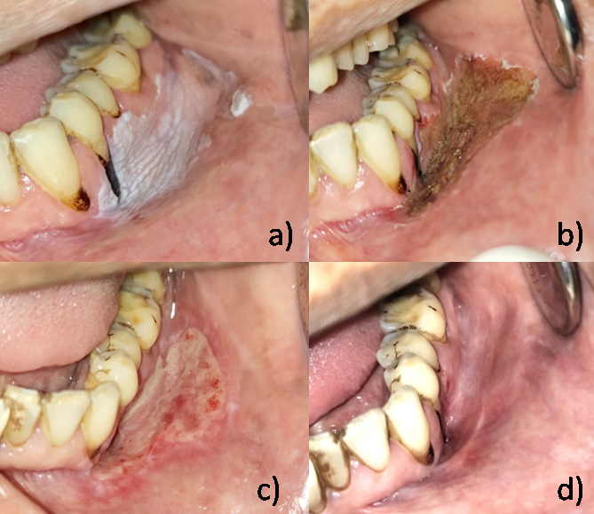

Figure 1- Case of leukoplakia treated by laser ablation: (a) Leukoplakia on the Vestibular region and gingiva in relation with 34-37 (b) Immediate post‑operative view, (c) Two weeks after laser ablation, (d) Complete healing after 1–1.5 months

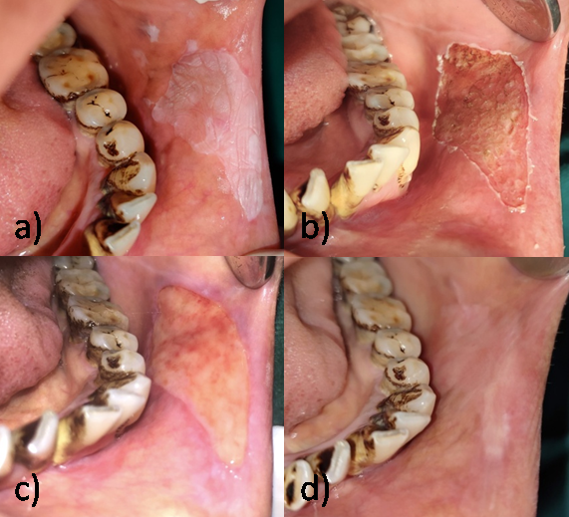

Figure 2- Case of leukoplakia treated by laser ablation: (a) Leukoplakia on the left buccal mucosa (b) Immediate post‑operative view, (c) Two weeks after laser ablation, (d) Complete healing after 1–1.5 months

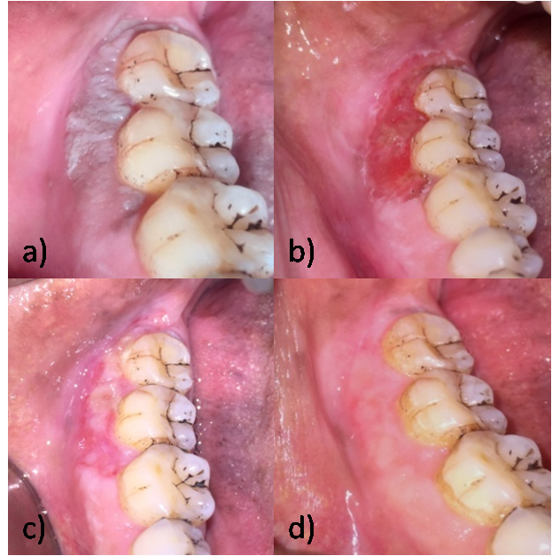

Figure 3- Case of leukoplakia treated by laser ablation: (a) Leukoplakia on the right gingival lesion (b) Immediate post‑operative view, (c) Two weeks after laser ablation, (d) Complete healing after 1months

**Table 1-** The parameters used for the diode laser device

|  |  |  |  |  |  |  |  |
| --- | --- | --- | --- | --- | --- | --- | --- |
| Gender | Age | Habit | Site and extent | Site | Type of leukoplakia | Healing period | Recurrence |
| Male | 40 year | 10 packets tobacco chewing per day past 5 years | Vestibular region and gingiva, extending from distal of 34 to distal of 37 region involving most of the gingiva (Figure 1a) | Vestibular region and gingiva in relation with 34-37 (Figure 1) | Homogeneous leukoplakia | 1.5 month | No |
| Male | 45 year | 5 packets tobacco chewing per day past 6 years along with cigarette smoking one pack for last 3 years | Left buccal mucosa extending from retrocommissural area to 2cm posteriorly in the occlusal plane. (Figure 2) | Left buccal mucosa (Figure 2) | Homogeneous leukoplakia | 1.5 month | No |
| Male | 33 year | 5 packets tobacco chewing per day past 3 years | Gingival region in relation with 47-48, extending upto mucogingival junction (Figure 3a) | Gingival region in relation with 47-48(Figure 3) | Homogeneous leukoplakia | 1 month | No |

**Table 2-** The parameters used for the diode laser device

|  |  |
| --- | --- |
| **Type of laser** | Diode laser (Ga-Al-As, DILAS, Germany; IndiLase, MEDSOL, Hosur, India) |
| **Emission mode** | Continuous mode with initiated tip |
| **Contact/noncontact mode** | Contact mode |
| **Delivery system** | 400 μm, Polyamide coated Optical fiber |
| **Wavelength** | 980-nm |
| **power** | 2 watt |
| **Energy density** | 1592.35 Jule/cm2 |
| **Tip initiation** | Yes |
| **Voice conﬁrmation** | Yes |