**Rare Synchronous Colonic and Ovarian Carcinomas in a 26 Year Old Female Patient: A Case Report**

**Abstract:**

**Background**: Synchronous primary malignancies, characterised by the diagnosis of two or more histologically distinct cancers within six months, are uncommon, and data from Sub-Saharan Africa is limited. Their occurrence in young individuals, particularly with colorectal and ovarian primaries, is rare and suggests the possibility of underlying hereditary cancer syndromes.

**Case study Presentation:** This report describes an uncommon case of synchronous Rectoanal adenocarcinoma and left ovarian endometrioid carcinoma in a 27-year-old Nigerian female, who exhibited altered bowel habits, rectal bleeding, and weight loss. The diagnostic evaluation identified a circumferential rectal tumour, which was histologically confirmed as adenocarcinoma. The patient underwent a diverting colostomy and received neoadjuvant XELOX chemotherapy. Over two months, a rapidly enlarging pelvic mass was observed in her. Surgical exploration identified a large sessile left ovarian tumour, which was histologically confirmed as FIGO Grade 2 endometrioid carcinoma. The postoperative recovery proceeded without complications, and a plan for adjuvant therapy was established.

**Discussion:** This case highlights the diagnostic challenges in distinguishing between metastatic spread and genuine synchronous primaries. The lack of a family history combined with the early age of presentation indicates the potential for sporadic early-onset colorectal cancer or an undiagnosed hereditary syndrome. The dual pathology underscores the necessity for thorough immunohistochemical and genetic assessments, especially in younger patients. In low-resource environments, the delay in diagnosis and restricted access to molecular diagnostics impede the provision of optimal care.

**Conclusion**: The occurrence of synchronous rectal and ovarian malignancies in young females is exceedingly uncommon. This case highlights the necessity of maintaining high clinical suspicion, utilising histopathologic and molecular diagnostics, and implementing genetic screening protocols, especially in Sub-Saharan Africa, to improve early detection and customised management strategies.

**Keywords:** Early-onset colorectal cancer; Nigeria; Low-resource settings; Ovarian endometrioid carcinoma; Rectal adenocarcinoma; Synchronous malignancy.

**Introduction:**

Synchronous Primary Malignancies, defined as two or more primary tumours diagnosed simultaneously or within six months of each other, are rare, with an incidence ranging between 2% and 17% in cancer patients, depending on diagnostic intensity and population studied¹. The simultaneous occurrence of Colonic Adenocarcinoma and Ovarian Endometrioid Carcinoma is particularly uncommon, more so in young individuals under the age of 30. When such Dual Malignancies occur in young females, they often raise suspicion for hereditary cancer syndromes such as Lynch syndrome (hereditary non-polyposis colorectal cancer) or MUTYH (mutY DNA glycosylase)-associated polyposis².

Colorectal cancer (CRC) is the third most commonly diagnosed cancer globally, and although it predominantly affects older adults, a rising incidence in young adults has been reported in both high-income and low- and middle-income countries³. Young-onset CRC tends to present at advanced stages, with aggressive histologic features and a higher likelihood of synchronous or metachronous malignancies⁴. Similarly, Ovarian Carcinoma in young women is rare and is more frequently associated with Endometrioid and clear cell histologies, both of which may overlap molecularly and pathogenetically with Colorectal Adenocarcinomas⁵.

Synchronous Ovarian and Colorectal Carcinomas may present a diagnostic challenge due to overlapping clinical and radiologic features, particularly when metastatic disease cannot be reliably distinguished from Dual Primaries based solely on imaging or serum markers⁶. Immunohistochemistry and molecular profiling are critical in confirming distinct primaries, with markers such as CK7, CK20, PAX8, and mismatch repair (MMR) protein expression aiding in tissue origin determination⁷.

In Sub-Saharan Africa, Colorectal Cancer remains under-diagnosed and often presents late, with few reported cases of Synchronous Malignancies. A recent Nigerian study by Nwafor and Omenu in the South-South region described rising trends in young-onset Colorectal Cancer, with notable proportions of patients under 40 years of age⁸. However, there remains a paucity of data on Synchronous Primary Cancers in this demographic. Similarly, Ovarian Cancers in Nigerian and sub-Saharan populations often present at advanced stages and are less likely to be screened for synchronous pathology9,10

We present a rare case of Synchronous Colonic Adenocarcinoma and Ovarian Endometrioid Carcinoma in a 26-year-old Nigerian female, highlighting the diagnostic, pathological, and management considerations. A brief review of similar reports is included to contextualise this case within global and regional patterns.

**Case report**

A 27-year-old female who had 3 months of change in bowel habit, which was associated with passage of pencil-like faeces, haematochezia, tenesmus, anorexia and progressive weight loss. 4-days before the presentation, she developed colicky abdominal pains, absolute constipation and progressive abdominal distention. She has no known family member with similar complaints or any malignancy.

Physical findings revealed a young female in distress, to pain, not pale, anicteric, chronic ill-looking with a grossly distended abdomen, visible intestinal pattern and hyperactive bowel sounds. Rectal examination revealed a hard nodular circumferential rectal tumour 8cm from the anal verge with minimal contact bleeding.

She was optimised and had a Rectal Tumour Incision Biopsy and diverting sigmoid colostomy. The surgical pathology confirmed adenocarcinoma of the colon (Fig.1).

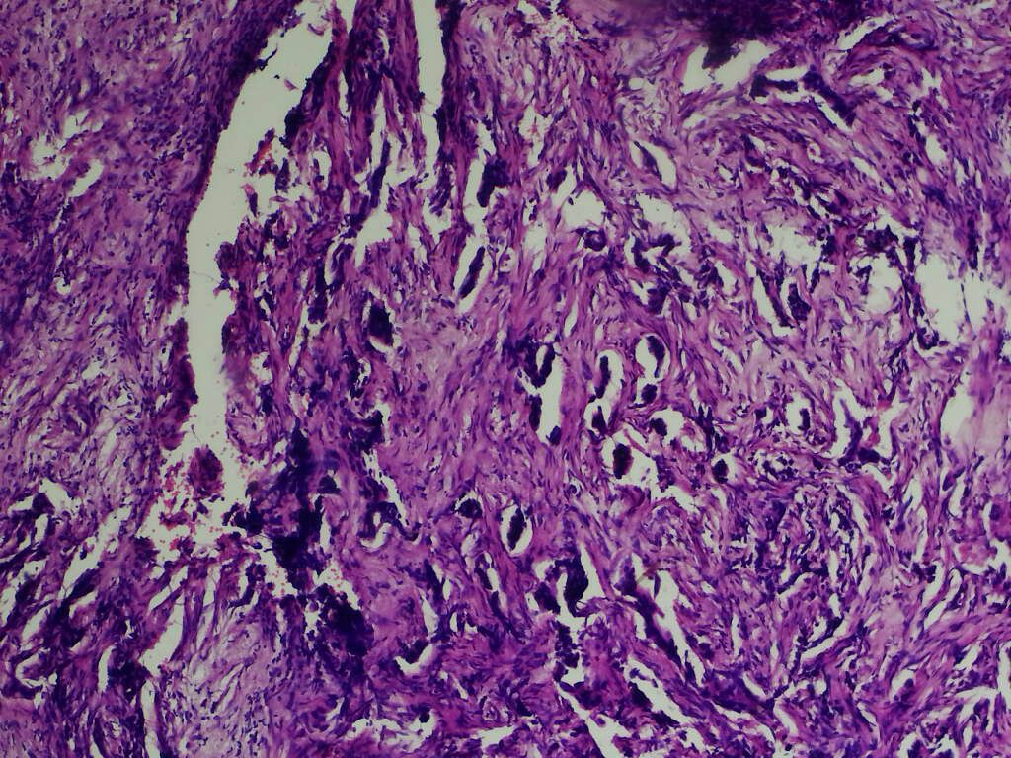

**Fig.1**.Histological sections of bowel lesion show sheets and nests of epithelial cells invading the lamina propria and muscularis muscle layers with associated desmoplasis of the stroma. These dysplastic epithelial cells show poorly formed glands. These cells have hyperchromatic nuclei, frequent abnormal mitosis. There are also signet ring cells seen in the stroma (H&E x40)

She had four courses of neo-adjuvant chemotherapy (Xerox Regimen). However, she presented within 2 months of commencing chemotherapy with a rapidly progressive abdominal distention but no constipation. Abdominal examination at presentation revealed a functioning sigmoid colostomy. Ultrasonography showed a complex solid mass with cystic pelvic component measuring 20x18cm in its greatest dimensions and minimal ascites.

She had an exploration, and intra-operative findings were a huge sessile left Ovarian Cyst tumour. Surgical pathology revealed Endometroid carcinoma, International Federation of Gynaecology and Obstetrics (FIGO) Grade 2 (Fig.2).

Post-operative was uneventful, and she is to commence adjuvant chemotherapy.

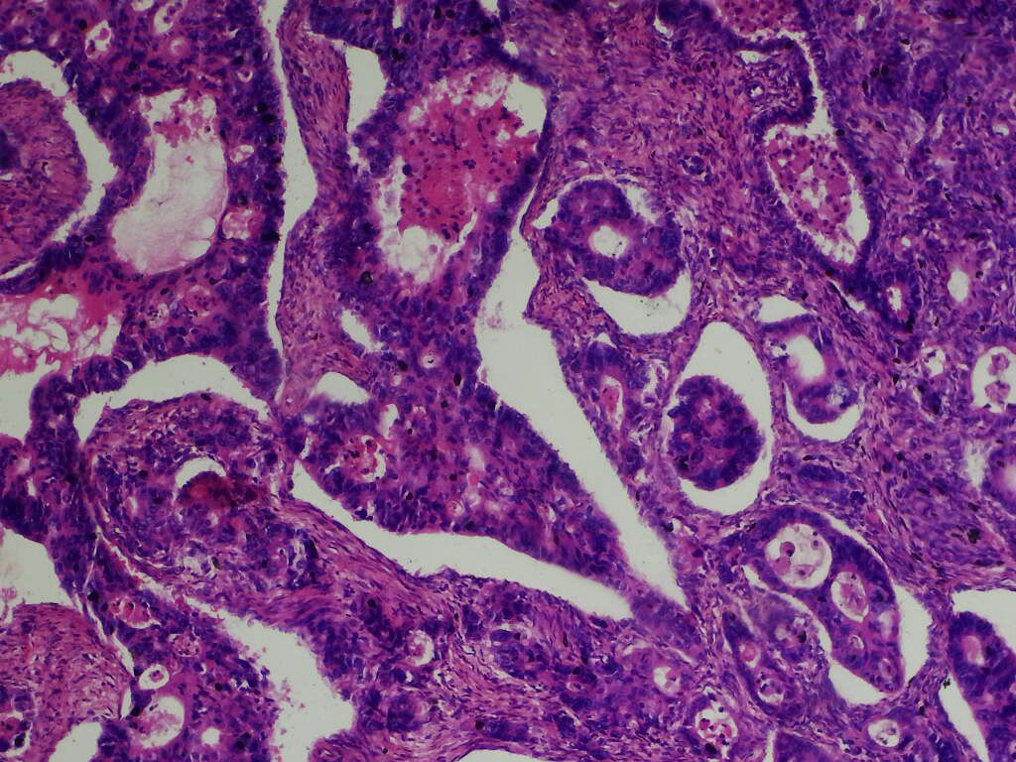

Fig.2. Histological section of the ovarian tumour shows a malignant neoplasm composed of neoplastic epithelial cells invading the stroma in sheets, poorly formed glands and singles. These epithelial cells are markedly pleomorphic both in nuclear and cellular morphology. Some of the nuclear of these dysplastic epithelial cells have coarse chromatin distribution while others are hyperchromatic. Some show prominent nucleoli while others have abnormal mitotic figures. In most foci are seen features of squamous metaplasia, with other foci having features of endometriosis. These are consistent with Endometrioid Carcinoma (FIGO - GRADE 2). (H&E x40).

**Discussion:**

This case highlights a rare and diagnostically challenging occurrence of Synchronous Primary Recto-anal Adenocarcinoma and Left Ovarian Endometrioid Carcinoma in a 27-year-old female. The rarity of this combination, particularly in such a young patient without a family history of malignancy, presents an opportunity to explore both the clinical and pathological implications in light of existing global and regional literature.

Globally, Synchronous Primary Malignancies involving the gastrointestinal and gynecologic tracts have been reported but remain uncommon. The ovary is a known site for metastatic spread from Colorectal Cancer, particularly in advanced-stage disease, with synchronous involvement seen in approximately 1–8% of female colorectal cancer cases11. However, true Synchronous Primary Malignancies—especially those involving Endometrioid Carcinoma of the Ovary and Rectoanal Adenocarcinoma—are exceedingly rare12. In high-income settings, early diagnosis is often facilitated by routine colorectal cancer screening, pelvic ultrasonography, and tumour marker evaluation13. Such mechanisms are not routinely accessible in many resource-limited environments, contributing to delayed presentation and advanced disease at diagnosis.

The patient’s age is also notable. Increasing attention has been given to Early-Onset Colorectal Cancer (EOCRC), which typically presents in patients less than 50 years old. This subset of Colorectal Cancer has been associated with distinct clinic-pathologic features, including aggressive histology and a predilection for distal tumours14. Recent epidemiological trends from North America and Europe suggest a rise in EOCRC incidence, frequently in the absence of identifiable hereditary cancer syndromes15. Our patient’s presentation with a distal rectal mass and absence of familial malignancy fits the clinical spectrum of EOCRC, though further genetic evaluation (e.g., mismatch repair status or Lynch syndrome screening) needs to be done.

In Sub-Saharan Africa, data on synchronous malignancies remain sparse, but isolated case reports and institutional series suggest that younger age at onset and advanced-stage disease are common among Colorectal Cancer patients16. A retrospective Kenyan study reported that synchronous gynecologic and gastrointestinal malignancies occurred in only 2.3% of cases, with endometrioid histology contributing marginally17. The scarcity of such dual presentations highlights both their rarity and the need for heightened clinical suspicion in similar settings.

In Nigeria, Colorectal Cancer is increasingly diagnosed, with rectal tumours constituting up to 40% of colorectal malignancies in tertiary institutions18. Synchronous Tumours are infrequently reported. For example, a study in Northern Nigeria found that fewer than 5% of Colorectal Cancer Patients had Synchronous Tumours, and none involved ovarian neoplasms19. Regarding ovarian malignancies, Endometrioid Carcinoma represents a minority of epithelial ovarian tumours, accounting for less than 10% in most Nigerian series20. Consequently, the coexistence of both tumours in this patient underscores a unique clinical phenomenon that may reflect either an underlying genetic predisposition or coincidental tumourigenesis.

This case also underscores the challenges of multidisciplinary management in low-resource environments. Initial management with biopsy, colostomy, and neo-adjuvant chemotherapy (XELOX regimen) was appropriate and consistent with global guidelines. The subsequent presentation with a rapidly enlarging ovarian mass during chemotherapy prompted surgical intervention, with histology confirming a FIGO Grade 2 Endometrioid Carcinoma. Postoperative recovery was uneventful, and the patient was planned for adjuvant chemotherapy, reflecting a commendable continuity of care despite systemic limitations.

**Conclusion:**

This case highlights a rare and diagnostically challenging occurrence of synchronous rectoanal adenocarcinoma and ovarian endometrioid carcinoma in a young Nigerian female, underscoring the need for heightened clinical vigilance in evaluating new or evolving symptoms during cancer treatment. The presentation in a patient under 30 years old without a significant family history raises critical questions about possible underlying hereditary syndromes such as Lynch syndrome, although further genetic evaluation is warranted. In resource-limited settings such as Sub-Saharan Africa, the prevalence of late-stage presentation and inadequate diagnostic infrastructure may lead to under-recognition or misclassification of such cases. Accurate histopathologic differentiation, supported by immunohistochemistry and, when possible, molecular profiling, is crucial for distinguishing synchronous primary tumours from metastatic disease. This case emphasises the importance of a multidisciplinary approach, early and coordinated diagnostic workup, and the integration of genetic screening into oncologic care frameworks. Strengthening cancer diagnostic capacity and awareness of rare tumour associations is imperative for improving outcomes in similar low-resource environments.

**Recommendations:**

Early-onset colorectal cancer patients, particularly those with unusual or rapidly progressing features, should be thoroughly assessed for synchronous malignancies using advanced imaging and clinical evaluation. Genetic counselling and testing for hereditary cancer syndromes like Lynch syndrome are essential, especially in low-resource settings, and can be supported through regional or international collaborations. A multidisciplinary approach involving coordinated care from various specialists should be institutionalised. Diagnostic capacity must be strengthened through investment in pathology infrastructure and training. There is a need to improve cancer surveillance via robust registries and regional research collaborations. Lastly, targeted awareness and screening programs should focus on younger populations to enhance early detection and outcomes.

**Consent**

As per international standards or university standards, patient(s) written consent has been collected and preserved by the author(s).

**Disclaimer:** **The authors affirm that generative AI technologies, including large language models and text-to-image generators, were not utilised in the writing or editing of this manuscript.**

**References:**

1. Vogt A, Schmid S, Heinimann K, Frick H, Herrmann C, Cerny T, et al. Multiple primary tumours: challenges and approaches, a review. ESMO Open. 2017;2(2):e000172.
2. Umar A, Boland CR, Terdiman JP, Syngal S, de la Chapelle A, Rüschoff J, et al. Revised Bethesda Guidelines for hereditary nonpolyposis colorectal cancer (Lynch syndrome) and microsatellite instability. J Natl Cancer Inst. 2004;96(4):261–8.
3. Siegel RL, Miller KD, Wagle NS, Jemal A. Colorectal cancer statistics, 2023. CA Cancer J Clin. 2023;73(3):233–54.
4. Araghi M, Soerjomataram I, Bardot A, Ferlay J, Cabasag CJ, Morrison DS, et al. Changes in colorectal cancer incidence in seven high-income countries: a population-based study. Lancet Gastroenterol Hepatol. 2019;4(7):511–8.
5. Kurman RJ, Shih I-M. The origin and pathogenesis of epithelial ovarian cancer: a proposed unifying theory. Am J Surg Pathol. 2010;34(3):433–43.
6. Vogt, A., Schmid, S., Heinimann, K., Frick, H., Herrmann, C., Cerny, T., & Omlin, A. (2017). Multiple primary tumours: Challenges and approaches, a review. *ESMO Open*, *2*(2), e000172. <https://doi.org/10.1136/esmoopen-2017-000172>.
7. Baker, P. M., & Oliva, E. (2005). Immunohistochemistry as a tool in the differential diagnosis of ovarian tumors: an update. International journal of gynecological pathology, 24(1), 39-55.
8. Abdulkareem FB, Abudu EK, Awolola NA, Elesha SO, Rotimi O, Akinde OR, Atoyebi AO, Adesanya AA, Daramola AO, Banjo AA, Anunobi CC. Colorectal carcinoma in Lagos and Sagamu, Southwest Nigeria: a histopathological review. World J Gastroenterol. 2008 Nov 14;14(42):6531-5. doi: 10.3748/wjg.14.6531. PMID: 19030207; PMCID: PMC2773341.
9. Onyiaorah IV, Anunobi CC, Banjo AA, Fatima AA, Nwankwo KC. Histopathological patterns of ovarian tumours seen in Lagos University Teaching Hospital: A ten-year retrospective study. Nig Q J Hosp Med. 2011 Apr-Jun;21(2):114-8. PMID: 21916045.
10. Sanni DA, Soyemi SS, Popoola AO, Rabiu KA. Morphological spectrum and epidemiological profile of ovarian tumours in black West African women at Lagos State University Teaching Hospital, Ikeja, Nigeria. Int J Res Med Sci. 2020;8(6):2067–73.
11. Thornblade LW, Han E, Fong Y. Colorectal cancer ovarian metastases. Int J Gynecol Cancer. 2021 Aug;31(8):1137-1144. doi: 10.1136/ijgc-2020-002328. Epub 2021 Jun 3. PMID: 34083378.
12. Grammatoglou X, Skafida E, Glava C, Katsamagkou E, Delliou E, Vasilakaki T. Synchronous endometrioid carcinoma of the uterine corpus and ovary. A case report and review of the literature. Eur J Gynaecol Oncol. 2009;30(4):437-9. PMID: 19761140.
13. Prat J. Ovarian carcinomas: five distinct diseases with different origins, genetic alterations, and clinicopathological features. Virchows Arch. 2012 Mar;460(3):237-49. doi: 10.1007/s00428-012-1203-5. Epub 2012 Feb 10. PMID: 22322322.
14. Kratzer, T. B., Jemal, A., Miller, K. D., Nash, S., Wiggins, C., Redwood, D., ... & Siegel, R. L. (2023). Cancer statistics for A merican I ndian and A laska N ative individuals, 2022: Including increasing disparities in early onset colorectal cancer. CA: a cancer journal for clinicians, 73(2), 120-146.
15. Chang DT, Pai RK, Rybicki LA, Dimaio MA, Limaye M, Jayachandran P, Koong AC, Kunz PA, Fisher GA, Ford JM, Welton M, Shelton A, Ma L, Arber DA, Pai RK. Clinicopathologic and molecular features of sporadic early-onset colorectal adenocarcinoma: an adenocarcinoma with frequent signet ring cell differentiation, rectal and sigmoid involvement, and adverse morphologic features. Mod Pathol. 2012 Aug;25(8):1128-39. doi: 10.1038/modpathol.2012.61. Epub 2012 Apr 6. PMID: 22481281.
16. Gullickson C, Goodman M, Joko-Fru YW, Gnangnon FHR, N'Da G, Woldegeorgis MA, Buziba NG, Karugu C, Manraj SS, Lorenzoni CF, Hansen R, Finesse A, Somdyala NIM, Bukirwa P, Chingonzoh T, Chokunonga E, Liu B, Kantelhardt E, Parkin DM, Jemal A. Colorectal cancer survival in sub-Saharan Africa by age, stage at diagnosis and Human Development Index: A population-based registry study. Int J Cancer. 2021 Oct 15;149(8):1553-1563. doi: 10.1002/ijc.. 33715. Epub 2021 Jul 21. PMID: 34164808.
17. Pan, S. Y., Huang, C. P., & Chen, W. C. (2022). Synchronous/metachronous multiple primary malignancies: review of associated risk factors. Diagnostics, 12(8), 1940.
18. Irabor DO, Arowolo A, Afolabi AA. Colon and rectal cancer in Ibadan, Nigeria: an update. Colorectal Dis. 2010 Jul;12(7 Online):e43-9. doi: 10.1111/j.1463-1318.2009.01928. x. Epub 2009 Apr 27. PMID: 19438886.
19. **Yusuf M, Mohammed MF, Muhammad NO, Yusuf I, Abdulrashid O, Samaila A, et al.** Clinical, endoscopic and histological profile of colorectal cancers seen on colonoscopy in Kano, North‑Western Nigeria: a 10-year retrospective review. Niger Postgrad Med J. 2021;28(1):22–6.
20. **Sanni, D. A., Soyemi, S. S., Popoola, A. O., & Rabiu, K. A. (2020). Morphological spectrum and epidemiological profile of ovarian tumours in black West African women at Lagos state university teaching hospital, Ikeja, Nigeria. International Journal of Research in Medical Sciences, 8(6), 2067.**