**Binucleated Cells: A comprehensive Review of Biological and Pathological Significance**

**ABSTRACT**

**Background**: Binucleated cells are a type of cell that contains two nuclei within their cytoplasm and are commonly observed in both normal and pathological conditions. They play essential roles in physiological processes, such as tissue repair and adaptation, and are also implicated in various diseases. Understanding their formation and behavior is critical to uncovering their significance in health and disease. **Objectives**: This review aims to discuss the literature on binucleated cells, focusing on their presence in normal tissues and disease states, the mechanisms of their formation, their clinical significance, and potential implications in diagnostics and therapeutics. **Methods**: For this narrative review, PubMed, Medline, and Google Scholar were utilized to search for articles about binucleated cells. The final set includes 23 academic articles that matched the inclusion criteria. **Results**: The reviewed studies indicate that binucleated cells are present in various normal tissues, including the liver, bone, and spleen, where they contribute to regeneration and immune response. They also play significant roles in autoimmune diseases, infections (e.g., HPV and HSV), and cancers, serving as crucial diagnostic markers for early detection and disease progression. Conclusions: Binucleated cells represent a valuable tool for understanding and addressing diseases. Their biological and pathological roles open new avenues for scientific advancements in diagnostics and treatment strategies.

**Keywords**: Binucleated cells, Cell fusion, Cytokinesis failure, Polyploidization, Endoreplication, Binucleated cells in infection.

**1. INTRODUCTION**

Binucleated cells are characterized by the presence of two distinct nuclei within a single cell **[1].** They are observed not only in malignant tumors but also in normal tissues **[2].** In normal tissues, they can be found in the heart, muscle cells, platelet progenitor megakaryocytes, liver parenchyma, and bladder **[3].** In malignant tumors, they appear in malignant epithelium tumors, pancreatic cancer, angiosarcoma, and acute myeloid leukemia **[4].** The biological importance of binucleated cells in normal tissue lies in their ability to protect tissues from genetic damage or serve as part of normal development, as seen in liver and heart tissues, where they help prevent cellular degeneration **[5].** In tumors, binucleated cells may indicate genetic instability, contributing to tumorigenesis and metastasis. Their presence can be associated with specific stages of tumor development **[6],** and may also act as a marker for genetic damage in cancer cells, which facilitates the transformation of normal cells into cancerous ones **[7].** There are two different mechanisms for the formation of binucleated cells: cell-cell fusion and abnormal mitosis **[8].** Cell fusion is a specialized biological process in which cell membranes merge to create a new cell containing two or more nuclei. This process is crucial in many biological systems **[9].** Abnormal mitosis refers to a cell division process where errors occur, such as cytokinesis failure **[10],** chromosomal instability, and cellular stress **[11].** Binucleated cells may be reversible or irreversible. Reversible binucleated cells can divide and proliferate **[12],** whereas irreversible binucleated cells usually undergo cell death or senescence due to significant genetic mutations, preventing them from proliferating or surviving for long periods **[13].** While binucleated cells have been linked to certain diseases, their role and underlying mechanisms are not fully understood. There is a need to investigate the biological significance of binucleation and its association with pathological states. This narrative review aims to bridge this gap by summarizing recent findings, highlighting their clinical relevance, and providing a foundation for future research in the field.

**2. MATERIALS AND METHODS**

In this review, we conducted a narrative analysis and discussed the relevant literature that has examined binucleated cells with various designs. The literature was searched on PubMed, Medline, and Google Scholar using the Chrome browser. The search terms were "binucleated cells", "mechanism of binucleation", "cell fusion", "cytokinesis failure", "binucleated cells in infection", and "polyploidization". The inclusion criteria stipulated that the articles were written in English and addressed research published within the last 10 years. The exclusion criteria included articles written in non-English languages, studies that did not directly focus on binucleated cells, duplicate studies, articles lacking full-text availability, and research published more than 10 years ago. Ultimately, I selected a total of 23 studies. In addition to these selected studies, several other works were chosen from their references.

**2.1. Binucleated cells in normal tissues**

**2.1.1 Bone marrow**

Recent research challenges the belief that adult cells are restricted to their tissue of origin, highlighting their plasticity and potential to differentiate into unrelated lineages, termed adult cell plasticity **[14].** This concept emerged from bone marrow transplantation studies, showing that bone marrow-derived cells (BMDCs) could transdifferentiate into neuronal-like cells **[15].** Bone marrow contains two key stem cell types: hematopoietic stem cells (HSCs), which produce blood cells, and mesenchymal stromal cells (MSCs), which differentiate into mesodermal lineages like osteocytes and adipocytes **[16].** Both BMDCs and MSCs have shown the ability to transdifferentiate into neural-like cells in vitro **[17]** and in vivo **[15].** However, some studies debate these findings, suggesting neural-like morphologies in vitro may result from cytoplasmic retraction rather than neurite extension **[18].** Additionally, BMDCs might fuse with host neurons rather than undergoing transdifferentiation, explaining the presence of binucleated neurons after BMDC transplantation **[19].** Bueno et al. **[20]** demonstrated in an experimental study that human BM-MSCs can form binucleated cells, suggesting these cells play a role in neural differentiation without fusing with existing neurons. These findings underscore the potential of neuronal transdifferentiation and its implications for neurodegenerative disease therapies **[21].**

**2.1.2. The brain**

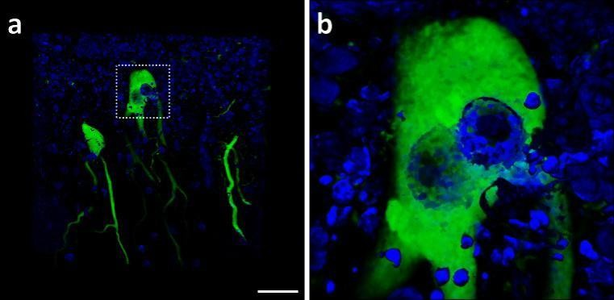Kemp et al. explored the occurrence of binucleated cells in the brain, particularly in cerebellar Purkinje cells, arising from bone marrow cell fusion **[22].** This process is believed to occur in response to injury or inflammation and may represent a novel mechanism for neuronal repair. Research indicates that cell fusion events increase under conditions such as aging, radiation exposure, inflammation, and chemotherapy **[23].** The role of immune cell infiltration in forming binucleated cells remains unclear, although soluble factors may significantly influence this process **[23].** Binucleated cells are hypothesized to aid in neuroprotection and the restoration of homeostasis in neurodegenerative diseases, making them a promising area for therapeutic research. These findings provide insights into endogenous neuronal repair mechanisms, potentially offering new avenues for treating neurodegeneration and brain injuries **[23].**

**Fig.1.** A binucleated Purkinje cell in the human cerebellum. This 3D confocal image shows cells in the human cerebellum, with Purkinje cells labeled using the Calbindin-D28K marker (green) and DAPI nuclear stain (blue). The hatched region in part (A) corresponds to the magnified image shown in part (B), with a scale bar of 25 μm **[22].**

**2.1.3. The heart**

Binucleated cardiomyocytes (CMs) are polyploid heart muscle cells, often resulting from cytokinesis failure during cell division, where cytoplasmic division does not follow nuclear division **[24].** These cells are particularly significant due to their enhanced contractile function, larger cellular size, and distinct electrical properties, which are crucial for maintaining coordinated heart rhythms **[25].** Binucleated CMs are more prevalent in the ventricles, supporting their specialized structural and functional roles **[26].** The formation of binucleated and polyploid CMs occurs through regulated failures in karyokinesis and cytokinesis, distinct from the uncontrolled mitotic failures seen in cancer cells. This programmed process reduces the proliferative potential of polyploid CMs, limiting their ability to regenerate after injury **[27].** Despite questions about transcriptional differences between diploid and polyploid cardiomyocytes, current findings suggest that transcriptional profiles may be more injury-dependent than nucleation-related, necessitating further research **[27].** Developing cardiomyocytes possess a greater regenerative capacity due to their ability to divide during the embryonic stage. In contrast, most adult cardiomyocytes lose this capacity postnatally, becoming "acytokinetic," which limits heart regeneration after injury **[28].** The rise in multinucleated and polyploid CMs is linked to a diminished capacity for regeneration, as these cells cannot effectively replace dead cells **[29].** Metabolic reprogramming has been identified as a potential mechanism to enhance the regenerative capacity of the heart. This process increases cell cycle activity in mononuclear diploid CMs, potentially improving cardiac repair post-injury. Activation of developmental signaling pathways in the heart can further promote this reprogramming and enhance recovery **[28].** This highlights the role of binucleated cardiomyocytes in heart function, their contribution to cardiac efficiency, and the challenges they pose in 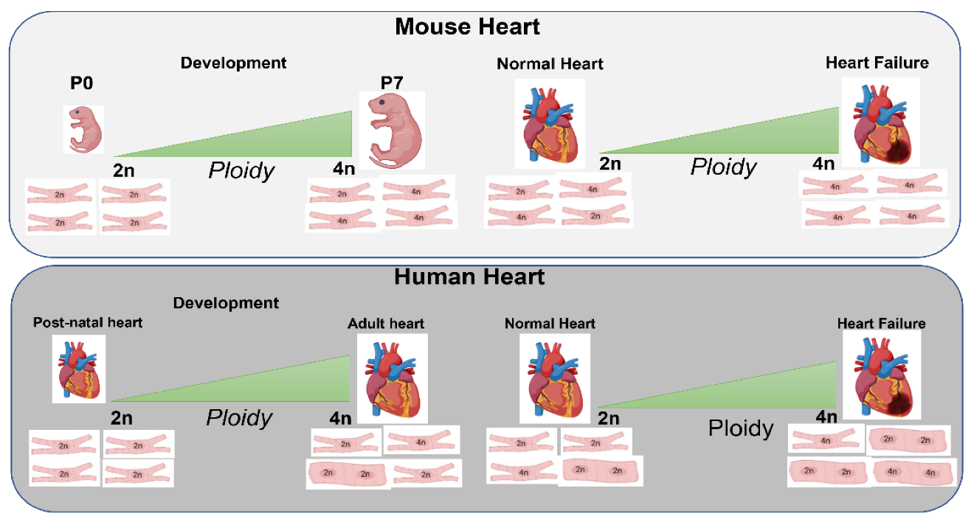regeneration and repair.

**Fig.2. The relationship between cardiomyocyte polyploidy, development, and heart injury [28].**

**2.1.4. The liver**

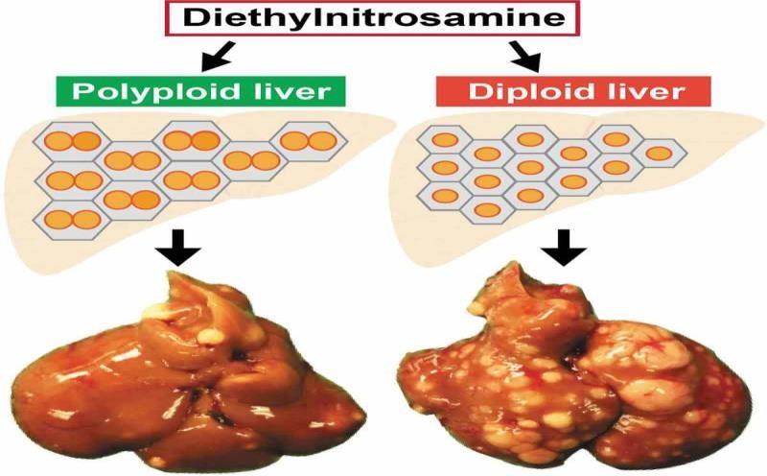The liver is an organ that carries out essential functions such as nutrient synthesis and distribution, storage of amino acids, lipids, and carbohydrates **[30],** These functions are conducted primarily by hepatocytes. At birth, every hepatocyte contains a single nucleus with a 2n DNA content, making them diploid. As development progresses after birth, hepatocytes typically become polyploid due to the failure of cytokinesis **[31].** Polyploid hepatocytes can take many forms: they can be tetraploid (binucleated with two 2n nuclei or mononucleated with one 4n nucleus) or octaploid (binucleated with two 4n nuclei or mononucleated with one 8n nucleus), and the proportion of polyploid hepatocytes rises with age **[32].** The mechanisms that can lead to polyploidization in hepatocytes are: cell fusion and alternative cell cycling **[33].** Zhang et al **[34]** conducted a review article on the origins and functions of hepatic polyploidy and hypothesized that polyploidy in the liver is regulated during development and in response to cellular stress or disease. It is hypothesized that polyploidy enhances the metabolic capacity of hepatocytes to support rapid growth **[35].**

**Fig.3. Polyploid hepatocytes safeguard the liver against tumorigenesis induced by mutagens [34].**

**2.1.5. The lung**

Guild et al. conducted an experimental study on evidence for lung barrier regeneration by differentiation before binucleated and stem cell division, focused on understanding the mechanisms of lung tissue repair after injury, specifically in the alveolar epithelial layer, the study explores how cells regenerate, particularly the role of stem cells, alveolar type I (AT1) and binucleated cells in tissue repair **[35]**. The lung epithelium consists of a thin cellular layer that plays a dual role in gas exchange and preventing fluid leakage from capillaries into alveoli **[36].** Given these limitations, the alveolar epithelium has developed into a fragile, simple monolayer made up of cuboidal, surfactant-producing alveolar type II (AT2) cells and extremely thin (AT1) cells **[37].** When this epithelium layer is damaged, it is rapidly repaired without scarring through the action of (AT2) stem cells, which differentiate into (AT1) cells to restore functionality **[38].** Binucleated AT2 cells play a critical role in the repair process. When AT2 cells are depleted due to their transformation into AT1 cells, binucleated cells undergo a unique division process. First, they undergo ploidy reduction (reduction in DNA content), followed by further stages of cell division to replenish the depleted AT2 cells. This process is regulated by epidermal growth factor receptors (EGFR) and the surrounding cellular microenvironment, ensuring rapid and efficient repair to maintain alveolar function **[38].**

**2.1.6. The renal and urothelium**

Mühldorfer et al. **[39]** studied binucleation in podocytes, highlighting its association with foot process widening in renal diseases such as minimal change disease (MCD), IgA nephropathy (IgA-GN), lupus nephritis (LN), and diabetic nephropathy (DN). Podocytes are critical components of the glomerular filtration barrier **[40],** and they are terminally differentiated cells that typically do not proliferate. However, under conditions of renal injury or stress **[41],** podocytes may re-enter the cell cycle but fail to complete division **[42],** leading to the formation of binucleated or multinucleated cells **[43].** The study found binucleated podocytes prevalent in renal biopsies, particularly in IgA nephropathy. Their presence in IgA-GN patients showed a weak correlation with glomerular structural damage and serum creatinine levels. However, no significant association was observed between binucleated podocytes and kidney function in other renal diseases. Challenges in accurately classifying podocyte nuclei were noted due to morphological variations. The findings suggest that binucleated podocytes could serve as markers of renal damage, necessitating 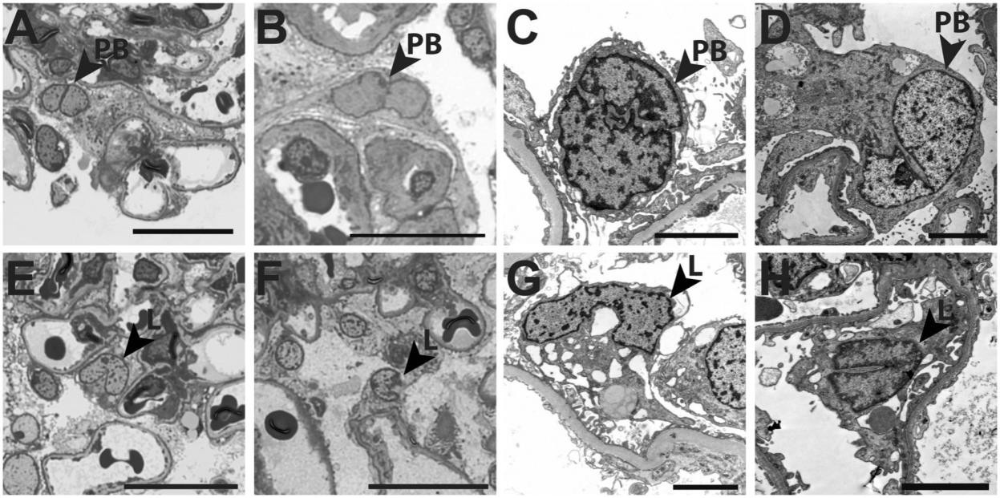further research to determine their role in disease progression.

**Fig.4. Potential bi-nucleated and lobulated podocytes in renal disease. Representative examples from podocytes with potential bi-nucleated (A–D; arrowhead, PB) and lobulated podocytes (E–H; red arrowhead, L) were shown. Scale bar represents 20 µm in semi-thin sections (A, B, E, and F) and 4 µm in electron microscopic pictures (C, D, G, and H). A color version of the figure is available in the online supplemental material [39].**

Wang et al. conducted an experimental technique on polyploid superficial cells that maintain the urothelial barrier **[44].** The urothelium serves as an epithelial barrier stretching from the renal pelvis to the bladder neck. It protects against pathogens and toxins while regulating the movement of water and ions between the mucosa and the underlying tissues. Polyploid cells in the urothelium are formed through incomplete cytokinesis, where cells enter mitosis but do not complete the division, resulting in binucleated cells. These cells can further increase their DNA content through endoreplication, which allows them to adapt to environmental changes **[45].** These polyploid cells contribute to the integrity and function of the urothelial barrier, which is essential for protecting the underlying tissues from urine and pathogens **[46].**

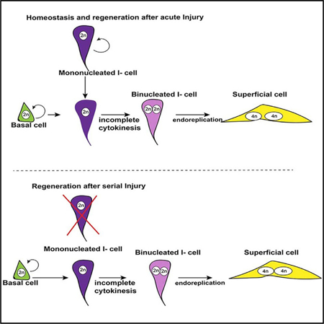

**Fig.5. Homeostasis and regeneration after acute injury [44].**

**2.1.7. The mammary gland**

Explored the mammary epithelium, focusing on the role of binucleated alveolar epithelial cells during lactation **[47]**. The mammary gland undergoes structural changes throughout life stages such as puberty, pregnancy, lactation, and involution **[48].** At birth, it features a rudimentary ductal structure composed of basal/myoepithelial cells expressing keratin 14 (K14) and luminal cells expressing keratin 8 (K8) or hormone receptors (ER+/PR+) **[49].** During lactation, binucleated cells play a pivotal role by producing large amounts of milk proteins, lipids, and carbohydrates to nourish offspring **[50].** These cells emerge as polyploid during lactation onset, increasing cytoplasmic volume to support organelles like ribosomes, ER, and Golgi apparatus, essential for milk synthesis **[51].** Their larger size also enhances apical surface area, facilitating efficient milk secretion. This highlights the adaptive significance of binucleated cells in lactogenesis **[52].**

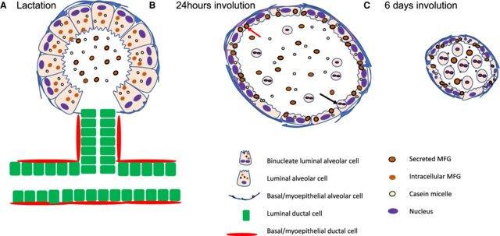

**Fig.6. The structure and morphological changes in mammary gland during lactation and involution [53].**

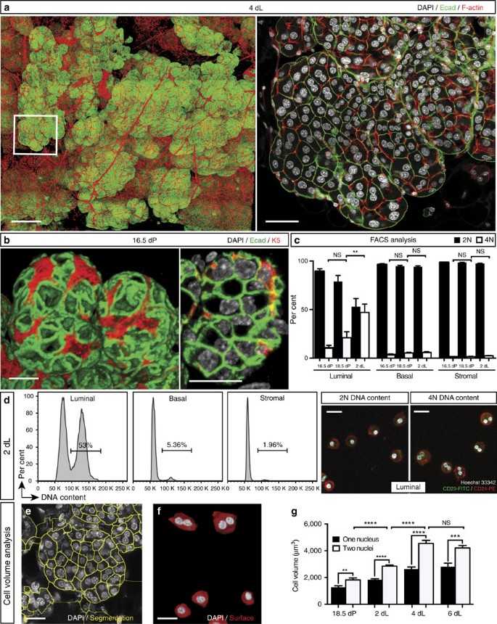

**Fig.7. Confocal image of a mammary ductal portion [47].**

**2.1.8. The oral mucosa**

Oliveira et al. conducted a study on the use of psychotropic drugs among health science students, focusing on the prevalence of binucleated cells in the buccal mucosa **[54]**. They found a high prevalence of psychoactive drug use, with a statistical association between drug use and the occurrence of binucleated cells in the oral mucosa. Although more common in females, this difference was not statistically significant. Other studies have shown that stress, anxiety, and depression, particularly in females, are linked to cellular changes, including binucleation **[55].** Similarly, Minhas et al. observed binucleated cells in both irradiated cancer cells and normal buccal mucosa of patients receiving chemoradiotherapy, indicating that ionizing radiation also induces binucleation.

**2.1.9. The spleen**

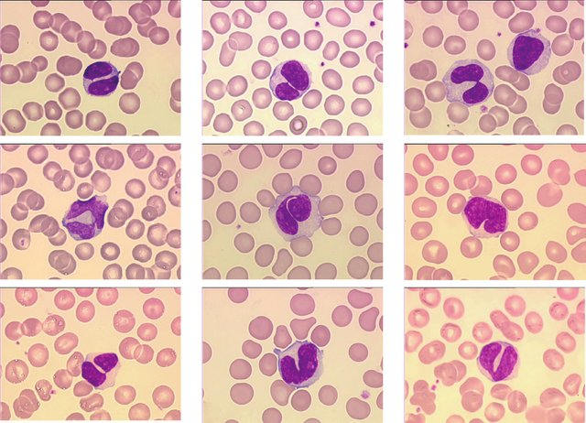Sun et al. investigated the role of binucleated cells in persistent polyclonal B-cell lymphocytosis (PPBL) and their importance in differentiating it from malignant lymphomas **[56]**. Analyzing a spleen sample from a 38-year-old woman with progressive splenomegaly, the study found that binucleated cells are a hallmark of PPBL, frequently observed in peripheral blood **[57].** These cells result from abnormal B-cell division, likely triggered by chronic antigenic stimulation **[58].** Despite PPBL's resemblance to lymphoma in histological and immunophenotypic features, genetic and clinical analyses are essential for accurate differentiation, preventing unnecessary treatments **[58].**

**Fig. 8. Morphologic features showing typical binucleated cells in a PPBL patient [56].**

**Fig.9. Histological features of the spleen. Images of the HCE-stained spleen sections at 20x (A), 100x (B), and 400x (C, D) magnification showing expansion of the white pulp nodules and significant infiltration of the red pulp by small mature lymphocytes with minimal cytologic atypia. Occasional binucleated lymphocytes are noted in the splenic sinusoids, indicated by black arrows (C, D, and D inset) [56].**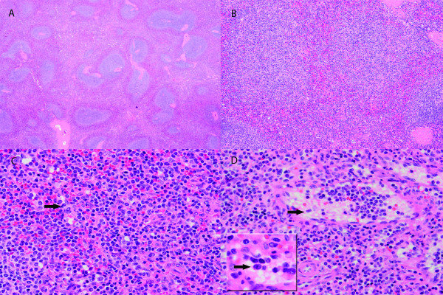

**2.1.10. The emberyo**

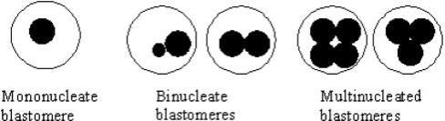Xanthopoulou et al. study the nature and origin of binucleate cells in human preimplantation embryos: relevance to placental mesenchymal dysplasia **[59]**. The study focused on understanding the formation of binucleate cells (Binucleate Blastomeres) in human embryos during the early stages of preimplantation development, to investigate the origin and mechanism of these cells, taken biopsies from embryo making an analysis and suggested that binucleate cells form due to the inactivity of cell-cycle checkpoint genes during the early stages of embryo development **[60],** this leads to tetraploid mosaicism, which is associated with arrested embryos and poor development **[61].**

**Fig. 10. Nuclear abnormalities seen in human preimplantation embryos [59].**

**2.2. Binucleated cells in infections**

**2.2.1. HPV Infections**

Binucleated cells serve as key markers in HPV-related infections. Okayama et al. identified binucleated cells as the most prevalent cytological marker in anal Pap smears of HIV-positive patients, aiding in the early detection of anal intraepithelial neoplasia (AIN) **[62]**. Okodo et al. **[63]** and **[64]** differentiated between binucleation in high-risk HPV (hr-HPV) and candida infections, noting that binucleated cells with positive compression are predominantly linked to hr-HPV, whereas reactive cellular changes (RCC) in candida infections are inflammation-driven. Okayama et al. [65] confirmed the predictive value of binucleated cells in hr-HPV infections, supporting early identification of HPV-related cancers.

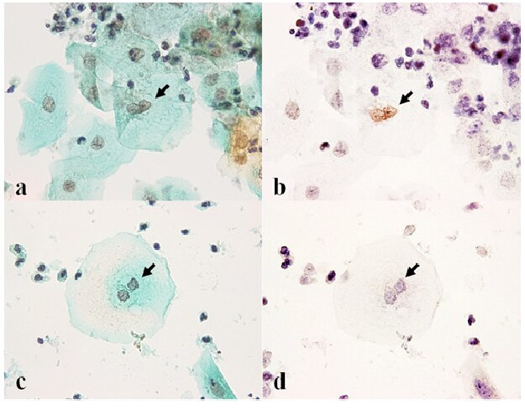

**Fig.11. Compression-Positive Binucleated Cells: (a) Pap staining (40×), (b) positive nuclear staining by in situ PCR with high-risk-HPV-specific primers (40×). Compression-negative binucleated cells: (c) Pap staining (40×), d) negative nuclear staining by in situ PCR with high-risk-HPV-specific primers (40×) [63].**

**2.2.2. Meningitis**

Delc et al. analyzed cerebrospinal fluid (CSF) cytology in viral meningitis and meningoencephalitis, observing binucleated lymphocytes and plasma cells as markers of intense immune activation. These findings reflect the robust immune response to viral inflammation and assist in disease characterization **[66]**.

**2.2.3. HSV Infections**

Kannan et al. described binucleated cells as a hallmark feature in HSV infections, especially in Papanicolaou-stained cervical smears **[67]**. These cells exhibit nuclear molding, intranuclear inclusions, and a ground-glass appearance, serving as a crucial diagnostic marker for reducing misdiagnosis and unnecessary interventions **[68].**

**2.2.4. Leishmaniasis**

Daneshbod et al. highlighted binucleated cells in mucosal leishmaniasis (ML) cases, often observed alongside Leishman-Donovan bodies, the causative agents of the disease. This combination supports accurate cytological and histopathological diagnosis of ML **[69]**.

**2.3. Binucleated cells in cancer**

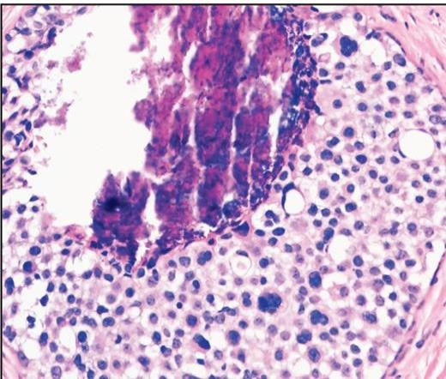Blanco et al. studied bi- and multinucleated cells as a histological marker that can be used to differentiate between various types of lobular carcinoma in situ (LCIS) and ductal carcinoma in situ (DCIS) in breast tissue **[70].** It focuses on comparing three types: Classic lobular carcinoma in situ (CLCIS), Pleomorphic lobular carcinoma in situ (PLCIS), and Ductal carcinoma in situ (DCIS). To enhance the differential diagnosis between the subtypes of LCIS and DCIS and highlight the presence of bi- and multinucleated cells as an objective marker to facilitate diagnosis. they found that binucleated cells were more frequent in PLCIS (100% of cases) compared to CLCIS (54%) and DCIS (43%).

**Fig.12. Pleomorphic lobular carcinoma in situ demonstrating scattered binucleated and multinucleated cells [70].**

Priyadharshini et al. conducted a retrospective study on 2086 aspiration cytosmears/imprint smears, the slides were examined to identify the presence of binucleate Reed-Sternberg (RS) cells and RS-like cells, cases containing binucleate cells were classified into different categories according to their corresponding histopathological diagnoses, and their cytomorphological features were analyzed and compared **[71].** They revealed that the presence of RS-like cells was identified in 100% of HL cases, 30% of NHL cases, 12.9% of carcinoma cases, and 0.7% of benign/inflammatory cases. The analysis of cytomorphological features showed that certain characteristics, such as eosinophilic nucleoli, eosinophils, and cell clustering, could aid in distinguishing HL from other conditions. However, relying solely on cytomorphological features has limitations in differentiating true RS cells from RS-like cells, emphasizing the need for further 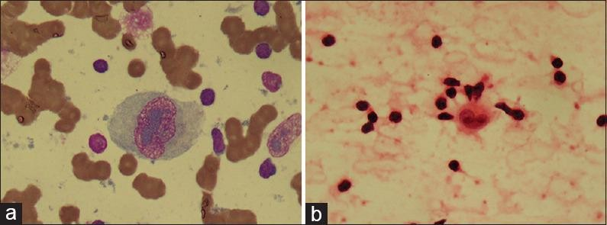histopathological examinations.

**Fig.13. (a) RS cell in Hodgkin's lymphoma showing pale-greyish magenta–colored inclusion-like nucleoli (MGG, ×100) (b) RS cell in Hodgkin's lymphoma showing eosinophilic inclusion-like nucleoli (H and E, ×100) [71].**

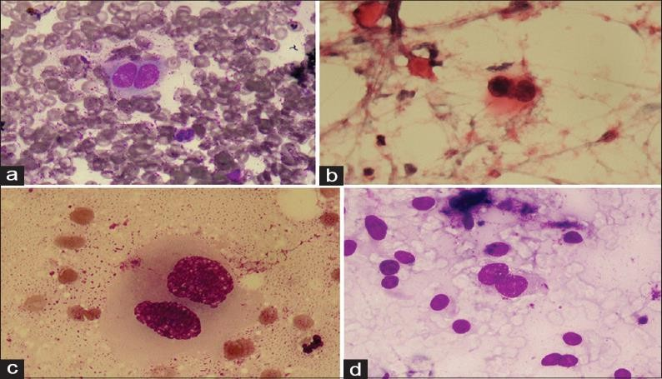

**Fig.14. RS-like cell in other malignancies (a) non-Hodgkin's lynmphoma (MGG x100) (b) RS- like cell in non- Hodgkin's lymphoma (H and E, ×100) (c) RS-like cells in carcinoma (MGG, x100) (d) RS-like cell in sarcoma (MGG, ×40) [71].**

**2.4. Detection of binucleated cells**

Immunohistochemistry (IHC): Uses specific antibodies like P16 and P53 to highlight abnormal cell division via chromogen staining under a microscope **[72].** Cytochemical Staining: Methods such as Papanicolaou staining detect nuclear changes, including binucleation **[73].** Digital Cytometry: Employs digital imaging to identify and measure binucleated cells with high accuracy **[74].** Fluorescence Microscopy: Uses fluorescent dyes for sensitive detection of nuclei in cellular samples **[75].** These methods effectively identify binucleated cells and contribute to understanding cellular abnormalities.

**3. Contradictions, Gaps, and Limitations**

One of the main contradictions in the literature involves the role of BNCs in cancer. In some tumor types, their presence is linked with aggressive, undifferentiated phenotypes, whereas in others, they are associated with well-differentiated, more stable conditions. These inconsistencies suggest that binucleation is context-dependent, possibly influenced by tissue origin, mutation profile, and microenvironmental factors. The formation of BNCs in under-studied tissues (such as the brain, intestines, heart, and vascular system) has not been adequately explored. The long-term fate of binucleated cells, whether they return to a proliferative state, undergo apoptosis, or contribute to disease progression, is not fully understood. Most research remains cross-sectional; few longitudinal or functional studies exist to establish causal relationships or temporal dynamics. Such limitations restrict the clinical translation of findings and emphasize the need for more robust experimental models, including animal studies and 3D tissue cultures.

**4. Future Directions**

Molecular studies focusing on cyclins, CDKs, mitotic spindle proteins, and fusion-related genes can clarify regulatory mechanisms. Tissue-specific investigations may uncover unique patterns of binucleation and its functional consequences. Longitudinal clinical studies are needed to determine the prognostic value of BNCs, especially in cancer and chronic infections.

**5. DISCUSSION**

**Binucleated cells have emerged as intriguing cellular entities with diverse implications in both physiological and pathological contexts. Their presence in normal tissues, including the liver, bone, spleen, and mammary gland, suggests that they may play active roles in tissue remodeling, regeneration, and maintenance of function. These cells are also frequently identified in disease settings, such as cancers, viral infections (e.g., HPV and HSV), autoimmune conditions (e.g., persistent polyclonal B-cell lymphocytosis), and even embryonic developmental disorders. Such wide distribution highlights their diagnostic, prognostic, and potentially therapeutic relevance. Despite their documented presence in various biological systems, a comprehensive understanding of binucleated cells remains limited. Most existing studies are descriptive or observational, relying on cytological smears, histopathological samples, and immunohistochemical staining. While these have contributed to mapping the occurrence of BNCs across different tissues, they often fall short in elucidating the underlying molecular mechanisms or functional consequences of binucleation. Multiple mechanisms have been proposed for the formation of binucleated cells, including incomplete cytokinesis, cell fusion, mitotic slippage, and DNA replication errors. In cancers, failure of mitotic checkpoints or disruption of the spindle assembly can lead to abnormal binucleation, potentially contributing to chromosomal instability and tumor progression. In contrast, in regenerative tissues such as the liver and kidneys, binucleated cells are often associated with tissue repair and recovery following damage or fibrosis. This dual behavior suggests that binucleation may serve as both a response to injury and a marker of dysregulation, depending on the context. However, the precise regulation of these processes remains unclear. The signaling pathways, gene expression profiles, and environmental triggers that determine whether binucleation leads to regeneration or malignancy have not yet been well-characterized. For example, while binucleation in hepatocytes is considered a normal adaptive mechanism, its role in hepatocellular carcinoma remains controversial. This ambiguity reflects a broader challenge in distinguishing physiological from pathological binucleation. Binucleated cells have demonstrated potential value as diagnostic biomarkers. In cytopathology, their detection can support early diagnosis of viral infections such as HPV or HSV, both of which are associated with cancer development. Moreover, in autoimmune conditions like PPBL, the persistent presence of BNCs may indicate chronic immune stimulation. Despite these associations, the interpretation of binucleated cells remains variable. Differences in staining techniques, sampling methods, and observer expertise can influence detection and classification. Therefore, there is a critical need to establish standardized diagnostic criteria and thresholds for the identification of BNCs across different diseases and tissue types.**

## **6. CONCLUSION**

Binucleated cells are not merely a biological phenomenon; they serve as a window into understanding health and disease. Their natural presence reflects their role in regeneration and cellular functions, while their association with diseases such as cancer and infections highlights their significance in diagnosis and treatment. Understanding the mechanisms behind their formation opens new horizons in regenerative medicine and disease targeting. They are not just pathological markers but also a promising scientific tool that can reshape how we approach diseases.

**DISCLAIMER (ARTIFICIAL INTELLIGENCE)**

As a result, the Author (s) declare that NO generative AI technologies such as Large Language Models (ChatGPT, COPILOT, etc) and text-to-image generators have been used during the writing or editing of manuscripts.

**References:**

1. Shi Q, King RW. Chromosome nondisjunction yields tetraploid rather than aneuploid cells in human cell lines. Nature. 2005;437(7061):1038-1042. doi:10.1038/nature03958.
2. Morin C, Bairati I, Bouchard C, et al. Cytologic predictors of cervical intraepithelial neoplasia in women with an ASCUS Pap smear. Acta Cytol. 2000;44(4):576-586. doi:10.1159/000328532
3. Celton-Morizur S, Merlen G, Couton D, Desdouets C. Polyploidy and liver proliferation: central role of insulin signaling. Cell Cycle. 2010;9(3):460-466. doi:10.4161/cc.9.3.10542.
4. Stoll LM, Duffield AS, Johnson MW, Ali SZ. Acute myeloid leukemia with myelodysplasia-related changes with erythroid differentiation involving pleural fluid: a case report and brief cytopathologic review. Diagn Cytopathol. 2011;39(6):451-454. doi:10.1002/dc.21470.
5. Guidotti JE, Brégerie O, Robert A, Debey P, Brechot C, Desdouets C. Liver cell polyploidization: a pivotal role for binuclear hepatocytes. J Biol Chem. 2003;278(21):19095-19101. doi:10.1074/jbc.M300982200
6. Ganem NJ, Storchova Z, Pellman D. Tetraploidy, aneuploidy and cancer. Curr Opin Genet Dev. 2007;17(2):157-162. doi:10.1016/j.gde.2007.02.011.
7. Bollmann M, Bánkfalvi A, Trosic A, Speich N, Schmittt C, Bollmann R. Can we detect cervical human papillomavirus (HPV) infection by cytomorphology alone? Diagnostic value of non-classic cytological signs of HPV effect in minimally abnormal Pap tests. Cytopathology. 2005;16(1):13-21. doi:10.1111/j.1365-2303.2004.00179.x.
8. Hu L, Ceresa BP. Characterization of the plasma membrane localization and orientation of HPV16 E5 for cell-cell fusion. Virology. 2009;393(1):135-143. doi:10.1016/j.virol.2009.07.034.
9. Petrany MJ, Millay DP. Cell Fusion: Merging Membranes and Making Muscle. Trends Cell Biol. 2019;29(12):964-973. doi:10.1016/j.tcb.2019.09.002.
10. Naylor RM, van Deursen JM. Aneuploidy in Cancer and Aging. Annu Rev Genet. 2016;50:45-66. doi:10.1146/annurev-genet-120215-035303.
11. Lengauer C, Kinzler KW, Vogelstein B. Genetic instability in colorectal cancers. Nature. 1997;386(6625):623-627. doi:10.1038/386623a0.
12. Johmura Y, Shimada M, Misaki T, et al. Necessary and sufficient role for a mitosis skip in senescence induction. Mol Cell. 2014;55(1):73-84. doi:10.1016/j.molcel.2014.05.003.
13. Polunovsky VA, Ingbar DH, Peterson M, Bitterman PB. Cell fusion to study nuclear-cytoplasmic interactions in endothelial cell apoptosis. Am J Pathol. 1996;149(1):115-128.
14. Blau HM, Brazelton TR, Weimann JM. The evolving concept of a stem cell: entity or function?. Cell. 2001;105(7):829-841. doi:10.1016/s0092-8674(01)00409-3.
15. Brazelton TR, Rossi FM, Keshet GI, Blau HM. From marrow to brain: expression of neuronal phenotypes in adult mice. Science. 2000;290(5497):1775-1779. doi:10.1126/science.290.5497.1775.
16. Azizi SA, Stokes D, Augelli BJ, DiGirolamo C, Prockop DJ. Engraftment and migration of human bone marrow stromal cells implanted in the brains of albino rats--similarities to astrocyte grafts. Proc Natl Acad Sci U S A. 1998;95(7):3908-3913. doi:10.1073/pnas.95.7.3908.
17. Nern C, Wolff I, Macas J, et al. Fusion of hematopoietic cells with Purkinje neurons does not lead to stable heterokaryon formation under noninvasive conditions. J Neurosci. 2009;29(12):3799-3807. doi:10.1523/JNEUROSCI.5848-08.2009.
18. Krabbe C, Zimmer J, Meyer M. Neural transdifferentiation of mesenchymal stem cells--a critical review. APMIS. 2005;113(11-12):831-844. doi:10.1111/j.1600-0463.2005.apm_3061.x.
19. Kemp K, Wilkins A, Scolding N. Cell fusion in the brain: two cells forward, one cell back. Acta Neuropathol. 2014;128(5):629-638. doi:10.1007/s00401-014-1303-1.
20. Bueno C, Blanquer M, García-Bernal D, Martínez S, Moraleda JM. Binucleated human bone marrow-derived mesenchymal cells can be formed during neural-like differentiation with independence of any cell fusion events. Sci Rep. 2022;12(1):20615. Published 2022 Nov 30. doi:10.1038/s41598-022-24996-8.
21. Hernández R, Jiménez-Luna C, Perales-Adán J, Perazzoli G, Melguizo C, Prados J. Differentiation of Human Mesenchymal Stem Cells towards Neuronal Lineage: Clinical Trials in Nervous System Disorders. Biomol Ther (Seoul). 2020;28(1):34-44. doi:10.4062/biomolther.2019.065.
22. Kemp K, Wilkins A, Scolding N. Cell fusion in the brain: two cells forward, one cell back. Acta Neuropathol. 2014;128(5):629-638. doi:10.1007/s00401-014-1303-1.
23. Alvarez-Dolado M, Pardal R, Garcia-Verdugo JM, et al. Fusion of bone-marrow-derived cells with Purkinje neurons, cardiomyocytes and hepatocytes. Nature. 2003;425(6961):968-973. doi:10.1038/nature02069.
24. Kirillova A, Han L, Liu H, Kühn B. Polyploid cardiomyocytes: implications for heart regeneration. Development. 2021;148(14):dev199401. doi:10.1242/dev.199401.
25. Adler CP, Friedburg H, Herget GW, Neuburger M, Schwalb H. Variability of cardiomyocyte DNA content, ploidy level and nuclear number in mammalian hearts. Virchows Arch. 1996;429(2-3):159-164. doi:10.1007/BF00192438.
26. Xin M, Olson EN, Bassel-Duby R. Mending broken hearts: cardiac development as a basis for adult heart regeneration and repair. Nat Rev Mol Cell Biol. 2013;14(8):529-541. doi:10.1038/nrm3619.
27. Yekelchyk M, Guenther S, Preussner J, Braun T. Mono- and multi-nucleated ventricular cardiomyocytes constitute a transcriptionally homogenous cell population. Basic Res Cardiol. 2019;114(5):36. Published 2019 Aug 9. doi:10.1007/s00395-019-0744-z.
28. Elia A, Mohsin S, Khan M. Cardiomyocyte Ploidy, Metabolic Reprogramming and Heart Repair. Cells. 2023;12(12):1571. Published 2023 Jun 7. doi:10.3390/cells12121571.
29. Olsson MC, Palmer BM, Stauffer BL, Leinwand LA, Moore RL. Morphological and functional alterations in ventricular myocytes from male transgenic mice with hypertrophic cardiomyopathy. Circ Res. 2004;94(2):201-207. doi:10.1161/01.RES.0000111521.40760.18.
30. Lima JP. Anatomia e fisiologia do aparelho excretor do fígado [Anatomy and physiology of the liver secretory apparatus]. Arq Gastroenterol. 1980;17(3):149-160.
31. Margall-Ducos G, Celton-Morizur S, Couton D, Brégerie O, Desdouets C. Liver tetraploidization is controlled by a new process of incomplete cytokinesis. J Cell Sci. 2007;120(Pt 20):3633-3639. doi:10.1242/jcs.016907.
32. Duncan AW. Aneuploidy, polyploidy and ploidy reversal in the liver. Semin Cell Dev Biol. 2013;24(4):347-356. doi:10.1016/j.semcdb.2013.01.003.
33. Øvrebø JI, Edgar BA. Polyploidy in tissue homeostasis and regeneration. Development. 2018;145(14):dev156034. Published 2018 Jul 18. doi:10.1242/dev.156034.
34. Zhang S, Lin YH, Tarlow B, Zhu H. The origins and functions of hepatic polyploidy. Cell Cycle. 2019;18(12):1302-1315. doi:10.1080/15384101.2019.1618123.
35. Davoli T, de Lange T. The causes and consequences of polyploidy in normal development and cancer. Annu Rev Cell Dev Biol. 2011;27:585-610. doi:10.1146/annurev-cellbio-092910-154234.
36. Matthay MA, Zemans RL, Zimmerman GA, et al. Acute respiratory distress syndrome. Nat Rev Dis Primers. 2019;5(1):18. Published 2019 Mar 14. doi:10.1038/s41572-019-0069-0.
37. Weibel ER. On the tricks alveolar epithelial cells play to make a good lung. Am J Respir Crit Care Med. 2015;191(5):504-513. doi:10.1164/rccm.201409-1663OE.
38. Greenlee KJ, Werb Z, Kheradmand F. Matrix metalloproteinases in lung: multiple, multifarious, and multifaceted. Physiol Rev. 2007;87(1):69-98. doi:10.1152/physrev.00022.2006.
39. Mühldorfer J, Pfister E, Büttner-Herold M, Klewer M, Amann K, Daniel C. Bi-nucleation of podocytes is uniformly accompanied by foot processes widening in renal disease. Nephrol Dial Transplant. 2018;33(5):796-803. doi:10.1093/ndt/gfx201.
40. Kriz W, Gretz N, Lemley KV. Progression of glomerular diseases: is the podocyte the culprit?. Kidney Int. 1998;54(3):687-697. doi:10.1046/j.1523-1755.1998.00044.x.
41. Lemley KV, Lafayette RA, Safai M, et al. Podocytopenia and disease severity in IgA nephropathy. Kidney Int. 2002;61(4):1475-1485. doi:10.1046/j.1523-1755.2002.00269.x.
42. Griffin SV, Krofft RD, Pippin JW, Shankland SJ. Limitation of podocyte proliferation improves renal function in experimental crescentic glomerulonephritis. Kidney Int. 2005;67(3):977-986. doi:10.1111/j.1523-1755.2005.00161.x.
43. Kriz W, Lemley KV. The role of the podocyte in glomerulosclerosis. Curr Opin Nephrol Hypertens. 1999;8(4):489-497. doi:10.1097/00041552-199907000-00014.
44. Wang J, Batourina E, Schneider K, et al. Polyploid Superficial Cells that Maintain the Urothelial Barrier Are Produced via Incomplete Cytokinesis and Endoreplication. Cell Rep. 2018;25(2):464-477.e4. doi:10.1016/j.celrep.2018.09.042.
45. Balsara ZR, Li X. Sleeping beauty: awakening urothelium from its slumber. Am J Physiol Renal Physiol. 2017;312(4):F732-F743. doi:10.1152/ajprenal.00337.2016.
46. Epstein CJ. Cell size, nuclear content, and the development of polyploidy in the Mammalian liver. Proc Natl Acad Sci U S A. 1967;57(2):327-334. doi:10.1073/pnas.57.2.327.
47. Rios AC, Fu NY, Jamieson PR, et al. Essential role for a novel population of binucleated mammary epithelial cells in lactation. Nat Commun. 2016;7:11400. Published 2016 Apr 22. doi:10.1038/ncomms11400.
48. Macias H, Hinck L. Mammary gland development. Wiley Interdiscip Rev Dev Biol. 2012;1(4):533-557. doi:10.1002/wdev.35.
49. Watson CJ, Khaled WT. Mammary development in the embryo and adult: new insights into the journey of morphogenesis and commitment. Development. 2020;147(22):dev169862. Published 2020 Nov 15. doi:10.1242/dev.169862.
50. Anderson SM, Rudolph MC, McManaman JL, Neville MC. Key stages in mammary gland development. Secretory activation in the mammary gland: it's not just about milk protein synthesis!. Breast Cancer Res. 2007;9(1):204. doi:10.1186/bcr1653.
51. Rudolph MC, McManaman JL, Phang T, et al. Metabolic regulation in the lactating mammary gland: a lipid synthesizing machine. Physiol Genomics. 2007;28(3):323-336. doi:10.1152/physiolgenomics.00020.2006.
52. Shackleton M, Vaillant F, Simpson KJ, et al. Generation of a functional mammary gland from a single stem cell. Nature. 2006;439(7072):84-88. doi:10.1038/nature04372.
53. Watson CJ. Alveolar cells in the mammary gland: lineage commitment and cell death. Biochem J. 2022;479(9):995-1006. doi:10.1042/BCJ20210734.
54. Oliveira LB, Parreiras JAR, Sebastião ECO, Silva GND. Increase of binucleated cells in the oral mucosa: a study on the use of psychotropics by students of a Brazilian institution. Rev Assoc Med Bras (1992). 2019;65(6):870-879. Published 2019 Jul 22. doi:10.1590/1806-9282.65.6.870.
55. Ibrahim MB, Abdelreheem MH. Prevalence of anxiety and depression among medical and pharmaceutical students in Alexandria University. Alexandria J Med. 2015;51(2):167-173.
56. Sun P, Juskevicius R. Histological and immunohistochemical features of the spleen in persistent polyclonal B-cell lymphocytosis closely mimic splenic B-cell lymphoma. Diagn Pathol. 2012;7:107. Published 2012 Aug 19. doi:10.1186/1746-1596-7-107.
57. Cornet E, Lesesve JF, Mossafa H, et al. Long-term follow-up of 111 patients with persistent polyclonal B-cell lymphocytosis with binucleated lymphocytes. Leukemia. 2009;23(2):419-422. doi:10.1038/leu.2008.208.
58. Himmelmann A, Gautschi O, Nawrath M, Bolliger U, Fehr J, Stahel RA. Persistent polyclonal B-cell lymphocytosis is an expansion of functional IgD(+)CD27(+) memory B cells. Br J Haematol. 2001;114(2):400-405. doi:10.1046/j.1365-2141.2001.02938.x.
59. Xanthopoulou L, Delhanty JD, Mania A, et al. The nature and origin of binucleate cells in human preimplantation embryos: relevance to placental mesenchymal dysplasia. Reprod Biomed Online. 2011;22(4):362-370. doi:10.1016/j.rbmo.2011.01.001.
60. Clouston HJ, Fenwick J, Webb AL, Herbert M, Murdoch A, Wolstenholme J. Detection of mosaic and non-mosaic chromosome abnormalities in 6- to 8-day old human blastocysts. Hum Genet. 1997;101(1):30-36. doi:10.1007/s004390050581.
61. Munné S, Alikani M, Tomkin G, Grifo J, Cohen J. Embryo morphology, developmental rates, and maternal age are correlated with chromosome abnormalities. Fertil Steril. 1995;64(2):382-391.
62. Okayama K, Okodo M, Kitamura H, Itoda I. Significance of the Cytological Signs of Human Papillomavirus Infection in Anal Pap Smears of Human Immunodeficiency Virus-Infected Japanese Men Who Have Sex with Men. Asian Pac J Cancer Prev. 2017;18(11):3173-3178. Published 2017 Nov 26. doi:10.22034/APJCP.2017.18.11.3173.
63. Okodo M, Okayama K, Fukui T, et al. Significance of Compression in Binucleation while Differentiating Reactive Cellular Changes Between Human Papillomavirus and Candida Infections. Asian Pac J Cancer Prev. 2017;18(9):2507-2511. Published 2017 Sep 27. doi:10.22034/APJCP.2017.18.9.2507.
64. Washiya K, Motoi M, Kobayashi T, Yoshioka H, Watanabe J. Significance of binucleated cells with compression in atypical squamous cells of undetermined significance. Acta Cytol. 2013;57(6):599-603. doi:10.1159/000353802.
65. Okayama K, Kakinuma M, Teruya K, et al. Predictive Value of Various Atypical Cells for the Detection of Human Papillomavirus in Cervical Smears. Int J Mol Sci. 2024;25(2):1212. Published 2024 Jan 19. doi:10.3390/ijms25021212.
66. Pelc S, De Maertelaere E, Denolin-Reubens R. CSF cytology of acute viral meningitis and meningoencephalitis. Eur Neurol. 1981;20(2):95-102. doi:10.1159/000115214.
67. Multinucleated cells in PAP smear—an institutional experience. J Clin Diagn Res. 2021 Jan;15(1):9-13. doi: 10.7860/JCDR/2021/49804.15300.
68. Coleman DV. Cytological diagnosis of virus-infected cells in Papanicolaou smears and its application in clinical practice. J Clin Pathol. 1979;32(11):1075-1089. doi:10.1136/jcp.32.11.1075.
69. Daneshbod Y, Oryan A, Davarmanesh M, et al. Clinical, histopathologic, and cytologic diagnosis of mucosal leishmaniasis and literature review. Arch Pathol Lab Med. 2011;135(4):478-482. doi:10.5858/2010-0069-OA.1.
70. Blanco LZ, Thurow TA, Mahajan A, et al. Multinucleation is an objective feature useful in the diagnosis of pleomorphic lobular carcinoma in situ. Am J Clin Pathol. 2015;144(5):722-726. doi:10.1309/AJCPZHZ2TUE2UYNV.
71. Priyadharshini G, Phansalkar M, Ambroise M, Ramdas A. Binucleate Cells in Cytosmears: What do They Signify?. J Cytol. 2021;38(1):38-43. doi:10.4103/JOC.JOC_178_20.
72. Elmahdi FM, Alsebaee RO, Ballaji MM, et al. Cytological Changes and Immunocytochemistry Expression of P53 in Oral Mucosa Among Waterpipe Users in the Kingdom of Saudi Arabia. Cureus. 2022;14(11):e31190. Published 2022 Nov 7. doi:10.7759/cureus.31190.
73. Liu S, Zhang M, Yang L, et al. Prevalence and patterns of tobacco smoking among Chinese adult men and women: findings of the 2010 national smoking survey. J Epidemiol Community Health. 2017;71(2):154-161. doi:10.1136/jech-2016-207805.
74. Persson L, Bergström J, Ito H, Gustafsson A. Tobacco smoking and neutrophil activity in patients with periodontal disease. J Periodontol. 2001;72(1):90-95. doi:10.1902/jop.2001.72.1.90.
75. Mohammed MEA, Brima EI. Cytological changes in oral mucosa induced by smokeless tobacco. Tob Induc Dis. 2019;17:46. Published 2019 May 28. doi:10.18332/tid/109544.