**Gastric Cancer Burden in Northern Nigeria: A Retrospective Study of 10-Years**

**Abstract**

Gastric cancer is a major contributor to global cancer mortality. In Nigeria, especially in North Central regions such as Makurdi, data on its prevalence and pathological features remain limited. To describe the demographic and histopathologic profile of gastric cancer cases diagnosed in Makurdi over a 10-year period and compare findings with national and global trends. A retrospective descriptive study was conducted at Benue State University Teaching Hospital and Federal Medical Centre, Makurdi, from January 2016 to December 2024. Histologically confirmed gastric cancer cases were analysed for age, sex, tumour subtype, and distribution within the spectrum of gastrointestinal cancers. Among 2,341 malignancies identified during the study period, 19 cases (0.81%) were gastric cancers, accounting for 12.3% of all gastrointestinal tumours (n=155). The peak incidence occurred in the 51–60-year age group (47%). Males were more commonly affected (68%). Adenocarcinoma was the predominant histological subtype (74%), followed by poorly differentiated carcinoma (16%), signet ring cell carcinoma (5%), and gastrointestinal stromal tumour (5%). Gastric cancer was the third most common gastrointestinal malignancy after colorectal/anal cancers (83.2%). Gastric cancer in Makurdi remains relatively rare but clinically important, with a clear male preponderance and predominance of adenocarcinoma. The pattern reflects late-stage detection and aligns with regional and global observations. These findings underscore the need for early detection strategies and improved diagnostic infrastructure in North Central Nigeria.

**Keywords:** Gastric cancer; Adenocarcinoma; Histopathology; Cancer epidemiology; Male predominance Gastrointestinal tumours;

**Introduction:**

Gastric cancer (GC) remains a formidable global health challenge, ranking as the fifth most common malignancy and the fourth leading cause of cancer-related mortality worldwide, with an estimated 968,784 new cases and 660,175 deaths in 20221,2. While age-standardized incidence rates have seen a general decline in many high-income countries, the absolute number of new cases and deaths continues to rise globally due to population growth and aging, with over 80% of GC-related deaths occurring in low- and middle-income countries (LMICs)2,3. Geographic disparities are significant, with the highest burden concentrated in East Asia, Eastern Europe, and parts of Central and South America1,4. GC is a multifactorial disease, impacted by genetic and environmental factors that result in wide epidemiologic variation (Patel et al., 2024). Up to 20-fold differences in incidence rates have been reported between different geographic regions. Accurate epidemiologic data has historically been dependent on population-based registries. In the absence of high-quality data, cancer incidence, and mortality have been reported by relying on mathematical estimates, which may not appreciate the regional heterogenicity of GC rates or may under-represent GC incidence (Ramadhar et al., 2024).

In sub-Saharan Africa (SSA), the epidemiological data on GC is comparatively sparse, though current estimates indicate approximately 22,992 incident cases and over 20,000 deaths annually3,5. Despite a high prevalence of *Helicobacter pylori* infection, a primary risk factor globally, the reported incidence of gastric cancer in Africa has historically been lower than expected, a phenomenon often termed the "African enigma"6. However, recent studies suggest a shifting landscape, with growing evidence of GC as a significant and often late-presenting malignancy across the region 5,7. The classification of gastric cancers into proximal and distal has mainly been anatomical. There are others that considered the demarcation to be surgical, as proximal gastric cancers are said to carry a worse prognosis compared to the distal group. The lack of serosa in the proximal part of the stomach is said to favor early local advancement (Aliyu & Ningi, 2020).

In Nigeria, gastric cancer is among the top ten most common cancers, though its precise burden and characteristics, particularly in diverse geopolitical zones, are not fully elucidated 8. Previous studies in the country have indicated varied relative frequencies and a concerning trend of late-stage presentation, which significantly impacts prognosis 8,9. Data from northern Nigeria, a region with unique socio-economic and environmental factors, are particularly limited, making comprehensive, long-term studies essential to understand the local disease burden and inform public health interventions. This 10-year retrospective study aims to address this gap by characterizing the gastric cancer burden in northern Nigeria, providing valuable insights into its trends, clinical profiles, and outcomes within this specific context.

**Materials and Methods**

This is a retrospective, descriptive study aimed at analysing the histopathological characteristics of patients diagnosed with gastric malignancies.The study was conducted at Benue State University Teaching Hospital (BSUTH) and Federal Medical Centre all in Makurdi Benue State North Central Nigerian which are all tertiary health facilities. It is a 10-year period from January 1, 2016, to December 31st, 2024. These centres have histopathology laboratories in Makurdi where histopathology services and specialist histopathologists for analysing and reporting are rendered in Makurdi, Benue state North Central Region of Nigeria and receive tissue specimens within and from surrounding states.

The specimens receive included endoscopic biopsies, and incision biopsies and gastrectomy tissues. These tissues were preserved in 10% buffered formalin and auto-processed and paraffin-embedded sections (at 2–3 μm) were routinely stained with heamatoxyln and eosin stains.

Data were extracted from the patient request forms, histopathology departmental registers, duplicate copies of histology reports of all cases, and case notes and files of patients. Information extracted included age, sex, side of the breast affected, and histological diagnosis. All data were computed and Continuous variables were summarized using range and mean, while categorical variables presented as percentage frequencies were determined using descriptive statistics. Data were displayed using tables and charts.

Patients with histologically confirmed gastric malignant tumours with complete clinical records available, including demographic, and histopathological data were included in the study while those with incomplete histopathological data were excluded.

**Results**

We had 2,341 cancers recorded from 2016 to 2024 in our centre, gastric cancers accounted for only 19 cases (0.81%). Within the gastrointestinal (GIT) subset of 155 tumours, gastric cancers represented 12.3%, ranking third after colorectal/anal cancers (83.2%) and ahead of other GIT tumours (4.5%).

The age distribution of gastric cancer cases reveals a higher prevalence in middle-aged to elderly populations. The largest group (47%) of patients falls within the **51-60 years** age range, but less common among in the younger age groups (1-40 years) suggesting a clear age-related risk, with a notable spike in the 51-60 years range. (Table 1 and figure 2)

A predominance of Male Patients (13 Males Vs. 6 Females), with males comprising 68% of the gastric cancer cases, aligns with global findings where males generally show higher gastric cancer incidence. The gender disparity is even more evident in the 51-60 years group, where 9 of the 13 cases were male. (Table 1 and figure 1)

Adenocarcinomas (74%) were the most predominant histological type and this was followed by Poorly Differentiated Carcinomas (16Other rare tumour such as Signet Ring Cell Carcinomas SRCC) and Gastrointestinal Stromal Tumours (GIST) made up only 5% of cases. (Table 2 and figure 2)

In the last 10 years of this study, we had a total 2,341 cancers recorded, 155 (6.6%) were gastrointestinal (GIT) tumours, with 19 (1.1%) specifically being gastric cancers. This low percentage of gastric cancers compared to other gastrointestinal tumours (like colorectal and anal cancers, 129 cases) suggests a relatively lower incidence of gastric cancer within the overall cancer burden in Makurdi.

**Table 1: Age and sex distribution of patients with gastric cancers**

|  |  |  |  |  |
| --- | --- | --- | --- | --- |
| Age group | Sex | | Total | Percentage |
| (years) | Male | Female |  |  |
| 1-10 | 0 | 0 | 0 | **0%** |
| 11-20 | 0 | 0 | 0 | **0%** |
| 21-30 | 1 | 0 | 1 | **5%** |
| 31-40 | 0 | 2 | 2 | **11%** |
| 41-50 | 0 | 3 | 3 | **16%** |
| 51-60 | 9 | 0 | 9 | **47%** |
| 61-70 | 2 | 1 | 3 | **16%** |
| 71+ | 1 | 0 | 1 | **5%** |
| Total | **13** | **6** | **19** | **100%** |

**Table 2: Gastric Cancers Histologic Subtypes.**

|  |  |  |
| --- | --- | --- |
| Histologic subtypes | Frequencies | Percentage  % |
| Adenocarcinomas | 14 | **74%** |
| Poorly Differentiated Carcinomas | 3 | **16%** |
| Signet Ring Cell Carcinomas | 1 | **5%** |
| Gastrointestinal Stromal Tumours | 1 | **5%** |
| Total | **19** | **100%** |

**Foot note:** The total Cancers registered from 2016 to 2024 was 2341 cases

A total of 2,341 cancers were registered between 2016 to 2024.

GIT Tumours: 155 cases

Colorectal Anal Cancers:129 cases

Gastric Cancers: 19 cases

Others (Hepatobiliary, Small Bowel, and Mesentery): 7 cases

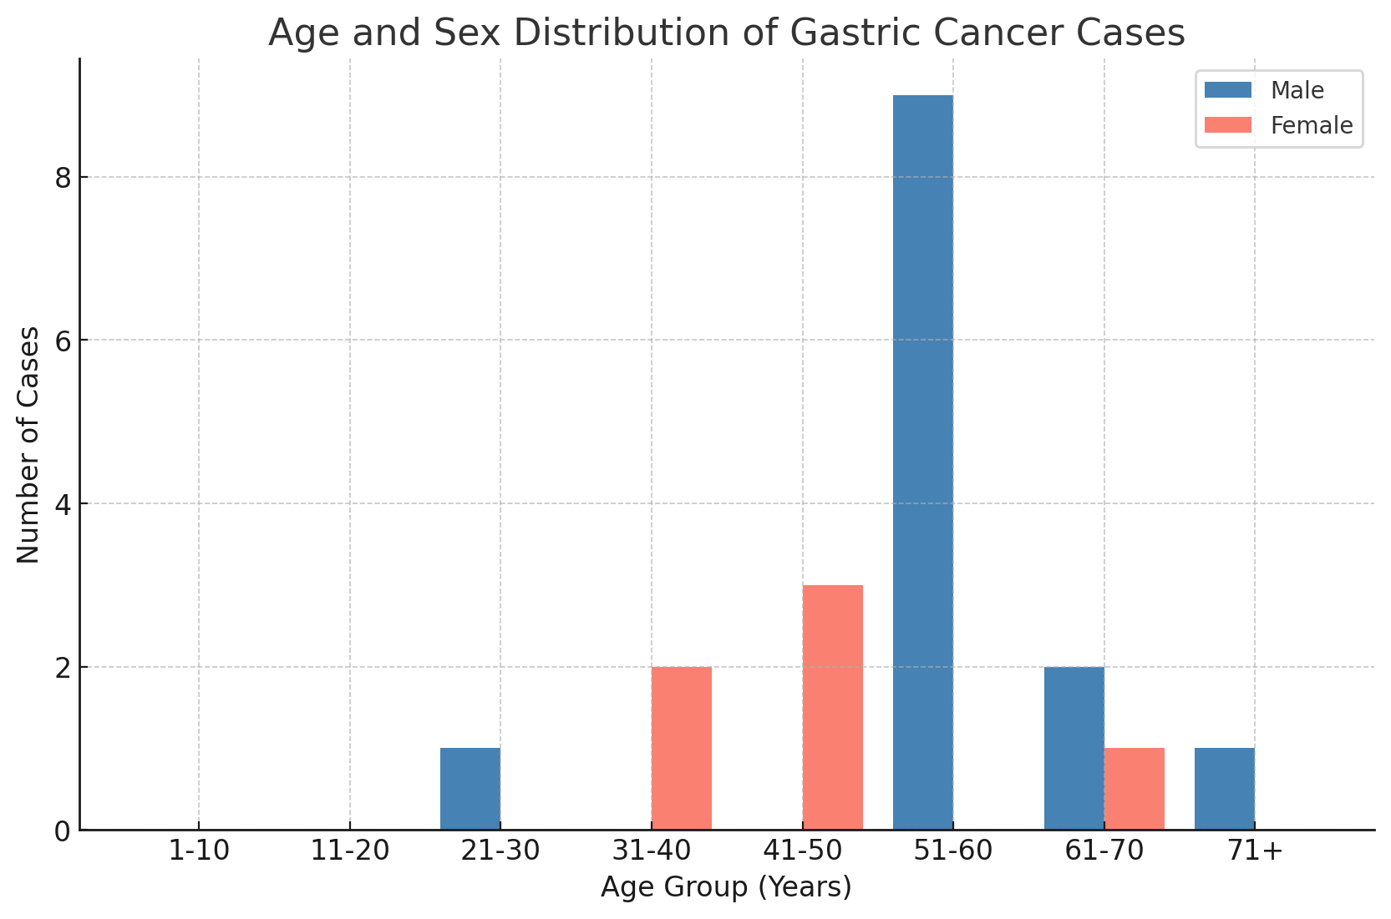

**Figure 1: age group and sex distribution of gastric cancer cases**

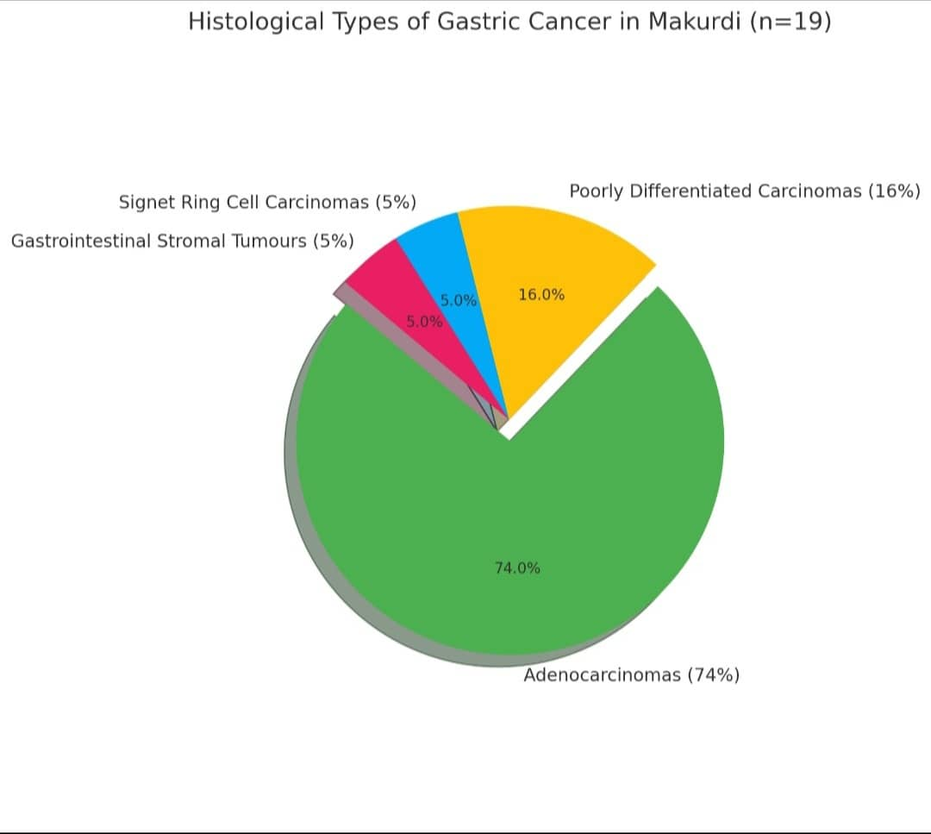

**Figure 2: Histological types of gastric cancers**

**Discussion**

Gastric cancer (GC) continues to pose a major oncologic and public health challenge globally. As of 2020, it remains the fifth most frequently diagnosed cancer and the fourth leading cause of cancer mortality worldwide, with over one million new cases and approximately 770,000 deaths annually10. Despite a general decline in incidence in high-income nations, largely due to improvements in Helicobacter pylori eradication, early screening, and dietary habits11-13, the burden of gastric cancer persists in low- and middle-income countries (LMICs), including Nigeria, where late presentation and poor outcomes are common14-16.

Our 10-year study revealed that gastric cancer accounts for only 0.81% of all cancers and 12.3% of GIT malignancies, ranking third after colorectal/anal cancers. This trend is consistent with findings from Jos and Ilorin, where gastric cancers represented a relatively small but significant share of gastrointestinal cancers17,18. The male predominance (68%) in our data aligns with established global patterns where male sex is a known risk factor, possibly related to hormonal and behavioural exposures such as tobacco and alcohol use19-20.

The peak incidence between 51–60 years in our study also reflects findings in other Nigerian studies, such as in Enugu, Ibadan, and Zaria, where GC is typically diagnosed in middle-aged and older adults18,21,22. Regional data from Tanzania, Zambia, and Kenya also report similar age distribution, underscoring a broader sub-Saharan African trend where most patients are diagnosed in their sixth or seventh decade of life23-25.

Adenocarcinoma was the dominant histological type (74%) in our series, consistent with national and global trends where intestinal-type adenocarcinoma is the most prevalent subtype26. This mirrors results from Kano, Jos, and Ilorin, where adenocarcinomas constituted over 70% of GC cases17,18,27. The poorly differentiated carcinomas and rare subtypes like signet ring cell carcinoma (SRCC) and gastrointestinal stromal tumours (GIST) also align with broader African findings, although SRCC remains underreported due to diagnostic limitations in many centers28, 29.

GISTs, comprising 5% in our study, are increasingly being recognized with better immunohistochemical support in tertiary centres, as also seen in Ghana and South Africa30,31. However, their low frequency compared to adenocarcinomas remains consistent globally.

A significant challenge highlighted by our findings—though not quantified in staging data—is the late stage at diagnosis, consistent with several Nigerian and African studies16,21,32. In Nigeria, delays stem from limited endoscopy access, low clinical suspicion, and poor referral systems. A study by Anyaehie et al. (2021) emphasized how many patients present only when symptoms like obstruction or weight loss have become severe33.

Globally, early gastric cancer (EGC) is detected at higher rates in countries like Japan and South Korea due to robust screening programs34,35. These contrasts highlight systemic weaknesses in Nigeria’s cancer control strategies, particularly for gastrointestinal malignancies.

Compared to our data from Makurdi, gastric cancer incidence appears relatively lower, though this may reflect underdiagnosis rather than true absence. In Eastern and Southern Africa, hospital-based studies report higher numbers, potentially due to better case documentation or referral systems36, 25. However, the overall mortality-to-incidence ratio remains high across Africa due to late-stage presentation, with minimal improvement over the past decade36.

Globally, while high-income countries have experienced declining GC rates, LMICs including Nigeria have not mirrored this trend due to persisting risk factors like H. pylori infection, smoking, salted/preserved food consumption, and poor healthcare infrastructure12,26. Our study, with a predominance of adenocarcinoma in middle-aged males, fits this global risk profile.

**Conclusion**

Findings from Makurdi north central Nigeria reinforce regional and global data emphasizing male predominance, adenocarcinoma histology, and late-stage presentation. However, the relatively low recorded incidence suggests possible underreporting or underdiagnosis, warranting more active case-finding and histopathologic documentation. Our data adds valuable insight into the North Central Nigerian GC landscape and calls for improved cancer registries, early screening, and public health interventions to reduce diagnostic delays and improve outcomes.

**Limitations:**

The limitation of this study by its retrospective nature, documentation bias are possible, and the absence of clinical-radiologic correlation. Additionally, histologic subclassification of gastric cancers according to WHO classification is so obvious but this may be as a result of non-adherent to WHO standards by the pathology department

**Ethical Approval:**  
Institutional ethical clearance was obtained.

**COMPETING INTERESTS DISCLAIMER:**

Authors have declared that they have no known competing financial interests OR non-financial interests OR personal relationships that could have appeared to influence the work reported in this paper.

Disclaimer (Artificial intelligence)

Option 1:

Author(s) hereby declare that NO generative AI technologies such as Large Language Models (ChatGPT, COPILOT, etc.) and text-to-image generators have been used during the writing or editing of this manuscript.

Option 2:

Author(s) hereby declare that generative AI technologies such as Large Language Models, etc. have been used during the writing or editing of manuscripts. This explanation will include the name, version, model, and source of the generative AI technology and as well as all input prompts provided to the generative AI technology

Details of the AI usage are given below:

1.

2.

3.

**References:**

1. World Cancer Research Fund International. Stomach cancer statistics. [Internet]. 2024. Available from: <https://www.wcrf.org/preventing-cancer/cancer-statistics/stomach-cancer-statistics/>
2. Du J, et al. Global, regional, and national trends in gastric cancer burden: 1990-2021 and projections to 2040. *Frontiers in Oncology*. 2024; 14:1468488.
3. Zeng H, et al. Global, regional, and national burden of early-onset gastric cancer. *Cancer Biology & Medicine*. 2024;21(4):1145-1160.
4. WCRF International. Stomach cancer statistics. (Accessed May 23, 2025).
5. Afuwape OO, et al. Gastric cancer in Sub-Saharan Africa - a systematic review of primary data. *eCancer*. 2024; 18:1680.
6. Gebresellassie HW. The Challenges of Gastric Cancer in Sub-Saharan Africa. *EC Gastroenterology and Digestive System*. 2019;6(10):969-970.
7. Bang GA, et al. Clinical epidemiology and mortality risk factors of gastric cancer in a sub-Saharan African setting: a retrospective analysis of 120 cases in Yaoundé (Cameroon). *Pan African Medical Journal*. 2020; 37:104.
8. Ibrahim M. Chapter 3.1. Gastric cancer in Africa, with a focus on Nigeria and Zambia. In: *Cancer in Africa*. ResearchGate; 2025.
9. Abdulkareem FB, et al. Topography and Morphology of Gastric Cancer in Nigeria: A Dual Institution Review of 622 Upper Gastrointestinal Endoscopies. *Nigerian Journal of Gastroenterology and Hepatology*. 2021;1(1):1-6.
10. Sung H, Ferlay J, Siegel RL, Laversanne M, Soerjomataram I, Jemal A, Bray F. Global cancer statistics 2020: GLOBOCAN estimates of incidence and mortality worldwide for 36 cancers in 185 countries. *CA Cancer J Clin*. 2021;71(3):209–249.
11. Rawla P, Barsouk A. Epidemiology of gastric cancer: Global trends, risk factors and prevention. *Prz Gastroenterol*. 2019;14(1):26–38.
12. Parkin DM, Ferlay J, Jemal A. Cancer in Sub-Saharan Africa. *IARC Sci Publ*. 2018;(167):9–24.
13. Plummer M, Franceschi S, Vignat J, Forman D, de Martel C. Global burden of gastric cancer attributable to Helicobacter pylori. *Int J Cancer*. 2020;147(12):3154–3162.
14. MY, H., PT, O., OM, A., AT, A., & FB, A. (2017). The distribution, histologic profile and clinical presentation of gastrointestinal malignancies in Lagos, Nigeria. Journal of the West African College of Surgeons, 7(1), 9.
15. Uchendu, O. J. (2020). Cancer incidence in Nigeria: a tertiary hospital experience. Asian Pacific Journal of Cancer Care, 5(1), 27-32.
16. Osinowo, A. O., Olajide, T. O., Balogun, O. S., Makanjuola, A., Adesanya, A. A., & Atoyebi, O. A. (2023). Clinicopathological Features and Treatment Outcome of Patients with Gastric Cancer in Lagos: Is the Outlook Getting Better?. Journal of West African College of Surgeons, 13(1), 67-73.
17. Uchendu, J. O., Otene, C. I., Akpo, E. E., Odion-Obomhense, H. K., Ikubor, J. E., Oriakhi, S. N., & Orugbo, P. V. (2020). Gastrointestinal Lesions in a Nigerian Tertiary Care Centre: A Histopathological Study. WAJM, 37(4), 358-363.
18. Suleiman, K. A., Afolayan, E. A. O., Ibrahim, O. O. K., Ahmed, A., & Abubakar-Akanbi, S. K. (2021). Histopathological analysis of gastric cancers in university of Ilorin teaching hospital: a 20-year review. Journal of BioMedical Research and Clinical Practice, 4(1), 85-95.
19. Mabula, J. B., Mchembe, M. D., Koy, M., Chalya, P. L., Massaga, F., Rambau, P. F., ... & Jaka, H. (2012). Gastric cancer at a university teaching hospital in northwestern Tanzania: a retrospective review of 232 cases. World journal of surgical oncology, 10, 1-10.
20. Afuwape, O. O., Irabor, D. O., Ladipo, J. K., & Ayandipo, B. (2012). A review of the current profile of gastric cancer presentation in the university college hospital Ibadan, a tertiary health care institution in the tropics. Journal of gastrointestinal cancer, 43, 177-180.
21. Usman, A. U., Bello, S. S., Shuaib, A., Dahiru, A., Rasheed, F. A., Abdurrahman, A., ... & Usman, A. (2024). A Histopathological Review of Cancer in Katsina State North-Western Nigeria. Annals of Tropical Pathology, 15(1), 1-10.
22. Suleiman, K. A., Afolayan, E. A. O., Ibrahim, O. O. K., Ahmed, A., & Abubakar-Akanbi, S. K. (2021). Histopathological analysis of gastric cancers in university of Ilorin teaching hospital: a 20-year review. Journal of BioMedical Research and Clinical Practice, 4(1), 85-95.
23. Kayamba, V., Mubbunu, M., & Kelly, P. (2024). Endoscopic diagnosis of gastric and oesophageal cancer in Lusaka, Zambia: a retrospective analysis. BMC gastroenterology, 24(1), 122.
24. Makanga, W., & Nyaoncha, A. (2014). Upper gastrointestinal disease in Nairobi and Nakuru counties, Kenya; a two year comparative endoscopy study. Annals of African Surgery, 11(2).
25. Mabula, J. B., Mchembe, M. D., Koy, M., Chalya, P. L., Massaga, F., Rambau, P. F., ... & Jaka, H. (2012). Gastric cancer at a university teaching hospital in northwestern Tanzania: a retrospective review of 232 cases. World journal of surgical oncology, 10, 1-10.
26. Yusefi AR, Lankarani KB, Bastani P, Radinmanesh M, Kavosi Z. Risk factors for gastric cancer: A systematic review. *World J Gastrointest Oncol*. 2020;12(8):651–669.
27. Rasheed, M. W., Abiodun, A. E., Eziagu, U. B., Idowu, N. A., Kabiru, A., Adegboye, T. A., ... & Ayoade, A. A. (2023). Clinicopathological and immunohistochemical characterization of gastrointestinal stromal tumour at four tertiary health centers in Nigeria using CD117, DOG1, and human epidermal growth factor receptor-2 biomarkers. Annals of African Medicine, 22(4), 501-507.
28. Suleiman, K. A., Afolayan, E. A. O., Ibrahim, O. O. K., Ahmed, A., & Abubakar-Akanbi, S. K. (2021). Histopathological analysis of gastric cancers in university of Ilorin teaching hospital: a 20-year review. Journal of BioMedical Research and Clinical Practice, 4(1), 85-95.
29. Efared, B., Kadi, M., Tahiri, L., Lahmidani, N., Hassani, K. I. M., Bouhaddouti, H. E., ... & Chbani, L. (2020). Gastric signet ring cell carcinoma: a comparative analysis of clinicopathologic features. Cancer Control, 27(1), 1073274820976596.
30. Farhat, F., Hussein, M., Sbaity, E., Alsharm, A., Rasul, K., Khairallah, S., ... & Kattan, J. (2023). Gastrointestinal stromal tumor in North Africa and the middle east: updates in presentation and management from an 11-year retrospective cohort. Hospital Practice, 51(5), 275-287.
31. Ayandipo, O. O., Ogun, G. O., Ajagbe, O. A., Adegoke, O. O., Adepoju, O. J., Rahman, A., ... & Shittu, O. B. (2021). Gastrointestinal stromal tumor experience in a surgical oncological unit in sub-Saharan Africa: A retrospective analysis. Journal of Clinical Sciences, 18(2), 98-102.
32. Zeeneldin, A. A., Ramadan, H., El Gammal, M. M., Saber, M. M., Elgamal, D., & Sherisher, M. A. (2014). Gastric carcinoma at Tanta Cancer Center: a comparative retrospective clinico-pathological study of the elderly versus the non-elderly. Journal of the Egyptian National Cancer Institute, 26(3), 127-137.
33. Oluyemi, A. O., Odeghe, E., & Owoseni, O. (2022). A clinicopathologic analysis of colorectal cancers diagnosed by histology of colonoscopy-derived specimens in Lagos, Nigeria. Afr. J. Med. Med. Sci, 51, 135-139.
34. Lee YC, Chiang TH, Chou CK, et al. Association between Helicobacter pylori eradication and gastric cancer incidence: A systematic review and meta-analysis. *Lancet Oncol*. 2014;15(11):1382–1394.
35. Montgomery, M., Fukuhara, S., Karpeh, M., & Brower, S. (2013). Evidence-based review of the management of early gastric cancer. Gastroenterology report, 1(2), 105-112.
36. Ferlay J, Ervik M, Lam F, Colombet M, Mery L, Piñeros M, Znaor A, Soerjomataram I, Bray F. *Global Cancer Observatory: Cancer Today*. Lyon, France: International Agency for Research on Cancer; 2020. Available from: <https://gco.iarc.fr/today>
37. Ramadhar, A., Miller, P. N., Muchengeti, M., Kagura, J., Chu, K., & Gaskill, C. (2024). Gastric cancer in Sub-Saharan Africa–a systematic review of primary data. ecancermedicalscience, 18, 1680.
38. Aliyu, S., & Ningi, A. B. The Upward Trend of Proximal Gastric Cancers and the Challenges of Advanced Gastric Cancer Management in Nigeria: Our Experience in a Tertiary Health Facility in North-Eastern Nigeria. World J Surg Surgical Res. 2020; 3, 1205.
39. Patel, Rushin, Mrunal Patel, Zalak Patel, Himanshu Kavani, Afoma Onyechi, Jessica Ohemeng-Dapaah, Dhruvkumar Gadhiya, Darshil Patel, and Chieh Yang. 2024. “Present State and Recent Developments of Artificial Intelligence and Machine Learning in Gastric Cancer Diagnosis and Prognosis: A Systematic Review”. Journal of Cancer and Tumor International 14 (1):1-10. https://doi.org/10.9734/jcti/2024/v14i1241.