ORIGINAL RESEARCH ARTICLE

PATHOLOGICAL AND PSYCHOSOCIAL CONSEQUENCES OF SEXUAL VIOLENCE AMONGST YOUNG AND ADOLESCENT GIRLS IN THE KUMBA HEALTH DISTRICT, S.W. REGION, CAMEROON
ABSTRACT
Sexual violence is a serious public health and human rights problem with both short- and long-term consequences on women's physical, mental, sexual and reproductive health. The main aim of this study was to outline the pathological and psychosocial consequences and its preventive measures amongst young and adolescent girls in the Kumba Health District. The sample size was calculated using the Cochran’s formula, a descriptive cross-sectional design was used with questionnaires for data collection. This study involved a total of 200 participants, 53% were internally displaced and 85.5% were not married. Most (71%) reported they had been forced into sexual experience and 67% reported they were threatened or beaten to have sexual experience. Majority (38.5%) of the young girls had poor knowledge of sexual violence, 68.5% mentioned armed conflict as a cause of sexual violence with gang members being the main perpetrators. Most (68.5%) of the participants indicated that sexual violence occurred during the night period. As to the pathological consequence of sexual violence, majority of the participants reported that the victims could end up with human immune-deficiency virus (HIV) (91%), unwanted pregnancy (59.0%) and some (22.5%) reported that it could result in unsafe abortion. Psychosocially, 20% suffered from depression and 17% had difficulty in sleeping, 48.5% felt unsecured while 29,5% were scared of darkness and 79% reported stigmatization. Most (72.5%) also reported that shyness and guilt were the major future consequences of sexual violence and 17% of the victims had no idea on what to do after being exposed to sexual violence. In terms of health seeking behaviour, 54% of the victims sought for help in a hospital/clinic and 70% said they didn’t report because they felt ashamed while 30.5% said they were afraid of the risk of retaliation. In terms of management, treatment and prophylaxis against sexually transmitted infections for victims could be of help. Psychological and emotional support could hasten the recovery process. Sexual violence could be prevented by massive sensitization on sex education. Sexual violence is a major concern and facilities should provide appropriate medical and psychosocial services together with a global sensitization campaign to create awareness on the predisposing factors, management and preventive measures.
Key words: Sexual violence, pathological consequences, psychosocial consequences, young and adolescent girls

Introduction
Globally, about 35.6% of women have experienced sexual violence (SV), with widely varying prevalence estimates [1]. The WHO estimates that 35.6% of women have ever experienced either partner physical or sexual violence or non-partner sexual violence (with estimates for the African region of 36.6% being among the highest) [2]. The prevalence in Southern Africa is estimated at 17.4% [3].
Sexual violence refers to “any sexual act, attempt to obtain a sexual act, unwanted sexual comments or advances, or acts to traffic or otherwise directed against a person’s sexuality using coercion, by any person regardless of their relationship to the victim, in any setting, including but not limited to home and work [4].

Sexual violence (SV) is a particularly disturbing phenomenon which exists in all regions of the world. The term refers to any harmful act that is perpetrated against one person’s will and that is based on socially ascribed (gender) differences between males and females [5]. It includes acts that inflict physical, mental, or sexual harm or suffering, threats of such acts, coercion and other deprivations of liberty, whether occurring in public or in private life [6]. Hale defined rape as vaginal penetration without consent but not necessarily involving emission [5]. SV entails widespread human rights violations, and is often linked to unequal gender relations within communities and abuses of power. It can take the form of sexual violence or persecution by the authorities, or can be the result of discrimination embedded in legislation or prevailing societal norms and practices [5]. It can be both a cause of forced displacement and an intolerable part of the displacement experience. All persons of concern, including refugees, asylum seekers, returnees, stateless persons and internally displaced persons, suffer disproportionately from SV, not only as a form of persecution and at the outbreak of a conflict but also during flight and displacement.

Women exposed to sexual violence often find it difficult to disclose to a third party especially in settings where credibility is doubtful. A high degree of credibility is often required from the raped woman. The victim is expected to be of previous ‘good fame’, should disclose the assault to a third party immediately, display some evidence of physical injury and be able to prove her efforts to resist. This makes it difficult at times for the victims to speak out leading to consequences that could have been treated [7]. Consent is needed before touch, use or manipulation of certain parts of the body. It is to be recollected that many women will not consent without some force in relation to those who want to abuse them or engage in forceful sexual deals with them [8].

Several factors can lead to rape. A brief review suggests that understanding the causes of rape requires an examination of genetics and associations of genetics with antisocial behaviors for those with abusive childhoods [9], developmental psychopathology [10], and gender theory [11]. The field understanding of rapists and the perpetration of rape relies in large part on clinical observations with detected and convicted rapists as well as individuals who report rape behaviors in surveys [11].

Consequences of sexual violence are numerous. Pathologically, sexually transmitted diseases, unintended pregnancy, and abortion together with their distortion of normal physiology and at times anatomy can be some of the principal consequences [12]. Unsafe abortion appears as an alternative to unwanted pregnancies, mainly in cases related to physical violence, sexual violence, usually caused by an intimate or known partner. The World Health Organization (WHO) shows an increase in rates of unwanted pregnancies, unsafe abortions, sexually transmitted diseases and neonatal repercussions in women who are sexually abused. At times psychological and social consequences may set in such as depression, isolation, and suicidal taught [13]. Young girls are still very ignorant on the effects of sexual violence (SV) and there is a need to carry out this study so that we can understand the burden of the SV especially related to the pathology and the psychology and henceforth put in place measures to address this traumatizing problem.

Statement of the Problem and Objectives
Globally, about 35.6% of women have experienced SV, with widely varying prevalence estimates [1]. The WHO estimates that 35.6% of women have experienced either partner physical or sexual violence or non-partner sexual violence with estimates for the African Region being 36.6% [2] and being among the highest in the world. The prevalence in Southern Africa is estimated at 17.4% [3]. There is an evidence of increased risk of sexually transmitted infections (STI) and HIV associated with sexual violence [14]. The World Health Organization (WHO) shows an increase in rates of unwanted pregnancies, unsafe abortions, sexually transmitted diseases and neonatal repercussions in women who are sexually abused [13]. Psychologically, most victims suffer from trouble sleeping, anxiety, and depression, to substance use to help with coping, post-traumatic stress disorder (PTSD), and many other concerns, the effects are wide ranging, varied, and completely on individual basis [15]. The link between violence and mental health concerns is found to be much higher for women: Studies have shown that women with histories of physical violence have significantly higher incidences of major depression, and that 50% of women who have experienced violence also have had a mental health diagnosis [15]. Not enough studies have been done on this topic and even if done, not enough have been documented on it. The pathological and psychosocial consequences of sexual violence may not be known as the young and adolescent girls are still very ignorant about the repercussions of sexual violence which underscores the importance of carrying out this study. Also, the present political crisis in the Kumba Heailth District has led to increased insecurity and human right abuses. Sexual violence being one major form of human right abuse cannot be ignored together with its pathological and psychosocial consequences. It is with this in mind that this study was conceived.
The general objective of the study was to assess the pathological and psychosocial consequences of sexual violence and the health seeking behaviours of young and adolescent girls in the Kumba Health District. The specific objectives were to assess the perception of the young and adolescent girls about sexual violence, its causes and predisposing factors, to identify the pathological consequences of SV amongst young adolescent girls, .to assess the psychosocial consequences of SV amongst young and adolescent girls, to assess the health seeking behaviors of the young and adolescent girls who have been sexually assaulted in the Kumba Health District, S.W. Region, Cameroon.

Significance of this study
This study was designed to identify the pathological and psychosocial consequences of sexual violence, its causes, risk factors and health seeking behaviors of young and adolescent girls in the Kumba Health District. The results of this study could be useful in providing data on the consequences of sexual violence on young and adolescent girls. The information provided by this research could be useful to health authorities in the provision of basic health services and drugs, redeployment of health staff to manage/provide care for the affected, the creation of some special services directed for the mental rehabilitation and counseling of the affected and general sensitization of the communities involved on ways that can be used to prevent sexual violence or reduce the incidence. An understanding of the health seeking behavior of young girls who have been sexually assaulted would give a clear understanding of the practices in the community in an attempt to restore health. Erroneous practices and poor approach to health seeking behavior can be addressed by a community sanitization at the end of this study. The findings of this research will also be useful in the following ways:
- It is going to create great awareness in the community especially amongst the female gender on the causes, risk factors and available services.
- It is going to help young and adolescent girls who have been sexually assaulted develop good coping mechanisms after the healthcare is provided.
- It can deepen the relationship between the survivor and the provider, making it a more honest and open one.
- The facility can be a place where the survivor feels understood and where the survivor gets the help she needs as soon as possible.
- It will allow the survivor to have more trust in the provider and the facility as a whole.
- It can teach providers new skills by increasing their ability to raise difficult topics with young and adolescent girls who have been sexually assaulted and talk about them in a sensitive way.
- It would increase the provider’s sense of truly being able to respond to their survivor’s fears.
1.4 Scope of the Study
This study was limited to the Kumba Health District and it involved young girls from 2 to 17 years who have been sexually abused.
1.5 Conceptual Framework
This study explored the factors related to sexual violence, related diseases (pathological consequences), mental issues (psychosocial) issues, the areas where such acts usually occur and the health seeking behavior of the affected young girls. It explored the fact the forceful sex can occur in localities that are not secured. Most young girls are vulnerable and the vulnerability is increased if the concerned is in a strange environment or is internally displaced. The health status of the perpetrators of sexual violence is often unknown. Often times, such people could be carriers of diseases that can e transmitted to the victim. Abused victims can have problems socializing with others in society and at times such problems could aggravate, leading to psychosocial consequences.

2.0 MATERIALS and METHODS

2.1. Study Design
A descriptive cross-sectional and retrospective study design was used for this study in which every participant was administered a questionnaire and guided at a distance. The cross sectional design is advantageous in that, it is time saving, but sees a cross section of the population in a short period of time.

2.2 Study Area
Kumba is situated about 40 miles (65 km) north-northwest of Douala. Kumba Health District was randomly selected amongst all the health districts in the southwest region. Kumba is an important regional transportation centre, connected by railway to Douala and by roads to Buea (south), Mamfe (north), Bafang (Northeast), and Douala. Kumba is also a trade Centre for locally grown oil palms, rubber, tea, bananas, plantains, and cocoa (the major export crop). Its food-processing, construction, and lumber industries use agricultural and forest products from the area. The town has a hospital and many health care centers. The surrounding region is noted for its many waterfalls and Lake Barombi Mbo, a crater lake several miles to the west. The inhabitant of this town come from different tribes with similar values and believes which plays a great role in the way they live.

2.3 Study Population and Sample Size
All young and adolescent girls who have been sexually assaulted aged (2-17years). The sample size will be calculated using the Cochran’s formula. Assuming a 95% (1.96) confidence level, 0.5 standard deviation for a population of unknown prevalence of the condition in question, and a margin of error 5%. The calculated sample size was 384 young adolescent girls who have been sexually assaulted in the Kumba health District. This sample size was distributed among the three health areas as shown in table 1.
Table 1: Proportionate distribution of participants according to population
 | HEALTH AREA 1 | HEALTH AREA 2 | HEALTH AREA 3 | TOTAL
HEALTH AREA | FIANGO | NTAM | KUMBA MBENG | 3
POPULATION | 58705 | 47303 | 72735 | 178,743
RATIOS | 32.8 | 26.5 | 40.5 | 100
PARTICIPANTS | 126 | 102 | 156 | 384
Since the calculated sample size was 384 people, a total of 400 consent forms were issued out but at the end only 200 people responded.

2.4 Sampling Technique
A clustered sampling technique was used to recruit participants from the Kumba Health District which has ten health areas. Three health areas (Fiango, Ntam, Kumba –Mbeng) were utilized because of easy accessibility. One facility was randomly selected from each health area (Cluster) where the researcher visited and collected information from records on all SV cases managed in the facility and through the focal person of the facility. The victims were called and made to seek consent/assent regarding participation in the study. The number of participants recruited per facility was according to the ratio of the population calculated per health area.

2.5. Inclusion Criteria
- The study included all young and adolescent girls who have been sexually assaulted.
- All young and adolescent girls who have been sexually assaulted and were willing to participate in the study.

2.6. Exclusion Criteria
- Young and adolescent girls who have been sexually assaulted not within the age range
- Young and adolescent girls who have been sexually assaulted not willing to participate.

2.7. Data Collection
Data was collected from the facility register and a structured questionnaire was administered to the participants and guided from a distance.

2.8. Data Management and Analysis
Completed questionnaires were stored in a waterproof container for transportation and data was encoded in a coded excel spreadsheet and they exported to SPSS version 20 for analysis.

2.9. Administrative and Ethical Consideration
Ethical clearances were gotten from all the necessary authorities;
    - Ethical clearance was obtained from the institutional review Board (IRB) of the Faculty of Health sciences, University of Buea.
    - An administrative clearance as collected from the southwest delegation of Public Health
    - An authorization was obtained from the study sites.
    - Consent was obtained from all participants and assent from the parents of the minors who will partake in the study while ensuring that confidentiality was strictly respected.

3.0 RESULTS

3.1: Socio-demographic Characteristics of the Study Population
This study involved a total of 200 participants. Out of these, the majority (67%) were females within the age group 14-20yrs and minority within 2-8yrs (figure 1). In relation to their level of education, most 40% were FSLC holders and others G.C.E O-Level holders (figure 2). Looking at the legal status, majority (53%) of the young and adolescent girls were residents of Kumba and 32% were internally displaced persons (see figure 3). Most (85.5%) of the girls were not married and only 5% of the adolescent girls were married (See table 2).
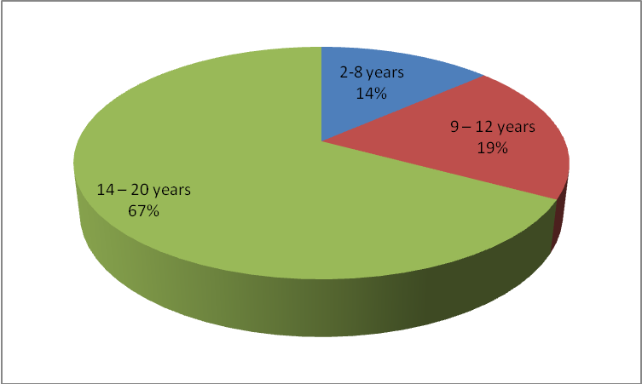
Figure 1: Age of study participants in years

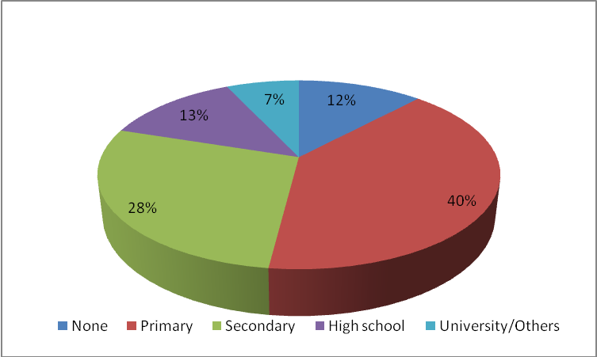
Figure 2: Educational level of study participants

Table 2: Socio demographic Characteristics of Young and Adolescent girls in the Kumba health district

Characteristic | Category | Frequency(n) | Percentage (%)
Sex | Female | 193 | 96.5
Sex | Others | 7 | 3.5
Sex | Total | 200 | 100
Religion | Christian | 156 | 78.0
Religion | Muslims | 13 | 6.5
Religion | Pagan | 19 | 9.5
Religion | Others | 12 | 6.0
Religion | Total | 200 | 100
Marital status | Never married | 171 | 85.5
Marital status | Married | 10 | 5.0
Marital status | Widow | 5 | 2.5
Marital status | Divorced | 1 | 0.5
Marital status | Cohabiting | 13 | 6.5
Marital status | Total | 200 | 100
Occupation | Student | 130 | 65.0
Occupation | House wife | 8 | 4.0
Occupation | Business | 14 | 7.0
Occupation | Farmer | 7 | 3.5
Occupation | Others | 41 | 20.5
Occupation | Total | 200 | 100

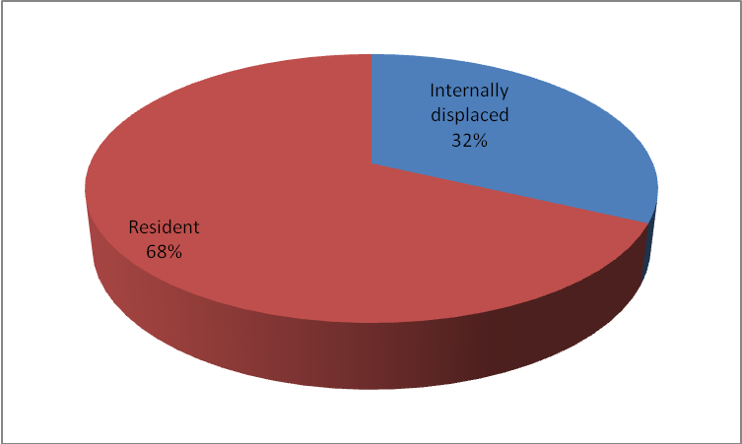

Figure 3: Residential status of Young and Adolescent girls in the Kumba Health District

3.2: Perceptions, Causes and Predisposing Factors of Sexual Violence in Kumba Health District
The results in figure 4 show the different ways young and adolescent girls experienced sexual violence. A majority (71%) reported they were forced to have sexual experience irrespective of the individual and 67% reported they were threatened or beaten to have sexual experience (see figure 4).
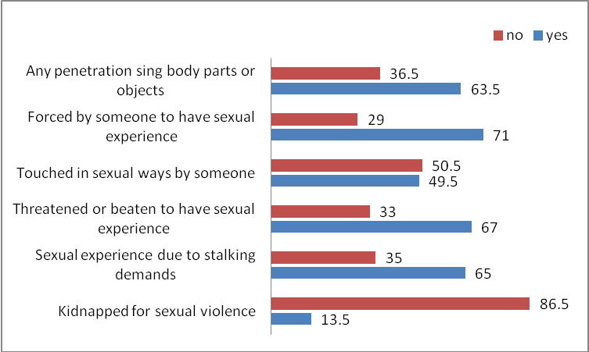

Figure 4: Different ways young and adolescent girls have experienced Sexual Violence

Majority of the young girls had poor knowledge on sexual violence irrespective of their level of education although this poor knowledge was highest among participants who had acquired only a primary level of education (33.5%). There was no statistical significance (P=0.0707) in relation knowledge and educational level (see table 3).
Table 3: Association of the knowledge of Sexual violence and Education
LEVEL OF EDUCATION | GOOD KNOWLEDGE | POOR KNOWLEDGE | P-value
None | 12(6%) | 12(6%)
Primary | 13(5.2%) | 67(33.5%) | 0.707
Secondary | 5(2.5%) | 51(25.5%) | 0.707
High school | 3(1.5%) | 23(11.5%) | 0.707
University | 2(1%) | 12(6%) | 0.707
Total | 35 (17.5%) | 165(82.5%)

There was a significant association between the majority who reported armed conflict, consuming alcohol in school, previously being raped before, being an orphan, having many sexual partners, poverty, poor parental guidance, indecent dressing and witchcraft and the perpetrators of the sexual violence (P <0.001). (table 4). The greatest perpetrators of sexual violence were gang members (n = 61, 30.5%) and neighbours (n= 50, 25%) and this was associated to the consumption of alcohol (table 4).
Table 4: Association between Causes of sexual violence and Perpetrators of Sexual violence
Causes of Sexual Violence | Perpetrators of Sexual Violence |  |  |  | P-value
Causes of Sexual Violence | Intimate partner | Others living in the same house | Parent | Neighbour | P-value
Armed conflict | 30(15%) | 17(8.5%) | 8(4%) | 37(18.5%) | 0.438
Being Young | 18(9%) | 22(11%) | 9(4.5%) | 41(20.5%) | 0.017
Consuming alcohol or drugs | 29(14.5%) | 31(15.5%) | 12(6%) | 50(25%) | 0.010
Being an Orphan | 7(3.5%) | 7(3.5%) | 3(1.5%) | 15(7.5%) | 0.018
Previously been raped or sexually abused | 6(3%) | 6(3%) | 4(2%) | 11(5.5%) | 0.002
Being in the wrong place | 19(8.5%) | 20(10%) | 4(2%) | 26(13%) | 0.001
Having many sexual partners | 11(5.5%) | 10(5%) | 2(1%) | 12(6%) | 0.008
Indecent dressing | 38(19%) | 24(12%) | 7(3.5%) | 35(17.5%) | <0.001
Poverty | 18(9%) | 14(7%) | 3(1.5%) | 25(12.5%) | 0.007
Poor parental guidance | 12(6%) | 23(11.5%) | 10(5%) | 21(10.5%) | 0.040
Witchcraft | 2(1%) | 0(0.00%) | 2(1%) | 2(1%) | 0.032

Table 4 continued: Association between Causes of sexual violence and Perpetrators of Sexual violence
Causes of Sexual Violence | Perpetrators of sexual violence |  |  | P-value
Causes of Sexual Violence | Gang members | Relatives | Strangers | P-value
Armed conflict | 61(30.5%) | 12(6%) | 28(14%) | <0.001
Being Young | 29(14.5%) | 10(5%) | 19(9.5%) | 0.641
Consuming alcohol or drugs | 61(30.5%) | 18(9%) | 36(18%) | <0.001
Being an Orphan | 10(5%) | 5(2.5%) | 11(5.5%) | 0.012
Previously been raped or sexually abused | 7(3.5%) | 7(3.5%) | 4(2%) | 1.000
Being in the wrong place | 18(9%) | 10(18.5%) | 15(7.5%) | 0.409
Having many sexual partners | 7(3.5%) | 5(2.5%) | 7(3.5%) | 0.418
Indecent dressing | 19(9.5%) | 6(3%) | 16(8%) | 0.001
Poverty | 10(5%) | 8(4%) | 10(5%) | .026
Poor parental guidance | 22(11%) | 14(7%) | 11(5.5%) | .003
Witchcraft | 2(1%) | 2(1%) | 0(0.0%) | 0.555

In relation to the period when sexual violence usually occurs, majority (68.5%) of the participants indicated that sexual violence occurred during the night period and a minority of sexual violence (10%) were reported during early morning.(see figure 5)
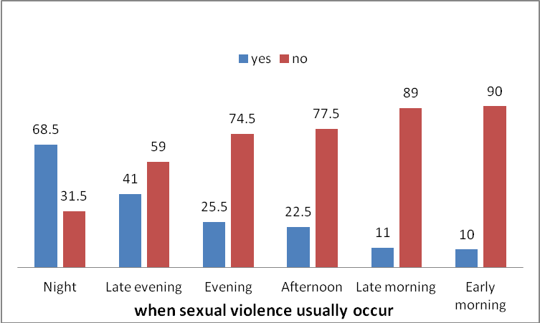
Figure 5: Period of Sexual Violence Occurrence

3:3 Pathological Consequences
The results in figure 6 show the different pathological consequences resulting from sexual violence. Majority of sexual violence victims reported HIV (41%) as the main pathological consequence and minority (2.5%) indicated unsafe abortion as the least pathological consequence (See figure 6).

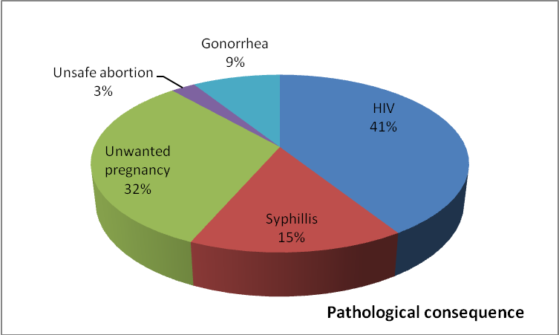
Figure 6: Pathological consequences from Sexual Violence among young and adolescent girls in the Kumba health district
The results in figure 7 show the immediate consequences of sexual violence on sexual violence victims. The majority reported unwanted pregnancy (68.5%) as the main consequence of sexual violence and 41% reported it could result to unsafe abortion. Most sexual violence victims (72.5%) reported shyness and guilt were the major future consequences of sexual violence and 50% also reported they will keep away from men in future (see figure 8).
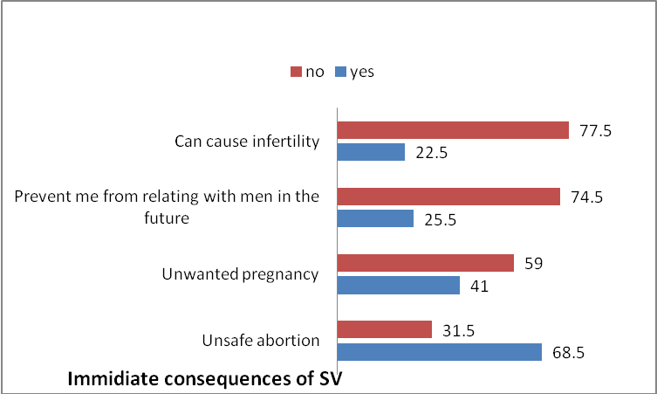
Figure 7: Immediate Consequence of Sexual Violence
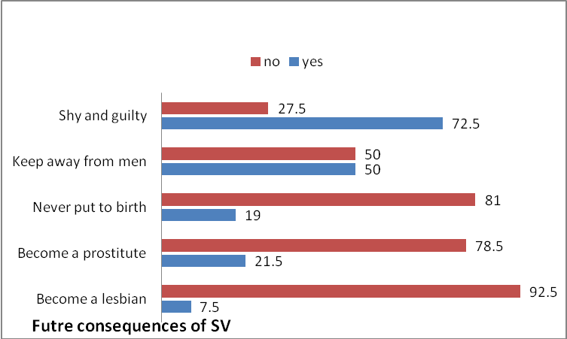
Figure 8: Future consequences of sexual violence of sexual violence victims
Majority of the sexual violence victims (54.5%) consulted a medical doctor in order to prevent pathological consequences while 4% of the victims had no idea on what to do after being exposed to sexual violence and some used traditional herbs (14%) as shown in figure 9.
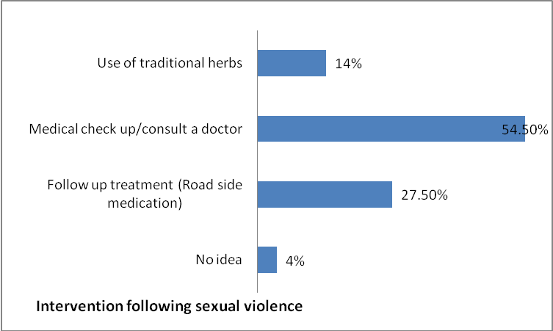
Figure 9: Ways of preventing consequences following sexual violence

3:4 Psychological Consequences
The result in figure 10 shows the psychosocial consequences of sexual violence on the victims. Some (20%) suffered from depression, others from suicidal taught (12%), others from stigmatization (15%), some (17%) reported that they had difficulty in sleeping and a few had phobia for men (11%) (Figure 10). Different effects regarding the psychological consequences of sexual violence on the victims was recorded as majority (26%) reported they felt unsecured, 19.5% had poor concentration, 17% experienced examination failure and 15.5% were scared of darkness (figure 11).
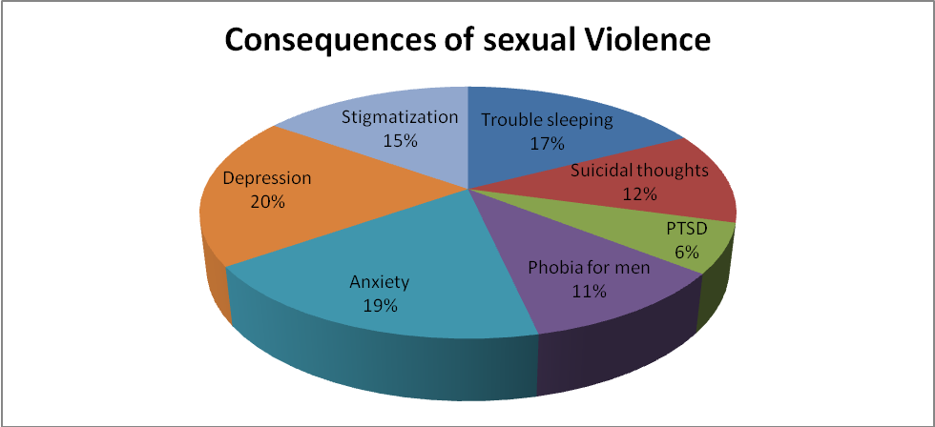
Figure 10: Psychosocial consequences of Sexual Violence
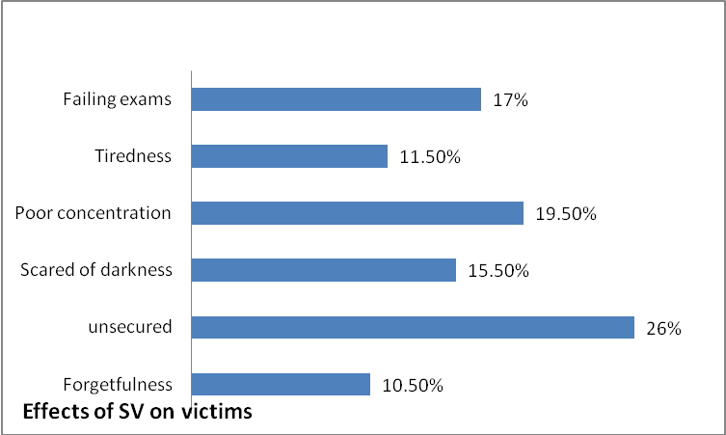
Figure 11: Effect of Psychological consequences of Sexual violence
The result shows the consequences of sexual violence on family members. A majority (77%) reported most of their family members were stigmatized and 5.5% experienced a reduced amount of income and more expenditure to manage other consequences like unwanted pregnancy (figure 12). Societal attitudes towards the family of a sexually violated victim showed that 39% reported that most of their family members had strange looks from neighbors, 37% indicated uncomfortable comments and 9% said that people kept away from them (figure 13).
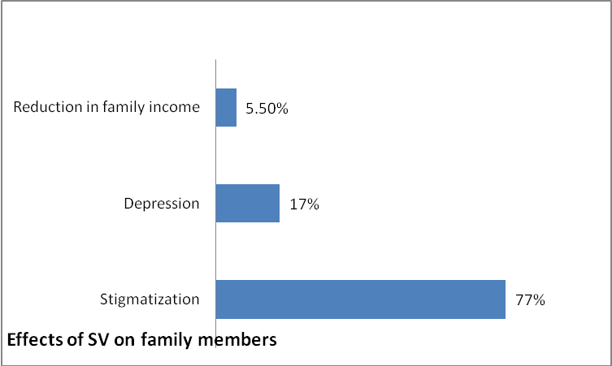
Figure 12: Consequences of Sexual Violence on Family members
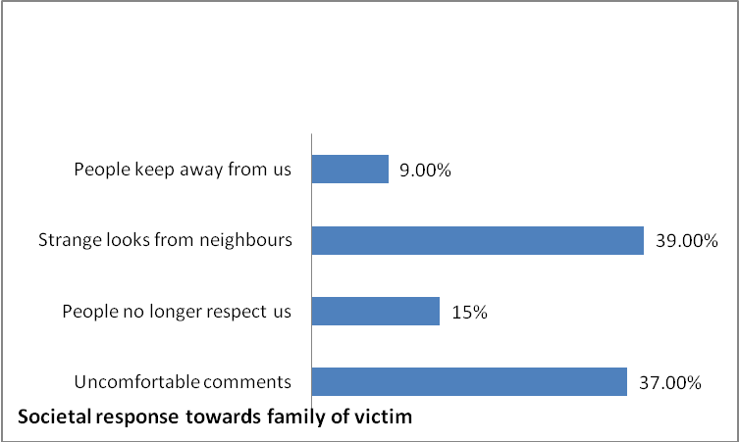
Figure 13: Societal attitudes towards the family of sexually violated victim

3.5: Sources of Health Seeking
Results here demonstrated that majority (40%) of the victims sought for help in hospital/clinic, 15.0% reported to a community leader or chief and 9% reported to the police (figure 14). There were different reasons why victims sought for help from the different sources. The main reason was to prevent complications (32%) and the facility was easily accessible (31.5%) as shown in figure 15.
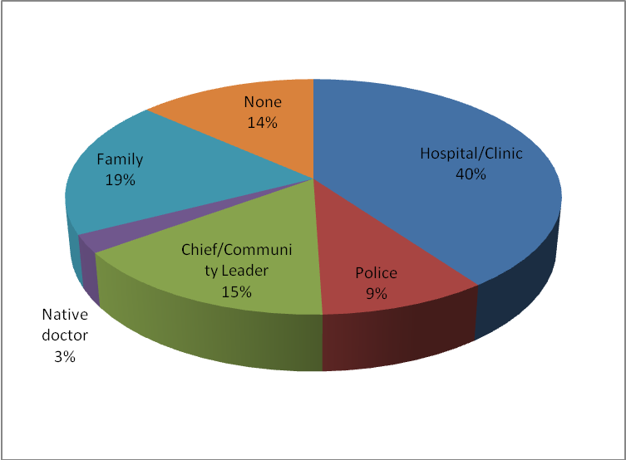
Figure 14: Health seeking source for Sexual Violence victims

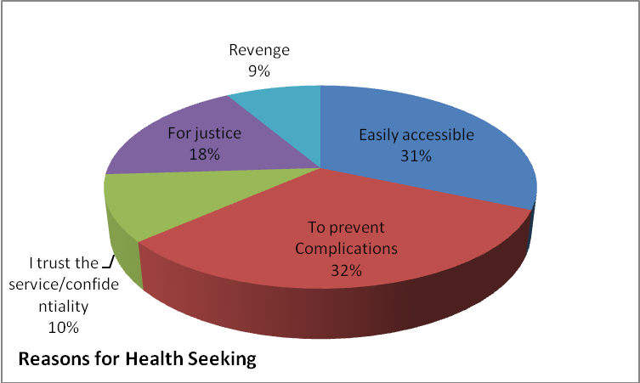
Figure 15: Reasons for ‘Help Seeking’ by Sexual Violence victims

The length of time between victimization and help seeking varied. Most (36%) reported that they sought for care immediately, (25%) did after 2-5days, 20% did after one week and 19% did after a month (figure 16). There were numerous reasons why women did not report sexual violence. A majority (38%) said they didn’t report because they felt ashamed, 16% said they were afraid of being blamed, 12% said they lacked sex education, 16% were scared of the risk of retaliation and 6% said they lacked adequate support system.
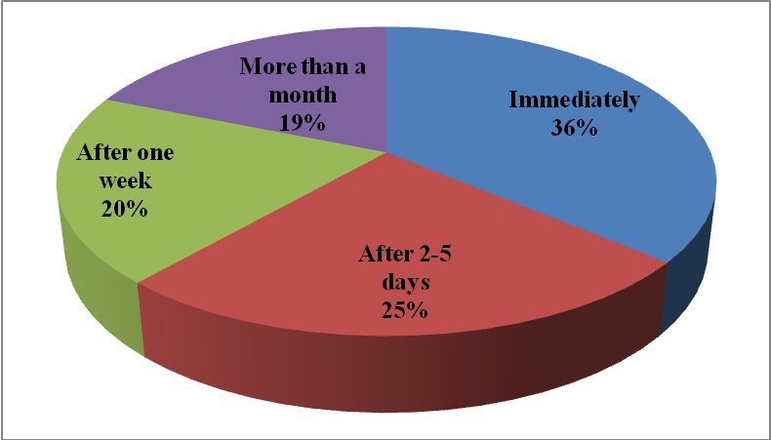
Figure 16: Duration of seeking Care
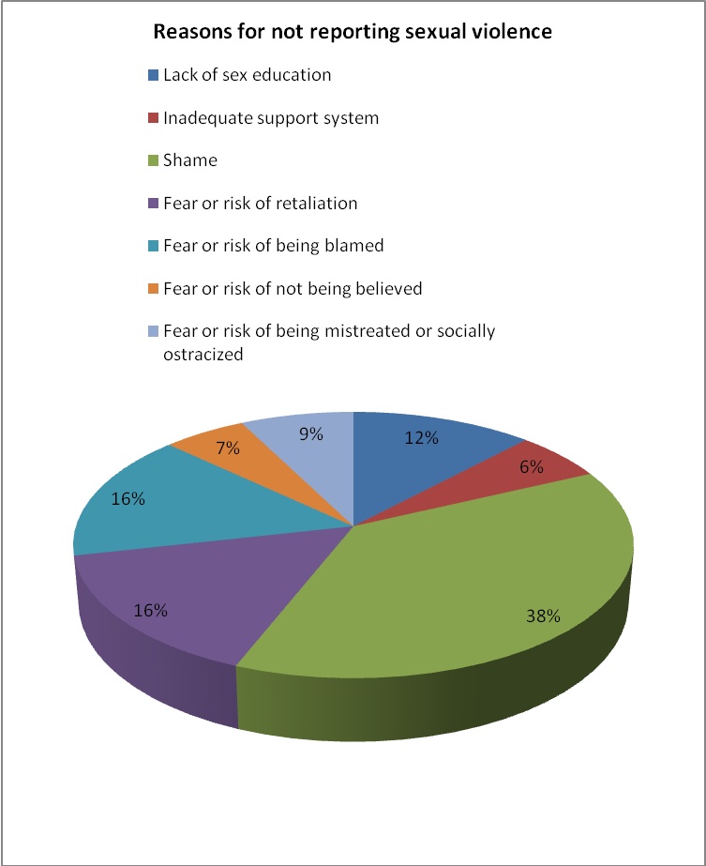
Figure 17: Reasons why Victims did not report sexual violence
For management strategies which could be implemented to sexual violence victims, 32.5% suggested psychological and emotional support, 25.5% suggested treatment and prophylaxis of sexual transmitted infections for Sexual violence victims (figure 17). The results further illustrated the different ways in which sexual violence could be prevented. Majority (56.5%) suggested that sexual violence could be prevented by massive sensitization on sex education to children as early as 3 years and 28% also said rape victims shouldn’t be blamed (figure 18).
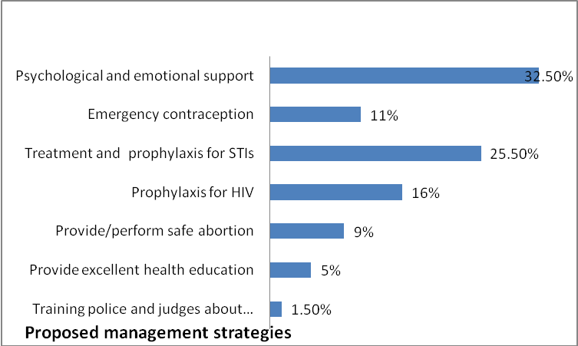
Figure 18: Proposed Management Strategies for Sexual violence
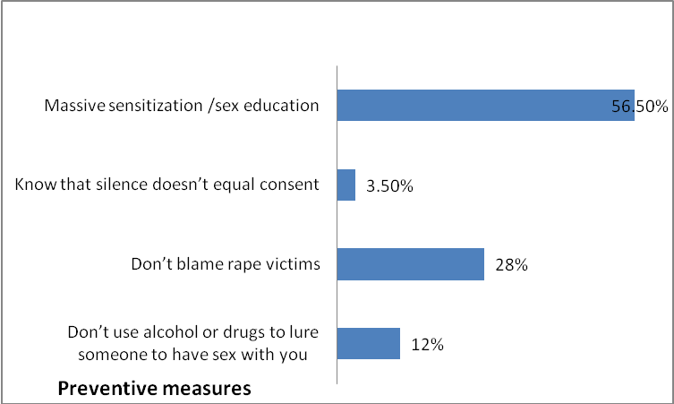
Figure 19: Preventive Measures of Sexual Violence amongst Victims

4.0 DISCUSSION

4.1. Perceptions, causes and predisposing factors of Sexual Violence
The results show that young and adolescent girls experienced sexual violence where majority (71%) reported they were forced to have sexual experience irrespective of the individual and 67% reported they were threatened or beaten to have sexual experience. This is in line with a survey carried out by Abraham [16] where a representative sample of women aged 18– 25 years in three provinces of South Africa found out that in 2004, 1.3% of women had been forced, physically or by means of verbal threats, to have non-consensual sex. Another confirmatory survey was carried out in Czech Republic by Weiss P [17], reported 11.6% women were forced to have sexual contact and 3.4% reported that forced vaginal intercourse had occurred more than once.
Majority (40%) of the young girls who had poor knowledge were of the First School Leaving Certificate category. This is in line with a study carried out in Tanzania by the National Bureau of Statistics (NBS) [18] where majority of participants had only completed primary education, and this factor could have contributed to their poor knowledge on sexual violence as 19% of women aged 15–30 years had received no formal education.
There is a significant association between the majority (30.5%) of sexual violence victims who reported armed conflict was a cause of sexual violence perpetrated by gang members. This in line with a surveillance study done by Swart L et al [19] in Johannesburg of women attending medico-legal clinics following a rape, found that one-third of the cases had been gang rapes. Another study by Greenfeld [20] supported through a National data on rape and sexual assault in the United States that revealed about 1 out of 10 sexual assaults involve multiple perpetrators unknown to their victims.

4.2. Pathological consequences
The results show the different pathological consequences resulting from sexual violence. Majority of sexual violence victims reported HIV (41%) as the main pathological consequence and (15%) indicated syphilis as the least pathological consequence. This is in line with a systematic review done by Hogben et al [21] on violence against sex workers from India and US who experience sexual violence had between 2 and 3-fold increased risk of HIV sero-positivity and Sex workers who experienced any form of physical or sexual violence by any perpetrator. Other studies also showed increased risk of STI. sexually transmitted diseases in victims of rape. HIV infection and other sexually transmitted diseases are recognized consequences of rape. Research on women in shelters has shown that women who experience both sexual and physical abuse from intimate partners are significantly more likely to have had sexually transmitted diseases [22].
The results show the immediate consequences of sexual violence. The majority of the sexual violence victims reported (68.5%) as the main immediate consequence of sexual violence and 41% reported it could result to unsafe abortion. This is strongly supported by UNFPA [23] in an article published in 2006 who stating that sexual violence, unwanted pregnancy and abortion are amongst the most controversial and stigmatized topics facing sexual violence victims, reproductive health researchers, advocates, and the public today.
Most sexual violence victims (72.5%) reported shyness and guilt were the major future consequences of sexual violence and 50% also reported they will keep away from men in future. This is in line with a study carried out by Keetha Mercer [24] in 2007 who found out that 16% sexual violence victims in felt guilty, developed crowd phobias, anger and had difficult relationships with men because of their previous experience.

4.3. Psychological Consequences
The result shows the psychosocial consequences of sexual violence on the victims. Twenty (20%) suffered from depression and 17% reported they had difficulty in sleeping. This is in line with a study carried out by Choquet M et al [25] on adolescents in France who also found a relationship between sexual violence and sleep difficulties, depressive symptoms (continuous sadness, feeling helpless, having low self-esteem, finding it difficult to make decisions), somatic complaints, tobacco consumption and behavioral problems.
Different effects regarding the psychological consequences of sexual violence on the victims was recorded as majority (26%) reported they felt unsecured while (15,50%) were scared of darkness respectively. This is in line with a study conducted by DiClemente et al. ^{[39]} who stated that Emotions may be expressed as anger or anxiety as some individuals may show feelings of shock ,numbness; difficulties in functioning well at work, home or school where fear may appear depending on the place and time the incident took place and most frequently the person may terminate an existing relationship with an intimate partner.

4.4. Health Seeking Behaviour and Prevention
There are numerous reasons why women do not report sexual violence. A majority (38%) said they didn’t report as they felt ashamed of what happened to them. This in line with a study done in 2017 by UNFPA [26] in Juba-South Sudan on tackling the stigmas associated with conflict related sexual violence where they stated that at individual level, sexual violence victims experience stigma through rejection, humiliation, isolation and blame.
Adama Dieng [27], supported that Sexual violence could turn victims into social outcasts, fracturing families, corroding community structures and that fear and cultural stigma prevented most survivors from ever coming forward. He continued by saying” stigma kills,” emphasizing that victims who often survive sexual violence face social repercussions, as shame and stigma were integral to the logic of sexual violence when used as a war tactic or terrorism.
This study also revealed that 16% of the victims said they were afraid of the risk of retaliation by the perpetrators. This is in line with a study carried out by Safe the Children[28], in 2019 where they stated that Sexual violence victims face several challenges including the fear of retaliation by the perpetrators in conflict zones who are usually gang members, terrorist or military groups and lack of proper support services available.
Results here demonstrated that majority (40%) of the victims sought for help in a hospital/clinic which was accessible to prevent complications and 15% reported to a community leader. This is in line with a research study in Canada by Du Mont [29] in 2000 stating that health facilities are the best place a victim can get assistance. Also the medico-legal documentation can increase the chance of a perpetrator being arrested, charged or convicted [30].
The results show the different management strategies which could be implemented to sexual violence victims as 32.5% suggested psychological and emotional support will be helpful after medical intervention. This is in line with a study done by Perry KJ et al. [31] in 2003 who supported that there is some evidence that a brief cognitive-behavioral program administered shortly after an assault can hasten the rate of improvement of psychological damage arising from trauma. He further added that counselling therapy and support group initiatives have been found to be helpful following sexual assaults [32], especially where there may be complicating factors related to the violence itself or the process of recovery.
There were victims 22.5% who suggested prophylaxis and treatment of sexual transmitted infections for all sexual violence victims. In 2001, WHO [33] Indicated that the possibility of transmission of HIV during sexual violence is a major cause for concern, especially in countries with a high prevalence of HIV infection. Another study was conducted in France [34] in 2006 which stated that the use prophylactic medication for all STI e.g. antiretroviral drugs following exposure to HIV is known to be reasonably effective. The administration of the antiretroviral drug zidovudine (AZT) to health workers following an occupational needle-stick exposure (puncturing the skin with a contaminated needle) has been shown to reduce the subsequent risk of developing HIV infection by 81%.
The results further illustrate the different ways in which sexual violence could be prevented Majority (56.5%) suggested that sexual violence could be prevented by massive sensitization on sex education to children as early as 3 years and (28%) also said rape victims shouldn’t be blamed. This in line with a sensitization program done in 2001 by Gordon G et al. where the results of the program showed reductions in violence against women have been reported in communities in Cambodia, the Gambia, South Africa, Uganda and the United Republic of Tanzania.

5.0 CONCLUSIONS
Conclusively, Sexual violence is a major concern in the Kumba Health District as 17% of the victims had little idea on what to do after being exposed to sexual violence, (38.5%) of the young girls had poor knowledge of SV, (70%) said they didn’t report because they felt ashamed while 30.5% said they were afraid of the risk of retaliation. In terms of management, 51% suggested treatment and prophylaxis of sexual transmitted infections for Sexual violence victims like HIV and 75% suggested psychological and emotional support will hasten the recovery process. Furthermore, (68.5%) suggested that sexual violence could be prevented by massive sensitization on sex education. reported in this Health District.

6.0 RECOMMENDATIONS
Sexual violence has generally been a neglected area of research in most parts of the world, yet the evidence suggests that it is a public health problem of substantial proportions. Much more needs to be done both to understand the phenomenon and to prevent it.
- Introduce massive sexual violence sensitization campaign in different languages that can be understood even by everybody in the community, schools, churches, markets, hospitals and on the media.
- Provide a comprehensive training to all health personnels in the holistic management of sexual violence from medical to psychosocial and emotional support for a faster recovery of the victims.
- Establishing proper codes of practice for sexual violence cases to maintain confidentiality and strict disciplinary procedures for health workers who abuse patients in health care settings or others who stigmatize them.
- CHWs could be involved in the whole spectrum of care from primary to tertiary prevention with CHWs carrying out activities to reduce stigma and increase social support at the community level, supportive counselling, providing linkages and referral to services.
DISCLAIMER
Authors hereby declare that there is no competing interest. This article is an original research work.

References
- Ezzati M et al., Child sexual abuse, Comparative quantification of health risks: global and regional burden of disease attributable to selected major risk factors. Volume 2. Geneva, World Health Organization 2013.
- Garcia-Moreno C et al. (2006). WHO Multi-Country study on women’s health and domestic violence against women. Geneva, World Health Organization.
- Abrahams N et al. (2004). Sexual violence against intimate partners in Cape Town: prevalence and risk factors reported by men. Bulletin of the World Health Organization, 82(5):330–337
- World Health Organization. Violence against women – Intimate partner and sexual violence against women. Geneva, World Health Organization, 2011.
- UNHCR. Fourth world conference on women: Beijing declaration and platform for action. Beijing; 2009. 28:839–855.
- UNICEF. Sexual violence in women’s lives:findings from the women’s safety project, a community-based survey in Indonesia. Violence Against Women,2007, 1:6–31.
- Bashar, Rape in England; J. M. Carter (1985) Rape in Medieval England: an historical and sociological study (New York: University Press of America); J. B. Post (1978) ‘Ravishment of women and the statutes of Westminster’, in J.H. Baker (Ed.) Legal Records and the Historian, pp. 150-160 (London: Royal Historical Society); B. Toner (1977) The Facts of Rape (London: Hutchinson); G. Geis (1978) Lord Hale, witches and rape, British Journal of Law and Society, 5, pp. 26-44.
- Toner, The Facts, pp. 95-96; Clark, Rape or seduction?, p. 17, quoting S. Farr 1815, Elements of Medical Jurisprudence, p. 45 (London) and T. R. Beck (1825) Elements of Medical Jurisprudence, pp. 55-57 (London).
- Caspi, A., McClay, J., Moffitt, T.E., et al., 2002. Role of genotype in the cycle of violence in maltreated children. Science 297, 851–854.
- Marshall, W., Serran, G., 2000. Improving the effectiveness of sexual offender treatment. Trauma, Violence, & Abuse 1, 203–222.
- Jewkes, R., 2012. Rape Perpetration: A Review. Pretoria: Sexual Violence Research Initiative.
- Brownmiller, S., 1975. Against Our Will: Men, Women, and Rape. New York, NY:Fawcett Books.
- Edwards, K.M., Turchik, J.A., Dardis, C.M., Reynolds, N., Gidycz, C.A., 2011. Rape myths: History, individual, and institutional-level presence, and implications for change. Sex Roles 65, 761–773.
- Burt, M.R., 1980. Cultural myths and support for rape. Journal of Personality and Social Psychology 38, 217–230.
- Hayes, R.M., Lorenz, K., Bell, K.A., 2013. Victim blaming others: Rape myth acceptance and the just world belief. Feminist Criminology 8, 202–220.
- Jewkes R, Abrahams N. The epidemiology of rape and sexual coercion in South Africa: an overview. Social Science and Medicine (in press) 2004.
- Weiss P, Zverina J. Experiences with sexual aggression within the general population in the Czech Republic. Archives of Sexual Behavior, 2002, 28:265–269.
- National Bureau of Statistics (NBS). Tanzania Demographic and Health Survey 2010. Dar es Salaam, Tanzania: National Bureau of Statistics; 2011.
- Swart L et al. Rape surveillance through district surgeons’ offices in Johannesburg, 1996–1998: findings, evaluation and prevention implications. South African Journal of Psychology, 2000, 30:1– 10. 62.
- Greenfeld LA. Sex offenses and offenders: an analysis of data on rape and sexual assault. Washington, DC, United States Department of Justice, Office of Justice Programs, Bureau of Justice Statistics (NCJ 163392).
- M S Hogben, J V Ford, J Becasen. Centers for Disease Control & Prevention, Atlanta,GA, United States, oi:10.1136/sextrans-2013-051184.0021
- Wingood G, DiClemente R, Raj A. Adverse consequences of intimate partner abuse among women in non-urban domestic violence shelters. American Journal of Preventive Medicine, 2000, 19:270–275
- United Nations Population Fund (UNFPA). Report of the international conference on population and development. Cairo; 2006.
- Dahlberg, L.L. and Krug, E.G. and Mercy, J.A. and Zwi, Anthony and Lozano, Rafael, 2002, 01,3-21, Violence – A global public health problem,World report on violence and health
- Choquet M et al. Self-reported health and behavioral problems among adolescent victims of rape in France: results of a cross-sectional survey. Child Abuse & Neglect, 2001, 21:823–832
- UNFPA Juba-South Susan;Tackling the stigmas associated with conflict related sexual violence. 2017.
- Adama Dieng UN security council in Ukraine on shame, stigma as an integral to logic of sexual violence as war tactic 2017.
- Safe the Children; Weapon of War: Sexual violence against children in conflict 1990-2019. Published in United Kingdom 18 February 2021.
- Du Mont J, Parnis D. Sexual assault and legal resolution: querying the medical collection of forensic evidence. Medicine and Law, 2000,19:779–792. 188.
- McGregor MJ et al. Examination for sexual assault: is the documentation of physical injury associated with the laying of charges? Journal of the Canadian Medical Association, 1999, 160:1565–1569.
- Foa EB, Hearst-Ikeda D, Perry KJ. Evaluation of a brief cognitive-behavioural program for the prevention of chronic PTSD in recent assault victims. Journal of Consulting and Clinical Psychology, 2003, 63:948–955. 178.
- Foa EB, Street GP. Women and traumatic events. Journal of Clinical Psychiatry, 2001, 62 (Suppl. 17):29–34
- Violence against women and HIV/AIDS: setting the research agenda. Geneva, World Health Organization, 2001 (document WHO/FCH/GWH/01.08).
- Case–control study of HIV seroconversion in health care workers after percutaneous exposure to HIVinfected blood: France, United Kingdom, and United States, January 1998 to August 2006. Morbidity and Mortality Weekly Report, 1995, 44:929–933

