Original Research Article

**Prevalence of pulp stones in molars: a cone-beam computed tomographic evaluation in a Brazilian subpopulation.**

.

**ABSTRACT**

|  |
| --- |
| **Aims:** Determine the prevalence of pulp stones by cone beam computerized  tomography (CBCT) and explore any potential correlation between the occurrence of  pulp stones with gender, age, tooth, arches, and condition of the dental crown.  **Methodology:** CBCT of 300 patients were assessed, totaling 631 molars. All  molars were analyzed in the sagittal, axial and coronal planes and, when present, pulp stones were identified as a round or oval hyperdense mass  **Results:** After data tabulation, statistical analysis was performed using chi-square tests, with a significance level set at 5%. Of a total of 300 patients, pulp stones were  identified in 35% of subjects and in 25.5% of molars. The presence of pulp  stones were most frequently found in females (41.1%) than in males (27.7%) and in  individuals aged over 60 years. The first upper molars showed the highest incidence of pulp stones. No significant difference was observed when maxillary and mandibular  arches were compared, neither side. The presence of pulp stones was higher in  restored molars when compared to intact teeth (P<0.05).  **Conclusion:** CBCT is an efficient resource for the diagnosis and location of pulp stones and may be used to assist clinicians planning the safest endodontic approach. The prevalence and distribution of pulp stones regarding gender and type of teeth is paramount for the proper design of root canal treatment. |

*Keywords: CBCT; Dental pulp calcifications; Endodontics.*

**1. INTRODUCTION**

Computerized tomography (CT) is a diagnostic imaging method that uses X-ray and

allows the reproduction of a section of the human body in any of the three planes (axial, coronal and sagittal [1]. Cone Beam Computerized Tomography (CBCT) was developed specifically for dentistry [2] and allows the visualization of anatomical structures in 3 dimensions with higher resolution. This improvement in the quality of imaging tests facilitates the diagnosis, planning, and follow-up of oral diseases [3, 4].

Unlike conventional radiographs that project in a single plane all structures crossed by X-rays, the CT shows the structural relationships in depth [1]. The unit that composes the tomographic image, named voxel, is classified as isotropic presenting height, width, and depth of equal dimensions [5], allowing objects within this volume (voxel) to be accurately measured in different planes [6].

Another feature of Cone Beam Tomography is the different sizes of the field of view (FOV). The advantage of different FOV sizes is to enable the evaluation of the region of interest with high resolution and greater accuracy, without exposing the patient to unnecessary radiation [6].

The CBCT can be used in all dental specialties such as implantology, endodontics,

orthodontics, periodontics, bucco-maxillofacial surgery and traumatology [7]. In endodontics,

CBCT assists the root canal treatment in several clinical situations, such as locating calcified

canals, position, and size of periapical lesions, furcal perforations, and interpretation of root canal anatomy [8, 9], aiding the treatment planning.

In addition, a clinical situation that may hinder endodontic treatment is the presence of a calcification in the pulp chamber, known as pulp stone [10], suspended, adhered or embedded in dentinal walls [11]. It’s important to emphasize that a single tooth may present more than one calcified nodule, varying its size from small particles to large masses that occupy the entire pulp chamber [12].

Pulp stones is a complex biological phenomenon characterized by the abnormal accumulation of mineralized tissue within the dental pulp. This condition can be the result of multiple factors, including dental trauma, chronic inflammatory processes, extensive caries, aging, and systemic diseases, which partially or completely block access to the root canals [10, 13], leading to accidents such as furcation perforation or even treatment failure.

Previous studies using standard radiographic analysis indicated that the occurrence of pulp stones ranges from 4 to 90%. However, only nodules larger than 200 μm in diameter are radiographically visible [14 – 16]. According to Da-Silva et al [17], the real prevalence of pulp stones is probably greater than most of those studies have suggested.

Due to the variation in current results and the limitation of previous studies performed with radiographs, the objective of this study was to evaluate the prevalence of pulp stones in molars, in a Brazilian subpopulation, using Cone Beam Computerized Tomography.

**2. MATERIAL AND METHODS**

**Study simple**

The present study was approved by the Human Research Ethics committee (2.352.750). From August 2017 to July 2018, CBCT scans were selected from a private radiology clinic. All CT scans were performed with previous clinical indication, without exposing the patient to unnecessary radiation. Free and informed consent was signed by the patient before CBCT

examination.

The inclusion criteria were: CBCT exams with FOV of 5cm x 5cm, 6cm x 8cm and 8cm x 8cm from upper and lower molars region, presenting first and second molars with complete apex. Exclusion criteria encompassed: patients younger than 18 years of age and images showing orthodontic retention device, endodontic treatment and metallic crowns. Due to anatomical variations and limited endodontic indication, third molars were not analyzed. At the end, 300 tomographic exams were selected for analysis, of which 137 were male and 163 females.

**Acquisition and analysis of CBCT**

All CBCT images were acquired by a licensed and experient radiologist using the EAGLE V-BEAM Cone Beam (Dabi Atlante, SP, Brazil) with the fields of view (FOV) of 5cm x 5cm, 6cm x 8cm and 8cm x 8cm. The image volume was reconstructed with isometric isotropes 5x5 0,10 x 0,10 x 0,10); 6x8 e 8x8 (0,16 x 0,16 x 0,16) voxels.

The tube voltage was 85 KVp and 4 mA, using an exposure time of 25.5 s. The workstation used the operating system Windows® 7 Professional 64 bits (Microsoft Corporation, Redmond, WA, EUA) processor Intel CORE i7 2.8 GHZ 6ª GER (Intel Corporation, EUA), graphic card GEFORCE GTX 1060 6GB XLR8 GAMING OC EDITION DDR5 256 BITS (Parsippany, New Jersey, EUA) and monitor Dell E2211H 21,5 inches - Resolution widescreen de 1920 x 1080 pixels (Dell Corporation, Round Rock, EUA).

The images in DICOM format were processed, interpreted and measured by Ondemand 3D Dental software (Cybermed Inc, Seoul, South Korea), brightness adjustments and contractions were performed to facilitate visualization. The tomographic images were analyzed by maxillary and mandibular hemi-arches, following the long axis of the tooth, in the coronal, sagittal and axial planes, with definition of a transverse range of 0.1 mm and a panoramic interval of 0.2 mm. The analyzed parameters are shown in table 1.

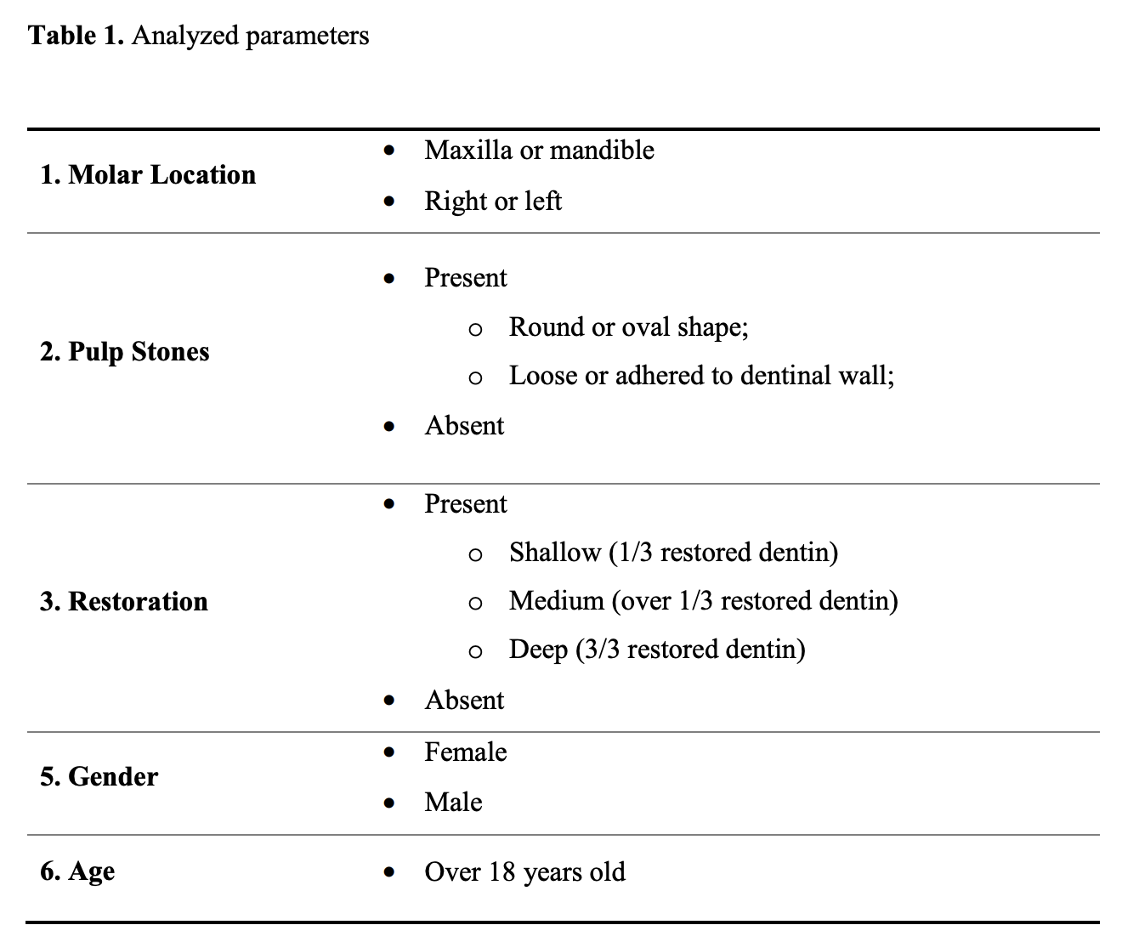

**Statistical Analysis**

Tabulated data were submitted to statistical analysis using Sigma Plot software (version 12.0). Shapiro-Wilk normality test indicated chi-square analysis, performed with a significance level of 5%.

**2. RESULTS**

**Prevalence of pulp stones and distribution between genders**

Of the 300 analyzed individuals, pulp stones were detected in 35% of the patients and in 25.5% of the molars. Pulp stones were observed in 27.7% of 137 male patients, while 163 females, showed calcifications in 41.1%. The association between gender and pulp stone is statistically significant (P <0.05), as observed in Table 2.

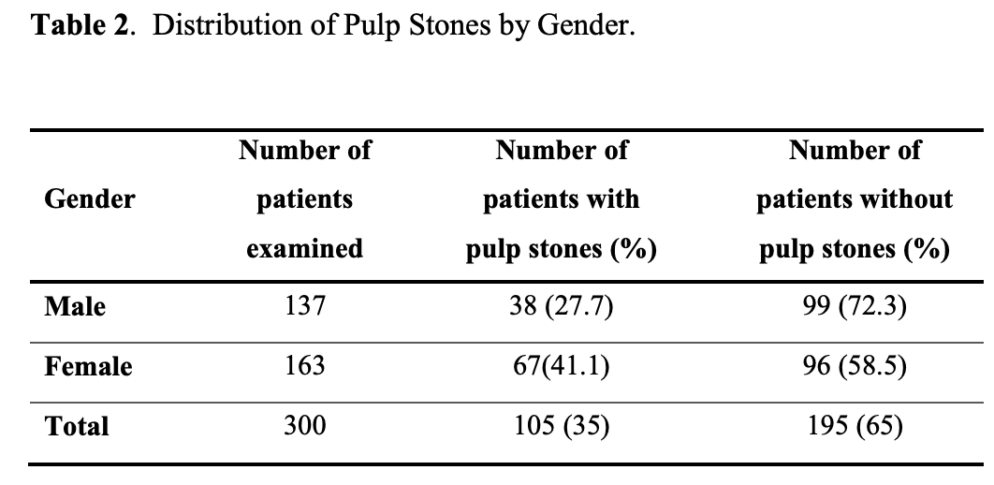

**Distribution of pulp stones between age groups**

The age of the selected patients ranged from 18 to 89 years, with the highest occurrence of pulp stones in patients above 60 years (33.8%) and lower occurrence in individuals aged 18- 29 years old (21.1%). There was a significant association between age groups and distribution of pulp stones (P <0.05) (Table 3).

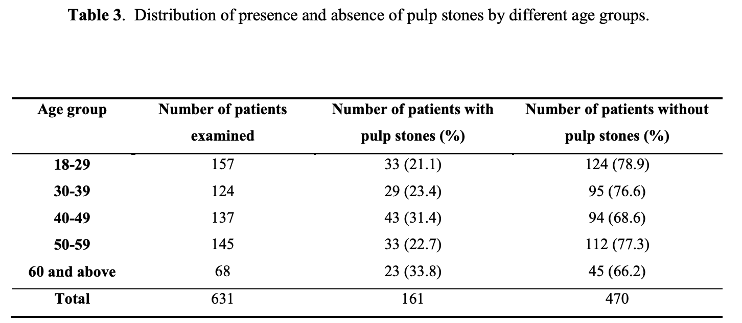

**Occurrence of pulp stones by dental arches**

The comparison between presence and absence of pulp stones according to the dental arch and the side is shown in table 4. There was no significant difference when comparing maxillary and mandibular arches, neither right nor left sides (p = 0.875).

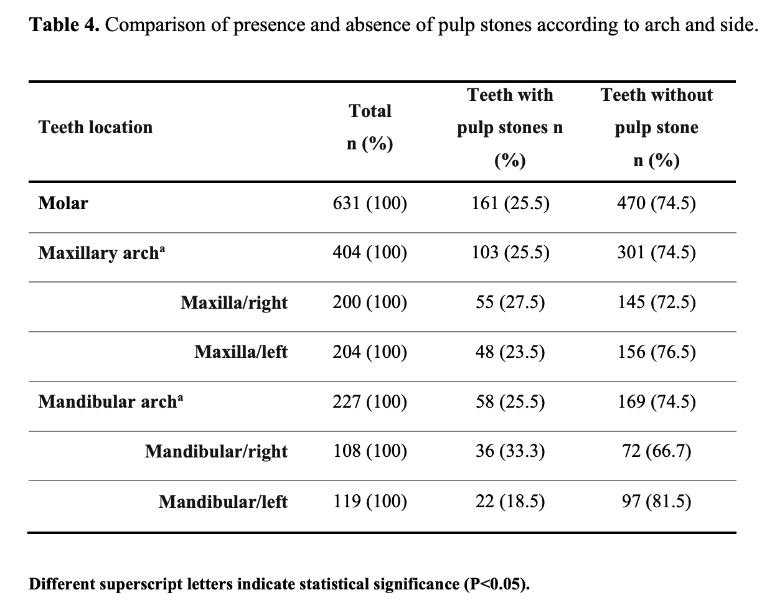

**Prevalence of pulp stones between molars**

Among molars that presented pulp stones, the first upper right molar showed the highest prevalence (40.4%), and a low occurrence was observed in the second upper molars (16%). Statistical analysis showed a significant difference in the occurrence of pulp stones within the analyzed molar groups (P<0.05) (Table 5).

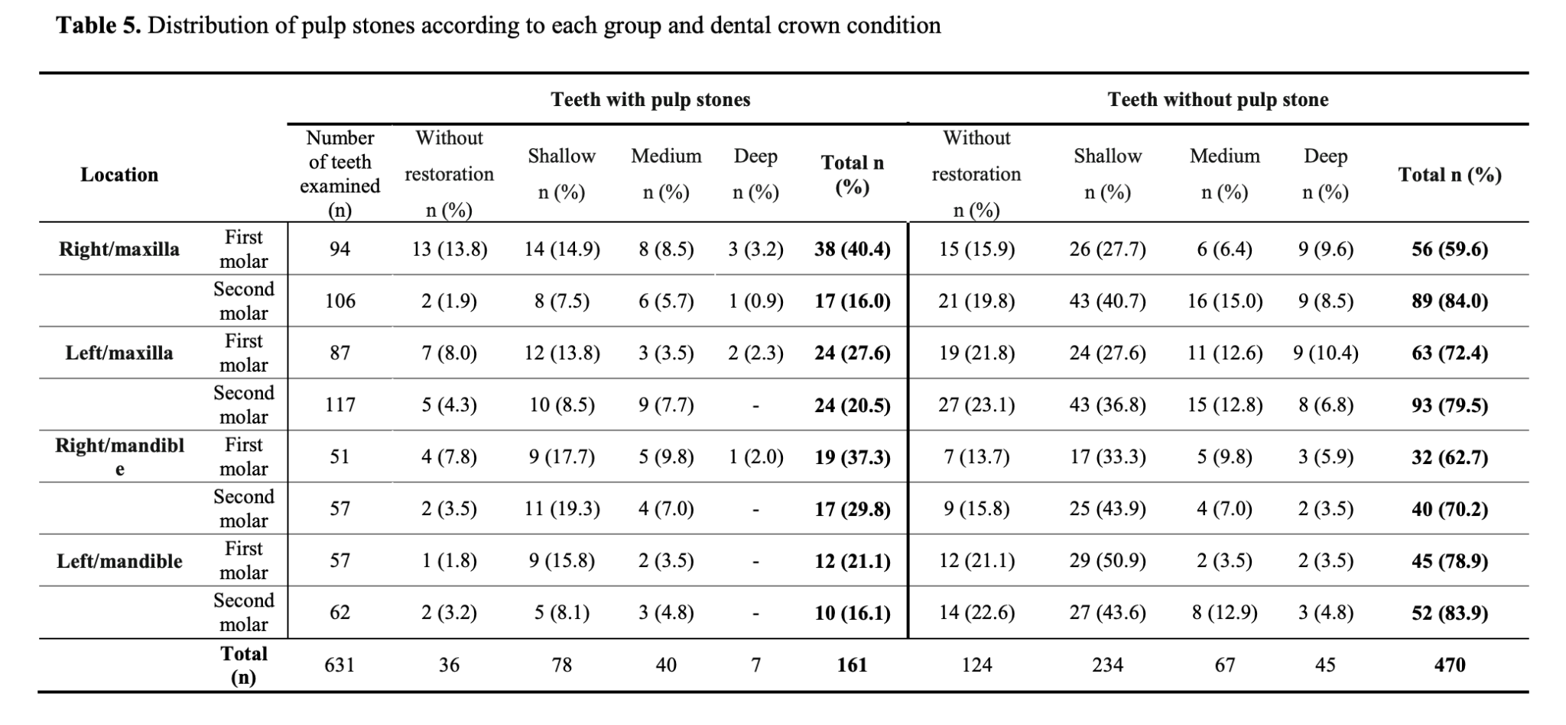

**Pulp stones and the condition of dental crown**

Of 161 teeth with pulp stones, 125 (77.6%) showed restoration. Shallow depth restoration was observed in 78 teeth, a medium depth in 40 teeth and 7 teeth presented deep restoration. Only 36 teeth (22.4%) with calcified nodules were considered healthy (Table 5). There was a statistical difference between the association of the pulp stones and the condition of the dental crown (P = 0.005).

**Characteristics of Pulp Stones**

Within the observed teeth with pulp stones, 70 molars had a round shape nodule, while 91 was oval (Figure 1), with a significant difference between shapes (P<0.05). In addition, pulp stones were mostly adhered to the floor of the pulp chamber (68.3%) when compared to loosen nodules (31.7%) (P<0.05).

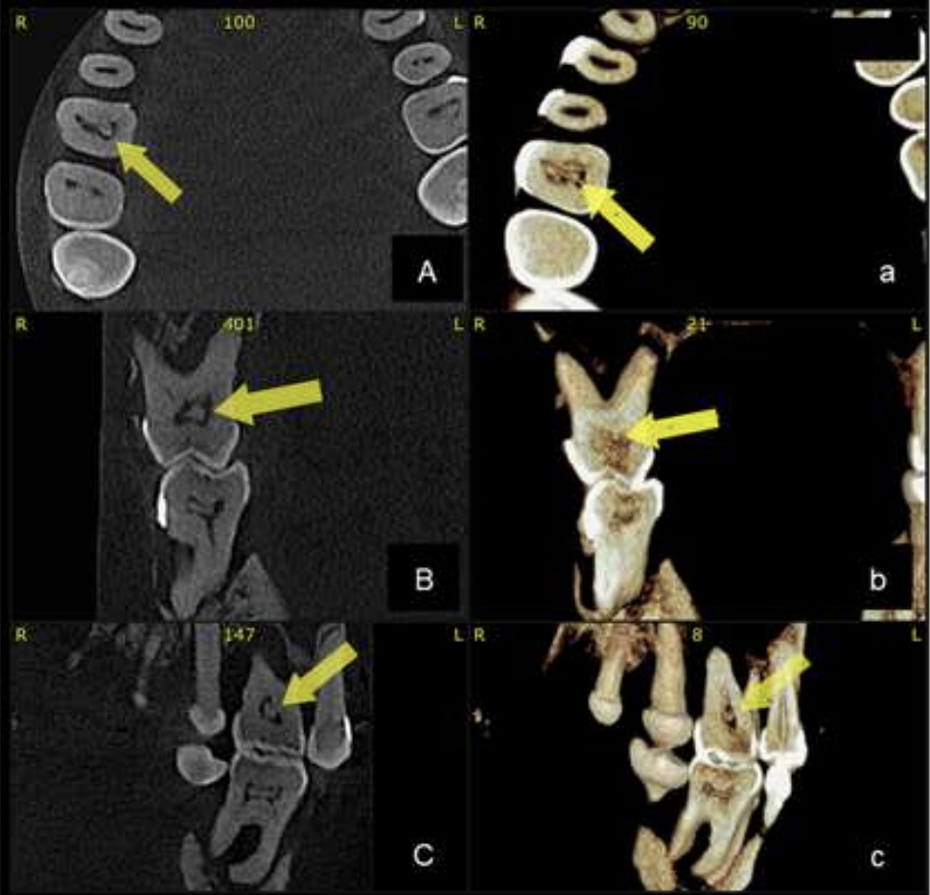

Figure 1. Presence of pulp stone in first superior right molar (yellow arrow) and in first lower right molar, on axial (A), sagittal (B) and coronal (C) planes, by 3D CBCT

Reconstruction.

**4. DISCUSSION**

To facilitate visualization of pulp stones and correctly plan treatment, clinicians may use imaging exams such as CBCT. Pulp stones are routinely observed in conventional or digital intraoral and extra-oral radiographs. One of the main limitations of this study would be the limited sample size, which was obtained from only one center, requiring additional multicenter studies with a larger number of samples.

In the present study, the use of CBCT allowed a detailed evaluation of tooth and pulp

stones anatomy (Figure 1), since through the 3-dimensional reconstructions it is possible to

eliminate the overlap of adjacent structures, facilitating analysis [4].

Pulp stones were observed in 35% of patients and in 25.5% of molars, which is not

consistent with previous studies using CBCT. Da Silva et al. [17] detected calcified nodules in

31.9% of the patients and in 9.5% of the evaluated teeth, showing lower result values when

compared to the results of the present study while Rodrigues et al. [18] notice that 55% of the patients had pulp stones, with both studies performed with Brazilian population. Patil et al. [19] conducted a study with the population of Saudi Arabia and verified the presence of pulp stones in 50.93% of the population and in 13.34% of the evaluated teeth.

Studies encompassing populations from other countries have also used CBCT to assess the presence of pulp stones. Research conducted with a northern Taiwanese population [20] detected a higher prevalence of pulp stones in the first molars (50%). Similar results were observed with the population of Turkey [21], where a higher prevalence of pulp stones was observed in the first molars (21%), followed by the second molars (12.8%). A recent retrospective observational study from southwest China analyzed 5066 teeth by CBCT [22]. Authors reported that nearly half of the population had pulp stones, more often in maxilla of females, in accordance with our findings of a Brazilian subpopulation.

Interestingly, a systematic review conducted in 2023 by Chalikkandy et al. [23] regarding prevalence of pulp stones in the Saudi Arabian population also reached 50% of prevalence among the study participants, also with a higher incidence in molars.

The results obtained in this research differ from those reported in the literature, possibly related to factors as sample size, methodology employed, ethnicity and geographical differences.

The prevalence of pulp stones was higher in females (41.1%) than in males (27.7%). The elevated incidence in women was also seen in the Australian population [22], Malaysian [24], and Turkish [25] but did not present differences between genders. In contrast to our findings, authors reported a higher prevalence of calcified nodules in men when compared to women [26,19, 27, 28].

The present study showed a higher prevalence of pulp stones in patients older than 60 years, corroborating previous studies [24, 27, 29-31], which evidenced a correlation between a more advanced age and the incidence of calcified nodules. A similar prevalence of pulp stones was observed in both maxillary and mandibular arches without statistical difference. These findings are consistent with results reported by Kannan et al. [23], da Silva et al. [17], Patil et al. [19], Gulsahi et al. [26] and Hamasha & Darwazeh [27].

Pulp stones, or pulp nodules are found in pulp tissue, as calcified masses that have calcium-phosphorus ratios comparable to dentin. Histologically, they normally consist of concentric layers of mineralized tissue formed by surface accretion around blood thrombi, dying or dead cells, or collagen fibers. Occasionally a pulp stone may contain tubules and be surrounded by cells resembling odontoblasts. If during the formation of a pulp stone, union occurs between it and the dentin wall, or if secondary dentin deposition surrounds the stone, the pulp stone is said to be attached, as distinguished from a free stone, which is surrounded only by soft tissue. The pathogenesis of pulp nodules is related to complex processes involving the differentiation of pulp cells into an osteogenic phenotype, leading to the deposition of mineralized material. The etiological factors for the formation of pulp stones are related to pulp degeneration, age, gender, systemic diseases, orthodontic tooth movement, circulatory disturbance and long-term local irritation (deep cavities, trauma and restorations), which can lead to their appearance at the orifice of the pulp chamber or within the root canal. [22, 23, 31 –33].

Regarding the evaluated molars, the first upper molar was the group that had a higher occurrence of pulp stones, in accordance with Ranjitkar et al. [24], Kannan et al. [25], Baghdady et al. [27]. This may be explained by the fact that first molars are the first teeth to outbreak in the permanent dentition, therefore, earlier subjected to etiological factors related to the development of pulp stones [26]. Hamasha & Darwazeh [29] emphasized that molars normally show an elevated pulp chamber volume, thus larger blood vessels and bloodstream, favoring precipitation of calcified structures.

According to Jung et al. [35], Baghdady et al. [27] and Ertas et al. [36], any irritation to the pulp caused by surgical procedures, orthodontic treatment or even chronic irritants such

as caries and restorations, may have deleterious influence on pulp tissue, resulting in the deposition of calcium salts inside the tissue, which possibly explain the correlation of higher prevalence of calcified nodules in restored teeth. The deposition of calcium salts can also occur in other parts of the body, as kidneys and gallbladder, as shown by Patil [37] and Virk et al. [38], which studied the relation of renal and vesicle calculi with pulp stones, evidencing a positive correlation. A systematic review ad meta-analysis [39] revealed a positive correlation between the presence of pulp stones and kidney stones. The authors also stated that further studies should be performed to confirm whether pulp stones are predictive indicators of undiagnosed kidney stones. In the present study, of the 161 molars that presented pulp stones, 125 were restored.

The size, shape, location, and number of pulp stones may vary between individuals [25]. In this study 5 isolated pulp stones were observed in a single tooth and most of the nodules investigated were adhered to the canal walls, presenting an oval shape. When endodontic treatment is required, removal of the pulp stones can be achieved with the use of ultrasonic [40], since not removing them may interfere with the outcome of endodontic treatment.

**5. CONCLUSION**

It's important to state a limitation of our study, as a single-center data evaluation, the results represent a Brazilian subpopulation and should not be extrapolated to an entire population. Our findings evidence the need for a more accurate investigation involving multicenter surveys from different parts of the country, with larger sample sizes and population variety.

The prevalence of pulp stones was observed in 35% of the patients and in 25.5% of the evaluated molars in this Brazilian subpopulation. Restored first upper molars showed the highest incidence of pulp stones, mostly found in female patients. For dentists, understanding the distribution of pulp stones is crucial for the proper design of root canal treatment.

**ETHICAL APPROVAL**

All procedures performed in the present study were in accordance with the ethical standards of the Human Research Ethics committee (2.352.750) and national research committee and with the 1964 Helsinki declaration and its later amendments or comparable ethical standards.

**COMPETING INTERESTS DISCLAIMER:**

Authors have declared that they have no known competing financial interests OR non-financial interests OR personal relationships that could have appeared to influence the work reported in this paper.

Disclaimer (Artificial intelligence)

Option 1:

Author(s) hereby declare that NO generative AI technologies such as Large Language Models (ChatGPT, COPILOT, etc.) and text-to-image generators have been used during the writing or editing of this manuscript.

Option 2:

Author(s) hereby declare that generative AI technologies such as Large Language Models, etc. have been used during the writing or editing of manuscripts. This explanation will include the name, version, model, and source of the generative AI technology and as well as all input prompts provided to the generative AI technology

Details of the AI usage are given below:

1.

2.

3.

**REFERENCES**

1. Da Silva MBG, Sant’anna EF (2013) The evolution of cephalometric diagnosis in Orthodontics. Dental Press Journal Orthodontics Brazil, 18(3), 63-71.
2. Ferreira FAC, Lascala CA, Costa C, Garib DG, Chilvarquer I, Cavalcanti MGP, Ferreira RI (2008) Modernos Métodos de Radiologia e Imaginologia para uso Ortodôntico. Ortodontia SPO, 41(1), 62-71.
3. Nair MK, Nair UP (2007) Digital and advanced imaging in endodontics: a review. Journal of Endodontics, 33(1), 1-6.
4. Patel S, Durack C, Abella F, Shemesh H, Roig M, Lemberg K (2015) Cone beam computed tomography in Endodontics – a review. International Endodontics Journal, 48(1), 3–15.
5. Cavalcanti MGP (2014) Tomografia Computadorizada por Feixe Cônico – Princípios de Formação de Imagem, Técnicas e Indicações em Odontologia. In: CAVALCANTI, MGP. Tomografia Computadorizada por Feixe Cônico. 2ª edição. São Paulo: Editora Santos, 2014, p. 1-26.
6. Scarfe WC, Farman AG, Sukovic P (2006) Clinical Applications of Cone-Beam Computed Tomography in Dental Practice. Journal Canadian Dental Association, 72(1), 75-80.
7. Tsiklakis K, Syriopoulos K, Stamatakis HC (2004) Radiographic examination of the temporomandibular joint using cone beam computed tomography. Dentomaxillofacial Radiology, 33(3), 196–201.
8. Ball RL, Barbizam JV, Cohenca N (2013) Intraoperative endodontic applications of cone-beam computed tomography. Journal of Endodontics, 39(4), 548–557.
9. Dutra KL, Haas L, Porporatti AL, Flores-Mir C, Santos JN, Mezzomo LA, Correa M, Canto GL (2016) Diagnostic accuracy of cone beam computed tomography and conventional radiography on apical periodontitis: a systematic review and meta-analysis. Journal of Endodontics, 42(3), 356–364.
10. Goga R, Chandler NP, Oginni AO (2008) Pulp stones: a review. International Endodontics Journal, 41(6), 457–468.
11. Neville BW, Damm DD, Allen CM, Bouquot JE (2009) Anomalias Dentárias. In: Neville BW, Damm, DD Allen CM, Bouquot JE, in Patologia Oral e Maxilofacial, 3ed edn; pp.53-118. Rio de Janeiro, São Paulo, Brazil.
12. Johnson PL, Bevelander G (1956) Histogenesis and histochemistry of pulpal calcification. Journal of Dental Research, 35(5), 714-722.
13. Verma KG, Juneja S, Randhawa S, Dhebar T M, Raheja A (2015) Retrieval of iatrogenically pushed pulp stone from middle third of root canal in permanent maxillary central incisor: a case report. Journal of Clinical Diagnostic Research, 9(6), ZD06–ZD07.
14. Moss-Salentijn L, Klyvertm HM (1988) Calcified structures in human dental pulps. Journal of Endodontics, 14(4), 184–189.
15. Sayegh FS, Reed AJ (1968) Calcification in the dental pulp. Oral Surgery, Oral Medicine, Oral Pathology, 25(6), 873-882.
16. Chandler NP, Pitt-Ford TR, Monteith BD (2003) Coronal pulp size in molars: a study of bitewing radiographs. International Endodontics Journal, 36(11), 757-763.
17. Da-Silva EJ, Prado MC, Queiroz PM, Nejaim Y, Brasil DM, Groppo CG, Haiter-Neto F (2016) Assessing pulp stones by cone-beam computed tomography. Clinical Oral Investigation, 21(7), 2327-2333.
18. Rodrigues V, Scamardi I, Schacht Junior CF, Bortolotto M, Manhães Junior LR, Tomazinho LF, et al (2014) Prevalence of pulp stones in cone beam computed tomography. Dental Press Endodontics, 4(1), 57‑62.
19. Patil SR, Ghani HA, Almuhaiza M, Al-Zoubi IA, Anil KN, Misra N, Raghuram PH (2018) Prevalence of pulp stones in a Saudi Arabian subpopulation: A cone-beam computed tomography study. Saudi Endodontic Journal, 8(2), 93-98.
20. Hsieh CY, Wu YC, Su CC, Chung MP, Huang RY, Ting PY, Lai CK, Chang KS, Tsai YC, Shieh YS (2018) The prevalence and distribution of radiopaque, calcified pulp stones: A cone-beam computed tomography study in a northern Taiwanese population. Journal of Dental Sciences,13(2),138-144.
21. Firincioglulari M, Aksoy S, Gülbeş M, Aksoy U, Orhan K. (2024). The Prevalence And Distribution Of Pulp Stones: A Cone-Beam Computed Tomography Study In A Group Of Turkish Patients. ADO Klinik Bilimler Dergisi,13(3), 496-502.
22. Zhang, W., Wang, Y., Ye, L. et al*.* (2024) Distribution and influencing factors of pulp stones based on CBCT: a retrospective observational study from southwest China. BMC Oral Health 24, 947.
23. Chalikkandy, S. N., Bhandi, S., Shawkani, H. A. A. A., Wadei, M. H. D. A., Mohammed Abdul Kader, M., Jaafari, A. H. H., Vinothkumar, T. S., Varadarajan, S., Testarelli, L., & Patil, S. (2023). A systematic review assessing the dental pulp stone prevalence in the Saudi Arabian population. The Saudi dental journal, *35*(7), 803–811.
24. Ranjitkar S, Taylor JA, Townsend GCA (2002) Radiographic assessment of the prevalence of pulp stones in Australians. Australian Dental Journal, 47(1), 36-40.
25. Kannan S, Kannepady SK, Muthu K, Jeevan MB, Thapasum A (2015) Radiographic Assessment of the Prevalence of Pulp Stones in Malaysians. Journal of Endodontics, 41(3), 333-337.
26. Sener S, Cobankara FK, Akgünlü F (2009) Calcifications of the pulp chamber: prevalence and implicated factors. Clinical Oral Investigation, 13(2), 209-215.
27. Baghdady VS, Ghose LC, Nahoom HY (1988) Prevalence of pulp stones in a teenage Iraqi group. Journal of Endodontics, 14(6), 309-311.
28. Gulsahi A, Cebeci AI, Ozden SA (2009) Radiographic assessment of the prevalence of pulp stones in a group of Turkish dental patients. International Endodontic Journal, 42(8), 735‑739.
29. Hamasha AA, Darwazeh A (1998) Prevalence of pulp stones in Jordanian adults. Oral Surgery, Oral Medicine, Oral Pathology, Oral Radiology, and Endodontics, 86(6), 730-732.
30. Nanci, A. (2013). Ten Cate’s Oral Histology, Chapter 8: Dentin-Pulp Complex, 8th ed, Mosby, 164-204.
31. Shafer WG, Hine MK, Levy BM (1983) A Textbook of Oral Pathology, 4th ed. Philadelphia, USA: W.B. Saunders.
32. Seltzer S, Bender IB (1985) The Dental Pulp, 3rd ed. Philadelphia: USA: J. B. Lippincott.
33. Bauss O, Neter D, Rahman A (2008) Prevalence of pulp calcifications in patients with Marfan syndrome. Oral Surgery, Oral Medicine, Oral Pathology, Oral Radiology, and Endodontics, 106(6), e56-61.
34. Edds AC, Walden JE, Scheetz JP, Goldsmith LJ, Drisko CL, Eleazer PD (2005) Pilot study of correlation of pulp stones with cardiovascular disease. Journal of Endodontics, 31(7), 504-506.
35. Jung S, Minoux M, Manière MC, Martin T, Schimittbuhl M (2013) Previously undescribed pulpal and periodontal ligament calcifications in systemic sclerosis: a case report. Oral Surgery, Oral Medicine, Oral Pathology, Oral Radiology, and Endodontics, 115(4), e47-51.
36. Ertas ET, Veli I, Akin M, Ertas H, Atici MY (2017) Dental pulp stone formation during orthodontic treatment: A retrospective clinical follow‑up study. Nigerian Journal of Clinical Practice, 20(1), 37-42.
37. Patil SR (2015) Prevalence of and relationship between pulp and renal stones: A radiographic study. Journal of Oral Biology and Craniofacial Research, 5(3), 189-192.
38. Virk RK, Handa A, Khanna R, Kaur H, Handa RS (2018) Correlation between Pulp Stones and Gall Bladder Stones: A Radiographic Retrospective Case–Control Stud. Contemporary Clinical Dentistry, 9(1), S107- S111.
39. Gabardo MCL, Wambier LM, Rocha JS, Kuchler EC, de Lara RM, Leonardi DP, Sousa-Neto MD, Baratto-Filho F, Michel-Crosato E (2019) Association between pulp stones and kidney stones: a systematic review and meta-analysis. Journal of Endodontics, 1-9. doi.org/10.1016/j.joen.2019.06.006
40. Lim A, Le Clerc J (2019) Endodontic treatment of a hypertaurodontic mandibular left second molar in a patient with many taurodonts combined with multiple pulp stones. Australian Endodontic Journal, 1-6.