Impact of Probiotics on Metabolic Interactions for the Prevention of Colorectal Cancer: A Comprehensive Network With Molecular Docking Studies

Abstract
Colorectal cancer (CRC) ranks as the third most diagnosed cancer globally and stands as the second leading cause of cancer-related deaths. Research suggests that modifications in the gut microbiome may influence the onset and advancement of cancer. Furthermore, the dietary habits of an individual and the quantity of alcohol intake can influence the microbiome, thereby affecting the progression of colorectal cancer. A diet emphasizing fiber consumption is regarded as advantageous, as it includes short-chain fatty acids like butyrate, which exhibit antitumor characteristics. Moreover, contemporary treatment approaches, including chemotherapy, are associated with a range of side effects. This study employed a network pharmacology-based approach to identify potent metabolites of gut microbiota and its key target. Active metabolites generated by gut microbiota from fermented foods (Ogi, Iru, Fufu, and Garri) were obtained utilizing the gutMGene database, and targets related to these metabolites were identified through the Swiss Target Prediction tool. The targets related to CRC were sourced from the GeneCards database. Molecular docking tests were conducted to validate the findings and evaluate the binding affinity of the metabolites with the target protein. The research identified the crystal structure of human anaplastic lymphoma kinase (ALK) as a potential therapeutic target for colorectal cancer. The metabolites (2S)-2-[[4-[(2-amino-4-oxo-1H-pteridin-6-yl)methylamino]benzoyl]amino]pentanedioic acid, uridine-5'-diphosphate, adenosine triphosphate, and lomerizine demonstrated significant binding affinity with the target proteins, yielding docking scores of -8.0, -7.4, -7.6, and -7.9 kcal/mol, respectively. In comparison, the FDA-approved drugs fluorouracil and capecitabine exhibited docking scores of -4.6 and -6.7 kcal/mol. This study employs a network pharmacology approach to identify significant metabolites of gut microbiota and key targets for the treatment of colorectal cancer (CRC). The results were corroborated through molecular docking experiments, establishing a basis for subsequent research on anti-colorectal cancer metabolites and their mechanisms of action.
Keywords: Colorectal cancer (CRC), fermented foods, gut microbiota, therapeutic targets, and molecular docking.
1.0 Introduction
Colorectal cancer (CRC) is one of the most common malignancies of the gastrointestinal tract. It is one of the primary contributors to cancer-related mortality on a global scale, resulting in over 600,000 deaths each year (Ferlay et al., 2010). The incidence rates for colorectal cancer (CRC) in the United States from 2016 to 2020 were recorded at 35.3 per 100,000 individuals, with a rate of 40.7 per 100,000 for males and 30.6 per 100,000 for females (Siegel et al., 2024). Although the overall incidence rates of colorectal cancer have decreased since their peak in 1985, there has been a notable increase in the prevalence of this disease among younger adults aged 20 to 49 years over the past several decades (Siegel et al., 2023). The median age at which colorectal cancer (CRC) is diagnosed is 67 years; however, it has been observed that younger patients often present with a more advanced stage of the disease in comparison to their older counterparts (Weinberg and Marshall, 2019). Colorectal cancer (CRC) ranks as the third most frequently diagnosed cancer among both men and women in the United States and globally, and it stands as the second leading cause of cancer-related mortality when considering the combined statistics for both genders (Siegel et al., 2024), (Hossain et al., 2022). Colorectal cancer is notably lethal due to its ability to develop asymptomatically over an extended period, often remaining undetected until it reaches a considerable size or an advanced stage, at which point it may have metastasized to other regions of the body.
The interaction between genetic and environmental risk factors, including lifestyle and dietary habits, contributes to the development of colorectal cancer (Yang et al., 2019). Hereditary factors account for approximately 10–20% of all patients diagnosed with colorectal cancer, indicating the sporadic nature of the disease (Chen et al., 2018). Recent studies suggest that particular gut bacteria, or imbalances in gut bacterial populations (dysbiosis), may play a role in the development of colorectal cancer (Saus et al., 2019). The commensal intestinal microflora enhances host immunity, contributes to metabolism, and functions as a protective barrier against pathogens (Jandhyala et al., 2015). The gut microbiota produces beneficial metabolites, including short-chain fatty acids (SCFAs) and bacteriocins, which exhibit various health-promoting properties. Short-chain fatty acids (SCFAs) serve as the primary energy source for colonocytes and play a crucial role in maintaining immune homeostasis. In contrast, bacteriocins are antimicrobial peptides that inhibit the proliferation of inflammation-associated pathogenic bacteria (Louis et al., 2014; O’keefe 2016; Khan et al., 2020). Nevertheless, an inadequate diet, the use of broad-spectrum antibiotics, and certain lifestyle choices (such as reduced physical activity, smoking, alcohol consumption, and the aging population) frequently lead to dysbiosis and compromise the integrity of the gut barrier. This facilitates the entry of pathogens and their carcinogenic metabolites, subsequently activating the host immune system and initiating ongoing inflammatory processes that contribute to the development of colorectal cancer (Conlon and Bird, 2014; Wong and Yu, 2019).
The intake of beneficial bacteria, commonly referred to as probiotics, in conjunction with dietary supplements has the potential to restore the disrupted balance of the gut microbiota (George Kerry et al., 2018). A plant-based diet, which is rich in grains, legumes, fruits, and vegetables, appears to be beneficial for human health by promoting the development of diverse and stable microbial ecosystems. Fermented cassava products like garri and fufu, fermented cassava products like ogi, and fermented legume products like iru contain high levels of probiotics, which are very important in regulating gut microbiota. Probiotics have been reported to downregulate colorectal cancer by mitigating chronic inflammatory and carcinogenic activities in the colon, resulting in a reduced recurrence of treatment toxicity; however, the detailed mechanism remains unclear.
Computational models and network-based methodologies are capable of generating association networks by utilizing data derived from published literature and databases, thereby facilitating the discovery of new insights from intricate biological interactions. Through this approach, it is possible to discern the underlying connections, illustrate the comprehensive landscape of pertinent biological interactions, and pinpoint the key target molecules that play a role in these interactions. Moreover, molecular docking studies can facilitate the assessment of ligand-target interactions at the molecular level (Pinzi and Rastelli, 2019).
In this study, we identified 48 gut microbiota found in food diets (garri, fufu, iru, and ogi) that act as therapeutic targets against CRC. Therefore, the research offers an in-depth mechanistic understanding of the function of probiotics in addressing colorectal cancer (CRC) and supports the justification for the use of probiotics as a potential treatment and preventive approach for the condition.
2.0 MATERIALS AND METHOD
2.1 Sample Collection
Traditional fermented foods (ogi, iru, fufu, and garri) were collected from local producers across Nigeria, Africa, to ensure diversity in microbial content.
2.2 Active Metabolite Screening
The gut microbiota and their potential metabolites in garri, fufu, iru, and ogi were sourced and confirmed from the gutMGene database (https://bio-annotation.cn/gutmgene/) (Cheng et al., 2021). The drug-likeness (DL) parameter and bioavailability factor were utilized to conduct a virtual screening of all metabolites, as these factors are critical in influencing the absorption, distribution, metabolism, and excretion (ADME) properties of pharmaceuticals. A tool, SwissADME (https://www.swissadme.ch), was utilized to assess the bioavailability and distribution levels of all metabolites (Daina and Zoete, et al 2016). The chemical structures, molecular weights, and CID numbers of the screened metabolites were sourced from PubChem.
2.3 Evaluation of Targets Associated with Colorectal Cancer (CRC).
Targets associated with CRC were sourced from GeneCards (https://www.genecards.org) (Keiser et al., 2007). These databases provide functional annotation and genomic information for known human genes. Duplicate genes were eliminated from the final gene list, and the target genes associated with metabolites were intersected with the targets related to CRC.
2.4 Molecular docking:
A flexible docking approach, as outlined by Trott and Olson 2010, was utilized to perform the molecular docking with minor modifications. The crystal structure of human anaplastic lymphoma kinase (ALK) (PDB ID: 4FOB) was obtained from the Protein Data Bank (http://www.rcsb.org). In this experiment, Discovery Studio 2024 was then used to remove ligands, solvents, and water molecules from the key targets, and the software PyRx was used to conduct docking of active metabolites and key targets (Dallakyan and Olson, 2015). The best docking complex results with the minimum binding energy were chosen for further investigations. The score between metabolites and key targets was considered as the core estimation criterion for filtering potential metabolites and their targets. The docking complex with the maximum binding energy value was suggested to be the most accurate. Finally, the interactions among active metabolites and putative target proteins were visualized using Discovery Studio (Kemmish et al., 2017).
2.5 Proximate Analysis
All analysis was carried out in triplicate. The parameters studied on the food extract include percentage moisture content, percentage crude protein, percentage crude fat, percentage crude fiber, percentage ash content, percentage nitrogen-free extract, percentage energy, and percentage carbohydrate.
2.5.1 Crude Protein Determination
The crude protein in the sample was determined by the routine semi-micro Kjeldahl procedure/technique. This consists of three techniques of analysis, namely Digestion, Distillation and Titration (George W Latimer, 2025).
Digestion
0.5g of each finely ground dried sample was weighed carefully into the Kjeldahl digestion tubes to ensure that all sample materials got to the bottom of the tubes. To this were added one Kjeldahl catalyst tablet and 10ml of Conc. H₂SO₄. These were set in the appropriate hole of the Digestion Block Heaters in a fume cupboard. The digestion was left on for 4 hours, after which a clear colourless solution was left in the tube. The digest was cooled and carefully transferred into 100 ml volumetric flask, thoroughly rinsing the digestion tube with distilled water and the flask was made up to mark with distilled water.
Distillation
The distillation was finished with Markham Distillation Apparatus which permits unpredictable substances, for example, smelling salts to be steam refined with complete assortment of the distillate. The apparatus steamed out for around ten minutes. The steam generator is then taken out from the intensity source to all the creating vacuum to eliminate condensed water. The steam generator is then put on the intensity source (for example warming mantle) and every part of the apparatus was repaired suitably. 5ml piece of the overview above was pipetted into the body of the apparatus by means of the little channel opening. To this was added 5ml of 40% (W/V) NaOH through a similar opening with the 5ml pipette. The blend was steam-refined for 2 minutes into a 50ml conical flask containing 10ml of 2% Boric Corrosive in addition to blended indicator arrangement set at the getting tip of the condenser.
Titration
The green color solution obtained was then titrated against 0.01N HCL contained in a 50ml Burette. At the end point or equivalent point, the green colour turns to wine colour which indicates that all the Nitrogen trapped as Ammonium Borate [(NH 4)2BO3] have been removed as Ammonium chloride (NH4CL). The percentage nitrogen in this analysis was calculated using the formula:
$$\text{\%}N=\frac{TitreValueXNitrogen\left(amu\right)XMolarityofHClXVolumeofFlaskX100}{Weightofsampledigested∈milligramxVol.ofdigestforsteamdistillation}$$
The crude protein content is determined by multiplying percentage Nitrogen by a constant factor of 6.25.
2.5.2 Crude Fat / Ether Extract Determination (AOAC Official Method 2003.06)
1g of each dried example was weighed into fat free extraction thimble and attachment gently with cotton fleece. The thimble was put in the extractor and fitted up with reflux condenser and a 250ml soxhlet flask which has been recently dried in the broiler, cooled in the desicator and gauged. The soxhlet flask is then filled to 3/4 of its volume with petrol ether (b.pt. 40º - 60ºC), and the soxhlet flask. Extractor in addition to condenser set was put on the radiator. The radiator was placed on for six hours with steady running water from the tap for buildup of ether fume. The set is continually looked for ether spills and the intensity source is changed properly for the ether to tenderly bubble. The Ether is passed on to direct north of a few times express over no less than 10 - multiple times until it is shy of siphoning. It is after this is seen that any ether content of the extractor is painstakingly depleted into the ether stock container. The thimble containing test is then eliminated and dried on a clock glass on the seat top. The extractor, flask and condenser are supplanted and the distillation go on until the flask is essentially dry. The flask which currently contains the fat or oil is separated, its outside cleaned and dried to a steady weight in the broiler. If the underlying load of dry Soxhlet flask is Weighed and the last weight of stove dried flask + oil/fat is W1, rate fat/oil is acquired by the equation:
$$\frac{W_{1}-W_{0}}{WeightofSample}X100$$
Where: $W_{1}$= weight of oil/fat
$W_{0}$= weight of empty crucible
2.5.3 Dry Matter and Moisture Determination (AOAC Official Method 967.08)
2g of the sample was weighed into a previously weighed crucible. The crucible plus sample taken was then transferred into the oven set at 100^{O}C to dry to a constant weight for 24 hours overnight. At the end of the 24 hours, the crucible plus sample was removed from the oven and transferred to desiccator, cooled for ten minutes and weighed. If the weight of empty crucible is W₀, Weight of crucible plus sample is W₁, Weight of crucible plus oven-dried sample W_{3.}
$$\text{\%}DryMatter=\frac{W_{3}-W_{O}}{W_{1}-W_{O}}X100$$
$$\text{\%}Moisture=\frac{W_{1}-W_{3}}{W_{1}-W_{O}}X100$$
$$\text{\%}Moisture=100-\text{\%}DryMoisture$$
Where: $W_{1}$= weight of oil/fat
$W_{3}$ = Weight of crucible plus oven-dried sample
$W_{0}$= weight of empty crucible
2.5.4 Determination of Ash
2.0gm of the sample were weighed into a porcelain crucible. This was transferred into the muffle furnace set at 550°C and left for about 4 hours. About this time, it had turned to white ash. The crucible and its content were cooled to about 100ºC in air, then room temperature in a desiccator and weighed. This was done in duplicate. The percentage ash was calculated from the formula below:
$$\text{\%}DryMatter=\frac{WeightofAsh}{WeightofSample}X100$$
Where: Wa = $WeightofAsh$
Ws = $WeightofSample$
2.5.5 Fiber Determination
2.0g of the sample was accurately into the fiber flask and 100ml of 0.255N H₂SO₄ added. The mixture was heated under reflux for 1 hour with the heating mantle. The hot mixture was filtered through a fiber sieve cloth. The filtrate obtained was thrown off and the residue was returned to the fiber flask to which 100 ml of (0.313N NaOH) was added and heated under reflux for another 1 hour. The mixture was filtered through a fiber sieve cloth and 10ml of acetone added to dissolve any organic constituent. The residue was washed with about 50ml hot water on the sieve cloth before it was finally transferred into the crucible. The crucible and the residue were oven-dried at 105°C overnight to drive off moisture. The oven-dried crucible containing the residue was cooled in a desiccator and later weighed to obtain the weight W₁. The crucible with weight W1 was transferred to the muffle furnace for ashing at 550°C for 4 hours¹⁷.
The crucible containing white or grey ash (free of carbonaceous material) was cooled in the desiccator and weight to obtain W₂. The difference W₁ – W₂ gives the weight of fiber. The percentage fiber was obtained by the formula:
$$\text{\%}Fibre=\frac{W_{1}-W_{2}}{WeightofSample}X100$$
Where: $W_{1}$= oven-dried crucible containing the residue
$W_{2}$= crucible containing white or grey ash
2.5.6 Nitrogen-Free Extract (NFE) or Carbohydrate by Difference Determination
NFE was determined by difference. This was done by subtracting Sum of (Moisture % +
% Crude Protein + % Ether Extract + % Crude Fibre + % Ash) from 100 i.e. (100 – (% M + % CP + % EE + % CF + % Ash).
2.6 Determination of Elements in AAS
The following elements may be determined directly by air/acetylene AAS: Ca, Mn, Fe, Cr, Cu, Pb, K, Na, and Zn. Principle of operation of Atomic Absorption Spectrometer using flame ionization dectector (FID) requires a liquid (digested) sample to be aspirated, aerosolized, and mixed with combustible gases, such as acetylene and air or acetylene and nitrous oxide (this test utilize acetylene and air). The mixture is ignited in a flame whose temperature ranges from 2100 to 2800 oC. During combustion, atoms of the element of interest in the sample are reduced to free, unexcited ground state atoms, which absorb light at characteristic wavelengths. To provide element specific wavelengths, a light beam from a lamp whose cathode is made of the element being determined is passed through the flame. A photomultiplier detects the amount of reduction of the light intensity due to absorption, and this is directly related to the amount of the element in the sample. A series of standard solutions for each metal ions was prepared using deionized distilled water and stock solutions (1000ppm): 0.00, 0.20,0.50,0.60, and 1.00. To obtain accurate quantitative data, the regression coefficient of the standard calibration curve for each element was made greater than 0.9960. The Buck Scientific Atomic Absorption Spectrometer Model 210 VGP was use for this analysis.
3.0 RESULTS
A total of fourty eight gut microbiota associated with dietary items (Garri, fufu, Iru, and Ogi) were obtained from the literature and the gutMGene database. The docking test effectively identified a strong binding association between the metabolites and the binding sites of the target proteins. In order to evaluate gut microbiota metabolites, we employed binding energy and docking score as essential criteria for assessment. The docking complex exhibiting the highest docking score and maximum binding energy was chosen for further analysis. The analysis revealed that ALK(4FOB) exhibited the highest binding energy and demonstrated excellent conformation, when docked with (2S)-2-[[4-[(2-amino-4-oxo-1H-pteridin-6-yl)methylamino]benzoyl]amino]pentanedioic acid, Uridine-5'-Diphosphate, Adenosine Triphosphate, Lomerizine. Consequently, our molecular docking study confirms that the metabolites of gut microbiota exhibit stable binding with the target proteins and function as inhibitors of Colorectal cancer (CRC). The CASTp tool was employed to identify the active binding sites of the targeted key proteins. The metabolites produced by gut microbiota were associated with the active binding site of the the ALK(4FOB) receptor through interactions with the amino acids VAL 1130, SER 1206, GLY 1201, LEU 1122, VAL 1130, GLY 1269, ASP 1270, MET 1199, LEU 1256, ALA 1148, LYS 1150, GLY 1202, GLU 1197, ASP 1203, ARG 1253. Among the 48 metabolites analyzed, the four metabolites identified as inhibitors include (2S)-2-[[4-[(2-amino-4-oxo-1H-pteridin-6-yl)methylamino]benzoyl]amino]pentanedioic acid, Uridine-5'-Diphosphate, Adenosine Triphosphate, Lomerizine. These selections were based on the highest docking score values for all target proteins, as illustrated in Table 1. The molecular docking analysis indicated that the selected ligands engage with the target (ALK) through a range of molecular interactions, including hydrogen bonding, hydrophobic interactions, and π-π stacking, which are supported by its conjugated structure containing both aromatic and glucuronide moieties. The findings indicate that gut microbiota metabolites may be effectively utilized against the target proteins for the improvement of colorectal cancer (CRC). Additional docking studies were performed involving the control drugs and the target proteins of the drug. The control drugs Fluorouracil and Capecitabine were assessed for their interactions with the protein ALK. The analysis indicated that Fluorouracil (PubChem ID: 3385) exhibited a binding affinity of −4.6 kcal/mol. Capecitabine (PubChem ID: 60953) exhibited a binding affinity of −6.7 kcal/mol. The findings suggest that the control drugs demonstrate moderate binding affinities, typically ranging from −4.6 to −6.7 kcal/mol, in relation to the respective target protein within the context of CRC. It is important to highlight that the lead metabolites identified in the present study exhibit greater binding affinities compared to the control drugs. This indicates that the metabolites may exhibit a synergistic effect, potentially augmenting their therapeutic potential through stronger binding to the target proteins compared to the control drugs. This presents promising opportunities for further research and development in the treatment of CRC.
3.1 Proximate Analysis
The proximate composition in fermented food diet (Garri, fufu, Iru and Ogi) is shown in Table 2. All of the data obtained were from a dry basis and expressed in percentage (%). The moisture content in Garri, fufu, Iru and Ogi was 0.72%, 73.1%, 52.75% and 50.33%, with fufu having higher moisture content. Higher amount of ash content (2.88%) was recorded in garri than the rest food diet. Crude protein content was ranged from 1.4% to 18.9% in Garri, fufu, Iru and Ogi on dry weight basis. The food dies are rich sources of crude fibre, an important dietary component for bowl movement. Significant amount of crude fat was recorded in Iru compare to other food diet. Considerable amount of carbohydrate was found in garri.
3.2 Mineral nutrient contents
The mineral ion compositions of the fermented food diet (Garri, fufu, Iru and Ogi) are presented in Table 3. Higher amount of calcium content was recorded in the Iru compare to other food diet on dry weight basis. Very little amount of iron content was recorded in fufu, ogi and garri, in Iru the iron content is higher. Higher amount magnesium content was recorded in Iru.

Table1: Binding score and interactions of active metabolites along with the target protein
S/N | Metabolite name | PubChem CID | Molecular Formula | Molecular Weight | Docking score kcal/mol
1. | Chorismic Acid | 12039 | C₁₀H₁₀O₆ | 226.18 g/mol | -6.9
2. | Phosphoadenosine Phosphosulfate | 10214 | C₁₀H₁₅N₅O₁₃P₂S | 507.27 g/mol | -7.0
3. | Tryptophan | 6305 | C₁₁H₁₂N₂O₂ | 204.22 g/mol | -6.1
4. | Threonine | 6288 | C₄H9NO₃ | 119.12 g/mol | -4.8
5. | Valine | 6287 | C₅H₁₁NO₂ | 117.15 g/mol | -5.7
6. | Histidine | 6274 | C₆H₉N₃O₂ | 155.15 g/mol | -5.1
7. | Asparagine | 6267 | C₄H₈N₂O₃ | 132.12 g/mol | -4.9
8. | Cytidine Triphosphate | 6176 | C₉H₁₆N₃O₁₄P₃ | 483.16 g/mol | -7.1
9. | Phenylalanine | 6140 | C₉H₁₁NO₂ | 165.19 g/mol | -5.7
10. | Methionine | 6137 | C₅H₁₁NO₂S | 149.21 g/mol | -4.1
11. | Cytidine Diphosphate | 6132 | C₉H₁₅N₃O₁₁P₂ | 403.18 g/mol | -6.9
12. | 5'-Cytidylic acid | 6131 | C₉H₁₄N₃O₈P | 323.20 g/mol | -6.4
13. | Leucine | 6106 | C₆H₁₃NO₂ | 131.17 g/mol | -4.1
14. | Adenosine Phosphate | 6083 | C₁₀H₁₄N₅O₇P | 347.22 g/mol | -6.0
15. | Tyrosine | 6057 | C₉H₁₁NO₃ | 181.19 g/mol | -6.1
16. | (2S)-2-[[4-[(2-amino-4-oxo-1H-pteridin-6-yl)methylamino]benzoyl]amino]pentanedioic acid | 6037 | C₁₉H₁₉N₇O₆ | 441.4 g/mol | -8.0
17. | Uridine-5'-Diphosphate | 6031 | C₉H₁₄N₂O₁₂P₂ | 404.16 g/mol | -7.4
18. | Uridine Monophosphate | 6030 | C₉H₁₃N₂O₉P | 324.18 g/mol | -6.9
19. | Adenosine-5'-diphosphate | 6022 | C₁₀H₁₅N₅O₁₀P₂ | 427.20 g/mol | -7.1
20. | Lysine | 5962 | C₆H₁₄N₂O₂ | 146.19 g/mol | -4.5
21. | Aspartic Acid | 5960 | C₄H₇NO₄ | 133.10 g/mol | -4.8
22. | Glutamine | 5961 | C₅H₁₀N₂O₃ | 146.14 g/mol | -4.5
23. | Glucose 6-phosphate | 5958 | C₆H₁₃O₉P | 260.14 g/mol | -6.2
24. | Adenosine Triphosphate | 5957 | C₁₀H₁₆N₅O₁₃P₃ | 507.18 g/mol | -7.6
25. | Glucopyranose | 5793 | C₆H₁₂O₆ | 180.16 g/mol | -5.4
26. | D-ribofuranose | 5779 | C₅H₁₀O₅ | 150.13 g/mol | -5.1
27. | Lomerizine | 3949 | C₂₇H₃₀F₂N₂O₃ | 468.5 g/mol | -7.9
28. | Lauric Acid | 3893 | C₁₂H₂₄O₂ | 200.32 g/mol | -4.6
29. | Capric Acid | 2969 | C₁₀H₂₀O₂ | 172.26 g/mol | -4.5
30. | Isocitric acid | 1198 | C₆H₈O₇ | 192.12 g/mol | -5.1
31. | Isopentenyl Pyrophosphate | 1195 | C₅H₁₂O₇P₂ | 246.09 g/mol | -5.4
32. | 3,4,5,6-Tetrahydropyridine-2-carboxylic acid | 1194 | C₆H₉NO₂ | 127.14 g/mol | -4.8
33. | Uracil | 1174 | C₄H₄N₂O₂ | 112.09 g/mol | -4.7
34. | Thiamine-pyrophosphate | 1132 | C₁₂H₁₉N₄O₇P₂S⁺ | 425.32 g/mol | -6.3
35. | Thiamine | 1130 | C₁₂H₁₇N₄OS⁺ | 265.36 g/mol | -5.0
36. | Spermidine | 1102 | C₇H₁₉N₃ | 145.25 g/mol | -3.8
37. | Pyruvic Acid | 1060 | C₃H₄O3 | 88.06 g/mol | -4.9
38. | Pyridoxal phosphate | 1051 | C₈H₁₀NO₆P | 247.14 g/mol | -6.1
39. | Pyridoxal | 1050 | C₈H₉NO₃ | 167.16 g/mol | -5.6
40. | Porphobilinogen | 1021 | C₁₀H₁₄N₂O₄ | 226.23 g/mol | -5.3
41. | Phosphoenolpyruvate | 1005 | C₃H₅O₆P | 168.04 g/mol | -5.1
42. | Oxaloacetic Acid | 970 | C₄H₄O₅ | 132.07 g/mol | -4.9
43. | 3-Phosphoglyceraldehyde | 729 | C₃H₇O₆P | 170.06 g/mol | -4.6
44. | Mevalonic Acid | 449 | C₆H₁₂O₄ | 148.16 g/mol | -4.7
45. | Allantoin | 204 | C₄H₆N₄O₃ | 158.12 g/mol | -5.2
46. | Leucine | 6106 | C₆H₁₃NO₂ | 131.17 g/mol | -4.7
47. | Tyrosine | 6057 | C₉H₁₁NO₃ | 181.19 g/mol | -6.4
48. | Uridine Triphosphate | 6133 | C₉H₁₅N₂O₁₅P₃ | 484.14 g/mol | -6.9

Standard drug
1. | Fluorouracil | 3385 | C₄H₃FN₂O₂ | 130.08 g/mol | -4.6
2. | Capecitabine | 60953 | C₁₅H₂₂FN₃O₆ | 359.35 g/mol | -6.7

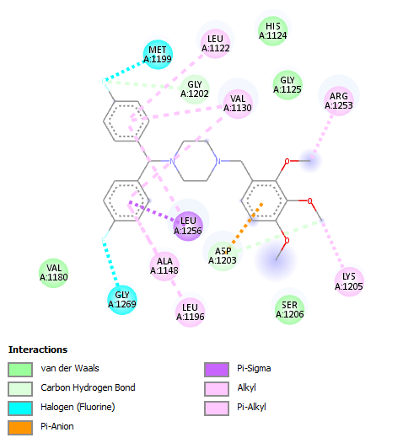
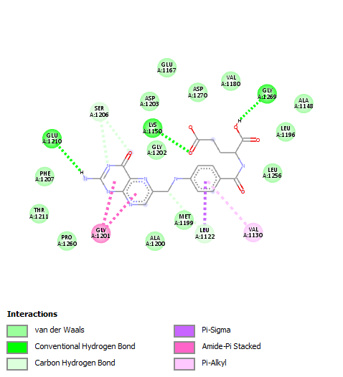
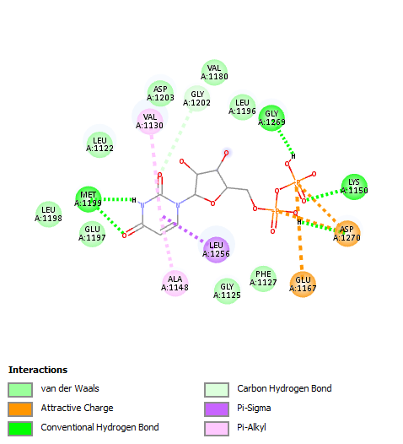
c.
b.
a.

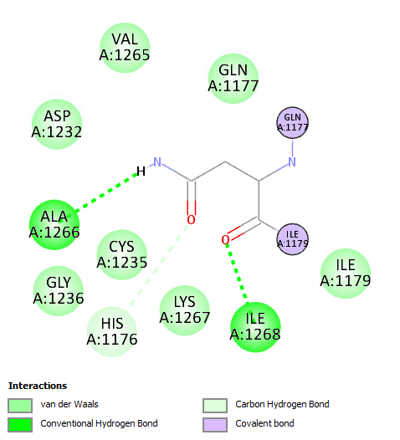
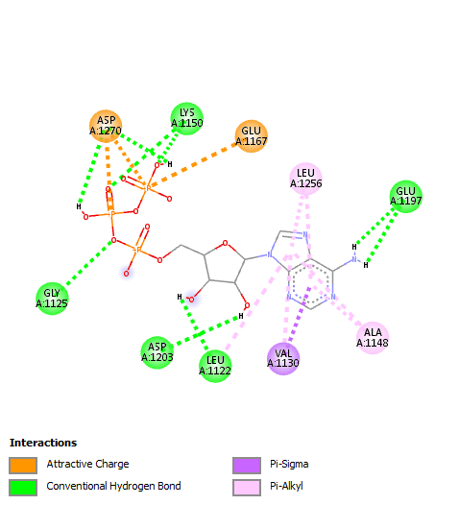
e.
d.

Figure 1: 2d view of the molecular interaction of the five compounds: (a) Uridine-5'-Diphosphate (b) (2S)-2-[[4-[(2-amino-4-oxo-1H-pteridin-6-yl)methylamino]benzoyl]amino]pentanedioic acid (c) Lomerizine (d) Adenosine Triphosphate (e) Adenosine-5'-diphosphate

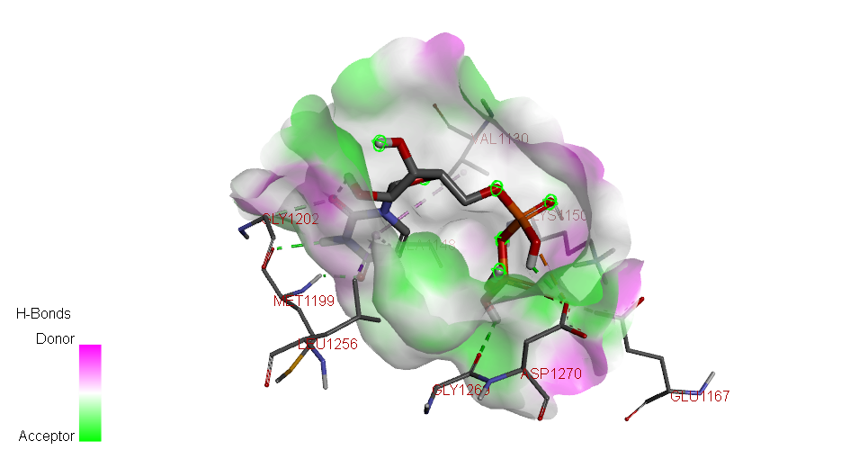
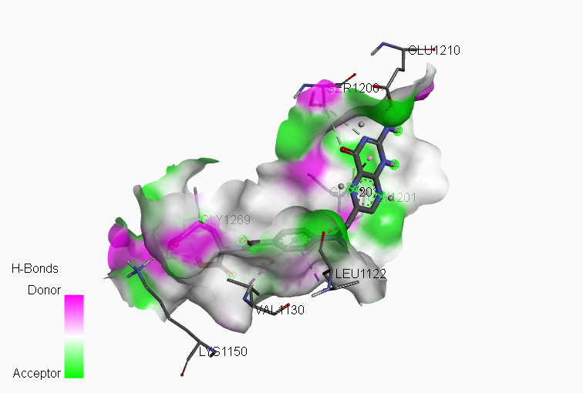
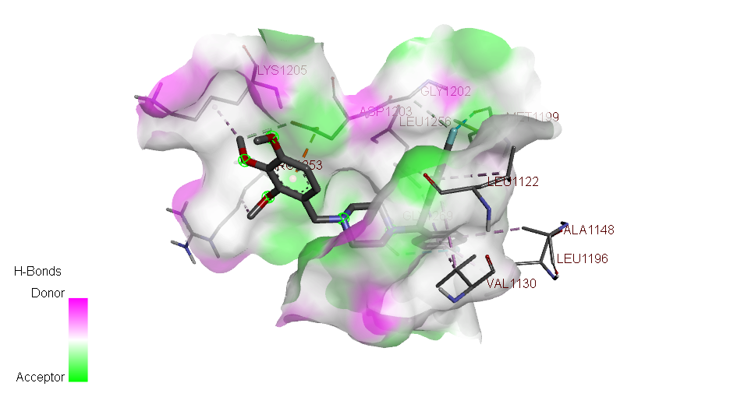
c.
b.
a.

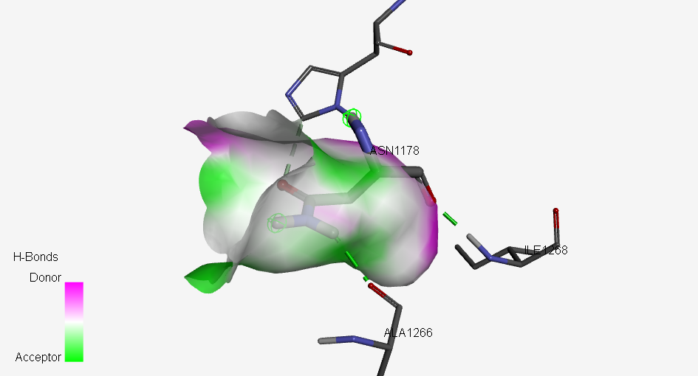
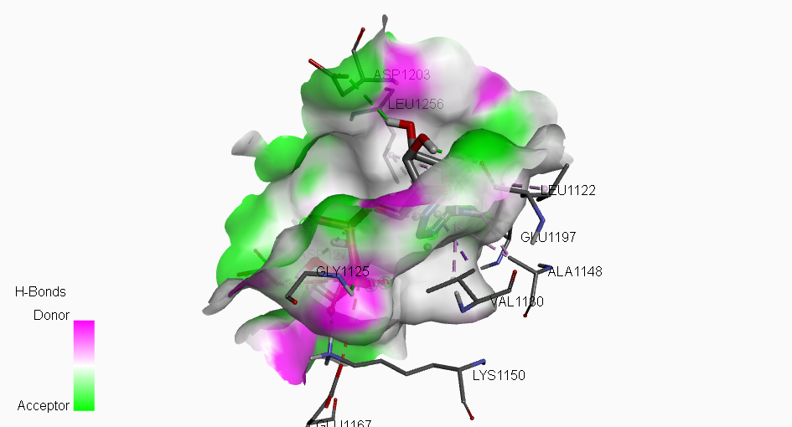
e.
d.

Figure 2: 3d view and amino-acid residue of the molecular interaction of the five compounds: (a) Uridine-5'-Diphosphate (b) (2S)-2-[[4-[(2-amino-4-oxo-1H-pteridin-6-yl)methylamino]benzoyl]amino]pentanedioic acid (c) Lomerizine (d) Adenosine Triphosphate (e) Adenosine-5'-diphosphate

TABLE 2: PROXIMATE COMPOSITION OF RAW AND FERMENTED FOOD
 |  |  |  | FERMENTED FOOD
SAMPLES | MOISTURE CONTENT  (%) | DRY MATTER  (%) | CRUDE FAT  (%) | TOTAL  ASH  (%) | CRUDE FIBRE  (%) | CRUDE  PROTEIN  (%) | TOTAL CARBOHYDRATE  (%)
GARRI | 0.72±0.02ª | 99.29±0.02e | 1.26±0.01^{b} | 2.88±0.03e | 5.75±0.04e | 3.14±0.03^{c} | 86.26±0.03e
FUFU | 73.10±0.03e | 26.90±0.03ª | 2.54±0.04^{c} | 0.54±0.02^{b} | 2.97±0.04^{b} | 1.45±0.02ª | 19.42±0.10^{c}
OGI | 50.34±0.02^{c} | 49.68±0.02^{c} | 1.11±0.04ª | 0.45±0.02ª | 2.29±0.03ª | 1.81±0.03^{b} | 44.03±0.13^{d}
IRU | 52.75±0.03^{d} | 47.25±0.03^{b} | 13.09±0.01^{d} | 2.05±0.02^{c} | 3.09±0.01^{c} | 18.94±0.02^{d} | 10.09±0.01ª
Mean values with different superscripts within the same column are significantly different (p <0.05)

TABLE 3: MINERAL COMPOSITION OF RAW AND FERMENTED FOOD
 |  | FERMENTED FOOD
SAMPLES | CALCIUM  (mg/100g) | MAGNESIUM  (mg/100g) | IRON  (mg/100g) |  | ZINC  (mg/100g)
GARRI | 14.87±0.00^{b} | 8.67±0.00ª | 3.06±0.00^{c} | 0.53±0.00^{c}
FUFU | 30.06±0.00^{c} | 26.14±0.00^{c} | 0.43±0.00^{b} | 0.31±0.00ª
OGI | 14.15±0.00ª | 10.41±0.00^{b} | 0.18±0.00ª | 0.40±0.00^{b}
IRU | 847.69±0.00e | 202.68±0.00^{d} | 17.32±0.00e | 5.31±0.00e
Mean values with different superscripts within the same column are significantly different (p <0.05)

4.0 DISCUSSION
Colorectal cancer (CRC) continues to pose a considerable challenge to global health. Despite progress in therapeutic strategies, various limitations remain evident. Current therapeutic modalities, including liver transplantation, surgical resection, local ablation, and systemic therapies sufluorouracilouracil demonstrate variable efficacy and are frequently associated with significant adverse effects. The financial implications linked to these treatments, along with the modest enhancement in survival rates, highlight the necessity for innovative therapeutic strategies that are not only more efficacious but also more accessible and better tolerated by patients (Oh et al., 2021). In this context, our research seeks to investigate the potential of gut microbiota metabolites as a supplementary therapeutic strategy that may mitigate some of these limitations by providing a natural, multitargeted approach with potentially reduced side effects. A number of studies have been undertaken to examine the potential of probiotics in inhibiting tumorigenesis and their effectiveness in mitigating the toxicity associated with cancer therapies (Xu et al., 2015). Given the numerous limitations inherent in current CRC treatment strategies, probiotics have emerged as potential therapeutic agents (Tripathy et al., 2021). It is widely recognized that they can engage with resident microflora, thereby leading to a range of host-microbe interactions. Moreover, these interactions facilitate the inactivation of carcinogens, modulation of apoptosis and cell differentiatiandition of the tyrosine kinase signaling pathway (Tripathy et al., 2021). In vitro studies have demonstrated that probiotic strains possess the ability to exert antimutagenic activity due to their structural peptidoglycans, secretory glycoproteins, and polysaccharides, as well as their production of anticarcinogenic compounds (Wilkins and Sequoia, 2017). For instance, the probiotic Lactobacillus casei has been identified as a producer of ferrichrome, a compound with anticarcinogenic properties that demonstrates tumor-suppressive effects (Tripathy et al., 2021).. This molecule promotes apoptosis in cancer cells via the c-Jun N-terminal kinase pathway (Sánchez-Alcoholado, 2020). Similarly, probiotics have the capacity to bind to mutagens, leading to biotransformation and detoxification processes. Furthermore, the induction of apoptosis can occur through the interference in various signaling pathways. A study indicates that Propionibacterium acidipropionici and Propionibacterium freudenreichii produce propionate and acetate, which are short-chain fatty acids that can induce cellular apoptosis in human colorectal cancer cell lines (Tripathy et al., 2021). The identified probiotic strains were observed to activate the caspase 3 enzyme, resulting in chromatin condensation, the formation of apoptotic nuclei bodies, and ultimately, the generation of reactive oxygen species (Tripathy et al., 2021). The secretion of acetate and propionate by Propionibacterium freudenreichii activates the mitochondrial apoptosis pathway, resulting in the death of human colorectal cancer cells (Tripathy et al., 2021). Additionally, the probiotic strains Pediococcus pentosaceus FP3, Enterococcus faecium, Lactobacillus salivarius FP25, and L. salivarius FP35 demonstrated antiproliferative effects against colorectal adenocarcinoma cells (Tripathy et al., 2021). Furthermore, the tyrosine kinase signaling pathway, which plays a crucial role in cellular differentiation and proliferation, may be inhibited by probiotics (Ambalam et al., 2016). The receptors present in tyrosine kinases may serve as targets for inhibitors, thereby representing a potential therapeutic approach for anti-CRC treatment (Ambalam et al., 2016). Moreover, probiotics may serve as therapeutic interventions to mitigate the side effects associated with anti-cancer treatments (Islam, S.U, 2016). Individuals receiving chemotherapy frequently experience diarrhea; research indicates that probiotics may mitigate the risk of this condition. The findings of a conducted study indicate that the administration of Lactobacillus rhamnosus GG is associated with a reduction in abdominal discomfort. Furthermore, research has demonstrated that probiotics are effective in the treatment of acute diarrhea (Islam, S.U, 2016). Numerous studies have demonstrated that probiotics can effectively reduce the incidence of antibiotic-associated bacteria (Islam, S.U, 2016). A meta-analysis involving 25 randomized trials conducted by McFarland demonstrated that probiotics can significantly reduce diarrhea associated with antibiotic use (Wilkins and Sequoia, 2017).
Furthermore, probiotics are considered to be effective in addressing Clostridium difficile associated diarrhea, ulcerative colitis, and hepatic encephalopathy; however, they are regarded as ineffective in the case of Crohn’s disease and acute pancreatitis. Additionally, their efficacy against diarrhea induced by viruses has been observed to be inconsistent (Wilkins and Sequoia, 2017). Furthermore, following surgical interventions, it is posited that probiotics may play a role in safeguarding the intestinal mucosal barrier in patients (Islam, S.U, 2016). Regrettably, there are specific regulatory challenges associated with the distribution of probiotics; since they are not classified as drugs, they fall outside the purview of regulation by the U.S. Food and Drug Administration (Ka´zmierczak-Siedlecka, 2020).

5.0 CONCLUTION
Given the prevalence of colorectal cancer and its associated high mortality rate, it is essential to comprehend the factors contributing to this disease. The modifications in the gut microbiome found in food diet significantly influence the progression and development of colorectal cancer (Cheng and Ning, 2019). Therefore, it is essential for individuals to sustain a balanced gut microbiome by adhering to a nutritious diet rich in fibers, as these fibers contain short-chain fatty acids (SCFAs) like butyrate, which is recognized for its antitumor properties ( Bishehsari et al., 2017). Nonetheless, alternative treatments including fecal microbiota transfer, postbiotics, and prebiotics have garnered significant interest among researchers, particularly given the diverse side effects associated with existing treatments. Nevertheless, additional research aimed at elucidating the efficacy of fecal microbiota transplantation is warranted. Furthermore, it is essential to comprehend the diverse microorganisms present in the gut microbiome and their role in colorectal cancer (CRC). Furthermore, additional research examining the metabolic interactions between cancer cells and the microbiome in which the tumor is developing is both necessary and warranted. In conclusion, as the significance of microorganisms becomes increasingly clear, additional research aimed at elucidating the mechanisms of action of each microorganism in carcinogenesis may be conducted.
ETHICAL APPROVAL AND CONSENT
It is not applicable.
DISCLAIMER (ARTIFICIAL INTELLIGENCE)
Author(s) hereby declarethat NO generative AI technologies such as Large Language Models (ChatGPT, COPILOT, etc) and text-to-image generators have been used during writing or editing of this manuscript.

COMPETING INTERESTS
Author has declared that he has no known competing financial interests or non-financial interests or personal relationships that could have appeared to influence the work reported in this paper.

REFERENCE:
- Ferlay J, Parkin DM, Steliarova-Foucher E. Estimates of cancer incidence and mortality in Europe in 2008. Eur J Cancer. 2010;46:765–781. doi: 10.1016/j.ejca.2009.12.014.
- Siegel, R.L.; Giaquinto, A.N.; Jemal, A. Cancer statistics, 2024. CA Cancer J. Clin. 2024, 74, 12–49.
- Siegel, R.L.; Wagle, N.S.; Cercek, A.; Smith, R.A.; Jemal, A. Colorectal cancer statistics, 2023. CA Cancer J. Clin. 2023, 73, 233–254.
- Weinberg, B.A.; Marshall, J.L. Colon Cancer in Young Adults: Trends and Their Implications. Curr. Oncol. Rep. 2019, 21, 3.
- Hossain, M.S.; Karuniawati, H.; Jairoun, A.A.; Urbi, Z.; Ooi, J.; John, A.; Lim, Y.C.; Kibria, K.M.K.; Mohiuddin, A.K.M.; Ming, L.C.; et al. Colorectal Cancer: A Review of Carcinogenesis, Global Epidemiology, Current Challenges, Risk Factors, Preventive and Treatment Strategies. Cancers 2022, 14, 1732.
- Yang, T., Li, X., Montazeri, Z., Little, J., Farrington, S. M., Ioannidis, J. P. A., et al. (2019). Gene-environment interactions and colorectal cancer risk: an umbrella review of systematic reviews and meta-analyses of observational studies. Int. J. Cancer 145, 2315–2329. doi: 10.1002/Ijc.32057
- Chen, E., Xu, X., and Liu, T. (2018). Hereditary nonpolyposis colorectal cancer and cancer syndromes: recent basic and clinical discoveries. J. Oncol. 2018, 1–11.doi: 10.1155/2018/3979135
- Saus, E., Iraola-Guzman, S., Willis, J. R., Brunet-Vega, A., and Gabaldon, T. (2019). Microbiome and colorectal cancer: roles in carcinogenesis and clinical potential. Mol. Aspects Med. 69, 93–106. doi: 10.1016/J.Mam.2019.05.001
- Jandhyala, S. M., Talukdar, R., Subramanyam, C., Vuyyuru, H., Sasikala, M., and Nageshwar Reddy, D. (2015). Role of the normal gut microbiota. World J. Gastroenterol. 21, 8787–8803. doi: 10.3748/Wjg.V21.I29.8787
- Louis, P., Hold, G. L., and Flint, H. J. (2014). The gut microbiota, bacterial metabolites and colorectal cancer. Nat. Rev. Microbiol. 12, 661–672. doi: 10.1038/Nrmicro3344
- O’keefe, S. J. (2016). Diet, microorganisms and their metabolites, and colon cancer. Nat. Rev. Gastroenterol. Hepatol. 13, 691–706. doi: 10.1038/Nrgastro.2016.165
- Khan, S., Moore, R. J., Stanley, D., and Chousalkar, K. K. (2020). The gut microbiota of laying hens and its manipulation with prebiotics and probiotics to enhance gut health and food safety. Appl. Environ. Microbiol. 86, E00600–00620. doi: 10.1128/Aem.00600-20
- Conlon, M. A., and Bird, A. R. (2014). The impact of diet and lifestyle on gut microbiota and human health. Nutrients 7, 17–44. doi: 10.3390/Nu7010017
- Wong, S. H., and Yu, J. (2019). Gut microbiota in colorectal cancer: mechanisms of action and clinical applications. Nat. Rev. Gastroenterol. Hepatol. 16, 690 704.doi: 10.1038/S41575-019-0209-8.
- George Kerry, R., Patra, J. K., Gouda, S., Park, Y., Shin, H. S., and Das, G. (2018). Benefaction of probiotics for human health: a review. J. Food Drug. Anal. 26, 927–939. doi: 10.1016/J.Jfda.2018.01.002
- Pinzi, L., and Rastelli, G. (2019). Molecular docking: shifting paradigms in drug discovery. Int. J. Mol. Sci. 20, 4331–4354. doi: 10.3390/Ijms20184331.
- Liang Cheng, Changlu Qi, Haixiu Yang, Minke Lu, Yiting Cai, Tongze Fu, Jialiang Ren, Qu Jin, Xue Zhang, gutMGene: a comprehensive database for target genes of gut microbes and microbial metabolites, Nucleic Acids Research, Volume 50, Issue D1, 7 January 2022, Pages D795–D800, https://doi.org/10.1093/nar/gkab786.
- A. Daina and V. Zoete, “A Boiled-Egg to Predict Gastrointestinal Absorption and Brain Penetration of Small Molecules,” ChemMedChem 11, no. 11 (2016): 1117–1121, https://doi.org/10.1002/cmdc.201600182.
- M. J. Keiser, B. L. Roth, B. N. Armbruster, P. Ernsberger, J.J.Irwin,andB.K.Shoichet,“RelatingProteinPharmacology by Ligand Chemistry,” Nature Biotechnology 25, no. 2 (2007):197–206, https://doi.org/10.1038/nbt1284.
- Trott O, Olson AJ. AutoDock Vina: improving the speed and accuracy of docking with a new scoring function, efficient optimization, and multithreading. J Comput Chem 2010 Jan 30;31(2):455–61. https://doi.org/10.1002/jcc.21334. PMID: 19499576; PMCID: PMC3041641
- S.Dallakyan and A.J.Olson,“Small-MoleculeLibraryScreening by Docking With PyRx,” Methods in Molecular Biology 1263 (2015): 243–250, https://doi.org/10.1007/978-1-4939-2269-7_19.
- H. Kemmish, M. Fasnacht, and L. Yan, “Fully Automated Antibody Structure Prediction Using BIOVIA Tools: Vali- dation Study,” PLoS One 12, no. 5 (2017): e0177923, https://doi.org/10.1371/journal.pone.0177923.
- Method Number Index', in Dr. George W Latimer, Jr. (ed.), Official Methods of Analysis of AOAC INTERNATIONAL, 22nd Edition (New York, 2023; online edn, AOAC Publications, 4 Jan. 2023), https://doi.org/, accessed 19 Apr. 2025.
- K.-K. Oh, M. Adnan, and D.-H. Cho, “Network Pharmacology-Based Study to Uncover Potential Pharma- cological Mechanisms of Korean Tistle (Cirsium Japonicum Var. Maackii (Maxim.) Matsum.) Flower Against Cancer,” Molecules 26, no. 19 (2021): 5904, https://doi.org/10.3390/ molecules26195904.
- Xu, M.-Q.; Cao, H.-L.; Wang, W.-Q.; Wang, S.; Cao, X.-C.; Yan, F.; Wang, B.-M. Fecal microbiota transplantation broadening its application beyond intestinal disorders. World J. Gastroenterol. 2015, 21, 102–111.
- Tripathy, A.; Dash, J.; Kancharla, S.; Kolli, P.; Mahajan, D.; Senapati, S.; Jena, M. Probiotics: A Promising Candidate for Management of Colorectal Cancer. Cancers 2021, 13, 3178.
- Wilkins, T.; Sequoia, J. Probiotics for gastrointestinal conditions: A summary of the evidence. Am. Fam. Physician 2017, 96, 170–178
- Sánchez-Alcoholado, L.; Ramos-Molina, B.; Otero, A.; Laborda-Illanes, A.; Ordóñez, R.; Medina, J.A.; Gómez-Millán, J.; Queipo Ortuño, M.I. The Role of the Gut Microbiome in Colorectal Cancer Development and Therapy Response. Cancers 2020, 12, 1406.
- Ambalam, P.; Raman, M.; Purama, R.K.; Doble, M. Probiotics, prebiotics and colorectal cancer prevention. Best Pr. Res. Clin. Gastroenterol. 2016, 30, 119–131.
- Islam, S.U. Clinical Uses of Probiotics. Medicine 2016, 95, e2658
- Wilkins, T.; Sequoia, J. Probiotics for gastrointestinal conditions: A summary of the evidence. Am. Fam. Physician 2017, 96, 170–178
- Ka´zmierczak-Siedlecka, K.; Daca, A.; Fic, M.; van de Wetering, T.; Folwarski, M.; Makarewicz, W. Therapeutic methods of gut microbiota modification in colorectal cancer management–fecal microbiota transplantation, prebiotics, probiotics, and synbiotics. Gut Microbes 2020, 11, 1518–1530.
- Cheng, M.; Ning, K. Stereotypes About Enterotype: The Old and New Ideas. Genom. Proteom. Bioinform. 2019, 17, 4–12.
- Bishehsari, F.; Magno, E.; Swanson, G.; Desai, V.; Voigt, R.M.; Forsyth, C.B.; Keshavarzian, A. Alcohol and gut-derived inflammation. Alcohol Res. Curr. Rev. 2017, 38, 163–171.

