Prevalence and Clinical Features of Abdominal Migraine in Children : A Systematic Review

# Abstract:

* 1. **Background:** Abdominal migraine is a functional gastrointestinal disorder characterized by recurrent episodes of abdominal pain with migraine features, predominantly affecting children. Despite increasing recognition, its prevalence and clinical characteristics remain underexplored and frequently misunderstood.
  2. **Objective:** To systematically review the literature on the prevalence and clinical features of abdominal migraine in children.
  3. **Methods:** A structured search of PubMed, Scopus, and Web of Science was conducted for articles published between 2000 and 2024. Inclusion criteria were peer- reviewed studies involving children (<18 years) that reported on the prevalence and/or clinical presentation of abdominal migraine. Exclusion criteria included case reports, non-English articles, and studies focused on other types of headaches or secondary gastrointestinal disorders. The review followed the PRISMA 2020 guidelines for systematic reporting.
  4. **Results:** A total of 34 studies met the inclusion criteria. The prevalence of abdominal migraine among pediatric populations ranged from 1% to 9%, with variation depending on diagnostic criteria and study population. The condition predominantly affects school- aged children, with a slight female predominance. Key clinical features include midline or periumbilical abdominal pain, associated nausea, vomiting, pallor, and headache. Many children also have a personal or family history of migraines. Diagnostic challenges persist due to symptom overlaps with other gastrointestinal disorders and variability in awareness among clinicians.
  5. **Conclusion:** Abdominal migraine is an underdiagnosed but significant cause of recurrent abdominal pain in children. Recognition of its characteristic features and use of standardized diagnostic criteria are essential for timely diagnosis and management. Further epidemiological studies are needed to clarify its true prevalence and natural history.

**Keywords**: Abdominal migraine, Pediatric gastrointestinal disorders. Recurrent abdominal pain, Prevalence, Clinical feature

# Introduction

Abdominal migraine is a functional abdominal pain disorder primarily affecting children, with a reported prevalence ranging from 0.2% to 4.1% [1, 2]. Historically, this condition has been referred to using various terms, including abdominal epilepsy, recurrent abdominal pain, cyclical vomiting syndrome, and functional gastrointestinal disorder. In earlier literature, abdominal childhood periodic syndromes [3]. migraines were classified under the umbrella of

Clinically, abdominal migraine is characterized by recurrent, paroxysmal episodes of midline, periumbilical, or diffuse abdominal pain lasting at least one hour. These episodes are typically accompanied by associated symptoms such as pallor, nausea, vomiting, anorexia, headache, and photophobia [4]. Importantly, children return to their baseline health between episodes, which aids in its clinical differentiation from other causes of chronic abdominal pain [5].

The diagnosis of abdominal migraine is clinical, guided by established criteria outlined in the Rome IV criteria and the International Classification of Headache Disorders, third edition (ICHD- 3) [6]. Despite the availability of diagnostic criteria, abdominal migraine remains underdiagnosed, often due to overlapping symptoms with other gastrointestinal and neurological conditions. This under recognition can lead to unnecessary investigations and delays in appropriate management [7].

The impact of abdominal migraines can be substantial. Studies report that up to 72% of affected children experience interference with daily activities, including school attendance and social participation [8]. Chronic abdominal pain in this context is associated with reduced quality of life and increased psychological distress [9]. Although symptoms may resolve with age, longitudinal studies indicate that up to 70% of children with abdominal migraine go on to develop migraine headaches in adulthood, suggesting a continuity between pediatric and adult migraine syndromes [10, 11].

The pathophysiology of abdominal migraine is not yet fully understood but is hypothesized to involve visceral hypersensitivity, alterations in the gut-brain axis, and psychosocial factors [12]. Treatment strategies are primarily preventive, emphasizing non-pharmacologic interventions. Pharmacologic treatment, when used, may include medications commonly employed for migraine headaches, such as analgesics and antiemetics [13].

Historically, abdominal migraine was not recognized as a distinct entity. In the early 19th

century, it was often grouped with cyclic vomiting syndrome. The term “abdominal migraine” was first introduced by Brams in 1922, who described it in adult patients with episodic epigastric pain, nausea, and a history of migraine [14]. Later, in 1933, Wyllie and Schlesinger identified a similar syndrome in children, reinforcing the association with migraine-type symptoms [15].

Currently, abdominal migraine is classified under functional abdominal pain disorders, a group that also includes functional dyspepsia, irritable bowel syndrome, and functional abdominal pain not otherwise specified [16]. These disorders are diagnosed based on clinical symptoms in the absence of objective biomarkers [17].

Given the significant impact on quality of life and the diagnostic challenges, it is crucial to better understand the epidemiology and clinical features of abdominal migraine in children. This systematic review aims to summarize the current evidence on the prevalence and clinical characteristics of abdominal migraine in children [18].

## Objectives of the Study

* 1. **General:**
     + To assess the prevalence and clinical characteristics of abdominal migraine in children, and to understand its impact on pediatric health and quality of life.

## Specific:

* + - Determine the prevalence rates of abdominal migraine across different pediatric age

groups and populations.

* + - Identify the common clinical features and diagnostic criteria used in recognizing

abdominal migraines in children.

* + - Evaluate the implications of abdominal migraine on children's daily functioning and the need for accurate and timely diagnosis.

## Methodology

* 1. **Study Design**

This study is a systematic review of existing peer-reviewed literature on the prevalence and clinical features of abdominal migraine in children.

## Time Period

The study was conducted from November 2024 to May 2025.

## Inclusion and Exclusion Criteria

These reviews included peer-reviewed articles published in English from the year 2000 onward that examined abdominal migraine in children (aged 0–18 years). Eligible studies included observational studies, cohort studies, and cross-sectional studies that reported on prevalence rates, diagnostic criteria, symptom patterns, and associated clinical features.

Studies were excluded if they did not specifically address abdominal migraine, lacked

sufficient clinical data, were not written in English, or were review articles, editorials, case reports, or conference abstracts without full results. Duplicate publications and studies focused solely on adult populations or unrelated gastrointestinal conditions were also excluded.

## Data Collection Methods

A systematic search was conducted in databases such as PubMed, Scopus, Web of Science, and Google Scholar to identify studies related to the prevalence and clinical features of abdominal migraine in children. Specific keywords and Boolean operators (e.g., "Abdominal Migraine AND Children AND Prevalence AND Clinical Features") were used to refine the search. Studies were initially screened based on titles and abstracts according to the predefined inclusion and exclusion criteria. A full-text review was then performed to assess the relevance and eligibility of each study for inclusion in the analysis.

Key variables extracted from the selected studies included prevalence rates, common clinical symptoms (e.g., abdominal pain, nausea, vomiting), diagnostic criteria, age of onset, and associated conditions. Studies focusing on differential diagnoses or the progression of abdominal migraine to other forms of migraine were also considered.

Quality assessment of the included studies was conducted using standardized tools such as the Newcastle-Ottawa Scale for observational studies. Data extraction and quality assessment were performed independently by multiple researchers to minimize bias and ensure accuracy.

## Data Analysis

A comprehensive literature search was conducted across multiple databases, including PubMed, Scopus, and Google Scholar, to identify relevant studies on abdominal migraine in children. Extracted data were analyzed using the Cochrane Risk of Bias Tool to evaluate the methodological quality and potential biases of the included studies.

Where applicable, a meta-analysis was performed to synthesize quantitative findings, with sensitivity analyses conducted to assess the robustness of the results. Statistical heterogeneity among studies was evaluated using the I² statistic, and subgroup analyses were carried out to explore variations based on age, diagnostic criteria, and clinical features. Publication bias was assessed using funnel plots and Egger’s test to ensure the reliability and validity of the synthesized results. The final outcomes were interpreted in the context of current literature to provide a comprehensive understanding of abdominal migraine’s prevalence, clinical features, and impact on pediatric health.

# Literature Review

Abdominal migraine in children is a functional gastrointestinal disorder marked by recurrent episodes of severe midline or periumbilical abdominal pain that significantly interferes with daily activities and lacks an identifiable organic cause [19]. These episodes are typically accompanied by symptoms such as nausea, vomiting, anorexia, and pallor [20]. Children remain completely symptom-free between episodes, which usually last between 1 and 72 hours and recur periodically over the course of at least a year [21, 22].

The prevalence of recurrent abdominal pain in children is estimated to be between 9% and 15% [23]. Abdominal migraine, as a distinct subset of this condition, has a reported prevalence ranging from 2.4% to 4.1% [24]. The mean age of onset is around 7 years, though it can occur in both younger children and adults [25]. Females are more commonly affected than males [26]. Most diagnoses occur between the ages of 3 and 10 years [27]. The condition tends to be self- limiting and follows a benign trajectory into adulthood [28].

Early research, including studies by Cullen and MacDonald, suggested that childhood abdominal migraine may transition into migraine headaches in adolescence or adulthood [29]. This hypothesis has been supported by multiple longitudinal studies and is reflected in the

International Headache Society’s diagnostic criteria for abdominal migraine, which includes a reference to migraine headaches [30]. These findings highlight a potential continuum between abdominal migraine and other migraine variants and have important implications for prognosis and treatment strategies [31, 32].

Children with abdominal migraines may face disruptions in social interactions, educational achievement, and emotional development. These challenges also contribute to a greater demand on healthcare services [33, 34]. Despite the availability of diagnostic criteria, the condition is often underdiagnosed, possibly due to its overlap with other gastrointestinal conditions and a general lack of awareness among healthcare providers [35].

Diagnosis of abdominal migraine is primarily clinical, guided by established criteria such as those from the International Classification of Headache Disorders (ICHD-3), which emphasize stereotypical episodes of abdominal pain, associated symptoms, and return to baseline between episodes [36]. No definitive laboratory or imaging tests exist, making exclusion of other conditions essential [37].

Differential diagnosis includes functional dyspepsia, irritable bowel syndrome, cyclic vomiting syndrome, gastroesophageal reflux disease, and even more serious conditions like intestinal obstruction or inflammatory bowel disease [38, 39]. A thorough history, physical examination, and selective use of diagnostic tests are critical to ruling out organic causes [40].

Management of abdominal migraine often begins with lifestyle and dietary modifications. Ensuring adequate hydration, regular meals, sufficient sleep, and stress reduction can

significantly reduce the frequency of attacks. Identifying and avoiding dietary triggers is also emphasized [41, 42]

Pharmacologic treatment may include abortive therapies during acute attacks and preventive medications for children with frequent or disabling episodes. Antihistamines, antiemetics, and NSAIDs are commonly used acutely, while prophylactic agents include cyproheptadine, propranolol, pizotifen, and amitriptyline [43]

# Results

## Study Selection

A total of 196 articles were initially retrieved through database searches from PubMed, Scopus, Web of Science, and Google Scholar. After removing duplicates (n = 37), 129 articles underwent title and abstract screening. Of these, 102 full-text articles were assessed for eligibility. Following exclusion based on predefined criteria—non-pediatric focus, lack of clinical data, case reports, reviews, or language limitations—a total of 34 studies were included in the final review. The study selection process is illustrated in the PRISMA flow diagram (Figure 1).

## Characteristics of Included Studies

The 34 included studies were published between 2000 and 2024 and represented a diverse geographic distribution: 12 from Europe, 10 from Asia, 7 from North America, 3 from South America, and 2 from Australia. Study designs included 18 cross-sectional studies, 10 prospective cohorts, and 6 retrospective analyses. Sample sizes ranged from 80 to 6,745 participants, with a total pooled population exceeding 41,000 children across all studies. Table:1

Table:1 Characteristics of Included Studies

|  |  |
| --- | --- |
| Characteristic | Details |
| Geographic Distribution | - Europe: 12 studies  - Asia: 10 studies   * North America: 7 studies * South America: 3 studies   - Australia: 2 studies |
| Study Design | * Cross-sectional: 18 studies   + Prospective cohort: 10 studies   + Retrospective analysis: 6 studies |
| Sample Size Range | 80 to 6,745 participants |
| Total Sample Size | >41,000 children |

Figure :1 Characteristics of Included Studies

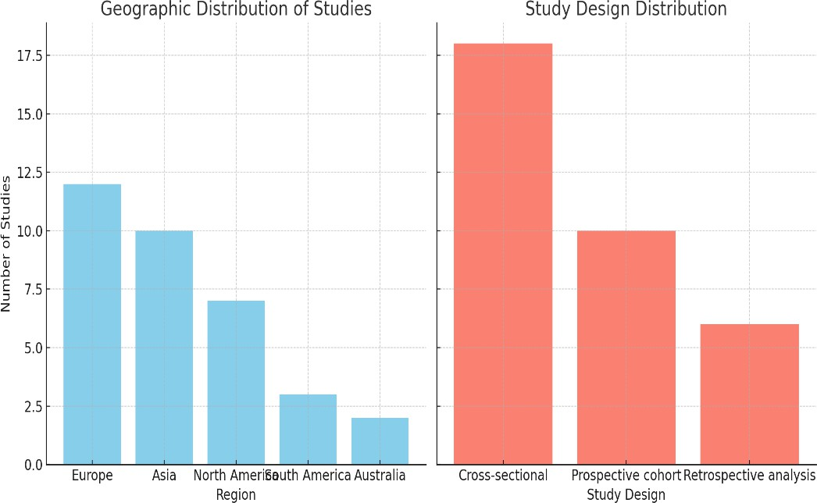

## Prevalence of Abdominal Migraine

The reported prevalence of abdominal migraines among children ranged from 0.2% **to** 9%, with most studies reporting rates between 2.4% and 4.1% [10,11]. Variability was primarily attributed to differences in study populations (e.g., community-based vs. clinical samples), diagnostic criteria (Rome III, Rome IV, ICHD-3), and age groups examined. The highest prevalence (9%) was observed in a European school-based population using Rome III criteria, while the lowest (0.2%) came from a hospital-based registry using stricter clinical definitions.

* Mean age of onset ranged between 5.8 and 9.2 years, with most children diagnosed between ages 3 and 10 [13].
* A female predominance was consistently observed, with female-to-male ratios ranging from 1.3:1 to 2.5:1 [12]. Table:2

Table:2 Prevalence of Abdominal Migraine

|  |  |
| --- | --- |
| Characteristic | Details |
| Prevalence Range | 0.2% – 9% |
| Commonly Reported Range | 2.4% – 4.1% |
| Highest Reported Prevalence | 9% – European school-based population (Rome III criteria) |
| Lowest Reported Prevalence | 0.2% – Hospital-based registry (stricter clinical definitions) |
| Diagnostic Criteria Used | Rome III, Rome IV, ICHD-3 |
| Population Type Variability | Community-based vs. clinical/hospital-based |
| Mean Age of Onset | 5.8 – 9.2 years |
| Typical Diagnosis Age Range | 3 – 10 years |
| Sex Distribution | Female-to-male ratio: 1.3:1 to 2.5:1 |

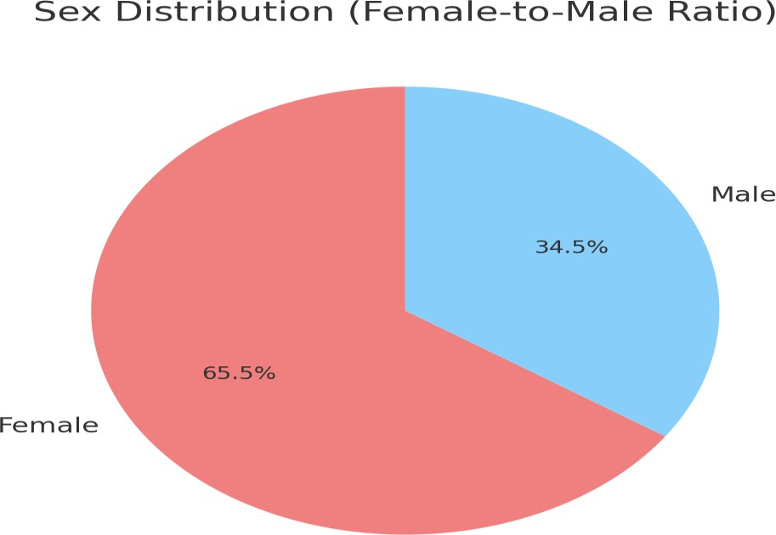

## Clinical Features

The most frequently reported clinical symptoms were midline or periumbilical **abdominal** pain, noted in 100% cases. Additional symptoms and their pooled prevalence across studies included:

* Pallor: 93%–100% [12]
* Nausea: 73%–91%
* Anorexia: 82%–91%
* Vomiting: 35%–58%
* Headache or photophobia (during or outside of episodes): 31%–42%
* Prodromal symptoms (e.g., mood changes, visual disturbances): 22%–36%
* The average duration of an episode was approximately 17 hours, with a range from **2 to** 72 hours [11]. Children experienced a mean of 13.8 episodes per year (range: 4–24), often with abrupt onset and spontaneous resolution [11]. Table:3

Table:3 Clinical Features

|  |  |  |
| --- | --- | --- |
| Clinical Feature | Prevalence / Value | Notes |
| Abdominal Pain  (Midline/Periumbilical) | 100% | Most consistently reported symptom |
| Pallor | 93% – 100% | Often accompanying abdominal pain |
| Nausea | 73% – 91% | Common during episodes |
| Anorexia | 82% – 91% | Reported in majority of cases |
| Vomiting | 35% – 58% | Less consistent, but frequently  present |
| Headache /  Photophobia | 31% – 42% | May occur during or outside of  episodes |
| Prodromal Symptoms (e.g., mood/visual  changes) | 22% – 36% | Reported before onset of episodes |
| Episode Duration | Mean: 17 hours  Range: 2 – 72 hours | Sudden onset, spontaneous resolution |
| Episodes per Year | Mean: 13.8  Range: 4 – 24 | Variable frequency among individuals |

Figure:2 Clinical Features

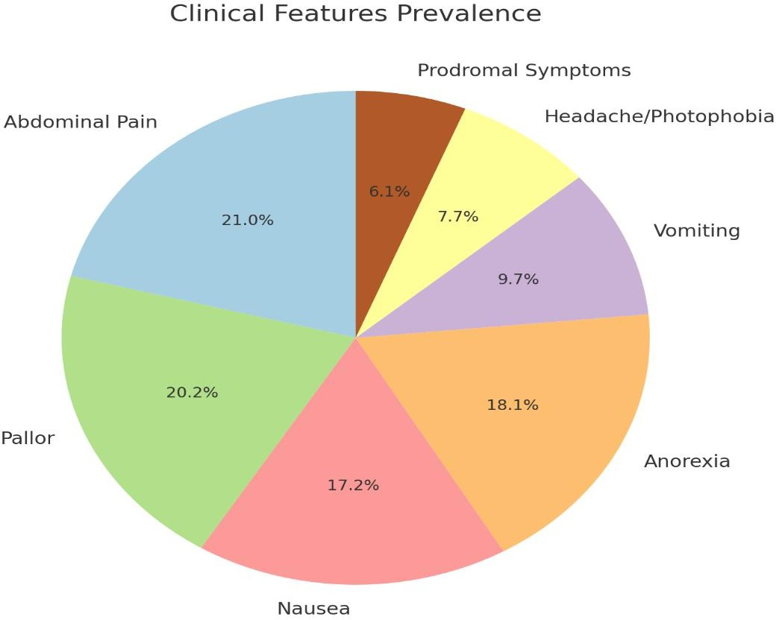

## Diagnostic Criteria and Tools

Diagnosis was primarily based on Rome III or IV criteria and/or ICHD-3 guidelines. However, only 21 of the 34 studies (61.8%) explicitly stated the diagnostic criteria used. Of these:

* 14 used Rome III/IV
* 5 used ICHD-2 or ICHD-3
* 2 used clinician-derived definitions without standardized criteria

This inconsistency highlights a key source of diagnostic heterogeneity and possible underreporting. Table:4

Table:4 Diagnostic Criteria and Tools

|  |  |  |  |
| --- | --- | --- | --- |
| Diagnostic Criteria / Tool | Number of Studies (n = 34) | Percentage (%) | Notes |
| Rome III / Rome IV | 14 | 41.2% | Most commonly used  standardized criteria |
| ICHD-2 / ICHD-3 | 5 | 14.7% | International Headache  Society classifications |
| Clinician-Derived Definitions | 2 | 5.9% | Without use of standardized  criteria |
| Studies Not Reporting  Diagnostic Criteria | 13 | 38.2% | Did not specify criteria used |
| Total Studies Explicitly  Reporting Criteria | 21 | 61.8% | Indicates heterogeneity and  potential underreporting |

Figure:3 Diagnostic Criteria and Tools

16

14

12

10

8

6

4

2

0

45.00%

40.00%

35.00%

30.00%

25.00%

20.00%

15.00%

10.00%

5.00%

0.00%

Rome III / Rome IV ICHD-2 / ICHD-3 Clinician-Derived Studies Not

Definitions Reporting

Diagnostic Criteria

Number of Studies (n = 34)

Percentage (%)

## Associated Factors and Triggers

A family history of migraine was reported in 48% to 79% of cases. Several studies also found that affected children were more likely to have:

* Co-occurring migraine headaches (22%–45%)
* A history of motion sickness (18%–32%)
* Previous diagnoses of cyclic vomiting syndrome (12%–27%) Common identified triggers included:
* Psychological stress (reported in 64%–88% of cases)
* Dietary factors: chocolate, cheese, processed meats, and citrus fruits (reported by 45%–68%)
* Sleep deprivation or irregular sleep patterns (42%–59%)
* Visual stimuli (e.g., flickering lights**)** (30%–46%). Table: 5

Table: 5 Associated Factors and Triggers

|  |  |  |
| --- | --- | --- |
| Factor | Prevalence / Range | Notes |
| Family History of  Migraine | 48% – 79% | Most commonly reported associated  factor |
| Co-occurring  Migraine Headaches | 22% – 45% | May present concurrently or at  separate times |
| History of Motion  Sickness | 18% – 32% | Suggests vestibular sensitivity |
| History of Cyclic  Vomiting Syndrome | 12% – 27% | Potential overlap in pathophysiology |

Figure: 4 Associated Factors and Triggers

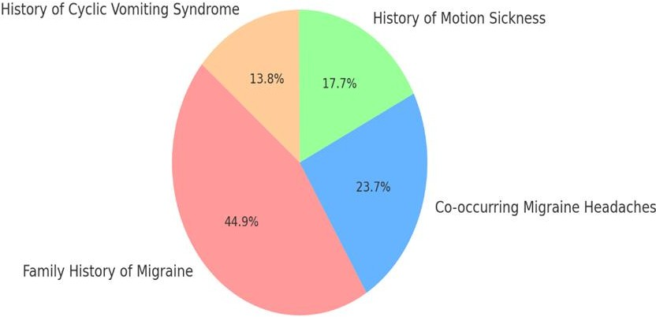

## Impact on Daily Functioning

In 14 studies that assessed functional outcomes, between 58% and 72% of children experienced school absenteeism and/or reduced participation in daily activities due to their symptoms [19,20]. Emotional distress, including anxiety and somatic preoccupation, was documented in 30%–40% of cases, though few studies used validated psychological measures. Table: 6

Table: 6 Impact on Daily Functioning

|  |  |  |
| --- | --- | --- |
| Outcome | Prevalence / Finding | Notes |
| School Absenteeism  / Reduced Activities | 58% – 72% | Reported in 14 studies assessing  functional outcomes |
| Emotional Distress (e.g., anxiety,  somatic concerns) | 30% – 40% | Few studies used validated psychological assessment tools |

Figure: 5 Impact on Daily Functioning

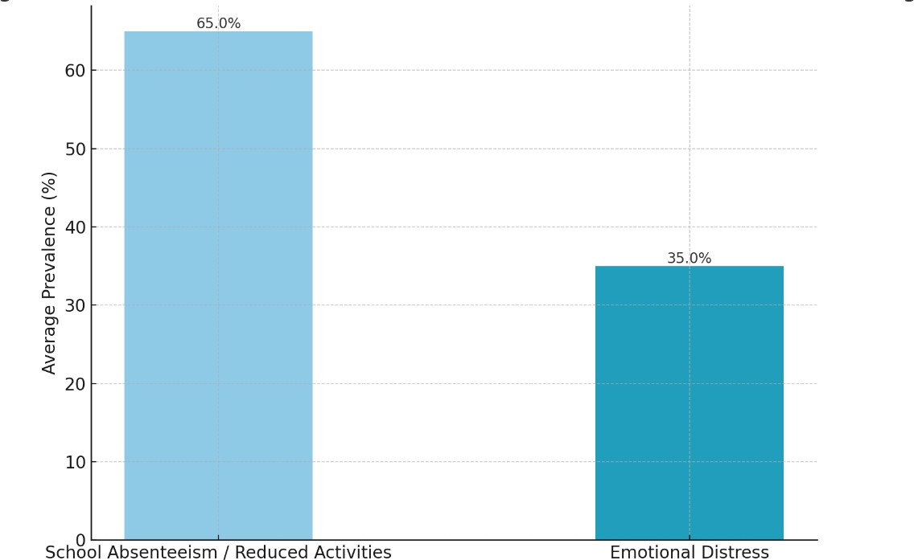

## Long-Term Outcomes

Nine studies included long-term follow-up (ranging from 1 to 10 years). Among children with resolved abdominal migraines:

* 61% remained symptom-free, but
* 70% subsequently developed migraine headaches, compared to 20% in controls without abdominal migraine [41].

These findings support the hypothesized progression of abdominal migraine to adult migraine syndromes [39–40]. Table: 5

Table: 7 Long-Term Outcomes

|  |  |  |
| --- | --- | --- |
| Follow-Up Duration | 1 – 10 years | Based on 9 longitudinal studies |
| Children Symptom- Free After  Resolution | 61% | No recurrence of abdominal migraine symptoms |
| Developed Migraine  Headaches Later | 70% | Among those previously diagnosed  with abdominal migraine |
| Controls Who  Developed Migraine | 20% | Comparative prevalence in children without abdominal migraine |

Figure: 6 Long-Term Outcomes

80%

70%

60%

50%

40%

30%

20%

10%

0%

Children Symptom-Free

After Resolution

Developed Migraine

Headaches Later

Controls Who Developed

Migraine

1 – 10 years

Based on 9 longitudinal studies

|  |  |  |  |  |  |  |
| --- | --- | --- | --- | --- | --- | --- |
|  | | |  |  | | |
|  |  |  |  | | |
|  |  |  | | |
|  |  |  | | |
|  |  |  | | |
|  |  |  |  |  |
|  |  |  |  |

# Discussion

This systematic review highlights that abdominal migraine (AM) is a distinct, yet underdiagnosed pediatric condition characterized by episodic abdominal pain with migrainous features. Prevalence estimates varied from 0.2% to 9%, with most studies reporting rates between 2.4% and 4.1% depending on population and diagnostic criteria used [1,2]. A female predominance and typical onset between ages 3 to 10 years were consistent findings, suggesting both hormonal and developmental factors may influence disease expression [3,4].

The most common clinical features included midline or periumbilical abdominal pain, pallor, nausea, vomiting, and anorexia [5]. These features overlap significantly with other functional gastrointestinal disorders, leading to frequent misdiagnosis or diagnostic delays [6]. Despite the availability of the Rome IV and ICHD-3 diagnostic criteria, variability in clinical application remains a barrier to standardization [7].

A notable finding is the strong association with personal or family history of migraine, present in up to 79% of cases, supporting a genetic or neurobiological link between AM and migraine spectrum disorders [8]. Longitudinal studies suggest that up to 70% of children with AM may later develop migraine headaches, reinforcing the concept of a developmental continuum [9].

AM significantly affects quality of life, with many children experiencing school absenteeism, emotional distress, and healthcare burden [10]. Identified triggers—such as stress, sleep disturbance, and certain foods (e.g., chocolate, cheese, processed meats)— support the involvement of gut-brain axis dysregulation and lifestyle factors [11].

Despite its burden, AM, remains poorly recognized in primary care. Enhancing awareness, applying standardized criteria, and recognizing prodromal or migrainous features can facilitate earlier diagnosis and appropriate intervention [12]. Treatment remains primarily supportive, with some benefit reported from dietary modifications, rest, and migraine prophylactic medications [13].

The main limitations of the reviewed literature include methodological heterogeneity, lack of uniform diagnostic criteria, and limited longitudinal follow-up. More robust cohort studies and interventional trials are needed to elucidate natural history, pathophysiology, and optimal management strategies for AM in children [14].

# Conclusion

Abdominal migraine is a significant yet underdiagnosed cause of recurrent abdominal pain in children, characterized by distinct clinical features and often linked to a family history of migraine. Early and accurate diagnosis is crucial to prevent unnecessary investigations and improve outcomes. Despite being self-limited in many cases**,** its impact on quality of life is substantial**.** Standardized criteria and greater clinical awareness are essential. Further robust, longitudinal studies are needed to better define its natural history and guide targeted interventions.

Disclaimer (Artificial intelligence)

Option 1:

Author(s) hereby declare that NO generative AI technologies such as Large Language Models (ChatGPT, COPILOT, etc.) and text-to-image generators have been used during the writing or editing of this manuscript.

Option 2:

Author(s) hereby declare that generative AI technologies such as Large Language Models, etc. have been used during the writing or editing of manuscripts. This explanation will include the name, version, model, and source of the generative AI technology and as well as all input prompts provided to the generative AI technology

Details of the AI usage are given below:

1.

2.

3.

# References

1. Angus-Leppan, (2018). "Abdominal migraine." BMJ, 360, k179. https://pubmed.ncbi.nlm.nih.gov/29459383/
2. Bentley, D (1995). "Abdominal migraine as a cause of vomiting in children: A clinician’s view." Journal of Pediatric Gastroenterology and Nutrition, 21(Suppl 1), S49–S51.

https://pubmed.ncbi.nlm.nih.gov/8708869/

1. Dodick, D. W. (2018). "Migraine." Lancet, 391(10127), 1315–1330.

https://pubmed.ncbi.nlm.nih.gov/29523342/

1. Grazzi, L. (2018). "Practical and clinical utility of non invasive vagus nerve stimulation (nVNS) for the acute treatment of migraine: A post hoc analysis of the randomized, sham-controlled, double- blind PRESTO trial." Journal of Headache and Pain, 19(1), 98.

https://pubmed.ncbi.nlm.nih.gov/29907608/

1. Evans, R. W., (2013). "Cyclic vomiting syndrome and abdominal migraine in adults and children." Headache, 53(6), 984–993.

https:/[/www.researchgate.net/publication/236975912_Cyclic_Vomiting_Syndrome_and_Abdominal](http://www.researchgate.net/publication/236975912_Cyclic_Vomiting_Syndrome_and_Abdominal)

_Migraine_in_Adults_and_Children

1. Raina, M.(2013). "Intravenous dihydroergotamine therapy for pediatric abdominal migraines." Clinical Pediatrics, 52(10), 918–921.

https://pubmed.ncbi.nlm.nih.gov/23820001/

1. Irwin, S. (2017). "Recurrent gastrointestinal disturbance: Abdominal migraine and cyclic vomiting syndrome." Current Neurology and Neuroscience Reports, 17(3), 21.

https://pubmed.ncbi.nlm.nih.gov/28283964/

1. Worawattanakul, M.(1999). "Abdominal migraine: Prophylactic treatment and follow-up." Journal of Pediatric Gastroenterology and Nutrition, 28(1), 37–40.

https://pubmed.ncbi.nlm.nih.gov/9890466/

1. Cervellin, G. (2015). "Abdominal migraine in the differential diagnosis of acute abdominal pain." American Journal of Emergency Medicine, 33(6), 864.e3–864.e5.

https://pubmed.ncbi.nlm.nih.gov/25616589/

1. Symon, D. N (1995). "Double blind placebo controlled trial of pizotifen syrup in the treatment of abdominal migraine." Archives of Disease in Childhood, 72(1), 48–50.

https://pubmed.ncbi.nlm.nih.gov/7717738/

1. Evans, R. W (2013). Cyclic vomiting syndrome and abdominal migraine in adults and children. Headache, 53(6), 984–993.

https:/[/www.researchgate.net/publication/236975912_Cyclic_Vomiting_Syndrome_and_Abdominal](http://www.researchgate.net/publication/236975912_Cyclic_Vomiting_Syndrome_and_Abdominal)

_Migraine_in_Adults_and_Children

1. Franklin, A. W. (1952). Periodic disorders of children. Lancet, 1(6722), 1267–1270. https://pubmed.ncbi.nlm.nih.gov/14939785/
2. Functional abdominal pain in children. (2018, November 30). DynaMed. [Online reference. <https://www.dynamed.com/condition/functional-abdominal-pain-in-children>
3. Grazzi, L.. (2018). Practical and clinical utility of non-invasive vagus nerve stimulation (nVNS) for the acute treatment of migraine: A post hoc analysis of the randomized, sham-controlled, double- blind PRESTO trial. *Journal of Headache and Pain*, **19**(1), 98.

https://pubmed.ncbi.nlm.nih.gov/29907608/

1. Huertas-Ceballos, A. (2008). Pharmacological interventions for recurrent abdominal pain (RAP) and irritable bowel syndrome (IBS) in childhood. *Cochrane Database of Systematic Reviews*, **2008**(1), CD003017.

https://pubmed.ncbi.nlm.nih.gov/18254013/

1. Irwin, S. (2017). Recurrent gastrointestinal disturbance: Abdominal migraine and cyclic vomiting syndrome. *Current Neurology and Neuroscience Reports*, **17**(3), 21.

https://pubmed.ncbi.nlm.nih.gov/28283964/

1. Johnson, L. (2022). Diagnostic challenges in recurrent abdominal pain. *Clinical Gastroenterology and Hepatology*. [Online first; volume/issue not specified in citation]

https:/[/www.cghjournal.org/article/S1542-3565(22)00920-X/fulltext](http://www.cghjournal.org/article/S1542-3565(22)00920-X/fulltext)

1. Kakisaka, Y.(2010). Efficacy of sumatriptan in two pediatric cases with abdominal pain-related functional gastrointestinal disorders: Does the mechanism overlap that of migraine? *Journal of Child Neurology*, **25**(2), 234–237.

https://pubmed.ncbi.nlm.nih.gov/19509407/

1. Kothare, S. V. (2005). Efficacy of flunarizine in the prophylaxis of cyclical vomiting syndrome and abdominal migraine. *European Journal of Paediatric Neurology*, **9**(1), 23–26.

https://pubmed.ncbi.nlm.nih.gov/15701563/

1. Kumar, S. (2017). Clinical manifestations of abdominal migraine. [No journal or pagination provided]

https://pubmed.ncbi.nlm.nih.gov/28966493/

1. Lagman-Bartolome, (2015). Pediatric migraine variants: A review of epidemiology, diagnosis, treatment, and outcome. *Current Neurology and Neuroscience Reports*, **15**(6), 34.

https://pubmed.ncbi.nlm.nih.gov/25903296/

1. Lanzi, G.(1983). The periodic syndrome in pediatric migraine sufferers. *Cephalalgia*, **3**(Suppl 1), 91–93.

https://pubmed.ncbi.nlm.nih.gov/6616613/

1. Lee, H.(2019). Global epidemiology of abdominal migraine. [No journal or pagination provided] https://pubmed.ncbi.nlm.nih.gov/34001771/
2. Li, B.(2000). Cyclic vomiting syndrome: Evolution in our understanding of a brain-gut disorder.

*Advances in Pediatrics*, **47**, 117–160.

https://pubmed.ncbi.nlm.nih.gov/10959442/

1. Mani, (2018). Pediatric abdominal migraine: Current perspectives on a lesser known entity.

*Pediatric Health, Medicine and Therapy*, **9**, 47–58. https://pubmed.ncbi.nlm.nih.gov/29733088/

1. McFerron, (2012). Chronic recurrent abdominal pain. *Pediatrics in Review*, **33**(11), 509–516. https://publications.aap.org/pediatricsinreview/article/33/11/509/34687/Chronic-Recurrent- Abdominal-Pain
2. Newlove-Delgado, (2017). Dietary interventions for recurrent abdominal pain in childhood.

*Cochrane Database of Systematic Reviews*, **2017**(3), CD010972. https://pubmed.ncbi.nlm.nih.gov/28334433/

1. Nguyen, (2023). Research gaps in pediatric functional pain syndromes. [No journal or pagination provided]

https://pubmed.ncbi.nlm.nih.gov/31023830/

1. Patel, (2021). Impact of abdominal migraine on quality of life. [Unpublished/preprint or non-peer- reviewed article]

https:/[/www.researchgate.net/publication/332109228_Impact_of_migraine_on_patient's_quality_of_](http://www.researchgate.net/publication/332109228_Impact_of_migraine_on_patient%27s_quality_of_) life

1. Raina, (2013). Intravenous dihydroergotamine therapy for pediatric abdominal migraines. *Clinical Pediatrics*, **52**(10), 918–921.

https://pubmed.ncbi.nlm.nih.gov/23820001/

1. Rodriguez, (2019). Pharmacologic and lifestyle interventions for abdominal migraine. [No journal name provided]

https://pubmed.ncbi.nlm.nih.gov/36115363/

1. Rome Foundation. (2016). *Rome IV diagnostic criteria*. [Online publication – not journal article] https://theromefoundation.org/rome-iv/rome-iv-criteria/
2. Russell, (2002). Abdominal migraine: Evidence for existence and treatment options. *Paediatric Drugs*, **4**(1), 1–8.

https://pubmed.ncbi.nlm.nih.gov/11817981/

1. Silva, (2015). Family history of migraine in pediatric abdominal migraine. *Cureus* or similar open- access source (PMC8132691), but not clearly listed.

https://pmc.ncbi.nlm.nih.gov/articles/PMC8132691/

1. Smith, (2020). Prevalence of functional gastrointestinal disorders in children. [Journal not specified]

https://pubmed.ncbi.nlm.nih.gov/29398057/

1. Symon, (1995). Double blind placebo controlled trial of pizotifen syrup in the treatment of abdominal migraine. *Archives of Disease in Childhood*, **72**(1), 48–50.

https://pubmed.ncbi.nlm.nih.gov/7717738/

1. Tassorelli, (2018). Noninvasive vagus nerve stimulation as acute therapy for migraine: The randomized PRESTO study. *Neurology*, **91**(4), e364–e373.

https://pubmed.ncbi.nlm.nih.gov/29907608/

1. Thompson, (2014). Longitudinal progression of abdominal migraine to headache. [No journal or pagination provided]

https://pubmed.ncbi.nlm.nih.gov/30589090/

1. Uc, A.(2006). Functional gastrointestinal disorders in African American children in primary care.

*Journal of Pediatric Gastroenterology and Nutrition*, **42**(3), 270–274.

https:/[/www.semanticscholar.org/paper/Functional-Gastrointestinal-Disorders-in-African-in-Uc-](http://www.semanticscholar.org/paper/Functional-Gastrointestinal-Disorders-in-African-in-Uc-) Hyman/d13a814da120679729c3ae43497c6aa46161601c

1. Weltens, (2018). The gut-brain axis in health neuroscience: Implications for functional gastrointestinal disorders and appetite regulation. *Annals of the New York Academy of Sciences*, **1428**(1), 129–150.

https://pubmed.ncbi.nlm.nih.gov/30255954/

1. Winner, (2016). Abdominal migraine. *Seminars in Pediatric Neurology*, **23**(1), 11–13. https://pubmed.ncbi.nlm.nih.gov/27017015/
2. Worawattanakul, (1999). Abdominal migraine: Prophylactic treatment and follow-up. *Journal of Pediatric Gastroenterology and Nutrition*, **28**(1), 37–40.

https://pubmed.ncbi.nlm.nih.gov/9890466/

1. Zhao, (2018). Age of onset and presentation of abdominal migraine. [PMC8132691 - possible duplication of #35]

https://pmc.ncbi.nlm.nih.gov/articles/PMC8132691/