**Modelling the Effects of Vaccination and Incubation on Covid-19 Transmission Dynamics**

# ABSTRACT

The Severe Acute Respiratory Syndrome Coronavirus 2 (SARS-COV-2) is a strain of Coronavirus that causes Coronavirus Disease 2019 (COVID-19). The respiratory illness responsible for the COVID19 pandemic began in December 2019 in Wuhan city, China. Mathematical modeling has enabled the epidemiologist to understand the dynamics of the disease, its impact and future predictions in order to provide the governments with the best policies and strategies to curb the spread of the virus. Deterministic susceptible-vaccinated-asymptomatic-infectious-recovered (SVAIR) model was formulated incorporated with time delay. The delay accounts for the time lapsed between exposure and infectious period. Furthermore, time delay and vaccination inversely affects the basic reproduction number hence play a major role in stabilizing the rate of infection. In this study delay differential equations (DDE) were formulated for the purposes of determining the stability of both disease free equilibrium (DFE) and endemic equilibrium point (EEP). It was found out that the model was stable at both Disease Free Equilibrium (DFE) and Endemic Equilibrium Point (EEP) and was attained whenever $R_{0}<1$ and $R_{0}>1$ respectively. Calculations based on secondary data from various works of literature and the WHO dashboard was used. The basic reproduction number ($R_{0}$) was computed using the next generation matrix (NGM) approach. Finally, numerical simulations were carried out using MATLAB for validation of the analytical results. Graphical representation shows that stability is achieved when $τ>5 days$ and that $R_{0}=0.95$ at DFE. Furthermore at EEP it was noted that $R_{0}=1.02$ hence stability was guaranteed.

**Keywords:** COVID-19, Reproduction number, Delay differential equations, Stability, Disease free equilibrium

**INTRODUCTION**

The devastating Severe Acute Respiratory Syndrome Coronavirus 2 (SARS-COV-2) is a strain of Coronavirus that causes Coronavirus Disease 2019 (COVID-19). The respiratory illness responsible for the COVID-19 pandemic which began in December 2019 (WHO, 2020) in Wuhan City, China and spread to many countries in the world (Shen *et al*., 2020). Kenya reported its first case of COVID-19 in March 2020. This resulted in the restriction of movement by the government, which included the closure of all learning institutions (McCloskey *et al.,* 2020)

As of 18th April 2022, COVID-19 had spread to every country in the world, resulting in 500,186,525 confirmed cases of infection and 6,190,349 deaths globally, according to the WHO's pandemic declaration from March 2020 (WHO, 2020). The number of COVID-19 cases reported to WHO by selected countries as at April 2022 include ; USA had 79,716,960 confirmed cases and 2,711,776 deaths, United Kingdom had reported 21,715,120 confirmed cases and 979,321 deaths, Africa had reported cumulative of 8,676,141 confirmed cases and 171,350 deaths and Kenya had reported 323,588 confirmed cases and 5649 deaths, (Shen *et al*., 2020).

Over time, it became evident that the Kenyan government's non-pharmaceutical mitigation measures to curb the spread of COVID-19 were not effective. Use of face masks, keeping of social distance, routine hand washing, isolation of suspected cases and contact tracing were a few examples of such intervention measures. Because of the rapid spread of COVID-19 globally, vaccination has been identified as the best containment strategy by several countries. The WHO approved COVID-19 vaccines where Kenya used different types of vaccines such as Astra Zeneca, Modena, Pfizer and Johnson and Johnson. In this study, an SVAIR mathematical model was formulated using delay differential equations (DDE) in which delay is incorporated to ascertain for the incubation period in the COVID-19 transmission dynamics.

**Review of Related Literature**

The novel coronavirus identified as Severe Acute Respiratory Syndrome Coronavirus 2 (SARS-COV-2) is a strain of Coronavirus that causes Coronavirus Disease 2019. This disease was named by the World Health Organization (WHO) as Coronavirus Disease 2019 (COVID-19) (WHO, 2020). WHO declared COVID-19 a pandemic in March 2020.

Musa *et al*., (2022), studied the infection fatality rate and infection rate of COVID-19 in Nigeria using a susceptible-exposed-infectious-recovered (SEIR) based model with a time-varying transmission rate controlled by systems of delayed differential equations (DDEs). They discovered that the awareness campaigns, in particular the use of non-pharmaceutical measures in mitigating the spread of COVID-19 were effective during the earliest period of infection.

Xu *et al*., 2021, in their study found out that in the absence of vaccines, early detection, isolation and treatment were then the most efficient intervention measures. The study only concentrated on non-pharmaceutical approaches for containing and lessening the pandemic impact in the absence of reliable vaccines or antivirals. These mitigation measures were temporary, since over time, the general populace has a tendency to loosen them, which would accelerate the spread of COVID-19. This study did not consider how the COVID-19 incubation period affected the isolated and confined patients.

Wangari *et al*., (2021), studied the mathematical modeling of COVID-19 transmission in Kenya, a model with a re-infection transmission mechanism. They found out that a large pool of infectious people who were asymptomatic would eventually increase symptomatic people with mild and severe symptoms, which may eventually increase the overall number of reported deaths. The model used deterministic ordinary differential equations (ODEs) for computation of basic reproduction number. Unfortunately, the model did not take into account the incubation period during asymptomatic period but it called for further research on the problems presented by asymptomatic patients in connection with reinfection.

Aldila *et al*., (2020), in their study, they considered the undiscovered asymptomatic individuals who actively contributed to the transmission of COVID-19 despite having no symptoms. The study also demonstrated that the inadequate healthcare resources contributed to the spread of COVID-19 virus. SVEIAHR mathematical model were developed, sensitivity analysis was used to determine how the model parameters affected the spread of the disease. The study found out that although it was necessary to reduce the basic reproductive number below one in order to stop the spread of infection, it was not sufficient because several additional intervention measures were required.

Lemaitre *et al*., (2020), in their study, they investigated the effects of non-pharmaceutical strategies, according to their studies, there was a significant amount of virus transmission through contaminated surfaces, depending on the nature of the virus. This study expressed concern over the fact that public awareness of COVID-19 was one of the major challenge in curbing the spread of COVID-19. Many people choose not to follow the safety precautions already in place including wearing face masks, regularly sanitizing, avoiding crowded areas and maintaining social distance. The mathematical model did not considered vaccination as the mitigation measure against the spread of COVID-19.

Shattock *et al.,* (2022), studied the mathematical model based on ordinary differential equations (ODEs). Their study subdivided the total population into; susceptible, vaccinated, infectious, asymptomatic and recovered (SVIAR). Their study showed that vaccinations could assist to reduce transmission rates, but they also stated that during the COVID-19 pandemic, proper waste management was essential. In addition, it did not state how the asymptomatic individuals affect the transmission dynamic of COVID-19 and the time delay.

The above studies did not consider the use of delay differential equations (DDEs) in modeling the transmission dynamics of COVID-19. This study formulated a mathematical model incorporating DDEs for the transmission dynamics of COVID-19 in Kenya in which incubation period is considered.

**Methodology**

**Introduction**

In epidemiology, the basic reproduction number of an infection is the mean number of new infections arising from a single infectious person introduced into a purely susceptible population during infectious period. The basic reproduction number $R_{0}$ is the threshold for many epidemiological models. When $R_{0}$ > 1 the disease-free equilibrium point is unstable, the infection will be able to spread in a population and locally stable for $R_{0}$ ˂ 1, the infection dies out in the long run.

To obtain $R_{0}$ the dominant eigenvalue of the next generation matrix is considered such that $R_{0}=ρFV^{-1}$. Where $ρ$ is the spectral radius of the next generation matrix. Matrix $F_{i}$ represents the rate of new infection entering compartment $i$, and matrix $V_{i}$ represents the rate of transfer into and out of compartment $i$ by other means. Since we are dealing with large population, compartmental mathematical model is used. The total population is subdivided into compartments each representing a specific stage of epidemic. The Susceptible-Vaccinated- Asymptomatic- Infected- Recovered (SVAIR) mathematical models are utilized to study and analyze the COVID-19 transmission dynamics.

**Methods of solution**

The stability of the model has been determined using the Jacobian matrix which is a system of partial derivative of equations for checking the stability of Disease Free Equilibrium (DFE) and numerical simulation was done using MATLAB to validate the analytic results.



Fig 1: SVAIR Model Flow Diagram

**Model equations**

$$\left.\begin{aligned}\frac{dS(t)}{dt}=p-ωS-β_{1}SI_{τ}- β_{2}SI_{τ}-γ_{1}S \\ \frac{dV(t)}{dt}=ωS-ε_{1}V_{τ}I_{τ}- ε_{2}V_{τ}I_{τ}-ε_{3}V_{τ}I_{τ}-γ_{2}V \\ \frac{dA(t)}{dt}=β_{2}SI_{τ}+ε_{2}V_{τ}I_{τ}-δ_{1}A_{τ}-δ_{2}A_{τ}-γ_{3}A \\ \frac{dI(t)}{dt}=β_{1}SI_{τ}+ε_{1}V_{τ}I_{τ}+δ_{1}A_{τ}-αI_{τ}-\left(γ_{4}+μ\right)I \\ \frac{dR(t)}{dt}=αI_{τ}+δ_{2}A_{τ}+ε_{3}V_{τ}I_{τ}-γ_{5}R \end{aligned}\right\} 3.2$$

**3.4 Model Preliminary Analysis**

**3.4.1 Positivity and Boundedness of the model**

Positivity and boundedness of the model is shown before doing result analysis for model equation 3.2 to be epidemiologically meaningful. Thus, we show that all state variables of the model equation (3.2) are nonnegative for all time $t>0$ and bounded and the existence of solutions are underscored by these properties.

Let C = C [- $τ,0$], $R^{5}$ be a Banach space of continuous functions mapping the interval [- $τ,0$] into $R^{5}$ with the topology of uniform convergence. By fundamental theory of differential equations, it can be shown that there exists a unique solution (S(t), V(t), A(t), I(t), R(t)) of the model equation 3.2 with initial data

$$\left(S\left(0\right)>0,V\left(0\right)>0,A\left(0\right)>0,I\left(0\right)>0,R\left(0\right)>0∈C\right) (3.3)$$

In addition, we assume that the initial data for the model equation 3.2 satisfies;

$$S_{0}\left(p\right)≥0, V_{0}\left(p\right)≥0,A_{0}\left(p\right)≥0,I_{0}\left(p\right)≥0 ,R_{0}\left(p\right)≥0 , ∈ \left[-τ,0\right] (3.4)$$

The following theorem establishes the positivity and boundedness of the solution with initial functions satisfying (3.3) and (3.4)

**Theorem 3.1**

Let (SVAIR) be the solution of the model equation 3.2 satisfying the condition 3.3 and 3.4. then S,V,A,I and R are all positive and bounded for all $t>0$ at which the solution exist.

**Proof**

From the equation 3.2 we have

$S\left(t\right)=S\left(0\right)e^{-\int_{0}^{t}{\left(ω+β_{1}I_{τ}+β_{2}I_{τ}+γ_{1}\right)}}dθ+\int_{0}^{t}{\left(p+\left(ω+β_{1}I_{τ}+β_{2}I_{τ}+γ_{1}\right)\right)}S\left(φ\right)e^{\int_{0}^{t}{\left(ω+β_{1}I_{τ}+β_{2}I_{τ}+γ_{1}\right)dθ}}dφ$

$(3.5)$

From 3.5 it is clearly seen that $S\left(t\right)>0$ hence positive. Similarly, it can be shown that

$V\left(t\right)>0, A\left(t\right)>0, I\left(t\right)>0, R\left(t\right)>0 (3.6)$

Using equation 3.3 and 3.4, positivity follows immediately from the above integral forms.

For boundedness we define

$$N\left(t\right)=S\left(t\right)+V\left(t\right)+A\left(t\right)+I\left(t\right)+R\left(t\right) (3.7)$$

$$\frac{dN(t)}{dt}=\frac{d(S\left(t\right)+V\left(t\right)+A\left(t\right)+I\left(t\right)+R\left(t\right))}{dt} (3.8)$$

$$\frac{dN\left(t\right)}{dt}=p-γ\left(S\left(t\right)+V\left(t\right)+A\left(t\right)+I\left(t\right)+R\left(t\right)\right) (3.9)$$

Thus $\frac{dN(t)}{dt}≤p-Σ$ (3.10)

Where $Σ=γS+γV+γA+γI+γR$ (3.11)

This implies that $N\left(t\right)$ is bounded and so are

$S\left(t\right)+V\left(t\right)+A\left(t\right)+I\left(t\right)+R\left(t\right)$. This complete the proof of theorem 3.1

**Computation of Basic Reproduction Number $R_{0}$**

Infections produced by a single infectious individual during the course of their infectious period are known as the basic reproduction number. $R_{0}$ is the threshold value for infectious disease models because when $R_{0}<1$, the disease dies off, indicating that the disease free equilibrium state (DFE) is stable and when $R_{0}>1$, the DFE is unstable, meaning that the disease spread throughout the population.

In this study we adopted the next generation matrix (NGM) approach in computation of $R_{0}$ such that $R_{0}=ρFV^{-1}$ where $ρ$ is the spectral radius for NGM while $F$ is the matrix of new infection by the disease and $V$ is the matrix of transfer of infection in and out of the compartment by other means. The dominant eigenvalue of the NGM is considered as $R_{0}$. In the model equation 3.2, there are two infectious classes; A and I hence at disease free equilibrium, the matrix of new infection is given by matrix F and V.

Matrix $F_{i}$ is obtained by considering the rate of new infections entering the compartment $i$ is given by;

$F_{i}=\left[\begin{aligned}β_{2}SI_{τ} +ε_{2}V_{τ}I_{τ} \\ β_{1}S I_{τ}+ε_{1}V_{τ}I_{τ}+δ_{1}A_{τ}\end{aligned}\right] (3.12)$

The matrix that represents the rate of transfer into and out of compartment by other means at DFE is given by;

$$V_{i}=\left[\begin{aligned}δ_{1}A_{τ}+{δ_{2}A}_{τ}+γ_{3}A \\ αI_{τ}+(γ_{4}+μ)I\end{aligned}\right] (3.13)$$

We then differentiate $F_{i}$ partially with respect to the state variables to obtain a $2×2$ matrix

$F_{i}=\left[\begin{matrix}0 & (ε_{2}V_{τ}+β_{2}S )e^{-λ_{τ}} \\ {δ_{1}e}^{-λ_{τ}} & (ε_{1}V_{τ}+β_{1}S)e^{-λ_{τ}}\end{matrix}\right] (3.14)$

Similarly, differentiating matrix $V_{i}$ partially with respect to the state variables, we obtain a $2×2$ matrix,

$V_{i}=\left[\begin{matrix}(δ_{1}+δ_{2})e^{-λ_{τ}}+γ_{3} & 0 \\ 0 & αe^{-λ_{τ}}+(γ_{4}+μ)\end{matrix}\right]$ (3.15)

The inverse of V is computed as

$V^{-1}=\left[\begin{matrix}\frac{1}{(δ_{1}+δ_{2})e^{-λ_{τ}}+γ_{3}} & 0 \\ 0 & \frac{1}{αe^{-λ_{τ}}+(γ_{4}+μ)}\end{matrix}\right]$ (3.16)

Using the next generation matrix (NGM) to determine the basic reproduction number $R_{0}$

$$NGM=FV^{-1}=\left[\begin{matrix}0 & \frac{\left(ε_{2}V_{τ}+β_{2}S \right)e^{-λ_{τ}}}{αe^{-λ_{τ}}+(γ_{4}+μ)} \\ \frac{δ_{1}e^{-λ_{τ}}}{(δ_{1}+δ_{2})e^{-λ_{τ}}+γ_{3}} & \frac{\left(ε_{1}V_{τ}+β_{1}S\right)e^{-λ_{τ}}}{αe^{-λ_{τ}}+(γ_{4}+μ)}\end{matrix}\right]$$

$(3.17)$

The eigenvalues of matrix $(3.17)$ are computed by $\left|J-Iλ\right|=0$, where $J$ is the matrix $FV^{-1}$ and $I$ is $2×2$ identity matrix.

$\left|\begin{matrix}0-λ & \frac{(ε_{2}V_{τ}+β_{2}S )e^{-λ_{τ}}}{αe^{-λ_{τ}}+(γ_{4}+μ)} \\ \frac{δ_{1}e^{-λ_{τ}}}{(δ_{1}+δ_{2})e^{-λ_{τ}}+γ_{3}} & \frac{\left(ε_{1}V_{τ}+β_{1}S\right)e^{-λ_{τ}}}{αe^{-λ_{τ}}+(γ_{4}+μ)}-λ\end{matrix}\right|$ (3.18)

Solving for the eigenvalues we obtain;

$\left.\begin{aligned}\begin{aligned}λ_{*1}=0 \\ \\ { λ}_{*2}=\frac{(ε_{1}V_{τ}+β_{1}S)e^{-λ_{τ}}}{αe^{-λ_{τ}}+(γ_{4}+μ)} \end{aligned} \\ \end{aligned}\right\}$ (3.19)

The dominant eigenvalue is;

$λ_{*2}= \frac{(ε_{1}V_{τ}+β_{1}S)e^{-λ_{τ}}}{αe^{-λ_{τ}}+(γ_{4}+μ)}$ (3.20)

Therefore, ${R_{0} }_{(model 3.2)}=λ_{*2}= \frac{(ε_{1}V_{τ}+β_{1}S)e^{-λ_{τ}}}{αe^{-λ_{τ}}+(γ_{4}+μ)}$ (3.21)

**Local stability of Disease Free Equilibrium**

Mathematical epidemiology considers two equilibria points; Disease Free Equilibrium Point (DFE) where $R_{0}<1$ and Endemic Equilibrium Point (EEP) where $R_{0}>1$. DFE occurs in absence of the disease while EEP occurs in presence of a disease. A system is stable if all the eigenvalues of the linearized matrix about a fixed point have negative real parts. The dominant eigenvalue of the Jacobian matrix obtained during disease DFE yield the basic reproduction number $R_{0}$ which determine the stability of the disease. DFE is an equilibrium point described when the rate of change is equal to zero. It is evaluated by equating the system of delay differential equations (3.2) to zero. The Jacobian matrix is obtained from the first partial derivative of the model equations 3.2 in which the DFE is locally asymptotically stable if $R_{0}<1$, otherwise unstable. To obtain the Jacobian matrix we differentiate equation (3.22) with respect to state variables at DFE.

$$\left.\begin{aligned}p-ωS-β_{1}SI_{τ}- β_{2}SI_{τ}-γ_{1}S=0 \\ ωS-ε_{1}V_{τ}I_{τ}- ε_{2}V_{τ}I_{τ}-ε_{3}V_{τ}I_{τ}-γ_{2}V=0 \\ β_{2}SI_{τ}+ε_{2}V_{τ}I_{τ}-δ_{1}A_{τ}-δ_{2}A_{τ}-γ_{3}A=0 \\ β_{1}SI_{τ}+ε_{1}V_{τ}I_{τ}+δ_{1}A_{τ}-αI_{τ}- \left(γ_{4}+μ\right)I=0 \\ αI_{τ}+δ_{2}A_{τ}+ε_{3}V_{τ}I_{τ}-γ_{5}R=0 \end{aligned}\right\} (3.22)$$

The linearization matrix is given by;

$$\left[\begin{matrix}-\left(ω+β_{1}I_{τ}+β_{2}I_{τ}+γ_{1}\right) & 0 & 0 & 0 & 0 \\ ω & -\left(ε_{1}+ε_{2}+ε_{3}\right){I_{τ}e}^{-λ_{τ}}-γ_{2} & 0 & -\left(ε_{1}+ε_{2}+ε_{3}\right){v_{τ}e}^{-λ_{τ}} & 0 \\ β_{2}I_{τ} & ε_{2}I_{τ}e^{-λ_{τ}} & -\left(δ_{1}+δ_{2}\right)e^{-λ_{τ}}-γ_{3} & (β_{2}S+ε_{2}V_{τ})e^{-λ_{τ}} & 0 \\ β_{1}I_{τ} & ε_{1}I_{τ}e^{-λ_{τ}} & δ_{1}e^{-λ_{τ}} & -\left(α-β_{1}s-ε_{1}v_{τ}\right)e^{-λ_{τ}}-(γ_{4}+μ) & 0 \\ 0 & ε_{3}I_{τ}e^{-λ_{τ}} & δ_{2}e^{-λ_{τ}} & \left(α+ε_{3}v_{τ}\right)e^{-λ_{τ}} & -γ_{5}\end{matrix}\right]$$

$(3.23)$

The equation 3.2 is locally asymptotically stable if all the eigenvalues of the linearization matrix of the equation 3.2 are negative. The eigenvalues are:

$λ_{**1}=-\left(ω+β_{1}I_{τ}+β_{2}I_{τ}+γ_{1}\right)$

$λ_{**2}=-\left(ε_{1}+ε_{2}+ε_{3}\right){I_{τ}e}^{-λ_{τ}}-γ_{2}$

$λ_{**3}=-\left(δ_{1}+δ_{2}\right)e^{-λ_{τ}}-γ_{3}$

$λ_{**4}=-\left(α-β_{1}s-ε_{1}v_{τ}\right)e^{-λ_{τ}}-(γ_{4}+μ)$

$λ_{**5}=-γ_{5}$ (3.24)

For the model 3.2, it is clear that the dominant eigenvalue is;

$λ_{**4}=-\left(α-β_{1}s-ε_{1}v_{τ}\right)e^{-λ_{τ}}-(γ_{4}+μ)$ (3.25)

**Theorem 3.2**

Disease free equilibrium is stable whenever $R_{0}<1$, otherwise it’s unstable.

**Proof**

$λ_{**4}$ should be negative. This can only be negative if,

$$-\left(α-β_{1}s-ε_{1}v_{τ}\right)e^{-λ_{τ}}-\left(γ_{4}+μ\right)=0$$

Which simplifies to

$\left(β_{1}s+ε_{1}v_{τ}\right)e^{-λ_{τ}}<αe^{-λ_{τ}}+\left(γ_{4}+μ\right)$ (3.26)

This implies that;

$R_{0}=$ $\frac{\left(β_{1}s+ε_{1}v_{τ}\right)e^{-λ_{τ}}}{αe^{-λ_{τ}}+\left(γ_{4}+μ\right) }<1$ (3.27)

Therefore $R_{0}<1$ is obtained for DFE to be stable.

**Numerical Analysis and Results**

This section comprises of parameter values obtained from literature and graphs obtained using Matlab. (Table 4.1)

Table 1:Table of parameters, parameter description, values and source

|  |  |  |  |
| --- | --- | --- | --- |
| Parameter | Description | Value | Source |
| $$S$$ | Susceptible class | $5.036×{10}^{7}$ ${years}^{-1}$ | Estimated from (Muchiri *et al*., 2022) |
| $$V$$ | Coronavirus disease vaccinated class | $$0$$ | (Carpio *et al*., 2021) |
| $$A$$ | Asymptomatic infected class | $7322$ ${years}^{-1}$ | (Carpio *et al*., 2021) |
| $$I$$ | Symptomatic infected class | $7545$ ${years}^{-1}$ | Estimated from (Muchiri *et al*., 2022) |
| $$R$$ | Recovered class | $203968$ ${years}^{-1}$ | Estimated from (Muchiri *et al*., 2022) |
| $$p$$ | Recruitment rate | $$1762 {days}^{-1}$$ | Estimated from (Muchiri *et al*., 2022) |
| $$ω$$ | Rate of progression from S to V | $$0.002 {days}^{-1}$$ | Assumed |
| $$β_{1}$$ | Transition rate from susceptible to infectious class | $$0.233 {days}^{-1}$$ | (Chae *et al*., 2020) |
| $$β_{2}$$ | Transition rate from susceptible to asymptomatic class | $0.09786$ ${days}^{-1}$ | (Algarni *et al*., 2022) |
| $$ε_{1}$$ | Rate of progression from V to I | $0.462$ ${days}^{-1}$ | Chae *et al*., 2020 |
| $$ε_{2}$$ | Rate of progression from V to A | $0.039$ ${days}^{-1}$ | (Li *et al.*, 2020) |
| $$\frac{1}{ε_{3}}$$ | Immunity development period | $$0.0714 {days}^{-1}$$ | (Algarni *et al*., 2022) |
| $$δ_{1}$$ | Rate of progression from A to I | $$0.1428 {days}^{-1}$$ | (Algarni *et al*., 2022) |
| $$δ_{2}$$ | Rate of progress from A to R | $$0.165 {days}^{-1}$$ | (Buonomo *et al*., 2022) |
| $$α$$ | Rate of progression from I to R | $$0.1 {days}^{-1}$$ | (Algarni *et al*., 2022) |
| $$γ$$ | Natural death rate | $$1.07×{10}^{-2} {years}^{-1}$$ | (Buonomo *et al*., 2022) |
| $$μ$$ | Disease induced death rate | $$6.248×{10}^{-4} {days}^{-1}$$ | (Buonomo *et al*., 2022) |
| $$τ$$ | Time delay | To be determined |  |

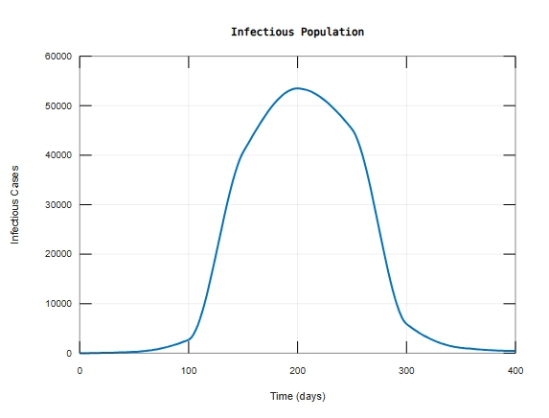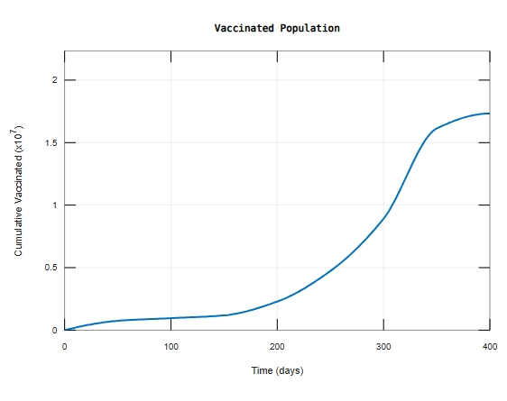

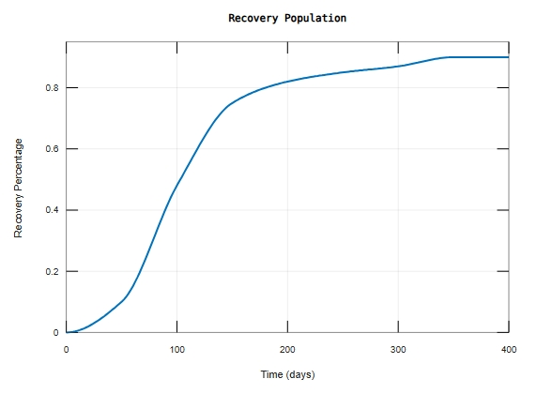

**Figure 2:** A plot of SVAIR model population against time

Figure 2 shows the dynamics of population of various compartments against time in days. From the graph, it is evident that nearly the entire population were susceptible from the onset and as the infections number increases, the number of susceptible individual drastically decreases to about 20 percent because vaccination, treatment and time delay played a major role in stabilizing the rate of infection. Increasing vaccination coverage means immunity of the susceptible individual is improved hence the infectious period delayed and therefore the basic reproduction number is lowered, minimizing the rate of infection.

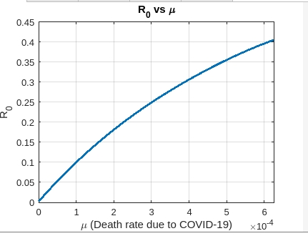

**Figure 3:** A plot of $R_{0}$ against Death rate due to COVID-19 ($μ$)

Figure 3 shows that the reproduction number $R_{0}$ is directly proportion to the rate of death due to COVID-19 ($μ$) unless intervention measures like vaccination is rolled out which increases the latent period hence $R_{0}$ is lowered resulting in reduced death rate.

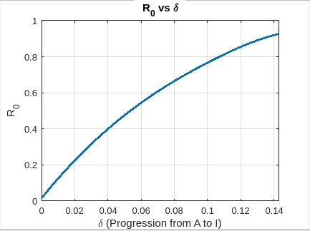

**Figure 4:** A plot of $R_{0}$ at EEP against Delta ($δ$)

Figure 4 shows a plot of reproduction number against the rate of progression from asymptomatic (A) to infectious (I). It is evident that $R_{0}$ is directly proportional to the rate of progression $δ$. A shorter asymptomatic infectious period potentially increases the value of $R_{0}$ hence higher rate of progression from A to I.

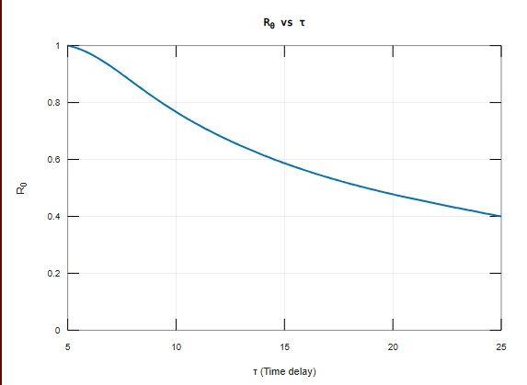

**Figure5:** A plot of $R_{0}$ against Time delay ($τ$)

Figure 5 shows a plot of reproduction number against time delay at DFE. From the graph $R_{0}$ is inversely proportional to time delay $τ$. A shorter $τ$ leads to a higher $R_{0}$, therefore highly contagious variants spread faster before intervention measures can take effect.

**Conclusion**

It was found out that the model was stable at both Disease Free Equilibrium (DFE) and Endemic Equilibrium Point (EEP) and was attained when $R_{0}<1$ and $R_{0}>1$ respectively. Parameter values were taken from the literature, and the analytical findings were verified numerically using the Matlab dde 23 solver. This was affected by vaccination, time delay and the rate of progression from asymptomatic class to infectious compartment. From the study it is evident that for time delay $τ>5 days$, DFE is stable otherwise unstable. Numerical simulation was carried out to validate the analytic results where it was found out that $R_{0}=0.95$ at DFE. Furthermore the results show that stability was guaranteed at EEP and is attained at $R_{0}=1.02$. Time delay, rate of vaccination and rate of progression from asymptomatic to infectious plays an important role in the transmission of COVID-19 and stability at DFE and EEP.

**Suggestions for Further Research**

This study has not exhausted all about COVID-19 transmission dynamics. Further studies can be done on COVID-19 vaccine efficacy. The model can be extended to include co-infection between COVID-19 and TB or any other underlying conditions. Further studies can be done on the effects of partially and fully vaccinated individuals on COVID-19 transmission dynamics.

Disclaimer (Artificial intelligence)

Option 1:

Author(s) hereby declare that NO generative AI technologies such as Large Language Models (ChatGPT, COPILOT, etc.) and text-to-image generators have been used during the writing or editing of this manuscript.

Option 2:

Author(s) hereby declare that generative AI technologies such as Large Language Models, etc. have been used during the writing or editing of manuscripts. This explanation will include the name, version, model, and source of the generative AI technology and as well as all input prompts provided to the generative AI technology

Details of the AI usage are given below:

1.

2.

3.

# References

Aldila, D., Khoshnaw, S. H. A., Safitri, E., Anwar, Y. R., Bakry, A. R. Q., Samiadji, B. M., Anugerah, D. A., Gh, M. F. A., Ayulani, I. D., & Salim, S. N. (2020). A mathematical study on the spread of COVID-19 considering social distancing and rapid assessment: The case of Jakarta, Indonesia. *Chaos, Solitons & Fractals*, *139*, 110042. https://doi.org/10.1016/j.chaos.2020.110042

Algarni, A. D., Ben Hamed, A., Hamdi, M., Elmannai, H., & Meshoul, S. (2022). Mathematical COVID-19 model with vaccination: A case study in Saudi Arabia. *PeerJ Computer Science*, *8*, e959. https://doi.org/10.7717/peerj-cs.959

Buonomo, B., Della Marca, R., d’Onofrio, A., & Groppi, M. (2022). A behavioural modelling approach to assess the impact of COVID-19 vaccine hesitancy. *Journal of Theoretical Biology*, *534*, 110973. https://doi.org/10.1016/j.jtbi.2021.110973

Carpio, C. E., Sarasty, O., Hudson, D., Macharia, A., & Shibia, M. (2021). The demand for a COVID-19 vaccine in Kenya. *Human Vaccines & Immunotherapeutics*, *17*(10), 3463–3471. https://doi.org/10.1080/21645515.2021.1938494

Chae, S. Y., Lee, K., Lee, H. M., Jung, N., Le, Q. A., Mafwele, B. J., Lee, T. H., Kim, D. H., & Lee, J. W. (2020). Estimation of Infection Rate and Predictions of Disease Spreading Based on Initial Individuals Infected With COVID-19. *Frontiers in Physics*, *8*, 311. https://doi.org/10.3389/fphy.2020.00311

Diagne, M. L., Rwezaura, H., Tchoumi, S. Y., & Tchuenche, J. M. (2021). A Mathematical Model of COVID-19 with Vaccination and Treatment. *Computational and Mathematical Methods in Medicine*, *2021*, 1–16. https://doi.org/10.1155/2021/1250129

Diekmann, O., Heesterbeek, J. A. P., & Roberts, M. G. (2010). The construction of next-generation matrices for compartmental epidemic models. *Journal of The Royal Society Interface*, *7*(47), 873–885. https://doi.org/10.1098/rsif.2009.0386

Lemaitre, J. C., Perez-Saez, J., Azman, A. S., Rinaldo, A., & Fellay, J. (n.d.). *Assessing the impact of non-pharmaceutical interventions on SARS-CoV-2 transmission in Switzerland*.

Li, Q., Tang, B., Bragazzi, N. L., Xiao, Y., & Wu, J. (2020). Modeling the impact of mass influenza vaccination and public health interventions on COVID-19 epidemics with limited detection capability. *Mathematical Biosciences*, *325*, 108378. https://doi.org/10.1016/j.mbs.2020.108378

McCloskey, B., & Heymann, D. L. (2020). SARS to novel coronavirus – old lessons and new lessons. *Epidemiology and Infection*, *148*, e22. https://doi.org/10.1017/S0950268820000254

Muchiri, S. K., Muthee, R., Kiarie, H., Sitienei, J., Agweyu, A., Atkinson, P. M., Edson Utazi, C., Tatem, A. J., & Alegana, V. A. (2022). Unmet need for COVID-19 vaccination coverage in Kenya. *Vaccine*, *40*(13), 2011–2019. https://doi.org/10.1016/j.vaccine.2022.02.035

Musa, S. S., Tariq, A., Yuan, L., Haozhen, W., & He, D. (2022). Infection fatality rate and infection attack rate of COVID-19 in South American countries. *Infectious Diseases of Poverty*, *11*(1), 40. https://doi.org/10.1186/s40249-022-00961-5

Shampine, L. F., & Thompson, S. (n.d.). *Solving Delay Diﬀerential Equations with*.

Shattock, A. J., Le Rutte, E. A., Dünner, R. P., Sen, S., Kelly, S. L., Chitnis, N., & Penny, M. A. (2022). Impact of vaccination and non-pharmaceutical interventions on SARS-CoV-2 dynamics in Switzerland. *Epidemics*, *38*, 100535. https://doi.org/10.1016/j.epidem.2021.100535

Shen, M., Peng, Z., Xiao, Y., & Zhang, L. (2020a). Modeling the Epidemic Trend of the 2019 Novel Coronavirus Outbreak in China. *The Innovation*, *1*(3), 100048. https://doi.org/10.1016/j.xinn.2020.100048

Wangari, I. M., Sewe, S., Kimathi, G., Wainaina, M., Kitetu, V., & Kaluki, W. (2021). Mathematical Modelling of COVID-19 Transmission in Kenya: A Model with Reinfection Transmission Mechanism. *Computational and Mathematical Methods in Medicine*, *2021*, 1–18. https://doi.org/10.1155/2021/5384481

WHO, 2020. (n.d.). *WHO REPORT Coronavirus disease 2019 (COVID-19) Situation Report – 54*. national authorities by 10 AM CET 14 March 2020.

Xu, S., Liu, P., Mei, S., Lv, Q., Cheng, C., Lu, Y., Kong, D., Wu, X., Wen, Y., Cao, B., Gao, S., Xiong, H., Zhao, J., Huang, Y., Luo, Y., & Feng, T. (2021). Analysis of the comprehensive non-pharmaceutical interventions and measures in containing the COVID-19 epidemic in Shenzhen: A retrospective study. *BMJ Open*, *11*(7), e044940. https://doi.org/10.1136/bmjopen-2020-044940