**Original Research Article**

**Numerical Analysis of Unsteady Boundary Layer Flow Over an Impulsively Started Sheet Using the Crank-Nicolson Method**

.

ABSTRACT

|  |
| --- |
| Fluid flow over moving surfaces creates complex flow patterns and thermal gradients, making analytical solutions computationally inefficient. Therefore, numerical methods that are stable, accurate, and capable of handling complex nonlinear problems are used. In this study, the Crank-Nicolson numerical technique was applied to investigate the combined effects of variable viscosity and viscous dissipation on unsteady flow over an impulsively moving flat sheet in a quiescent fluid. A two-dimensional laminar boundary layer flow of an incompressible Newtonian fluid, driven by the movement of the surface, with viscosity considered an inverse function of temperature, was analyzed. The effects of various flow parameters on velocity and temperature profiles were determined. The boundary layer partial differential equations governing the flow were transformed into a non-dimensional form and solved numerically. The numerical results demonstrate that an increase in Reynolds number, the variable viscosity parameter, and surface velocity leads to an increase in velocity profiles. Additionally, an increase in Prandtl number, the variable viscosity parameter, and surface velocity results in a decrease in temperature profiles. Finally, an increase in Eckert number was found to increase temperature profiles. Therefore, with suitable flow parameters, the velocity and temperature of the fluid can be regulated. These findings are useful for cooling hot sheets or metallic plates drawn over a quiescent fluid to obtain high-quality final products, as well as in hot rolling during metal processing and in the lubrication of sliding or rotating bearings. |

*Keywords: Impulsively moving sheet, Viscous dissipation, Variable viscosity parameter, Crank-Nicolson technique, Quiescent fluid, Boundary layer*

1. INTRODUCTION

Fluid flow over a moving sheet is a fundamental problem in fluid dynamics, with significant implications for a variety of industrial processes and engineering applications. Understanding the behavior of fluid flow in such scenarios is crucial for optimizing processes like extrusion, film production, wire drawing, and cooling of continuous strips or filaments [1-5]. These processes often involve the movement of a solid surface through a quiescent fluid, where the interaction between the moving sheet and the surrounding fluid creates complex flow patterns and thermal gradients.

In a quiescent fluid, the absence of initial fluid motion means that any movement imparted by the sheet is the primary driver of flow. This impulsive motion creates a time-dependent boundary layer that evolves rapidly as the fluid adjacent to the sheet accelerates. The study of unsteady fluid flow past an impulsively moving sheet is essential for understanding the transient phenomena that occur in various engineering applications, such as in the sudden startup of machinery, the initiation of extrusion processes, or the abrupt movement of mechanical components in a fluid environment [6-11]. The mathematical modeling of unsteady boundary layer flow involves solving coupled time-dependent boundary layer equations using appropriate boundary conditions that reflect the movement of the sheet and the initial quiescent state of the fluid. Analytical solutions for these boundary layer equations are computationally inefficient; therefore, numerical methods that are stable, accurate, and capable of handling complex nonlinear problems are used.

Several mathematical models for boundary layer flow over a moving surface have been formulated, considering various aspects. For instance, Jan et al. [12] studied the boundary layer flow of a viscous fluid over a moving cylinder in a quiescent fluid. The results of their study revealed that an increase in the Prandtl number increases the rate of heat transfer. Additionally, it was observed that an increase in curvature enhances both the thermal and momentum boundary layers. Nawaz et al. [13] conducted a study on two-dimensional laminar boundary layer flow over a moving plate in a quiescent fluid by introducing an exponential time integrator scheme for solving the governing partial differential equations. Their results indicated that an increase in the Prandtl number decreases the momentum boundary layer. Behera et al. [14] investigated the effects of plate movement on heat transfer characteristics in both the solid plate and the fluid domain due to wall jet flow over the plate in a quiescent surrounding. Their results indicated a higher cooling rate at increased plate velocity. Additionally, their findings showed that better heat transfer is achieved at a higher Reynold’s number. Razzaq and Farooq [15] conducted a study on boundary layer flow over a flat heated surface, considering the non-similar aspect of forced convection. Their results indicated that the convective heat transfer coefficient increases with an increasing Prandtl number.

Most studies on boundary layer fluid flow are based on the assumption of negligible viscous dissipation effects. However, viscous dissipation plays a crucial role in the thermal analysis of boundary layer flows, especially in high-speed, high-viscosity, or high-temperature-gradient scenarios [16-18]. While the inclusion of viscous dissipation complicates the mathematical modeling of these flows, it is essential for accurate predictions of temperature distribution and heat transfer rates. Neglecting viscous dissipation can lead to significant errors, particularly in engineering applications where precise temperature control is critical [19]. Therefore, the effects of viscous dissipation should be carefully considered in the study and design of boundary layer flows. Various mathematical models for boundary layer flow that take into consideration the effects of viscous dissipation have been formulated. Alrehil [20] conducted a numerical analysis of boundary layer flow to study the cooling process while accounting for viscous dissipation. The results of the study showed that viscous dissipation enhances the temperature while reducing the velocity. Jabeen et al. [21] studied boundary layer flow in the presence of viscous dissipation and activation energy over a nonlinear stretching sheet. Their results indicated that temperature profiles increase with an increase in the Eckert number, while they decrease with an increase in the Prandtl number. The effects of viscous dissipation on fluid flow over a vertically moving plate were investigated by [22]. The results of their study revealed that an increase in the Eckert number enhances fluid velocity. Abrar [23] considered boundary layer flow past a porous sheet that is linearly stretching, taking into account viscous dissipation. The results of the study indicated that an increase in the Prandtl number decreases the energy of the fluid and the thermal boundary layer, while higher values of the Eckert number were shown to increase the fluid energy.

In the study of boundary layer flows, the assumption of constant viscosity is often employed for simplicity. However, as the temperature of a fluid increases, its viscosity typically decreases, leading to changes in flow characteristics within the boundary layer [24, 25]. This variation affects momentum and energy transfer processes, which in turn influence the velocity and temperature profiles of the fluid. The effects of temperature-dependent viscosity are particularly pronounced in high-temperature environments or in systems where precise thermal management is crucial, such as in heat exchangers, lubrication systems, and aerodynamic surfaces [26-28]. Therefore, incorporating temperature-dependent viscosity into the analysis of boundary layer flows is critical for achieving accurate and reliable results in both theoretical studies and practical applications. Several studies have considered the effects of temperature-dependent viscosity. Gull et al. [29] conducted a study on boundary layer flow over a stretching surface, taking temperature-dependent viscosity into account. The results of their study indicated that an increase in the variable viscosity parameter decreases velocity profiles while increasing temperature profiles. A study on boundary layer flow of fluid with temperature-dependent viscosity over an exponentially stretching surface was carried out by [30]. The results of their study suggested that an increase in the variable viscosity parameter leads to a decrease in the thickness of the boundary layer. Elfeshawey et al. [31], in their research, considered boundary layer flow and heat transfer of power-law fluid with temperature-dependent viscosity. The results of their study showed that an increase in the variable viscosity parameter decreases the velocity of the fluid. Lawal et al. [32] investigated the effects of temperature-dependent viscosity on unsteady fluid flow over a stretching sheet. The governing boundary layer partial differential equations were transformed into ordinary differential equations using the similarity technique and then solved using the spectral quasi-linearization method. The results of their study indicated that an increase in the variable viscosity parameter decreases fluid velocity.

The main purpose of this study is to employ the Crank-Nicolson numerical technique to investigate the combined effects of viscous dissipation, variable viscosity, and a moving surface on unsteady fluid flow past an impulsively moving sheet in a quiescent fluid. Fluid flow over these domains creates complex flow patterns and thermal gradients, requiring an appropriate numerical technique to obtain their solutions. The justification for employing the Crank-Nicolson method stems from its stability, accuracy, and ability to handle complex, nonlinear problems. Based on an extensive literature review, no other study has addressed this specific research gap. Viscosity is considered an inverse function of fluid temperature. The partial differential equations governing the flow have been transformed into a non-dimensional form and solved numerically. The effects of varying flow parameters on velocity and temperature profiles within the boundary layer region have been examined.

**2**. **MATHEMATICAL FORMULATION**

A two-dimensional laminar boundary layer flow of an incompressible Newtonian fluid along a moving flat sheet is considered. The sheet is impulsively started and moves along the $x$-axis, causing fluid flow, while the $y$-axis is perpendicular to it, as shown in Figure 1. The velocity components parallel to the $x$ and $y$ axes are given by $u$ and $v$, respectively. The flow is assumed to be unsteady, with temperature-dependent viscosity and viscous dissipation effects influencing the thermal and momentum properties within the boundary layer region. It is further assumed that the moving sheet surface is kept at a constant temperature $T_{w}$ and moves with uniform velocity $U_{w}$. Additionally, the temperature of the quiescent fluid is considered to be $T_{∞}$ with $T_{w}$ being higher than $T_{∞}$.

$T_{∞}$

$y$

Sheet $x$

$T_{w}$, $U_{w}$

FIGURE 1: Flow configuration

The basic assumptions for the formulation of this study are as follows:

* The effects of viscous dissipation are considered.
* The fluid viscosity and temperature are inversely related.
* The boundary layer thickness is assumed to be very small compared to the length of the surface.

Taking into consideration the description and assumptions highlighted, the boundary layer equations governing the flow are given as follows:

Continuity:

$\frac{∂u}{∂x}+\frac{∂v}{∂y}=0$ (1)

Momentum:

$\frac{∂u}{∂t}+u\frac{∂u}{∂x}+v\frac{∂u}{∂y}=\frac{μ}{ρ}\left(\frac{∂^{2}u}{∂x^{2}}+\frac{∂^{2}u}{∂y^{2}}\right)$ (2)

$\frac{∂v}{∂t}+u\frac{∂v}{∂x}+v\frac{∂v}{∂y}=\frac{μ}{ρ}\left(\frac{∂^{2}v}{∂x^{2}}+\frac{∂^{2}v}{∂y^{2}}\right)$ (3)

Energy:

$\frac{∂T}{∂t}+u\frac{∂T}{∂x}+v\frac{∂T}{∂y}= \frac{1}{{ρC}_{P}}K\left(\frac{∂^{2}T}{∂x^{2}}+\frac{∂^{2}T}{∂y^{2}}\right)+\frac{μ}{ρC_{P}}{\left(\frac{∂u}{∂y}\right)}^{2}$ (4)

Where $K$ is the thermal conductivity of the fluid and $C_{P}$ is the specific heat capacity.

The boundary layer thickness is assumed to be very thin compared to the length of the surface. Therefore, the velocity component normal to the surface is much smaller than the velocity parallel to the surface, meaning that $v≪u$. Additionally, the gradient components normal to the surface are larger than those along the surface. Thus, $\frac{∂v}{∂y}≈0$, $\frac{∂v}{∂t}≈0$ and $\frac{∂v}{∂x}≈0$ in the momentum equations, and $\frac{∂^{2}u}{∂x^{2}}≪\frac{∂^{2}u}{∂y^{2}}$, $\frac{∂^{2}T}{∂x^{2}}≪\frac{∂^{2}T}{∂y^{2}}$ ​; hence, $\frac{∂^{2}u}{∂x^{2}}$ and $\frac{∂^{2}T}{∂x^{2}}$ ​ can be neglected. However, the $y$-component of velocity is still nonzero and necessary to satisfy the continuity equation.

The governing equations (1)-(4), considering temperature-dependent viscosity and boundary layer approximations, take the form of equations (5)-(7), as given below:

$\frac{∂u}{∂x}+\frac{∂v}{∂y}=0$ (5)

$\frac{∂u}{∂t}+u\frac{∂u}{∂x}+v\frac{∂u}{∂y}=\frac{μ\left(θ\right)}{ρ}\frac{∂^{2}u}{∂y^{2}}$ (6)

$\frac{∂T}{∂t}+u\frac{∂T}{∂x}+v\frac{∂T}{∂y}= \frac{1}{ρC_{P}}K\frac{∂^{2}T}{∂y^{2}}+\frac{μ\left(θ\right)}{ρC_{P}}{\left(\frac{∂u}{∂y}\right)}^{2}$ (7)

The initial and boundary conditions for the flow are as follows:

$u=0$, $v=0$, $T=T_{∞}$ at $t=0$

$u=U_{w}$, $v=0$, $T=T_{w}$ at $y=0$ (8)

$u=0$, $v=0$, $T=T_{∞}$ at $y→∞$

This study considers the inverse relationship between fluid viscosity and temperature as given by [33] as follows:

$μ\left(θ\right)=\frac{μ_{∞}}{1+\left(\frac{μ_{∞}-μ_{w}}{μ_{w}}\right)θ}$ (9)

Where $μ_{∞}$ ​ is the constant reference viscosity in the quiescent fluid, and $μ_{w}$ ​ is the viscosity at the sheet surface temperature.

The boundary layer equations (5-7) are transformed into a non-dimensional form using the non-dimensional variables given in equation (10).

$x^{*}= \frac{x}{H}$, ${ y}^{*}=\frac{y}{H}$, $u^{*}=\frac{u}{U_{∞}}$, $v^{*}=\frac{v}{U_{∞}}$, $t^{*}= \frac{U_{∞}t}{H }$, $θ=\frac{T-T_{∞}}{T_{w}-T_{∞}}$. (10)

where $H$, and $U_{∞}$ ​ are the characteristic quantities.

The non-dimensional form of Equation (9) is given as follows:

$\frac{μ\left(θ\right)}{μ_{∞}}= \frac{1}{1+εθ}$ (11)

where $ε$ is the variable viscosity parameter.

The non-dimensional variables given in equation (10) and the non-dimensional form of temperature-dependent viscosity given in equation (11) are employed to transform the governing boundary layer equations into the non-dimensional form as follows:

$\frac{∂u^{*}}{∂x^{*}}+\frac{∂v^{*}}{∂y^{*}}=0$ (12)

$\frac{∂u^{*}}{∂t^{*}}+u^{*} \frac{∂u^{*}}{∂x^{*}}+v^{*} \frac{∂u^{*}}{∂y^{*}} = \frac{1}{Re\left(1+εθ\right)}\frac{∂^{2}u^{*}}{∂{y^{*}}^{2}}$ (13)

$\frac{∂θ}{∂t^{*}}+u^{*}\frac{∂θ}{∂x^{*}} +v^{*}\frac{∂θ}{∂y^{*}} =$ $\frac{1}{Pr.Re} \frac{∂^{2}θ}{∂{y^{*}}^{2}} +$ $\frac{Ec}{Re\left(1+εθ\right)} {\left(\frac{∂u^{*}}{∂y^{*}}\right)}^{2}$ (14)

Where $Re$, $Pr$, and $Ec$ are dimensionless parameters given, respectively, as follows:

$Re=\frac{ρuL}{μ}$, $\operatorname{Pr}{= \frac{μC_{P}}{K}}$, $Ec=\frac{U^{2}}{C_{P}\left(T_{w}-T_{∞}\right)}$ (15)

The initial and boundary conditions in the non-dimensional form are given as:

$u^{*}=0$, $v^{*}=0$, $θ=0$ at $t=0$

$u^{*}=\frac{U_{w}}{U_{∞}}=a$, $v^{*}=0$, $θ=1$ at $y=0$ (16)

$u^{*}=0$, $v^{*}=0$, $θ=0$ at $y→∞$

Where $a$ is the non-dimensional velocity of the sheet.

**3.0 METHOD OF SOLUTION**

The unsteady two-dimensional boundary layer flow over an impulsively moving sheet in a quiescent incompressible Newtonian fluid, considering temperature-dependent viscosity and viscous dissipation effects, has been formulated. The non-dimensional, coupled, non-linear partial differential equations (12-14) with boundary conditions (16) have been solved numerically using the finite difference method, employing the Crank-Nicolson technique. The Crank-Nicolson technique is preferred for its stability, accuracy, and its ability to handle complex and nonlinear problems.

The finite difference form of the non-dimensional equations (12-14), employing the Crank-Nicolson technique, is given as follows:

$\frac{u_{i+1,j}^{k} -{ u}_{i-1,j}^{k}+u_{i+1,j}^{k+1}-u_{i-1,j}^{k+1} }{4∆x}+\frac{v_{i,j+1}^{k} -{ v}_{i,j-1}^{k}+v_{i,j+1}^{k+1}-v_{i,j-1}^{k+1} }{4∆y}= 0$ (17)

$\frac{u_{i,j}^{k+1}-u_{i,j}^{k}}{∆t}+\frac{1}{2}\left(u_{i,j}^{k}\frac{u_{i+1,j}^{k}-u_{i-1,j}^{k}}{2∆x}+u_{i,j}^{k+1}\frac{u_{i+1,j}^{k+1}-u_{i-1,j}^{k+1}}{2∆x}\right) +\frac{1}{2}\left(v_{i,j}^{k}\frac{u_{i,j+1}^{k}-u_{i,j-1}^{k}}{2∆y}+v_{i,j}^{k+1}\frac{u_{i,j+1}^{k+1}-u_{i,j-1}^{k+1}}{2∆y}\right) = \frac{1}{2} \left(\frac{1}{Re\left(1+εθ_{i,j}^{k}\right) }\frac{u_{i,j+1}^{k}-2u_{i,j}^{k} +u_{i,j-1}^{k}}{{\left(∆y\right)}^{2}}+\frac{1}{Re\left(1+εθ_{i,j}^{k+1}\right) }\frac{u_{i,j+1}^{k+1}-2u_{i,j}^{k+1} +u_{i,j-1}^{k+1}}{{\left(∆y\right)}^{2}}\right)$ (18) $\frac{θ_{i,j}^{k+1}-θ_{i,j}^{k}}{∆t}+\frac{1}{2}\left(u_{i,j}^{k}\frac{θ_{i+1,j}^{k}-θ_{i-1,j}^{k}}{2∆x}+u_{i,j}^{k+1}\frac{θ_{i+1,j}^{k+1}-θ_{i-1,j}^{k+1}}{2∆x}\right) +\frac{1}{2}\left(v_{i,j}^{k}\frac{θ_{i,j+1}^{k}-θ_{i,j-1}^{k}}{2∆y}+v_{i,j}^{k+1}\frac{θ_{i,j+1}^{k+1}-θ_{i,j-1}^{k+1}}{2∆y}\right)= \frac{1}{Pr.Re}\left(\frac{θ_{i,j+1}^{k}-2θ_{i,j}^{k} +θ_{i,j-1}^{k}+θ_{i,j+1}^{k+1}-2θ_{i,j}^{k+1}+θ_{i,j-1}^{k+1}}{2{\left(∆y\right)}^{2}}\right)+$

$\frac{1}{2}\frac{Ec}{Re} \left(\frac{{\left(u_{i,j+1}^{k}-u_{i,j-1}^{k}\right)}^{2}}{\left(1+εθ_{i,j}^{k}\right)4{\left(∆y\right)}^{2}}+\frac{{\left(u_{i,j+1}^{k+1}-u_{i,j-1}^{k+1}\right)}^{2}}{\left(1+εθ_{i,j}^{k+1}\right)4{\left(∆y\right)}^{2}}\right)$ (19)

Making $v_{i,j+1}^{k+1}$, $u_{i,j+1}^{k+1}$, and $θ_{i,j+1}^{k+1}$ the subject of the formulas in equations (17-19), respectively, yields:

$v_{i,j+1}^{k+1}={ v}_{i,j-1}^{k+1}+v_{i,j-1}^{k}-v_{i,j+1}^{k}-\frac{∆y}{∆x}\left(u_{i+1,j}^{k} -{ u}_{i-1,j}^{k}+u_{i+1,j}^{k+1}-u_{i-1,j}^{k+1}\right)$ (20)

$u_{i,j+1}^{k+1}=\frac{+\frac{u_{i,j}^{k}-u_{i,j}^{k+1}}{∆t}+\frac{1}{4∆x}\left[u_{i,j}^{k}\left(u_{i-1,j}^{k}-u_{i+1,j}^{k}\right)+u_{i,j}^{k+1}\left(u_{i-1,j}^{k+1}-u_{i+1,j}^{k+1}\right)\right]+\frac{1}{4∆y}\left[{ v}_{i,j}^{k}\left(u_{i,j-1}^{k}{-u}_{i,j+1}^{k}\right)+v_{i,j}^{k+1}\left(u_{i,j-1}^{k+1}\right)\right]+\frac{u_{i,j+1}^{k}-2u_{i,j}^{k}+u_{i,j-1}^{k}}{{2Re\left(1+εθ_{i,j}^{k}\right)\left(∆y\right)}^{2}}+\frac{u_{i,j-1}^{k+1}-2u_{i,j}^{k+1}}{{2Re\left(1+εθ_{i,j}^{k+1}\right)\left(∆y\right)}^{2}}}{\frac{1}{4∆y}{ v}_{i,j}^{k+1}-\frac{1}{{ 2Re\left(1+εθ_{i,j}^{k+1}\right)\left(∆y\right)}^{2}}}(21)$

$θ_{i,j+1}^{k+1}=\frac{\begin{aligned}\frac{θ_{i,j}^{k}-θ_{i,j}^{k+1}}{∆t}+\frac{1}{4∆x}\left[u_{i,j}^{k}\left(θ_{i-1,j}^{k}-θ_{i+1,j}^{k}\right)+u_{i,j}^{k+1}\left(θ_{i-1,j}^{k+1}-θ_{i+1,j}^{k+1}\right)\right]+\frac{1}{4∆y}\left[{ v}_{i,j}^{k}\left(θ_{i,j-1}^{k}-θ_{i,j+1}^{k}\right)+v_{i,j}^{k+1}\left(θ_{i,j-1}^{k+1}\right)\right]+\frac{θ_{i,j+1}^{k}-2θ_{i,j}^{k} +θ_{i,j-1}^{k}-2θ_{i,j}^{k+1}+θ_{i,j-1}^{k+1}}{2Pr.Re{\left(∆y\right)}^{2}}+ \\ \frac{1}{2}\frac{Ec}{Re} \left(\frac{{\left(u_{i,j+1}^{k}-u_{i,j-1}^{k}\right)}^{2}}{\left(1+εθ_{i,j}^{k}\right)4{\left(∆y\right)}^{2}}+\frac{{\left(u_{i,j+1}^{k+1}-u_{i,j-1}^{k+1}\right)}^{2}}{\left(1+εθ_{i,j}^{k+1}\right)4{\left(∆y\right)}^{2}}\right)\end{aligned}}{\frac{v_{i,j}^{k+1}}{4∆y}-\frac{1}{{ 2Pr.Re\left(∆y\right)}^{2}}}$ (22)

MATLAB software has been used to solve the finite difference equations (20-22) and to obtain the results discussed in Section 4.

4. results and discussion

The analysis of unsteady flow over a moving sheet in a quiescent fluid, considering the effects of temperature-dependent viscosity and viscous dissipation, has yielded the dimensionless parameters Reynolds number ($Re$), Eckert number ($Ec$), Prandtl number ($Pr$), variable viscosity ($ε$), and surface velocity ($a$). The base values of these non-dimensional parameters have been selected in accordance with a published work [34] as $Re=4.0$, $Ec=0.3$, $Pr=0.71$, $ε=0.3$, and $a=1.0$. The effects of these parameters on the velocity and temperature distribution within the boundary layer region have been investigated. The computations have been performed using $∆t=∆x=∆y=0.01.$ The convergence of the solutions has been tested by running the program using $∆x=$ 0.01, 0.015, 0.02, 0.025, 0.03 and $∆y=$ 0.01, 0.015, 0.02, 0.025, 0.03. It has been observed that there are no significant changes in results, ensuring that the finite difference method used in the study converges. The results are presented graphically, as shown in Figures 2-8.

Figure 2 depicts the effects of Reynolds number ($Re$) on the velocity profiles. An increase in Reynolds number results in an increase in velocity profiles. The Reynolds number represents the ratio of inertial forces to viscous forces. An increase in Reynolds number leads to a larger inertial force. The effects of inertial forces become more pronounced due to the decrease in resistance to shear stress between the layers of the fluid, which reduces viscous forces, causing the fluid to accelerate. Conversely, a decrease in Reynolds number leads to larger viscous forces, which oppose the motion of the fluid, resulting in a decrease in velocity profiles.

Figure 3 illustrates the effects of the variable viscosity parameter ($ε$) on the velocity profiles. It is observed that an increase in the variable viscosity parameter increases the velocity profiles. In this study, viscosity is considered an inverse function of temperature, implying that as the temperature of the fluid increases, its viscosity decreases. The variable viscosity parameter typically represents this relationship; therefore, an increase in the variable viscosity parameter implies that viscosity decreases more rapidly with increasing temperature. As the viscosity decreases, the fluid experiences less internal friction or resistance to flow. This reduction in resistance allows the fluid to move more easily, leading to an increase in its velocity.

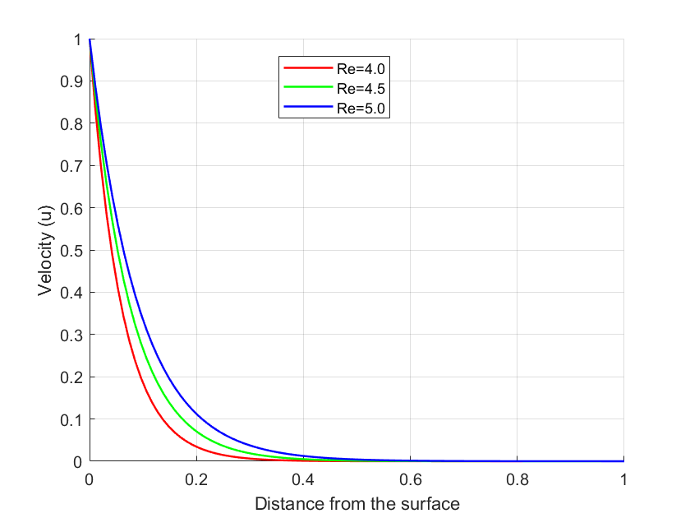

FIGURE 2: Effects of Varying Reynolds Number on Velocity Profiles

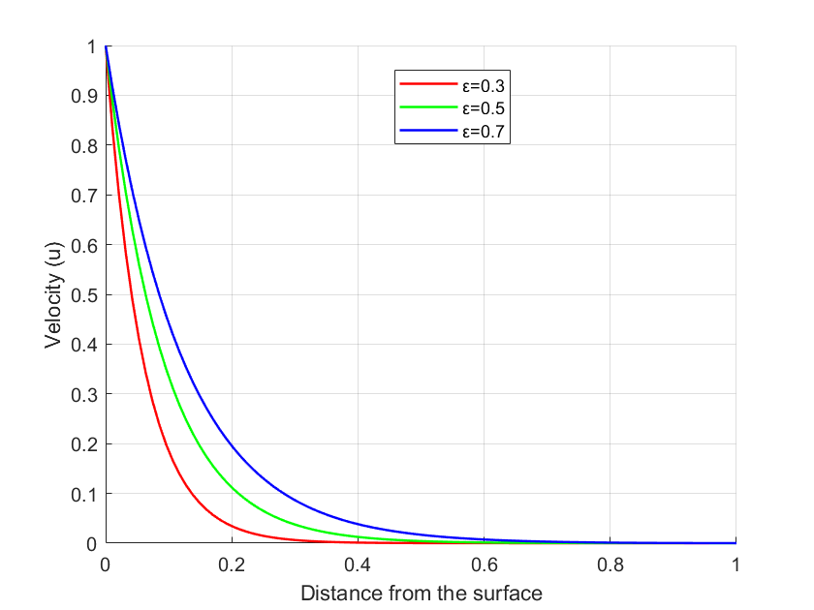

FIGURE 3: Effects of the Variable Viscosity Parameter on Velocity Profiles

Figure 4 illustrates the effects of varying surface velocity ($a$) on the momentum boundary layer. It is observed that an increase in surface velocity results in a thickening of the momentum boundary layer. At higher surface velocities, the viscous forces, which oppose the motion of fluid layers relative to each other, become less dominant compared to the inertial forces. This shift allows the momentum from the moving surface to penetrate deeper into the fluid, further expanding the boundary layer.

Figure 5 illustrates the effects of varying the Prandtl number (Pr) on the temperature profiles. An increase in the Prandtl number is observed to decrease the temperature profiles. The Prandtl number is a dimensionless parameter defined as the ratio of momentum diffusivity to thermal diffusivity. A higher Prandtl number indicates that momentum diffusivity is much larger than thermal diffusivity, resulting in a thinner thermal boundary layer compared to the velocity boundary layer. As the thermal boundary layer thins, the ability of heat to penetrate into the fluid away from the surface is reduced. This leads to a steeper temperature gradient near the surface and a lower overall temperature distribution within the fluid. Consequently, the temperature profiles decrease as the Prandtl number increases.

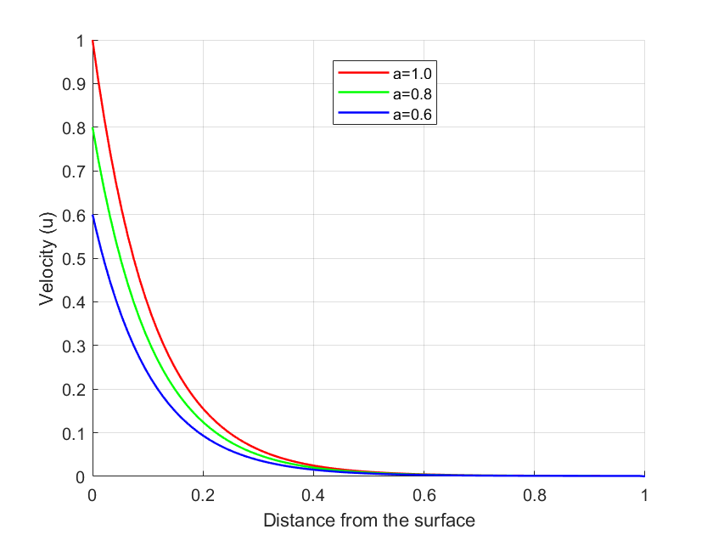

FIGURE 4: Effects of Varying Surface Velocity on the Momentum Boundary Layer

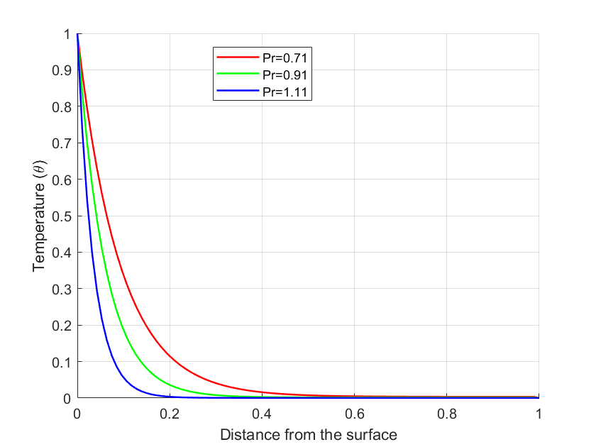

FIGURE 5: Effects of Varying Prandtl Number on Temperature Profiles

Figure 6 illustrates the effects of the Eckert number ($Ec$) on the temperature profiles. An increase in the Eckert number is observed to raise the temperature profiles. The Eckert number is a dimensionless parameter that represents the ratio of kinetic energy to enthalpy and measures the effect of viscous dissipation, which is the conversion of kinetic energy into internal energy due to frictional forces within the fluid. As the Eckert number increases, the viscous dissipation effect becomes more pronounced, resulting in more kinetic energy being converted into heat within the fluid. This additional heat generated by the dissipation process raises the fluid's temperature, leading to higher temperature profiles.

Figure 7 illustrates the effects of the variable viscosity parameter ($ε$) on the thermal boundary layer. It is observed that an increase in the variable viscosity parameter decreases the thermal boundary layer thickness. When viscosity is an inverse function of temperature, it implies that as the fluid temperature increases, its viscosity decreases. An increase in the variable viscosity parameter suggests that viscosity decreases more rapidly with increasing temperature. With a more pronounced decrease in viscosity, the fluid motion becomes more vigorous, enhancing convective heat transfer. This means that heat is carried away from the surface more efficiently by the moving fluid, which in turn decreases the temperature gradient away from the surface. As a result, the thermal boundary layer becomes thinner because the temperature difference between the surface and the surrounding fluid is distributed over a smaller distance.

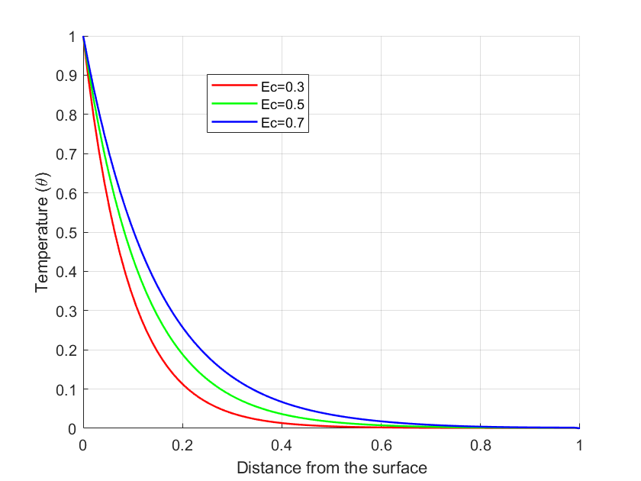

FIGURE 6: Effects of Varying Eckert Number on Temperature Profiles

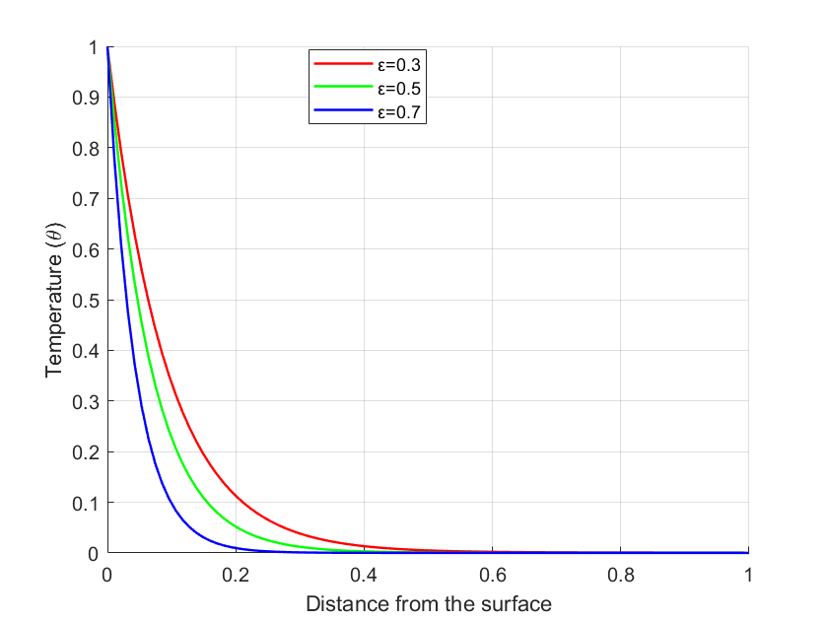

FIGURE 7: Effects of Varying the Variable Viscosity Parameter on the Thermal Boundary Layer

Figure 8 illustrates the effects of varying surface velocity ($a$) on the thermal boundary layer. It is observed that an increase in surface velocity reduces the thickness of the thermal boundary layer. When the surface velocity increases, the fluid adjacent to the surface is swept away more quickly, enhancing the convective heat transfer between the surface and the fluid. This increased convective heat transfer allows heat to be carried away from the surface more effectively. As a result, the region with significant temperature gradients becomes thinner. The fluid near the surface does not remain in contact with the surface long enough to undergo significant heating, leading to a steeper temperature gradient close to the surface and a reduction in the thermal boundary layer thickness. Additionally, the higher surface velocity increases the rate at which cooler fluid from outside the boundary layer is brought into contact with the warmer surface. This mixing effect enhances thermal diffusion, further contributing to the thinning of the thermal boundary layer.

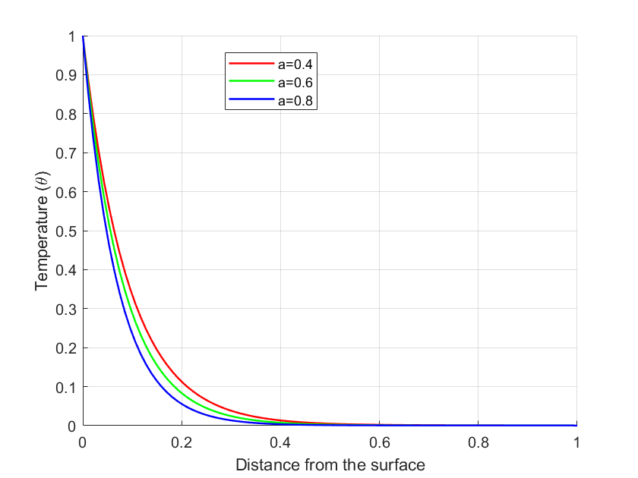

FIGURE 8: Effects of Varying Surface Velocity on the Thermal Boundary Layer

The results of this study were found to be similar to those of [35] indicating that flow parameters such as the Reynolds number, viscosity parameter, Prandtl number, Eckert number, and surface velocity influence the fluid flow characteristics.

The combined effects of temperature-dependent viscosity, viscous dissipation, and a moving surface in a quiescent fluid find application in hot rolling during metal processing and in the lubrication of sliding or rotating bearings [36].

In hot rolling, metals such as steel or aluminum are passed through rollers to reduce thickness and improve mechanical properties. The rolling surface moves over the metal sheet, creating fluid flow in the boundary layer. The metal's surface temperature is extremely high, which affects the viscosity of the lubricant or cooling fluid used to reduce friction and dissipate heat. As the viscosity of the fluid depends on temperature, and viscous dissipation generates additional heat, managing these effects is essential to ensuring smooth operation, avoiding excessive heat buildup, and preventing material defects.

In mechanical systems with sliding or rotating bearings, such as turbines, compressors, or large motors, the surfaces are often lubricated by oil. The moving surfaces create boundary layer flow in the lubricant. Viscous dissipation, caused by friction between the moving parts and the lubricant, generates heat, which changes the lubricant's temperature and affects its viscosity. Temperature-dependent viscosity plays a crucial role in maintaining the correct lubrication film thickness to minimize friction and wear.

In these applications, the combined effects of temperature-dependent viscosity, viscous dissipation, and a moving surface in a quiescent fluid significantly influence the efficiency, performance, and quality of the process or system. Proper management of these effects is crucial for optimizing heat transfer, minimizing friction, and ensuring smooth operation, whether in high-temperature manufacturing, lubrication systems, or thermal management.

5. Conclusion

In this paper, the Crank-Nicolson numerical technique was employed to investigate the combined effects of viscous dissipation, variable viscosity, and a moving surface on unsteady fluid flow past an impulsively moving sheet in a quiescent fluid. The flow is driven by the impulsive movement of the surface, with the viscosity of the fluid considered an inverse function of temperature. The boundary layer equations governing the flow were transformed into a non-dimensional form, yielding the following dimensionless parameters: Reynolds number (Re), Eckert number (Ec), Prandtl number (Pr), variable viscosity parameter (ε), and surface velocity (a). The non-dimensional governing equations were solved numerically, and the effects of varying these flow parameters were determined.

The numerical results demonstrate that an increase in Reynolds number, variable viscosity parameter, and surface velocity results in an increase in velocity profiles. Additionally, an increase in Prandtl number, variable viscosity parameter, and surface velocity results in a decrease in temperature profiles. Furthermore, an increase in the Eckert number was found to increase temperature profiles. Therefore, with appropriate flow parameters, the temperature of the fluid can be regulated during the cooling of hot sheets or metallic plates drawn over a quiescent fluid, thereby obtaining high-quality final products.

Recommendations for future studies include extending the analysis to fluid flow over a stretching sheet, considering different geometries, and examining the effects of magnetic fields and porous media.

**Nomenclature**

**Symbol Quantity**

$C_{P}$ Specific heat capacity

$Ec$ Eckert number $\left(= \frac{U^{2}}{C_{p}\left(T_{w}-T_{∞}\right)}\right)$

$K$ Thermal conductivity, $Wm^{-1}K^{-1}$

$H$ Characteristic length, $m$

$Pr$ Prandtl number $\left(= \frac{μC_{p}}{K}\right)$

$Re$ Reynold’s number $\left(=\frac{ρuH}{μ}\right)$

$T$ Dimensional temperature, $K$

$T_{w}$ Temperature at the wall, $K$

$T_{∞}$ Free stream temperature, $K$

$u$, $v$ Dimensional velocity components, $ms^{-1}$

$u^{*}$, $v^{*}$ Dimensionless velocity components

$U_{w}$ Sheet velocity, $ms^{-1}$

$U_{∞}$ Characteristic velocity, $ms^{-1}$

$x$, $y$ Cartesian coordinate in dimensional form, $m$

$x^{*}$, $y^{*}$ Cartesian coordinate in dimensionless form

$∆x$, $∆y$ Distance intervals, $m$

$t$ Time in dimensional form, $s^{-1}$

$t^{*}$ Time in dimensionless form

$ε$ Viscosity variation parameter in dimensionless form

$a$ Surface velocity in dimensionless form

$μ$ Coefficient of viscosity, $kgm^{-1}s^{-1}$

$μ_{∞}$ Coefficient of viscosity at free stream temperature, $kgm^{-1}s^{-1}$

$μ_{w}$ Coefficient of viscosity at surface temperature, $kgm^{-1}s^{-1}$

$ρ$ Fluid density, $kgm^{-3}$

$θ$ Dimensionless temperature

.

**DATA AVAILABILITY STATEMENT**

The data used for this study are from the published articles that are cited.\

Disclaimer (Artificial intelligence)

Option 1:

Author(s) hereby declare that NO generative AI technologies such as Large Language Models (ChatGPT, COPILOT, etc.) and text-to-image generators have been used during the writing or editing of this manuscript.

Option 2:

Author(s) hereby declare that generative AI technologies such as Large Language Models, etc. have been used during the writing or editing of manuscripts. This explanation will include the name, version, model, and source of the generative AI technology and as well as all input prompts provided to the generative AI technology

Details of the AI usage are given below:

1.

2.

3

References

[1] Alrehili, M. (2023). Viscoelastic thermal nanofluid flow and heat mass transfer due to a stretching sheet with slip velocity phenomenon and convective heating. *International Journal of Thermofluids*, *17*, 100281.

[2] Aldhabani, M. S., & Alrihieli, H. (2024). Variation of fluid characteristics in radiated Sutterby fluid flow over a stretched surface exhibiting thermophoretic phenomenon. *Case Studies in Thermal Engineering*, 104695.

[3] Opanuga, A. A., Agboola, O. O., Okagbue, H. I., & Ogunniyi, P. O. (2020). Influence of inclined magnetic field and chemical reaction on the entropy generation of blasius and sakiadis flows. *Scientific African*, *10*, e00640.

[4] Basha, H., & Naduvinamani, N. B. (2024). Numerical analysis of velocity slip and magnetic Soret effect on dissipative Maxwell liquid motion about a stretching wall with heat source/sink. *Numerical Heat Transfer, Part B: Fundamentals*, 1-25.

[5] Alzahrani, F., Bég, O. A., & Ferdows, M. (2024). Numerical solutions for magneto-convective boundary layer slip flow from a nonlinear stretching sheet with wall transpiration and thermal radiation effects. *Numerical Heat Transfer, Part A: Applications*, *85*(12), 1922-1936.

[6] Huera-Huarte, F. J. (2018). On the impulse produced by chordwise flexible pitching foils in a quiescent fluid. *Journal of Fluids Engineering*, *140*(4), 041206.

[7] Turkyilmazoglu, M. (2018). A note on the induced flow and heat transfers due to a deforming cone rotating in a quiescent fluid. *Journal of Heat Transfer*, *140*(12), 124502.

[8] Ray, A. K., & Vasu, B. (2018). Hydrodynamics of non-Newtonian Spriggs fluid flow past an impulsively moving plate. In *Applications of Fluid Dynamics: Proceedings of ICAFD 2016* (pp. 95-107). Springer Singapore.

[9] Abdel-Raouf, E., Sharif, M. A., & Baker, J. (2017). Impulsively started, steady and pulsated annular inflows. *Fluid Dynamics Research*, *49*(2), 025511.

[10] Sreenivasulu, P., Poornima, T., & Malleswari, B. (2020). Viscous dissipation impact on electrical resistance heating distributed Carreau nano liquid along stretching sheet with zero mass flux. *The European Physical Journal Plus, 135*(705).

[11] Alam, M. S., Hossain, S. C., & Rahman, M. M. (2016). Transient thermophoretic particle deposition on forced convective heat and mass transfer flow due to a rotating disk. *Ain Shams Engineering Journal*, *7*(1), 441-452.

[12] Jan, N., Marwat, D. N. K., & Rehman, S. (2022). Forced convection flow over a moving porous and non-uniform cylinder of variable thickness. *Advances in Mechanical Engineering*, *14*(6), 16878132221106261.

[13] Sreenivasulu, P., Poornima, T., & Bhaskar Reddy, N. (2016). Thermal radiation effects on MHD boundary layer slip flow past a permeable exponential stretching sheet in the presence of Joule heating and viscous dissipation. *Journal of Applied Fluid Mechanics, 9*(1), 267–278.and Viscous dissipation”. *Journal of Applied Fluid Mechanics*, Vol.9(1), 2016, pp.267-278

[14] Behera, V. M., & Rathore, S. K. (2024). Heat transfer augmentation by plate motion in a wall jet flow over a heated plate: A conjugate heat transfer technique. *Numerical Heat Transfer, Part A: Applications*, *85*(14), 2280-2297.

[15] Razzaq, R., & Farooq, U. (2021). Non-similar forced convection analysis of Oldroyd-B fluid flow over an exponentially stretching surface. *Advances in Mechanical Engineering*, *13*(7), 16878140211034604.

[16] Ajibade, A. O., & Umar, A. M. (2020). Effects of viscous dissipation and boundary wall thickness on steady natural convection Couette flow with variable viscosity and thermal conductivity. *International Journal of Thermofluids*, *7*, 100052.

[17] Jusoh, R., Nazar, R., & Pop, I. (2019). Magnetohydrodynamic boundary layer flow and heat transfer of nanofluids past a bidirectional exponential permeable stretching/shrinking sheet with viscous dissipation effect. *Journal of Heat Transfer*, *141*(1), 012406.

[18] Muntazir, R. M., Mushtaq, M., Shahzadi, S., & Jabeen, K. (2022). MHD nanofluid flow around a permeable stretching sheet with thermal radiation and viscous dissipation. *Proceedings of the Institution of Mechanical Engineers, Part C: Journal of Mechanical Engineering Science*, *236*(1), 137-152.

[19] Ibrahim, M. (2020). Numerical analysis of time-dependent flow of viscous fluid due to a stretchable rotating disk with heat and mass transfer. *Results in Physics*, *18*, 103242.

[20] Alrehili, M. (2023). Improvement for engineering applications through a dissipative Carreau nanofluid fluid flow due to a nonlinearly stretching sheet with thermal radiation. *Case Studies in Thermal Engineering*, *42*, 102768.

[21] Jabeen, K., Mushtaq, M., Mushtaq, T., & Muntazir, R. M. A. (2024). A numerical study of boundary layer flow of Williamson nanofluid in the presence of viscous dissipation, bioconvection, and activation energy. *Numerical Heat Transfer, Part A: Applications*, *85*(3), 378-399.

[22] Das, U. J., & Patgiri, I. (2024). Effects of viscous dissipation, gravity modulation and Joule heating on MHD Casson fluid flow over a vertically moving plate with second-order slip velocity. *International Journal of Ambient Energy*, *45*(1), 2331226.

[23] Abrar, M. N. (2024). Entropy analysis of double diffusion in a Darcy medium with tangent hyperbolic fluid and slip factors over a stretching sheet: Role of viscous dissipation. *Numerical Heat Transfer, Part A: Applications*, 1-14.

[24] Animasaun, I. L. (2015). Dynamics of unsteady MHD convective flow with thermophoresis of particles and variable thermo-physical properties past a vertical surface moving through binary mixture. *Open Journal of Fluid Dynamics*, *5*(2), 106-120.

[25] Makinde, O. D., Mabood, F., Khan, W. A., & Tshehla, M. S. (2016). MHD flow of a variable viscosity nanofluid over a radially stretching convective surface with radiative heat. *Journal of Molecular Liquids*, *219*, 624-630.

[26] Ahmad, S., Ahmad, A., Ali, K., Bashir, H., & Iqbal, M. F. (2021). Effect of non-Newtonian flow due to thermally-dependent properties over an inclined surface in the presence of chemical reaction, Brownian motion and thermophoresis. *Alexandria Engineering Journal*, *60*(5), 4931-4945.

[27] Huda, A. B., & Akbar, N. S. (2017). Heat transfer analysis with temperature-dependent viscosity for the peristaltic flow of nano fluid with shape factor over heated tube. *International Journal of Hydrogen Energy*, *42*(39), 25088-25101.

[28] Khan, Z., Shah, R. A., Altaf, M., Islam, S., & Khan, A. (2018). Effect of thermal radiation and MHD on non-Newtonian third grade fluid in wire coating analysis with temperature dependent viscosity. *Alexandria engineering journal*, *57*(3), 2101-2112.

[29] Gull, L., Mustafa, M., & Haq, R. U. (2024). A novel model for viscoelastic fluid flow and heat near a stretchable plate using variable fluid properties: A computational study. *Numerical Heat Transfer, Part B: Fundamentals*, *85*(6), 649-661.

[30] Karthik, S., Iranian, D., Alhazmi, H., Khan, I., Singh, A., & Khan, M. I. (2024). Double diffusive on powell eyring fluid flow by mixed convection from an exponential stretching surface with variable viscosity/thermal conductivity. *Case Studies in Thermal Engineering*, *55*, 104091.

[31] Elfeshawey, A. S., & Waheed, S. E. (2022). Effect of viscous dissipation and thermal radiation on MHD flow and heat transfer for a power-law fluid with variable fluid properties over a permeable stretching sheet. *Waves in Random and Complex Media*, 1-15.

[32] Lawal, M. O., Kasali, K. B., Ogunseye, H. A., Oni, M. O., Tijani, Y. O., & Lawal, Y. T. (2022). On the mathematical model of Eyring–Powell nanofluid flow with non-linear radiation, variable thermal conductivity and viscosity. *Partial Differential Equations in Applied Mathematics*, *5*, 100318.

[33] Mutwiri, E., Mwenda, E., & Karanja, S. (2016). Effects of temperature dependent viscosity and viscous dissipation on fluid flow past a moving flat plate.

[34] Mureithi, E. W., Mwaonanji, J. J., & Makinde, O. D. (2013). On the boundary layer flow over a moving surface in a fluid with temperature-dependent viscosity

[35] Mehmood, A., & Ali, A. (2007). Unsteady boundary layer flow due to an impulsively started moving plate. *Proceedings of the Institution of Mechanical Engineers, Part G: Journal of Aerospace Engineering*, *221*(3), 385-390.

[36] Reddy, B. M., Kesavaiah, D. C., & Reddy, G. R. (2018). Effects of radiation and thermal diffusion on MHD heat transfer flow of a dusty viscoelastic fluid between two moving parallel plates. *ARPN Journal of Engineering and Applied Sciences*, *13*(22), 8863-8872.