Evaluation of Antimicrobial Activity of Methanol and Aqueous Extracts of Begonia cucullata Against Selected Human Pathogenic Bacteria

Abstract
Background: Plants are a significant source of bioactive compounds with potential therapeutic properties. Due to the growing concern of antibiotic-resistant pathogens, exploring plant-based antimicrobials has become increasingly essential. This study evaluated the antimicrobial activity of methanol and aqueous extracts of Begonia cucullata against 12 bacterial strains to validate its traditional use and identify its potential bioactivity.
Methods: Methanol, aqueous, petroleum ether, and chloroform extracts of Begonia cucullata were prepared and tested for antimicrobial activity using the agar well diffusion method on Muller Hinton media. The diameter of the inhibition zones was measured after 48 hours of incubation at 37°C. Minimum Inhibitory Concentrations (MICs) were determined using the broth microdilution method.
Results: The methanol extract exhibited significant antibacterial activity against Escherichia coli, Klebsiella pneumoniae, and Proteus vulgaris, with inhibition zones ranging from 13 to 18 mm. The aqueous extract also demonstrated activity against Klebsiella pneumoniae, Escherichia coli, Bacillus cereus, and Pseudomonas aeruginosa, with inhibition zones ranging from 8 to 18 mm. The MIC values for Bacillus cereus and Escherichia coli were 125 µg/mL, while Klebsiella pneumoniae showed inhibition at 62.5 µg/mL. Petroleum ether and chloroform extracts showed no antibacterial activity.
Conclusion: The study confirms that the methanol and aqueous extracts of Begonia cucullata possess potent antibacterial properties against several pathogenic bacteria, highlighting their potential as natural antimicrobial agents. These findings suggest that Begonia cucullata could serve as a valuable source for developing plant-based therapeutics to combat antibiotic-resistant infections, warranting further investigation into its bioactive constituents.

Keywords: Begonia cucullata, Methanol extract, aqueous extract, antimicrobial activity, Enterobacter aerogenes, Klebsiella pneumonia, Bacillus subtilis

1. Background
Plants have always been a cornerstone in battling infections and illnesses worldwide. Especially in developing nations, traditional medicine, primarily based on medicinal flora, remains essential for basic healthcare. The healing power of these plants stems from a diverse array of active components, including bioflavonoids, steroidal glycoalkaloids, phenolic compounds, and alkaloids, all of which offer therapeutic benefits for human health [1]. However, only a small fraction of the vast number of potential medicinal plants has been scientifically explored, leaving much therapeutic promise undiscovered [2]. India boasts an exceptionally diverse flora, and its traditional medicine systems have historically utilised a wide array of these plants to treat numerous health conditions [3]. Antimicrobial compounds from plants may kill bacteria in ways different from our current drugs. This is important because it could be effective against resistant strains [4]. Drying extends the conservation of edible flowers (EFs) by preventing microbial growth and enzymatic degradation, while also reducing weight for lower transport and storage costs [5]. Therefore, systematically screening plants is essential to validate their traditional uses and to identify their bioactive components through the separation and characterisation of their phytoconstituents [6]. A standardized approach to screening, purifying, and identifying these biochemicals could lead to the discovery of novel bioactive principles with beneficial applications [12]. However, it's essential to use them carefully, considering the correct dosage, potential interactions with other medications, and individual differences [7].
Begonia is a massive group with over 1,800 species worldwide, and many of them are "micro-endemics" – found only in minimal, specific areas. The rise of mountains (like the Andes) and rapid geological changes in Southeast Asia seem to have created new places for Begonia to grow and evolve [8]. Begonia has been cultivated for centuries, starting in China around 1400 with the frost-hardy Begonia grandis. This species, along with others, was initially valued for its medicinal uses (such as healing wounds) or as a food and tea source, before becoming popular as an ornamental plant [9]. Begonia species are not only valued for their medicinal properties but are also widely utilised as food, drinks, and flavouring agents globally. Notably, the blooms of Begonia cucullata are officially recognised as edible for culinary use by the Korean Food and Drug Administration (KFDA) [10]. The Malasar and Malai Malasar tribal communities in the Pollachi region (Southern India) use Begonia malabarica as a traditional medicine to treat arthritis and general joint pains [11]. The B. cucullata samples were collected from nurseries in Depok, Indonesia, at an altitude of 50–100 meters above sea level and were cultivated under a 50% shade net at the nurseries [13]. Historically, however, testing natural or synthetic compounds for medicinal effects has led to the discovery of countless essential drugs [14]. Earlier studies have shown that Begonia pecta has anti-inflammatory (reduces swelling), hypoglycemic (lowers blood sugar), and cytotoxic (kills harmful cells) properties. [15].
Begonia plants are increasingly recognised in research as dual-purpose decorative and air purifying plants due to their ability to control airborne microbes. Consequently, the volatile compounds from 24 different Begonia species (whole plants) have been examined for their antibacterial activity against several dangerous pathogens [16]. Beyond their traditional uses, scientific investigations into Begonia species have consistently demonstrated that numerous isolated compounds exhibit significant bioactivity and therapeutic potential [17]. The leaves of Begonia grandis are notably rich in orientin, a dominant C-glycosyl flavone, alongside other flavonols and free aglycones such as quercetin and luteolin, all playing a significant role in the plant's remarkable cold adaptation [31]. Studies evaluating the antimicrobial activity of Begonia cordifolia leaf extracts against Vibrio harveyi and Pseudomonas aeruginosa revealed that while organic (acetone) and water extracts showed less activity, hexane and ethyl acetate extracts exhibited greater antimicrobial effects against these reference strains [18]. The reports reveal the antimicrobial activity of organic leaf exudate of Begonia goegoensis using the reference strains of Pseudomonas aerogenosa (ATCC 27583) and β-lactamase-producing Pseudomonas aerogenosa .
The ethanolic extract of Begonia goegoensis showed maximum activity against Pseudomonas aerogenosa. In contrast, the methanolic leaf extract gave the minimum activity. β-lactamase-producing Pseudomonas aerogenosa tested positive with both organic extracts, namely the ethanolic and methanolic extracts of Begonia goegoensis [19]. Researchers' report reveal the germicidal property tests were carried out using the water-alcohol extract (L) and the alcohol extricate (E exudate) of Begonia grandis against the experimental cultures of Candida albicans, Staphylococcus aureus and Bacillus subtilis,The extract L resulted positive for three strains , two bacteria and one fungal strain and exudates E for both microorganisms- one bacteria and one fungus [20]. A few herbs of the Begonia genus have been previously studied for their their germicidal properties. The germicidal property of alcoholic extricate separated using the leaf samples of Begonia dregei, Begonia erythrophylla, Begonia foliosa, Begonia goegoensis, Begonia heracleifolia, Begonia Mexicana, Begonia peltate, Begonia solimutata and Begonia theme were tested on the reference cultures of Citrobacterfreundii . A maximum number of the alcoholic extricates purified from the leaves of Begonia plant species showed greater activity on Citrobacterfreundii (BuynLyudymula et al.,2019)[21]. Experts have revealed that many Begonia species and hybrids exhibit significant antimicrobial activity against common bacteria and fungi, with varying effectiveness depending on the season. Practical applications in childcare centres have demonstrated a reduction in airborne microbes [23].
2. Methods

Collection of plant and extract preparation: The experimental work was carried out at the Department of Biotechnology, Gulbarga University, Kalaburagi, from March 2022 to September 2022.
Plant collection: Begonia is a plant widely grown in nurseries in Pune, Maharashtra, India. Prof. Rajasamarsen Modi, Associate Professor and Head of the Department of Studies and Research in Botany at Autonomous Government College, Kalaburagi, verified the authenticity of the plant, which was purchased for the current study from nearby nurseries in Pune, Maharashtra, India in February 2022. Voucher No. HGUG.17 was attached to a conserved specimen from the Herbarium. (Fig No. 1).

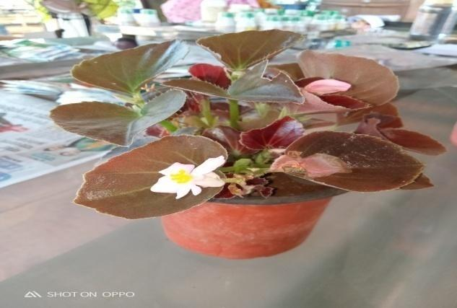
Fig 1: Begonia cucullata Plant

Extract preparation using Begonia cucullata plant: After being thoroughly cleaned with tap water, the entire plant was left to dry in the shade for 15 to 20 days. The Begonia cucullata plant was ground into a fine powder, and extraction was carried out using a variety of chemical solvents and pure water (distilled water) . The dried fine Begonia cucullata plant was extracted using three different organic solvents, with a 1L Extraction device, and later decoction preparation was achieved by boiling in pure water [21, 22]. The Begonia cucullata plant extract was then used for additional analysis after the solvent containing the extract was allowed to evaporate. The process of aqueous extraction involved boiling the Begonia cucullata plant in 850 millilitres of distilled water for up to 2 hours, allowing it to cool for a while, and then collecting the dried filtrate [10]. The antimicrobial activity was evaluated using the organic extracts and aqueous extract (Fig. 02). The methyl alcohol and aqueous extracts confirmed the antibacterial properties for a few organisms. Petroleum extract and chloroform extract did not exhibit antimicrobial activity against the selected strains.

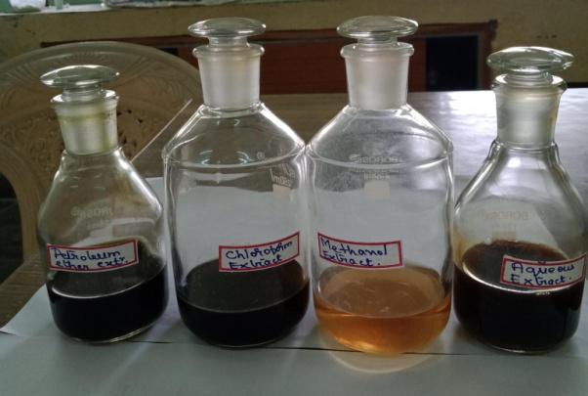
Fig 2: Begonia cucullata organic and aqueous extracts

Bacterial cultures: The antibacterial property against twelve microorganisms was tested. The following six organisms, namely Escherichia coli, Bacillus cereus, Klebsiella pneumoniae, Pseudomonas aeruginosa, Staphylococcus aureus, and Salmonella typhi, were collected from the Department of Microbiology, Karnatak University, Dharwad. The following six organisms Bacillus subtilis Microbial type culture and collection (MTCC) (MTCC1427), Enterobacter aerogenes(MTCC2822) Micrococcus luteus(MTCC106) Proteus vulgaris (MTCC426) Shigella flexneri(MTCC1457) and Vibrio cholera (MTCC15025) were purchased from IMTEC, Chandigarh. The microbial cultures Bacillus cereus (MTCC 430), Escherichia coli (MTCC 443), and Klebsiella pneumoniae (MTCC 109) have been selected for the evaluation of the minimum inhibitory concentration. All three bacterial strain cultures have been preserved at storage temperature in the refrigerator and retained in vials of solid microbial media. All the microorganisms were suspended in the liquid broth medium, and the inoculated vials were transferred to an incubator preset to 37˚C and left for 48 hours. The antibacterial property was tested using Mueller-Hinton agar as the medium.
Antimicrobial activity: The well plate method was used to test the antimicrobial properties. The glass vials were labelledlabelled from 1 to 4, and organic plant extracts were distributed in the first three glass vials, while an aqueous plant extract was dissolved in the fourth glass vial.The procedures for the antimicrobial activity have been performed with standard micobiological methods. The Mueller Hinton agar media was used for the antimicrobial activity. Twenty five ml of the mentioned media (45˚C) was aseptically transferred into autoclaved petriplates. Inocula containing 100µl of twenty four hours incubated cultures of have been uniformly spread upon media surface. After the molten agar solidified, 8mm diameter holes were made with the help of a sterile borer. The plant extracts were used at concentrations of 10 mg/mL and 50 mg/mL for testing. In each plate,,25 µll,50 µll, and100 µl100µl of organic and wextractstracts were loaded into the, wells,, apetri platesi plates werePetri plates were transferred to the a refrigerator for 60to allow forminutes for extract diffusion. For each microorganism and each plant extract, separate plates were prepared. After 60 minutes,, the plates werewere transferred to an an incubator set at 37˚C overnight incubation. Azithromycin (30 mcg) standard disc served as the positive control, and solvent without plant extract was used as the negative control. The experiments were carried out as triplicates, and, and then the the average of all values waswas taken.
Minimum Inhibitory Activity: Minimum inhibitory activity was carried out with the Methanol extract of Begonia cucullata.
For the antimicrobial screening experiment, a 96-well microwell plate with a lid was used. Mueller-Hinton broth was used in the test. Since the plant extract have been added by an equivalent number of organisms, Mueller Hinton broth, it was made at a concentration double the intended final concentration. In rows P–R (in column 1), 0.2 mL of the prepared plant extract in Mueller-Hinton broth has been added to the first wells. As a sterility control, column 12 contained 200 μL of the broth, while columns 2–11 in rows P–R contained 100 μL of the broth alone. Twofold serial dilutions were systematically performed, starting from column 1 and1 and ending at column 10, with the help of a a micropipette. (From rows P–R). The process was repeated up to the last column (10), where the final 100 μL was disposed of after 100 μL was taken out of the initially concentrated broth ( 1–10 numbered columns in–R rows) and moved to the following column with the 100 μL broth. To achieve the desired final inoculum load of 5x 10⁵ CFU/mL( Colony forming unit ) individually in a separate plate, 0.1 mL of the 1 × 10⁶Colony- forming units per millilitre microbial [Bacillus cereus labeled with accession number MTCC 430,Escherichia coli labelled with accession number MTCC 443, and Klebsiellapneumoniae labeled with accession number MTCC 109 ] inoculum was transferred into each well except the 12th column. Column 11 is maintained as a drug-free growth control column. The microtitermicrotiter plates were maintained at 37°C for 18 to 20 h, and the plant extract was prepared in several different conc,entrations, ranging from to 21 µg/mL,decreasing in increments of 125 0 µg/mL250 50 µg/mand 500nd decreasing to 2 µg/mL. The lowest plant extract concentrations at which no bacterial growth was discernible to the unaided eye were identified visually as the Minimum Inhibitory Concentrations (MIC) in the Mueller-Hinton broth dilutions [24].

3.Results

It can be inferred from the literature that few studies have investigated the antibacterial properties of Begonia cucullata.
The antimicrobial activity was tested with twelve different microorganisms using three organic solvent extracts and one water extract of Begonia cucullata. The extractions of chloroform and petroleum ether, prepared from powdered Begonia cucullata plants, resulted in a negative test with all twelve microorganisms selected for studying antimicrobial activity. The microorganisms Escherichia coli, Klebsiella pneumonia, and Proteus vulgaris have shown Positive results with the Methanol extract of Begonia cucullata at a 10 mg/ml concentration of the plant extract (Table 1).

Table 1. Antimicrobial activity of Begonia cucullata methanol extract(10mg/ml)
Sl No. | Name of Microorganism | Methylalchohol extricate (10mg/ml)  25ul | Methylalchohol extricate (10mg/ml)  50ul | Methylalchohol extricate (10mg/ml)  100ul | Azithromycin  30mcg
1. | Bacillus cereus | - | - | - | -
2. | Bacillus subtilis (MTCC1427) | - | - | - | -
3. | Escherichia coli | - | 14 | 16 | 40
4. | Enterobacteraerogenes(MTCC2822) | - | - | - | -
5. | Klebshella pneumonia | 15 | 17 | 18 | 35
6. | Micrococcus luteus(MTCC106) | - | - | - | -
7. | Pseudomonas aerogenosa | - | - | - | -
8. | Proteus vulgaris (MTCC426) | - | - | 13 | -
9. | Staphylococcus aureus | - | - | - | -
10. | Salmonella typhi | - | - | - | -
11. | Shigellaflexneri(MTCC1457) | - | - | - | -
12. | Vibrio cholera(MTCC15025) | - | - | - | -

Escherichia coli and Klebsella pneumonia have tested positive with water extract of Begonia cucullata at 10mg/ml concentration of plant extract(Table.2 ) (Fig No3 and Fig 4)

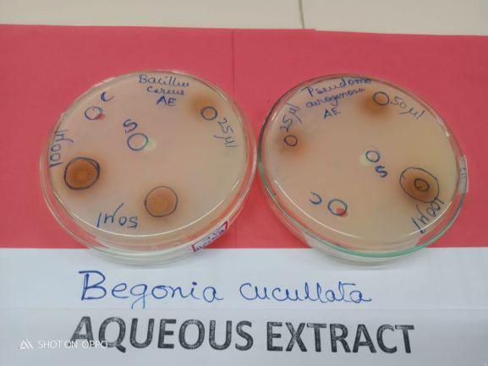
Fig 3: Antimicrobial activity of Begonia cucullata Aqueous extract (10 mg/ml)withBacillus cereus and Pseudomonas aerogenosa.

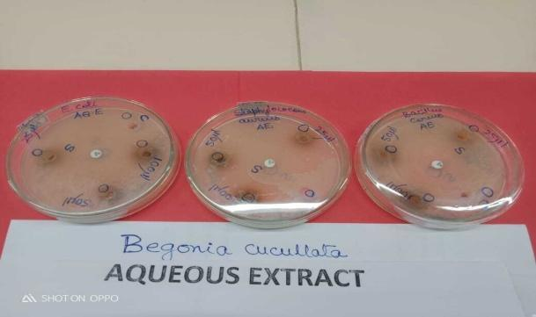
Fig 4: Antimicrobial activity of Begonia cucullataAqueous extract (10 mg/ml) with E coli, Staphylococcus aureus and Bacillus cereus.

Table 2.Antimicrobial activity of Begonia cucullata Aqueous extract.(10mg)
Sl No. | Name of Microorganism | Aqueous extract (10mg/ml)  25ul | Aqueous Extract  (10mg/ml)  50ul | Aqueous Extract  (10mg/ml)  100ul | Azithromycin  30mcg
1. | Bacillus cereus | - | 12 | 14 | 42
2. | Bacillus subtilis (MTCC1427) | - | - | - | -
3. | Escherichia coli | 13 | 18 | 18 | 40
4. | Enterobacteraerogenes(MTCC2822) | - | - | - | -
5. | Klebshella pneumonia |  | 14 | 17 | 35
6. | Micrococcus luteus(MTCC106) | - | - | - | -
7. | Pseudomonas aerogenosa | - | 14 | 14 | 08
8. | Proteus vulgaris (MTCC426) | - | - | - | -
9. | Staphylococcus aureus | - | - | - | -
10. | Salmonella typhi | - | - | - | -
11. | Shigellaflexneri(MTCC1457 | - | - | - | -
12. | Vibrio cholera(MTCC15025) | - | - | - | -

The microorganisms Klebsiella pneumonia, Proteus vulgaris and other infection-causing agents tested positive with methanol extract of Begonia cucullata at 50mg/ml concentration of plant extract (Table No.3).

Table 3.Antimicrobial activity of Begonia cucullata methanol extract.(50mg)
Sl No. | Name of Microorganism | Methanol extract (50mg/ml)  25ul | Methanol Extract  (50mg/ml)  50ul | Methanol Extract  (50mg/ml)  100ul | Azithromycin  30mcg
1. | Bacillus cereus | - | - | 12 | 42
2. | Bacillus subtilis (MTCC1427) | - | 18 | 18 | 32
3. | Escherichia coli | 10 | 11 | 13 | 29
4. | Enterobacteraerogenes(MTCC2822) | - | - | 12 | 15
5. | Klebshella pneumonia | 15 | 17 | 18 | 35
6. | Micrococcus luteus(MTCC106) | - | - | - | -
7. | Pseudomonas aerogenosa | - | - | - | -
8. | Proteus vulgaris (MTCC426) | - | 13 | 13 | 15
9. | Staphylococcus aureus | - | - | - | -
10. | Salmonella typhi | - | - | - | -
11. | Shigellaflexneri(MTCC1457) | - | - | - | -
12. | Vibrio cholera(MTCC15025) | - | - | - | -

Bacillus cereus and Pseudomonas aerogenosa have tested positive with water extract of Begonia cucullata at 50 mg/ml concentration (Table 4).

Table 4.Antimicrobial activity of Begonia cucullata Aqueous extract.(50mg)
Sl No. | Name of Microorganism | aqueous extract (50mg/ml)  25ul | Aqueous Extract  (50mg/ml)  50ul | Aqueous Extract  (50mg/ml)  100ul | Azithromycin  30mcg
1. | Bacillus cereus | - | 14 | 16 | 42
2. | Bacillus subtilis (MTCC1427) | - | - | - | -
3. | Escherichia coli | 13 | 18 | 18 | 40
4. | Enterobacteraerogenes(MTCC2822) | - | - | - | -
5. | Klebshella pneumonia |  | 14 | 17 | 35
6. | Micrococcus luteus(MTCC106) | - | - | - | -
7. | Pseudomonas aerogenosa | - | 16 | 16 | 08
8. | Proteus vulgaris (MTCC426) | - | - | - | -
9. | Staphylococcus aureus | - | - | - | -
10. | Salmonella typhi | - | - | - | -
11. | Shigellaflexneri(MTCC1457) | - | - | - | -
12. | Vibrio cholera(MTCC15025) | - | - | - | -

The microorganisms Bacillus subtilis, Enterobacter aerogenes, Micrococcus luteus, Pseudomonas aeruginosa, Staphylococcus aureus, Salmonella typhi, Shigella flexneri, and Vibrio cholera have tested negative with the methanol and water extracts of Begonia cucullata at a 10 mg/ml concentration. The microorganisms Escherichia coli, Bacillus subtilis, Enterobacter aerogenes, Klebsiella pneumoniae, Micrococcus luteus, Proteus vulgaris, Staphylococcus aureus, Salmonella typhi, Shigella flexneri, and Vibrio cholera tested negative for antimicrobial activity with an aqueous extract at a 50mg/ml concentration. The microorganisms Micrococcus luteus, Pseudomonas aeruginosa, Staphylococcus aureus, Salmonella typhi, Shigella flexneri, and Vibrio cholera tested negative with the organic solvent extract of Begonia cucullata at a 50000 µg/ml concentration.
The three bacteria, namely Bacillus cereus, Escherichia coli, and Klebsiella pneumoniae, were selected for the experiment to determine the minimum inhibitory concentration of Begonia cucullata plant extract. The procedure followed was the micro-broth dilution technique using a 96-well microtitre plate (Figures 05-06).

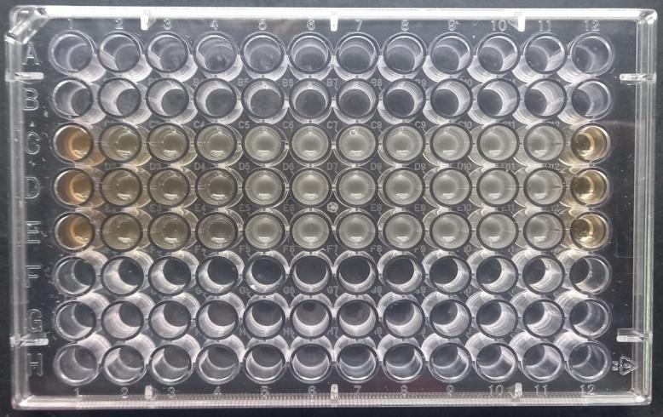
Fig 5: Determination of MIC against B. cereus

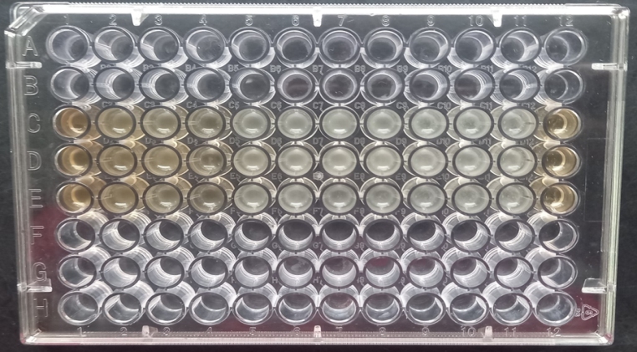
Fig 6: Determination of MIC against E. Coli

Through observation, it was understood that negative microbial growth appeared in columns one to four, with the maximum rows from P-R of concentration 1.0-0.125 mg/mL when treated against Escherichia coli and Bacillus cereus. Whilst column 1-5 were showed no growth against Klebsiella pneumoniae(Table 5B). The tested bacteria Escherichia coli and Bacillus cereus was found to be inhibited at concentration 125µg/mL of Begonia cucullata extract (Table 5A)(Table 6) and and confirmed as least concentration level to control the microbial population (Figures5-6). The MIC of the plant extract against Klebsiella pneumoniae was achieved at a concentration of 62.5 µg/mL (Table No. 6), as shown in Figure 5 (Table 5B, Figures 7, 8, and 9).

Table 5A. E coli: Begonia cucullata ME concentration and OD value.
Begonia cucullata ME conc. in µg/ml | Avg O.D at 625 nm
Medium control | 0.767
Begonia cucullata ME Conc. in µg/ml | 1.071
1000 | 1.071
500 | 1.092
250 | 1.087
125 | 1.068
63 | 1.267
31 | 1.353
16 | 1.416
8 | 1.433
4 | 1.412
2 | 1.439
0.00 | 1.303

Table 5B. KlebshellaPneumonia :Begonia cucullata ME concentration and OD value
Begonia cucullata ME conc. in µg/ml | Avg O.D at 625 nm
Medium control | 0.684
Begonia cucullata Conc. in µg/ml | 1.173
1000 | 1.173
500 | 0.843
250 | 0.857
125 | 0.810
63 | 0.920
31 | 1.816
16 | 1.244
8 | 1.261
4 | 1.264
2 | 1.248
0.00 | 1.307

Table 6: MIC determination of Begonia cucucllata Methanol Extract (ME) against various bacteria
Name of the organism | MIC (µg/mL)
Bacillus cereus | 125
Escherichia coli | 125
Klebshella pneumoniae | 62.5

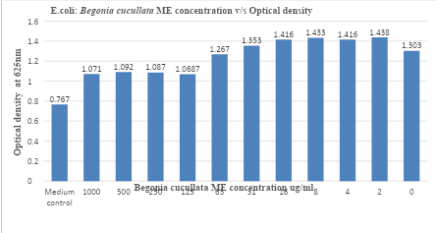
Fig 7: E.coli: Begonia cucullata ME concentration V/s Optical density

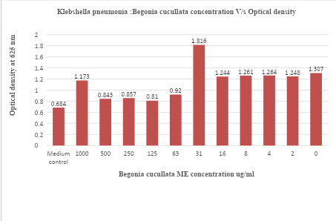
Fig 8: Klebshella pneumonia: Begonia cucullata ME concentration V/s Optical density
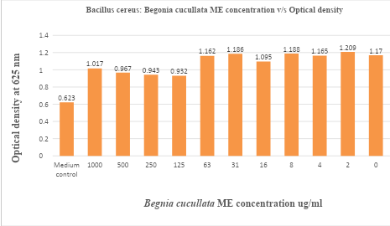
Fig 9: Bacillus cereus: Begonia cucullata concentration V/s Optical density

4. Discussion

Concerning the previous reports, the organic extracts of the Begonia maculata leaf sample have shown intermediate antibacterial activity, as tested with reference strains such as Klebsiella pneumoniae and Escherichia coli. The extract of Begonia maculata leaves resulted in high antibacterial activity (14.00mm , zone of inhibition) tested with Escherichia coli and has shown to be more susceptible to the extract of (14.00mm) with reference to to standard antimicrobial antibiotics gentamicin (CN). However, Begonia maculate extract showed fefeweraantimicrobial propertiess in testing ag the Pseudomonas aeruginosaklebsiellaella pneumonia than withreferencee antibiotics, which maithemined the standard. The experiments yielded a negative test for the antimicrobial activity of the Begonia maculata leaf sample extract against the Pseudomonas aeruginosa organism. It was observed that there was no antibacterial effect found in the extract of Begonia maculata leaf against the strain [25].
Concerning the previous reports, Jeeva and Antonisamy (2012) [26] studied the germicidal properties and biochemical analysis of Begonia floccifera Bedd organic extract from a flower sample, testing it with various reference microbial cultures. The germicidal property was experimented with the methanol extricate of Begonia flocciferra was tested using the reference microbial cultures resulted difference in the antimicrobial property. The Bacillus cereus resulted in theas the highest diameter of the zone of inhibition, 28 mm. The bacteria labelledlabelled as gram-positive resulted in 25 mm, the strain designated as gram-negative measured 15 mm, 13mm for Proteus mirabilis, and 7mm for KlebsiellaKlebsiella pneumonia. In addition, several infectious microorganisms showed a lesser susceptibility to the inhibitory effect of the tested extract. With comparing the results of Begonia cucullata methanolic extract antibacterial activity with the results of Begonia floccifera methanolic extract antibacterial activity (Jeeva and Antonisamy,2012) similar results are observed with the microorganisms namely Escherichia coli, Bacillus cereus and Klebsella pneumonia with a zone of inhibition for Escherichia coli was13mm, Bacillus cereus was 18mm,. Klebsellapmeumonia was 14mm [26] .
Concerning the previous report, the experiments on the antimicrobial properties of Begonia cordifolia using organic and aqueous extracts, methyl alcohol, and water extracts have tested positive for the germicidal properties against Vibrio harveyi and Pseudomonas aeruginosa. The methanolic extract of Begonia cordifolia showed the largest zone of inhibition against Vibrio harveyi, and the aqueous extract showed the minimum antimicrobial activity [18]. The chemical composition of fresh flower VOCs, hydrosols, and essential oils varies significantly across different edible flowers; however, hydrosols consistently demonstrate antibacterial activity against several common bacterial pathogens [27]. Begonia cordifolia methanolic extract showed vigorous antibacterial activity against Vibrio harvayie and Escherichia coli. The efficiency of Begonia cordifolia extract was mainly confirmed by the selection of the solvent used [18]. Research shows silver nanoparticles (AgNPs) derived from Rhinacanthus nasutus ethanolic leaf extracts are promising. These small AgNPs effectively combat bacteria and their protective biofilms, even against antibiotic-resistant strains, likely due to the plant's natural compounds and the nanoparticles' cell-damaging properties. While these findings are significant, more research is needed to isolate specific active compounds and conduct safety trials in animal models before clinical application [28]. When compared to aqueous extracts, the organic extracts of Begonia malabarica exhibited more antibacterial activity. All ten of the examined bacteria were susceptible to the effects of the chloroform and methanol extract (Ramesh et al 2002) [29].The antimicrobial property of the water extract from the Begonia cucullata plamicwas demonstrated roorganisms icroorganisms Ba Escherichias, EschKlebsiellaoli, Klebsiella pneumonia, anerogenousas aeruginosa. The aqueous extract from Begonia cucullata exhibited antibacterial action against Pseudomonas aeruginosa, with a zone of inhibition of 16 mm. The standard showed ashowed a zone of inhibition of 8 mm. Studies reveal that the water extract of Begonia cordifolia showed minimum antibacterial activity against Pseudomonas aeruginosa, Pseudomonaswith a a zone of inhibition of of 12 mm [18]. The reports reveal that water extracts from the leaves of P. ocerifolius haveresultedeminent antibacterial propertpartiesiagainst disease-causing-causingsmicroorganisms2008) [30]. The organic and water extracts of Begonia cucullata were assessed in this study to determine their antibacterial activity against a variety of microorganisms. Reports explain that different extracts of Begonia cordifolia were experimented with for the exploration of their antimicrobial activity against reference strains [18]. The present study may be helpful in the treatment of diseases and infections caused by several bacterial strains, as both aqueous and methanol extracts of Begonia cucullata have been shown to have to have antimicrobial activity against four to eight microbial strains,, respectively, and can be used in medication as an alternative to antibiotics. A few active compounds in plants identified as secondary metabolites may be the cause of the antibacterial activity found in a specific portion of a species. (Baladrin and Kloeke 1988) [27]. The limitation of the present research work is that the antifungal activity of the Begonia cucullata plant extract is not included in the study.

5. Conclusion

The present study demonstrates that methanol and aqueous extracts of Begonia cucullata exhibit significant antimicrobial activity against several pathogenic bacterial strains, including Escherichia coli, Klebsiella pneumoniae, Proteus vulgaris, Bacillus cereus, and Pseudomonas aeruginosa. These findings suggest that Begonia cucullata is a promising natural source of bioactive compounds with potential applications in the development of plant-based antimicrobial agents. However, to fully understand the therapeutic potential, further studies are required to isolate, characterize, and identify the specific phytoconstituents responsible for the observed antimicrobial effects. Additionally, evaluating cytotoxicity, mechanism of action, and in vivo efficacy will be essential to advance these findings toward practical and clinical applications.
Abbreviations
KFDA Korean Federation of Drug and Administration
MTCC Microbial Type Culture Collection and Gene Bank.
IMTEC Institute of Microbial Technology
CFU Colony Forming Unit
MIC Minimum Inhibitory Concentration
ME Methanol Extract
CN Gentamicin

References

[1]Ediogal HO, Okwu DE, Mbaebie BO. Phytochemical constituents of some Nigerian medicinal plants. Afr J Biotechnol. 2005;4:685–8.
[2]Mahesh B, Satish S. Antimicrobial activity of some important medicinal plants against plant and human pathogens. World J Agric Sci. 2008;4:839–43.
[3]Ahmad I, Aqil F. In vitro efficacy of bioactive extracts of 15 medicinal plants against ESBL-producing multidrug-resistant enteric bacteria. Microbiol Res. 2007;162:264–75.
[4]Barbour EK, Al Sharif M, Sagherian VK, Habre AN, Talhook RS. Screening of selected indigenous plants of Lebanon for antimicrobial activity. J Ethnopharmacol. 2004;93:1–7.
[5]Marchioni I, Taglieri I, Dimita R, Ruffoni B, Zinnai A, Venturi F, et al. Postharvest treatments on sensorial and biochemical characteristics of Begonia cucullata Willd edible flowers. Foods. 2022;11(10):1481.
[6]Tomoko N, Takashi et al. Antimicrobial activity of extracts prepared from tropical and subtropical plants on Methicillin-resistant Staphylococcus aureus. J Health Sci. 2002;48:273–6.
[7]Ghutke TD, Parvin K, Banu AMR, Bansal S, Srivastava A, Rout S, et al. A comprehensive review on the therapeutic properties of medicinal plants. Acta Tradit Med. 2023;2:13–8.
[8]Hughes M, Peng C-I, Lin C-W, Rubite RR, Blanc P, Chung K-F. Chloroplast and nuclear DNA exchanges among Begonia sect. Baryandra species (Begoniaceae) from Palawan Island, Philippines and descriptions of five new species. PLoS One. 2018;13(5):e0194877.
[9]Tebbitt MC. Begonias: Cultivation, Identification, and Natural History. Portland: Timber Press; 2005.
[10]Londonkar R, Hemalatha SA. Preliminary phytochemicals investigation in Begonia cucullata. Int J Pharm Biomed Sci. 2024;4:370–7.
[11]Pandikumar et al. Medicinal plants used by Malasar tribes of Coimbatore district, Tamil Nadu. Indian J Tradit Knowl. 2007;6(4):579–82.
[12]Amutha S, et al. Evaluation of antimicrobial activity of different solvent extracts of Begonia cordifolia. Int J Zool Appl Biosci. 2016;1(3):144–7.
[13]Suffan W, Metusala D. Micromorphometric analysis of five Begonia spp. leaves (Begoniaceae). IOP Conf Ser Earth Environ Sci. 2021;846(1):012005.
[14]Indrakumar I, Gomati R, Karpagam S. Antimicrobial and in vitro antioxidant potential of Begonia dipetala Graham. Int J Pharm Sci Rev Res. 2014;27(2):382–6.
[15]Gurung R, Agrawal R, Thapa Y, Khanal S, Gautam S. Preliminary phytochemical screening, in-vitro antioxidant and antibacterial activity of Begonia pecta. World J Pharm Pharm Sci. 2019;8(10):1241–57.
[16]Karpova EA, Nabieva AY, Fershalova TD, Tsybulya NV, Yakimova YL. Flavonoids and antimicrobial properties of Begonia fischeri var. palustris in vitro plantlets. Online J Biol Sci. 2019;19(1):20–7.
[17]Tkachenko H, Osadowski Z, Buyun L. The antimicrobial properties of extracts obtained from Begonia goegoensis NE Br. leaf against Pseudomonas aeruginosa isolates. Agrobiodiversity. 2017;1:–.
[18]Amutha S, et al. Evaluation of antimicrobial activity of different solvent extracts of Begonia cordifolia. Int J Zool Appl Biosci. 2016;1(3):144–7.
[19]Tkachenko H, et al. The antimicrobial properties of extracts obtained from Begonia goegoensis NE Br. leaf against Pseudomonas aeruginosa isolates. Agrobiodiversity. 2017;:454–60.
[20]Karpova E, et al. Phenolic compounds and antimicrobial properties of Begonia grandis Dryand. subsp. grandis leaves. Bot Pac. 2019;8(2):51–61.
[21]Buyun L, et al. Screening for antimicrobial activity of nine ethanolic extracts obtained from leaves of Begonia plant: A possible alternative in the treatment of infections caused by Citrobacter freundii. Agrobiodiversity. 2019;:312–22.
[22]Azwanida NN. A review on the extraction method used in medicinal plants, principles, strength and limitations. Med Aromat Plants. 2015;4(3):1–6.
[23]Tsybulya NV, Fershalova TD. Seasonal antimicrobial activity of volatile substances emitted by representatives of Begonia L. genus (Begoniaceae). Samara J Sci. 2021;10(1):167–72.
[24]Wiegand I, Hilpert K, Hancock REW. Agar and broth dilution methods to determine the minimal inhibitory concentration (MIC) of antimicrobial substances. Nat Protoc. 2008;3(2):163–75.
[25]Bursalioglu EO. Evaluation of antibacterial activity of Triticum monococcum seeds, Castanea sativa seeds and Begonia maculata leaves against several bacterial strains. Turk J Biod. 2020;3(1):9–11.
[26]Jeeva S, Antonisamy JM. Antibacterial and phytochemical studies on methanolic extracts of Begonia floccifera Bedd. flower. Asian Pac J Trop Biomed. 2012;2(Suppl.1):S151–4.
[27]Najar B, Pieracci Y, Fratini F, Pistelli L, Turchi B, Varriale D, et al. Exploring the volatile composition and antibacterial activity of edible flower hydrosols with insights into their spontaneous emissions and essential oil chemistry. Plants. 2024;13(8):1145.
[28]Nagasinduja V, Shahitha S. In-vitro antimicrobial activity of green synthesised silver nanoparticles of leaf extract of Rhinacanthus nasutus against bacterial food-borne pathogens. J Clin Diagn Res. 2022;–.
[29]Ramesh et al. Phytochemical and antimicrobial studies of Begonia malabarica. J Ethnopharmacol. 2002;79(1):129–32.
[30]Thatio HN, Panda SK, Dutta SK. Antimicrobial activity and ethnomedicinal uses of some medicinal plants from Similipal Biosphere Reserve, Orissa. Asian Med J Plant Sci. 2008;7(3):260–7.
[31]Karpova EA, Krasnikov AA, Fershalova TD, Baikova EV, Petruk AA, Yakimova YL. Phenolic compounds and antimicrobial properties of Begonia grandis Dryand. subsp. grandis leaves. Bot Pac. 2019;8(2):51–61.

