In-silico Evaluation of Allium sativum Derived Phytochemicals Reveals Promising Drug Candidates for p53-MDM2 Interaction in Osteosarcoma Therapy

ABSTRACT
Osteosarcoma is a rare but aggressive bone cancer with poor prognosis, largely due to chemoresistance and the absence of effective targeted therapies. The MDM2 oncoprotein, a negative regulator of the p53 tumour suppressor, has emerged as a key driver of osteosarcoma progression and drug resistance. While synthetic MDM2 inhibitors have shown potential, concerns over toxicity, poor selectivity, and limited clinical success have prompted the search for safer, natural alternatives. This study employed an integrated computer-aided drug design approach to identify Allium sativum-derived phytochemicals as potential MDM2 inhibitors for osteosarcoma therapy.
A total of 154 bioactive compounds identified through GC-MS analysis were screened against the crystal structure of MDM2 using molecular docking. Further filtering based on drug-likeness and ADMET predictions led to the identification of three lead compounds—gallic acid, cis-13,16-docosadienoic acid, and p-toluic acid heptadecyl ester—with favourable pharmacokinetic properties and potential binding stability. These compounds demonstrated better predicted affinity and safety profiles than the standard drug doxorubicin, suggesting possible therapeutic relevance.
While these findings provide promising insight into the use of natural compounds targeting the p53-MDM2 axis, it is important to note that experimental validation through in-vitro and in-vivo studies is essential to confirm their efficacy and clinical potential in osteosarcoma therapy.
Keywords: Allium sativum, Computer-aided Drug Design, Doxorubicin, MDM2, Osteosarcoma, p53, Phytochemical

1.0 INTRODUCTION
Osteosarcoma is the most common and aggressive malignant bone tumour, primarily affecting children and adolescents. Despite progress in multimodal therapy, it remains a difficult cancer to treat, with high rates of metastasis, recurrence, and poor long-term survival outcomes [1]. The tumour typically arises in the metaphyseal regions of long bones, such as the femur and tibia, and progresses rapidly. Delayed diagnosis—owing to vague early symptoms—further contributes to treatment failure [2]. Current treatment protocols involve surgical resection combined with multi-agent chemotherapy using drugs such as doxorubicin, methotrexate, and cisplatin [3]. Although these combinations have improved survival to some extent, many patients still relapse or develop drug resistance. Moreover, the toxic side effects and limited tumour specificity of these agents highlight the urgent need for safer and more targeted therapies [4].
Recent advances in molecular oncology have identified murine double minute 2 (MDM2) as a key oncogenic driver in osteosarcoma. MDM2 is an E3 ubiquitin ligase that negatively regulates the p53 tumour suppressor protein by promoting its degradation and inhibiting its transcriptional activity [5,6]. Overexpression or amplification of MDM2 has been frequently observed in osteosarcoma and is linked to uncontrolled cell proliferation, impaired apoptosis, and chemotherapy resistance. As a result, reactivating p53 through the inhibition of MDM2 has become a promising therapeutic strategy [7]. Several synthetic MDM2 inhibitors, including nutlin-3 and idasanutlin, have been developed to block the p53-MDM2 interaction. While these agents have shown preclinical efficacy, their clinical success has been limited by poor oral bioavailability, off-target toxicity, and acquired resistance [8, 9]. Doxorubicin, although not a direct MDM2 inhibitor, is often used as a standard drug in anticancer screening due to its well-characterised binding properties, established therapeutic relevance, and measurable cytotoxic response. However, it too is associated with severe adverse effects and lacks specificity towards molecular targets like MDM2 [10].
Natural compounds, particularly phytochemicals derived from medicinal plants, are increasingly being explored as alternative therapeutic agents due to their multitargeted action, better safety profiles, and pharmacological diversity [11,12]. Among these, Allium sativum (garlic) has received attention for its anticancer potential, attributed largely to its rich content of organosulphur compounds such as allicin, diallyl disulphide, and ajoene [13,14]. While some of these compounds have demonstrated pro-apoptotic and antiproliferative effects in cancer models, their potential to inhibit MDM2 and reactivate p53 remains underexplored.
The emergence of computational drug discovery methods has made it feasible to identify promising therapeutic candidates in-silico before proceeding to experimental studies [15]. Computer-aided drug design (CADD) tools, such as molecular docking, binding energy calculations, and pharmacokinetic modelling, can predict how candidate compounds interact with biological targets and evaluate their absorption, metabolism, and toxicity profiles efficiently [16,17]. This study employs a CADD-based strategy to evaluate 154 bioactive compounds derived from Allium sativum, identified via gas chromatography–mass spectrometry (GC-MS), for their potential to inhibit MDM2. These compounds were screened using molecular docking, drug-likeness, ADMET profiling, and MM-GBSA energy analysis. The aim is to identify natural compounds capable of effectively inhibiting MDM2, with favourable pharmacokinetic properties, to offer novel therapeutic alternatives for the treatment of osteosarcoma.
2.0 METHODOLOGY
2.1 Protein Preparation and Active Site Prediction
The crystal structure of the human mouse double minute 2 homolog (MDM2) G443T RING domain homodimer (PDB ID: 7AI0; resolution: 1.56 Å) (https://doi.org/10.2210/pdb7AI0/pdb) was retrieved from the Protein Data Bank (PDB) (https://www.rcsb.org). This structure, comprising residues from chain A (Leu430 to Pro491), chain B (Ala2 to Met147), and chain C (Met1 to Gly76), was optimised using Biovia Discovery Studio 2021 to remove water molecules and correct bond geometries. The active binding pocket was predicted using both the CASTp 3.0 web server and existing literature on co-crystallised doxorubicin with MDM2, enabling site-specific docking by accurately mapping surface cavities and binding residues [18,19].
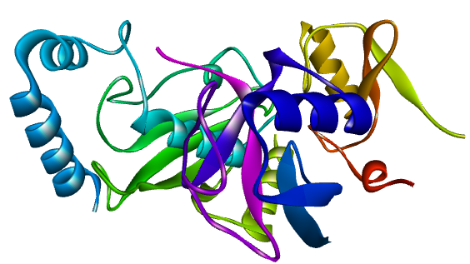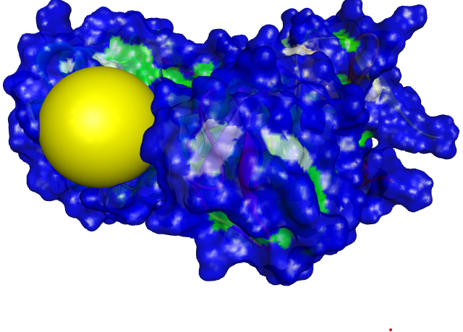
(a) Cartoon model (b) Surface model with the active site coloured in yellow

Figure 1: Visualisation of the Human MDM2-G443T RING Domain (PDB ID: 7AI0)
2.2 Ligand Selection and Preparation
In this study, GC-MS analysis of Allium sativum (garlic) phenolic extract revealed 154 bioactive compounds, whose 3D structures were downloaded from the PubChem database (https://pubchem.ncbi.nlm.nih.gov/). These compounds were initially provided in the SDF format and subsequently converted to PDB format using Open Babel GUI software for compatibility with molecular docking tools [20].
2.3 Molecular Docking
Molecular docking was conducted using iGEMDock version 2.1 due to its superior performance in reproducing the binding conformation of co-crystallised ligands within the MDM2 RING domain (PDB ID: 7AI0), compared to other widely used software such as AutoDock Vina, Schrödinger Glide, MOE, and Sybyl-X during preliminary validation studies. iGEMDock demonstrated the highest structural similarity and pose accuracy relative to the experimentally resolved binding orientation, which justified its selection for this study. The docking protocol employed the “prepare binding site” function, with an 8.0 Å grid radius centred on the active site. Parameters were optimised with a population size of 800, 80 generations, and 10 solutions per ligand to ensure adequate conformational sampling and accurate prediction of binding affinity and orientation [18, 21].
2.4 Pharmacokinetic and Toxicological Prediction
2.4.1 Drug-likeness Prediction
Lipinski's Rule of Five (Ro5) was used to evaluate the drug-likeness properties of the compounds [22,23]. This evaluation was done using pkCSM and ADMETLab 3.0 [24,25]. The Ro5 considers essential molecular properties critical for oral bioavailability, including molecular weight, octanol-water partition coefficient (logP), and hydrogen bond acceptors and donors [23]. This criterion, a refinement of drug-likeness, aids in predicting whether a compound possesses the pharmacological or biological activity suitable for oral administration in humans.
2.5.2 Absorption, Distribution, Metabolism, Excretion, and Toxicity (ADMET) Prediction
The evaluation of small molecules in medicinal chemistry and pharmacokinetics necessitates critical ADMET studies [24, 25]. pkCSM and ADMETLab 3.0 were used to investigate the ADMET properties of possible therapeutic candidates. Key parameters such as Caco-2 permeability, human intestinal absorption, P-glycoprotein, blood-brain barrier, cytochrome P450 enzyme, half-life, total clearance, acute oral toxicity, genotoxicity, carcinogenicity, cytotoxicity, neurotoxicity, hepatotoxicity, haematotoxicity, nephrotoxicity, and cardiotoxicity were assessed [26,27,28]. This was done by entering the Simplified Molecular Input Line Entry System (SMILES) of the ligands from PubChem into the web servers pkCSM and ADMETLab 3.0, respectively.
2.6 Molecular Mechanics (MM-GBSA)
MM-GBSA analysis was performed using the Prime MM-GBSA tool in Maestro version 12.5 to calculate the relative binding free energies of each ligand. This method decomposes energy contributions (electrostatic interactions, van der Waals forces, hydrogen bonds, and solvation energies) to determine binding free energy [18]. The binding free energy (ΔG_bind) was calculated as:
ΔGbind = ΔEMM ​+ ΔGGB ​+ ΔGSA. ​
where ΔEMM equals Eele (electrostatic energy) + Evdw (van der Waals energy) + EHbond (hydrogen bond energy) + Eint (torsional angle energy) and represents molecular mechanical energy, ΔGGB is the polar solvation energy, and ΔGSA is the nonpolar solvation energy. The findings from this analysis provided insight into the stability of binding of each ligand [19,29].
3.0 RESULT AND DISCUSSION
3.1 Molecular Docking
Molecular docking was used to evaluate the binding potential of 154 bioactive compounds identified from Allium sativum via GC-MS analysis against the MDM2 (PDB ID: 7AI0) protein target. Using iGEMDock, all ligands were docked into the predicted active site of MDM2 to assess their binding affinities relative to the standard drug, doxorubicin. Following the initial screening, compounds with binding energies lower than that of doxorubicin (indicating stronger binding affinity) were selected. Sixteen compounds met this criterion and were advanced for further analysis, as shown in Table 1 and Figure 2.

Table 1: Binding Energies of Doxorubicin and the 16 Hit Bioactive Compounds on Igemdock.
S/N | Compound Identifier | Binding affinity  (iGEMDock) Kcal/mol)
1 | Doxorubicin (Standard Drug) | -6.97
2 | Gallic acid | -8.74
3 | cis-13,16-Docosadienoic acid | -8.71
4 | p-Toluic acid, heptadecyl ester | -8.67
5 | 1,6,10,18,22-tetracosahexaen-3-ol | -8.36
6 | Phosphine, tridodecyl | -8.32
7 | 4,4'-(5-Iodofurfurylidene)bis(antipyrine) | -8.29
8 | 7-Chloro-1-[(E)-heptylimino]-10-hydroxy-3-(3-trifluoromethyl-phenyl)-1,3,4,10-tetrahydro-2H-acridin-9-one | -8.26
9 | Sarcosine, N-isobutyryl-, octadecyl ester | -8.23
10 | 1,15-Di(1-phenylpropyl)-2,2,4,4,6,6,8,8,10,10,12,12,14,14-tetradecamethyl-1,3,5,7,9,11,13,15-octaoxa-2,4,6,8,10,12,14-heptasilapentadecane | -8.21
11 | 2-Bromo-1,3-bis(dicyclohexylaminomethyl)benzene | -8.09
12 | 4-Pyrrol3-[1-(2-carboxy-1-phenyl-ethyl)-2-oxo-pyrrolidin-3-ylcarbamoyl]-propionylmorpho-piperazine-1-carboxylic acid tert-butyl ester | -7.94
13 | Azastreptonigrin | -7.91
14 | Beta-Carotene | -7.67
15 | Cholestan-6-en-3-ol, O-acetyl-24-methyl-5,8-(tetrahydrofuran-2,5-dione-3,4-diyl) | -7.53
16 | Nonacos-1-ene | -7.39
17 | Octasiloxane, 1,1,3,3,5,5,7,7,9,9,11,11,13,13,15,15-hexadecamethyl | -7.14

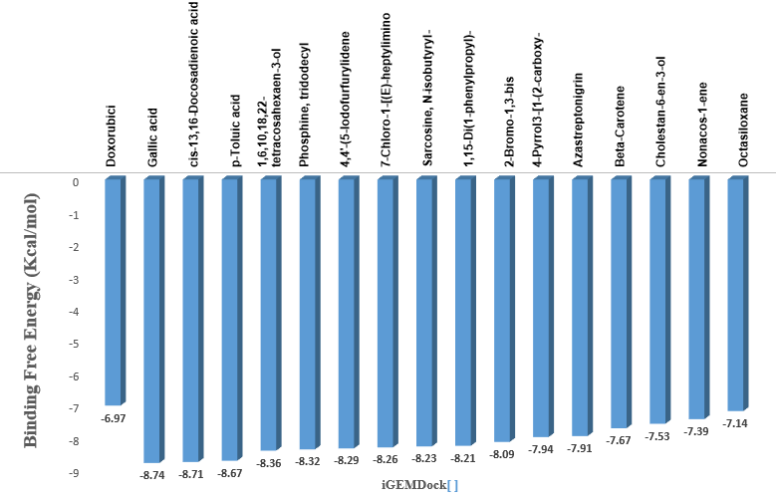
Figure 2: Binding Energies of Doxorubicin and the 16 Hit Compounds on iGEMDock.
As presented in Table 1, doxorubicin exhibited a binding affinity of −6.97 kcal/mol. In contrast, several compounds demonstrated stronger interactions. Gallic acid showed the highest binding affinity at −8.74 kcal/mol, followed closely by cis-13,16-docosadienoic acid (−8.71 kcal/mol) and p-toluic acid, heptadecyl ester (−8.67 kcal/mol). Other notable compounds included 1,6,10,18,22-tetracosahexaen-3-ol (−8.36 kcal/mol), phosphine, tridodecyl (−8.32 kcal/mol), and 4,4′-(5-iodofurfurylidene)bis(antipyrine) (−8.29 kcal/mol). The remaining selected ligands also displayed favourable docking scores, ranging from −8.26 to −7.14 kcal/mol (as shown in Appendix Table 6), indicating stronger receptor-ligand interactions compared to the standard compound. Figure 2 illustrates the comparative binding energies of these compounds, clearly demonstrating that all 16 hits outperformed doxorubicin.
The top three compounds—gallic acid, cis-13,16-docosadienoic acid, and p-toluic acid heptadecyl ester—were prioritised due to their superior docking scores and strong spatial complementarity within the MDM2 binding pocket. These results align with previous experimental studies reporting gallic acid’s capacity to induce apoptosis and modulate the p53-MDM2 axis in osteosarcoma models [30]. Additionally, phytochemicals from Allium sativum, including allicin and diallyl disulphide, have demonstrated antitumour effects in breast, colon, and prostate cancers, reinforcing their broader therapeutic potential [31,32]. Although garlic-derived MDM2 inhibitors have not been extensively characterised, their multitargeted activity and low toxicity profiles offer advantages over synthetic agents such as nutlin-3, idasanutlin, siremadlin, and milademetan, which are limited by poor tolerability and narrow therapeutic windows [33]. While machine learning-enhanced docking models are gaining attention for boosting predictive accuracy in virtual screening, the structure-based methods employed in this study remain robust and well-validated.
3.2 Pharmacokinetic and Toxicological Prediction
3.2.1 Drug-likeness Prediction
The 16 hit bioactive compounds identified from the molecular docking analysis were screened for oral drug-likeness using Lipinski’s Rule of Five (Ro5). This evaluation was used to eliminate compounds with suboptimal physicochemical properties that may impair absorption or bioavailability. The results are summarised in Table 2.
Table 2: Drug-likeness (Rule of 5) evaluation and physicochemical properties of Doxorubicin and the 16 hit bioactive compounds.
Ligands | Molecular  Weight | H-bond donor | H-bond acceptor | Log p | Inference
Compound ID | < 500 | < 5 | < 10 | < 5 | MEET R05
Doxorubicin (Standard Drug) | 543.17 | 7.0 | 12.0 | 1.208 | Rejected
Gallic acid | 170.02 | 4.0 | 5.0 | 0.692 | Accepted
cis-13,16-Docosadienoic acid | 350.32 | 0.0 | 2.0 | 8.404 | Accepted
p-Toluic acid, heptadecyl ester | 374.32 | 0.0 | 2.0 | 9.253 | Accepted
1,6,10,18,22-tetracosahexaen-3-ol | 426.39 | 1.0 | 1.0 | 9.739 | Accepted
Phosphine, tridodecyl | 586.55 | 0.0 | 3.0 | 3.228 | Accepted
4,4’-(5-Iodofurfurylidene)bis(antipyrine) | 580.1 | 0.0 | 7.0 | 2.137 | Accepted
7-Chloro-1-[(E)-heptylimino]-10-hydroxy-3-(3-trifluoromethyl-phenyl)-1,3,4,10-tetrahydro-2H-acridin-9-ol | 519.19 | 1.0 | 5.0 | 4.095 | Accepted
Sarcosine, N-isobutyryl-, octadecyl ester | 411.37 | 0.0 | 4.0 | 6.556 | Accepted
1,15-Di(1-phenylpropyl)-2,2,4,4,6,6,8,8,10,10,12,12,14,14-tetradecamethyl-1,3,5,7,9,11,13,15-octaoxa-2,4,6,8,10,12,14-heptasilapentadecane | 772.3 | 0.0 | 8.0 | 8.757 | Rejected
2-Bromo-1,3-bis(dicyclohexylaminomethyl)benzene | 542.32 | 0.0 | 2.0 | 6.845 | Rejected
4-Pyrrol3-[1-(2-carboxy-1-phenyl-ethyl)-2-oxo-pyrrolidin-3-ylcarbamoyl]-propionyl | 516.26 | 2.0 | 11.0 | 1.018 | Rejected
Azastreptonigrin | 547.21 | 5.0 | 12.0 | 0.223 | Rejected
Beta-Carotene | 536.44 | 0.0 | 0.0 | 13.335 | Rejected
Cholestan-6-en-3-ol, O-acetyl-24-methyl-5,8-[tetrahydrofuran-2,5-dione-3,4-diyl | 540.38 | 0.0 | 5.0 | 7.763 | Rejected
Nonacos-1-ene | 406.45 | 0.0 | 0.0 | 9.834 | Accepted
Octasiloxane, 1,1,3,3,5,5,7,7,9,9,11,11,13,13,15,15-hexadecamethyl | 576.16 | 0.0 | 7.0 | 9.559 | Rejected

Out of the 16 compounds, only 9—gallic acid, cis-13,16-docosadienoic acid, p-toluic acid, heptadecyl ester, 1,6,10,18,22-tetracosahexaen-3-ol, phosphine, tridodecyl, 4,4′-(5-iodofurfurylidene)bis(antipyrine), 7-chloro-1-[(E)-heptylimino] -10-hydroxy-3-(3-trifluoromethyl-phenyl) -1,3,4,10-tetrahydro-2H-acridin-9-ol, sarcosine, N-isobutyryl-, octadecyl ester, and nonacos-1-ene—met the critical Ro5 criteria (as shown in Table 2). These compounds complied with the acceptable limits for molecular weight (<500 Da), hydrogen bond donors (<5), hydrogen bond acceptors (<10), and log P (<5), indicating favourable oral bioavailability.
In contrast, 7 compounds were excluded for violating one or more Ro5 thresholds. These rejections were primarily due to high molecular weight, excessive hydrogen bonding capacity, or log P values beyond optimal lipophilicity ranges. These findings align with previous studies that associate poor membrane permeability and low oral absorption with increased molecular size and polar surface area [34]. The remaining 9 compounds with acceptable physicochemical profiles were subjected to ADMET prediction to further assess their pharmacokinetic performance and safety potential.
3.2.2 ADMET Prediction
The 9 selected compounds that passed the drug-likeness screening were evaluated for ADMET properties using in-silico prediction tools. The standard drug doxorubicin was included as a reference for comparison. The ADMET results are presented in Table 3.
Among the 9 compounds, gallic acid, cis-13,16-docosadienoic acid, and p-toluic acid, heptadecyl ester, demonstrated excellent pharmacokinetic profiles, exhibiting superior Caco-2 permeability and high human intestinal absorption (HIA) compared to doxorubicin, which showed poor absorption parameters. These three also displayed favourable blood–brain barrier permeability, and none were predicted to inhibit P-glycoprotein, indicating a lower risk of efflux-mediated drug resistance. Regarding metabolism, all three compounds showed no inhibitory effects on major cytochrome P450 enzymes—CYP2D6, CYP3A4, CYP1A2, CYP2C19, and CYP2C9—suggesting a minimal risk of metabolic drug–drug interactions. This is important for patients undergoing multi-drug regimens in cancer therapy. Their excretion profiles were also favourable, with moderate to excellent predicted clearance and acceptable half-lives (Gallic acid: 2.2 hours; cis-13,16-docosadienoic acid: 0.8 hours; p-Toluic acid, heptadecyl ester: 2.1 hours), suggesting efficient elimination with minimal accumulation potential.
Toxicological screening indicated that these three compounds were non-carcinogenic, non-genotoxic, and non-cytotoxic, with no predicted risks of hepatotoxicity, nephrotoxicity, neurotoxicity, or cardiotoxicity. In contrast, doxorubicin showed multiple predicted toxicities, including hepatotoxicity and cardiotoxicity, which correlate with its known clinical limitations [35]. Based on the overall ADMET profiles (as shown in Table 3), gallic acid, cis-13,16-docosadienoic acid, and p-toluic acid, heptadecyl ester, emerged as the most promising candidates for further optimisation. Their high absorption, metabolic safety, effective excretion, and non-toxic profiles are in agreement with earlier studies supporting the therapeutic potential of plant-derived compounds in anticancer drug development [36]. These three compounds were therefore advanced to molecular mechanics analyses to evaluate their binding energy and structural stability with MDM2.

Table 3: ADMET properties of Doxorubicin and the 9 hit bioactive compounds.

Ligands | Absorption |  |  | Distribution | Metabolism |  |  |  |  | Excretion |  | Toxicity
Compound Identifier | Caco2 permeability | Human Intestinal absorption | P-glycoprotein Inhibitor | Blood Brain Barrier | CYP2D6 | CYP3A4 | CYP1A2 | CYP2C19  CYP2C19 | CYP2C9 | Half-life | Total Clearance | Acute oral toxicity | Cytotoxicity | Carcinogenicity | Cardiotoxicity | Genotoxicity | Hematoxicity | Hepatoxicity | Nephrotoxicity | Neurotoxicity
Doxorubicin (Standard Drug) | P | P | P | E | E | E | E | E | E | 3.8 | M | P | P | P | P | P | P | P | P | M
Gallic acid | E | E | E | E | E | E | E | E | E | 2.2 | E | E | E | E | E | M | E | E | E | E
cis-13,16-Docosadienoic acid | E | E | E | E | E | E | E | E | E | 0.8 | E | E | E | E | E | E | E | M | E | E
p-Toluic acid, heptadecyl ester | E | E | E | E | E | E | E | E | E | 2.1 | E | E | E | E | E | E | E | M | E | E
1,6,10,18,22-Tetracosahexaen-3-Ol,2,6,10,15,19,23-Hexamethyl | E | E | E | E | E | E | E | E | E | 0.7 | E | E | E | E | E | E | E | P | P | M
Phosphine, tridodecyl | E | M | E | E | M | M | E | M | M | 3.1 | M | E | E | P | P | E | E | P | P | E
4,4’-(5-Iodofurfurylidene)bis(antipyrine) | E | E | E | P | E | E | P | E | E | 1.0 | E | M | E | M | M | E | M | M | M | P
7-Chloro-1-[(E)-heptylimino]-10-hydroxy-3-(3-trifluoromethyl-phenyl)-1,3,4,10-tetrahydro-2H-acridin-9-o | E | E | E | P | E | E | E | E | E | 1.1 | E | P | M | E | P | M | E | P | P | P
Sarcosine, N-isobutyryl-, octadecyl ester | E | E | E | E | E | E | P | P | E | 0.8 | E | E | M | E | E | E | E | E | E | M
Nonacos-1-ene | E | P | E | E | E | E | P | P | E | 3.3 | M | E | E | E | P | E | E | M | E | E
Where E = Excellent M = Medium P = Poor

3.3 Molecular Mechanics
To further refine and validate the selection of lead compounds, MM-GBSA binding free energy calculations were performed for the top three ligands identified from ADMET analysis—gallic acid, cis-13,16-docosadienoic acid, and p-toluic acid, heptadecyl ester—in comparison to the standard drug, doxorubicin. The MM-GBSA values, including contributions from van der Waals forces, covalent bonding, hydrogen bonding, and polar solvation, are summarised in Table 4, with corresponding graphical representations shown in Figure 3a and Figure 3b.

As shown in Table 4, Gallic acid exhibited the most favourable overall binding energy at −8.74 kcal/mol, followed by cis-13,16-docosadienoic acid (−8.71 kcal/mol) and p-Toluic acid, heptadecyl ester (−8.67 kcal/mol), all of which were superior to doxorubicin (−6.97 kcal/mol). These enhanced affinities are primarily driven by stronger van der Waals interactions (−48.92 kcal/mol for gallic acid, −40.11 kcal/mol for cis-13,16-docosadienoic acid, and −38.43 kcal/mol for p-toluic acid, heptadecyl ester) compared to −27.41 kcal/mol for doxorubicin. Furthermore, covalent interactions and polar solvation energies contributed significantly to ligand stability, with gallic acid showing the highest covalent bond energy (6.08 kcal/mol) and favourable polar solvation (38.17 kcal/mol), also outperforming doxorubicin in both categories (3.35 and 19.92 kcal/mol, respectively). Hydrogen bonding contributions also supported overall binding, particularly in gallic acid (−4.07 kcal/mol) versus doxorubicin (−2.83 kcal/mol).
Table 4: MM-GBSA binding free energies of Doxorubicin and the 3 lead bioactive compounds.
Ligands | MMGBSA ΔG  Bind H-bond  (Kcal/mol) | MMGBSA ΔG  Bind Covalent bond  (Kcal/mol) | MMGBSA ΔG  Bind Vander Waal Forces  (Kcal/mol) | MMGBSA ΔG  Bind Polar Solvation  (Kcal/mol) | MMGBSA ΔG  Overall Binding  Energy (Kcal/mol)
Doxorubicin | -2.83 | 3.35 | -27.41 | 19.92 | -6.97
Gallic acid | -4.07 | 6.08 | -48.92 | 38.17 | -8.74
cis-13,16-Docosadienoic acid | -1.36 | 7.09 | -40.11 | 25.67 | -8.71
p-Toluic acid, heptadecyl ester | -1.02 | 9.71 | -38.43 | 21.07 | -8.67

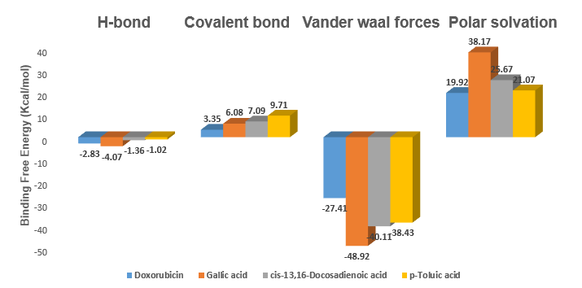Figure 3a: MMGBSAΔG Bind H-bond, Covalent bond, Vander waal forces, and Polar solvation of Doxorubicin and the 3 lead bioactive compounds in Maestro 12.5

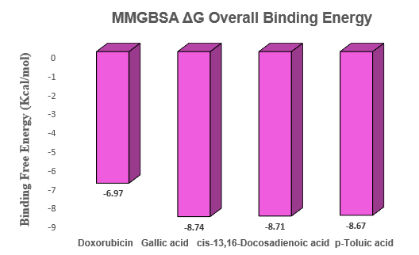
Figure 3b: MMGBSAΔG overall binding energy for Doxorubicin and the 3 lead bioactive compounds in Maestro 12.5.
Table 5: Binding affinities, interactions, and 3D structures of Doxorubicin and the three lead bioactive compounds.
Compound  Identifier | H-bond interaction | Other  Interactions | 3-D structure
Doxorubicin  (Standard Drug) | Lys6, Glu9, Cys11, Asp12, Arg15, Glu436. | Arg5, Lys8, Thr9, Gly10, Thr12, Leu13, Asp16, Thr98, Leu432, Asn433, Val439, Glu442. | 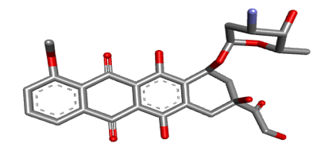
Gallic acid | Pro25. | Arg22, Ala23, Gly24, Val26, Gln34, Ala35, Thr36, Phe51. | 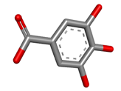
cis-13,16-Docosadienoic acid | Asp116 | Phe45, Ala46, Lys48, Gln49, Leu50, Tyr59, Asn60, Gln62, Arg74, Cys111, Asp112, Pro113, Asn114, Pro115, Asp116, Tyr127. | 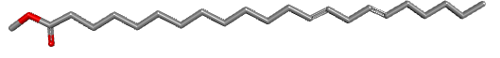
p-Toluic acid,  heptadecyl ester | - | Phe45, Ala46, Lys48, Gln49, Tyr59, Asp60, Gln62, Cys111, Asp112, Pro113, Arg74, Pro115, Asp116. | 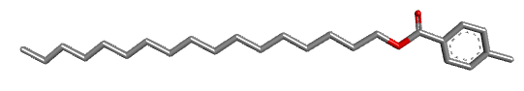

(4a) 7AI0_Doxorubicin

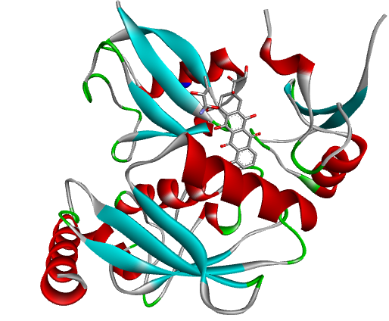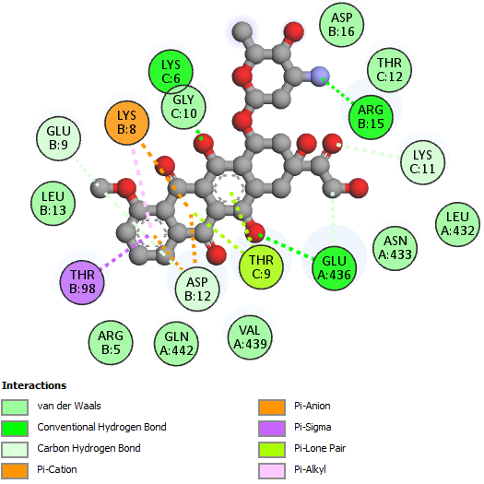

(4b) 7AI0_ Gallic acid

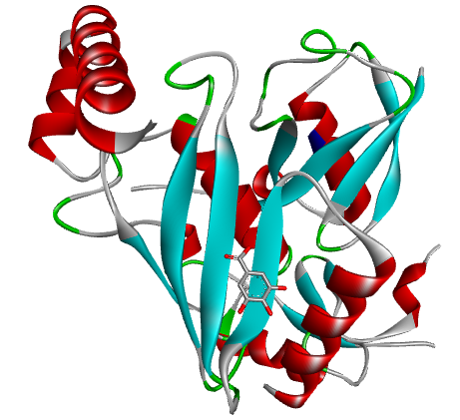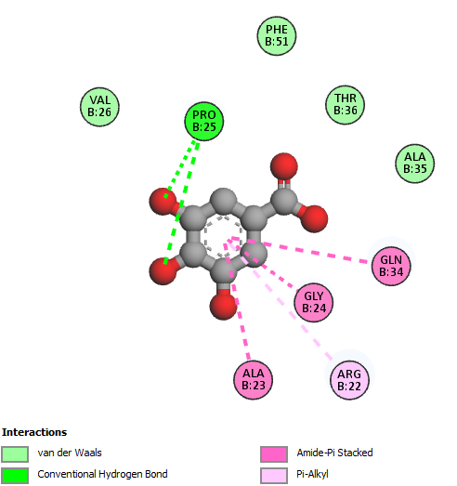

(4C) 7AI0_ Cis-13,16-Docosadienoic acid
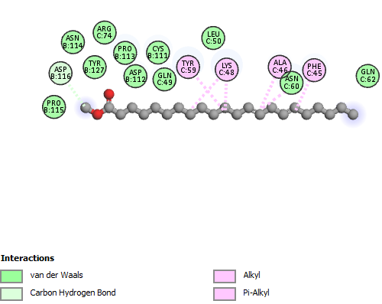

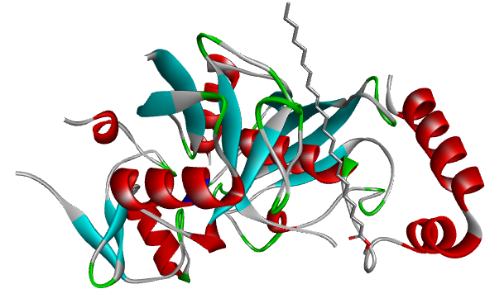

(4d) 7AI0_ p-Toluic acid, heptadecyl ester
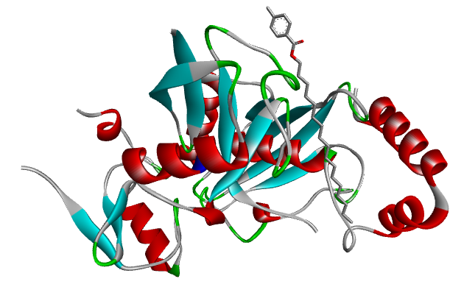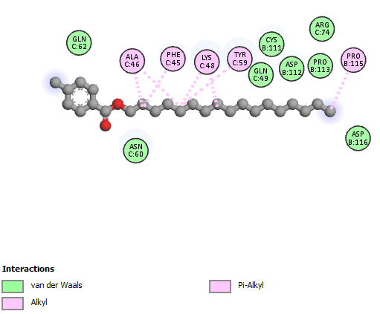

Figure 4: Molecular interaction between Doxorubicin and the 3 lead bioactive compounds at the active site of human mouse double minute 2 homolog (MDM2) G443T RING domain (7AI0) (A) Doxorubicin (Standard drug) (b) Gallic acid (c) Cis-13,16-Docosadienoic acid (d) p-Toluic acid, heptadecyl ester. The structures were rendered using Biovia Discovery Studio 2021.

Interaction analysis further revealed distinct amino acid contributions that account for these energy differences (Table 5 and Figure 4a–4d). Gallic acid formed a key hydrogen bond with Pro25 and stabilised within the MDM2 binding pocket through interactions with Arg22, Ala23, Gly24, Val26, Gln34, Ala35, Thr36, and Phe51. Cis-13,16-docosadienoic acid established a hydrogen bond with Asp116 and additional van der Waals contacts involving residues such as Phe45, Lys48, Gln49, Tyr59, and Asp112. P-Toluic acid, heptadecyl ester, despite lacking hydrogen bonds, maintained strong hydrophobic and electrostatic interactions with similar key residues. These residue-specific interactions are critical for anchoring ligands at the MDM2 active site, and similar stabilisation patterns for gallic acid have been reported in previous in-silico studies [37]. The structural consistency observed here supports their potential as selective binders within the p53-MDM2 interface.
In comparison, doxorubicin engaged multiple residues, including Lys6, Glu9, Cys11, and Glu436, but with weaker overall energetic contributions (Table 5, Figure 4a). These observations are in line with previous computational studies highlighting the limitations of conventional drugs in disrupting MDM2-p53 binding effectively [38]. Emerging natural compounds from Allium sativum have demonstrated broad anticancer activity, primarily via apoptotic and anti-proliferative mechanisms, though their direct modulation of MDM2 is less studied. Synthetic inhibitors such as siremadlin and milademetan, currently in clinical trials, face challenges including dose-limiting toxicity and suboptimal selectivity in solid tumours [39]. As molecular mechanics approaches evolve—with improved solvation models and energy scoring—compound prioritisation has become more reliable [40]. In this study, the stronger binding stability of gallic acid, cis-13,16-docosadienoic acid, and p-toluic acid, heptadecyl ester highlights their potential as lead MDM2 inhibitors for future therapeutic development in osteosarcoma.
4.0 CONCLUSION
This study investigated 154 GC-MS-identified phytochemicals from Allium sativum for their inhibitory potential against MDM2, a validated oncogenic target in osteosarcoma. Using an integrated computer-aided drug discovery approach comprising molecular docking, physicochemical screening, pharmacokinetic and toxicity prediction, and MM-GBSA binding free energy estimation, gallic acid, cis-13,16-docosadienoic acid, and p-toluic acid, heptadecyl ester, were identified as the most promising MDM2 inhibitors. These compounds exhibited superior binding affinity, favourable pharmacokinetic profiles, and enhanced receptor-binding stability compared to the standard drug doxorubicin. The findings contribute to the development of safer, plant-derived therapeutic candidates for osteosarcoma therapy and provide a rational basis for future experimental validation, including structural optimisation and formulation strategies to address potential limitations in oral bioavailability and clinical applicability.

GLOSSARY
Abbreviation | Meaning
2D | Two-Dimensional
3D | Three-Dimensional
ADMET | Absorption, Distribution, Metabolism, Excretion, and Toxicity
AMES | Ames Mutagenicity Test
BBB | Blood Brain Barrier
CADD | Computer-Aided Drug Design
CYP | Cytochrome P450
GC-MS | Gas Chromatography–Mass Spectrometry
HBA | Hydrogen Bond Acceptors
HBD | Hydrogen Bond Donors
hERG | Human Ether-à-go-go Related Gene
HIA | Human Intestinal Absorption
iGEMDock | Generic Evolutionary Method for Molecular Docking
LogP | Logarithm of Octanol–Water Partition Coefficient
MD | Molecular Dynamics
MDM2 | Murine Double Minute 2 Homolog
MM-GBSA | Molecular Mechanics Generalised Born Surface Area
MW | Molecular Weight
PDB | Protein Data Bank
pkCSM | Pharmacokinetics of Small Molecules
Ro5 | Rule of Five
SBDD | Structure-Based Drug Design

LIMITATIONS
As the study was computational and self-funded, no experimental validation using synthesis and characterization, in vitro and in vivo assays of Gallic acid, cis-13,16-docosadienoic acid, and p-Toluic acid heptadecyl ester could be performed.
Disclaimer (Artificial intelligence)The authors acknowledge the use of generative AI technologies during the preparation and editing of this manuscript. Specifically, Grammarly’s paraphrasing and grammar-checking tools were utilized to enhance the clarity, coherence, and grammatical accuracy of the text. These tools were applied to refine sentence structure, streamline ideas, and ensure the manuscript adhered to high linguistic standards.
Details of AI Usage:
- Generative AI Tool Used: Grammarly Paraphrasing and Grammar Checking Tool
- Purpose of Usage: To improve paraphrasing, summarization, and grammatical accuracy throughout the manuscript.
- Prompts Used: The authors provided original content, particularly sections such as the Methodology and Results, for Grammarly to refine in terms of grammar and coherence.
Following the use of these tools, the authors meticulously reviewed and edited the content to ensure it met the scientific rigor and accuracy required for publication. The authors take full responsibility for the integrity, originality, and quality of the final manuscript.

REFERENCES
- Isakoff MS, Bielack SS, Meltzer P, Gorlick R. (2015). “Osteosarcoma: Current treatment and a collaborative pathway to success.” Journal of Clinical Oncology, 33(27):3029–3035. https://doi.org/10.1200/JCO.2014.59.4895
- Kansara M, Teng MW, Smyth MJ, Thomas DM. (2014). “Translational biology of osteosarcoma.” Nature Reviews Cancer, 14(11):722–735. https://doi.org/10.1038/nrc3838
- Marina N, Gebhardt M, Teot L, Gorlick R. (2004). “Biology and therapeutic advances for pediatric osteosarcoma.” Oncologist, 9(4):422–441. https://doi.org/10.1634/theoncologist.9-4-422
- Luetke A, Meyers PA, Lewis I, Juergens H. (2014). “Osteosarcoma treatment—Where do we stand? A state of the art review.” Cancer Treatment Reviews, 40(4):523–532. https://doi.org/10.1016/j.ctrv.2013.11.006
- Yao Y, Zhang Q, Li Z, Zhang H. MDM2: Current research status and prospects of tumor treatment. Cancer Cell Int. 2024;24(1). https://doi.org/10.1186/s12935-024-03356-8
- Arena G, Riscal R, Linares LK, Le Cam L. MDM2 controls gene expression independently of p53 in both normal and cancer cells. Cell Death Differ. 2018;25(9):1533–1535. https://doi.org/10.1038/s41418-018-0156-x
- Chou AJ, Geller DS, Gorlick R. (2008). “Therapy for osteosarcoma: Where do we go from here?” Paediatric Drugs, 10(5):315–327. https://doi.org/10.2165/00148581-200810050-00005
- Momand J, Zambetti GP, Olson DC, George D, Levine AJ. (1992). “The mdm-2 oncogene product forms a complex with the p53 protein and inhibits p53-mediated transactivation.” Cell, 69(7):1237–1245. https://doi.org/10.1016/0092-8674(92)90644-R
- Secchiero, P., Bosco, R., Celeghini, C., and Zauli, G. (2011). Recent Advances in the Therapeutic Perspectives of Nutlin-3. Current Pharmaceutical Design, 17(6), 569–577. https://doi.org/10.2174/138161211795222586
- Khurana, A., and Shafer, D. A. (2019). MDM2 antagonists as a novel treatment option for acute myeloid leukemia: Perspectives on the therapeutic potential of idasanutlin (RG7388). OncoTargets and Therapy, 12, 2903–2910. https://doi.org/10.2147/OTT.S172315
- Cragg GM, Grothaus PG, Newman DJ. (2009). “Impact of natural products on developing new anti-cancer agents.” Chemical Reviews, 109(7):3012–3043. https://doi.org/10.1021/cr900019j
- Aggarwal BB, Shishodia S. (2006). “Molecular targets of dietary agents for prevention and therapy of cancer.” Biochemical Pharmacology, 71(10):1397–1421. https://doi.org/10.1016/j.bcp.2006.02.009
- Bayan L, Koulivand PH, Gorji A. (2014). “Garlic: A review of potential therapeutic effects.” Avicenna Journal of Phytomedicine, 4(1):1–14. https://pubmed.ncbi.nlm.nih.gov/25050296/
- Amagase H. (2006). “Clarifying the real bioactive constituents of garlic.” Journal of Nutrition, 136(3 Suppl):716S–725S. https://doi.org/10.1093/jn/136.3.716S
- Lionta E, Spyrou G, Vassilatis DK, Cournia Z. (2014). “Structure-based virtual screening for drug discovery: Principles, applications and recent advances.” Current Topics in Medicinal Chemistry, 14(16):1923–1938. https://doi.org/10.2174/1568026614666140929124445
- Meng XY, Zhang HX, Mezei M, Cui M. (2011). “Molecular docking: A powerful approach for structure-based drug discovery.” Current Computer-Aided Drug Design, 7(2):146–157. https://doi.org/10.2174/157340911795677602
- Hospital A, Andrio P, Cugnasco C, Codo L, Becerra Y, Dans PD, et al. (2012). “MDWeb and MDMoby: An integrated web-based platform for molecular dynamics simulations.” Bioinformatics, 28(9):1278–1279. https://doi.org/10.1093/bioinformatics/bts139
- Atanda, O. E., Olaniyan, L. W. B., Fadare, O. A., Ehigie, A. F., Adisa, T. A., Odunitan, T. T., Alabi, O. T., Omonijo, B. A., Aloba, G. O., and Ehigie, L. O. (2024). “In-silico evaluation of phenylisocytosine and its analogs as potent inhibitors of Plasmodium falciparum transketolase: A strategic approach in anti-malarial drug discovery”. International Journal of Biochemistry Research and Review, 33 (6):616-36. https://doi.org/10.9734/ijbcrr/2024/v33i6941.
- Olaniyan, L. W. B., Ehigie, L. O., Ehigie, A. F., Atanda, O.E., Odunitan, T. T., and Fakuade, A. A. (2024). In silico investigation of indenoimidazole derivatives as promising arsenal against methicillin resistant staphylococcus aureus through staphylococcal protein A inhibition. European Journal of Biomedical, 11(6), 04-16. Issn 2349-8870
- O'Boyle, N. M., Banck, M., James, C. A., Morley, C., Vandermeersch, T., and Hutchison, G. R. (2011). Open babel: An open chemical toolbox. Journal of Cheminformatics, 3(1), 1-14. https://doi.org/10.1186/1758-2946-3-33
- Oyedele, A. Q. K., Adelusi, T. I., Ogunlana, A. T., Adeyemi, R. O., Atanda, O. E., Babalola, M. O., and Boyenle, I. D. (2022). Integrated virtual screening and molecular dynamics simulation revealed promising drug candidates of p53-MDM2 interaction. Journal of Molecular Modeling, 28(6), 142.https://doi.org/10.1007/s00894-022-05131-w
- Lipinski, C. A. (2004). Lead-and drug-like compounds: The rule-of-five revolution. Drug Discovery today: Technologies, 1(4), 337-341. https://doi.org/10.1016/j.ddtec.2004.11.007
- Chen, X., Li, H., Tian, L., Li, Q., Luo, J., and Zhang, Y. (2020). Analysis of the physicochemical properties of acaricides based on Lipinski's rule of five. Journal of Computational Biology, 27(9), 1397-1406. https://doi.org/10.1089/cmb.2019.0323

- Fu, L., Shi, S., Yi, J., Wang, N., He, Y., Wu, Z., ... and Cao, D. (2024). ADMETlab 3.0: An updated comprehensive online ADMET prediction platform enhanced with broader coverage, improved performance, API functionality and decision support. Nucleic Acids Research, gkae236. https://doi.org/10.1093/nar/gkae236
- Pires, D. E., Blundell, T. L., and Ascher, D. B. (2015). pkCSM: Predicting small-molecule pharmacokinetic and toxicity properties using graph-based signatures. Journal of Medicinal Chemistry, 58(9), 4066-4072. https://doi.org/10.1021/acs.jmedchem.5b00104
- Daoud, N. E. H., Borah, P., Deb, P. K., Venugopala, K. N., Hourani, W., Alzweiri, M., ... and Tiwari, V. (2021). ADMET profiling in drug discovery and development: Perspectives of in silico, in vitro and integrated approaches. Current Drug Metabolism, 22(7), 503-522. https://doi.org/10.2174/1389200222666210705122913
- Babalola, M. O., Ashiru, M. A., Boyenle, I. D., Atanda, E. O., Oyedele, A. Q. K., Dimeji, Y., ... and Imaga, N. A. (2022). In vitro analysis and molecular docking of gas chromatography-mass spectroscopy fingerprints of polyherbal mixture reveals significant antidiabetic miture. Nigerian Journal of Experimental and Clinical Biosciences, 10(4), 105-115. https://doi.org/10.4103/njecp.njecp_15_22
- Kehinde, O. A. Q., Boyenle, D. I., Ogunlana, A., Ayoola, M. A., Atanda, O.E., and Adelusi, T.I. (2022). Inhibitors of α-glucosidase and angiotensin-converting enzyme in the treatment of type 2 diabetes and its complications: A review on in silico approach. Pharmaceutical and Biomedical Research, 8(4), 237-258. http://dx.doi.org/10.32598/PBR.8.4.1052.1
- Ajao, F. O., Ehigie, A. F., Odunitan, T. T., Atanda, O. E., Ayoola, P. B., and Olaniyan, L. W. (2024). Computational exploration of psidii guajavae folium bioactive compounds as novel Dpp-Iv inhibitors for type 2 diabetes mellitus intervention. Issn 2394-3211
- Talib, W. H., Daoud, S., Mahmod, A. I., Hamed, R. A., Awajan, D., Abuarab, S. F., ... and Al Kury, L. T. (2022). Plants as a source of anticancer agents: From bench to bedside. Molecules, 27(15), 4818. https://doi.org/10.3390/molecules27154818
- Mondal, A., Banerjee, S., Bose, S., Mazumder, S., Haber, R. A., Farzaei, M. H., and Bishayee, A. (2022). Garlic constituents for cancer prevention and therapy: From phytochemistry to novel formulations. Pharmacological Research, 175, 105837. https://doi.org/10.1016/j.phrs.2021.105837
- Talib, W. H., Atawneh, S., Shakhatreh, A. N., Shakhatreh, G. A. N., Hamed, R. A., and Al-Yasari, I. H. (2024). Anticancer potential of garlic bioactive constituents: Allicin, Z-ajoene, and organosulfur compounds. Pharmacia, 71, 1-23. https://doi.org/10.3897/pharmacia.71.e114556
- Twarda-Clapa, A. (2024). An update patent review of MDM2–p53 interaction inhibitors (2019–2023). Expert Opinion on Therapeutic Patents, 34(12), 1177-1198. https://doi.org/10.1080/13543776.2024.2419836
- Negru, P. A., Miculas, D. C., Behl, T., Bungau, A. F., Marin, R. C., and Bungau, S. G. (2022). Virtual screening of substances used in the treatment of SARS-CoV-2 infection and analysis of compounds with known action on structurally similar proteins from other viruses. Biomedicine and Pharmacotherapy, 153, 113432. https://doi.org/10.1016/j.biopha.2022.113432
- Tian, S., Wang, J., Li, Y., Li, D., Xu, L., and Hou, T. (2015). The application of in silico drug-likeness predictions in pharmaceutical research. Advanced Drug Delivery Reviews, 86, 2–10. https://doi.org/10.1016/j.addr.2015.01.009
- Chen, X., Pan, S., Li, F., Xu, X., and Xing, H. (2022). Plant-derived bioactive compounds and potential health benefits: involvement of the gut microbiota and its metabolic activity. Biomolecules, 12(12), 1871. https://doi.org/10.3390/biom12121871

- Shoaib, T. H., Abdelmoniem, N., Mukhtar, R. M., Alqhtani, A. T., Alalawi, A. L., Alawaji, R., ... and Alzain, A. A. (2023). Molecular docking and molecular dynamics studies reveal the anticancer potential of medicinal-plant-derived lignans as MDM2-P53 interaction inhibitors. Molecules, 28(18), 6665. https://doi.org/10.3390/molecules28186665
- Ghafoor, N. A., and Yildiz, A. (2023). Targeting MDM2–p53 axis through drug repurposing for cancer therapy: A multidisciplinary approach. ACS Omega, 8(38), 34583-34596. https://doi.org/10.1021/acsomega.3c03471
- Wang, S., and Chen, F. E. (2022). Small-molecule MDM2 inhibitors in clinical trials for cancer therapy. European Journal of Medicinal Chemistry, 236, 114334. https://doi.org/10.1016/j.ejmech.2022.114334
- Dong, L., Qu, X., Zhao, Y., and Wang, B. (2021). Prediction of binding free energy of Protein–Ligand complexes with a hybrid molecular mechanics/generalized born surface area and machine learning method. ACS Omega, 6(48), 32938–32947. https://doi.org/10.1021/acsomega.1c04996
APPENDIX
Table 6: Binding energies of Doxorubicin and the 154 bioactive compounds on iGEMDock.
S/N | COMPOUND IDENTIFIER | Binding affinity  (iGEMDock) Kcal/mol)
1 | Doxorubicin (Standard Drug) | -6.97
2 | Gallic acid | -8.74
3 | cis-13,16-Docosadienoic acid | -8.71
4 | p-Toluic acid, heptadecyl ester | -8.67
5 | 1,6,10,18,22-tetracosahexaen-3-ol | -8.36
6 | Phosphine, tridodecyl | -8.32
7 | 4,4'-(5-Iodofurfurylidene)bis(antipyrine) | -8.29
8 | 7-Chloro-1-[(E)-heptylimino]-10-hydroxy-3-(3-trifluoromethyl-phenyl)-1,3,4,10-tetrahydro-2H-acridin-9-one | -8.26
9 | Sarcosine, N-isobutyryl-, octadecyl ester | -8.23
10 | 1,15-Di(1-phenylpropyl)-2,2,4,4,6,6,8,8,10,10,12,12,14,14-tetradecamethyl-1,3,5,7,9,11,13,15-octaoxa-2,4,6,8,10,12,14-heptasilapentadecane | -8.21
11 | 2-Bromo-1,3-bis(dicyclohexylaminomethyl)benzene | -8.09
12 | 4-Pyrrol3-[1-(2-carboxy-1-phenyl-ethyl)-2-oxo-pyrrolidin-3-ylcarbamoyl]-propionylmorpho-piperazine-1-carboxylic acid tert-butyl ester | -7.94
13 | Azastreptonigrin | -7.91
14 | Beta-Carotene | -7.67
15 | Cholestan-6-en-3-ol, O-acetyl-24-methyl-5,8-(tetrahydrofuran-2,5-dione-3,4-diyl) | -7.53
16 | Nonacos-1-ene | -7.39
17 | Octasiloxane, 1,1,3,3,5,5,7,7,9,9,11,11,13,13,15,15-hexadecamethyl | -7.14
18 | 2-Dodecen-1-yl-succinic anhydride | -5.31
19 | 5-Ethoxycarbonylamino-2,6-dimethylpyridin-3-yl)carbamic acid | -5.94
20 | (E)-1-(4-hydroxy-3-methoxyphenyl)dec-3-en-5-one | -6.72
21 | (E)-15,16-Dinorlabda-8(17),12-dien-14-al | -4.33
22 | 4-(4-Phenylthiazol-2-yl)piperazin-1-yl](O-tolyl)methanone | -4.75
23 | 1-(4-Hydroxy-3-methoxyphenyl)dec-4-en-3-one | -3.94
24 | 1-(Benzenesulfonyl)-2-methylaziridine | -6.48
25 | 1',1'-Dicarboethoxy-1beta,2beta-dihydro-3'H-cycloprop(1,2)cholesta-1,4,6-trien-3-one | -5.54
26 | 1,2,3,4-Tetrahydro-9-methyl-6-cyclohexyl-1-carbazolone | -4.73
27 | 1,2-Benzenediol, 3-[[(3,5-dichlorophenyl)imino]methyl | -6.81
28 | 1,2-Cinnolinedicarboxylic acid, 1,2,3,5,6,7,8,8a-octahydro-4-trimethylsilyloxy-diethyl ester | -6.72
29 | 1,3,5-Triazine-2,4,6(1H,3H,5H)-trione, 1,3,5-tris(2-chloroethyl) | -6.90
30 | 1,5-Dimethyl-2-vinylcyclohexanecarboxylic acid | -6.04
31 | 1,5-Methano-1H,7H,11H-furo[3,4-g]pyrano[3,2-b]xanthene-7,15-dione, 3,3a,4,5-tetrahydro-8-hydroxy-3,3,11,11-tetramethyl-1,13-bis(3-methyl-2-butenyl)-,[1R-(1.alpha.,3a.beta.,5.alpha.,14aS)] | -6.55
32 | 1-[2,6-Dinitro-4-(trifluoromethyl)phenyl]piperazine | -6.40
33 | 1-[4-(4-Fluoro-phenyl)-thiazol-2-yl]-4-methanesulfonyl-piperazine | -4.89
34 | 1-Benzazirene-1-carboxylic acid, 2,2,5a-trimethyl-1a-[3-oxo-1-butenyl] perhydro-methyl ester | -2.90
35 | 1-Butanol | -4.71
36 | 1H-1,2,3,4-Tetrazole-1,5-diamine, N(1)-[(2-ethoxy-3-methoxyphenyl)methyl] | -5.85
37 | 1-Hexene | -2.34
38 | 1H-Pyrazol-3(2H)-one | -3.89
39 | 1-Octadecene | -4.02
40 | 1-Pentene | -5.31
41 | 1-Undecene | -3.86
42 | 2-(2,4-Dichlorophenoxy)-n'-(4-ethoxybenzylidene)acetohydrazide | -6.06
43 | 2-(4-Chlorophenyl)-5,7-dimethylimidazo[1,2-a]pyridine-8-carbonitrile | -6.71
44 | 2,2-Dibromocholestanone | -4.23
45 | 2,3,4-Pyrrolidinetrione, 1,5,5-trimethyl-, 3-(4-bromophenyl)hydrazone 4-oxime | -6.82
46 | 2,4,6(1H,3H,5H)-Pyrimidinetrithione | -4.43
47 | 2,4-Diamino-6,8-bis[3,4-dichlorophenyl]-5,6-dihydro-8H-thiapyrano[4',3'-4,5]thieno[2,3-d]pyrimidine | -6.89
48 | 2,4-Diethoxybenzaldehyde | -6.14
49 | 2,5-Bis[trichloromethyl]-6-chlorophenyl-2,4,6-trichlorophenyl ether | -6.87
50 | 2,5-Cyclohexadien-1-one, 2,6-dichloro-4-[(4-methoxyphenyl)imino]- | -6.53
51 | 2,5-Cyclohexadiene-1,4-dione, 2-cyclohexyl | -5.80
52 | 2-Azetidinone | -4.91
53 | 2-Butanone, 4-(4-hydroxy-3-methoxyphenyl) | -2.78
54 | 2-Butenal, 2-methyl-4-[3a,4,5,7-tetrahydro-8-hydroxy-3,3,11,11-tetramethyl-13-(3-methyl-2-butenyl)-7,15-dioxo-1,5-methano-1H,3H,11H-furo[3,4-g]pyrano[3,2-b]xanthen-1-yl]-, [1R-[1alpha | -6.81
55 | 2-Formylamino-3-phenylpropionic acid, 1,7,7-trimethylbicyclo[2.2.1]hept-2-yl ester | -5.70
56 | 2-Furancarboxaldehyde | -3.08
57 | 2H-1,3-benzoxazine-7-carboxamide, 3,4-dihydro-6-hydroxy-3-methyl-N-octadecyl-5,8-dipropyl | -4.42
58 | 2H-Azepin-2-one | -3.92
59 | 2-Methyl-1-tridecene | -4.99
60 | 2-Pyrimidinamine | -5.67
61 | 2-t-Butyl-6-[2-hydroxy-2-(4-methoxyphenyl)ethyl]-[1,3]dioxin-4-one | -6.31
62 | 3-(6-Hydroxy-3,7-dimethyl-octa-2,7-dienyl)-4-methoxy-phenol | -5.82
63 | 3-(antipyrin-4-yl)-5-(5-nitrosalicylidene)rhodamine | -4.73
64 | 3,3-Dimethylbutylbis(trifluoromethyl)borane | -2.23
65 | 3,4-Dihydroxymandelic acid | -3.80
66 | 3,5-Dihydro-3-[[1-methylethyl]imino]-N,5-bis[4-[trifluoromethyl]phenyl]-2-phenazinamine | -6.48
67 | 3,5-Dimethylpiperidine | -1.89
68 | 3-[beta-Keto-gamma-[3-ethyl-5-methyl-2-oxazolidinone-4-yl]propyl]-4-quinazolone | -4.43
69 | 3-Bromo-4-methylphenol | -1.34
70 | 3H-pyrazol-3-one, 4-[2-(6-amino-5-hydroxy-2-pyridinyl)diazenyl]-1,2-dihydro-1,5-dimethyl-2-phenyl | -4.82
71 | 4-([3,3,3-Trifluoro-2-(trifluoromethyl)propanoyl]oxy)phenyl 2-bromo-3,3,3-trifluoro-2-(trifluoromethyl)propanoate | -1.95
72 | 4-(5-Methoxyindol-3-ylmethyleneamino)-2,3-dimethyl-1-phenyl-3-pyrazolin-5-one | -5.85
73 | 4-(5-Nitrofurfurylideneamino)antipyrine | -6.22
74 | 4-[(4-Nitrobenzylidene)amino]phenol | -4.89
75 | 4a,7a-Epoxy-5H-cyclopenta[a]cyclopropa[f]cycloundecen-4(1H)-one, 1a,6,7,10,11,11a-hexahydro-7,10,11-trihydroxy-1,1,3,6,9-pentamethyl | -6.07
76 | 4-Aminobenzoic acid | -3.21
77 | 5-(4-Chloro-phenyl)-2,4-dihydro-pyrazol-3-one | -5.23
78 | 5.beta.-Pregnane, 3.alpha.,11.beta.,17,20.alpha.,21-pentakis(trimeth ylsiloxy) | -6.79
79 | 5-Stannaspiro[4.4]nona-1,3-diene, 6,6,9,9-tetrakis(trimethylsilyl)- | -4.57
80 | 6-[N-Aziridyl]hexadiene-1,3 | -1.22
81 | 6-Octadecenoic acid | -3.87
82 | 7,7-Dimethyl-(5Z,8Z)-eicosadienoic acid | -4.66
83 | 7H-9,11b-Epoxy-5a,13a-propanophenanthro[2,1-f][1,4]oxazepin-3(4H)-one, 12-(acetyloxy)-14-[1-(acetyloxy)ethyl]dodecahydro-9-methoxy-2,11a-dimethyl | -6.94
84 | 7-Oxa-15,20,24,27-tetraazatetracyclo[13.9.6.2(8,11).1(2,6)]tritriaconta-2,4,6(33),8,10,12,31-heptaene-14,26-dione, 20-acetyl-5-methoxy-, [s-(Z)] | -6.91
85 | 7-Oxabicyclo[4.1.0]heptane, 1-(1,3-dimethyl-1,3-butadienyl}-2,2,6-trimethyl- (E) | -6.73
86 | 9,19-Cycloergost-24(28)-en-3-ol, 4,14-dimethyl-, acetate, (3.beta.,4.alpha.,5.alpha.) | -5.42
87 | 9-Desoxo-9-xi-hydroxy-3,7,8,9,12-pentaacetate ingol | -4.58
88 | Acetamide | -2.92
89 | Acetonitrile | -3.28
90 | Acrylophenone | -3.36
91 | Antipyrine | -2.11
92 | Benz[e]azulene-3,8-dione3a,4,6a,7,9,10,10a,10b-octahydro-3a,10a-di hydroxy-5-(hydroxymethyl)-2,10-dimethyl-,(3a.alpha.,6a.alpha.,10.be ta.,10a.beta.,10b.beta.)-(+)- | -6.49
93 | Benzamide | -1.35
94 | Benzenamine | -4.43
95 | Benzene, 1-methoxy-4-(2-cyano-2-phenylethenyl) | -4.89
96 | Benzo[1,2-b4,5-b']bisbenzofuran-6,12-dione, 2,3,8,9-tetrakis(acetyloxy) | -4.96
97 | Benzoic acid | -1.35
98 | beta-trans-Zearalenol | -1.98
99 | Boroxin | -3.24
100 | Butane, 1-(1-ethoxyethoxy) | -1.19
101 | Butanenitrile | -3.52
102 | Cholest-2-eno[2,3-b]quinoxaline, 6'-nitro | -5.99
103 | Cholest-6-en-3-ol | -6.28
104 | Colchicine | -6.56
105 | Cyclodecanone | -4.22
106 | Cycloheptasiloxane | -3.89
107 | Cyclohexanemethanol | -4.36
108 | Cyclohexene | -5.01
109 | Cyclopentadecanone | -3.30
110 | Cyclopentadienyl | -2.86
111 | Cyclopropyl-(2-nonyloxy-benzyl)-amine | -5.32
112 | Cyclotetradecanamine | -4.87
113 | D.B-Friedo-18,19-secolup-19-ene,,10-epoxy-, (3.beta.,10.beta) | -1.77
114 | Distannoxane | -4.56
115 | Di-tert-butyl peroxide | -2.45
116 | Estrone | -5.13
117 | Furfural | -5.88
118 | Germane, 3,4-pentadien-1-yne-1,3-diyl-5-ylidenetetrakis[trimethyl | -3.05
119 | Gibb-3-ene-1,10-dicarboxylic acid | -3.97
120 | Heptadecanoic acid | -6.22
121 | Hexadecanoic acid | -6.05
122 | Isopropyl 4-(4-dimethylaminophenyl)-3,4-dihydro-1,6-dimethyl-2(1H)-oxo-5-pyrimidinecarboxylate | -5.43
123 | Molybdenum | -2.23
124 | m-Toluic acid | -6.88
125 | Myristic acid | -2.60
126 | Nickel | -1.04
127 | N-Methyl-N-(4-(3,4,5-trimethoxyphenyl)methylidine)aminophenylacetamide | -6.23
128 | Octadec-9-enoic acid | -4.50
129 | Octadecanoic acid | -5.95
130 | Oleana-12-ene-29-oic acid | -4.61
131 | Oleic acid | -2.67
132 | Oxazol-2-thione[4,5-o]ergost-7,22-dien-3-ol | -3.48
133 | Pentadecane | -3.98
134 | Pentamethylcyclopentadiene | -5.22
135 | Pentanamide | -2.58
136 | Pentane | -1.76
137 | Phenanthrene | -4.35
138 | Phenol | -4.78
139 | Piperazine | -3.29
140 | Platinum | -1.34
141 | Pregn-5-en-18-ol | -2.46
142 | Propanenitrile | -3.35
143 | Propionamide | -3.27
144 | Pyridine | -1.95
145 | Pyrimido[4,5-d]pyrimidine-2,4(1H,3H)-dione | -5.53
146 | Sebacic acid | -4.73
147 | Silanamine | -4.39
148 | Silane | -2.67
149 | Tetracosapentaene | -5.79
150 | Thiocarbamic acid | -4.36
151 | trans-4-aminocyclohexanecarboxylic acid | -5.82
152 | trans-13-octadecenoic acid | -6.79
153 | Tricyclo[10.2.2.2(5,8)]octadeca-5,7,12,14,15,17-hexaene | -2.45
154 | Tris(3-acetyltetramsaeure)-gadolinium(iii) | -5.88
155 | Zinc, bis(dipentylcarbamodithioato-S,S')-, (T-4) | -2.94

