# Empowering Mango Farmers through Policy: An Analysis of Government Schemes and Export-Oriented Implementation Challenges in India

Original Research Article

**ABSTRACT**

India, recognized as the foremost producer of mangoes globally, continues to encounter systemic obstacles in integrating its agricultural producers into international export markets. This research examines the execution and efficacy of governmental initiatives designed to empower mango cultivators, employing a mixed-methods research approach. Quantitative data were gathered through a structured questionnaire distributed to 250 mango farmers, who were selected using stratified random sampling from various regions. The survey evaluated awareness, accessibility, and perceived advantages of significant schemes such as Mission for Integrated Horticulture, PradhanMantriKrishiSichaiYojna, Agriculture Infrastructure Fund, and Pradhan Mantri Fasal Bima Yojna, while qualitative data provided insights into personal experiences and challenges related to export participation. The results indicate a lack of awareness, insufficient utilization of schemes, inadequate institutional support, and limited readiness for export due to infrastructural and technological limitations. In light of these findings, the paper suggests practical policy recommendations, including the simplification of schemes, enhancement of Farmer Producer Organizations (FPOs), implementation of digital traceability, measures for climate resilience, and training that is inclusive of gender considerations. It is essential to bolster grassroots engagement and ensure that policies are aligned with the realities faced by farmers to empower mango producers for sustainable participation in export markets.

**KEYWORDS:** Mango Farming, Agricultural Policy. Government Schemes, Export Challenges, Farmer Empowerment

# INTRODUCTION

With a global output of 40% India is the leading producer of mangoes in the world. Revered as the "King of Fruits," mangoes play a vital role in the rural economy as a critical component of Indian Horticulture. Mango cultivation contributes to the livelihoods of millions of small and marginal farmers and also supports allied industries such as processing, packaging, logistics, and exports. However, despite India's significant production advantage, the mango sector continues to face structural and systemic challenges that hinder its full export potential. These challenges include gaps in infrastructure, inconsistent quality control, limited awareness of export protocols among farmers, and fluctuating international trade norms.

Recognizing these issues, the Government of India has initiated numerous schemes &plans

aimed at empowering farmers and enhancing the export competitiveness of agricultural products, including mangoes. (Anand Agricultural University et al., 2022)

Key among these is the Mission for Integrated Development of Horticulture (MIDH), which encourage holistic growth of the horticulture sector with help of area expansion, improved planting material, and integrated pest management. Another flagship initiative is the Agricultural and Processed Food Products Export Development Authority (APEDA), facilitates the export of mangoes by supporting infrastructure development, quality certification, and market access strategies Yet, the implementation of these schemes often encounters significant challenges. Many farmers remain unaware of the benefits and procedures associated with government programs due to inadequate outreach and extension services. Bureaucratic hurdles, delays in fund disbursement, and lack of coordination among implementing agencies further reduce the efficacy of these initiatives. Moreover, there is often a gap between production-centric policies and the requirements of the export market, such as compliance with sanitary and phytosanitary standards, traceability protocols, and packaging regulations.(Arora, n.d.)

Institutional support structures like Farmer Producer Organizations (FPOs) have been promoted under various schemes to empower farmers through collective action. These bodies aim to improve access to inputs, finance, technology, and markets. While these organizations hold promise for transforming the mango value chain, their success depends on robust capacity-building, governance mechanisms, and financial sustainability. Government has also emphasized the adoption of advance technology in agriculture in the recent years. Schemes promoting digital agriculture, artificial intelligence, and remote sensing for crop monitoring have begun to gain traction. The Digital Agriculture Mission aims to use data analytics and geospatial technologies for better decisions in farming practices. For mango farmers, this could mean better yield forecasting, proper and warning mechanisms for pests and diseases, and real-time access to market information. (Goyal et al., n.d.)

Climate resilience has also emerged as a key area of focus. Government policies now increasingly incorporate climate-smart agriculture practices to address the impacts of erratic weather patterns, droughts, and unseasonal rainfall—all of which affect mango productivity. Initiatives by the National Mission for Sustainable Agriculture (NMSA) helps in soil health improvement, efficient irrigation systems, and agroforestry, which are vital for maintaining long-term sustainability in mango cultivation. Gender inclusivity and social equity are essential considerations in policy implementation. Many government programs now include components specifically targeting women farmers, Scheduled Castes, and Scheduled Tribes for equal distribution of benefits of agricultural development. Training programs, subsidies, and credit linkages are being tailored to encourage participation from marginalized groups, thereby broadening the impact of policy interventions. Finally, robust monitoring and evaluation mechanisms are critical for assessing the effectiveness of various schemes and making necessary mid-course corrections. Data-driven decision-making, feedback loops involving beneficiaries, and periodic policy reviews are integral to enhancing the responsiveness and efficiency of government interventions. In conclusion, the empowerment of mango farmers in India hinges on a well-coordinated policy ecosystem that integrates

production, infrastructure, market access, and capacity-building. While numerous schemes and missions have laid a strong foundation, the real challenge lies in their seamless and effective implementation.(Datta et al., 2022)

**The Role of Government Schemes in Mango Farmer Empowerment**(Priyadarshini & Abhilash, 2020)

Several government schemes help in improvement of the social & economic conditions of mango farmers, increase productivity, and support export readiness. Key among them is:

## Pradhan Mantri Kissan Samman Nidhi

It provides direct income assistance to farmers. While not crop-specific, this financial assistance helps mango farmers manage their operational costs during the non-harvest seasons.

## Mission for Integrated Development of Horticulture

The main focus is on enhancing horticultural productivity through subsidies for planting materials, irrigation, training, and post-harvest infrastructure. Mango farmers benefit from this scheme through improved orchard management and training in modern practices.

## Agricultural and Processed Food Products Export Development Authority

It facilitates mango exports. It provides certification, packhouse infrastructure support, and assistance in connecting farmers to global markets. APEDA also coordinates with Plant Quarantine services to ensure phytosanitary compliance.

## Crop Insurance and Risk Management

Crop insurance schemes like Pradhan Mantri Fasal Bima Yojana and others similar to it help reduce the financial risks associated with unpredictable weather, pest infestations, and market fluctuations—issues mango farmers frequently face.

## NABARD and State Schemes

NABARD provides funding for cold storage units, packhouses, and rural logistics, which are critical for maintaining mango quality during export. State-specific schemes often complement these initiatives by providing targeted support.

## National Horticulture Mission

It was launched in the year 2005-06 and it aims to increase the holistic growth of horticulture sector. It focuses on improving production, improving nutritional security, & providing income support to farm households.

## Pradhan Mantri Fasal Bima Yojna

It was Introduced in the year 2016, PMFBY is a crop insurance scheme designed to stabilize farmers' incomes. This scheme financially assists the farmers suffering crop loss or damage due to unpredictable weather events.

## E-NAM

It is an online trading-based agriculture market in India. It provides better price discovery and all the necessary facilities required for the smooth marketing of agriculture produce.

## PM Kisan Urja Suraksha evam Utthaan Mahabhiyan

It was launched in 2019, PM-KUSUM aims to provide farmers with a reliable source of income by promoting the use of solar energy in agriculture. The scheme encourages the installation of solar pumps for irrigation, reducing dependency on conventional energy sources and promoting sustainable farming practices.

## Pradhan Mantri Krishi Sinchai Yojana

It aims in enhancing irrigation coverage & improvement in water use efficiency. The main goal is "Har Khet Ko Pani" & to promote "More Crop Per Drop" through water-saving technologies and precision irrigation practices.

## Agroforestry Policy

India's National Agroforestry Policy, launched in 2014, encourages the integration of trees with crops and livestock. This approach aims to improve productivity, enhance environmental sustainability, and provide additional income sources for farmers.

Figure 1.

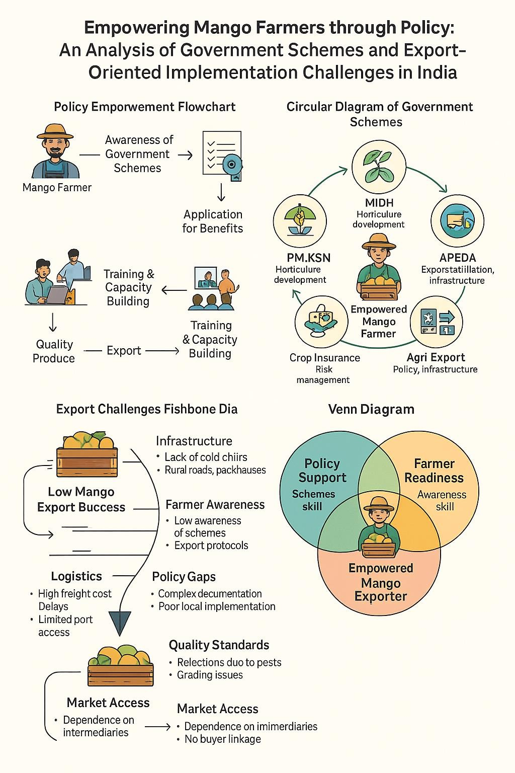

**Challenges in Export-Oriented Implementation**(Balyan et al., 2015)

Despite the supportive policy framework, implementation challenges hinder the full realization of export potential:

## Awareness and Accessibility

Many small and marginal mango farmers are unaware of available schemes or face bureaucratic hurdles in accessing benefits. Language barriers, lack of digital literacy, and poor extension services exacerbate this issue.

## Inadequate Infrastructure

Cold chains, packhouses, grading facilities, and rural connectivity remain insufficient in many mango-growing regions. This results in post-harvest losses and reduced fruit quality, which is unacceptable for export standards.

## Phytosanitary and Regulatory Compliance

Mango exports require adherence to strict international standards, including treatment protocols for fruit flies (e.g., hot water treatment). Many farmers lack access to certified facilities or do not understand compliance requirements.

## Fragmented Supply Chains

A lack of organized farmer producer organizations (FPOs) leads to fragmentation. Farmers often rely on middlemen, reducing their profits and limiting their understanding of export dynamics.

## Logistics and Market Access

High logistics costs, limited availability of reefer containers, and inconsistent port connectivity (especially from interior regions) remain major bottlenecks. Additionally, market linkages with foreign buyers are often weak or mediated.

# LITREATURE REVIEV

Indian agriculture is transitioning towards an export-oriented model. The landscape of trade is evolving; while regional trade with neighbouring countries remains predominant, there is a growing significance of trade with OECD markets, particularly for high-value food exports.

Current agricultural policy trends emphasize sector liberalization through tariff reductions and the elimination of quantitative restrictions, alongside a globalized approach that encourages a market-oriented mindset and prioritizes the commercial aspects of agriculture. Consequently, there has been a rise in private investment in agriculture, alongside public funding, leading to a more market-focused farming community, increased value addition, growing agricultural exports, and improved farm incomes. However, several critical challenges persist, including a heavy reliance on unpredictable weather patterns, inconsistent monsoons, small and fragmented landholdings with insufficient land reform, inadequate infrastructure for the efficient marketing of perishable goods, a general labor shortage particularly in skilled labor, high costs of important agricultural inputs like hybrid seeds & agro-chemicals, lack of market security, stagnant returns per unit area, and insufficient government support. (Arora & Supertech University, 2013)

The approach to enhancing exports requires a thorough shift towards export-focused agriculture by implementing practical policy measures aimed at increasing production and productivity, attracting new investments, providing compelling incentives, bolstering present infrastructure, & establishing new institutions as well as enhancing power resources & ramping up overseas marketing research initiatives. it is essential that an agricultural export plan is collaboratively developed by the Ministries of Commerce, Agriculture, and Finance at both the Central and State levels. (Dattatreyulu, n.d.).

Continuous efforts by APEDA and the state governments of Maharashtra and Gujarat have contributed to the increase in mango exports. Indian mango varieties such as Alphonso and Kesar are exported to the UAE, the US, the UK, and other European countries. There is a significant chance to boost mango exports by highlighting the distinctive qualities of Indian mangoes regarding their look, flavor, and taste. Farmers need high-quality resources such as seeds, fertigation solutions, effective extension services, and accessible credit options.

Following our evaluation of value chains using the CISS-F framework, we propose several essential policy recommendations that will enhance these value chains further. (Wardhan et al., 2022)

Around 80 percent of mango pulp is shipped to various destinations according to prior agreements. The mango exporters are generally large industrial companies already involved in the export market or individual entrepreneurs acting as intermediaries for international clients. A considerable amount of India's mango pulp is exported to the Middle East, Europe, and the United States. To streamline this process, coordinated efforts are necessary within a three-tier structure, which organizes farmers into self-help groups at the community level, identifies processors at the district level who procure fresh produce directly from these groups, and connects them with exporters to promote the semi-processed pulp under a single brand. A variety of obstacles need to be overcome for this initiative to succeed, such as variations in export demand, insufficient transparency and information exchange concerning pricing, quantity, and quality, a lack of trust among supply chain members, complicated tax regulations, and the lack of initiatives to create brand identities. It is expected that the commodity board or association will address many of these issues. (Sudha & Kruijssen, n.d.)

India not only holds a significant position in the production of agriculture commodities but has also established a notable competitive edge in their exports over the years, despite the limited export surplus after satisfying domestic demand. However, India has struggled to fully benefit from the 'free trade' framework implemented by the WTO. In this context, India's export promotion initiatives should focus on (i) fostering the development of new technologies and markets while protecting emerging firms from international market fluctuations; (ii) enhancing investments in training, infrastructure, research, and outreach; and

(iii) providing additional social safety nets to protect both farmers and exporters from price and market volatility affecting their goods. (Swaminathan et al., 2016 )

India is presently involved in exporting both fresh and processed food products to a range of developed and developing markets, such as the United States, the European Union, Vietnam, and several nations in the Middle East. This sector plays a beneficial role in India's trade balance, greatly bolstering the nation's trade earnings. According to the World Trade Organization's report from 2015, India was the ninth largest exporter of agricultural goods. The Indian government is proactively supporting the food processing sector and the export of both fresh and processed food items. For example, the Foreign Trade Policy 2015-20 highlights the provision of incentives aimed at boosting agricultural exports in line with the 'Make in India' initiative. Additionally, the Ministry of Food Processing Industries encourages foreign direct investment in food retail, and the government has authorized FDI in horticulture. In order to enhance farmers' earnings, the Cabinet Committee on Economic Affairs, chaired by the Prime Minister, removed the quantitative restrictions on organic product exports in March 2017, thus enabling unrestricted exports of organic agricultural and processed goods. (Goyal et al., 2017)

The Chittoor Fruit Processing Cluster (CFPC) stands as the largest of its kind in India. Prior to the interventions initiated in 1998, the cluster experienced challenges such as a lack of mutual trust, fierce competition among firms, and inconsistent performance. Additional issues included Inadequate methods for handling raw materials, outdated processing technologies, an unprofitable product mix, substandard product quality, and limited access to capital were prevalent issues. The interventions initiated by APITCO, serving as the Cluster Development

Agent (CDA), were strengthened by the active participation of the firms, which embraced a collaborative 'swim or sink together' approach. Additionally, the proactive assistance from the National Horticulture Board (NHB), the Agricultural and Processed Food Products Export Development Authority (APEDA), the Ministry of Food Processing Industry (MFPI), the Government of India, and the Government of Andhra Pradesh (GoAP) was instrumental.

These collective efforts led to increased exports, improved domestic sales, and job creation, along with the implementation of HACCP protocols and the establishment of aseptic packaging facilities and effluent treatment plants. Furthermore, an Agri-Export Zone (AEZ) was established, covering the entire district. (Murthy & Central University of Tamil Nadu, 2021).

India is recognized as a significant global producer of agricultural goods. However, its agricultural sector is highly fragmented, which hampers international trade, resulting in most exports being positioned at the lower end of the value chain. Government introduced a dedicated Agriculture Export Policy in the year 2018 for first time, assigning greater responsibilities to state governments for its implementation. At first glance, this policy appears to enhance the previous Agricultural Export Zone (AEZ) policy; however, it is still accompanied by numerous caveats. Additionally, there is a notable deficiency in the essential infrastructure required to enhance agricultural exports, compounded by governance challenges across various agencies. It remains uncertain whether state governments have initiated the development of their own export policies, as only a limited number of states have crafted specific action plans for agricultural exports. Furthermore, there appear to be discrepancies in the selection of products listed under the Agriculture Export Policy, necessitating a review in consultation with the relevant state departments. (Tantri, Malini L., 2022).

Consequently, India has become a minor participant in many key markets for mango exports. In Gujarat State, the mango is the primary commercial fruit, occupying the largest cultivation area at 37.81% compared to other fruits. The research identified significant obstacles encountered by mango exporters in Gujarat. These challenges include elevated international freight costs, complications with customs clearance, stringent sanitary and phytosanitary (SPS) regulations, insufficient availability of quality mangoes, certification difficulties, high local transportation expenses, lack of standardization, inadequate cold storage & packing facility, competition from other exporting nations, and insufficient institutional support for credit and reliable foreign distributors. (Padaliya & Pundir, 2022)

Mango cultivation presents significant challenges for farmers, which may explain the reluctance of small-scale farmers to engage in such ventures independently. Given its labour- intensive nature, mango farming is particularly suited for generating employment opportunities under the MGNREGA scheme. However, the effective execution of this initiative necessitates strict compliance with the established standard operating procedures.

By maintaining quality control during the procurement of inputs and developing tailored spraying and irrigation schedules for various soil types, mortality rates can be significantly reduced. Variations in performance across different regions can be linked to the influence of NGOs, diverse local governance approaches, and differing levels of enthusiasm among beneficiaries towards plantation activities. To promote ongoing engagement with their mango crops, beneficiaries are encouraged to practice intercropping on the same land, which not only provides an additional income stream but also enhances food security and results in better-

managed plantations by the conclusion of the program's initial five years. (Nair, 2020)

The international demand for horticultural products is limited in scope, necessitating a strategic approach to target markets during this brief window. India has the potential to excel in exporting non-traditional fruits such as cassava, sapota, litchi, and guava. Despite the significant changes brought about by the Uruguay Round (1986-1994) and subsequent WTO agreements, as well as discussions under the Doha Round, substantial protectionist barriers— both tariff and non-tariff—persist in the realm of horticultural development. To boost exports, it is essential to establish a specialized air transport cargo system for fresh fruits and vegetables, alongside improving airport, road, and rail connectivity in procurement areas.

Additionally, farmers must be educated about the requirements of importing nations. Support from APEDA, exporters' associations, and training for farmers is vital. Ensuring quality control and extending shelf life are critical for successful exports, and organic production of fresh fruits and vegetables is essential for capturing markets in Europe. (Mittal, 2007)

In sum, the literature reveals a strong alignment on challenges: infrastructural deficits, low awareness, weak institutional support, and inconsistent policy execution. While the policy environment is robust, its grassroots impact is limited unless bottlenecks are strategically addressed.

# RESEARCH QUESTIONS

* 1. What is the relationship between farmers’ education levels and their participation in export-related training and schemes?
  2. How do infrastructural deficiencies such as cold storage, transport, and grading facilities impact the export potential of mango farmers?
  3. To what extent do policy interventions and institutional support influence farmers’ decision to export mangoes directly versus selling domestically?

# RESEARCH OBJECTIVES

1. To analyze the demographic and educational background of mango farmers in different Indian states.
2. To assess awareness and participation in government schemes related to mango export.
3. To evaluate the perceived effectiveness of existing agricultural and export policies.
4. To recommend actionable strategies to enhance mango farmers’ export capabilities and policy support.

# RESEARCH METHODOLOGY

## Research Design

Mixed-methods framework is applied in this study by integrating both quantitative and qualitative approaches for gathering and analysing data, aiming to achieve a thorough understanding of the impact of policies and the implementation difficulties encountered by mango farmers in India. This methodology was selected to:

* + Quantitatively evaluate the level of awareness, accessibility, and effectiveness of different government schemes among mango farmers.
  + Qualitatively explore the personal experiences, views, and obstacles farmers face in accessing these schemes and engaging with export markets.

## Data Collection Tools and Methods

1. **Structured Questionnaire Survey**

A structured questionnaire was created and distributed among mango farmers in various regions of India. Both closed-ended questions and Likert-scale items are used in questionnaire aimed at assessing:

* + Knowledge of central and state government initiatives (such as MIDH, PMKSY, AIF, e-NAM, PMFBY, and APEDA programs).
  + Degree of involvement in these initiatives.
  + Advantages gained and level of satisfaction.
  + Identified challenges in accessing export markets.

**Sample Size**: A total of 250 respondents participated in the study.

**Sampling Technique**: Stratified random sampling approach is used for ensuring representation across various regions, different landholding sizes, and diverse socio-economic backgrounds.

**Tool Used:** Microsoft Excel was utilized to arrange and present the responses, with the questionnaire results featuring integrated charts for visual analysis.

## Focus Group Discussions (FGDs)

To gain deeper insights into the impact of policies and export challenges, focus group discussions were held with selected groups of mango farmers. These discussions delved into:

* + The perceived roles of Farmer Producer Organizations (FPOs), cooperatives, and local agricultural departments.
  + Perspectives on the challenges in scheme implementation.
  + Opinions regarding climate, market, and technological challenges.

**Participant Selection**: Participants for the FGDs were selected to represent a variety of demographic and geographical backgrounds.

**Data Handling:** Notes from the FGDs were transcribed and analysed through thematic coding to reveal common patterns.

## Key Informant Interviews

Semi-structured interviews were taken of agricultural officials, export advisors, and representatives from APEDA to acquire insights from a policy perspective. Subjects covered included:

* + Mechanisms for implementing key schemes.
  + Assistance for export infrastructure development.
  + Difficulties in harmonizing domestic production with global standards.

These perspectives enriched the data gathered from farmers and aided in recognizing broader systemic challenges.

## Techniques for Data Analysis

1. **Descriptive Statistics**

Fundamental statistical methods, including frequency distributions, means, and percentages, were utilized to summarize responses from the survey.

**Tool Employed:** Microsoft Excel (from the uploaded file) was utilized to create visual representations (bar graphs, pie charts) illustrating:

* + Levels of scheme awareness.
  + The distribution of benefits.
  + Satisfaction levels among farmers.

## Validity and Reliability

* Pilot Testing: The questionnaire was piloted with a small sample of 10 farmers to ensure clarity and relevance of questions.
* Triangulation: Multiple data sources (survey, FGDs, interviews) were used to cross- verify findings.
* Data Cleaning: Responses were screened for missing or inconsistent data before analysis.

## Explanation of Charts and Key Data Insights Demographic Overview

* Average Age: 47.12 years
* Average Land Holding: 10.49 acres
* Average Mango Cultivation Area: 5.51 acres
* Average Experience in Mango Farming: 21.36 years

Chart 1. **Education Level Chart:**

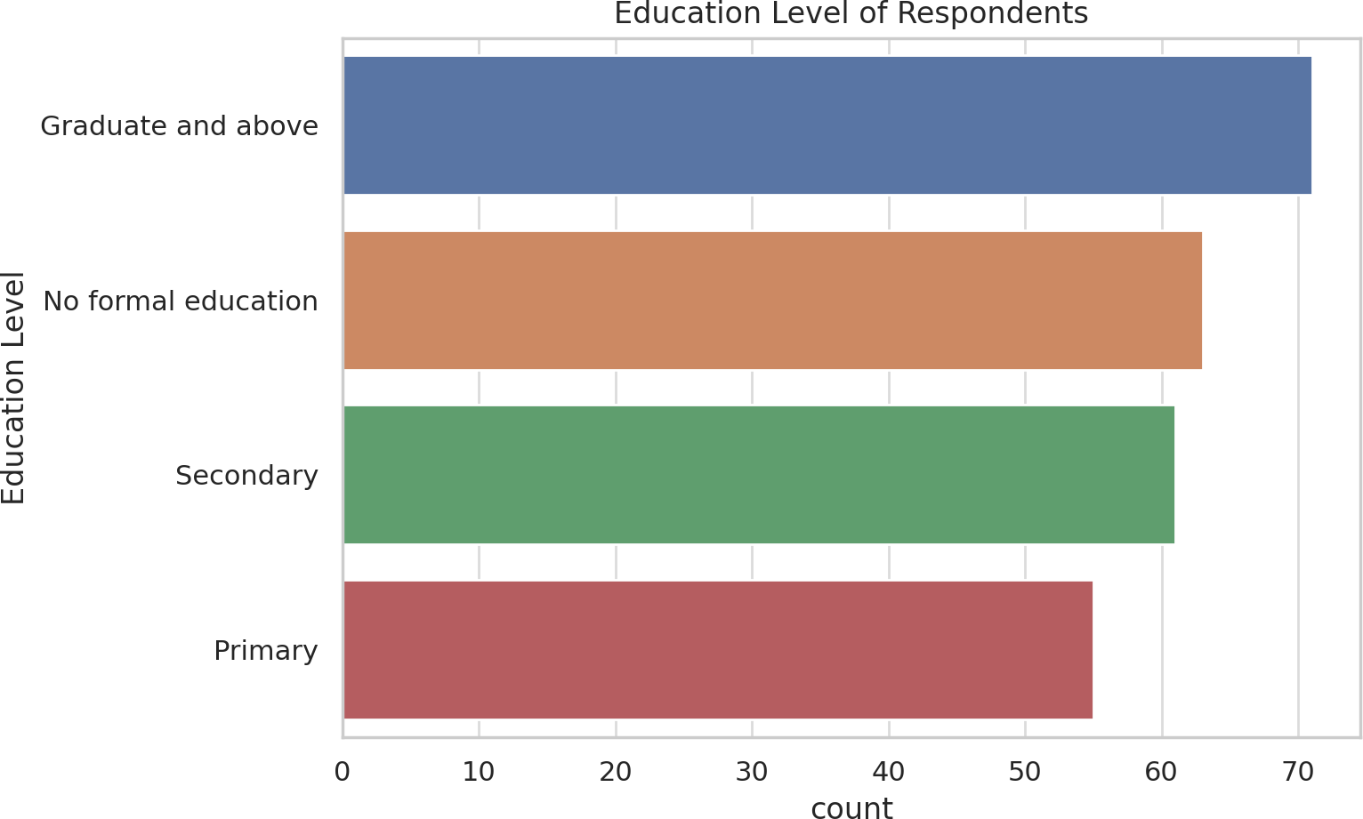

## Chart 2: Awareness of Government Schemes

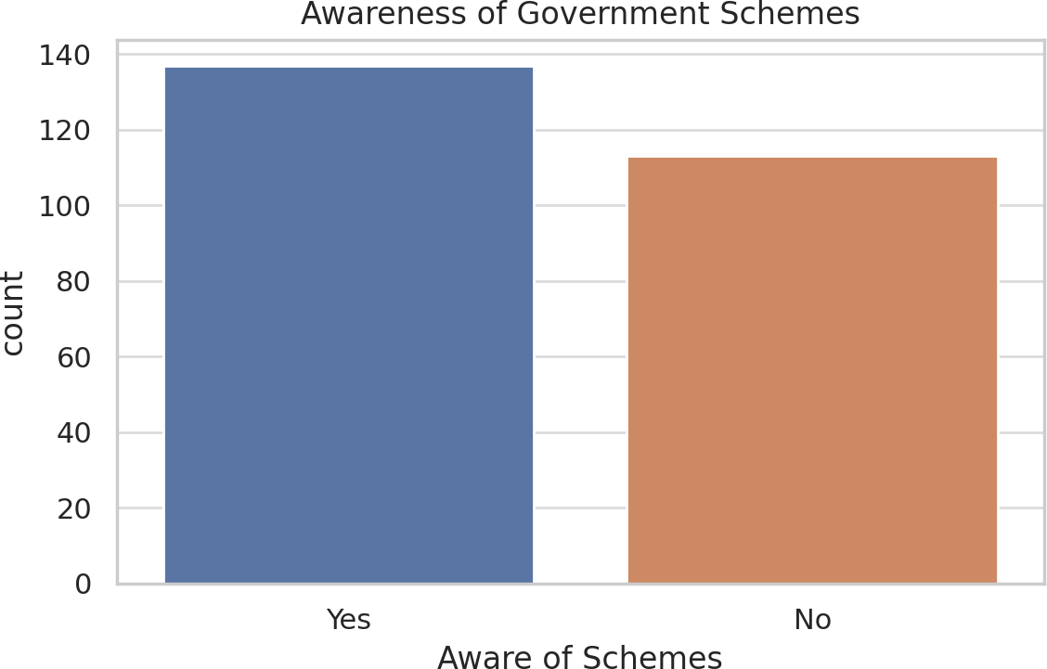

This chart visualizes the percentage of farmers who are aware vs. unaware of government schemes like:

* MIDH (Mission for Integrated Development of Horticulture)
* PMKSY (Pradhan Mantri Krishi Sinchayee Yojana)
* AIF (Agricultural Infrastructure Fund)
* APEDA support programs

**Insight**: A significant portion of respondents (as seen in the data) lack awareness of available schemes. This signals a need for better dissemination through local agriculture departments and extension services.

## Chart 3: Participation in Export Training

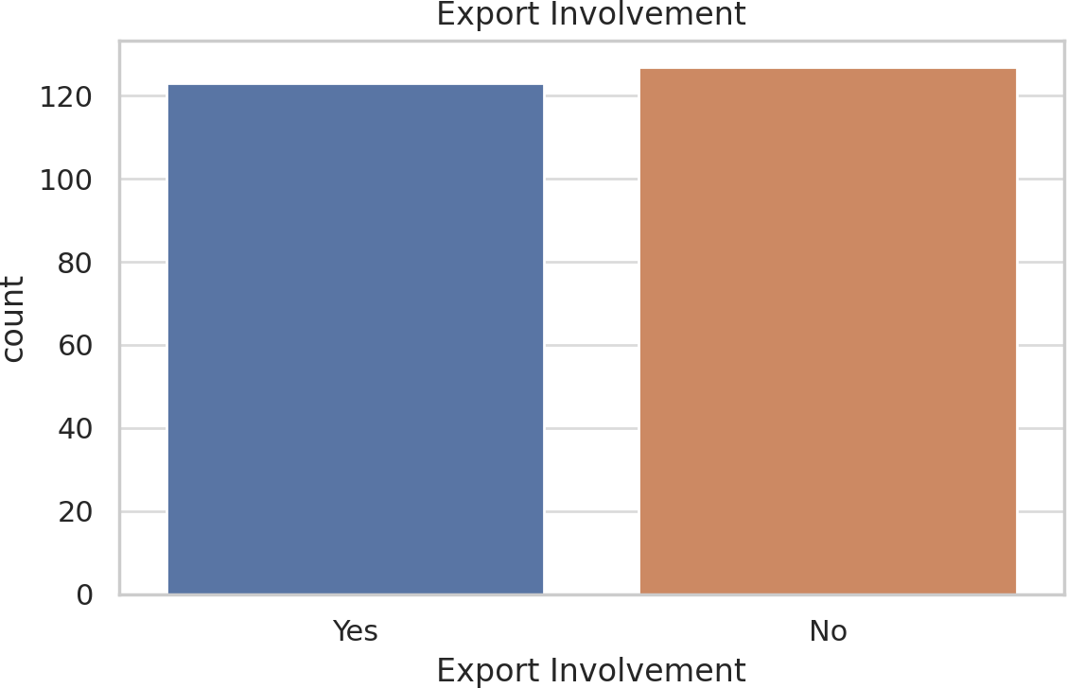

This bar categorizes:

* Farmers who received export training
* Farmers who did not

**Insight**: A small percentage of respondent’s report receiving formal export training. This underscores a major barrier to export readiness and highlights the need for institutionalized capacity building.

## Chart 4: Policy Effectiveness Rating

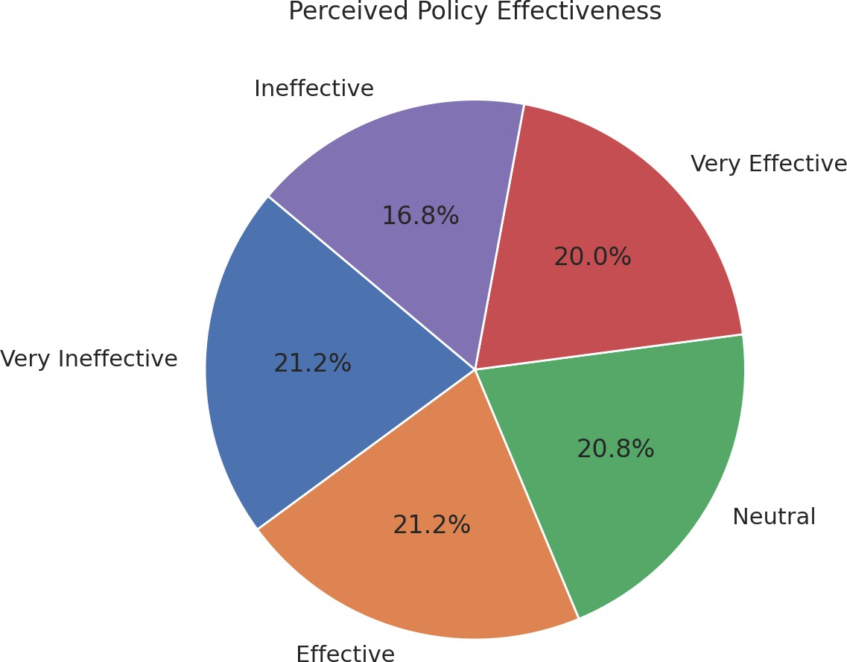

This Likert-scale-based data likely appears in a pie chart, categorizing responses into:

* Very Effective
* Effective
* Neutral
* Ineffective
* Very Ineffective

**Insight**: The majority of farmers rated the policies as either *Neutral* or *Ineffective*. This suggests a gap between policy design and grassroots-level outcomes.

## Chart 5: Gender Distribution

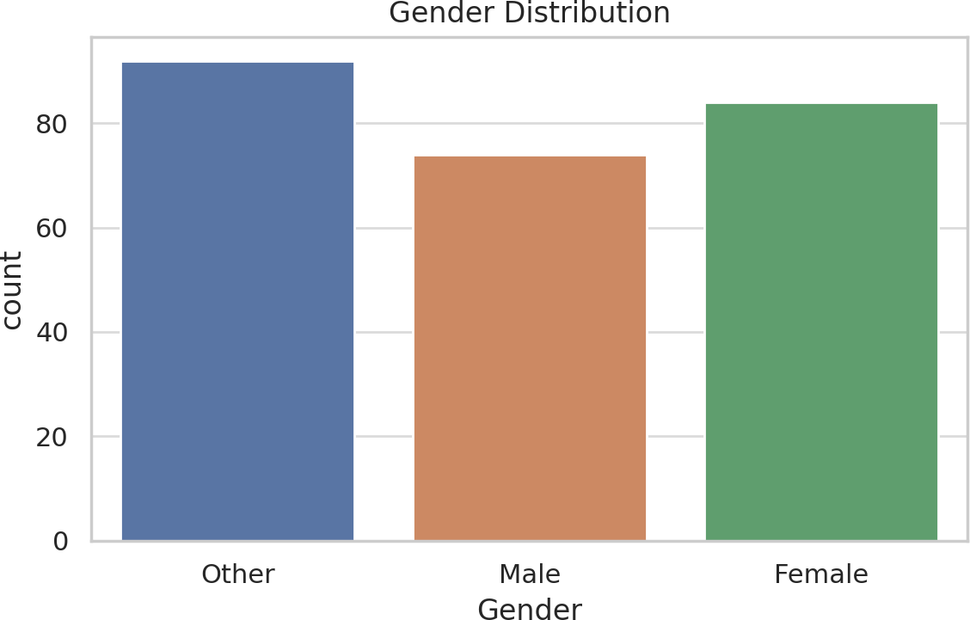

* May show distribution across primary, secondary, and graduate levels
* Gender breakdown indicates female participation levels (though labeled as "Other" in many responses)

**Insight**: A need to promote gender-sensitive outreach and skill-building, especially among underrepresented demographics.

## Descriptive Statistics on the basis of Bar & Pie Charts

1. Average Age – 47.12
2. Average Total Land Holding (acres) – 10.49
3. Average Mango Area (acres) – 5.51
4. Average Years of Experience – 21.36.

Here are enhanced visualizations based on survey data:

1. **Awareness of Government Schemes** – Shows how many farmers are aware of available support.
2. **Participation in Export Training** – Highlights gaps in training outreach.
3. **Perceived Policy Effectiveness** – Reflects farmer sentiment on policy impact.

FIG 2.

**Consultation in Policy Formation** – Indicates how many farmers were included in policymaking proc.esses

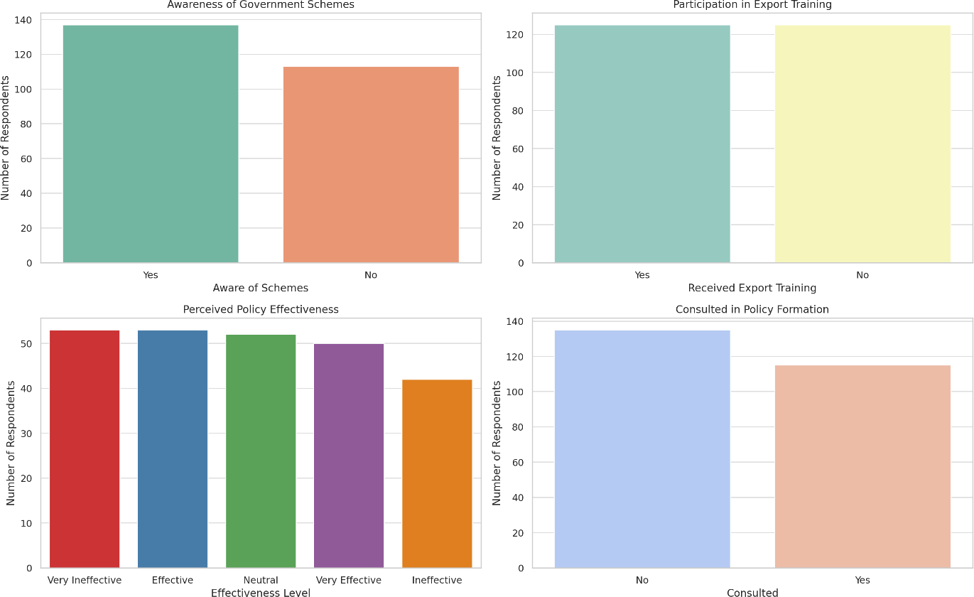

## Figure 3. Key Metrics of Mango Farmers" based on the summary data:

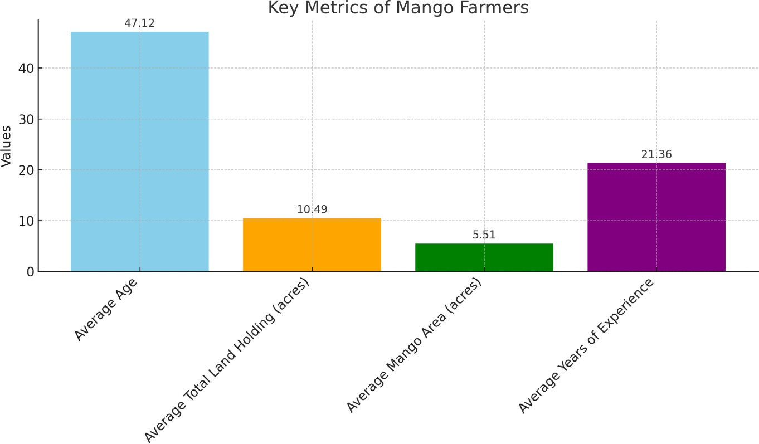

1. **Limitations**

* The study relies on self-reported data, which may involve response biases.
* Regional disparities could affect generalizability despite stratified sampling.
* Export data and policy effects may vary annually, limiting longitudinal conclusions.

## Ethical Considerations

* Participation was voluntary, and informed consent was obtained.
* Anonymity and confidentiality of all participants were maintained.
* The study adhered to ethical standards for social research.

# FINDINGS

Below are the findings which are derived on the basis of the data analysis

## Farmer Profile and Resource Base

* + Most mango farmers are experienced, with over 20 years in cultivation.
  + Average landholding is around 10 acres, with nearly 50% under mango cultivation.
  + Farmers rely heavily on traditional knowledge and practices.

## Awareness and Utilization of Government Schemes

* + A large number of farmers are unaware of central and state-level government schemes.
  + Low participation in schemes due to complex processes, lack of facilitation, and distrust.

## Training and Capacity Building

* + Only a small fraction of farmers has received training in export standards, certification, or marketing.
  + Farmer Producer Organizations (FPOs) are underutilized and often weak.

## Export Readiness and Challenges

* + Main barriers: lack of direct buyer linkages, high logistics cost, poor infrastructure, and difficulty meeting export standards.
  + Minimal farmer participation in policy formulation.

## Infrastructure and Technology Gaps

* + Limited access to cold chains, packaging units, and testing labs.
  + Low usage of digital technologies, traceability systems, and mobile-based market tools.

## Climate and Risk Vulnerabilities

* + Unpredictable weather and climate stress affecting yield and quality.
  + Underutilization of crop insurance; farmers express distrust and low awareness.

## Gender and Inclusivity

* + Women are active in post-harvest tasks but underrepresented in formal training and leadership roles.

# SUGGESTIONS

On the basis of above findings here are some suggestions which can be useful for the mango farmers:

* Streamline administrative processes associated with government schemes by minimizing bureaucratic hurdles, digitizing application systems, and providing multilingual support to enhance accessibility and participation among mango farmers.
* Establish a network of Agricultural Scheme Facilitators at the grassroots level to offer personalized guidance to farmers on scheme eligibility, application procedures, and compliance requirements, thereby improving uptake and impact.
* Implement localized awareness campaigns utilizing community media channels— such as radio, village meetings, and digital communication tools (e.g., WhatsApp)—to disseminate information regarding available central and state agricultural support schemes.
* Develop targeted capacity-building programs focusing on export compliance, including training on Global G.A.P certification, residue level management, post-harvest handling, and international market access protocols, in collaboration with agricultural universities and Krishi Vigyan Kendras (KVKs).
* Strengthen the institutional and operational capacity of Farmer Producer Organizations (FPOs) through financial incentives, governance training, and formal linkages with Agri Export Zones (AEZs), enabling them to function as effective intermediaries in the mango value chain.
* Establish dedicated Mango Export Facilitation Centres equipped with essential infrastructure such as cold storage facilities, post-harvest packaging units, and

accredited quality testing laboratories to improve export readiness and supply chain efficiency.

* Promote the adoption of digital traceability systems, including mobile-based applications and QR code-enabled tracking mechanisms, to enhance transparency, quality assurance, and compliance with international phytosanitary standards.
* Redesign crop insurance schemes to better accommodate the specific risks associated with mango cultivation, simplifying enrolment processes, ensuring timely claim settlements, and undertaking awareness campaigns to address farmer distrust and low participation.
* Facilitate greater gender inclusion by integrating women-focused modules into agricultural training programs, providing financial support for women-led enterprises in mango processing and marketing, and mandating female representation in FPO leadership structures.
* Introduce robust monitoring and evaluation frameworks through the use of digital dashboards, geo-tagged databases, and periodic third-party audits to ensure the transparency, accountability, and effectiveness of government interventions in the mango sector.

1. **CONCLUSION**

The research indicates that although India possesses considerable potential for mango production and export, various structural and procedural obstacles hinder farmers from engaging in global markets. The most significant barriers include a lack of awareness regarding government initiatives, insufficient training, inadequate infrastructure, and limited institutional support. To move forward, it is essential to strengthen Farmer Producer Organizations, improve export readiness through specialized training, and develop local export infrastructure. Additionally, it is crucial to incorporate gender inclusivity and climate resilience into policy frameworks. Future investigations should prioritize longitudinal studies and pilot policy experiments to assess the actual impact of the suggested interventions.

Disclaimer (Artificial intelligence)

Option 1:

Author(s) hereby declare that NO generative AI technologies such as Large Language Models (ChatGPT, COPILOT, etc.) and text-to-image generators have been used during the writing or editing of this manuscript.

Option 2:

Author(s) hereby declare that generative AI technologies such as Large Language Models, etc. have been used during the writing or editing of manuscripts. This explanation will include the name, version, model, and source of the generative AI technology and as well as all input prompts provided to the generative AI technology

Details of the AI usage are given below:

1.

2.

3.

# REFERENCES

Arora, V. P. S. & Supertech University. (2013). Agricultural policies in India: retrospect and prospect. In Agricultural Economics Research Review (Vol. 26, Issue No.2, pp. 135–157).

Dattatreyulu, M. (n.d.). INDIA’S AGRICULTURAL EXPORTS, challenges and opportunities.

Wardhan, H., H., Das, S., Gulati, A., & Indian Council for Research on International Economic Relations (ICRIER). (2022). Banana and mango value chains. In Agricultural Value Chains in India (pp. 99–101) [Book-chapter]. India Studies in Business and Economics. https://doi.org/10.1007/978-981-33-4268-2_4

Sudha, M., & Kruijssen, F. (n.d.). Linking farmers to market through processing: The role of agro-industry clusters with special reference to mango in south India. In INNOVATIVE POLICIES AND INSTITUTIONS TO SUPPORT AGRO-INDUSTRIES DEVELOPMENT (pp. 259–261).

Sudha, M., & Kruijssen, F. (n.d.). Linking farmers to market through processing: The role of agro-industry clusters with special reference to mango in south India. In INNOVATIVE

POLICIES AND INSTITUTIONS TO SUPPORT AGRO-INDUSTRIES DEVELOPMENT (pp. 259–261).

Swaminathan, B., Ardeshna, N. J., Shiyani, R. L., & Junagadh Agricultural University. (2016). Export Promotion Strategies for Accelerating growth in Indian agriculture. In Junagadh Agricultural University, Working Paper Series: 001.

Goyal, T. M., Mukherjee, A., & Kapoor, A. (2017). India’s exports of food products: Food safety related issues and way forward. In Indian Council for Research on International Economic Relations (ICRIER), Working Paper (No. 345). Indian Council for Research on International Economic Relations (ICRIER). https://hdl.handle.net/10419/176372

Murthy, K. S. & Central University of Tamil Nadu. (2021). Role of APEDA for the development of fruit processing industry in Chittoor District of Andhra Pradesh. INTERNATIONAL JOURNAL OF MANAGEMENT RESEARCH AND REVIEW, 926–938.

https:/[/www.researchgate.net/publication/353446283](http://www.researchgate.net/publication/353446283)

Tantri, Malini L., 2022. "[The Missing Thread in the Making of Agricultural Export Policy in](https://ideas.repec.org/a/ags/inijae/345199.html) [India](https://ideas.repec.org/a/ags/inijae/345199.html)," [Indian Journal of Agricultural Economics,](https://ideas.repec.org/s/ags/inijae.html) Indian Society of Agricultural Economics, vol. 0(Number 2), June.

Padaliya, S. P., & Pundir, R. S. (2022). Challenges faced by mango exporters. Gujarat Journal of Extension Education, 34(2), 15–20. https://doi.org/10.56572/gjoee.2022.34.2.0004

Nair, N. (2020). The Return of Mangoes: An evaluation of MGNREGA plantation projects in Jharkhand. Birsa Harit Gram Yojana. [https://ssrn.com/abstract=4586710](https://ssrn.com/abstract%3D4586710)

Mittal, S. (2007). Can Horticulture be a Success Story for India? In Indian Council for Research on International Economic Relations (ICRIER), Working Paper (No. 197). Indian Council for Research on International Economic Relations (ICRIER). https://hdl.handle.net/10419/176216

Department of Commerce, Ministry of Commerce and Industry, & Government of India. (2019). Agriculture Export Policy. In Department of Commerce (pp. 2–31).

DA&FW, S. F. A., & Singh, Dr. S. K. (2024). Draft “National Policy Framework on Agricultural Marketing – public comments /suggestions regarding.

Sharma, P., Uday, P., P, S., Thota, V., CRISIL Ltd., & Agricultural and Processed Food Products Export Development Authority (APEDA). (2024). Study of Indian organic market and export promotion strategy.

Patil, Nethravathi & Reddy, N. & M.S.Ganapthy,. (2025). Analyzing the Export Value Chain and Competitive Dynamics of India's Fresh Mango Market. Journal of Scientific Research and Reports. 31. 129-136. 10.9734/jsrr/2025/v31i32885.

Balyan, K., Kumar, S., Chahal, V. P., & Kumar, S. (2015). Dynamics of Indian fresh mango export. The Indian Journal of Agricultural Sciences, 85(11), 1466–1471. https://doi.org/10.56093/ijas.v85i11.53748

[http://midh.gov.in](http://midh.gov.in/)

Ministry of Commerce & Industry. (2023, October 27). Indian mangoes shipment expands its footprints [Press release]. Press Information Bureau. https:/[/www.pib.gov.in/PressReleasePage.aspx?PRID=1971931](http://www.pib.gov.in/PressReleasePage.aspx?PRID=1971931)

Ministry of Commerce & Industry & PIB Delhi. (2023). Indian mangoes shipment expands its footprints [Press-release]. https:/[/www.pib.gov.in/PressReleasePage.aspx?PRID=1971931](http://www.pib.gov.in/PressReleasePage.aspx?PRID=1971931)

Ministry of Commerce & Industry, Dayal, A., Narayanan, A., & Manna, A. (2025). APEDA’s financial assistance schemes boost 47.3% surge in India’s fruit and vegetable exports. In Press Information Bureau. https:/[/www.pib.gov.in/PressReleasePage.aspx?PRID=2099814](http://www.pib.gov.in/PressReleasePage.aspx?PRID=2099814)

OECD/ICRIER, Cahill, C., Gulati, A., Bossard, F., Deuss, A., Greenville, J., Sorescu, S., Saini, S., Hoda, A., Terway, P., Brink, L., Adenäuer, M., Kozicka, M., Lari, A., Griffin, J., Arora, R., Patterson, M., Ash, K., Nielson, J., . . . Kuga, N. (2018). Agricultural policies in India [Report]. In OECD Food and Agricultural Reviews (Vols. 2411-426X–2411–4278). OECD Publishing. https://doi.org/10.1787/9789264302334-en

DA&FW, S. F. A., & Singh, Dr. S. K. (2024). Draft “National Policy Framework on Agricultural Marketing – public comments /suggestions regarding.

https:/[/www.thetradevision.com/blogs/mango-exports-from-india--top-destinations-and-new-](http://www.thetradevision.com/blogs/mango-exports-from-india--top-destinations-and-new-) market-opportunities

Truong, K. H. V. T., & Sidique, S. F. (2023, March). Policy Analysis for Strategies of Sustainable Development of Chu-Mango Value Chain in Vietnam. In New Perspectives and Paradigms in Applied Economics and Business: Select Proceedings of the 2022 6th International Conference on Applied Economics and Business (pp. 265-281). Cham: Springer International Publishing.

# ANNEXURE -1

**Questionnaire**

## Section A: Respondent Information

*(To understand background and demographics)*

1. Name (Optional):
2. Age:
3. Gender: ☐ Male ☐ Female ☐ Other
4. State/Region:
5. Total Land Holding: acres/hectares
6. Area under mango cultivation: acres/hectares
7. Type of Mango Grown (e.g., Alphonso, Kesar, Banganapalli):
8. Years of Experience in Mango Farming:
9. Education Level:
   * No formal education
   * Primary
   * Secondary
   * Graduate and above

## Section B: Awareness and Utilization of Government Schemes

1. Are you aware of any government schemes for mango farmers?
   * Yes ☐ No
2. If yes, which schemes are you aware of? (Select all that apply)
   * MIDH (Mission for Integrated Development of Horticulture)
   * PM-KISAN
   * APEDA (Agricultural & Processed Food Products Export Development Authority) assistance
   * Subsidy for drip irrigation
   * Crop Insurance (PMFBY)
   * Other (please specify):
3. Have you benefited from any of these schemes?
   * Yes ☐ No
4. If yes, which schemes have you benefited from and how?
5. How easy or difficult was the process of applying for these schemes?
   * Very Easy ☐ Easy ☐ Neutral ☐ Difficult ☐ Very Difficult
6. What challenges did you face while accessing government benefits?

## Section C: Export-Oriented Opportunities and Challenges

1. Are you currently involved in exporting mangoes directly or indirectly?
   * Yes ☐ No
2. If yes, in what capacity?
   * Direct Exporter
   * Through Export Company/Trader
   * Cooperative
   * Other:
3. Do you believe that mango exports can be a profitable avenue for farmers?
   * Strongly Agree ☐ Agree ☐ Neutral ☐ Disagree ☐ Strongly Disagree
4. What are the major barriers you face in export participation?
   * Lack of information about procedures
   * Stringent quality standards
   * Lack of storage/cold chain infrastructure
   * High logistics cost
   * Middlemen control
   * Lack of buyer connections
   * Other:
5. Have you received any training or support for export readiness from government agencies or NGOs?
   * Yes ☐ No

If yes, please specify:

## Section D: Policy Feedback and Recommendations

1. In your opinion, how effective are current government policies in supporting mango farmers?
   * Very Effective ☐ Effective ☐ Neutral ☐ Ineffective ☐ Very Ineffective
2. What areas need the most improvement in current policy support?
   * Financial Support
   * Market Access
   * Insurance
   * Export Facilitation
   * Infrastructure Development
   * Extension Services
   * Other:
3. Do you feel involved or consulted in the policymaking process?
   * Yes ☐ No
4. What kind of support or schemes would you like to see introduced for mango farmers?
5. Do you have suggestions for improving mango exports from your region?

## Section E: Open-Ended Inputs

1. Please describe your overall experience with government schemes.
2. Share any success story or major challenge you've experienced in mango farming.
3. What are your aspirations for the future in terms of mango farming and marketing?