***Research Article***

**Evaluation of antimicrobial resistance, biofilm formation and virulence factors in *Staphylococcus pseudintermedius* recovered from canine pyoderma**

**ABSTRACT**

**Background:** Pyoderma is considered as one of the most frequently encountered dermatological disorders in dogs. **Aim:** The present investigation was carried out with an objective to isolate and identify *Staphylococcus pseudintermedius*, to evaluate their antibiogram patterns, to detect virulence genesandto evaluate biofilm formation in *S. pseudintermedius* isolated from canine pyoderma cases. **Materials and Methods:** The investigation was carried out on 104 skin swabs collected from clinical cases of canine pyoderma. **Results:** Through the conventional and Molecular methods 82 (78.84%) isolates were identified as *Staphylococcus.* Out of 82 isolates of *Staphylococcus*, 68 isolates were identified as *S. pseudintermedius.*In the present study higher percentage of susceptibility was observed for doxycycline (80.88%), levofloxacin (61.76%) and clindamycin (57.35%), while higher resistance was recorded against ampicillin (95.59%), amikacin (72.06%) and erythromycin (45.59%). In the present study, 46 (67.64%) isolates were identified as a Multi Drug Resistant (MDR) isolates.In the present study *lukF, lukS, siet and seC* virulencegenewere targeted to detect their presence in *S. pseudintermedius* isolates through PCR. Out of the 68 *S. pseudintermedius* isolates *lukF, lukS, siet and seC* genewere detected in 63 (92.65%), 63 (92.65%), 65 (95.59%) and 8 (11.76%) isolates, respectively. In the present study micro titer plate assay was used to detect the biofilm formation in *S. pseudintermedius* isolates. Out of 68 *S. pseudintermedius* isolates, 46 (67.65%) were non biofilm former, 19 (27.94%) were weak biofilm former and 3 (4.41%) were moderate biofilm former. Molecular detection of biofilm gene was carried out through PCR by targeting *icaA and icaD* gene. Out of the 68 *S. pseudintermedius* isolates 46 (67.65%) were yielded 134 bp amplicon of *icaA* gene, while 45 (66.18%) were yielded 166 bp amplicon of *icaD* gene. **Conclusion:** Higher antibiotic resistance and more number of virulence genes detected in present study shows *Staphylococcus pseudintermedius* having a major public health concerns.

**Keywords:** Biofilm, Multidrug resistance, Pyoderma, Virulence gene

**Introduction**

Pyoderma is a cutaneous infection caused by pus-forming (pyogenic) bacteria. One of the principal bacteria that colonize the skin and mucous membranes of dogs is *Staphylococcus pseudintermedius.* It is an opportunistic pathogen that can cause canine pyoderma in up to 92% of cases and is prevalent in 46-92% of healthy canines(Lynch and Helbig, 2021). The main clinical signs include circular alopecia, erythema, pustules, epidermal collarettes, crusts, desquamation and pruritus (Botoni *et al.*, 2016).

One of the biggest global issues in both human and veterinary health is the rise of antibiotic-resistant bacterial infections. Due to higher morbidity, mortality, and treatment costs associated with untreated infections, it has considerable negative health effects. As a result of the indiscriminate use of multiple antibiotics over time, multi-drug resistant staphylococcal strains have developed, which are either caused by changes in the genes that encode target proteins or by the acquisition and accumulation of genes that confer antibiotic resistance (Silva *et al.* 2021). Evidence of the zoonotic transmission of *S. pseudintermedius* from dogs to humans has been reported (Pitchenin *et al.* 2017). The potential for horizontal gene transfer from the dog-to-owner strain could lead to an increase in multi-drug-resistant bacteria in the future, making it harder for humans to cure bacterial diseases (Lai *et al.* 2022).

The virulence and antibiotic resistance factors that *S. pseudintermedius* either possesses or may acquire from other bacteria during co-colonization influence its pathophysiology and clinical significance. The presence of several enzymes (coagulase, thermonuclease, proteases), toxins (cytotoxin, exfoliative toxin, enterotoxin, leukocidins, haemolysin), and adhesion factors (clumping factor, protein A, biofilm forming proteins) can increase the pathogenicity of *S. pseudintermedius* (Hritcu *et al*. 2020).

Biofilms are bacterial communities made up of cells that are reversibly linked together and fixed in a self-producing polymeric matrix (Andrade *et al*. 2022). Biofilm is a virulence factor of *S. pseudintermedius* that promotes the adherence of bacteria to host surfaces. Some bacteria, such the species of *Staphylococcus* and *Pseudomonas*, have the capacity to develop biofilm, which could make their infections more resistant to antibiotics (Chan *et al.* 2019). The work was carried out with the aim to isolate and identify *Staphylococcus pseudintermedius*, to evaluate their antibiogram patterns, to detect virulence genesandto evaluate biofilm formation in *S. pseudintermedius* isolated from canine pyoderma cases.

**MATERIALS AND METHODS**

***Ethical approval:*** It is not required because only skin swabs were collected from dogs which is non-invasive procedure that do not harm the animals.

***Sample collection:*** A total of 104 skin swabs from clinical cases of canine pyoderma presented at Veterinary Clinical Complex (VCC), Veterinary College, Kamdhenu University (KU), Navsari were collected aseptically and transported to the laboratory by placing it in the sterile container on the same day of sampling by maintaining cold chain.

***Bacterial isolation and identification of bacteria:*** All the skin swabs were cultured for primary isolation**.** Initially, swabs were cultured onto 5% sheep blood agar for 18 hours at 37℃. After reading colony morphology, the colonies were again streaked on Mannitol Salt Agar plates and incubated further at 37℃ for 18 hr. to obtain a pure culture. Then gram staining performed followed by catalase and oxidase test (Makwana *et al.,* 2023).

***Molecular identification of Staphylococcus Genus and S. pseudintermedius:*** The genomic DNA of bacterial cultures were extracted by method described by Chitra *et al.* (2015) with slight modifications. Briefly, four to five colonies were suspended in 200 μl Nuclease Free Water (NFW) and boiled at 100°C for 10 min. Then the tubes were cooled immediately by placing them on the ice. Later, they were centrifuged at 10000 rpm for 10 min and the supernatant was used as template in the amplification. The primers targeting *16S rRNA* gene of *Staphylococcus* Genusand *nuc* gene of *S. pseudintermedius* as detailed in **Table 1** were used for molecular detection of *Staphylococcus* Genus *and S. pseudintermedius*. The PCR cycling condition was kept as follow: initial denaturation at 95ºC for 5 minute followed by 35 cycles of denaturation at 94ºC for 30 second, annealing at 54ºC for *Staphylococcus* Genus and 60ºC for *S. pseudintermedius* for 30 second, extension at 72ºC for 30 second with a final extension step at 72ºC for 10 minutes using thermal cycler (Applied Biosystems, USA).

***Antimicrobial susceptibility testing:*** The antibiotic-susceptibility profile of *S. pseudintermedius* isolates was prepared using the disc diffusion method on Mueller-Hinton agar plate Zones of inhibition were measured and compared with zone size interpretative table as per the guidelines by Clinical and Laboratory Standards Institute. Total 7 antimicrobials from various antibiotic classes *viz*., Amikacin (AK, 30 mcg), Ampicillin (AMP, 10 mcg), Cefpodoxime (CPD, 10 mcg), Clindamycin (CD, 2 mcg), Doxycycline (DO, 30 μg), Erythromycin (E, 15 mcg), Levofloxacin (LE, 5 mcg) were used to perform antimicrobial susceptibility testing.

***Microtiter plate assay for biofilm formation:*** The experiment was performed using polystyrene flat bottom microtiter plates based on the techniques described by Ebrahimi *et al*. (2013). The mean optical density (OD) of the negative control +3 standard deviations of negative control was considered as the cut-off (ODc). The biofilm producers are categorized as: Non biofilm former : ODs ≤ ODc, Weak biofilm former : ODc < ODs ≤ 2 × ODc, Moderate biofilm former : 2 × ODc < ODs ≤ 4 × ODc, Strong biofilm former : ODs > 4 × ODc, Where ODc = cut-off OD and ODs = Mean OD of sample.

***Molecular detection of virulence and biofilm genes:*** PCR was carried out for detection of virulence and biofilm associated genes using primer sequences as detailed in **Table 2**. The PCR cycling conditions were kept as follow: initial denaturation at 95ºC for 5 minute followed by 35 cycles of denaturation at 94ºC for 30 second, annealing at 57ºC for *lukF* & *lukS* gene, 55ºC for *seC* gene,56ºC for *siet* & *icaD* and 60ºC for *icaA* genefor 30 second, extension at 72ºC for 30 second with a final extension step at 72ºC for 10 minutes using thermal cycler (Applied Biosystems, USA).

***Dendrogram and Heatmap:*** Dendrograms and heatmap were generated in R using hierarchical clustering in the base *stats* package on Euclidean distance matrices representing ABST interpretations for each antibiotic (where 0 = resistant, 0.5 = intermediate, 1 = susceptible) and for virulence and biofilm genes (where 0= absent, 1= present).

**RESULTS AND DISCUSSION**

**Isolation and prevalence of *S. pseudintermedius:*** Based on cultural isolation and identification from 104 skin swabs, total 82 *Staphylococcus* isolates were recovered. All the 82 *Staphylococcus* isolates yielded desired 370 bp amplicon of *16S rRNA* gene. Out of 82 molecularly confirmed *Staphylococcus* isolates, 68 (82.93%) isolates yielded 99 bp amplicon of *nuc* gene, specific for *S. pseudintermedius.* In the present study higher prevalence (82.93%) of *S. pseudintermedius* was recorded. Similar results were observed by Kawakami *et al.* (2010), Ravens *et al.* (2014), Mustak *et al*. (2020) and Lai *et al.* (2022).

***Antimicrobial susceptibility testing results:*** Hhigher percentage of susceptibility was detected for doxycycline (80.88%), levofloxacin (61.76%) and clindamycin (57.35%), while higher resistance for all the isolates was recorded for ampicillin (95.59%), amikacin (72.06%) and erythromycin (45.59%). It was found that 46 (67.64%) isolates were resistant to more than 3 class of antibiotics which were considered as a Multi Drug Resistant (MDR) isolate. Heatmap and dendrogram showed the pattern of antibiotic susceptibility test **(Fig. 1).** In this study higher sensitivity was observed against doxycycline, levofloxacin and clindamycin. Similar findings were obtained by Dziva *et al.* (2015), Van Damme *et al*. (2020) and Abusleme *et al*. (2022). Contrast findings were mentioned by Stefanetti *et al*. (2017), Lai *et al.* (2022), Park *et al.* (2018) and Srednik *et al*. (2023). In the current study higher resistance was observed against ampicillin, amikacin and erythromycin in similarity to what determined by Huerta *et al.* (2011), Stefanetti *et al*. (2017), Chitra *et al.* (2018), Bertelloni *et al*. (2021), Lai *et al.* (2022), Park *et al.* (2018) and Tabatabaei *et al.* (2019). Compared to present study, different results were reported by Gonzalez-Dominguez *et al.* (2020), Meroni *et al.* (2019), Mustak *et al*. (2020) and Abusleme *et al*. (2022). The difference between results of our study and various scientists is mainly due to the region and use of different antibiotics in the area of research.

***Microtiter plate assay:*** To detect biofilm formation ability of *S. pseudintermedius* isolates, micro titer plate assay was performed. Out of 68 *S. pseudintermedius* isolates, 46(67.65%) were non biofilm former, 19(27.94%) were weak biofilm former and 3(4.41%) were moderate biofilm former. No sample was observed as strong biofilm producer **(Fig. 2).** In present study, lower prevalence of biofilm formation was recorded by microtiter plate assay. Contrary to our findings, higher prevalence was reported by Singh *et al.* (2013) and Jantorn *et al.* (2021). The result difference is due to change in the location and climate of the research area. Low prevalence of biofilm producing *S. pseudintermedius* in the geographical area we investigated presents a positive sign for animal health.

***Detection of virulence and biofilm genes:*** In the present study four virulence genes *viz*., *lukF*, *lukS*, *siet* and *seC* gene were targeted to check virulence of *S. pseudintermedius* isolates. Out of 68 *S. pseudintermedius* isolates 63 isolates were amplified at 572 bp amplicon of *lukF* gene, 63 isolates were amplified at 503 bp amplicon of *lukS* gene, 65 isolates were amplified at 359 bp amplicon of *siet* gene and 8 isolates were amplified at 271 bp amplicon of *seC* gene. The entire results are summarized in **Table 3.** Among *S. pseudintermedius* isolates, virulence genes *lukF*, *lukS*, and *siet* were found to be more abundant, but *seC* was found to be less prevalent. These came in agreement with previous studies carried out by Tanabe *et al*. (2013), Couto *et al*. (2016), Pitchenin *et al*. (2017) and Hritcu *et al.* (2020). Out of 68 *S. pseudintermedius* isolates 6(8.82%) were found positive for all the four virulence genes. All 68(100%) isolates were found positive for at least one virulence gene screened in the present study. The study of virulence genes of *S. pseudintermedius* is helpful for understanding the molecular basis of pathogenesis of *S. pseudintermedius* causing pyoderma.In present study two biofilm associated gene*viz. icaA and icaD*were targeted to check its presence in *S. pseudintermedius* isolates. Out of the 68 *S. pseudintermedius* isolates 46 were yielded 134 bp amplicon of *icaA* gene, while 45 were yielded 166 bp amplicon of *icaD* gene. Heatmap and dendrogram showeddifferent pattern of detected virulence and biofilm genes (**Fig. 3**). In present study we reported high prevalence of biofilm associated genes. Similar kind of findings were observed by Singh *et al.* (2013) and Meroni *et al.* (2019). In present study prevalence of biofilm associated gene is high but microtiter plate assay results show low prevalence of biofilm forming *S. pseudintermedius.* The reason might be these isolates harboring biofilm producing genes but they lack gene expression.

**CONCLUSIONS**

Overall this study reported higher prevalence of multidrug resistant bacteria and higher prevalence of virulence genes, which shows significant therapeutic and infection control challenges.

**Disclaimer (Artificial intelligence)**

Author(s) hereby declare that No generative AI technologies such as Large Language Models, etc. have been used during the writing or editing of manuscripts.

**REFERENCES**

Abusleme F, Galarce N, Quezada-Aguiluz M, Iraguen D and Gonzalez-Rocha, G. 2022. Characterization and antimicrobial susceptibility of coagulase-positive *Staphylococcus* isolated in a veterinary teaching hospital in Chile. *Revista Argentina de microbiologia* **54**(3): 192-202.

Andrade M, Oliveira K, Morais C, Abrantes P, Pomba C, Rosato A E and Costa S S. 2022. Virulence Potential of Biofilm-Producing *Staphylococcus pseudintermedius, Staphylococcus aureus* and *Staphylococcus coagulans* Causing Skin Infections in Companion Animals. *Antibiotics* **11**(10): 1339.

Becker K, Roth R and Peters G. 1998. Rapid and specific detection of toxigenic *Staphylococcus aureus*: use of two multiplex PCR enzyme immunoassays for amplification and hybridization of staphylococcal enterotoxin genes, exfoliative toxin genes, and toxic shock syndrome toxin 1 gene. *Journal of Clinical Microbiology* **36**(9): 2548-2553.

Bertelloni F, Cagnoli G and Ebani V V. 2021. Virulence and antimicrobial resistance in canine *Staphylococcus* spp. isolates. *Microorganisms* **9**(3): 515.

Botoni, L. S., Scherer, C. B., Silva, R. O., Coura, F. M., Heinemann, M. B., Paes-Leme, F. O. and Costa-Val, A. P. (2016). Prevalence and *in vitro* susceptibility of methicillin-resistant *Staphylococcus pseudintermedius* (MRSP) from skin and nostrils of dogs with superficial pyoderma. *Pesquisa Veterinária Brasileira,* **36**(12), 1178-1180.

Chan W Y, Hickey E E, Page S W, Trott D J and Hill P B. 2019. Biofilm production by pathogens associated with canine otitis externa, and the antibiofilm activity of ionophores and antimicrobial adjuvants. *Journal of Veterinary Pharmacology and Therapeutics* **42**(6): 682-692.

Chitra M A, Jayanthy C and Nagarajan B. 2015. Detection and sequence analysis of accessory gene regulator genes of *Staphylococcus pseudintermedius* isolates. *Veterinary World* **8**(7): 902.

Chitra M A, Jayanthy C and Nagarajan B. 2018. Virulence genes detection and antimicrobial susceptibility of *Staphylococcus pseudintermedius* isolates from canine skin infection in Chennai, India. *Proceedings of the National Academy of Sciences, India Section B: Biological Sciences* **88**: 355-361.

Couto N, Belas A, Oliveira M, Almeida P, Clemente C and Pomba C. 2016. Comparative RNA-seq-based transcriptome analysis of the virulence characteristics of methicillin-resistant and-susceptible *Staphylococcus pseudintermedius* strains isolated from small animals. *Antimicrobial Agents and Chemotherapy* **60**(2): 962-967.

Dziva F, Wint C, Auguste T, Heeraman C, Dacon C, Yu P and Koma L M. 2015. First identification of methicillin-resistant *Staphylococcus pseudintermedius* strains among coagulase-positive staphylococci isolated from dogs with otitis externa in Trinidad, West Indies. *Infection Ecology and Epidemiology* **5**: 29170.

Ebrahimi A, Moatamedi A, Lotfalian S and Mirshokraei P. 2013. Biofilm formation, hemolysin production and antimicrobial susceptibilities of *Streptococcus agalactiae* isolated from the mastitis milk of dairy cows in Shahrekord district, Iran. *Veterinary Research Forum: an International Quarterly Journal* **4**(4): 269.

Futagawa-Saito K, Sugiyama T, Karube S, Sakurai N, Ba-Thein W and Fukuyasu T. 2004. Prevalence and characterization of leukotoxin-producing *Staphylococcus intermedius* in isolates from dogs and pigeons. *Journal of Clinical Microbiology* **42**(11): 5324-5326.

Gonzalez-Dominguez M S, Carvajal H D, Calle-Echeverri D A and Chinchilla-Cardenas D. 2020. Molecular Detection and Characterization of the *mecA* and *nuc* Genes from *Staphylococcus* Species (*S. aureus, S. pseudintermedius*, and *S. schleiferi*) Isolated From Dogs Suffering Superficial Pyoderma and Their Antimicrobial Resistance Profiles. *Frontiers in Veterinary Science* **7**: 376.

Hritcu O M, Schmidt V M, Salem S E, Maciuca I E, Moraru R F, Lipovan I, Mareş M, Solcan G and Timofte D. 2020. Geographical Variations in Virulence Factors and Antimicrobial Resistance Amongst Staphylococci Isolated From Dogs From the United Kingdom and Romania. *Frontiers in Veterinary Science* **7**: 414.

Huerta B, Maldonado A, Ginel P J, Tarradas C, Gomez-Gascon L, Astorga R J and Luque I. 2011. Risk factors associated with the antimicrobial resistance of staphylococci in canine pyoderma. *Veterinary Microbiology* **150**(3-4): 302-308.

Jantorn P, Heemmamad H, Soimala T, Indoung S, Saising J, Chokpaisarn J and Saeloh D. 2021. Antibiotic resistance profile and biofilm production of *Staphylococcus pseudintermedius* isolated from dogs in Thailand. *Pharmaceuticals* **14**(6): 592.

Kawakami T, Shibata S, Murayama N, Nagata M, Nishifuji K, Iwasaki T and Fukata T. 2010. Antimicrobial susceptibility and methicillin resistance in *Staphylococcus pseudintermedius* and *Staphylococcus schleiferi* subsp. *coagulans* isolated from dogs with pyoderma in Japan. *The Journal of Veterinary Medical Science* **72**(12): 1615-1619.

Lai C H, Ma Y C, Shia W Y, Hsieh Y L and Wang C M. 2022. Risk Factors for Antimicrobial Resistance of *Staphylococcus* Species Isolated from Dogs with Superficial Pyoderma and Their Owners. *Veterinary Sciences* **9**(7): 306.

Lautz S, Kanbar T, Alber J, Lämmler C, Weiss R, Prenger‐Berninghoff E and Zschock M. 2006. Dissemination of the gene encoding exfoliative toxin of *Staphylococcus intermedius* among strains isolated from dogs during routine microbiological diagnostics. *Journal of Veterinary Medicine, Series B*, **53**(9): 434-438.

Lynch S A and Helbig K J. 2021. The complex diseases of *Staphylococcus pseudintermedius* in canines: where to next?. *Veterinary Sciences* **8**(1): 11.

Makwana P.M., Parmar S.M., Vala J.A., Parasana D.K., Patel D.R., Kalyani I.H. and Solanki J.B. (2023). Molecular Characterization and Antimicrobial-resistant Pattern of *Staphylococcus* species Isolated from Pyoderma Cases in Dogs. *Biological Forum – An International Journal,* **15**(11): 82-87.

Martineau F, Picard F J, Ke D, Paradis S, Roy P H, Ouellette M and Bergeron M G. 2001. Development of a PCR assay for identification of staphylococci at genus and species levels. *Journal of Clinical Microbiology* **39**(7): 2541-2547.

Meroni G, Soares Filipe J F, Drago L and Martino P A. 2019. Investigation on antibiotic-resistance, biofilm formation and virulence factors in multi drug resistant and non multi drug resistant *Staphylococcus pseudintermedius*. *Microorganisms* **7**(12): 702.

Mustak I B, Mustak H K, Saricam S, Ustun T and Erdem A E. 2020. Frequency of *Staphylococcus pseudintermedius* in canine skin infections and antibiotic resistance profiles of the recovered isolates. *Etlik Veteriner Mikrobiyoloji Dergisi* **31**(2): 127-132.

Park J H, Kang J H, Hyun J E and Hwang C Y. 2018. Low prevalence of mupirocin resistance in *Staphylococcus pseudintermedius* isolates from canine pyoderma in Korea. *Veterinary Dermatology* **29**(2): 95–e37.

Pitchenin L C, Brandão L N S, Rosa J M A, Kagueyama F C, da Silva Alves A, Rocha Í S M and Dutra V. 2017. Occurrence of toxin genes in *Staphylococcus pseudintermedius* from diseased dogs and other domestic and wild species. *The Journal of Infection in Developing Countries* **11**(12): 957-961.

Proietti P C, Stefanetti V, Hyatt D R, Marenzoni M L, Capomaccio S, Coletti M and Passamonti F. 2015. Phenotypic and genotypic characterization of canine pyoderma isolates of *Staphylococcus pseudintermedius* for biofilm formation. *Journal of Veterinary Medical Science* **77**(8): 945-951.

Ravens P A, Vogelnest L J, Ewen E, Bosward K I and Norris J M. 2014. Canine superficial bacterial pyoderma: evaluation of skin surface sampling methods and antimicrobial susceptibility of causal *Staphylococcus* isolates. *Australian Veterinary Journal* **92**(5): 149-155.

Silva V, Oliveira A, Manageiro V, Caniça M, Contente D, Capita R, Alonso-Calleja C, Carvalho I, Capelo J L, Igrejas G and Poeta P. 2021. Clonal Diversity and Antimicrobial Resistance of Methicillin- Resistant *Staphylococcus pseudintermedius* isolated from Canine Pyoderma. *Microorganisms* **9**(3): 482.

Singh A, Walker M, Rousseau J and Weese J S. 2013. Characterization of the biofilm forming ability of *Staphylococcus pseudintermedius* from dogs. *BMC Veterinary Research* **9**(1): 1-6.

Srednik M E, Perea C A, Giacoboni G I, Hicks J A, Foxx C L, Harris B and Schlater L K. 2023. Genomic Features of Antimicrobial Resistance in *Staphylococcus pseudintermedius* isolated from Dogs with Pyoderma in Argentina and the United States: A Comparative Study. *International Journal of Molecular Sciences* **24**(14): 11361.

Stefanetti V, Bietta A, Pascucci L, Marenzoni M L, Coletti M, Franciosini M P and Casagrande Proietti P. 2017. Investigation of the antibiotic resistance and biofilm formation of *Staphylococcus pseudintermedius* strains isolated from canine pyoderma. *Veterinaria Italiana* **53**(4): 289-96.

Tabatabaei S, Najafifar A, Badouei M A, Salehi T Z, Tamai I A, Khaksar E and Ghazisaeedi F. 2019. Genetic characterisation of methicillin-resistant *Staphylococcus aureus* and *Staphylococcus pseudintermedius* in pets and veterinary personnel in Iran: new insights into emerging methicillin-resistant S. pseudintermedius (MRSP). *Journal of Global Antimicrobial Resistance* **16**: 6-10.

Tanabe T, Toyoguchi M, Hirano F, Chiba M, Onuma K and Sato H. 2013. Prevalence of staphylococcal enterotoxins in *Staphylococcus pseudintermedius* isolates from dogs with pyoderma and healthy dogs. *Microbiology and Immunology* **57**(9): 651-654.

Van Damme C M, Broens E M, Auxilia S T and Schlotter Y M. 2020. Clindamycin resistance of skin derived *Staphylococcus pseudintermedius* is higher in dogs with a history of antimicrobial therapy. *Veterinary Dermatology* **31**(4): 305-e75.

**TABLE 1 *Staphylococcus* Genus specific (*16S rRNA*) primer sequences**

|  |  |  |  |
| --- | --- | --- | --- |
| **Primer (5’ to 3’)** | **Target gene** | **Product size** | **Reference** |
| F: GGCCGTGTTGAACGTGGTCAAATCA  R: TIACCATTTCAGTACCTTCTGGTAA | *16S*  *rRNA* | 370bp | Martineau *et al.*(2001) |
| F: TGATGCAGCTTTTCCGTATG  R: AAAGATGGGCAAGATGAACG | *nuc* | 99bp | Gonzalez-Dominguez *et al.* (2020) |

**TABLE 2 Virulence *and* biofilmgene specific primer sequences for *S. pseudintermedius***

|  |  |  |  |
| --- | --- | --- | --- |
| **Primer (5’ to 3’)** | **Target gene** | **Product size** | **Reference** |
| F: CCTGTCTATGCCGCTAATCCA  R: AGGTCATGGAAGCTATCTCGA | *luk-F* | 572 bp | Futagawa-Saito *et al.* (2004) |
| F: TGTAAGCAGCAGAAAATGGGG  R: GCCCGATAGGACTTCTTACAA | *luk-S* | 503 bp |
| F: ATGGAAAATTTAGCGGCATCTGG  R: CCATTACTTTTCGCTTGTTGTGC | *siet* | 359 bp | Lautz *et al.* (2006) |
| F: CTCAAGAACTAGACATAAAAGCTAGG  R: TCAAAATCGGATTAACATTATCC | *seC* | 271 bp | Becker *et al.* (1998) |
| F: ACTGTTTCGGGGACAAGCAT  R: ATTGAGGCTGTAGGGCGTTG | *icaA* | 134 bp | Proietti *et al.* (2015) |
| F: CGTTAATGCCTTCTTTCTTATTGCG  R: ATTAGCGCACATTCGGTGTT | *icaD* | 166 bp |

**Table 3: Distribution of virulence genes in *S*. *pseudintermedius* (n=68)**

|  |  |  |
| --- | --- | --- |
| **Virulence genes** | **Positive (no.)** | **Percentage** |
| *lukF* | 63 | 92.65 % |
| *lukS* | 63 | 92.65 % |
| *siet* | 65 | 95.59 % |
| *seC* | 8 | 11.76 % |
| *lukF+lukS+siet+seC* | 6 | 8.82 % |
| *lukF+lukS+siet* | 57 | 83.82 % |
| *lukF+lukS+seC* | 7 | 10.29 % |
| *lukS+siet+seC* | 7 | 10.29 % |
| *lukF+siet+seC* | 6 | 8.82 % |
| *lukF+lukS* | 59 | 86.76 % |
| *lukF+siet* | 60 | 88.24 % |
| *lukF+seC* | 7 | 10.29 % |
| *lukS+siet* | 61 | 89.71 % |
| *lukS+seC* | 8 | 11.76 % |
| *Siet+seC* | 7 | 10.29 % |

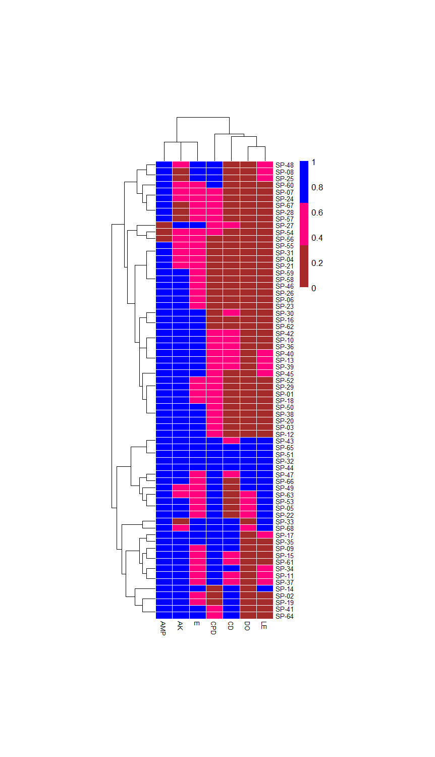

|  |  |
| --- | --- |
|  | Sensitive |
|  |  |
|  | Intermediate |
|  |  |
|  | Resistant |

|  |
| --- |
| AMP = ampicillin |
| AK = amikacin |
| CPD = cefpodoxime |
| CD = clindamycin |
| DO = doxycycline |
| E = erythromycin |
| LE = levofloxacin |

**Fig. 1 Heatmap and dendrogram of the antibiogram profiles of**

***S. pseudintermedius* isolates**

(where 0 = susceptible, 0.5 = intermediate, and 1 = resistant)

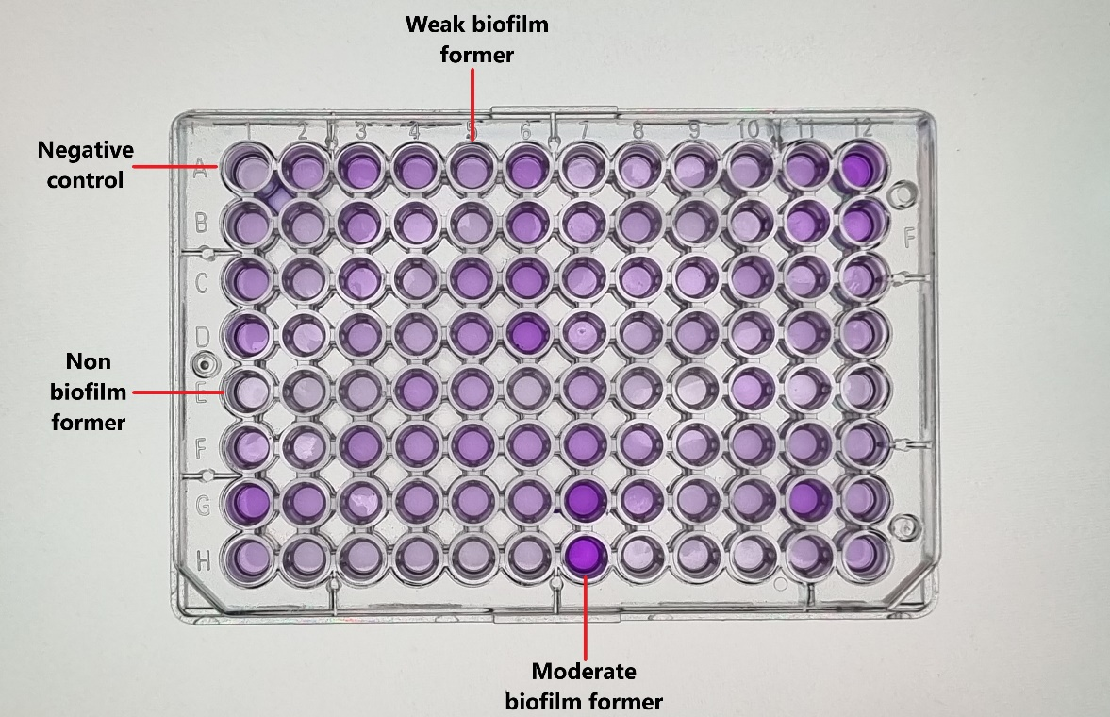

|  |  |
| --- | --- |
|  | Present |
|  |  |
|  | Absent |

**Fig. 2 Microtitre plate assay for biofilm formation**

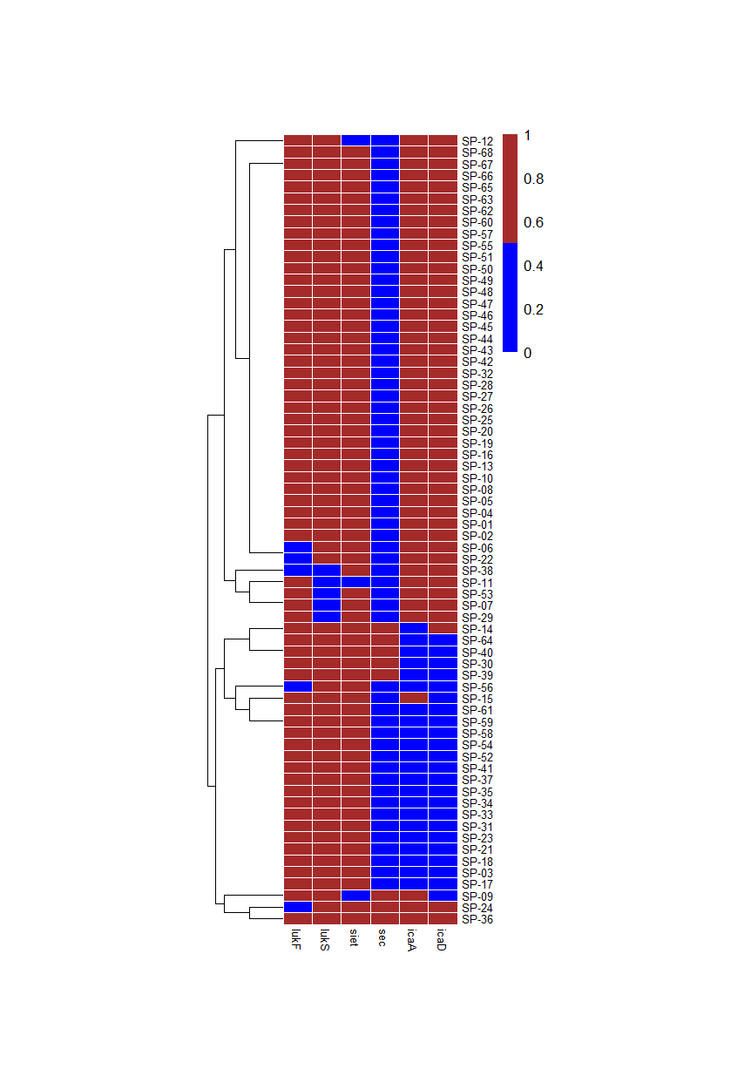

**Fig. 3 Heatmap and dendrogram of the virulence and biofilm genes detected in *S. pseudintermedius* isolates** (where 0 = absent, 1 = present)