Original Research Article

Comparative Morphometric Analysis of Body and Skull Parameters in German Shepherd, Golden Retriever, and Siberian Husky Dogs

ABSTRACT

The present study involved 18 adult dogs, equally divided among three breeds: 6 German Shepherds, 6 Golden Retrievers, and 6 Siberian Huskies. The objective was to analyze various body conformation parameters, which included height, body length, heart girth, neck girth, length of the back, and overall height. Measurements were taken using a standard measuring tape to ensure accuracy. In addition to body dimensions, external skull morphometric parameters were also assessed, including skull length, skull width, cranial length, cranial width, facial length, jaw length, and key anatomical landmarks such as the prosthion, nasion, and bregma.The findings revealed that German Shepherds exhibited the highest average height compared to the other breeds, while Golden Retrievers followed closely behind, and Siberian Huskies had the lowest average height. The body length ratios among the breeds were approximately 5.50:6.50:7.0 for Siberian Husky, Golden Retriever, and German Shepherd, respectively. In terms of neck girth, the ratios were approximately 8.0:9.0:11.0 for the same breeds, with the shoulder girth ratio measured at 6.0:7.0:8.0.Moreover, the ratio of back lengths between the Golden Retriever and Siberian Husky was approximately 4.0:3.0. The cranial length ratios indicated a measurement of 4.0:3.0:3.0 for German Shepherds, Golden Retrievers, and Siberian Huskies, respectively. These results provide valuable insights into the physical characteristics of these popular dog breeds, which can aid in breed selection and understanding breed standards.
Key words: German Shepherd, Golden Retriever, Siberian Husky, Morphometry, Skull, Body Conformation.

INTRODUCTION

Morphometric analysis in dogs serves as a crucial tool for breed characterization, health assessment, and understanding functional adaptations across various breeds. Each dog breed exhibits unique body conformations and skull morphologies, reflecting their evolutionary history, working roles, and selective breeding practices. For instance, German Shepherds are known for their herding and protection skills, while Golden Retrievers are prized for their retrieving capabilities and friendly disposition. Siberian Huskies, on the other hand, are recognized for their endurance and strength in sled pulling.Cranial and body morphometry generates essential data for veterinarians, breeders, and researchers, guiding breed development and the assessment of conformation-related health issues. Variations in skeletal conformation are not only important for aesthetic standards but also significantly affect biomechanics, movement patterns, and the likelihood of developing specific orthopedic and neurological disorders. For example, a longer jaw can increase bite force, potentially making certain breeds more effective in specific tasks, while a broader skull may correlate with distinct behavioral traits.Moreover, understanding the morphometric differences between breeds aids forensic investigations and archaeological studies by assisting in the identification of breed types from skeletal remains. Comparative morphometric studies also help in tracking the impacts of selective breeding on anatomical features, revealing shifts across generations that may affect the breed's health and functionality. This research thus not only evaluates current anatomical benchmarks, but also contributes to a comprehensive understanding of the historical and evolutionary mapping of canine breeds. By analyzing these morphological traits, we gain insights into the adaptability, health, and welfare of dogs, ensuring informed practices in breeding and care that support both the animals’ well-being and owners' needs.
MATERIALS AND METHODS
Eighteen clinically healthy adult dogs, comprising six each of German Shepherd, Golden Retriever, and Siberian Husky breeds, were selected. The dogs were matched for age (between 2 to 4 years) and were not subjected to any prior orthopedic or cranial trauma. Each animal was examined by a veterinarian to ensure health status before inclusion.
The following morphometric parameters were measured:
Body parameters: Height, body length, back length, neck girth, and chest girth using standard measuring tape.
Skull parameters: Skull length, skull width, cranial length, cranial width, facial length, jaw length, prosthion, nasion, and bregma using precision digital calipers.
Each measurement was repeated thrice to minimize observer error and to maintain consistency. The average value was recorded for each parameter.For the statistical analysis of the data collected, descriptive statistics, including the mean and standard error for each measured parameter, were calculated using SPSS software. Comparisons between the different groups regarding the various parameters studied were performed using the One Way ANOVA function of the same software.
RESULTS AND DISCUSSION
Morphometric evaluations remain vital for understanding breed conformation, functional anatomy, and suitability for specific tasks in dogs (Miller et al, 1985; Wayne, 1986). This study systematically compares external body and cranial morphometric parameters across three prominent dog breeds—German Shepherd (GSD), Golden Retriever (GR), and Siberian Husky (SH)—to characterize breed-specific anatomical traits and their functional implications. Each breed exhibits unique morphological characteristics that can influence their performance in various roles, such as service work, companionship, and athletic activities. By identifying these breed-specific traits, the research provides essential reference points for establishing standards, conducting clinical assessments, and guiding the selection of working dogs (Onar et al., 2001; Simoens et al., 1994). Understanding the intricacies of breed anatomy and physiology not only enhances our knowledge of each breed's capabilities but also supports responsible breeding practices that ensure dogs excel in their intended tasks. This study contributes to the broader understanding of dog morphology and functionality, highlighting the importance of rigorous morphometric analysis in informing breeding decisions and promoting optimal health and performance in canine companions. Insights gained from this research are invaluable for veterinarians, trainers, and breeders alike.
Body Conformation
- Height at Withers - German Shepherds (GSDs) exhibited the highest mean height at the withers, measuring an average of 71.55 cm, followed by Golden Retrievers (GRs) at 56.61 cm and Siberian Husky (SHs) at 52.03 cm (Table & Fig. 1). This height trend aligns with previous research (Malharrao et al., 2021), highlighting the substantial size differences among various breeds. The increased height in GSDs is particularly advantageous, providing a more extended stride length that enhances their mobility and agility. Additionally, this trait improves their visibility, making them highly effective in roles such as police and military operations (de Miranda-Magalhães et al., 2023). The physical attributes of GSDs contribute not only to their performance in various working capacities but also influence their overall health and longevity. Understanding these size dynamics among breeds aids in selecting the right dog for specific tasks or companionship roles, emphasizing the importance of breed characteristics in decision-making.
Table. 1 - Mean ± SE of gross parameters of body conformation
Group | Height | Body length | Back length | Neck | Girth
German Shepherd | 71.55$±$0.95ª | 74.60$±$2.02ª | 68.55$±$1.93ª | 53.36$±$1.28ª | 79.28$±$3.08ª
Golden Retriever | 56.61$±$0.49^{b} | 64.48$±$1.14^{b} | 61.13$±$0.98^{b} | 43.81$±$0.48^{b} | 72.85$±$1.06^{ab}
Siberian Husky | 52.03$±$0.73^{c} | 58.01$±$0.63^{c} | 48.75$±$1.05^{c} | 41.30$±$0.77^{b} | $68.08±$1.52^{b}

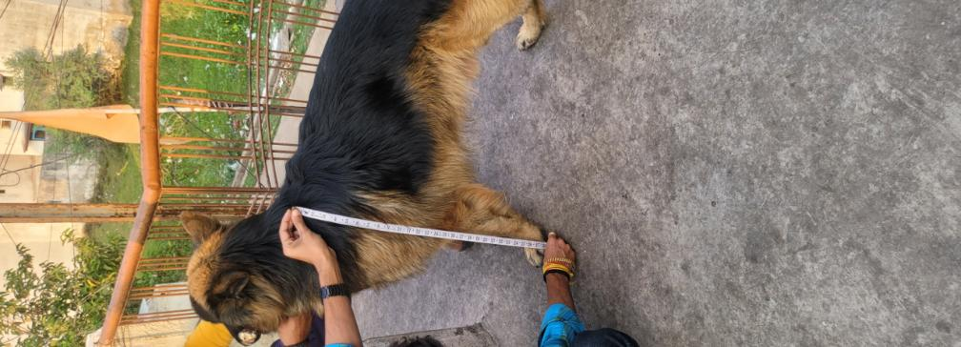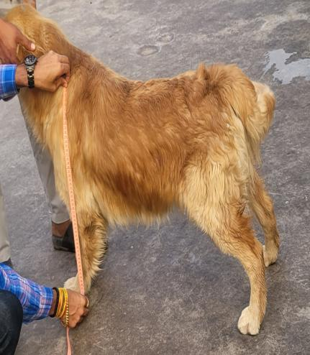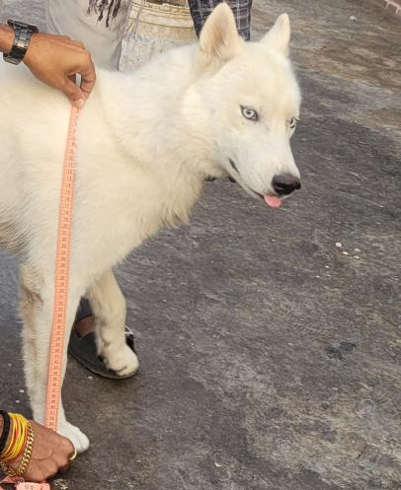
Fig 1. Measurement of height of German Shepherd, Golden Retriever and Siberian Husky

- Body and Back Length - The body length measurements of different dog breeds show a clear hierarchy: German Shepherd Dogs (GSDs) averaged 74.60 cm, Golden Retrievers (GRs) 64.48 cm, and Siberian Husky (SHs) 58.01 cm. This extended axial frame is associated with enhanced balance and endurance, which are critical attributes for canines involved in search-and-rescue operations (Jeusette et al.,2010) (Singh 2022)). Additionally, back length significantly correlates with spinal flexibility and the efficiency of carrying gear, suggesting that these physical traits are vital for performance in demanding tasks. Understanding these relationships can aid in the selection and training of dogs for specialized roles in emergency services.
- Neck and Chest Girth - German Shepherd Dogs (GSDs) exhibit notable physical traits, including a larger neck girth of 53.36 cm and chest girth of 79.28 cm (Fig .2). These measurements suggest enhanced respiratory and muscular capacities, which are vital for their performance in various activities. Such thoracic development aligns with the increased demands for endurance necessary for executing high-intensity tasks. This anatomical advantage is essential in their roles, from working dogs to companions, highlighting the breed’s capability and versatility in physically demanding environments. Overall, the body structure of GSDs reflects their evolutionary adaptation to ensure optimal performance in various physical challenges ( Curth et al., 2017).
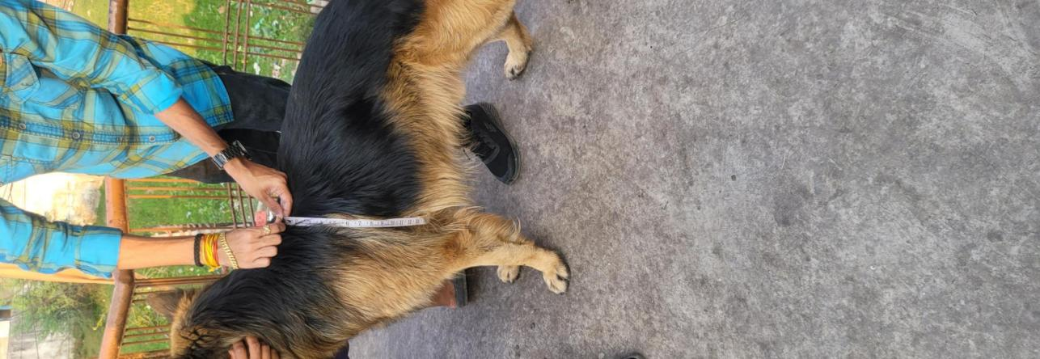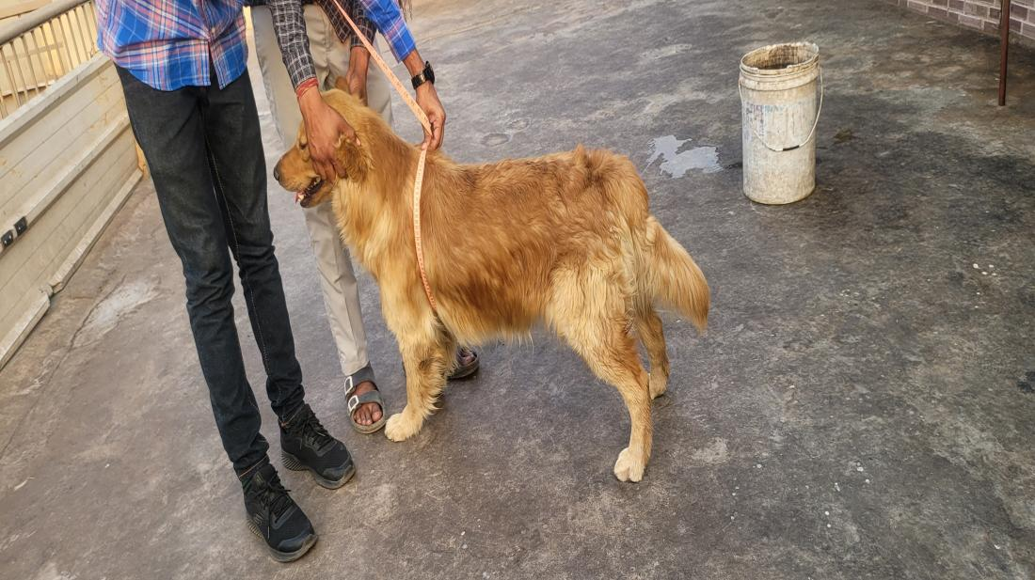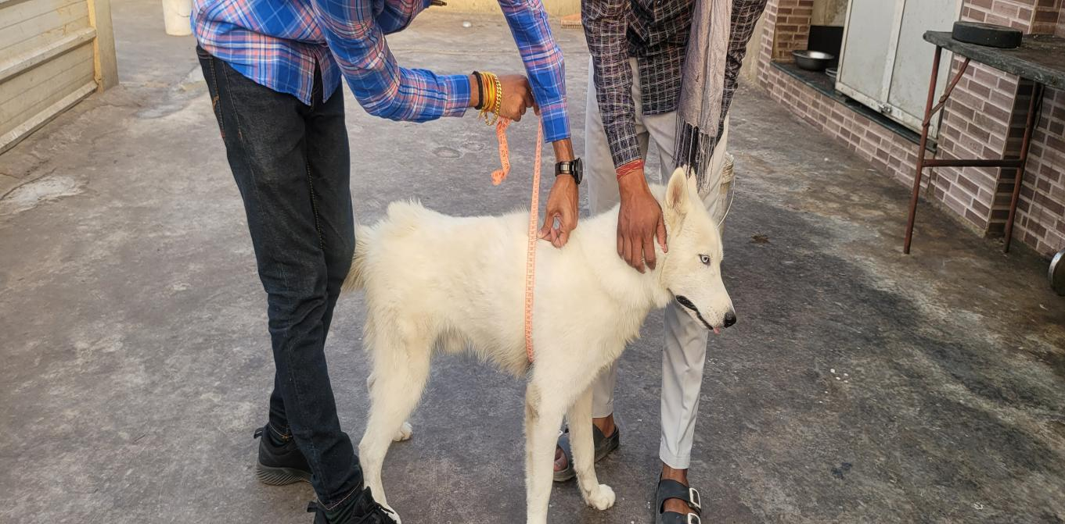
Fig 2. Measurement of heart girth of German Shepherd, Golden Retriever and Siberian Husky

4. Functional Implications - The dimensions of these breeds highlight their specific design purposes: German Shepherds (GSDs) are built for agility and power, Golden Retrievers (GRs) are suitable for a variety of tasks, and Siberian Huskies (SHs) are adapted for endurance in cold climates (Coppinger & Coppinger, 2001; Fischer & Lilje, 2011). The compact bodies of Siberian Huskies reflect the evolutionary pressures that favor minimizing heat loss, which aligns with their thermoregulatory adaptations.
Skull Morphometry
- Skull and Cranial Length - GSDs possess significantly longer skulls and crania compared to GRs and SHs, which notably enhances nasal airflow and olfaction (Vilà et al., 1997). The cranial length of GSDs (25.21 cm) clearly substantiates the assertion that working breeds exhibit larger cerebral capacity (Sutter et al., 2007).
- Facial and Jaw Dimensions - In German Shepherd Dogs (GSDs), facial and jaw lengths are the longest, which correlates with a stronger bite force . In contrast, these traits are less pronounced in Golden Retrievers (GRs) and Siberian Huskies (SHs), reflecting their gentler roles in therapy work and sled pulling, respectively.
3. Prosthion, Nasion, Bregma - German Shepherd Dogs (GSDs) exhibited the largest distances between the prosthion and nasion, as well as between the nasion and bregma, indicating significant facial elongation (Onar, 1999). These anatomical landmarks are essential for cephalometric assessments and have applications in forensic science (Wayne, 1986).
Table. 2 Mean ± SE of gross parameters of skull morphometry
Group | Skull length | Skull  Width | Cranial length | Cranial  Width | Facial length | Prosthion | Nasion | Bregma | Length of jaw
GSD | 34.36$±$0.61a | 24.80$±$0.59 | 25.48$±$0.66a | 23.65$±$0.63a | 18.55$±$0.59a | 21.65$±$0.58a | 16.66$±$0.48a | 18.70$±$0.53a | 19.95$±$0.54a
GR | 26.03$±0.27$b | 24.16$±0.40$ | 16.23$±0.74$b | 17.36$±$0.73b | 10.41$±$0.29b | 16.86$±$21.02b | 12.78$±$0.28b | 13.65$±$0.25b | 14.63$±$0.85b
SH | 25.31$±0.79$b | 23.20$±0.57$ | 15.65$±$0.59b | 12.36$±$0.37c | 9.53$±$0.36b | 16.18$±$0.44b | 11.85$±$0.50b | 12.26$±$0.35b | 13.75$±$0.41b

Skull Indices
- Skull Index - The Skull Index indicates that German Shepherd Dogs (GSDs) are dolichocephalic, with a score of 72.12, while Golden Retrievers (GRs) and Siberian Husky (SHs) are classified as mesaticephalic, scoring 92.88 and 91.90, respectively. Dolichocephalic breeds tend to have improved directional vision and better nasal airflow (Schoenebeck & Ostrander, 2013; Miller & Murphy, 1995).
2.Cranial Index - Golden Retrievers had the highest cranial index at 108.49, which signifies a broader braincase conducive to learning and social behavior (Serpell & Duffy, 2014; Miklósi et al., 2009). In contrast, Siberian Husky exhibited a lower cranial index of 79.30, reflecting their leaner head profiles.
- 3.Nasal and Orbital Indices - German Shepherd Dogs recorded the highest nasal index at 37.20 and the highest orbital index at 77.12 (Table. 3). These indices reflect enhanced olfactory capabilities and spatial awareness—traits that are advantageous in fieldwork(Miller & Murphy, 1995).

Table. 3 Mean ± SE of gross parameters of skull indices
Group | Skull Index | Cranial Index | Nasal Index | Orbital Index
GSD | 72.12$±$0.48^{b} | 92.79$±$0.32^{ab} | 37.20$±$0.55ª | 77.12$±$0.98ª
GR | 92.88$±$1.81ª | 108.49$±$7.78ª | 31.05$±$1.87^{b} | 55.55$±$2.38^{b}
SH | 91.90$±$2.56ª | 79.30$±$2.35^{b} | 28.42$±$0.73^{b} | 53.65$±$1.98^{b}
Functional and Evolutionary Implications
Morphometric distinctions are closely aligned with the specific roles of different dog breeds:
German Shepherds (GSDs) are optimized for protection and utility, featuring strong skeletal and cranial development that enhances their bite strength, sense of smell, and cognitive abilities (Schmutz & Berryere, 2007).
Golden Retrievers (GRs), with their intermediate body structure, excel in companionship, retrieval, and therapy roles (Helton, 2009; Battaglia, 2009).
Siberian Huskies (SHs) possess traits that are essential for pulling loads over icy terrain, including stamina and efficient body proportions.
Comparative Significance and Clinical Relevance
This study provides a validated comparative framework for breed-specific conformation. Veterinary professionals can use these metrics to assess development, diagnose anomalies, and inform training and nutrition protocols. Furthermore, skull morphometrics serve in forensic contexts for breed identification (Onar, 1999).
Limitations and Future Directions
While this analysis establishes breed-specific morphometric baselines, further studies should include larger sample sizes, sex-based differences, and age stratification. Integrating radiological methods such as CT, 3D photogrammetry, and geometric morphometrics would enhance the understanding of craniofacial mechanics.
CONCLUSION
This comprehensive morphometric study reveals significant differences in body and skull dimensions among German Shepherds, Golden Retrievers, and Siberian Huskies. German Shepherds consistently exhibited the largest measurements for both body and cranial parameters, indicating their suitability for demanding functional roles. Golden Retrievers displayed balanced traits that are ideal for retrieving and companionship, while Siberian Huskies showed adaptations that emphasize endurance and resilience in cold climates. These findings not only confirm established breed characteristics but also provide valuable anatomical references for veterinary professionals, breeders, and researchers seeking to enhance canine health, performance, and well-being.
Disclaimers
The views and conclusions expressed in this article are solely those of the authors and do not necessarily represent the views of their affiliated institutions. The authors are responsible for the accuracy and completeness of the information provided, but do not accept any liability for any direct or indirect losses resulting from the use of this content.
Conflict of interest
The authors declare that there are no conflicts of interest regarding the publication of this article. No funding or sponsorship influenced the design of the study, data collection, analysis, decision to publish,
or preparation of the manuscript.
ETHICAL APPROVAL
All animal procedures and handling techniques for experiments were approved by the Institutional Animal

Disclaimer (Artificial intelligence)

Option 1:

Author(s) hereby declare that NO generative AI technologies such as Large Language Models (ChatGPT, COPILOT, etc.) and text-to-image generators have been used during the writing or editing of this manuscript.

Option 2:

Author(s) hereby declare that generative AI technologies such as Large Language Models, etc. have been used during the writing or editing of manuscripts. This explanation will include the name, version, model, and source of the generative AI technology and as well as all input prompts provided to the generative AI technology

Details of the AI usage are given below:
- Grammarly (Only gor grammatical corrections)
2.
3.

References
Battaglia, C. L. (2009). Periods of early development and the effects of stimulation and social experiences in the canine. Journal of Veterinary Behavior, 4(5), 203-210.
Coppinger, R., & Coppinger, L. (2001). Dogs: A startling new understanding of canine origin, behavior & evolution. Simon and Schuster.
Curth, S., Fischer, M. S., & Kupczik, K. (2017). Can skull form predict the shape of the temporomandibular joint? A study using geometric morphometrics on the skulls of wolves and domestic dogs. Annals of Anatomy-Anatomischer Anzeiger, 214, 53-62.
Miller, M. E., Evans, H. E., & Christensen, G. C. (1985). Miller’s Anatomy of the Dog.
Helton, W. S. (2009). Cephalic index and perceived dog trainability. Behavioural processes, 82(3), 355-358.
Jeusette, I., Greco, D., Aquino, F., Detilleux, J., Peterson, M., Romano, V., & Torre, C. (2010). Effect of breed on body composition and comparison between various methods to estimate body composition in dogs. Research in veterinary science, 88(2), 227-232.
Malharrao, d. S. (2021). Management practices adopted and morphometric characterization of caravan dog (Doctoral dissertation, Maharashtra Animal and Fishery Sciences University).
de Miranda-Magalhães, A. J., Jantorno, G. M., Pralon, A. Z., de Castro, M. B., & de Melo, C. B. (2023). Explosive detection dogs: a perspective from the personality profile, selection, training methods, employment, and performance to mitigate a real threat. Animals, 13(24), 3773.
Topál, J., Miklósi, Á., Gácsi, M., Dóka, A., Pongrácz, P., Kubinyi, E., ... & Csányi, V. (2009). The dog as a model for understanding human social behavior. Advances in the Study of Behavior, 39, 71-116.
Miller, P. E., & Murphy, C. J. (1995). Vision in dogs. Journal of the American Veterinary Medical Association, 207(12), 1623-1634.
Onar, V. (1999). A morphometric study on the skull of the German shepherd dog (Alsatian). Anatomia, histologia, embryologia, 28(4), 253-256.
Schmutz, S. M., & Berryere, T. G. (2007). Genes affecting coat colour and pattern in domestic dogs: a review. Animal genetics, 38(6), 539-549.
Schoenebeck, J. J., & Ostrander, E. A. (2013). The genetics of canine skull shape variation. Genetics, 193(2), 317-325.
Serpell, J. A., & Duffy, D. L. (2014). Dog breeds and their behavior. In Domestic dog cognition and behavior: The scientific study of Canis familiaris (pp. 31-57). Berlin, Heidelberg: Springer Berlin Heidelberg.
Simoens, P., Poels, P., & Lauwers, H. (1994). Morphometric analysis of the foramen magnum in Pekingese dogs. American Journal of Veterinary Research, 55(1), 34-39.
Singh, S. (2022). Comparative Evaluation of Radiographic Morphometry of Proximal Femur and Hip Joint in Healthy Labrador Retriever and German Shepherd Breeds of Dog (Doctoral dissertation, Indian Veterinary Research Institute)..
Sutter, N. B., Bustamante, C. D., Chase, K., Gray, M. M., Zhao, K., Zhu, L., ... & Ostrander, E. A. (2007). A single IGF1 allele is a major determinant of small size in dogs. Science, 316(5821), 112-115.
Vilà, C., Savolainen, P., Maldonado, J. E., Amorim, I. R., Rice, J. E., Honeycutt, R. L., ... & Wayne, R. K. (1997). Multiple and ancient origins of the domestic dog. Science, 276(5319), 1687-1689.
Wayne, R. K. (1986). Limb morphology of domestic and wild canids: the influence of development on morphologic change. Journal of morphology, 187(3), 301-319.

