***Original Research Article***

**Optimizing Pot-Anthurium Growth and Blooms: Exploring the Impact of Plant Growth Regulators**

**ABSTRACT**

The study was conducted from June 2022 to June 2023 in the shade-net house of All-India Co-ordinated Research Project on Floriculture at Odisha University of Agriculture and Technology, Bhubaneswar, to evaluate the effect of plant growth regulators on pot-Anthurium production, with sixteen treatments replicated thrice, in a Completely Randomized Design. The plants were sprayed with Benzyl adenine (BA), Gibberellic acid (GA3) and Cycocel (CCC) at five different concentrations (100 ppm, 200 ppm, 300 ppm, 400 ppm and 500ppm). The results revealed that plants treated with GA3 @ 500 ppm recorded the highest vegetative growth parameters, including plant height (21 cm), leaf length (7.38 cm), and leaf width (3.26 cm). Other growth parameters, such as the number of suckers per plant (3.8), number of leaves per plant (23) and the plant spread in both East-West (21.32 cm) and North-South (23.2 cm) directions, were maximized in plants treated with BA @ 500 ppm. Floral parameters, including the number of flowers per plant (3.2), spadix length (1.38cm), spadix breadth (0.36cm), spathe length (4.46cm) and spathe breadth (2.82cm) were recorded highest in plants treated with GA3 @ 500 ppm. Overall, the application of GA3 @ 500 ppm and BA @ 500 ppm exhibited the best results in vegetative growth, flowering habit, quality, and flower production compared to other treatments.

**Keywords:** Anthurium, Growth regulators, GA3, BA, CCC

1. **INTRODUCTION**

Anthuriums are tropical plants highly valued for their vibrant cut flowers and ornamental foliage (Thomas et al., 2024). They have emerged as a significant commodity in commercial farming, capitalizing on a lucrative market for both cut flowers and whole plants. Anthurium, a slow-growing perennial crop with over 100 genera and approximately 1,599 species, predominantly from tropical regions, thrive in shady, humid conditions reminiscent of tropical forests, making them ideal for cultivation in such environments (Chowdhuri et al., 2021; Muraleedharan *et al.,* 2020).

Anthuriums are becoming increasingly favoured due to their ability to provide excellent returns per unit area and the allure of their striking, long-lasting flowers. Anthurium is ranked as the ninth leading cut flower in international trade (Kumar et al., 2022) with high demand and respectable pricing both as a cut flower and as well as a whole plant (Anand et al., 2017).

In recent years, pot anthurium production has gained prominence alongside cut flower cultivation, especially due to urbanization and the increasing interest in vertical farming and interior landscaping.. Annually, India records approximately 3,230 tonnes of anthurium flower production, with Assam contributing 2,050 tonnes and Meghalaya 740 tonnes. (Bhati, 2023). While considerable research has been dedicated to the cultivation of cut anthurium, there remains a noticeable dearth of studies addressing pot anthurium. The research addresses the challenge of anthurium cultivation, specifically focusing on pot anthurium. It explores how growth regulators impact the growth and flowering of pot anthuriums.

Nowadays, there has been a significant rise in the use of plant growth regulators. They influenc the physiological and morphological processes of vegetables, fruit crops and other plants (Davies, 2004). Gibberellic acid (GA3) is a member of the gibberellin family of plant growth regulators. It plays a vital role in regulating various physiological processes, including stem elongation, seed germination, enzyme induction, fruit development, and flowering. GA₃ promotes cell elongation and division, facilitates mobilization of stored nutrients during seed germination, delays senescence in certain tissues, and can influence chloroplast development and morphogenesis (Bagale et al., 2022; Shudo, 2019).. Benzyl adenine (BA) is an important group of plant growth regulators within the cytokinin family, commonly referred to as the "cell division hormone" (Mangena 2022). It helps to improves plant yield by influencing growth, flowering, and various physiological processes throughout the plant life cycle (Yadav *et al*., 2021). Recently, BA has been used as an additional source to preserve or improve the condition of a variety of ornamental plants (Gabrel *et al.*, 2018). To create dwarf and visually appealing pot plants, various growth retardants such as Cycocel (CCC), B-Nine, Phosphon, and Anacymidal have been tested on different ornamental species. Cycocel is a synthetic substance that reduce stem growth and prolongs the shelf life of flowers. The foliar application of higher concentrations of CCC leds to phytotoxic effects, with growth retardation becoming more marked as the concentration increased (Singh *et al*., 2018). These regulators, readily available in the market, play a significant role in influencing the growth and flowering attributes of pot anthurium. Despite advancements in the anthurium industry in India, comprehensive research on systematically cultivating pot anthuriums, with an emphasis on foliar applications of growth regulators, is still limited. With the background above, the objectives of this study this research seeks to evaluate vegetative and flowering parameters, placing special emphasis on the effect of growth regulators like BA, GA3, and CCC with the overarching goal of enhancing pot anthurium cultivation under protected conditions.

1. **MATERIALS AND METHODS**

The experiment was conducted during June 2022 to june2023 to study the effect of plant growth regulators on growth and flowering of pot anthurium. It was carried out under the shade-net house of the All-India Co-ordinated Research Project on Floriculture, Odisha University of Agriculture and Technology, Bhubaneswar, Odisha, India (Fig. 1).

The experiment was laid out following completely randomized block design, with three replications and sixteen treatments. Uniform plants of pot anthurium (10cm high), raised through tissue culture were chosen for this experiment. The plants were planted in 6-inch earthen pots in a substrate containing cocopeat: perlite: sand in the ratio 10: 1: 1. All plants were sprayed uniformly with a nutrient mixture of 20:20:20 (water soluble NPK) @ 20g/l on alternate days and micro-nutrient @1ml l-1 was sprayed at 15 days interval. One month after planting, the plants were sprayed with different concentration of BA, GA3 & CCC as per the details given in table 1.

**Table 1: Treatment details**

|  |  |
| --- | --- |
| **Treatment** | **Treatment Details** |
| T1 | Control |
| T2 | BA@100ppm |
| T3 | BA@200ppm |
| T4 | BA@300ppm |
| T5 | BA@400ppm |
| T6 | BA@500ppm |
| T7 | GA3@100ppm |
| T8 | GA3@200ppm |
| T9 | GA3@300ppm |
| T10 | GA3@400ppm |
| T11 | GA3@500ppm |
| T12 | CCC@100ppm |
| T13 | CCC@200ppm |
| T14 | CCC@300ppm |
| T15 | CCC@400ppm |
| T16 | CCC@500ppm |

Note: T: Treatment; BA: Benzyl adenine; GA3: Gibberellic acid; CCC: Cycocel; ppm: Parts Per Million

A 1000 ppm stock solution for each of BA, GA₃, and CCC was prepared by dissolving 500 mg of each substance in its designated solvent: BA in a small volume of 0.1N NaOH, GA₃ in ethyl alcohol, and CCC in distilled water, with each solution was brought to a final volume of 500 ml using distilled water. To prepare solutions of 100, 200, 300, 400, and 500 ppm, respective volumes of 10, 20, 30, 40, and 50 ml from each stock solution were diluted to 100 ml with distilled water. Prior to application, the pH of each spray solution was adjusted to a range of 5.7–5.8 using 0.1N HCl or NaOH.

First spray was done one month after planting, followed by subsequent sprays at 15-days interval. For recording various grow and flowering parameters, five plants in each treatment were selected at random. Various growth and flowering parameters like plant height (cm), number of leaves per plant, number of suckers per plant, plant spread (cm), leaf length and width (cm), number of flowers per plant, spadix length (cm), spadix breadth (cm), spathe length (cm), spathe breadth (cm), spathe colour were recorded.

The experiment was l ANOVA was calculated using the observations recorded on different growth and floral parameters, following this design, at 5% level of significance. The statistical method described by Gomez and Gomez (1984) was used to evaluate the recorded data.

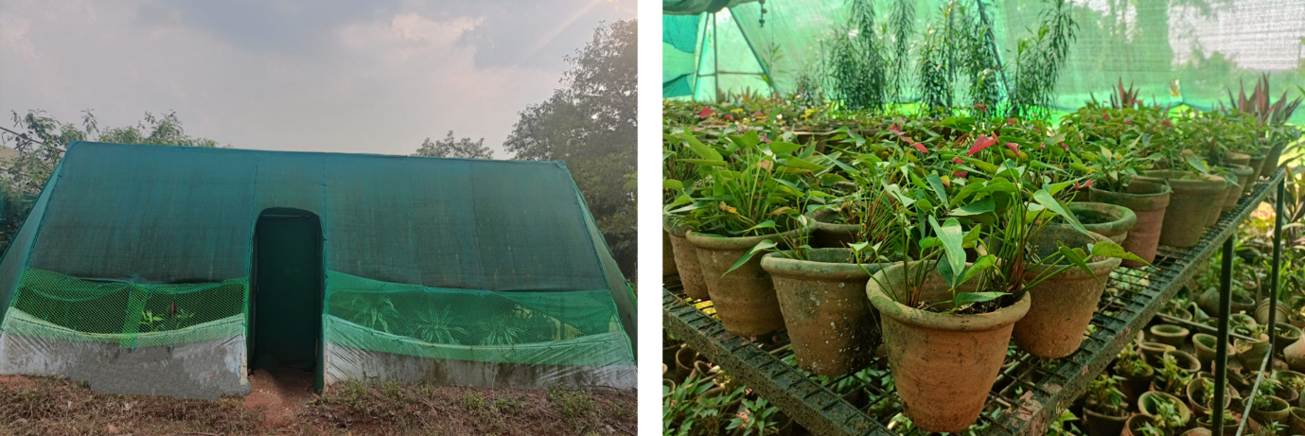**Fig. 1 A view of the pot Anthurium grown in agro shade-net house at Biotechnology-cum-Tissue Culture Centre, O.U.A.T., Bhubaneswar**

1. **RESULTS AND DISCUSSION**

The application of plant growth regulators significantly influenced the vegetative parameters of pot anthurium sown in Table 2 and fig.2 . The plant height in different treatments varied from 15.6 cm to 21.0 cm. The maximum height of 21.0 cm was achieved with plants treated with GA3 @ 500 ppm and the minimum plant height observed with CCC@ 500 ppm (15.6 cm). The significant increase in plant height observed with GA3 application due to the effective action of gibberellins, which promote vegetative growth through cell division and elongation, This effect aligns closely with the findings of Ara *et al.,* 2022. This likely resulted in the enhanced plant height. Additionally, GA₃ promotes photosynthetic activity, likely aiding in the osmotic absorption of water and nutrients by sustaining stable turgor pressure, which counters the softening of cell walls (Jayashree *et al.* 2020).

The number of leaves per plant showed significant differences among treatments. Maximum number of leaves (23.0) was recorded with BA @ 500 ppm, which was statistically at par with BA@400ppm (21.8) and GA3@500ppm(20.6). The lowest leaf count (16.0) was observed with CCC @ 500 ppm. Sucker production per plant was also significantly affected by the treatments. Plants treated with 500 ppm BA produced the highest number of suckers i.e.3.8 (Fig. 3) and control had the least number of suckers (0.6). Application of Benzyl adenine may have caused the plant to produce the highest number of leaves possibly by stimulating the leaf primordial in the apical growing region. This effect aligns closely with the findings of Ragini *et al.* (2019).

Leaf dimensions were also significantly enhanced by the growth regulators. The maximum leaf length (7.38 cm) and breadth (3.26 cm) were observed in plants treated with GA3 @ 500 ppm, statistically similar to those treated with BA @ 500 ppm, GA3 @ 400 ppm, and BA @ 400 ppm. The increase in leaf size may be attributed to the stimulatory effects of gibberellins, which promote cell division and subsequently enhance cell elongation and expansion (Ritonga et al., 2023). and.

Further, plant spread in both directions (East-West and North-South) was highest in plants treated with BA @ 500 ppm, with dimensions of 21.32 cm and 23.2 cm, respectively. These results were statistically comparable to plants treated with BA @ 400 ppm and GA3 @ 500 ppm. Such increase in plant spread in both directions (E-W and N-S) is likely due to enhanced cell division and elongation, as well as the production of a higher number of lateral branches. This ultimately led to an improved plant spread and an increased number of leaves per branch. Gibberellin plays a major role in regulating various physiological process in plant tissue (Sharma and Zheng, 2019). Thakur *et al.*  (2023) also explained that gibberellins have a very prominent role in increasing plant growth and development and also adaptation to environmental conditions.

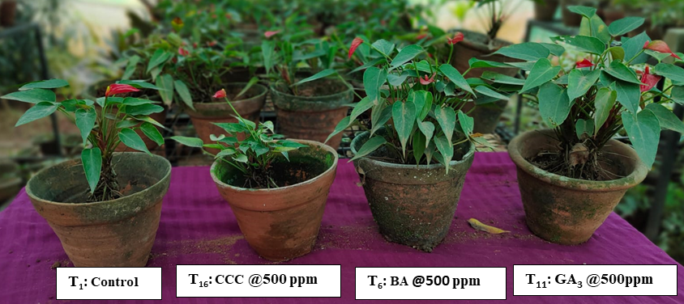

**Fig. 2 Effect of growth and flowering of pot Anthurium as influenced by BA, GA3 and CCC**

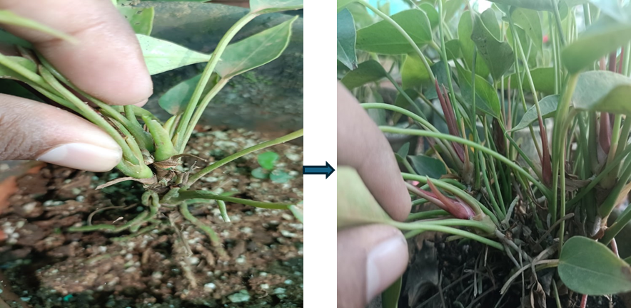

**Fig. 3 Effect of benzyl adenine on sucker development in Pot Anthurium**

**Table 2. Effect of plant growth regulators on vegetative parameters of pot Anthurium**

|  |  |  |  |  |  |  |  |  |
| --- | --- | --- | --- | --- | --- | --- | --- | --- |
| **Treatments** | | **Vegetative parameters** | | | | | | |
| **Plant height (cm)\*** | **Number of leaves per plant\*** | **Number of suckers per plant\*** | **Leaf length (cm)\*** | **Leaf breadth**  **(cm)\*** | **Plant spread**  **(E-W)**  **(cm)\*** | **Plant spread**  **(N-S)**  **(cm)\*** |
| T1 | Control | 17.6 | 17.4 | 0.6 | 6.22 | 2.6 | 17.24 | 19 |
| T2 | BA@100 ppm | 18 | 19.2 | 1.8 | 6.36 | 2.66 | 18.4 | 20.4 |
| T3 | BA@200 ppm | 18.4 | 19.8 | 2.4 | 6.54 | 2.74 | 18.6 | 21 |
| T4 | BA@300 ppm | 18.8 | 20.2 | 2.6 | 6.6 | 2.7 | 19.34 | 21.4 |
| T5 | BA@400 ppm | 19 | 21.8 | 3.2 | 6.64 | 2.88 | 20.3 | 22 |
| T6 | BA@500 ppm | 19.2 | **23** | **3.8** | 6.92 | 2.94 | **21.32** | **23.2** |
| T7 | GA3@100 ppm | 18.6 | 17.8 | 1.6 | 6.4 | 2.46 | 17.4 | 19.2 |
| T8 | GA3@200 ppm | 18.8 | 18 | 1.8 | 6.58 | 2.58 | 17.6 | 19.24 |
| T9 | GA3@300 ppm | 19.4 | 18.4 | 2.2 | 6.62 | 2.8 | 18 | 19.44 |
| T10 | GA3@400 ppm | 20.4 | 18.6 | 2.6 | 6.86 | 2.92 | 19.8 | 20.2 |
| T11 | GA3@500 ppm | **21** | 20.6 | 3 | **7.38** | **3.26** | 20 | 21.4 |
| T12 | CCC@100 ppm | 17 | 17.4 | 0.8 | 6.18 | 2.6 | 17.6 | 19.4 |
| T13 | CCC@200 ppm | 16.6 | 17 | 1 | 6.14 | 2.58 | 17.7 | 19.6 |
| T14 | CCC@300 ppm | 16.4 | 16.6 | 1.2 | 5.9 | 2.3 | 18.1 | 20.08 |
| T15 | CCC@400 ppm | 16 | 16.4 | 1.4 | 5.76 | 2.32 | 18.2 | 20.16 |
| T16 | CCC@500 ppm | 15.6 | 16 | 1.6 | 5.42 | 2.2 | 18.6 | 20.3 |
|  | SEm (±) | **0.71** | **0.90** | **0.31** | **0.27** | **0.19** | **0.70** | **0.78** |
|  | CD 5% | **2.00** | **2.53** | **0.87** | **0.75** | **0.53** | **1.99** | **2.20** |

**\*Significant at 5%**Note: T: Treatment; BA: Benzyl adenine; GA3: Gibberellic acid; CCC: Cycocel;E-W: East-West;N-S: North-South cm: Centimetre; ppm: Parts Per Million

The effect of growth regulators on flowering parameters of pot anthurium were also found significantly different across various parameters. For instance, the number of flowers per plant exhibited considerable variation among treatments (Table 3). Notably, plants treated with GA3 @ 500 ppm produced the highest number of flowers per plant (3.2), statistically at par with plant treated with BA @ 500 ppm (2.8) and GA3 @ 400 ppm (2.6). Whereas, untreated plants displayed the lowest flower count per plant (0.8). Pot anthurium treated with GA3 @ 500 ppm produce the highest number of flowers, likely because GA3 stimulates the rapid growth of auxiliary buds and promotes flowering. This enhanced bud development is a key factor in the increased flower production per plant. (Kumar *et al.*, 2019). The increase in the number of flowers observed with GA3 @ 500 ppm can also be attributed to several key effects of the hormone. This treatment led to elevated levels of chlorophyll and protein in the leaves, while also significantly reducing the activity of chlorophyllase enzymes. By inhibiting chlorophyllase, GA3 prevented the degradation of chlorophyll and proteins, thereby enhancing the rate of photosynthesis. As a result, photosynthates were more effectively directed towards reproductive structures, leading to a highest number of flowers per plant (Morris, 2017).

Further, spadix length and breadth were significantly influenced by the application of growth regulators. Treatment with GA3 @ 500 ppm notably enhanced spadix length to 1.38 cm and breadth to 0.36 cm (Table 3). Similarly, marked differences were observed in spathe length and breadth among treatments. The highest spathe length and breadth were recorded in plants treated with GA3 @ 500 ppm i.e. 4.46 cm and 2.82 cm, followed by GA3 @ 400 ppm and BA @ 500 ppm. In contrast, untreated plants exhibited the minimum spathe dimensions. Increase in spadix length and breadth may be attributed to favourable conditions near the root zone, which facilitate increased nutrient and water uptake, thereby improving the supply of photosynthates to the developing sinks. These results are in consistent with the findings of previous studies conducted on anthurium plants (Anjali *et al.,* 2013). The enhancement of spathe size attributed to GA3 can be traced to its role in promoting the efficient translocation of metabolites to the spathe development site. Gibberellic acid (GA3) likely triggers a complex developmental process by activating regulatory genes during the later stages of corolla formation, as documented in studies on anthurium. This activation fosters increased spathe length and breadth through heightened cell division and elongation in the flowers, thus strengthening the sink capacity of these growing structure (Muraleedharan *et al*., 2018; Chandel *et al.*, 2023). The spathe colour was red (46 A) as per RHS colour chart (Fig.4), irrespective of treatments. It was observed that the color of the flowers remains unchanged even after the application of various plant growth regulators. This phenomenon has also been observed by Beena (2000) in Anthurium plants.

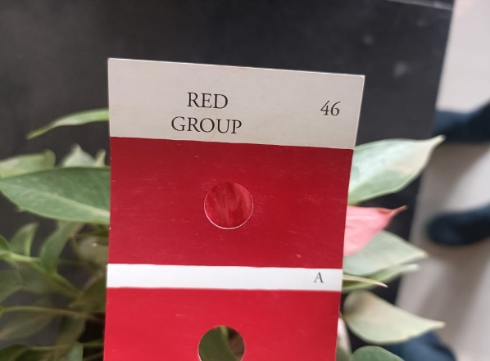

**Fig. 4 Red colour (46A) spathe as per RHS colour chart**

**Table 3. Effect of plant growth regulators on flowering parameters of pot Anthurium**

|  |  |  |  |  |  |  |  |
| --- | --- | --- | --- | --- | --- | --- | --- |
| **Treatments** | | **Flowering parameters** | | | | | |
| **Number of flowers per plant\*** | **Spadix length (cm)\*** | **Spadix breadth**  **(cm)\*** | **Spathe length**  **(cm)\*** | **Spathe breadth**  **(cm)\*** | **Spathe**  **Colour\*\*** |
| T1 | Control | 0.8 | 0.86 | 0.18 | 2.92 | 2.1 | Red (46A) |
| T2 | BA@100 ppm | 1.4 | 1.06 | 0.22 | 3.12 | 2.24 | Red (46A) |
| T3 | BA@200 ppm | 1.8 | 1.14 | 0.24 | 3.2 | 2.28 | Red (46A) |
| T4 | BA@300 ppm | 2 | 1.16 | 0.26 | 3.22 | 2.3 | Red (46A) |
| T5 | BA@400 ppm | 2.4 | 1.24 | 0.28 | 3.44 | 2.42 | Red (46A) |
| T6 | BA@500 ppm | 2.8 | 1.32 | 0.32 | 3.74 | 2.56 | Red (46A) |
| T7 | GA3@100 ppm | 2 | 1.12 | 0.24 | 3.36 | 2.18 | Red (46A) |
| T8 | GA3@200 ppm | 2.2 | 1.18 | 0.26 | 3.66 | 2.36 | Red (46A) |
| T9 | GA3@300 ppm | 2.4 | 1.24 | 0.28 | 3.84 | 2.38 | Red (46A) |
| T10 | GA3@400 ppm | 2.6 | 1.3 | 0.32 | 4.06 | 2.54 | Red (46A) |
| T11 | GA3@500 ppm | **3.2** | **1.38** | **0.36** | **4.46** | **2.82** | Red (46A) |
| T12 | CCC@100 ppm | 1 | 1.12 | 0.28 | 3.56 | 2.48 | Red (46A) |
| T13 | CCC@200 ppm | 1.2 | 1.06 | 0.26 | 3.22 | 2.4 | Red (46A) |
| T14 | CCC@300 ppm | 1.8 | 1.06 | 0.24 | 3.12 | 2.32 | Red (46A) |
| T15 | CCC@400 ppm | 2 | 1 | 0.22 | 3.18 | 2.3 | Red (46A) |
| T16 | CCC@500 ppm | 2.2 | 0.88 | 0.2 | 2.96 | 2.2 | Red (46A) |
|  | SEM (±) | **0.23** | **0.06** | **0.03** | **0.21** | **0.11** |  |
|  | CD 5% | **0.66** | **0.16** | **0.10** | **0.60** | **0.31** |  |

**\*Significant at 5%**

**\*\*Colour of spathe was measured using RHS colour chart**

Note: T: Treatment; BA: Benzyl adenine; GA3: Gibberellic acid; CCC: Cycocel; cm: Centimetre; ppm: Parts Per Million

1. **CONCLUSION**

The present study, indicated that applying GA3@500 ppm and BA@500 ppm plays crucial role in enhancing in terms of vegetative growth, flowering habit, quality and flower yield. These growth regulators significantly influenced physiological processes such as cell division, elongation, and floral induction, leading to improved plant architecture and marketable quality. Pot anthurium cultivation promises flower growers increased revenue; highly educated but unemployed youth can proudly engage themselves in the cultivation of this high-value flower, thus elevating their socio-economic status. This study provides a scientific foundation for standardizing growth regulator-based protocols, paving the way for entrepreneurial opportunities in high-value floriculture. Pot-anthurium is more than just a flower; it's an opportunity, a symbol of elegance, and a source of prosperity for our region's agricultural landscape. This research leads the way for entrepreneurs to venture into this wealthy crop.

**DISCLAIMER (ARTIFICIAL INTELLIGENCE)**

Author (s) hereby declares that no generative AI technologies such as Large Language Models (ChatGPT, COPILOT etc.) and text-to-image generators have been used during the writing or editing of this manuscript

**COMPETING INTERESTS**

The authors declare that there is no conflict of interest.

.**REFERENCES**

Anand, M., Sankari, A., Arulmozhiyan, R., & Kayalvizhi, K. (2017). Evaluation of different varieties of anthurium (*Anthurium andraeanum* Linden Ex André) for cut flower production under Shevaroys Hills. *Electronic Journal of Plant Breeding*, 8(3), 792–798.

Anjali, K. B., Akshay, K. R., & Sudharani, N. (2014). Evaluation and studies on effect of gibberellic acid on growth and yield of anthurium. *International Journal of Tropical Agriculture*, 32(1–2).

Ara, K. A., Kabir, K., Rashid, M. T., Sharifuzzaman, S. M., & Sadia, M. A. (2022). Influence of foliar application of growth regulators on vegetative growth and flowering of chrysanthemum. *Bangladesh Journal*, 69.

Bagale, P., Pandey, S., Regmi, P., & Bhusal, S. (2022). Role of plant growth regulator “Gibberellins” in vegetable production: An overview. *International Journal of Horticultural Science and Technology*, 9(3), 291–299.

Beena, R. (2000). Effect of growth regulators on the growth and flowering of anthurium (*Anthurium andreanum* Linden) (Doctoral dissertation, Department of Plant Physiology, College of Agriculture, Vellayani).

Bhati, M. I. (2023). Chapter 2: Advances in production technology of anthurium. In *A Textbook on Advances in Production Technology of Commercial Flowers* (pp. 25–43). Ahmedabad: Integrated Publications.

Chandel, A., Thakur, M., Rakwal, A., Chauhan, S., & Bhargava, B. (2023). Exogenous applications of gibberellic acid modulate the growth, flowering and longevity of calla lily. *Heliyon*, 9.

Chowdhuri, T. K., Sadhukhan, R., & Ghosh, T. (2021). Varietal performance of anthurium (*Anthurium andreanum*) on growth and flowering in the subtropical zone of West Bengal. *International Journal of Plant & Soil Science*, 33(3), 32–37. <https://doi.org/10.9734/ijpss/2021/v33i330419>

Davies, P. J. (Ed.). (2004). *Plant hormones: Biosynthesis, signal transduction, action!*. Springer Science & Business Media.

Gabrel, F., Mahmoud, K., & Ali El, N. (2018). Effect of benzyl adenine and gibberellic acid on the vegetative growth and flowering of chrysanthemum plant. *Alexandria Journal of Agricultural Sciences*, 63, 29–40.

Gomez, K. A., & Gomez, A. A. (1984). *Statistical procedures for agricultural research*. John Wiley and Sons.

Jayashree, N., Chandrashekar, S. Y., Hemla Naik, B., Hanumantharaya, L., & Ganapathi, M. (2020). Influence of benzyl adenine and gibberellic acid on morphological behaviour of Asiatic lily. *International Journal of Chemical Studies*, 8, 2028–2031.

Kumar, M., Malik, S., Singh, M. K., Singh, S. P., Chaudhary, V., & Sharma, V. R. (2019). Optimization of spacing, doses of vermi-compost and foliar application of salicylic acid on growth, flowering and soil health of chrysanthemum (*Dendranthema grandiflora* Tzvelev) cv. ‘Guldasta’. *International Journal of Agriculture, Environment and Biotechnology*, 12, 213–224.

Kumar, S., Nongthombam, J., Chaudhary, K. P., Devi, N. L., Shukla, R., & Pandey, N. K. (2022). Impact and economics on frontline demonstration (FLD) of good horticultural practices in anthurium. *Biological Forum – An International Journal*, 14(4), 288–291.

Mangena, P. (2020). Benzyl adenine in plant tissue culture – succinct analysis of the overall influence in soybean (*Glycine max* L. Merrill.) seed and shoot culture establishment. *Journal of Biotech Research*, 11.

Morris, D. A. (2017). Hormonal regulation of source-sink relationships: An overview of potential control mechanisms. In *Photoassimilate distribution in plants and crops: Source-sink relationships* (pp. 441–466).

Muraleedharan, A., Kumar, R. S., Kousika, S., & Joshi, J. L. (2018). Growth and flowering on anthurium (*Anthurium andreanum* cv. Tropical) plants treated with foliar application of growth regulators. *Journal of Emerging Technologies and Innovative Research*, 5.

Muraleedharan, A., Sha, K., Kumar, S., Sujin, G. S., Joshi, J. L., & Kumar, C. P. (2020). Influence of seaweed extract along with growth regulators on the growth, flowering and yield of anthurium plants. *Plant Archives*, 20, 1196–1199.

Ragini, B. K., Chandrashekar, S. Y., Hemla, N. B., Shivaprasad, M., & Ganapathi, M. (2019). Effect of cytokinins (benzyl adenine and kinetin) on bulbous flower crops: A review. *International Journal of Chemical Studies*, 7, 2618–2622.

Ritonga, F. N., Zhou, D., Zhang, Y., Song, R., Li, C., Li, J., & Gao, J. (2023). The roles of gibberellins in regulating leaf development. *Plants*, 12(6), 1243.

Sharma, A., & Zheng, B. (2019). Molecular responses during plant grafting and its regulation by auxins, cytokinins, and gibberellins. *Biomolecules*, 9, 397.

Shudo, K. (2019). Chemistry of phenylurea cytokinins. In *Cytokinins* (pp. 35–42). CRC Press.

Singh, J., Nigam, R., Singh, R., Kumar, A., & Kumar, A. (2018). Effect of gibberellic acid and cycocel on growth, flowering and yield of chrysanthemum (*Dendranthema grandiflora* Ramat) cv. Birbal Sahni. *Journal of Pharmacognosy and Phytochemistry*, 7, 2753–2758.

Thakur, R., Chandermohan, N. C., & Kanwar, B. (2023). Effect of gibberellic acid and benzyl adenine on ornamental plants: A review. *[Journal Name Missing]*.

Thomas, J. M., Reshmi, C. R., Rafeekher, M., Priyakumari, I., & Aparna, B. (2024). Biostimulants for promoting growth, yield and flower quality in *Anthurium andreanum* Lind. *International Journal of Environment and Climate Change*, 14(2), 330–339. <https://doi.org/10.9734/ijecc/2024/v14i23948>

Yadav, B., Jogawat, A., Rahman, M. S., & Narayan, O. P. (2021). Secondary metabolites in the drought stress tolerance of crop plants: A review. *Gene Reports*, 23, 101040.