Original Research Article
Evaluation of fungicides for management of maize banded leaf and sheath blight disease caused by Rhizoctonia solani f. sp. sasakii and impact on economics of maize cultivation

.
ABSTRACT

Aims: To evaluate the in vitro and in vivo efficacy of selected fungicides against Banded Leaf and Sheath Blight (BLSB) of maize caused by Rhizoctonia solani, and identify the most effective fungicide for disease management and yield improvement.
Place and Duration of Study: The study was conducted at Agricultural Research Station, Peddapuram (ANGRAU), Andhra Pradesh, India, over three consecutive kharif seasons from 2022 to 2024.
Methodology: Seven fungicides were evaluated for their efficacy against Rhizoctonia solani f. sp. sasakii under in vitro conditions by poisoned food technique. Each fungicide was evaluated at three different concentrations. Field trial was laid out in Randomized Block Design (RBD) with three replications, treatments were imposed at 35 and 45 days after sowing. Data on disease severity and grain yield was recorded and analysed as per standard protocols.
Results: Among the fungicides evaluated, combination fungicide formulations consistently outperformed individual fungicide formulations under both laboratory and field conditions. Foliar spray of azoxystrobin 11% + tebuconazole 18.3% @ 1.0 ml/l for 2 times during crop season at 35 and 45 DAS was most effective recording a pooled Percent Disease Index (PDI) of 15.1, grain yield of 6826 kg/ha, net returns of ₹79,615, and a benefit-cost ratio of 2.27. While individual fungicide formulations showed considerable efficacy, they were notably less effective than combination formulations.
Conclusion: In the field trial for testing efficacy of seven fungicides against BLSB of maize, scheduled foliar spray of fungicide, azoxystrobin 11% + tebuconazole 18.3% @ 1.0 ml/l for 2 times i.e., at 35 and 45 DAS was effective resulting in a 65.2% reduction in banded leaf and sheath blight severity over untreated control. Fungicide combination formulations evaluated were superior in recording lower disease severity, improved productivity, higher net returns with superior B:C indicating a strong correlation between disease suppression and yields

Keywords: Maize, Rhizoctonia solani, Banded leaf and sheath blight (BLSB), fungicides, Azoxystrobin, Tebuconazole, Disease Management

1. INTRODUCTION

Maize (Zea mays L.) crop known for its wide adaptability to different agro-ecological regions finds use in diverse range of applications particularly in food, feed and commercial industries. India ranks seventh in maize production in the world with an estimated production of 376.65 lakh metric tons. In 2023-24, Andhra Pradesh is ranked thirteenth among maize growing states in India. In India, production and productivity of maize is highly influenced by rainfall distribution and biotic factors. Among the various biotic factors hindering maize production, fungal diseases viz., blights, banded leaf and sheath blight, maydis leaf blight apart from stalk rots were known to cause significant crop losses (Malik et al., 2018). Banded leaf and sheath blight (BLSB) incited by Rhizoctonia solani f. sp. sasakii is major threat to maize growers in Andhra Pradesh particularly in rice fallow maize crop (zero tillage) systems (Madhavi et al., 2021). Under favourable environmental conditions the disease can result in yield losses ranging from 40% and in some instances complete crop failure (Chaudhary et al., 2016). Identifying resistance sources for BLSB in maize is a challenging task due to the anastomosis behaviour of Rhizoctonia solani f. sp. sasakii. Among the management options available, cultural practices i. e., stripping of the lower 2–3 leaf sheaths, biological control and physical methods was found to have limited effect on disease management. In the recent past, chemical fungicides, tebuconazole + trifloxystrobin, propiconazole + difenoconazole etc. were documented as economically viable and reliable approach for management of soil borne R. solani in fenugreek, chilli and paddy (Yadav et al., 2020; Madhura et al., 2024; Kumar et al., 2018). Keeping in view, increasing demand from industry for sustained domestic supply of maize, there a need for timely and effective management of disease. In this context, the present study was undertaken to evaluate in vitro and in vivo evaluation of some new fungicides against BLSB pathogen and study the cost effectiveness of the practice.

2. material and methods

The present study was conducted during Kharif, 2022–2024 at Agricultural Research Station, Peddapuram (ANGRAU), Andhra Pradesh, located at 17.06306°N latitude and 82.13804°E longitude, at an altitude of 35 meters above mean sea level (MSL).
Poisoned food technique was adopted for studying in vitro efficacy of fungicides. Field trial was laid out in randomized block design with seven treatments each replicated thrice. Plot size of 4.8 m x 3.0 m was adopted. Maize hybrid BIO 9544 was used for the field study. The trial was conducted under artificially inoculated conditions.

2.1 In vitro evaluation of fungicides
The efficacy of fungicides at three different concentrations was tested using poisoned food technique (Nene and Thapliyal, 1993). Each fungicide was evaluated at 50%, 100%, and 150% of the Recommended Dose of Fungicide (RDF). Stock solutions were prepared at 10× the RDF, and a predetermined volume of each was added to luke warm molten Potato Dextrose Agar (PDA) to achieve the desired final concentration (R/2, R and 2R) of poisoned medium. The medium was poured into sterile Petri dishes and allowed to solidify. A 5 mm mycelial disc from a 5-day-old actively growing culture of the BLSB pathogen was placed centrally in each plate. Plates containing PDA without fungicide served as the control
All plates were incubated in a BOD incubator at 28±2⁰C. Data on mycelial growth was measured at 24-hour intervals individually in the treatments and final observations on colony diameter were recorded once full growth of pathogen was observed in control plate. The percent inhibition of mycelial growth was calculated using the formula described by Vincent (1947).
Percent Inhibition = (C−T /C​) × 100
Where,
C = Colony diameter in the control (untreated)
T = Colony diameter in the treatment (fungicide-treated)

2.2 Mass multiplication of the pathogen (R. solani) and artificial inoculation
Artificial inoculation technique described by Ahuja and Payak (1981) was adopted for creating BLSB artificial epiphytotic conditions. For mass multiplication, 5 mm mycelial disc from actively growing pure fungal culture (5-day old culture) in Petri plate was inoculated onto soaked and sterilized white sorghum grains in polypropylene bags under aseptic conditions and incubated at 28±2⁰C. The fungus was allowed to grow on sorghum grains for two weeks with periodic mixing of inoculum for effective distribution of substrate. In the field trial, three colonized sorghum grains were inoculated in leaf sheath axis (3rd leaf from bottom) of 30-day old maize plants during evening hours. During the first week post artificial inoculation, sprinkler system was used for maintaining high humidity during evening hours (1 hour) which ensured optimum conditions for development of disease.

2.3 Field study
Standard agronomic practices for maize cultivation as recommended by ANGRAU, Lam, Guntur were followed throughout the study. Spacing of 60 × 20 cm was adopted and uniform plant population was maintained. Fungicidal treatments were imposed at 35 and 45 DAS preferably during evening hours. Spray fluid @ 500 l/ha was used.
Data on severity was collected 10 days after the application of each fungicidal spray. Disease severity rating was calculated based on the modified standard scale proposed by Hooda et al. (2018). Percent Disease Index (PDI) was calculated as per the formula given by Wheeler (1969). Grain yield was recorded from each plot and expressed in kg ha⁻¹. The Benefit-Cost (B:C) ratio was computed based on the total cost of cultivation and gross returns.
PDI Formula (Wheeler, 1969):
PDI (%)= (∑(Numerical ratings)​ × Maximum disease grade) ×100
-----------------------------------------------------------------
Total number of plants observed

Chart 1: Disease rating scale (1-9) adopted for assessment of BLSB in maize (R. solani f. sp. sasakii)
Rating Scale | Degree of Infection (Percent Diseased leaf area) | PDI (%) | Disease Reaction
1.0 | Disease on one leaf sheath only; few small, non-coalescent lesions present (≤10%) | ≤11.11 | Resistant (R)  (Score: ≤3.0 ) (DLA: <30%) (PDI: ≤33.33)
2.0 | Disease on two sheaths; lesions large and coalescent (10.1–20%) | 22.22 | Resistant (R)  (Score: ≤3.0 ) (DLA: <30%) (PDI: ≤33.33)
3.0 | Disease up to four sheaths; lesions many and always coalescent (20.1–30%) | 33.33 | Resistant (R)  (Score: ≤3.0 ) (DLA: <30%) (PDI: ≤33.33)
4.0 | As in disease rating symptoms 3.0, + rind discolored with small lesions (30.1–40%) | 44.44 | Moderately Resistant (MR)  (Score: 3.1–5.0) (DLA: 30.1–50%)  (PDI: 33.34–55.55)
5.0 | Disease on all sheaths except two internodes below the ear (40.1–50%) | 55.55
6.0 | Disease up to one internode below ear shoot; rind discoloration on many internodes with large lesions (50.1–60%) | 66.66 | Moderately Susceptible (MS)  (Score: 5.1–7.0) (DLA: 50.1–70%) (PDI: 55.56–77.77)
7.0 | Disease up to the internodes bearing the ear shoot; but shank not affected (60.1–70%) | 77.77
8.0 | Disease on ear; husk leaves bleached, cracked; fungal growth on kernels; ear size reduced (70.1–80%) | 88.88 | Susceptible (S)  (Score: >7.0) (DLA: >70%) (PDI: >77.77)
9.0 | In addition to disease rating symptoms of 8.0: ear disorganized, kernel formation absent, premature death, abundant sclerotia production on husk leaves, kernels ear tips and silk fibres (>80%) | 99.99 | Susceptible (S)  (Score: >7.0) (DLA: >70%) (PDI: >77.77)

3. results and discussion

3.1 In vitro evaluation of fungicides
Complete inhibition of radial growth of the test pathogen was observed at 50% of the recommended dose of fungicide (RDF) in all the three combination fungicide formulations tested, viz., azoxystrobin 11% + tebuconazole 18.3% @ 1.0 ml/l, trifloxystrobin 25% + tebuconazole 50% @ 0.4g/l and azoxystrobin 18.2% + difenoconazole 11.4% @ 1.0 ml/l (Table 1). Whereas, among the individual fungicide formulations, propiconazole 25% EC and tebuconazole 250EC were found effective at 100% RDF in completely inhibiting the growth of BLSB pathogen. However, difenoconazole 25% EC and mancozeb 75 WP at 150% RDF were partly effective recording 88.9% and 96.7% inhibition of growth respectively over untreated control. The findings on in vitro efficacy of selected fungicides on BLSB of maize can be corroborated with the earlier research indicating the efficacy of metalaxyl 8% + mancozeb 64% WP, propiconazole 25% EC, hexaconazole 5% SC, tebuconazole 25.9% EC, azoxystrobin (alone or with propiconazole), trifloxystrobin + propiconazole, pyraclostrobin, and flutolanil against R. solani in little millet and paddy (Rathi et al., 2021, Singh et al., 2024, Dhami and Maharajan, 2023; Madhura et al., 2024, Uppala & Zhou, 2018).
Table.1 In vitro screening of fungicides against mycelial growth of BLSB pathogen, R. solani f. sp. sasakii
Treatment | Fungicide formulation | RDF | Mean Radial growth (mm)
Treatment | Fungicide formulation | RDF | 50 % RDF |  | 100% RDF |  | 150% RDF
Treatment | Fungicide formulation | RDF | Radial growth (mm) | % Inhibition of radial growth | Radial growth (mm) | % Inhibition of radial growth | Radial growth (mm) | % Inhibition of radial growth
T1 | Mancozeb 75WP | 2.5 g/l | 10.0 | 88.9 | 8.0 | 91.1 | 3.0 | 96.7
T2 | Propiconazole 25%EC | 1.0 ml/l | 3.5 | 96.1 | 0.0 | 100.0 | 0.0 | 100.0
T3 | Tebuconazole 250EC | 1.0 ml/l | 2.3 | 97.4 | 0.0 | 100.0 | 0.0 | 100.0
T4 | Trifloxystrobin 25% + Tebuconazole 50% WG | 0.4g/l | 0.0 | 100.0 | 0.0 | 100.0 | 0.0 | 100.0
T5 | Azoxystrobin 11% + Tebuconazole 18.3% SC | 1.0 ml/l | 0.0 | 100.0 | 0.0 | 100.0 | 0.0 | 100.0
T6 | Azoxystrobin 18.2% + Difenoconazole 11.4% SC | 1.0 ml/l | 0.0 | 100.0 | 0.0 | 100.0 | 0.0 | 100.0
T7 | Difenoconazole 25%EC | 1.0 ml/l | 16.3 | 81.9 | 11.3 | 87.4 | 10.0 | 88.9
T8 | Untreated check |  | 90.0 | 0.0 | 90.0 | 0.0 | 90.0 | 0.0
 | CD(P = .05)
 | Factor A (Fungicide) |  | 0.91
 | Factor B (Dose) |  | 0.55
 | Interaction A x B (Fungicide x Dose) |  | 1.57
* RDF- Recommended dose of fungicide

3.2 Field study
Mean disease severity was highest during 2024, with a BLSB severity of 31.9 per cent disease index (PDI), followed by 25.3 in 2022 and 18.8 PDI in 2023 (Table 2). During the 3-year study, formulations with combination of fungicides were found superior recording disease suppression in the range of 55.4- 65.2% over untreated control (Fig. 1). Among the fungicide formulations evaluated, foliar spray of azoxystrobin 11% + tebuconazole 18.3% @ 1.0 ml/l for 2 times at 35 and 45 DAS was found most effective resulting in a 65.2% reduction in disease severity over untreated control. This was followed by trifloxystrobin 25% + tebuconazole 50% @ 0.4 g/l (58.0% reduction in disease) and azoxystrobin 18.2% + difenoconazole 11.4% @ 1.0 ml/l (55.4% reduction).
Combination formulations evaluated were statistically at par and more effective than individual fungicide formulations. Tebuconazole 250EC, difenoconazole 25EC and propiconazole 25EC at RDF formulations showed moderate efficacy with 48.0%, 39.5% and 37.1% reduction in disease severity respectively over the untreated control.
Scheduled spraying of fungicides at appropriate time was earlier reported effective in sheath blight management in paddy (Verma et al., 2017). In the present study, formulations with single fungicide although were found effective (> 37.1% reduction in disease over control), their efficacy was significantly lower than that of combination products. Similar observations were made by Bag (2009) and Malik et al. (2018) who reported that the combination fungicide, trifloxystrobin 25% + tebuconazole 50% as more effective than antifungal antibiotic validamycin 3L in managing sheath blight of paddy. In vitro and field efficacy of combination product formulations has also been documented against BLSB of maize. (Madhavi et al., 2018, Manjunatha et al., 2023).
The superior performance of combination fungicides in the present study may be attributed to the presence of multiple active ingredients with different modes of action, which target distinct biochemical pathways in the pathogen, thereby enhancing overall antifungal activity.
Table. 2 Evaluation of fungicides for management of Banded Leaf and Sheath Blight of Maize – 3 year pooled data (Kharif, 2022 - 2024)
Trt. No. | Fungicide formulation | BLSB Severity (PDI)
Trt. No. | Fungicide formulation | 2022 | 2023 | 2024 | Pooled Mean
T1 | Mancozeb 75WP @ 2.5 g/l | 33.8*  (35.5)^{b} | 21.1  (27.3)^{b} | 38.4  (38.3)^{b} | 31.1  (33.7)^{b}
T2 | Propiconazole 25%EC @ 1.0 ml/l | 30.3  (33.4)^{c} | 19.2  (26.0)^{c} | 32.2  (34.6)^{d} | 27.2  (31.3)^{bc}
T3 | Tebuconazole 250EC @ 1.0 ml/l | 19.6  (26.3)^{f} | 17.9  (25.0)^{d} | 30.1  (33.3)^{e} | 22.5  (28.2)^{bcd}
T4 | Trifloxystrobin 25% + Tebuconazole 50% @ 0.4g/l | 19.3  (26.1)^{f} | 15.2  (22.9)^{f} | 20.0  (26.6)^{f} | 18.2  (25.2)^{cd}
T5 | Azoxystrobin 11% + Tebuconazole 18.3% @ 1.0 ml/l | 15.1  (22.9)^{g} | 12.7  (20.9)^{g} | 17.4  (24.7)^{g} | 15.1  (22.8)^{d}
T6 | Azoxystrobin 18.2% + Difenoconazole 11.4% @ 1.0 ml/l | 21.3  (27.5)^{e} | 16.6  (24.0)^{e} | 20.1  (26.6)^{f} | 19.3  (26.0)^{cd}
T7 | Difenoconazole 25%EC @ 1.0 ml/l | 24.9  (29.9)^{d} | 18.4  (25.4)^{cd} | 35.3  (36.5)^{c} | 26.2  (30.6)^{bc}
T8 | Untreated check | 38.1  (38.1)ª | 29.4  (32.8)ª | 62.3  (52.1)ª | 43.3  (41.0)ª
 | Mean (Year) | 25.3  (30.2)^{b} | 18.8  (25.7)^{c} | 31.9  (34.4)ª
 | CV (%) | 13.9 | 12.7 | 11.6 | 10.6
 | CD (P = .5) | 7.3 | 5.7 | 7.0 | 5.6

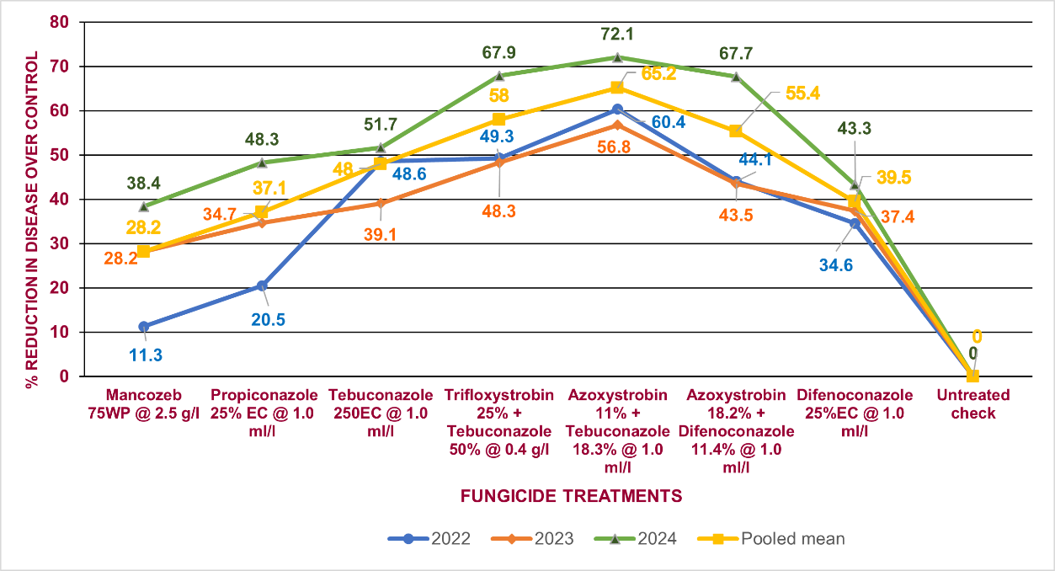
Fig. 1. Comparative efficacy (% reduction in disease over untreated control) of fungicide formulations against BLSB in Maize – 3 year pooled data (Kharif, 2022 - 2024)

3.3 Yield
During Kharif, 2024, mean yields were comparatively lower due to the high disease pressure recorded during the season. Among the treatments, azoxystrobin 11% + tebuconazole 18.3% @ 1.0 ml/l recorded the highest pooled mean grain yield of 6826 kg/ha (Fig. 2), followed by trifloxystrobin 25% + tebuconazole 50% @ 0.4 g/l (6603 kg/ha) and azoxystrobin 18.2% + difenoconazole 11.4% @ 1.0 ml/l (6418 kg/ha). These treatments were also associated with the lowest disease severity, indicating a strong correlation between effective disease suppression and improved productivity.
Among the single active ingredient treatments, tebuconazole 250 EC @ 1.0 ml/l recorded significantly higher yields (6387 kg/ha), outperforming other individual fungicide treatments. The results highlight the potential of combination fungicides to provide superior protection under high disease pressure conditions. Mancozeb 75WP @ 2.5 g/l yielded significantly lower (5471 kg/ha) compared to the untreated inoculated control (4957 kg/ha), clearly demonstrating the detrimental impact of BLSB under artificial inoculation. Crop losses due to diseases could be minimized by adopting proper and timely interventions with fungicides (Sundravadana et al., 2007: Yadav et al., 2023). The findings of the present study are supported by Kumar and Kaure (2020), who also reported the effectiveness of combination fungicide formulations in reducing disease severity and achieving higher yields.
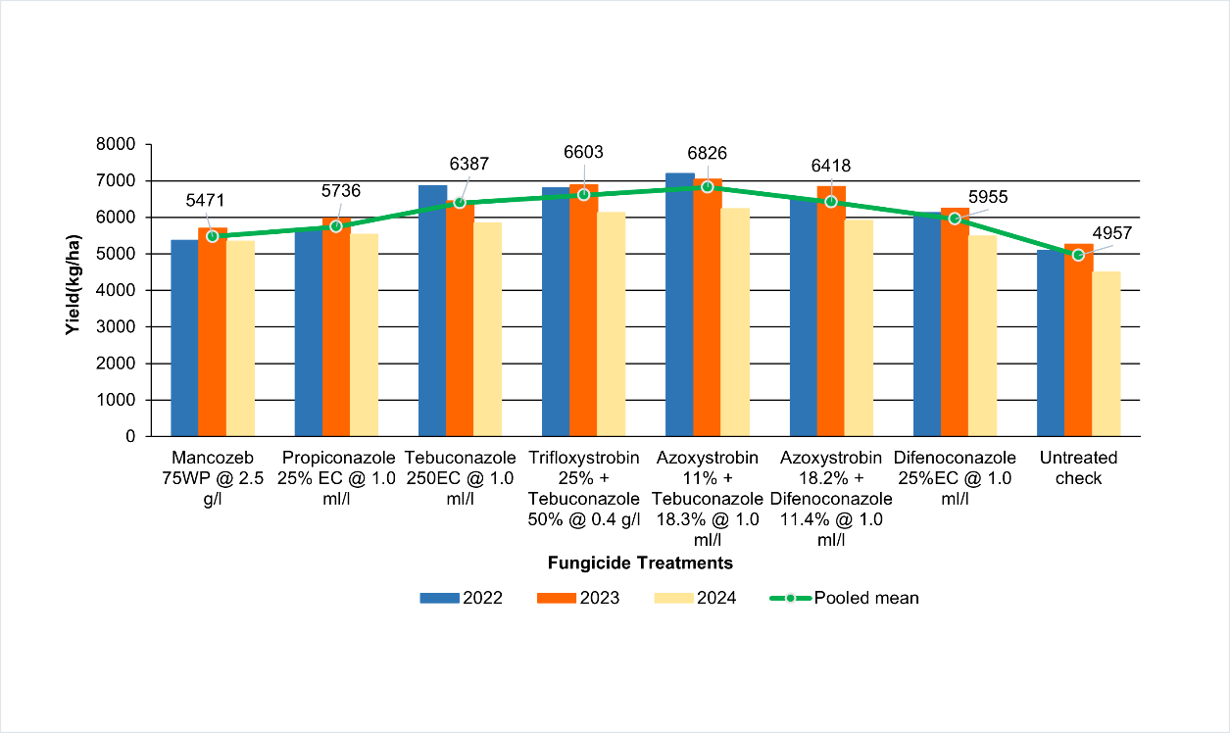
Fig. 2. Effect of fungicidal sprays evaluated for BLSB management on yield in Maize – 3 year pooled data (Kharif, 2022 - 2024)

3.4 Economics
The economic analysis of the fungicidal treatments was conducted by considering the cost of fungicides, cultivation costs, gross returns, net returns and Benefit-Cost (B:C) ratios (Table 3). Azoxystrobin 11% + tebuconazole 18.3% SC @ 1.0 ml/l recorded the highest net returns and B:C ratio (₹79,615/ha and 2.27, respectively), followed by trifloxystrobin 25% + tebuconazole 50% @ 0.4 g/l (₹72,823/ha and 2.12, respectively) and tebuconazole 250EC @ 1.0 ml/l (₹70,701/ha and 2.13, respectively). Among the single-active fungicides, tebuconazole 250EC was the economically efficient, recording a superior B:C ratio of 2.13 with net returns of ₹70,701/ha. Propiconazole 25EC @ 1.0 ml/l showed moderate profitability with a B:C ratio of 1.97. Whereas, difenoconazole 25% EC @ 1.0 ml/l and mancozeb 75WP @ 2.5 g/l registered relatively lower B:C ratios of 1.90 and 1.87 respectively. These results emphasize the economic feasibility of systemic combination fungicides, particularly those combining strobilurins and triazoles. Despite slightly higher input costs, these treatments provided significantly better disease control, enhanced yields and higher net returns. Therefore, adopting such fungicides can improve both profitability and sustainability of maize production under high BLSB disease pressure.

Table. 3: Impact of fungicidal sprays used for BLSB management on yield and economics of Maize – 3-year pooled data (Kharif, 2022-2024)
Trt. No. | Fungicide | Dose (g/ l) | Fungicide  Dosage (per ha) | Cost of fungicide (L or Kg) | % Increase of yield over control |  |  |  | Cost of cultivation + Chemical cost  (Rs.) | Gross returns (Rs.) | Net returns (Rs.) | B: C ratio
 |  |  |  |  | 2022 | 2023 | 2024 | Pooled mean
T1 | Mancozeb 75WP | 2.5 | 1250 | 550 | 5.2 | 8.3 | 18.6 | 10.4 | 61303 | 114451 | 53148 | 1.87
T2 | Propiconazole 25 EC | 1.0 | 500 | 1100 | 11.8 | 13.3 | 22.9 | 15.7 | 61028 | 119943 | 58915 | 1.97
T3 | Tebuconazole 250EC | 1.0 | 500 | 2550 | 34.6 | 22.5 | 29.6 | 28.8 | 62478 | 133179 | 70701 | 2.13
T4 | Trifloxystrobin 25% + Tebuconazole 50% WG | 0.4 | 200 | 8500 | 33.3 | 30.7 | 36.0 | 33.2 | 65028 | 137851 | 72823 | 2.12
T5 | Azoxystrobin 11% + Tebuconazole 18.3% SC | 1.0 | 500 | 2860 | 41.2 | 33.8 | 38.3 | 37.7 | 62788 | 142403 | 79615 | 2.27
T6 | Azoxystrobin 18.2% + Difenoconazole 11.4% SC | 1.0 | 500 | 4250 | 27.5 | 29.9 | 31.2 | 29.5 | 64178 | 134030 | 69852 | 2.09
T7 | Difenoconazole 25% EC | 1.0 | 500 | 5390 | 20.3 | 18.6 | 21.7 | 20.1 | 65318 | 124304 | 58986 | 1.90
T8 | Untreated check | 0 | 0 | 0 | 0 | 0 | 0 | 0 | 59128 | 103460 | 44332 | 1.75
*Gross returns were computed based on the Minimum Support Prices (MSP) for maize: ₹19.62/kg (2022–23), ₹20.90/kg (2023–24), and ₹22.25/kg (2024–25).

4. Conclusion

Crop losses due to BLSB could be minimized by adopting timely interventions with fungicides. In the present study, foliar spray of azoxystrobin 11% + tebuconazole 18.3% @ 1.0 ml/l for 2 times at 35 and 45 DAS was effective resulting in a 65.2% reduction in disease severity over untreated control. Among the single active ingredient formulations evaluated, tebuconazole 250 EC @ 1.0 ml/l recorded significantly higher yields (6387 kg/ha), outperforming other individual fungicide treatments. Fungicide combination formulations were found superior to single fungicide formulations, which recorded lower disease severity, improved productivity, higher net returns with superior B:C indicating a strong correlation between disease suppression and yields. Hence, adopting timely chemical interventions through use of fungicide combination formulations can improve both profitability and sustainability in maize production under high BLSB disease pressure.

Disclaimer (Artificial intelligence)
Author(s) hereby declare that NO generative AI technologies such as Large Language Models (ChatGPT, COPILOT, etc.) and text-to-image generators have been used during the writing or editing of this manuscript.

References
Ahuja, S. C., and Payak, M. M. (1981). A laboratory method for evaluating maize germplasm to banded leaf and sheath blight. Indian Phytopathology 31, 34–37.
Bag, M. K. (2009). Efficacy of a new fungicide ‘Trifloxystrobin 25% + Tebuconazole 50%’ 75WG against sheath blight (Rhizoctonia solani Kühn) of rice. Journal of Crop and Weed 5(1), 43–45.
Chaudhary, S., Sagar, S., Tomar, A., Sengar, R., and Chaurasia, M. (2016). Banded leaf and sheath blight: A menacing disease of maize (Zea mays L.) and its management. Journal of Applied and Natural Science 8(3), 1720–1730.
Dhami, G., & Maharjan, D. (2023). In vitro evaluation of chemical fungicides for control of Rhizoctonia solani Kuhn. Journal of Plant Protection Society, 10(1), 45–50.
Hooda, K.S.; Bagaria, P.K.; Khokhar, M.; Kaur, H.; and Rakshit, S. (2018). Mass Screening Techniques for Resistance to Maize Diseases. ICAR-Indian Institute of Maize Research, PAU Campus, Ludhiana- 141004, 08- 20pp.
Kumar, P., Ahlawat, S., Chauhan, R., Kumar, A., Singh, R., and Kumar, A. (2018). Bio-efficacy and post harvest residual toxicity of new fungicides against sheath blight (Rhizoctonia solani) of rice (Oryza sativa). The Indian Journal of Agricultural Sciences, 88(10), 1587-1592.
Kumar, S., and Kaure, H. (2020). Prevalence of banded leaf and sheath blight of maize in Punjab and its management with fungicides. Agricultural Research Journal, 57(5).
Madhavi, G. B., Grace, G. A. D., & Suresh, M. (2021). Evaluation of fungicides against Rhizoctonia solani f. sp. sasakii inciting banded leaf and sheath blight disease of maize in vitro. Chemical Science Review and Letters, 10(38), 247–251.
Madhavi, M., Reddy, P., Manohar, K., and Kumari, A. (2018). Effect of fungicides and herbicides against Rhizoctonia solani f. sp. sasakii Exner causing banded leaf and sheath blight in maize (Zea mays L.). International Journal of Bio-resource and Stress Management 9(1), 142–153.
Madhura B., Mane S.S., Ingle S.T., and Ingole.M.N. (2024). In vitro evaluation of fungicides efficacy against Rhizoctonia solani causing root rot of chilli. International Journal of Advanced Biochemistry Research, 8(9), 953-956.
Malik, V. K., Singh, M., Hooda, K. S., Yadav, N. K., and Chauhan, P. K. (2018). Efficacy of newer molecules, bioagents, and botanicals against maydis leaf blight and banded leaf and sheath blight of maize. The Plant Pathology Journal 34(2), 103–110.
Manjunatha, S. E., Yadahalli, K. B., and Kalappanavar, I. K. (2023). In vitro sensitivity of Rhizoctonia solani f. sp. sasakii causing banded leaf and sheath blight of maize against different fungicides. Journal of Farm Sciences 36(4), 355–359.
Nene, Y. L., and Thapliyal, P. N. (1993). Fungicides in Plant Disease Control. 3rd ed. New Delhi: Oxford and IBH Publishing Co. Pvt. Ltd.
Rathi, V., Sunaina, V., & Jain, S.K. (2021). In-vitro evaluation of some commercial fungicides on linear growth of Rhizoctonia solani. Indian Journal of Plant Protection, 49(3).
Singh, A., Netam, R.S., Netam, P.S., Kerketta, A., Thakur, A.K., Singh, D.P., Rakse, R., Kumar, D., Thakur, K., & Yadu, S. (2024). Efficacy of different fungicides against Rhizoctonia solani Kuhn under In vitro condition. International Journal of Advanced Biochemistry Research, 8(12S), 884–888.
Sundravadana, S., Alice, D., Kuttalam, S., and Samiyappan, R. (2007). Azoxystrobin activity on Rhizoctonia solani and its efficacy against rice sheath blight. Tunisian Journal of Plant Protection 2, 79–84.
Uppala, S., and Zhou, X. G. (2018). Field efficacy of fungicides for management of sheath blight and narrow brown leaf spot of rice. Crop Protection 104, 72-77.
Verma, R. C., Singh, P. K., and Arya, J. K. (2017). Evaluation of different modules for the management of sheath blight of rice under field conditions. International Journal of Current Research 9(09), 56945–56946.
Vincent, J. M. (1947). Distortion of fungal hyphae in the presence of certain inhibitors. Nature, 159: 850.
Wheeler, B. E. J. (1969). An introduction to plant diseases. John Wiley & Sons.
Yadav, L., Kumar, A., Singh, H., Punia, R., and Singh, N. (2023). Field evaluation of fungicides for the management of banded leaf and sheath blight of maize and their effect on yield parameters. Agricultural Science Digest 43(1), 92–96.
Yadav, S. L., Ghasolia, R. P. and Sharma, J. (2020). Management of root rot (Rhizoctonia solani) of fenugreek through newer combined formulations of fungicides. Legume Research, 43(4), 559–563.

