Original Research Article

Genome-wide identification and in silico analysis of Fatty Acid Desaturase (FAD) genes of pearl millet (Pennisetum glaucum L.)

Abstract
Aim
The present study focused on a comprehensive in silico investigation to identify and characterize the fatty acid desaturase gene family in Pennisetum glaucum L. (pearl millet). Fatty Acid Desaturases (FADs) are essential enzymes in plants that introduce double bonds into fatty acid chains and play a key role in the producing unsaturated fatty acids. These key enzymes identified and characterized through the Kennedy pathway play a major role in fatty acid metabolism. They significantly contribute to plant membrane fluidity, stress tolerance and oil quality.
Methodology
To identify the FAD gene family NovoGene Millet database was used; their gene, promoter, complementary DNA (cDNA) and the corresponding amino acid sequences were retrieved from the database. Chromosomal distribution was predicted through mapping tools in the millet database, and synteny maps were developed through MCscanX option in the TB-tools. Gene Structure Display Server 2.0 software was used to predict gene structures, and the PlantCARE database was employed to identify the cis-regulatory elements in the putative promoter sequences of respective FAD genes.
Results
A total of 22 PgFAD genes were identified and mapped across seven chromosomes of pearl millet, indicating their uneven distribution and suggesting potential duplication events. The gene structure of PgFADs was represented by various introns and exons. Cis-regulatory element analysis of 1 kb upstream promoter regions of all PgFADs highlighted the presence of various stress and phytohormone-responsive elements like STRE, WRE3, ABRE, MYB, ERE and WUN motifs indicating the potential involvement of PgFAD genes in stress and developmental regulation in plants. Synteny analysis with different cereal species such as rice (Oryza sativa), foxtail millet (Setaria italica), finger millet (Eleusine coracana), maize (Zea mays) and sorghum (Sorghum bicolor) revealed conserved evolutionary relationships and potential gene duplication events.
Conclusion
This study provides valuable insights into the molecular characteristics and evolutionary relationships of FAD genes in pearl millet and lays the foundation for future functional studies and crop improvement strategies that target fatty acid metabolism.
Keywords: Pearl millet; Kennedy pathway; Fatty acid desaturase (FAD); Gene structure; cis-regulatory elements.

1. INTRODUCTION
Malnutrition is a leading cause of death across the world and contributing to over half of the fatalities globally. This alarming reality has intensified efforts to increase the nutritional quality of staple food crops and those who rely on them for their daily dietary requirements. Among the staple foods, cereals and millets play an important role and provide more than 50% of the energy required in the human diet. In recent years, these millets have drawn attention, particularly for their rich nutritional profile, which supports both better health and food security. Pearl millet (Pennisetum glaucum L.) stands out among all millets because of its high nutrient profile that may help to prevent chronic illnesses such as type 2 diabetes and obesity [1]. Despite its nutritional benefits, pearl millet has struggled to gain widespread consumer acceptance mainly because of the development of rancidity and unfavorable odors during storage of milled grains. The shelf life of flour is significantly affected by various grain components, including lipids, phenolic compounds, sugars, volatile molecules, free amino acids, and small peptides [2]. “The unpleasant flavor changes are largely due to the oxidation of fatty acids, which produces fatty acid hydroperoxides along with secondary compounds like aldehydes and ketones. These oxidative processes reduce the flour’s freshness and appeal. The issue is further compounded by high lipid content and increased enzyme activity, particularly from lipase, lipoxygenase, peroxidase, and polyphenol oxidase under typical storage conditions” [3].
Very recent studies using non-targeted metabolomics have shed light on the various biochemical pathways linked to rancidity, these include pathways involving fatty acids, glycerophospholipids, sphingolipids, glycerolipids, flavonoids, and alkaloids. Mainly, the gene families responsible for rancidity are identified through the Kennedy pathway, the predominant mechanism by which cells synthesize phosphatidylcholine (PC) for incorporation into lipid deriving signaling molecules [4]. Among those gene families, FAD (Fatty acid Desaturases) is one of the major members responsible for rancidity. “Fatty acid desaturases (FADs) are vital plant enzymes that introduce double bonds into fatty acid chains, a modification that is important for maintaining membrane flexibility, adapting to various environmental challenges, and enhancing the nutritional profile of plant oils. Extensive studies have demonstrated that fatty acid desaturases play a key role in plant stress tolerance, such as high and low temperatures, drought, salinity, and heavy metal exposure” [5,6].
“Growing evidence suggests that members of the fatty acid desaturase gene family regulate plant defense responses to various plant stresses” [7,8]. “Fatty acids are the primary constituents of plant cell membranes, and fatty acid desaturases (FADs) are essential enzymes in plant lipid metabolism. The FAD gene family regulates the ratio of saturated to unsaturated fatty acids, which affects plasma membrane fluidity and stability under different stresses” [9]. These enzymes exhibit diverse substrate specificity, acting on acyl-CoAs, sphingolipids, phospholipids, and galactolipids [10]. Plant FADs are broadly divided into two categories. The first type, soluble desaturases, mainly stearoyl-ACP desaturases (SADs) function within plastids [11]. “They initiate desaturation by converting saturated fatty acids, such as stearic acid, into monounsaturated fatty acids like oleic acid” [12,13]. The second group, membrane-bound desaturases, are located in plastid membranes and the endoplasmic reticulum [14,15].
“These enzymes are responsible for the incorporation of additional double bonds, therefore synthesizing polyunsaturated fatty acids (PUFAs), including linoleic and α-linolenic acids” [16]. “Desaturase enzymes are categorized according to the location of the double bond they create. Δ (delta) desaturases introduce double bonds at certain positions from the carboxyl terminus; for example, Δ9-desaturase inserts a bond between the ninth and tenth carbon atoms. Conversely, ω (omega) desaturases operate from the methyl terminus, such as ω3 desaturase, which synthesizes omega-3 fatty acids. An example is Δ6-desaturation, where a double bond is introduced between carbons 6 and 7 of linoleic acid (C18:2-n6) or α-linolenic acid (C18:3-n3), which leads to γ-linolenic acid (GLA, C18:3-n6) and stearidonic acid (SDA, C18:4-n3), respectively. The enzyme stearoyl-ACP desaturase, or FAB2, is important in plastids among soluble FADs, as it introduces a Δ9 double bond, enabling the conversion of stearic acid into oleic acid” [17].
“Membrane-bound Fatty acid desaturases can be classified into four functional subfamilies, which includes Omega 6 desaturases (FAD2, FAD6), Omega 3 desaturases (FAD3, FAD7, FAD8), FAD4, and DES/ADS” [18]. Members of each subfamily generally contain conserved amino acid motifs. Fatty acid desaturases are identified in several plant species, including rice [19, 20], soybean [21], tobacco [22], and banana (Musa spp.) [23]. “The first group consists of the soluble acyl carrier protein (acyl-ACP) desaturases, which are exclusively present in plants. These enzymes only function inside plastids and use the NADPH/ferredoxin system as an electron donor to add the first double bond to the saturated fatty acid chains connected to an ACP. Usually, each member of this family targets a particular bond and chain length. For instance, Δ9 stearoyl-ACP desaturase breaks the connection between stearoyl-ACP's carbons 9 and 10 to create oleoyl-ACP” [24]. Crystallography and other structural investigations have been made easier by their solubility. The second and bigger category of acyl-lipid desaturases is made up of 300–350 amino acids and is membrane-bound. These hydrophobic enzymes are found in the ER and chloroplasts, and they traverse membranes four times. The NADPH/ferredoxin system drives the desaturation reaction in chloroplasts, whereas the NADH/cytochrome b5 system provides electrons in the ER. Structural data are still scarce despite their importance because there are no crystallographic models for this category [25].
The omega desaturases, one of the subfamilies of the acyl-lipid desaturase group, add a double bond between an existing double bond and the fatty acids methyl terminus. For instance, omega-3 FADs transform oleic acid into linoleic acid by adding a double bond between the methyl end's third and fourth carbon atoms. Pearl millet (Pennisetum glaucum L.) is the most significant cereal crop in the world. A wide variety of fatty acids are present in pearl millet grains in because of their high unsaturated fatty acid concentration those fatty acids are linoleic acid (C18:2), palmitic acid (C16:0), oleic acid (C18:1), linolenic acid (C18:3), and stearic acid (C18:0). FAD genes play a crucial role in metabolism of these fatty acids. The characterization of the fatty acid desaturase (FAD) gene family in pearl millet is yet to be analyzed. Therefore, this study focuses on the in-silico genome-wide identification of FAD genes, their chromosomal distribution, and analysis of gene and putative promoter elements in pearl millet to better understand their roles in lipid metabolism.
2. Materials and Methods
2.1. In silico analysis
The genomic, CDS, putative promoter, complementary DNA (cDNA) and the corresponding amino acid sequences were retrieved from the Novogene Millet Database (http://milletdb.novogene.com/home/) using the keyword FAD in the search option.
2.2. Gene structure
To gain insights into the FAD gene structures such as the gene size, the number of introns and exons, as well as the GC content, the CDS, cDNA and gene sequences were extracted from the Novogene Millet DB and the genome browser, respectively, and the gene structures were predicted through GSDS (Gene Structure Display Server 2.0 software).
2.3. Chromosomal distribution of PgFADs
The chromosomal distribution of PgFADs was determined by submitting the corresponding locus IDs of 22 FAD candidates to the gene mapping tool of MilletDB, specifically selecting the PI583800 genotype option. Subsequently, the location of each candidate at its corresponding locus on the chromosome was manually identified based on the output obtained.
2.4. The prediction of cis-regulatory elements
Cis-acting regulatory elements (CREs) are DNA sequences found in the upstream regions of genes that are required to govern differential gene expression. The 1000 bp upstream promoter regions of each PgFAD gene were retrieved from the Novogene Millet database and subsequently evaluated for potential cis-acting elements and transcription factor-binding sites using the PlantCARE (http://bioinformatics.psb. ugent.be/webtools/plantcare/html/). To predict the various cis-regulatory elements within the promoter regions of PgFAD genes, approximately 1 kb upstream nucleotide sequence of each FAD gene was retrieved from the Novogene Millet genome browser. This sequence was then submitted to the PlantCARE database to determine the location and number of repeats of cis-regulatory elements in FAD genes.
3. Results and Discussion
3.1. Pearl millet Fatty acid desaturases
A keyword search for Fatty Acid Desaturase resulted in the identification of 22 FAD genes in pearl millet. Of these 22 FADs, 13 were classified as ACP desaturases, one is an Omega 3 FAD, two are Omega 6 FADs, and one is a Sphingolipid desaturase. These FADs are classified and named according to their location on the respective chromosomes.
3.2. Chromosomal distribution of PgFAD genes
The genome-wide distribution of all 22 FAD genes is distributed across all pearl millet genome. Chromosome five carries the highest number of FAD genes (7), followed by chromosome one (4), whereas chromosomes 3,4 and 6 carry 3 FAD genes each and chromosomes 2 and 7 carry one FAD gene each (Fig. 1). The chromosomal location and size of all PgFADs are given in the Table 1.
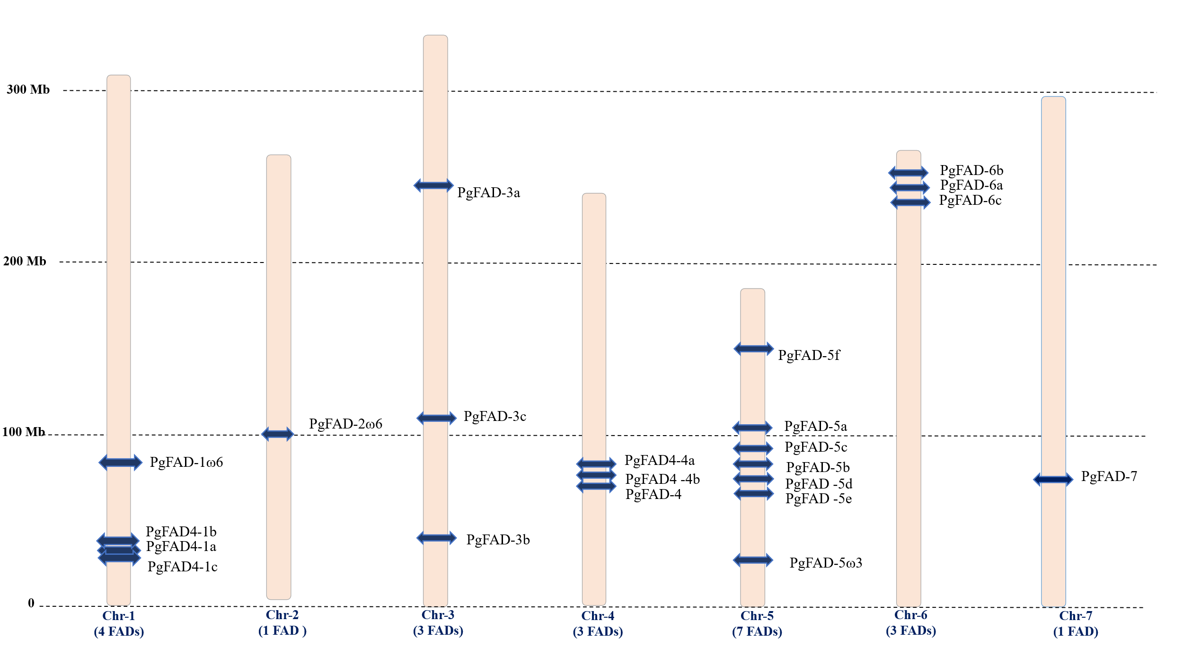
Fig 1. Chromosomal map of pearl millet Fatty Acid Desaturase genes. The genome-wide distribution of 22 FAD genes in pearl millet. Each chromosome is accompanied by its respective chromosomal number at the bottom, while the chromosome size is provided on the left side of the map. The number of FAD genes per chromosome is denoted within brackets at the bottom of each chromosome. The position of each FAD gene on a chromosome is illustrated by horizontal bars across the chromosomes.
3.3. Collinearity relationship of FAD genes between pearl millet and other plant species
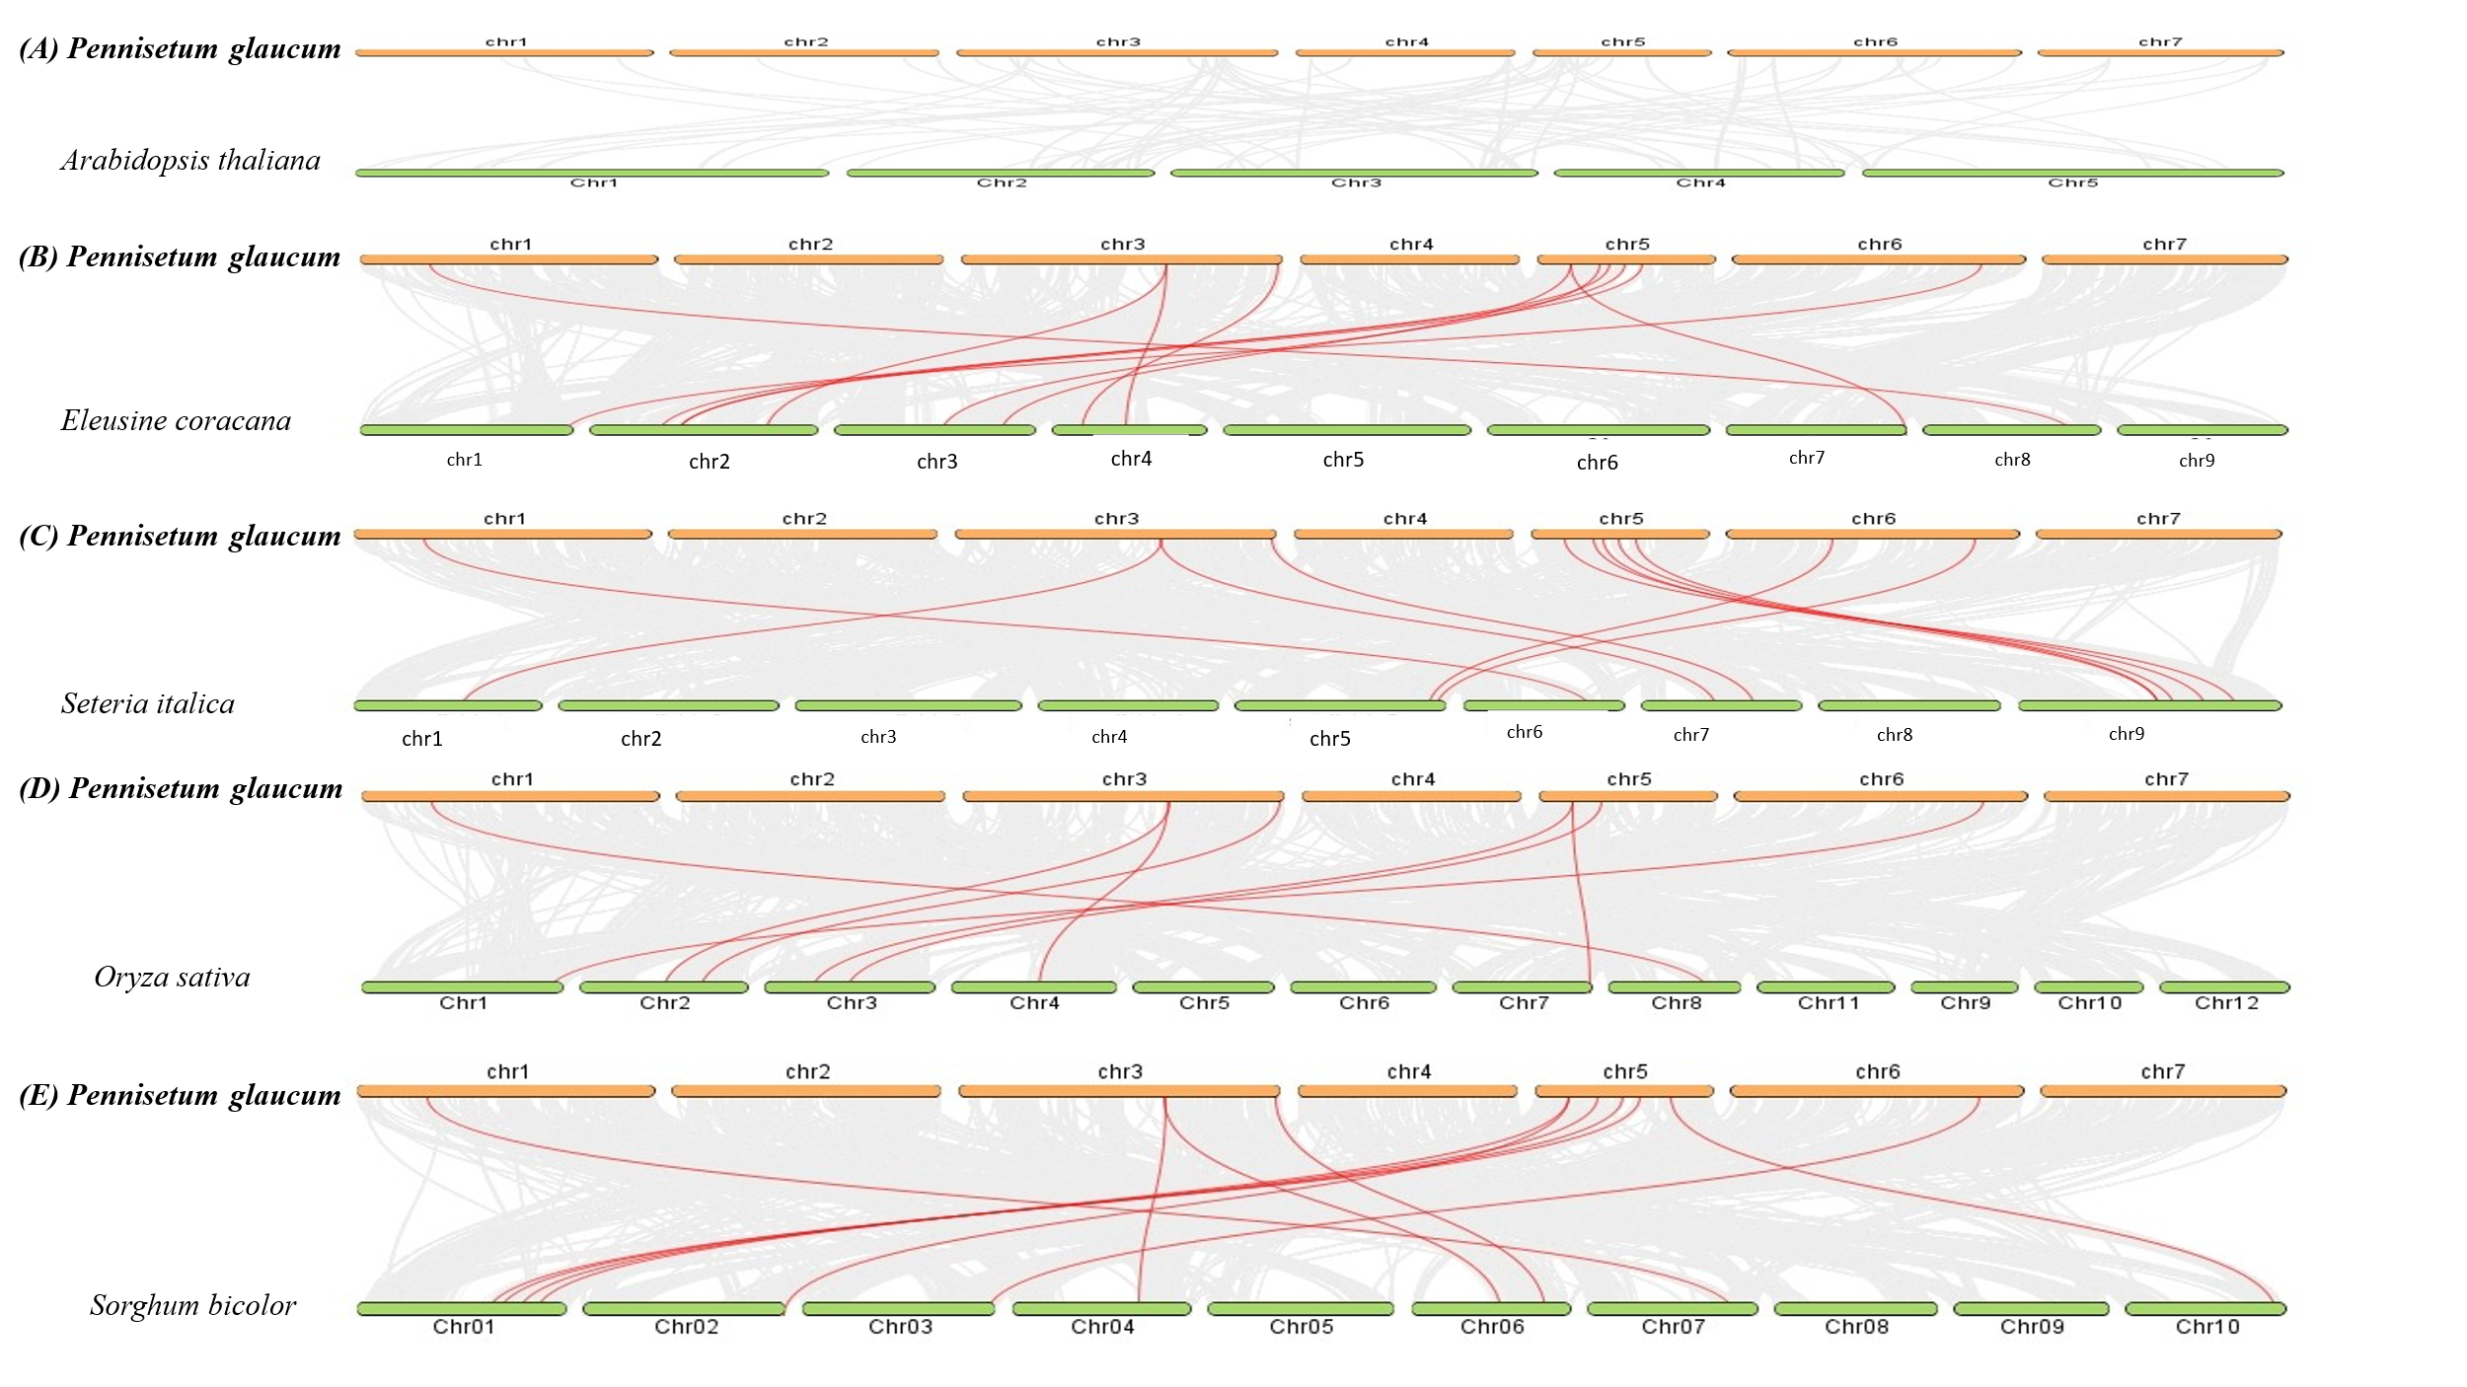
Synteny analysis or collinearity provides the preserved order of genes between various species or within different regions of the same genome and helps in understanding how genes and chromosomes have evolved by revealing shared ancestry and genomic rearrangements. These syntenic maps are especially used for identifying gene conservation and trace evolutionary relationships. The collinearity relationship among PgFAD genes in six plant species was analyzed to compare FADs with their homologs. The number of homologous pairs of FADs between pearl millet and various species, including rice, sorghum, finger millet, and foxtail millet, was found to be 8, 11, 11, and 11, respectively (Fig. 2). These results indicate a remarkably close genetic relationship between FADs of pearl millet and those of foxtail millet, finger millet and sorghum, followed by rice, suggesting the conservation of the FAD gene family during the evolutionary process [26, 27 & 28]. Interestingly, there is no collinearity between the pearl millet and Arabidopsis, suggesting that there is a least phylogenetic relationship between these two species (Fig. 2).
Fig 2. Collinearity relationship of FAD genes between pearl millet and other plant species. Synteny analysis was conducted to examine the evolutionary relationship between FAD genes in pearl millet and several other plant species, including (A) Arabidopsis (Arabidopsis thaliana, 2n = 10), (B) rice (Oryza sativa, 2n = 24), (C) sorghum (Sorghum bicolour, 2n = 20), (D) finger millet (Eleusine coracana, 2n = 36), and (E) foxtail millet (Setaria italica, 2n = 18). The syntenic blocks between pearl millet and these species are represented by light grey lines in the background, while the collinear FAD gene pairs are indicated by red lines. The synteny plot was generated using the step MCscanX option in the TB-tools
3.4. The prediction of cis elements within the putative promoter regions of PgFAD genes
Analyzing the 1 kb upstream promoter regions provides valuable insights into gene regulation and interactions, particularly under stress conditions. Transcription factors (TFs) play a crucial role in modulating gene expression during abiotic stress responses by binding to specific cis-acting elements within promoter regions, thereby activating or repressing gene transcription [29].
A comprehensive analysis of the 1 kb upstream regions of the 22 PgFADs genes revealed the presence of numerous stress- and signal-responsive cis-elements (Tables 2, 3 and 4). Several elements associated with oxidative stress were detected, including STRE (Stress-Response Element), as-1 (activation sequence-1), and hypoxia-responsive elements (O2-elements), as well as elements linked to cold stress, such as LTR (Low-Temperature Responsive element) and MYC motifs [30]. Furthermore, promoter regions showed widespread presence of dehydration-responsive elements such as the DRE core motif (A/GCCGAC) and MBS (MYB Binding Site), both known for their involvement in drought stress responses. MBS, specifically, serves as the binding site for MYB transcription factors, which are instrumental in regulating genes under water-deficient conditions [31]. Likewise, W-box elements binding sites for WRKY family transcription factors were frequently found [32] indicating potential involvement in drought-induced gene expression. The detection of these motifs suggests that PgFAD genes are likely activated under environmental stress conditions such as drought or oxidative stress. Box 4, G-Box, GT1-motif, ACE, A-box, AT1, ATC-motif, chs-CMA2a, GA, GATA-motif, LAMP-element and MRE are involved in the light responsiveness.
Previous studies have demonstrated that the FAD gene promoters have various cis elements that respond to different hormone and stress responsive elements [33]. In addition to abiotic stress-responsive elements, the promoter regions also contained multiple hormone-responsive motifs, including ABRE (abscisic acid responsive element), ERE (estrogen response element), ARE (Anerobic responsiveness), TGACG- and CGTCA-motifs (methyl jasmonate responsiveness), TCA-motif (salicylic acid), GARE-motif (gibberellic acid), and TGA-motif and AuxR (auxin responsiveness), as illustrated in Fig. 3. Other elements involved in general transcription regulation, such as Sp1 and the Pribnow box (P-box), were also present. Elements responsive to biotic stress were identified as well, including the WUN-motif, WRE3, and TCA elements, suggesting broader roles for PgFADs genes in pathogen defense. The TGACG and CGTCA motifs are specifically associated with methyl jasmonate response [34, 35], while ABRE and MBS are key in mediating responses to abscisic acid and drought, respectively. Jasmonate signaling has been implicated in seed germination, senescence, and resistance to both biotic and abiotic stresses [36, 37].
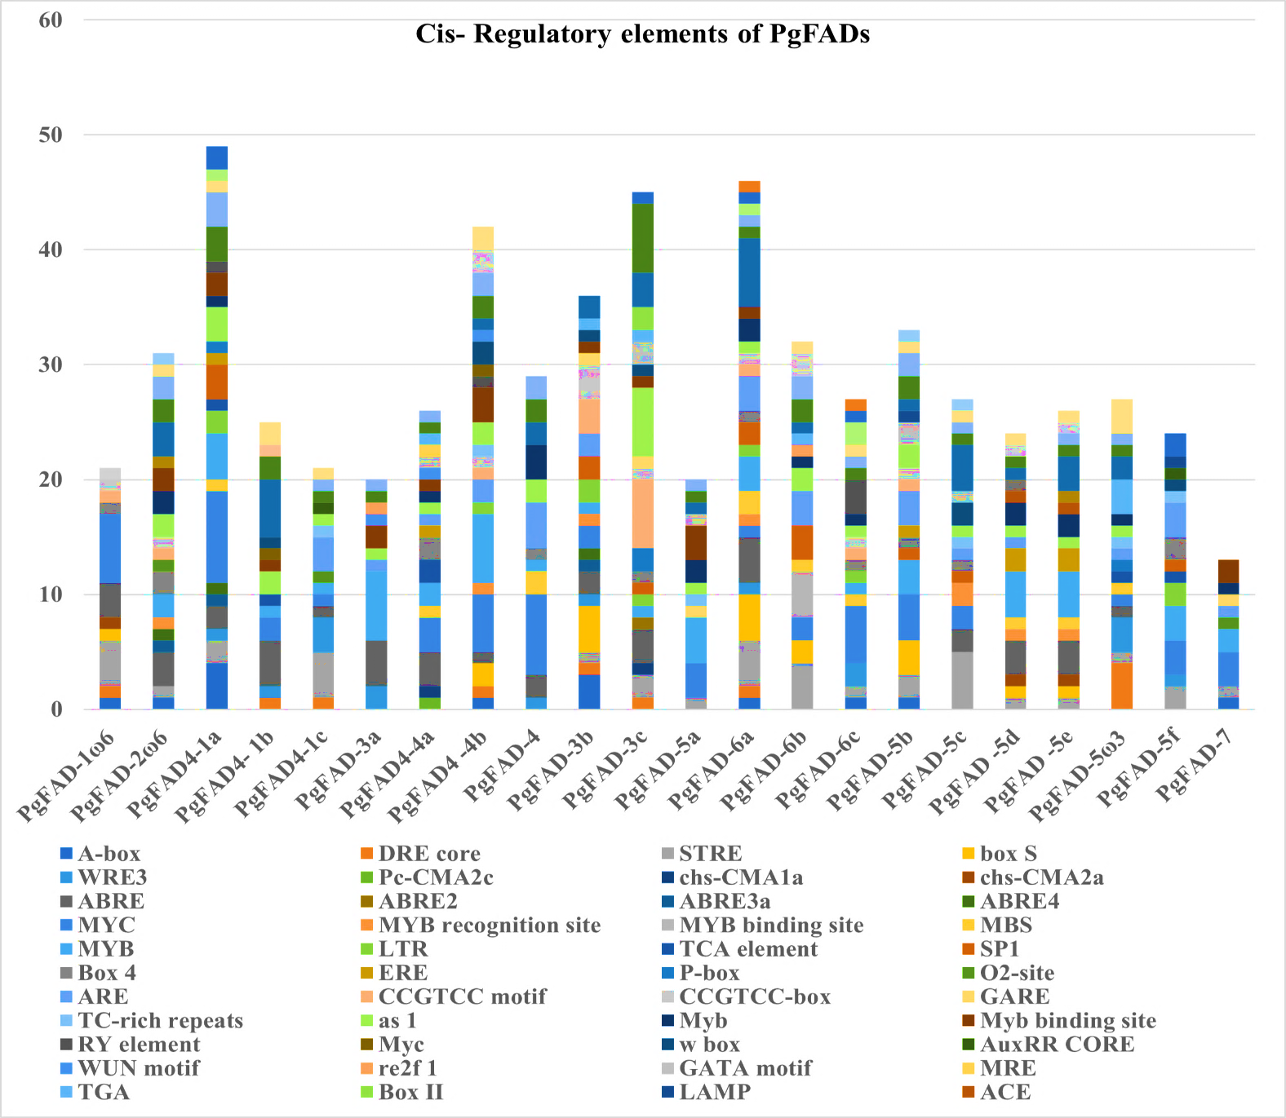
The ABRE motif, characterized by the sequence TACGGTC, is activated by ABA and plays a significant role in enhancing plant tolerance to drought and salinity. Altogether, the high frequency of cis-elements responsive to various hormones and environmental stimuli, including jasmonate, ABA, drought, cold, pathogens, auxin, gibberellin, and ethylene, strongly suggests that the PgFADs gene family contributes to a wide range of stress responses in pearl millet.

Fig 3. In silico analysis of the 1 kb upstream region of pearl millet FAD genes for the identification of cis-regulatory elements. The 1 kb upstream putative promoter sequences of FAD genes exhibit multiple copies of different cis-elements that respond to hormones and stress-inducing elements. The bar diagrams illustrate the enrichment of distinct stress/signal-responsive elements, with each colour denoting a specific element highlighted on the bottom side.
3.5. Analysis of gene structures
To gain further insight into the structural diversity of FADs, we investigated the structures of PgFAD genes and showed that the exon-intron organization of the PgFAD genes varied in number, positions and lengths. The number of exons ranged from 1 to 10. The PgFAD-1ω6 and PgFAD-5ω3 were characterized by ten and eight exons, respectively, whereas the PgFAD-3c and PgFAD-6c have 3 exons each, remaining all genes contained one exon each. PgFAD-1ω6, PgFAD-5ω3, PgFAD-3c and PgFAD-6c have 9,7,2 and 2 introns, respectively. All remaining genes have only exon regions without any introns (Fig. 4).
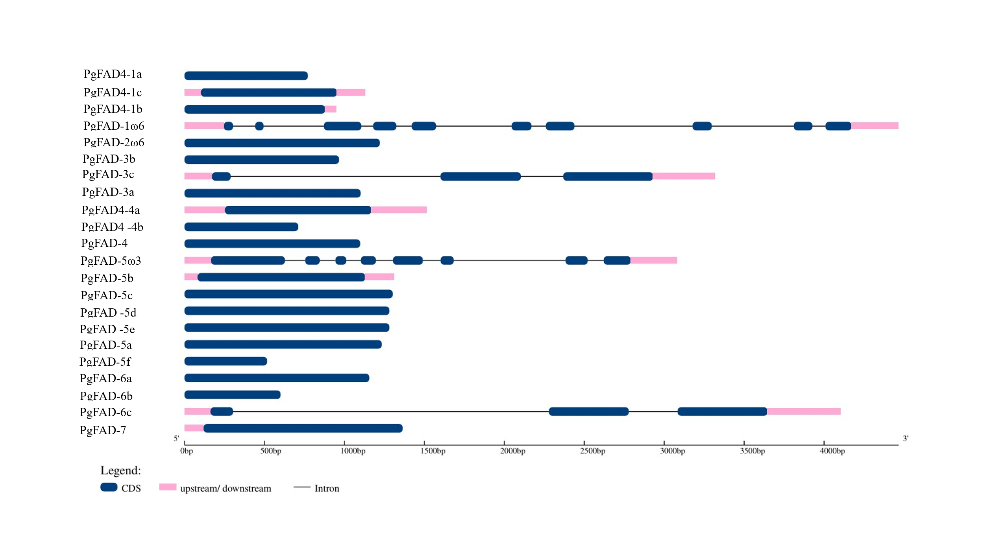
Fig 4. Gene structure of 22 PgFAD genes. Exon-intron structure of FADs using a Gene Structure Display Server tool. Blue boxes represents exons; pink boxes represents the 3′ and 5′ untranslated regions (UTR); and the grey lines represent introns.
4. Conclusion
This study provides an in-silico analysis of the pearl millet Fatty Acid Desaturase (PgFADs) gene family. A total of 22 PgFAD gene members are distributed across all seven chromosomes of the pearl millet genome, which reflects gene duplication and diversification events during evolution based on chromosomal mapping. At the same time, the conserved motif analysis of PgFAD proteins revealed the functional significance of these proteins; the gene structure of all these PgFADs showed important diversity in intron–exon organization. Multiple stress and hormone-related cis-regulatory elements were identified by promoter analysis through PlantCARE, suggesting that these FAD genes may be crucial for stress adaptation and development. Moreover, the evolutionary conservation and divergence of this gene family were shown by phylogenetic relationships and synteny with other plant species. Collectively, our results offer significant new understandings of the molecular architecture as well as potential functions of FAD genes in pearl millet, paving the path for crop improvement initiatives that emphasize lipid metabolism and stress tolerance. Our findings offer insights into the regulation of FAD genes in pearl millet, enhancing our comprehension of their contributions to various yield and quality-related traits, including their involvement in stress responses. These findings may also be applied to utilize one of the candidate genes for enhancing quality-related traits of pearl millet via breeding or genetic engineering methods.
DISCLAIMER (ARTIFICIAL INTELLIGENCE)
Authors hereby declare that NO generative AI tools or technologies such as Large Language Models (ChatGPT, COPILOT, etc.) and text-to-image generators have been used during the writing or editing of this manuscript.
ACKNOWLEDGEMENTS
Thalari Vasanthrao expresses gratitude to the UGC-CSIR, Government of India, for the fellowship support. The authors also convey their thanks to ICRISAT, Patancheru, Hyderabad, and PJTSAU, Hyderabad, for the facilities provided.
COMPETING INTERESTS
Authors declare that no competing interests exist.
References
1.Yadav, S, Singh, S, Singhal, T, Anju-Mahendru, S, Bhargavi, H, Aavula, N, Goswami, S, Satyavathi, C.T. Genetic elucidations of grain iron, zinc, and agronomic traits by generation mean analysis in pearl millet (Pennisetum glaucum (L.) R. Br. Journal of Cereal Science; 2023; 113, 10375
2.Ali, A, Kumar, R.R, Vinutha, T, Bansal, N, Bollinedi, H, Singh, S.P, Satyavathi, C.T, Praveen, S. and Goswami, S. Characterization of biochemical indicators and metabolites linked with rancidity and browning of pearl millet flour during storage. Journal of Plant Biochemistry and Biotechnology. 2022; 32: 121-131. https://doi. org/10.1007/s13562-022-00787-0.
3. Goyal, P, Chugh, L, Shelf-life determinants and enzyme activities of pearl millet: a comparison of changes in stored flour of hybrids, CMS lines, inbreds, and composites. Journal of Food Science and Technology. 2017; 54, 3161–3169.
4. Yogendra, K, Sanivarapu, H, Avuthu, T, Gupta, S. K, Durgalla, P, Banerjee, R, and Tyagi, W. Comparative Metabolomics to Unravel the Biochemical Mechanism Associated with Rancidity in Pearl Millet (Pennisetum glaucum L.). International Journal of Molecular Sciences. 2024; 25(21), 11583.
5. Abedi E, Sahari MA. Long-chain polyunsaturated fatty acid sources and evaluation of their nutritional and functional properties". Food Science and Nutrition. 2014; 2 (5): 443–463. Doi:10.1002/fsn3.121. PMC 4237475. PMID 25473503.
6. Xue, Y, Chen, B. J, Wang, R, Win, A. N, Li, J. N, Chai, Y. R. Genome-wide survey and characterization of fatty acid desaturase gene family in Brassica napus and its parental species. Applied biochemistry and biotechnology. 2018; 184, 582–598. Doi: 10.1007/s12010-017-2563-8.
7. Kachroo, P, Venugopal, S. C, Navarre, D. A, Lapchyk, L, and Kachroo, A. Role of salicylic acid and fatty acid desaturation pathways in ssi2-mediated signaling. Plant Physiology. 2005; 139, 1717–1735. Doi: 10.1104/pp.105.071662.
8. Dar, A. A, Choudhury, A. R, Kancharla, P. K, Arumugam, N. The FAD2 gene in plants: occurrence, regulation, and role. Frontiers in Plant Science. 2017; 8, 1789. Doi: 10.3389/fpls.2017.01789.
9. Zhu S, Zhu Z, Wang H, Wang L, Cheng L, Yuan Y, Zheng Y, Li D. Characterization and functional analysis of a plastidial FAD6 gene and its promoter in the mesocarp of oil palm (Elaeis guineensis). Scientia Horticulturae. 2018; 239:163–170.
10. Li, X, Munir, M, Zeng, W, Sun, Z, Chang, X, and Yang, W. Characterization of fatty acid desaturase gene family in Glycine max and their expression patterns in seeds after Fusarium fujikuroi infection. Frontiers in Plant Science, 2025; 16, 1540003.
11. Murata, N, and Wada, H. Acyl-lipid desaturases and their importance in the tolerance and acclimatization to the cold of cyanobacteria. The Biochemical Journal. 1995; 308:1–8.
12. McNaughton, A. D, Shanklin, J, Raugei, S, and Kumar, N. Data-Driven Modeling and Analysis of Fatty Acid Desaturase in Plants. bioRxiv, 2023; 08. Doi: https://doi.org/10.1101/2023.08.17.553759.
13. El Faqer, A, Rabeh, K, Alami, M, Filali-Maltouf, A, Belkadi, B. In Silico Identification and Characterization of Fatty Acid Desaturase (FAD) Genes in Argania spinosa L. Skeels: Implications for Oil Quality and Abiotic Stress. Bioinformatics and Biology Insights, 2024; 18, 11779322241248908.
14. D. Li, R. Moorman, T. Vanhercke, J. Petrie, S. Singh, C. J. Jackson. Classi cation and substrate head-group specificity of membrane fatty acid desaturases, Computational and Structural Biotechnology Journal. 2016; 14: 341- 349. Doi: 10.1016/j.csbj.2016.08.003.
15. Feng, J. Y, Dong, Y. T, Liu, W, He, Q. L, Daud, M. K, Chen, J. H. Genome-wide identification of membrane-bound fatty acid desaturase genes in Gossypium hirsutum and their expressions during abiotic stress. Scientific Reports. 2017; 7, 45711. DOI: 10.1038/srep45711.
16. Jiao J, Zhang Y. Transgenic biosynthesis of polyunsaturated fatty acids: a sustainable biochemical engineering approach for making essential fatty acids in plants and animals. Chemical Reviews. 2013; 113 (5): 3799. 3814. doi:10.1021/cr300007p. PMID 23421688.
17. Xue, Y, Chen, B. J, Wang, R, Win, A. N, Li, J. N, Chai, Y. R. Genome-wide survey and characterization of fatty acid desaturase gene family in Brassica napus and its parental species. Applied biochemistry and biotechnology. 2018; 184, 582–598. Doi: 10.1007/s12010-017-2563-8.
18. Nayeri, F. D, and Yarizade, K. Bioinformatics study of delta-12 fatty acid desaturase 2 (FAD2) gene in oilseeds. Molecular Biology Reports. 2014; 41: 5077–5087. DOI: 10.1007/ s11033-014-3373-5.
19. Wang, J, Ming, F, Pittman, J, Han, Y, Hu, J, Guo, B. Characterization of a rice (Oryza sativa L.) gene encoding a temperature-dependent chloroplast w-3 fatty acid desaturase. Biochemical and Biophysical Research Communications. 2006; 340, 1209–1216. Doi: 10.1016/ j. bbrc .2005.12.126.
20. Mikkilineni, V, and Rocheford, T. R. Sequence variation and genomic organization of fatty acid desaturase-2 (fad2) and fatty acid desaturase-6 (fad6) cDNAs in maize. Theoretical and Applied Genetics. 106, 2013; 1326–1332. Doi: 10.1007/s00122-003-1190.
21. Chi, X, Yang, Q, Lu, Y, Wang, J, Zhang, Q, Pan, L. Genome-wide analysis of fatty acid desaturases in soybean (Glycine max). Plant Molecular Biology Reporter. 2011;29, 769–783. Doi: 10.1007/s11105-010-0284-z.
22. Sayanova, O, Smith, M.A, Lapinskas, P, Stobart, A. K, Dobson, G, Christie, W.W. Expression of a borage desaturase cDNA containing an N-terminal cytochrome b5 domain results in the accumulation of high levels of D 6-desaturated fatty acids in transgenic tobacco. Proceedings of the National Academy of Sciences. 1997; 94, 4211–4216. Doi: 10.1073/pnas.94.8.4211.
23. Cheng, C, Liu, F, Sun, X, Wang, B, Liu, J, Ni, X. Genome-wide identification of FAD gene family and their contributions to the temperature stresses and mutualistic and parasitic fungi colonization responses in banana. International Journal of Biological Macromolecules. 2022; 204, 661–676. Doi: 10.1016/j.ijbiomac.2022.02.024.
24. Ha, B. K., Monteros, M. J., and Boerma, H. R. Development of SNP assays associated with oleic acid QTLs in N00-3350 soybean. Euphytica. 2010; 176, 403–415. Doi: 10.1007/s10681-010-0225-9
25. Díaz ML, Cuppari S, Soresi D, Carrera A. In silico analysis of fatty acid desaturase genes and proteins in grasses. Applied Biochemistry and Biotechnology. 2018; 184:484-499.
26. Zhao, X, Wei, J, He, L, Zhang, Y, Zhao, Y. Xu, X. and Xu, J. Identification of fatty acid desaturases in maize and their differential responses to low and high temperature. Genes, 2019, 10(6), 445.
27. Cao, T, Du, Q, Ge, R, and Li, R. Genome-wide identification and characterization of FAD family genes in barley. PeerJ, 2024, 12, e16812.
28. Chen, C, Yang, J, Tong, H, Li, T, Wang, L., and Chen, H. Genome-wide analysis of fatty acid desaturase genes in rice (Oryza sativa L.). Scientific reports, 2019, 9(1), 1-11.
29. Lindemose S, O'Shea C, Jensen M, Skriver K. Structure, function and networks of transcription factors involved in abiotic stress responses. Internal Journal of molecular science. 2013; 14(3):5842–78. 48.
30. Garretón V, Carpinelli J, Jordana X, Holuigue L. The as-1 promoter element is an oxidative stress-responsive element and salicylic acid activates it via oxidative species. Plant Physiology. 2002;130(3):1516–26.
31. Urao T, Yamaguchi-Shinozaki K, Urao S, Shinozaki K. An Arabidopsis myb homolog is induced by dehydration stress and its gene product binds to the conserved MYB recognition sequence. Plant Cell. 1993; 5(11):1529–39.
32. Dhatterwal P, Basu S, Mehrotra S, Mehrotra R. Genome wide analysis of W-box element in Arabidopsis thaliana reveals TGAC motif with genes down regulated by heat and salinity. Scientific Reports. 2019; 9(1):1681.
33. Soria-Garcï, A. Ï. N, Rubio, M. A. C, Lagunas, B, Lï-Pez-Gomollï, N. S, de Los Ï Ngeles Lujï, N. M. A, Dï-Az-Guerra, R. L. Tissue distribution and specific contribution of Arabidopsis FAD7 and FAD8 plastid desaturases to the JA- and ABA-Mediated cold stress or defense responses. Plant Cell Physiology. 2019; 60, 1025–1040. Doi: 10.1093/pcp/pcz017.
34. Dong C-J, Shang Q-M. Genome-wide characterization of phenylalanine ammonia-lyase gene family in watermelon (Citrullus lanatus). Planta. 2013; 238(1):35–49. 49.
35. Cao, T, Du, Q, Ge, R, and Li, R. Genome-wide identification and characterization of FAD family genes in barley. Peer Journal. 2024; 12, e16812.
36. Li, X, Munir, M, Zeng, W, Sun, Z, Chang, X, and Yang, W. Characterization of fatty acid desaturase gene family in Glycine max and their expression patterns in seeds after Fusarium fujikuroi infection. Frontiers in Plant Science, 2025; 16, 1540003.
37. Cao J, Li M, Chen J, Liu P, Li Z. Effects of MeJA on Arabidopsis metabolome under endogenous JA deficiency. Scientific Reports. 2016; 6:37674.
38. Moin, M., Bommineni, P. R., & Tyagi, W. (2024). Exploration of the pearl millet phospholipase gene family to identify potential candidates for grain quality traits. BMC genomics, 25(1), 581.

Table 1: The classification and location of PgFAD genes across the chromosomes in pearl millet.
Gene ID | Gene name | Gene size | Location of chromosomes
PMD1G02263.1 | PgFAD-1ω6 | 4471bp | Chro1
PMD2G02512.1 | PgFAD-2ω6 | 1221bp | Chro2
PMD1G00698.1 | PgFAD4-1a | 771bp | Chro1
PMD1G00701.1 | PgFAD4- 1b | 949bp | Chro1
PMD1G00700.1 | PgFAD4 -1c | 1132bp | Chro1
PMD3G05617.1 | PgFAD-3a | 1101bp | Chro3
PMD4G02572.1 | PgFAD4-4a | 1517bp | Chro4
PMD4G02574.1 | PgFAD4-4b | 711bp | Chro4
PMD4G02703.1 | PgFAD-4 | 1098bp | Chro4
PMD3G01595.1 | PgFAD-3b | 966bp | Chro3
PMD3G03626.1 | PgFAD-3c | 3322bp | Chro3
PMD5G04087.1 | PgFAD-5a | 1233bp | Chro5
PMD6G06386.1 | PgFAD-6a | 1155bp | Chro6
PMD6G06388.1 | PgFAD-6b | 600bp | Chro6
PMD6G06710.1 | PgFAD-6c | 4104bp | Chro6
PMD5G03309.1 | PgFAD-5b | 1313bp | Chro5
PMD5G03528.1 | PgFAD-5c | 1302bp | Chro5
PMD5G03553.1 | PgFAD-5d | 1281bp | Chro5
PMD5G03554.1 | PgFAD-5e | 1281bp | Chro5
PMD5G01612.1 | PgFAD-5ω3 | 3087bp | Chro5
PMD5G05355.1 | PgFAD-5f | 516bp | Chro5
PMD7G02412.1 | PgFAD-7 | 1369bp | Chro7

Table 2: A comprehensive analysis of the cis-regulatory elements found in the putative promoters of PgFAD genes in pearl millet. The presence of each cis-element in the putative promoter region is denoted by an asterisk (*), indicating the number of copies
Gene ID | Name | A-box | DRE core | STRE | box S | WRE3 | Pc-CMA2c | chs-CMA1a | chs-CMA2a | ABRE | ABRE2 | ABRE3a | ABRE4 | MYC
PMD1G02263.1 | PgFAD-1ω6 | * | * | **** | * | * |  |  | * | *** |  |  |  | ******
PMD2G02512.1 | PgFAD-2ω6 | * |  | * |  |  |  |  |  | *** |  | * | *
PMD1G00698.1 | PgFAD4-1a | **** |  | ** |  | * |  |  |  | ** |  | * | * | ********
PMD1G00701.1 | PgFAD4- 1b |  | * |  |  | * |  |  |  | **** |  |  |  | **
PMD1G00700.1 | PgFAD4 -1c |  | * | **** |  | *** |  |  |  | * |  |  |  | *
PMD3G05617.1 | PgFAD-3a |  |  |  |  | ** |  |  |  | ****
PMD4G02572.1 | PgFAD4-4a |  |  |  |  |  | * | * |  | *** |  |  |  | ***
PMD4G02574.1 | PgFAD4-4b | * | * |  | ** |  |  |  |  | * |  |  |  | *****
PMD4G02703.1 | PgFAD-4 |  |  |  |  | * |  |  |  | ** |  |  |  | *******
PMD3G01595.1 | PgFAD-3b | *** | * | * | **** | * |  |  |  | ** |  | * | * | **
PMD3G03626.1 | PgFAD-3c | * | * | ** |  |  |  | * |  | *** | *
PMD5G04087.1 | PgFAD-5a |  |  | * |  |  |  |  |  |  |  |  |  | ***
PMD6G06386.1 | PgFAD-6a | * | * | **** | **** | * |  |  |  | **** |  |  |  | *
PMD6G06388.1 | PgFAD-6b |  |  | **** | ** |  |  |  |  |  |  |  |  | **
PMD6G06710.1 | PgFAD-6c | * |  | * |  | ** |  |  |  |  |  |  |  | *****
PMD5G03309.1 | PgFAD-5b | * |  | ** | *** |  |  |  |  |  |  |  |  | ****
PMD5G03528.1 | PgFAD-5c |  |  | ***** |  |  |  |  |  | ** |  |  |  | **
PMD5G03553.1 | PgFAD-5d |  |  | * | * |  |  |  | * | ***
PMD5G03554.1 | PgFAD-5e |  |  | * | * |  |  |  | * | ***
PMD5G01612.1 | PgFAD-5ω3 |  | **** | * |  | *** |  |  |  | * |  |  |  | *
PMD5G05355.1 | PgFAD-5f |  |  | ** |  | * |  |  |  |  |  |  |  | ***
PMD7G02412.1 | PgFAD-7 | * |  | * |  |  |  |  |  |  |  |  |  | ***

Table 3: A comprehensive analysis of the cis-regulatory elements found in the promoters of PgFAD genes in pearl millet. The presence of each cis-element in the putative promoter region is denoted by an asterisk (*), indicating the number of copies
Gene ID | Name | MYB recognition site | MYB binding site | MBS | MYB | LTR | TCA element | SP1 | Box 4 | ERE | P-box | O2-site | ARE | CCGTCC motif | CCGTCC-box
PMD1G02263.1 | PgFAD-1ω6 |  |  |  |  |  |  |  | * |  |  |  |  | * | *
PMD2G02512.1 | PgFAD-2ω6 | * |  |  | ** |  |  |  | ** |  |  | * |  | * | *
PMD1G00698.1 | PgFAD4-1a |  |  | * | **** | ** | * | *** |  | * | *
PMD1G00701.1 | PgFAD4- 1b |  |  |  | * |  | *
PMD1G00700.1 | PgFAD4 -1c |  |  |  | * |  |  |  |  |  |  | * | ***
PMD3G05617.1 | PgFAD-3a |  |  |  | ****** |  |  |  |  |  |  |  | *
PMD4G02572.1 | PgFAD4-4a |  |  | * | ** |  | ** |  | ** | * |  |  | *
PMD4G02574.1 | PgFAD4-4b | * |  |  | ****** | * |  |  |  |  |  |  | ** | * | *
PMD4G02703.1 | PgFAD-4 |  |  | ** | * |  |  |  | * |  |  |  | ****
PMD3G01595.1 | PgFAD-3b | * |  |  | * | ** |  | ** |  |  |  |  | ** | *** | ***
PMD3G03626.1 | PgFAD-3c |  |  |  | * | * |  | * | * |  | ** |  |  | ****** | *
PMD5G04087.1 | PgFAD-5a |  |  |  | ****
PMD6G06386.1 | PgFAD-6a | * |  | ** | *** | * |  | ** | * |  |  |  | *** | * | *
PMD6G06388.1 | PgFAD-6b |  | **** | * |  |  |  | *** |  |  |  |  | ***
PMD6G06710.1 | PgFAD-6c |  |  | * | * | * |  |  | * |  |  |  |  | * | *
PMD5G03309.1 | PgFAD-5b |  |  |  | *** |  |  | * | * | * |  |  | *** | * | *
PMD5G03528.1 | PgFAD-5c | ** |  |  |  |  |  | * | * |  |  |  | *
PMD5G03553.1 | PgFAD-5d | * |  | * | **** |  |  |  |  | ** |  |  | *
PMD5G03554.1 | PgFAD-5e | * |  | * | **** |  |  |  |  | **
PMD5G01612.1 | PgFAD-5ω3 |  |  | * |  |  | * |  |  |  | * |  | *
PMD5G05355.1 | PgFAD-5f |  |  |  | *** | ** | * | * | ** |  |  |  | ***
PMD7G02412.1 | PgFAD-7 |  |  |  | ** |  |  |  |  |  |  | * | *

Table 4: A comprehensive analysis of the cis-regulatory elements found in the promoters of PgFAD genes in pearl millet. The presence of each cis-element in the putative promoter region is denoted by an asterisk (*), indicating the number of copies
Gene ID | Name | TC-rich repeats | as 1 | Myb | Myb binding site | RY element | Myc | w box | WUN motif | GATA motif | G Box | TGACG-motif | CGTCA-motif | Box S | AAGAA-motif
PMD1G02263.1 | PgFAD-1ω6 |  |  |  |  |  |  |  |  |  |  |  |  | *
PMD2G02512.1 | PgFAD-2ω6 |  | ** | ** | ** |  |  |  |  |  | *** | ** | ** |  | *
PMD1G00698.1 | PgFAD4-1a |  | *** | * | ** | * |  |  |  |  |  | *** | *** |  | *
PMD1G00701.1 | PgFAD4- 1b |  | ** |  | * |  | * | * |  |  | ***** | ** |  |  | **
PMD1G00700.1 | PgFAD4 -1c | * | * |  |  |  |  |  |  |  |  | * | * |  | *
PMD3G05617.1 | PgFAD-3a |  | * |  | ** |  |  |  | * |  |  | * | *
PMD4G02572.1 | PgFAD4-4a |  | * | * | * |  |  |  | * | * |  | * | *
PMD4G02574.1 | PgFAD4-4b | * | ** |  | *** | * | * | ** | * |  | * | ** | ** | ** | **
PMD4G02703.1 | PgFAD-4 |  | ** | *** |  |  |  |  |  |  | ** | ** | **
PMD3G01595.1 | PgFAD-3b |  |  |  | * |  |  | * |  |  | **
PMD3G03626.1 | PgFAD-3c |  | ****** |  | * |  |  | * |  | ** | *** | ******
PMD5G04087.1 | PgFAD-5a | * | * | ** | *** |  |  |  |  | * | * | * | *
PMD6G06386.1 | PgFAD-6a |  | * | ** | * |  |  |  |  |  | ****** | * | *
PMD6G06388.1 | PgFAD-6b |  | ** | * |  |  |  |  |  |  | * | ** | ** | ** | *
PMD6G06710.1 | PgFAD-6c |  | * | * |  | *** |  |  |  |  |  | * | * |  | *
PMD5G03309.1 | PgFAD-5b |  | ** |  |  |  |  |  |  | ** | * | ** | ** |  | *
PMD5G03528.1 | PgFAD-5c | * | * |  |  |  |  | ** |  | * | **** | * | * |  | *
PMD5G03553.1 | PgFAD-5d |  | * | ** |  |  |  |  |  |  | * | * |  | * | *
PMD5G03554.1 | PgFAD-5e |  | * | ** |  |  |  |  |  |  | *** | * | * | * | *
PMD5G01612.1 | PgFAD-5ω3 | * | * | * |  |  |  |  |  |  | ** | * | * |  | ***
PMD5G05355.1 | PgFAD-5f | * |  |  |  |  |  | *
PMD7G02412.1 | PgFAD-7 |  |  | * | **

