Original Research Article

Trait Association and Path Analysis for Yield Improvement in Garden Pea (Pisum sativum L.)

.

ABSTRACT

|  |
| --- |
| **Aims:** Pea (*Pisum sativum* L.) is one of the most important legume crops in India. It improves the genetic diversity of the crop to generate high-yielding varieties of field pea. This research aims at investigating the variability and identify the relative value of main and secondary qualities as selection criteria for increasing productivity.  **Study design:** The experiment was laid out in the Augmented Complete Block Design.  **Place and Duration of Study:** Study was conducted in the Regional Horticultural Research and Training Station field, Jachh, Dr. Y.S. Parmar University of Horticulture and Forestry, Himachal Pradesh from between October, 2019 to April, 2020.  **Methodology:** The experiment materials comprised of 115 genotypes alongside 6 check varieties evaluated during the year 2019-20. The data generated was subjected to genetic variability, correlation and path analysis.  **Results:** Pod yield (q/ha) had showed a significant and positive correlation with the number of pods per plant, 100-seed weight, number of seeds per pod, and total soluble solids and. Pod yield (q/ha) and number of pods per plant had the most positive and direct influence on seed production per plant, according to path analysis. Number of pods per plant, pod length, number of seeds per pod, 100-seed weight, and days to 50 percent flowering all had a highly favorable indirect influence on pod yield (q/ha). The characters identified above as important direct and indirect yield component.  **Conclusion:** A significant positive correlation coefficient was observed between pod yield (q/ha) and multiple agronomic traits, including days to marketable maturity and pod length, while a negative correlation was found with the pea leaf miner; additionally, path coefficient analysis demonstrated that characteristics like pod length and number of seeds/pods had provided a significant direct effect on pod yield (q/ha) at both genotypic and phenotypic levels. |

*Keywords: Pea, correlation, path analysis,* *pod,* yield

1. INTRODUCTION

“Pea (*Pisum* *sativum* L.) is a common green leguminous vegetable grown in temperate and subtropical climates” (Kalapchieva *et al.,* 2021). It has consistently ranked among the top four crops after farmed for human consumption, both as a fresh vegetable and as a dried seed. Central Asia, the Near East, Abyssinia, and the Mediterranean have all been identified as pea-growing regions based on genetic diversity (Ali *et al.,* 2021). In the edible pea-green pod contains digestible proteins (7.2g/100g), carbs (15.8g/100g), lipids (0.1g/100g), minerals (0.8g/100g), vitamin 'A' (600-3300 I.U/100g), calcium, magnesium, phosphorus, copper, Sulphur, and iron (Gopalan *et al.,* 2007). It requires loams, silt loams, and good textured soils with a pH of 6.0-7.5 and strong moisture-holding capacity to achieve maximum yield. . Rowland *et al.* (1994) reported that enhancing the nitrogen condition of the soil boosts the yield (from how much to what) of the crop produced in rotation with pea.

“Pea is aself-pollinated diploid crop (2n=14), an annual pulse crop and is valued as high proteineous food” (Bishnoi *et al.,* 2021). “It is widely grown in the cooler temperate zone and in the highland tropical region of the world. Field pea is amongst the most important leguminous crop in India belonging to family fabaceae, the area under pea production in India likely to be stagnating due to competition of irrigated wheat and other pulses crops with wider consumer use” (Ali *et al.,* 2009).

“The elements of variability, such as the phenotypic and genotypic coefficients of variation, heritability, and genetic advancement, serve as crucial instruments for assessing heterogeneity within a population, thereby facilitating the processes of evaluation and selection for enhancement” (Mawblei *et al.,* 2022). In addition, correlation analyses allow for the investigation of the magnitude and directionality of the association between distinct traits. Although correlation studies do not establish a causal relationship, they elucidate the patterns of association between various component traits and yield, as well as the overall impact of specific traits on yield. (Anand *et al.,* 2024). However, correlation does not adequately clarify the causal relationships among various traits, thereby necessitating the use of the path coefficient methodology to systematically classify the effects into direct and indirect influences separately (Thakur *et al.,* 2024). “Through the implementation of path coefficient analysis, genotypic correlations can be dissected into the direct and indirect impacts of multiple traits on yield” (Mahbub et al., 2015). The present experiment was, therefore, conducted to assess the association of different horticultural traits with pod yield (q/ha) with an overall goal of identifying the variety that is most suitable for growth.

2. material and methods

The experiment was conducted during 2019-2020 seasons at Regional Horticultural Research and Training Station, Jachh, Dr. Y.S. Parmar University of Horticulture and Forestry, Himachal Pradesh situated at an altitude of 428 m above sea level, lying between 32016’54.02” N latitude and 75051’4.38” E longitude under sub-mountain and low hill sub-tropical agro-climatic zone of Himachal Pradesh, India. A total 115 genotypes including 6 check varieties evaluated in augmented block design during Rabi, 2019-2020. The data was recorded on five randomly selected plants from every genotype for yield and quality characters viz., DFF= Days to 50% flowering (days), NFF= Node at which first flower appear (number), PH= Plant height (cm), NPP= Number of pods per plant (number), PL= pod length (cm), NSP= Number of seeds per pod (number), SP= shelling percentage (%), DMM= Days to marketable maturity(days), PYPH=Pod yield (q/ha), TSS=Total soluble solids (Brix), PL= Pea leaf miner (PLI= Percentage of leaf infested by leaf miner, MTL= Number of maggots per 10 leaves of pea plant), and SI= Seed index (100-seed weight in grams).The analysis of variance was done using SPAD (Statistical Package for Augmented Design) software developed by IASRI, New Delhi. The correlation coefficient between characters was determined as per the method given by Al-Jibouri et al. (year). Path coefficient analysis was carried out using phenotypic correlation values of yield components on yield as illustrated by Dewey and Lu, 1959. All analyses were performed in Rv 4.2.1 using R Studio IDE version 2023.12.1.402 (R Core Team, 2022 and Posit, 2023) for pooled data analyses.

3. results and discussion

**3.1 Correlation studies**

The correlation coefficients among the various traits were analyzed at both phenotypic and genotypic levels and are presented in Table 1. Furthermore, it was observed that the genotypic correlation coefficients exhibited greater magnitudes compared to their phenotypic counterparts. The correlation coefficients for fourteen traits revealed a robust and significant association between pod yield (q/ha) with the number of pods per plant (0.616), pod length (0.254), total soluble solids (0.229) and number of seeds per pod (0.299). Additionally, the number of pods per plant was exhibited a robust correlation with 100-seed weight (0.192), number of seeds per pod (0.263), and total soluble solids (0.131). The pod length similarly demonstrated a favorable correlation with the pod yield (q/ha) (0.254), number of seeds per pod (0.500) and 100-seed weight (0.388). The number of pods per plant (0.263) also had a strong significant correlation with the number of seeds per pod and total soluble solids (0.066) as well as with 100-seed weight (0.092). Node at which first flower appear exhibited a significant positive correlation with total soluble solids (0.023) and days to marketable maturity (0.127). Further, shelling percentage (%) revealed a significant positive correlation with total soluble solids (0.112) while simultaneously indicating a significant negative correlation with 100-seed weight (- 0.228). The 100-seed weight also presented a significant negative correlation with plant height (-0.191). The occurrence of pea leaf miner as measured by of percent leaves infested (PLI) and number of maggots (MTL) exhibited a negative and statistically significant correlation with days to marketable maturity i.e. -0.386 and -0.367, respectively. Conversely, a positive and significant correlation was observed for these two parameters with pod length (0.258 and 0.238). Similar findings were also documented for correlation studies of various characters of pea genotypes by and Singh et al. (2014); Parihar et al. (2014); Tofiq et al. (2015); Pandey et al. (2017); Srivastava et al. (2018); Sharma et al. (2023), Kumar et al. (2023) Anand et al. (2024), Latha et al. (2024) and Pratap et al. (2024).

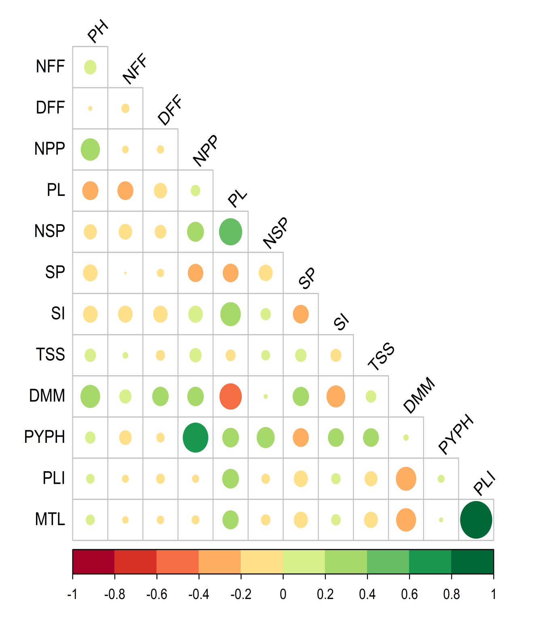

**Fig 1**: Correlogram showing relationship among yield and yield components

#### **Table 1. Correlations among different traits in pea.**

|  |  |  |  |  |  |  |  |  |  |  |  |  |  |
| --- | --- | --- | --- | --- | --- | --- | --- | --- | --- | --- | --- | --- | --- |
| **Traits** | **PH** | **NFF** | **DFF** | **NPP** | **PL** | **NSP** | **SP** | **SI** | **TSS** | **DMM** | **PYPH** | **PL** | |
| **PLI** | **MTL** |
| **PH** | 1.00 | 0.134 | -0.011 | 0.338**\*\*** | -0.235**\*\*** | -0.151 | -0.189 | -0.191**\*\*** | 0.112 | 0.359**\*\*** | 0.093 | 0.057 | 0.068 |
| **NFF** |  | 1.000 | -0.053 | -0.033 | -0.231**\*\*** | -0.160 | -0.002 | -0.188**\*\*** | 0.023 | 0.127 | -0.139 | -0.036 | -0.031 |
| **DFF** |  |  | 1.000 | -0.039 | -0.154 | -0.119 | -0.040 | -0.188**\*\*** | -0.069 | 0.247**\*\*** | -0.055 | -0.062 | -0.042 |
| **NPP** |  |  |  | 1.000 | 0.079 | 0.263**\*\*** | -0.217**\*\*** | 0.192**\*\*** | 0.131 | 0.251**\*\*** | 0.616**\*\*** | -0.038 | -0.049 |
| **PL** |  |  |  |  | 1.000 | 0.500**\*\*** | -0.226**\*\*** | 0.388**\*\*** | -0.085 | -0.468**\*\*** | 0.254**\*\*** | 0.258**\*\*** | 0.238 |
| **NSP** |  |  |  |  |  | 1.000 | -0.177 | 0.092 | 0.066 | 0.011 | 0.299**\*\*** | -0.061 | -0.076 |
| **SP** |  |  |  |  |  |  | 1.000 | -0.228**\*\*** | 0.112 | 0.246**\*\*** | -0.233**\*\*** | -0.178 | -0.179 |
| **SI** |  |  |  |  |  |  |  | 1.000 | -0.103 | -0.326**\*\*** | 0.228**\*\*** | 0.076 | 0.079 |
| **TSS** |  |  |  |  |  |  |  |  | 1.000 | 0.095 | 0.229**\*\*** | -0.147 | -0.173 |
| **DMM** |  |  |  |  |  |  |  |  |  | 1.000 | 0.021 | -0.386**\*\*** | -0.367**\*\*** |
| **PYPH** |  |  |  |  |  |  |  |  |  |  | 1.000 | 0.036 | 0.012 |
| **PLI** |  |  |  |  |  |  |  |  |  |  |  | 1.000 | 0.978 |
| **MTL** |  |  |  |  |  |  |  |  |  |  |  |  | 1.000 |

**Significant at 1% level of significance Where,

NFF= Node at which first flower appear, DFF=Days to 50 % flower, PL=Pod length, NPP=Number of pods per plant, SP= Shelling percentage, NSP= Number of seeds per pod, PH=Plant height, TSS=Total soluble solids, DMM=Days to marketable maturity, PYPH=Pod yield (q/ha), PL = Pea leaf miner (PLI = Percentage of leaf infested by leaf miner, MTL = Number of maggots per 10 leaves of pea plant), and SI= Seed index (100-seed weight).

**3.2 Path coefficient analysis**

To recognize factors contributing significantly towards pod yield (q/ha), the estimates of indirect impact with direct impact were also determined via the application of direction coefficient analysis, and conclusions were reported in Table 2. The analysis of path coefficient analysis indicated that among all the traits studied, number of pods per plant (0.571) exhibited the highest positive direct effect on the pod yield (q/ha) followed by the pod length (0.136), 100-seed weight (0.032), number of seeds per pod (0.020), days to 50 % flowering (0.001), total soluble solids (0.191) and days to marketable maturity (0.022).Shelling percentage (-0.107), plant height (-0.099), number of maggots per 10 leaves of pea plant (-0.192), percentage of leaf infestation by leaf miner (-0.145) and node at which first flower appear (-0.071) were found to have a negative direct effect on pod yield (q/ha). Additionally, total soluble solids (0.229), pod length (0.254), number of pods per plant (0.616), 100-seed weight (0.228) and number of seeds per pod (0.020), observed highest positive indirect impact on pod yield (q/ha). Singh et al. (2014) found comparable results regarding plant height, number of pods/plant and the yield of seeds per plant. The path analysis revealed a significant positive and direct effect of plant height on the yield of pod per plant. Pandey et al. (2017) also reported similar results for plant height, number of pods per plant, weight of pods per plant and the length of pods which contributed to an enhanced pea pod yield (q/ha). Srivastava et al. (2018) found that the maximum positive direct effect on pod yield (q/ha) was reported by the 100-seed weight, number of seeds per pod and number of pods per plant, whereas the most negative direct effect on the yield of pod per plant was shown by the plant height. Similarly, Pratap et al. (2024) observed that biological yield per plant had the maximum direct effect on seed yield, tracked by the harvest index, number of seeds per pod, number of effective nodes per plant and days to 50% flowering. Sharma et al. (2023) reported positive direct impact on days to 50% flowering, number of pods per plants and number of seeds per pods on pod yield per plant. Similar findings were also documented for path coefficient analysis studies of various characters of pea genotypes by Ali et al. (2021), Sharma et al. (2023), Kumar et al. (2023), Anand et al. (2024), Latha et al. (2024) and Pratap et al. (2024).

#### **Table 2. Genotypic path estimates of direct and indirect effects of different traits on pod yield per plant in pea.**

|  |  |  |  |  |  |  |  |  |  |  |  |  |  |
| --- | --- | --- | --- | --- | --- | --- | --- | --- | --- | --- | --- | --- | --- |
| **Traits** | **PH** | **NFF** | **DFF** | **NPP** | **PL** | **NSP** | **SP** | **SI** | **TSS** | **DMM** | **PL** | | **PYPH** |
| **PLI** | **MTL** |
| **PH** | **-0.099** | -0.010 | 0.000 | 0.193 | -0.032 | -0.003 | 0.020 | -0.006 | 0.021 | 0.008 | 0.013 | -0.013 | 0.093 |
| **NFF** | -0.013 | **-0.071** | 0.000 | -0.019 | -0.031 | -0.003 | 0.000 | -0.006 | 0.004 | 0.003 | -0.008 | 0.006 | -0.139 |
| **DFF** | 0.001 | 0.004 | **0.001** | -0.022 | -0.021 | -0.002 | 0.004 | -0.006 | -0.013 | 0.006 | -0.014 | 0.008 | -0.055 |
| **NPP** | -0.034 | 0.002 | 0.000 | **0.571** | 0.011 | 0.005 | 0.023 | 0.006 | 0.025 | 0.006 | -0.009 | 0.009 | 0.616**\*\*** |
| **PL** | 0 .023 | 0.016 | 0.000 | 0.045 | **0.136** | 0.010 | 0.024 | 0.012 | -0.016 | -0.010 | 0.059 | -0.046 | 0.254**\*\*** |
| **NSP** | 0.015 | 0.011 | 0.000 | 0.150 | 0.068 | **0.020** | 0.019 | 0.003 | 0.013 | 0.000 | -0.014 | 0.015 | 0.299**\*\*** |
| **SP** | 0.019 | 0.000 | 0.000 | -0.124 | -0.031 | -0.004 | **-0.107** | -0.007 | 0.021 | 0.005 | -0.041 | 0.034 | -0.233**\*\*** |
| **SI** | 0.019 | 0.013 | 0.000 | 0.110 | 0.053 | 0.002 | 0.025 | **0.032** | -0.020 | -0.007 | 0.018 | -0.015 | 0.228**\*\*** |
| **TSS** | -0.011 | -0.002 | 0.000 | 0.075 | -0.012 | 0.001 | -0.012 | -0.003 | **0.191** | 0.002 | -0.034 | 0.033 | 0.229**\*\*** |
| **DMM** | -0.036 | -0.009 | 0.000 | 0.144 | -0.064 | 0.000 | -0.026 | -0.010 | 0.018 | **0.022** | -0.089 | 0.070 | 0.021 |
| **PLI** | -0.006 | 0.003 | 0.000 | -0.022 | 0.035 | -0.001 | 0.019 | 0.002 | -0.028 | -0.009 | **-0.145** | 0.187 | 0.036 |
| **MTL** | -0.007 | 0.002 | 0.000 | -0.028 | 0.032 | -0.002 | 0.019 | 0.003 | -0.033 | -0.008 | 0.224 | **-0.192** | 0.012 |

**Significant at 1% level of significance Where,

NFF= Node at which first flower appear, DFF=Days to 50 % flower, PL=Pod length, NPP=Number of pods per plant, SP= Shelling percentage, NSP= Number of seeds per pod, PH=Plant height, TSS=Total soluble solids, DMM=Days to marketable maturity, PYPH=Pod yield (q/ha), PL = Pea leaf miner (PLI = Percentage leaf infested by leaf miner, MTL = Number of maggots per 10 leaves of pea plant), and SI= Seed index (100-seed weight).

#### **Residual effect 0.5246**

Diagonal figures represent the direct effect

4. Conclusion

The significant and positive correlation coefficient for pod yield (q/ha) at both the genotypic and phenotypic level were recorded in relation to several factors including plant height, days to marketable maturity, number of pods per plant, pod yield quintal per hectare, pod length, number of seeds per pod, 100-seed weight, total soluble solids, node at which first flower appear, shelling percentage and days to 50 % flowering while it was negatively and significantly correlated with pea leaf miner.

In the context of path coefficient analysis at both the genotypic and phenotypic levels, days to marketable maturity, pod length, number of seeds per pod, 100-seed weight, number of pods per plant, days to 50 % flowering, number of pods per plant and total soluble solids, exhibited a significant direct impact on the pod yield (q/ha).

5. DisclAimEr

Author(s) hereby declare that no generative ai technologies such as large language models (Chat GPT, Copilot, etc.) and text-to-image generators have been used during the writing or editing of this manuscript.

References

Abuali, A.I., Abdelmulla, A.A. & Idris, A.E. (2012). Character association and path analysis in pearl millet. *American Journal of Experimental Agriculture*, **2**(3): 370-381.

Ali, B., Kumar, S. & Ahmed, W. (2021). Genetic variability, heritability and correlation coefficient in production traits of pea (*Pisum* *sativum* l.) genotypes. *International Journal of Genetics and Genomics*, **9**(4): 78-88.

Ali, M.A., Nawab, N.N., Abbas, A., Zulkiffal, M. & Sajjad, M. (2009). Evaluation of selection criteria in Cicer arietinum L. using correlation coefficients and path analysis. *Australian* *Journal of Crop Science*, **3**(2): 65-70.

Al-Jibouri, H.A., Miller, P.A. & Robinson, H.P. (1958). Genotypic and phenotypic co-variances in an upland cotton cross of inter-specific origin. *Agronomy Journal,* **50**(10): 633-636.

Anand, J.K., Singh, S.K., Nagre, P.S., Thakur, S., Patel, T. & Moitra, P.K. (2024). Exploring genetic variability, trait associations and path coefficient analysis in pea (*Pisum sativum* L.) to advance breeding strategies. *International Journal of Bio-resource and Stress Management*, **15**(9): 01-10.

Bishnoi, R., Marker, S., Kumar, K.Y.& Taranum, S.A. (2021). Genetic variability parameters for quantitative traits in farmers’ pea (*Pisum* *sativum* var. arvense L.) varieties. *Biological Forum An International Journal,* **13**(4): 320-325.

Dewey, D.R. & Lu, K.H. (1959). A correlation and path coefficient analysis of components of crested wheat grass seed production. *Agronomy Journal,* **51**(9): 515-518.

Gopalan, C., Rama, S.B.V & Balasubramanian, S.C. (2007). Nutritive Value of Indian Foods. Revised edition. National Institute of Nutrition, Indian Council of Medical Research, Hyderabad, India. p. 50.

Kalapchieva, S., Kosev, V. & Vasileva, V. (2021). Correlation dependences of quantitative traits in garden pea (*Pisum* *sativum* L.). *Analele Universitatii din* *Oradea, Fascicula Biologie*, **28**(1): 85-90.

Kumar, R., Singh, B., Tomar, H., Kumar, V., Chaudhary, A.K., Marwah, A. & Yashraj, (2023). Genetic heritability, variability, genetic advance, correlation and path analysis assessment in garden pea (*Pisum* *sativum* L.). *International Journal of Plant & Soil Science*, **35**(14). 69-79.

Latha, G.K., Kerure, P., Devaraju, Kantharaj, Y., Srinaivasa, V. & Ramesh, A.N. (2024). Genetic investigation in garden pea for yield and quality characters. *Journal of Experimental Agriculture International*, **46**(5): 322-329.

Mahbub, M.M., Rahman, M.M., Hossain, M.S., Mahmud, F. & Kabir. M.M. (2015). Genetic variability, correlation and path analysis for yield and yield components in Soybean. *American Eurasian Journal of Agricultural & Environmental Sciences,* **15**(2): 231-236.

Mawblei, C., Premalatha, N., Rajeswari, S. & Manivannan, A., (2022). Genetic variability, correlation and path analysis of upland cotton (*Gossypium* *hirsutum* L.) germplasm for seed cotton yield. *Electronic Journal of Plant Breeding,* **13**(3): 820-825.

Pandey, M. Singh, V.B., Yadav, G.C., Pandey, P. & Singh, Y.P. (2017). Genetic variability, heritability and genetic advance in vegetable pea (*Pisum* *sativum* L. var. hortense). *Vegetable Science*, **44**(1): 139-141.

Parihar, A.K., Dixit, G.P., Pathak, V. & Singh, D. (2014). Assessment of the genetic components and trait associations in diverse set of field pea (*Pisum sativum*) genotypes. *Bangladesh Journal of Botany,* **43**(3): 323-330.

Posit team (2023). RStudio: Integrated Development Environment for R. Posit Software, PBC, Boston, MA. URL http://www.posit.co/.

Pratap, V., Sharma, V. & Shukla, G. (2024). Assessment of genetic variability and relationship between different quantitative traits in field pea (*Pisum* *sativum* var. arvense) germplasm. *Legume Research: An International Journal,* **47**(6): 905.

R Core Team (2022). R: A language and environment for statistical computing. R Foundation for Statistical Computing, Vienna, Austria. URL https://www.R-project.org/.

Rowland, I.C., Mason, M.G., Pritchard, I.A. & French, R.J. (1994) Effect of field peas and wheat on the yield and protein content of subsequent wheat crops grown at several rates of applied nitrogen. *Australian Journal of Experimental* *Agriculture*, **34**(1): 641-646.

Sharma, S., Bhushan, A., Samnotra, R.K., Kumar, B., Wani, O.A., Naik, R. & Kumar, M. (2023). Genetic variability, correlation and path coefficient analysis in advanced matromorphic generations of garden pea (*Pisum* *sativum* L.). *Legume Research-An International Journal,* **28**(1): 1-7.

Singh, S., Singh, L., Rahul, V.P. & Kuldeep. (2014). Study on characters association and path analysis in field pea (*Pisum sativum* L.). *International Journal of Plant Science,* **9**(1): 213-215.

Srivastava, A., Sharma, A., Singh, T. & Kumar, R. (2018). Correlation coefficient and path coefficient in field pea (*Pisum* *sativum* L.). *International Journal of Current Microbiology and Applied Sciences,* **7**(2): 549-553.

Thakur, A., Bisht, Y., Singh, S. & Devi, P. (2024). Genetic variability, character association and multivariate analysis in garden pea (*Pisum* *sativum* L.) for quality and biochemical traits. *Vegetable Science*, **51**(2): 319-326.