**Review Article**

**Understanding Waterlogging Stress in Cowpea: An Overview**

**Abstract**

Waterlogging stress is a significant threat to the global agriculture, resulted in the 33% reduction in the average crop yield. It is predicted that annual daily precipitation will increase by 14% by 2050 in IPCC report. Increase in precipitation increases waterlogging condition. This stress causes a cascade of physiological and morphological responses in plants, including limiting photosynthesis, respiration, nutrient uptake, biomass and formation of adventitious roots. As a result, the growth and development of plant becomes completely disrupted. Cowpea plants under stress exhibit a decline in their number of leaves, leaf area, fresh weight, dry weight, etc. An important morphological change is the emergence of adventitious roots. This root system helps in the absorption and oxygen transport of plant, even after the death of primary roots. Tolerant genotypes survive the stress condition by switching into alternate pathways like anaerobic respiration or structural modifications. This review aims to provide a comprehensive understanding of the impact of waterlogging on cowpea, thereby contributing to the advancement of future research objectives.

Keywords: Adventitious roots, Aerenchyma, Cowpea, Ethylene, Hormonal regulation, Waterlogging stress

***Introduction***

Legume crops are essential for sustainable agriculture, food security, and the well-being of farming communities worldwide. Cowpea (*Vigna unguiculata* L.) is considered as the second most important legume in the world after common beans (*Phaseolus vulgaris* L.). Cowpea is also regarded as one of the most versatile crops as it can be utilized as green pods, seeds, forage and for green manure purpose (Vala and Patel, 2021). The crop grows well in almost all seasons and is well adopted to humid tropics and sub-tropical zones. Cowpea tolerates heat and drought stress, but is more sensitive towards waterlogging (Minchin *et al*., 1978). The crop can grow all year if it is properly irrigated, but excessive precipitation can reduce yield by 10-90% and which varies by crop stages (Timsina *et al*., 1994). Increasing anthropogenic activities have escalated the occurrence of extreme climatic conditions. According to IPCC report, by 2050 the projected annual daily precipitation will increase 14% (IPCC, 2021). Increase in precipitation will lead to more waterlogging events in the world. It is documented that globally waterlogging affects more than 1700 million hectare land each year (Voesenek and Sasidharan, 2013) and limits the mean global crop yield by 33% (Tian *et al*., 2021).

Waterlogging stress inflicts severe constraints on the growth and productivity of plants (Jackson and Colmer, 2005). Waterlogging causes the depletion of oxygen in the soil, disrupting the diffusion rate of gases (Bailey-Serres *et al*., 2012). This eventually points towards the reduction of redox potential of soil and causing oxygen deficiency (hypoxia) or its complete absence (anoxia) (Ponnamperuma, 1972; Nishiuchi *et al*., 2012). The slow diffusion rate and high microbial activity reduces the concentration of soil oxygen and helps in building up toxic compounds (Ponnamperuma, 1984; Gambrell *et al*., 1991)

Oxidative decomposition of gases like carbon dioxide, ethylene, etc inhibits during waterlogging (Herzog *et al*., 2016). All these affect the growth and development of roots. Plants try to alleviate the effects of soil hypoxia through a different mechanism of anatomical, morpho-physiological, and metabolic responses. Under waterlogging condition, plants turn to anaerobic fermentation instead of aerobic respiration, which reduces the ATP production from 36 moles of glucose metabolized to 2 moles (Gibbs and Greenway, 2003; Sousa and de, Sodek, 2002). This shift of their metabolism to basal metabolic rate (BMR) causes an energy deficit upto 37.5% (Gibbs and Greenway, 2003). But during anaerobic fermentation, byproducts such as alcohols, aldehydes and reactive oxygen species (ROS) are produced, which are harmful to the plants (Cotrozzi *et al*., 2021; Langan *et al*., 2022; Sairam *et al*., 2011). If the stress condition is sustained for longer duration, plant metabolism may go beyond BMR and causes its death (Irfan *et al*., 2010).

Studies on the effect of waterlogging stress on cowpea is very limited. In the context of climate change, comprehensive insights into this topic are very important. This review is trying to showcase the effect of waterlogging stress on cowpea, so that it will help in future to develop tolerant cowpea genotypes.

***Effect of waterlogging on the morphology and anatomy of cowpea***

Cowpea (*Vigna unguiculata* (L.) Walp.) is an important grain legume with inherent resilience to cope with abiotic stress like drought and heat stress (Hall, 2004: Goufo *et al*., 2017), but are highly sensitive to waterlogging stress due to their inability to absorb nutrients under waterlogging (Minchin *et al*., 1978: Hong *et al*., 2021). The growth and development of cowpeas are restricted when the soil water content is 2-3 cm above the soil level (Minchin and Summerfield, 1976; Umaharan *et al*., 1997).

The first notable difference in plants subjected to waterlogging is the chlorosis of leaves. This is primarily due to hypoxia-induced root dysfunction, reduced nutrient uptake, impaired chlorophyll synthesis, stress hormone accumulation and inhibited photosynthesis (Pan *et al*., 2021). Reduced chlorophyll content in the leaves leads to visible yellowing (Barickman *et al*., 2019). All these causes leaf senescence and [chlorosis](https://www.sciencedirect.com/topics/agricultural-and-biological-sciences/chlorosis) ([Zheng](https://www.sciencedirect.com/science/article/pii/S0098847224001825" \l "bib138) *[et al](https://www.sciencedirect.com/science/article/pii/S0098847224001825" \l "bib138)*[., 2009](https://www.sciencedirect.com/science/article/pii/S0098847224001825" \l "bib138)). Increase in the chlorosis is observed with the duration of waterlogging (Dethvongsa *et al*., 2021). Under prolonged waterlogging, chlorosis is often accompanied by other symptoms such as wilting, stunted growth, leaf fall, and dieback. Generally, yellowing appears first on older leaves but can affect the whole plant if conditions persist for a long time. The chlorosis pattern looks similar to the pattern caused by nutrient deficiency, but here it is due to the inability of roots to absorb nutrients (RHS, 2025).

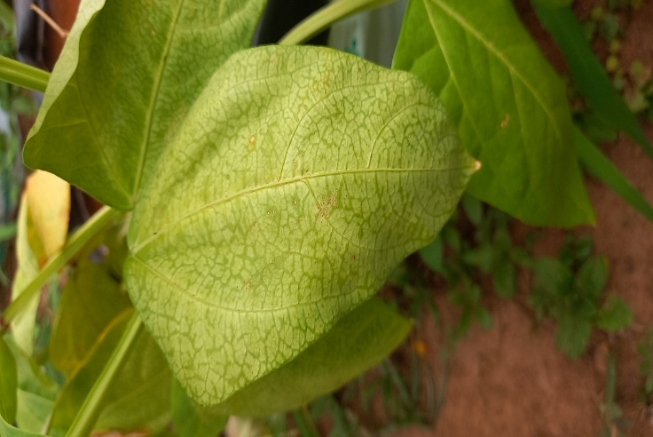

Fig 1. Chlorosis on cowpea leaves after waterlogging

The major effects of waterlogging on the shoots include reduction in shoot elongation, chlorosis of leaves, early senescence and eventual abscission of the lower leaves and flowers, wilting, hypertrophy, development of adventitious roots on the lower portion of the stem, epinasty, leaf curling, lenticel formation, and reduced rate of dry weight increase (Minchin and Summerfield, 1976; Hong *et al*., 1977; Timsina *et al*., 1994). The number of leaves in cowpea showed significant reduction under stress condition (Olorunwa *et al*., 2022a). Hong *et al*. (1977) observed the appearance of pale green colour leaves and suggests this might be due to impaired symbiotic nitrogen fixation. Hong *et al*., (1977) also observed delayed formation and decreased number of branches. Senthamil *et al*. (2024) also recorded reduction in the number of branches in cowpea under waterlogging stress and suggests that this might be resulted from increased energy expenditure for recovery mechanisms.

Reduction of leaf area, fresh weight and dry weight were noticed in cowpea after waterlogging (Hong *et al*., 1977; Olorunwa *et al*., 2022a). Tolerant cowpea genotypes showed improved biomass accumulation under moderate waterlogging, but severe waterlogging completely affected the biomass of susceptible ones (Takele and McDavid, 1994). The significant decline in the plant biomass might have resulted from drastic senescence of leaves and restricted nutrient absorption (Olorunwa *et al*., 2022b). The extent of reduction can vary according to the genotypes and growth stages. Minchin *et al*. (1978) reported 52 % reduction in the grain yield of cowpea when plants were subjected to waterlogging during the seedling stage. In the early stage of growth, roots will get destroyed first by waterlogging. Thus, the early stage of plant growth (from V2 to V4 stage) is considered as the most sensitive stage of cowpea to waterlogging stress (Hong *et al*., 1977). There was a reduction of 60.81% in the yield of cowpea, when the plants were imposed to waterlogging at 15 days after emergence (Basavaraj *et al*., 2024). However, Minchin *et al*. (1978) reported more than 50% yield reduction when cowpea was waterlogged during flowering. Similarly, susceptible cowpea genotype recorded less than 50 % reduction of plant biomass when stress was given at reproductive stage (Olorunwa *et al*., 2022b). That is, waterlogging stress causes the reduction of yield and yield attributing traits.

Another major morphological change under waterlogging is the growth of adventitious roots. Waterlogging causes the decaying of primary roots. This causes an energy crisis. Thus as a response, adventitious roots (AR) emerge from base of stem, nodes, etc to replace the primary roots. The emergence of AR has been recorded in different plant species including rice (Mhimdi and Pérez-Pérez, 2020), barley (Zhang *et al*., 2015), maize (Liang *et al*., 2020), blackgram (Alam *et al*., 2024), soybean (Kim *et al*., 2019), etc. All the cowpea genotypes formed AR under waterlogging, variation was significant between tolerant and sensitive genotypes. The emergence of AR benefits the internal oxygen transport to roots, which increases the concentration of oxygen in the rhizospheric zone (Shimamura *et al*., 2010; Teakle *et al*., 2011). Thomas *et al*. (2005) stated that there is an association between the formation of AR and metabolism of nitrogen in legume roots.

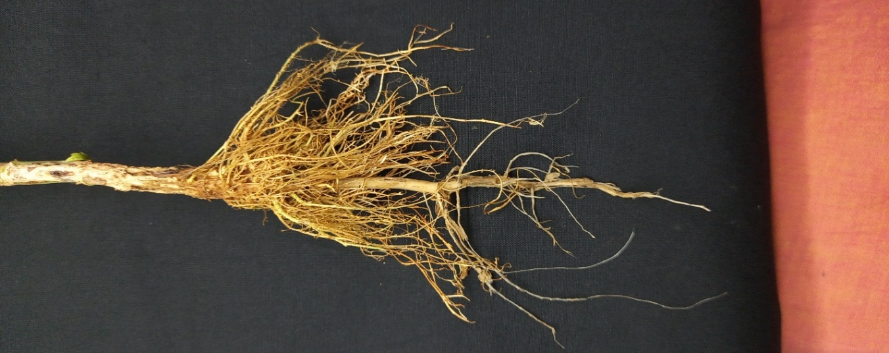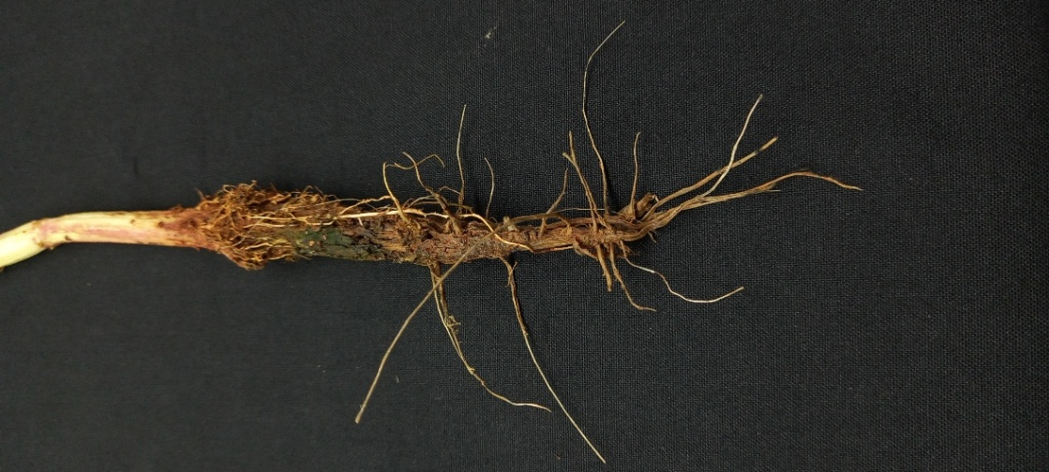

B

Aa

Fig 2. Variation in the root growth of two cowpea genotypes under waterlogging (A: tolerant genotype; B: sensitive genotype)

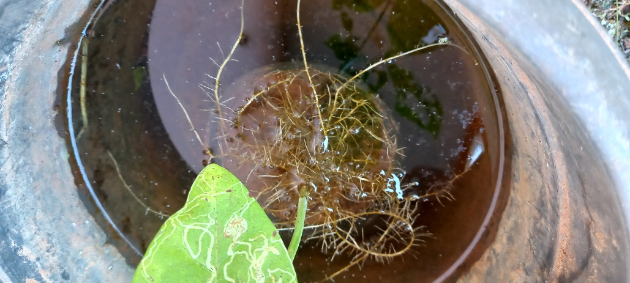

Fig 3. Emergence of adventitious roots in cowpea genotype

Presence of aerenchyma is another structural change occurs during waterlogging. Air filled space across and along the roots are known as aerenchyma and these also help in the gas diffusion and nutrient uptake (Steffens and Rasmussen, 2016). Cortical cells are transformed to aerenchyma under hypoxic stress condition (He *et al*., 1996). These can remove toxic volatile substances and CO2 from waterlogged tissue. Thus, presence of aerenchyma is vital in regulating the normal physiological metabolism in the roots under stress (Evans, 2004; Yamauchi *et al*., 2013).

***Effect of waterlogging on the physiology of cowpea***

Waterlogging stress adversely affects the physiology of cowpea, hampering the processes like carbon metabolism, nutrient absorption, etc (Ploschuk *et al*., 2018; Kaur *et al*., 2020). Given that yield is an outcome of complex physiological phenomena, these stress induced disruptions will be ultimately reflected in reduced yield. Wang *et al*. (2017) concluded that damage was more noticeable during the reproductive stage because this stage is associated with more physiological processes like flowering, pollination, fertilization, etc till grain formation, those have significant influence in the productivity of crop.

 Waterlogging has a direct influence on [oxygen diffusion](https://www.sciencedirect.com/topics/biochemistry-genetics-and-molecular-biology/oxygen-diffusion) in the plant tissues. So, gaseous exchange will be tampered affecting the mitochondrial respiration between cells, ultimately disturbing the normal physiological and biochemical activities of plants ([Liu](https://www.sciencedirect.com/science/article/pii/S0098847224001825" \l "bib61) *[et al](https://www.sciencedirect.com/science/article/pii/S0098847224001825" \l "bib61)*[., 2012](https://www.sciencedirect.com/science/article/pii/S0098847224001825" \l "bib61), [Voesenek and Bailey-Serres, 2013](https://www.sciencedirect.com/science/article/pii/S0098847224001825" \l "bib109)). Restricted gaseous exchange can cause rapid accumulation or deterioration of plant hormones ([Kuroha](https://www.sciencedirect.com/science/article/pii/S0098847224001825" \l "bib51) *[et al](https://www.sciencedirect.com/science/article/pii/S0098847224001825" \l "bib51)*[., 2018](https://www.sciencedirect.com/science/article/pii/S0098847224001825" \l "bib51)). Leaf gas exchange is highly correlated to the photosynthetic capacity of plants. Several studies recorded reduced gaseous exchange in the susceptible genotypes, with lower photosynthetic capacity (Trought and Drew, 1982; Jackson and Kowalewska, 1983). Likewise, tolerant genotypes maintain better photosynthetic capacity (Topa and Cheesemann, 1992)

Photosynthesis, the fundamental process for plant growth, is highly susceptible to waterlogging stress in cowpea. Waterlogging leads to a reduction in photosynthetic rate, primarily due to stomatal closure, which limits CO2 diffusion into the leaves (Acosta *et al*., 2021). The reduced availability of CO2 impairs the carboxylation efficiency of RuBisCO, the key enzyme responsible for carbon fixation in the Calvin cycle (Jaleel *et al*., 2009). Under waterlogging, significant reduction of average net photosynthesis by 57% was observed in cowpea compared to control condition. Similarly, tolerant genotypes exhibited higher stomatal conductance in contrast to the lower values of sensitive cowpea genotypes (Olorunwa *et al*., 2022a).

To meet the energy demands, plant replaces oxidative phosphorylation with anaerobic fermentation under anoxic condition (Davies, 1980). Different theories are there regarding the modification of ethanol fermentation pathway. Davies (1980) proposed a hypothesis that short term flood tolerance prefers ethanol over lactate, as lactate increases cytoplasmic acidosis (Roberts *et al*., 1984). Later Vartapetian (2005) also concluded that increasing ethanol production in plant cells are correlated with the tolerance to hypoxic conditions of waterlogging. Besides, the activity of lactate dehydrogenase (LDH) was also found higher during hypoxia (Hoffman *et al*. 1986). Lactate produced by LDH accumulates and lowers pH. This activates pyruvate decarboxylase and shifts metabolism towards ethanol production, which is a less acidifying pathway for plant cells under prolonged stress (O'Carra and Mulcahy, 1997).

Membrane stability index (MSI) is a critical physiological indicator for assessing the tolerance of crop to waterlogging stress. It reflects the integrity of cell membranes under adverse conditions. Hypoxia caused by waterlogging attributes to the oxidative damage, which disrupts the structure and function of membranes. Significant reduction of MSI was observed in cowpea genotypes under stress. This decline could be associated with plant growth reduction (Olorunwa *et al*. 2023). Similar findings were reported by Kumar *et al*. (2013).

Reactive Oxygen Species (ROS) are highly reactive molecules derived from oxygen (O₂), which are produced naturally as the by-products of aerobic metabolism and common ROS include hydrogen peroxide (H₂O₂), superoxide (O₂⁻), hydroxyl radical (- OH), and singlet oxygen (¹O₂) (Huang *et al*., 2019). In normal conditions, the concentration of ROS produced are very low. But under stress condition, their levels become excessive and cause oxidative damage to cellular components such as DNA, proteins, and lipids (Ashraf, 2012). Accumulation of ROS causes lipid peroxidation and leakage of membrane (Abid *et al*., 2018; Bansal *et al*., 2019). To neutralize the hazardous ROS activity, plants have evolved an endogenous system of enzymes (e.g., catalase, peroxidase, SOD, etc.) and metabolites (e.g., ascorbate, glutathione, proline, etc.) (Apel and Hirt, 2004). Tolerant genotypes may upregulate the activities of anti-oxidant enzymes, protecting the cellular components from oxidative damage (Huang *et al*., 2019). However, over production of ROS in the waterlogging-sensitive plants causes degradation of cell structures and serious oxidative damage, which disturbs the normal metabolism ([Herzog](https://www.sciencedirect.com/science/article/pii/S0098847224001825" \l "bib35) *[et al](https://www.sciencedirect.com/science/article/pii/S0098847224001825" \l "bib35)*[., 2016](https://www.sciencedirect.com/science/article/pii/S0098847224001825" \l "bib35)). This can eventually leads to cell death ([Bali and Sidhu, 2019](https://www.sciencedirect.com/science/article/pii/S0098847224001825" \l "bib9), [Pais](https://www.sciencedirect.com/science/article/pii/S0098847224001825" \l "bib83) *[et al](https://www.sciencedirect.com/science/article/pii/S0098847224001825" \l "bib83)*[., 2023](https://www.sciencedirect.com/science/article/pii/S0098847224001825" \l "bib83)).

Waterlogging creates hypoxia or anoxia, which inhibits aerobic respiration and normal ATP generation. This affects the transport of nutrients like Potassium, Calcium, Magnesium, etc. (Zhang *et al*., 2025). In the study, Steffens *et al*. (2005) also recorded significant reduction of N, P, K, Mg, Cu, Zn, and Mn concentrations in the shoots of plants under waterlogging treatment. Schubert and Yan (1999) reported the lower concentration of ATP in roots affect the H+ ATPase activity of plasma membrane. This might have caused difficulty in the nutrient absorption (Steffens *et al*., 2005). Restriction in Mg uptake lowers photosynthetic efficiency, whereas disrupted Ca signaling hinders stomatal closure, leading to water loss and nutrient leakage (Zhang *et al*., 2025). Potassium is essential for maintaining cell turgor and osmotic regulation, vital for plant cells to recover from stress induced damage. Also, potassium has a critical role in activating antioxidant enzymes, which are crucial to mitigate oxidative stress (Kumari *et al*., 2022). Prolonged hypoxia causes oxidative stress, which damages root tissues, further reducing the surface area of roots for nutrient absorption (Lou *et al*., 2024). Similarly, altered soil redox potential changes the chemical profile of soil, which might also affect the nutrient availability (Beegum *et al*., 2023). Morphological changes like reduced root and shoot growth, leaf area, etc can affect the ability of plant to assimilate and transport nutrients effectively (Beegum *et al*., 2023). All these ultimately causes the collapse of entire plant.

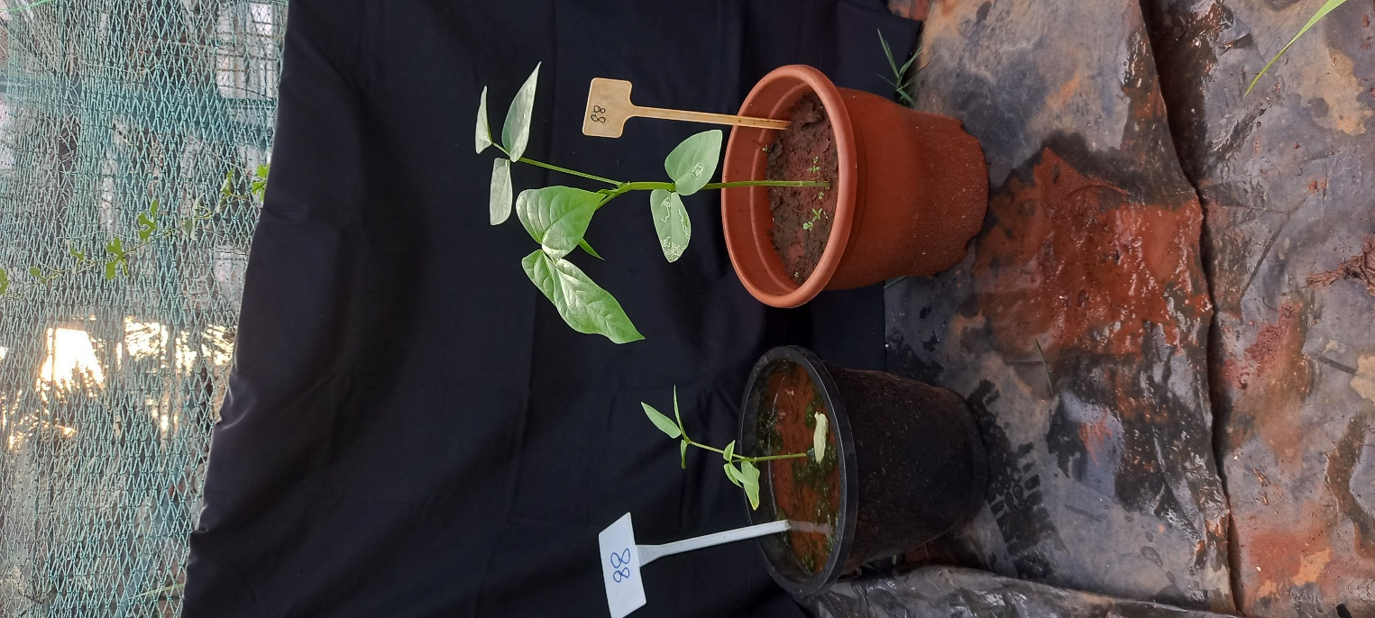

Fig 4. Variation in the growth and biomass of cowpea genotype under waterlogging condition

***Effect of waterlogging at hormonal level***

Absence of oxygen induces a series of anaerobically induced polypeptides (ANPs) including ACC (1-Aminoacyl cyclopropane-1-carboxylic acid) in the roots, which is a precursor for ethylene biosynthesis. The formation of ethylene from ACC holds a major weightage in determining the tolerance of plants under stress. ACC converts to ethylene by ACC oxidase in shoots (Voesenek *et al*., 1993). Presence of molecular oxygen is required for ACC oxidase for the biosynthesis of ethylene (Bleecker and Kende, 2000). Ethylene thus formed later facilitates the formation of adventitious roots and other metabolic changes (Irfan *et al*., 2010). When accumulation of ethylene occurs at nodes, epidermal cell covering the tip of primordia will go into programmed cell death and this facilitates emergence of adventitious root (Mergemann and Sauter, 2000). Ethylene production can promote the transport of auxin, while auxin accumulation can induce the biosynthesis of ethylene (Pan *et al*., 2021). The interaction of auxins and ethylene is important for the induction of adventitious root formation (Drew *et al*., 1981; McNamara and Mitchell 1989). Auxin accumulation can trigger cell division, which aids in the induction of ARs.

Abscisic acid (ABA) has a main role in regulating the opening and closing of stomata by adjusting the size of guard cells. ABA promotes stomatal closure, thus reducing transpiration and maintaining the water potential in plants. This improves the tolerance level of plants against waterlogging. Because of this, ABA is considered to be a key hormone in water stress responses (Zhu, 2016; He *et al*., 2018). Under anoxic condition lower level of ABA synthesis occurs (Hoffmann-Benning and Kende, 1992) which may assist in the elongation of plants to avoid the negative effects of stress (Mapelli *et al*. 1995). Different studies have recorded the presence of significant higher concentration of ABA under waterlogging condition than in control: cotton (Zhang *et al*., 2016), wheat (Nan *et al*., 2002).

Gibberellins (GAs) are essential for regulating growth and development of plants. Studies in rice proved that the upregulation of GA plays great role in the internode elongation, which helps rice to grow beyond water level and reestablish gaseous exchange (Hattori *et al*., 2009; Ayano *et al*., 2014). Likewise, notable variation was observed in the GA content between the waterlogging tolerant and susceptible genotypes, where GA content was significantly higher in tolerant ones (Kim *et al*., 2015). In addition, Wang *et al*. (2016) observed that exogenous application of GA reduced oxidative stress of plants growing under waterlogging condition, imparting tolerance to plants. Other hormones like salicyclic acid, jasmonic acid, brassinosteroid, melatonin, etc. can also induce changes in the physiological properties of the plants under stress condition. Hormonal variation in cowpea under waterlogging is barely studied.

Recent studies recorded the expression of ANPs like heat shock proteins, WRKY factors (Lasanthi-Kudahettigeetal, 2007), mtATPase α-subunit (Ahsan *et al*., 2007), etc are recorded under waterlogging stress condition. Further studies and understanding the molecular mechanisms behind these physiological variations are very much needed.

***Conclusion***

Waterlogging stress is one of the most hazardous abiotic stresses faced by agriculture. Climate change intensifies the incidents like floods, drought, cyclone, waterlogging, etc. This adversely affects crop production. Cowpea is a widely adapted, drought tolerant legume which can be used as vegetable, grain and fodder. Cowpea affects severely under waterlogging. Yield and yield attributing parameters like number of primary branches, number of leaves, leaf area, biomass, etc. were reduced after imposing with waterlogging. Tolerant genotypes maintain their growth and development through alternate respiratory mechanisms like anaerobic fermentation, development of adventitious roots, normal nutrient uptake, etc. Sensitive genotypes will die after the exposure to few days. It is important to develop desirable cowpea genotypes with both stress tolerance and high yield. Deep understanding on the effects of waterlogging on cowpea is a pre-requisite for this. But the studies regarding the effect of waterlogging on cowpea are very limited. This review tries to provide an overall view on the impact of waterlogging on cowpea.

Disclaimer (Artificial intelligence)

Option 1:

Author(s) hereby declare that NO generative AI technologies such as Large Language Models (ChatGPT, COPILOT, etc.) and text-to-image generators have been used during the writing or editing of this manuscript.

NO generative AI technologies have been used during during the writing or editing of this manuscript

Option 2:

Author(s) hereby declare that generative AI technologies such as Large Language Models, etc. have been used during the writing or editing of manuscripts. This explanation will include the name, version, model, and source of the generative AI technology and as well as all input prompts provided to the generative AI technology

Details of the AI usage are given below:

1.

2.

3.

***Reference***

Abid, M., Ali, S., Qi, L. K., Zahoor, R., Tian, Z., Jiang, D., Snider, J. L., & Dai, T. (2018). Physiological and biochemical changes during drought and recovery periods at tillering and jointing stages in wheat (*Triticum aestivum* L.). *Scientific Reports, 8*(1), 4615.

Acosta, M. D. L. L. C., Soto, B. H. S., Islas, J. D. R. R., Félix, C. S. R., Tarín, S. B., & Ruíz, V. G. A. (2021). Morpho-physiological characteristics of corn (*Zea mays* L.) affected by drought during its vegetative stage. *Agro Productividad,* I14(8), 71-77.[*https://doi.org/10.32854/agrop.v14i8.1960*](https://doi.org/10.32854/agrop.v14i8.1960)

Ahsan, N., Lee, D. G., Lee, S. H., Lee, K. W., Bahk, J. D., & Lee, B. H. (2007). A proteomic screen and identification of waterlogging-regulated proteins in tomato roots. *Plant and Soil, 295*, 37–51.

Alam, S. B., Sultana, N., Zannat, J. S., & Naher, N. (2024). Waterlogging effect on growth, yield and physiological responses of blackgram (*Vigna mungo* L.) genotypes. *Journal of Agroforestry and Environment, 17*(2), 213–222.

Apel, K., & Hirt, H. (2004). Reactive oxygen species: Metabolism, oxidative stress, and signal transduction. *Annual Review of Plant Biology, 55*, 373–399.

Ayano, M., Kani, T., Kojima, M., Sakakibara, H., Kitaoka, T., Kuroha, T., Angeles‐Shim, R.B., Kitano, H., Nagai, K., & Ashikari, M. (2014). Gibberellin biosynthesis and signal transduction is essential for internode elongation in deepwater rice. *Plant, Cell & Environment, 37*, 2313–2324. https://doi.org/10.1111/pce.12377

Bailey-Serres, J., Lee, S. C., & Brinton, E. (2012). Waterproofing crops: Effective flooding survival strategies. *Plant Physiology, 160*, 1698–1709.

**Bali, A. S., & Sidhu, G. P. S. (2019).** Abiotic stress-induced oxidative stress in wheat. In: Hasanuzzaman, M., Nahar, K., & Hossain, M. A. (Eds.), Wheat production in changing environments: Responses, adaptation and tolerance, 225–239, Springer, Singapore. https://doi.org/10.1007/978-981-13-6883-7

Bansal, R., Sharma, S., Tripathi, K., & Kumar, A. (2019). Waterlogging tolerance in black gram [*Vigna mungo* (L.) Hepper] is associated with chlorophyll content and membrane integrity. *Indian Journal of Biochemistry and Biophysics, 56*, 81–85.

Barickman, T. C., Simpson, C. R., & Sams, C. E. (2019). Waterlogging causes early modification in the physiological performance, carotenoids, chlorophylls, proline, and soluble sugars of cucumber plants. *Plants, 8*(6), 160.

Beegum, S., Truong, V., Bheemanahalli, R., Brand, D., Reddy, V., & Reddy, K. R. (2023). Developing functional relationships between waterlogging and cotton growth and physiology—towards waterlogging modeling. *Frontiers in Plant Science, 14*, 1174682.

Bleecker, A. B., & Kende, H. (2000). Ethylene: A gaseous signal molecule in plants. *Annual Review of Cell and Developmental Biology, 16*, 1–18.

Cotrozzi, L., Lorenzini, G., Nali, C., Pisuttu, C., Pampana, S., & Pellegrini, E. (2021). Transient waterlogging events impair shoot and root physiology and reduce grain yield of durum wheat cultivars. *Plants, 10*, 2357. https://doi.org/10.3390/plants10112357

Davies, D. D. (1980). Anaerobic metabolism and the production of organic acids. In: D. D. Davies (Ed.) *Metabolism and respiration* (Vol. II), Academic Press, Massachusetts, United States, 611p.

Dethvongsa, S., Vu, N. A., & Van, T. K. (2021, March). Comparison of waterlogging tolerance potential of cassava. In: *IOP Conference Series: Earth and Environmental Science* (Vol. 707, No. 1, p. 012002). IOP Publishing.

Drew, M. C., Jackson, M. B., Giffard, S. C., & Campbell, R. (1981). Inhibition by silver ions of gas spaces (aerenchyma) formation in adventitious roots of *Zea mays* L. subjected to exogenous ethylene or to oxygen deficiency. *Planta, 153*, 217–224.

Evans, D. E. (2004). Aerenchyma formation. *New Phytologist, 161*, 35–49. https://doi.org/10.1046/j.1469-8137.2003.00907.x

Gambrell, R. P., deLaune, R. D., & Patrick, W. H., Jr. (1991). Redox processes in soils following oxygen depletion. In M. B. Jackson, D. D. Davies, & H. Lambers (Eds.), *Plant life under oxygen deprivation: Ecology, physiology and biochemistry* (pp. 101–117). SPB Academic Publishing.

Gibbs, J., & Greenway, H. (2003). Mechanisms of anoxia tolerance in plants. I. Growth, survival, and anaerobic catabolism. *Functional Plant Biology, 30*(1), 1–47. https://doi.org/10.1071/PP98095

Gibbs, J., & Greenway, H. (2003). Review: Mechanisms of anoxia tolerance in plants. I. Growth, survival and anaerobic catabolism. *Functional Plant Biology, 30*(1), 1–47. <https://doi.org/10.1071/PP98095>

Hattori, Y., Nagai, K., Furukawa, S., Song, X.-J., Kawano, R., Sakakibara, H., *et al*. (2009). The ethylene response factors SNORKEL1 and SNORKEL2 allow rice to adapt to deep water. *Nature, 460*, 1026–1030. https://doi.org/10.1038/nature08258

He, C. J., Drew, M. C., & Morgan, P. W. (1994). Induction of enzymes associated with lysigenous aerenchyma formation in roots of *Zea mays* during hypoxia or nitrogen starvation. *Plant Physiology, 105*(3), 861–865.

He, F., Wang, H.-L., Li, H.-G., Su, Y., Li, S., Yang, Y., *et al*. (2018). PeCHYR1, a ubiquitin E3 ligase from *Populus euphratica*, enhances drought tolerance via ABA-induced stomatal closure by ROS production in *Populus*. *Plant Biotechnology Journal, 16*(6), 1514–1528. https://doi.org/10.1111/pbi.12893

Herzog, M., Striker, G. G., Colmer, T. D., & Pedersen, O. (2016). Mechanisms of waterlogging tolerance in wheat: A review of root and shoot physiology. *Plant, Cell & Environment, 39*(5), 1068–1086. <https://doi.org/10.1111/pce.12676>

Hoffman, N. E., Bent, A. F., & Hanson, A. D. (1986). Induction of lactate dehydrogenase by oxygen deficit in barley root tissue. *Plant Physiology, 82*, 658–663.

Hoffmann-Benning, S., & Kende, H. (1992). Cuticle biosynthesis in rapidly growing internodes of deepwater rice. *Plant Physiology, 99*, 1156–1161.

Hong, T. D., Minchin, F. R., & Summerfield, R. J. (1977). Recovery of nodulated cowpea plants from waterlogging during vegetative growth. *Plant and Soil, 48*(3), 661–672.

Huang, H., Ullah, F., Zhou, D. X., Yi, M., & Zhao, Y. (2019). Mechanisms of ROS regulation of plant development and stress responses. *Frontiers in Plant Science, 10*, 800. https://doi.org/10.3389/fpls.2019.00800

IPCC (2021). Summary for Policymakers. In: Zhai, V., P., Pirani, A., Connors, S.L., P´ ean, C., Berger, S., Caud, N., Chen, Y., Goldfarb, L., Gomis, M.I., Huang, M., Leitzell, K., Lonnoy, E., Matthews, J.B.R., Maycock, T.K., Waterfield, T., Yelekçi, O., Yu, R., Zhou, B. (Eds.), Climate Change 2021: The Physical Science Basis. Contribution of Working Group I to the Sixth Assessment Report of the Intergovernmental Panel on Climate Change [Masson-Delmotte. Intergovernmental Panel on Climate Change (IPCC), Cambridge, UK and New York, New York, USA.

Irfan, M., Hayat, S., Hayat, Q., Afroz, S., & Ahmad, A. (2010). Physiological and biochemical changes in plants under waterlogging. *Protoplasma, 241*, 3–17. <https://doi.org/10.1007/s00709-009-0098-8>

Jackson, M. B., & Colmer, T. D. (2005). Response and adaptation by plants to flooding stress. *Annals of Botany, 96*, 501–505.

Jackson, M. B., & Kowalewska, A. K. B. (1983). Positive and negative messages from roots induce foliar desiccation and stomatal closure in flooded pea plants. *Journal of Experimental Botany, 34*, 493–506.

Jaleel, C. A., Manivannan, P., Wahid, A., Farooq, M., Al-Juburi, H. J., Somasundaram, R., & Panneerselvam, R. (2009). Drought stress in plants: A review on morphological characteristics and pigments composition. *International Journal of Agriculture and Biology, 11*(1), 100–105.

Kaur, G., Singh, G., Motavalli, P. P., Nelson, K. A., Orlowski, J. M., & Golden, B. R. (2020). Impacts and management strategies for crop production in waterlogged or flooded soils: A review. *Agronomy Journal, 112*(3), 1475–1501. <https://doi.org/10.1002/agj2.20093>

Kim, K. H., Cho, M. J., Kim, J. M., Lee, T., Heo, J. H., Jeong, J. Y., Lee, J., Moon, J. K., & Kang, S. (2019). Growth response and developing simple test method for waterlogging stress tolerance in soybean. *Journal of Crop Science and Biotechnology, 22*, 371–378.

Kim, Y.-H., Hwang, S.-J., Waqas, M., Khan, A. L., Lee, J.-H., Lee, J.-D., *et al*. (2015). Comparative analysis of endogenous hormone levels in two soybean (*Glycine max* L.) lines differing in waterlogging tolerance. *Frontiers in Plant Science, 6*, 714. https://doi.org/10.3389/fpls.2015.00714

Kumar, P., Pal, M., Joshi, R., & Sairam, R. K. (2013). Yield, growth and physiological responses of mung bean [*Vigna radiata* (L.) Wilczek] genotypes to waterlogging at vegetative stage. *Physiology and Molecular Biology of Plants, 19*, 209–220. https://doi.org/10.1007/s12298-012-0153-3

Kumari, V. V., Banerjee, P., Verma, V. C., Sukumaran, S., Chandran, M. A. S., Gopinath, K. A., Venkatesh, G., Yadav, S. K., Singh, V. K., & Awasthi, N. K. (2022). Plant nutrition: An effective way to alleviate abiotic stress in agricultural crops. *International Journal of Molecular Sciences, 23*(15), 8519.

Kuroha, T., Nagai, K., Gamuyao, R., Wang, D. R., Furuta, T., Nakamori, M., Kitaoka, T., Adachi, K., Minami, A., Mori, Y., & Mashiguchi, K. (2018). Ethylene-gibberellin signaling underlies adaptation of rice to periodic flooding. *Science, 361*(6398), 181–186.

Langan, P., Bernád, V., Walsh, J., Henchy, J., Khodaeiaminjan, M., Mangina, E., & Negrão, S. (2022). Phenotyping for waterlogging tolerance in crops: Current trends and future prospects. *Journal of Experimental Botany, 73*(17), 5149–5169. https://doi.org/10.1093/jxb/erac243

Lasanthi-Kudahettige, R., Magneschi, L., Loreti, E., Gonzali, S., Licausi, F., & Novi, G. (2007). Transcript profiling of the anoxic rice coleoptile. *Plant Physiology, 144*, 218–231.

Liang, K., Tang, K., Fang, T., & Qiu, F. (2020). Waterlogging tolerance in maize: Genetic and molecular basis. *Molecular Breeding, 40*(12), 111.

Liu, Z., Kumari, S., Zhang, L., Zheng, Y., & Ware, D. (2012). Characterization of miRNAs in response to short-term waterlogging in three inbred lines of *Zea mays*. *PLOS ONE, 7*(6), e39786. https://doi.org/10.1371/journal.pone.0039786

Luo, H., Liu, S., Song, Y., Qin, T., Xiao, S., Li, W., Xu, L., & Zhou, X. (2024). Effects of waterlogging stress on root growth and soil nutrient loss of winter wheat at seedling stage. *Agronomy, 14*(6), 1247.

Mapelli, S., Locatelli, F., & Bertani, A. (1995). Effect of anaerobic environment on germination and growth of rice and wheat: Endogenous levels of ABA and IAA. *Bulgarian Journal of Plant Physiology, 21*, 33–41.

McNamara, S. T., & Mitchell, C. A. (1989). Differential flood stress resistance of two tomato genotypes. *Journal of the American Society for Horticultural Science, 105*, 751–755.

Mergemann, H., & Sauter, M. (2000). Ethylene induces epidermal cell death at the site of adventitious root emergence in rice. *Plant Physiology, 124*, 609–614.

Mhimdi, M., & Pérez-Pérez, J. M. (2020). Understanding of adventitious root formation: What can we learn from comparative genetics? *Frontiers in Plant Science, 11*, 582020. https://doi.org/10.3389/fpls.2020.582020

Minchin, F. R., & Summerfield, R. J. (1976). Symbiotic nitrogen fixation and vegetative growth of cowpea (*Vigna unguiculata* (L.) Walp.) in waterlogged conditions. *Plant and Soil, 45*, 113–127. <https://doi.org/10.1007/BF00011133>

Minchin, F. R., Summerfield, R. J., Eaglesham, A. R. J., & Stewart, K. A. (1978). Effects of short-term waterlogging on growth and yield of cowpea (*Vigna unguiculata*). *Journal of Agricultural Science, 90*(2), 355–366. <https://doi.org/10.1017/S0021859600055465>

Nan, R., Carman, J. G., & Salisbury, F. B. (2002). Water stress, CO₂ and photoperiod influence hormone levels in wheat. *Journal of Plant Physiology, 159*, 307–312. https://doi.org/10.1078/0176-1617-00703

Nishiuchi, S., Yamauchi, T., Takahashi, H., Kotula, L., & Nakazono, M. (2012). Mechanisms for coping with submergence and waterlogging in rice. *Rice, 5*(1), 2.

O'Carra, P., & Mulcahy, P. (1997). Plant lactate dehydrogenase: NADH kinetics and inhibition by ATP. *Phytochemistry, 45*(5), 897–902.

Olorunwa, O. J., Adhikari, B., Shi, A., & Barickman, T. C. (2022a). Screening of cowpea (Vigna unguiculata (L.) Walp.) genotypes for waterlogging tolerance using morpho-physiological traits at early growth stage. *Plant Science*, *315*, 111136.

Olorunwa, O. J., Adhikari, B., Brazel, S., Bheemanahalli, R., Barickman, T. C., & Reddy, K. R. (2023). Waterlogging stress reduces cowpea (Vigna unguiculata L.) genotypes growth, seed yield, and quality at different growth stages: Implications for developing tolerant cultivars under field conditions. *Agricultural Water Management*, *284*, 108336.

Olorunwa, O. J., Adhikari, B., Brazel, S., Shi, A., Popescu, S. C., Popescu, G. V., & Barickman, T. C. (2022b). Growth and photosynthetic responses of cowpea genotypes under waterlogging at the reproductive stage. *Plants*, *11*(17), 2315.

Pais, I. P., Moreira, R., Semedo, J. N., Ramalho, J. C., Lidon, F. C., Coutinho, J., Maçãs, B., & Scotti-Campos, P. (2022). Wheat crop under waterlogging: Potential soil and plant effects. *Plants, 12*(1), 149.

Pan, J., Sharif, R., Xu, X., & Chen, X. (2021). Mechanisms of waterlogging tolerance in plants: Research progress and prospects. *Frontiers in Plant Science, 11*, 627331. https://doi.org/10.3389/fpls.2020.627331

Ploschuk, R. A., Miralles, D. J., Colmer, T. D., Ploschuk, E. L., & Striker, G. G. (2018). Waterlogging of winter crops at early and late stages: Impacts on leaf physiology, growth and yield. *Frontiers in Plant Science, 9*, 1863. https://doi.org/10.3389/fpls.2018.01863

Ponnamperuma, F. N. (1972). The chemistry of submerged soils. In N. C. Brady (Ed.), *Advances in Agronomy* (Vol. 24, pp. 29–96). Academic Press.

Ponnamperuma, F. N. (1984). Effect of flooding on soils. In T. T. Kozlowski (Ed.), *Flooding and Plant Growth* (pp. 9–45). Academic Press.

RHS [Royal Horticultural Society]. (2025). *Waterlogging and flooding*. <https://www.rhs.org.uk/soil-composts-mulches/waterlogging-flooding> *(Accessed 24 May 2025)*

Sairam, R. K., Dharmar, K., Lekshmy, S., & Chinnusamy, V. (2011). Expression of antioxidant defense genes in mung bean (*Vigna radiata* L.) roots under water-logging is associated with hypoxia tolerance. *Acta Physiologiae Plantarum, 33*, 735–744. https://doi.org/10.1007/s11738-010-0598-3

Schubert, S., & Yan, F. (1999). Changes in net proton release by roots of intact maize plants after local nutrient supply in a split-root system. *Journal of Plant Nutrition and Soil Science, 162*, 577–582.

Sena Gomes, A. R., & Kozlowski, T. T. (1980). Growth responses and adaptation of *Fraxinus pennsylvanica* seedlings to flooding. *Plant Physiology, 66*, 267–271.

Shimamura, S., Yamamoto, R., Nakamura, T., Shimada, S., & Komatsu, S. (2010). Stem hypertrophic lenticels and secondary aerenchyma enable oxygen transport to roots of soybean in flooded soil. *Annals of Botany, 106*, 277–284. https://doi.org/10.1093/aob/mcq123

Sousa, C. A. F., & Sodek, L. (2002). The metabolic response of plants to oxygen deficiency. *Brazilian Journal of Plant Physiology, 14*(2), 83–94. https://doi.org/10.1590/S1677-04202002000200002

Steffens, B., & Rasmussen, A. (2016). The physiology of adventitious roots. *Plant Physiology, 170*, 603–617. https://doi.org/10.1104/pp.15.01360

Steffens, D., Hutsch, B. W., Eschholz, T., Losak, T., & Schubert, S. (2005). Water logging may inhibit plant growth primarily by nutrient deficiency rather than nutrient toxicity. *Plant Soil and Environment, 51*(12), 545.

Takele, A., & McDavid, C. R. (1994). Effects of short-term waterlogging on cultivars of cowpea (*Vigna unguiculata* (L.) Walp.). *Tropical Agriculture,* 71(4), 275-280.

Teakle, N. L., Armstrong, J., Barrett-Lennard, E. G., & Colmer, T. D. (2011). Aerenchymatous phellem in hypocotyl and roots enables O₂ transport in *Melilotus siculus*. *New Phytologist, 190*, 340–350. https://doi.org/10.1111/j.1469-8137.2011.03655.x

Thomas, A. L., Guerreiro, S. M. C., & Sodek, L. (2005). Aerenchyma formation and recovery from hypoxia of the flooded root system of nodulated soybean. *Annals of Botany, 96*, 1191–1198. https://doi.org/10.1093/aob/mci272

Tian, L., Zhang, Y., Chen, P., Zhang, F., Li, J., Yan, F., Dong, Y., Feng, B., 2021. How does the waterlogging regime affect crop yield? A global meta-analysis. Front. Plant Sci. 12, 634898 <https://doi.org/10.3389/fpls.2021.634898>.

Timsina, J., Garrity, D. P., & Pandey, R. K. (1994). The interaction of cowpea maturity with degree of waterlogging in the post-rice environment. *Field Crops Research*, *39*(1), 39-48.

Topa, M. A., & Cheesemann, J. M. (1992). Effects of root hypoxia and a low P supply on relative growth, carbon dioxide exchange rates and carbon partitioning in *Pinus serotina* seedlings. *Physiologia Plantarum, 86*, 136–144.

Trought, M. C. T., & Drew, M. C. (1982). Effects of waterlogging on young wheat plants (*Triticum aestivum* L.) and on soil solutes at different temperatures. *Plant and Soil, 69*, 311–326.

Umaharan, P., Ariyanayagam, R.P., & Haque, S.Q. (1997). Effect of short-term waterlogging applied at various growth phases on growth, development and yield in Vigna unguiculata. The Journal of Agricultural Science, 128(2), 189–198. https://doi.org/10.1017/ S0021859696004121.

Vala, Y. B., & Patel, C. K. (2021). Cowpea: as a future food legume in relation to changing climate. Just Agriculture, 1(12) (e-ISSN: 2582-8223).

Voesenek, L. A. C., Banga, M., Thier, R. H., Mudde, C. M., Harren, F. J., Barendse, G. W., & Blom, C. W. P. (1993). Submergence-induced ethylene synthesis, entrapment, and growth in two plant species with contrasting flooding resistances. *Plant Physiology*, *103*(3), 783-791.

Voesenek, L. A. C. J., & Bailey-Serres, J. (2013). Flooding tolerance: O₂ sensing and survival strategies. *Current Opinion in Plant Biology, 16*(5), 647–653.

Voesenek, L.A.C.J. & Sasidharan, R. (2013). Ethylene – and oxygen signalling – drive plant survival during flooding. *Plant Biology* 15, 426–435. https://doi.org/10.1111/ plb.12014.

Wang, C., Zhu, J., & Dai, S. (2016). Effects of chemical control and nutrient control on waterlogging of rapeseed in flower and fruit stage. *Jiangsu Agricultural Sciences, 44*, 136–138.

Wang, X., Deng, Z., Zhang, W., Meng, Z., Chang, X., & Lv, M. (2017). Effect of waterlogging duration at different growth stages on the growth, yield and quality of cotton. PLoS One 12, e0169029. https://doi.org/10.1371/journal.pone.0169029.

Yamauchi, T., Shimamura, S., Nakazono, M., & Mochizuki, T. (2013). Aerenchyma formation in crop species: a review. *Field Crops Research,* 152, 8–16. doi: 10.1016/j.fcr.2012.12.008

Zhang, Y., Chen, X., Geng, S., & Zhang, X. (2025). A review of soil waterlogging impacts, mechanisms, and adaptive strategies. *Frontiers in Plant Science*, *16*, 1545912.

Zhang, X., Shabala, S., Koutoulis, A., Shabala, L., Johnson, P., Hayes, D., Nichols, D.S., & Zhou, M. (2015). Waterlogging tolerance in barley is associated with faster aerenchyma formation in adventitious roots. *Plant and soil*, *394*, 355-372.

Zhang, Y., Chen, Y., Lu, H., Kong, X., Dai, J., Li, Z., & Dong, H. (2016). Growth, lint yield and changes in physiological attributes of cotton under temporal waterlogging. *Field Crops Research*, *194*, 83-93.

Zheng, C., Jiang, D., Liu, F., Dai, T., Jing, Q., & Cao, W. (2009). Effects of salt and waterlogging stresses and their combination on leaf photosynthesis, chloroplast ATP synthesis, and antioxidant capacity in wheat. *Plant Science*, *176*(4), 575-582.

Zhu, J. K. (2016). Abiotic stress signaling and responses in plants. *Cell, 167*(2), 313–324. https://doi.org/10.1016/j.cell.2016.08.029