Phosphorus solubilization by actinobacteria from Brazilian Semiarid in different culture media and rock dust

Abstract
Phosphorus (P) is an essential mineral macronutrient for maintaining plant growth and development. Plants absorb phosphorus in the form of inorganic phosphate; however, it is one of the macronutrients available in minimal amounts in the soil and is considered a limiting element under specific conditions due to its high reactivity with metals, combined with factors such as soil pH and composition. Phosphate-solubilizing microorganisms (PSMs) play an important role in supplying phosphorus to plants, as they are capable of solubilizing insoluble phosphates—either added or already present in the soil—through processes such as acidification, chelation, and ion exchange reactions. Qualitative and quantitative assays were conducted in NBRIP and VERMA culture media with and without the addition of rock powder. The quantitative assays involved the growth of actinomycetes in liquid media, with pH measurements performed at the end of the experiment. The VERMA medium proved to be the most effective for phosphorus solubilization, whereas the addition of the remineralizer BTGRAN to the NBRIP and VERMA media often resulted in a reduction in solubilization. This suggests that the choice of growth medium and the presence of additives can significantly influence the effectiveness of actinobacteria in phosphorus solubilization.
Keywords: Bioavailability, Organic Acids, Soil microbiome, Sustainable Agriculture, Microbial inoculants

Introduction
Plants require various essential chemical elements for their vital functions, classified into macro- and micronutrients. Among the macronutrients, nitrogen (N), phosphorus (P), and potassium (K) are required in large quantities for plant growth and development. However, the indiscriminate and excessive use of chemical fertilizers can compromise agricultural sustainability, affecting both soil health and environmental safety.
Phosphorus is a crucial mineral macronutrient for plants, mainly absorbed as inorganic phosphate. Nevertheless, its availability in soils is limited due to its high reactivity with metals and the formation of insoluble compounds, influenced by soil pH and composition. According to Lizcano-Toledo et al. (2021), most of the phosphorus in soils exists in forms unavailable to plants, making it a key limiting factor in plant development.
Although a portion of the phosphorus used in agriculture comes from recycled sources, such as organic waste and compost, a significant amount still relies on phosphate-based mineral fertilizers derived from non-renewable phosphate rocks (Saed et al., 2019). The low efficiency of phosphorus fertilizer use poses a major challenge to sustainable agriculture, particularly considering the depletion of phosphorus reserves and the high cost of extraction.
Phosphate-solubilizing microorganisms (PSMs) play a fundamental role in making phosphorus available to plants. They convert insoluble forms of phosphorus into bioavailable ones through mechanisms such as organic acid secretion, pH reduction, and enzymatic activity (Pang et al., 2024). Inoculation with PSMs has been shown to significantly increase phosphorus availability in soil and promote plant growth, especially in phosphorus-deficient conditions (Bai et al., 2024).
Moreover, co-inoculation strategies combining PSMs with other beneficial microorganisms - such as arbuscular mycorrhizal fungi (AMF) - demonstrate synergistic effects in nutrient absorption and overall plant development (Minaxi et al., 2013). These microbial interactions are vital for maintaining soil fertility and promoting sustainable agricultural systems, especially in tropical and degraded soils.
Cozzolino et al. (2021), investigating the effects of the combined application of phosphate-solubilizing bacteria (Pseudomonas spp. and Bacillus amyloliquefaciens), humic acids extracted from plant-based compost, and arbuscular mycorrhizal fungi (AMF) on maize growth and soil microbial structure, observed that the combination of these bioeffectors significantly increased plant biomass, nitrogen and phosphorus content in plant tissues, and mycorrhizal root colonization.
The application of PSMs, either alone or in microbial consortia, represents a promising approach for modern agriculture (Silva et al., 2022). It contributes to reduced dependency on chemical fertilizers and enhances the efficiency of phosphorus use, supporting both food security and environmental conservation. In view of the above, the objective of this study was to evaluate the potential for phosphate solubilization by actinobacteria isolated from the soil of the semiarid region of Northeastern Brazil.

Material and Methods
Microorganism Isolates
Five unidentified actinobacterial isolates obtained from the rhizosphere of Caatinga species were used. These isolates belong to the microbiological repository of the Laboratory of Microbiology at the Center for Engineering and Agricultural Sciences.

Phosphorus Sources
A rock concentrate, a residue from crushed stone production known as the BTGRAN (Biotite Granodiorite) remineralizer, was used as a phosphorus source. Its composition was as follows: P₂O₅ 0.25%; K₂O 3.09%; CaO 3.18%; SiO₂ 36.11%; Fe 3.81% (w/w).

Inoculum Preparation
The bacterial isolates were cultivated in nutrient agar medium (18 g agar, 5 g peptone, 3 g beef extract, 8 g NaCl, 1 L distilled water, pH 7.2) for five days. Cultures were scraped using 10 mL of water and diluted. The cell concentration in the suspension was measured using a spectrophotometer, adjusted to 10⁸ CFU/mL (OD₅₅₀ = 0.1).

Phosphate Solubilization in Solid Culture Medium (Qualitative Assessment)
The isolates were evaluated in solid NBRIP medium (National Botanical Research Institute's phosphate growth medium) (1% glucose, 0.5% MgCl₂·6H₂O, 0.02% KCl, 0.025% MgSO₄·7H₂O, 0.01% (NH₄)₂SO₄, 2.0 g agar) supplemented with the ultrafine BTGRAN remineralizer (5 g/L) as the phosphorus source. Cultures were incubated at 28°C for 21 days. On the 15th and 21st days, the phosphate solubilization capacity was assessed through the Solubilization Index (SI), calculated as the ratio of the halo diameter to colony diameter. Solubilization was classified as follows: SI < 2 = low solubilization; 2 ≤ SI ≤ 3 = moderate solubilization; SI > 3 = high solubilization. The experiment followed a completely randomized design with a factorial arrangement and three replicates.

Phosphate Solubilization in Liquid Medium (Quantitative Assessment)
Soluble phosphorus levels were quantified using liquid media: NBRIP and Verma (Verma et al., 2001) (Sucrose 20,0 g, KH₂PO₄ 0,5g, (NH₄)NO₃ 1,0 g, MgSO₄·7H₂O 0,25g, CaCl₂·2H₂O 0,25g, FeCl₃·6H₂O 0,012g), with and without the addition of ground BTGRAN (PDR) remineralizer (5 g/L) as the sole phosphorus source. Test tubes containing 10 mL of NBRIP medium were inoculated in triplicate with 100 μL of bacterial inoculum (10⁸ CFU/mL, OD₅₅₀ = 0.1). Controls consisted of tubes with 10 mL of Verma or NBRIP media without inoculum. Cultures were incubated for 15 days at 28°C with shaking at 180 rpm. After incubation, 1000 μL from each sample was transferred to 1.5 mL microtubes and centrifuged at 10,000 rpm for 5 minutes. Then, 145 μL of the supernatant was mixed with 570 μL of distilled water and 285 μL of ammonium molybdate-vanadate reagent (5% ammonium molybdate and 0.25% ammonium vanadate; 1:1 v/v).
To construct the standard curve, a stock solution of KH₂PO₄ (0.0875%) corresponding to 0.1 mg P/mL was prepared, from which aliquots of 1 to 10 mL were mixed with 2.5 mL of the reagent, and the volume was adjusted to 50 mL. Ten minutes after reagent addition, absorbance readings were taken at 420 nm using a UV-1601 PC spectrophotometer (Shimadzu). The negative control consisted of non-inoculated NBRIP medium (145 μL), 570 μL of distilled water, and 285 μL of reagent. The spectrophotometer was calibrated using the negative control. Experiments were carried out in triplicate, and a positive result was indicated by the formation of a yellow coloration. Absorbance values were converted into phosphorus concentrations (μg/mL) using the standard curve equation.

pH Measurement
A 10 mL aliquot of each Erlenmeyer flask medium was collected. The liquid medium was filtered using Whatman No. 42 filter paper to separate bacterial cells. Non-inoculated control flasks were used to determine the initial pH and soluble phosphorus content immediately after autoclaving and at each sampling interval. Values obtained from non-inoculated controls were subtracted from those of the inoculated treatments.

Statistical Analysis
All experiments were conducted in triplicate under a completely randomized design. Assumptions for ANOVA were verified by assessing normality (Lilliefors test) and homogeneity of variances (Cochran’s test). Non-homogeneous data were transformed and analyzed using analysis of variance. F-test was applied (P ≤ 0.05), and means were compared using the Scott-Knott test (P ≤ 0.05) or polynomial regression analysis.

Results and Discussion
In the qualitative analysis of phosphate solubilization, it was observed that the actinobacterial isolates did not exhibit significant efficiency in solid NBRIP media or NBRIP supplemented with the BTGRAN remineralizer. None of the isolates produced clear halos around the colonies, which typically indicates the phosphate solubilization capacity of microorganisms. Therefore, under the tested conditions, the isolates were unable to solubilize phosphorus in a detectable manner in solid media.
These results support recent studies that question the reliability of the solubilization index (SI) in solid media as the sole indicator of phosphate solubilization capacity. Johri et al. (2025) emphasize that halo formation in solid media may not accurately reflect the actual ability of microorganisms to solubilize phosphorus, suggesting the need for complementary evaluations in liquid media for a more comprehensive analysis.
Moreover, factors such as the composition of the culture medium and the presence of additives can significantly influence the expression of genes related to phosphate solubilization. Zhang et al. (2025) demonstrated that the addition of certain remineralizers could negatively affect the activity of phosphate-solubilizing microorganisms, possibly due to interference with nutrient availability or the gene expression related to organic acid production.
Therefore, the absence of halo in solid NBRIP and NBRIP + BTGRAN media can be attributed to methodological limitations and the influence of environmental and nutritional factors that affect the expression of phosphate solubilization by actinobacteria.
The data obtained demonstrate significant variations in the phosphorus solubilization capacity among different actinobacterial isolates and the culture media used (Figure 1). These differences underscore important findings regarding the effectiveness of the isolates and the influence of phosphorus sources in the culture media.

Figure 1. P solubilization in liquid NBRIP and Verma media after inoculation by actinobacteria isolates, under cultivation for 15 days. Means followed by the same letter do not differ each other (Scott-Knott p<0.05).
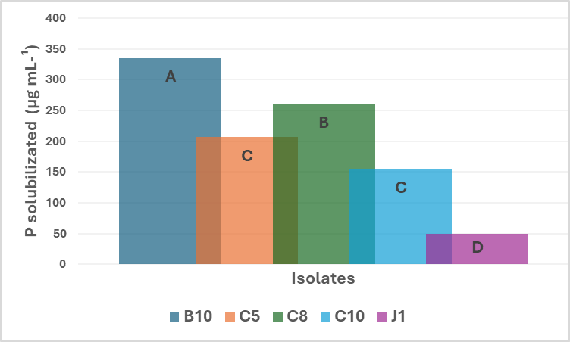
In NBRIP medium, isolate C8 showed the highest phosphate solubilization capacity (482.61 μg/mL), followed by C10 (326.64 μg/mL) and C5 (254.97 μg/mL). Isolate B10 demonstrated intermediate solubilization (211.33 μg/mL), while J1 exhibited the lowest value (71.59 μg/mL). These results are consistent with previous studies that identified variability in phosphate solubilization efficiency among different actinobacterial strains, attributed to differences in organic acid production and gene expression related to phosphorus solubilization (Soumare et al., 2021).
In NBRIP + BTGRAN medium, the addition of ultrafine BTGRAN remineralizer resulted in a reduction in phosphorus solubilization for most isolates (Figure 2, Table 1). However, C5 still recorded the highest solubilization (166.25 μg/mL). Isolate B10 showed a significant decrease to 63.86 μg/mL, suggesting that BTGRAN may inhibit phosphorus solubilization in some isolates. J1 had the lowest value (31.98 μg/mL), confirming that the addition of PDR is not beneficial for this isolate.
Figure 2. Efficiency of P solubilization in liquid NBRIP and Verma media after inoculation by actinobacteria isolates, under cultivation for 15 days. Means followed by the same letter do not differ each other (Scott-Knott p<0.05).
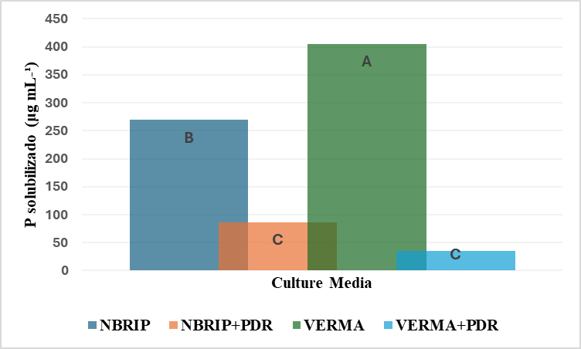
Table 1. Breakdown of soluble P content in NBRIP and Verma liquid culture media by actinobacteria isolates by inoculation time. Means followed by the same letter do not differ each other (Scott-Knott p<0.05).
Culture Media | Isolates | Solubilization (μg mL-¹)
NBRIP | B10 | 211,33c
NBRIP | C5 | 254,97c
NBRIP | C8 | 482,61a
NBRIP | C10 | 326,64b
NBRIP | J1 | 71,59b
NBRIP+PDR | B10 | 63,86b
NBRIP+PDR | C5 | 166,25a
NBRIP+PDR | C8 | 89,06b
NBRIP+PDR | C10 | 91,77b
NBRIP+PDR | J1 | 31,98c
VERMA | B10 | 933,90a
VERMA | C5 | 392,32b
VERMA | C8 | 466,02b
VERMA | C10 | 187,52b
VERMA | J1 | 44,70c
VERMA+PDR | B10 | 94,00a
VERMA+PDR | C5 | 12,97c
VERMA+PDR | C8 | 3,67d
VERMA+PDR | C10 | 14,45c
VERMA+PDR | J1 | 48,91b

These findings align with research indicating that the addition of certain remineralizers can negatively affect the activity of phosphate-solubilizing microorganisms. Zhang et al. (2025) observed that the presence of remineralizers might interfere with the availability of essential nutrients or the expression of genes related to organic acid production, thereby impacting phosphorus solubilization efficiency.
In Verma medium, results indicate superior phosphate solubilization compared to other media. B10 stood out with the highest value recorded across all media and isolates (933.90 μg/mL). C8 and C5 also showed high levels of solubilization (466.02 μg/mL and 392.32 μg/mL, respectively). Isolate J1 had relatively low solubilization (44.70 μg/mL), indicating performance variability depending on the medium used.
These results suggest that Verma medium may provide more favorable conditions for the expression of genes related to phosphate solubilization in actinobacteria. Soumare et al. (2021) highlight that the composition of the culture medium, including the carbon source and the presence of micronutrients, can significantly influence the activity of phosphate-solubilizing microorganisms.
In Verma + BTGRAN medium, the addition of BTGRAN remineralizer resulted in a significant reduction in phosphate solubilization for all isolates. Still, B10 maintained the highest value (94.00 μg/mL) among them. However, C5 and C8 dropped drastically to 12.97 μg/mL and 3.67 μg/mL, respectively, while J1 reached 48.91 μg/mL. These data suggest that BTGRAN negatively impacts phosphate solubilization in Verma medium.
These findings reinforce the need to carefully evaluate the interaction between phosphate-solubilizing microorganisms and mineral additives in the development of biofertilizers. Zhang et al. (2025) emphasize that the efficacy of microbial consortia may be compromised by the presence of certain additives that interfere with microbial activity, highlighting the importance of preliminary testing to ensure compatibility between biofertilizer components.
Based on the pH measurement data (Figure 3) from the culture media, a statistically significant difference (p<0.05) was observed among the treatments. Overall, it was noted that the addition of rock powders (RPs) acted as a buffer, reducing the acidification of the culture media after 15 days of incubation. Thus, the best results were associated with isolates C10 and C8.
Figure 3. pH measurement of culture media with and without rock powder (RP) 15 days after incubation. Means followed by the same letter do not differ each other (Scott-Knott p<0.05).
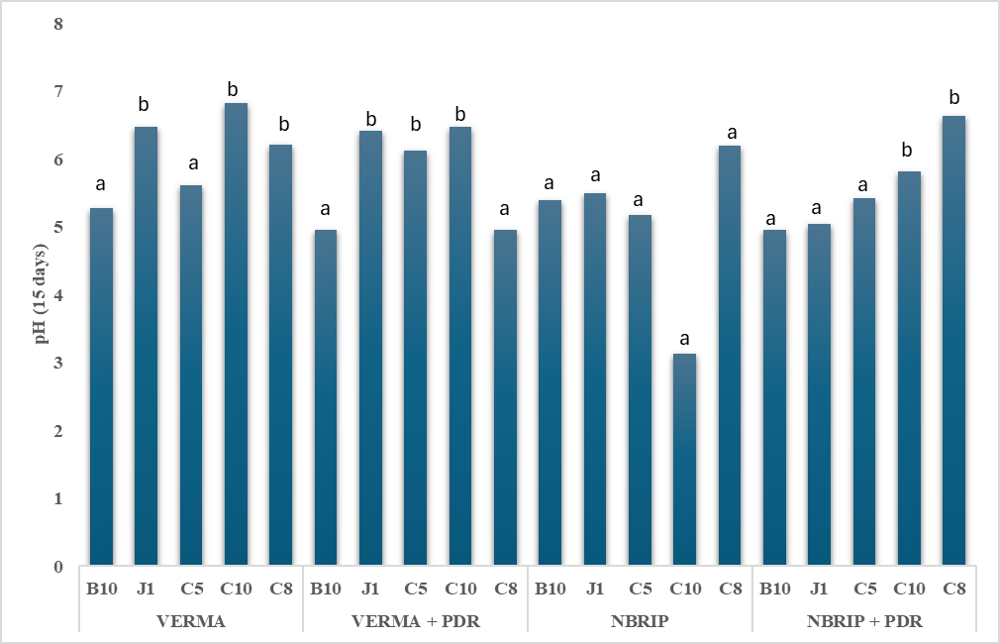

The determination of pH in culture media during phosphate solubilization tests by bacteria is a critical parameter for understanding the activity of phosphate-solubilizing microorganisms. In media such as NBRIP and VERMA, pH reduction is often correlated with the release of organic acids by bacteria, such as gluconate, citrate, and oxalate, which promote the solubilization of insoluble phosphates, especially tricalcium phosphate and apatites. According to Meena et al. (2020), acidification of the medium is the main biochemical mechanism involved in phosphate solubilization, with bacteria of the genera Pseudomonas and Bacillus exhibiting a significant ability to modulate pH as a functional strategy.
The relevance of pH in these assays is reinforced by the fact that the efficacy of phosphate biofertilizers depends on the microorganisms' ability to act under various soil conditions, especially in alkaline soils or those with low phosphorus bioavailability. Recent studies show that bacteria efficient in reducing pH in media such as NBRIP retain this capability under field conditions, enhancing the release of phosphorus from natural sources like rock phosphates. Furthermore, pH adjustments in the culture medium may affect the selectivity and differential growth of colonies, directly influencing the results of solubilization activity quantification.
In Verma medium, which contains mineral salts and glucose as a carbon source, measuring the initial and final pH allows for the evaluation of the intensity and type of organic acids released, providing an indirect indication of the bacterial isolate's metabolic potential. According to Oliveira et al. (2024), monitoring pH decline in Verma medium can be more sensitive in differentiating isolates with high acidification capacity, making it particularly useful in the selection of bioinoculants. Thus, pH analysis not only reflects the physiological mechanisms underlying phosphate solubilization but also serves as a selection criterion in the development of inoculants for sustainable agricultural systems. Thus, VERMA médium was the highest efficience in phosphate solubilization in association with rock dust in vitro.

Conclusions
The results indicate that different actinobacterial isolates exhibit variations in phosphorus solubilization capacity depending on the culture medium used. The VERMA medium proved to be the most effective for phosphorus solubilization, whereas the addition of the BTGRAN remineralizer to both NBRIP and VERMA media resulted in a reduction of solubilization. This suggests that the choice of culture medium and the presence of additives can significantly influence the effectiveness of actinobacteria in phosphorus solubilization.

Disclaimer (Artificial intelligence)
Author(s) hereby declare that NO generative AI technologies such as Large Language Models (ChatGPT, COPILOT, etc.) and text-to-image generators have been used during the writing or editing of this manuscript.

References
Alves, L., Oliveira, V. L., & Filho, G. N. S. (2010). Utilization of rocks and ectomycorrhizal fungi to promote growth of eucalypt. Brazilian Journal of Microbiology, 41, 676–684. https://doi.org/10.1590/S1517-83822010000300009
Bai, K., Wang, W., Zhang, J. et al. (2024). Effects of phosphorus-solubilizing bacteria and biochar application on phosphorus availability and tomato growth under phosphorus stress. BMC Biol 22, 21. https://doi.org/10.1186/s12915-024-02011-y
Carmo, T. S., Moreira, F. S., Cabral, B. V., Dantas, R. C. C., Resende, M. M., Cardoso, V. L., & Ribeiro, E. J. (2019). Phosphorus recovery from phosphate rocks using phosphate-solubilizing bacteria. Geomicrobiology Journal, 36(3), 195–203. https://doi.org/10.1080/01490451.2018.1538100
Hayat, R., Ali, A., Amara, U., Khalid, R., & Ahmed, I. (2010). Soil beneficial bacteria and their role in plant growth promotion: A review. Annals of Microbiology, 60, 579–598. https://doi.org/10.1007/s13213-010-0117-1
Johari, N. D., Yusof, N. L. N., Khit, K. Y., Kamarudin, M., Nosbi, N., & Ali, W. F. F. W. (2025). Effect of calcination temperature and holding time on MCAS formation through the solid-state method: Structural and phase analysis. Ceramics International.
Khan, M. S., Zaidi, A., & Wani, P. A. (2007). Role of phosphate solubilizing microorganisms in sustainable agriculture: A review. Agronomy for Sustainable Development, 27, 29–43. https://doi.org/10.1051/agro:2007024
Lizcano-Toledo, R., Reyes-Martín, M. P., Celi, L., & Fernández-Ondoño, E. (2021). Phosphorus Dynamics in the Soil–Plant–Environment Relationship in Cropping Systems: A Review. Applied Sciences, 11(23), 11133. https://doi.org/10.3390/app112311133
Meena, V. S., Maurya, B. R., Verma, J. P., Meena, R. S., & Mitchell, J. (2020). Phosphate solubilizing microorganisms: Mechanisms and applications in sustainable agriculture. Bioresource Technology, 313, 123345. https://doi.org/10.1016/j.biortech.2020.123345
Minaxi, Saxena, J, Chandra, S, & Nain, L. (2013). Synergistic effect of phosphate solubilizing rhizobacteria and arbuscular mycorrhiza on growth and yield of wheat plants. Journal of soil science and plant nutrition, 13(2), 511-525. https://dx.doi.org/10.4067/S0718-95162013005000040
Oliveira, T. F. D., Kuniyoshi, T. M., Frota, E. G., Bermúdez-Puga, S., Sakaue, L. N., Cassiano, L. L., ... & Oliveira, R. P. D. S. (2024). Anti-listerial activity of bacteriocin-like inhibitory substance produced by Enterococcus lactis LBM BT2 using alternative medium with sugarcane molasses. Antibiotics, 13(3), 210.
Pang, F., Li, Q., Solanki, M.K., Wang, Z., Xing, Y-X., and Dong, D-F. (2024). Soil phosphorus transformation and plant uptake driven by phosphate-solubilizing microorganisms. Frontiers in Microbiology. 15:1383813. https://10.3389/fmicb.2024.1383813
Saeed, R. G., Mohammad E. W., Andrzej, K. (2019). Environmental sustainability of phosphorus recycling from wastewater, manure and solid wastes, Science of The Total Environment, 672, 2019. https://doi.org/10.1016/j.scitotenv.2019.03.439
Silva, J. M., Dalbon, V. A., Acevedo, J. P. M., Massahud, R. T. R. L., Alves, E. S. A., da Silva, P. C. V., dos Santos, T. M. C., & Lima, G. S. A. (2022). Development of tomatoes seedlings (Lycopersicum sculentum L.) in combination with silicate rock powder and rhizospheric fungi inoculation. Current Science, 122(7), 819–825. https://doi.org/10.18520/cs/v122/i7/819-825
Soumare, A., Boubekri, K., Lyamlouli, K., Hafidi, M., & Ouhdouch, Y. (2021). Efficacy of phosphate solubilizing Actinobacteria to improve rock phosphate agronomic effectiveness and plant growth promotion. Rhizosphere, 17, 100284.
Verma, S.C., Ladha, J.K., & Tripathi, A.K. (2001). Evalution of plant growth promoting and colonization ability of endophytic diazotrophs from deep water rice. Journal of Biotechnology, 91, 127-141. https://doi.org/10.1016/S0168-1656(01)00333-9
Zhang, T., Wang, X.-L., Zhou, J., Zhou, W., & Zhou, S.-Q. (2025). Construction of Phosphate-Solubilizing Microbial Consortium and Its Effect on the Remediation of Saline-Alkali Soil. Microbial Ecology, 88, 11.

