Short Research Article

Ethnoveterinary medicines practised in management of wound by farmers of Gossaigaon, Kokrajhar, BTR, Assam,India

ABSTRACT
Aim: The objective of this study were to collect the ethnoveterinary practices used for cure of various types of wounds using indigenous plants having medicinal properties by livestock owners and healers. As these practices are in vogue amongst the villagers and has been passed down from one generation to the next, it has now become pertinent for documentation for its sustainability.
Place and duration: The study was carried out in the Gossaigaon sub-division of Kokrajhar district, Assam for a period six months i.e. November, 2024 to April, 2025.
Methodology: The study was conducted in different villages of the sub-division namely Joymaguri, Joyma no.2, Hudumkhata no. 2, Saljuri no.3 and Jambuguri F.V. of Gossaigaon sub-division during regular extensive and intensive field visits.
Results: A total of eleven plants and two other remedies using oils along with its application method and healing time were studied for different types of wounds of animals. The plants used are Curcuma longa(turmeric), Azadirachta indica (neem), Brassica campestris (mustard), Allium sativum (garlic), Zingiber officinale (ginger), Piper nigrum (black pepper), Nicotiana tabacum (tobacco), Mikania micrantha (bitter vine), Centella asiatica (Asian pennywort), Senna obtusifolia (sicklepod), Datura sp. Amongst all, the most widely used plant for wound healing was turmeric. The preparations were in powdered form, paste or concoctions, however, leaves were extensively used for the preparations. Six preparations are from leaves, others are either the fruit or seeds. Two other preparations were also involved, one using coconut oil and the other using a commercially available oil named Pain nil oil. The healing time ranges from three to seven days for most of the remedies.
Keywords: Animals, ethnoveterinary practices, plants, wounds
1.INTRODUCTION
Traditional system of medicine also referred to as ethnoveterinary medicine (EVM) is commonly defined as a system of folk beliefs, skills, techniques and practice relating to the healthcare of animals that is passed verbally from generation to generation (Swarup and Patra, 2005). It is a field for protecting animal health and treating illnesses that is associated with traditional beliefs and indigenous knowledge and practices (Khan et al.,2019). These practices concerning to animal healthcare is as old as the domestication of various livestock species which comprise belief, knowledge, practices and skills pertaining to healthcare and management of livestock (Balaji and Chakravarthi, 2010). The ethnoveterinary systems are ecosystem and ethnic community specific and therefore, the characteristics, sophistication, and intensity of these systems differ greatly among individuals, societies and regions; however, they are facing the threat of rapid erosion (Balaji and Chakravarthi, 2010). Since, India is the land of Ayurveda wherein this knowledge originated more than 5,000 years ago, is often called the “Mother of All Healing”. Ayurveda has been playing the role in veterinary medicine too within traditional therapeutic way since a considerable time in India and other countries around the world (Boonmasawai, 2012). Veterinary and animal husbandry practices are mentioned in the Rigveda and Atharvaveda (Nair, 2006). Ancient Egyptians also used various methods including the application of herbs for the treatment of animal diseases, and it is believed that during that period physicians had knowledge of more than 250 medicinal plants and 120 mineral salts (Swarup and Patra, 2005). The Indian subcontinent has rich ethnoveterinary health traditions that are the products of decades of experiences (Nair, 2006). Several ancient and modern literatures have depicted usefulness of herbs in treating animals (Garnayak et al.,2023). According to the World Health Organization, at least 80% of people in developing countries depend largely on indigenous practices for the control and treatment of various diseases affecting both human beings and their animals (Balaji and Chakravarthi, 2010). Nearly 70% of the world’s rural poor depend on livestock as a critical component of their livelihood (Nair, 2006). It is even cited that primitive human medicine was learnt through observing behaviour of sick animals and both human and animal complaints were addressed by the same physician (Swarup and Patra, 2005).
The traditional knowledge on ethnoveterinary practices is still prevalent in local tribal and religious minority communities of the country to a large extent. Livestock raisers and healers everywhere have traditional ways of classifying, diagnosing and preventing and treating common animal diseases (Balaji and Chakravarthi, 2010). Plants are the most commonly used ingredients in the preparation of ethnoveterinary medicines. These practices have immense contemporary relevance (Nair,2006). There exists a rich and efficient ethnoveterinary tradition in the villages of India which form integral part of the family and plays an important social religious and economic role comprising of belief, knowledge, practices and skills pertaining to health care and management of livestock (Patil and Deshmukh, 2015). There are many advantages of these remedies. They are accessible, easy to prepare and administer, at little or no cost at all to the farmer (Balaji and Chakravarthi, 2010). High treatment costs, inaccessibility and indiscriminate use of antibiotics and hormones, which leads to user-unfriendly effects such as high antibiotic and hormone residues in milk and other animal products, are serious limitations of modern veterinary management whereas ethnoveterinary systems are ecosystem and ethnic community specific, and therefore, the characteristics, sophistication, and intensity of these systems differ greatly among individuals, societies and regions (Nair,2006). The knowledge of these practices is being passed from generation to generation without any written scribe (Garnayak et al.,2023). However, the knowledge and art of using it is vanishing rapidly among the population. It is worthwhile to mention that in rural and under privileged parts of India like these regions still these practices are going on to some extent.
The objectives of this study were to collect information on prevailing ethnoveterinary practices for cure of various types of wounds of animals and its associated flora from the livestock owners and local healers of Gossaigaon sub-division, Kokrajhar, Assam.
2. MATERIALS AND METHODS
2.1 Study area
The present study was planned to gather prevailing knowledge of ethnoveterinary practices and use of medicinal plants for treatment of wounds in the Gossaigaon sub-division (26°25′11″N 89°59′03″E). Vegetation is deciduous and evergreen, also grasslands at patches (Wikipedia retrieved on 25/05/2025).The study was carried out in different villages of the sub-division namely Joymaguri (26.460494°N, 90.028589°E), Joyma no.2 (26.485862°N, 90.023858°E), Hudumkhata no. 2 (26.47941°N, 90.015275°E), Saljuri no.3 (26.497624° N, 89.994604°E) and Jambuguri F.V. (26.544968°N, 89.960615°E) of Gossaigaon sub-division during regular extensive and intensive field visits. Most of the residents are members of Scheduled Tribe (Plains) i.e. the Bodo community followed by religious minority communities, then the Santhali people.
2.2 Data collection
The data were collected verbally followed by informal conversations with the farmers, livestock owners, elderly people and local quacks or traditional healers who uses herbal medicines. The procedure included name of the plants being used, its utilized parts, methods of preparation and administration and the approximate healing time. The experienced rural folk, traditional herbal medicine practitioners who were having knowledge of traditional healing were interviewed about the use of plants for wound healing. The plant specimens were identified by using established flora of Kokrajhar District. Field trips ranging from three days to a week were made in the study area in every month of the study (November 2024 to April 2025) in the aforementioned villages of the sub-division. A total of fifty responses (25 males and 25 females) were recorded during the study. All participants provided informed consent prior to study participation. Ten people each from a village were selected for the purpose. A pilot study was undertaken in consultation with the experienced people of the villages wherein it was decided who will be most suitable to provide information for the purpose. Experienced people here refers to some elders and local healers who has been providing these indigenous knowledge regarding medicinal plants. The participants were in 1:1 ratio i.e. 50% male and 50 % female. The insights of the local people during field trips were recorded across different socio-demographic categories such as gender, age groups and healing experiences.
3. RESULTS AND DISCUSSION
Different parts of the plants, viz., leaves, bark, fruits, flowers, roots, and seeds, are used in medicinal preparations (Guleria and Radha, 2024). Decoction, paste, powder and mixture of plants are the common methods employed for the preparation of medicinal plants (Patil and Deshmukh, 2015).
Table 1. Common plants used for ethnoveterinary practices in this region
Sl no. | Scientific name of the plant | Common name | Part used | Method of application | Approximate healing time
1. | Curcuma longa | Turmeric | Rhizome | - The dry rhizome powder is applied directly over wounds.  - Heated and grinded turmeric rhizome is used in wounds caused by broken joints.  - A concoction of turmeric powder and mustard oil is also applied for deeper wounds.  - A concoction of Datura, Asian pennywort and Sicklepod levaes mixed with grinded turmeric is used for wounds caused by fractured bones. | 3 to 6 days applied twice a day.
2. | Azadirachta indica | Neem | Leaves | Dried leaves powder is applied directly over wounds. | 7 days applied once a day
3. | Brassica campestris | Mustard | Seeds and oil | A concoction of turmeric powder and mustard oil is applied for deeper wounds. | 5 to 6 days applied once to twice a day
4. | Allium sativum | Garlic | Clove (bulb) | A concoction of turmeric powder, mustard oil alongwith one grinded clove of garlic is applied over maggoted wounds. | 7 days applied once a day
5. | Zingiber officinale | Ginger | Rhizome | Ginger powder is mixed with grinded Datura leaves and peppercorn and used directly over open wounds. | 7 days applied once a day
6. | Piper nigrum | Black pepper | Peppercorn  (dried fruit) | Peppercorn is grinded and applied as first aid in dog bite cases. | 7 days applied once a day
7. | Nicotiana tabacum | Tobacco | Dried leaves | - A concoction of dried tobacco leaves, fresh bitter vine leaves are grinded and mixed with soot and applied in maggoted wounds.  - A concoction of dried tobacco leaves and kerosene oil is applied in maggoted wounds.  - A concoction of dried tobacco leaves, lime and kerosene oil is applied in maggoted wounds. | 5 to 7 days applied once a day
8. | Mikania micrantha | Bitter vine | Leaves | Fresh leaves are grinded and applied directly over the wounds. | 7 days applied twice a day
9. | Centella asiatica | Indian pennywort | Leaves | Fresh leaves alongwith Datura leaves and sicklepod leaves are grinded and the paste is applied in wounds at the hind side of body wounds.* | 4 to 5 days applied once in 2 days
10. | Senna obtusifolia | Sicklepod | Leaves | Fresh leaves alongwith Datura leaves and Indian pennywort leaves are grinded and the paste applied in wounds at the hind side of body wounds.* | 4 to 5 days applied once in 2 days
11. | Datura sp. | Datura | Leaves | A paste of Datura leaves, black pepper powder and ginger powder is used to cure maggoted wounds. | 5 to 7 days applied once a day
12. | Others  - Camphor and coconut oil  - Pain nil oil (active ingredients are Datura metel, Zingiber officinale, Ricinus communis, Withania somnifera, Nardostachys jatamansi,Piper longum Wordfordia fructicosa, Vitex nigundo and Allium sativum)  N.B.* the wound should be first cleaned with lukewarm water and the paste is bandaged over the wound for 3 days and again the process is repeated after 3 days. |  |  | A concoction of grinded camphor and coconut oil is applied in maggoted wounds.  This oil is used over wounds caused by broken joints or fractured bones. | 7 days applied twice a day  7 days applied once a day

Table 2: Medicinal properties of the plants (related to wound healing) (Wikipedia, 2025)
Sl. No. | Plant name | Properties
1. | Curcuma longa | Antiseptic, antibacterial, anti-inflammatory, maggoticidal
2. | Azadirachta indica | Antibacterial, antifungal, antiparasitic, maggoticidal
3. | Brassica campestris | Anti-microbial, anti-inflammatory, fly repellant
4. | Allium sativum | Anti-inflammatory, antifungal
5. | Zingiber officinale | Analgesic, anti-inflammatory
6. | Piper nigrum | Anti-inflammatory
7. | Nicotiana tabacum | Antiparasitic, antifungal, antibacterial, maggoticidal, fly repellant
8. | Mikania micrantha | Anti-microbial, anti-inflammatory, blood clotting agent
9. | Centella asiatica | Anti-microbial, anti-inflammatory, soothing properties
10. | Senna obtusifolia | Anti-microbial, anti-inflammatory
11. | Datura sp. | Analgesic, anti-inflammatory

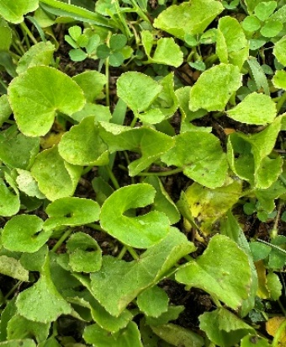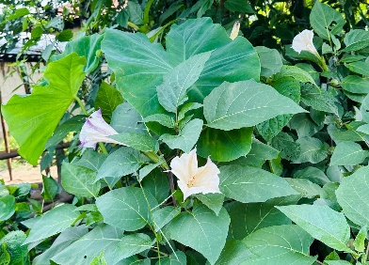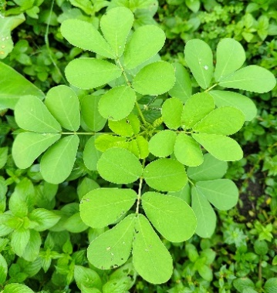
Fig 1. Asian pennywort Fig 2. Datura sp. Fig 3. Sicklepod

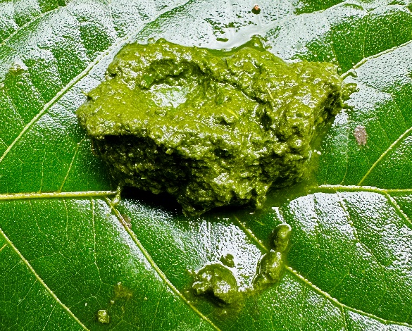
Fig 4. Paste of Datura, Asian pennywort and Sicklepod leaves
The most widely used plant for wound healing is turmeric. The preparations are in powdered form, paste or concoctions. Leaves are extensively used for the preparations. Six preparations are from leaves, others are either the fruit or the seeds. Tobacco leaves has more efficacy when maggots are concerned. The healing time ranges from three to seven days for most of the preparations. The rural folks have developed extensive knowledge in utilizing plants as medicines since times immemorial. It was observed that mostly the elderly people were experienced in this regard and constituted the majority of the information providers. These traditional healing practices are referred to as "Ethnoveterinary medicine," which is cost-effective and dynamic (Guleria and Radha, 2024). Similar types of studies have been carried out by various workers from other parts of the country viz. Swarup and Patra, 2005; Nair, 2006; Balaji and Chakravarthi, 2010; Saikia and Borthakur, 2010; Patil and Deshmukh, 2015; Gogoi and Bora, 2022; Doley et al., 2022; Garnayak et al., 2023, Borah et al., 2023; Guleria and Radha, 2024; Pathak et al., 2024 etc. It can be more or less analysed that most of the plants are common in many regions of the country viz. turmeric, neem, black pepper, garlic, Datura etc. Most of the plants used in our study are also commonly available in the other parts of the country. In this study it can be seen that neem, turmeric and tobacco leaves are used for curing many dermatological problems including wounds, this is in accordance with workers viz. Gogoi, 2021, Doley et al., 2022, Garnayak et al., 2023, Guleria and Radha, 2024 etc. Thus, it can be analysed that these therapeutic plants have been in practical use across different cultures. These are the most widely used plants for treating wounds in an ethnoveterinary manner. Even though these practices sometimes might not yield desired results but the fact that it got has no or any side effect and that too these remedies come with nominal or no cost at all, it can be suggested to the livestock owners as a form of first aid. Balaji and Chakravarthi, 2010, stated that ethnoveterinary medicine can make economic differences but its cost-effectiveness varies, and depends on different factors. As, such important practices for management of wound are in vogue by villagers, it has now become pertinent for documentation for sustainability of these practices. These information are invaluable and are of immense significance for future generations. This short research article will help in contributing to further detailed studies in this regard.

4. CONCLUSION
The present study included a preliminary survey regarding the use of herbal medicines in Gossaigaon sub-division of Kokrajhar district. Notably, this study marks the first documentation of ethnoveterinary medicinal plants in this locality. As observed in most of the livestock owners of the rural areas, they, by and large, prefer to use these herbal remedies as their first choice of treating their animals but exceptions can never be ignored. Owing to the easy availability and cost effectiveness of these remedies the importance of its use in rural areas is significant. These remedies cost negligible in comparison to modern veterinary medicines as prescribed by the veterinarians. It was observed that majority of the inhabitants of these villages solely depends on agriculture and animal husbandry, their poor economic backdrop prevents them to meet the cost of allopathic medicines many a times. So, they like to rely upon these practices as first aid measures. Thus, it can be concluded that these practices have been there since ages and are likely to continue, so, a further in-depth study of this knowledge by analysing the phytochemicals present in it, shall prove to be beneficial for the communities and the future generations to come.
Prior informed consent: All participants provided informed consent prior to study participation.
Disclaimer (Artificial Intelligence): Author(s) hereby declare that NO generative AI technologies such as Large Language Models (ChatGPT, COPILOT, etc) and text-to-image generators have been used during writing or editing of this manuscript.
References
Balaji, S. N. and Chakravarthi, P.V. (2010). Ethnoveterinary practices in India - A Review, Veterinary World, 3(12), 549-551.
Boonmasawai S. (2012). Ethnoveterinary medicine based on Ayurveda plant, Journal of Applied Animal Science, 5(3), 9-14.
Borah, N., Bey, B. S. and Deka, N.(2023) Indigenous technical knowledge (ITK) used in agriculture by selected ethnic communities of Assam, Indian Journal of Traditional Knowledge, 22 (2), 264-272.
Doley, M. K., Maibangsa, S., Baruah, N., Neog, M., Shyam, J., Hazarika, R., and Pathak, P.K. (2022). Ethnoveterinary practices amongst tribal pig farmers in Karbi Anglong district of Assam, India, Indian Journal of Traditional Knowledge, 21(3), 558-568.
Garnayak, N., Senapti, S.K., Patra, R.C. and Ranabijuli, S. (2023). A study on prevailing ethno-veterinary practices in north-eastern ghat regions of Ganjam and Kandhamal districts, Odisha, The Pharma Innovation Journal, 12(2), 2924-2930.
Gogoi, C. (2021). Ethnoveterinary treatment of livestock and poultry by ethnic community of Dhemaji district, Assam, India, Agricultural Science Digest, 42 (3), 371-376.
Guleria, M. and Radha. (2024). Ethnoveterinary Plants used by Rural People of Bandli Wildlife Sanctuary District Mandi of Himachal Pradesh, India, Biological Forum – An International Journal, 16(4), 70-79.
Khan K., Rahman, I.U., Soares, E.C., Ali, N., and Ijaz, F. (2019). Ethnoveterinary therapeutic practices and conservation status of the medicinal flora of Chamla Valley, Khyber Pakhtunkhwa, Pakistan. Frontiers in Veterinary Science. 6:122 doi: 10.3389/fvets.2019.00122
Nair, M.N.B. (2006). Documentation and assessment of ethnoveterinary practices from an Ayurvedic viewpoint. Proceedings of the National conference on Contemporary Relevance of Ethnoveterinary Medical Traditions of India (Ed.) FRLHT, Bangalore Traditional Knowledge Systems of India and Sri Lanka, 78-90.
Pathak, P.,Gogoi, G.,Konwar, B.,Saikia, A.S. and Neog, M., (2024). Insights into ethnoveterinary practices used by various communities in Dhemaji district of Assam. Indian Journal of Traditional Knowledge, 23(11), 1063-1072.
Patil, U. S. and Deshmukh, O. S. (2015). Traditional ethno-veterinary practices in Betul district (M.P.) India, International Journal of Current Research in Life Sciences, 4(10), 423-428.
Saikia, B and Borthakur, S. K. (2010). Use of medicinal plants in animal healthcare-A case study from Gohpur, Assam, Indian Journal of Traditional Knowledge, 9 (1), 49-51.
Swarup, D. and Patra, R.C. (2005). An overview of prospects of ethno-veterinary medicine in India, Indian Journal of Animal Sciences, 75 (12), 1481-1491.
Wikipedia retrieved on 25/05/2025

