**Biotechnological Potential of Biodigester-Derived Bacteria**

ABSTRACT

**Aim**: To isolate and characterize bacterial strains derived from a bovine biodigester sludge with potential for biotechnological application.

**Study design:** We used six bacterial isolates from genera *Brucella*, *Microbacterium*, and *Brevibacillus* previously isolated from swine and bovine sludge samples collected from an up-flow anaerobic sludge blanket reactor fed with bovine manure in western Paraná, Brazil.

**Place and duration of study**: The research was conducted at the Laboratory of Biochemistry and Genetics, UFPR/Sector Palotina, between June 2023 and July 2024**.**

**Methodology:** The microbiological composition of the sludge was established by 16sRNA genetic characterization, phosphate and potassium solubilization capacity, catalase and oxidase, fungal antagonism, and enzymatic (protease, caseinolytic, lipolytic, amylolytic, and cellulolytic) capacities.

**Results:** *Microbacterium mangrovi* and *M. arabinogalactanolyticum* showed the highest values for the defined enzyme index. Three isolates showed potassium solubilization but none showed phosphate-solubilizing capacity. Partial antifungal activity was detected exclusively against *M. arabinogalactanolyticum*. Biofilm formation was strain-, carbon source-, and incubation time-dependent. Further, several isolates consistently showed low biofilm production, which is advantageous for industrial application.

**Conclusions:** Our findings highlight the untapped microbial potential of biodigester sludge and strongly support the idea of testing it as a source of promising bacteria for biotechnological applications and sustainable agriculture.

*Keywords: biodigesters, biofilm, enzymatic capacity, solubilization*

1. INTRODUCTION

Microbial populations represent a vast natural resource in all habitats. In particular, swine and bovine biodigester sludges can harbor a wide range of bacterial genera that are capable of anaerobic fermentation, resulting in methane production and the generation of organic fertilizers for use in agricultural lands (Manyi-Loh *et al.*, 2013; Vendruscolo *et al.*, 2020). Nonetheless, to date, only a small fraction of such rich biodiversity has been explored (Sawarkar Scholar *et al.*, 2019).

Specifically, bioprospecting is defined as the search for new products derived from natural resources including plants, animals, and microorganisms; it basically involves exploring biodiversity to identify potential sources of valuable substances or genetic information for use in various industries (Almeida *et al.*, 2015). In so doing, it is the first step in the process of valuing biodiversity (Sawarkar Scholar *et al.*, 2019) for the purpose of enabling the development of biotechnological innovations in fields such as biofuels, medicine, pharmaceuticals, and agriculture (Maester *et al.*, 2017; Sekurova *et al.*, 2019; Maciel *et al.*, 2020).

Bacterial genera comprise numerous valuable species with biotechnological potential (Cortez *et al.*, 2022) as they can produce a wide range of versatile biomolecules for industrial, pharmaceutical, and agronomic applications, which in turn is largely due to their enzymatic stability, catalytic efficiency, ease of production, and optimization for plant and animal enzyme applications (Singh *et al.*, 2019; Rani *et al.*, 2021). Indeed, many bacterial genera are known to produce enzymes such as amylases, proteases, pectinases, lipases, cellulases, and xylanases, which are widely used in industry for the production of detergents, textiles, chemicals, foods and beverages, biofuels, animal feeds, and products used for personal care (Nigam, 2013; Adrio & Demain, 2014). Owing to their biochemical diversity, these enzymes offer important advantages, such as high performance and ease of modification and optimization. Additionally, bacteria are amenable to genetic manipulation and selected strains can produce purified and well-characterized enzymes, antibiotics, and other bioactive compounds on a large scale (Mahdizade Ari *et al.*, 2024; Yang *et al.*, 2024).

Biofilms are structured communities of bacterial cells embedded in a self-produced extracellular polymeric matrix primarily composed of exopolysaccharides (EPS), DNA, and proteins. Further, biofilm formation occurs in moist environments where nutrients and surfaces are available for attachment, offering protection and nourishment to the bacterial cells (Singh *et al.*, 2006; Flemming & Wingender, 2010;Fessia *et al.*, 2022; Kim *et al.*, 2023) Although biofilms can be problematic in the medical, dental, and food industries (Muhammad *et al.*, 2020; Thi *et al.*, 2020), recent research suggests that they may have industrial application in the development of new materials, chemical and biological products (Flemming & Wingender, 2010; Shineh *et al.*, 2023), agriculture (Li *et al.*, 2024)], wastewater treatment and bioremediation (Chattopadhyay *et al.*, 2022), and in preventing corrosion (Muhammad *et al.*, 2020).

Therefore, in this study, we aimed to identify and characterize bacterial isolates with potential biotechnological applications, specifically in terms of their ability to degrade starch, casein, proteins, cellulose, and lipids. The experimental isolates were obtained from a bovine biodigester sludge collected from an up-flow anaerobic sludge blanket reactor fed with bovine manure in the western region of Paraná, Brazil. Additionally, we evaluated their ability to solubilize phosphorus and potassium and form biofilms, and determined whether they showed any antifungal activity.

2. material and methods

### **2.1 Molecular characterizations of the experimental isolates**

Bacterial genomic DNA was extracted following the DNA extraction protocol of the Quick DNA Fecal/Soil Microbe Microprep kit. Subsequently, PCR was performed for amplification of the 16S rDNA gene using a BIOER thermocycler (Life Express). The PCR reactions were performed using 3 μL of 10x Taq buffer, 2.25 μL of 25 mM MgCl2, 1 μL of 10 mM of each deoxyribonucleotide, 1 μL of each primer oligonucleotide (primer 27F and 1492R at a concentration of 4 mM) (Senthilraj *et al.*, 2016) 2 μL of Taq DNA polymerase, 2 μL of DNA (50 to 100 ng), and sterile milli-Q water to bring the final reaction volume to 30 μL. The samples were amplified according to the following program: 93ºC for 2 min; 35 cycles of 93ºC for 45 s, 62ºC for 30 s, 72ºC for 2 min, followed by a final extension for 5 min at 72ºC. To confirm the amplification, 5 μL of the reaction volume was subjected to electrophoresis in a 0.8% agarose gel in TBE buffer, together with 3.5 μL of the 100 bp molecular weight marker to check for the presence of 1.5 Kb bands.

The sequences were analyzed by the Mega program (Tamura *et al.*, 2007), which was used to taxonomically classify the sequences according to the bacterial taxonomy proposed by Bergey's Trust or as classified by NCBI - available on the website (Ribosomal Database Project - http://rdp.cme.msu.edu).

## **2.2 Biochemical characterization of the isolates**

## **2.2.1 Detection of enzymatic activity on solid media**

Protease, caseinolytic, lipolytic, amylolytic, and cellulolytic activities of the experimental bacterial isolates were evaluated using the agar diffusion method on a modified Basal Medium (MM) composed of 2.5 g yeast extract, 1 g glucose, and 14 g agar, as described by Mazzucotelli *et al.*, (2013). Bacteria were inoculated into the center of the Petri dish quadrants and incubated at 30°C for 48 h. Three plates were used per isolate, each with 12 replicates.

Protease activity was assessed in MM supplemented with 6.2 g.L-1 of skim milk protein; a clear halo around the colony indicated positive protease activity. In turn, caseinolytic activity was evaluated in MM cells treated with 1% casein; in this case, the white halo around the colony indicated casein degradation. Meanwhile, amylolytic activity was tested in MM supplemented with 1% soluble starch. Finally, cellulolytic activity was assessed in MM containing 7.5% cellulose biomass (2.5 g of shredded paper in 75 mL of water). Plates were flooded with an iodine solution (1% iodine and 2% KI), and a clear halo around the bacterial colonies indicated the degradation of starch and cellulose.

Lipolytic activity was determined using Tween Agar Medium (10 g peptone, 0.1 g CaCl₂·2H₂O, 5 g NaCl, 10 mL Tween 80, and 15 g agar, pH 7–7.4) as described by Harrigan & McCane (1998). After 15 days of incubation at 30°C, a white precipitate around the bacterial colony was considered as indicative of lipase activity. This precipitate was formed by calcium salts of the released fatty acids.

All enzyme activities were quantified using the Enzyme Index, (EI), calculated as the ratio of the diameter (mm) of the halo (zone of hydrolysis) to that of the bacterial colony, IE = DMH/DMC, where DMH = total diameter (mm) of the hydrolysis zone (hydrolysis halo), and DMC = diameter (mm) of the bacterial colony. Diameters were measured using a graduated ruler (Carrim *et al.*, 2006; Oliveira *et al.*, 2006).

**2.2.2 Potassium and phosphate solubilization capacity**

Potassium solubilization was evaluated after Sun *et al.*, (2020) using the solid Aleksandrov medium, which contains 5 g.L-1 glucose, 0.005 g.L-1 MgSO₄·7H₂O, 0.1 g.L-1 FeCl₃, 2 g.L-1 CaCO₃, 3 g.L-1 K₂SiO₃, 2 g.L-1 Ca₃(PO₄)₂, and 20 g.L-1 agar. The plates were incubated at 30°C for three days. After incubation, the formation of a clear halo around the colonies indicated potassium solubilization. Each isolate was tested in three separate plates. Each plate was divided into four quadrants, with one quadrant inoculated per replicate, for 12 replicates per isolate.

Phosphate solubilization was assessed using the NBRIP medium (Nautiyal *et al.*, 2000) plated in quadrants. The plates were incubated at 30°C for six days before the diameters of the solubilization halos and colonies were measured. Solubilization indices (IS) were obtained using the formula IS = halof (mm) / colonyf (mm), where f is the diameter (Nautiyal *et al.*, 2000).

**2.2.3 Catalase and Oxidase Activity**

Catalase activity was confirmed by bubble formation after applying a drop of 3% hydrogen peroxide (H₂O₂) onto the bacterial colony. Oxidase activity was tested by placing a colony on filter paper, followed by the addition of 1% TEMED (tetramethylethylenediamine) solution (Kovacks,1956). A purple color indicated a positive reaction. Both tests followed the procedures of Yano et al. (1991).

**2.2.4 Antagonistic or anti-fungal capacity**

The antagonistic potential of the bacterial isolates was evaluated after Freitas *et al.*, (2016), using the dual culture method by direct contact between each bacterial isolate and two phytopathogenic fungi, *Fusarium* spp. and *Curvularia lunata*. Fungi were first cultivated on Sabouraud Agar in Petri dishes and incubated at 28°C for 7 to 14 days to ensure sufficient fungal growth. After this period, the bacterial isolates were inoculated laterally at an appropriate distance from the fungal colony to allow for interaction during co-culture. The inoculated Petri dishes were incubated in triplicate at 30°C for 10 days. Fungal inhibition or antagonistic activity was assessed visually by observing the presence or absence of an inhibition zone between the bacterial and fungal colonies, or changes in fungal growth patterns near the site of bacterial inoculation.

### **2.2.5 Biofilm production and quantification**

To evaluate the influence of media composition (carbon source) and incubation time on biofilm formation by biodigester isolates, growth tests were conducted under static conditions following the methodology proposed by O’Toole, (2011) after modification. Initially, the isolates were pre-inoculated in LB broth supplemented with various carbon source treatments (none, i.e., control), fructose, glucose, or lactose, and incubated for 12–16 h under agitation. Subsequently, 1 mL of a 1:100 dilution of the inoculum was transferred to 2 mL microtubes for incubation at 30°C in a BOD chamber for 24, 48, or 72 h.

After each incubation period, the medium was discarded and the tubes were gently rinsed twice with distilled water to remove non-adherent cells. The tubes were tapped onto a sheet of absorbent paper and left to dry at room temperature for 15 min. Next, 1.25 mL of 0.1% crystal violet solution (0.1 g in 100 mL distilled water) was added to each tube, and the biofilm was stained for 10–15 min. After staining, the tubes were washed four times with distilled water to remove the excess dye and left to dry at room temperature. For biofilm quantification, 1.25 mL of 30% acetic acid was added to each tube to solubilize any crystal violet retained. After 10–15 min, the optical density (OD) was measured at 550 nm using a UV spectrophotometer. All assays were performed in triplicate.

**2.3 Statistical analysis**

All data obtained from the assays described above were subjected to analysis of variance (ANOVA). Means were compared and grouped using the Scott-Knott test at a 5% significance level. All statistical analyses were performed using the GENES software package (Cruz, 2013).

3. results and discussion

**3.1 Molecular characterization of the experimental isolates**

The genetic characteristics of the isolates obtained from the biodigester-derived sludge are summarized in Table 1. These isolates were classified as *Brucella* (Pseudomonadota), UFPR04, UFPR05, *Microbacterium* (Actinomycetota), UFPR13, UFPR20, UFPR28, and *Brevibacillus* (Bacillota), all three of which have previously been associated with bovine manure: *Brucella* (Morales-Estrada *et al.*, 2016), *Microbacterium* (Jaafarzadeh *et al.*, 2021), and *Brevibacillus* (Aiysha & Latif, 2019).

In particular, *Microbacteriaceae* play a significant role in soil ecosystems by acting as both decomposers and nutrient mobilizers (Corretto *et al.*, 2020). Further, they enhance plant nutrient uptake by solubilizing phosphates and mobilizing other essential nutrients that promote plant growth. Additionally, their ability to produce enzymes and biopolymers has led to their application in various industries, including food, pharmaceuticals, and agriculture. Thus, for example, *Microbacterium arabinogalactanolyticum* produces d-arabinofuranosidases that degrade the complex d-arabinan core structures of lipoarabinomannan and arabinogalactan (Shimokawa *et al.*, 2023). In turn, *Microbacterium esteraromaticum* exhibits salt tolerance (Bhambure *et al.*, 2018). Meanwhile, *Brevibacillus laterosporus* produces antimicrobial peptides for use as animal feed; it enhances crop growth by secreting hydrolases to improve nutrient uptake, synthesizes growth hormones, and produces proteins that inhibit the reproduction of harmful organisms, thus functioning as a probiotic (Liu *et al.*, 2024).

Although genus *Brucella* is typically associated with brucellosis, zoonotic diseases caused by *B. melitensis*, *B. suis*, and *B. abortus* that affect livestock and humans (Ferrero *et al.*, 2020), none of the isolates used in this study showed pathogenicity. Indeed, all isolates, including *Brucella*, tested negative in biosafety tests conducted on blood agar plates (5% v/v sheep blood).

**3.2 Biochemical characterization of isolates**

The results of the biochemical characterization conducted are shown in Figure 1. No isolates tested positive for oxidase activity. Meanwhile, catalase activity was detected in only two species, namely, *M. arabinogalactanolyticum* and *M. esteraromaticum*. Partial antifungal activity was observed only for *M. arabinogalactanolyticum* against *Curvularia lunata*.

Enzymatic assays revealed that five of the six isolates (83%) showed hydrolytic activity in at least one assay (Figure 1). The visual appearance of the halos around the bacterial colonies, indicative of enzymatic activity, is described in Figure 1. Four of the six isolates showed multi-enzymatic activity (positive in two or more assays), suggesting a greater ability to degrade and use various substrates for growth and adaptation (Mazzucotelli *et al.*, 2013).

Amylase activity was observed in isolates *M. mangrovi* and *B. laterosporus*, with *M. mangrovi* showing the highest values for the enzymatic index (EI) defined above. Cellulase activity was detected in four isolates, namely, *B. pseudogrignonensis*, *M. mangrovi*, *M. esteraromaticum*, and *B. laterosporus*, with *M. mangrovi* showing the highest value (3.13 cm) for EI. Generally, EI values are higher for isolates of genus *Bacillus*, which is known to degrade cellulose (Venkatachalam, 2014). Meanwhile, protease production was noted in four isolates, with EI values ranging from 2.72 to 4.23 cm. The highest protease activity was observed in *M. mangrovi* and *B. laterosporus* (EI: 4.15 - 4.23 cm). In contrast, none of the isolates showed caseinase activity, while lipase activity was detected only in *M. arabinogalactanolyticum*, with maximum production observed after 72 h. Similarly, Tripathi *et al.* (2014) reported maximum lipase activity after 48 h for *Microbacterium* spp.

Intermediate amylase and protease activities have been previously reported for *Microbacterium* spp. (Battisti *et al.*, 2024). Although *B. laterosporus* did not show any caseinase activity in our study, it has been previously reported to do so (Hussein *et al.*, 2020; Battisti *et al.*, 2024). Notably, isolates from the same genus did not always display the same enzymatic profiles (Figure 1). This variation might be owing to gene gain or loss via horizontal gene transfer, which allegedly contribute to bacterial genome plasticity (Lee *et al.*, 2022).

Potassium solubilization was detected in *M. mangrovi*, *M. esteraromaticum*, and *B. laterosporus*, with *M. mangrovi* exhibiting the highest solubilization index (7.31 cm). However, none of the isolates showed the ability to solubilize phosphate (Figure 1), nor did they exhibit any antifungal activity against *Fusarium spp.* or *Curvularia lunata*, except for *M. arabinogalactanolyticum*, as previously mentioned.

Biofilm production is another important feature of interest with regard to industrial application. Their ability to form biofilms hinders the use of certain bacterial strains in industrial reactors. Our results showed variation among the tested isolates in response to growth time, carbon source, and biofilm production (Figure 2 and 3). The greatest extent of biofilm formation was observed for *B. pseudogrignonensis* and *M. esteraromaticum* after 72 h of incubation under all tested conditions, but especially when fructose and sucrose were added as carbon sources.

Similar findings were reported by Haney *et al.*, (2018) who showed that fructose and sucrose promoted the highest levels of biofilm formation in *Pseudomonas aeruginosa* and *Staphylococcus aureus*. Similarly, Zhou *et al.*, (2023) noted that high concentrations of the carbon sources used, particularly glucose and maltose, stimulated biofilm formation in *Bacillus* spp. While in our experiments all carbon sources were tested at a concentration of 1%, optimal biofilm production apparently occurs under treatment with 2.5% glucose, maltose, lactose, or sucrose (Zou & Liu, 2020).

Further, M. arabinogalactanolyticum and *M. mangrovi* showed lower biofilm production than that observed when *M. esteraromaticum* was tested. Consistently, Kim *et al.*, (2023) identified different gene clusters responsible for biofilm formation in various *Microbacterium* strains, which may explain the observed differences in biofilm production among isolates.

**Table 1.** Probable taxonomic classification of biodigester bacterial isolates.

|  |  |  |  |  |  |  |
| --- | --- | --- | --- | --- | --- | --- |
| **Isolate** | **Classification** | **Size** | **E value** | | **% Identity** | **Genbank Access** |
| UFPRBD04 | *Brucella pseudogrignonensis* | 1387 | 1,00E-119 | 83.19% | | NR_042589.1 |
| UFPRBD05 | *Brucella grignonensis* | 1407 | 6,00E-103 | 87.82% | | NR_114149.1 |
| UFPRBD13 | *Microbacterium arabinogalactanolyticum* | 1462 | 0 | 92.24% | | NR_044932.1 |
| UFPRBD20 | *Microbacterium mangrovi* | 1463 | 0 | 93.67% | | NR_026468.1 |
| UFPRBD22 | *Brevibacillus laterosporus* | 1486 | 0 | 93.09% | | NR_112212.1 |
| UFPRBD28 | *Microbacterium esteraromaticum* | 1463 | 6,00E-76 | 83.18% | | [NR_026468.1](https://www.ncbi.nlm.nih.gov/nucleotide/NR_026468.1?report=genbank&log$=nucltop&blast_rank=1&RID=GV63GVX7016) |

Size: Sequence size. E Value: probability of randomly finding the same alignment between two sequences. Identity %: percentage of identity between the isolate's sequence and the related organism. GenBank Access: Sequence accession number of the related organism.

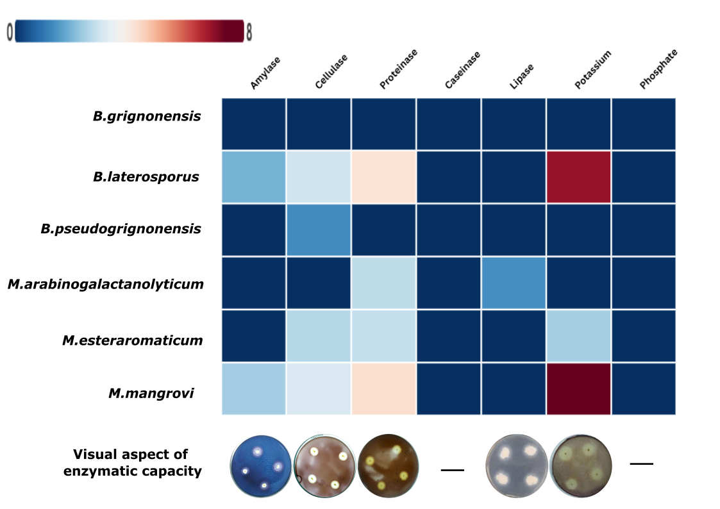

**Fig. 1.** Enzymatic activity, solubilization capacity of isolates and visual aspects of Petri dishes showing the positive solubilization halo. The enzymatic index represents the halo diameter of degradation/diameter of colony in cm. Heatmap scale: Blue color represents a lower EI index while brown color a higher EI index (approximately 8 cm).

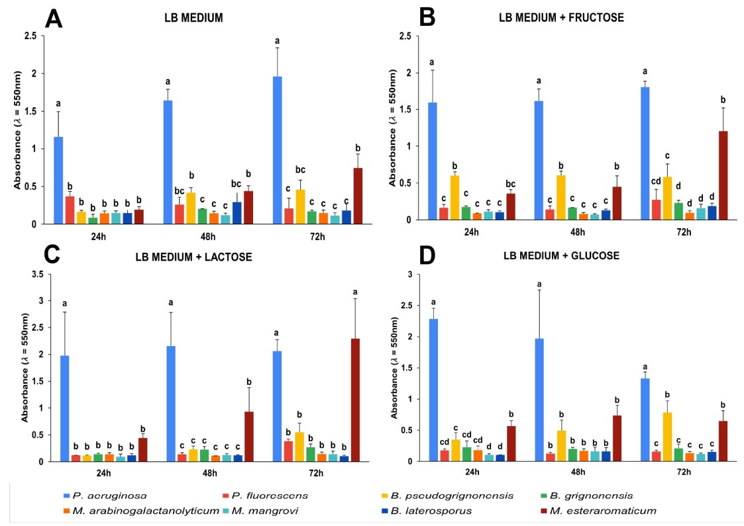

**Fig 2. Bacteria biofilm formation using different carbon sources in the growth medium.** **A**. LB medium (control) **B**.LB medium added fructose. **C**. LB medium added lactose and **D**. LB medium added glucose. Averages followed by the same letter did not differ among themselves (Tukey test, p < 0.05).

**Fig 3. Visual aspect of the biofilm evaluation.** **A.** Biofilm production using *Pseudomonas aeruginosa* (P) as control and *B. pseudogrignonensis* (B) **B.** 1Biofilm production using *Pseudomonas aeruginosa* (P) as control and *M. esteraromaticum* (M).

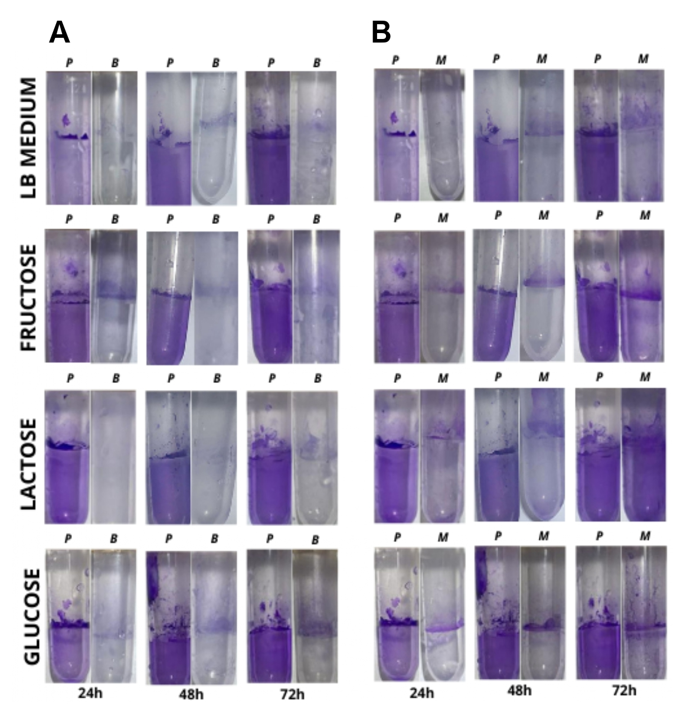

4. Conclusion

The exploration of bacterial diversity for biotechnological applications remains a critical first step in the development of new industrial technologies. In this study, we evaluated the enzymatic activityand biofilm-forming capacity of six bacterial isolates obtained from a bovine biodigester sludge. The isolates obtained herein, belong to genera *Brucella*, *Microbacterium*, and *Brevibacillus*, which are commonly associated with bovine sludge environments. Among these isolates, *Microbacterium arabinogalactanolyticum* and *M. mangrovi* were identified as promising candidates for semi-industrial trials. These strains showed the ability to produce important enzymes, such as protease, amylase, and cellulase; additionally, they showed potassium solubilization capacity along with low biofilm production, which is an important requirement for industrial scalability. However, none of the isolates showed any significant phosphate solubilization ability or antagonistic activity against the tested fungal species. Despite these limitations, our findings highlight the value of bovine biodigester sludge as a source of bacterial genera whose potential for application in agriculture and industry warrant further exploration.

AcknowledgEments

This research was supported by PRPPG/UFPR through a Scientific Initiation scholarship awarded to the first author. The authors would like to thank the Editage (www.editage.com.br) for assistance with English language developmental editing.

**DISCLAIMER (ARTIFICIAL INTELLIGENCE)**

The author(s) here by declare that no generative AI technologies, including Large Language Models (such as ChatGPT, COPILOT, etc.) or text-to-image generators, were utilized in the writing or editing of this manuscript.

Competing interests

Authors have declared that no competing interests exist.

Authors’ Contributions

This work was carried out in collaboration among all authors. All authors read and approved the final manuscript

References

Adrio, J. & Demain, A. (2014). Microbial enzymes: Tools for biotechnological processes. *Biomolecules*, **4**, 117–139. [**https://doi.org/10.3390/biom4010117**](https://doi.org/10.3390/biom4010117)

Aiysha, D. & Latif, Z. (2019). Insights of organic fertilizer micro flora of bovine manure and their useful potentials in sustainable agriculture. *PLOS ONE*, **14**, e0226155. <https://doi.org/10.1371/journal.pone.0226155>

Almeida, J.R.M., Collares, D.G. & Barbosa, P.A. (2015). *Microbial Bioprospecting*.

Battisti, R., Junkerfuerbom, A., Machado, K.N., Mesa, D., Santos, M.F. & Vendruscolo, E.C.G. (2024). Determination of biotechnological potential of poultry litter isolated bacteria. *Bioscience Journal*, e40030. <https://doi.org/10.14393/BJ-v40n0a2024-69345>

Bhambure, A.B., Mahajan, G.R. & Kerkar, S. (2018). Salt tolerant bacterial inoculants as promoters of rice growth and microbial activity in coastal saline soil. *Proceedings of the National Academy of Sciences, India Section B: Biological Sciences*, **88**, 1531–1538. <https://doi.org/10.1007/s40011-017-0901-9>

Carrim, A.J.I., Barbosa, E.C. & Vieira, J.D.G. (2006). Enzymatic activity of endophytic bacterial isolates of Jacaranda decurrens Cham. (Carobinha-do-campo). *Brazilian Archives of Biology and Technology*, **49**, 353–359. <https://doi.org/10.1590/S1516-89132006000400001>

Chattopadhyay, I., J, R.B., Usman, T.M.M. & Varjani, S. (2022). Exploring the role of microbial biofilm for industrial effluents treatment. *Bioengineered*, **13**, 6420–6440. <https://doi.org/10.1080/21655979.2022.2044250>

Corretto, E., Antonielli, L., Sessitsch, A., Höfer, C., Puschenreiter, M., Widhalm, S., Swarnalakshmi, K. & Brader, G. (2020). Comparative genomics of *Microbacterium* species to reveal diversity, potential for secondary metabolites and heavy metal resistance. *Frontiers in Microbiology*, **11**.

Cortez, S.C., Cherri, A.C., Jugend, D., Jesus, G.M.K. & Bezerra, B.S. (2022). How can biodigesters help drive the circular economy? An analysis based on the swot matrix and case studies. *Sustainability*, **14**, 7972. [**https://doi.org/10.3390/su14137972**](https://doi.org/10.3390/su14137972)

Cruz, C.D. (2013). GENES - Software para análise de dados em estatística experimental e em genética quantitativa. *Acta Scientiarum - Agronomy*, **35**, 271–276. <https://doi.org/10.4025/actasciagron.v35i3.21251>

Ferrero, M.C., Alonso Paiva, I.M., Muñoz González, F. & Baldi, P.C. (2020). Pathogenesis and immune response in Brucella infection acquired by the respiratory route. *Microbes and Infection*, **22**, 407–415. <https://doi.org/10.1016/j.micinf.2020.06.001>

Fessia, A., Sartori, M., García, D., Fernández, L., Ponzio, R., Barros, G. & Nesci, A. (2022). In vitro studies of biofilm-forming Bacillus strains, biocontrol agents isolated from the maize phyllosphere. *Biofilm*, **4**, 100097. <https://doi.org/10.1016/j.bioflm.2022.100097>

Flemming, H.-C. & Wingender, J. (2010). The biofilm matrix. *Nature Reviews Microbiology*, **8**, 623–633. <https://doi.org/10.1038/nrmicro2415>

Freitas, A.D.G.A., Souza, A.Q.L., Maki, C.S. & Silva, N.M. (2016). Atividade antagonista de bactérias endofíticas de plantas da Amazônia contra o fungo simbionte *L . gongylophorus* , e dos fungos associados presentes nos ninhos de Atta sexdens. *Scientia Amazonia*, **5**, 1–14. <http://doi.org/10.15580/GJAS.2016.3.063014287>

Haney, E.F., Trimble, M.J., Cheng, J.T., Vallé, Q. & Hancock, R.E.W. (2018). Critical assessment of methods to quantify biofilm growth and evaluate antibiofilm activity of host defense peptides. *Biomolecules*, **8**. <https://doi.org/10.3390/biom8020029>

Harrigan, W.F. & McCane, E.M. (1998)*. Laboratory Methods in Microbiology*. 3rd ed. Academic Press, London.

Hussein, N.N.A., Ibrahim, A.I., Kamar, F.H. & Nechifor, A.C. (2020). Caseinase production and media optimization from *Bacillus subtilis*. *Revista de Chimie*, **71**, 1–9. <https://doi.org/10.37358/RC.20.11.8368>

Jaafarzadeh, N., Jorfi, S., Mirzaiy, A. & Ghaedrahmat, Z. (2021). Bovine manure as a rich source for isolation of halo-tolerant bacterial strains capable of PAHs biodegradation in Slurry bioreactor. *Biointerface Research in Applied Chemistry*, **11**, 14964–14973. <https://doi.org/10.33263/BRIAC116.1496414973>

Kim, B., Gurung, S., Han, S.-R., Lee, J.-H. & Oh, T.-J. (2023). Comparative genomic analysis of biofilm-forming polar *Microbacterium sp*. strains PAMC22086 and PAMC21962 isolated from extreme habitats. *Microorganisms*, **11**, 1757. <https://doi.org/10.3390/microorganisms11071757>

Kovacs, N. Identification of *Pseudomonas pyocyanea* by the oxidase reaction. *Nature* **178**, 703 (1956). <https://doi.org/10.1038/178703a0>

Lee, I.P.A., Eldakar, O.T., Gogarten, J.P. & Andam, C.P. (2022). Bacterial cooperation through horizontal gene transfer. *Trends in Ecology & Evolution*, **37**, 223–232. <https://doi.org/10.1016/j.tree.2021.11.006>

Li, Y., Narayanan, M., Shi, X., Chen, X., Li, Z. & Ma, Y. (2024). Biofilms formation in plant growth-promoting bacteria for alleviating agro-environmental stress. *Science of The Total Environment*, **907**, 167774. <https://doi.org/10.1016/j.scitotenv.2023.167774>

Liu, Y., Zai, X., Weng, G., Ma, X. & Deng, D. (2024). *Brevibacillus laterosporus*: A Probiotic with Important Applications in Crop and Animal Production. *Microorganisms*, **12**, 564. <https://doi.org/10.3390/microorganisms12030564>

Maciel, F.L., Souza, C.B.R.S., Vieira, C.B.R.C., Salbego, E.L.S., Balzan, G.D., Re, I. & Savio, V.M. (2020). *Microrganismos com potencial biotecnológico*. Universidade Estadual do Rio Grande do Sul, Bento Gonçalves-RS.

Maester, T.C., Gomes, E.S., Pereira, M.R., Sierra, E.G.M., Lemos, M.V.F. & de Macedo Lemos, E.G. (2017). Bioprospecting studies: transforming the natural genetic heritage into biotechnological richness. In: *The Brazilian Microbiome*, pp. 87–109. Springer International Publishing, Cham. <https://doi.org/10.1007/978-3-319-59997-7_6>

Mahdizade Ari, M., Dadgar, L., Elahi, Z., Ghanavati, R. & Taheri, B. (2024). Genetically engineered microorganisms and their impact on human health. *International Journal of Clinical Practice*, **2024**. [**https://doi.org/10.1155/2024/6638269**](https://doi.org/10.1155/2024/6638269)

Manyi-Loh, C.E., Mamphweli, S.N., Meyer, E.L., Okoh, A.I., Makaka, G. & Simon, M. (2013). Microbial anaerobic digestion (bio-digesters) as an approach to the decontamination of animal wastes in pollution control and the generation of renewable energy. *International Journal of Environmental Research and Public Health*, **10**, 4390–4417. <https://doi.org/10.3390/ijerph10094390>

Mazzucotelli, C.A., Ponce, A.G., Kotlar, C.E. & Moreira, M. del R. (2013). Isolation and characterization of bacterial strains with a hydrolytic profile with potential use in bioconversion of agroindustial by-products and waste. *Food Science and Technology*, **33**, 295–303. <https://doi.org/10.1590/S0101-20612013005000038>

Morales-Estrada, A.I., Hernández-Castro, R., López-Merino, A., Singh-Bedi, J. & Contreras-Rodriguez, A. (2016). Isolation, identification, and antimicrobial susceptibility of Brucella spp. cultured from cows and goats manure in Mexico. *Arch Med Vet*, **48**, 231–235.

Muhammad, M.H., Idris, A.L., Fan, X., Guo, Y., Yu, Y., Jin, X., Qiu, J., Guan, X. & Huang, T. (2020). Beyond risk: bacterial biofilms and their regulating approaches. *Frontiers in Microbiology*, **11**. <https://doi.org/10.3389/fmicb.2020.00928>

Nautiyal, C.S., Bhadauria, S., Kumar, P., Lal, H. & Mondal, R. (2000). Stress induced phosphate solubilization in bacteria isolated from alkaline soils. *FEMS Microbiology Letters*, **182**, 291–296. <https://doi.org/10.1111/j.1574-6968.2000.tb08910.x>

Nigam, P. (2013). Microbial enzymes with special characteristics for biotechnological applications. *Biomolecules*, **3**, 597–611. <https://doi.org/10.3390/biom3030597>

Oliveira, A.N. de, Oliveira, L.A. de, Andrade, J.S. & Chagas Júnior, A.F. (2006). Atividade enzimática de isolados de rizóbia nativos da Amazônia Central crescendo em diferentes níveis de acidez. *Ciência e Tecnologia de Alimentos*, **26**, 204–210. <https://doi.org/10.1590/S0101-20612006000100032>

O’Toole, G.A. (2011). Microtiter dish biofilm formation assay. *Journal of Visualized Experiments*. <https://dx.doi.org/10.3791/2437>

Rani, A., Saini, K.C., Bast, F., Varjani, S., Mehariya, S., Bhatia, S.K., Sharma, N. & Funk, C. (2021). A review on microbial products and their perspective application as antimicrobial agents. *Biomolecules*, **11**. <https://doi.org/10.3390/biom11121860>

Sawarkar Scholar, A., Sawarkar, A., Sharma, R. & Gautam, V. (2019). Bioprospecting: Creating value for biodiversity. *~ 256 ~ The Pharma Innovation Journal*, **8**, 256–265.

Sekurova, O.N., Schneider, O. & Zotchev, S.B. (2019). Novel bioactive natural products from bacteria via bioprospecting, genome mining and metabolic engineering. *Microbial Biotechnology*, **12**, 828–844. https://doi.org/10.1111/1751-7915.13398

Senthilraj, R., Prasad, G.S. & Janakiraman, K. (2016). Sequence-based identification of microbial contaminants in non‑parenteral products. **52**. <https://doi.org/10.1590/S1984-82502016000200011>

Shimokawa, M., Ishiwata, A., Kashima, T., Nakashima, C., Li, J., Fukushima, R., Sawai, N., Nakamori, M., Tanaka, Y., Kudo, A., Morikami, S., Iwanaga, N., Akai, G., Shimizu, N., Arakawa, T., Yamada, C., Kitahara, K., Tanaka, K., Ito, Y., Fushinobu, S. & Fujita, K. (2023). Identification and characterization of endo-α-, exo-α-, and exo-β-d-arabinofuranosidases degrading lipoarabinomannan and arabinogalactan of mycobacteria. *Nature Communications*, **14**, 5803. <https://doi.org/10.1038/s41467-023-41431-2>

Shineh, G., Mobaraki, M., Perves Bappy, M.J. & Mills, D.K. (2023). Biofilm formation, and related impacts on healthcare, food processing and packaging, industrial manufacturing, marine industries, and sanitation–A Review. *Applied Microbiology*, **3**, 629–665. <https://doi.org/10.3390/applmicrobiol3030044>

Singh, R., Paul, D. & Jain, R.K. (2006). Biofilms: implications in bioremediation. *Trends in Microbiology*, **14**, 389–397. <https://doi.org/10.1016/j.tim.2006.07.001>

Singh, R.S., Singh, T. & Pandey, A. (2019). Microbial Enzymes—An Overview. In: *Advances in Enzyme Technology, First Edition*, pp. 1–40. Elsevier. <https://doi.org/10.1016/B978-0-444-64114-4.00001-7>

Sun, F., Ou, Q., Wang, N., Guo, Z. Xuan, Ou, Y., Li, N. & Peng, C. (2020). Isolation and identification of potassium-solubilizing bacteria from *Mikania micrantha* rhizospheric soil and their effect on M. micrantha plants. *Global Ecology and Conservation*, **23**, e01141. <https://doi.org/10.1016/j.gecco.2020.e01141>

Tamura, K., Dudley, J., Nei, M. & S, K. (2007). MEGA4: Molecular Evolutionary Genetics Analysis (MEGA) software version 4.0. *Molecular Biology and Evolution*, **24**, 1596–1599. <https://doi.org/10.1093/molbev/msm092>

Thi, M.T.T., Wibowo, D. & Rehm, B.H.A. 2020. *Pseudomonas aeruginosa* Biofilms. *International Journal of Molecular Sciences*, **21**, 8671. https://doi.org/10.3390/ijms21228671

Tripathi, R., Singh, J., Bharti, R. Kumar & Thakur, I.S. 2014. Isolation, Purification and Characterization of Lipase from *Microbacterium sp*. and its Application in Biodiesel Production. *Energy Procedia*, **54**, 518–529. <https://doi.org/10.1016/j.egypro.2014.07.293>

Vendruscolo, E.C.G., Mesa, D., Rissi, D.V., Meyer, B.H., de Oliveira Pedrosa, F., de Souza, E.M. & Cruz, L.M. (2020). Microbial communities network analysis of anaerobic reactors fed with bovine and swine slurry. *Science of the Total Environment*, **742**, 140314, <https://doi.org/10.1016/j.scitotenv.2020.140314>. https://doi.org/10.1016/j.scitotenv.2020.140314

Venkatachalam, S. (2014). Bioprospecting of cellulase producing extremophilic bacterial isolates from Indi. *British Microbiology Research Journal*, 4, 142–154. <https://doi.org/10.9734/BMRJ/2014/5395>

Yano DMY, Attili DS, V GMS, Eguchi SY & Oliveira UM (1991) Técnicas de microbiologia em controle de qualidade. Fundação Tropical de Pesquisa e Tecnologia André Tosello, Campinas.

Yang, P., Condrich, A., Lu, L., Scranton, S., Hebner, C., Sheykhhasan, M. & Ali, M.A. (2024). Genetic Engineering in Bacteria, Fungi, and Oomycetes, Taking Advantage of CRISPR. *DNA*, **4**, 427–454. <https://www.mdpi.com/2673-8856/4/4/30>. <https://doi.org/10.3390/dna4040030>

Zhou, J., Wu, Y., Liu, D. & Lv, R. (2023). The effect of carbon source and temperature on the formation and growth of *Bacillus licheniformis* and *Bacillus cereus* biofilms. *LWT*, **186**, 115239. <https://doi.org/10.1016/j.lwt.2023.115239>

Zou, M. & Liu, D. (2020). Effects of carbon sources and temperature on the formation and structural characteristics of food-related Staphylococcus epidermidis biofilms. *Food Science and Human Wellness*, **9**, 370–376. <https://doi.org/10.1016/j.fshw.2020.05.007>