**Synthesis, characterization and antimicrobial evaluation of zinc oxide nanoparticle peptide conjugates**

**ABSTRACT**

**Aim**: The study aimed to develop a zinc oxide nanoparticle–peptide conjugate (ZONPC) using peptides derived from whey fermentation and to compare its physicochemical and antimicrobial properties with conventional zinc oxide nanoparticles (ZONP). The goal was to enhance antimicrobial efficacy, particularly against antibiotic-resistant organisms.

**Study design**: A comparative approach was used to evaluate the physicochemical and antibacterial properties of ZONPC against conventional zinc oxide nanoparticles (ZONP).

**Place and Duration of Study:** Department of Dairy Microbiology, National Dairy Research institute, Karnal, Haryana, between June 2022 and July 2023.

**Study design:** This was a laboratory-based experimental study involving the synthesis of zinc oxide nanoparticle–peptide conjugates (ZONPC) using whey-derived peptides, followed by characterization and antimicrobial testing. A comparative approach was used to evaluate the physicochemical and antibacterial properties of ZONPC against conventional zinc oxide nanoparticles (ZONP).

**Methodology:** ZONPC was synthesized under optimized conditions using a 1 mol/L solution of Zn(NO₃)₂·6H₂O and peptides at a 1:3 ratio, reacted at 90°C for 4 hours. Characterization involved particle size and zeta potential measurements, along with FTIR analysis to confirm peptide conjugation. Antimicrobial efficacy was assessed using zone of inhibition (ZOI), minimum inhibitory concentration (MIC), and minimum bactericidal concentration (MBC) tests.

**Result**: ZONPC showed an increase in particle size from 36.87 to 152.6 nm and a reduction in zeta potential from –19.4 to –4.16 mV. FTIR confirmed peptide binding via the presence of an amide III bond. Antimicrobial tests revealed a ZOI of 34–40 mm. While both ZONP and ZONPC had an MIC of 2 µg/mL, the MBC of ZONPC was significantly lower (16.5 µg/mL vs. 65 µg/mL), indicating enhanced bactericidal activity.

**Conclusion**: The study concluded that peptide conjugation significantly enhanced the antimicrobial efficacy of zinc oxide nanoparticles, especially against antibiotic-resistant bacteria.

***Key words****: Zinc oxide nanoparticle, zinc oxide nanoparticle peptide conjugate, antimicrobial activity, characterization*

1. **INTRODUCTION**

For high-producing animals, like dairy cows, to remain healthy and happy, cleaning and sanitation are crucial. Infection risk is increased in dense, modern housing with high production (Barbuddhe et al., 2012). To lower the pathogen level or stop the illness cycle, thorough cleaning and disinfection are required (Ahemed et al.,2020). The three main diseases that affect calves and result in decreased feed conversion, poor growth, and occasionally mortality include calf pneumonia, calf scours, and neonatal calves diarrhea. Sanitizing after each animal entry is advised since an increase in microbial load raises the risk of infection (Schreiner and Ruegg, 2003; Dohmen et al., 2010; Reneau et al., 2005). Therefore, pathogens and antibiotic-resistant microorganisms (AMR) must be eliminated through efficient sanitization. In recent decades, nanotechnology has been the subject of the most academic study. It creates a variety of materials with sizes ranging from 1 to 500 nm at the nanoscale level. They display distinctive physicochemical characteristics (Ealia et al., 2017). Nanoparticles have improved catalytic, magnetic, electrical, mechanical, optical, chemical, and biological capabilities as a result of the high surface-to-volume ratio (Khan et al., 2019). World-wide, bacterial infections are acknowledged as major health problems. The need for stronger antimicrobial agents is growing as a result of the emergence of new pathogenic stains like organisms with increased antibiotic resistance.

Zinc oxide nanoparticles (ZnO NPs) are well-known for their strong antimicrobial properties, primarily due to their capacity to disrupt essential biomolecules such as proteins, DNA, lipids, and carbohydrates and to induce oxidative stress (Janaki et al., 2015). Their antibacterial effectiveness is largely linked to the release of zinc ions, hydrogen peroxide (H₂O₂), and reactive oxygen species (ROS) (Manna et al., 2011).

Antimicrobial peptides (AMPs), which are protein fragments produced by enzymes, have a wide range of applications in the biomedical, pharmaceutical, and food industries (Sanchez et al., 2017). These peptide-based compounds hold significant promise in the pharmaceutical field due to their bioavailability, low toxicity, high selectivity, and ease of customization (Aguilar-Toalá et al., 2017). Combining ZnO NPs with antimicrobial peptides has gained significant attention across various fields due to the unique properties and potential applications of these conjugates. ZnO NPs possess natural antibacterial properties (Ismail et al., 2022), and when combined with peptides, their antibacterial activity is enhanced. This combination is particularly important for developing novel antibacterial strategies, especially against antibiotic-resistant germs (Jeong et al., 2018). Research has also explored the use of ZnO NP-peptide conjugates in environmental remediation, such as water purification and pollution removal. These conjugates are effective in absorbing and breaking down contaminants, addressing environmental contamination challenges (Mostafaii et al., 2017). Nano particle- peptide conjugate can effectively reduce the number of anti-biotic resistant organism also showed a better anti-inflammatory property (Wang et al., 2025).

In dairy production, ZnO NP-peptide conjugates can significantly improve sanitation. By combining ZnO NPs with antimicrobial peptides, their intrinsic antibacterial properties are strengthened (Vignoni et al., 2014). These conjugates can prevent the growth of bacteria, fungi, and other microorganisms commonly found in milk production environments. They can be applied by spraying, coating, or incorporating them into cleaning solutions to reduce microbial populations on surfaces like equipment, storage tanks, pipes, and utensils. Their antibacterial properties help maintain cleanliness and prevent the spread of disease.

1. **MATERIAL AND METHODS**

All chemicals of analytical grade (AR) were procured from Hi-Media Pvt. Ltd., Mumbai and Sisco Research Laboratories Pvt. Ltd. Taloja, Maharashtra. All the test organisms used in the study were procured from the National Collection of Dairy Culture, ICAR-National Dairy Research Institute, Karnal, , and Microbial Type Culture Collection (MTCC), Chandigarh, India and American Type Culture Collection (ATCC), Manassas, USA. Peptide was produced by the method described by Ashok, (2020).

**2.1 Optimization and synthesis of Zinc oxide nanoparticle peptide conjugate**

There are several methods for preparing nanoparticles, with biosynthesis or "green synthesis" being the most eco-friendly and emerging technique. Green synthesis is widely studied because it avoids the use of harmful chemicals as reducing agents, reducing the emission of toxic substances. In this process, peptide fractions with a molecular weight of 10 kDa were used as reducing agents, minimizing the production of harmful chemicals.

For the production of zinc oxide nanoparticle-peptide conjugates, the method described by Abomuti et al. (2021) was followed. Zinc nitrate hexahydrate (Zn(NO₃)₂·6H₂O) was used as the base material (precursor), which was converted into zinc hydroxide using the 10 kDa peptide fraction. The resulting product was further dried to form zinc oxide bonded with peptides.

In the process, thirty-six different combinations were tested, and the best one was selected. Zinc nitrate was used as the base material, and various concentrations of zinc nitrate were tried (0.001, 0.01, 0.1, and 1 mol/L). The <10 kDa peptide fraction served as the reducing agent, and three different temperatures (70°C, 80°C, and 90°C) were tested for optimization. Different ratios of zinc nitrate and <10 kDa peptide fraction (1:1, 1:2, and 1:3) were also evaluated. The reaction time was optimized using UV-VIS spectrophotometry by measuring absorbance at hourly intervals to monitor peak formation as well as the antimicrobial activity against *E.Coli.* Zinc nitrate with required quantity (298.5, 29.85, 2.98, 0.298) was dissolved in 1000 mL distilled water according to the concentrations (1, 0.1, 0.01, 0.001 mol/L) which was then put over magnetic stirrer until proper mixing. <10KDa peptide fraction was taken in burette, and was added drop wise to the uniform mixture of zinc nitrate. UV-VIS reading was taken in all one h interval until 6th h and reaction time was chosen as the time at which UV-VIS reading become constant. The reaction mixture was kept undisturbed for overnight for precipitation. The supernatant was removed and the precipitate was taken for further procedure. Precipitate was taken and centrifuged at 10000 rpm for 15 min with Thermo Scientific Heraeus Multifuge X1R centrifuge. Further washed 5 times with double distilled water with the help of centrifuge at 8000rpm for 10 min. The resulting pellet was dried with the help of hot air oven at 60°C for 24 h. Remaining dried pellet was crushed to fine powder with the help of motor and pistil. The powder was used for further characterization and analysis. For the optimization of zinc oxide nanoparticle peptide conjugate production UV-VIS absorbance of 200-800 nm wavelength. In the same reaction conditions zinc oxide nanoparticle was also produced for conforming production of conjugate. For the production of zinc oxide nanoparticle 0.1 Mol/L of NaOH was used as the reducing agent .

**2.2 Characterization of zinc oxide nanoparticle**

Characterizing zinc oxide nanoparticle-peptide conjugate is a crucial step in understanding their physical, chemical, and structural properties, as well as their potential applications. Various techniques are used to characterize these nanoparticles. UV-Visible spectroscopy, Zeta potential, Dynamic Light Scattering (DLS), Scanning electron microscope (SEM) and Fourier-transform infrared spectroscopy (FTIR).

**2.2.1 Optical properties of zinc oxide nanoparticle peptide conjugate**

The size, shape, and interplay of the metal nanoparticles greatly influence their optical characteristics. Zinc oxide nanoparticle peptide conjugate was examined after ultrasonication. The absorbance of zinc oxide nanoparticle peptide conjugate was analyzed at 800 to 200 nm wavelength. For checking UV-VIS absorbance UV 1800, SHIMADZU, Japan instrument was used and the absorbance peak was noted.

**2.2.2 The size of zinc oxide nanoparticle peptide conjugate (ZONPC) by dynamic light scattering**

The Zinc oxide nanoparticle peptide size was analyzed using zeta- size analyzer (Mavern particle and Zeta sizer). The result obtains the size distribution against intensity.

**2.2.3 The surface charge of zinc oxide nanoparticle conjugates (ZONPC) by zeta potential**

The zeta potential was measured to study the interactions between colloids and electrolytes. The analysis was conducted using a zeta potential cuvette at room temperature (25°C) with an applied voltage of 5V/cm. The experiment was repeated three times for accuracy. The resulting graph displayed the total count versus the apparent zeta potential in millivolts (mV).

**2.2.4 Fourier transformer infrared spectroscopy (FTIR)**

Surface functional group on zinc oxide nanoparticle conjugates were determined by Fourier transformer infrared spectroscopy. For the experiment, conjugate power was taken and which was placed on the diamond of FTIR Instrument (IRAffinity-1 Fourier Transformer Infrared Spectroscopy by Shimadzu, Japan). The background run was carried-out first and further spectra recorded in the range of 400-4000 cm-1(Aslinjensipriya *et al*., 2020). The result was obtained in as % Transmittance against infrared wave length. The peak point was noted and the result was interpreted according to the standard transmission data. The same procedure was carried out for zinc oxide nano particle.

**2.2.5 Nanocrystal shape and size of zinc oxide nanoparticle peptide conjugate by Scanning electron microscope (SEM)**

Scanning Electron Microscopy (SEM) is a powerful imaging technique used to analyse the surface morphology and structure of zinc oxide nanoparticles. It provides high-resolution images and allows researchers to observe the size, shape, and distribution of the nanoparticles. Before analysis sample was prepare as per following method the zinc oxide nanoparticle peptide conjugate was uniformly distributed over carbon-coated grid.

**2.3 Efficiency of zinc oxide nanoparticle peptide conjugate as anti-microbial agent**

**2.3.1 Antimicrobial activity of zinc oxide nanoparticle-peptide conjugate**

Antimicrobial activity of conjugate was checked against standard cultures as well as samples taken from the milk production area using well diffusion method.

**2.3.2 Minimum inhibitory concentration of zinc oxide nanoparticle peptide conjugate**

The Minimum Inhibitory Concentration (MIC) was determined using the micro-dilution method. First, 50 µL of the bacterial culture was added to separate test tubes and incubated overnight at 37°C. Then, 100 µL of each dilution was transferred into a pre-sterilized 96-well plate using a multichannel pipette. The 96-well plate was labeled with the corresponding concentrations of the nanoparticle-peptide conjugates.

In column 12, 200 µL of broth was added as a sterility control, and in column 11, 100 µL was added as a growth control. Each well, except the first, received 100 µL of media. In the first well, 200 µL of the peptide solution was added. From this well, 100 µL was transferred to the next well, which already contained 100 µL of media, and mixed thoroughly. This process was repeated through to the 10th well, creating serial dilutions. Afterward, 50 µL of bacterial suspension, adjusted to 1×10⁸ CFU/mL, was added to each well along with 50 µL of media. The plates were properly covered with lids and incubated overnight at 37°C. Finally, the optical density of each well was measured using an ELISA plate reader at 600 nm (Wiegand et al., 2008).

**2.3.3 Minimum bactericidal concentration**

For the MBC determination, 5 mL of sterile BHI broth was added to sterile glass tubes. To each tube, 50 µL of the sample (taken from the wells in the MIC analysis that showed no growth) was added. The sample and broth were mixed thoroughly using a vortex and incubated overnight at 37°C.

The tubes that showed no visible growth after incubation were selected for further confirmation. From these tubes, 1 mL of broth was transferred to a sterile plate, which was then incubated overnight at 37°C. The plates were checked for any visible growth the next day. The lowest dilution where no growth was observed was recorded as the Minimum Bactericidal Concentration (MBC) (Wiegand et al., 2008).

**2.3.4 Optimization of contact time and concentration of zinc oxide nanoparticle peptide conjugate**

Sample collected from LRC, ICAR-NDRI Karnal was used for this experiment. Different time concentration combinations were taken as shown in **Table 1.**

Swab samples were collected as previously described. From each sample, 1 mL was transferred into separate tubes, and various time and concentration combinations were applied. The treated samples were then poured into Petri plates, followed by the addition of 20 mL of nutrient agar to each plate. The plates were incubated at 37°C for 24 hours. After incubation, the number of colonies on each plate was counted, and the best combination was selected based on the results.

**Table 1: Different time concentration combinations**

|  |  |  |
| --- | --- | --- |
| **Sl no** | **Time (Min)** | **Concentrations (µL/ml)** |
| 1 | 1 | 10, 50, 100, 150, 200 and 400 |
| 2 | 5 | 10, 50, 100, 150, 200 and 400 |
| 3 | 10 | 10, 50, 100, 150, 200 and 400 |
| 4 | 30 | 10, 50, 100, 150, 200 and 400 |
| 5 | 60 | 10, 50, 100, 150, 200 and 400 |

**2.3.5** **Antimicrobial Efficiency of zinc oxide nanoparticle peptide conjugate against individual microorganisms**

The efficiency of zinc oxide nanoparticle peptide conjugate for reducing different microbial counts was analysed using samples taken from LRC, ICAR-NDRI Karnal. Four different microbial counts were analysed using selective agar. Two test tubes were prepared, with one tube serving as a control sample and the other treated with the nanoparticle-peptide conjugate at a concentration of 200 µL/mL for 5 minutes. Both tubes were then incubated in selective agar at 37°C for 24 hours.

**3. RESULT AND DISCUSSION**

**3.1 Optimization and synthesis of Zinc oxide nanoparticle peptide conjugate**

**3.1.1 Optimization of Zinc oxide nanoparticle peptide conjugate formation using UV-Visible readings**

At 70°C, 80°C, and 90°C, UV-VIS absorbance measurements of zinc oxide nanoparticle conjugates with various precursor-to-reductant concentration ratios (1:1, 1:2, and 1:3) showed maximum absorbance at 1 mol/L precursor concentration, with the highest absorbance recorded at 364 nm being 0.534 at 70°C, 1.000 at 80°C, and 0.991 at 90°C, indicating that an increase in precursor concentration led to increased absorbance, thereby optimizing 1 mol/L as the precursor concentration.

Out of the 36 different combinations tested, the optimal conditions were found to be a precursor concentration of 1 Mol/L, a reducing agent to precursor ratio of 1:3, and a reaction temperature of 80°C, with a reaction time of 4 hours. Fig. 1. (a, b, and c) shows the graphical representation of the absorbance of the nanoparticle conjugates for the various combinations tested.

Tukey's Multiple Comparison Test (P<0.05, n=3) shows a significant change in UV-VIS absorbance with varying precursor concentrations, consistent with Osman et al. (2015), who reported increased absorbance due to higher zinc oxide nanoparticle production at higher precursor concentrations.

**3.1.2 Optimization of Zinc oxide nanoparticle peptide conjugate using antimicrobial activity**

At a ratio of 1:1, ZONPC did not exhibit antimicrobial activity at precursor concentrations of 0.001 and 0.01 mol/L. However, when the concentration was increased from 0.1 to 1 mol/L, there was a significant improvement in antimicrobial activity. Upon comparing different reaction temperatures, ZONPC showed maximum activity at 80°C. Similarly, at a ratio of 1:2, no antimicrobial activity was observed at 0.001 and 0.01 mol/L, but a notable increase occurred between 0.1 and 1 mol/L, with maximum activity again recorded at 80°C. For the ratio of 1:3, ZONPC followed the same pattern, with no activity at lower concentrations but a significant increase in antimicrobial activity at higher concentrations, peaking at 80°C. observations are graphically represented in Fig:1(d, e and f). Across all combinations, the highest antimicrobial activity was consistently observed at 1 mol/L, In this study, statistical analysis at P < 0.05 (n=3) revealed that variations in precursor concentration had a significant impact on antimicrobial activity. A similar study by Faisal et al. (2023) demonstrated that zinc oxide nanoparticles at 1 mg/mL showed maximum antimicrobial activity against *Klebsiella pneumoniae*, with a zone of inhibition measuring 27 ± 1.73 mm.





a b c

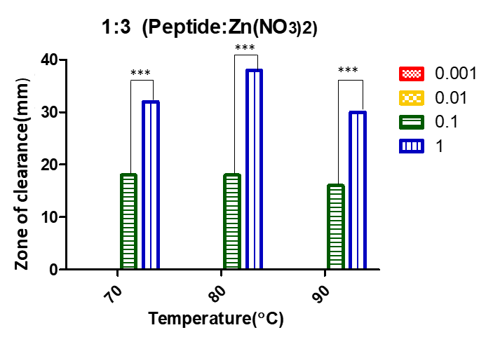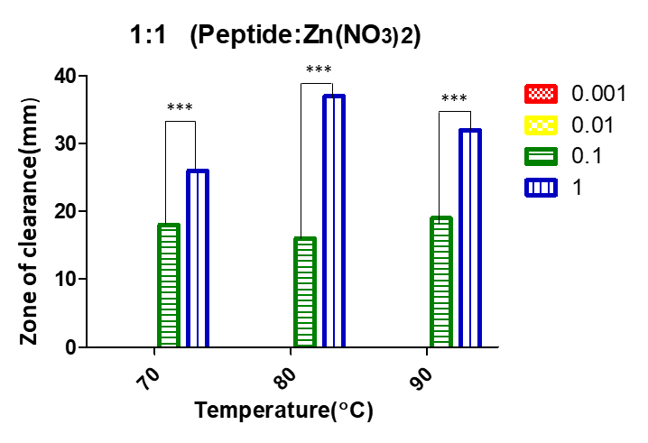 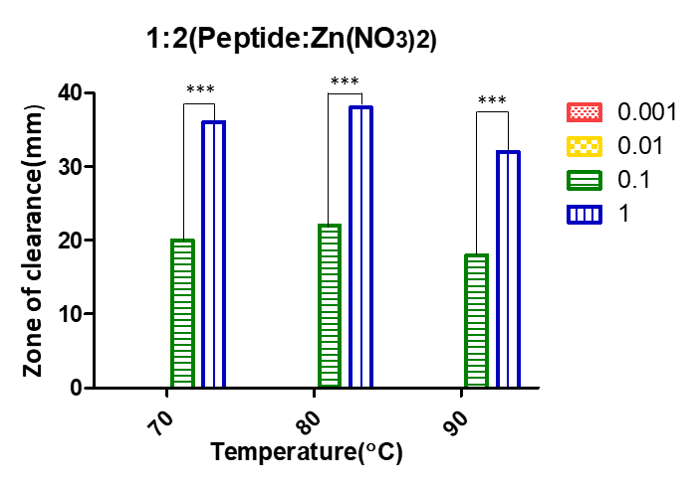

d e f

**Fig.1. UV-VIS absorbance of zinc oxide nanoparticle peptide conjugate in different precursor Concentration at different temperatures 70°C (a), 80°C (b) and 90°C (c) antimicrobial activity of ZONPC with different precursor concentration, precursor reducing agent ratio (d-1:1, e-1:2, f-1:3) and temperatures**

**3.2 Characterization of zinc oxide nanoparticle**

**3.2.1 Optical properties of zinc oxide nanoparticle peptide conjugate**

The absorption spectrum can be influenced by the size, shape, composition, and surface properties of the nanoparticle. In this study, Double beam UV-VIS spectrophotometer was used. Zinc oxide nanoparticle peptide conjugate absorption peak was observed at a wavelength of 364 nm with absorbance of 1 which is presented in **Fig:2a** presence of sharp peak at 364 nmconformed the formation of zinc oxide nanoparticle peptide conjugate. Mahamuni *et al*., 2019 reported that, the maximum absorbance peak was observed between 360-380nm of wavelength which indicated the production of zinc oxide nanoparticles.

**3.2.2 The size of zinc oxide nanoparticle peptide conjugate (ZONPC) by dynamic light scattering**

The size of Zinc oxide nanoparticle was observed as 36.87 nm with a PDI value of 0.836 and the size of zinc oxide nanoparticle conjugate was 152.6 nm with a PDI value of 0.282 as presented in **Fig:2 b,c.** An increase in the size was observed which indicated production of peptide layer around the zinc oxide nanoparticle which ultimately increased the size by 3-4 times. Gumala *et al*., 2020 reported that during conjugate production, the size of gold nanoparticles increased by 2 to 4 times and the increase in the size indicated the conjugate production.

**3.2.3 The surface charge of zinc oxide nanoparticle conjugates (ZONPC) by zeta potential**

The zeta potential of the zinc oxide nanoparticles was reported as -19.4 mV and the zeta potential of the zinc oxide nanoparticle peptide conjugate was reported as -4.16 mV which is shown in Fig.2(d,e). The negative sign indicates the presence of a negative surface charge on the particle. The decrease in the zeta potential indicates the coating of peptide around the nanoparticle which ultimately reduced the surface charge of nanoparticle conjugate. Gumala *et al*. (2020) reported that, the zeta potential reduced from -36.33 ± 3.12 to -6.4 ± 9.90 during conjugation of gold nano particle with Trans-resveratrol-PEG-folic acid.

**3.2.4 Fourier transformer infrared spectroscopy (FTIR)**

During FTIR analysis of zinc oxide nanoparticles, four main stretching bonds were identified. In the case of zinc oxide nanoparticle-peptide conjugates, an additional Amide III stretch was observed alongside the four original stretches, confirming the formation of the nanoparticle-peptide conjugate. The observed bonds were at 3321.42 cm⁻¹, 2151.25 cm⁻¹, 1653 cm⁻¹, 1350 cm⁻¹, and 446 cm⁻¹, corresponding to OH stretching, azide (N≡N≡N) stretching, amine (N-H) stretching, Amide III stretching, and ZnO stretching, respectively, as shown in Fig 2 (f,g).

The OH stretching indicated the presence of water in the sample, likely due to the water used in the reaction. The azide stretching originated from the nitrate, while the amine stretching may have resulted from byproducts during the reaction. The ZnO stretch at 446 cm⁻¹ confirmed the presence of zinc oxide nanoparticles in both cases. Beyond these bonds, no other significant peaks were observed in the FTIR spectrum, suggesting that both the nanoparticles and nanoparticle-peptide conjugates were in a relatively pure form.

Gumala et al. (2020) reported that the extra C=O and C=N stretches between 1600–1700 cm⁻¹ confirmed the production of gold nanoparticle trans-resveratrol-PEG-folic acid conjugates. Similarly, Abomuti et al. (2021) observed Zn-O bonding at 440–450 cm⁻¹ during their FTIR analysis. Khan et al. (2023) also reported a bond at 454 cm⁻¹ during the green synthesis of zinc oxide nanoparticles, along with OH stretching at 3323 cm⁻¹ and amine stretching at 1629 cm⁻¹.

**3.2.5 Nanocrystal shape and size of zinc oxide nanoparticle peptide conjugate by Scanning electron microscope (SEM)**

The scanning electron microscopy (SEM) images of the zinc oxide nanoparticle-peptide conjugates show that the original nanoparticles had a spherical shape. However, after conjugation with peptides, many particles displayed irregular shapes, while some remained spherical. This indicates that not all nanoparticles were conjugated with peptides. The particle sizes of conjugate ranged from 100 to 150 nm, with smaller particles between 25 and 50 nm also visible, likely due to the absence of conjugation. Some particles sized between 50 and 100 nm were conjugated with peptides, but the degree of conjugation was lower. Additionally, a few particles were larger than 150 nm, which could be due to either a higher level of conjugation or nanoparticle aggregation. The SEM images also show clusters of conjugates, suggesting that they combined to form larger aggregates, as illustrated in Fig. 2h.

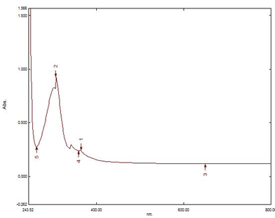

a

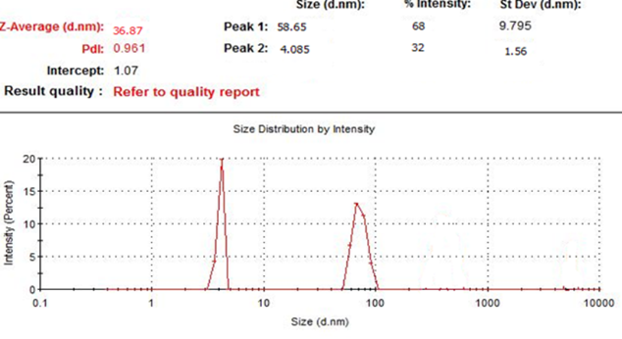 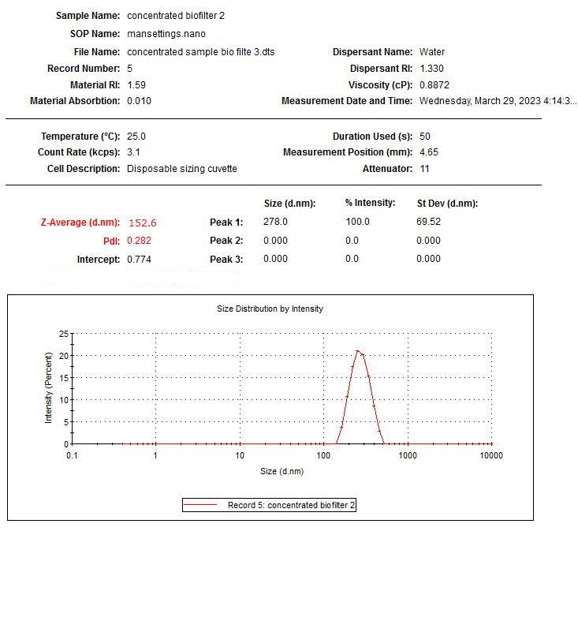

b c

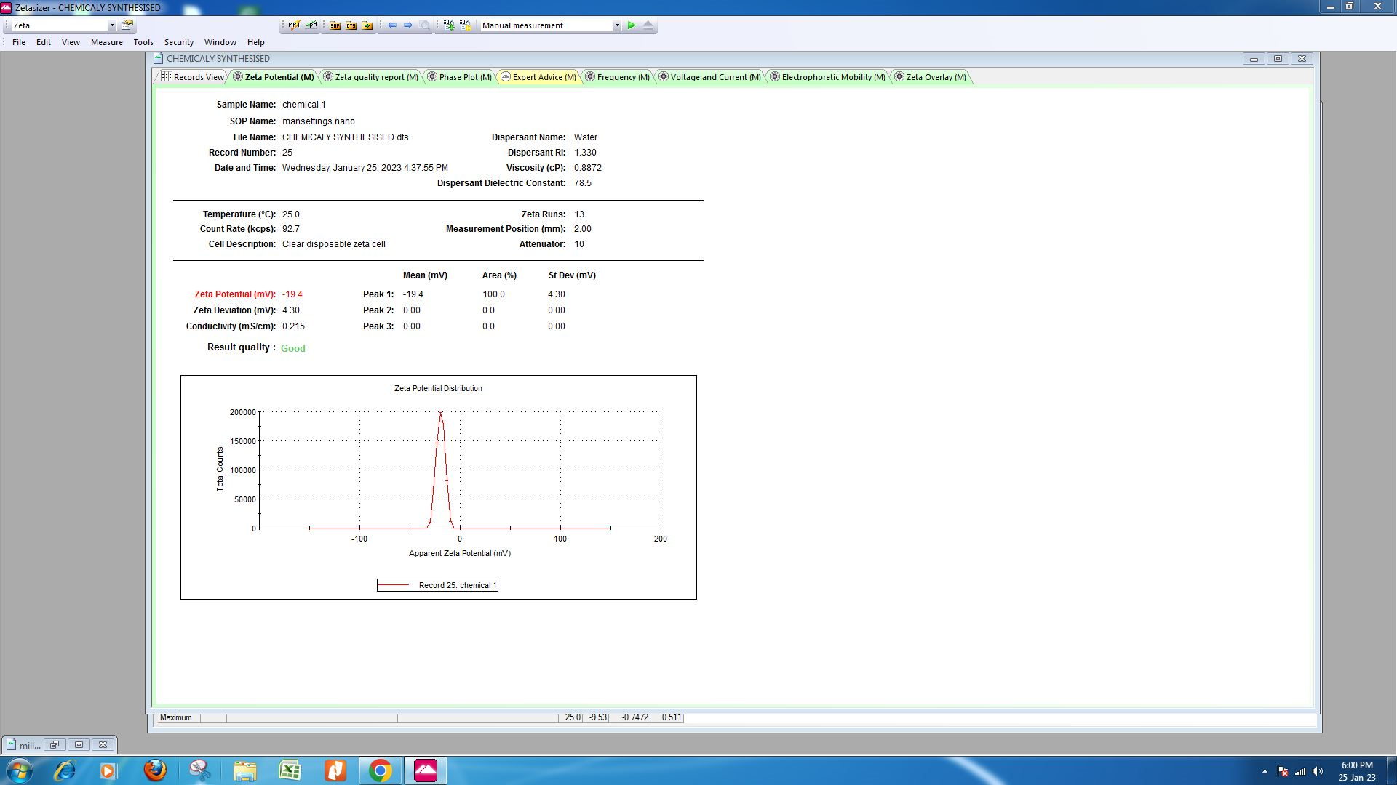 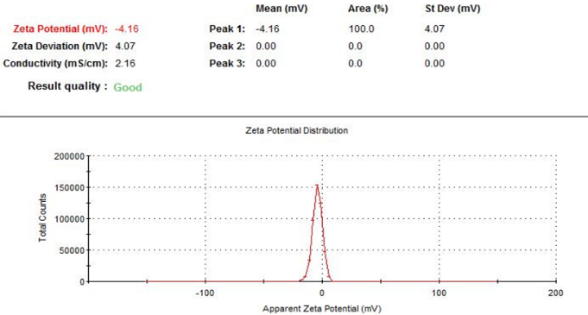

d e

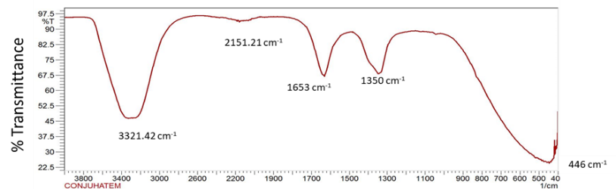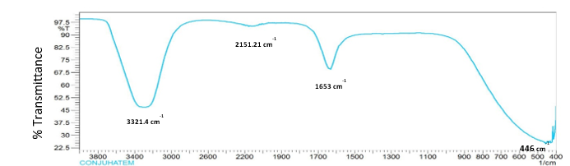

f g

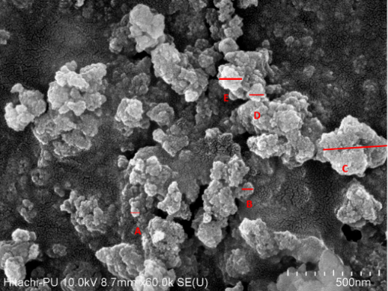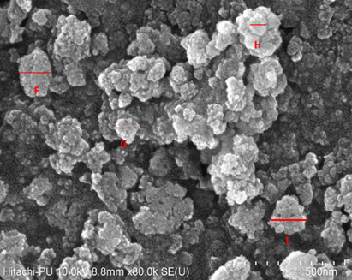

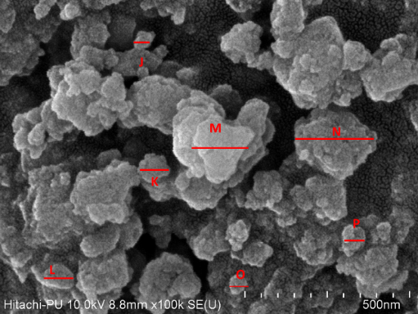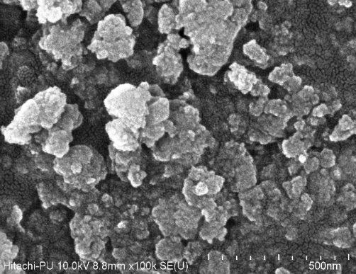

**h**

**Fig. 2. Characterization of zinc oxide nano particle and zinc oxide nanoparticle peptide conjugate. (a)UV-VIS absorbance of zinc oxide nanoparticle peptide conjugate,(b) Dynamic Light Scattering of zinc oxide nanoparticle (c) Dynamic Light Scattering zinc oxide nanoparticle peptide conjugate,(d) Zeta potential of zinc oxide nanoparticle (e) Zeta potential of zinc oxide nanoparticle peptide conjugate, (f) FTIR of Zinc oxide nanoparticle (g) FTIR of zinc oxide nanoparticle peptide conjugate, (h) SEM images of zinc oxide nanoparticle peptide conjugate**

**3.3 Efficiency of zinc oxide nanoparticle peptide conjugate as antimicrobial agent**

**3.3.1 Antimicrobial activity of zinc oxide nanoparticle-peptide conjugate**

Among different organisms, *E. faecalis* showed maximum antimicrobial activity with a zone of clearance of 43±0.76 mm followed by *S. enterica subs. enterica* and *S. aureus* with42±0.76 mm followed by *S. aureus*and *E. coli* showed 41±0.76 mm. *B. cereus* showed a minimum zone of clearance of 40±0.76mm. shown in Fig. 3. A recent study reported that nanoparticle–peptide conjugates offer a promising approach for immunomodulation, helping to maintain a balance between antimicrobial activity and inflammatory responses (Wang et al., 2025).

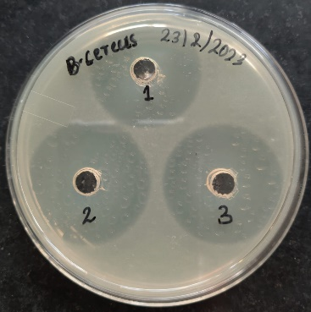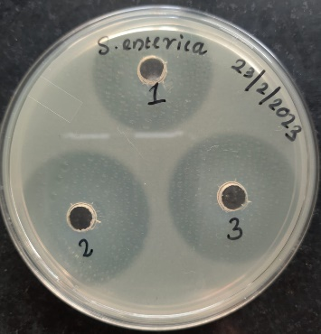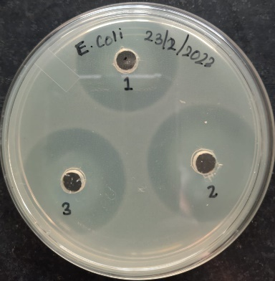

a b c

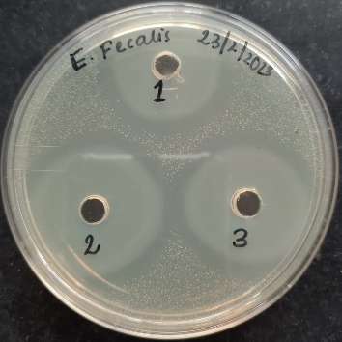 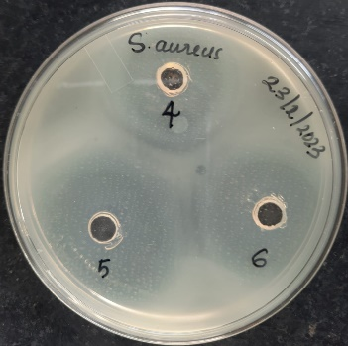

d e

**Fig. 3. Antimicrobial activity of zinc oxide nanoparticle peptide conjugate against a-*B. cereus*, b*-S. enterica*, c- *E. coli*, d-*E. faecalis*, e-*S. aureus***

**3.3.2 Minimum inhibitory concentration and minimum bactericidal concentration of zinc oxide nanoparticle peptide conjugate**

All the organisms showed the same minimum inhibitory concentration which was 1.01±0.20 µg/mL. *E. coli* and *B. cereus* showedleast value of MBC that is 8.125±0.20 µg/mL. On the other hand, *E. faecalis*, *S. enterica subs. enterica* and *S. aureus* showed a maximum value of MBC (16.25±0.33 µg/mL).

**3.3.3 Optimization of contact time and concentration of zinc oxide nanoparticle peptide conjugate**

Swab samples were collected from the calving area, which had an initial microbial count of 13.93 Log CFU/mL. These samples were treated with different concentrations of zinc oxide nanoparticle-peptide conjugates (ZONPC) for various time intervals at room temperature. At a concentration of 10 µL/mL and a contact time of 5 minutes, the microbial count was reduced by approximately half. Extending the contact time to 60 minutes resulted in a 2-log reduction. When the concentration was increased to 50 µL/mL, a 4-log reduction from the initial count was observed after 60 minutes. At a concentration of 150 µL/mL, there was a significant reduction a 6-log decrease in microbial count within just 1 minute. Increasing the contact time to 10 minutes resulted in an 8-log reduction, and after 60 minutes, an 11-log reduction was reported. At a concentration of 200 µL/mL, even with just 1 minute of contact time, there was a 10-log reduction in microbial count. Extending the contact time to 5 minutes resulted in an 11-log reduction, and complete destruction of the microorganisms was observed after 30 minutes.

Finally, at a concentration of 400 µL/mL, complete destruction of microorganisms was achieved within 1 minute. Based on these results, a concentration of 200 µL/mL and a contact time of 5 minutes were selected for further studies.

**3.3.4** **Antimicrobial Efficiency of zinc oxide nanoparticle peptide conjugate against individual microorganisms**

On treating the sample with ZONPC for the specific contact time at a specific concentration the initial count of the respective organisms ie, *B. cereus*(5.75 Log CFU/mL), *S. aureus* (5.10 Log CFU/mL), Salmonella, Shigella (6.42 Log CFU/mL) and Coliform (6.26 Log CFU/mL) reduced to zero. Fig.9 represents the individual microbial count before and after treatment with zinc oxide nanoparticle peptide conjugate. Reduction in microbial colonies can be observed in Fig. 4.

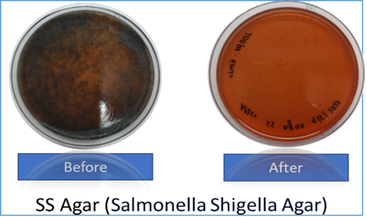  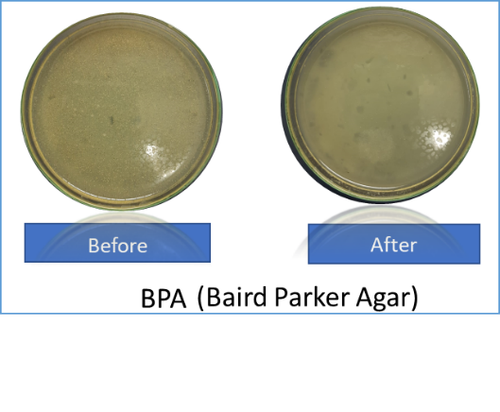

**a b**

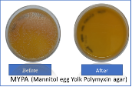 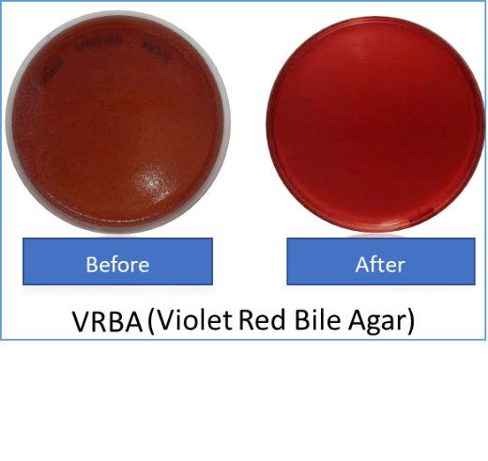

**c d**

**Fig. 4. Reduction in different microbial count (a)- *Salmonella, Shigella*, (b)- *S. aureus,* (c)- *B. cereus* and (d) *Coliform***

1. **CONCLUSION**

It can be concluded that zinc oxide nanoparticle peptide conjugate which have high efficiency to kill or reduce the number of organisms present in milk production area. Nanoparticle-peptide conjugates have shown great promise in various applications, including water treatment, sanitation of floor area and cleaning of animal’s skin, udder etc. Therefore, the developed technology can be used as an ecofriendly alternative to the chemical sanitizer. Further, the application of the prepared ZONPC as effective innovative sanitizing solutions as an alternate to traditional sanitizer in milk production area may be extensively explored and may also be used against different antibiotic-resistant and non-resistant organisms. Further studies may be required to test the toxicity of the developed nanoparticle conjugates for its safe use.

**Disclaimer (Artificial intelligence)**

Option 1:

Author(s) hereby declare that NO generative AI technologies such as Large Language Models (ChatGPT, COPILOT, etc.) and text-to-image generators have been used during the writing or editing of this manuscript.

**REFERENCES**

Abomuti, M. A., Danish, E. Y., Firoz, A., Hasan, N., & Malik, M. A. (2021). Green synthesis of zinc oxide nanoparticles using salvia officinalis leaf extract and their photocatalytic and antifungal activities*. Biology*, 10(11): 1075

Aguilar-Toalá, J. E., Santiago-López, L., Peres, C. M., Peres, C., Garcia, H. S., Vallejo Cordoba, B., & Hernández-Mendoza, A. (2017). Assessment of multifunctional activity of bioactive peptides derived from fermented milk by specific Lactobacillus plantarum strains. *Journal of Dairy Science*, 100(1): 65-75.

Ahmed, I., Kumar, S., & Aggarwal, D. (2020). Assessment of knowledge and practices of hygienic milk production among dairy farmworkers, Southwest Delhi. *Indian Journal of Community Medicine*: Official Publication of Indian Association of Preventive & Social Medicine, 45(Suppl 1): S26

Aslinjensipriya, A., Narmadha, S., Deepapriya, S., John, D. R., Grace, I. S., Reena, R. S., & Jerome, D. S. (2020, June). Synthesis and characterization of ZnO nanoparticles by novel sol gel technique. In AIP Conference Proceedings (Vol. 2244, No. 1, p. 070013). AIP Publishing LLC.

Barbuddhe S.B., Malik S.V.S., J. Ashok Kumar, Kalorey, D.R., and Chakraborty, T. (2012). Epidemiology and management of listeriosis in India. *International Journal of Food Microbiology*. 154(3):113-118.

Dohmen, T., Falk, A., Huffman, D., & Sunde, U. (2010). Are risk aversion and impatience related to cognitive ability?. *American Economic Review*, 100(3):1238-1260.

Ealia, S. A. M., & Saravanakumar, M. P. (2017, November). A review on the classification, characterisation, synthesis of nanoparticles and their application. In IOP conference series: *Materials Science and Engineering* (Vol. 263, No. 3, p. 032019). IOP Publishing.

Gumala, A., & Saputri, F. C. (2020). Characterization and biodistribution of trans resveratrol-PEG-folic acid-gold nanoparticle conjugates. *Tropical Journal of Pharmaceutical Research*, 20(2): 223-230.

Ismail, A., Raya, N. R., Orabi, A., Ali, A. M., & Abo-Zeid, Y. (2022). Investigating the Antibacterial Activity and Safety of Zinc Oxide Nanoparticles versus a Commercial Alcohol-Based Hand-Sanitizer: Can Zinc Oxide Nanoparticles Be Useful for Hand Sanitation?. *Antibiotics,* 11(11): 1606.

Janaki, A. C., Sailatha, E., & Gunasekaran, S. (2015). Synthesis, characteristics and antimicrobial activity of ZnO nanoparticles. *Spectrochimica Acta Part A: Molecular and Biomolecular Spectroscopy*, *144*, 17-22.

Jeong, W. J., Bu, J., Kubiatowicz, L. J., Chen, S. S., Kim, Y., & Hong, S. (2018). Peptide–nanoparticle conjugates: a next generation of diagnostic and therapeutic platforms?. *Nano Convergence*, *5*, 1-18.

Khan, I., Saeed, K., & Khan, I. (2019). Nanoparticles: Properties, applications, and toxicities. *Arabian Journal of Chemistry*, 12(7): 908-931

Mahamuni, P. P., Patil, P. M., Dhanavade, M. J., Badiger, M. V., Shadija, P. G., Lokhande, A. C., & Bohara, R. A. (2019). Synthesis and characterization of zinc oxide nanoparticles by using polyol chemistry for their antimicrobial and antibiofilm activity. *Biochemistry and Biophysics Reports*, 17: 71-80.

Manna, A. C. (2011). Synthesis, characterization, and antimicrobial activity of zinc oxide nanoparticles. In *Nano-antimicrobials: Progress and prospects* (pp. 151-180). Berlin, Heidelberg: Springer Berlin Heidelberg.

Mostafaii, G., Chimehi, E., Gilasi, H., & Iranshahi, L. (2017). Investigation of zinc oxide nanoparticles effects on removal of total coliform bacteria in activated sludge process effluent of municipal wastewater. *Journal of Environmental Science and Technology*, 10(1): 49-55.

Osman, D. A. M., & Mustafa, M. A. (2015). Synthesis and characterization of zinc oxide nanoparticles using zinc acetate dihydrate and sodium hydroxide. *J. Nanosci. Nanoeng*, *1*(4), 248-251.

Reneau, J. K., Seykora, A. J., Heins, B. J., Endres, M. I., Farnsworth, R. J., & Bey, R. F. (2005). Association between hygiene scores and somatic cell scores in dairy cattle. *Journal of the American veterinary medical association*, 227(8): 1297- 1301.

Sánchez, A., & Vázquez, A. (2017). Bioactive peptides: A review. *Food Quality and Safety*, 1(1): 29-46.

Schreiner, D. A., & Ruegg, P. L. (2003). Relationship between udder and leg hygiene scores and subclinical mastitis. *Journal of Dairy Science*, 86(11), 3460-3465.

Siddiqi, K. S. Rahman, A., Tajuddin, N., & Husen, A. (2018). Properties of zinc oxide nanoparticles and their activity against microbes. *Nanoscale Research Letters*, 13, 1-13.

Vignoni, M., de Alwis Weerasekera, H., Simpson, M. J., Phopase, J., Mah, T. F., Griffith, M., ... & Scaiano, J. C. (2014). LL37 peptide@ silver nanoparticles: combining the best of the two worlds for skin infection control. *Nanoscale*, 6(11): 5725-5728.

Wang, Y., Zhou, H., Liu, Y., Wang, X., Zhang, L., Cai, J., & Zhang, W. (2025). A peptide-nanoparticle conjugate to steer elimination of drug-resistance bacteria and LPS. *Chemical Engineering Journal*, *511*, 161993.

Wiegand, I., Hilpert, K., & Hancock, R. E. (2008). Agar and broth dilution methods to determine the minimal inhibitory concentration (MIC) of antimicrobial substances. *Nature Protocols*, 3(2): 163-175.

**ABBREVIATIONS**

MBC- Minimum bactericidal concentration

MIC - Minimum inhibitory concentration

ZONP-zinc oxide nanoparticle

ZONPC-zinc oxide nanoparticle peptide conjugates

CFU- Colony forming unit

ZOI-Zone of inhibition

FTIR-Fourier transformer infrared spectroscopy

SEM- Scanning electron microscope