**Biofortification Strategies in Horticultural Crops: Addressing Micronutrient Malnutrition through Innovation**

**Abstract**

Micronutrient malnutrition, or "hidden hunger," is still a serious world public health issue, especially in developing nations. It occurs due to insufficient intake of vital vitamins and minerals like iron, zinc, iodine, and provitamin A, affecting one-third of the world's population. Biofortification, the increase in the content of nutrients in plants by traditional breeding, transgenic approaches, or agronomy practices has been a cost-efficient and sustainable solution to address this phenomenon. Although the majority of attention has been given to staple crops, horticultural crops such as vegetables and fruits have vast potential owing to their inherent richness in vitamins, minerals, and antioxidants. Recent progress in biofortification methods like molecular breeding, genome editing, and nanotechnology is addressed in this review. It also mentions the production of nutrient-dense horticultural varieties such as Pusa Betakesari, Bhu Sona, Bhu Krishna, Kufri Neelkanth.

**Keywords**- Biofortification, Hidden hunger, Antioxident, Biofortification Strategies

**Introduction**

The international agricultural agenda has taken a dramatic shift over the years showing concern for food security during the latter part of the 20th century to nutritional security during the 21st century (Falcon, and Naylor, 2005). Although calorie sufficiency has been met for much of the world, and it is still gripped by the issue of "hidden hunger" micronutrient malnutrition that plagues more than 2 billion individuals worldwide (WHO) (Kent, 2015). This type of malnutrition is especially prevalent among children and women in poor countries and is marked by a lack of vital vitamins and minerals in spite of sufficient caloric consumption (Parida et al., 2023).

Bio-fortification derived fromtwo-word***Bios & Fortificare*** *in which* **“*Bios*” Greek word means “life” and “*Fortificare*” derived from latin word means “Make strong” Bio-fortification is** an process by which the nutritional worth of food is increased through selective breeding or genetic modification. Bio-fortification is different from traditional fortification, because this process changes the plant itself ( Saikanth, et al., 2023). Bio-fortification can be defined as the development of micronutrient-dense staple crops (cereals and vegetables) using traditional plant breeding practices, modern biotechnology, and agronomical approached.

Bio-fortification is a process that alters crops to improve their nutritional value. Bio-fortification is different from traditional fortification, because this process changes the plant itself.

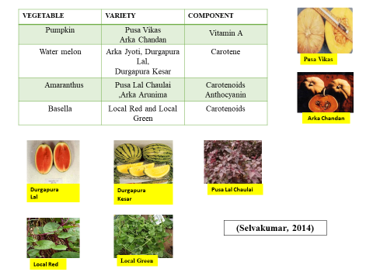

**Figure-1. Image of different nutrient rich varieties**

Malnutrition in the form of micronutrient deficiencies also known as "hidden hunger" remains a leading global public health problem (Nagar et al., 2024). It is estimated that billions of individuals have low intake of key vitamins and minerals like iron, zinc, vitamin A, and iodine, causing weakened immune systems, stunted cognitive growth, excess mortality among children and mothers, and lower economic productivity (Awuchi et al., 2020). This is particularly so in low- and middle-income countries where dietary restriction prevails and intake of nutrient-dense foods is limited.

Conventional methods of fighting micronutrient deficiency have, to a great extent, depended on supplementation (e.g., iron and folic acid tablets) and fortification of food (e.g., iodization of salt or vitamin A fortification of oil) (Berti, et al., 2014). Although these strategies have been successful in urban and semi-urban areas, their effect has been limited in distant and rural areas. Logistical challenges, costs, poor infrastructure, weak health systems, and low awareness have been major limitations to the wide coverage and ultimate sustainability of these interventions (Balabanova et al., 2013).

Biofortification, a comparatively newer and more sustainable strategy, circumvents these drawbacks by increasing the nutritional value of crops during their natural growth cycle through conventional breeding, agronomic intervention, or advanced biotechnological means (Ofori, et al., 2022). In contrast to external supplementation or fortification, biofortified food produces essential micronutrients directly through regular diets without calling for extensive behavior modification or recurring external input. Early biofortification interventions focused on staple food crops such as rice, wheat, maize, and cassava principal energy sources for most of the world's population (Bouis, et al., 2010).

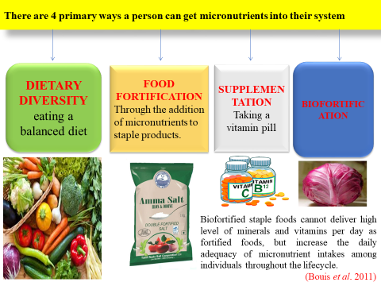

**Figure-2. Image of way to get micronutrient**

(Source, Bouns et al., 2011)

In the last decade or so, an increasing awareness of the possibility of biofortifying horticultural crops, including fruits, vegetables, tubers, and legumes, has gained momentum (Kumari,. Et al., 2022) Horticultural crops contain micronutrients, antioxidants, dietary fiber, and phytochemicals in higher concentrations, making them important in closing nutritional gaps and enhancing overall well-being (Wamiq et al., 2022) Their nutrient content can be increased through biofortification, and this not only makes them more valuable but also assists in the attainment of several Sustainable Development Goals (SDGs), such as those on zero hunger, good health and well-being, and sustainable agriculture (Atukunda, et al., 2021).

As global food systems align more resilient and nutrient-dense, and as consumer concern about nutrition and health continues to grow, the biofortification of horticulture crops is becoming an important strategy (Dwivedi, et al., 2023). Not only does it have the potential to fight malnutrition successfully, but it also has the potential to enhance livelihoods, empower smallholder farmers, and support climate-resilient food systems.

HarvestPlus's founding director, Dr. Howarth Bouis, first used the strategy of biofortification in the early 1990s. He envisioned fighting hidden hunger in a sustainable, low-cost approach: enhancing the nutritional quality of staple and horticultural foods through the fortification of vitamins and micronutrients like iron (Fe), zinc (Zn), selenium (Se), magnesium (Mg), calcium (Ca), iodine (I), and provitamin A (Sharma et al., 2017). By 2030, HarvestPlus seeks to eradicate hidden hunger by promoting access to biofortified crops for everybody, particularly the marginal and far-flung communities (Jangra, and Tiwari, 2025).

Micronutrient malnourishment, also known as "hidden hunger," is a prevalent global health problem that continues to impact more than two billion individuals, especially in underdeveloped and developing areas (Bouis, H. (2018). Micronutrient malnourishment occurs as a result of poor consumption levels of critical vitamins and minerals like iron, zinc, iodine, and vitamin A (Wakeel, et al., 2018). It results in a variety of health issues such as compromised immune systems, growth retardation in children, vulnerability to infections, compromised cognitive functioning, and high maternal and infant mortality. In spite of various international efforts to end hunger and malnutrition, the problem endures as a result of poverty, low dietary diversity, and lack of access to fortified or nutrient-dense foods, primarily in the rural and marginalized communities (Li et al., 2020).

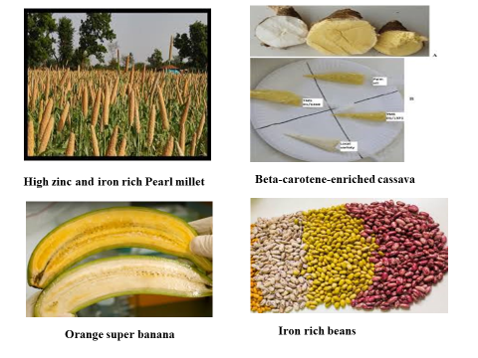

**Figure-3. Image of some Biofortification crop**

Horticultural crops consisting of fruits, vegetables, tuber crops, and spices contribute significantly to human nutrition by offering a broad range of essential micronutrients, antioxidants, dietary fiber, and bioactive compounds (Dias, 2012). Such crops not only contribute to satisfying daily nutritional needs but also to minimizing the threat of non-communicable diseases like cardiovascular disorders, diabetes, and some cancers. In contrast to staple cereals, horticulture crops occur naturally in high nutritional density, which makes them important to advocate for balanced diets and enhanced overall health and well-being (Welch et al., 2001).

**Table-1. Traditional Fortification vs. Biofortification**

|  |  |  |
| --- | --- | --- |
| **Aspect** | **Traditional Fortification** | **Biofortification** |
| **When applied** | During food processing | During crop growth |
| **Example** | Adding iron to breakfast cereals | Developing iron-rich beans |
| **Sustainability** | Needs continuous investment | One-time investment in seed breeding |
| **Reach** | Urban and processed food consumers | Rural, low-income, subsistence farming families |
| **Method** | Industrial food processing | Breeding, genetic modification, or fertilization |

**(Source, Yadav et al., 2020)**

**Biofortification of Horticultural Crops**

While most efforts at biofortification have originally targeted cereals, horticulture crops are becoming increasingly significant because they are naturally rich in vitamins and minerals (Ofori, et al., 2022). Their augmentation through biofortification is needed for the better handling of deficiency problems. Biofortification of vegetables with vitamins (A, C, folate) and micronutrients (Fe, Zn, Se) is the need of the hour, particularly in areas affected by chronic malnutrition (Bouis et al., 2017).

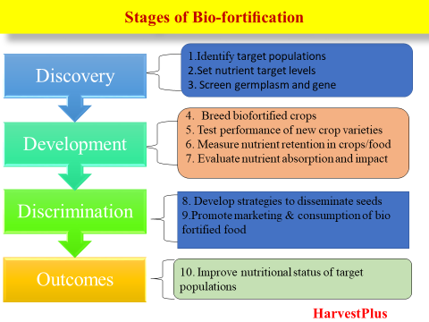

(Source, Winkler 2011 and Lal et al., 2020)

**Figure-4. Stage of Biofortification**

**Why is Biofortification Necessary?**

Biofortification has emerged as a revolutionary strategy to redress the global burden of micronutrient malnutrition, especially in low- and middle-income nations (Priyashantha et al., 2025). It presents a strategic, sustainable, and economically viable way of enhancing the diet's nutritional quality by increasing the micronutrient composition of crops at the point of origin.

**Table 2. Achievements in Bio-fortified Nutraceuticals in Some Vegetables**

|  |  |  |
| --- | --- | --- |
| **Crop** | **Biofortified Element / Mineral / Vitamin / Phytochemical** | **References** |
| **Tomato** | Chlorogenic acid, flavonoids, anthocyanin, stilbene, folate, phytoene, β-carotene, lycopene, provitamin A | Rosati et al. 2000; Muir et al. 2001; Giovinazzo et al. 2005; DellaPenna 2007 |
| **Onion & Broccoli** | Selenium | Adhikari 2012; Goto et al. 2000 |
| **Lettuce** | Iron | Morris et al. 2008 |
| **Carrot** | Calcium | Park and Lee 2003 |
| **Radish** | Selenium | Fernandes et al. 2014 |
| ***Brassica* spp.** | Selenium | Seppanen et al. 2010 |

(Source, Parulekar et al., 2019)

**Addresses Micronutrient Deficiencies**

Micronutrient deficiencies, or so-called "hidden hunger," reach more than two billion people worldwide and are particularly common among vulnerable groups like children and women of childbearing age. Among the most prevalent and harmful deficiencies are those for iron (Fe), zinc (Zn), selenium (Se), iodine (I), and vitamin A, which lead to stunted cognitive development, compromised immunity, blindness, and death (Kurdekar et al., 2023). Biofortification addresses these deficiencies directly by enhancing the concentration and bioavailability of critical nutrients in staple and horticultural foods. This approach guarantees improved nutrient intake by consumption of regular foods, without dietary change (Naik, et al., 2024).

**Cost-Effective and Self-Sustaining**

One of the strongest points about biofortification is that it is cost-effective. Compared to supplementation and industrial fortification of foods, which entail repeated expenditure, distribution chains, and reliance on continued government or donor funding, biofortified crops provide a single up-front investment in breeding or biotechnology. After developing and adopting nutrient-enriched varieties, the advantageous traits are reproduced perpetually through seeds, rendering the gains sustainable in the long term. This renders biofortification especially appealing for low-resource environments and national nutrition policy (Birol et al., 2014).

**Accessible to the Rural Poor**

Biofortification is intended to target populations who are frequently left out of traditional nutrition interventions, including individuals who live in rural, isolated, and impoverished areas. Such populations tend to subsist on subsistence agriculture and have restricted access to fortified processed foods, health facilities, or nutritional supplements. By incorporating nutrition into crops they already produce and eat e.g., tomatoes, sweet potatoes, bananas, and beans biofortification facilitates wide reach and enables smallholder farmers to grow and eat more nutritious food (Saltzman et al., 2013).

**Environmentally Sustainable**

Aside from its nutritional value, biofortification is also an environmentally friendly intervention. After the development of biofortified varieties, they do not need more land, water, or chemical inputs than the conventional varieties. In other cases, agronomic biofortification by micronutrient fertilization can enhance soil health and crop yields. Additionally, most biofortified crops are also developed for abiotic and biotic stress tolerance, which furthers climate-smart agriculture and long-term food system sustainability (Ofori, et al., 2022).

**Fights Malnutrition at the Root**

Biofortification fights malnutrition at its agricultural root, long before food makes it to processing, distribution, or consumption levels. This upstream preventive measure means that food contains important nutrients at the point of harvesting, storage, cooking, and consumption. It reduces post-harvest handling and processing losses of nutrients and achieves a minimum nutritional value even at unprocessed or raw levels. This "nutrition-sensitive agriculture" approach reinforces the connection between agriculture and public health and contributes to the overall objective of food and nutrition security (Wakeel et al., 2018).

**Malnutrition: The Problem Biofortification Seeks to Address**

Malnutrition happens when the body lacks enough nutrients for health and growth. Hidden hunger, or micronutrient malnutrition, impacts mental performance, immunity, reproduction, and physical development (Kurmi, et al., 2023). The World Health Organization estimated that almost 1 in 3 individuals globally experience micronutrient deficiencies, despite having sufficient calories. Biofortification presents a science-based, sustainable, and inclusive response to this pervasive problem.

Malnutrition is when the body does not receive sufficient essential nutrients to grow or live and severe cases will result in death. Globally, numerous individuals endure malnutrition (Saunders et al., 2011). Researchers have come up with a method known as bio-fortification to enhance the nutritional value of crops and avoid malnutrition. Envision a disease that impacts 2 billion people globally. This problem is known as malnutrition, and it has to do with the food that we eat! Some individuals experience malnutrition because they are not receiving enough food to eat. But other individuals who do obtain sufficient calories are still at risk for malnutrition, of a different sort (Chatindiara et al., 2020).

In spite of this chance, the UNICEF, WHO, World Bank global and regional child malnutrition estimates indicate that we are still far from a malnutrition-free world. The joint estimates, which came out in March 2020, include indicators of stunting, wasting, severe wasting and overweight in children under the age of 5, and indicate poor progress towards the World Health Assembly targets for 2025 and the Sustainable Development Goals for 2030.

**Type of malnutrition**

**Stunting:** - Stunted growth is a child who is too short for his or her age. Such children can develop serious irreversible physical and mental damage that goes with stunted growth. The ruinous consequences of stunting can last throughout life and even be passed on to the next generation (Stenvinke et al.,2000).

**Wasting:** Wasting is a child who is too thin for his or her height. Wasting results from recent rapid weight loss or inability to gain weight. A moderately or severely wasted child has a higher risk of dying, yet treatment is available ((Stenvinke et al.,2000).

Overweight is a child who is heavier than his or her height. This type of malnutrition arises from energy from food and drinks in excess of children's energy needs. Overweight poses the risk of diet-related non-communicable diseases in the future.

**Table-3. Micronutrients Targeted in Biofortification Programs**

|  |  |  |
| --- | --- | --- |
| **Nutrient** | **Function** | **Example Crop** |
| **Iron (Fe)** | Prevents anemia | Beans, Pearl millet |
| **Zinc (Zn)** | Boosts immunity and growth | Wheat, Amaranthus |
| **Vitamin A** | Maintains vision and immune system | Sweet potato, Banana, Carrot |
| **Selenium (Se)** | Antioxidant and thyroid function | Broccoli, Onion |
| **Iodine (I)** | Prevents goiter, supports metabolic health | Biofortified leafy gr |

**Table-4. Recommended dietary allowances for Indians adult**

|  |  |  |  |
| --- | --- | --- | --- |
| Minerals | Daily requirement | Functions | Deficiency symptoms |
| Calcium | 1000 mg/d | Development of teeth and bones, required for phosphorus absorption. | Causes improper blood clotting and osteomalacia. |
| Phosphorous | 1000 mg/d | Component of nucleic acid and plays vital role in cellular metabolism | Causes weight loss and general weakness. |
| Iron | 19mg/d | Formation of haemoglobin and involved in transport of oxygen. | Anaemia, pale lips and spoon shaped nails. |
| Sodium | 2000 mg/d | To maintain the osmotic balance and keep the cells in proper shape. | Weight loss and nervous breakdown. |
| Iodine | 1.5µg/d | Functioning of thyroid gland and production of thyroxin hormone. | Goiter. |
| Calcium | 1000 mg/d | Development of teeth and bones, required for phosphorus absorption. | Causes improper blood clotting and osteomalacia. |
| Vit A  (Retinol) | 1000 µg/d | For clear vision and increases resistance to infections | Night blindness, xerophthalamia and keratinisation |
| Vit B1  (Thiamine) | 1.4 mg/d | For proper utilization of carbhohydrates | Beriberi disease |
| Vit B2  (Riboflavin) | 2.0 mg/d | Oxidation reaction inside the cell | Ulcer in oral cavity. |
| Vit B12  (Cobalamin) | 2.2 µg/d | Maturation of red cell and proper functioning of CNS | Pernicious anaemia |
| Vit C  (Ascorbic acid) | 80 mg/d | For collagen synthesis and calcification of bones and teeth | Scurvy and reduced resistance to diseases |
| Vit D | 600IU/d | Calcification of bones and teeth | Rickets in children and osteomalacia in adults |
| Vit E  (Tocopherol) | 7.5-10 mg/d | Promotion of fertility | Paralysis of eye muscles |
| Vit K  (Anti hemorrhagic vitamin) | 7.5-10 mg/d | Coagulation of blood and secretion of bile juice from liver | Unusual bleeding from the gums, nose or gastrointestinal tract |

(Source, Deepthi et al., 2023)

**Biofortification and Zero Hunger Challenge**

The world community is confronted with an urgent task: making sure all people have access to adequate, safe, and nutritious food throughout the year. In this regard, biofortification becomes a key instrument in making the Zero Hunger Challenge, which was initiated by the United Nations with the aim of ending hunger and malnutrition by 2030, a reality (Srivastav et al., 2022).

Biofortification is a revolutionary new development in the battle against hunger and malnutrition. When combined with wider agricultural and nutritional strategies, it has the potential to make a major contribution to the Zero Hunger Challenge, enhancing the lives and prospects of millions (Atukunda et al., 2021).

The Zero Hunger Challenge is an international call to action to stop hunger, eradicate all malnutrition, and establish inclusive and sustainable food systems (Lile et al., 2023). It is a call for collective action by governments, civil society, scientists, and communities to achieve food security and better nutrition for everyone.

Regardless of various interventions and programs taken up by the state and central governments as well as non-government organizations (NGOs), India still suffers from unacceptable levels of malnutrition. The most critical reason for it is also the separation between nutrition and agriculture. Hunger and malnutrition cannot be eradicated until we are able to integrate nutritional objectives with agricultural activities successfully.

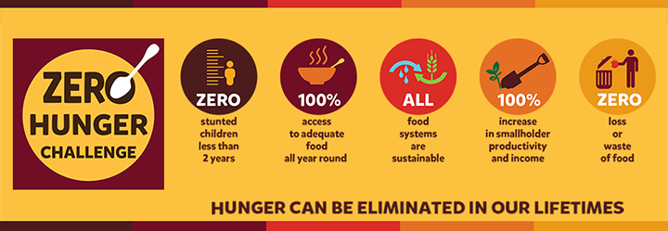

(Source, <https://discover.hubpages.com/business/Global-Efforts-to-Zero-Hunger>)

**Figure-5. Hunger Elimination**

**Key Micronutrients Prioritized for Biofortification**

Prioritized in biofortification are several key micronutrients that are most often lacking in human diets and have major public health implications (Srivastav et al., 2022). Biofortification with these nutrients in horticultural crops not only enhances dietary diversity but is directly involved in the prevention of micronutrient malnutrition ((Johns, and Eyzaguirre, 2007). The following is a summary of the most essential micronutrients prioritized for biofortification and horticultural crops involved:

**Iron (Fe)**

Iron is vital for the synthesis of hemoglobin and myoglobin, which are involved in the transport of oxygen in blood and muscles. Iron deficiency results in anemia, weakness, impaired growth in children, and higher maternal mortality.

Biofortified crops for iron are characterized by high-iron beans (*Phaseolus vulgaris*), particularly bred through traditional breeding schemes in East Africa (Beebe, 2020). Amaranth and spinach, with their natural high content of iron, have also been chosen to have their content improved through varieties. Pumpkin leaves and cowpea leaves also have potential as iron-rich leafy greens that can be further enhanced.

**Zinc (Zn)**

Zinc is important for immune function, wound healing, and cell growth and development. Zinc deficiency is linked to impaired growth, impaired immunity, and susceptibility to infections.

Crop horticulture for zinc biofortification involves crops like tomatoes, which are enriched with agronomic practices like foliar sprays and soil application (Rabbi et al., 2024). Zinc enhancement potential has been demonstrated using field trials in onions and garlic, especially by means of nano-fertilizers (Afify etal., 2023). Certain varieties of cabbage and carrots have also been found to accumulate more zinc.

**Vitamin A (β-Carotene)**

Vitamin A is required to ensure eyesight, facilitate the immune system, and encourage epithelial tissue wellness. Its lack can lead to night blindness and increased susceptibility to infections.

Biofortification for vitamin A targets crops like orange-fleshed sweet potato (*Ipomoea batatas*), which is high in β-carotene and heavily marketed in Asia and Africa. Carrots (Daucus carota), which are rich in provitamin A, have been bred to have an even higher content of carotene. Golden banana, a genetically engineered crop cultivated in Uganda, is rich in provitamin A. Also, tomato crops with higher levels of β-carotene and lycopene have been produced using genome editors such as CRISPR/Cas9.

**Iodine (I)**

Iodine is essential for the synthesis of thyroid hormones, which control metabolism, growth, and mental functions. Iodine deficiency may cause goiter, hypothyroidism, and stunted growth.

Agronomic biofortification of spinach and lettuce with iodine-fortified irrigation has been fruitful (Duborská, et al., 2020). Cucumber has exhibited enhanced iodine levels when foliar iodine sprays are administered (Ikram et al., 2025). Likewise, experimental application of iodine-fortified fertilizers in tomato and cabbage has been encouraging.

**Selenium (Se)**

Selenium is essential for antioxidant protection, thyroid hormone function, and immune response. Selenium deficiency may cause diseases like Keshan disease, infertility, and impaired brain function.

Horticultural produce has been targeted for selenium-rich biofortification, such as broccoli that occurs naturally high in selenium and is currently being researched for varietal improvement (Hossain, et al., 2021). Onion has also demonstrated good selenium accumulation, particularly when cultivated in selenium-amended soil or foliar-fertilized with selenium-containing fertilizers. Foliar selenium sprays and nano-selenium formulations have been investigated in experimental research to increase the selenium concentration in tomatoes and lettuce (Tsivileva, 2025).

**Strategies of Biofortification in Horticultural Crops**

Biofortification of horticultural crops can be done through different scientific and technological approaches, each having merits and facing limitations. The approach depends on the crop variety, target nutrient, local agro-climatic conditions, and socio-economic viability. The prominent strategies are conventional breeding, agronomic biofortification, transgenic strategies, genome editing, and nanotechnology-based intervention (Prasad et al. 2015).

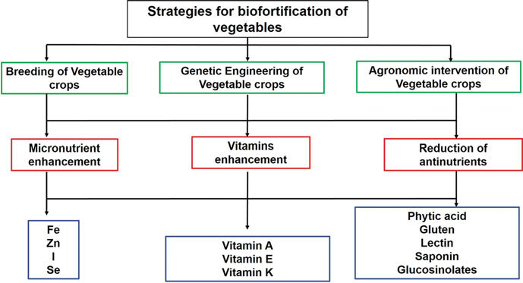

(Lal et al., 2020)

**Figure-6. Strategies for Biofortification**

**Conventional Breeding**

Traditional breeding is one of the oldest and most accepted techniques of biofortification. It consists of crossing and selecting parent plants that naturally carry higher levels of desirable nutrients and creating nutritionally superior cultivars (Shahzad, et al., 2021). The effectiveness of this technique depends greatly on the availability of ample genetic variation and the heritability of nutritional characters.

Prominent success stories are the release of orange-fleshed sweet potato with high provitamin A, which has been adopted in Sub-Saharan Africa in a big way, and high-iron beans launched in Latin America and Africa that contribute to the reduction of iron deficiency anemia (Gurmu, et al., 2014). These instances show the potential of traditional breeding for enhancing public health through dietary diversification.

Nevertheless, this strategy is not free of constraints. Narrow genetic base for specific traits, extended breeding periods, and possible yield-nutrient trade-offs can inhibit progress. Moreover, simultaneous breeding for multiple nutrients may be challenging with existing genetic correlations and environmental interactions.

Plant breeding is an excellent tool to combat the problem of malnutrition with the use of varieties to develop new, productive and ‘biofortified’ crop lines for farmers to grow (Sao et al., 2023). These techniques are used to identify varieties with high amount of desired nutrients. Then this characteristic is transferred into cultivated varieties by crossing and individual plants were selected for those desired characteristics. Breeding approach can be used to develop biofortified varieties that enriched with high levels of micronutrients such as zinc or betacarotene etc. (Nestel *et al*., 2006). biofortified cassava with improved vitamin and mineral contents.

Strategy of conventional breeding is crossing between one of parent having higher levels of that nutrient and second parent wild relatives with the domesticated crop. Most prominent example of conventional breeding is orange fleshed sweet potato (OFSP) (Low et al., 2020). The progress has been made in the breeding of these important crops. Biofortified crops are released through

HarvestPlus and its partners in Uganda (OFSP), Zambia (maize), Nigeria (cassava), the Democratic Republic of the Congo (DRC) (cassava and beans), Rwanda (beans), and India (pearl millet).

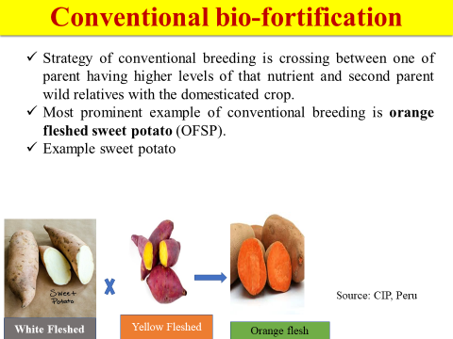

**Figure-7. Image of Conventional Biofortification**

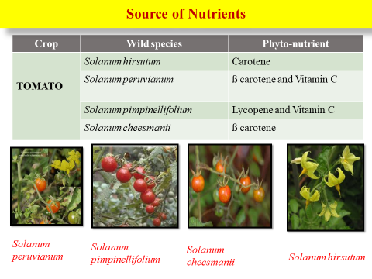

(Source, Parulekar et al., 2019)

**Figure-8. Different tomato species rich source of nutrient**

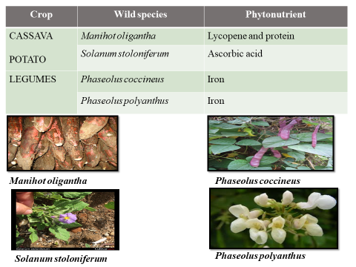

(Source, Parulekar et al., 2019)

**Figure-9. Different topica, Bean, Potato species rich source of nutrient**

**Agronomic Biofortification**

Agronomic biofortification is the use of soil or plant foliar application of mineral fertilizers to enhance the influx and accumulation of vital micronutrients like zinc (Zn), iron (Fe), selenium (Se), and iodine (I) in food parts of horticultural crops (Çakmak et al., 2018).

This method involves techniques such as foliar sprays, soil amendments, and fertigation methods that assist in enhancing nutrient density, especially in deficient soils. For example, zinc sulfate foliar application in leafy greens or selenium-rich fertilizers for garlic has yielded satisfactory results (Dhaliwal et al., 2022).

Combining agronomic biofortification with Good Agricultural Practices (GAPs) like adequate irrigation, organic matter management, and balanced fertilizer application will further improve the efficiency of nutrient acquisition and crop yields (Ofori, et al., 2022). But its advantage may not be sustainable and usually must be applied several times, which may bring economic and environmental issues in the long run.

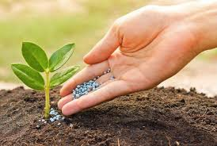

**Figure-10. Image of Agronomic biofortification**

Agronomic bio-fortification is the soil and/or foliar application of micronutrient-containing mineral fertilizer (blue circles) to boost micronutrient levels of the edible component of food crops. Soil, plant leaf (foliar) application of micronutrient-containing mineral fertilizer to enhance micronutrient levels of food crops' edible parts. (De Valença et al. 2017).

The bio-fortification of vegetables through agronomic is one of the easiest and simple approaches of bio-fortification. This method, however, involves a long duration and sufficient money, and this method proves to be valuable in those nations where the genetic engineering approach of Bio-fortification is not well received. In this method, fertilizer is applied either as spray on leaves or as the application of fertilizer in soil (Weng et al. 2013). Success in the bio-fortification of Fe and Zn was indicated where the use of foliar application was utilized for improving these nutrients in edible part as well as plant tissue (Saltzman et al. 2017). Agronomic strategy for bio-fortification also involves crop growing season management practices. The package and practices such as tillage, water management, and nutrient interaction are part of micronutrient improvement. Foliar is the better choice for agronomic bio-fortification with lower amount of Fe and Zn fertilizer compared to soil application (Dimkpa and Bindraban, 2016).

**Transgenic Approaches**

Transgenic or genetically modified biofortification is the process of introducing selected genes into horticultural crops to improve the biosynthesis or storage of necessary nutrients (Malik, and Maqbool, 2020). Transgenic biofortification enables selected manipulation of metabolic pathways which cannot otherwise be manipulated in a chosen way using traditional approaches (Kiran, 2020).

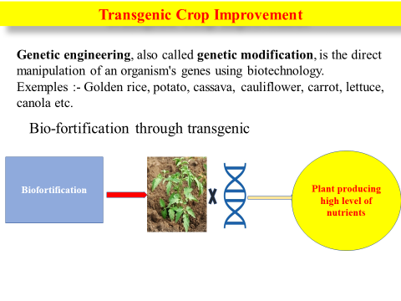

**Figure-11. Image of Transgenic biofortification**

Examples are the production of Golden Banana, which contains higher levels of provitamin A, and high-lysine tomatoes, which provide remedies for essential amino acid deficiencies (Hefferon, 2018). Furthermore, other transgenes like ferritin (to store iron), phytase (to minimize anti-nutritional factors), and carotenoid biosynthetic genes have been effectively employed to enhance bioavailable micronutrients (Kumar et al., 2019).

Although transgenic biofortification has its promise, it is hampered by regulatory challenges, biosafety issues, and acceptability among the public, particularly in countries with stringent GMO regulations (Adeyeye et al., 2019). Environmental risks and ethical implications also call for stringent safety evaluations and open communication.

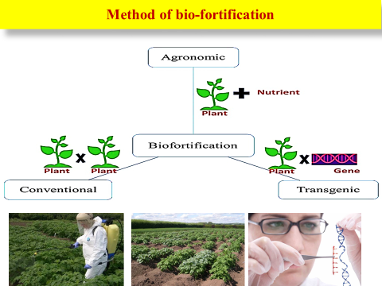

**Figure-12. Image of different method of biofortification**

**Genome Editing (CRISPR/Cas9)**

Genome editing using the CRISPR/Cas9 system is a breakthrough technology that enables targeted modifications in the plant genome without the incorporation of foreign DNA. It is a more accurate, efficient, and rapid alternative to classical genetic engineering (Mishra, et al., 2024).

Recent examples include the creation of lycopene-enriched tomatoes with improved antioxidant activity and stress relief and cardiovascular health tomatoes with high GABA (gamma-aminobutyric acid) content. These features were attained by altering individual genes associated with biosynthetic pathways, providing a high level of specificity and control. Yet, genome editing has also ethical and legal implications, most notably intellectual property rights, labeling, and public attitudes. Gene-edited crops are classified differently in countries, leaving scientists and stakeholders uncertain (Sankhla et al., 2024).

**Nanotechnology-Based Approaches**

Nanotechnology provides a new front in horticultural biofortification through enhanced nutrient delivery systems and improved micronutrient bioavailability. Nano-fertilizers, encapsulated micronutrients within nanoscale particles, enable controlled and effective release of nutrients, thus reducing losses and environmental contamination (Khan et al., 2025).

Although nanotechnology is highly promising, it still raises concerns over its long-term environmental consequences, possible toxicity, and health effects of nano-materials.

**Table-5. Recent Developments in Biofortification of Specific Horticultural Crops**

|  |  |  |  |
| --- | --- | --- | --- |
| **Crop** | **Nutrient Enhanced** | **Strategy Used** | **Outcome** |
| Tomato | Lycopene, Vitamin A | CRISPR, breeding | Higher antioxidant capacity |
| Sweet Potato | β-carotene | Breeding | Golden-fleshed varieties |
| Banana | Iron, Vitamin A | Genetic engineering | Field trials in Africa |
| Carrot | β-carotene | Breeding | Improved varieties for malnutrition |
| Amaranthus | Iron, Zinc | Agronomic practices | Enhanced leaf mineral content |

**Table-6. Key Achievements in Horticultural Crop Biofortification**

|  |  |  |  |
| --- | --- | --- | --- |
| **Crop** | **Nutrient Enhanced** | **Strategy** | **Example** |
| Sweet Potato | Beta-carotene (Vit. A) | Breeding | Orange-fleshed varieties (e.g., ‘Kakamega’) |
| Carrot | Beta-carotene | Breeding | Deep orange varieties |
| Tomato | Lycopene, Folate | Genetic Engineering | Transgenic tomato lines |
| Banana | Vitamin A | Transgenic | Golden Banana |
| Spinach | Iron, Zinc | Agronomic | Foliar Zn/Fe spray |
| Pomegranate | Iron | Breeding | High-Fe cultivars |

**Table 7. Donor Parents Having Nutraceutical Values in Different Vegetable Crops**

|  |  |  |
| --- | --- | --- |
| **Crop** | **Trait** | **Donor(s)** |
| **Tomato** | High ascorbic acid | Solanum pimpinellifolium, Double Rich |
|  | Pro-vitamin A (β-carotene) | Crimson, Caro Red |
| **Potato** | High protein content | — |
| **Pea** | Protein | GC 195, Kinnauri, Laxton |
| **Pumpkin** | Carotene | Golden Delicious |
| **Carrot** | Vitamin A | Pusa Meghali |
| **Pepper** | Carotene | Douxed Alger |

**Case Examples of Biofortified Crops**

Various successful programs across the globe establish the real-world effect of biofortification in combating micronutrient malnutrition. The case examples represent the range of methods rom traditional breeding to advanced genetic engineering and illustrate the achievement in improving the nutritional value of horticultural and staple crops.

**Cassava Fortified with β-Carotene for Vitamin A Deficiency**

Cassava (*Manihot esculenta*), a food staple for millions of sub-Saharan Africans, has been biofortified to have increased levels of β-carotene, a vitamin A precursor (La Frano,et al.,2013). Regular cassava varieties contain minimal amounts of micronutrients, thus populations that are predominantly based on them are at risk of vitamin A deficiency (VAD), whose effects include blindness and elevated child mortality (Eyinla, et al., 2019). With the aid of traditional breeding and marker-assisted selection, orange-fleshed cassava varieties have been bred and distributed in Nigeria and other regions of West and Central Africa. They offer a sustainable food source of vitamin A and have been highly accepted as a result of their comparable agronomic characteristics and enhanced health benefits (Talsma et al., 2016).

**Iron-Dense Beans Distributed in East Africa**

Iron-deficiency anemia is a significant public health challenge in countries such as Rwanda, Uganda, and Kenya (Vaiknoras, and Larochelle, 2021). To fight against this, scientists have generated iron-biofortified common bean (*Phaseolus vulgaris*) varieties using traditional breeding that boost iron content by up to 80% compared to traditional varieties (Beebe, 2020). These common beans are also equipped with favorable traits like high yield, pest resistance, and cooking quality. Since their release by HarvestPlus and national agricultural research systems, these iron-fortified beans have been embraced by farmers and consumers alike and have significantly enhanced iron consumption among vulnerable groups, especially women and children (Cichy et al., 2022).

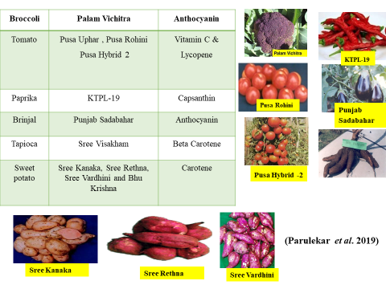

**Figure-13. Image of different nutrient enrichment variety of vegetable**

**Golden Banana Engineered for Provitamin A in Uganda**

The Golden Banana is a genetically modified biofortified crop that was created in Uganda to combat vitamin A deficiency. Locally grown bananas in East Africa, a food staple, are provitamin A-poor by nature (Paul et al., 2018). With transgenic methods, scientists at Queensland University of Technology and Ugandan institutes inserted maize and soil bacterium genes into the banana fruit to dramatically boost β-carotene levels (Kozicka et al., 2021). Trials from the fields in Uganda have shown encouraging results, where certain lines are yielding 20 times the amount of provitamin A compared to standard varieties. Subject to regulation approval, these bananas promise to significantly improve dietary vitamin A intake among banana-reliant communities (Paul et al., 2017).

**Tomato Rich in Amplified Lycopene with CRISPR/Cas9**

Lycopene is a red pigment with potent antioxidant properties linked with lower risk of some cancers and cardiovascular diseases (Przybylska ,and Tokarczyk, 2022). Tomatoes (*Solanum lycopersicum*) are one of the main dietetic sources of lycopene, and recent progress made in genome editing has allowed for its content to be significantly increased. With the use of CRISPR/Cas9 technology, scientists have knocked out genes responsible for the lycopene degradation pathway or edited transcription factors that control carotenoid biosynthesis (Mishra, et al., 2024). They produced tomato varieties with fivefold higher levels of lycopene without any introduction of foreign DNA. Genome-edited tomatoes are free from undesirable taste and shelf-life traits and provide an example of non-transgenic biofortification in horticulture crops. Although regulatory systems for genome-edited crops remain in development, these technologies represent a viable pathway for nutritional improvement with little public pushback (Sankhla et al., 2024).

**Example of different bio fortified variety in india**

The primary objective of the bio-fortification initiatives is the replacement of white fleshed low pro-vitamin A sweet potato cultivars with orange fleshed high pro-vitamin A varieties (Gurmu et al., 2014). In addition, retention of beta carotene from boiled orange fleshed sweet potatoes has been demonstrated to be extremely high with approximately 80% of the original concentration (Neela, and Fanta, 2019). Central Tuber Crop Research Institute (CTCRI) have released number of biofortified varieties containing different nutraceuticals have been released for commercial cultivation in potential areas. In sweet potato, Bhu Sona, Sree Kanaka and Bhu Krishna whereas in tapioca Sree Visakham have been released as biofortified varieties. Pioneer research work on developing nutraceutical varieties have been initiated by Indian Council of Agricultural Research (ICAR), New Delhi.

**Carrot**

In carrot, Pusa Rudhira has been released that is nutritionally superior compared to other types of carrots. The variety was found to contain greater content of carotenoid (7.41 mg) and phenols (45.15 mg 100g-1). The key advantage of these compounds is their antioxidant activity that protects against a number of cancers, seemingly by restricting the abnormal proliferation of cells. Pusa Rudhira is a blessing to consumers and farmers too. Likewise, Pusa Asita better quality carrot variety was released with long black root having self coloured core. Pusa Nayanjyoti, Pusa Vrishti, Pusa Yamdagni, Pusa Meghali rich source of B carotene (Parulekar et al., 2019).

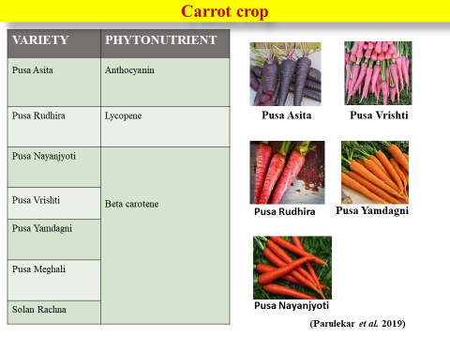

**Figure-14. Image of carrot nutrient enrichment varieties**

**Radish**

Pusa Gulabi is first pink fleshed radish variety out-going in the year 2013 which contains high total carotenoids, anthocyanin and maximum ascorbic acid content which grows very well in the summer heat where as Pusa Jamuni is first purple fleshed nutritionally dense variety containing high anthocyanin and ascorbic acid content (ztmbpd. iari.res.in). Pusa Jamuni, Palam Hriday is rich source of anthocynin.

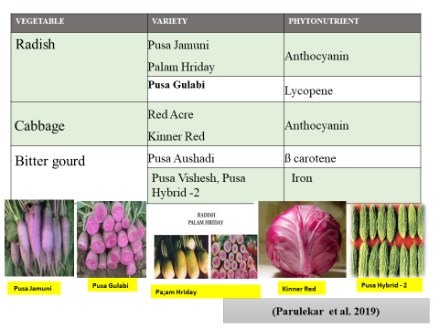

**Figure-15. Image of radish nutrient enrichment varieties**

**Brinjal**

A better nutritionally dense variety of brinjal 'Pusa Safed Baigan 1' has been released by IARI in 2018. It is oval round fruited white coloured variety apt for cultivation during kharif season in north plains. It has improved total phenol content (31.21 mg GAE 100g-1) and elevated antioxidant activity (3.48 CUPR AC μ moltrolox g-1, 2.58 FRAP μ moltrolox g-1) ([www.agriicarjrf.com](http://www.agriicarjrf.com)).

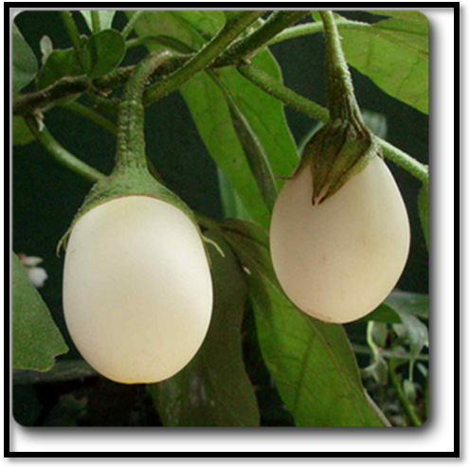

Pusa Safed Baigan-1

**Figure-16. Image of Brinjal nutrient enrichment varieties**

Nutritional quality of cucumber (*Cucumis sativus* L.) can be enhanced by introgressing β-carotene (i.e, provitamin A and/or orange flesh) genes from "Xishuangbanna gourd" (XIS*; Cucumis sativus var. Xishuangbannanesis Qi et Yuan)* into US pickling cucumber. The genetics of β-carotene content, however, are not evidently established in this US market type (Cuevas et al. 2010). Interspecific crosses between XIS (PI509549) and *Cucumis sativus*.

**Potato biofortified variety (Kufri Neelkanth)**

It is table potato variety of medium maturity with high yield of tubers, field resistance against late blight, good keeping/culinary quality and can be grown in North Indian plains. First research on cow pea bio-fortification was conducted at G.B. Pant University of Agriculture and Technology, Pantnagar, India. Released two varieties rich in iron & Zinc

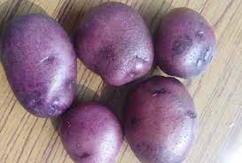

Kufri Neelkanth

**Figure-17. Image of potato nutrient enrichment varieties**

Transgenic potato plants with a gene for non-allergenic protein AmA1 from A. Hypochondriacus were generated. Tubers of such genetically modified potato plants are compared to control plants described by enhanced production of all the amino acids (Hong, and Bu, 2013).. They are characterized by potatoes with an inserted gene for phosphofructokinase from bacterium *Lactobacillus bulgaricus*. Potatoes with elevated levels of simple sugars become brown when fried and are thereby less appealing for consumers. Transgenic potato plants not only contain less sugar content, but further, chips made from such potatoes are lighter in colour than chips made from non-modified varieties (Pribylova et al., 2006).

**Sweet Potato**

To enhance the storage root carotenoid content of sweet potato, transgenic sweet potato plants over expressing IbOr-Inscontrolled by the cauliflower mosaic virus (CaMV) 35 Spromoter in an anthocyanin-hight purple-fleshed line (termed as IbOr plants) was created. IbOrplants had elevated carotenoid content (upto 7-fold) in their storage roots relative to wild type (WT) plants, as shown by HPLC analysis. Therefore, over-expression of IbOr-Inscan enhance sweet potato storage root carotenoid contents (Kang, et al., 2017).

**Tomato**

The approach taken was pathway extension beyond β-carotene by the expression in the tomato fruit of the β-carotene hydroxylase (CrtZ) and oxyxgenase (CrtW) from *Brevundimonas* sp., and then β-carotene enhancement through the introgression into a *Solanum galapagense* background of a lycopene β-cyclase (β-Cyc) allele (Choi et al., 2006).

**Table 8. Biofortified Varieties Released in Tuber Crops**

|  |  |  |  |  |
| --- | --- | --- | --- | --- |
| **Crop** | **Variety** | **Character** | **Developing Institute** | **Source** |
| **Sweet Potato** | **Bhu Sona** | Developed through pureline selection  High β-carotene (14.0 mg/100g) compared to 2.0–3.0 mg/100g  Dry matter: 27–29%  Total sugars: 2–2.4%  Recommended for Odisha  Released in 2017 | CTCRI, Thiruvananthapuram | Yadav et al., 2017 |
|  | **Sree Kanaka** | Dark orange flesh with very high β-carotene  Developed through pureline selection  High anthocyanin (90.0 mg/100g)  Tolerant to high salinity | CTCRI, Thiruvananthapuram | [www.ctcri.org](http://www.ctcri.org) |
| **Potato** | **Bhu Krishna** | Dry matter: 24.0–25.5%  Starch: 19.5%  Total sugar: 1.9–2.2%  Recommended for Odisha  Released in 2017 | CTCRI, Thiruvananthapuram | Yadav et al., 2017 |
|  | **MS/8-1565 (Kufri Neelkanth)** | Attractive purple ovoid tubers with shallow eyes and yellow flesh  Higher antioxidants vs. other red-skin varieties  Medium maturity, high yield   Field resistant to late blight   Good culinary quality  Suitable for North Indian plains | CPRI, Shimla | http://cpri.icar.gov.in |
| **Tapioca** | **Sree Visakham** | Carotene content: 466 IU/100g | CTCRI, Thiruvananthapuram |  |

**Cauliflower**

**Achievements:-** Pusa Beta Kesari 1First biofortified cauliflower.

Pusa Betakesari

* Year of release: 2015-16.
* Characteristics: First ever

Indigenously bred bio-fortified

betacarotene (8-10 mg/100 g) rich cauliflower variety.

* Marker assisted backcrossing.

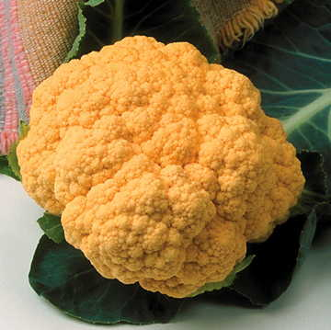

Pusa Betakesari

**Figure-18. Image of cauliflower bio-fortified varieties**

**Cowpea varieties**

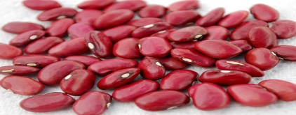 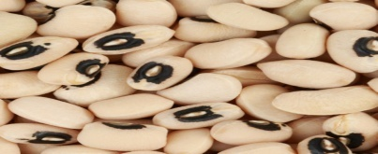

**Plate -1 Pant Lobia-2 Plate-2 Pant Lobia-1**

**Pant Lobia-1 & Pant Lobia-2 rich source of iron and Zinc.**

**Figure-19. Image of cowpea nutrient enrichment varieties**

**Glucoraphanin accumilation in broccoli**

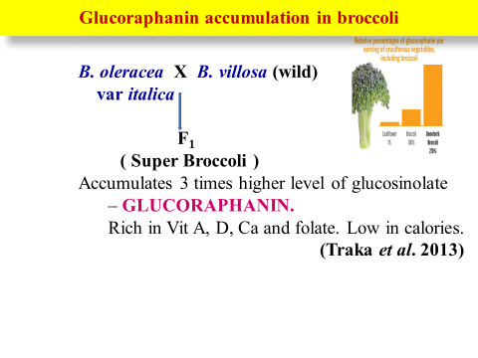

(Source, Traka et al., 2013)

**Figure-20. Image of broccoli glucoraphanin enrichment method**

**Different phytochemicals derived from vegetables used as nutraceutical:-**

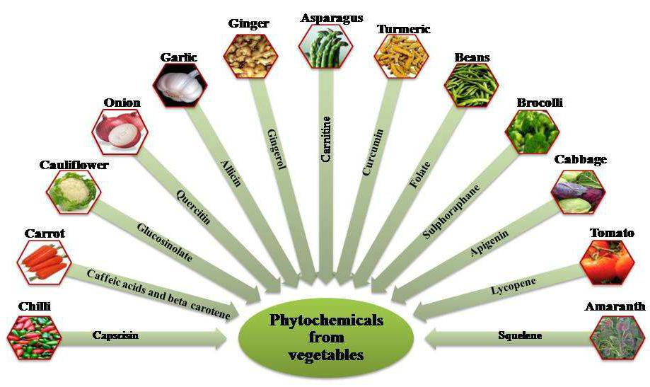

**(Source, Thakur and Sharma, 2018)**

**Figure-21. Image of different phytochemical found in vegetable crop**

**Table-9. Different vegetable crop and nutraceuticals properties**

|  |  |  |  |
| --- | --- | --- | --- |
| **Crop** | **Botanical name** | **Nutraceuticals** | **Disease control potential** |
| Cole crops | *Brassica* spp. | Glucosinolates, Sulforaphane, Vitamin C, Luteolin, Apigenin | Breast cancer, stomach and lung cancer |
| Tomato and other Solanaceous crops | *Solanum lycopersicum,*  *Capsicum* spp.,  *Solanum melongena* | Lycopene | Cancer, CVD, and arthritis |
| Artichoke | *Cynara cardunculus* var. scolymus | Silymarin | Liver diseases |
| GLV | *Amaranthus* spp.  *Spinacea oleracea,*  *Trigonella foenum-graecum* | Vitamin E, C and Folates | CVD, constipation |
| Onion and Garlic | *Allium cepa*  *Allium sativum* | Allyl propyl disulfide, Quercetin, Alliin, Methiin | Stomach and colon cancer, cough and cold, diabetes, hypertension |
| Carrot, Pumpkin, Cantaloupe | Daucus carota, Cucurbita moschata, *Cucumis melo* var. *cantalupensis* | Vitamin A | Bladder cancer and lymphoma |
| Endive, Horse Radish | *Cichorium intybus* var. *foliosum*  *Armoracia rusticana* | Kaempferol, Myricetin, Fisetin | Inhibit LDL, antioxidant, anti carcinogenic |
| Celery, Broccoli | *Apium graveolens*  *Brassica oleracea* var. *italica* | Luteolin, Apigenin | Cancer of breast, skin |
| Legume vegetables | *Pisum sativum*  *Vigna unguiculata*  *Cyamopsis tetragonoloba* | Isoflavonoids | Osteoporosis and obesity and menopause |
| Okra | *Abelmoschus esculentus* | Quercetin and  flavonol derivatives | Diabetes and Vitality |
| Potato | *Solanum tuberosum* | Lysine, Chlorgenic Acid | Cold sores and BP |
| Egg plant | *Solanum melongena* | Caffeic acid, Chlorgenic Acid, and Nasunin | CVD skin blemishes |
| Broccoli | *Brassica oleracea* var. *italica* | Glucobrassicin, Progoitrin, and Gluconasturtiin | Cancer |
| Soybean | *Glycine max* | Genistein Daidzein , and Nattokinase | Reduce LDL, coronary artery plaque |
| Turnip and Rutabaga | *Brassica rapa*  *Brassica napus* | Glucoerucin and Glucoraphanin | Cancer and heart diseases |
| Beet root | *Beta vulgaris* | Ferulic Acid and Betanin | Skin disease, ant ageing |
| Sweet Potato | *Ipomoea batatas* | Anthocyanin, Chlorgenic Acid | Anti diabetic antiobesity |
| Red Chilli | *Capsicum annuum* | Capsaicin | Cancer, gastritis, headache |
| Red Onion | *Allium cepa* | Resveratrol | Anticancer, ant ageing |
| Asparagus  Green Chilli | *Asparagus officinalis*  *Capsicum annuum* | Rutin | Vericose Veins |
| Spinach | *Spinacea oleracea* | Patuletin and Spinacetin | Weight loss, good eye sight |
| Plantain | *Musa paradisiaca* | Benzoic and chlorogenic acid; citric and ferulic acid; oleanolic, Salicylic acid | Antimicrobial, anti-inflammatory, antitusive, cardiac stimulant |

(Singh et al., 2015 and Parulekar et al., 2019)

**Bioavailability and Consumer Acceptance**

Biofortification success also requires not only elevating nutrient levels but also assuring that such nutrients are bioavailable, or that they can be utilized effectively and absorbed in the human body. Several factors affect bioavailability, ranging from the presence of antinutritional factors (e.g., phytates, oxalates) that interfere with the absorption of minerals, to the food matrix that determines how nutrients interact within a specific food product. For instance, iron and zinc absorption can be greatly diminished by phytates present in leafy green vegetables or beans.

Postharvest processing and handling procedures also are important. Drying, boiling, or fermentation can improve or reduce nutrient availability. For example, cooking may enhance the bioavailability of carotenoids (such as β-carotene) in carrots and sweet potatoes but cause the destruction of temperature-sensitive vitamins.

Another key success determinant is the sensory attribute of biofortified crops, such as color, taste, texture, and smell. Any undesired shift in these characteristics could diminish consumer acceptability and marketability. For instance, as much as orange-fleshed sweet potato is dense in vitamin A, its unusual color has been met with initial resistance in areas that are used to white-fleshed types.

Consumer attitude and acceptance, especially towards genetically modified organisms (GMOs), continue to be controversial. Although GM biofortified staple foods such as the Golden Banana or high-lysine tomato have shown profound nutritional improvements, concerns about food safety, ethics, and regulatory issues could impede massive acceptance. Clear communication, health promotion campaigns, and participation of local communities in decision-making can assist in establishing confidence and increasing acceptance of biofortified foods.

**Challenges in Biofortification of Horticultural Crops**

Notwithstanding the increasing interest and promise of biofortification in improving the nutritional content of horticultural crops, a number of scientific, socio-economic, and regulatory challenges impede its widespread adoption and application. These challenges must be addressed critically to ensure the sustainability and success of biofortification programs.

**Limited Genetic Variation for Certain Nutrients in Existing Germplasm**

One of the greatest limiting factors in biofortifying horticultural crops using traditional breeding is that there is limited natural genetic variability for some micronutrients in available germplasm collections. In contrast to staple cereals, horticultural crops usually do not have adequate variability in characteristics such as iron, zinc, or vitamin A content, so plant breeders cannot easily find suitable donor lines. This limited genetic range limits the potential for substantial improvements in nutrition without sacrificing other desirable agronomic characteristics. In addition, the inheritance of micronutrient characteristics in horticultural crops tends to be multifaceted and environmentally affected, making breeding more difficult.

**Trade-Offs Between Yield, Quality, and Nutrient Content**

There is also another considerable challenge posed by the possible trade-offs between yield, fruit quality, and improved nutrient content. Selection for elevated nutrient levels can inadvertently influence other desirable characteristics like fruit yield, post-harvest storage ability, taste, or resistance to stress. Dry matter or carotenoid concentration, for instance, may cause alterations in texture or palatability, which can impact consumer acceptability. Farmers could also resist the use of biofortified varieties if a trade-off in yield or market quality is perceived. Achieving the correct balance between nutritional quality and agronomic performance is therefore an important breeding goal.

**Consumer Acceptance and Marketability Issues**

Consumer and market acceptance of biofortified horticultural crops is a major factor determining their success. In most instances, biofortified crops could appear different, taste differently, or have different cooking characteristics than common varieties. For example, orange-fleshed sweet potatoes or golden-fleshed bananas can be unknown to populations used to white-fleshed ones. This can generate resistance to uptake, especially if the health advantage is poorly publicized. Moreover, consumer unease regarding genetically modified or gene-edited crops can further restrict marketability, particularly where disinformation or cultural prejudices exist.

**Regulator Barriers, Particularly for Transgenic Crops**

Application of genome-editing and transgenic technologies in biofortification is associated with an important regulatory hurdle across most countries. Approvals of genetically modified (GM) crops are usually protracted, expensive, and politically charged. Regimes can differ considerably between nations, with some imposing strict biosafety evaluation, public consultations, and labeling regimes. Consequently, the release of transgenic biofortified horticultural crops is delayed or outright banned, reducing the extent and scope of such innovations. Furthermore, public controversy and court cases regarding GMOs fuel regulatory uncertainty and discourage private sector investment.

**Farmers' and Consumers' Low Awareness**

One important non-technical constraint to the uptake of biofortified crops is farmers' and consumers' low awareness and knowledge. Such farmers are not aware of the biofortification concept and might not understand its health and income benefits. Unless there are proper extension services, demonstration plots, or incentive programs, they might be afraid to move from conventional to biofortified varieties. Likewise, people tend to not have the information required to make informed decisions regarding nutrient-rich fruits and vegetables, particularly where literacy is low or nutrition education not readily accessible. Such information shortages reduce the demand pull that biofortification programs require to succeed.

**Future Prospects and Recommendations**

Biofortification of horticultural crops offers a promising solution to fight stealthy hunger by fortifying widely consumed fruits and vegetables with vital vitamins and minerals. Although the method is still in its nascent stages, some avenues are available for scaling up its influence via innovation, convergence, and support from institutions. The following future prospects and strategic recommendations can serve to optimize the potential of biofortification in horticulture:

**Multi-Nutrient Biofortification**

Future studies must aim to generate multi-nutrient biofortified varieties that are fortified with multiple key nutrients like iron, zinc, provitamin A, and folate. This combined approach is more efficient at solving complex and overlapping micronutrient deficiencies in vulnerable groups.

Later breeding methods, genomics, and biotechnology can be used to pyramid multiple traits without decreasing yield or quality. Examples like tomatoes fortified with both lycopene and GABA or leafy greens with greater iron and calcium content show the practicability of multiple-nutrient targets.

**Synergy with Organic Farming**

Synergizing biofortification with organic and sustainable agriculture is very promising for enhancing nutritional quality as well as ecological well-being. Organic biofortified crops could fetch higher market value and consumer acceptance because of the combined advantages of nutrition as well as environmental care. Application of bio-based fertilizers, compost, and microbial inoculants can also promote the bioavailability and nutrient uptake of crops, providing a green alternative to chemicals. Development of compatible biofortification technologies for organic systems needs to be researched to meet health-oriented markets.

**Public-Private Partnerships**

Enhancing public-private partnerships (PPPs) is paramount to hasten the development, release, and commercialization of biofortified horticultural crops. Effective PPPs among research organizations, government agencies, seed firms, food processors, and retailers can work towards linking laboratory inventions with field-level implementation. PPPs can also support broad-scale awareness creation, training of farmers, and value chain development for ensuring profitability and sustainability. Illustrations like HarvestPlus have demonstrated the merits of such multi-stakeholder partnerships in the domain of staple crop biofortification.

**Policy Support**

There is a critical need for supportive policies to mainstream biofortification in national agriculture and nutrition planning. Governments need to acknowledge biofortified horticultural crops as an essential part of food security measures and incorporate them into key public health programs like mid-day meals, Integrated Child Development Services (ICDS), and public distribution systems (PDS). Financial incentives to farmers and producers for biofortified seed production, coverage under crop insurance programs, and streamlined regulatory approval particularly for non-GMO products may also increase farmers' and producers' adoption.

**Consumer Education**

Mass adoption and uptake of biofortified horticultural products are in large part contingent upon consumer education and behavior change communication. Public education campaigns that emphasize the health advantage of biofortified fruits and vegetables through school, health centers, media, and packaging labeling can reorient consumption towards nutritious products. Nutrition literacy must also be customized for different demographic groups, particularly in rural and low-income environments, to encourage intelligent food choices and minimize resistance to new varieties.

**Conclusion**

Biofortification of horticultural crops is a sustainable and promising approach for solving the long-standing problem of micronutrient malnutrition worldwide. In contrast to traditional supplementation and food fortification schemes, biofortification enriches the nutritional content of crops in the production stage, hence being a cost-saving and long-term measure, particularly among vulnerable and rural communities.

The efficacy of biofortification in horticulture relies on synergetic incorporation of various strategies—such as traditional breeding, agronomic management, transgenics, genome editing methods such as CRISPR/Cas9, and novel tools like nanotechnology. Each has its own advantages and limitations, and their deployment needs to be modulated to crop types, regional environmental conditions, and societal requirements.

To completely realize the potential of biofortified horticultural crops, strong support from public policy, scientific research, and extension services will be required. This entails the generation of high-yielding nutrient-dense varieties, effective dissemination systems, and focused education campaigns to enhance farmer adoption and consumer acceptance. Overcoming regulatory barriers, especially in the case of genetically modified crops, and enhancing public understanding will also be vital.

Finally, higher investment in inter-disciplinary research, value chain development, and nutrition-sensitive agricultural extension will be primary drivers in up-scaling biofortification activities. If the ingredients are well in line, biofortified fruits and vegetables can be a catalytic function in strengthening food and nutritional security, public health improvement, and contributing toward achievement of global sustainable development goals.

COMPETING INTERESTS DISCLAIMER:

Authors have declared that they have no known competing financial interests OR non-financial interests OR personal relationships that could have appeared to influence the work reported in this paper.

Disclaimer (Artificial intelligence)

Option 1:

Author(s) hereby declare that NO generative AI technologies such as Large Language Models (ChatGPT, COPILOT, etc.) and text-to-image generators have been used during the writing or editing of this manuscript.

Option 2:

Author(s) hereby declare that generative AI technologies such as Large Language Models, etc. have been used during the writing or editing of manuscripts. This explanation will include the name, version, model, and source of the generative AI technology and as well as all input prompts provided to the generative AI technology

Details of the AI usage are given below:

1.

2.

3.

**Reference**

Adeyeye, S. A. O., & Idowu-Adebayo, F. (2019). Genetically modified and biofortified crops and food security in developing countries: a review. Nutrition & Food Science, 49(5), 978-986.

Adhikari, P. (2012). Biofortification of selenium in broccoli and onion (Master’s thesis). Norwegian University of Life Sciences, Norway.

Afify, R. R. M., & El-Nwehy, S. S. (2023). Nano fertilizers with algae extract as biostimulant affecting growth, bulb yield, and quality of onion. SABRAO J. Breed. Genet, 55(6), 2128-2139.

Atukunda, P., Eide, W. B., Kardel, K. R., Iversen, P. O., & Westerberg, A. C. (2021). Unlocking the potential for achievement of the UN Sustainable Development Goal 2–‘Zero Hunger’–in Africa: targets, strategies, synergies and challenges. Food & nutrition research, 65, 10-29219.

Awuchi, C. G., Igwe, V. S., Amagwula, I. O., & Echeta, C. K. (2020). Health benefits of micronutrients (vitamins and minerals) and their associated deficiency diseases: A systematic review. International Journal of Food Sciences, 3(1), 1-32.

Balabanova, D., Mills, A., Conteh, L., Akkazieva, B., Banteyerga, H., Dash, U., ... & McKee, M. (2013). Good health at low cost 25 years on: lessons for the future of health systems strengthening. The Lancet, 381(9883), 2118-2133.

Beebe, S. (2020). Biofortification of common bean for higher iron concentration. Frontiers in Sustainable Food Systems, 4, 573449.

Berti, C., Faber, M., & Smuts, C. M. (2014). Prevention and control of micronutrient deficiencies in developing countries: current perspectives. Nutrition and Dietary Supplements, 41-57.

Birol, E., Asare-Marfo, D., Fiedler, J. L., Ha, B., Lividini, K., Moursi, M., ... & Stein, A. J. (2014). Cost-effectiveness of Biofortification. Bouis H E. 2002. Plant breeding: A new tool for fighting micronutrient malnutrition. J of Nutrition. 132:491–494.

Bouis HE, Hotz C, McClafferty B, Meenakshi JV, & Pfeiffer, WH (2011) Biofortification: a new tool to reduce micronutrient malnutrition. Food and nutrition bulletin, 32(1_suppl1), S31-S40.

Bouis, H. (2018). Reducing mineral and vitamin deficiencies through biofortification: progress under HarvestPlus. World Rev. Nutr. Diet, 118, 112-122.

Bouis, H. E., & Saltzman, A. (2017). Improving nutrition through biofortification: a review of evidence from HarvestPlus, 2003 through 2016. Global food security, 12, 49-58.

Bouis, H. E., & Welch, R. M. (2010). Biofortification—a sustainable agricultural strategy for reducing micronutrient malnutrition in the global south. Crop science, 50, S-20.

Bouis, H. E., Hotz, C., McClafferty, B., Meenakshi, J. V., & Pfeiffer, W. H. (2011). Biofortification: a new tool to reduce micronutrient malnutrition. Food and nutrition bulletin, 32(1_suppl1), S31-S40.

Bouis, HE (2003) Micronutrient fortification of plants through plant breeding: can it improve nutrition in man at low cost? Proc. Nutr. Soc. 62: 403–411

Çakmak, İ., & Kutman, U. Á. (2018). Agronomic biofortification of cereals with zinc: a review. European journal of soil science, 69(1), 172-180.

Chatindiara, I., Sheridan, N., Kruger, M., & Wham, C. (2020). Eating less the logical thing to do? Vulnerability to malnutrition with advancing age: A qualitative study. Appetite, 146, 104502.

Choi, S. K., Matsuda, S., Hoshino, T., Peng, X., & Misawa, N. (2006). Characterization of bacterial β-carotene 3, 3′-hydroxylases, CrtZ, and P450 in astaxanthin biosynthetic pathway and adonirubin production by gene combination in Escherichia coli. Applied microbiology and biotechnology, 72, 1238-1246.

Cichy, K., Chiu, C., Isaacs, K., & Glahn, R. (2022). Dry bean biofortification with iron and zinc. In Biofortification of staple crops (pp. 225-270). Singapore: Springer Singapore.

De Valença, A. W., Bake, A., Brouwer, I. D., & Giller, K. E. (2017). Agronomic biofortification of crops to fight hidden hunger in sub-Saharan Africa. Global food security, 12, 8-14.

Deepthi, R., Anil, N. S., Narayanaswamy, D. M., Sathiabalan, M., Balakrishnan, R., & Lonimath, A. (2023). Recommended dietary allowances, ICMR 2020 guidelines: A practical guide for bedside and community dietary assessment–A review. Indian Journal of Forensic Community Medicine, 10, 4-10.

DellaPenna, D. (2007). Biofortification of plant-based food: Enhancing folate levels by metabolic engineering. Proceedings of the National Academy of Sciences of the United States of America (PNAS), 104, 3675–3676.

Dhaliwal, S. S., Sharma, V., Shukla, A. K., Verma, V., Kaur, M., Shivay, Y. S., ... & Hossain, A. (2022). Biofortification—A frontier novel approach to enrich micronutrients in field crops to encounter the nutritional security. Molecules, 27(4), 1340.

Dias, J. S. (2012). Nutritional quality and health benefits of vegetables: A review. Food and Nutrition Sciences, 3(10), 1354-1374.

Dimkpa, C. O., & Bindraban, P. S. (2016). Fortification of micronutrients for efficient agronomic production: a review. Agronomy for Sustainable Development, 36(1), 7.

Duborská, E., Urík, M., & Šeda, M. (2020). Iodine biofortification of vegetables could improve iodine supplementation status. Agronomy, 10(10), 1574.

Dwivedi, S. L., Garcia-Oliveira, A. L., Govindaraj, M., & Ortiz, R. (2023). Biofortification to avoid malnutrition in humans in a changing climate: Enhancing micronutrient bioavailability in seed, tuber, and storage roots. Frontiers in plant science, 14, 1119148.

Eyinla, T. E., Maziya-Dixon, B., Alamu, O. E., & Sanusi, R. A. (2019). Retention of pro-vitamin A content in products from new biofortified cassava varieties. Foods, 8(5), 177.

Falcon, W. P., & Naylor, R. L. (2005). Rethinking food security for the twenty-first century. American Journal of Agricultural Economics, 87(5), 1113-1127.

Fernandes, K. F. M., & Berton, R. S. (2014). Selenium biofortification of rice and radish: Effect of soil texture and efficiency of two extractants. Plant, Soil and Environment, 60, 105–110.

Giovinazzo, G., D'Amico, L., Paradiso, A., Bollini, R., Sparvoli, F., & De Gara, L. (2005). Antioxidant metabolite profiles in tomato fruit constitutively expressing the grapevine stilbene synthase gene. Plant Biotechnology Journal, 3, 57–69.

Goto, F., & Yoshihara, S. (2000). Iron accumulation and enhanced growth in transgenic lettuce plants expressing the iron-binding protein ferritin. Horticultural Science, 100, 658–664.

Gurmu, F., Hussein, S., & Laing, M. (2014). The potential of orange-fleshed sweet potato to prevent vitamin A deficiency in Africa. Int J Vitam Nutr Res, 84(1-2), 65-78.

HarvestPlus (2014) The 2nd Global Conference on Biofortification. Conference report. HarvestPlus,Washington, DC.

HarvestPlus (2014d) Biofortification Progress Brief: August 2014. Washington, D.C.

Hefferon, K. L. (2018). Crops with improved nutritional content though agricultural biotechnology. In Plant Micronutrient Use Efficiency (pp. 279-294). Academic Press.

Hong, Y., & Bu, Y. P. (2013). Transgenic Plants. In Microbial Biotechnology: Principles and Applications (pp. 521-583).

Hossain, A., Skalicky, M., Brestic, M., Maitra, S., Sarkar, S., Ahmad, Z., ... & Laing, A. M. (2021). Selenium biofortification: roles, mechanisms, responses and prospects. Molecules, 26(4), 881.

http://cpri.icar.gov.in

Ikram, N. A., Ghaffar, A., Khan, A. A., Nawaz, F., & Hussain, A. (2025). Foliar iodine application: A strategy for tomato biofortification and yield optimization. Journal of Plant Nutrition, 48(3), 540-556.

Jangra, A., & Tiwari, S. (2025). Empowering Nutrition: Biofortification to Combat Hidden Hunger. In Advances in Agri-Food Systems: Volume II (pp. 285-305). Singapore: Springer Nature Singapore.

Johns, T., & Eyzaguirre, P. B. (2007). Biofortification, biodiversity and diet: a search for complementary applications against poverty and malnutrition. Food Policy, 32(1), 1-24.

Kang, L., Park, S. C., Ji, C. Y., Kim, H. S., Lee, H. S., & Kwak, S. S. (2017). Metabolic engineering of carotenoids in transgenic sweetpotato. Breeding science, 67(1), 27-34.

Kapoor, P., Dhaka, R. K., Sihag, P., Mehla, S., Sagwal, V., Singh, Y., ... & Kumar, U. (2022). Nanotechnology-enabled biofortification strategies for micronutrients enrichment of food crops: Current understanding and future scope. NanoImpact, 26, 100407.

Kent, G. (2015). Ending hunger worldwide. Routledge.

Khan, M. K., Pandey, A., Hamurcu, M., & Gezgin, S. (2025). Nanotechnology-Based Biofortification for Sustainable and Holistic Plant Development. In Agricultural Sustainability through Nanotechnology (pp. 13-26). CRC Press.

Kiran, K. (2020). Advanced approaches for biofortification. Advances in agri-food biotechnology, 29-55.

Kozicka, M., Elsey, J., Ekesa, B., Ajambo, S., Kikulwe, E., & Gotor, E. (2021). Reassessing the cost-effectiveness of high-Provitamin a bananas to reduce vitamin a deficiency in Uganda. Frontiers in Sustainable Food Systems, 5, 649424.

Kumar, S., Palve, A., Joshi, C., & Srivastava, R. K. (2019). Crop biofortification for iron (Fe), zinc (Zn) and vitamin A with transgenic approaches. Heliyon, 5(6).

Kumari, M., Sharma, D., & Sandeep, S. (2022). Biofortification of vegetable crops: an option for mitigating hidden hunger. International Journal of Economic Plants, 9(3), 184-193.

Kurdekar , A. K., Banu , A. M., Das , H., Rani , K. S., Rana , S., Rai , S., & Pandey , S. (2023). A Promising Approach for Addressing Micronutrient Deficiencies and Enhancing Nutritional Quality in Food Crops through Biofortification. International Journal of Plant & Soil Science, 35(18), 2127–2134. https://doi.org/10.9734/ijpss/2023/v35i183503

Kurmi, A., Jayswal, D. K., Saikia, D., & Lal, N. (2023). Current perspective on malnutrition and human health. In Nano-Biofortification for Human and Environmental Health (pp. 155-177). Cham: Springer International Publishing.

La Frano, M. R., Woodhouse, L. R., Burnett, D. J., & Burri, B. J. (2013). Biofortified cassava increases β-carotene and vitamin A concentrations in the TAG-rich plasma layer of American women. British Journal of Nutrition, 110(2), 310-320.

Lal, M. K., Kumar, A., Kardile, H. B., Raigond, P., Changan, S. S., Thakur, N., ... & Singh, B. (2020). Biofortification of vegetables. Advances in agri-food biotechnology, 105-129.

Li, X., Yadav, R., & Siddique, K. H. (2020). Neglected and underutilized crop species: the key to improving dietary diversity and fighting hunger and malnutrition in Asia and the Pacific. Frontiers in Nutrition, 7, 593711.

Lile, R., Ocnean, M., Balan, I. M., & KIBA, D. (2023). Challenges for Zero Hunger (SDG 2): Links with Other SDGs. Transitioning to Zero Hunger. Chapter, MDPI, 9-66.

Low, J. W., Ortiz, R., Vandamme, E., Andrade, M., Biazin, B., & Grüneberg, W. J. (2020). Nutrient-dense orange-fleshed sweetpotato: advances in drought-tolerance breeding and understanding of management practices for sustainable next-generation cropping systems in sub-Saharan Africa. Frontiers in Sustainable Food Systems, 4, 50.

Malik, K. A., & Maqbool, A. (2020). Transgenic crops for biofortification. Frontiers in Sustainable Food Systems, 4, 571402.

Mishra, M., Afzal, S., & Singh, N. K. (2024). CRISPR/Cas9-Mediated Genome Engineering for Production of Biofortified Crops. In Phytoremediation and Biofortification (pp. 303-333). Apple Academic Press.

Morris, J., Hawthorne, K. M., Hotze, T., Abrams, S. A., & Hirschi, K. D. (2008). An evaluation of calcium bioavailability from calcium-fortified food. Proceedings of the National Academy of Sciences of the United States of America (PNAS), 105, 1431–1435.

Muir, S. R., Collins, G. J., Robinson, S., Hughes, S., Bovy, A., Ric De Vos, C. H., van Tunen, A. J., & Verhoeyen, M. E. (2001). Overexpression of petunia chalcone isomerase in tomato results in fruit containing increased levels of flavonols. Nature Biotechnology, 19, 470–474.

Nagar, B. L., Thakur, S. S., Goutam, P. K., Prajapati, P. K., Kumar, R., Kumar, S., ... & Kumar, A. (2024). The Role of Bio-fortification in Enhancing the Nutritional Quality of Vegetables: A Review. Advances in Research, 25(4), 64-77.

Naik, B., Kumar, V., Rizwanuddin, S., Mishra, S., Kumar, V., Saris, P. E. J., ... & Rustagi, S. (2024). Biofortification as a solution for addressing nutrient deficiencies and malnutrition. Heliyon, 10(9).

Nanoencapsulation technologies have also been used to shield sensitive nutrients against degradation and to make them more easily absorbed by the human body. For instance, encapsulated zinc or iron nanoparticles can be added to fruits and vegetables without modifying their taste or color (Kapoor et al., 2022).

Neela, S., & Fanta, S. W. (2019). Review on nutritional composition of orange‐fleshed sweet potato and its role in management of vitamin A deficiency. Food science & nutrition, 7(6), 1920-1945.

Nestel P, Howarth E, Bouis JV, Meenakshi, Pfeiffe W (2006) Biofortification of Staple Food Crops. J. Nutr., 22-3166

Ofori, K. F., Antoniello, S., English, M. M., & Aryee, A. N. (2022). Improving nutrition through biofortification–A systematic review. Frontiers in nutrition, 9, 1043655.

Parida, S. P., Behera, B. K., Raut, M. S., Panda, M. K., & Bhattacharjee, M. S. (Eds.). (2023). Micronutrient deficiency. Newredmars Education Pvt Ltd.

Park, M. K., & Lee, C. (2003). Lipid oxidation and carotenoid content in frying oil and fried dough containing carrot powder. Journal of Food Science, 68, 1248–1253.

Parulekar YR, Haldankar PM, Dalvi N V, Salvi BR, Bhattacharyya T (2019) Nutraceuticals and their biofortification in vegetable crops: A review. Adv. Agric. Res. Technol. J, 3, 219-229.

Paul, J. Y., Harding, R., Tushemereirwe, W., & Dale, J. (2018). Banana21: From gene discovery to deregulated golden bananas. Frontiers in plant science, 9, 558.

Paul, J. Y., Khanna, H., Kleidon, J., Hoang, P., Geijskes, J., Daniells, J., ... & Dale, J. (2017). Golden bananas in the field: elevated fruit pro‐vitamin A from the expression of a single banana transgene. Plant Biotechnology Journal, 15(4), 520-532.

Pfeiffer WH, McClafferty B (2007) HarvestPlus: breeding crops for better nutrition. Crop Science, 47, S88.

Prasad, B. V. G., Mohanta, S., Rahaman, S., & Bareily, P. (2015). Bio-fortification in horticultural crops. Journal of Agricultural Engineering and Food Technology, 2(2), 95-99.

Pribylova, R., Pavlik, I., & Bartos, M. (2006). Genetically modified potato plants in nutrition and prevention of diseases in humans and animals: a review. Veterinarni Medicina-Praha-, 51(5), 212.

Priyashantha, H., Kurukulasuriya, M. S., Ranadheera, C. S., Jayarathna, S., & Vidanarachchi, J. K. (2025). Biofortification as a sustainable solution to combat micronutrient malnutrition in the global south with a focus on Sri Lanka: potential, challenges, and policy implications. Discover Food, 5(1), 1-26.

Przybylska, S., & Tokarczyk, G. (2022). Lycopene in the prevention of cardiovascular diseases. International journal of molecular sciences, 23(4), 1957.

Rabbi, R. H. M., Chowdhury, M. A. H., Uddin, M. K., & Saha, B. K. (2024). Agronomic biofortification of zinc in tomato. Journal of Plant Nutrition, 47(11), 1819-1833.

Rosati, C., Riccardo, A., & Dharmapur, S. (2000). Metabolic engineering of beta carotene and lycopene content in tomato fruit. The Plant Journal, 24, 413–420.

Saikanth, D. R. K., Kesarwani, A., Nain, M., Pandey, S. K., Singh, B. V., & Maurya, C. L. (2023). Bio-fortification and its impact on global health. J. Exp. Agric. Int, 45(10), 106-115.

Saltzman A, Birol E, Oparinde A, Andersson MS, Asare Marfo D, Diressie MT, Zeller M (2017) Availability, production, and consumption of crops biofortified by plant breeding: current evidence and future potential. Annals of the New York Academy of Sciences, 1390(1), 104-114.

Saltzman, A., Birol, E., Bouis, H. E., Boy, E., De Moura, F. F., Islam, Y., & Pfeiffer, W. H. (2013). Biofortification: progress toward a more nourishing future. Global food security, 2(1), 9-17.

Sankhla, I. S., Kumar, A., & Singh, C. P. (2024). Nutrient Biofortification in Crop Plants by the CRISPR/Cas9 Technology: A Potential Approach for Sustainable Food Security. In Gene Editing in Plants: CRISPR-Cas and Its Applications (pp. 333-348). Singapore: Springer Nature Singapore.

Sao, R., Sahu, P. K., Khute, I. K., Baghel, S., Patel, R. R. S., Thada, A., ... & Sharma, D. (2023). Crop Biofortification: Plant Breeding and Biotechnological Interventions to Combat Malnutrition. In Advanced Crop Improvement, Volume 1: Theory and Practice (pp. 143-183). Cham: Springer International Publishing.

Saunders, J., Smith, T., & Stroud, M. (2011). Malnutrition and undernutrition. Medicine, 39(1), 45-50.

Seppänen, M. M., Kontturi, J., Heras, I. L., Madrid, Y., Cámara, C., & Hartikainen, H. (2010). Agronomic biofortification of Brassica with selenium—enrichment of SeMet and its identification in Brassica seeds and meal. Plant and soil, 337, 273-283.

Shahzad, R., Jamil, S., Ahmad, S., Nisar, A., Khan, S., Amina, Z., ... & Zhou, W. (2021). Biofortification of cereals and pulses using new breeding techniques: current and future perspectives. Frontiers in nutrition, 8, 721728.

Sharma, P., Aggarwal, P., & Kaur, A. (2017). Biofortification: A new approach to eradicate hidden hunger. Food Reviews International, 33(1), 1-21.

Singh, S. A. U. R. A. B. H., & Devi, M. B. (2015). Vegetables as a potential source of nutraceuticals and phytochemicals: A review. Int. J. Med. Pharm. Sci, 5, 1-14.

Srivastav, P., Vutukuru, M., Ravindran, G., & Awad, M. M. (2022). Biofortification—present scenario, possibilities and challenges: a scientometric approach. Sustainability, 14(18), 11632.

Stenvinkel, P., Heimbürger, O., Lindholm, B., Kaysen, G. A., & Bergström, J. (2000). Are there two types of malnutrition in chronic renal failure? Evidence for relationships between malnutrition, inflammation and atherosclerosis (MIA syndrome). Nephrology Dialysis Transplantation, 15(7), 953-960.

Talsma, E. F., Brouwer, I. D., Verhoef, H., Mbera, G. N., Mwangi, A. M., Demir, A. Y., ... & Melse-Boonstra, A. (2016). Biofortified yellow cassava and vitamin A status of Kenyan children: a randomized controlled trial. The American journal of clinical nutrition, 103(1), 258-267.

Thakur, A., & Sharma, R. (2018). Health promoting phytochemicals in vegetables: a mini review. International Journal of Food and Fermentation Technology, 8(2), 107-117.

Traka, M. H., Saha, S., Huseby, S., Kopriva, S., Walley, P. G., Barker, G. C., ... & Mithen, R. F. (2013). Genetic regulation of glucoraphanin accumulation in Beneforté® broccoli. New Phytologist, 198(4), 1085-1095.

Tsivileva, O. (2025). Selenium-Containing Nanoformulations Capable of Alleviating Abiotic Stress in Plants. International Journal of Molecular Sciences, 26(4), 1697.

UNICEF / WHO / World Bank Group Joint Child Malnutrition Estimates Key findings of the 2020 edition

Vaiknoras, K., & Larochelle, C. (2021). The impact of iron-biofortified bean adoption on bean productivity, consumption, purchases and sales. World development, 139, 105260.

Wakeel, A., Farooq, M., Bashir, K., & Ozturk, L. (2018). Micronutrient malnutrition and biofortification: recent advances and future perspectives. Plant micronutrient use efficiency, 225-243.

Wamiq, M., Alam, K., Ahmad, K., & Luthra, S. (2022). Biofortification in Vegetable Crops. Modern Concept in Agriculture, 143.

Welch, R. M. (2001). Micronutrients, agriculture and nutrition; linkages for improved health and well being. Perspectives on the micronutrient nutrition of crops. Jodhpur, India: Scientific Publishers, 247-289.

Weng H, Hong C, Xia T, Bao L, Liu H, Li D (2013) Iodine bio-fortification of vegetable plants-An innovative method for iodine supplementation. Chinese Science Bulletin, 58(17): 2066-2072.

Winkler JT (2011) Biofortification: improving the nutritional quality of staple crops. In: Pasternak C (ed) Access not excess. Smith-Gordon, Cambridgeshire, pp 100–112

World Health Organization (WHO).

www. iari.res.in

www.ctcri.org

www.ztmbpd.iari.res.in.

Yadav, D. K., Choudhury, P. R., Hossain, F., & Kumar, D. (2017). Biofortified varieties: Sustainable way to alleviate malnutrition. New Delhi: Indian Council of Agricultural Research.

Yadav, D. N., Bansal, S., Tushir, S., Kaur, J., & Sharma, K. (2020). Advantage of biofortification over fortification technologies. In Wheat and barley grain biofortification (pp. 257-273). Woodhead Publishing.