**Assessment of Genetic Variability and Trait Association in Okra (*Abelmoschus esculentus* L. Moench)**

**ABSTRACT**  
**Aim:** The present study was conducted to assess genetic variability, heritability and trait associations among yield and its contributing characters in okra (*Abelmoschus esculentus* L.).

**Study design:** The experiment was laid out in a randomized complete block design (RBD) with recommended agronomic practices

**Place and duration of Study:** All India Coordinated Research Project on Vegetable Crops, Odisha University of Agriculture and Technology, Bhubaneswar during *Kharif,* 2023-24.

**Methodology:** A diverse set of 52 genotypes was evaluated for key agronomic traits, including plant height, number of branches per plant, fruit length, fruit weight, number of fruits per plant and yield per plant.

**Results:** Analysis revealed significant variation among genotypes for all studied traits, indicating the presence of ample genetic diversity. High heritability coupled with high genetic advance was observed for yield and related traits, suggesting that selection would be effective for genetic improvement. Correlation analysis demonstrated that fruit yield per plant had strong positive associations with number of fruits per plant and fruit weight, highlighting their importance in selection strategies.

**Conclusion:** These findings provide valuable insights for breeding programs aimed at enhancing okra productivity through selection of superior genotypes based on key yield-contributing traits.

***Keywords:*** *okra, genetic variability, heritability, trait association, yield, breeding*

1. **INTRODUCTION**

Okra (*Abelmoschus esculentus* L. Moench), a member of the Malvaceae family, is a popular vegetable crop grown widely in tropical and subtropical regions (De Candolle, 1886). It plays an important role in the Indian diet due to its tender, mucilaginous fruits, which are rich in vitamins, minerals and dietary fiber (Tindall, 1983 and Berry *et al*., 1988). Nutritionally, okra is a rich source of carbohydrates, fats, fibers and oils and it provides a variety of essential vitamins including A, B, C and K. It is also abundant in important minerals such as iron, iodine, calcium, manganese and magnesium and contains high levels of antioxidants like xanthin and lutein. Okra leaves are occasionally used as feed for cattle. The fresh pods offer 2.1 grams of protein, 0.2 grams of fat, 8 grams of carbohydrates, 36 calories, 1.7 grams of fiber and 175.2 milligrams of minerals per 100 grams. This includes 103 milligrams of potassium, 6.9 milligrams of sodium, 56 milligrams of phosphorus, 66 milligrams of calcium, 1.5 milligrams of iron, 30 milligrams of sulfur and 88 milliliters of water. Additionally, the pods provide 88 IU of vitamin A, 0.07 milligrams of thiamine, 0.1 milligrams of riboflavin and 13 milligrams of vitamin C (Tindall, 1983 and Berry *et al*., 1988). Okra is also noted for its medicinal properties due to its alkaline pH, which helps alleviate gastrointestinal ulcers by neutralizing stomach acid. It is believed to reduce pain and symptoms associated with hemorrhoids and exhibits anti- inflammatory and anti-diarrheal effects (Andualem, 2023). The mucilage from okra has been utilized as a plasma replacement or blood volume expander (ElKhalifa *et al***.,** 2021). In Turkey, okra leaves are used in traditional medicine to decrease inflammation (Mehta, 1959).

India is the world's leading producer of okra, cultivating the crop over approximately 523 thousand hectares with an annual output of 6,416 thousand metric tons (NHB, 2021-22). Gujarat is the top producer in the country, yielding 1,019.42 thousand metric tons followed by West Bengal, Bihar, Madhya Pradesh and Odisha. Due to high consumer demand and favorable prices, okra is extensively grown across all thirty districts of Odisha, primarily during the summer and rainy seasons and to a lesser extent in winter. Odisha produces about 662 thousand metric tons of okra with a productivity rate of 10.11 metric tons per hectare, covering an area of 65 thousand hectares. In terms of production, Odisha ranks fifth in India (NHB, 2021-22).

Despite its commercial importance and adaptability, the average productivity of okra in India remains low, primarily due to limited genetic variability among cultivated varieties and the absence of targeted selection strategies for yield improvement (Ranga and Darvhankar, 2022). Genetic variability is the foundation for any successful breeding program, as it determines the potential for selecting and improving desirable traits. Heritability estimates, coupled with genetic advance, provide insight into the efficiency of selection and the nature of gene action controlling various traits. Moreover, understanding the correlation among traits and their direct and indirect contributions to yield through path coefficient analysis helps breeders in prioritizing selection criteria (Kumar *et al*., 2021). To achieve genetic improvement in yield traits, it is essential to gather information on variability, including its heritable components and the interrelationships among breeding materials. This process helps identify superior recombinants in advanced generations. By examining yield and its components, we can also assess the impact of environmental factors on yield (Vani *et al*., 2021). Studying the interrelationships among growth, earliness and yield-related attributes can enhance the efficiency of breeding programs by informing the selection criteria used.

Given these considerations, the present investigation was undertaken to assess the extent of genetic variability, heritability and genetic advance for key quantitative traits in okra and to determine the nature and strength of trait associations and their contribution to yield, using 52 diverse genotypes.

1. **MATERIALS AND METHODS**

**Experimental material**

This study was conducted using 52 genetically pure genotypes of okra (*Abelmoschus esculentus* L.), sourced from AICRP, OUAT, Bhubaneswar. The experiment was laid out in a randomized complete block design with recommended agronomic practices. The field was prepared with farmyard manure (25 t/ha) and fertilizer doses of 80:50:60 kg/ha (N:P:K). Standard irrigation, manual weeding and plant protection measures were adopted.

Observations were recorded from three randomly selected plants per genotype. The characters studied included different morphological traits such as plant height, plant spread (north-south and east-west), number of nodes, internodal length and leaf area; flowering traits such as days to first flowering and days to 50% flowering; quality traits such as total soluble solids (TSS), protein content and phenolic content and yield traits such as number of fruits per plant, fruit length, fruit girth, fruit weight and total fruit yield per plant. Statistical analyses included the estimation of genotypic and phenotypic coefficients of variation (GCV and PCV), broad-sense heritability, genetic advance and correlation and path coefficient analyses to assess trait associations and their contribution to fruit yield.

1. **RESULTS AND DISCUSSION**
   1. **Mean performance of fifty-two okra genotypes**
      1. Analysis of variance for fifty-two okra genotypes

The analysis of variance revealed highly significant differences among the genotypes for all twenty-one traits studied. The highest mean sum of squares was observed for yield per plant (26,153.40), followed by leaf area (17,108.52) and yield per hectare (3,720.77). The experimental precision was satisfactory, with coefficient of variation (CVe) values within 10% for most traits, except for plant spread (E-W), number of nodes and days to first flowering.

**Table 1. Analysis of variance for twenty-one characters of fifty-two okra genotypes**

|  |  |  |  |  |  |
| --- | --- | --- | --- | --- | --- |
| **Sl.**  **No.** | **Characters** | **Mean sum of square** | | | **Calculated F** |
| **Replication (2)** | **Treatment (51)** | **Error (51)** |
| 1. | Plant height (cm) | 18.11 | 962.04** | 167.13 | 5.75 |
| 2. | Plant spread (N-S) (cm) | 10.00 | 164.94** | 7.44 | 22.17 |
| 3. | Plant spread (E-W) (cm) | 19.98 | 210.25** | 8.59 | 24.45 |
| 4. | Number of nodes | 1.17 | 21.08** | 1.06 | 19.85 |
| 5. | Internodal length (cm) | 0.74 | 16.50** | 0.27 | 60.65 |
| 6. | Leaf area (cm2) | 32,268.14 | 17,108.52** | 946.51 | 18.07 |
| 7. | Days to 1st flowering | 7.58 | 4.10** | 3.90 | 1.05 |
| 8. | Days to 50 % flowering | 4.17 | 5.15* | 4.93 | 1.04 |
| 9. | Days to 1st fruiting | 25.51 | 8.84** | 5.42 | 1.63 |
| 10. | Days to 1st harvest | 2.79 | 2.60** | 6.20 | 0.42 |
| 11. | Pedicel length (cm) | 0.67 | 0.28* | 0.03 | 9.76 |
| 12. | Fruit length (cm) | 2.83 | 7.54** | 0.88 | 8.50 |
| 13. | Fruit girth (cm) | 0.37 | 0.26** | 0.14 | 1.88 |
| 14. | Average fruit weight (g) | 3.12 | 422.01** | 40.93 | 10.30 |
| 15. | No. of fruits per plant | 1,104.02 | 293.37** | 13.91 | 21.08 |
| 16. | Total yield per plant (g) | 2,085.89 | 26,153.40** | 816.94 | 32.01 |
| 17. | Total yield per plot (kg) | 3.55 | 24.60** | 0.77 | 31.94 |
| 18. | Total yield per hectare (q ha-1) | 560.14 | 3,720.77** | 116.92 | 31.82 |
| 19. | TSS (oBrix) | 0.85 | 4.28** | 0.19 | 21.62 |
| 20. | Protein (mg 100 g-1) | 0.68 | 1.28** | 0.15 | 8.18 |
| 21. | Phenol (mg 100 g-1) | 0.07 | 0.11** | 0.02 | 61.06 |

* + 1. Vegetative growth parameters

Significant variation was observed among the fifty-two okra genotypes for vegetative traits including plant height, plant spread (N-S and E-W), number of nodes, internodal length and leaf area (Table 2). The plant height ranged from 73.70 cm (BO-2-19) to 182.39 cm (BO-19-17), with a mean of 141.01 cm (Table 2). The plant spread (N-S) varied from 24.93 cm (BO-19-2) to 65.53 cm (BO-2-14), mean 37.19 cm whereas the plant spread (E-W) ranged between 24.33 cm (Utkal Gaurav) and 68.63 cm (BO-2-14), with a mean of 40.90 cm (Table 2). The number of nodes spanned from 9.66 (BO-18-37) to 25.33 (BO-19-17), mean value 15.79 (Table 2). Similarlysignificant variation was recorded in internodal length, ranging from 4.53 cm (BO-19-17) to 14.03 cm (BO-18-38), with a mean of 9.55 cm. BO-19-17, BO-19-6 and BO-2-4 had the shortest internodes, showing statistical similarity (Table 2). The leaf area varied significantly among genotypes, from 378.16 cm² (BO-19-3) to 714.66 cm² (BO-18-6), with an average of 497.84 cm² (Table 2). BO-18-6 and BO-19-1 exhibited the largest leaf areas, statistically *at par*.

**Table 2. Mean performance of okra genotypes for vegetative growth parameters**

|  |  |  |  |  |  |  |  |
| --- | --- | --- | --- | --- | --- | --- | --- |
| **Sl.**  **No.** | **Genotypes** | **Plant height (cm)** | **Plant spread (N-S)**  **(cm)** | **Plant spread (E-W)**  **(cm)** | **No. of nodes** | **Internodal length (cm)** | **Leaf area (cm2)** |
| 1 | BO-18-40 | 141.86 | 42.63 | 51.46 | 13.33 | 10.16 | 398.56 |
| 2 | BO-18-57 | 128.46 | 40.90 | 34.20 | 10.00 | 10.90 | 478.66 |
| 3 | BO-18-37 | 144.26 | 29.90 | 27.66 | 9.66 | 8.90 | 487.93 |
| 4 | BO-18-38 | 123.70 | 33.60 | 39.40 | 14.00 | 14.03 | 498.70 |
| 5 | BO-18-7 | 166.03 | 34.56 | 39.13 | 14.33 | 9.36 | 390.70 |
| 6 | BO-18-47 | 157.90 | 34.23 | 32.00 | 11.33 | 6.40 | 509.96 |
| 7 | BO-18-8 | 173.46 | 36.40 | 40.63 | 15.00 | 10.83 | 508.16 |
| 8 | BO-18-5 | 163.70 | 39.66 | 45.66 | 17.00 | 12.30 | 569.96 |
| 9 | BO-18-9 | 181.96 | 39.23 | 42.50 | 15.00 | 11.06 | 486.50 |
| 10 | BO-18-6 | 169.53 | 33.80 | 45.46 | 17.66 | 11.26 | 714.66 |
| 11 | BO-19-7 | 170.90 | 35.16 | 49.90 | 20.33 | 12.53 | 440.00 |
| 12 | BO-19-1 | 153.66 | 36.50 | 38.96 | 17.66 | 7.73 | 674.26 |
| 13 | BO-19-3 | 156.70 | 32.43 | 35.60 | 11.33 | 6.76 | 378.16 |
| 14 | BO-19-4 | 133.33 | 25.16 | 28.96 | 14.66 | 13.83 | 466.30 |
| 15 | BO-19-5 | 156.60 | 25.10 | 28.43 | 14.66 | 4.80 | 434.13 |
| 16 | BO-19-2 | 99.40 | 24.93 | 31.60 | 12.66 | 9.53 | 447.43 |
| 17 | BO-19-6 | 138.16 | 34.83 | 39.00 | 23.85 | 5.20 | 407.03 |
| 18 | BO-19-22 | 141.00 | 33.46 | 36.66 | 15.66 | 13.46 | 557.00 |
| 19 | BO-18-17 | 142.83 | 40.83 | 38.30 | 16.66 | 10.33 | 598.86 |
| 20 | BO-2-14 | 141.56 | 65.53 | 68.63 | 21.46 | 7.33 | 409.40 |
| 21 | BO-19-8 | 134.86 | 36.86 | 42.23 | 12.33 | 9.50 | 570.10 |
| 22 | BO-2-4 | 148.50 | 51.86 | 61.90 | 22.35 | 5.90 | 557.70 |
| 23 | Pusa Sawani | 141.86 | 35.93 | 32.23 | 13.00 | 9.40 | 422.23 |
| 24 | Utkal Gaurav | 95.46 | 30.80 | 24.33 | 14.00 | 8.10 | 485.60 |
| 25 | BO-19-20 | 144.73 | 36.86 | 40.33 | 18.33 | 11.40 | 556.46 |
| 26 | BO-19-21 | 151.53 | 26.96 | 32.96 | 14.66 | 13.56 | 582.90 |
| 27 | BO-19-13 | 146.00 | 36.13 | 41.46 | 16.66 | 11.50 | 554.06 |
| 28 | BO-19-14 | 164.40 | 26.26 | 31.46 | 13.00 | 7.50 | 501.23 |
| 29 | BO-19-15 | 174.65 | 44.46 | 55.70 | 20.85 | 7.90 | 594.56 |
| 30 | BO-19-16 | 144.56 | 36.73 | 40.23 | 18.33 | 7.56 | 552.00 |
| 31 | BO-19-17 | 182.39 | 39.83 | 46.46 | 25.33 | 4.53 | 560.33 |
| 32 | BO-19-9 | 139.30 | 35.73 | 38.96 | 16.66 | 9.16 | 507.10 |
| 33 | BO-19-10 | 144.26 | 33.43 | 39.86 | 12.33 | 12.36 | 496.10 |
| 34 | BO-19-11 | 124.83 | 41.06 | 49.66 | 18.00 | 7.33 | 588.66 |
| 35 | BO-19-12 | 133.53 | 34.33 | 39.50 | 17.00 | 8.33 | 535.13 |
| 36 | BO-2-19 | 73.70 | 26.23 | 30.16 | 11.00 | 6.10 | 399.66 |
| 37 | BO-1 | 137.06 | 39.10 | 48.30 | 17.00 | 11.23 | 541.03 |
| 38 | BO-20-2 | 140.60 | 35.53 | 43.33 | 17.33 | 6.83 | 528.93 |
| 39 | BO-21-2 | 138.50 | 31.50 | 36.53 | 18.00 | 7.46 | 575.46 |
| 40 | BO-12-2 | 159.80 | 34.90 | 38.20 | 16.33 | 8.20 | 512.16 |
| 41 | BO-2-13 | 142.40 | 40.70 | 49.90 | 19.00 | 9.36 | 559.30 |
| 42 | Arka Anamika | 146.80 | 36.16 | 40.56 | 18.33 | 9.73 | 531.03 |
| 43 | BO-2-3 | 159.13 | 50.40 | 44.40 | 18.33 | 7.93 | 437.26 |
| 44 | Parbhani Kranti | 165.56 | 39.00 | 43.33 | 15.00 | 9.10 | 484.30 |
| 45 | BO-2-5 | 149.36 | 43.13 | 49.16 | 17.66 | 9.13 | 386.06 |
| 46 | BO-2-6 | 147.86 | 49.16 | 43.20 | 16.00 | 7.20 | 426.43 |
| 47 | BO-2-7 | 143.76 | 50.40 | 41.16 | 18.33 | 10.16 | 454.90 |
| 48 | BO-2-9 | 158.16 | 35.86 | 33.23 | 15.33 | 6.40 | 439.46 |
| 49 | BO-4-6 | 156.63 | 41.26 | 45.90 | 16.00 | 10.13 | 469.76 |
| 50 | BO-5-6 | 147.03 | 34.90 | 37.30 | 16.33 | 11.13 | 411.86 |
| 51 | BO-8-3 | 132.23 | 36.23 | 41.33 | 16.66 | 6.16 | 410.80 |
| 52 | BO-10-2 | 138.16 | 43.26 | 49.03 | 18.33 | 8.33 | 398.76 |
| **Grand Mean** | 141.01 | 37.19 | 40.90 | 15.79 | 9.55 | 497.84 |  |
| **SE(m) ±** | 7.46 | 1.57 | 1.69 | 0.59 | 0.30 | 17.76 |  |
| **CD (0.05)** | 20.96 | 4.42 | 4.75 | 1.67 | 1.84 | 49.90 |  |
| **CV (%)** | 8.89 | 7.33 | 7.17 | 6.52 | 5.46 | 6.18 |  |

* + 1. Flowering parameters

Significant variation was observed among the fifty-two okra genotypes for days to first flowering and days to 50% flowering (Table 3). The days to first flowering ranged from 35.33 days (BO-2-14) to 41.33 days (Arka Anamika), with a mean of 38.80 days. BO-2-14, BO-2-5 and BO-2-4 flowered earliest, while Arka Anamika, BO-4-6 and BO-19-16 recorded maximum number of days to flowering. The days to 50% flowering in different genotypes varied between 41.00 days (BO-18-47) and 46.00 days (BO-19-3), with an average of 43.37 days. BO-18-47, BO-19-17 and BO-1 exhibited earliest 50% flowering (Table 3).

**Table 3. Mean performance of okra genotypes for flowering parameters**

|  |  |  |  |
| --- | --- | --- | --- |
| **Sl. No.** | **Genotypes** | **Days to 1st flowering** | **Days to 50 % flowering** |
| 1 | BO-18-40 | 40.33 | 45.66 |
| 2 | BO-18-57 | 39.33 | 44.00 |
| 3 | BO-18-37 | 40.33 | 45.33 |
| 4 | BO-18-38 | 38.66 | 44.00 |
| 5 | BO-18-7 | 38.66 | 43.00 |
| 6 | BO-18-47 | 36.66 | 41.00 |
| 7 | BO-18-8 | 39.33 | 41.66 |
| 8 | BO-18-5 | 36.66 | 40.66 |
| 9 | BO-18-9 | 38.66 | 43.33 |
| 10 | BO-18-6 | 38.66 | 42.33 |
| 11 | BO-19-7 | 40.33 | 42.33 |
| 12 | BO-19-1 | 37.33 | 44.00 |
| 13 | BO-19-3 | 39.00 | 46.00 |
| 14 | BO-19-4 | 38.00 | 44.00 |
| 15 | BO-19-5 | 39.00 | 43.66 |
| 16 | BO-19-2 | 40.33 | 45.00 |
| 17 | BO-19-6 | 39.66 | 42.33 |
| 18 | BO-19-22 | 38.66 | 42.33 |
| 19 | BO-18-17 | 37.66 | 42.00 |
| 20 | BO-2-14 | 35.33 | 42.33 |
| 21 | BO-19-8 | 39.00 | 43.00 |
| 22 | BO-2-4 | 36.66 | 43.00 |
| 23 | Pusa Sawani | 38.00 | 44.00 |
| 24 | Utkal Gaurav | 38.33 | 43.66 |
| 25 | BO-19-20 | 38.66 | 43.66 |
| 26 | BO-19-21 | 39.00 | 43.33 |
| 27 | BO-19-13 | 38.33 | 42.33 |
| 28 | BO-19-14 | 39.33 | 43.66 |
| 29 | BO-19-15 | 39.00 | 44.00 |
| 30 | BO-19-16 | 40.00 | 45.00 |
| 31 | BO-19-17 | 39.00 | 42.00 |
| 32 | BO-19-9 | 38.00 | 43.33 |
| 33 | BO-19-10 | 39.66 | 45.33 |
| 34 | BO-19-11 | 39.00 | 43.66 |
| 35 | BO-19-12 | 38.66 | 43.00 |
| 36 | BO-2-19 | 40.66 | 44.66 |
| 37 | BO-1 | 38.66 | 42.33 |
| 38 | BO-20-2 | 38.00 | 42.66 |
| 39 | BO-21-2 | 39.00 | 44.66 |
| 40 | BO-12-2 | 39.00 | 43.00 |
| 41 | BO-2-13 | 38.33 | 44.00 |
| 42 | Arka Anamika | 41.33 | 45.00 |
| 43 | BO-2-3 | 39.00 | 43.33 |
| 44 | Parbhani Kranti | 39.00 | 45.33 |
| 45 | BO-2-5 | 36.33 | 42.33 |
| 46 | BO-2-6 | 39.00 | 42.66 |
| 47 | BO-2-7 | 39.66 | 42.66 |
| 48 | BO-2-9 | 40.66 | 44.66 |
| 49 | BO-4-6 | 40.00 | 43.33 |
| 50 | BO-5-6 | 38.00 | 41.33 |
| 51 | BO-8-3 | 38.00 | 41.33 |
| 52 | BO-10-2 | 39.66 | 42.00 |
| **Grand Mean** | 38.80 | 43.37 |  |
| **SE(m) ±** | 1.14 | 1.28 |  |
| **CD (0.05)** | 3.16 | 2.34 |  |
| **CV (%)** | 5.09 | 5.12 |  |

## Table 4. Mean performance of okra genotypes for fruit yield and yield attributing traits

|  |  |  |  |  |  |  |  |  |  |  |  |
| --- | --- | --- | --- | --- | --- | --- | --- | --- | --- | --- | --- |
| **Sl.**  **No.** | **Genotypes** | **Days to 1st fruiting** | **Days to 1st harvest** | **Pedicel Length (cm)** | **Fruit length (cm)** | **Fruit girth (cm)** | **Average fruit weight (g)** | **No. of fruits per plant** | **Total yield per plant (g)** | **Total yield per plot (kg)** | **Total yield per hectare (q ha-1)** |
| 1 | BO-18-40 | 47.66 | 52.00 | 3.06 | 12.90 | 6.66 | 82.33 | 17.00 | 155.96 | 10.90 | 135.80 |
| 2 | BO-18-57 | 47.00 | 50.66 | 2.66 | 12.00 | 6.36 | 75.00 | 19.00 | 187.30 | 11.86 | 147.33 |
| 3 | BO-18-37 | 46.33 | 50.66 | 2.93 | 15.70 | 6.33 | 86.66 | 13.00 | 85.06 | 8.73 | 108.93 |
| 4 | BO-18-38 | 46.00 | 49.66 | 2.66 | 12.43 | 6.06 | 83.33 | 16.66 | 76.66 | 8.50 | 105.79 |
| 5 | BO-18-7 | 45.33 | 49.33 | 2.66 | 12.23 | 6.20 | 70.00 | 6.00 | 33.06 | 6.53 | 81.20 |
| 6 | BO-18-47 | 44.00 | 48.66 | 3.06 | 13.33 | 5.66 | 76.66 | 19.33 | 128.43 | 10.06 | 125.06 |
| 7 | BO-18-8 | 43.66 | 47.66 | 2.70 | 16.20 | 6.56 | 91.00 | 15.33 | 51.67 | 4.56 | 57.03 |
| 8 | BO-18-5 | 43.00 | 48.66 | 3.20 | 13.86 | 5.86 | 75.33 | 4.00 | 125.26 | 9.96 | 123.83 |
| 9 | BO-18-9 | 45.00 | 48.33 | 2.60 | 13.20 | 6.20 | 87.00 | 6.66 | 137.40 | 10.33 | 128.13 |
| 10 | BO-18-6 | 45.66 | 49.00 | 3.30 | 12.56 | 6.30 | 76.33 | 8.33 | 197.73 | 12.23 | 151.66 |
| 11 | BO-19-7 | 46.33 | 49.00 | 3.13 | 14.60 | 6.53 | 77.66 | 20.00 | 157.96 | 10.96 | 136.46 |
| 12 | BO-19-1 | 45.33 | 48.00 | 1.96 | 13.03 | 5.76 | 64.66 | 3.33 | 105.73 | 9.36 | 116.60 |
| 13 | BO-19-3 | 46.66 | 50.66 | 2.86 | 12.16 | 5.66 | 70.00 | 0.66 | 16.33 | 1.17 | 14.76 |
| 14 | BO-19-4 | 47.33 | 51.00 | 1.93 | 12.13 | 6.23 | 72.33 | 15.00 | 233.96 | 13.30 | 164.70 |
| 15 | BO-19-5 | 45.00 | 49.33 | 3.10 | 13.23 | 5.80 | 78.33 | 21.33 | 33.60 | 6.53 | 81.46 |
| 16 | BO-19-2 | 47.66 | 51.00 | 3.13 | 12.60 | 6.26 | 86.33 | 3.33 | 159.36 | 11.03 | 137.03 |
| 17 | BO-19-6 | 46.33 | 50.00 | 2.86 | 14.46 | 6.16 | 83.66 | 22.66 | 272.23 | 14.50 | 179.86 |
| 18 | BO-19-22 | 45.33 | 49.00 | 2.80 | 12.33 | 6.56 | 88.66 | 19.00 | 160.66 | 11.06 | 137.46 |

Contd……

|  |  |  |  |  |  |  |  |  |  |  |  |
| --- | --- | --- | --- | --- | --- | --- | --- | --- | --- | --- | --- |
| **Sl.**  **No.** | **Genotypes** | **Days to 1st fruiting** | **Days to 1st harvest** | **Pedicel Length (cm)** | **Fruit length (cm)** | **Fruit girth (cm)** | **Average fruit weight (g)** | **No. of fruits per plant** | **Total yield per plant (g)** | **Total yield per plot (kg)** | **Total yield per hectare (q ha-1)** |
| 19 | BO-18-17 | 46.66 | 49.33 | 2.43 | 13.00 | 6.30 | 73.66 | 10.66 | 230.20 | 13.20 | 163.90 |
| 20 | BO-2-14 | 44.66 | 49.33 | 3.06 | 13.20 | 6.10 | 80.66 | 22.66 | 248.50 | 13.76 | 167.36 |
| 21 | BO-19-8 | 44.33 | 49.66 | 2.70 | 11.80 | 5.90 | 72.00 | 5.66 | 211.60 | 12.60 | 156.50 |
| 22 | BO-2-4 | 46.00 | 51.00 | 3.06 | 13.80 | 6.16 | 86.33 | 18.33 | 270.80 | 14.43 | 177.00 |
| 23 | Pusa Sawani | 45.33 | 48.66 | 2.70 | 12.63 | 6.10 | 76.00 | 3.00 | 182.60 | 11.73 | 145.96 |
| 24 | Utkal Gaurav | 44.33 | 49.00 | 2.43 | 15.76 | 6.10 | 86.00 | 9.33 | 208.93 | 12.53 | 155.56 |
| 25 | BO-19-20 | 47.00 | 50.33 | 2.83 | 13.26 | 6.43 | 91.00 | 8.66 | 30.33 | 6.43 | 80.20 |
| 26 | BO-19-21 | 46.00 | 49.66 | 3.00 | 13.53 | 6.63 | 81.33 | 16.66 | 35.23 | 6.90 | 86.03 |
| 27 | BO-19-13 | 46.33 | 49.00 | 3.13 | 13.76 | 6.23 | 92.33 | 1.66 | 59.53 | 7.96 | 99.06 |
| 28 | BO-19-14 | 45.33 | 49.00 | 2.66 | 13.76 | 6.30 | 82.00 | 2.66 | 82.50 | 8.66 | 107.53 |
| 29 | BO-19-15 | 48.33 | 49.33 | 2.53 | 15.73 | 6.30 | 85.66 | 14.00 | 244.53 | 13.63 | 166.50 |
| 30 | BO-19-16 | 50.00 | 50.33 | 2.70 | 18.30 | 6.60 | 87.33 | 5.33 | 102.36 | 9.26 | 114.96 |
| 31 | BO-19-17 | 45.33 | 49.00 | 2.33 | 12.53 | 6.53 | 88.33 | 23.00 | 278.13 | 14.66 | 181.66 |
| 32 | BO-19-9 | 44.33 | 48.33 | 3.06 | 14.16 | 6.13 | 90.66 | 22.66 | 83.46 | 8.70 | 108.16 |
| 33 | BO-19-10 | 47.66 | 50.00 | 2.50 | 14.10 | 5.80 | 70.33 | 3.20 | 125.93 | 10.00 | 123.96 |
| 34 | BO-19-11 | 45.00 | 48.66 | 2.83 | 12.63 | 6.43 | 77.33 | 13.00 | 44.53 | 5.36 | 67.26 |
| 35 | BO-19-12 | 45.33 | 49.00 | 2.93 | 12.16 | 6.13 | 69.00 | 8.66 | 107.53 | 9.43 | 116.83 |
| 36 | BO-2-19 | 45.00 | 48.00 | 2.70 | 10.16 | 6.60 | 62.33 | 8.40 | 47.90 | 7.60 | 94.93 |
| 37 | BO-1 | 46.33 | 50.33 | 3.30 | 13.93 | 6.13 | 80.66 | 16.66 | 22.80 | 6.83 | 85.00 |

Contd……

|  |  |  |  |  |  |  |  |  |  |  |  |
| --- | --- | --- | --- | --- | --- | --- | --- | --- | --- | --- | --- |
| **Sl.**  **No.** | **Genotypes** | **Days to 1st fruiting** | **Days to 1st harvest** | **Pedicel Length (cm)** | **Fruit length (cm)** | **Fruit girth (cm)** | **Average fruit weight (g)** | **No. of fruits per plant** | **Total yield per plant (g)** | **Total yield per plot (kg)** | **Total yield per hectare (q ha-1)** |
| 38 | BO-20-2 | 44.33 | 49.33 | 2.63 | 13.433 | 6.40 | 78.00 | 3.33 | 46.80 | 6.63 | 82.73 |
| 39 | BO-21-2 | 46.33 | 50.66 | 2.43 | 14.30 | 5.86 | 82.00 | 10.00 | 54.60 | 7.80 | 96.80 |
| 40 | BO-12-2 | 48.33 | 51.33 | 2.93 | 11.46 | 5.83 | 75.66 | 11.66 | 141.36 | 10.46 | 129.82 |
| 41 | BO-2-13 | 46.33 | 49.33 | 2.40 | 15.60 | 6.20 | 81.33 | 14.66 | 108.73 | 9.46 | 117.50 |
| 42 | Arka Anamika | 48.33 | 50.00 | 2.93 | 15.30 | 7.13 | 114.66 | 9.33 | 213.13 | 12.66 | 156.76 |
| 43 | BO-2-3 | 44.66 | 49.33 | 2.90 | 13.36 | 6.40 | 122.33 | 3.00 | 77.00 | 8.63 | 105.63 |
| 44 | Parbhani Kranti | 45.33 | 50.33 | 3.26 | 13.50 | 6.26 | 101.33 | 3.66 | 149.26 | 10.70 | 132.53 |
| 45 | BO-2-5 | 43.33 | 48.66 | 2.80 | 13.26 | 6.10 | 79.00 | 15.66 | 43.13 | 6.03 | 75.16 |
| 46 | BO-2-6 | 46.00 | 49.00 | 2.43 | 13.63 | 6.20 | 67.66 | 7.00 | 25.23 | 6.90 | 85.50 |
| 47 | BO-2-7 | 44.33 | 49.33 | 2.36 | 13.03 | 6.53 | 70.66 | 3.33 | 77.06 | 8.50 | 105.73 |
| 48 | BO-2-9 | 48.33 | 51.00 | 2.76 | 16.46 | 6.10 | 81.66 | 11.00 | 25.13 | 5.36 | 68.40 |
| 49 | BO-4-6 | 45.00 | 49.33 | 3.20 | 13.66 | 6.53 | 78.33 | 19.33 | 79.23 | 8.56 | 106.53 |
| 50 | BO-5-6 | 45.00 | 50.33 | 2.80 | 18.50 | 6.86 | 116.00 | 15.66 | 142.50 | 10.50 | 130.03 |
| 51 | BO-8-3 | 43.33 | 48.66 | 2.53 | 15.43 | 6.36 | 88.66 | 22.66 | 26.03 | 6.93 | 86.30 |
| 52 | BO-10-2 | 43.66 | 49.33 | 2.80 | 13.66 | 6.40 | 69.00 | 5.33 | 70.63 | 8.30 | 101.16 |
| **Grand Mean** | | 46.50 | 49.50 | 2.78 | 13.69 | 6.26 | 81.78 | 12.22 | 127.59 | 9.62 | 117.59 |
| **SE(m) ±** | | 1.34 | 1.43 | 0.09 | 0.54 | 0.21 | 3.69 | 2.15 | 16.50 | 0.50 | 6.24 |
| **CD (0.05)** | | 3.77 | 2.12 | 0.27 | 1.52 | 0.61 | 10.37 | 6.05 | 46.35 | 1.42 | 17.53 |
| **CV (%)** | | 5.00 | 5.02 | 6.17 | 6.88 | 6.02 | 7.82 | 8.27 | 9.25 | 9.26 | 9.19 |

**3.2 Genetic variability**

The estimates for genetic variability parameters including range, mean, GCV, PCV, heritability and genetic advance for 52 okra genotypes are presented in Table 5.

* + 1. General Mean:

Wide variation was observed across 18 traits, with mean values ranging from 0.82 (phenol) to 497.84 (leaf area). Traits like plant height (141.01 cm), yield per plant (127.59 g), average fruit weight (81.78 g) and leaf area (497.84 cm²) had higher mean values, indicating notable genotypic diversity (Walling *et al*., 2020).

* + 1. Range of Variation

Substantial ranges were noted: plant height (73.70–182.39 cm), plant spread N-S (24.93–65.53 cm), internodal length (4.53–14.03 cm) and yield per plant (16.33–278.13 g), highlighting wide genetic differences.

* + 1. Coefficient of Variation:

GCV was consistently lower than PCV, with GCV ranging from 0.63% (days to 50% flowering) to 29.89% (yield). High PCV (>20%) was recorded for traits like plant spread, fruits per plant, phenol, internodal length and yield. Moderate PCV (10–20%) was seen for fruit length, plant height and leaf area. Low PCV (<10%) was noted for flowering days, fruit girth and protein (Veeresh *et al*., 2024).

* + 1. Heritability:

Heritability estimates ranged from 1.51% (days to 50% flowering) to 95.24% (phenol). High heritability (>60%) was observed for traits like plant height (71.32%), nodes (86.27%), internodal length (95.21%), leaf area (85.05%), fruits per plant (87.00%) and yield (91.13%), as noted by (Yadav and Singh, 2024).

* + 1. Genetic Advance:

Genetic advance as a percent of mean (GA%) varied from 0.16% (days to 50% flowering) to 57.96% (yield). Traits like plant height (21.07%), leaf area (28.01%), phenol (48.17%) and yield (57.96%) showed high GA%, supporting their usefulness in selection (Reddy *et al*., 2022).

* + 1. Heritability and GA% together:

Traits with both high heritability and high GA%—including plant height, plant spread, number of nodes, internodal length, leaf area, fruit traits, TSS, phenol and yield—indicate strong genetic control and are ideal for direct selection. Conversely, flowering and fruiting days showed low heritability and GA%, suggesting greater environmental influence (Kenaw *et al*., 2023).

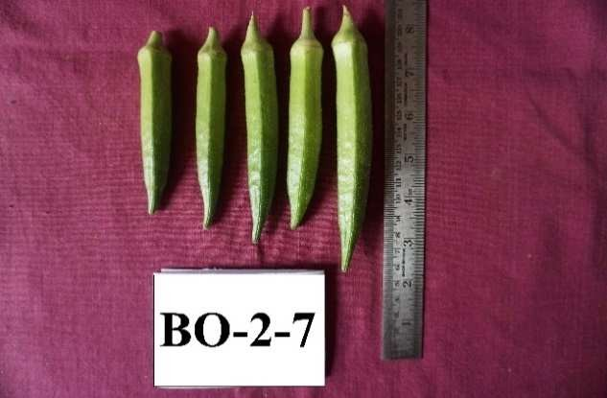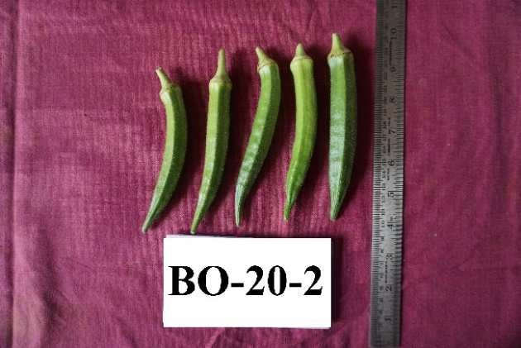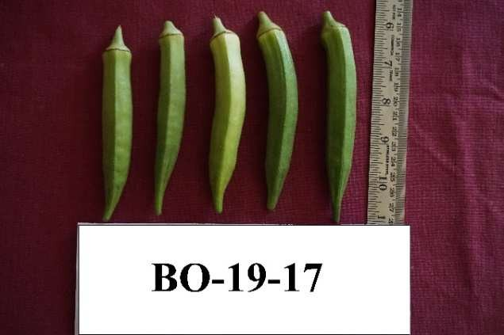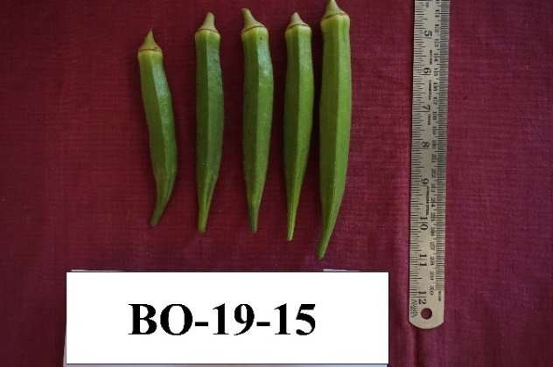

**(Fig.1 Fruits of different okra genotypes)**

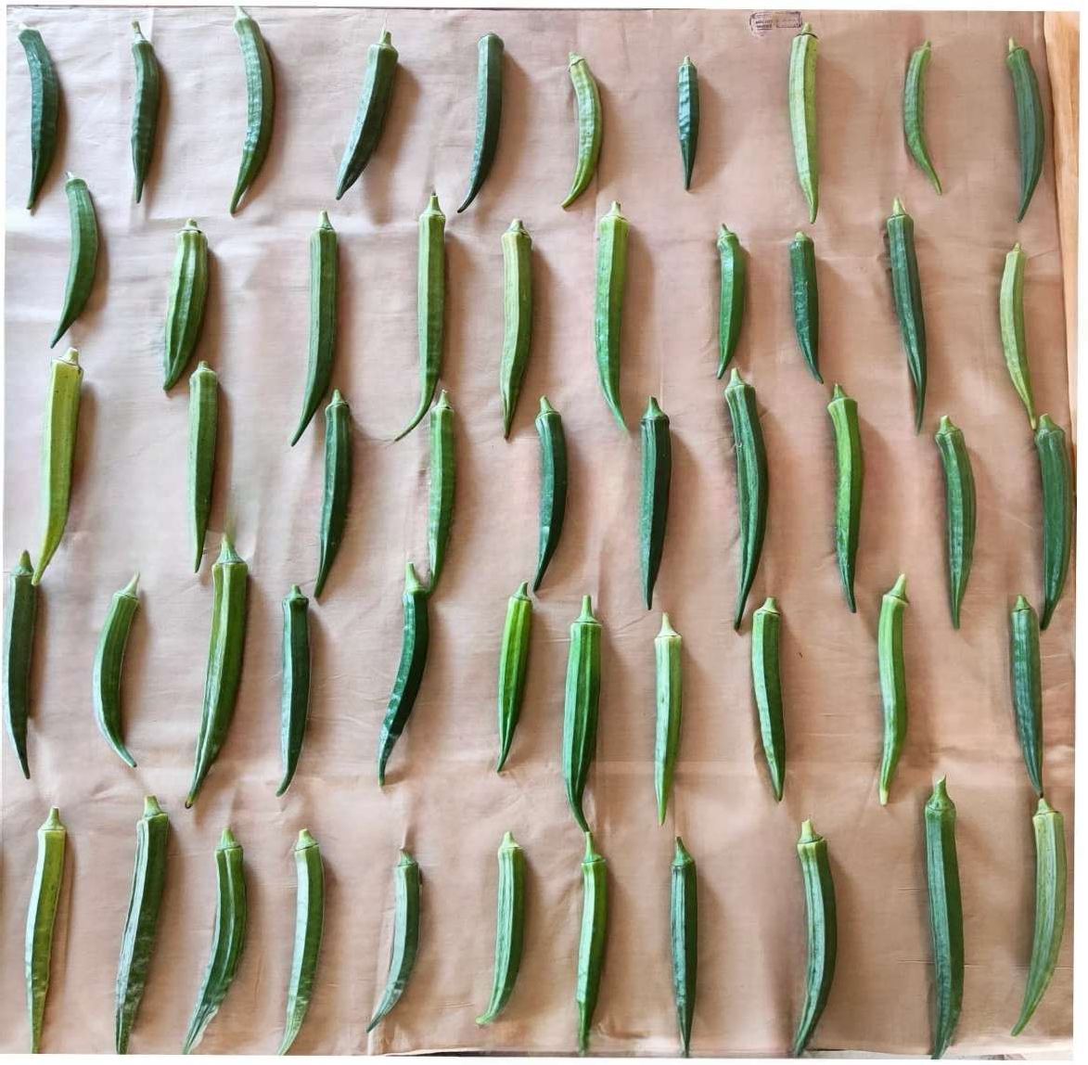

**(Fig. 2 Variability in okra fruits)**

**Table 5. Genetic variability of okra genotypes**

|  |  |  |  |  |  |  |  |  |
| --- | --- | --- | --- | --- | --- | --- | --- | --- |
| **Sl.**  **No.** | **Characters** | **Mean** | **Range** | **GCV** | **PCV** | **H (%)** | **GA** | **GA (%) of**  **mean** |
| 1. | Plant height (cm) | 141.01 | 73.70-182.39 | 11.20 | 14.30 | 71.32 | 26.25 | 21.07 |
| 2. | Plant spread (N-S) (cm) | 37.19 | 24.93-65.53 | 19.48 | 20.81 | 87.59 | 13.97 | 37.56 |
| 3. | Plant spread (E-W) (cm) | 40.90 | 24.33-68.63 | 20.34 | 21.29 | 88.66 | 15.90 | 38.88 |
| 4. | Number of nodes | 15.79 | 9.66-25.33 | 16.81 | 17.61 | 86.27 | 4.94 | 31.30 |
| 5. | Internodal length (cm) | 9.55 | 4.53-14.03 | 24.36 | 24.96 | 95.21 | 4.67 | 48.97 |
| 6. | Leaf area (cm2) | 497.84 | 378.16-714.66 | 14.99 | 15.98 | 85.05 | 139.45 | 28.01 |
| 7. | Days to 1st flowering | 38.80 | 35.33-41.33 | 0.67 | 5.13 | 1.71 | 0.07 | 0.18 |
| 8. | Days to 50 % flowering | 43.37 | 41.00-46.00 | 0.63 | 5.15 | 1.51 | 0.07 | 0.16 |
| 9. | Days to 1st fruiting | 46.50 | 43.00-50.00 | 2.17 | 5.60 | 15.00 | 0.91 | 1.73 |
| 10. | Pedicel length (cm) | 2.78 | 1.93-3.30 | 10.55 | 12.22 | 74.49 | 0.52 | 18.76 |
| 11. | Fruit length (cm) | 13.69 | 10.16-18.50 | 10.88 | 12.87 | 71.44 | 2.59 | 20.94 |
| 12. | Fruit girth (cm) | 6.26 | 5.66-7.13 | 3.26 | 6.85 | 62.74 | 2.20 | 23.21 |
| 13. | Average fruit weight (g) | 81.78 | 62.33-122.33 | 13.78 | 15.84 | 75.62 | 20.19 | 24.68 |
| 14. | No. of fruits per plant | 12.22 | 0.66-23.00 | 21.99 | 22.96 | 87.00 | 18.54 | 41.15 |
| 15. | TSS (oBrix) | 8.00 | 5.80-10.50 | 14.60 | 15.62 | 87.30 | 2.24 | 28.10 |
| 16. | Protein (mg 100g-1) | 7.90 | 6.06-10.20 | 7.75 | 9.23 | 70.55 | 1.05 | 13.41 |
| 17. | Phenol (mg 100g-1) | 0.82 | 0.43-1.38 | 23.96 | 24.55 | 95.24 | 0.39 | 48.17 |
| 18. | Total Yield per plant (g) | 127.59 | 16.33-278.13 | 29.89 | 30.87 | 91.13 | 68.15 | 57.96 |

* 1. **Correlation coefficient**

The correlation analysis among fifty-two okra genotypes revealed both positive and negative associations. Generally, genotypic correlations were higher than phenotypic ones, with close correspondence across traits (Table 6 & 7).The plant height showed positive and significant correlations with number of nodes, fruit length, average fruit weight and leaf area, but a significant negative correlation with total soluble solids (TSS) at both levels (Arumugam *et al*., 2020). The plant spread (N-S) was positively correlated with plant spread (E-W) and negatively with days to first flowering. Plant spread (E-W) was positively associated with number of nodes and yield per plant (Ashraf *et al*., 2020). The number of nodes showed positive correlations with leaf area and fruit length and negative correlations with days to first flowering, 50% flowering, first fruiting and phenol content (Bagadiya *et al*., 2022).

Similarly, the internodal length had positive correlations with leaf area and yield per plant and a negative correlation with days to 50% flowering (Temam *et al*., 2020). The leaf area showed a strong positive correlation with yield per plant and days to first fruiting whereas the days to first flowering and days to 50% flowering correlated positively with each other and days to first fruiting, but negatively with yield and number of fruits per plant (Kunwar *et al*., 2024). The days to first fruiting correlated positively with flowering days and number of fruits per plant and negatively with pedicel length, fruit girth and TSS at the genotypic level (Nayak *et al*., 2022). The fruit length also showed a significant positive correlation with plant height, number of nodes, fruit girth and average fruit weight, but negatively with days to 50% flowering (only at the genotypic level) (Walling *et al*., 2020). The fruit girth and average fruit weight both showed strong positive correlations with fruit length and each other (Rynjah *et al*., 2020). The average fruit weight also correlated positively with plant height and pedicel length. The number of fruits per plant showed a positive correlation with total yield per plant and a negative correlation with TSS whereas the TSS displayed a minor positive correlation with yield (Shinde *et al*., 2023). The protein content correlated positively with phenol content and yield (Mohammed *et al*., 2020). The yield per plant correlated positively with plant spread (N-S and E-W), internodal length and leaf area and negatively with days to first and 50% flowering at both phenotypic and genotypic levels (Neeraja *et al*., 2022).

|  |  |  |  |  |  |  |  |  |  |  |  |  |  |  |  |  |  |  |
| --- | --- | --- | --- | --- | --- | --- | --- | --- | --- | --- | --- | --- | --- | --- | --- | --- | --- | --- |
| **Characters** | **Plant height (cm)** | **Plant spread (N-S)**  **(cm)** | **Plant spread (E-W)**  **(cm)** | **No. of nodes** | **Internodal length (cm)** | **Leaf area (cm2)** | **Days to 1st flowering** | **Days to 50 %**  **flowering** | **Days to 1st fruiting** | **Pedicel length (cm)** | **Fruit length (cm)** | **Fruit girth (cm)** | **Average fruit weight (g)** | **No. of fruits per plant** | **TSS**  **(oBrix)** | **Protein (mg 100g-1)** | **Phenol (mg 100g-1)** | **Total yield per plant (g)** |
| Plant height (cm) | **1.000** | 0.245** | 0.263** | 0.319** | 0.141 | 0.229** | -0.932** | -1.598** | -0.176* | 0.124 | 0.423** | -0.106 | 0.221** | 0.081 | -0.469** | -0.077 | -0.134 | 0.078 |
| Plant spread (N-S) (cm) |  | **1.000** | 0.849** | 0.569** | -0.018 | -0.079 | -1.663** | -1.368** | -0.498** | 0.067 | 0.048 | 0.109 | 0.090* | 0.104* | 0.094* | -0.035 | -0.116 | 0.190* |
| Plant spread (E-W) (cm) |  |  | **1.000** | 0.692** | 0.127 | 0.098 | -1.411** | -1.064** | -0.272** | 0.250** | 0.045 | 0.165* | 0.055 | 0.176* | -0.041 | 0.157 | -0.153 | 0.205* |
| No. of nodes |  |  |  | **1.000** | 0.066 | 0.226** | -1.092** | -1.629** | -0.353** | 0.047 | 0.301** | 0.295** | 0.230** | 0.113** | -0.088 | -0.042 | -0.228** | 0.108* |
| Internodal length (cm) |  |  |  |  | **1.000** | 0.185* | -0.273** | -0.699** | 0.251** | 0.108 | -0.018 | 0.287** | 0.141 | 0.175* | -0.165* | 0.206** | 0.010 | 0.372** |
| Leaf area (cm2) |  |  |  |  |  | **1.000** | -0.604** | -0.001 | 0.188* | -0.065 | 0.005 | -0.077 | -0.047 | -0.130 | -0.089 | -0.020 | 0.063 | 0.233** |
| Days to 1st flowering |  |  |  |  |  |  | **1.000** | 1.608** | 0.563** | -0.019 | 0.364** | 3.226** | 0.260** | -1.165** | 0.001 | 0.351** | 0.581** | -0.461** |
| Days to 50 % flowering |  |  |  |  |  |  |  | **1.000** | 2.283** | -0.400** | -0.368** | -0.113 | 0.238** | -1.140** | -0.371** | 0.232** | 0.958** | -0.316** |
| Days to 1st fruiting |  |  |  |  |  |  |  |  | **1.000** | -0.238** | 0.033 | -0.171* | -0.136 | 0.047** | -0.220** | 0.089 | 0.024 | 0.118 |
| Peduncle length (cm) |  |  |  |  |  |  |  |  |  | **1.000** | -0.003 | 0.078 | 0.322** | 0.138 | -0.142 | 0.045 | -0.194* | -0.085 |
| Fruit length (cm) |  |  |  |  |  |  |  |  |  |  | **1.000** | 0.360** | 0.571** | 0.129 | -0.157 | -0.095 | -0.053 | -0.030 |
| Fruit girth (cm) |  |  |  |  |  |  |  |  |  |  |  | **1.000** | 0.743** | -0.109 | 0.078 | -0.203* | -0.162* | 0.165* |
| Average fruit weight (g) |  |  |  |  |  |  |  |  |  |  |  |  | **1.000** | -0.060 | -0.108 | -0.226** | -0.118 | 0.116 |
| No. of fruits per plant |  |  |  |  |  |  |  |  |  |  |  |  |  | **1.000** | -0.335** | -0.159* | -0.177* | 0.131** |
| TSS (OBrix) |  |  |  |  |  |  |  |  |  |  |  |  |  |  | **1.000** | 0.034 | 0.122 | 0.042** |
| Protein (mg 100g-1) |  |  |  |  |  |  |  |  |  |  |  |  |  |  |  | **1.000** | 0.303** | 0.140** |
| Phenol (mg 100g-1) |  |  |  |  |  |  |  |  |  |  |  |  |  |  |  |  | **1.000** | -0.005 |
| Total yield per plant (g) |  |  |  |  |  |  |  |  |  |  |  |  |  |  |  |  |  | **1.000** |

**Table 6. Genotypic correlations coefficient analysis in okra genotypes**

**\***Significant @5 % level and **significant @1 % level

|  |  |  |  |  |  |  |  |  |  |  |  |  |  |  |  |  |  |  |
| --- | --- | --- | --- | --- | --- | --- | --- | --- | --- | --- | --- | --- | --- | --- | --- | --- | --- | --- |
| **Characters** | **Plant height (cm)** | **Plant spread (N-S)**  **(cm)** | **Plant spread (E-W)**  **(cm)** | **No. of nodes** | **Internodal length (cm)** | **Leaf area (cm2)** | **Days to 1st flowering** | **Days to 50 % flowering** | **Days to 1st fruiting** | **Pedicel length (cm)** | **Fruit length (cm)** | **Fruit girth (cm)** | **Average fruit weight (g)** | **No. of fruits per plant** | **TSS**  **(oBrix)** | **Protein (mg 100g-1)** | **Phenol (mg 100g-1)** | **Total yield per plant (g)** |
| Plant height (cm) | **1.000** | 0.181* | 0.193* | 0.247** | 0.103 | 0.209** | -0.060 | -0.129 | -0.019 | 0.055 | 0.314** | 0.023 | 0.279** | 0.061 | -0.372** | -0.026 | -0.113 | 0.049 |
| Plant spread (N-S) (cm) |  | **1.000** | 0.741** | 0.510** | -0.027 | -0.058 | -0.221** | -0.174* | -0.188* | 0.041 | 0.043 | 0.048 | 0.091* | 0.075* | 0.077* | -0.011 | -0.110 | 0.179* |
| Plant spread (E-W) (cm) |  |  | **1.000** | 0.614** | 0.116 | 0.104 | -0.204* | -0.085 | -0.127 | 0.193* | 0.027 | 0.077 | 0.036 | 0.154 | -0.021 | 0.095 | -0.136 | 0.180* |
| No. of nodes |  |  |  | **1.000** | 0.066 | 0.218** | -0.194* | -0.204* | -0.161* | 0.034 | 0.230** | 0.133 | 0.183* | 0.086** | -0.071 | -0.013 | -0.204* | 0.102* |
| Internodal length (cm) |  |  |  |  | **1.000** | 0.159* | 0.010 | -0.061** | 0.113 | 0.107 | -0.008 | 0.137 | 0.097 | 0.178* | -0.157 | 0.155 | 0.007 | 0.338** |
| Leaf area (cm2) |  |  |  |  |  | **1.000** | -0.105 | -0.019 | 0.058* | -0.080 | 0.009 | -0.039 | -0.022 | -0.131 | -0.069 | -0.019 | 0.037 | 0.231** |
| Days to 1st flowering |  |  |  |  |  |  | **1.000** | 0.439** | 0.396** | 0.091 | 0.084 | 0.143 | 0.093 | -0.115** | 0.006 | 0.083 | 0.087 | -0.106** |
| Days to 50 % flowering |  |  |  |  |  |  |  | **1.000** | 0.425** | 0.019 | -0.005 | -0.024 | 0.011 | -0.102 | 0.008 | 0.017 | 0.136 | -0.050** |
| Days to 1st fruiting |  |  |  |  |  |  |  |  | **1.000** | 0.007 | 0.037 | 0.080 | -0.002 | 0.033** | -0.117 | -0.074 | 0.021 | 0.042 |
| Peduncle length (cm) |  |  |  |  |  |  |  |  |  | **1.000** | -0.038 | 0.055 | 0.210** | 0.145 | -0.121 | 0.046 | -0.134 | -0.075 |
| Fruit length (cm) |  |  |  |  |  |  |  |  |  |  | **1.000** | 0.244** | 0.434** | 0.116 | -0.127 | -0.016 | -0.057 | -0.022 |
| Fruit girth (cm) |  |  |  |  |  |  |  |  |  |  |  | **1.000** | 0.273** | -0.038 | 0.008 | -0.063 | -0.066 | 0.097 |
| Average fruit weight (g) |  |  |  |  |  |  |  |  |  |  |  |  | **1.000** | -0.058 | -0.089 | -0.121 | -0.109 | 0.086 |
| No. of fruits per plant |  |  |  |  |  |  |  |  |  |  |  |  |  | **1.000** | -0.301** | -0.126 | -0.153 | 0.099** |
| TSS (OBrix) |  |  |  |  |  |  |  |  |  |  |  |  |  |  | **1.000** | 0.083 | 0.116 | 0.044** |
| Protein (mg 100g-1) |  |  |  |  |  |  |  |  |  |  |  |  |  |  |  | **1.000** | 0.256** | 0.084** |
| Phenol (mg 100g-1) |  |  |  |  |  |  |  |  |  |  |  |  |  |  |  |  | **1.000** | 0.005 |
| Total yield per plant (g) |  |  |  |  |  |  |  |  |  |  |  |  |  |  |  |  |  | **1.000** |

**Table 7. Phenotypic correlations coefficient analysis in okra genotypes**

**3.4 Path analysis**

In a study of 52 okra genotypes, the number of nodes had the highest positive direct effect (0.258) on fruit yield per plant, followed by plant height (0.244), leaf area (0.242) and average fruit weight (0.154) (Table 8). Other traits with positive direct effects included number of fruits per plant (0.116), protein content (0.105), fruit girth (0.078) and plant spread (E-W) (0.005). Negative direct effects were observed for days to 1st flowering (-0.077), fruit length (-0.087) and internodal length (-0.109) (Rana *et al*., 2020). Indirect effects also influenced yield, with the number of nodes positively affecting it through traits like plant height, leaf area and average fruit weight (Komolafe *et al*., 2021). Plant height and leaf area contributed through multiple positive indirect pathways (Pundir *et al*., 2022). Traits like TSS and protein content showed moderate positive effects, while phenol content, days to 1st fruiting and days to 50% flowering had negative effects (Bambhaniya *et al*., 2024). Plant spread (N-S) and days to 1st flowering had notable negative effects. Overall, traits linked to plant vigor, fruit size and number positively impacted yield, while late flowering, fruiting and long internodes reduced it (Alemu, 2022).

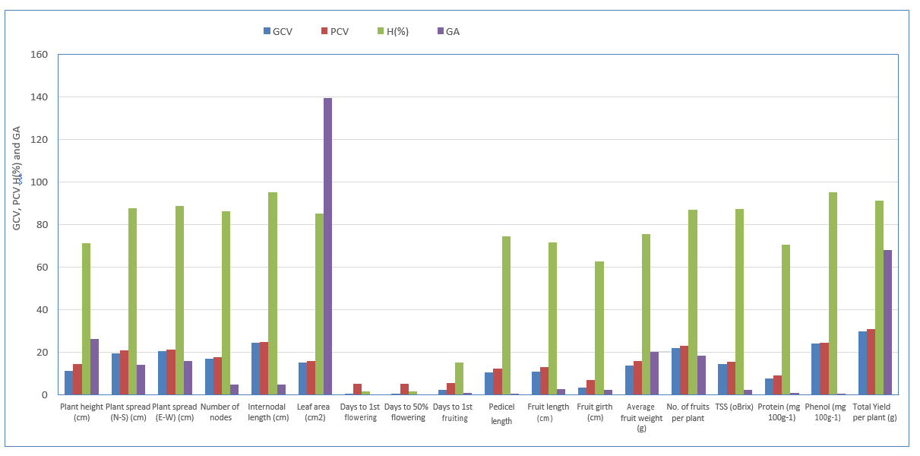**Fig.3 Genetic variability of okra genotypes**

**Table 8. Path coefficient analysis for okra genotypes at phenotypic level**

|  |  |  |  |  |  |  |  |  |  |  |  |  |  |  |  |  |  |
| --- | --- | --- | --- | --- | --- | --- | --- | --- | --- | --- | --- | --- | --- | --- | --- | --- | --- |
|  | **Plant height (cm)** | **Plant spread (N-S)**  **(cm)** | **Plant spread (E-W)**  **(cm)** | **No. of nodes** | **Internodal length (cm)** | **Leaf area (cm2)** | **Days to 1st flowering** | **Days to 50**  **%**  **flowering** | **Days to 1st fruiting** | **Pedicel length (cm)** | **Fruit length (cm)** | **Fruit girth (cm)** | **Average fruit weight (g)** | **No. of fruits per plant** | **TSS**  **(oBrix)** | **Protein (mg 100g-1)** | **Phenol (mg 100g-1)** |
| Plant height (cm) | **0.244** | 0.044 | 0.001 | -0.027 | 0.027 | 0.050 | 0.005 | -0.001 | -0.001 | -0.008 | -0.027 | 0.002 | 0.043 | 0.007 | 0.008 | -0.003 | 0.002 |
| Plant spread (N-S) (cm) | -0.013 | **-0.072** | 0.004 | -0.055 | -0.007 | -0.014 | 0.017 | -0.001 | -0.010 | -0.006 | -0.004 | 0.004 | 0.014 | 0.009 | -0.002 | -0.001 | 0.002 |
| Plant spread (E-W) (cm) | -0.014 | 0.181 | **0.005** | -0.067 | 0.031 | 0.025 | 0.016 | -0.001 | -0.007 | -0.028 | -0.002 | -0.006 | 0.006 | 0.018 | 0.000 | 0.010 | 0.002 |
| No. of nodes | 0.018 | 0.124 | 0.003 | **0.258** | 0.017 | 0.053 | 0.015 | -0.002 | -0.009 | -0.005 | -0.020 | 0.010 | 0.028 | 0.010 | 0.002 | -0.001 | 0.003 |
| Internodal length (cm) | -0.007 | -0.007 | 0.001 | -0.007 | **-0.109** | 0.039 | -0.001 | -0.001 | 0.006 | -0.016 | 0.001 | 0.011 | 0.015 | -0.021 | 0.003 | 0.016 | 0.000 |
| Leaf area (cm2) | -0.015 | -0.014 | 0.001 | -0.024 | 0.042 | **0.242** | 0.008 | 0.000 | 0.003 | 0.012 | -0.001 | -0.003 | -0.003 | 0.015 | 0.001 | -0.002 | -0.001 |
| Days to 1st flowering | -0.004 | -0.054 | -0.001 | 0.021 | 0.003 | -0.025 | **-0.077** | 0.004 | 0.021 | -0.013 | -0.007 | 0.011 | 0.014 | -0.013 | 0.000 | 0.009 | -0.001 |
| Days to 50 % flowering | -0.009 | -0.042 | 0.000 | 0.022 | -0.016 | -0.004 | -0.034 | **-0.008** | 0.022 | -0.003 | 0.000 | -0.002 | 0.002 | -0.012 | 0.000 | 0.002 | -0.002 |
| Days to 1st fruiting | -0.001 | -0.046 | -0.001 | 0.017 | 0.030 | 0.014 | -0.031 | 0.004 | **-0.053** | -0.001 | -0.003 | 0.006 | 0.000 | 0.004 | 0.002 | -0.008 | 0.000 |
| Peduncle length (cm) | -0.004 | 0.010 | 0.001 | -0.004 | 0.028 | -0.019 | -0.007 | 0.000 | 0.000 | **-0.147** | 0.003 | 0.004 | 0.032 | 0.017 | 0.003 | 0.005 | 0.002 |
| Fruit length (cm) | 0.023 | 0.010 | 0.000 | -0.025 | -0.002 | 0.002 | -0.006 | 0.000 | 0.002 | 0.006 | **-0.087** | 0.019 | 0.067 | 0.013 | 0.003 | -0.002 | 0.001 |
| Fruit girth (cm) | 0.002 | 0.012 | 0.000 | -0.014 | 0.036 | -0.009 | -0.011 | 0.000 | 0.004 | -0.008 | -0.021 | **0.078** | 0.042 | -0.004 | 0.000 | -0.007 | 0.001 |
| Average fruit weight (g) | 0.020 | 0.022 | 0.000 | -0.020 | 0.026 | -0.005 | -0.007 | 0.000 | 0.000 | -0.031 | -0.038 | 0.021 | **0.154** | -0.007 | 0.002 | -0.013 | 0.002 |
| No. of fruits per plant | 0.004 | 0.018 | 0.001 | -0.009 | 0.047 | -0.032 | 0.009 | -0.001 | 0.002 | -0.021 | -0.010 | -0.003 | -0.009 | **0.116** | 0.006 | -0.013 | 0.002 |
| TSS (OBrix) | 0.027 | 0.019 | 0.000 | 0.008 | -0.042 | -0.017 | 0.000 | 0.000 | -0.006 | 0.018 | 0.011 | 0.001 | -0.014 | -0.035 | **0.021** | 0.009 | -0.002 |
| Protein (mg 100g-1) | 0.002 | -0.003 | 0.000 | 0.001 | 0.041 | -0.005 | -0.006 | 0.000 | -0.004 | -0.007 | 0.001 | -0.005 | -0.019 | -0.015 | -0.002 | **0.105** | -0.004 |
| Phenol (mg 100g-1) | 0.008 | -0.027 | -0.001 | 0.022 | 0.002 | 0.009 | -0.007 | 0.001 | 0.001 | 0.020 | 0.005 | -0.005 | -0.017 | -0.018 | -0.002 | 0.027 | **-0.014** |

1. **Summery**

The analysis of variance showed significant differences among 52 okra genotypes for all traits, indicating substantial genetic variability, which is useful for selection and improvement. High genotypic and phenotypic coefficients of variation (GCV and PCV) for traits like total fruit yield, average fruit weight and number of fruits per plant suggest these traits are genetically influenced and suitable for selection. High heritability estimates and genetic advance for traits such as average fruit weight, number of nodes, fruit length, fruit girth, number of fruits per plant and total yield per plant indicate additive gene action, making them reliable for improvement through direct selection.

Correlation analysis showed that number of fruits, average fruit weight and fruit length were positively correlated with total yield, while traits like internodal length and number of primary branches had negative associations with yield. Overall results on character association of present investigation indicated that plant height, nodes per plant, fruit length, average fruit weight and number of fruits per plant are important parameters contributing more towards fruit yield in okra. Path coefficient analysis confirmed that average fruit weight had the highest positive direct effect on yield, followed by number of fruits and fruit length, with indirect effects being lower. These findings highlight the potential of selecting based on fruit weight, number of fruits and fruit length for yield improvement in okra. Hence, these traits should be considered for selection to improve fruit yield in okra.

1. **Conclusion**

The study demonstrated substantial genetic variability among the 52 okra genotypes for key agronomic traits, with high heritability and genetic advance estimates for characters such as **fruit length**, **average fruit weight** and **total fruit yield per plant**. Correlation and path coefficient analyses identified **average fruit weight** and **number of fruits per plant** as the most influential traits contributing to yield. The significant positive correlations and direct effects of these traits suggest their suitability as primary selection criteria in breeding programs. Overall, the findings provide valuable insight into the genetic architecture of yield-related traits and offer a strong foundation for the improvement of okra through trait-based selection.

**DISCLAIMER (ARTIFICIAL INTELLIGENCE)**

Author(s) hereby declares that NO generative AI technologies such as Large Language Models (ChatGPT, COPILOT etc.) and text-to-image generators have been used during writing or editing of the manuscript.

**REFERENCES**

1. Alemu F. 2022. Agro-morphological characterization and evaluation of okra [*Abelmoschus esculentus* (L.) Moench] landraces for yield and association among traits at Pawe, Northwest Ethiopia, 172: 20-42.
2. Andualem, M. (2023). Nutritional and Anti-nutritional Characteristics of Okra (*Abelmoschus esculentus* (L.) Moench) Accessions Grown in Pawe District, Northwestern Ethiopia. *International Journal of Agriculture and Biosciences*, 12(1), 18–21. <https://doi.org/10.47278/journal.ijab/2022.040>
3. Arumugam T. Ganesan KN and Kamalkumaran PR. 2020. Correlation and path coefficient analysis studies in okra (*Abelmoschus esculentus* (L.) Moench), *Journal of Pharmacognosy and Phytochemistry*, **9**(3): 1423-1427.
4. Ashraf ATMH, Rahman MM, Hossain MM and Sarker U. 2020. Study of correlation and path analysis in selected okra genotypes, *Asian Research Journal of Agriculture*, **12**(4): 1-11.
5. Bagadiya PG, Intwala CG, Patel P and Usadad JS. 2022. Assessment of the correlation and path analysis with association of growth and yield characteristics in okra [*Abelmoschus esculentus* (L.) Moench], *The Pharma Innovation Journal*, 11(4): 769-774.
6. Bambhaniya UB, Makwana SM, Chauhan LD and Kulkarni GU. 2024. Correlation and path coefficient analysis studies in okra [*Abelmoschus esculentus* (L.) Moench], *International Journal of Advanced Biochemistry Research*, 8(7): 532-535.
7. Berry, S. K., Kalra, C. L., & Sehgal, R. C. (1988). Quality characteristics of seeds of five okra (*Abelmoschus esculentus* (L.) Moench) cultivars. *Journal of Food Science and Technology*, 25(5), 303–305. https://ir.cftri.res.in/5151/
8. De Candolle, A. (1886). *The Origin of Cultivated Plants* (2nd ed.). Kegan Paul, Trench & Co.
9. Elkhalifa, A. B. O., Alshammari, E., Adnan, M., Alcantara, J. C., Awadelkareem, A. M., Eltoum, N. E., Mehmood, K., Panda, B. P., & Ashraf, S. A. (2021). Okra (*Abelmoschus esculentus*) as a potential dietary medicine with nutraceutical importance for sustainable health applications. *Molecules*, 26(3), 696. https://doi.org/10.3390/molecules26030696
10. Kenaw U, Mohammed W, Woldetsadik K. 2023. Morpho-agronomic variability of okra [*Abelmoschus esculentus* (L.) Moench] genotypes in Dire Dawa, eastern Ethiopia, *PLoS ONE* 18(7): e0288534.
11. Komolafe RJ, Ariyo OJ and Alake CO. 2021. Correlation and path coefficient analysis of fruit yield attributes in forty genotypes of okra (*Abelmoschus esculentus*), *Agricultural Research*, 11(1), 15-23.
12. Kumar A, Singh AK, Singh BK and Pal AK. 2021. Mean performance analysis for various traits in okra (*Abelmoschus esculantus* (L.) Moench), *The Pharma Innovation Journal*, 10(9): 1275-1278.
13. Kunwar A, Khatri L, Gurung L, Dhami R and Rawal J. 2024. Evaluation of varietal performance of okra under subtropical conditions of Nepal, *Journal of Genetics, Genomics & Plant Breeding*, **8**(1): 21-27.
14. Mehta, Y. R. (1959). *Vegetable Growing in Uttar Pradesh*. Bureau of Agriculture Information.in UP, Lukhnow.
15. Mohammed J. Mohammed W and Shiferaw E. 2020. Correlation and path coefficient analysis among agro-morphological and biochemical traits of okra [*Abelmoschus esculentus* (L) Moench) genotypes in Ethiopia, *Acta Agriculturae Slovenica*, 115(2): 329-339.
16. National Horticultural Board (NHB). (2022). *Database 2021–2022*. <https://www.nhb.gov.in/annual_report.aspx?enc=3ZOO8K5CzcdC/Yq6HcdIxOBX3ZfjXi13RgCoILztD0k>=
17. Nayak NJ, Tripathy P, Sahu GS, Dash SK, Lenka D and Mishra S. 2022. Correlation and Path Analysis of Okra (*Abelmoschus esculentus* L. Monech) Germplasms for Fruit Yield and its Components, *International Journal of Environment and Climate Change,* 12(12): 1963-1969.
18. Neeraja S, Srinivas J, Joshi V, Nikhil B and Sathish G. 2022. Correlation and path analysis studies in okra (*Abelmoschus esculentus* L.) genotypes, *Biological Forum - An International Journal*, 14(4): 1097-1106.
19. Pundir S, Singh M, Kumar M, Lodhi S K, Singh A and Alam K. 2022. Studies on correlation and path coefficient for direct selection between pair of traits using green fruit yield as dependent characters in okra, *International Journal of Environment and Climate Change*, **12**(4): 90-96.
20. Rana A, Singh S and Bakshi M. 2020. Study on genetic variability, correlation and path analysis for morphological, yield and yield attributed traits in okra [*Abelmoschus esculentus* (L.) Moench), *International Journal of Agricultural and Statistical Sciences*, 16(1): 387-394.
21. Ranga AD and Darvhankar MS. 2022. Diversity analysis of phenotypic traits in okra (*Abelmoschus esculentus* L. Moench), *Journal of Horticultural Science*, 17(1): 63-72.
22. Reddy JP, Anbanandan V and Kumar SB. 2022. Genotypic, phenotypic variability and evaluation of okra [*Abelmoschus esculentus* (L.) Moench] genotypes for yield components, *Journal of Applied and Natural Science*, 14(1): 180-187.
23. Rynjah S, Arumugam T, Ganesan KN and Kamalkumaranı A. 2020. Corelation and path coefficient analysis in okra [*Abelmoschus esculentus* (L.) Moench), *Journal of Pharmacognosy and Phytochemistry*, **9**(3): 1423-1427.
24. Shinde SL, Zate DK, Gavade SS, Zate AK and Shinde JV. 2023, Correlation analysis for fruit yield and its related traits in okra [*Abelmoschus esculentus* (L.) Moench), *The Pharma Innovation Journal*, **12**(1): 215-220.
25. Temam N, Mohamed W and Aklilu S. 2020. Agro-morphological characterization and evaluation of okra [*Abelmoschus esculentus* (L.) Moench.] genotypes for yield and other variability components at Melkassa, Central Ethiopia, *MOJ Eco Environ Sci*., 5(2): 80-87.
26. Tindall, H. D. (1983). *Vegetables in the Tropics*. McMillan AVI. https://www.cabidigitallibrary.org/doi/full/10.5555/19840321042
27. Vani VM, Singh BK, Raju SVS and Singh A. 2021. Studies on genetic variability, heritability and genetic advance for various quantitative traits in okra [*Abelmoschus esculentus* (L.) Monech] genotypes under north gangetic plains of Uttar Pradesh, *Journal of Pharmacognosy and Phytochemistry*, 10(3): 272-274.
28. Veeresh, Y. P., Diwan, J. R., Patil, M. G., & H., A. (2024). Assessment of genetic variability in okra (*Abelmoschus esculentus* L. Moench) genotypes. *Journal of Scientific Research and Reports*, 30(8), 234–241. <https://doi.org/10.9734/jsrr/2024/v30i82243>
29. Walling N, Kanaujia SP, Alila P, Sharma MB and Ozukum C. 2020. Genetic variability and correlation studies in okra [*Abelmoschus esculentus* (L.) Moench] genotypes under foothill conditions of Nagaland, *International Journal of Scientific Research*, 11(2): 37651-37654.
30. Yadav KS and Singh AP. 2024. The Study of Variability Heritability and Genetic Advance in Okra [*Abelmoschus esculentus* L. Moench] Crop, *Journal of Experimental Agriculture International*, 46(7): 569-573.