***Original Research Article***

**EXPLORING THE HEXAPOD NATURAL ENEMY COMPLEX OF WEST BENGAL'S TERAI RICE ECOSYSTEM**

**ABSTRACT**

**Aims:** The aim of this study is to investigate into the hexapod natural enemy fauna prevailing in the rice (Oryza sativa L.) ecosystem under the Terai agro-ecological region of West Bengal.

**Study design:** The study was conducted using the rice variety MTU 1153, cultivated under standard agronomic practices without any plant protection measures to allow natural pest and predator interactions. To assess the hexapod natural enemy complex, sweeping net sampling was employed. Sampling was performed at five predetermined 1 m² plots within the experimental field.

**Place and duration of study:** Field study was carried out at the Instructional Farm of Uttar Banga Krishi Viswavidyalaya (UBKV), Pundibari, Coochbehar for consecutive two seasons *viz*. Kharif rice (2022) and Boro rice (2023).

**Methodology:** Predators and parasitoids were collected by 10 sweeps per m2 area per sampling site. Sampling began at 15 days after transplanting and continued at weekly intervals till maturity of the crop. At each designated 1 m² sampling site, 10 sweeps were conducted per sampling session to standardize collection effort and ensure consistency. The collected samples were categorized and classified based on their taxonomic orders.

**Results:** Study revealed a diverse range of natural enemy fauna with a record of thirteen predatory and parasitic insect species belonging to seven families and three orders. Correlation coefficient (r) between the weekly captured predator/ parasitoids and the weather parameters were calculated. The population build-up *Micraspis*sp was correlated negatively and significantly with minimum temperature (r = -0.775) during kharif and was positively and significantly correlated with GDD (r = 0.573) during both kharif and rabi season. Population of cardiochilinae wasp has shown a significant and positive correlation with maximum (r = 0.625) and minimum relative humidity (r = 0.622) during kharif season. Different diversity indices for kharif and rabi such as Shannon-Wiener index (2.32,2.174), Simpson’s index (0.892,0.866), Pielou’s index (0.932,0.875) and Margalef index (1.992,1.967) revealed moderately rich biodiversity of natural enemies in the rice ecosystem.

**Conclusion:** The rice ecosystem revealed a remarkable level of diversity of natural enemies. The predators and parasitoids recorded during the experiment are well known for their multifaceted valuable role in maintaining ecological equilibrium by regulating pest population.

*Key words: Natural enemy, Rice ecosystem, Predators, Parasitoids, Terai region, Diversity*

**INTRODUCTION**

Rice (*Oryza sativa* L.) is a primary staple food for almost half of the world's population, making it a crucial global food grain (Prasad *et al.,* 2017) and worldwide nearly 3.5 billion people rely on rice as a dietary intake (Gadal *et al.,* 2019). India emerges as the second-largest producer and a significant exporter of rice on the global stage contributing around 44.6 million hectares to rice cultivation, yielding approximately 104.32 million tonnes annually at an average rate of 2.34 tonnes per hectare (Rajasekar and Jeyakumar 2014). The eastern part of India comprises 60% of rice growing area of the country and West Bengal is a main rice producing state where rice crop occupies nearly 66% of the gross cropped area (Acharjee *et al.,* 2020).The crop is attacked by 100 different insect species, among them 20 are identified as primary pests (Atwal and Dhaliwal 2005). Some of the notable pests are stem borers, rice leafhoppers, plant hoppers, rice gall midge, rice leaf folders, and various grain sucking insects such as the rice bug and stink bug. In India, 20% yield reduction in rice is due to insect pests every season (Dhaliwal *et al.,* 2010). An account by Krishnaiah (2015) indicated average yield loss in rice pest wise, as 30% by stem borers, 20% by plant hoppers, 15% by gall midge, 10% by leaf folder and 25% by other pests if they were not controlled in a timely manner.

For million years, natural enemies have coexisted with pests in natural ecosystem, globally. They are responsible for managing many of the rice insect pests. Pest outbreaks are the output of imbalance in the relationship between pests and their natural enemies in agro ecosystem.The challenges with insect pests have intensified with the adoption of contemporary agricultural methods. IPM programmes include a significant amount of biological control through predators and parasitoids (Islam 1990, Kalode 2005). Natural enemies provide an eco-friendly and cost-effective method of pest control in rice fields, benefiting both crop and environmental health. Their role is critical in lowering dependency on synthetic pesticides and supporting sustainable agriculture methods. The dynamic rice ecosystem is a reservoir for these beneficial organisms and is integral component to the Bio Intensive Pest Management (BIPM) system. Knowledge of the natural enemy complex of any region is a prerequisite for the better understanding of the ecosystem functioning.

**MATERIALS AND METHODS**

***Experimental details:***

Field study was carried out at the instructional farm of Uttar Banga Krishi Viswavidyalaya (UBKV) in Pundibari, Coochbehar, in Kharif rice (2022) and Boro rice (2023). The rice variety MTU 1153 was cultivated using standard agricultural practices, without employing any plant protection measures. To capture the predators and parasitoids present in the rice fields, a sweeping net was used. Five specific spots each measuring 1 m² were identified within the experimental field. Four of these locations were positioned at the corners, while the fifth was centrally located within the field. The process of collecting predators and parasitoids commenced 15 days post-transplanting and continued until the crop reached maturity. Sampling activities involved using a hand-mounted circular net with a fine cloth mesh. Each sample comprised of 10 sweeps done in the eachsampling site comprising of 1 m² area.

**Table -1: Details of the experiment conducted in Kharif rice (2022) and Boro rice (2023)**

|  |  |  |  |
| --- | --- | --- | --- |
| **No. of Entry** | : | One (MTU 1153) | |
| **Seasons** | : | Kharif | Boro |
| **Time of sowing** | : | First fortnight of June | First fortnight of January |
| **Time of transplanting** | : | First fortnight of July | First fortnight of March |
| **Plot size** | : | 50m × 50m | |
| **Spacing** | : | 20 cm × 20 cm | |
| **Number of sweeps in each sampling** | : | 10 | |
| **Time of sampling** | : | Early morning | |
| **Frequency of observations** | : | Weekly | |
| **Specification of sweep net** | : | 30 cm diameter with 75cm long handle | |
| **Plant Protection measures** | : | No measure | |

***Collection, preservation and identification of predators and parasitoids:***

Natural enemies collected from each sampling unit were placed in separate polythene bags. These bags were brought to the laboratory, Department of Agricultural Entomology, UBKV. Specimens were examined using a stereomicroscope Zoomstar-II-BR. The collected natural enemies from the samples were categorized and classified based on their taxonomic orders. From the collected sample, number of individuals was recorded genus wise and species wise. Few of the insects were identified up to the generic level using available database (ICAR-NBAIR 2013). Subsequently, few of the samples (Braconidae, Chalcididae and Libellulidae) were sent to ZSI Kolkata for identification. High-resolution images were captured using a ZEISS Stemi 508 stereo zoom microscope. The diversity indices were calculated using the formulae presented in Table 2

***Observation on macroclimate data:***

Macroclimate data (maximum and minimum temperature, maximum and minimum relative humidity, rainfall and bright sunshine hours) were collected from, Gramin Krishi MausamSewa Kendra, UBKV, Pundibari. Correlation coefficient (r) between the numbers of weekly captured natural enemy and weather parameters were calculated only in case of three most dominant natural enemies.

**Table-2: Calculation of diversity indices:**

|  |  |
| --- | --- |
| Simpson’s Index (D) This index measures the probability that two individuals randomly selected from a sample will belong to the same species. | $$D=Σn\frac{(n - 1) }{N(N - 1)}$$ n = number of individuals of a particular specie  N = total number of individuals of all species |
| **Shannon-Wiener index**  This index accounts for both abundance and evenness of the species present. | $$H^{'}= -∑Pi​ln(Pi​)$$*Pi* = proportion of individuals belonging to the *ith* species |
| Margalef Index (α) This index is used to measure species richness. | $$α=\frac{(S – 1) }{ln(N)}$$*S* = total number of species  *N* = total number of individuals |
| **Pielou’s Evenness Index (E₁)**  This index measures how evenly individuals are distributed across species. | $$E^{1}= \frac{H' }{ln(S)}$$ H′ = Shannon-Wiener diversity index  *S* = total number of species |

**RESULTS AND DISCUSSION:**

In the comprehensive field study, a diverse array of predatory and parasitic insects was recorded. In total, 13 distinct species of beneficial insects belonging to seven families and three orders were identified and documented (Table-3). The relative abundance of these species is presented in Table-4. The pictures of the natural enemies are presented in Fig-3.

**Table – 3: Different natural enemies collected from kharif rice 2022 and boro rice 2023**

|  |  |  |
| --- | --- | --- |
| **NATURAL ENEMY** | **FAMILY** | **ORDER** |
| *Micraspis discolor* | **Coccinellidae** | **Coleoptera** |
| *Propylea dissecta* |
| *Propylea japonica* |
| *Ophionea* sp. | **Carabidae** |
| *Cardiochilinae wasp* | **Braconidae** | **Hymenoptera** |
| *Brachymeria* sp. | **Chalcididae** |
| *Xanthopimpla* sp*.* | **Ichneumonidae** |
| *Rhyothemis variagata* | **Libellulidae** | **Odonata** |
| *Crocothemis servilla* |
| *Orthetrum sabina* |
| *Agriocnemis* sp*.* | **Coenagrionidae** |
| *Ischnura* sp. |

**Table-4: Relative abundance of natural enemies collected from kharif rice (2022) and boro rice (2023) by making 10 sweeps/ 1 m2 sampling site.**

|  |  |  |  |
| --- | --- | --- | --- |
| **Natural Enemy** | **Kharif rice 2022** | **Boro rice 2023** | **Average relative abundance (%)** |
| *Micraspis discolor* | 40 | 62 | 19.69 |
| *Propyleac dissecta* | 25 | 19 | 8.49 |
| *Propylea japonica* | 20 | 9 | 5.60 |
| *Ophionea* sp. | 16 | 38 | 10.42 |
| *Cardiochilinae wasp* | 44 | 41 | 16.41 |
| *Brachymeria* sp. | 8 | 8 | 3.09 |
| *Xanthopimpla* sp. | 13 | 11 | 4.63 |
| *Rhyothemis variagata* | 9 | 6 | 2.90 |
| *Crocothemis servilla* | 4 | 3 | 1.35 |
| *Orthetrum sabina* | 16 | 9 | 4.83 |
| *Agriocnemis* sp. | 32 | 42 | 14.29 |
| *Ischnura* sp. | 23 | 20 | 8.30 |

The order Coleoptera was prominent represented Coccinellidae and Carabidae. Within the Coccinellidae family, three distinct beetles species namely *Micraspis discolor*, *Propylea dissecta*, and *Propylea japonica* were recorded in varying proportion. *Micraspis discolor* was the most dominant beetle with a relative abundance of 19.69% followed by *Ophionea* sp (10.42%).These beetles, well-known as general predators, play a pivotal role in maintaining ecological balance by preying on different insect pests of rice. The family Carabidae was slightly more restrained in its diversity, with only one member, *Ophionea* sp., being observed during the study (Table 4).

Another significant order that emerged from the study was Hymenoptera, having a vibrant diversity of unique families and three distinct genera. The most abundant parasitoid was a wasp from the subfamily Cardiochilinae (family Braconidae) and it was identified only upto subfamily level due to unavailability of taxonomist. Proper identification of this wasp is very important because it can be an additional member to the existing biodiversity of natural enemies in this region.

Other two were *Brachymeria* sp. from Chalcididae family and *Xanthopimpla* sp. from the Ichneumonidae family (Table 4). These parasitic species are instrumental in regulating pest populations ensuring the health and productivity of rice crops. The relative abundance of the cardiochilinae wasp was 16.41% followed by *Xanthopimpla* sp. (4.63%).

The dragonflies and damselflies of the Odonata order exhibited a fascinating diversity in the rice fields and the number of damselflies was higher when compared to dragon flies (Parsappa *et al.,* 2017). In the present study, this order was represented by five distinctive genera of Libellulidae and Coenagrionidae. The dragonflies species included *Rhyothemis variegata*, *Crocothemis servilia*, and *Orthetrum sabina* (Table4). These aerial predators offer significant ecological benefits by preying on a variety of insect pests. The two damselfly spedies ,*Agriocnemis* sp. and *Ischnura* sp., added another layer of biodiversity, The most abundant among the dragonflies was *Orthretum sabina* (4.83%) and the predominant damselfly species was *Agriocnemis* sp. (14.29%) .

Several researchers have shown that rice field are rich reservoir of natural enemies. In the surveys conducted by Devi *et al*.(2018)during kharif season (2012-2014) in Manipur, a total 33 species of predators from 26 genera and 15 families as well as 15 species of parasitoids from 5 families were collected. Likewise, Madhukar (2011), recorded predatory natural enemy complex consisting of 23 insects belonging to 7 orders and 18 families in both the kharif (wet) and rabi (dry) seasonsin rice ecosystem in eastern Vidarbha of Maharashtra. Mondal *et al.* (2017)examined the relative abundance of various natural enemies in rice from Murshidabad, West Bengal, India. In their survey, lady bird beetles were the most abundant one (51.06%) followed by long jawed spider (18.91%), carabid beetle (7.47%), damsel fly (6.54%), wolf spider (6.32%), lynx spider (3.86%), dragon fly (2.96%) and wasps (2.85%). In the present study, lady bird beetles were found to be a very important group of predators in rice and *Micaspis* sp. was the most dominant species, Further, the parasitic cardiochilinae wasp was the second most dominant natural enemy in rice ecosystem. Among dragon flies and damselflies, members of Libellulidae and Coenagrionidae were found. Previous records also show occurrence of three families of odonates such as lestidae (one species), libellulidae (12 species), and coenagrionidae (6 species) in rice (Arulprakash *et al*. 2017).

Different indices were also calculated to understand the level of diversity of the natural enemy complex visiting rice ecosystem. The Shannon- wiener index, Simpson diversity index, Margalef and Pielou’s index were calculated as 2.32, 0.892, 1.99 and 0.932 respectively for kharif rice and 2.13, 0.856, 1.96 and 0.857 respectively for boro rice. Study conducted on different diversity indices by Daniel and Ramaraju (2019) from Tamil Nadu revealed that Shannon-Wiener index (H’) ranged from 0.97 to 1.02, Simpson’s Diversity Index (SDI) ranged from to 0.83-0.87, and Pielou’s Evenness Index (E1) ranged from 0.30- 0.33 in the three rice growing zones. Similarly, Gnanakumar*et al* (2012) recorded Simpson’s Diversity Index (SDI) for organic paddy as 0.977 and 0.898 for conventional paddy ecosystem. Busniah*et al* (2019) showed that the diversity index in rice ecosystem was high (4.675) and the evenness index was also high (0.887). The result of the present study also revealed that rice ecosystems of the present experimental area are moderately rich in diversity of predators and parasitoids.

**Table-5: Different diversity indices for natural enemies in kharif rice and boro rice.**

|  |  |  |
| --- | --- | --- |
| **Diversity indices** | **Kharif rice** | **Boro rice** |
| Shannon-Wiener index | -Σ Pi ln (Pi) = 2.32 | -Σ Pi ln (Pi) = 2.174 |
| Simpson’s index | Σ (ni(ni - 1)) / (N(N - 1)) = 0.108  SID=1-Σ (ni (ni - 1)) / (N (N - 1))  = 0.892 | Σ (ni (ni - 1)) / (N (N - 1)) = 0.134  D=1-Σ (ni (ni - 1)) / (N (N - 1))  = 0.866 |
| Pielou’s evenness index | E1=H’/ ln(S) = 0.932 | E1=H’/ ln(S) = 0.875 |
| Margalef index | α=(S–1)/ln (N) =1.992 | α=(S–1)/ln (N) =1.967 |

***Seasonal incidence of natural enemies in relation to weather parameters and growing degree days:***

The population build-up of the most dominant predator and parasitoids from each order were correlated with prevailing weather parameter and growing degree days. The population of coleopteran predator *Micraspis* sp. was found to be correlated significantly and negatively with minimum temperature (r = -0.775) and was significantly and positively correlated with Growing Degree Days (r = 0.573) during kharif season (Fig-1). Whereas in boro rice, *Micraspis* sp. has shown positive and significant correlation only with GDD (Fig-2). Population of the cardiochilinae wasp has shown a significant and positive correlation with maximum (r = 0.625) and minimum relative humidity (r = 0.622) in kharif rice but has not revealed any significant correlation with any of abiotic factors in boro rice. The population of damselfly *Agriocnemis* sp. has not shown any significant correlation with any of the abiotic factors in any of the seasons. Selvam et al. (2021) found the trap catch of natural enemies to be positively correlated with minimum temperature (0.644, 0.137), and sunshine hours (0.352, 0.214) whereas rainfall showed a negative correlation (-0.252, -0.048).

**Fig-1: Population of *Micraspis* sp. and Cardiochilinae wasp as influenced by weather parameters and GDD in kharif rice (2022)**

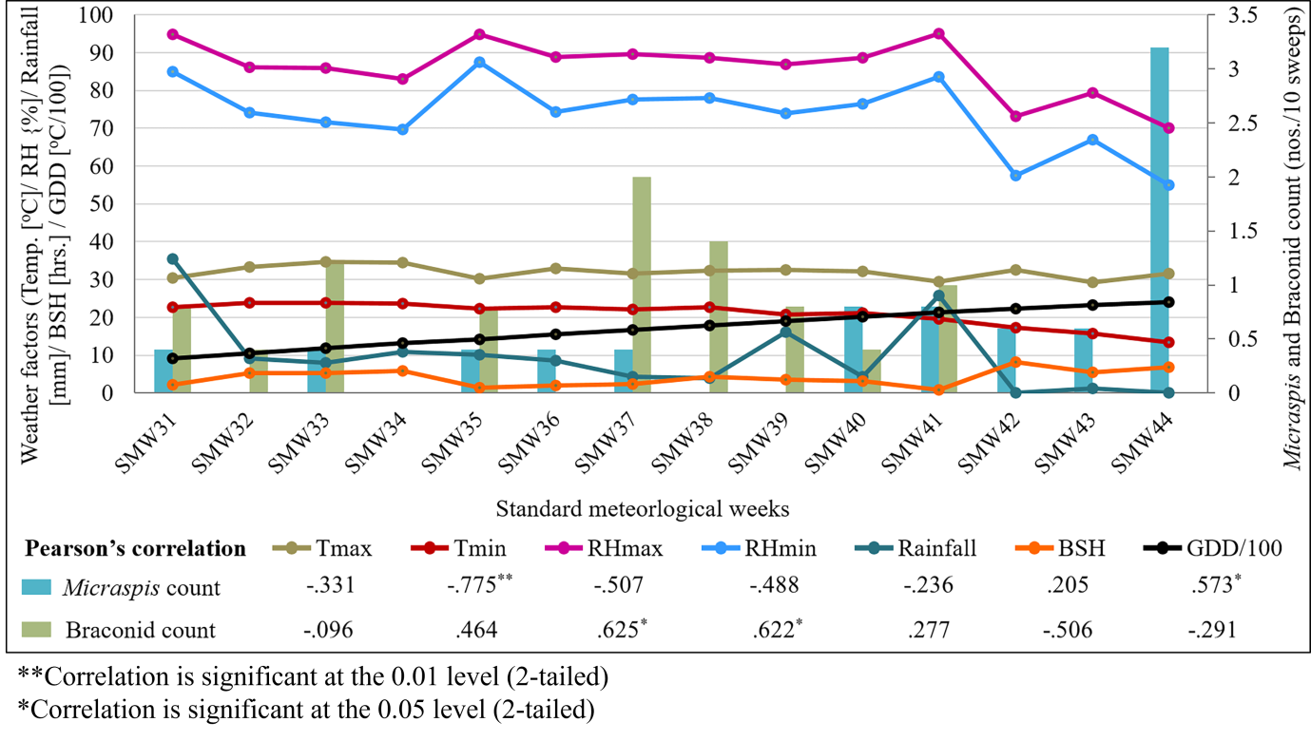

**Fig-2: Population of *Micraspis* sp. as influenced by weather parameters and GDD in boro rice (2023)**

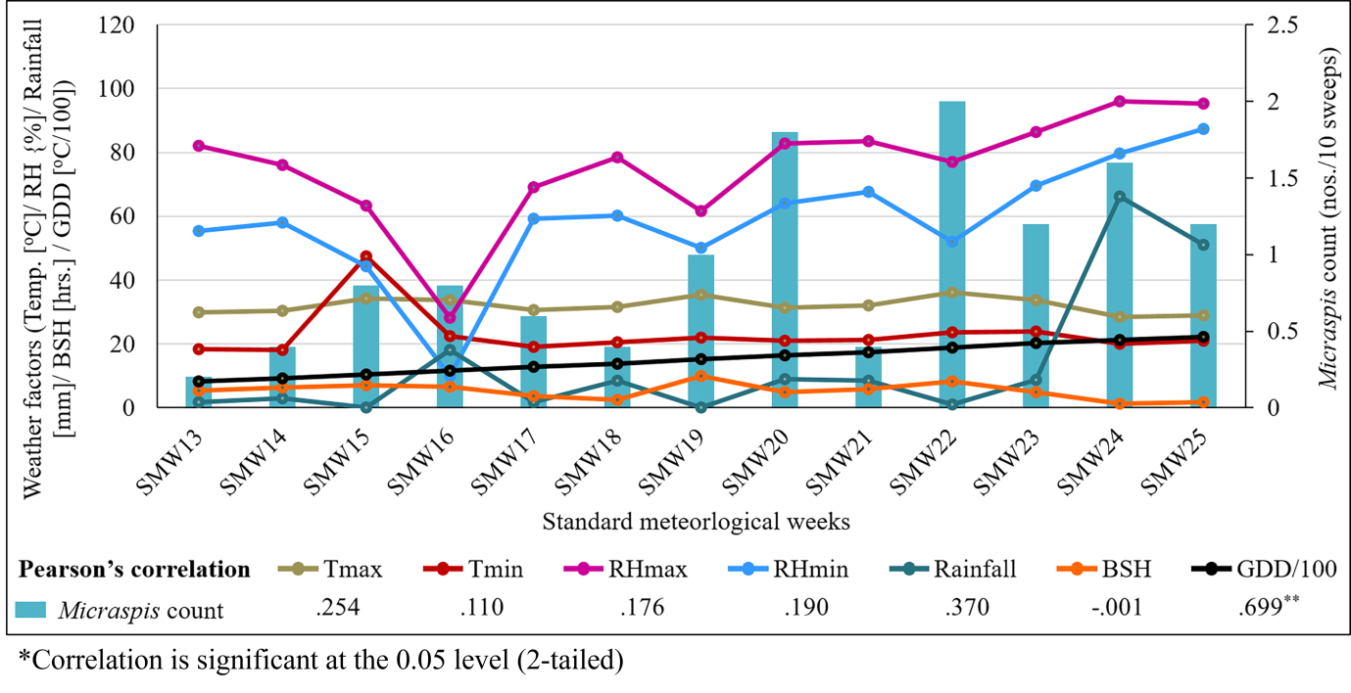

**CONCLUSIONS:**

The experiment has revealed a remarkable level of richness and diversity of natural enemies in rice ecosystem for both kharif as well as boro season. The findings can be used as baseline information for understanding the of natural enemies in rice ecosystem which might have significant role in natural control of pests. The predators and parasitoids recorded during the experiment are well known for their multifaceted valuable role in maintaining ecological equilibrium by regulating pest population. Presence of this diverse group of natural enemies in the experimental region is an added advantage towards implementation of biological control which can ultimately contribute to sustainable and resilient rice cultivation ensuring long term agricultural productivity and food security.

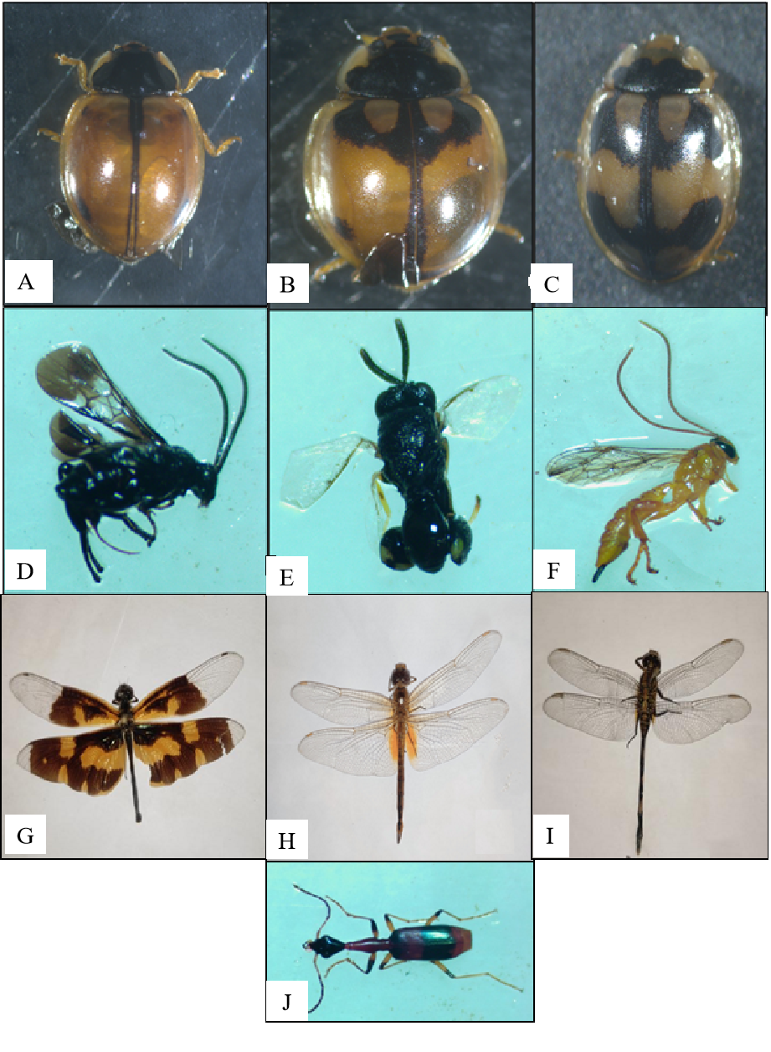

**Figure 3**: Different natural enemies of rice ecosystem. (A) *Micraspis discolor*, [B] *Propylea dissecta*, [C] *Propylea japonica*, [D] Cardiochilinae wasp, [E] *Brachymeria* sp., [F] *Xanthopimpla* sp.; [G] *Rhyothemis variegata*, [H]*Crocothemis servilia*,[I] *Orthetrum sabina*; [J] *Ophionea* sp.

Disclaimer (Artificial intelligence)

Option 1:

Author(s) hereby declare that NO generative AI technologies such as Large Language Models (Chat GPT, COPILOT, etc.) and text-to-image generators have been used during the writing or editing of this manuscript.

**References:**

Acharjee,P.,Satpathi, C. R., and Modak, M. K. (2020). Long term studies on role of parasitic nematode *Hexamermis*sp. in controlling brown planthopper in farmer’s rice field of West Bengal. International Journal of Current Research and Review,12, 7-11.

Arulprakash, R., Chitra, N., and Gunathilagaraj, K. (2017). Biodiversity of Odonata in Rice at Pattukkottai in Tamil Nadu. Indian Journal of Entomology,79 (4), 498-502.

Atwal, A. S., and Dhaliwal, G. S. (2005). Agricultural pests of South Asia and their management. Kalyani publishers, New Delhi, pp 181-82.

Busniah, M., Hakiki, A., and Martinius, M., (2019). Diversity of Hymenopteran parasitoid in agricultural and primary forest in LubukKilangan, Padang, West Sumatera, Indonesia.IOP Conf. Series: Earth and Environmental Science**, 497,**012034. IOP Publishing doi:10.1088/1755-1315/497/1/012034.

Daniel, A. J., and Ramaraju, K., (2019). Diversity of parasitic Hymenoptera in three rice- growing tracts of Tamil Nadu, India. Journal of Threatened Taxa,**11**(13), 14681– 14690. htps://doi.org/10.11609/jot.4529.11.13.14681-14690.

Dhaliwal, G. S., Jindal, V., and Dhawan, A. K. (2010). Insect pest problems and yield losses: Changing trends. Indian Journal of Ecology**,**37,1-7.

Gadal, N., Shrestha, J., Poudel, M. N. and Pokharel, B. (2019). A review on production status and growing environments of rice in Nepal in the world.Archives of Agriculture and Environmental Science, 4(1), 83-87.

Gnanakumar, M., Rajmohana, K. C., Bijoy, D., Balan, and Nishi, R., (2012). Diversity of Hymenopteran Egg Parasitoids in Organic and Conventional Paddy Ecosystems. Tropical Agricultural Research*,* 23(4), 300–308.

Islam, Z., (1990). Influence of *Scirpophagaincertulas*(Lepidoptera: Pyralidae) on deep-water rice. Bulletin of Entomological Research**,**80 (3), 301-308.

Kalode, M. B. (2005). Insect pest of rice and their management in Rice in Indian Perspective edited by S.D.Sharma and B.C.Nayak. Today and tomorrow printers and publishers (India), 819-854.

Krishnaiah., Varma, N. R. G. (2015). Changing Insect Pest Scenario in the Rice Ecosystem – A National Perspective. IRRIBook, 31-42.

Madhukar, F. J. (2011). A preliminary study of the predatory natural enemy complex of rice ecosystem in Vidarbha region of Maharashtra, India. International Referred Research Journal,2(22), 25-27.

Mondal, H. I. and Chakraborty, K., (2017). Observation on the impact of environmental parameters on rice yellow stem borer, *Scirpophagaincertulas*(Walker) and its natural enemies at Murshidabad, West Bengal, India. Journal of Entomology and Zoology Studies,5(6), 1656-1663.

Parasappa, H.H. and Reddy, N.G., (2017). Rice insect pests and their natural enemies complex in different rice ecosystem of Cauvery command areas of Karnataka. Journal of Entomology and Zoology Studies, 5(5), 335-338.

Prasad, R., Shivay, Y. S. and Kumar, D. (2017). Current status, challenges, and opportunities in rice production. (In) Rice DOI: <https://doi.org/10.1007/978-3-319-47516-5_1>

Rajasekar, N., and Jeyakumar, P., (2014). Differential response of trifloxystrobin in combination with tebuconozole on growth, nutrient uptake and yield of rice (*Oryza sativa* L.). International Journal of Agriculture, Environment and Biotechnology 6(1), 87-93.

Ranjeeta, Devi, M., Singh, K. I. and Ray, D. C. (2018). Predators and Parasitoids of rice insect pests under rice ecosystems of Manipur Valley. Indian Journal of Entomology**,**80(3).

Selvam, K., Archunan, K., Pavitra, devi, P., Mary, Floret. F. and Kannan, R., (2021). Population Dynamics of Insects and their Natural Enemies in Rice Ecosystem Assessed with Light Traps. DOI: 10.55446/IJE.2021.308.