**Effect of extract of *Lantana camara* on germination and seedling growth of maize, wheat and blackgram**

**Abstract**

**Aim:** To evaluate the allelopathic potential of *Lantana camara*, an invasive weed known for its phenolic and aromatic alkaloid allelochemicals, for its effects on the seed germination and early seedling growth and vigour of three agricultural crops maize (*Zea mays*), wheat (*Triticum aestivum*) and blackgram (*Vigna mungo*).

**Materials and Methods:** This study was conducted by treating the seeds with 20% aqueous extract of *Lantana camara* derived from equal proportions of mature plant parts (leaves, stems, roots, flowers, and fruits) and distilled water (control) and allowing them to germinate in the laboratory setup at Department of Agronomy, AAU, Jorhat. It was monitored for seven days followed by calculations of germination percentage (GP), germination speed index (GSI), radical and plumule lengths, and seedling vigour index-I.

**Results:** Results showed that while GP of maize (30%) and wheat (100%) remained unaffected as compared to control, blackgram exhibited a 25% reduction in germination under extract treatment. The extract showed 59.93% and 26.07% inhibitory effect on seedling radical in wheat and maize seeds, respectively. Conversely, blackgram demonstrated stimulated root growth under extract exposure. The seedling vigour index-I varied from 9.18 (maize) to 63.8 (wheat) under 20% *Lantana camara* extract.

**Conclusion:** These findings suggest that *Lantana camara*’s allelopathic effects are species-specific, with inhibitory effects on germination of blackgram seeds and root and shoot growth of maize and wheat.

***Keywords: Lantana camara, germination percentage, germination speed index, seed vigour index-I, allelopathy, maize, wheat, blackgram***

**1. Introduction**

*Lantana camara,* considered as one of the known allelopathic weeds, ranks among the top ten nastiest weeds in the world (Sharma *et al*., 2005). *Lantana camara* has some 650 varieties distributed over 60 countries and was introduced in India for the first time in 1809 from Sri Lanka as an ornamental plant (Mishra, 2015). It is an aggressive intruder creating havoc in agricultural ecosystems as its leaf, seed and root extracts contain allelochemicals mainly phenolic and aromatic alkaloids (Ambika *et al*., 2003; Bais *et al*., 2004; Noguchi and Kurniadie, 2021) interfering growth and germination of many species. The extract of this weed can be useful botanical in crop production especially in terms of weed management as an alternative to synthetic herbicides (Verdeguer Sancho *et al*., 2018; Anwar *et al*., 2019). Das *et al.* (2024) found higher weed control efficiency and weed control index when one mechanical weeding at 30 days after sowing (DAS) of maize was done following spraying of 15 % *Lantana camara* extract at 15 DAS without sacrificing crop yield. However, several studies have indicated that the extracts of different concentrations of *Lantana camara* used for controlling weeds are also capable of suppressing the germination process, growth, and accumulation of dry matter in various cultivated crops in the fields (Nawab & Yogamoorthi, 2016; Julio *et al.*, 2019; Ngonadi *et al.*, 2019a & 2019b; Ntaila & Mbeya, 2023). The present laboratory study was therefore conducted with the objective to study the effects of 20% *Lantana camara* extract obtained from leaves, stems, roots, flowers and fruits of mature *Lantana* plants on germination and on radical and plumule growth of three common agricultural cropsmaize (*Zea mays*), wheat (*Triticum aestivum*) and blackgram (*Vigna mungo*) seeds.

**2. Materials and methods**

*Lantana camara* is an erect and vigorous shrub that grows to a height of 2 to 4 meters and exudes an intense odour from its crushed leaves. The species may reach a height of 3 m within 3 to 4 years period and usually forms dense thicket (Tadele, 2014). This perennial shrub has a very stout root system consisting of numerous shallow lateral roots in addition to a primary taproot.

**2.1 *Lantana camara* extract preparation**

Collected mature *Lantana* plant was properly cleaned (i.e. leaves, stems, roots, flowers and fruits). After shade drying, the plants parts were shredded into small sized pieces. 20 gm of sample biomass containing all the parts of the plant in equal proportion were then crushed hard and a 20% aqueous extract of *Lantana camara* (20% LC) was prepared by adding 100 ml of water. The mixture was then kept for 48 hours at room temperature and stirred intermittently. The mixture was thereafter filtered through muslin cloth. This 20% aqueous extract of *Lantana camara* plant (on fresh weight basis) was used to test germination and seedling growth of maize (NMH 713), wheat (HD3118) and blackgram (SBC 40) (Fig.1.c).

**2.2 Germination and seedling growth records**

The prepared 20% fresh *Lantana* extract were then added to each of the petridishes lined with Whatman No. 1 filter paper to soak the same without overflowing it and the amount is sufficient enough to keep the seeds moist, favourable for germination and growth. Twenty-five pre-sterilized seeds of each of maize (NMH 713), wheat (HD3118) and blackgram (SBC 40) were arranged in these petridishes (9 cm diameter). Control plates prepared for each type of seeds were treated with only distilled water. The petridishes were then kept at the laboratory of Department of Agronomy, AAU, Jorhat at room temperature. The seeds were soaked with the extracts or distilled water periodically when needed and was observed likewise for seven days on daily basis for rate of germination. The germination was recorded periodically by counting the number of seeds germinated. The seeds having radical emerged were considered germinated.

**2.3 Parameters and indices**

**Germination percentage (GP):** The data obtained were then quantified as germination percentage (GP) calculated as GP (%) = (Numbers of seeds germinated / total numbers of seeds taken) x 100

**Germination speed index (GSI):** The numbers of seed germinated were noted on daily basis and the GSI was calculated as GSI = Σ Pi/Di where, Pi and Di represents the number of germinated seeds and number of days from start to ith day, respectively (Maguire, 1962).

**Seedling growth parameters**: The **lengths** of the radicals and plumules of the germinated seedlings were also recorded at the end of the experiment (at 7 days after treatment) and averaged. The **root length inhibition percentage** was computed using the percentage root length inhibition formula (Enyew and Raja, 2015) as-

% inhibition of the root length = (RLC-RLT) x100/RLC

Where, RLC is root length in control, RLT is root length in treatment.

**Seed vigour index I:** The seedling vigour index I was calculated using the formula given by (Abdul-Baki and Anderson, 1973) as given -

Seedling vigour index-I = Standard germination (%) x seedling length (cm)

Here, seedling length (cm) was calculated using the same seedlings which were used for calculating shoot/plumule and root/radical lengths for all the crops and average seedling length was measured.

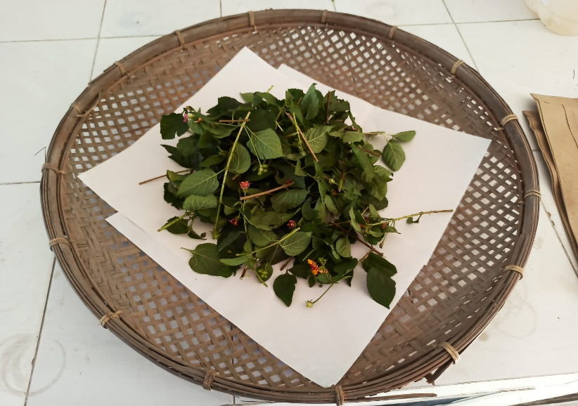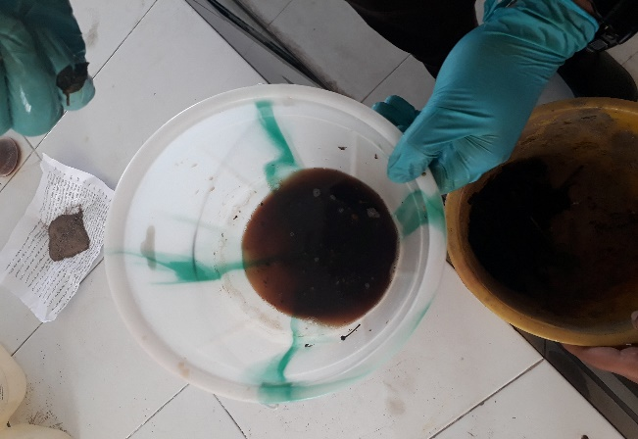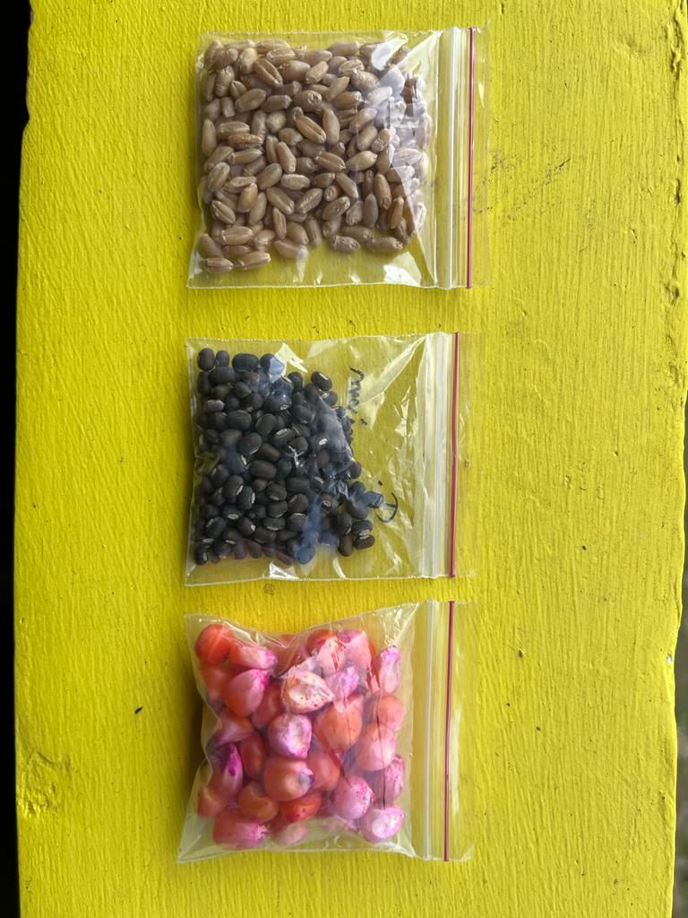

**Wheat**

**Blackgram**

**Maize**

**(a)**

**(b)**

**(c)**

**Fig.1. a) Chopped parts of *Lantana camara*, b) Extract of *Lantana camara*, c) Seeds of the agricultural crops used for study**

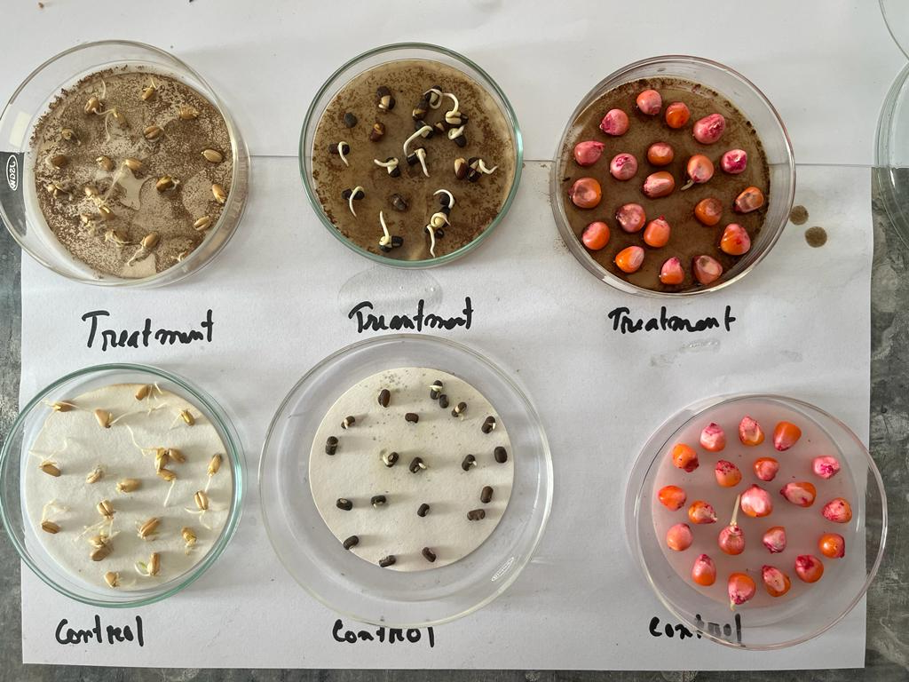

**Fig.2. The petridishes with germinated seeds during experiment under control and 20% *Lantana camara* extract treatment on the 5th day after treatment**

**3. Results and Discussions**

**3.1 Effect of extract on germination percentage of the selected crops**

The observations of germination percentage (GP) for a week (7 days) starting of application of 20% *Lantana camara* extract (20% LC) treatment and control (water only) on the seeds are presented in Fig.3. Seeds of all the three crops were found to be germinated under both 20% LC and control. However, days required to initiate germination and the germination percentage varied crop-wise in both the cases. In case of wheat and maize seeds, initiation of germination was delayed due to application of 20% LC unlike control.

After seven days of treatment (Fig. 3.d), for maize and wheat seeds, the treated plates showed germination percentage to be same as controls i.e., 30% and 100% respectively. On the other hand, blackgram seeds germinated higher in control (95%) than in treatment (70%) after 7 days of observation. Therefore, the results indicated germination of both wheat and maize seeds was neither stimulated nor inhibited by the 20% *Lantana camara* extract as compared to respective controls; however, the inhibitory effect was prominent for the seeds of blackgram after seven days of observation showing only 70% GP at 20% *Lantana camara* extract contrasting to 95% GP in case of control. The difference in GP for the seeds may be attributed to the varying quality and nature of seeds or related physiological and enzymatic activities that facilitates the seed for germination. Ahmed *et al*. (2007) also reported results of inhibition of germination of seeds of *Phaseolus mungo L.* (Blackgram) under various concentrations of *L. camara* leaf extract. Enyew and Raja (2015) noted higher GP (96.60%) of wheat in pot experiment with 25, 50 and 75 g of *L. camara* leaf powder as compared to maize (53.33%). Inhibition of germination in selected agricultural crops by the extracts of *L. camara* (Ahmed *et al*., 2007; El-Kenany and Salama, 2013; Kar *et al*., 2014; Tadele, 2014) plays a significant role in studying the allelopathic behaviour of this weed. The response to the allelochemicals present in *L. camara* creates enzymatic and non-enzymatic antioxidant defence system induction which provides a potent tool in elucidating the action mechanisms of such allelopathic compounds effecting germination (Gindri *et al*., 2020 and Zuo *et al.*, 2012).

**3.2 Effect of extract on germination speed index (GSI)**

At the end of the experiment period of seven days, the germination speed index (GSI) of maize, wheat and blackgram are represented in Fig. 4. The speed index for germination denotes the time required for attaining a certain germination percentage. The GSI at 20% *Lantana camara* extract showed higher germination speed index (19.13) as compared to control in blackgram (15.50). It indicates that after 7 days of test, irrespective of the final germination percentage result, blackgram seeds showed quicker germination response. In case of maize and wheat, the GSI was more in control than the treatment. However, in case of wheat the difference between GSI in case of control and extract was minimal. The maximum speed of germination was observed in wheat whilst it was the minimum for maize out of all the three crops. GSI is a prominent and sensitive indicator of allelopathic effects (Wardle *et al.*, 1991) and the variation among the crops in terms of germination speed index might be attributed due to the influence of different phytochemicals released from the extract of *L. camara* as well as germination abilities of different crops’ seeds.

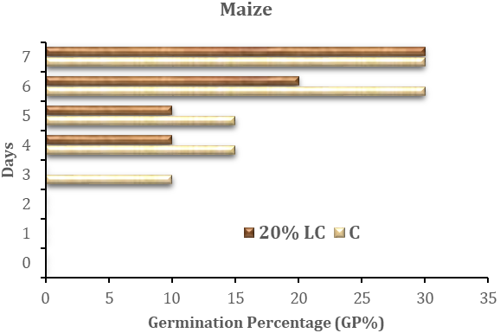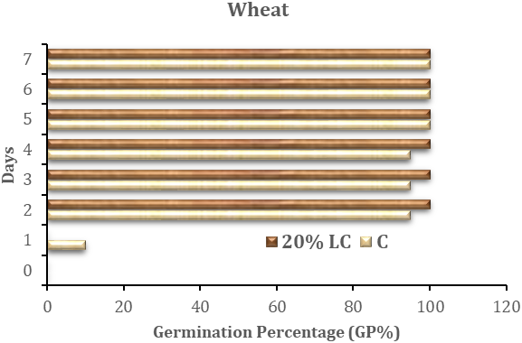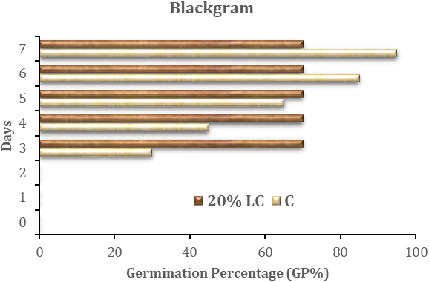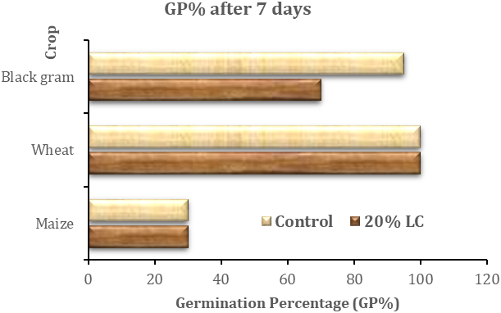

**Fig. 3. Germination percentage (GP) of a) maize, b) wheat and c) blackgram seeds under 20% *Lantana camara* extract treatment and control (C) at days of experiment period and d) GP of all three crops after 7 days of treatment**

**Fig.4. Germination speed index (GSI) of maize, wheat and blackgram after 7 days of observation**

**3.3 Effect of extract in seedling growth records**

The comparison of radical and plumule lengths (in mm) at the end of the observation period (Fig.5.a - 5.c) under 20% LC treatment versus control is presented in Table 1. The radical length for both wheat and maize were higher in control than that in case of seedling with treatment. Higher inhibitory effect (59.93 %) on radical growth of wheat was noted by extract than maize radical (26.07%). However, in blackgram, the seedlings with 20% LC extract had higher lengths of radical than in control. The percent inhibition for radical length of blackgram attained negative value i.e. stimulation of root growth in blackgram by 20% LC extract was observed (Table 1). Similar observations were recorded in case of plumule length of blackgram (Table 1), whereas, the 20% LC extract lowered the plumule/shoot growth of wheat and maize seedlings than that of plumule growth in control. The results indicated that the shoot growth inhibitory effect of *Lantana camara* extracts were profound in case of wheat and maize having per cent values of 20.44 and 17.19, respectively. The inhibition might be attributed due to the presence of certain allelochemicals in *L. camara* extracts which obstruct vital metabolic processes helpful cell proliferation as well as elongation resulting shortening of roots and shoots (Gebreyohannes *et al*., 2023). The shoot growth (mm) in blackgram was negligible for both control and treatment. However, in case of treatment the slight increase in plumule length was observed with a mean value of 0.23 mm. It is prominent from Table 1 that the 20% LC extract had more percent inhibitory effect in case of root growth than that of shoot growth for both wheat and maize. Acharya *et al*. (2022) also observed strong critical inhibitory effect of aqueous leaf extracts obtained from *L. camara* on root elongation of certain crop species than on shoot elongation.

**Table 1. Mean radical and plumule lengths in mm of germinated maize, wheat and blackgram seeds and % inhibition of root and shoot length under 20% *Lantana camara* extract treatment and control (C) after 7 days**

|  |  |  |  |  |  |
| --- | --- | --- | --- | --- | --- |
| **Crop** | **Treatment** | **Mean radical length**  **(mm)** | **Mean plumule length**  **(mm)** | **% Inhibition** | |
| **Radical/Root length** | **Plumule/Shoot length** |
| **Maize** | C | 2.33 | 1.60 | 26.07 | 17.19 |
| 20% LC | 1.73 | 1.33 |
| **Wheat** | C | 6.93 | 4.53 | 59.93 | 20.44 |
| 20% LC | 2.78 | 3.60 |
| **Blackgram** | C | 1.40 | - | -196.43 | - |
| 20% LC | 4.15 | 0.23 |

20% LC= 20% *Lantana camara* extract (on fresh weight basis), C=Control.

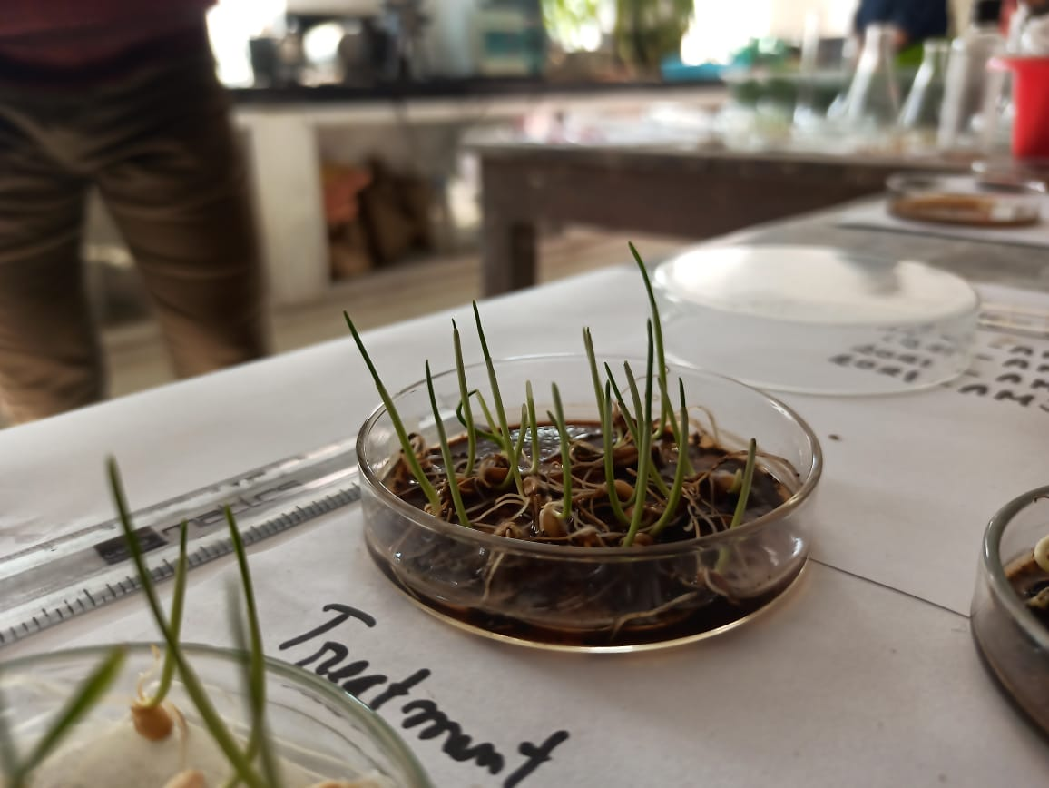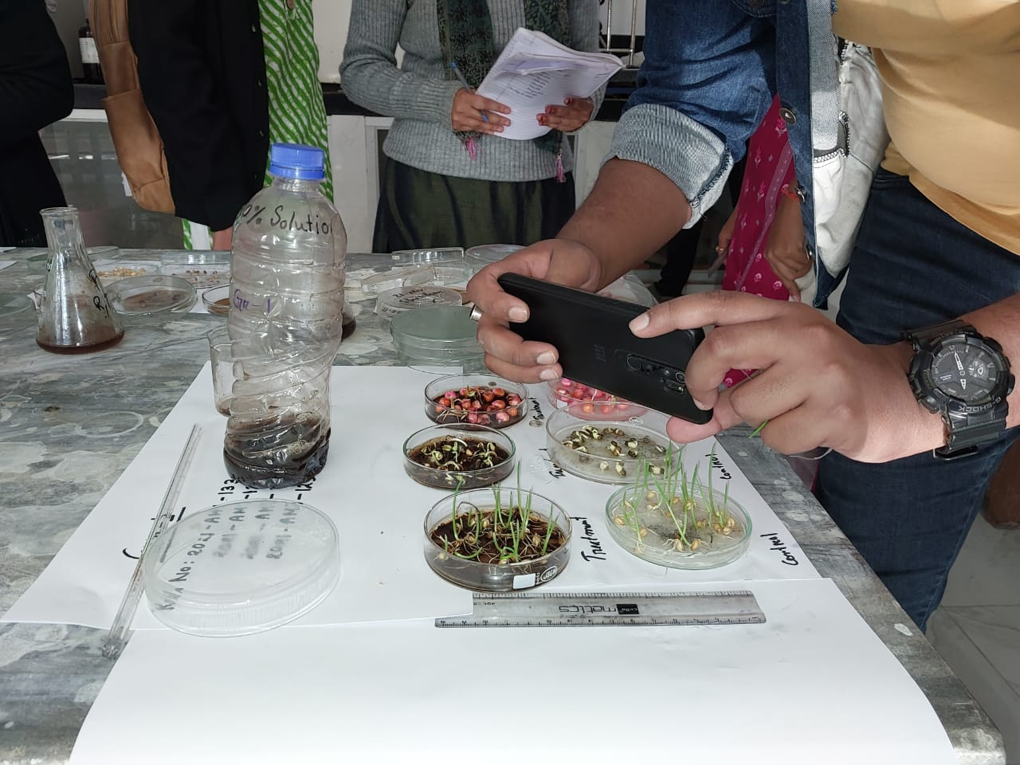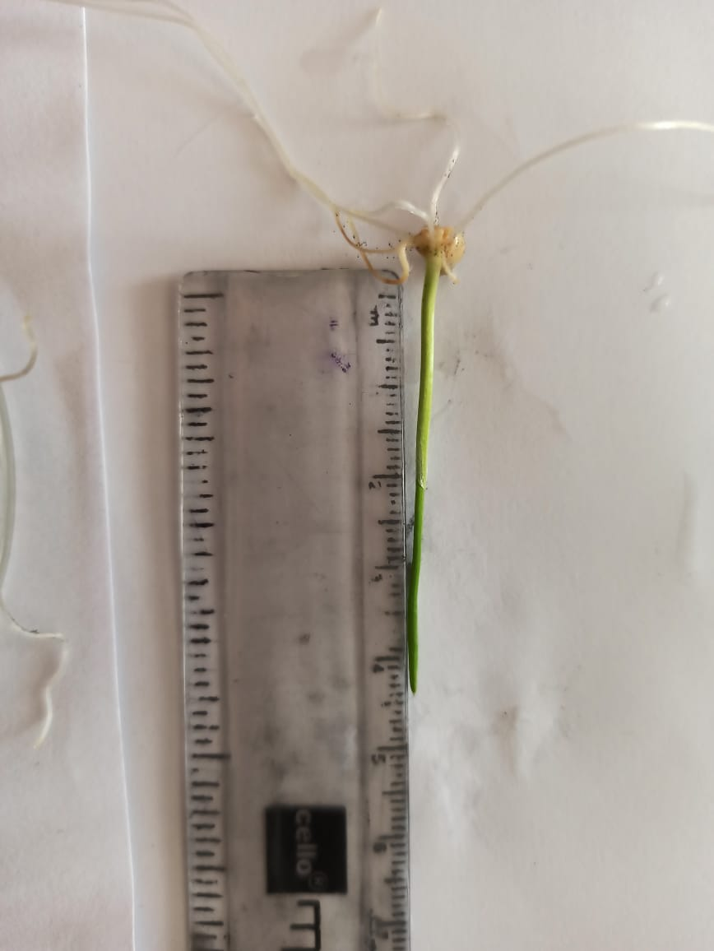

**Fig.5. a) Petridishes b) Elongated plumule and radical of treated wheat c) Measuring length of wheat plumule after 7 days of treatment**

The inhibition of radical and plumule growth of wheat and maize by 20% LC extract was in agreement with the observations of Enyew and Raja (2015) who have reported reduction in root and shoot length in wheat and maize grown in *L. camara* leaf powder treated pots. The growth of the seedling depends mainly on mitotic division, synthesis of DNA and proper mobilization of seed reserve (Cardoso, 2004; Bewley *et al*., 2012). *L. camara* contains phytochemical 1,8-cineol (Singh *et al*., 2012) which has been reported to be a root growth reducer and an index for mitosis (Romagni *et al*., 2000). The inhibitory effect was more prominent in case of root growth than the growth of shoot which might be due to close proximity of the extracts with the roots than the growing shoots in the laboratory condition. However, the *Lantana camara* extracts had stimulatory effects in growth of roots of blackgram. The stimulatory allelopathy might be the result of interaction between weed materials and micro-organism in presence of water (Oudhia *et al*., 2002).

Inhibition of seed germination in blackgram and root and shoot growth of maize and wheat as well as stimulatory root growth in blackgram in the present investigation showed that the allelopathic effect of *Lantana camara* are prominently species specific and the effects were more in case of roots than shoots. Previous studies also revealed these effects on agricultural crops to be dependent on extract concentrations (Ahmed *et al*., 2007; Tadele, 2014; Enyew and Raja, 2015). However, the effects observed in laboratory conditions might not be equally intensified in the field conditions. This may be due to the probable lowering of the extract concentrations in natural field environment than that in the aqueous extract (Rice, 1984) or due to binding of the allelochemicals released to the soil particles (Dalton *et al.,* 1983).

**3.4 Effect of extract in seedling vigour index-I**

The values of seedling vigour index-I calculated are represented in Table 2. The 20% *L. camara* extract showed the vigour index-I of 9.18 in maize and 63.8 in wheat as compared to the respective control values of 11.79 and 114.60, respectively. On the contrary the value of the index for blackgram was 30.66 in treatment as compared to 13.3 in control. The lower value in case of maize and wheat at 20% *Lantana camara* extract might be attributed to the inhibitory effect of *Lantana* extracts on the growth of the seedlings while the GP for both control and treatment remained same. This result might be beneficial in determining overall germination and growth of seedling of such crops in presence of allelopathic weeds like *Lantana camara* which through their phenolic allelochemicals might influence the seed vigour of agricultural crops.

**Table 2. Seedling vigour index-I of maize, wheat and blackgram after 7 days of treatment with 20% *Lantana camara* and distilled water**

|  |  |  |  |  |  |  |
| --- | --- | --- | --- | --- | --- | --- |
| ***Values after 7 days*** | **Maize** | | **Wheat** | | **Blackgram** | |
| **C** | **20% LC** | **C** | **20% LC** | **C** | **20% LC** |
| *GP (%)* | 30 | 30 | 100 | 100 | 95 | 70 |
| *Length (cm)* | 0.393 | 0.306 | 1.146 | 0.638 | 0.14 | 0.438 |
| ***Seedling Vigour Index-I*** | **11.79** | **9.18** | **114.6** | **63.8** | **13.3** | **30.66** |

20% LC= 20% *Lantana camara* extract (on fresh weight basis), C=Control

**Conclusion**

The present investigation enlightened the allelopathic impact of aqueous 20% extract of *Lantana camara* plant (on fresh weight basis) on the germination and growth of maize, wheat and blackgram seeds. Unlike wheat and maize seeds, the extract inhibited the germination of blackgram seeds as observed seven days after treatment. Analysis of radical and plumule lengths highlighted varied responses across the crop species, with wheat and maize showing inhibited growth and blackgram displaying stimulated root growth under extract treatment. The GSI and seed vigour index I both at 20% *Lantana camara* extract were higher as compared to control in blackgram. However, consideration of variables such as extract concentration, environmental factors and species-specific nature of allelopathic interactions could significantly influence the intensity of allelopathic effects. Therefore, further characterization studies of phytochemicals and their specific allelopathy on different agricultural crops in both laboratory and field condition to fully grasp the implications of *Lantana camara* allelopathy in agricultural contexts is important.

**Disclaimer (Artificial Intelligence)**

Author(s) hereby declares that NO generative AI technologies such as Large Language Models (ChatGPT, COPILOT, etc.) and text-to-image generators have been used during the writing or editing of this manuscript.

**References**

Abdul- Baki, A.A. & Anderson, J.D. (1973). In Physiological and biochemical deterioration of seeds. Kozlowski, T.T. (ed.). Seed biology. 2: 283-315. Academic Press, New York.

Acharya, K., Poudel, S., & Acharya, D. (2022). Effect of Leaf Extracts of *Lantana Camara L*. on Germination and Growth of Some Crops Species. Saptagandaki Journal, 32-47.

Ahmed, R., Uddin, M. B., Khan, M. A. S. A., Mukul, S. A., & Hossain, M. K. (2007). Allelopathic effects of *Lantana camara* on germination and growth behavior of some agricultural crops in Bangladesh. Journal of Forestry Research, 18, 301-304.

Ambika, S. R., Poornima, S., Palaniraj, R., Sati, S. C., & Narwal, S. S. (2003). Allelopathic plants. 10. *Lantana camara L*.

Anwar, T., Ilyas, N., Qureshi, R., Qureshi, H., Gilani, N., Khan, S. & Maqsood, M. (2019). Comparative allelopathic activity of *Rhazya stricta, Pinus Roxburghii, Carica papaya* and *Lantana camara* against noxious weeds. Applied Ecology & Environmental Research, 17(3),7175-7187.

Bais, H. P., Park, S. W., Weir, T. L., Callaway, R. M., & Vivanco, J. M. (2004). How plants communicate using the underground information superhighway. Trends in plant science, 9(1), 26-32.

Bewley, J. D., Bradford, K., & Hilhorst, H. (2012). *Seeds: physiology of development, germination and dormancy*. Springer Science & Business Media.

Cardoso, V. (2004). Germinação. In. KERBAUY, GB (Ed). Fisiologia vegetal.

Dalton, B.R., Blum, U., & Weed, S.B. (1983). Allelopathic substances in ecosystems: Effectiveness of sterile soil components in altering recovery of ferulic acid. Journal of Chemical Ecology, 9, 1185-1201.

Das, R., Kalita, S., Dutta, R., Das, K., & Hazarika, R. (2024). Weed management integrating plant extract in rabi maize. International Journal of Research in Agronomy, 7(10), 640-643.

El-Kenany, E. T., & Salama, M. (2013). Suppression effects of *Lantana camara L.* aqueous extracts on germination efficiency of Phalaris minor Retz. and Sorghum bicolor L.(Moench). Journal of Taibah University for Science, *7*(2), 64-71.

Enyew, A., & Raja, N. (2015). Allelopathic effect of *Lantana camara* L. leaf powder on germination and growth behaviour of maize, *Zea mays Linn*. and wheat, *Triticum turgidum Linn.* cultivars. Asian Journal of Agricultural Science, 7(1), 4-10.

Gindri, D. M., Coelho, C. M. M., & Uarrota, V. G. (2020). Physiological and biochemical effects of *Lantana camara L*. allelochemicals on the seed germination of *Avena sativa* *L*. Pesquisa Agropecuária Tropical, *50*.

Gebreyohannes, L., Egigu, M. C., Manikandan, M., & Sasikumar, J. M. (2023). Allelopathic Potential of *Lantana camara L.* Leaf Extracts and Soils Invaded by It on the Growth Performance of *Lepidium sativum L*. The Scientific World Journal, 2023(1), 6663686.

Julio, A., Carven, T.W., Daniel, T.H., Franzine, V.Y., Yanesa, Z.,& Tare, V.R.J.K. (2019). Allelopathic effect of *Lantana camara* and *Chromolaena odorata* leaf extracts on plant germination. Asian Journal of Agriculture and Biology, 7(2), 190-196.

Kar, I., Ram, V., & Panda, P. (2014). Allelopathic effect of *Lantana camara* on germination and seedling growth behavior of garden pea (*Pisum sativum L*.). World J Agric Sci, 10(5), 243-6.

Maguire, J.D. (1962). Speed of germination aid in selection and evaluation for seedling emergence and vigour. Crop Sci., 2, 176–177.

Mishra, A. (2015). Allelopathic properties of *Lantana camara*. International Research Journal of Basic and Clinical Studies, 3(1), 13-28.

Nawab, N.P. & Yogamoorthi, A. (2016). Allelopathic effects of aqueous extract of *Lantana camara L.* on seed germination of blackgram (Vigna mungo L.) Environmental Sciences: Indian Journal, 12(11), 1-9.

Ngonadi, E.N., Awodoyin, R.O., Worlu, C.W., & Onyeyirim, S.O. (2019a). Evaluation of Allelopathic Potential of *Lantana camara* and *Tithonia diversifolia* on seed germination attributes Of Cowpea [*Vigna Unguiculata (L) Walp*]. Journal of Environmental Science, Toxicology and Food Technology, 13(5), 34-38.

Ngonadi, E.N., Worlu, C.W., & Onyeyirim, S. O. (2019b). Evaluation of Allelopathic property of *Lantana camara* vegetative parts on seed germination attributes of maize *[Zea mays L.]*. International Journal of Environment, Agriculture and Biotechnology (IJEAB), 4(5), 1304-1307.

Noguchi, H.K. & Kurniadie, D. (2021). Allelopathy of *Lantana camara* as an invasive plant. Plants, 10(1028), 2-10.

Ntaila, Y. W., & Mbeya, R. A. (2023). Allelopathic effects of *Lantana Camara* Extract on weeds and cultivated crops: A systematic review. Journal of Agriculture, Food, Environment and Animal Sciences, 4(2), 243-258.

Oudhia, P., Kolhe, S. S., & Tripathi, R. S. (2002). Negative (stimulatory) allelopathy of *Lantana camara L*. on linseed cv. Kiran. Biotechnology of microbes and sustainable utilization, 63-66.

Rice, E.L. (1984). Allelopathy. 2nd edition. Academic Press, New York, 422p.

Romagni, J. G., Allen, S. N., & Dayan, F. E. (2000). Allelopathic effects of volatile cineoles on two weedy plant species. Journal of chemical ecology, 26, 303-313.

Sharma, G. P., Raghubanshi, A. S., & Singh, J. S. (2005). *Lantana* invasion: an overview. Weed Biology and Management, 5(4), 157-165.

Singh, R. K., Tiwari, B., Sharma, D. K., & Singh, S. P. (2012). Comparative study of chemical composition of *Lantana camara* leaf, flower & fruit essential oil. International Journal of Pharmaceutical and Chemical Sciences, 1(1), 895-899.

Tadele, D. (2014). Allelopathic effects of *Lantana* (*Lantana camara L.*) leaf extracts on germination and early growth of three agricultural crops in Ethiopia. Momona Ethiopian Journal of Science, *6*(1), 111-119.

Verdeguer Sancho, M.M., Blazque, M.A., Boira Tortajada, H. (2018). Phytotoxic potential of *Lantana camara*, *Eucalyptus camaldulensis, Eriocephalus africanus, Cistus ladanifer* and *Artemisia gallica* aqueous extracts to control weeds. Journal of Allelochemical Interactions, 4(2), 17-26.

Wardle, D.A., Ahmed, M., & Nicholson, K.S. (1991). Allelopathic influence of noddling thistle (Carduus nutuns L.) seed germination and radicle growth of paster plant. New Zealand J. Agri. Res., 34, 185-191.

Zuo, S.P., Ma, Y.Q., & Ye, L.T. (2012). In-vitro assessment of allelopathic effects of wheat on potato. Allelopathy J., 30(1), 1-10.