**Diversity Analysis of Insect Pests of Apple and Apricot in the Trans-Himalayan Region**

**ABSTRACT: Apple (*Malus domestica*) and apricot (*Prunus armeniaca)* are significant temperate fruit crops that are widely cultivated in the cold-arid, high-altitude regions of Ladakh, particularly in the Leh district. While these areas provide ideal conditions for fruit production, the presence of insect pests often limits yields and affects fruit quality. However, little is known about the diversity and population patterns of these pests in such challenging agro-climatic zones. To bridge this gap, this study was conducted during the 2022 and 2023 growing seasons to document and analyse the diversity of insect pests in apple and apricot orchards across three blocks in Leh: Leh, Saspol, and Khaltsi. Surveys were carried out using standard entomological methods, including visual inspection, handpicking, and various traps. Pest data were analysed using ecological indices, such as Shannon-Wiener’s diversity index, Margalef’s species richness, and Pielou’s evenness index. Results revealed notable variation in pest diversity**

***Keywords: -*** *apricot pest, apple, Shannon-Wiener’s diversity index, Margalef’s species richness, Pielou’s evenness index*

**INTRODUCTION**

Apple (*Malus domestica*) and apricot (*Prunus armeniaca*) are among the most economically significant temperate fruit crops cultivated in the high-altitude, cold-arid regions of the Trans-Himalayas, especially in the Leh district of Ladakh (Stobdan *et al.,* 2021). These unique agro-ecological zones, characterised by their cool temperatures and low humidity, provide favourable conditions for producing high-quality fruits (Ahmad *et al.,* 2017). Despite these advantages, the cultivation of these crops is frequently hampered by the incidence of insect pests, which contribute substantially to yield losses. These pests inflict direct damage by feeding on foliage, shoots, and fruits and can also serve as vectors for various plant pathogens, ultimately diminishing both yield and fruit quality (Vallad *et al.,* 2018; Sharma *et al.,* 2023).

Due to the remote and climatically challenging nature of the cold-desert ecosystem, the diversity and population dynamics of insect pests in these areas remain insufficiently documented. The region experiences a short growing season, pronounced temperature fluctuations, and minimal rainfall—factors that contribute to the development of a distinct, and in some cases endemic, pest complex (Shaheen et al., 2013; Behera et al., 2014). Consequently, there is a pressing need for detailed, location-specific studies that can inform integrated pest management (IPM) programs tailored to these unique environmental conditions. Although some observational studies have reported insect pests of temperate fruit crops in such regions, systematic and quantitative evaluations of pest diversity are sparse. The application of ecological diversity indices such as the Shannon-Wiener Index (1949) for species diversity, Margalef’s Index (1958) for species richness, and Pielou’s Evenness Index (1966) provides a structured approach to understanding pest community composition, dominance, and spatial distribution. According to Magurran (2013), these indices are crucial instruments for monitoring biodiversity and aid in directing focused efforts at pest control and surveillance.

Against this backdrop, the present study was designed to conduct a structured field survey to document and analyse the diversity of insect pests associated with apple and apricot cultivation across three blocks of Leh district, namely Leh, Saspol, and Khaltsi, during the active growing seasons of 2022 and 2023. The primary objective was to assess species richness, relative abundance, and evenness of pest populations using established ecological indices. The outcomes of this research are intended to serve as a foundational reference for future studies and contribute to the development of sustainable pest management strategies suited to the cold-arid agroecosystems of the Trans-Himalayan region.

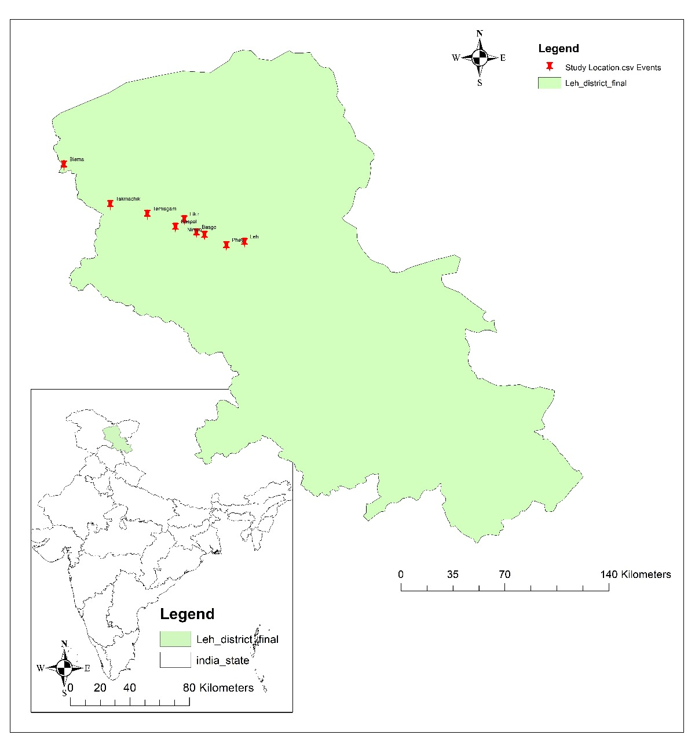

Map 1: Map showing study location

**MATERIAL AND METHODS**

A structured orchard survey was conducted during the 2022 and 2023 growing seasons in selected apple and apricot orchards within the Leh district to assess pest incidence. Three apple orchards, located in Leh, Saspol, and Khalsti, along with their associated pests, were sampled from selected localities using visual searching methods, handpicking, collection of fallen fruits, and various types of traps, including sticky traps, suction traps, light traps, and sweep nets. Fortnightly observations were conducted to assess insect pest incidence in apple and apricot orchards. In each orchard, three trees were randomly selected, and sap-sucking pests were counted per leaf on 30 terminal leaves (10 from each canopy level). Pest abundance was also estimated using direct count methods. Larvae of butterflies and moths were randomly collected, and fallen or infested fruits were examined for pest damage. Diversity assessments were carried out in pesticide-free orchards. Collected specimens, including adults and nymphs, were preserved using standard entomological methods.

**Estimation of diversity indices:**

Quantitative estimation of individual species will be made using the data derived from the filed survey. Shannon and Wiener Index (1949), Margalef index (1958) and Pielou’s Evenness Index (1969will be employed to examine the range and number of insect pests that affect apples and apricots.

Index of species diversity (H`) = -∑ pi In pi

Where pi = the proportion within the sample of the number of individuals of the “ith” species and is denoted as Ni/N

Ni = Number of ‘ith’ species.

N = Total number of species

1. Evenness index (Pielou, 1966):

Evenness index (J) =H`/In S

Where H` = Shannon Weiner’s index

S = Number of species.

1. Species richness (Margalef’s index (1958) :

Margalef’s index = S-1/In N

Where S = Total number of species

N =Total number of individuals in the sample.

**RESULT AND DISCUSSION**

1. **For Apple Pests**

Three blocks Leh, Saspol, and Khaltsi were selected from the Leh region of Ladakh to estimate different diversity indices of apple and apricot pests. Three locations in each block were deleted and changed based on the results of the field study. Shannon and Wiener Index (1949), Margalef Index (1958), and Pielou’s Evenness Index (1969) were used to investigate the variety and prevalence of insect pests that affect apples and apricots The data sets gathered during the two-year study period in 2022 and 2023, were subjected to three different diversity indices, as previously stated, and are listed in Tables 1 and 2. The Shannon-Wiener diversity index shows the species diversity; the greater the index values, the more the diversity. Margalef’s index enables us to know the richness of species with distributional patterns, whereas Pielou’s index gives the evenness of different species, i.e., similarity in abundance of different species.

In the apple orchards of the Leh district, the overall Shannon-Wiener diversity index calculated for the years 2022 and 2023 ranged from 0.50 to 1.29. Shannon-Weiner index explains both the evenness and richness of species. Its higher value indicated an increase in the total number of species. When the three blocks were compared, the Leh block's diversity index had a high value of 1.29. and a minimum value of 0.50 at Khalsti for the year (Table 1). According to reports, the Leh block diversity index for 2023 has a low value of 0.22 at Khalsti and a maximum value of 0.58. This index reflects the extent to which individual species are evenly distributed among various other species. Whereas the Shannon-Weiner index for three blocks in the Leh district showed that the highest richness was in the Leh block, followed by the Saspol block, and the lowest Shannon-Weiner index value was recorded in Khalsti

The Evenness index (Pielou, 1966) for apple pest showed a maximum value of 0.94 at Leh, 0.89 in Saspol, and a minimum value of 0.19 in Khalsti, during the experimental period (Table 1).

The number of species is provided using Margalef’s index, meaning that as the number of species increases, the index value also increases. For apple pest, the calculated value ranged from 0.23 to 0.53. The highest value was recorded at Leh (0.53), followed by Saspol (0.37), while the lowest was at the Khalsti block (0.23) during the experimental period.

**Table 1: Diversity Indices of Different Locations for Apple in the Years 2022 and 2023**

|  |  |  |  |  |  |
| --- | --- | --- | --- | --- | --- |
| Location (Block) | Taxa | Individuals | Shannon Weiner H index | [Pielou's Evenness](https://www.google.com/search?sca_esv=449df59cb87f206b&rlz=1C1GCEU_enIQ1161IQ1161&sxsrf=AE3TifOCIo1eiIiaB7XG5E8YZWNqbRdH7w:1748525477537&q=Pielou%27s+Evenness&spell=1&sa=X&ved=2ahUKEwjSquD_5MiNAxWa7bsIHUaOBqcQBSgAegQIChAB) | Species Richness (Margalef) |
| Leh | 4 | 270 | 1.29 | 0.94 | 0.53 |
| Saspol | 2 | 161 | 0.57 | 0.89 | 0.37 |
| Khaltsi | 2 | 120 | 0.50 | 0.19 | 0.23 |

Fig.1: Diversity indices of different locations for Apple in the years 2022 and 2023

1. **For Apricot Pests**

In the years 2022 and 2023, the Leh district's overall Shannon-Weiner index value for apricot pests varied between 0.347 and 0.788. When comparing the three blocks, the diversity index for the year 2022 had a low value of 0.34 at Leh and a maximum value of 0.78 at Saspol (Table 2). This index reflects the extent to which individual species are evenly distributed among various other species. The Evenness index (Pielou, 1966) for apricot pest showed a maximum value of 0.73 at Saspol and a value of 0.72 at Khalsti, while the lowest value of 0.70 is recorded at Leh during the experimental period (Table 2). Lower evenness values in these locations are likely to indicate dominance by only a few species, affected by factors such as climatic conditions, competition, succession predation. The number of species is provided using Margalef’s index, meaning that as the number of species increases, the index value also increases. The computed value for the apricot pest varied between 0.18 and 0.37 during the survey period. Saspol had the greatest rating (0.37), Leh came in second (0.19), and the Khaltsi block had the lowest (0.18).

**Table 2: Diversity Indices of Different Locations for Apricots in the Years 2022 and 2023**

|  |  |  |  |  |  |
| --- | --- | --- | --- | --- | --- |
| Location (Block) | Taxa | Individuals | Shanon Weiner H index | Pielous Evenness | Species Richness (Margalef) |
| Leh | 2 | 174 | 0.347 | 0.707 | 0.193 |
| Saspol | 3 | 215 | 0.788 | 0.733 | 0.372 |
| Khaltsi | 2 | 256 | 0.568 | 0.727 | 0.180 |

Fig.2: Diversity indices of different locations for Apricot in the years 2022 and 2023

Species diversity is a crucial parameter for comparing study areas under biotic and abiotic disturbances, as it aids in assessing the significance of collected data from different study sites across various seasons, considering the distributional patterns of pests (Solow, 1993). This study marks the initial attempt to sample insect pests affecting apricots and apples in Leh district, Ladakh. Five pest species from various orders and families were collected, allowing for an assessment of pest abundance and diversity on apple and apricot trees. Similar findings were reported by Mir and Wani (2005), who examined pests associated with walnut trees in the Kashmir Valley. In the Hemiptera order, according to UCIPM (2011) and Wani & Ahmad (2015), the Aphididae family was the most prevalent in all study sites, indicating more host availability and untreated trees that support species diversity and a robust ecosystem. Altieri (1991) observed that plant community manipulation tends to increase pest incidence, and species richness is significantly affected by food availability for each pest life stage (Pinheiro & Ortiz, 1992). Greater species richness often indicates a higher number of niches associated with the host plant (Hutchinson, 1959). In this study, the Berger-Parker index recorded its highest value in the Baramulla district, reflecting a higher abundance of predominant species in Srinagar. Results demonstrated similar diversity index values across sites within the same district, though species diversity, evenness, and richness varied among districts due to differences in habitat (Denys & Tschantke, 2002). These diversity values differed across districts due to variations in pest occurrence, activity, distribution, and host plant abundance. For example, the Shannon-Wiener index revealed minor variability among sites within the same block. pest diversity is directly impacted by a heterogeneous natural environment. varying values of Margalef's index across study sites indicate that species richness is significantly influenced by land use, whether it be agricultural, urban, or landscaped, which contributes to variations across districts (Kim, 2009). Lower evenness values indicate dominance by only a few species, affected by factors such as competition, succession, and predation (Magurran, 1988; Weiher & Keddy, 1999).

Our findings of non-uniform diversity values over two years are consistent with studies conducted by Memon (2011) on sugarcane insects in three sites that revealed no similarities in diversity indices. According to Panzer and Schwartz (1998), plant species richness accounts for almost 49% of the variation in insect species. This pattern was also shown in the current study, which found that untreated walnut orchards had a varied pest community. The species richness, diversity, and evenness diversity indicators used in this study closely matched those discovered in mango orchards by Reddy and Moos (2015).In line with Aslam's (2009) study on moth richness and evenness in Peshawar, Pakistan, our results demonstrated a decline in Shannon diversity with decreased pest abundance.. Management practices, as noted by Khan and Alam (2007), significantly shape diversity indices of pests and predators. Rahman *et al.* (2004) also concluded that pest and natural enemy abundance are linked to the host's growth stage, with microhabitat shifts driving variations in diversity, abundance, and species richness (Turner & Pharo, 2005).

Abbas *et al.* (2014) observed that seasonal variations affect micro-invertebrate abundance and diversity, consistent with this study's findings of fluctuating Lepidopteran pest populations across seasons. Their presence was confined to a few months, reflecting a seasonal diapause (Kuntee, 2000). Similar findings by Amber *et al*. (2015) indicated high Lepidopteran species richness in March and April, with Shannon diversity index values of 2.47 and 2.40, respectively. Pest life cycles varied slightly among districts, possibly due to temperature, which can alter insect lifespans, as shown by Regniere *et al.* (2012). Additionally, *L. obfuscata* was less abundant or absent at multiple sites compared to *C*. *odata* and *E.* *musculana*, supporting findings by Lindroth *et al.* (1990) that walnut foliage contains juglone, a toxin inhibiting *L. dispar* feeding and contributing to low diversity values. Environmental factors such as seasonal variations in relative humidity and rainfall influence pest diversity, as pests favour hosts with abundant food (Sharma *et a*l., 2006). Furthermore, differences in pest populations across seasons or years are often due to microclimatic changes, which enable pests to exhibit physiological adaptations to temperature and humidity (Sudhikumar *et al*., 2005).

**CONCLUSION**  
This study provides a first-hand look into the diversity of insect pests affecting apple and apricot orchards in the unique cold-arid climate of Leh district, Ladakh. Through two growing seasons of scanning three different blocks—Leh, Saspol, and Khaltsi—we were able to pinpoint important trends in the diversity, richness, and evenness of pest species. The results clearly show that pest populations vary not just in numbers, but also in how evenly they're distributed across locations. Among the three sites, Leh consistently showed higher diversity and richness, while Khaltsi had fewer species and greater dominance by specific pests. These differences are likely influenced by local factors such as altitude, temperature fluctuations, host plant availability, and minimal pesticide use. The relatively high diversity in orchards suggests a stable and potentially resilient ecosystem, but also highlights the need for careful monitoring. Further field-specific research is needed to better understand how pests adapt in these challenging situations, according to our findings. This baseline information can guide the development of more effective, locally adapted pest management strategies. Moving forward, regular surveys and more in-depth ecological studies will be essential for promoting sustainable fruit production in this fragile Himalayan ecosystem.

Disclaimer (Artificial intelligence)

Option 1:

Author(s) hereby declare that NO generative AI technologies such as Large Language Models (ChatGPT, COPILOT, etc.) and text-to-image generators have been used during the writing or editing of this manuscript.

Option 2:

Author(s) hereby declare that generative AI technologies such as Large Language Models, etc. have been used during the writing or editing of manuscripts. This explanation will include the name, version, model, and source of the generative AI technology and as well as all input prompts provided to the generative AI technology

Details of the AI usage are given below:

1.

2.

3.

**REFERENCES**

Abbas, M. N., Rana, S. A., Mahmood-ul-Hassan, M., Kana, N., Kausar, S. and Iqbal. M. (2014). Biodiversity and dynamics of macro-invertebrate populations in wheat- weeds agro-ecosystem of Punjab (Pakistan). The Journal of Animal and Plant Sciences, 24 (4): 1146-1156.

Ahmad, L., Habib Kanth, R., Parvaze, S., Sheraz Mahdi, S., Ahmad, L., Habib Kanth, R., ... & Sheraz Mahdi, S. (2017). Agro-climatic and agro-ecological zones of India.

Altieri, M. A. (1991). Increasing biodiversity to improve insect pest management in agro ecosystems. In “The Biodiversity of Microorganisms and Invertebrates: Its role in sustainable Agriculture”. pp. 165-82, Cd. D. L. Hawksworth. CAB International, (Walling ford, UK)

Amber, N., Ashraf, I., Hussain, T. and Ahmad, I. (2015). Studies on the diversity and relative abundance of Orthoptera and Lepidoptera species in urban and crop lands areas of Dera Ghazi Khar. American-Eurasian Journal of Agricultural & Environmental Sciences, 15 (8): 1693-1699.

Aslam, M. (2009). Diversity, Species richness and evenness of moth fauna of Peshawar. Pakistan Entomology, 31 (2): 99-102.

Behera, M. D., Matin, S., & Roy, P. S. (2014). Biodiversity of Kargil cold desert in the Ladakh Himalaya. *Integrative Observations and Assessments*, 253-274.

Denys, C. and Tschantke, T. (2002). Plant-Insect communities and predator-prey ratios in field margin strips, adjacent crop fields and fallows. Oecologia, 130: 315-324

Hutchinson, G. E. (1959). Homage to Santa Rosalia, or why are there so many kinds of animals? The American Naturalist, 93: 145-159.

Khan, M. M. H. and Alam, M. I. (2007). Influence of management practices and growth stages of rice on the abundance and diversity of insect pests and natural enemies. Annals of Bangladesh Agriculture, 11 (2): 21.

Kim, K. C. (2009). Taxonomy and management of insect biodiversity, pp. 561-574. In Foottit, R. G. and Adler, P. H. (eds.), Insect biodiversity: science and society. Blackwell, Chichester, United Kingdom.

Kuntee, K. (2000). Butterflies of Peninsular India. Universities Press, Hyderabad, India

Lindroth, R. L., Anson, B. D. and Weisbrod, A.V. (1990). Effects of protein and juglone on gypsy moths: growth performance and detoxification enzyme activity. Journal of Chemical Ecology, 16 (8): 2533-2547.

Magurran, A. E. (2013). *Measuring biological diversity*. John Wiley & Sons.

Magurran, A. E. (1988). Diversity indices and species abundance models, pp. 7-45. In Magurran, A. E. (ed.), Ecological diversity and its measurement. Princeton University Press, Princeton, NJ.

Margalef, R. (1958) Information Theory in Ecology. *General Systems*, 3, 36-71.

Memon, I. A. (2011). Insect diversity in cauliflower agro-ecosystem at Tandojam. Msc. Thesis. Sindth Agriculture University Tandojam, pp. 80.

Mir, G. M. and Wani, M. A. (2005). Severity of infestation and damage to walnut plantation by important insect pests in Kashmir. Indian Journal of Plant Protection, 33 (2): 188-193.

Panzer, R. and Schwartz, M. W. (1998). Effectiveness of a vegetation based approach to insect conservation. Conservation Biology, 12 (3): 693-702.

Perfecto, I., Vandermeer, J., Hanson, P. and Carten, V. (1997). Arthopod biodiversity loss and the transformation of a tropical agro ecosystem. Biodiversity and conservation, 6: 935-945

Pielou, E.C. (1966) The Measurement of Diversity in Different Types of Biological Collections. *Journal of Theoretical Biology*, 13, 131-144.

Pinheiro, C. E. G. and Ortiz, J. V. C. (1992). Communities of fruit feeding butterflies along a vegetation gradient in Central Brazil. Journal of Biogeography, 19: 505-511.

Rahman, M. A., Khan, M. M. H., Hasan, M. F. and Alam. M. M. (2004). Incidence and abundance of insect pests and their natural enemies at different growth stages of rice. Journal of Science Education and Technology, 7 (1 and 2): 19-24.

Reddy, K. V. G. and Moos, M. M. (2015). Insecta diversity, species richness and evenness of “The walking mango tree”. International Daily Journal for species, 15 (48):19-23.

Regniere, J., Powell. J., Bentz. B. and Nealis, V. (2012). Effects of temperature on development, survival and reproduction of insects: Experimental design, data analysis and modeling. Journal of Insect Physiology, 58: 634-647.

Shaheen, F. A., Wani, M. H., Wani, S. A., & Norphel, C. (2013). Climate change impact in cold arid desert of North–Western Himalaya: Community based adaptations and mitigations. In *Knowledge systems of societies for adaptation and mitigation of impacts of climate change* (pp. 239-256). Berlin, Heidelberg: Springer Berlin Heidelberg.

Shannon, C. E., & Weaver, W. (1949). The Mathematical Theory of Communication. Urbana, IL: The University of Illinois Press, 1-117.

Sharma, K. K., Jaiswal, A. K. and Kumar, K. K. (2006). Role of lac culture in biodiversity conservation: Issues at stake and conservation strategy. Current Science, 91 (7):894-897.

Sharma, S., Nayak, R. K., & Singh, J. (2023). insect pests and Diseases of temperate Fruits and their Management. *Hasan W, Verma B, Minnatullah Md, editors. Pests and disease management of horticultural crops. New Delhi: Biotech Books*, 41-62.

Solow, A. R. (1993). A simple test for change in community structure. Journal of Animal Ecology, 62: 191-193.

Stobdan, T., Namgial, D., Chaurasia, O. P., Wani, M., Phunchok, T., & Zaffar, M. (2021). Apricot (Prunus armeniaca L.) in trans-Himalayan Ladakh, India: Current status and future directions. *J. Food Agric. Res*, *1*, 86-105.

Sudhikumar, A. V., Mathew, M. J., Sunish, E., Murugesan, S. and Sebastian, P. A. (2005). Preliminary studies on the Spider fauna in Mannavan Shola forest, Kerala, India (Araneae). Euro. Arachnol. Acta Zoologica bulgarica, 1: 319-327.

Turner, P. A. M. and Pharo, E. J. (2005). Influence of substrate type and forest age on bryophyte species distribution in Tasmanian mixed forest. Bryologist, 108: 67-85.

UCIPM. (2011). Pest Management Guidelines: Walnut. University of California. Agriculture and Natural Resources, 3471: 5-41

Vallad, G. E., Messelink, G., & Smith, H. A. (2018). Crop protection: Pest and disease management. *Tomatoes, 2nd ed.; Euvelink, E., Ed.; CAB International: Boston, MA, USA*, 207-257.

Wani, S. A. and Ahmad, S. T. (2015). Biology and population dynamics of new colour morph of Chromaphis juglandicola Kalt. (Hemiptera: Aphididae) in Kashmir, India. Journal of Entomology and Zoology Studies, 3 (4): 28-31.

Weiher, E. and Keddy, P. A. (1996). Relative abundance evenness patterns along diversity and biomass gradients. Oikos, 87: 355-361