Preliminary study on size structure and condition factor of Oreochromis niloticus (Cichlidae) in the Ayame 2 manmade lake, Côte d’Ivoire

.
ABSTRACT
The Ayame 2 lake, located in southeastern Côte d’Ivoire, is a tropical lentic ecosystem characterized by strong seasonal fluctuations and pronounced eutrophication, particularly during the dry seasons (December–March and August–September). This study aimed to assess the size structure and condition factor of Oreochromis niloticus, a key economic fish species, in order to better understand its population dynamics and physiological status in this fluctuating environment. A total of 1888 O. niloticus individuals were sampled monthly from January to December 2017 at various artisanal fishing sites around the lake. Total length (cm) and body weight (g) were recorded for each specimen to assign size classes and calculate the condition factor (K). The results revealed a size distribution dominated by intermediate classes ([10.5–12.5[ cm), indicating active recruitment but a reduced number of larger individuals (>22.5 cm). The condition factor varied significantly by month and size class (p < 0.05), with highest values observed during the rainy seasons and marked lows during the dry season. The highest mean K (1.90) was found in the [10.5–12.5[ cm class, while larger size classes showed extremely low values (as low as 0.01).These findings highlight the significant influence of seasonal environmental conditions on the morphophysiology of O. niloticus and underscore the need for integrated management strategies considering size at capture, breeding seasons, and habitat quality.

Keywords: Oreochromis niloticus, condition factor, size structure, Ayame lake

1. INTRODUCTION

Fish constitute the primary source of animal protein for approximately 200 million individuals across the African continent. In addition to being a staple food source, fishing provides direct employment to over 10 million Africans, with an additional five to ten times more people engaged in fishing as a secondary activity, thereby contributing significantly to food security, particularly in rural areas ((Karr, 1981). In this context, fishing in lake Ayame 2 plays a vital role in the livelihoods of the local population (Blahoua et al., 2018). However, similar to other lakes across Africa and specifically in Côte d'Ivoire, lake Ayame 2 has experienced a decline in fish production. The primary drivers of this decline include pollution, overfishing, and habitat degradation (Adou et al., 2017). Additionally, climate change is exerting long-term pressure on fish stocks (Bulengela et al., 2019). Given these mounting threats to the lake's aquatic resources, the implementation of enhanced management strategies is imperative. Among these, the assessment of fish size structure and condition factor is considered essential (Oni et al., 1983).
According to Da et al. (2018), size structure (including total and standard length) and condition factor (based on body mass) are critical parameters in fish biology and fisheries management. These metrics are crucial for characterizing fish landings and understanding growth dynamics in natural habitats (Heins et al., 2004 ; Soumaïla et al., 2009). As highlighted by Lévêque and Paugy (2006), fish size structure and growth are strongly influenced by environmental factors, particularly the seasonal contraction of water body surface areas. Size frequency distributions offer valuable insight into the demographic composition of exploited fish populations (Diouf and Goudiaby, 2018), and a general decrease in size is often observed under high fishing pressure.
The condition factor reflects the physical and physiological state of fish (Paugy and Lévêque, 2017), allowing for seasonal or regional comparisons of population health (Oni et al., 1983). It serves as an indicator of a fish's well-being in relation to its body condition (Tabassum et al., 2013). Although the length-weight relationship has been extensively studied in Côte d’Ivoire, research specifically focusing on size structure and condition factor remains limited (Oussou et al., 2018). To address this gap, this study investigates these parameters in Oreochromis niloticus, a Cichlid species of high aquaculture value and one of the main fish species exploited in Lake Ayamé 2 Adou et al. (2017). In addition to its economic significance, O. niloticus is a crucial source of animal protein and income for the local population, playing a vital role in food security and livelihoods. This species is also widely distributed across most freshwater bodies in Côte d’Ivoire, making it ecologically and commercially important on a national scale. The aim of the study was to assess the size structure and condition factor of this species throughout the year, with the aim of supporting its sustainable exploitation in the lake.

2. material and methods

2.1 Sampled area
The Bia River is a relatively small coastal watershed, extending approximately 300 km in length and encompassing a drainage area of 9,650 km². Originating in Ghana, it flows southwest into the Aby Lagoon, located in southeastern Côte d’Ivoire (Ouattara et al., 2006). The river’s course has been modified by the construction of two hydroelectric dams, resulting in its fragmentation into four distinct aquatic systems: (1) the upper Bia River, (2) lake Ayame 1, (3) lake Ayame 2, and (4) the lower Bia River. Lake Ayame 2, situated between latitudes 5°34′-5°37′ N and longitudes 3°09′-3°10′ W, spans an area of approximately 7 km² (Figure 1). Its hydrological regime is regulated by the upstream dam, which modulates water inflows and outflows via periodic sluice gate operations (Ouattara et al., 2007). The lake receives substantial nutrient inputs, particularly during rainfall events, due to runoff from adjacent agricultural plantations and forested areas. One of the main tributaries, the Aniassue River, discharges directly into Lake Ayame 2 and serves as a significant source of nutrient enrichment. These conditions facilitate the proliferation of floating aquatic macrophytes, primarily Pistia stratiotes and Eichhornia crassipes. The persistent accumulation and subsequent decomposition of these plants contribute to severe oxygen depletion in the water column, often resulting in foul odors and indicating eutrophic and hypoxic conditions. The region experiences a transitional equatorial climate characterized by four distinct seasons (Ahoussi et al., 2013): a long rainy season from April to July, a short dry season from August to September, a short rainy season from October to November, and a long dry season from December to March. Annual rainfall ranges between 1,400 and 1,600 mm (Brou et al., 2005).
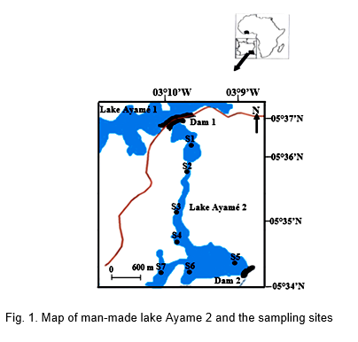

2.2 Fish sampling

During the study period from January to December 2017, a total of 1888 specimens of Oreochromis niloticus were collected through monthly sampling. Fish were captured using a series of 14 experimental gillnets with mesh sizes ranging from 8 to 60 mm (8, 10, 12, 14, 15, 20, 25, 30, 35, 40, 45, 50, 55, and 60 mm). Each net was 100 meters long and 3 meters deep. The gillnets were deployed at 17:00 and retrieved at 07:00 the following morning for night catches. For daytime sampling, the nets were inspected again and removed at 12:00. To complement the experimental fishing, additional samples were obtained from artisanal fisheries using various traditional gears, including bamboo and vine traps, bamboo fish traps, hand lines, longlines, and cast nets. All captured fish were identified to species level using the taxonomic keys of Paugy et al. (2003a, b). For each specimen, standard length (SL) and total length (TL) were measured to the nearest centimeter using an ichthyometer. Body weight was determined to the nearest gram with an electronic balance, and all individuals were systematically counted.
Data analysis
2.3. Morphometric Structure Analysis by Size Classes
The analysis of fish size class structure offers valuable insights into the status of a given population, including recruitment dynamics, reproductive success, resource exploitation levels, and potential episodic events affecting recruitment in specific years. In this study, the standard lengths (SL) of individual specimens from the selected species were categorized into distinct size classes. The number and range of these size classes were determined using Sturges’ rule, as described by Scherrer (1984).
-Determination of size classes
k = 1 + 3,322 * log10(n)
With :
k : Represents the number of classes or intervals you want to use in your histogram.
1 : Is a constant added to start the calculation process.
3.322 : Is a constant factor based on the logarithm base 10.
log (10)(n) : Calculates the base 10 logarithm of the total number of observations (n).
n : Is the total number of observations in your dataset.
- Fulton's Condition Factor (K)
The Fulton's Condition Factor (K) suggests that the weight of the fish is proportional to the cube of the length and was used to assess the general health of the fishes, on individual and population level. In all individuals’ total length, standard length and body mass were measured. The allometric equation where the b exponent is a constant was used to compare the health index of the different category of fishes.
Thus, Fulton’s condition factor (K) was calculated using the formula:
K = W*100/ Lb3 (Le Cren, 1951)
Where W = weight of fish (g), L = standard length of the fish (cm), b = coefficient of allometry considered equal to 3).
The Fulton’s condition factor was multiplied with 100 to get it close to 1, and the number 1 indicated a normal condition of the fish, greater 1 indicated fat fish and less than 1 indicated skinny fish. This morphometric index assumes that the heavier fish for a given length the better condition.
2.4 Statistical Analysis
The Kruskal-Wallis (K) and Mann-Whitney (U) tests were used to analyze the monthly variations in size structure and condition factor. These tests allowed for comparisons of individual sizes and condition factors across different months throughout the year. The Kruskal-Wallis test, a non-parametric equivalent of the one-way ANOVA, was applied to test the null hypothesis that the distribution of values is identical across all groups (months). In this study, it was used to determine whether there were overall differences in size structure or condition factor over the course of the year. Each month represented an independent group, and individuals sampled each month were compared in terms of size and condition factor. A significant result indicated that at least one month differed significantly from the others. When the Kruskal-Wallis test detected significant differences among groups, post hoc pairwise comparisons were conducted to identify which months differed from each other. For this purpose, the Mann-Whitney U test, a non-parametric test used to compare two independent samples was employed. It enabled the detection of significant differences between specific months with respect to size or condition factor. The level of statistical significance was set at α = 0.05. Statistical analyses were performed using Statistica version 7.1 and PAST software.

3. results
3.1 Temporal variation in the Abundance of Oreochromis niloticus Individuals
Analysis of figure 2 reveals a notable monthly variation in the abundance of Oreochromis niloticus individuals in the Ayame 2 lake. The number of fish captured each month ranged from a minimum of 79 individuals in August to a peak of 273 individuals in November. An initial increase in catches was observed from March (90 individuals), reaching a first peak in June (223 individuals), followed by a marked decline in August. A second phase of increase began in September, culminating in November with the highest number of individuals captured (273), before a slight decline in December (150 individuals). The Kruskal-Wallis and Mann-Whitney tests applied to the dataset revealed a highly significant difference in the number of individuals captured across months (p < 0.001). These results confirm that the abundance of O. niloticus varied significantly throughout the year.

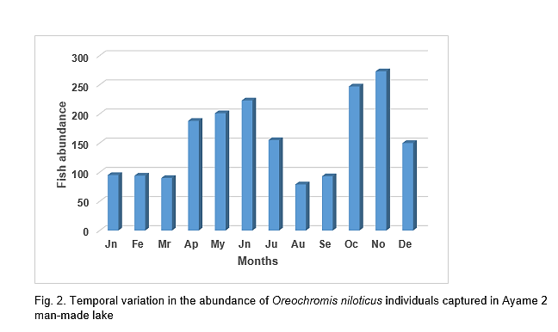

3.2 Temporal variation in the Condition Factor of Oreochromis niloticus
The condition factor of Oreochromis niloticus exhibited monthly variation throughout the year in the Ayame 2 lake (Figure 3). The lowest values were recorded in January (0.14), February (0.16), and March (0.21). An increasing trend began in April (0.60), continued through May (0.71), and peaked at 0.78 in June. In July, the condition factor decreased to 0.54, followed by further declines in August (0.39) and September (0.41). The highest annual value was observed in October (0.83), followed by a slight decrease in November (0.80), and a more pronounced drop in December (0.37). Statistical analysis using the Kruskal-Wallis and Mann-Whitney tests revealed a significant difference between months (p = 0.03 ; p = 0.01 < 0.05), indicating a statistically significant variation in the condition factor throughout the year.

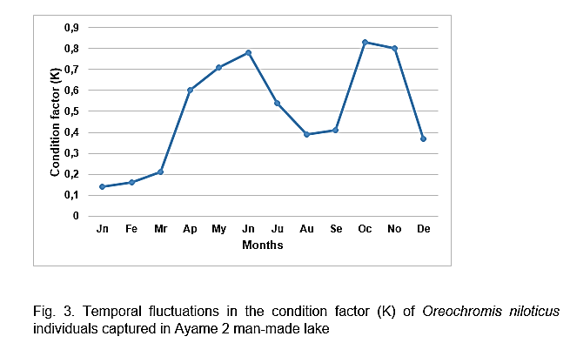

3.3 Size-class distribution of Oreochromis niloticus individuals
The size-class distribution of Oreochromis niloticus individuals revealed a heterogeneous pattern (Figure 4). The [10.5-12.5[ cm class was the most represented, with 428 individuals, followed by the [20.5-22.5[ cm (238 individuals) and [8.5-10.5[ cm (218 individuals) classes. The least represented size classes were [22.5-24.5[ cm (106 individuals) and [24.5-26.5] cm (104 individuals). The Kruskal-Wallis and Mann-Whitney tests revealed a significant variation in the number of individuals among different size classes (p = 0.01 ; p = 0.02 < 0.05), indicating a heterogeneous size distribution within the population.

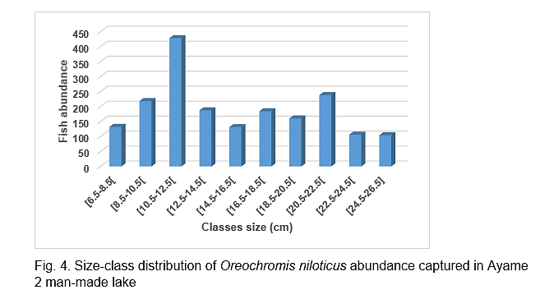

3.4 Condition factor according to size classes
The mean condition factor varied markedly across different size classes of Oreochromis niloticus (Table 1). The highest value was recorded in the [10.5-12.5[ cm class (1.90), followed by the [8.5-10.5[ cm (0.86) and [16.5-18.5[ cm (0.71) classes. In contrast, the lowest condition factors were observed in the [24.5-26.5] cm (0.01), [22.5-24.5[ cm (0.11), and [6.5-8.5[ cm (0.11) classes. Kruskal-Wallis and Mann-Whitney tests applied to these data revealed a highly significant difference among the size classes (p = 0.02 ; p = 0.01 < 0.05), indicating that the condition factor significantly varied with individual size.

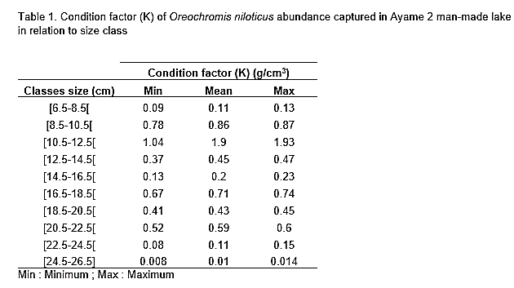

4. discussion

The assessment of size structure and condition factor of Oreochromis niloticus in the Ayame 2 reservoir provided valuable insights into the population dynamics of this species in an ecosystem subject to significant seasonal environmental stress, particularly related to eutrophication and hydrological fluctuations typical of tropical lake systems. The population’s size structure was dominated by intermediate size classes, notably the [10.5-12.5[ cm group, which accounted for nearly one-third of the sampled individuals. This high representation suggests active recruitment, indicating relatively favorable reproductive conditions and rapid early growth of juveniles. However, the low frequency of larger individuals (> 22.5 cm) is likely a consequence of size-selective fishing pressure. Larger fish are often preferentially targeted by fishers due to their higher commercial value, leading to their underrepresentation in the breeding stock. This pattern may also be exacerbated by chronic environmental stress observed in the lake. Indeed, the persistence of eutrophic conditions, particularly during the dry season, could negatively impact the longevity of larger individuals or inhibit their growth. Previous studies on tilapia populations in similar environments have demonstrated that excessive exploitation, combined with degraded environmental conditions, can lead to a reduction in the average size of the population, ultimately compromising its reproductive potential (Bwanika et al., 2006 ; Njiru et al., 2008).
The condition factor (K) of a fish is a direct indicator of its overall physiological state, reflecting influences from feeding, health status, reproductive activity, and environmental conditions. In this context, the observed monthly and size-class variations are particularly informative. The highest K values, reaching up to 1.90 in the [10.5-12.5[ cm size class indicate a phase of active growth among juvenile and subadult individuals. These peaks coincided with the wet seasons (May to July and October to November), during which water levels are elevated, environmental conditions are more stable, and planktonic productivity increases, resulting in greater food availability. Conversely, the lowest K values were recorded during the dry season (January to March and August to September), periods characterized by intense eutrophication, reduced dissolved oxygen, and elevated water temperatures. These environmental stressors likely reduce food availability and increase energy demands for survival, thereby diminishing body condition. This phenomenon is well documented in tropical aquatic systems, where cumulative effects of drought, pollutant concentration, and turbidity adversely affect fish physiology (Talling and Lemoalle, 1998 ; Komolafe and Arawomo, 2008). Notably, larger individuals (> 22.5 cm) consistently exhibited the lowest K values (0.01-0.11), which may reflect either an energy reallocation toward reproduction or a reduced feeding efficiency in degraded environments, particularly when prey availability or suitable foraging substrates are altered. The observed dynamics also appear to reflect an adaptive strategy of Oreochromis niloticus, a species known for its resilience and opportunistic behavior, capable of exploiting a wide range of ecological niches. The synchronization of peaks in body condition with periods of rising water levels suggests a reproductive strategy aligned with the reservoir filling phases, when environmental conditions are more favorable for spawning and larval growth. This pattern is consistent with findings from other tropical reservoirs, where tilapia species adjust their reproductive activity according to hydrological conditions (Cowx et al., 2004).

5. Conclusion

The findings of this study highlight a Oreochromis niloticus population that is dynamic yet ecologically vulnerable, inhabiting an ecosystem characterized by high seasonal variability. The size structure, dominated by intermediate classes, indicates active reproduction, though potentially constrained by size-selective fishing and environmental stressors. The condition factor (K) emerges as a sensitive indicator of the population’s health status, strongly influenced by seasonal patterns and disturbances associated with eutrophication.

DISCLAIMER (ARTIFICIAL INTELLIGENCE)
Author(s) hereby declare that NO generative AI technologies such as Large Language Models (ChatGPT, COPILOT, etc) and text-to-image generators have been used during writing or editing of this manuscript.

References

Adou, Y. E., Blahoua, K. G., Bamba, M., Yao, S. S., Kouamelan, E. P., & N’Douba, V. (2017). Premières données sur l’inventaire du peuplement ichtyologique d’un lac Ouest Africain situé entre deux barrages hydroélectriques: Lac d’Ayamé 2 (Côte d’Ivoire). Journal of Applied Biosciences, 110, 10808-10808.
Ahoussi, K. E., Koffi, Y. B., Kouassi, A. M., Soro, G., Soro N., & Biémi J. (2013). Etude de la variabilité hydroclimatique et de ses conséquences sur les ressources en eau du Sud forestier et agricole de la Côte d'Ivoire : cas de la région d'Abidjan-Agboville. International Journal of Pure & Applied Bioscience, 1 (6) : 30-50.
Blahoua KG, Adou YE, Etile RN, Yao SS., & N’Douba V. Occurrence of gill Monogenean parasites in Redbelly tilapia, Tilapia zillii (Teleostei: Cichlidae) from Lobo River, Côte d’Ivoire. 2018. Journal of Animal and Plants Sciences, 2018, 35(3):5674-5688.
Brou Y. T., Akindes F., Bigot S., & (2005). La variabilité climatique en Côte d'Ivoire: entre perceptions sociales et réponses agricoles. Cahiers Agricultures, 14: 533-540.
Bulengela, G. M., Kimirei, I. A., Hønneland, G., & Fiksen, Ø. (2019). Bring fishermen at the center: the value of local knowledge for understanding fisheries resources and climate-related changes in Lake Tanganyika. Environment, Development and Sustainability, 23, 5389–5410.
Bwanika, G. N., Chapman, L. J., Kizito, Y., & Balirwa, J. (2006). Comparative age and growth of Nile tilapia (Oreochromis niloticus) in lakes Wamala and Nabugabo, Uganda. Hydrobiologia, 589(1), 287–301.
Cowx, I.G., Almeida, O., Bene, C., Brummett, R., Bush, S., Darwall, W., Pittock, J., & Van Brakel, M., 2004. Value of river fisheries. In: Welcomme, R.L., Petr, T. (Eds.), Sustaining livelihoods and Biodiversity in the New Millennium, Proceedings of the 2nd Large Rivers Symposium, vol. 1. Mekong River Commission, Phnom Penh, Cambodia.
Da N., Ouédraogo., & R Ouéda, A. (2018).Relation poids-longueur et facteur de condition de Clarias anguillaris et Sarotherodon galilaeus pêchées dans le lac Bam et le réservoir de la Kompienga au Burkina Faso. Int. J. Biol. Chem. Sci. 12(4): 1601-1610.
Diouf, K. D., & Goudiaby, K. D. (2018). Etude de la structure des tailles, de la croissance et de la reproduction d’Ethmalosa fimbriata à Joal et Saint-Louis.Projet USAID/COMFISH-plus, IFAN, Dakar, 11 p.
Heins, D. C., Baker, J A., & Guill, J. M. (2004). Seasonal and interannual components of intra population variation in clutch size and egg size of a darter, Ecology Freshwater Fisheries, 13, 258- 265.
Karr, J. R (1981). Assessment of biotic integrity using fish communities. Fisheries of Bethesda. 7: 2-8.
Komolafe, O. O., & Arawomo, G. A. O. (2008). Preliminary Observations on Fish Species in a Newly Impounded Osinmo Reservoir. Turkish Journal of Fisheries and Aquatic Sciences, 8, 289–292.
Le Cren, E. D. (1951). The length weight relationship and seasonal cycle in gonad weight and condition in the Perch (P. fluviatilis). Journal of Animal and Ecology, 20, 201-219.
Lévêque, C., & Paugy, D. (2006)., Les poissons des eaux continentales africaines. Institut de Recherche pour le Développement. IRD Edition, Paris, 2006.
Njiru, M., Nyamweya, C., Gichuki, J., Mugidde, R., & Mkumbo, O. (2008). Increasing dominance of Nile tilapia, Oreochromis niloticus (L) in Lake Victoria, Kenya: Consequences for the Nile perch Lates niloticus (L) fishery.Aquatic Ecosystem Health & Management, 11(1), 1–8.
Oni, S. K., Olayemi, J. Y., & Adegboye J. D. (1983). Comparative physiology of three ecologycally distinct freshwater fishes, Alestes nurse Rüppell, Synodontis schall Broch and Schneider and Tilapia zillii Gervais.J. Fish. Biol., 22, 105-409.
Oni, S., Olayemi, J. Y., & Adegboye, J. D. (1983). The comparative physiology of three ecologically distinct freshwater fishes : Alestes nurse, Synodontis schall and Tilapia zilli. Journal of Fisheries and Biology, 22, 105-109.
Ouattara, M., Gourène, G., & Vanga, A. F. (2006). Proposition de fermeture saisonnière de la pêche en vue d’une exploitation durable du poisson au lac d’Ayamé (Côte d’Ivoire). Tropicultura, 24 (1) : 713.
Ouattara, A., Gourène, G., & Podoor, N. (2007). Activité photosynthétique du phytoplancton dans le barrage hydroélectrique d’Ayamé 1 (Côte d’Ivoire). Agronomie Africaine 19 : 63 - 70.
Oussou, K. H., N’Gessan, D. C., Soro, Y. & N’Da K. (2018.) Pêche et Caractéristiques morphologiques d’un poisson-chat endémique Synodontis punctifer (Daget, 1964) dans le lae barrage hydroéletrcique de Taaba (Côte d’Ivoire) European Scientifc Journal, 14 (15), 101116.
Paugy, D & Lévêque, C. (2017).Impacts of human activities. In : Paugy D., Leveque C. et Otero O. (eds): The inland water fishes of Africa: Diversity, Ecology and Human use, Institut de Recherche pour le Développement (IRD), Royal Museum for Central Africa (RMCA), Pp 459-478.
Scherrer, B. (1984). L’inférence statistique : les tests d’hypothèse in Biostatistique (Gaëtan M. M., éd) 1ere édition, Paris, 487p, 1984.
Soumaïla S., Atsé, B.C. & Kouassi, N’G. J. (2009). Stratégie de Reproduction du Carangidae Trachinotus teraia Cuvier, 1832 dans la lagune Ebrié (Côte d’Ivoire), Sciences Nature., 6(1), 83- 94.
Tabassum, S., Elahi, N. & Baloch, W. A. (2013). Comparison of Condition factor of the Ribbonfish Trichiurus lepturus (Linnaeus, 1758) and Lepturacanthus savala (Cuvier, 1829) from Karachi Coast, Pakistan. Sindh University Researh Journal (Sci. Ser.) 45(4): 657-660.
Talling, J. F., & Lemoalle, J. (1998). Ecological Dynamics of Tropical Inland Waters. Cambridge University Press, Cambridge. ISBN: 9780521350315. 315.

