***Original Research Article***

**Effect of *Pongamia pinnata* Extract as a Priming Agent on the Growth and Development of Radish (*Raphanus sativus*)**

**ABSTRACT**

*Pongamia pinnata* extract is the natural plant growth stimulant that is well known for its ability to improve the plant growth and development. This study investigated the effect of *Pongamia pinnata* leaf extract as a seed priming agent and foliar spray on the growth and development of radish (*Raphanus sativus* 'Pusa Chetki'). The extract was applied at one week’s interval with different frequencies. A Randomized Block Design (RBD) with four treatments (Control, Seed Treatment, Spray Treatment, and Combined Seed Treatment + Spray) and three replications was conducted at the research farm of Amity Institute of Organic Agriculture, Amity University Noida, Uttar Pradesh, India, during the winter season of 2024-2025. Data on germination percentage, plant height, number of leaves, leaf area, number of flowers, number of branches, number of pods, number of seeds per plant, number of seeds per siliqua, root length, fresh weight, and dry weight were collected at different days after sowing (DAS). Results indicated that *Pongamia pinnata* extract significantly improved seed germination in a separate test. Furthermore, treatments involving *Pongamia pinnata* extract, particularly the combined seed and spray application (T4), consistently showed enhanced vegetative growth, reproductive development, and biomass accumulation compared to the untreated control (T1) and other treatments (T2 and T3). Therefore, applying pongamia pinnata extract hold a holds potential as a natural biostimulant for improving radish growth and potentially yield under the tested conditions. Further research is recommended to optimize application methods and extract concentrations, evaluate effects under diverse environmental conditions, and investigate the underlying physiological and biochemical mechanisms.

***Keywords:*** *Pongamia pinnata*, seed priming, radish, *Raphanus sativus*, plant extract, growth, development, yield.

1. **INTRODUCTION**

Radish (*Raphanus sativus* L.) is a globally important and widely cultivated root vegetable, prized for its rapid growth cycle and nutritional value cultivated root vegetable, prized for its rapid growth cycle and nutritional value (Gamba *et al.,* 2021). It plays a significant role in diverse culinary traditions and serves as a source of essential vitamins and minerals, such as Vitamin C, Potassium, Calcium, and Magnesium (Yousaf *et al*., 2021). In the North Indian Plains, the 'Pusa Chetki' variety is particularly popular due to its adaptability, including tolerance to warmer growing periods typically spanning from March to August (Pavitra *et al.,* 2024). However, the cultivation period for this experiment, commencing on December 23, 2024, extends into the cooler winter months, which may influence the physiological responses of the radish plants. Environmental factors like temperature and day length are known to significantly impact plant metabolism and development, potentially altering the efficacy of various agricultural interventions, including seed priming (Nieuwhof *et al*., 1976). Therefore, considering the specific environmental context of this experiment is crucial for a comprehensive interpretation of the results.

Seed priming is a well-established pre-sowing technique that involves controlled hydration of seeds to initiate the early metabolic processes necessary for germination without allowing the radicle to emerge (Parera *et al*., 2010). This treatment offers several advantages, including a faster rate of emergence, improved uniformity in seedling establishment, and an enhanced capacity to tolerate various biotic and abiotic stresses such as drought, salinity, and extreme temperatures through Modulation of Seed (Farooq et al., 2019). Seed Priming: A Feasible Strategy to Enhance Drought Tolerance in Crop Plants (Kanjevac *et al*., 2022). For a fast-growing crop like radish, these benefits are particularly relevant as they can lead to more efficient utilization of resources and potentially higher yields within its relatively short growth duration (Aboyeji *et al*., 2019).

The increasing demand for sustainable agricultural practices has led to the exploration of natural alternatives to synthetic chemicals. Plant extracts, rich in various bioactive compounds, have shown promise as potential biostimulants and priming agents (Yadav *et al*., 2024). These extracts can contain plant growth regulators, antioxidants, and antimicrobial compounds that can positively influence seed germination, seedling vigor, and overall plant growth (MacDonald *et al*., 2025). *Pongamia pinnata* (L.) Pierre, also known as Karanja, is a leguminous tree native to the Indian subcontinent. It is well-recognized for its ecological benefits and the presence of various bioactive compounds in its different parts, including leaves, seeds, and bark. These compounds include flavonoids such as karanjin and pongamol, which have demonstrated biological activities (Swamy *et al*., 2015).

While *Pongamia pinnata* is primarily known for its potential as a source of biodiesel and its use in traditional medicine and pest management, its application as a seed priming agent for enhancing crop growth is less explored (Scott *et al*.,2008). Given the potential of plant extracts as natural priming agents and the known bioactivity of *Pongamia pinnata* compounds, this study aims to investigate the effect of *Pongamia pinnata* leaf extract as a seed priming agent on the growth and development of radish (*Raphanus sativus* 'Pusa Chetki'). The study evaluates various growth, developmental, and yield-related parameters to determine the efficacy of different application methods of the extract. Based on the potential benefits of seed priming and the known properties of *Pongamia pinnata*, it was hypothesized that treatments with *Pongamia pinnata* leaf extract, particularly the combined seed priming and foliar spray, would positively influence the germination, growth, development, and yield of radish (*Raphanus sativus* 'Pusa Chetki') compared to the untreated control.

1. **MATERIALS AND METHODS**

**2.1 Experimental Site, conditions and material**

The experiment was conducted at the research farm of the Amity Institute of Organic Agriculture, Amity University Noida, Uttar Pradesh, India. The site is located at 28° 53' N latitude and 77° 39'E longitude. The experiment was conducted during the winter season, with a sowing date of December 23, 2024. The specific environmental conditions (temperature, rainfall, humidity) during the experimental period were not recorded in the provided materials but are important for interpreting the results, especially considering the typical growing season of 'Pusa Chetki'. Seeds of radish (*Raphanus sativus* L.) variety 'Pusa Chetki' were used for the experiment.

**2.2 Preparation of *Pongamia pinnata* Leaf Extract**

Fresh leaves of *Pongamia pinnata* were collected. The extract was prepared using two different ratios of leaves to water: 1:1 (for seed treatment) and 1:10 (for spray treatment). The specific method of extraction (e.g., grinding, soaking, filtration) and the duration of soaking were not detailed in the provided materials. For the germination test, a 1:10 leaf to water ratio was used for the treated seeds.

**2.3 Treatments**

The Table 1 presents a structured overview of four experimental treatments designed to assess the effects of *Pongamia pinnata* leaf extract on radish (*Raphanus sativus*) growth. Treatment T1 serves as the control, comprising untreated seeds to establish baseline physiological and morphological parameters. Treatment T2 involves seed priming with *P. pinnata* leaf extract prepared at a 1:1 (w/v) leaf-to-water ratio; however, specific details regarding soaking duration and treatment protocol are not provided. Treatment T3 consists of foliar application of a diluted *P. pinnata* extract (1:10 w/v), applied to plants grown from untreated seeds. Although the exact schedule and frequency of foliar spraying are not defined, this treatment is presumed to be initiated post-germination during the vegetative phase. Treatment T4 integrates both seed treatment (1:1 extract) and subsequent foliar spraying (1:10 extract) on the same plant cohort. The dual-application approach in T4 allows for assessment of potential synergistic or additive effects of combined pre-sowing and post-emergence exposure to the bioactive components of *P. pinnata*. These treatments enable comparative evaluation of *P. pinnata* extract as a potential biostimulant or bio-protectant in radish cultivation.

**Table-1** Detail descriptions of the different treatments with there concentration

|  |  |  |
| --- | --- | --- |
| **Treatment** | **Description** | **Extract Type & Concentration** |
| **T1 (Control)** | Untreated seeds | None |
| **T2** | Seed priming with *P. pinnata* | 1:1 (w/v) leaf: water extract |
| **T3** | Foliar spray on plants from untreated seeds | 1:10 (w/v) diluted extract |
| **T4** | Seed priming + foliar spray on same plants | 1:1 (seed) and 1:10 (foliar) extracts |

**2.4 Experimental Design**

The experiment was laid out in a Randomized Block Design (RBD). This design is appropriate for experiments conducted in the field to minimize the effect of variability in soil fertility or other environmental factors across the experimental area. The experiment had three replications. Each replication included all four treatments. The total number of experimental plots was 4 treatments×3 replications=12 plots. However, the provided materials state there were 6 plots in total for an RBD, with 3 blocks and 2 plots per block. This contradicts the description of 4 treatments and 3 replications. Based on the data tables provided, which show data for T1, T2, T3, and T4 with three replicates (R1, R2, R3), it is assumed that there were indeed 4 treatments and 3 replications, totaling 12 experimental units, and the mention of 6 plots in the PDF was either a mistake or referred to a different experiment. Assuming 4 treatments and 3 replications in an RBD, each plot measured 1.0×1.0 m2. The treatments were randomly assigned to the plots within each block.

**2.5 Crop Management**

Radish seeds were sown on December 23, 2024. The seed rate was maintained at 10 kg per hectare. The spacing between rows was 40 cm, and the spacing between plants within a row was 10 cm. This spacing results in a plant density of approximately 25 plants per 1.0×1.0 m2 plot. Details regarding irrigation schedule, weeding practices, and any pest or disease management measures taken during the experiment were not provided in the available materials.

**2.6 Data Collection**

For parameters measured on a per-plant basis, it is assumed that a representative sample of plants was randomly selected from each plot for measurement. The number of plants sampled per plot was not specified.

**2.7 Statistical Analysis**

The collected data for each parameter were subjected to statistical analysis. For experiments conducted in an RBD, Analysis of Variance (ANOVA) is typically used to determine if there are statistically significant differences among the treatment means. If the ANOVA reveals a significant treatment effect (usually at a significance level of p<0.05), post-hoc tests, such as Tukey's Honestly Significant Difference (HSD) test, are performed to make pairwise comparisons between the treatment means and identify which specific treatments are significantly different from each other. The provided materials do not include the results of the statistical analysis (ANOVA tables, p values, etc.). Therefore, the statistical significance of the observed differences among the treatments cannot be determined from the available data.

1. **RESULTS AND DISCUSSION**

The results of this study demonstrate that the application of *Pongamia pinnata* leaf extract as a seed priming agent and foliar spray significantly influenced the growth and development of radish (*Raphanus sativus* 'Pusa Chetki') (Prakash *et al*., 2019). The findings generally support the hypothesis that *Pongamia pinnata* extract can positively impact radish growth. The experimental data were analyzed by assessing various biometric parameters like Germination percentage, plant height, number of leaves, leaf area, number of flowers, number of pods, number of siliquae, number of branches, number of seeds, fresh weight of plant, dry weight of plant, root length.

**3.1 Germination Percentage**

A germination test comparing untreated seeds with seeds treated with *Pongamia pinnata* extract (1:10 leaf: water ratio) showed a notable difference in germination percentage. The results indicate that treating radish seeds with *Pongamia pinnata* extract at a 1:10 leaf to water ratio resulted in a significantly higher germination percentage (81%) compared to untreated seeds (53%), representing a 28% increase. The observed increase in germination percentage with *Pongamia pinnata* extract treatment is a crucial finding. Improved germination is a primary benefit of seed priming and leads to faster and more uniform seedling emergence, which is essential for establishing a healthy crop stand (Khalequzzaman *et al*., 2023). This suggests that the *Pongamia pinnata* extract contains compounds that can break seed dormancy, enhance metabolic activity during imbibition, and promote the early stages of germination (Chandra *et al.,* 2024) (Fig.1).

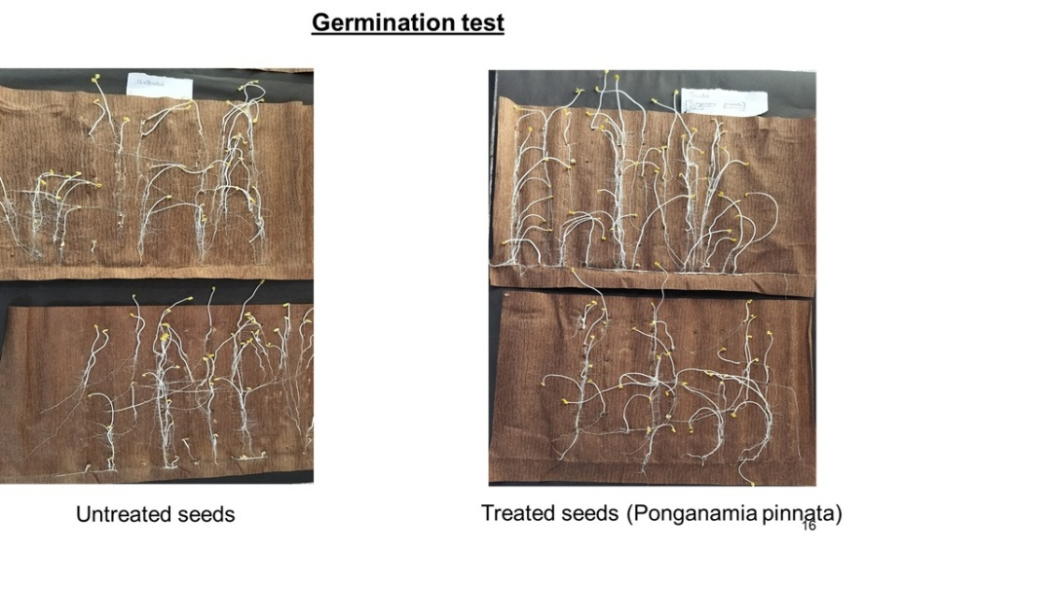

**Fig.1.** Seed Quality Parameters

**3.2 Plant Height**

Plant height was measured at 30, 60, and 90 DAS to assess the vertical growth of radish plants under different treatments. At 30 DAS, treatments T3 and T4 showed higher mean plant height compared to T1 and T2. This trend continued at 60 and 90 DAS, with T4 consistently exhibiting the greatest plant height, followed by T3, T2, and the control T1 (Fig.2). The data on plant height indicate that treatments with *Pongamia pinnata* extract, particularly T4 (combined seed treatment and foliar spray) and T3 (foliar spray), promoted vegetative growth. T4 consistently resulted in the tallest plants at 60 and 90 DAS.

**3.3 Number of Leaves per Plant**

The number of leaves per plant is an indicator of vegetative growth and photosynthetic capacity. The number of leaves per plant increased over time for all treatments. At 30 DAS, T3 and T4 had slightly more leaves than T1 and T2. By 60 and 90 DAS, treatments T3 and T4 showed a considerably higher number of leaves per plant compared to T1 and T2, with T4 having the highest mean number of leaves at 90 DAS (Fig.2). The data on plant number of leave indicate that treatments with *Pongamia pinnata* extract, particularly T4 (combined seed treatment and foliar spray) and T3 (foliar spray), promoted vegetative growth. T4 consistently resulted in a higher number of leaves per plant at 60 and 90 DAS.

**3.4 Leaf Area**

Leaf area is another important parameter reflecting the plant's photosynthetic capacity. Leaf area generally increased over time. At 30 DAS, the differences among treatments were small. At 60 DAS, T3 and T4 showed higher mean leaf area compared to T1 and T2, although there was high variability in T3. At 90 DAS, T1 had the highest mean leaf area, which is an unexpected trend compared to other parameters. T4 had the second highest mean leaf area at 90 DAS (Fig.2). The data on leaf area indicate that treatments with *Pongamia pinnata* extract, particularly T4 (combined seed treatment and foliar spray) and T3 (foliar spray), promoted vegetative growth. T4 consistently resulted in the increased leaf area. Increased leaf area in these treatments suggests enhanced photosynthetic capacity, which is fundamental for biomass production. The unexpected high leaf area in T1 at 90 DAS warrants further investigation and could be due to variability or other unmeasured factors.

**3.5 Number of Flowers per Plant**

The number of flowers per plant indicates the reproductive potential of the plant. The number of flowers per plant increased from 60 to 90 DAS. At both time points, treatments T2, T3, and T4 had a higher mean number of flowers compared to the control T1. Treatment T4 consistently showed the highest mean number of flowers per plant (Fig.2). The influence of *Pongamia pinnata* extract extended to the reproductive phase of the radish plants. Treatments, especially T4, led to a higher number of flowers per plant. This indicates that the extract may contain compounds that stimulate flowering.

**3.6 Number of Branches per Plant**

Branching contributes to the overall size and complexity of the plant structure. The number of branches per plant increased from 60 to 90 DAS. At 60 DAS, T3 and T4 had more branches than T1 and T2. At 90 DAS, treatments T2, T3, and T4 showed a higher mean number of branches compared to T1, with T4 having the highest mean (Fig.2). The influence of *Pongamia pinnata* extract extended to the reproductive phase of the radish plants. Treatments, especially T4, led to a higher number of branches per plant. This indicates that the extract may contain compounds that stimulate the development of reproductive structures.

**3.7 Number of Pods per Plant**

The number of pods per plant is a key yield component in seed production. The number of pods per plant generally increased from 60 to 90 DAS, although T1 showed a decrease, which might indicate maturity and senescence. At both 60 and 90 DAS, treatments T2, T3, and T4 had a higher mean number of pods compared to T1. Treatment T4 exhibited the highest mean number (Fig.2). The influence of *Pongamia pinnata* extract extended to the reproductive phase of the radish plants. Treatments, especially T4, led to a higher number of pods per plant. This indicates that the extract may contain compounds that stimulate the development of reproductive structures.

**3.8 Number of Seeds per Plant**

The total number of seeds per plant is a direct measure of seed yield potential. At 90 DAS, all treatments with *Pongamia pinnata* extract (T2, T3, and T4) resulted in a higher mean number of seeds per plant compared to the control (T1). Treatment T4 had the highest mean number of seeds per plant, followed by T3 and T2 (Fig.2). The influence of *Pongamia pinnata* extract extended to the reproductive phase of the radish plants. Treatments, especially T4, led to a higher number of seeds per plant. This indicates that the extract may contain compounds that stimulate the development of reproductive structures, ultimately contributing to a higher potential for seed production. The increased number of seeds per plant in the treated plots, particularly T4, further supports this observation and is a direct indicator of improved seed yield components.

**3.9 Number of Seeds per Siliqua**

The number of seeds per siliqua (pod) is another component contributing to seed yield. Treatments with *Pongamia pinnata* extract (T2, T3, and T4) resulted in a higher mean number of seeds per siliqua compared to the control (T1). Treatment T4 had the highest mean number of seeds per siliqua (Fig.3). The influence of *Pongamia pinnata* extract extended to the reproductive phase of the radish plants. Treatments, especially T4, led to a higher number of seeds per siliqua. This indicates that the extract may contain compounds that stimulate the development of reproductive structures, ultimately contributing to a higher potential for seed production. The increased number of seeds per siliqua in the treated plots, particularly T4, further supports this observation and is a direct indicator of improved seed yield components.

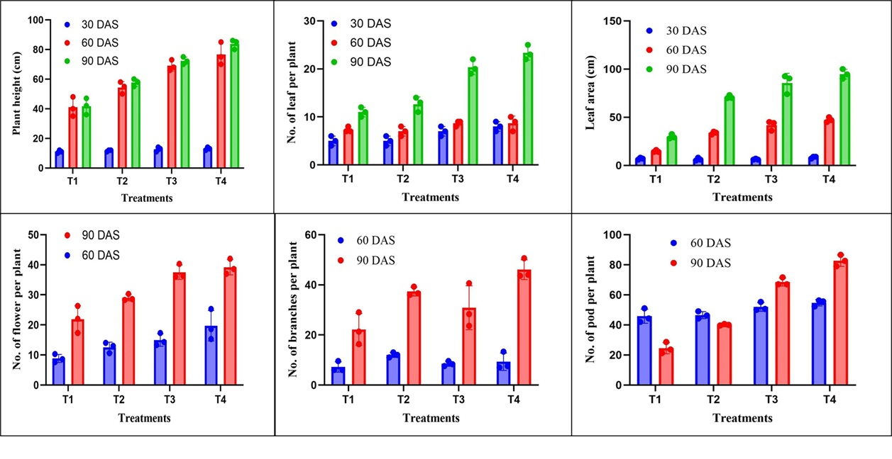

**Fig.2.** Effect of *Pongamia pinnata* Extract Treatments on yield quality attributes of Radish at Different DAS

**3.10 Root Length of Plant**

Root length is an indicator of root system development, which is crucial for nutrient and water uptake. At 90 DAS, treatments with *Pongamia pinnata* extract (T2, T3, and T4) resulted in greater mean root length compared to the control (T1). Treatment T4 showed the longest mean root length, followed by T3 and T2 (Fig. 3). Root development is critical for nutrient and water uptake, which in turn supports overall plant growth (Wang *et al*., 2006). The increased root length at 90 DAS in the treated plants, especially T4, suggests that *Pongamia pinnata* extract promoted root system development. A more extensive root system can enhance the plant's ability to access resources from the soil, contributing to improved growth and biomass accumulation (Shen *et al*., 2013).

**3.11 Fresh Weight and Dry weight**

Fresh weight is a measure of the total biomass of the plant including water content. At 90 DAS, treatments T3 and T4 resulted in higher mean fresh weight compared to T1 and T2. Treatment T4 had the highest mean fresh weight. Dry weight represents the accumulated biomass excluding water content (Fig. 3). At 90 DAS, treatments T2, T3, and T4 resulted in higher mean dry weight compared to the control T1. Treatment T4 had the highest mean dry weight, followed by T3 and T2 (Figure 3). The data on fresh and dry weight at 90 DAS provide insights into the total biomass accumulated by the plants. Treatments with *Pongamia pinnata* extract, particularly T4, resulted in higher fresh and dry weights. This indicates that the extract treatments led to increased accumulation of plant matter, which is a reflection of enhanced overall growth and productivity. While radish is typically harvested for its root at an earlier stage, the biomass data at 90 DAS, representing the mature plant, still demonstrates the potential of *Pongamia pinnata* extract to promote vigorous growth throughout the plant's life cycle.

Comparing the different application methods, the combined seed treatment and foliar spray (T4) generally resulted in the most pronounced positive effects on most growth and yield parameters. This suggests a potential synergistic effect of applying *Pongamia pinnata* extract at different stages of plant development. Seed priming provides a head start by improving germination and early seedling vigor, while subsequent foliar applications can provide a continuous supply of beneficial compounds to support vegetative and reproductive growth (Mehra *et al*., 2021). The foliar spray treatment alone (T3) also showed positive effects compared to the control, indicating the efficacy of foliar absorption of the active compounds in the extract. The seed treatment alone (T2) was beneficial for germination and showed some positive effects on later growth parameters compared to the control, but it was generally less effective than the treatments involving foliar spray.

The positive effects observed in this study can be attributed to the rich phytochemical composition of *Pongamia pinnata* leaves. *Pongamia pinnata* contains various bioactive compounds, including flavonoids (like karanjin and pongamol), terpenoids, and phenolic compounds (Usharani *et al*., 2019). These compounds may act as biostimulants by influencing plant hormone levels, enzyme activities, and metabolic pathways involved in growth and development. For example, some flavonoids have been shown to exhibit auxin-like activity, promoting cell division and elongation. Antioxidant compounds in the extract could help protect plant cells from oxidative damage caused by environmental stresses, leading to improved growth and vigor. Furthermore, the potential antimicrobial properties of *Pongamia pinnata* extract could contribute to healthier plant growth by suppressing soil-borne pathogens or foliar diseases (Degani *et al.,* 2022).

The findings of this study are consistent with research on the use of other plant extracts as biostimulants and priming agents in agriculture. Extracts from various plant species have been shown to improve seed germination, seedling growth, and yield in different crops, which is attributed to the presence of similar classes of bioactive compounds (Patra *et al*., 2018). However, the specific effects of *Pongamia pinnata* leaf extract on radish have not been widely reported, making this study a valuable contribution to the understanding of the potential agricultural applications of this plant.

Despite the promising results, it is important to consider the limitations of this study. The experiment was conducted at a single location during one growing season, which may limit the generalizability of the findings to other environments. The number of replications (three) is relatively low, which can affect the statistical power of the analysis (Bates *et al*., 1992). While the data tables provide mean values and standard deviations, the lack of statistical analysis results (e.g., ANOVA tables, p-values, results of post-hoc tests) makes it difficult to definitively determine the statistical significance of the observed differences among the treatments. The specific method of extract preparation and the precise concentrations of bioactive compounds in the extracts were not quantified, which makes it challenging to standardize the treatment and compare the results with other studies. The study focused primarily on growth and yield components, and a more comprehensive evaluation could include parameters related to root quality (e.g., root shape, texture, pungency) and nutritional composition.

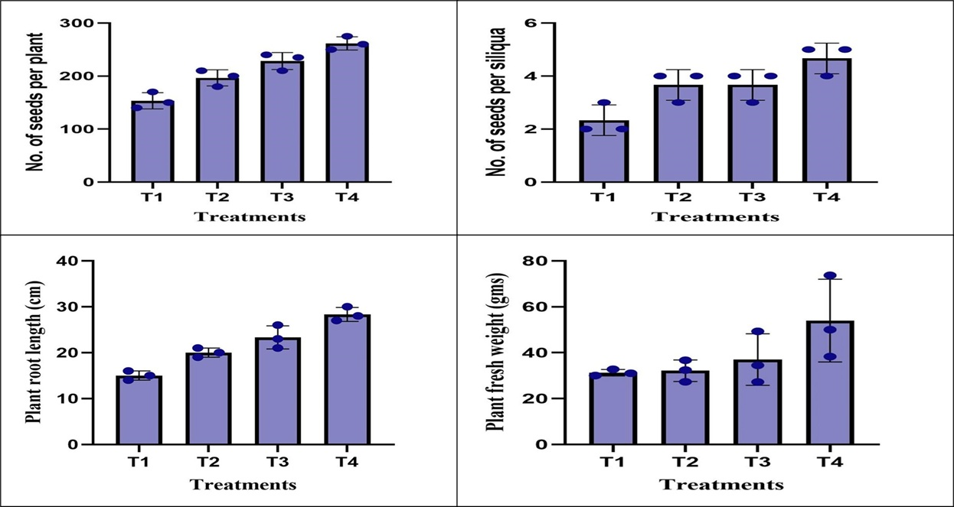

**Fig. 3.** Effect on the different yield parameters of different treatment.

1. **CONCLUSION**

In conclusion, this study demonstrated that *Pongamia pinnata* leaf extract has a positive effect on the growth and development of radish (*Raphanus sativus* 'Pusa Chetki'). The seed treatment with *Pongamia pinnata* extract significantly improved seed germination percentage. Furthermore, the application of *Pongamia pinnata* extract, particularly the combined seed treatment and foliar spray (T4), resulted in enhanced vegetative growth (plant height, number of leaves, leaf area), improved reproductive development (number of flowers, branches, pods, and seeds), and increased biomass accumulation (fresh and dry weight) compared to the untreated control. The increased root length in the treated plants also indicates improved root system development. These findings suggest that *Pongamia pinnata* leaf extract contains bioactive compounds that can act as natural biostimulants, promoting various aspects of radish growth and potentially leading to higher yields. The combined application of seed treatment and foliar spray appears to be the most effective method among the tested treatments.

**DISCLAIMER (ARTIFICIAL INTELLIGENCE)**

Author(s) hereby declare that NO generative AI technologies such as Large Language Models (ChatGPT, COPILOT, etc.) and text-to-image generators have been used during the writing or editing of this manuscript.

**REFERENCES**

Aboyeji, C. M., Adekiya, A. O., Dunsin, O., Agbaje, G. O., Olugbemi, O., Okoh, H. O., & Olofintoye, T. A. J. (2019). Growth, yield and vitamin C content of radish (*Raphanus sativus* L.) as affected by green biomass of Parkia biglobosa and Tithonia diversifolia. *Agrofor. Syst.*, *93*, 803-812.

Bates, B. T., Dufek, J. S., and Davis, H. P. (1992). The effect of trial size on statistical power. *Med Sci Sports Exerc.*, *24*(9), 1059-1065.

Chandra, R. J., Masilamani, P., Suthakar, B., Rajkumar, P., Sivakumar, S. D., and Manonmani, V. (2024). Seed Dormancy and After-ripening Mechanisms in Seed Germination: A Comprehensive Review. *IJPSS.*, *36*(10), 68-92.

Degani, E., Prasad, M. V. R., Paradkar, A., Pena, R., Soltangheisi, A., Ullah, I., ... and Tibbett, M. (2022). A critical review of *Pongamia pinnata* multiple applications: from land remediation and carbon sequestration to socioeconomic benefits. *J. Environ. Manag.*, *324*, 116297.

Farooq, M., Usman, M., Nadeem, F., ur Rehman, H., Wahid, A., Basra, S. M., and Siddique, K. H. (2019). Seed priming in field crops: potential benefits, adoption and challenges. *Crop Pasture Sci.*, *70*(9), 731-771.

Gamba, M., Asllanaj, E., Raguindin, P. F., Glisic, M., Franco, O. H., Minder, B., ... and Muka, T. (2021). Nutritional and phytochemical characterization of radish (*Raphanus sativus*): A systematic review. *Trends Food Sci. Technol.*, *113*, 205-218.

Kanjevac, M., Jakovljević, D., Todorović, M., Stanković, M., Ćurčić, S., and Bojović, B. (2022). Improvement of germination and early growth of radish (*Raphanus sativus* L.) through modulation of seed metabolic processes. *Plants*, *11*(6), 757.

Khalequzzaman, Ullah, H., Himanshu, S. K., Islam, N. E. T., Tisarum, R., Cha-Um, S., and Datta, A. (2023). Seed priming improves germination, yield, and water productivity of cotton under drought stress. *J. Soil Sci. Plant Nutr.*, *23*(2), 2418-2432.

MacDonald, M. T., and Mohan, V. R. (2025). Chemical Seed Priming: Molecules and Mechanisms for Enhancing Plant Germination, Growth, and Stress Tolerance. *Curr. Issues Mol. Biol.*, *47*(3), 177.

Mehra, H. S., Wang, X., Russell, B. P., Kulkarni, N., Ferrari, N., Larson, B., and Vinyard, D. J. (2024). Assembly and Repair of Photosystem II in *Chlamydomonas reinhardtii*. *Plants*, *13*(6), 811.

Nieuwhof, M. (1976). The effect of temperature on growth and development of cultivars of radish under winter conditions. *Sci. Hortic.*, *5*(2), 111-118.

Parera, C. A., and Cantliffe, D. J. (2010). Presowing seed priming. *Hort. Rev.*, *16*, 109-141.

Patra, J. K., Das, G., Lee, S., Kang, S. S., and Shin, H. S. (2018). Selected commercial plants: A review of extraction and isolation of bioactive compounds and their pharmacological market value. *Trends Food Sci Technol.*, *82*, 89-109.

Pavitra, K., Thakur, V., Sharma, S., & Bhat, S. A. (2024). Efficacy of organic amendments and biofertilizers on yielding, biochemical and soil nutritional attributes of radish (*Raphanus sativus* L.).  *IJROWA.*, *13*(4), 1-16.

Prakash, M., NARAYANAN, G. S., Anandan, R., and KUMAR, B. S. (2019). Effect of organic seed treatment and foliar spray on growth, yield and resultant seed quality in sesame (*Sesamum indicum* L.). *J. Oilseeds Res.*, 30.

Scott, P. T., Pregelj, L., Chen, N., Hadler, J. S., Djordjevic, M. A., & Gresshoff, P. M. (2008). *Pongamia pinnata*: an untapped resource for the biofuels industry of the future. *Bioenergy Res.*, *1*, 2-11.

Shen, J., Li, C., Mi, G., Li, L., Yuan, L., Jiang, R., & Zhang, F. (2013). Maximizing root/rhizosphere efficiency to improve crop productivity and nutrient use efficiency in intensive agriculture of China. *J. Exp. Bot.*, *64*(5), 1181-1192.

Swamy, M. K., and Sinniah, U. R. (2015). A comprehensive review on the phytochemical constituents and pharmacological activities of *Pogostemon cablin* Benth.: an aromatic medicinal plant of industrial importance. *Molecules*, *20*(5), 8521-8547.

Usharani, K. V., Naik, D., and Manjunatha, R. L. (2019). *Pongamia pinnata* (L.): Composition and advantages in agriculture: A review. *J Pharmacogn Phytochem*, *8*(3), 2181-2187.

Wang, H., Inukai, Y., and Yamauchi, A. (2006). Root development and nutrient uptake. *Crit Rev Plant Sci*, *25*(3), 279-301.

Yousaf, M., Bashir, S., Raza, H., Shah, A. N., Iqbal, J., Arif, M., ... & Hu, C. (2021). Role of nitrogen and magnesium for growth, yield and nutritional quality of radish. *Saudi J. Biol. Sci.*, *28*(5), 3021-3030.