Case report

Modifications and Clinical Use of Sub-Tenon's Anesthesia in Canine Ophthalmic Surgery: A Case Report

.
ABSTRACT:

This case report details the successful application of a specifically adapted sub-Tenon's block (STB) technique in a four-year-old male Shih Tzu undergoing dermoid cyst excision with concurrent left eye discomfort. While sub-Tenon's anaesthesia is a well-established and advantageous regional anaesthetic technique in human ophthalmology, known for its efficacy in providing both anesthesia and analgesia while minimizing potential complications, its clinical application in veterinary medicine, particularly in dogs, remains relatively unexplored, with limited published data available. In this instance, the STB, in conjunction with systemic analgesics, effectively managed post-operative pain and provided adequate intraoperative akinesia, thereby negating the need for systemic neuromuscular blockade. This outcome is significant, as systemic neuromuscular blockade often necessitates mechanical ventilation and intensive monitoring, potentially increasing the complexity and risks associated with the procedure. The successful application of STB in this case underscores its potential as a valuable alternative for regional anaesthesia in canine ophthalmic procedures. This approach mirrors the reduced complication rates, such as globe perforation and retrobulbar hemorrhage, and the efficacy observed in human patients, suggesting a potential for improved safety and outcomes in veterinary patients as well. This preliminary report advocates for further investigation into the broader applicability and safety profile of sub-Tenon's anaesthesia in veterinary ophthalmology. Future studies should aim to evaluate the technique across a larger sample size, encompassing various canine breeds and different types of ophthalmic surgeries, to establish standardized protocols and optimal drug dosages.

Keywords: Sub-Tenon's, ophthalmic surgeries, anaesthesia, veterinary ophthalmology

1. INTRODUCTION

Regional anaesthesia plays a crucial role in ophthalmic surgery, aiming to provide adequate analgesia and akinesia, thereby facilitating surgical manipulation and improving patient comfort both intra- and post-operatively. In human ophthalmology, sub-Tenon's anaesthesia has emerged as a preferred technique over peribulbar and retrobulbar injections due to its comparable efficacy and significantly lower risk of sight-threatening complications such as globe perforation, retrobulbar haemorrhage, and optic nerve damage^{(4, 8).} The sub-Tenon's space, located between the sclera and Tenon's capsule, allows for the relatively atraumatic delivery of local anaesthetic agents, bathing the extraocular muscles and sensory nerves supplying the globe and adnexa ^{(11).}
Despite the established benefits in human medicine, the application of sub-Tenon's anaesthesia in veterinary ophthalmology remains largely unexplored. While systemic anaesthesia with or without neuromuscular blockade is commonly employed for canine ophthalmic procedures, it carries inherent risks and may not be ideal for all patients or surgical scenarios. This case report presents the successful application of a specifically developed sub-Tenon's block (STB) technique in a canine patient undergoing ophthalmic surgery, highlighting its potential as a safe and effective regional anaesthetic modality in this species.
The successful application of sub-Tenon's anesthesia ⁽¹⁾ in the presented canine case underscores its potential as a valuable tool, mirroring the effective and lower-risk regional anesthesia observed in human medicine ^{(3,5, 6, 7, 10)}.
2. PRESENTATION OF CASE
The preparation for the four-year-old shih tzu's corneal dermoid cyst surgery involved several key steps to ensure patient safety and optimal surgical conditions. Initially, the patient received premedication with atropine sulfate to manage potential bradycardia and reduce salivary secretions. Anaesthesia was induced using midazolam and ketamine, providing sedation and analgesia, and was maintained with propofol, allowing for controlled depth of anaesthesia throughout the procedure. To maintain hydration and facilitate intravenous drug administration, intravenous fluids were administered. Prophylactic antibiotics, specifically amoxicillin-clavulanate, were given to minimize the risk of post-operative infection, considering the surgical manipulation involved. Corneal dermoids are congenital growths consisting of skin-like tissue on the cornea, citing references ^{(2, 9)} likely present in the original source.
To achieve adequate immobilization of the eye, a STB using 2% lignocaine was performed. The procedure commenced with the preparation of standard ophthalmic surgical instruments, as depicted in figure 1. This basic set included curved mosquito hemostats, 0.5mm rat-toothed thumb forceps, curved conjunctival scissors, an eyelid speculum, and a 20g curved sub-tenon's cannula respectively shown in figure 1. Lignocaine 2% was the chosen local anaesthetic agent for the STB technique.
The initial step in the STB procedure involved the insertion of an eyelid speculum to retract the eyelids and provide a clear surgical field. Subsequently, as illustrated in figure 2, curved mosquito hemostats were secured to the perilimbal dorsolateral bulbar conjunctiva. This maneuver effectively immobilized the globe, positioning it in a ventromedially rotated orientation, providing optimal access to the surgical site for the subsequent steps of the block. Following globe fixation, a small snip incision was made in the dorsolateral bulbar conjunctiva, approximately 5mm posterior to the limbus, as shown in figure 3. A minimal amount of local anaesthetic, precisely 0.1ml of 2% lignocaine, was then carefully injected into tenon's capsule, deep to the conjunctival incision. This initial, small volume of anaesthetic served to hydrate the connective tissue layers, aiding in the clearer identification and dissection of tenon's capsule. Next, as depicted in figure 4, tenon's capsule was grasped with forceps and meticulously dissected bluntly using the curved conjunctival scissors to expose the underlying sclera. Following this exposure, the tips of the scissors were carefully angled posteriorly, maintaining a trajectory along the 'line of latitude' situated between the dorsal rectus and lateral rectus extraocular muscles, immediately external to the sclera. This precise positioning allowed for controlled access to the sub-tenon's space. Blunt dissection was continued to create a sub-tenon's tunnel, extending posteriorly until the scissor tips advanced beyond the globe's equator. This typically occurred when the hinge of the scissors aligned with the initial conjunctival incision, providing a visual guide for the extent of dissection.
A 20g curved flattened sub-tenon's cannula, connected to a syringe prefilled with 2ml of the 2% lignocaine local anaesthetic, was then carefully introduced into the sub-tenon's tunnel. As shown in figure 5, this cannula was gently guided along the curvature of the globe until its tip was positioned posterior to the globe's equator, ensuring adequate distribution of the anaesthetic agent to affect the extraocular muscles and sensory nerves. The anaesthetic solution was then slowly infused into the sub-tenon's space, with the cannula tip being rotated during the infusion to maximize the spread of the solution throughout the targeted area. Upon completion of the anaesthetic infusion, the cannula was carefully withdrawn.
The successful STB resulted in globe centralization, indicating effective paralysis of the eye-moving muscles due to the absence of muscle tone. Additionally, pupillary dilation (mydriasis) was observed. While mydriasis alone does not definitively confirm muscle paralysis, it strongly suggests that the local anaesthetic reached the orbital area. This would block the ciliary nerves, leading to paralysis of the pupillary sphincter muscle and consequently, pupillary dilation. This observation of mydriasis, therefore, serves as an indirect indicator that the local anaesthetic was appropriately positioned to also affect the extraocular muscles responsible for eye movement.

3. discussion
The sub-Tenon's block (STB) is a technique used to provide local anesthesia and akinesia—or lack of movement—of the eye, crucial for certain types of eye surgery. While the fundamental goal of STB remains consistent across species, its application and assessment vary considerably between humans and dogs. These differences are primarily attributed to anatomical variations and the challenges of evaluating anesthesia in non-verbal subjects.
In human patients, the ventromedial area is the preferred site for STB administration. This approach is favored due to its minimal interference with subsequent cataract surgery, a common procedure in humans. Specifically, any potential bruising or swelling resulting from the injection at this site is unlikely to obstruct the surgical field or impede the surgeon's access to the eye, both of which are critical for the precision required in cataract procedures.
However, the ventromedial approach presents significant challenges in anesthetized dogs. The natural downward and inward rotation of the canine eyeball under general anesthesia, combined with the presence of the third eyelid, complicates access to this region. Consequently, veterinary ophthalmologists have adapted the STB technique for dogs, opting for the dorsolateral—or upper-outer—region of the eye. This area offers greater accessibility in dogs, and while there's a theoretical risk of swelling near a cataract surgery incision, it's generally not expected to cause substantial complications.
Beyond the procedural differences in STB placement, a notable divergence exists in how the effectiveness of the block is assessed. Human patients can readily communicate their ability or inability to move their eyes, providing direct feedback on the efficacy of the anesthesia. This straightforward assessment is not possible in dogs. Instead, veterinarians rely on indirect clinical signs to evaluate the success of STB.
Two primary indicators are used in canine patients: globe centralization and pupillary dilation, or mydriasis. Globe centralization, where the eye rests in a central position within the orbit, suggests effective paralysis of the extraocular muscles responsible for eye movement. In contrast, mydriasis, while not a direct confirmation of eye muscle paralysis, indicates that the local anesthetic has reached the orbital area. Specifically, it suggests the anesthetic is blocking the ciliary nerves, which control the pupillary sphincter muscle. The presence of mydriasis, therefore, implies that the anesthetic is in the vicinity of the extraocular muscles and likely affecting them as well.

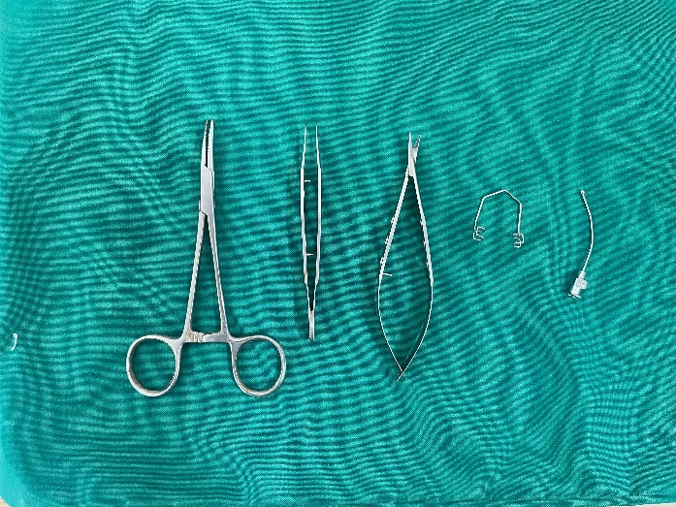 | 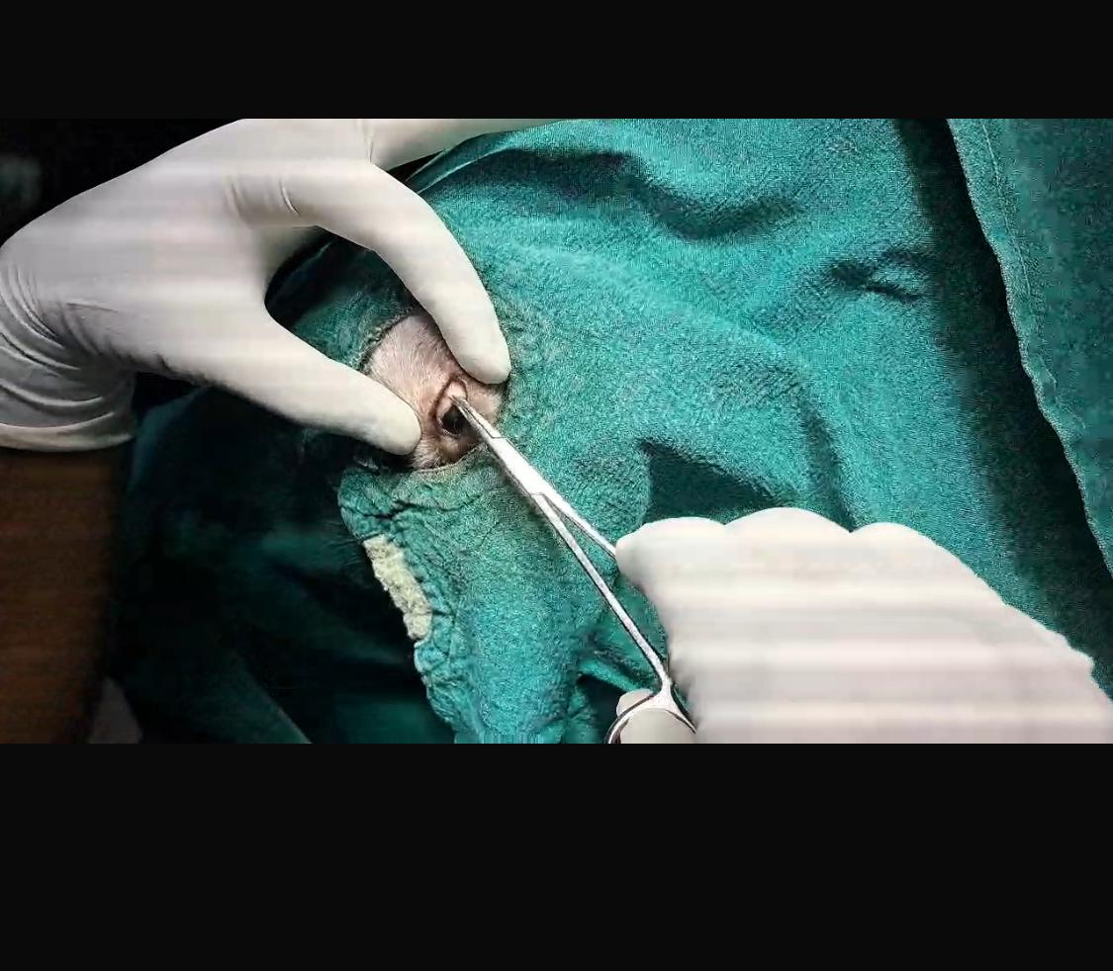
Fig.1: Surgical instrumentation used for STB | Fig. 2: Fixing the globe with mosquito hemostat
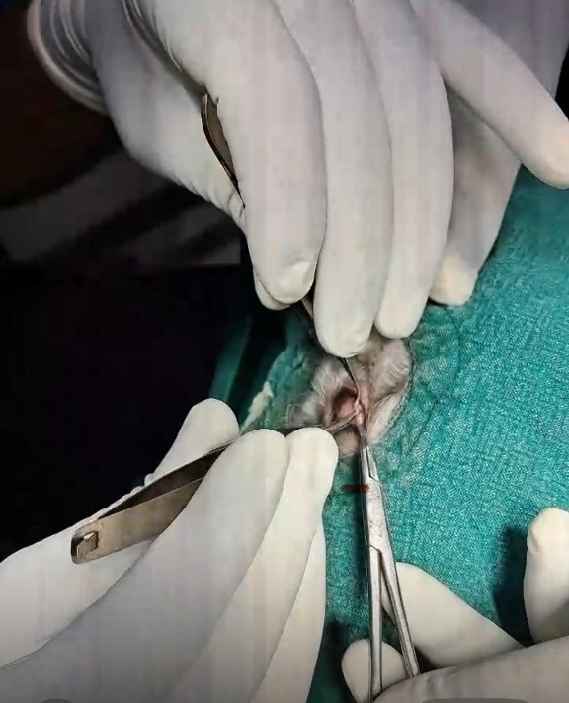 | 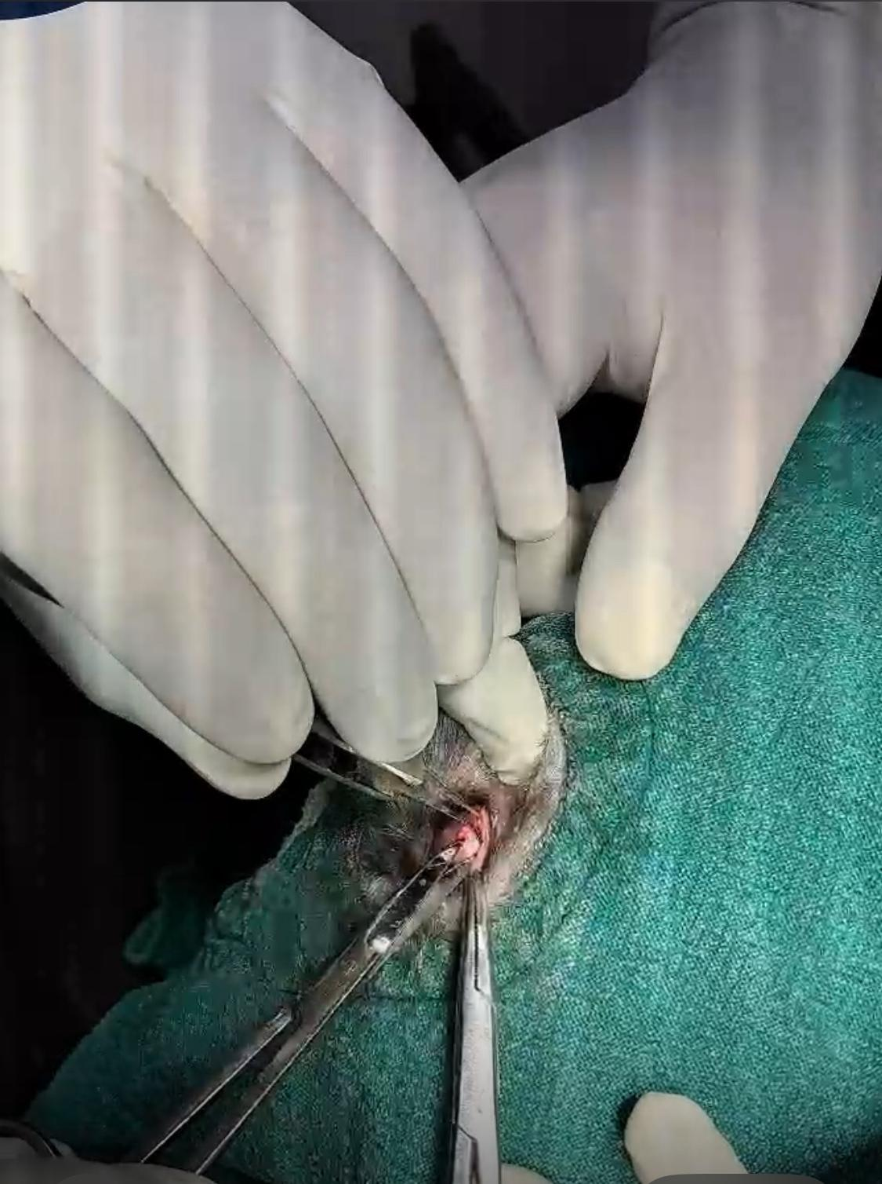
Fig. 3: Minor snip incision was created in the dorsolateral bulbar conjunctiva using scissors | Fig.4: showing Tenon's capsule was held with forceps and carefully dissected bluntly with scissors to expose the sclera.
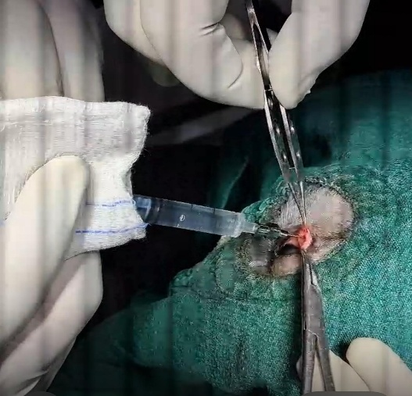
Fig. 5: Infusion of 2% lignocaine into the sub-Tenon's space

4. CONCLUSION
The adaptation of the STB technique from human to canine subjects represents a valuable advancement in veterinary ophthalmology. The established human STB technique served as a strong foundation for developing an effective STB method for dogs, demonstrating the potential for cross-species application of regional anesthesia techniques. Sub-Tenon's anesthesia holds significant promise in providing both anesthesia and analgesia, potentially improving patient comfort and surgical outcomes in a range of canine ophthalmic procedures. However, to fully determine its clinical utility in canine ophthalmology, future research should focus on evaluating this novel STB technique across a broader population of dogs, encompassing diverse breeds and various ophthalmic procedures. Such studies would help to standardize the procedure, optimize drug dosages, and further refine the assessment of block efficacy in veterinary patients.
Ethical Approval
Animal Ethic committee approval has been collected and preserved by the author(s)

Disclaimer (Artificial intelligence)
Option 1:
Author(s) hereby declare that NO generative AI technologies such as Large Language Models (ChatGPT, COPILOT, etc.) and text-to-image generators have been used during the writing or editing of this manuscript.
Option 2:
Author(s) hereby declare that generative AI technologies such as Large Language Models, etc. have been used during the writing or editing of manuscripts. This explanation will include the name, version, model, and source of the generative AI technology and as well as all input prompts provided to the generative AI technology
Details of the AI usage are given below:
1.
2.
3.
References

- Bayley, K.D., & Read, R.A. (2018) Sub-Tenon's anesthesia for canine cataract surgery. Vet Ophthalmol. Nov;21(6):601-611. doi: 10.1111/vop.12554. Epub 2018 Feb 6. PMID: 29411508. 1
- Horikiri K, Ozaki K, Maeba H, Narama I. (1994) Corneal dermoid in two laboratory Beagle dogs. Experimental Animals, 43, 417-420. 2
- Kılıç, Y., Gürsoy, H.H., Bilgeç, M.D. Ayten Bilir and Mehmet Sacit Güleç (2024). Peribulbar vs. incisionless sub-Tenon's blocks: a retrospective cohort study. Eur J Med Res 29, 635. https://doi.org/10.1186/s40001-024-02251-2
- Kumar, C. M., Dodds, C., & Esfahani, M. R. (2006). Sub-Tenon's anaesthesia: a safe and effective alternative to retrobulbar and peribulbar blocks. Journal of Cataract & Refractive Surgery, 32(12), 2141-2146.
- Liu, P., Feldman, H. S., Covino, B. M., Giasi R., & Covino BG. (1982) Acute cardiovascular toxicity of intravenous amide local-anesthetics in anesthetized ventilated dogs. Anesthesia and Analgesia.;61(4):317-22. 3
- Ripart, J., Prat-Pradal, D., Vivien, B., Charavel, P., & Eledjam JJ. (1998) Medial canthus episcleral (sub Tenon) anesthesia imaging. Clinical Anatomy.;11(6):390-5. 4
- Roman, S.J., Sit DAC, Boureau C.M., Auclin F.X., Ullern M.M. Sub-Tenon's anaesthesia: an efficient and safe technique. British Journal of Ophthalmology. 1997;81(8):673-6. 169. 5
- Romanowski, R. R., & Nevin, T. R. (2007). Sub-Tenon's anesthesia: a review. Current Opinion in Ophthalmology, 18(3), 207-211.
- Slatter, D. Fundamentals of Veterinary Ophthalmology. 3rd ed. pp. 208, Saunders, Philadelphia, 2001. 6
- Stevens, J. D. (1992). A new local-anesthesia technique for cataract-extraction by one quadrant sub-Tenons infiltration British Journal of Ophthalmology.;76(11):670-4. 7
- Williamson, T. H. (1999). Sub-Tenon's local anaesthesia in ophthalmic surgery. British Journal of Ophthalmology, 83(1), 1-2.

