Original Research Article

Toxicological and Histopathological Analysis of Neem Leaf Extract and Edible Camphor on the Liver of Wistar Rats
ABSTRACT

Aim: This study investigated the toxicological effect and the biochemical changes in the liver after the administration of Azadirachta indica (Neem) extract and a mixture of edible camphor in albino Wistar rats.
Study design: Experimental study.
Place and Duration of Study: Department of Clinical Chemistry, Faculty of Medical Laboratory Science, Rivers State University, Port Harcourt, Nigeria, between October and December 2024.
Methodology: Thirty albino Wistar rats were used for the study. They were divided into six groups randomly. Group 1 served as control group, group 2 served as the vehicle group and was administered daily dose of coconut oil, while group 3 received 500mg/kg of Neem dissolved in coconut oil, group 4 received 50mg/kg of camphor dissolved in coconut oil, group 5 received 100mg/kg of camphor dissolved in coconut oil and group 6 received 50mg of Neem and 50mg of camphor dissolved in coconut oil daily for 30 days. At the end of administration of the extract, the rats were sacrificed, and samples were taken and examined for the determination of liver enzymes using spectrophotometric methods, and liver tissues were collected for histological examination. GraphPad Prism Version 9.04 of Windows statistical package was used for statistical analysis. Data was expressed as mean ± standard deviation, one-way ANOVA and Tukey`s multiple comparison tests was used to assess differences in mean values between groups. Results were considered statistically significant at 95% confidence interval (p<0.05).
Results: The results showed that there was no significant difference in AST and ALT virtually in all the comparisons for all the experimental groups. However, there was a significant increase in ALT when values for the negative and positive control groups were compared with those of group 5 (Camphor 100mg in Coconut Oil) and 6 (Neem and Camphor in Coconut Oil), and.
Conclusion: The findings demonstrate the potential hepatotoxic effects of edible camphor, highlighting the need for cautious consumption and further research to establish safe guidelines.
Keywords: Azadirachta indica (Neem) Leaf Extract, Edible Camphor, Liver, Albino Wistar Rats

1. INTRODUCTION
“The development of medicines from natural products has the world’s attention today. Natural products have a unique chemical structure, produce a diversity of biological activities and have a drug-like property” [1]. “The practice of medicine using natural products has occurred since prehistoric times in preventing and treating various diseases. Natural products offer many advantages in terms of efficiency and selectivity of the molecule target so that they can be used repeatedly to supply the urgent need of medicines effectively” [2]. “Natural products contain active compounds with various pharmacological activities against various diseases without or with minimal side effects” [3].
“However, available herbal products have no clear statement of content or medically related information on the package labels and have not been validated or certified by any recognized body. This concerns consumers and medical practitioners who may unknowingly counter-prescribe these herbal products. Not all the plants reported to be useful are harmless. These considerations underlie the study of ethno-medicinal plants” [4]. “In recent years, an increasing number of people have been using complementary and alternative medicines” [5]. Herbal therapies appear most promising, thus encouraging the necessary toxicity studies to be performed on these therapies.
“Neem (Azadirachta indica A. juss) belongs to the family meliaceae and is one of the most versatile and eco-friendly trees of tropical regions which are now widely distributed in south Asia and part of Africa. Neem has great medical benefits through its various biological properties. Almost all parts of the neem plant can be used to treat various diseases. These include the oil, bark and leaf extract have been therapeutic used as medicine to control leprosy, respiratory disorders. Based on various reports, neem leaves extract has numerous biological and pharmacological activities including antipyretic, analgesic, anti-hepatotoxic [6], spermicide, anti-implantation” [7] antihyperglycemic, antiulcer, antifungal, antibacterial, anti-inflammatory, immunomodulatory, antimutagenic, anticancer, antimalarial, antiviral, antioxidant, antifertility and contraception [8]. Oral administration of neem leaf has been reported to show anti-fertility in mice [9].
“Camphor is a natural antioxidant and a ketone terpenoid that is found in the cinnamomum camphora tree. Camphor trees have many applications in various fields, such as industry, cosmetics, pesticides, pharmaceuticals, timber, ornamental, and many cultural purposes stretching back thousands of years” [10] Researchers have shown that camphor effectively reduces pain, removes warts, treats hemorrhoids and osteoarthritis. Furthermore, it is suggested that it has anti-inflammatory, [11] antifungal, [12] and antimicrobial properties [13].

2. materialS and methods
2.1 Experimental Animals
Thirty albino Wistar rats weighing 95g ± 5 were obtained from The Holding Company for Biological Products and Vaccines. After an acclimatization period of one week, the animals were divided into six groups (5rats per group) and housed in wire bottomed cages in a room under standard conditions of illumination with a 12-hour light-dark cycle at 25 ± 1°C. They were provided with water and a balanced diet ad libitum. All animals received care in compliance with the rules for animal protection and guidance.
2.2 Experimental Design
Albino Wistar rats weighing 95g ± 5 was obtained. After an acclimatization period of one week, the animals were divided into six groups (6rats per group) and housed in wire bottomed cages in a room under standard conditions of illumination with a 12-hour light-dark cycle at 25 ± 1°C. They were provided with water and a balanced diet ad libitum. All animals received care in compliance with the health rules for animal protection.
• Group I served as normal control.
• Group II animals served as vehicle control and were only administered daily dose of coconut oil for 30 days,
• Group III received a daily oral administration of Neem leaves extract 50mg for 30 days.
• Group IV received a daily oral administration of camphor extract 50mg orally for 30 days.
• Group V received a daily oral administration of camphor extract 100mg for 30 days.
• Group VI received a daily oral administration of the 50mg Neem and 50mg camphor extract for 30 days.

2.3 Sample Collection and Preparation
Twenty-four hours after the last administrations, animals were sacrificed. They were handled and used in accordance with the international guide for the care and use of laboratory animals. Liver was harvested; the tissues were then fixed in 10% formal saline for histopathology. Blood samples were also collected for liver function tests and oxidative stress markers. The animals of all groups were sacrificed by fast decapitation; blood samples were collected into plain bottles for ELISA test and for liver enzymes, and allowed to stand for half an hour, and then centrifuged at 3000 rpm for 15 min at 4°C to separate serum which was stored at −20°C for different biochemical measurements.
2.4 Plants Materials
The Neem leaves were harvested. The samples were identified in the Botany Department, Faculty of Science, RSU University. The leaves were cleaned and sun-dried for three days on hygienic cement floors until they became crispy but still retaining the greenish tint and after then they were powdered. Edible camphor tablets were bought from herbs suppliers in Port Harcourt, Rivers State Nigeria.
2.5 Biochemical Estimation
2.5.1 Alanine transaminase (ALT) and aspartate aminotransferase (AST)
Alanine transaminase (ALT) and aspartate aminotransferase (AST) were assayed using available diagnostic kit according to the manufacturer’s instructions
-Test Method: Serum glutarate-oxaloacetate-aminotransferase (AST/SGOT) and serum glutarate-pyruvic aminotransferase (SGPT/ALT) [14] method.
- Test Principle: AST catalyzes the reversible transfer of an amino group from aspartate to α-ketoglutarate. AST catalyzes the transfer of the amino group from the aspartate to ketoglutarate, forming oxaloacetate and glutamate. The oxaloacetate reacts with 2,4-dinitrophenylhdrazine to form 2,4-dinitrophenydrazone which in alkaline medium gives a red-brown color. The absorbance of the color produced is measured at 540nm spectrophotometrically.
2.5.2 Alkaline Phosphate (ALP)
-Test Principle: Alkaline phosphatase acts upon buffered sodium thymolphthalein monophosphate, the addition of the alkaline reagent stops enzyme activity and simultaneously develops a blue chromogen which is measured photometrically.
- 2.5.3 Total Protein (biuret colorimetric method by Burtis et al. [15]
- -Test Method: Total Protein was assayed using the biuret colorimetric method by Burtis et al. [15]
- Test Principle: protein gives an intensive violet-blue complex with copper salts in an alkaline medium. Iodide is included as an antioxidant. The intensity of the color formed is proportional to the total protein concentration in the sample.
2.5.4 Serum Albumin (bromocresol green method
- Test Method: Serum Albumin was assayed using the bromocresol green method by Grant et al. [16]
- Test Principle: The measurement of serum albumin is based on its quantitative binding to indicator 3.3’,5.5’-tetrabomo-m-cresol sulphonephthalein (bromocresol-green, BCG). Albumin-BCG-complex absorbs maximally at 578nm, the absorbance being directly proportional to the concentration of albumin in the sample.
2.5.5 Globulin Estimation
- Test Method: Globulin was derived using the calculation method by Grant et al. [16]
In this method globulin values were calculated as a difference when albumin values are substracted from the value of the total protein gotten from the same sample.
Globulin(g/dl) = total protein(g/dl) - Albumin(g/dl)
2.5.6 Histopathology Study
Organs of the liver of one animal per group were sacrificed during the chronic study, were placed in labelled plastic bottles containing 10% formalin fixative. The tissues were sliced and dehydrated with different, increasing concentrations (50, 70, 80, 95 and 100%) of ethanol for about 24 hours. After that they were cleared with xylene, to remove the alcohol and improve their refractive index. It was then imbedded in the molten paraffin wax, allowed to solidify inside the wax. The resulting blocks were sectioned with a Shandon AS 325 rotary microtome, and later slides were prepared with the best of the sections. The slides were stained with hematoxylin /eosin solution, and the stained slides were carefully studied for any histological lesions as a result of the toxicant (paraquat). Photomicrographs were made using a Leitz Wetzlar (model Dialux 20) at 100, 200 and 400 magnifications, depending on the size of the organ under examination.
2.6 Statistical Analysis
GraphPad Prism Version 9.04 of Windows statistical package was used for statistical analysis. Data was expressed as mean ± standard deviation (SD). Comparison of the mean and standard deviation values were made for the various parameters for the various groups using the one-way ANOVA and Tukey`s multiple comparison tests was used to assess differences in mean values between groups. Results were considered statistically significant at 95% confidence interval (p<0.05).

3. results and discussion
Table 1: Descriptive and ANOVA Results for Liver Enzymes for all Experimental Groups
Group/Parameter | AST (IU/L) | ALT(IU/L) | ALP(IU/L)
 | Mean ± SD | Mean ± SD | Mean ± SD
Control Grp (N=5) | 36.48 ± 2.948 | 37.40 ± 2.408 | 137.4 ± 5.128
Grp 2 (Coconut Oil) (N=5) | 36.52 ± 3.148 | 38.80 ± 1.789 | 138.0 ± 11.92
Grp 3 (50mg Neem Leaf in Coconut Oil) (N=5) | 38.36 ± 7.411 | 39.80 ± 4.025 | 139.0 ± 11.70
Grp 4 (Camphor 50mg in Coconut Oil) (N=5) | 40.16 ± 2.868 | 45.00 ± 4.583 | 160.0 ± 25.74
Grp 5 (Camphor 100mg in Coconut Oil) (N=5) | 44.04 ±3 .791 | 46.40 ± 3.847 | 164.0 ± 21.04
Grp 6 (Neem and Camphor in Coconut Oil) (N=5) | 39.32 ± 5.649 | 44.00 ± 3.162 | 147.0 ± 14.83
p-value | 0.1397 | 0.0012 | 0.0548
F-value | 1.857 | 5.792 | 2.551
Remark | NS | S | NS
Key: ALP -Alkaline Phosphatase, ALT -Alanine aminotransferase, AST – Aspartate Aminotransferase

Table 2: Tukey's Multiple Comparisons Test Results of Livers Enzymes for all Groups
In-between Group Comparison | ALP (IU/L) | ALT(IU/L) | AST(IU/L)
Control vs. Grp 2 | >0.9999 | 0.9863 | >0.9999
Ctrl vs. Grp 3 | 0.9863 | 0.8753 | >0.9999
Ctrl vs. Grp 4 | 0.9224 | 0.0566 | 0.9372
Ctrl vs. Grp 5 | 0.8032 | 0.0204* | 0.2886
Ctrl vs. Grp 6 | 0.1391 | 0.0045* | 0.1489
Grp 2 vs. Grp 3 | 0.9876 | 0.9971 | >0.9999
Grp 2 vs. Grp 4 | 0.9265 | 0.1993 | 0.9516
Grp 2 vs. Grp 5 | 0.8101 | 0.0831 | 0.3155
Grp 2 vs. Grp 6 | 0.1427 | 0.0204* | 0.1655
Grp 3 vs. Grp 4 | 0.9994 | 0.4090 | 0.9705
Grp 3 vs. Grp 5 | 0.9888 | 0.1993 | 0.3637
Grp 3 vs. Grp 6 | 0.4015 | 0.0566* | 0.1965
Grp 4 vs. Grp 5 | 0.9997 | 0.9971 | 0.8096
Grp 4 vs. Grp 6 | 0.5968 | 0.8753 | 0.5875
Grp 5 vs. Grp 6 | 0.7670 | 0.9863 | 0.9988
Key: ALP -Alkaline Phosphatase, ALT -Alanine aminotransferase, AST – Aspartate Aminotransferase, * Significant p-values

Table 3: Descriptive and ANOVA Results for Total Protein and Albumin for all Experimental Groups
Group/Parameter | TP (g/L)  Mean ± SD | Alb(g/L)  Mean ± SD
Control Group (N=5) | 89.20 ± 7.694 | 38.00 ± 5.431
Grp 2 (Coconut Oil) (N=5) | 90.00 ± 9.592 | 38.80 ± 3.701
Grp 3 (Neem Leaf in Coconut Oil) (N=5) | 95.80 ± 8.955 | 30.20 ± 4.494
Grp 4 (Camphor 50mg Cnut Oil) (N=5) | 85.80 ± 5.495 | 26.60 ± 3.647
Grp 5 (Camphor 100mg in Coconut Oil) (N=5) | 111.6 ± 18.240 | 32.60 ± 3.435
Grp 6(neem and camphor in coconut oil) (N=5) | 103.0± 7.071 | 28.00±3.162
p-value | 0.0052 | 0.0002
F-value | 4.456 | 7.931
Remark | S | S
Key: TP – Total Protein, Alb - Albumin

Table 4: Tukey's Multiple Comparisons Test Results of Total Protein and Albumin for all Groups
In-between Group Comparison | TP (g/L) | Alb(g/L)
Control vs. Grp 2 | >0.9999 | 0.9995
Ctrl vs. Grp 3 | 0.9111 | 0.0554
Ctrl vs. Grp 4 | 0.3178 | 0.0078
Ctrl vs. Grp 5 | 0.9949 | 0.0021
Ctrl vs. Grp 6 | 0.0243 | 0.3169
Grp 2 vs. Grp 3 | 0.9465 | 0.0279
Grp 2 vs. Grp 4 | 0.3801 | 0.0037
Grp 2 vs. Grp 5 | 0.9866 | 0.0010
Grp 2 vs. Grp 6 | 0.0320 | 0.1892
Grp 3 vs. Grp 4 | 0.8772 | 0.9527
Grp 3 vs. Grp 5 | 0.6519 | 0.7238
Grp 3 vs. Grp 6 | 0.1922 | 0.9329
Grp 4 vs. Grp 5 | 0.1298 | 0.9935
Grp 4 vs. Grp 6 | 0.7757 | 0.4872
Grp 5 vs. Grp 6 | 0.0072 | 0.2168
Key: TP – Total Protein, Alb - Albumin * Significant p-values

Liver Histology
Fig 1-Photomicrographs of group 1 and group 2
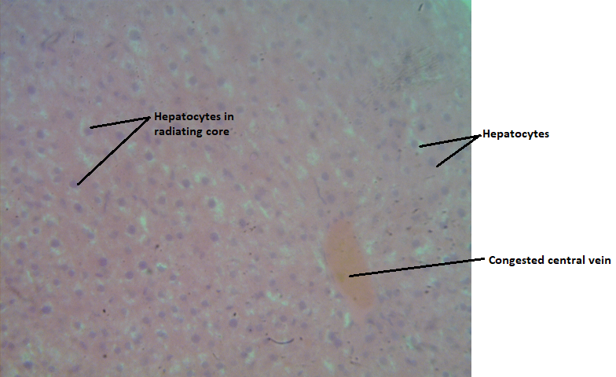 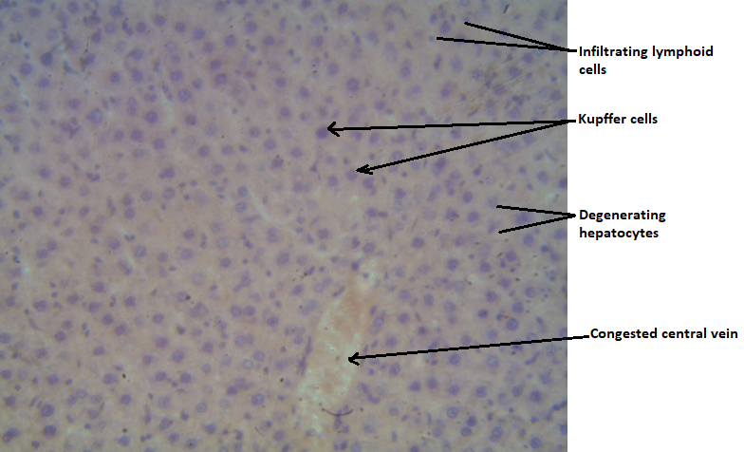s
Slide 1a Slide 1b
Slide; 3.0: H & E stain, Mag. ×400. Group 1. (Control group) Photomicrograph of liver tissue showing congested central vein, hepatocytes in radiating core from central vein. H & E, X400
Slide 3.1: H & E stain, Mag. ×400. Group 2. vehicle group (coconut oil) Photomicrograph of the liver tissue showing degenerating hepatocytes, Kupffer cells and infiltrating lymphoid cells. Congested central vein is also observed, Distortion of tissue microstructure is indicated. H & E, X400

Fig 2-Photomicrographs of group 2 and group 3
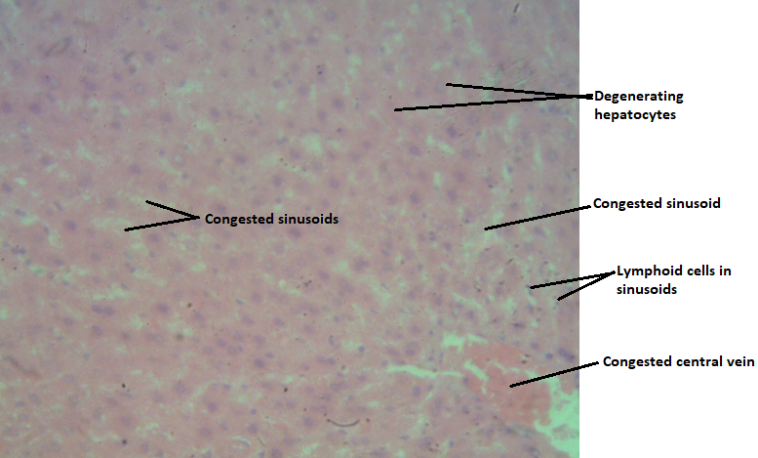
Slide 2a Slide 2b
Slide 3.1: H & E stain, Mag. ×400. Group 2. vehicle group (coconut oil) Photomicrograph of the liver tissue showing degenerating hepatocytes, kupffer cells and infiltrating lymphoid cells. Congested central vein is also observed. Distortion of tissue microstructure is indicated.
Slide 3.2: H & E stain, Mag. ×400. Group 3(500mg neem leave dissolved in coconut oil) Photomicrograph of the liver tissue showing degenerating hepatocytes, congested sinusoids and central vein. Presence of lymphoid cells in sinusoid is indicated. Distortion of tissue microstructure is indicated.
Fig 3-Photomicrographs of group 2 and group 4
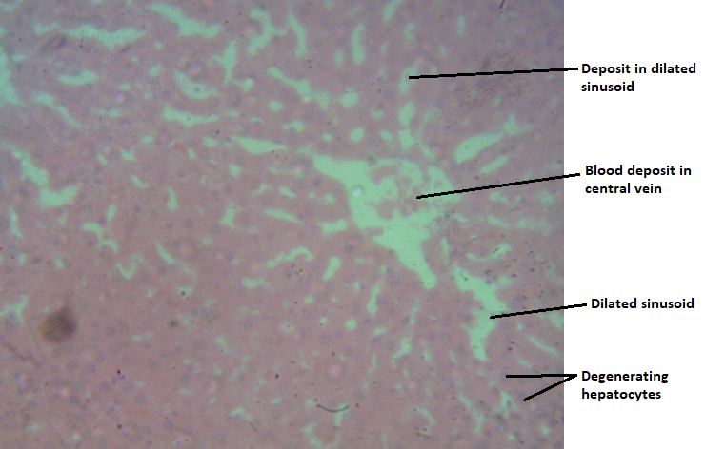
Slide 3a Slide 3b
Slide 3.1: H & E stain, Mag. ×400. Group 2. vehicle group (coconut oil) Photomicrograph of the liver tissue showing degenerating hepatocytes, kupffer cells and infiltrating lymphoid cells. Congested central vein is also observed. Distortion of tissue microstructure is indicated.
Slide 3.3: H & E stain, Mag. ×400 group 4 (100mg of camphor in coconut oil) photomicrograph of the liver tissue showing degenerating hepatocytes in radiating core, dilated sinusoids and blood deposit in central vein. Distortion of tissue microstructure is indicated.

Fig 4-Photomicrographs of group 2 and group 5
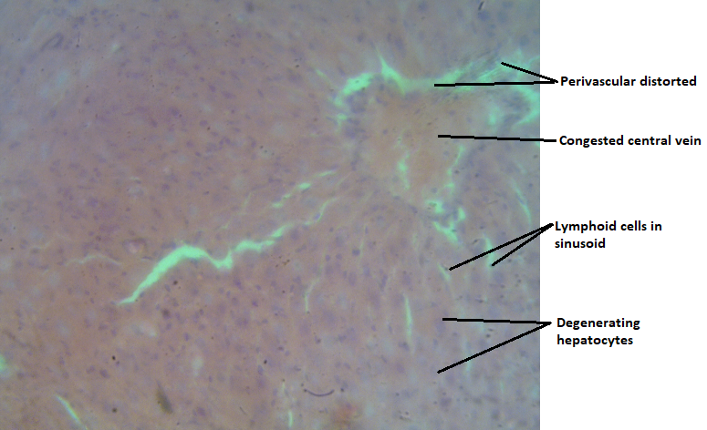
Slide 4a Slide 4b
Slide 3.1: H & E stain, Mag. ×400. Group 2. vehicle group (coconut oil) Photomicrograph of the liver tissue showing degenerating hepatocytes, kupffer cells and infiltrating lymphoid cells. Congested central vein is also observed. Distortion of tissue microstructure is indicated.
Slide 3.4 H & E stain, Mag. ×400.group 5(100mg of camphor in coconut oil) Photomicrograph of the liver tissue showing distorted hepatocytes (pygnosis), lymphoid cells in sinusoids, congested central vein with perivascular distorted. Tissue distortion of the microstructure is indicated.

Fig 5-Photomicrographs of group 2 and group 6
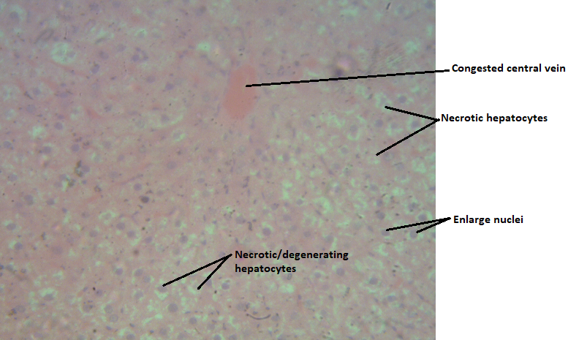
Slide 5a Slide 5b
Slide 3.1: H & E stain, Mag. ×400. Group 2. vehicle group (coconut oil) Photomicrograph of the liver tissue showing degenerating hepatocytes, kupffer cells and infiltrating lymphoid cells. Congested central vein is also observed, Distortion of tissue microstructure is indicated.
Slide 3.5: H & E stain, Mag. ×400.group 6 (neem and camphor dissolved in coconut oil) Photomicrograph of the liver tissue showing several necrotic and degenerating hepatocytes, enlarge nuclei and congested central vein. Severe distortion of tissue microstructure is indicated. H & E, X400

Fig 6- Photomicrographs of group 4 and group 5

Slide 6a Slide 6b

Slide 3.3: H & E stain, Mag. ×400 group 4 (100mg of camphor in coconut oil) photomicrograph of the liver tissue showing degenerating hepatocytes in radiating core, dilated sinusoids and blood deposit in central vein. Distortion of tissue microstructure is indicated.
Slide 3.4: H & E stain, Mag. ×400.group 5(100mg of camphor in coconut oil) Photomicrograph of the liver tissue showing distorted hepatocytes (pygnosis), lymphoid cells in sinusoids, congested central vein with perivascular distorted. Tissue distortion of the microstructure is indicated

Fig 7-Photomicrographs of group 3 and group 6
Slide 7a Slide 7b
Slide 3.2: H & E stain, Mag. ×400. Group 3(500mg neem leave dissolved in coconut oil) Photomicrograph of the liver tissue showing degenerating hepatocytes, congested sinusoids and central vein. Presence of lymphoid cells in sinusoid is indicated. Distortion of tissue microstructure is indicated.
Slide 3.5: H & E stain, Mag. ×400.group 6 (neem and camphor dissolved in coconut oil) Photomicrograph of the liver tissue showing several necrotic and degenerating hepatocytes, enlarge nuclei and congested central vein. Severe distortion of tissue microstructure is indicated.

Fig 8-Photomicrographs of group 4 and group 6
Slide 8a Slide 8b
Slide 3.3; H & E stain, Mag. ×400 group 4 (100mg of camphor in coconut oil) photomicrograph of the liver tissue showing degenerating hepatocytes in radiating core, dilated sinusoids and blood deposit in central vein. Distortion of tissue microstructure is indicated.
Slide 3.5: H & E stain, Mag. ×400.group 6 (neem and camphor dissolved in coconut oil) Photomicrograph of the liver tissue showing several necrotic and degenerating hepatocytes, enlarged nuclei and congested central vein. Severe distortion of tissue microstructure is indicated.

ALT levels increase significantly with the addition of camphor particularly in group 4, (50mg of camphor dissolved in coconut oil) group 5(100mg of camphor dissolved in coconut oil) and group6 (neem and camphor dissolved in coconut oil). With mean values of (45.00U/L, 46.40 IU/L and 44.00 U/L compared to 37.40 IU/L in the control group) respectively, with a p-value of 0.0012. This suggests potential hepatocellular damage or stress due to camphor. Alanine aminotransferase (ALT) is an enzyme found predominantly in the liver but also in other tissues such as kidneys, heart and muscle cells. An increase in ALT serum level indicates definite liver cell injury due to many causes.
The liver is also the primary site of metabolism of both endogenous substances and exogenous compounds e.g. drugs and toxins. Therefore, the elevation of serum ALT activity is sensitive to measure hepatocellular damage. The toxicity of camphor probably could cause an increase in this enzyme [17]. This finding is like the findings by Aliye et al. [18], suggested hemolysis or more generalized tissue damage in liver due to camphor toxicity. Hepatotoxicity occurs because of camphor toxicity. A high serum LDH level and a high AST-ALT ratio have been observed because of camphor poisoning. Camphor is metabolized in the liver and is excreted as an inactive glucuronide compound in the urine [18]. According to research by Mereto et al. [19], high doses of cinnamaldehyde may induce genetic alterations at the chromosomal level and suggest that the liver is the preferential target of its undesirable effects.

According to the results obtained from the experimental groups, there was no significant difference in AST and ALP concentration between groups. There was an increase in the level of enzymes, but it was not significant. However, to recognize the liver damage. It is enough to consider ALT concentration and the increase of it means the damage of the liver cells. These experimental findings indicate that camphor affects the liver as doses increase, the concentration of enzymes also increases, leading to significant increase in enzymes and liver damage as shown in the histological report.
The increase in total protein levels, particularly in group 5 (100 mg of camphor dissolved in coconut oil) as compared to the control group, suggests an enhanced protein synthesis or a response to liver stress. While higher total protein levels can indicate improved nutritional status or recovery from liver damage, they may also reflect an inflammatory response or increased production of acute-phase proteins. Albumin levels were significantly lower in group 6 (Neem and camphor dissolved in coconut oil) and group 5 (50mg of camphor in coconut oil) compared to the control, which recorded levels of 28.00 g/L and 26.60 g/L, respectively. The analysis indicated a highly significant p-value of 0.0002. The decrease in albumin levels is concerning, as albumin is a key marker of liver function and nutritional status. Lower levels may indicate impaired liver synthetic capacity, which can occur due to liver injury or dysfunction. The combination of neem and camphor, along with higher doses of camphor, appears to adversely affect albumin synthesis, suggesting potential hepatotoxicity and a compromised ability of the liver to maintain protein synthesis.
The liver are organs that have an important role in the metabolism and excretion of drugs or other substances. In the study, it was shown that the administration of group 3 (50mg of neem dissolved in coconut oil) did not cause abnormalities and damage to the rat liver. The liver in group 3 rats showed the normal general structure of the liver and normal appearance of central veins and hepatocyte cells. The liver histopathology is following the results of the analysis of the AST and ALT enzymes which showed that there was no significant difference between the control and group 3. This is in line with some of the previous reports that the neem leaf extract has potential hepatoprotective and nephroprotective effects [21].

4. Conclusion
The 50mg of neem leaves dissolved in coconut oil (group 3) did not cause damage to the liver of the Wistar albino rats as indicated by the analysis of AST, ALT enzymes. The addition of neem to camphor did not mitigate this effect, and instead, the combination of neem and camphor showed adverse effects on albumin synthesis, suggesting potential hepatotoxicity.
While other liver enzymes such as AST and ALP showed no significant changes, the elevation of ALT serves as a critical marker for liver damage. The results also suggest that higher doses of camphor may lead to increased liver stress and impaired protein synthesis, as indicated by the decreased albumin levels in groups receiving camphor. Conversely, the administration of neem alone did not result in any liver damage, supporting previous findings of its hepatoprotective properties. The findings of this study also indicate that camphor affects the liver and by dose increment, the concentration of enzymes increased, which lead to a significant increase in the enzyme’s concentration at higher doses. However, it is better to do more investigation in the future.

Ethical approval
All authors hereby declare that Principles of laboratory animal care (NIH publication No. 85-23, revised 1985) were followed, as well as specific national laws where applicable. All experiments have been examined and approved by the appropriate ethics committee.

Disclaimer (Artificial intelligence)
Option 1:
Author(s) hereby declare that NO generative AI technologies such as Large Language Models (ChatGPT, manuscript.
Option 2:
Author(s) hereby declare that generative AI technologies such as Large Language Models, etc. have been used during the writing or editing of manuscripts. This explanation will include the name, version, model, and source of the generative AI technology and as well as all input prompts provided to the generative AI technology
Details of the AI usage are given below:
1.
2.
3.

References

- Yuan H., Ma Q., Ye L., and Piao G. The traditional medicine and modern medicine from natural products, Molecules, 2016; 21:559, 1–18.
- Velu G., Palanichamy V., and Rajan A. P. Phytochemical and pharmacological importance of plant secondary metabolites in modern medicine, Bioorganic Phase in Natural Food: An Overview, 2018; 1: 135–56.
- Rout S. P., Choudhary K. A., Kar D. M., Lopamudra D., and Jain A. Plants in traditional medicinal system future source of new drugs, International Journal of Pharmacy and Pharmaceutical Sciences, 2009; 1: 1–23.
- Lans C.A. Ethnomedicines used in Trinidad and Tobago for urinary problems and diabetes mellitus. J Ethnobiol Ethnomed., 2006; 2: 45-9.
- MacLennan AH, Wilson DH, Taylor AW. The escalating cost and prevalence of alternative medicine. Prev Med., 2002; 35:166–73.
- Gupta S. C., Prasad S., Tyagi A. K., Kunnumakkara A. B., and Aggarwal B. B., Neem (Azadirachta indica): an indian traditional panacea with modern molecular basis, Phytomedicine, 2017; 34: 14–20, https://doi.org/10.1016/j.phymed.2017.07.001, 2-s2.0-85026837600
- Asif M. A review on spermicidal activities of Azadirachta indica, Journal of Pharmacognosy and Phytochemistry, 2013; 1: 5: 61–79.
- Gbotolorun S. C., Osinubi A. A., Noronha C. C., and Okanlawon A. O. Antifertility potential of neem flower extract on adult female sprague dawley rats, African Health Science, 2008; 8: 168–73.
- Saleem S., Muhammad G., Hussain M. A., and Bukhari Y. N. A. A comprehensive review of phytochemical profile, bioactives for pharmaceuticals and pharmacological attributes of Azadirachta indica, Phytotherapy Research, 2018; 32: 1241–72.
- Zhou Y. & Yan W. Conservation and applications of camphor tree (Cinnamomum camphora) in China: Ethnobotany and genetic resources. Genet. Resour. Crop Evol., 2016; 63: 1049–61.
- Guo S., Geng Z., Zhang W., Liang J., Wang C., Deng Z., Du S. The chemical composition of essential oils from Cinnamomum camphora and their insecticidal activity against the stored product pests. Int. J. Mol. Sci., 2016; 17:1836-9.
- Pragadheesh V., Saroj A., Yadav A., Chanotiya C., Alam M., Samad A. Chemical characterization and antifungal activity of Cinnamomum camphora essential oil. Ind. Crops Prod., 2013; 49: 628–33.
- Shi S., Wu Q., Su J., Li C., Zhao X., Xie J., Gui S., Su Z., Zeng H. Composition analysis of volatile oils from flowers, leaves and branches of Cinnamomum camphora chvar. Borneol in china. J. Essent. Oil Res., 2013; 25: 395–401.
- Reitman S, Frankel S. A colorimetric method for determination of serum glutamate oxaloacetate and glutamic pyruvate transaminase. Am. J. Clin. Pathol., 1957; 28: 56-8.
- Burtis, C.A. and Ashwood, E.R. Tietz Textbook of Clinical Chemistry. 3rd Edition, W. B. Saunders Co., Philadelphia, 1999; 29-150.
- Grant, G. A., & McKenzie, A. The bromocresol green method for the determination of albumin. Clinical Chemistry, 1987; 33(10): 1832-5.
- Drotman, R and Lawhan, G. Serum enzymes are indication of chemical induced liver damage. Drug Chem Toxicol., 1978; 1(2): 163-71.
- Aliye, U.C., Warren, P Bishop., Kathleen, D Sanders. Camphor Hepatotoxicity. South Med J., 2000; 93: 6-9.
- Mereto, E., Brambilla-Campart, G., Ghia, M., Martelli, A and Brambilla, G. Cinnamaldehyde-induced micronuclei in rodent liver. Mutat Res., 1994; 322 (1): 1-8.
- Rahmani A., Almatroudi A., Alrumaihi F., Khan A. Pharmacological and therapeutic potential of neem (Azadirachta indica) Pharmacognosy Reviews, 2018; 12(24): 250–5.
- Seriana, I., Akmal, M., Darusman, D., Wahyuni, S., Khairan, K., & Sugito, S. Neem leaf (Azadirachta indica A. Juss) ethanolic extract on the liver and kidney function of rats. The Scientific World Journal, 2021(1), 7970424.

