Kissing Canines: Maxillary Impacted and Migrated Canines

ABSTRACT
Aims: This case aims to present a rare clinical situation involving bilateral transmigration of maxillary canines, termed "kissing canines," and its successful surgical management.
Study design: Case Report.
Place and Duration of Study: Department of Oral & Maxillofacial Surgery, C.S.M.S.S Dental College and Hospital, Chhatrapati Sambhajinagar, India, over a period of 6 months.
Methodology: A 18 -year-old female presented with a complaint of anterior malalignment. OPG and CBCT revealed horizontally impacted maxillary canines converging at the midline. Prophylactic RCT of anterior teeth was performed, followed by surgical removal of impacted canines under local anesthesia with PRF placement in sockets.
Results: Postoperative recovery was uneventful with excellent healing observed in follow-ups at 1 week, 1 month, 3 months, and 6 months. CBCT aided precise localization and planning. PRF enhanced healing outcomes.
Conclusion: Bilateral "kissing canines" are extremely rare. Accurate diagnosis using CBCT and a multidisciplinary surgical-orthodontic approach ensure optimal esthetic and functional outcomes.
Keywords: Canine Impaction, Transmigration, Maxillary Canine, Kissing Canines, Orthodontics, CBCT, PRF Therapy

1. INTRODUCTION
Canine impaction and transmigration, particularly of maxillary canines, are rare clinical entities.^{[1]} Fiedler and Alling also advocate for the extraction of transmigrated canines ^{[1]}
Maxillary canines rank second after third molars in frequency of impaction ^{[2]} . Transmigration, especially bilateral and converging at the midline, is even more unusual and often discovered incidentally through radiographic assessments ^{[3]} .
Ericson and Kurol reported an ectopic eruption rate of canines at 1.7%. According to existing literature, approximately 85% of impacted canines erupt on the palatal side, while 15% occur buccally^{[3][1]}.
Peck et al. (1994) proposed that impacted canines result from polygenic, multifactorial inheritance, often seen alongside other dental anomalies like peg laterals and premolar agenesis. Contributing factors include supernumerary teeth, odontomas, cysts, delayed exfoliation of deciduous canines, trauma, cleft lip/palate, ankylosis, crypt displacement, long eruption paths, and syndromes such as cleidocranial dysplasia^{[3]}.
The term "kissing canines" denotes this convergence and is associated with aesthetic, anatomical, and psychological considerations.^{[4][5]} Early diagnosis and interdisciplinary treatment planning are crucial to avoid complications^{[5]}
Failure of tooth eruption due to impaction can disrupt occlusion and may also negatively impact the psychological development of affected individuals.^{[6]}

2. Case Presentation:
2.1 Clinical Evaluation A 18-year-old female patient presented with anterior teeth malalignment. Intraoral examination revealed good hygiene, bilateral class I molar relationships, and retained primary canines (FDI 53 and 63).
2.2 Radiographic Assessment OPG showed bilateral horizontally impacted canines converging at midline. CBCT confirmed buccal impaction and facilitated planning.(Refer fig 1, 2a , 2b )
2.3 Orthodontic Opinion : Orthodontic traction and alignment of the impacted maxillary canines was not possible considering the severe angulations of the teeth and proximity to the roots of lateral and central incisors. Transplantation of the impacted maxillary canines was not chosen as the preferred treatment option, as the roots were fully formed, increasing the risk of ankylosis and root resorption. Fixed orthodontic treatment for the lower arch is planned after 6 months of surgical removal of maxillary canines to allow for bone regeneration.
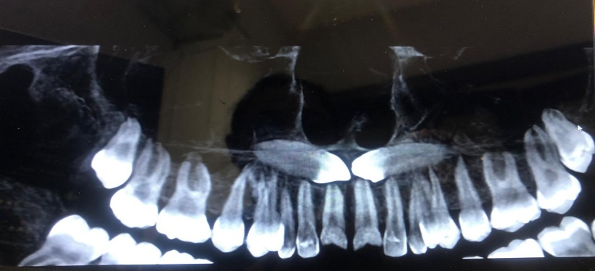
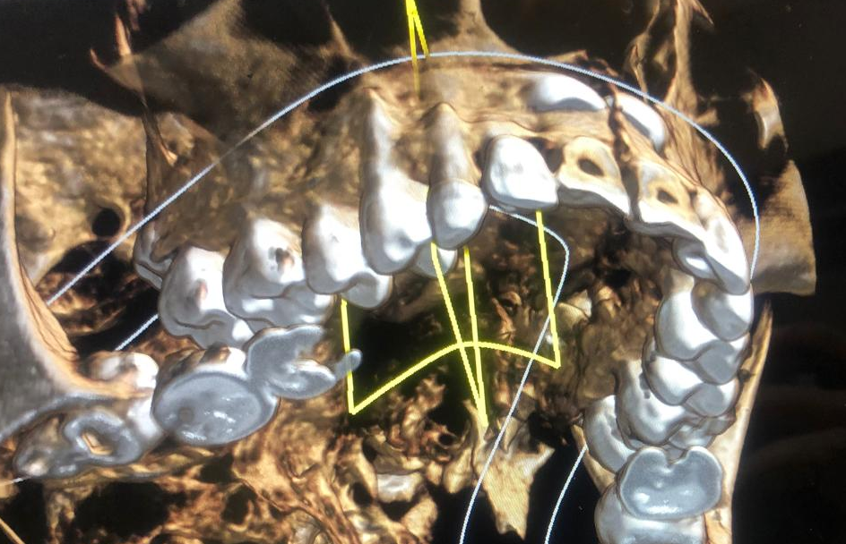
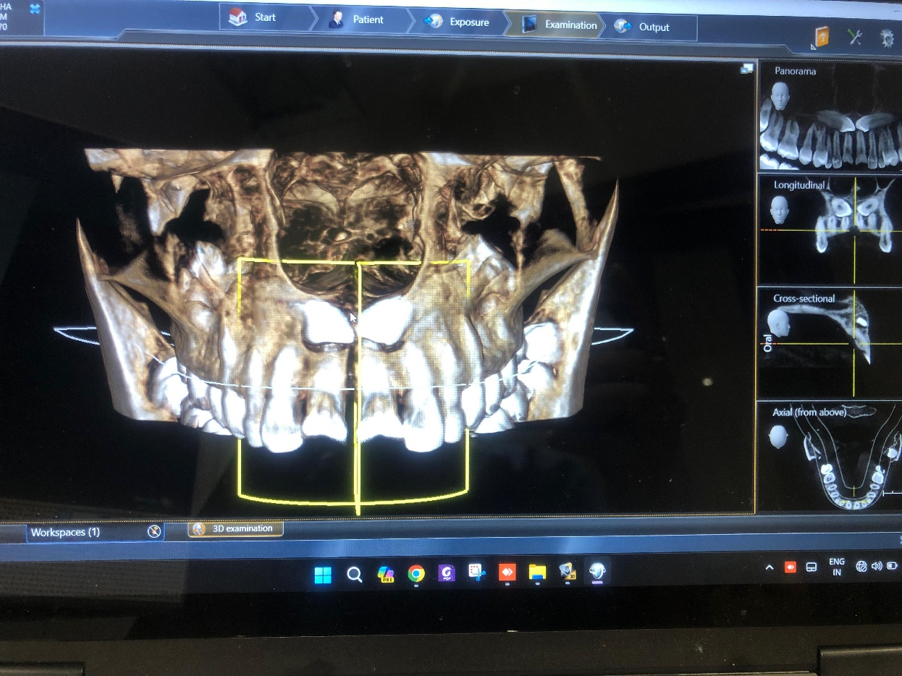
Figure 1 Radiograph showing CBCT upper arch section scan , coronal view of bilateral impacted maxillary canine.
Figure 2 a Figure 2 b
Figure 2 (a), (b) CBCT showing buccally impacted maxillary canine.
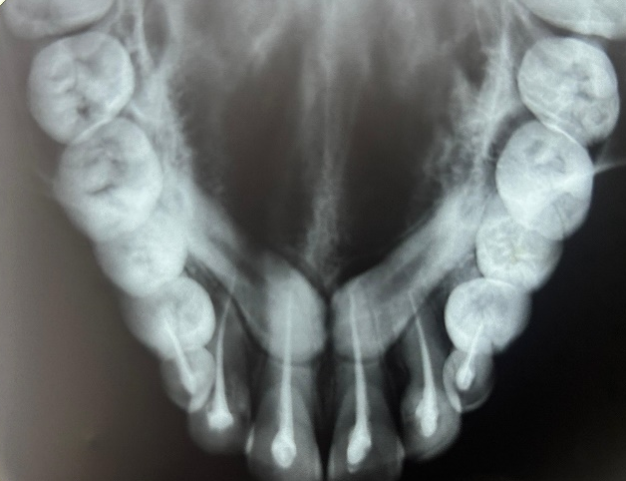
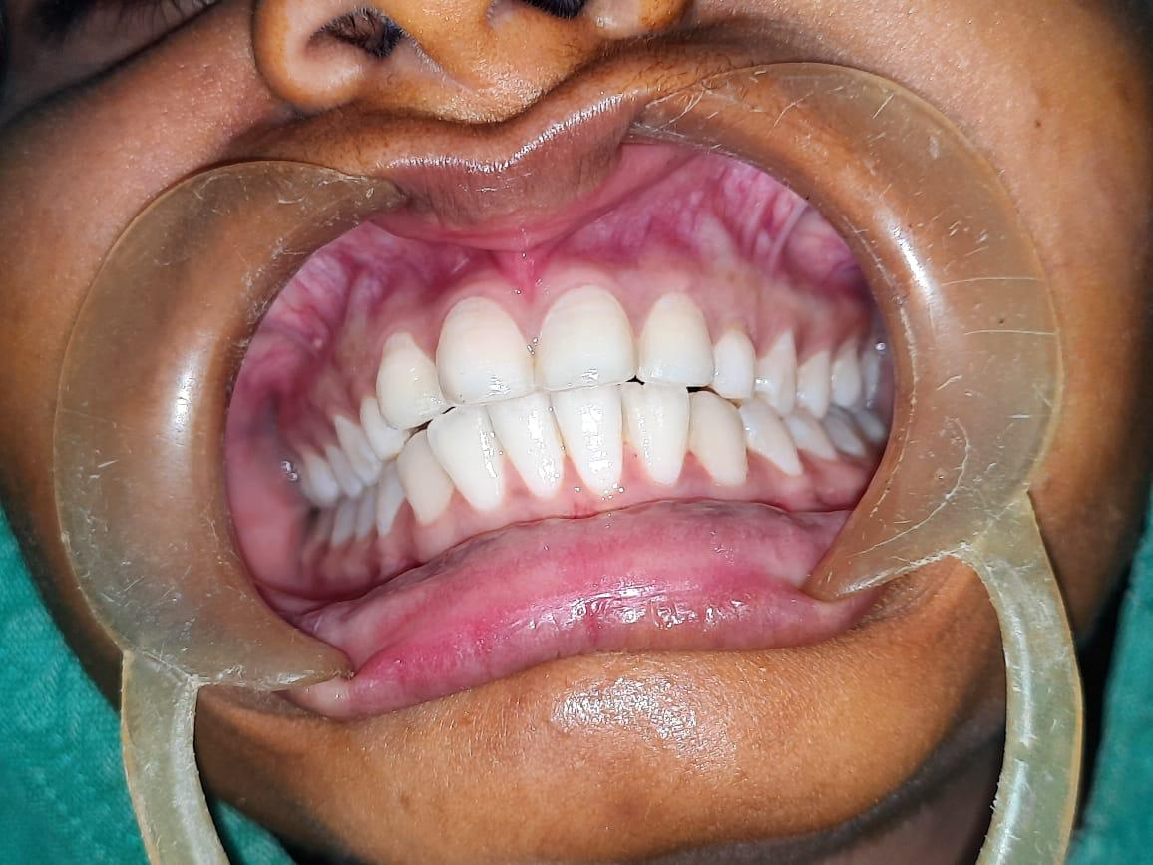
2.4 Pre-surgical Phase Prophylactic RCTs were carried out for teeth 11, 12, 21, 22, 53, and 63 to prevent vitality loss in adjacent teeth. (Refer fig 3a ,3b)

Fig 3a Fig 3b
Fig 3a, 3b : Pre Surgical Prophylactic phase : RCT of 11,21,22,12,53 and 63

2.5 Surgical Procedure Under local anesthesia (2% Lignocaine with 1:200,000 adrenaline), bilateral infraorbital and nasopalatine nerve blocks were administered. A crevicular incision from tooth 14 to 24 enabled flap reflection. Buccal bone was shaved to access crowns. Bone guttering permitted atraumatic removal of impacted 13 and 23 with follicles along with preservation of anterior nasal spine . (Refer Fig 4a,4b,4c,4d ). Impacted 13 and 23 removed with tooth follicle in toto.(Refer Fig 5a ,5b)
PRF was packed in sockets. (Refer Fig 6a , 6b).
Closure done using 3-0 Mer silk sutures. Suture removal done after 7 days. (Refer Fig 7a,7b) Follow up taken after 6 months . (Refer Fig 8a, 8b)
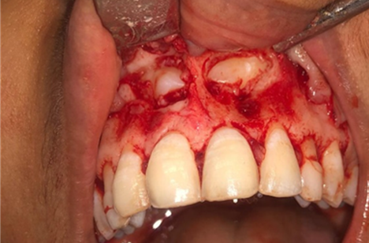
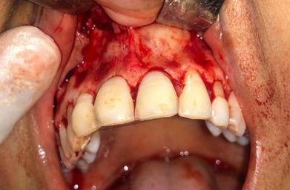

Figure 4 a Figure 4 b
Figure 4 (a) Incision and Full thickness mucoperiosteal flap reflected , (b) exposure of impacted canine

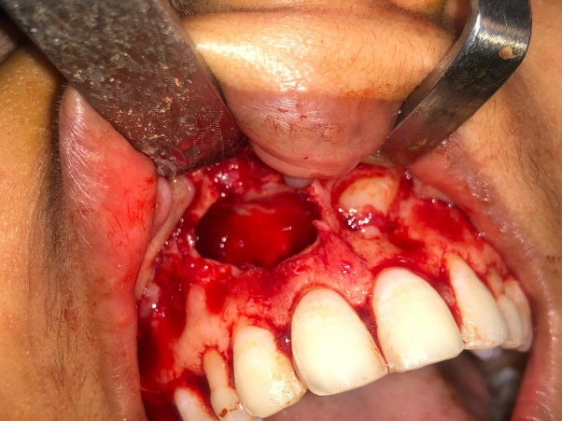
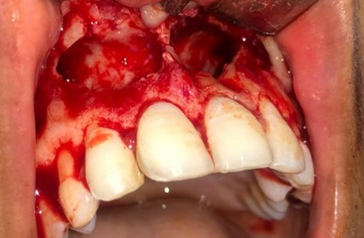
Figure 4 c Figure 4 d
Fig 4 (c) Disimpaction with 13 (d) Disimpaction with 23
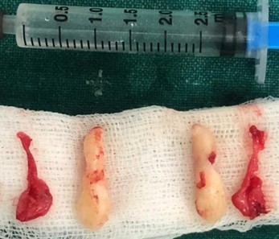
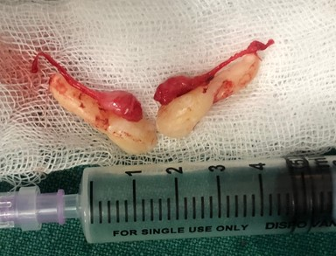

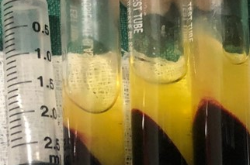
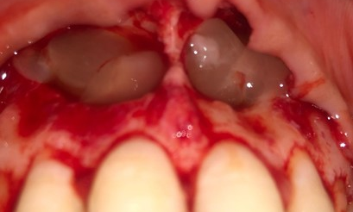
Figure 5 (a) , (b) surgical removal of 13 and 23 with germinal follicle extraction socket of 13, 23

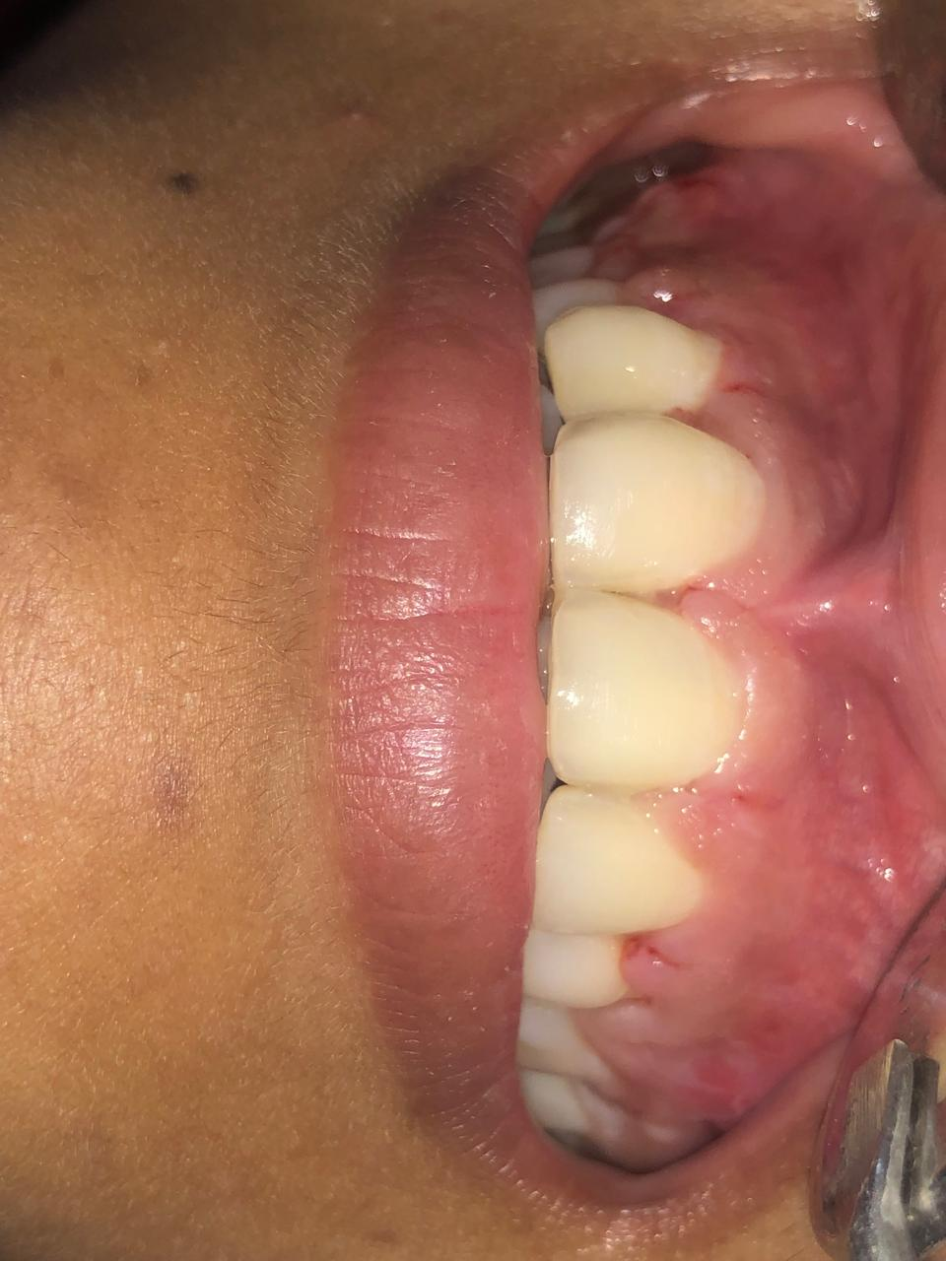
Figure 6 (a) Figure 6 (b)
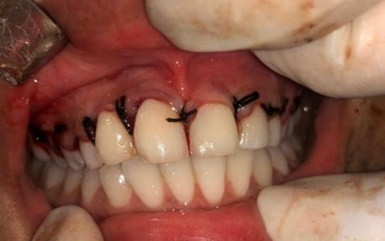
Figure 7 (b) 7th postoperative day
Figure 7 (a) Closure done with 3-0 mersilk

Figure 6 (a) Platelet rich Fibrin (b) PRF placed in extraction socket

Figure 8 (b)
Figure 8 (a)
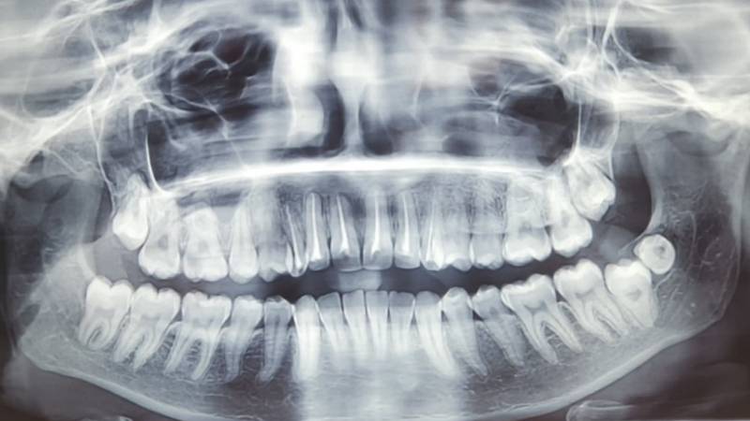
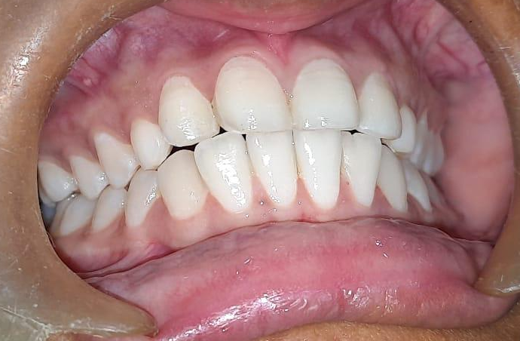
Figure 8- 6 months postoperative (a) Clinical picture (b) Radiographic picture

3. DISCUSSION
3.1 Mupparapu categorized transmigrated mandibular canines into five distinct types [1]:
- Type 1: The canine is mesioangularly impacted, crossing the midline either labially or lingually to the anterior teeth, with the crown extending beyond the midline.
- Type 2: The canine is horizontally impacted near the lower border of the mandible, positioned beneath the apices of the incisors.
- Type 3: The canine has erupted on the opposite side, either mesial or distal to the contralateral canine.
- Type 4: The canine is horizontally impacted near the inferior mandibular border, below the apices of the premolars or molars on the opposite side.
- Type 5: The canine is vertically positioned with its long axis crossing the midline.

The incidence of these types varies, with Type 1 being the most common at 45.6%, followed by Type 2 (20%), Type 4 (17%), Type 3 (14%), and Type 5 as the least common at 1.5%^{[1]}.
This case falls under Type 1 transmigration. Though mandibular cases dominate literature, bilateral maxillary instances like this are seldom recorded.^{[1]}

Figure 9 flowchart explains treatment options for transmigrated canine teeth [1]

3.2 Most studies on impacted maxillary canines focus on unilateral cases, often overlooking bilateral occurrences. However, bilateral impactions have been reported in 8% to 45% of cases. The current study supports the higher end of this range, suggesting a possible genetic basis, particularly for palatal displacement. Peck et al. proposed that this bilateralism is not due to chance but likely involves genetic and environmental factors—such as lack of lateral incisor guidance. While buccal impactions are usually linked to space deficiencies, this study also found 17.6% of bilateral cases had one buccal and one palatal impaction, hinting that both types may share genetic origins or result from random variation.^{[2]}
3.3 Etiology and Radiographic Relevance Etiological factors include retained primary teeth, aberrant eruption paths. CBCT provided crucial data on proximity to nasal spine and incisive canal, enabling safe extraction^{[3]}
3.4 Maxillary canines in dental arch form and aesthetics, noting that they are the second most commonly impacted teeth after mandibular third molars. The incidence of maxillary canine impaction ranges from 0.8% to 2.8%, with palatal impactions being more prevalent than buccal ones.^{[4]}
3.5 Role of Multidisciplinary Approach Combined endodontic, surgical, and orthodontic planning yielded favorable results^{[5]}.
3.6 PRF significantly accelerated healing and minimized complications^{[6]}. Outcome of Surgery Healing was excellent, confirmed through routine follow-ups. PRF contributed to socket regeneration^{[6]}.
3.7 Platelet-Rich Fibrin (PRF) contains a concentrated mix of biologically active growth factors that play vital roles in bone regeneration and tissue healing. Among the most important is Transforming Growth Factor Beta-1 (TGF-β1), which promotes the synthesis of collagen and fibronectin, thereby supporting osteoblast differentiation and matrix formation. Platelet-Derived Growth Factor (PDGF) stimulates the proliferation of osteoblasts and mesenchymal stem cells, while also enhancing angiogenesis, which is crucial for supplying nutrients to regenerating tissues. Vascular Endothelial Growth Factor (VEGF) is another key component that drives the formation of new blood vessels, essential for bone repair. Bone Morphogenetic Protein-1 (BMP-1) contributes to extracellular matrix remodeling, indirectly aiding osteogenesis. Additionally, Insulin-Like Growth Factor-I (IGF-I) boosts osteoblast proliferation and promotes matrix synthesis. Other growth factors like Fibroblast Growth Factor (FGF) and Epidermal Growth Factor (EGF), although present in smaller amounts or in specialized PRF variants, also support tissue repair by enhancing fibroblast activity and epithelial regeneration. These growth factors are gradually released from the PRF’s fibrin matrix, creating a sustained and localized healing environment ideal for oral and maxillofacial bone regeneration.^{[7]} No complications observed.
4. CONCLUSION
Bilateral maxillary "kissing canines" represent a rare anomaly. Impacted maxillary canines—second only to mandibular third molars in frequency—often go unrecognized in bilateral cases, though they occur in 8–45% of patients, with a strong genetic and anatomical basis, especially for palatal displacement. Accurate diagnosis using CBCT and a multidisciplinary approach combining surgical, orthodontic, and endodontic care ensures optimal outcomes. The use of Platelet-Rich Fibrin (PRF) significantly enhances healing and bone regeneration due to its rich content of growth factors, resulting in minimal complications and excellent postoperative recovery. Documenting such cases expands clinical insight for evidence-based protocols.

Abbreviations: OPG – Orthopantomogram radiograph , PRF- Platelet rich firbrin , RCT – Root cannal treatment , CBCT - Cone-beam Computed Tomography.

ACKNOWLEDGEMENTS
We sincerely thank the Department of Oral & Maxillofacial Surgery and the Endodontic Unit for their valuable support during the diagnosis and treatment process.
AUTHORS’ CONTRIBUTIONS
Dr Nishigandha Pawar and Dr Uma Mahindra designed the study and performed the surgery and conducted literature review contributed to final drafting. Dr Yashashree Deshmukh supported surgical intervention and follow-ups. Dr Kshma Sarthak performed the endodontic treatment of maxillary anterior teeth . Dr Simran Mahindra analyzed imaging and. All authors reviewed and approved the manuscript.
CONSENT
All authors declare that written informed consent was obtained from the patient for publication of this case report and accompanying images. A copy of the written consent is available for review by the editorial office.
ETHICAL APPROVAL
All authors hereby declare that all procedures were performed in accordance with institutional guidelines and the Declaration of Helsinki. Ethical clearance was granted by the institutional ethics committee.
Disclaimer (Artificial intelligence)
Option 1:
Author(s) hereby declare that NO generative AI technologies such as Large Language Models (ChatGPT, COPILOT, etc.) and text-to-image generators have been used during the writing or editing of this manuscript.

REFERENCES
- Rahul VC Tiwari, Philip Mathew, Yasmin Jose, Heena Tiwari and Jisha David, Kissing Canines: Impacted & Migrated: Case Report, International Journal of Applied Dental Sciences 2018; 4(4): 22-24
- Anand K. Sajnani & Nigel M. King, Prevalence and characteristics of impacted maxillary
canines in southern Chinese children and adolescents, Journal of Investigative and Clinical Dentistry (2014), 5, 38–44, doi: 10.1111/jicd.12027.
- Kate Counihan, EA Al-Awadhi and Jonathan Butler, Guidelines for the Assessment of
the Impacted Maxillary Canine, orthodontics , 2013 Dental Update 777
- Ashvini Vadane et al. Surgical management of impacted maxillary canine: A short case report, International Dental Journal of Student’s Research. January-March 2019;7(1):22-23
- Sridhar Premkumar1, Shameer SFs2, Marcos Roberto Tovani-Palone3, Management of impacted maxillary canines: a case report, Electron J Gen Med 2019;16(5):em155
ISSN:2516-3507
- Srinivas B, Das P, Rana MM, Qureshi AQ, Vaidya KC, Ahmed Raziuddin SJ. Wound healing and bone regeneration in post extraction sockets with and without platelet-rich fibrin. Annals of Maxillofacial Surgery, 2018;8:28-34.
- Yiping Liu, Xiaolin Sun, Jize Yu, Jia Wang, Peisong Zhai Platelet-Rich Fibrin as a Bone Graft Material in Oral and Maxillofacial Bone Regeneration: Classification and Summary for Better Application BioMed Research International Volume 2019, Article ID 3295756, 16 pagehttps://doi.org/10.1155/2019/3295756

