Case report
Severe hyperbilirubinemia in a case of Non-Transfusion Dependent Thalassemia (NTDT) with Coexisting Gilbert Syndrome and Congenital Thrombotic Thrombocytopenic Purpura (cTTP) : A rare case report

ABSTRACT

Background:
The coexistence of haemoglobinopathies and thrombotic microangiopathies is an exceedingly rare clinical occurrence, particularly when involving beta-thalassaemia intermedia, Gilbert syndrome, and congenital thrombotic thrombocytopenic purpura (cTTP). Each condition independently contributes to haemolysis and jaundice but their intersection represents a unique diagnostic and therapeutic challenge.
Case Summary:
We report a rare case of a young adult male with a long-standing history of recurrent jaundice since early childhood. Initially diagnosed with beta-thalassaemia minor and later confirmed to have coexisting Gilbert syndrome, the patient remained transfusion-independent until late adolescence. He subsequently developed severe and disproportionate hyperbilirubinemia with microangiopathic haemolytic features, thrombocytopenia, and evidence of iron overload. High-performance liquid chromatography (HPLC) and iron studies were consistent with beta-thalassaemia intermedia. Imaging revealed features of extramedullary haematopoiesis, intrahepatic cholestasis, splenic infarction, and splenic vein thrombosis. Notably, peripheral smear demonstrated schistocytes, raising the suspicion for thrombotic microangiopathy. Whole exome sequencing confirmed homozygous mutations in Hb Beta gene (beta-thalassaemia), UGT1A1 (Gilbert syndrome), and ADAMTS13 (cTTP), establishing a final diagnosis of a rare triple disorder. Liver biopsy revealed cholestatic liver injury with moderate fibrosis.
Conclusion:
This case underscores one of the rarest triads reported in hematology— beta-thalassemia intermedia, Gilbert syndrome, and congenital TTP. The overlapping clinical features demand a high index of suspicion and a comprehensive genetic evaluation when standard etiologies fail to explain persistent or severe hyperbilirubinemia. The report also highlights the importance of considering cTTP in patients with unexplained thrombocytopenia and hemolytic jaundice, even in the setting of known haemoglobinopathies. Early recognition is crucial for appropriate therapeutic intervention, long-term follow up and genetic counselling.

Keywords: Non transfusion dependent thalassemia, Beta thalassemia intermedia, Gilbert syndrome, Congenital thrombotic thrombocytopenic purpura, Severe hyperbilirubinemia

1. INTRODUCTION

Hemoglobinopathies and thrombotic microangiopathies are two distinct haematological entities with overlapping clinical features, such as anaemia and jaundice, yet are rarely encountered together. Beta-thalassaemia intermedia, a non-transfusion-dependent thalassemia (NTDT) is characterised by ineffective erythropoiesis, chronic haemolysis, and iron overload-related complications⁽¹⁾. Gilbert syndrome, a benign hereditary disorder caused by mutations in the UGT1A1 gene, results in unconjugated hyperbilirubinemia due to impaired hepatic bilirubin conjugation. While each of these conditions may independently contribute to episodes of jaundice, their co-occurrence can significantly complicate the diagnostic and therapeutic approach.

Congenital thrombotic thrombocytopenic purpura (cTTP), or Upshaw–Schulman syndrome, is a rare autosomal recessive disorder caused by mutations in the ADAMTS13 gene, resulting in severe deficiency of the Von Willebrand factor–cleaving protease. Clinically, it presents with thrombocytopenia, microangiopathic haemolytic anaemia, and end-organ damage secondary to microvascular thrombosis. Diagnosis is often delayed due to its clinical infrequency and the broad differential diagnoses in patients with chronic anaemia and jaundice.

Here, we report a unique and rare clinical case of a young adult male with recurrent episodes of jaundice, initially attributed to coexisting beta-thalassaemia minor and gilbert syndrome⁽²⁾, who later progressed to thalassaemia intermedia. Persistent hyperbilirubinemia, thrombocytopenia, and microangiopathic features prompted further investigation, revealing a coexisting homozygous ADAMTS13 mutation, establishing the diagnosis of congenital TTP⁽³⁾. Hence this represents one of the rarest triads described in medical literature—coexistence of beta-thalassaemia intermedia, gilbert syndrome, and congenital TTP—emphasising the need for a high index of suspicion and comprehensive evaluation in atypical cases of severe jaundice.

2. CASE PRESENTATION

2.1 PRESENTING HISTORY:

A male in his early 20’s came to the OPD with chief complaints of yellowish discoloration of eyes * 2 weeks, associated with occasional bleeding gums. Apart from that there were no further significant symptoms present

The patient was first diagnosed with beta-thalassemia minor at the age of 1, during an episode of jaundice which resolved spontaneously . At the age of 12, he developed a recurrent episode of jaundice (serum bilirubin ~5 mg/dL), later diagnosed with coexisting Gilbert syndrome. He was managed symptomatically. Around 19 years, he presented with another episode of jaundice. Laboratory investigations revealed markedly elevated bilirubin levels (30–40 mg/dL, predominantly direct fraction) without clinical signs of liver failure. Imaging via MRCP incidentally revealed cholelithiasis and he underwent prophylactic cholecystectomy. However, bilirubin level still remained elevated (~10 mg/dL). Notably, he remained transfusion-independent these years, maintaining Hb levels around 8–9 g/dL without overt features of failure. Approximately 2 years later, he got readmitted with severe jaundice and he was investigated further

2.2 EXAMINATION FINDINGS:

On examination he was conscious, and oriented, with stable vital signs (blood pressure 110/70 mmHg, pulse 70/min, respiratory rate 14/min, SpO₂ 99%, capillary blood glucose- 100mg/dl). He had pallor, severe icterus, no other external markers of liver failure were present. He had prominent hemolytic facies (frontal bossing, protrusion of maxillary eminences, depressed nasal bridge)

Abdominal examination revealed moderate hepatomegaly and massive splenomegaly while genital examination corresponded to Tanner’s III staging.

2.3 INVESTIGATIONS ^{(TABLE-1)}
(TABLE-1- Investigation panel)

LAB INVESTIGATIONS | RESULTS | REFERENCE RANGE
LIVER FUNCTION TESTS:  Total bilirubin  Direct bilirubin  AST/ALT  ALP/GGT  Total Protein/Albumin  PT/INR/APTT | 35.5 mg/dl  19.5 mg/dl  186/120 IU/L  133 IU/L  7.7/4.3 g/dL  13.54 s /0.9/28.5 s | 0.3 - 1 mg/dl  0.1 - 0.3 mg/dl  10-40 / 10-40 IU/L  30-120 IU/L  5.5-9 / 3.5-5.5 g/dL  11-13 s/0.8-1.1/25-35 s
Haemoglobin  Platelet  WBC | 7.1 g/dl  96000/µL  5600/µL | 12 – 16 g/dl  150000 -450000 /µL  4000-11000 /µL
VIRAL MARKERS PANEL  (HbsAg, Anti-HCV,HIV,  IgM anti HAV,HEV, IgM- CMV,EBV,HSV) | NEGATIVE
TROPICAL ILLNESS PANEL  (SCRUB typhus, LEPTO MAT, QBC smear) | NEGATIVE
Auto immune Hepatitis Panel  (ANA, SMA, ANTI- LKM 1) | NEGATIVE
24 hr Urinary Copper  S. Alpha 1 anti trypsin  S. IgG | 120 µg in 24 hrs  150 mg/dL  900 mg/dL | 0-100µg / 24hrs  150-350 mg/dl  800-1500 mg/dL
Peripheral Smear | Microcytic hypochromic anaemia, target cells, schistocytes (Grade 3 +)present
HPLC (patient)  HPLC (both parents) | Hb A2 – 5 %, Hb F -45 %,HbA – 50 %  Hb A2 –6%, Hb F -1%,HbA – 93% (patient’s mother)  Hb A2 –7 %, Hb F -1%,HbA – 92% (patient’s father ) | Suggestive of Thalassemia intermedia  Suggestive of Thalassemia trait
Iron Profile:-  S. Ferritin  S. Iron  TIBC | 1560 ng/mL  231 µg/dL  120 µg/dL | 24-336 ng/mL  60-170 µg/dL  240- 450 µg/dL
S. Amylase/ S. Lipase | 300/ 350 IU/L | 25-125 / 10-140 IU/L
Direct Coomb’s test | Negative
ADAMTS 13 activity  ADAMTS 13 antibodies | < 10 %  negative | ≥ 50-70 %
Abbreviations:-
ng- nanogram, pg- picogram, mg- milli gram, dL- decilitre, mL- millilitre, IU- International Unit,
µ-micro, AST- Aspartate aminotransferase, ALT- Alanine aminotransferase, ALP- Alkaline phosphatase,
GGT- Gamma glutamyl transferase, PT- Prothrombin time, INR- International normalised ratio, APTT- Activated partial thromboplastin time, WBC- White blood cells, HbsAg- Hepatitis B virus surface antigen, Anti-HCV- Anti hepatitis C virus antibody, HIV- Human immunodeficiency virus, anti HAV-Hepatitis A virus ,HEV- Hepatitis E virus, CMV- Cytomegalovirus, EBV- Epstein Barr virus, HSV- Herpes simplex virus, LEPTO MAT- Leptospirosis Microscopic agglutination test, QBC- Quantitative buffy coat smear for malaria, ANA- Anti nuclear antibody, Anti-SmA – Anti Smooth muscle antibody, Anti- LKM 1—Anti Liver kidney microsomal -1 antibody, IgM- Immunoglobulin M, IgG- Immunoglobulin G, HbA,F,A2 – haemoglobin A,F,A2; HPLC- High performance liquid chromatography, TIBC – Total iron binding capacity, ADAMTS13- A disintegrin and metalloproteinase with thrombospondin motifs 13

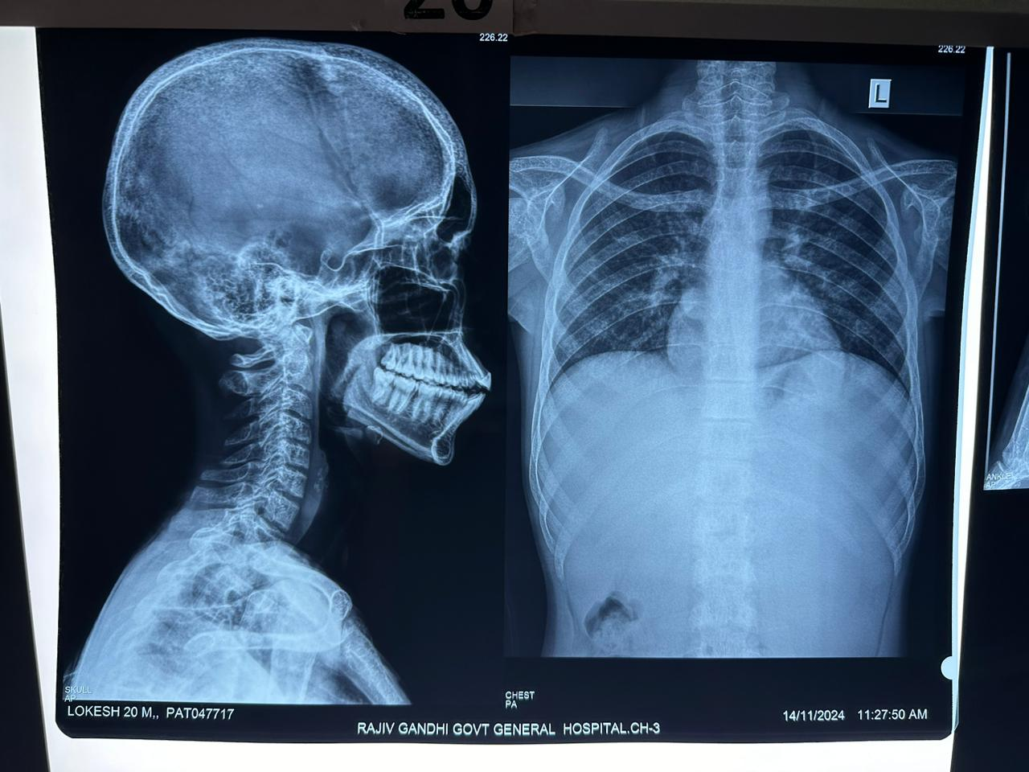
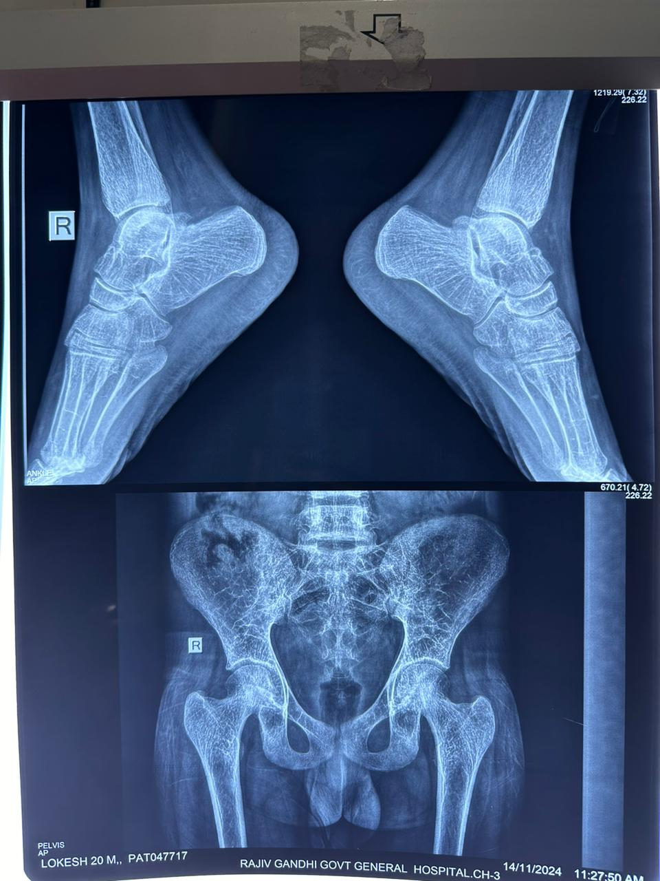
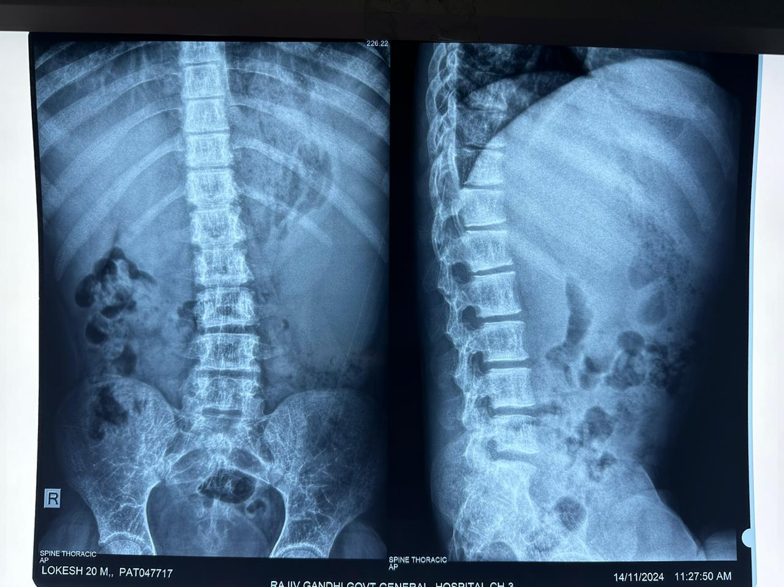
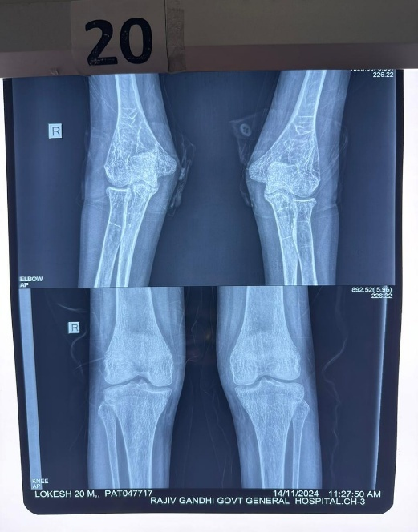

Fig. 1: Whole Body Xray 2.1 frontal bossing, maxillary hyperplasia, coarse trabeculae (red arrow); 2.2,2.3 Coarse trabeculae, cortical thinning, increased medullary thickness(red arrow); - Patient’s own Xray image

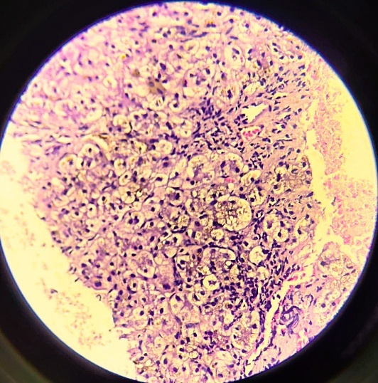

Fig. 2: Liver Biopsy. H&E stain: Deranged liver architecture with hepatocytes showing intrahepatic cholestasis (red arrow)- Patient’s own liver biopsy image

2.3.1 IMAGING MODALITIES:-
- USG Abdomen– Moderate hepatomegaly with massive splenomegaly, No free fluid present
- CECT Abdomen: Hepatomegaly ,massive splenomegaly with interstitial pancreatitis, splenic vein thrombosis, splenic infarct was present
- Whole Body Xray - revealed features of extra medullary hematopoiesis ^{(Fig. 1)}
- MRCP- No evidence of extrahepatic obstruction

2.3.2 LIVER BIOPSY^{(Fig.2):-}
Deranged liver architecture with hepatocytes showing ballooning and degeneration. Sinusoids appeared congested. Portal tracts showed minimal fibrosis and minimal inflammation. Perls’ stain positive. Modified HAI score – 2/18, ISHAK fibrosis score – 4/6. Final report- Cholestatic pattern of injury with significant iron overload and occasional regenerative nodules present

2.3.3 WHOLE EXOME SEQUENCING:-
- Hb Beta gene - Homozygous – Beta thalassemia
- UGT1A1 gene - Homozygous – Gilbert syndrome
- ADAMTS13 gene (variant c.961G>A, p.Ala321Thr ) - Homozygous – Hereditary thrombotic thrombocytopenic purpura

2.4 DIAGNOSTIC CONSIDERATIONS:

Given the patient’s longstanding history of recurrent jaundice since early childhood—initially attributed to beta-thalassemia minor and subsequently diagnosed as coexistent Gilbert syndrome—he later underwent prophylactic cholecystectomy when jaundice became progressively severe. However, at the current presentation, evaluation for disproportionately elevated hyperbilirubinemia was undertaken, wherein common infectious, metabolic, and autoimmune causes were systematically excluded. Clinical examination revealed classical thalassaemic facies indicative of extramedullary haematopoiesis, accompanied by features of significant iron overload and peripheral haemolysis. This constellation of findings was associated with profound hyperbilirubinemia, intrahepatic cholestasis (causing pancreatitis), hepatic fibrosis, splenic vein thrombosis, and splenic infarction.

Further work-up suggested progression from beta-thalassaemia minor to intermedia over time, accounting for part of the clinical picture. Yet, the degree of hyperbilirubinemia remained unexplained. Given the coexisting thrombocytopenia, MAHA and vascular events, a thrombotic microangiopathy was suspected. Whole exome sequencing confirmed a homozygous pathogenic variant in the ADAMTS13 gene, establishing a diagnosis of congenital thrombotic thrombocytopenic purpura (cTTP).

This case exemplifies a rare and diagnostically challenging convergence of beta-thalassaemia intermedia, Gilbert syndrome, and cTTP, manifesting as severe and disproportionate hyperbilirubinemia. It highlights the critical importance of maintaining a broad differential and employing advanced genomic diagnostics in atypical haematological presentations.

2.5 TREATMENT:

This patient was treated with plasma infusions, iron chelators, hydroxyurea and anti-platelet drugs over a week. He clinically improved, genetic counselling given and kept under regular follow-up on outpatient basis.

3. discussion

3.1 Non- transfusion dependent thalassemia (NTDT):- ^{(1,4–7)}

Beta thalassemias are a group of inherited hemoglobinopathies characterized by defective synthesis of beta-globin chains, resulting in a spectrum of clinical presentations ranging from severe transfusion-dependent anemia to asymptomatic carriers. These conditions are predominantly inherited in an autosomal recessive pattern and are broadly classified into thalassemia major, intermedia, and minor. Beta thalassemia intermedia, along with mild to moderate Hb E/β-thalassemia and α-thalassemia intermedia (HbH disease), constitutes the group of non-transfusion dependent thalassemias (NTDT). These syndromes are hallmarked by ineffective erythropoiesis and peripheral hemolysis and are more commonly observed in populations with a high prevalence of consanguinity.

The pathophysiology involves imbalanced globin chain production, leading to the accumulation of unstable tetramers that precipitate within erythroid precursors. This process generates reactive oxygen species, resulting in oxidative membrane damage and the exposure of senescence markers such as phosphatidylserine. Consequently, erythroid cells undergo premature destruction either within the bone marrow (ineffective erythropoiesis) or in the peripheral circulation (hemolysis). As a compensatory response, marked expansion of erythroid marrow and extramedullary hematopoiesis are frequently observed. Furthermore, hepcidin suppression leads to increased intestinal iron absorption, culminating in iron overload and subsequent target organ damage, even in the absence of regular transfusions

Fig – 3 : Clinical spectrum of NTDT^{(1,4)}

3.1.1 CLINICAL FEATURES

- Anemia, jaundice

- Extra-medullary hematopoiesis⁽⁴⁾ – Deformities of the facial bones; erythropoietic masses in the spleen, liver, lymph node, skin, heart, retroperitoneal tissue, kidneys, spinal canal etc., (Extramedullary hematopoietic pseudotumors) causing neurological problems like spinal canal compression, hepatosplenomegaly

- Iron overload(8) – Increased risk for thrombosis, pulmonary hypertension, hypothyroidism, hypogonadism, osteoporosis, diabetes, renal tubular dysfunction, hepatic fibrosis(eventually to cirrhosis and HCC), cholestasis (causing pancreatitis)

- Hypercoagulable state(9) – especially in splenectomized individuals leading to thrombotic events (mostly venous ), pulmonary hypertension(right heart failure), leg ulcers, silent cerebral infarcts

- Pregnancy(8)- associated with IUGR, spontaneous abortions and thrombotic events

3.1.2 MANAGEMENT ^{(1,4,8,10,11)}

- Transfusion therapy – Indicated occasionally during pregnancy, infections, surgery or any setting with anticipated blood loss; frequently in cases of growth failure, decreased exercise tolerance, failure of secondary sexual development; Patients who receive preventive transfusions are at high risk of iron overload, thrombosis, leg ulcers, pulmonary hypertension and silent brain infarcts

- Iron chelation therapy – indicated in patients of 10yrs or older with Liver Iron Concentration (LIC) >or = 5 mg Fe/g dry weight ( or serum ferritin > or = 800ng/mL). Oral Deferasirox is the drug of choice in this case (recommended dose is 5-20 mg/kg/day). LIC is estimated using MRI (T2*/ R2* parameters) or Magnetic biosusceptometry (SQUID)

- Splenectomy – indicated in cases of hypersplenism, worsening pancytopenia or massive splenomegaly which increases Hb level by 1-2g/dl but associated with adverse outcomes like hypercoagulable state

- Bone marrow transplantation – can be considered in severe cases

- Novel therapies- Hb F inducers like hydroxyurea, JAK 2 inhibitors like ruxolitinib, hepcidin agonists, apo-transferrin therapy, activin receptor fusion proteins (Sotatercept, Luspatercept), gene therapy , antiplatelets ( in case of proven thrombosis/ post-splenectomy patients)are under clinical trials.

3.2 GILBERT SYNDROME:- ^{(2,12,13)}

It is a benign recurrent condition due to mutation in UDP glucuronosyl transferase (UGT1A1) gene presenting with asymptomatic unconjugated hyperbilirubinemia without any liver disease or evidence of hemolysis. Although rifampicin test is used as a bedside test for diagnosis, confirmation is via genetic analysis. No specific treatment available for this as it is a benign condition and requires reassurance.

3.3 CONGENITAL THROMBOTIC THROMBOCYTOPENIC PURPURA:-^{(6,14–16)}

Congenital TTP (also known as Upshaw-Schulman syndrome) is a rare inherited deficiency of ADAMTS-13, accounting for up to only 5% of all TTP cases. The majority of patients present during the neonatal period or during childhood but the clinical manifestations are highly variable with mild manifestations of isolated thrombocytopenia throughout childhood in some, and severe neonatal hyperbilirubinemia with episodes of thrombocytopenia and MAHA developing soon after birth in others. In addition, onset may also occur during adulthood, particularly in women. The clinical course in congenital TTP is characterized typically by chronic, frequently relapsing disease developing neurological anomalies, renal manifestations, cardiac dysfunction and gastrointestinal symptoms due to widespread microvascular thrombosis.

3.3.1 diagnosis
A diagnosis of TTP should be considered in all patients with thrombocytopenia and microangiopathic hemolytic anemia, a positive familial history, laboratory studies (schistocytes on peripheral blood smears, high serum LDH levels, low platelet counts and reticulocytosis) and a severe ADAMTS13 deficiency (<10% of normal values), in the absence of anti-ADAMTS13 antibodies, suggests a diagnosis of cTTP. Diagnosis is confirmed by molecular analysis revealing a double heterozygous or homozygous mutation in the ADAMTS 13 gene.

3.3.2 MANAGEMENT
Acute episodes in cTTP can be treated by plasma infusion (10-15 ml/kg/day until remission) but exchange transfusion is usually required in newborns. Patients with a chronic relapsing disease course may be considered for prophylactic plasma therapy. Therapeutic plasma exchange and plasma infusion has led to a decrease in the mortality rate. Recombinant ADAMTS13 (apadamtase alfa) can be tried

4. Conclusion

This case presents an exceedingly rare triad—beta-thalassemia intermedia, gilbert syndrome, and congenital thrombotic thrombocytopenic purpura—manifesting with disproportionate hyperbilirubinemia and complex hematological interplay. It underscores the critical importance of maintaining a high index of suspicion in atypical presentations of jaundice and anemia and highlights the pivotal role of comprehensive genetic analysis in unravelling rare multisystemic disorders. Early recognition and a multidisciplinary approach are imperative to optimize clinical outcomes in such diagnostically challenging scenarios.

Consent (where ever applicable)

"All authors declare that ‘written informed consent was obtained from the patient (or other approved parties) for publication of this case report and accompanying images. A copy of the written consent is available for review by the Editorial office/Chief Editor/Editorial Board members of this journal."

Ethical approval (where ever applicable)

“All authors hereby declare that all experiments have been examined and approved by the appropriate ethics committee and have therefore been performed in accordance with the ethical standards laid down in the 1964 Declaration of Helsinki.”

Abbreviations
NTDT- Non transfusion dependent thalassemia
cTTP- Congenital thrombotic thrombocytopenic purpura
Hb- Hemoglobin
HCC- Hepato-cellular carcinoma
IUGR- Intra uterine growth restriction
MRI- Magnetic resonance imaging
LIC- Liver iron concentration
MAHA- Microangiopathic hemolytic anemia
ADAMTS13- A disintegrin and metalloproteinase with thrombospondin motifs 13
LDH- Lactate dehydrogenase
UGT1A1- UDP glucuronosyl transferase 1A
JAK 2 – Janus kinase 2
HPLC- High performance liquid chromatography
MRCP- Magnetic resonance cholangio pancreatography

Disclaimer (Artificial intelligence)
Option 1:
Author(s) hereby declare that NO generative AI technologies such as Large Language Models (ChatGPT, manuscript).

References

1. Musallam KM, Rivella S, Vichinsky E, Rachmilewitz EA. Non-transfusion-dependent thalassemias. Haematologica. 2013 Jun 1;98(6):833–44.
2. Kediya A, Atreja CB, Upadhyay M, Dhawan V. Amalgamation of the Rarest: Homozygous Beta Thalassemia and Gilbert Syndrome. Ann Pathol Lab Med. 2024 Aug 11;11(8):C120-124.
3. Gallivan CD, Conrad DM, Kew AK. A case of congenital TTP presenting with microganiopathy in adulthood. BMC Hematol. 2014 Dec;14(1):16.
4. Ben Salah N, Bou-Fakhredin R, Mellouli F, Taher AT. Revisiting beta thalassemia intermedia: past, present, and future prospects. Hematology. 2017 Nov 26;22(10):607–16.
5. Sharma S, Parikh L, Pandhare P. Iron overload in Non-transfusion-dependent thalassemia- a tertiary care experience. Pediatr Hematol Oncol J. 2025 Jun;100458.
6. Assiri M, AlMalki A, AlHunif B, AlMofareh M. Congenital Thrombotic Thrombocytopenic Purpura: A Rare Cause of Recurrent Thrombocytopenia and Anemia. Cureus [Internet]. 2023 Sep 10 [cited 2025 Jun 23]; Available from: https://www.cureus.com/articles/171625-congenital-thrombotic-thrombocytopenic-purpura-a-rare-cause-of-recurrent-thrombocytopenia-and-anemia
7. Ali M, Yassin MA, Aldeeb M. Iron Overload in a Patient with Non-Transfusion-Dependent Hemoglobin H Disease and Borderline Serum Ferritin: Can We Rely on Serum Ferritin for Monitoring in This Group of Patients? Case Rep Oncol. 2020 Jun 15;13(2):668–73.
8. Chein May C, Kanwar S Vikramjit. emedicine.medscape.com/article/959122.
9. Vasilopoulou M, Stafylidis C, Politou M. The thrombotic spectrum of B-thalassemia. Thromb Update. 2022 May;7:100102.
10. Taher A, Musallam K, Cappellini MD, editors. Guidelines for the management of non-transfusion dependent thalassaemia (NTDT). 2nd edition. Nicosia, Cyprus: Thalassaemia International Federation; 2017.
11. Keerthana MBS, Sinduja P, Priyadharshini R. Role of Curcumin in Beta Thalassemia: A Review. J Pharm Res Int. 2021 Dec 28;144–50.
12. Azeez AA, Sharma P, Hira JK, Bansal D. Coexisting β-Thalassemia Trait, Gilbert Syndrome and Alpha-Globin Gene Triplication in a Child with Non-Transfusion Dependent Thalassemia Phenotype. Hemoglobin. 2025 Jan 2;49(1):60–2.
13. Agrawal A, Chandra J. Gilbert syndrome in patients with inherited hemolytic anemia modifies the clinical phenotype. Pediatr Hematol Oncol J. 2024 Jun;9(2):62–4.
14. Alwan F, Vendramin C, Liesner R, Clark A, Lester W, Dutt T, et al. Characterization and treatment of congenital thrombotic thrombocytopenic purpura. Blood. 2019 Apr 11;133(15):1644–51.
15. Albagshi MH, Al Omran AM, Elhakeem HA. Congenital Thrombotic Thrombocytopenic Purpura Simulating Alloimmune Thrombocytopenia. J Clin Neonatol. 2022 Oct;11(4):224–6.
16. Toret E, Demir-Kolsuz O, Ozdemir ZC, Bor O. A Case Report of Congenital Thrombotic Thrombocytopenic Purpura: The Peripheral Blood Smear Lights the Diagnosis. J Pediatr Hematol Oncol. 2022 Jan;44(1):e243–5.

